
ª Charles Sturt University
Institute for Land, Water and Society
LMB 588, Wagga Wagga, 2678

^{b} Rivers and Wetlands Unit
NSW Office of Environment and Heritage, Department of Premier and Cabinet
PO Box A290 Sydney South NSW 1232

Monitoring of ecosystem responses to the delivery of environmental water in the Murrumbidgee system

Skye Wassensª, Robyn J. Wattsª, Julia Howittª, Jennifer Spencer^{b},
Alek Zanderª, and Andrew Hallª

Report 1, December 2011

Wassens, S. Watts, R.J., Howitt, J., Spencer, J., Zander, A. and Hall, A. (2011) Monitoring of ecosystem responses to the delivery of environmental water in the Murrumbidgee system. Institute for Land, Water and Society. Report 1.

This report was funded and published by the Department of Sustainability, Environment, Water, Population and Communities.

The views and opinions expressed in this publication are those of the authors and do not necessarily reflect those of the Australian Government or the Minister for Sustainability, Environment, Water, Population and Communities.

While reasonable efforts have been made to ensure that the contents of this publication are factually correct, the Commonwealth does not accept responsibility for the accuracy or completeness of the contents, and shall not be liable for any loss or damage that may be occasioned directly or indirectly through the use of, or reliance on, the contents of this publication.

© Commonwealth of Australia 2011
This work is copyright. Apart from any use as permitted under the Copyright Act 1968, no part may be reproduced by any process without prior written permission from the Commonwealth. Requests and enquiries concerning reproduction and rights should be addressed to Department of Sustainability, Environment, Water, Populations and Communities, Public Affairs, GPO Box 787 Canberra ACT 2601 or email public.affairs@environment.gov.au

Executive summary

In June 2011 nearly 110 gigalitres of Commonwealth environmental water was provided to a watering action managed by New South Wales, which totalled 161 gigalitres (including 23 gigalitres The Living Murray; 21 gigalitres of New South Wales Environmental Water Allowance and 8 gigalitres of private donations) targeting the mid-Murrumbidgee wetlands.

The environmental water was released from Burrinjuck and Blowering Dams with the environmental flow reaching a maximum daily discharge of 24908 ML/day in the Murrumbidgee River downstream of Burrinjuck Dam on 17th June 2011 and 9492 ML/day in the Tumut River downstream of Blowering Dam on 16th June 2011.

Monitoring of in-channel parameters (biofilms and macroinvertebrates) was undertaken at three reaches in the Murrumbidgee River downstream of Burrinjuck Dam and four reaches in the Tumut River downstream of Blowering Dam. Sampling was also undertaken in the Goobarragandra River, an unregulated tributary of the Tumut River that will serve as a reference site. Sampling was undertaken on four occasions between June and September 2011; one prior to the first flow pulse, and three sample dates after the environmental flow. The final monitoring of in-channel parameters will be undertaken in early October.

Aquatic vegetation, water quality, frogs, fish and waterbirds were monitored in mid-Murrumbidgee wetlands on three occasions between June (pre-watering) to August (post watering). The monitoring focused on 12 wetlands between Wagga Wagga and Carathool. Nine of the 12 wetlands were inundated as part of the environmental flow release in June 2011. Two types of control wetlands have been included in the monitoring: (1) Control 1 wetland was inundated in December 2010 from the river but was not inundated by the environmental watering event in June 2011; and (2) Control 2 wetlands were not inundated via the Murrumbidgee River in December 2010 or June 2011 but are subject to relatively frequent low level inundation via rainfall run-off and as managed flows through the Murrumbidgee Irrigation Area. Monitoring of the ecosystem responses in the wetlands will continue until February 2012.

The ecosystem responses to date have been as expected, with a stronger ecological response likely to be detected in spring 2011 and summer 2012.

- Water quality was good at all of the inundated wetlands with no evidence of low dissolved oxygen or high salinity at any of the wetlands that received environmental water in June 2011.
- Aquatic vegetation cover remains low but there is evidence of germination by an increasing number of aquatic and semi-aquatic species which suggests that at least some species are beginning to recover following drought.
- Waterbirds were abundant with 26 species recorded. Dabbling ducks and fish-eating waterbirds such as little pied and little black cormorants were dominant. There is not yet any evidence of breeding activity, but this is not unexpected given the time of year and further surveys will be conducted in October.
- Fish communities were surveyed at seven wetlands in August. In contrast to earlier studies, two native fish, carp gudgeon and Australian smelt, dominated fish communities and juvenile carp gudgeon were observed at a number of wetlands.
- Frog species, particularly the winter and early spring active frog species including spotted marsh frog and plains froglet, have commenced breeding and egg masses were observed during August surveys although it is still too early to expect large numbers of tadpoles to be present. The spring and summer active species (Southern bell frog, Barking marsh frog and Peron’s tree frog) are not yet active but are expected to commence breeding by October when further surveys are planned.
- Water rats were recorded at two of the wetlands that were inundated; this is the first time that this cryptic species has been recorded in the mid-Murrumbidgee wetlands between Narrandera and Hay.
- Biofilm response to the environmental flow suggest a short term benefit to in-channel communities. Immediately following the environmental watering event there was a significant reduction in the biomass of nuisance biofilm at some of the monitoring sites, most likely due to scouring of biofilms from increased water velocity. However, by 30th July (approximately 5 weeks after the recession of the environmental flow) when the dam operations returned to normal regulated practices, the biofilm biomass had increased to levels higher than observed prior to the environmental flow at most sites.

1.0 Introduction

The mid-Murrumbidgee River has been highly altered by river regulation and water extraction. At Gundagai, summer and autumn flows have been increased and flows during winter and spring have been reduced (Frazier et al., 2003; Frazier and Page 2006). There has been a significant reduction in the frequency of intermediate and large flood events (Page et al., 2005). Consequently, the in-channel environment has altered water velocities and habitats. The regulation of flows has also altered the frequency and duration of inundation of the mid-Murrumbidgee wetlands. Some wetlands have experienced a reduction in flooding due to the altered flow regime, and others have an increase in hydroperiod due to their use as water storages or as a result of receiving draining water at the end of the irrigation season. For wetlands between Gundagai and Hay, with river connections higher than the level of irrigation flows, there has been a halving of the average frequency of inundation (Frazier et al. 2003). Thornton and Briggs (1994) note that 62% of wetland area in the mid-Murrumbidgee been subject to some level of hydrological modification, in the early 1990s 34% of this area had been made more permanent.
Significant decreases in the frequency of intermediate flood events had been reported for the period between 1970 and 1998 (Page et al., 2005). However, the following decade was drier. Severe drought conditions occurred throughout the region from 2000-2010 with only two minor flood events filling low-lying wetlands in 2000 and 2005 (Figure 1). The period between 2006 and 2009 was extremely dry and even wetlands traditionally used as water storages dried out. A number of large flow events occurred in 2010 with the first high flow occurring in August. Further high flow events occurred in October 2010 with a peak in December coinciding with heavy rainfall across the region which created significant floodplain inundation.

The release of environmental water from Burrinjuck and Blowering Dams commenced on June 14th 2011 (Figure 1). The environmental flow reached a maximum daily discharge of 24,908 ML/day in the Murrumbidgee River downstream of Burrinjuck Dam on 17th June 2011 and 9,492 ML/day in the Tumut River downstream of Blowering Dam on 16th June 2011. A second natural top-up of wetlands occurred in August 2011 in response to river rises caused by heavy rain (Figure1).

Figure 1. Mean discharge (ML/d) at Narrandera between August 1973 and August 2011 showing the change in discharge over time. Dashed line is indicative of partial or complete filling for low-lying wetlands (e.g Berry Jerry, Sunshower, Gooragool and Yarrada). Unbroken line is indicative of filling for higher wetlands (e.g Molleys, Dry Lake, McKenna’s).

1.1 In-channel responses to environmental flows
Altered variability of flows following the construction of dams has been shown to result in reduced aquatic macroinvertebrate diversity downstream of dams (Doeg, 1984; Boon, 1988), high biomass of nuisance biofilms, and reduced diversity of biofilms (Ryder 2004; Watts et al 2008). Increasing the variability and magnitude of flows through the release of pulsed flow events has been demonstrated to scour and reset biofilms, reducing the biomass of nuisance biofilm and enabling early successional diatoms to become established, facilitating a shift in the biofilm community towards that of a reference stream (Watts et al., 2011; Watts et al., 2005; Watts et al., 2008). Similar shifts in invertebrate community towards reference condition have also been observed following managed flow pulses (Sutherland et al 2002).

There are two main reasons why it is desirable to scour biofilms from cobble substrate through the release of environmental flows from dams:
- To promote early successional algal taxa and result in a biofilm that has a higher diversity. Biofilms are central to important nutrient and biogeochemical processes and are a major food resource for higher organisms including crustaceans, insects and some fish. A high diversity of biofilms usually indicates good ecosystem health.
- To reduce the nuisance factor when biofilm growing on the beds of rivers builds to levels that are unacceptable to the general public or landholders. Quinn (1991) recommended that “to protect contact recreational areas the seasonal maximum cover of stream or river bed by periphyton as filamentous growths or mats (greater than about 3mm thick) should not exceed 40% and /or biomass should not exceed 100mg Chlorophyll a /m²”.
The following hypotheses will be tested in this study:
- Algal and total biomass on cobbles will decrease following the environmental flow pulse due to scouring of biofilms from increased flow velocity
- Following the environmental flow pulse, there will be a change in the community composition of algal biofilms, with an increase in early successional algal taxa due to scouring from increased velocity.
- There will be an increase in the diversity of aquatic macroinvertebrates following the environmental flow pulse
- Following the flow pulse there will be a shift in community composition of aquatic macroinvertebrates towards the composition observed in the unregulated tributary.

1.2 Wetland flora and fauna responses to flooding
While wetland flora and fauna are generally considered to be well adapted to highly variable wetting and drying cycles, individual species differ in their thresholds to drying and their ability to recover following rewetting. There are two key processes that influence fauna and flora responses to flooding: (1) the level of connectivity by flood water which facilitates dispersal and recolonisation of wetlands by aquatic species (Sheldon et al., 2002); and. (2) the in-situ conditions within a particular wetland before, during and after flooding which can influence seed and egg bank persistence, viability and germination (Brock et al., 2003).

Refugia are habitats that support a population during periods of disturbance, such as drought, for fully- and semi-aquatic species such as fish, frogs and turtles. During dry periods refugia can take the form of a permanent waterbody (Sheldon et al., 2010), or in some instances artificial habitat such as farm dams and irrigation infrastructure (Wassens, 2006). During dry periods, aquatic individuals are effectively trapped within their refuge habitats, which are typically disconnected from other water bodies. Following flooding, dispersal is the key mechanism that allow these species to move out of refugia and into the newly-flooded habitats. For example, dispersal of Southern bell frogs is closely linked to flooding, with individuals moving large distances to recolonise wetlands following a flood event (Wassens et al.). As a consequence the recovery of aquatic and semi-aquatic fauna may be closely linked to the quality of the refuge habitat and the level of connectivity between it and surrounding wetlands. Small floods will connect fewer wetlands then large events and hence the size of the flood event will influence the level of re-colonisation of wetlands and the recovery of wetland populations (Magoulick & Kobza, 2003).
The production of resistant propagules (seeds, eggs, spores) that can survive in the soil between floods and during drought is common for many aquatic plants, zooplankton, phytoplankton and some macro invertebrates (Brock et al., 2003). Individual species have specific cues that are required to break their dormancy and as a result not all species within the seed or egg bank will geminate or hatch at the same time. Instead, multiple successive communities may establish with successive flood events (Brock et al., 2003). The viability of the seedbank can also be influenced by disturbance (for example grazing and cultivation) (Tuckett et al., 2010) and the hydrological characteristics of the filling event itself (for example depth, duration and oxygen) (Casanova & Brock, 2000). As a result the community that emerges from the seed and egg bank is unlikely to contain all the species present. The viability of seeds and eggs declines over time (Casanova & Brock, 2000). Some studies have demonstrated that up to 50% of the seed bank can be lost after 10 years (Leck & Brock, 2000). Repeat flooding over a number of years may be required to fully restore wetland plant communities and replenish depleted seed and egg banks following extended droughts (Alexander et al., 2008).

As the wetlands included in this study were dry prior to 2010, the composition of fish communities within the wetlands will be strongly influenced by connectivity between each wetland and the Murrumbidgee River and drought refuges, and the maintenance of viable populations within these habitats between flood events. Recolonisation of wetlands by fish is also influenced by the timing of flooding, with movements into wetlands typically lower in winter than in spring and summer (Humphries et al., 1999). Once fish enter the wetland or anabranch, breeding success and survival can be influenced by water quality, in particular dissolved oxygen and water temperature, depth, food availability and competition and predation (King et al., 2003). Many native fish species prefer to breed as water recedes rather than immediately after a flood pulse, and as a consequence recruits are often more abundant in late summer (Humphries et al., 2002).

Fish communities within the Murrumbidgee catchment were last assessed in 2004 (Gilligan, 2005). These surveys described fish communities in the mid-Murrumbidgee as being severely degraded with eight of the 21 native fish species previously recorded being either locally extinct or occurring in very small numbers. Only five fish species were recorded from three wetlands, and wetlands were dominated by introduced fish species , mainly Gambusia along with Carp, Goldfish and two native species Carp Gudgeon and Australian smelt were also recorded (Gilligan, 2005). The proportion of native species increases downstream and is higher in wetlands across the lower Murrumbidgee floodplain which have retained a somewhat more natural flooding regime than those in the mid-Murrumbidgee (Gilligan, 2005). Spencer and Wassens (2010) recorded seven native fish species: Bony bream, Carp gudgeon, Australian smelt, Flat-head gudgeon, Murray-Darling rainbow fish, Unspecked hardyhead and Golden perch in newly-flooded wetlands in the lower Murrumbidgee floodplain (downstream of Hay) between 2008 and 2011.

Like fish, frog populations within wetlands can be influenced by both connectivity which influences the ability of individuals to move into newly-flooded habitats (Smith & Green, 2005; Smith & Green, 2006; Wassens et al., 2008) and the conditions within the wetland (Jansen & Healey, 2003; Wassens et al., 2010; Wassens & Maher, 2011). Aquatic vegetation complexity (Jansen & Healey, 2003), abundance of introduced fish, such as Gambusia (Reynolds, 2009) and European carp (Spencer & Wassens, 2010), can all influence the occupancy of wetlands and the level of recruitment (tadpole abundance and survival through to metamorphosis). Frogs have defined activity periods and it is common to see a succession of species breeding within a single wetland between autumn and summer (Paton & Crouch, 2002).

The mid and lower Murrumbidgee floodplain supports upwards of 10 frog species including the nationally vulnerable Southern bell frog (EPBC Act 1999). Frog communities were assessed as part of the Integrated Monitoring of Environmental Flows program by James Maguire (NSW OEH) and Lorraine Hardwick (NSW Office of water) between 1998 and 2005 and eight species were recorded in wetlands of the mid-Murrumbidgee. Jansen and Healy (2003) recorded six species in their assessment of wetlands along the Murrumbidgee River, and identified the complexity of aquatic vegetation and grazing intensity as key predictors of frog species occurrence within a wetland and subsequent breeding success.

The following hypotheses will be tested in this study:
- Frog community composition will shift back towards the pre-drought composition (1998-2005) with subsequent flooding in 2011.
- Recruitment outcomes based on the number of metamorphs will increase with subsequent flooding in comparison to the 2010-2011 outcomes.
- Tadpole abundance and species richness will increase with increasing dominance of small bodied fish communities by native species

MONITORING OBJECTIVES
- Quantify the rate of recovery of frog communities and aquatic and riparian plant communities by comparing the baseline pre-drying (1998-2005), immediately after natural flood events (2010/2011) and following the delivery of environmental water in mid 2011
- Describe temporal changes to tadpole and small bodies fish communities following wetland flooding
- Quantify the exchange of dissolved organic carbon (DOC) and particulate organic carbon (POC) between riverine and wetland systems
- Assess the changes in biofilm biomass and diversity and abundance and diversity of aquatic macroinvertebrates in reaches downstream of Burrinjuck and Blowering dams in response to the flow pulse.
- To generate knowledge to assist environmental water managers to better predict future ecological responses to large releases of environmental water.

2.0 Survey Area
Monitoring of in-channel and wetland responses was conducted in the mid-Murrumbidgee catchment downstream of Blowering and Burrunjuck dams to Carrathool in the west (Figure 2).
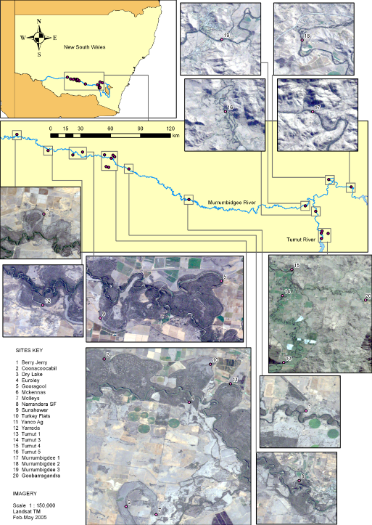

Figure 2 Distribution of in-channel and wetland monitoring sites along the Murrumbidgee River.
3.0 Monitoring of in-channel parameters

3.1 Methods

Monitoring of in-channel parameters was undertaken at three reaches in the Murrumbidgee River downstream of Burrinjuck Dam and four reaches in the Tumut River downstream of Blowering Dam (see Figure 2). One reach in the Goobarragandra River, an unregulated tributary of the Tumut River, was sampled as a reference. The Murrumbidgee River downstream of Burrinjuck Dam is highly regulated. The flows in the Tumut River downstream of Blowering Dam is also highly regulated, however the Tumut River downstream of the confluence of the Goobarragandra River is influenced by unregulated in-flows from this river. Cobble benches were present at each study reach (Plate 1). These habitats undergo considerable hydrological change during a pulsed flow due to increased water velocity and area of inundation.

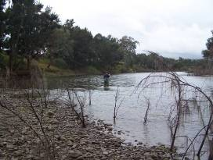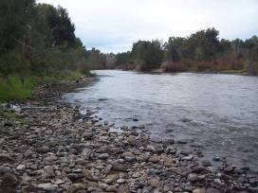

Plate 1 Murrumbidgee River at Gundagai (left) and Jugiong (right) showing presence of cobble benches at each site.

Sampling was undertaken on four survey dates; one prior to the first flow pulse, and three dates after the June environmental flow (Table 1, Figure 3). The fourth sample from Murrumbidgee site 1 was collected on the 9th September, five days later than all other sites were sampled. This is because a large flow was released from Burrinjuck Dam on the morning of 4th September and so this site could not be sampled safely until the flow had receded several days later. The final survey on in-channel paramteres will be undertaken in early October 2011.

River discharge data (ML/day) were obtained from the New South Wales Water Information website for three hydrographic gauging stations in close proximity to the study reaches: station 410008 downstream of Burrinjuck Dam, station 410073 at Oddy’s Bridge for the Tumut River downstream of Blowering Dam, and Station 410057 at Lacmalac for the Goobarragandra River.

The environmental water was released from both Burrinjuck and Blowering Dams. The release commenced on June 14th and reached maximum daily discharge of 24908 ML/day in the Murrumbidgee River downstream of Burrinjuck Dam on 17th June 2011 and 9492 ML/day in the Tumut River downstream of Blowering Dam on 16th June 2011 (Figure 3). Following the watering event there were two smaller flow pulses of different magnitudes from Burrinjuck Dam in mid-late August and early September. During the study period there were several regulated releases from Blowering Dam reaching a maximum discharge of approximately 8000 ML/day and one event in July continued at this discharge for approximately 3 weeks.

Table 1 Average daily discharge on each survey date. Samples were collected between high flow events.
Survey event | Survey date | Discharge in Murrumbidgee River DS Burrinjuck Dam (ML/d) | Discharge in Tumut River DS Blowering Dam (ML/d)
1 | 3/6/2011 | 473 | 2806
2 | 28/6/2011 | 451 | 572
3 | 30/7/2011 | 792 | 719
4 | 4/9/2011 | 690 (site 1 collected 9/9) | 3358
5 | To be collected

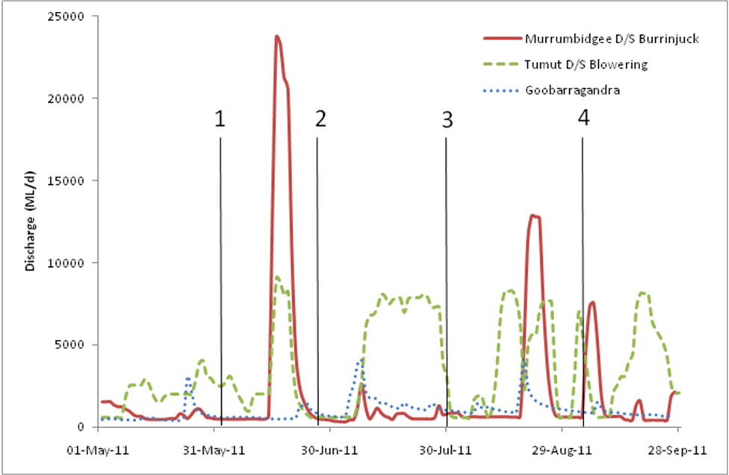
Figure 3 Timing of survey events in relation to discharge in the Murrumbidgee River downstream of Burrinjuck Dam, Tumut River downstream of Blowering Dam and in the Goobarragandra River (reference stream). Lines indicate timing of (1) survey in June 2011 prior to the environmental flow, and (2-4) for surveys conducted after the environmental flow.

A Horiba water quality monitor was placed just below the water surface at each site on each sampling date to obtain spot measures of the temperature (ºC), specific conductivity (mS/cm), dissolved oxygen (%), pH, and turbidity (NTU) of the water.

This project used biofilms (also known as periphyton) as an indicator of the ecological response to the flow pulses because they respond to flow changes in a time frame (days to weeks) that is appropriate for the management change. Biofilms are a combination of bacteria, algae, fungi and detritus that grow on submerged surfaces. They are central to important nutrient and biogeochemical processes and are a major food resource for higher organisms including crustaceans, insects and some fish. An area in the channel at each river reach was selected as the sample area for the entire study, as this area would remain permanently inundated throughout the study period. On each sampling occasion 5 cobbles (ranging between 12 and 20cm diameter) were collected from this area within each reach, placed in labeled sealed plastic bags and stored in the dark in an esky for transport back to the laboratory.

The biofilm was scrubbed from each cobble into 100 millilitres of distilled water using a soft nailbrush within 12 hours of field collection. Sub-samples were removed from the 100 millilitre residue for determination of chlorophyll-a and were filtered through a GC-50 0.5 micrometres filter. The amount filtered was recorded and a 10 millilitre sample for the assessment of taxonomic composition was stored in Lugols solution. Using GC-50 0.5 micrometres filter papers (for which the loss on ashing had been predetermined) a recorded amount of the solution was filtered, the filter paper was dried at 80°C for 24 hours, weighed, combusted for 4 hours at 500°C and reweighed. All samples were weighed to four decimal places and converted to dry weight (DW) and ash free dry weight (AFDW). Chlorophyll-a was determined following Tett et al. (1975). Samples were placed in 8 millilitres of methanol containing 150 milligrams magnesium carbonate, extracted for 18 hours at 4°C, transferred to a 70°C water bath and boiled for 2 minutes. Samples were centrifuged at 4500 rpm for 3 minutes and optical densities at 750 and 666 nanometres were measured pre- and post-acidification (1M HCl) using a UV/Visible Spectrophotometer.

Each cobble was measured for colonisable rock surface area (CRSA) by covering the exposed surface area of the rock (excluding the buried surface) with aluminium foil (after Doeg & Lake 1981). CRSA measurements were used to standardise biofilm dry weight (DW) and ash free dry weight (AFDW) to g/m² and chlorophyll-a to mg/m². Percent organic matter was calculated as the proportion of AFDW to DW and converted to a percentage to standardise across sites and dates. Samples to assess biofilm algal species composition have been collected but are yet to be processed. The biofilm composition results will be presented in the final report.

Aquatic macroinvertebrates were sampled from riffle, pool and edge habitats at each river reach using a sweep net with 250 micrometre mesh. Following sampling, net contents were emptied into a labeled sample jar and were preserved in 70% alcohol. Laboratory processing of samples commenced in August. Aquatic macroinvertebrates abundance and diversity will be assessed, with identification to family level. Results of the abundance and diversity of macroinvertebrates will be presented in future memos and the final report.

3.2 Results - Monitoring of in-channel parameters

This is a preliminary assessment of the in-channel benefits of the environmental flows. Full details of macroinvertebrates and biofilm results will be included in the final report.

A comparison of biofilm biomass prior to the environmental flow (sample date 1) to that immediately after the environmental flow (sample date 2) demonstrates the immediate in-stream response of biofilm to the flow. The environmental flow significantly reduced the biomass of biofilm at Tumut sites 3 and 4 and Murrumbidgee sites 1 and 2, most likely due to scouring of biofilms from increased water velocity (Figures 4 and 5).

By 30th July (approximately 5 weeks after the recession of the environmental flow) the biomass of biofilm at most sites had significantly increased to levels higher than observed prior to the environmental flow, with the exception of the downstream sites in the Tumut River (Tumut 4 and 5) (Figures 4 and 5). By September the biomass of biofilm was very high at several sites in the Murrumbidgee and Tumut Rivers, comparable with the highest levels that have previously been observed downstream of Dartmouth Dam in the regulated Mitta Mitta River (Watts et al. 2005; Watts et al. 2008; Watts et al 2011). In contrast, the biofilm biomass in the unregulated reference reach in the Goobarragandra River was low throughout the study (Figures 4 and 5).

The biofilm biomass at the two downstream sites in the Tumut River (sites 4 and 5) did not increase to the same extent as the upstream sites because those sites are influenced by the variable inflows from the unregulated Goobarragandra River.

A reduction in biofilm biomass was observed at Murrumbidgee site 1 between the 3rd and 4th sampling event. This site could not be sampled on 4th September when all other sites were sampled,because the discharge from Burrinjuck Dam was rapidly increased that morning and it was unsafe to sample the reach. If this site had been sampled prior to the release the site would most likely have followed a similar trajectory of increasing biofilm biomass similar to that observed at Murrumbidgee 2 (Figures 4 and 5). The results suggest the biofilm at Murrumbidgee site 1 was scoured by the large flow on 4th September.

Figure 4 Biofilm total dry biomass (dry weight mg/m²) on cobbles at reaches in the Murrumbidgee River, Tumut River and Goobarragandra River. Red arrow indicates the time of peak discharge for the environmental flow pulse.
Figure 5 Biofilm organic biomass (dry weight mg/m²) on cobbles at reaches in the Murrumbidgee River, Tumut River and Goobarragandra River. Red arrow indicates the time of peak discharge for the environmental flow pulse.

4.0 Monitoring of Mid-Murrumbidgee wetlands

4.1 Survey sites
This study is focused on 12 wetlands that make up part of the mid-Murrumbidgee wetland complex between Wagga Wagga and Carathool (see Figure 2). The majority of surrounding land is cleared grazing and cropping (see Figure 2 insets). Wetlands on both private land and within the reserves are subject to periodic cattle grazing.

The hydrology of some wetlands included in this study is influenced by water extraction. Nine of the 12 wetlands are moderately deep ox-bow lagoons, two are large open depressions (Turkey Flat and Dry Lake) and one is a prior stream channel (Molleys) (Plate 2). River red gum (Eucalyptus camaldulensis) is the dominant vegetation community surrounding these wetlands.

Nine of the 12 wetlands were inundated by the Commonwealth environmental flow release in June 2011 (Plates 2 a-g). Two types of control wetlands have been included in this study: (1) Control 1 (Euroley, Plate 2h) received flooding in December 2010 from the river but was not inundated by the environmental flow in June 2011; and (2) Control 2 wetlands (Turkey Flats and Yanco Ag, Plates 2i-j) were not flooded via the Murrumbidgee River in December 2010 or June 2011 but are subject to relatively frequent low level inundation via rainfall run-off and as managed flows through the Murrumbidgee Irrigation Area. Surveys were conducted in June 2nd - 4th 2011 (pre-flood), July 5th – 7th 2011 (post flood), and August 30th to September 2nd 2011 (post –flood 2) (Figure 6).

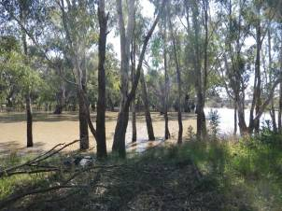  a. Berry Jerry | 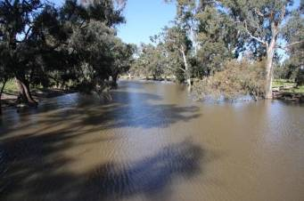  b. Molleys
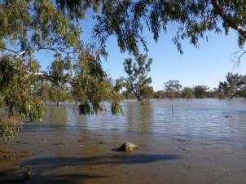  c. Dry Lake | 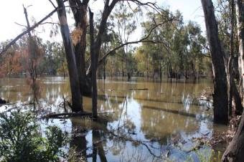  d. Gooragool
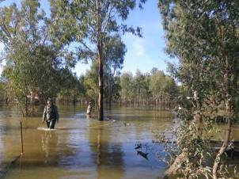  e. Sunshower | 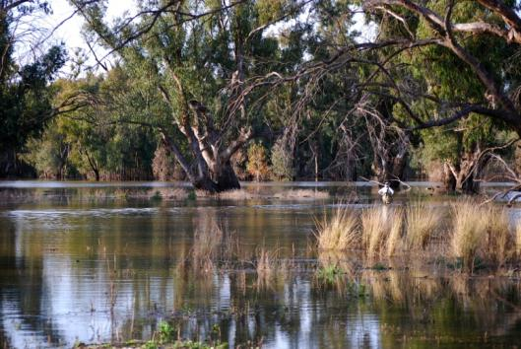  f. Yarrada
Plate 2 Survey wetlands in the Mid-Murrumbidgee (a-f)

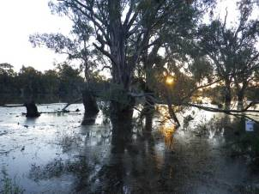  g. Mckennas | 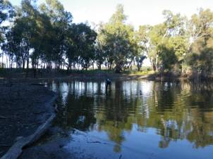  h. Euroley (Control 1)
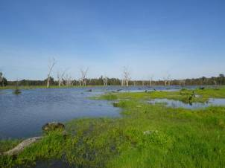  i. Turkey Flat (Control 2) | 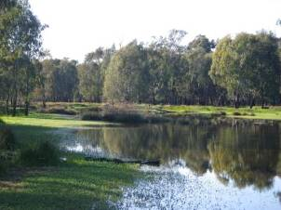  j. Yanco Ag (Control 2)

Plate 2 cont. Survey wetlands in the Mid-Murrumbidgee (g-j)

1
3
4
2
Figure 6. Timing of survey events in relation to discharge in the Murrumbidgee River at Narrandera and Darling Point. Vertical lines show (1) pre-flood reference surveys in June 2011, water quality and carbon monitoring during peak flow in late June (2) and post flood surveys in (3) July and (4) August 2011.

4.2 Methods

4.2.1 Broad scale assessment of the change in frog communities in the mid-Murrumbidgee wetlands over time

Methodology follows that used previously as part of the IMEF (1998-2005) and CSU research (Wassens, 2006; Wassens & Amos, 2011). Surveys were conducted in June 2nd - 4th 2011 (pre-flood), July 5th – 7th 2011 (post flood), and August 30th to September 2nd 2011 (post –flood 2) (Figure 6).

Habitat descriptions
Biophysical variables (e.g. aquatic and fringing vegetation aquatic species and percent cover of each wetland plant species along with percent cover leaf litter, bare ground cover and depth) were measured at three 25 m transects with measurement every 1 m.

Frog and tadpole surveys
Adult frogs and metamorphs were surveyed at each wetland after dark using a 3 x 10 minute visual encounter and a 3 x 1 minute audio survey (Heyer et al., 1994). All individuals encountered were identified to species. Tadpoles and small-bodied fish were surveyed using timed 5 x 1 minute sweeps with soft mesh sweep-net in addition to 3 minute day time visual searches along the water’s edge for egg masses and metamorphs.

4.2.2 Intensive assessment of tadpole communities, native fish and waterbirds
Intensive assessments of fish and tadpoles communities were conducted from August 30th to September 2nd 2011, using methodology previously described in (Spencer & Wassens, 2010). A combination of sampling methods targeting different habitats within each wetland were employed to survey for fish and tadpoles. Sweeping netting, seining, bait traps and large and small fyke nets were utilized to survey the seven intensive monitoring sites (Table 1). Five bait traps (dimensions 25 x 10 cm, 5 mm mesh), two large (2 x 10 m wings, 12 mm mesh) and two small (2 x 2 m wings, 2 mm mesh) fyke nets were left overnight at each site. Three replicate samples using a seine net were employed at Euroley wetland which was too shallow to sample using large fyke nets. Wing width and depth (m) were recorded at each site. Fish species were identified and measured to the nearest millimetre (standard length). Native fish were returned immediately to the water when possible, but alien fish were euthanased under NSW Fisheries ethics guidelines (NSW Fisheries approval ACEC 06/08). The percentage of recruits within the samples was estimated using size limits established by Gilligan (2005).

Waterbirds were surveyed at 10 wetlands in the mid-Murrumbidgee (Table 1) in August 2011 surveys using replicate ground counts conducted over two consecutive days. Only one count was completed at the Yanco Ag site. Birds were observed using binoculars (8 x 30 mm) and a telescope (Swarovski 20 – 60X zoom). Total counts for each waterbird species and any evidence of breeding activity (nesting and/or the presence of young) were recorded during each survey.

4.2.3 Water Quality and productivity changes in response to environmental watering
Water quality and productivity was monitored within each of the 12 wetlands and from three locations at sites upstream of the wetlands (Murrumbidgee at Wagga Wagga), nearby to the wetlands (Murrumbidgee at Euroley) and downstream of the wetlands (Murrumbidgee at Darlington Point). Water quality variables (water temperature, conductivity, pH, turbidity, dissolved oxygen and water depth) were measured at each site using a handheld YSI meter.
Water samples were collected to assess for Total Organic Carbon (TOC), Dissolved Organic Carbon (DOC) and (by difference) Particulate Organic Carbon (POC), humic and fulvic character (by fluorescence spectroscopy) and nutrients.

Samples for dissolved organic carbon, soluble phosphate, ammonia, nitrate and fluorescence spectroscopy were filtered through a 0.45 μm membrane at the time of sampling. Unfiltered samples for total organic carbon and total nutrients and filtered samples for carbon and nutrients were frozen in the field and samples for fluorescence were stored on ice and analysed within one day of returning from the field. Fluorescence and absorbance scans were recorded on both acidified (HCl to give a final pH of approx 2) and non-acidifed samples from each site. Absorbance scans were recorded from 550 nm to 200 nm with a 1nm step size. Fluorescence emission was recorded across this range using excitation wavelengths from 200 to 400 nm with a 10 nm step size. Fluorescence results were corrected for sample absorption and plotted as contour plots (Howitt et al., 2008). Nutrient analysis was undertaken by the Environmental Analytical Laboratories at Charles Sturt University and organic carbon analysis at the Murray Darling Freshwater Research Centre.

4.3 Results - mid-Murrumbidgee wetlands

4.3.1 Aquatic vegetation
A total of 25 aquatic and semi-aquatic plant species have been recorded across the 12 wetlands. Aquatic vegetation cover remains low all flooding sites, but species richness is increasing overall (Table 2). There has been little change in aquatic vegetation cover and diversity since June 2011 which is expected given that surveys were outside the growing season for the majority of aquatic plants. Short spike rush is the most widespread species occurring at 75% of wetlands followed by Warrego grass (62% of wetlands).

The control 2 wetlands (rainfall run-off/irrigation) Turkey Flat and Yanco Ag, had relatively high diversity and cover of aquatic vegetation. These two are shallow (less than 50 cm) open wetlands that receive frequent rain run-off from the surrounding areas. Vegetation at these wetlands has recovered far more quickly that the less frequently flooded wetlands (Plates 3).

Table 2 Aquatic and semi-aquatic plant species list for 12 mid-Murrumbidgee wetlands for June – August 2011. C1 indicates the control type 1 wetland that was inundated in December 2010 from the river but was not inundated by the environmental watering event in June 2011. C2 indicates the control type 2 wetlands that were not inundated in December 2010 or June 2011 but are subject to relatively frequent low level inundation via rainfall run-off and as managed flows through the Murrumbidgee Irrigation Area.

Common name | Scientific Name | Berry Jerry | Narrandera SF | Molleys | Dry Lake | Coonacoocabil | Sunshower | Gooragool | Yarrada | Mckennas | Turkey Flats (C2) | Yanco Ag (C2) | Euroley (C!) | percent of sites
Azolla | Azolla filiculoides |  |  |  |  |  |  |  |  |  |  | * |  | 8
Knob sedge | Cyperus difformis |  |  |  |  |  |  |  |  |  | * |  |  | 8
Sedge | Cyperus eragrostis* |  |  |  |  |  |  |  |  |  |  |  | * | 8
Short spike rush | Eleocharis acuta | * | * | * | * |  | * | * | * |  | * | * |  | 75
Cushion rush | Eleocharis pusilla |  |  | * |  |  |  |  |  |  |  |  |  | 8
Tall spike rush | Eleocharis sphacelata | * |  |  |  |  |  |  |  |  |  | * |  | 17
Duck Weed | Lemnaoideae |  |  |  |  |  |  | * |  |  | * | * |  | 25
Water primrose | Ludwigia peploides |  | * | * |  |  |  |  |  |  | * | * |  | 33
Common nardoo | Marsilea drummondii |  |  | * |  |  |  |  |  |  | * |  |  | 17
Nardoo | Marsilea hirsuta |  |  |  |  |  |  |  |  |  | * |  |  | 8
Warrego Grass | Paspalidium jubiflorum | * | * | * |  | * | * |  | * |  | * |  | * | 67
Water Couch | Paspalum distichum | * | * |  |  |  | * |  | * |  | * |  | * | 50
swamp buttercup | Ranunculus undosus |  |  |  |  |  |  |  |  |  | * |  |  | 8
Water ribbons | Triglochin procera |  |  |  |  | * |  |  |  |  |  |  |  | 8
Narrow leaf Cumbungi | Typha domingensis |  |  |  |  | * |  |  |  |  |  | * |  | 17
Carex | Carex inversa | * |  | * |  | * |  |  |  |  |  |  | * | 33
Pennywort | Centella sp. | * |  |  |  |  |  |  |  |  |  |  |  | 8
Common Sneezeweed | Centipeda cunninghamii | * |  | * | * |  |  |  | * |  | * |  |  | 42
Cotula | Cotula coronopilia |  |  |  |  |  |  |  |  |  | * |  |  | 8
Swamp Goodenia | Goodenia pusilliflora |  |  | * |  |  |  |  |  |  |  |  |  | 8
Juncus | Juncaceae family | * |  | * |  | * |  |  |  |  |  | * |  | 42
Pale Knotweed | Persicaria lapathifolia | * |  | * |  |  |  |  |  |  |  | * |  | 25
Slender knotweed | Persicaria decipiens |  |  | * |  |  | * |  |  |  | * |  |  | 24
Ferny buttercup | Ranunculus pumilio |  |  |  |  |  |  |  |  |  | * |  |  | 8
Swamp Dock | Rumex brownii | * |  | * |  | * |  |  |  |  | * | * |  | 42
Percent of total species |  | 40 | 16 | 48 | 8 | 24 | 16 | 8 | 16 | 0 | 56 | 35 | 16
* Indicates introduced species

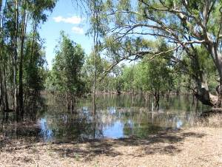  Sunshower lagoon (November 2010) | 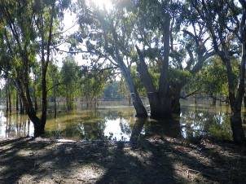  Sunshower lagoon (August 2011)
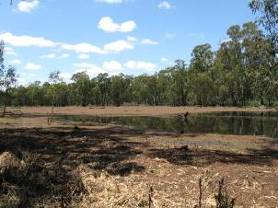  Yanco Ag (November 2010) | 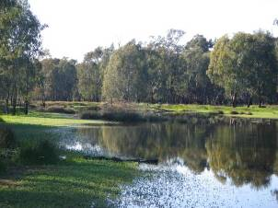  Yanco Ag (August 2011)
Plate 3 Vegetation responses at Sunshower and Yanco Ag Lagoon

4.3.2 Frogs and tadpoles
Frog activity increased markedly between the July and August survey periods (Figure 7). Large numbers of Spotted marsh frogs and Plains froglet were recorded calling across the majority of flooded wetlands sites in the August surveys and egg masses were observed at Yarrada Lagoon. The number of species recorded also increased with small numbers of Peron's tree frogs and Barking marsh frog adults observed, although these species had not yet commenced breeding activity (Table 3). Adult Inland Banjo frogs were recorded calling at Molleys Lagoon, and a single Spotted marsh frog was recorded at Yarrada Lagoon. No tadpoles of any species were recorded, although Spotted marsh frog egg masses were abundant at some wetlands, which is typical for late winter (Spencer & Wassens, 2010). The spring and summer active species (Southern bell frog, Barking marsh frog and Peron’s tree frog) are not yet active but are expected to commence breeding by October when further surveys are planned.

Figure 7. Change in the number of observations of calling, adults observed and egg masses in the mid-Murrumbidgee wetlands between June and August 2011.

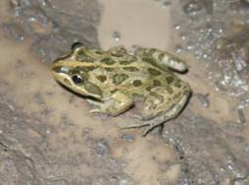 | 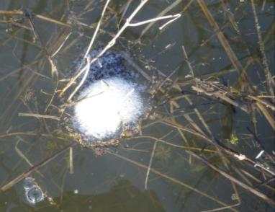
Spotted marsh frogs commenced breeding in late August with large number of egg masses recorded

As activity levels increased, so did the number of wetlands where each species was observed. Plains froglet was recorded at all 12 wetlands in August 2011, whereas only three species were recorded in June prior to the environmental flow, and six species in July. Spotted marsh frogs were active at 11 of the 12 wetlands in August. Very small numbers of spring/summer active species, Peron's tree frogs and Barking marsh frogs, were recorded at a small number of wetlands; neither of these species has yet to commence calling but are expected to be observed calling later in the season.

Table 3 Frog species recorded at mid-Murrumbidgee wetlands sites prior to the environmental watering (2-5 June 2011), and the surveys after the environmental watering (4-7 July 2011, post-watering 1; and 25 Aug – 2 Sep 2011, post-watering 2).
 |  | Berry Jerry | Narrandera SF | Molleys | Dry Lake | Coonancoocabil | Gooragool | Sunshower | Yarrada | McKennas | Euroley (C1) | Turkey Flats (C2) | Yanco Ag C2)
June | Plains froglet | 1 |  |  |  |  |  |  |  |  |  | 2 | 1
(prior to watering) | Barking marsh frog |  |  |  |  |  | 2 |  | 1
 | Spotted marsh frog |  |  |  |  |  |  |  |  |  |  | 1
July | Plains Froglet |  | 3 |  | 1 |  | 3 | 2 |  | 3 | 1
(post-watering 1) | Spotted marsh frog |  |  |  |  |  |  |  | 1
August | Plains Froglet | 3 | 8 | 1 | 5 | 3 | 9 | 5 | 4 | 2 | 10 | 23 | 10
(post-watering 2) | Spotted marsh frog | 2 |  | 7 | 13 | 1 | 28 | 8 | 9 | 16 | 3 | 21 | 5
 | Peron’s tree frog |  | 4 |  |  | 2 |  |  |  |  |  | 2
 | Barking marsh frog |  |  |  |  |  |  |  | 1 |  |  | 1

4.3.3 Waterbirds

Since June 2011, 2918 individual waterbirds of 26 species were observed in the mid-Murrumbidgee wetlands (Table 4). None of the observed species are listed on the Threatened Species Conservation Act or the Environment Protection and Biodiversity Conservation 1999 Act. The Great egret is listed on the on Japan and China bilateral agreements (JAMBA and CAMBA).

Dabbling ducks (Grey teal and Pacific black ducks) were the most abundant and widespread species, the grazing Australian wood duck was also very common. Of the fish-eating species, little pied and little black cormorants were still abundant. Species richness was highest at Sunshower and Gooragool lagoon (15 species) followed by Turkey Flat (13 species). Overall there was no significant difference in species richness between the controls and the flooded wetlands (GLM F = 0.2, p = 0.804). Survey intensity was higher in August than in previous months, with two intensive surveys being conducted at each wetland, as a consequence of differing levels of survey effort it is not possible to compare the abundance of water birds over the three survey periods. No breeding activity (nesting or young) was observed during the surveys.

Table 4 Waterbird counts (June, July and August 2011)

 | Berry Jerry (n=2) | Narrandera SF(n=2) | Molleys (n=3) | Dry Lake (n=3) | Coonacoocabil (n=2) | Gooragool(n=3) | Sunshower (n=3) | Yarrada(n=3) | McKennas (n=3) | Euroley (C1)(n=3) | Turkey Flat (C2) (n=3) | Yanco Ag (C2) (n=3) | Total
Australasian grebe | 7 | 1 | 7 |  | 8 | 3 | 4 | 5 | 5 | 2 | 13 | 4 | 59
Australasian shoveler |  |  |  |  |  |  |  |  |  |  | 11 |  | 11
Australian white ibis |  |  | 3 |  |  |  |  | 3 |  |  | 1 |  | 7
Australian wood duck | 4 |  | 14 | 6 | 2 | 46 | 143 | 150 | 28 | 8 | 254 | 26 | 681
Black duck |  |  |  |  | 2 | 1 | 5 |  |  | 1 | 2 | 2 | 13
Black swan |  |  |  | 2 |  |  | 2 |  |  |  | 5 |  | 9
Black-fronted dotterel |  |  |  |  |  |  | 5 |  |  |  |  |  | 5
Chestnut teal |  |  |  |  |  |  | 7 |  |  |  |  |  | 7
Darter | 1 |  |  | 25 |  | 28 | 7 |  | 6 | 1 | 2 |  | 70
Dusky moorhen |  |  |  |  |  |  |  |  |  |  |  | 9 | 9
Eurasian coot |  |  |  |  |  | 2 |  |  |  |  |  | 4 | 6
Great cormorant |  |  |  | 1 |  | 27 |  |  | 74 |  |  |  | 102
Great egret | 1 |  | 16 | 10 |  |  |  | 2 |  | 2 |  | 2 | 45
Grey teal | 3 | 3 |  | 8 | 19 | 47 | 127 | 23 | 54 | 18 | 362 | 34 | 698
Intermediate egret |  |  | 5 |  |  | 4 | 1 | 5 | 19 |  |  |  | 34
Little black cormorant |  |  |  |  |  | 15 |  | 3 | 42 | 72 |  |  | 132
Little pied cormorant | 84 |  | 32 | 2 | 5 | 55 | 25 | 20 | 167 | 49 | 3 |  | 450
Masked lapwing |  |  |  |  |  |  |  |  |  |  |  | 2 | 2
Nankeen night heron |  |  | 1 |  |  |  |  |  |  |  |  |  | 1
Pacific black duck |  | 2 |  |  |  | 41 | 56 | 4 | 6 | 39 | 149 | 13 | 310
Pied cormorant |  |  |  | 1 |  |  |  |  |  |  |  |  | 1
Pink-eared duck |  |  |  |  |  | 5 |  |  |  |  |  |  | 5
Straw-necked ibis |  |  | 23 |  |  |  | 1 | 6 | 13 |  | 2 |  | 46
White-faced heron | 4 |  | 4 | 3 |  | 5 | 6 | 15 | 4 | 2 | 10 | 11 | 66
White-necked heron |  |  | 15 | 1 |  | 3 | 8 | 32 |  |  | 17 | 2 | 90
Yellow-billed spoonbill |  |  |  |  |  | 14 | 1 |  | 1 | 3 |  | 6 | 25
Grand Total | 105 | 6 | 111 | 62 | 40 | 303 | 401 | 272 | 420 | 199 | 835 | 117 | 2918
Total Species | 7 | 3 | 9 | 9 | 4 | 15 | 15 | 12 | 12 | 9 | 13 | 12

3.3.4 Other species

Three species of owl and the Tawny frog mouth were recorded during nocturnal surveys (Table 5). A pair of white-bellied sea eagles (listed under the China-Australia Migratory Bird Agreement) was recorded at Dry Lake. Water rats were recorded at two wetlands, Berry Jerry and Euroley in August 2011 (Plate 4). This is the first time that water rats have been recorded in the mid-Murrumbidgee wetlands between Narrandera and Carrathool, although they are known from wetlands in the Murrumbidgee Irrigation Area (Atlas of NSW Wildlife database, 2011).

Table 5 Summary of other vertebrates recorded between June and August 2011
 | Berry Jerry | Narrandera SF | Molleys | Dr Lake | Coonacoocabil | Gooragool | Sunshower | Yarrada | McKennas | Euroley (C1) | Turkey Flat (C2) | Yanco Ag (C2) | Number of sites
Barking Owl |  |  |  |  |  |  |  |  |  |  |  | 2 | 1
Barn Owl |  |  |  | 1 | 2 | 4 | 2 |  |  |  | 2 |  | 5
Boobook owl |  |  | 3 |  | 2 | 1 | 1 | 2 |  |  | 2 |  | 6
Tawny frog mouth |  |  |  |  |  | 1 |  | 2 | 1 |  |  |  | 4
White-bellied sea eagle |  |  |  | 2 |  |  |  |  |  |  |  |  | 1
Water rat | 1 |  |  |  |  |  |  |  |  | 2 |  |  | 2

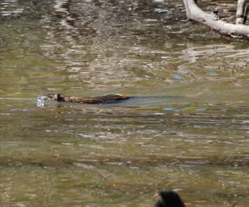
Plate 4 Water rat at Euroley wetland, August 2011

3.3.5 Fish

Diversity and abundance
Fish were surveyed at six of the wetlands (inundated by the environmental watering event in June 2011) and one control site (Euroley, not inundated in June 2011). Seven species were recorded; two native species (Australian Smelt and Carp Gudgeon) and five introduced species (European carp, Goldfish, Gambusia , Oriental weather loach and Redfin perch). Fish abundance was highly variable among the wetlands. Dry Lake contained more than twice as many individuals as any other wetland. Sunshower and Yarrada contained the fewest individuals (Figure 8).

Overall native fish species were more abundant than introduced species and dominated the fish communities at Dry Lake, Molleys, Gooragool and Yarrada where more than 70% of individuals recorded were native species. The remaining wetlands still had a relatively high proportion of native fish of between 35 and 65%. Of interest is the collection of the Oriental weatherloach at Molleys and Dry Lake (Plate 5). This introduced species was absent from the lower Murrumbidgee and from wetlands in the mid-Murrumbidgee in 1994 (Gilligan). Of some concern is that this species appears to be spreading through the Murrumbidgee Catchment, with records of this species in the Lowbidgee in 2010-11 (Spencer & Wassens). A single juvenile Redfin perch was collected at Euroley only.

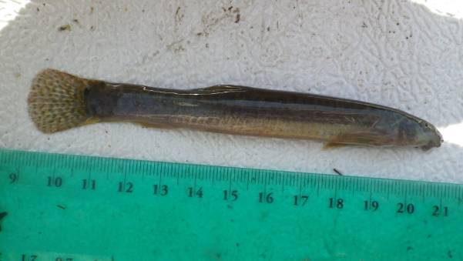

Plate 5 Oriental weatherloach
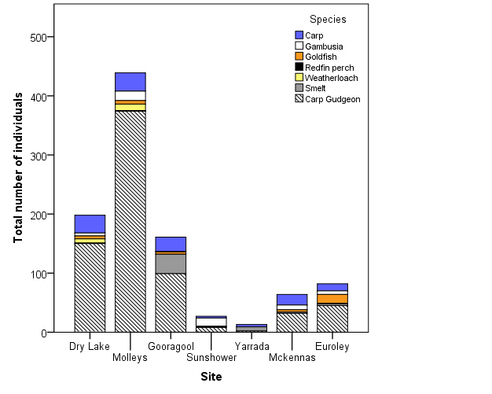

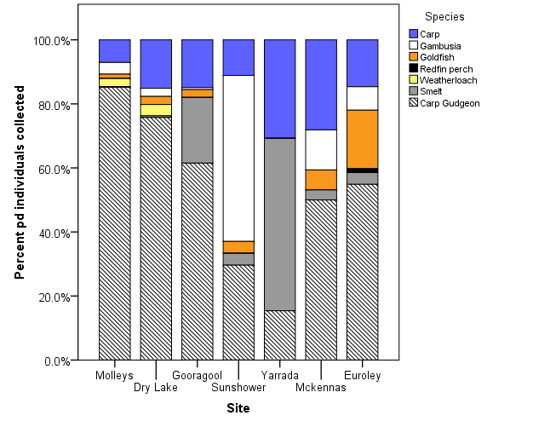

Figure 8. Relative abundance and contribution of fish species to the seven sites sampled in August 2011. The grey portion of the graphs indicates native species. Euroley is a control type 1 wetland that was inundated in December 2010 from the river but was not inundated by the environmental watering event in June 2011.

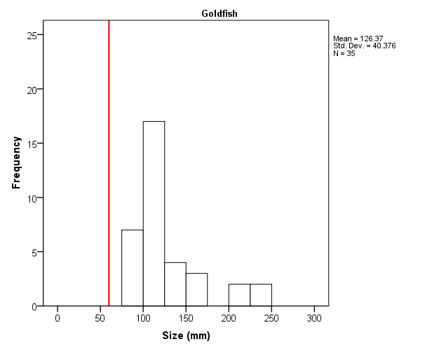

Figure 9. High-low box plots showing the minimum, maximum and mean (circle) standard lengths (mm) for the five most widespread fish species by wetland. The line indicates estimated size at maturity (Gilligan, 2005). Weather loach and Redfin perch have been excluded because they were recorded infrequently.

Evidence of fish recruitment
Juvenile stages of one native species, Carp gudgeon, and three introduced species (European carp, Gambusia and Weather Loach) were recorded during the August surveys (Figure 9). Juvenile Carp gudgeon were detected at five of the seven wetlands sampled in August 2011. It is likely that these individuals hatched in late summer-early autumn (ie before the June environmental watering event) when the wetlands were still fairly warm and have over wintered in the wetlands. Juvenile carp were comparatively large, minimum of around 50 mm, which suggests that these individuals were produced in the summer 2010. There was no evidence of recruitment by either Australian Smelt or Goldfish (see Figure 9).

3.3.6 Water quality

Overall water quality in the flooded wetlands is good; within the wetlands that received environmental water in June 2011 there are no indications of problems associated with low dissolved oxygen (due to black water event potential) or high conductivities. In order to establish if there were significant differences between wetlands that were inundated in 2011 and those that were not we included two types of controls: (1) control 1 (Euroley) wetland was inundated in December 2010 from the river but was not inundated by the environmental watering event in June 2011 and (2) control 2 wetlands (Yanco Ag and Turkey Flat) that did were not connected to the Murrumbidgee River in either 2010 or 2011 but are filled through a combination of rainfall runoff and controlled flooding via the Murrumbidgee Irrigation Area.

None of the measured water quality variables changed substantially over time (June- August) (Figure 10). In general, water quality was similar among the inundated wetlands compared to the control 1 wetland (Euroley). However conductivity was consistently higher at the control 2 (rainfall/irrigation) wetlands than at all other sites (F = 35.27, p <0.001) (Figure 10). Dissolved oxygen was on average higher in the inundated wetlands and river sites when compared to the two controls (F = 5.99, p = 0.001). pH did not differ among treatments (F = 3.19, p = 0.046). Conductivity was also unchanged across the three survey occasions (GLM F= 1.09, p = 0.342). The control 2 (flooded via rainfall run off) treatments had significantly higher conductivities than either the river, inundated wetlands or control 1 wetland Water temperature remained relatively cool, ranging from 9 to 15ºC during the August surveys, and was not significantly different to the June or July surveys periods (GLM F = 0.27, p = 0.765).
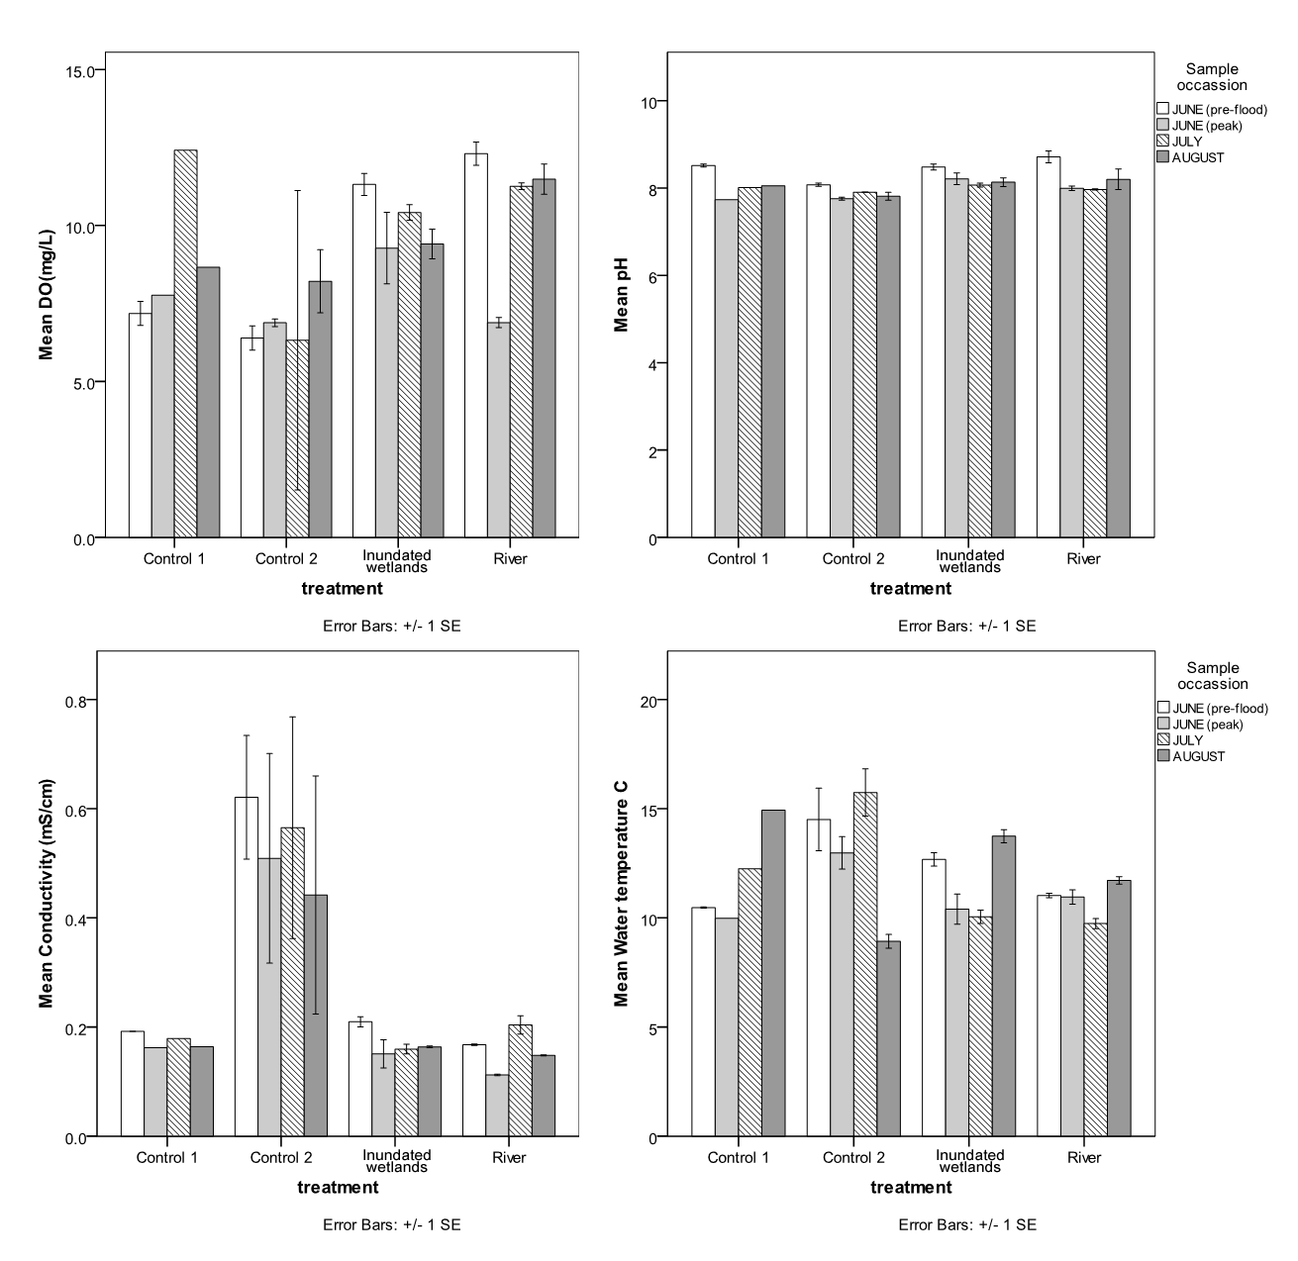
Figure 10. Change in mean (± standard error) water quality variables in the inundated wetlands, controls and Murrumbidgee River in June (pre and post flood), July and August 2011.

While analysis of DOC, TOC and nutrient data is not yet complete, the data available so far gives an indication of water quality associated with the environmental water release. Overall the in-channel sites immediately downstream of Burrinjuck and Blowering dams had lower concentrations of DOC and TOC than the mid-catchment river istes, wetland sites and control sites (Figure 11). The Murrumbidgee 1 site had consistently higher organic carbon concentrations than the other upstream in-channel sites, with the bulk of the organic matter in the dissolved fraction (Figure 12). During the flow peak the Murrumbidgee 3 site also had elevated carbon, likely reflecting the lower proportion of flow from the Tumut sites on this sampling date. In-channel sites further downstream (nearby to the mid-Murrumbidgee wetlands) have concentrations that are consistent with those at the Murrumbidgee 3 site and indicate there is minimal input of organic matter to the river from wetlands or floodplain sources.

Wetland sites show a general trend towards reduced dissolved organic matter concentrations on inundation, followed by a slight increase in the following week (with the exception of McKennas and Dry Lake (Figures 11 and 12), where organic matter concentrations continued to fall - possibly indicating that flushing with river water was incomplete at the time of the peak sampling). There is no indication of rapid leaching of floodplain litter which would indicate the onset of a blackwater event. An event of this nature would not be expected with the low water temperatures and recent flushing of these systems in the summer floods. Organic matter concentrations increased in the control wetlands over June and July, indicating a concentration effect as water levels fell. This trend was reversed at Yanco Ag and Turkey Flats wetlands (control 2 wetlands) in August following a rain-fed rise in water levels.

Dissolved oxygen concentrations have been plotted as % saturation to remove the influence of changing water temperature on the concentration of dissolved oxygen and facilitate comparison (Figure 13). All in-channel and treatment wetlands had DO concentrations above 6 mg/L on all sampling dates (well above the thresholds for impacts on fish). The control wetlands had highly variable DO results in July and this may be partially influenced by the exposed nature of the Turkey Flats wetland and the extremely windy conditions at the time of sampling. A slight reduction in DO concentration is evident at the time of the environmental watering, however this is evident in both the river sites, where the DOC concentration increased slightly, and the wetland sites, where the DOC concentration had decreased.

Preliminary nutrient data indicates that the control sites have a different nutrient status to all other sites - these sites were the only ones to have ammonia present at detectable levels (in some cases up to a third of the total nitrogen measured). This is indicative of a shallow water column in contact with anoxic sediments. It was noted during the sampling trip on 1/9/11 that at Gooragool wetland had water flowing into the wetland from the channel. Water quality in the channel appeared poor (Plate 6) and a spot sample was taken for nutrients. Nitrogen data for this water is not yet available, however Total P results indicate elevated nutrients (2.51 mg/L P compared to 0.11 mg/L in the wetland).

Figure 11. Change in mean (± standard error) Dissolved Organic Carbon (DOC) and Total Organic Carbon (TOC) concentrations at all sites, during June (pre and post environmental watering), July and August 2011. Note that carbon samples were only taken from the upper river sites during the June prior to and on the peak of the environmental flow. ‘In-channel’ refers to river sites immediately downstream of Burrinjuck and Blowering dams. ‘River’ refers to samples collected from the Murrumbidgee River nearby to the wetlands.

Figure 12. Total and Dissolved Organic Carbon for a) river sites upstream of Wagga Wagga, b) river sites downstream of Wagga Wagga, c) inundated wetlands and d) control wetlands.
Figure 13. Trends in dissolved oxygen saturation over time for a) river sites upstream of Wagga Wagga, b) river sites downstream of Wagga Wagga, c) inundated wetlands and d) control wetlands.

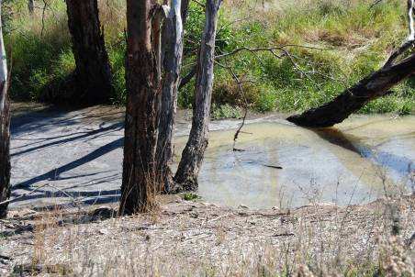

Plate 6 Water entering Gooragool wetland from the channel

5.0 Discussion

5.1 In–channel environment

This is a preliminary assessment of the in-channel benefits of the environmental flows. Assessment of macroinvertebrates and biofilm biodiversity will be included in the final report and will provide further information on the in-channel benefits of the environmental flow.

The environmental flow significantly reduced the biomass of biofilm at Tumut sites 3 and 4 and Murrumbidgee sites 1 and 2, most likely due to scouring of biofilms from increased water velocity. These findings are consistent with studies of biofilm responses to variable flow releases from Dartmouth Dam. It has been demonstrated that pulsed flows can scour and reset biofilms; reducing biomass, reducing the dominant taxa and enabling early successional diatoms to become established, facilitating a shifting in the biofilm community towards that of the reference stream (Watts et al., 2011; Watts et al., 2005; Watts et al., 2008).

Approximately 5 weeks after the recession of the environmental flow, the biomass of biofilm had significantly increased at most sites. By September the biomass of biofilm was very high at several sites in the Murrumbidgee and Tumut Rivers, comparable with the highest levels that have previously been observed downstream of Dartmouth Dam in the highly regulated Mitta Mitta River (Watts et al. 2005; Watts et al. 2008; Watts et al 2011). The biomass of biofilm present in the Tumut River and Murrumbidgee River exceed the recommendations of Quinn (1991). This suggests that while the environmental flow in the Murrumbidgee River provided a short-term benefit to the in-channel biofilm communities, the benefits were not sustained when the dam operations returned to normal regulated practices. It is expected that the biofilm scouring will have resulted in a short term improvement in the biodiversity of biofilms and macroinvertebrates. This prediction will be assessed in the final report when all data are available. These findings are consistent with observations in the Mitta Mitta River, where following pulsed flow events biofilm biomass increased when dam releases were returned to relatively constant discharge levels. One of the new interim guidelines developed for the operation of Dartmouth Dam (Watts et al., 2009) is to “Include pulses of different magnitudes (over a period of months) that reflect the variability of a more natural flow hydrograph” so that the benefits of pulsed flows can be sustained over time.

5.2 Mid-Murrumbidgee wetlands

Vegetation
Aquatic vegetation cover in the mid-Murrumbidgee wetlands remained low but there was evidence of germination by an increasing number of aquatic and semi-aquatic species. This suggests that at least some species were beginning to recover. A seed bank assessment was made for some of the wetlands included in this study in 2004 which indicated that seed banks at that stage were relatively intact in McKenna’s (17 species), Berry Jerry (Currawarna lagoon) (7 species), Molleys (20 species) and Dry Lake (12 species) (Clifton, 2004). Interestingly the response of vegetation to the 2010 and 2011 events is far lower than might have been expected given their past aquatic vegetation communities and diversity within the seed bank. There are a number of factors that could have influenced vegetation responses. The seed-bank may have been have become more depleted since 2004 with few individuals of each species available to germinate between 2004 and 2010 (Brock et al., 2003). Successive flooding over multiple years may be required to re establish aquatic vegetation communities and allow the seed bank to replenish.

Lack of germination cues for the plant species present may also explain the limited aquatic vegetation cover. Successive naturally occurring flood events in 2010 led to highly fluctuating water levels which remained relatively deep in the majority of wetlands over the summer of 2010-11. Deep water can inhibit germination, especially for emergent and fringe dwelling species (Casanova & Brock, 2000). If this is the case it is likely that vegetation communities will begin to re-establish once water levels stabilise.

Frogs
The observed frog responses are typical for the survey period (Spencer & Wassens, 2010), with winter- and early spring-breeding species commencing breeding in August. Tadpoles of winter- and early summer-breeding species such as the Spotted marsh frog are expected to be present in the wetlands during the October survey period. Late spring- and summer-breeding species such as the Barking marsh frog, Peron’s tree frog and Southern bell frog were not active during the July or August surveys but are expected to start calling activity by October.

Fish
Fish communities within the mid-Murrumbidgee wetlands were similar to those recorded by Gilligan (2005). One key difference is that native fish, Carp gudgeon and Australian smelt, dominated wetland fish communities in the majority of wetlands. Recruitment was also observed for Carp gudgeon, it is most likely that these juvenile fish hatched in autumn, either in the wetlands or the Murrumbidgee River, and are over-wintering. The June 2011 environmental watering event is likely to increase survival of these juvenile fish by increasing food availability and stabilizing water levels so that they can reach maturity. It was noted that juvenile carp gudgeon were also present at Euroley lagoon that was inundated in December 2010 from the river but was not inundated by the environmental watering event in June 2011, however these individuals are unlikely to survive due to declining water levels.

Juveniles of the four introduced species, European carp, Gambusia, Goldfish and Redfin perch were recorded, however the large size of these juveniles indicates that they were the product of the 2010 flood, rather than recent recruits, as these species spawn in spring or summer months (Lintermans 2007). Weather loach were recorded at two wetlands, this species has increased its range in the Murrumbidgee since the December 2010 floods and was also recorded for the first time in the Lowbidgee wetlands following flooding in October 2010 (Spencer et al., 2011). It will be important to monitor the distribution and abundance of this species to ensure that it does not establish large breeding populations within the mid-Murrumbidgee wetlands.

Waterbirds
Although we observed a limited response in waterbirds in the mid-Murrumbidgee wetlands during the August 2011 surveys, this may have been a result of the high mobility of this group and greater wetland availability in the rest of the Murray-Darling Basin, as significant and widespread flooding occurred in 2010-11. Surveys to date have also indicated that the mid-Murrumbidgee wetlands are still in a state of recovery with (most likely) depleted aquatic vegetation seed banks and invertebrate populations, which provide food for many waterbird species. Most waterbirds prefer wetland habitats with some aquatic vegetation, either as foraging habitat or to provide shelter from the elements or cover from predators, therefore, the wetlands may become more attractive to birds after aquatic vegetation has re-established. Although no breeding activity was detected during the August surveys, colonially-nesting waterbird species are more likely to commence nesting in spring when flooding occurs in autumn or winter (Scott, 1997). Several of the wetlands (e.g. McKennas and Gooragool) also supported breeding in cormorants and herons in the 2010-11 flood year (Wassens pers. obs. 2010). Further surveys planned for spring and summer 2011 will allow for a greater assessment of waterbird responses.

Water quality
The environmental water release resulted in a slight increase in in-channel organic carbon concentrations (including at upstream sites) and this was accompanied by a small reduction in dissolved oxygen concentrations at the peak of the flow. Dissolved oxygen was not observed to fall to levels which would be of concern to aquatic organisms. The wetland sites had initially high DOC (this is expected in wetland systems) and this was reduced by dilution/flushing on connection with the river. The exchange of carbon between the river and wetlands did not result in an anoxic blackwater event and this can be attributed to a number of factors including: the low temperature of the water which increases oxygen solubility and reduces the rates of both leaching of organic matter from leaf litter and microbial respiration (Howitt et al., 2007); dilution of the dissolved organic matter; and the fact that the dissolved organic matter in the wetlands is likely to have been well aged and of low bioavailability, resulting in only gradual degradation by aquatic microbial communities (Howitt et al., 2008).

Recommendations

Recommendation 1
To provide maximum benefits of environmental flows to in-channel communities, multiple flow pulses may need to be delivered over a period of months to avoid long periods of relatively constant discharge.

Recommendation 2
Aquatic vegetation recovery has to date been slow since the improved water availability in 2010. Low seed-bank viability and fluctuating water levels may have contributed to reduced germination of aquatic vegetation. Follow-up flooding over multiple years may be required to re-establish aquatic vegetation communities and seed-banks.

Recommendation 3
Frog, fish and water bird responses recorded to date are typical of late winter. Top-up flows may be required later in summer to ensure successful breeding by summer active frog species such as the Southern bell frog or if bird breeding occurs. The need for top-up flows will be established during later monitoring in October and December 2011

Acknowledgements

We extend our thanks to landowners for allowing access to their properties. Our surveys were supported by the NSW Parks and Wildlife Service. James Maguire, NSW Office of Environment and Heritage provided information on flows. On-ground surveys were approved under NPWS scientific licenses S12700 and S13080. Waterbird surveys were approved by the OEH Animal Ethics Committee (AEC No. 091214/01). Fish sampling was carried out under NSW Fisheries license F89/1598 and approved by the NSW Fisheries Animal Ethics Committee (ACEC 06/08). Frog surveys were approved by the Charles Sturt University Animal Care and Ethics (ACEC 07/125).

References

Watts, R. J., A. Zander, A. Burns & C. Allan. 2011. Environmental monitoring of pulsed releases from Dartmouth Dam to the Mitta Mitta River in 2009/2010.Report to the Murray Darling Basin Authority. Charles Sturt University, Institute for Land Water and Society Report Number 63, Albury.

