# F2183 ILWS_Robyn 3b_Page_1.jpg

**Monitoring of ecosystem responses to the delivery of environmental water in the Edward-Wakool river system, 2011-2012**

**Report 1**

**October 2012**

**Watts, RJa, Kopf, R.K.a, Hladyz, S.b, Grace, M.b, Thompson, R.b, McCasker, N.a, Wassens, S.a, Howitt, J.A.a, and Conallin, J.c (2012). Monitoring of ecosystem responses to the delivery of environmental water in the Edward-Wakool river system, 2011-2012. Institute for Land, Water and Society, Charles Sturt University, Report 1. Prepared for Commonwealth Environmental Water Office.**

a Institute for Land, Water and Society

Charles Sturt University

Institute for Land, Water and Society

PO 789 Box, Albury, NSW 2640

b. Water Studies Centre & Australian Centre for Biodiversity

Monash University,

Clayton, Victoria, 3800, AUSTRALIA

c. Murray Catchment Management Authority

PO Box 835

Deniliquin, NSW 2710

This monitoring project was commissioned by Commonwealth Environmental Water Office to a consortium managed by the Murray-Darling Freshwater Research Centre. The project was sub-contracted to Charles Sturt University, the Murray Catchment Management Authority and Monash University. The project was funded by the Commonwealth Environmental Water Office with in-kind contributions from Charles Sturt University, Murray Catchment Management Authority and Monash University.

The views and opinions expressed in this publication are those of the authors and do not necessarily reflect those of the Australian Government or the Minister for Sustainability, Environment, Water, Population and Communities. While reasonable efforts have been made to ensure that the contents of this publication are factually correct, the Commonwealth does not accept responsibility for the accuracy or completeness of the contents, and shall not be liable for any loss or damage that may be occasioned directly or indirectly through the use of, or reliance on, the contents of this publication.

© Commonwealth of Australia 2012. This work is copyright. Apart from any use as permitted under the Copyright Act 1968, no part may be reproduced by any process without prior written permission from the Commonwealth. Requests and enquiries concerning reproduction and rights should be addressed to Department of Sustainability, Environment, Water, Population and Communities, Public Affairs, GPO Box 787 Canberra ACT 2601 or email [public.affairs@environment.gov.au](mailto:public.affairs@environment.gov.au)

# Executive summary

**Report 2 May 2012**

**Monitoring of ecosystem responses to the delivery of environmental water in the Murrumbidgee system**

The Edward-Wakool river system, a major anabranch and floodplain of the Murray River, is a complex system of interconnected regulated streams, ephemeral creeks, flood runners and wetlands intersected by a network of irrigation channels. It has a history of regulated flows for irrigation, stock and domestic supply. This system has a high native species richness and diversity, including threatened and endangered fishes, frogs, mammals, and riparian plants.

Environmental water use options for the Edward-Wakool river system are outlined in Hale and SKM (2011). Potential water use options for the Edward-Wakool river system include: providing base flows to Jimaringle and Cockrans Creeks to maintain in stream water quality; augmenting natural flows to improve connectivity between the river channel and floodplains within Werai Forest; and providing pulse flows in the Edward-Wakool rivers to promote ecosystem function for in-channel flora and fauna.

In 2011-12 Commonwealth environmental water was delivered to the Edward-Wakool river system on three occasions. The overarching purpose of the delivery of Commonwealth environmental water was to provide pulse flows in the Edward-Wakool rivers to promote ecosystem function for in-channel flora and fauna. However each of the individual watering events also had specific targeted objectives. The three environmental watering actions were:

* November 2011 environmental watering in Colligen Creek
* February 2012 environmental watering in Colligen Creek and the Wakool River
* April to May 2012 environmental watering via irrigation escapes to the Edwards, Yallakool and Wakool Rivers.

Preliminary results of the monitoring of ecosystem responses to environmental watering in the Edward-Wakool river system in 2011-2012 are presented in this report. A final report will be available later in 2012.

Delivery of environmental water in November 2011

In November 2011 5.5 gigalitres (GL) of Commonwealth environmental water was delivered to Colligen Creek in conjunction with 1.7 GL of water supplied by the New South Wales Government. The environmental water was used to gradually raise flows commencing on 19/11/2011 and then lower flows over 20 days.

The primary objective for the November 2011 environmental watering was to encourage movement of large bodied native fish such as Murray cod, silver perch and golden perch to initiate spawning and recruitment of these species. The watering event was also expected to maintain and enhance instream habitat (Commonwealth Environmental Water 2012a).

Delivery of environmental water in February 2012

In February 2012 7.5 GL of Commonwealth environmental water was delivered to Colligen Creek and the Wakool River in conjunction with 6.9 GL of water supplied by the New South Wales Government. The environmental watering in Colligen Creek commenced on 7/2/2012 to build on a natural high-flow event due to rainfall in the Murray catchment. The flow was maintained for five days before receding to baseflows by 1/3/2012. The delivery of environmental water to the Wakool River from the Wakool escape (providing water from the Mulwala Canal) commenced on 14/2/2012 but was reduced on 1/3/2012 and suspended on 6/3/2012 due to rainfall in the upper catchment.

The objective of the February 2012 watering action in Colligen Creek and the Wakool River was to improve the condition of the river and riparian ecosystems. The action was expected to enable the transfer of carbon, sediment, nutrients and biota, providing benefits to river channel food chains and the riverine ecosystem, and provide opportunities for small-bodied fish, such as Murray-Darling Rainbow fish and carp-gudgeon, to access important breeding and feeding habitat (Commonwealth Environmental Water, 2012b).

Delivery of environmental water in April to May 2012

During April and early May 2012 42 GL of Commonwealth environmental water was delivered into the Edward-Wakool river system in conjunction with 2 GL of water provided by the New South Wales Government. Releases were made from the Edward, Yallakool and Wakool Escapes (from the Mulwala Canal). The environmental water was in addition to unregulated flows that had been delivered into the system via the escapes.

The objective of the April to May 2012 environmental watering action in the Edward-Wakool river system was to provide and maintain refuge habitats for remnant fish populations, particularly Murray cod, (Commonwealth Environment Water, 2012c). The Commonwealth environmental water contributed to watering efforts of the Murray-Darling Basin Authority to prevent environmental damage in the area and ensure native fish such as the Murray cod have the best possible conditions.

Monitoring of responses to environmental watering

Monitoring of ecosystem responses to environmental watering was undertaken in four rivers in the Edward-Wakool river system; Colligen Creek from the northern part of the system, Wakool River and Yallakool Creek from the southern part of the system, and Little Merran Creek from the western part of the system.

Parameters assessed were water quality, organic carbon, leaf-litter breakdown rates, biofilms, phytoplankton, zooplankton, macroinvertebrates, frogs and fish. For the majority of the parameters, sampling was undertaken monthly between August 2011 and early May 2012. Sampling was undertaken fortnightly for fish larvae between September 2011 and April 2012. Additional sampling of water chemistry was undertaken during the blackwater event in autumn 2012.

Hypotheses

This preliminary report focuses on responses to the November 2011 environmental watering in Colligen Creek by comparing results from samples collected before the environmental watering in November 2011 to those collected in December 2011, immediately after the watering event. The following hypotheses were examined:

* There will be a short-term increase in dissolved organic carbon and particulate organic carbon levels following the in-channel environmental watering in Colligen Creek in November 2011, but the environmental watering is not expected to trigger a blackwater event in this system.
* Following the environmental watering in Colligen Creek in November 2011, there will be a change in the community composition of algal biofilms, with an increase in early successional algal taxa in this river.
* Increased flow variability in Colligen Creek following environmental watering in November 2011 will ensure biofilm organic biomass in Colligen Creek remains below nuisance levels. Biofilm organic biomass is expected to be highest in Yallakool Creek that had a constant discharge over this period.
* Increased flow variability in Colligen Creek following environmental watering in November 2011 will maintain macroinvertebrate biodiversity via the provision of additional habitat and food resources made available with bank inundation (organic matter) and potential increases in algal primary production.
* Increased flow variability in Colligen Creek following environmental watering in November 2011 will maintain macroinvertebrate biodiversity via disturbance which eliminates competitive exclusion in the community by continually allowing less competitive species opportunities to colonise.
* Increases in river flow should select for invertebrate biological traits such as smaller body size, firmer attachment to substrate, and a streamlined body form, whereas decreases in flow should favour invertebrates with larger body size, increased swimming abilities, and spherical shape.
* Spawning of some native fish species, as measured by the abundance of larvae, will increase following the environmental watering in Colligen Creek in November 2011.

Preliminary findings from the delivery of environmental water to Colligen Creek in November 2011

Preliminary results of the monitoring and evaluation are presented in this report. It will focus primarily on short-term responses to the November 2011 environmental watering in Colligen Creek by comparing results from samples collected in November 2011 before the environmental watering to those collected in December 2011, immediately after the environmental watering.

* The primary objective for the November 2011 environmental watering was to initiate spawning and recruitment of large bodied native fish. **There were consistent numbers of Murray cod larvae present at all reaches, but no evidence of immediate increases in spawning of this species in response to the environmental watering in Colligen Creek.** Despite evidence of silver perch and golden perch adults occurring in the system, we did not detect these species spawning in response to the environmental watering with the sampling methodology employed in this project. Therefore no conclusion can be made regarding the effect of the environmental watering on spawning of these species.
* **There was an increase in the abundance of carp gudgeon larvae in Colligen Creek following the November environmental watering**. This response may be attributed to the environmental watering because at the same time there was little or no increase in the abundance of carp gudgeon larvae in the Wakool River, Little Merran Creek or Yallakool Creek. All fish larvae sampled in Colligen Creek following the environmental watering were native species. Larvae and juveniles of seven species of fish were sampled, with the dominant species in all rivers being Carp gudgeon *spp*., Australian smelt, and Murray cod.
* **The November 2011 environmental watering had no adverse impacts on water quality in Colligen Creek**. Dissolved oxygen concentrations measured *in situ* in all river reaches were above the 4mg/L (milligrams per litre) threshold of concern for aquatic health and were similar in all four rivers between September 2011 and February 2012. There was no evidence of blackwater associated with the November 2011 environmental watering in Colligen Creek, as dissolved organic matter profiles for the four rivers during November and December 2011 were very similar.
* **There was a** **positive response of phytoplankton biomass (water column chlorophyll-*a* concentrations) to the November environmental watering in Colligen creek**. Chlorophyll-*a* concentrations in water from Colligen Creek remained relatively constant after the environmental watering, whereas over the same period chlorophyll-*a* levels reduced in Yallakool Creek, Wakool River and Little Merran Creek that did not receive environmental water.
* **There was no apparent response of leaf-litter breakdown rates to the November 2011 environmental watering, as** **breakdown rates were similar among the four rivers**. This suggests that leaf-litter breakdown rates may not be a sensitive short-term response indicator of environmental watering. These results may change after examining samples from January to March 2012, as increasing summer temperatures potentially increases biological activity (microbial degradation and invertebrate feeding) and therefore breakdown rates.
* **There was no change in** **organic biomass of one month old biofilms in Colligen Creek after the November environmental watering, although there was a build up of inorganic sediment on the bioflms over this period.** Further analysis will test whether the environmental watering resulted in a change in the community composition of algal biofilms.
* **There was a** **positive response of biofilm algal biomass (chlorophyll-*a*) to the November environmental watering in Colligen creek**. **Chlorophyll-*a* concentrations of one month old biofilms from Colligen Creek remained relatively constant in November and December 2011, whereas over the same period chlorophyll-*a* levels of one month old biofilms increased in the Wakool River and increased substantially in Yallakool Creek,** as the constant discharge in these systems created conditions beneficial for rapid algal growth. The chlorophyll-*a* levels in Yallakool Creek in December did not approach nuisance levels outlined by Quinn (1991), but there is the potential for this to occur under prolonged low flows and increasing summer temperatures. Analysis of samples from January to April 2012 will determine whether environmental watering in Colligen Creek limited algal biomass in biofilms in that system compared to the other rivers.
* **There was a seasonal increase in the abundance of zooplankton from November to December 2011 in all four rivers. This parameter did not appear to respond to environmental watering, as patterns of abundance in Colligen Creek were comparable to the rivers not receiving environmental water.**
* **There was an increase in the** **diversity of zooplankton in Colligen Creek following the November 2011 environmental watering, largely due to increases in a small number of rarely sampled taxon**. This suggests that environmental watering may promote diversity in this group. The robustness of this pattern will be assessed following the processing of the remaining samples and analysis of the entire dataset.
* **Preliminary findings suggest** **macroinvertebrate abundances decreased in Colligen Creek immediately after the environmental watering relative to the other three rivers.** Macroinvertebrate family richness was higher in Colligen Creek prior to the environmental watering than in the other three rivers, but was similar to the other rivers after the environmental watering. This pattern may be related to the initial disturbance caused by the environmental watering. These preliminary findings may change once more data is processed.

Preliminary findings from the delivery of environmental water between February and May 2012

Although this report focuses on short-term responses to the November 2011 environmental watering in Colligen Creek, preliminary results for January to May 2012 are available for water quality, dissolved organic matter characterisation, and frogs. The final report on this project (available later in 2012) will include a detailed assessment of ecosystem responses over this period.

* Dissolved oxygen concentrations measured *in situ* on each sample date reveal that **Colligen Creek had higher dissolved oxygen levels than all of the other rivers following the February 2012 environmental watering in Colligen Creek.** There was **no evidence of blackwater associated with the environmental watering**, as the dissolved organic matter profiles for the four rivers during February were very similar.
* **During the blackwater event in April 2012, Colligen Creek, Yallakool Creek and Wakool River (rivers that received environmental water as dilution flows via irrigation escapes) had higher dissolved oxygen levels than Little Merran Creek that did not receive the dilution flows**. Dissolved oxygen data from continuous loggers (to be presented in the final report) will provide more detail related to the environmental watering and natural pulses. Weekly water samples collected during the natural flow events in March 2012 illustrate the progression of the associated blackwater event through all sites, with Little Merran Creek being the only system continuing to be affected in early April and all sites returning to normal levels by May 2012.
* **There was no immediate response of frogs to the environmental watering in Colligen Creek in February 2011.** The abundance of frogs in Colligen Creek did not change in response to the February environmental watering or during the unregulated high flows in March. In contrast the abundance of frogs increased in March and April in Yallakool, Wakool and Little Merran Creeks with the most notable increase occurring in Yallakool Creek. The frog community in Colligen Creek was different to that in the other three rivers. It is not clear whether this was influenced by the environmental watering in Colligen Creek or reflects specific geomorphic features of the study reach. In future studies a more comprehensive understanding of frog responses to environmental watering would be gained by increasing the number of sample reaches within each river in order to capture the full extent of geomorphic diversity within each river.

**Table of Contents**

[Executive summary iii](#_Toc336511799)

[1. Introduction 1](#_Toc336511800)

[1.1. Assessment of ecosystem responses to in-channel environmental flow pulses 1](#_Toc336511801)

[1.2. Edward-Wakool river system 2](#_Toc336511802)

[1.3. Environmental watering actions and watering objectives 3](#_Toc336511803)

[1.4. Location of monitoring sites 6](#_Toc336511804)

[2. Indicators, study design and hypotheses 1](#_Toc336511805)

[2.1. Indicators 1](#_Toc336511806)

[2.2. Monitoring design 5](#_Toc336511807)

[2.3. Hypotheses 7](#_Toc336511808)

[3. Methods 9](#_Toc336511809)

[3.1. Water quality 9](#_Toc336511810)

[3.2. Organic matter characterisation 10](#_Toc336511811)

[3.3. Phytoplankton biomass (chlorophyll-*a*) 11](#_Toc336511812)

[3.4. Leaf-litter breakdown rates 11](#_Toc336511813)

[3.5. Biofilms 12](#_Toc336511814)

[3.6. Zooplankton 14](#_Toc336511815)

[3.7. Macroinvertebrates 14](#_Toc336511816)

[3.8. Frogs 15](#_Toc336511817)

[3.9. Fish 15](#_Toc336511818)

[4. Results and discussion 17](#_Toc336511819)

[4.1. Water quality 17](#_Toc336511820)

[4.2. Organic matter characterisation 20](#_Toc336511821)

[4.3. Phytoplankton biomass 26](#_Toc336511822)

[4.4. Leaf-litter breakdown rates 26](#_Toc336511823)

[4.5. Biofilms 28](#_Toc336511824)

[4.6. Zooplankton 31](#_Toc336511825)

[4.7. Macroinvertebrates 35](#_Toc336511826)

[4.8. Frogs 37](#_Toc336511827)

[4.9. Fish 39](#_Toc336511828)

[5. Summary 43](#_Toc336511829)

6. [Acknowledgements 47](#_Toc336511830)

7. [References 48](#_Toc336511831)

1. Introduction
   1. Assessment of ecosystem responses to in-channel environmental flow pulses

The regulation of the world’s major river systems is a threat to global biodiversity ([Nilsson *et al.* 2005](#_ENREF_31); [Poff *et al.* 1997](#_ENREF_34); [Poff *et al.* 2007](#_ENREF_36); [Ward *et al.* 2001](#_ENREF_48)). Under natural flow regimes, riverine systems are a complex mosaic of habitats which vary across space and time with changes in water volume, velocity and flooding duration ([Stanley *et al.* 2010](#_ENREF_42); [Ward *et al.* 1999](#_ENREF_47); [Ward *et al.* 2001](#_ENREF_48)). Periods of high flows (flood pulse) inundate river benches, fill back waters and small anabranches and raise ground water levels which can lead to the creation of groundwater ponds along river margins ([Poff *et al.* 1997](#_ENREF_36); [Ward *et al.* 1999](#_ENREF_47)). Likewise periods of low flow result in slow flowing or still water which can provide habitat for taxa sensitive to higher flow velocities ([Bogan and Lytle 2007](#_ENREF_9); [Hazell *et al.* 2003](#_ENREF_22)). Under river regulation, these periods of very high and very low flows are reduced with subsequent reductions in the availability of habitat types linked to these flow conditions ([Ward, Tockner *et al.* 1999](#_ENREF_47)).

Despite the threat presented by river regulation, there are only a small number of empirical studies testing the mechanisms whereby changes to the river flow regimes drive changes in key population processes and ecological functions ([Arthington *et al.* 2006](#_ENREF_4); [Arthington *et al.* 2010](#_ENREF_5)). In the case of fish, changes in natural flooding regimes can lead to reduced recruitment success ([Humphries *et al.* 2002](#_ENREF_28)), changes in movement patterns ([Tonkin *et al.* 2008](#_ENREF_45)) and increased densities of exotic fish species ([Gehrke and Harris 2001](#_ENREF_16)). Changes to aquatic macroinvertebrate communities ([Armitage 2006](#_ENREF_3); [Grubbs and Taylor 2004](#_ENREF_21); [Sheldon *et al.* 2002](#_ENREF_41); [Vallania and Corigliano 2007](#_ENREF_46)) and biofilm production ([Ryder 2004](#_ENREF_38)) also occur following the simplification of flow regimes. The impacts of river regulation on other riverine taxa, such as frogs, are poorly understood.

In recent years, growing awareness of the ecological impacts of river regulation has led to increased interest in managing flows and delivering environmental water to restore the ecological function of regulated river systems ([Arthington *et al.* 2010](#_ENREF_5); [Arthington and Pusey 2003](#_ENREF_6); Poff 2009). In Australia over the past five to ten years there have been numerous examples of the delivery of environmental water to inundate wetlands, and in many cases there has been monitoring and evaluation of ecosystem responses to wetland watering. In contrast, there are very few cases where environmental water has been specifically used to deliver in-channel pulsed flows (Watts *et al..*, 2009a). In Australia, in-channel pulsed flows have historically been used to disperse algal blooms and other contaminants in the Murray Darling Basin (e.g. Sherman *et al.* 1998; Maier *et al.* 2004; Mitrovic *et al.* 2003). Internationally, there have been a few high profile examples of in-channel pulsed flows, such as the experimental flood downstream of the USA‘s Glen Canyon Dam in the mid-1990s (e.g. Speas, 2000; Shannon *et al..* 2001; Valdez *et al..* 2001) and more recently in 2009 (Cross *et al.* 2011), and a well-documented example of a pulsed flow in the Spöl River in Switzerland (Robinson *et al.* 2003; 2004).

This project focuses on the assessment of ecosystem responses to environmental water delivered as instream pulses in the Edward-Wakool river system in New South Wales.

* 1. Edward-Wakool river system

The Edward-Wakool river system is a major anabranch and floodplain of the Murray River in southern NSW. It is a complex system of interconnected regulated streams, ephemeral creeks, flood runners and wetlands intersected by a network of irrigation channels (Figure 1). The Edward-Wakool river system has a history of regulated flows for irrigation, stock and domestic supply. It comprises three sections:

1. Northern system: Edward River, Werai Forest, Colligen Creek, Niemur River, Jimaringle, Cockran and Gwynnes Creeks, Murrain and Yarrein Creeks
2. Southern system: Wakool River and Yallakool Creek
3. Western system: Merran Creek, Waddy Creek, Coobool Creek, Speewa Creek, Wee Wee Creek.

The Edward-Wakool river system is considered to be important for its high native species richness and diversity including threatened and endangered fishes, frogs, mammals, and riparian plants. It is listed as an endangered ecosystem, as part of the ‘aquatic ecological community in the natural drainage system of the lower Murray River catchment’ in New South Wales (NSW Fisheries Management Act 1994).

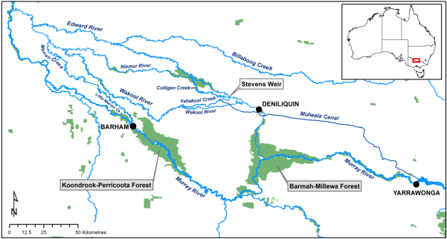

**Figure 1.** Map showing the main rivers in the Edward-Wakool river system.

* 1. Environmental watering actions and watering objectives

Water regimes within the Edward-Wakool River have been greatly altered by river regulation. In particular, there have been changes to the timing of flows and the frequency of flow events, with a reduction in the frequency of in-channel flow events and over-bank floods. These changes in flow regime are likely to have resulted in changes in water velocities, the availability of in-channel habitat types, and ecosystem processes and functions.

Daily discharge data were obtained from NSW Government water information website (NSW Office of Water, 2012) for four gauging stations in the Edward-Wakool river system; Colligen Creek regulator (409024), Wakool River offtake regulator (409019), Yallakool Creek offtake regulator (409020), and the Little Merran Creek gauge at Franklings Bridge (409044). Data for the Wakool River escape from Mulwala canal, and Yallakool Creek escape were obtained from State Water Corporation.

Severe drought conditions occurred throughout eastern Australia between 2000 and 2010. Between February 2006 and September 2010 there were periods of minimal or no flow in the Edward-Wakool river system (Figure 2). A number of large natural flow events occurred in the Edward-Wakool river system between September 2010 and March 2011 coinciding with heavy rainfall in the catchment (Figure 2).

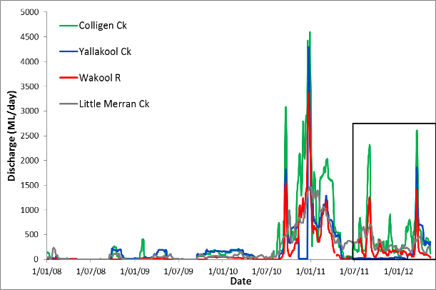

**2011/2012 monitoring and**

**evaluation period**

**Figure 2.** Daily discharge between 01/01/2008 and 13/05/2012 in four rivers in the Edward-Wakool river system; Colligen Creek (below regulator), Yallakool Creek (offtake regulator), Wakool River (offtake regulator) and Little Merran Creek (Franklings bridge. The monitoring and evaluation period in 2011-2012 is shown.

Environmental water use options for the Edward-Wakool river system are outlined in Hale and SKM (2011). Potential water use options for the Edward-Wakool river system include: providing base flows to Jimaringle and Cockrans Creeks to maintain in stream water quality; augmenting natural flows to improve connectivity between the river channel and floodplains within Werai Forest; and providing pulse flows in the Edward-Wakool rivers to promote ecosystem function for in-channel flora and fauna.

In 2011-12 Commonwealth environmental water was delivered to the Edward-Wakool river system on three occasions, contributing to the overarching strategy of providing pulse flows in the Edward-Wakool rivers to promote ecosystem function for in-channel flora and fauna. The three watering actions were:

* November 2011 environmental watering in Colligen Creek
* February 2012 environmental watering in Colligen Creek and the Wakool River
* April to May 2012 environmental watering via irrigation escapes to the Edwards, Yallakool and Wakool Rivers.

In November 2011 5.5 GL of Commonwealth environmental water was delivered to Colligen Creek in conjunction with 1.7 GL of water supplied by the New South Wales Government. The environmental water was used to gradually raise flows commencing on 19/11/2011 and then lower flows over 20 days (Figure 4).

The primary objective for the November 2011 environmental watering was to encourage movement of large bodied native fish such as Murray cod, silver perch and golden perch to initiate spawning and recruitment of these species. The watering event was also expected to maintain and enhance in-stream habitat (Commonwealth Environmental Water, 2012a).

In February 2012 7.5 GL of Commonwealth environmental water was delivered to Colligen Creek and the Wakool River in conjunction with 6.9 GL of water supplied by the New South Wales Government. The environmental watering in Colligen Creek commenced on 7/2/2012 to build on a natural high flow event due to rainfall in the Murray catchment. The flow was maintained for five days before receding back to baseflows by 1/3/2012. The delivery of environmental water to the Wakool River from the Wakool escape (which provides flows from the Mulwala Canal) commenced on 14/2/2012 but was reduced on 1/3/2012 and suspended on 6/3/2012 due to heavy rainfall in the upper catchment of the River Murray system (Figure 4).

The objective of the February 2012 watering action in Colligen Creek and the Wakool River was to improve the condition of the river and riparian ecosystems. The action was expected to enable the transfer of carbon, sediment, nutrients and biota, providing benefits to river channel food chains and the riverine ecosystem, and provide opportunities for small-bodied fish, such as Murray-Darling Rainbow fish and carp-gudgeon, to access important breeding and feeding habitat (Commonwealth Environmental Water, 2012b).

During April and May 42 GL of Commonwealth environmental water was delivered into the Edward-Wakool river system in conjunction with 2 GL of water provided by the New South Wales Government. Releases were made from the Edward, Yallakool and Wakool Escapes (from the Mulwala Canal). The environmental water was in addition to unregulated flows that had been delivered into the system via the escapes.

The objective of the April to May 2012 environmental watering action in the Edward-Wakool river system was to provide and maintain refuge habitats for remnant fish populations, particularly Murray cod, from [“hypoxic” blackwater](http://www.mdba.gov.au/water/blackwater) that can severely impact fish due to very low dissolved oxygen levels (Commonwealth Environmental Water, 2012c). The Commonwealth environmental water contributed to watering efforts of the Murray-Darling Basin Authority to prevent environmental damage in the area and ensure native fish such as the Murray cod have the best possible conditions.

Commonwealth environmental water was delivered in cooperation with the New South Wales Office of Environment and Heritage, Murray Catchment Management Authority, State Water Corporation, and New South Wales Department of Primary Industries (Fisheries).

* 1. Location of monitoring sites

This monitoring program reports on ecosystem responses to the Commonwealth environmental watering actions in the Edward-Wakool river system in 2011-2012. This project focused on four rivers in the Edward-Wakool river system; Colligen Creek, Yallakool Creek, Wakool River, and Little Merran Creek (Figure 3, plate 1). Study sites were located on both private land and crown land.

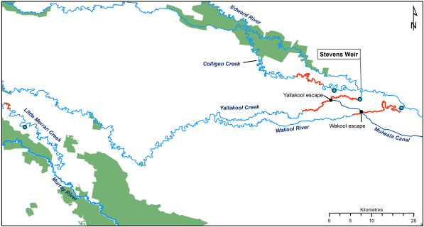

Environmental watering in November 2011, February 2012 and April to May 2012

Environmental watering in February 2012 and April to May 2012

No environmental watering in 2011-2012

Environmental watering in April to May 2012

**Figure 3**. Map showing the location of the four study reaches in the Edward-Wakool river system (denoted with red lines), location of irrigation escapes (black circles), hydrological gauging stations (blue circles) and timing of environmental watering in each of the four rivers.

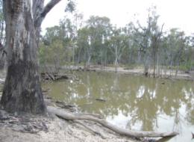 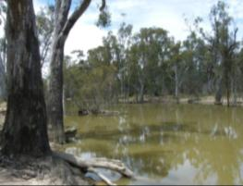

(a) Colligen Creek, pre-environmental watering (b) Colligen Creek, environmental watering

(17/11/2011) (29/11/2011)

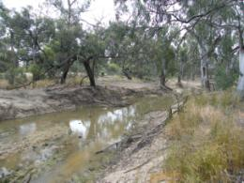 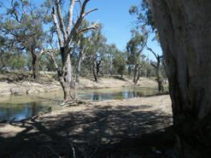

(c) Yallakool Creek upstream escape (17/11/2011) (d) Yallakool Creek downstream escape (16/11/2011)

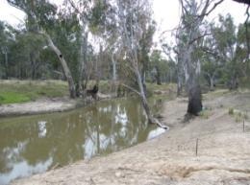 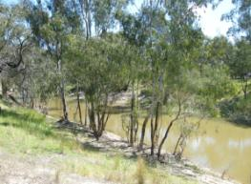

(e) Wakool River upstream escape (16/11/2011) (f) Wakool River downstream escape (17/11/2011)

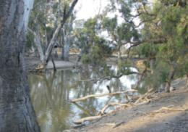

(g) Little Merran Creek (16/11/2011)

**Plate 1.** Study river reaches in the Edward-Wakool river system (a – g)

The delivery of water from regulators and from escapes resulted in six different hydrological regimes in the four study reaches (Figure 4):

* **Colligen Creek:** Natural flow pulses between July and September 2011 followed by delivery of Commonwealth environmental water in November 2011 and February 2012. Delivery of environmental water in April to May 2012 from Edward escape in conjunction with natural pulses at this time.
* **Wakool River upstream of escape**: Natural flow pulses between July and September 2011. Relatively low flows from November 2011 to March 2012. No Commonwealth environmental water in November 2011 and February 2012. Delivery of environmental water in April to May 2012 from Edward escape in conjunction with natural pulses at this time.
* **Wakool River downstream of escape**: Natural flow pulses between July and September 2011 followed by delivery of a small volume of Commonwealth environmental water in February 2012. Delivery of environmental water in April to May 2012 from Edward escape and Wakool escape in conjunction with natural pulses at this time.
* **Yallakool Creek upstream escape:** No natural pulses in 2011 and no environmental water in November 2011 and February 2012. This system had a constant low discharge from July 2011 to February 2012 due to the construction works on the Yallakool Creek offtake regulator. Delivery of environmental water in April to May 2012 from Edward escape in conjunction with natural pulses at this time.
* **Yallakool Creek downstream escape:** No natural pulses in 2011 and no environmental water in November 2011 and February 2012. This system had a constant low discharge from July 2011 to February 2012, due to the construction works on the Yallakool Creek offtake regulator. Delivery of environmental water in April to May 2012 from Edward escape and Yallakool escape in conjunction with natural pulses at this time.
* **Little Merran Creek:** Small natural flow pulses in 2011 and natural pulses in April to May 2012. Relatively low flows from November 2011 to March 2012. No Commonwealth environmental water.

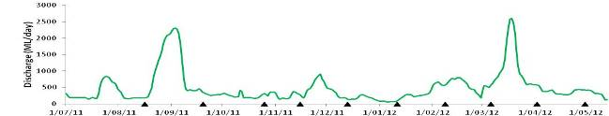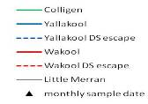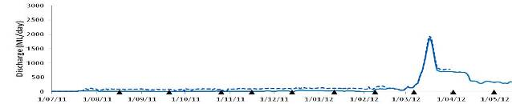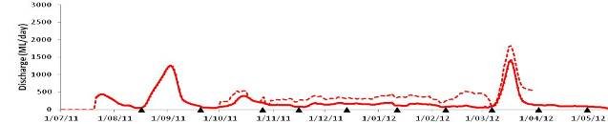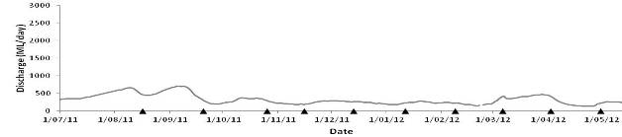

November 2011 Environmental watering

February 2012 Environmental watering

Natural flow includes some environmental watering (dilution of blackwater)

February 2012 Environmental watering downstream of Wakool escape

Natural flow includes some environmental watering (dilution of blackwater)

Natural flow includes some environmental watering (dilution of blackwater)

**Figure 4.** Timing of survey events in relation to discharge and environmental watering actions in the Edward-Wakool river system in 2011-2012. Black triangles indicate the timing of monthly sampling. In addition, fortnightly sampling for fish larvae was undertaken in between each of the monthly sample dates.

1. Indicators, study design and hypotheses
   1. Indicators

The indicators used to monitor the watering objectives (Table 1) were selected to reflect recommendations provided in the Environmental Water Delivery document for the Edward-Wakool river system (Hale and SKM 2011) and align with standard methods commonly used for similar monitoring programs (e.g. Sustainable Rivers Audit 2001; Living Murray Icon site monitoring programs).

**Table 1.** Conceptual links of monitoring indicators with ecological objectives.

|  |  |  |  |
| --- | --- | --- | --- |
| **Objective** | **Desired Outcome** | **Monitoring indicators recommended in Water Delivery document** | **Indicators used**  **in this project** |
| Water quality | Minimise accumulation of litter in channels and effect early inundation of wetland and floodplain organic debris | * Litterfall * DO, DOC | * Leaf-litter breakdown rates/carbon processing * DO, DOC, pH, salinity, temperature, turbidity |
| Productivity | Move nutrients and carbon between main channel, upper benches and small low commence to flow floodrunners | * Phytoplankton | * Open water   chlorophyl-*a*   * Open water metabolism |
| Connectivity | Enable longitudinal connectivity, inundate low benches, floodrunners, billabongs wetlands and backwaters | * Stream flow and height | * Stream flow and height * Zooplankton abundance and diversity |
| Biofilms | Inundate low benches, floodrunners, billabongs wetlands and backwaters | * None specified | * Biofilm biomass and diversity |
| Fish spawning and recruitment | Enable connectivity, inundate wetlands to improve habitat, spawning and recruitment | * Community composition and abundance | * Fish community composition and abundance * Fish recruitment |
| Frogs | Inundate key wetlands and floodplain areas | * Community composition and abundance | * Frog community composition and abundance * Frog recruitment |
| Macroinvertebrates | Increase flow variability to increase habitat diversity, encourage growth of aquatic and littoral vegetation and provide suitable food sources | * Community composition and abundance | * Macroinvertebrate composition and abundance |

**Water quality and chemistry**

A range of parameters can be measured as indicators of water quality in river systems and many of these may be directly or indirectly influenced by environmental flows. Parameters such as dissolved oxygen, temperature and pH will directly influence the suitability of the water for aquatic organisms, such as fish. These may be influenced by flow through changes in water volume, turbulence and through indirect processes, such as alterations in rates of bacterial metabolism and photosynthesis. Nutrients and organic matter concentrations may be influenced by flow, either by dilution or through inputs associated with water contacting parts of the channel or floodplain which were previously dry and which have stores of nutrients and carbon in both plant materials and the soil (Baldwin, 1999; Baldwin & Mitchell, 2000). Inputs of these substances may have a positive influence on the river community through the stimulation of productivity and increased food availability for downstream communities (Roberston *et al.* 1999), however, excessive inputs can result in poor water quality through the development of problem algal blooms or blackwater events resulting in very low dissolved oxygen concentrations ([Howitt *et al.* 2007](#_ENREF_9); [Hladyz *et al.* 2011](#_ENREF_7)a). Australian riverine ecosystems can be heavily reliant on both algal and dissolved organic matter for microbial productivity and can be limited by DOC (dissolved organic carbon) concentrations ([Hadwen *et al.* 2010](#_ENREF_6)). Organic matter is made up of a complex mixture of compounds from a diverse range of sources and microbial communities do not respond to all types of organic matter in the same way (Baldwin, 1999; Howitt *et al.*, 2008). This project aims to assess changes to water quality in response to alterations in flow and to consider changes in both the quantity and type of organic matter present in the system.

**Ecosystem Processes - Leaf-litter breakdown rates**

The importance of metrics describing changes in ecosystem processes when assessing river health, such as primary production and leaf-litter breakdown rates, is well recognised in theory but not routinely undertaken as part of standard bioassessment monitoring programs (Gessner and Chauvet 2002; Sandin and Solimini 2009). Functional assessments are useful in that they can be used to synthesise responses across entire ecosystems (Kingsford *et al.* 2010) and to provide the information needed to alleviate negative impacts, for example, hypoxic blackwater events and fish kills (Hladyz *et al.* 2011b).

Leaf-litter breakdown has been proposed as a useful functional indicator of river health because this process responds to a variety of natural (e.g. climate) and anthropogenic stressors (e.g. organic pollution, land use) and is relatively easy to measure with inexpensive equipment (Gessner and Chauvet 2002; Young *et al.* 2008; Hladyz *et al.* 2011a). The rate at which litter is broken down represents an integrated response to both biological (microbial degradation via fungi and bacteria, invertebrate feeding) and physical processes (i.e. abrasion, fragmentation by current) (Webster and Benfield 1986), highlighting its potential as a bioassessment tool (Gessner and Chauvet 2002; Young *et al.* 2008 Hladyz *et al.* 2011a). Litter breakdown rates have been shown to respond to various aspects of flow regime (e.g. flow magnitude, flow velocity, timing of flows, Ferreira *et al.* 2006; Watkins *et al.* 2010; Niu and Dudgeon 2011). However, the understanding of functional responses to altered flow regimes in general is limited (Poff and Zimmerman 2010). This project aims to assess the response of leaf-litter breakdown rates to different hydrological regimes.

**Biofilms**

Biofilms (also known as periphyton) are a combination of bacteria, algae and fungi that grow on submerged surfaces (e.g. wood, sediment) in aquatic systems. They are a major instream source of carbon in river systems and provide food and habitat for a range of organisms. Biofilms are excellent indicators of ecological responses to environmental flow pulses because they respond to flow changes in a time frame (days to weeks) that is appropriate for the management change (Burns and Ryder 2001). Previous studies (e.g. Ryder 2004, Watts *et al.* 2006, 2008, 2009b) have shown that long periods of constant discharge can result in lower productivity, high biomass and less diverse biofilm than a regime that has a more variable discharge.

There are several reasons why it is desirable to reset biofilms through the delivery of in-channel environmental flows:

* To promote early successional algal taxa (e.g. diatoms) and higher biofilm diversity. A high diversity of biofilms usually indicates good ecosystem health
* To contribute nutrients and food into the water column, thus providing an important food resource for downstream communities
* To reduce the nuisance factor that occurs when biofilm growing on the beds of rivers builds to levels that are unacceptable to the general public or landholders. Quinn (1991) recommended that “the seasonal maximum cover of stream or river bed by periphyton as filamentous growths or mats (greater than about 3 mm thick) should not exceed 40% and/or biomass should not exceed 100 mg chlorophyll-*a* /m2 .

**Zooplankton**

Zooplankton are abundant, widely distributed and a diverse group of organisms which are the foundation of many aquatic food-webs. More than 133 taxonomic groups of zooplankton occur in lowland rivers of the Murray-Darling Basin (Shiel *et al.*. 1982). These organisms, are typically smaller than 4 mm in size (Shiel 1995), are responsive to environmental changes in temperature, turbidity, nutrients and other ecological parameters, and are relatively easy to sample. Different taxonomic groups and life-history stages also have varying flow velocity requirements which, in addition to the previously mentioned characteristics, make them a potential indicator for the assessment of environmental watering. Furthermore, changes in zooplankton abundance and diversity are linked directly to native fish communities since most fish larvae depend on these organisms for food and therefore survival.

**Macroinvertebrates**

Macroinvertebrates are a major component of the biodiversity of flowing water systems and are a critical resource to higher trophic levels such as fish. Macroinverterbate communities are diverse, and the relatively rapid nature of their life-history characteristics means that they can respond relatively rapidly (weeks to months) to changes in environmental management. As a result there are well established indices for interpreting information on macroinvertebrate communities in a context of ecosystem condition (species abundance, richness, family richness, SIGNAL ([Chessman 1995](#_ENREF_48)), AUSRIVAS ([Davies 2000](#_ENREF_55)), and EPT (Ephemeroptera, Plecoptera and Trichoptera) ([Barbour *et al.* 1992](#_ENREF_16)). This project aims to examine how hydrological regime influences macroinvertebrate biodiversity by examining temporal dynamics of macroinvertebrate communities in the Edward-Wakool river system.

**Frogs**

Riverine amphibians have a range of life history strategies which allow them to occupy riverine habitats. In south-eastern Australia nine frog species are listed as being obligate stream breeders, wholly dependent on flowing water for reproduction, and six of these nine species are listed under Commonwealth threatened species legalisation ([Gillespie and Hines 1999](#_ENREF_3)). Five others are classed as facultative stream breeding species which means that they utilise streams for breeding only under certain flow conditions, with two of these classified as Threatened ([Gillespie and Hines 1999](#_ENREF_3); [Heard *et al.* 2006](#_ENREF_4)). Many generalist riverine species utilise the range of habitats created during a flood-pulse, such as back-waters and ground-water pools ([Bateman *et al.* 2008](#_ENREF_2); [Wassens and Maher 201](#_ENREF_5)1). Environmental flows in rivers are most likely to lead to an increase in frog abundance and calling activity if they create temporary habitats adjacent to the main channel. For example Wassens and Maher (2011) found that temporary water bodies created during environmental flows were preferentially utilised for breeding over the more persistent habitat within the stream channel.

**Fish**

Despite their importance in maintaining adult populations, there is very little information concerning the environmental requirements of young (larval and juvenile) fish in the Murray-Darling Basin. Information from around the world and in Australia suggests that river flows during spring are important to adult spawning and subsequent survival of young fish. However, the precise water requirements needed to initiate spawning and support survival of most species is unknown.

Although the Murray-Darling is not particularly species rich, fish in this system encompass multiple trophic levels, make up a large proportion of vertebrate biomass, occupy a diverse array of habitats, and have wide range of environmental tolerances. For these reasons fish indicators have been used to evaluate the health of river ecosystems worldwide. More specifically, these attributes allow fish to be used to better understand the broader ecological effects of environmental flows.

* 1. Monitoring design

The delivery of water from regulators and from irrigation escapes resulted in six different hydrological regimes in the four study reaches (Figure 4). There were two sample sites in each river with replicate samples collected within each site. Each site comprised an approximately 200 m section within each of the four rivers.

An assessment of the delivery of environmental water in Colligen Creek in November 2011 and February 2012 was made by comparing the following:

* **Environmental watering treatment 1**: Natural flow pulses between July and September 2011 followed by environmental watering in November 2011 and February 2012 (Colligen Creek)
* **Environmental watering treatment 2**: Natural flow pulses between July and September 2011 followed by limited environmental watering in February 2012 (Wakool River downstream escape)
* **Control 1**: Natural flow pulses between July and September 2011 and no environmental water (Wakool River upstream of escape and Little Merran Creek)
* **Control 2:** No natural flow pulses in 2011 and no Commonwealth water (Yallakool Creek upstream escape, Yallakool Creek downstream escape).

An assessment of the delivery of environmental water to Colligen Creek, Yallakool Creek and Wakool River via irrigation escapes in April and May 2012 will be made by comparing the following:

* **Environmental watering treatment**: Environmental water delivered via Edward, Yallakool and Wakool escapes in conjunction with natural pulses from March to early May 2012 (Colligen Creek, Yallakool Creek upstream escape, Yallakool Creek downstream escape, Wakool River upstream escape, Wakool River downstream escape)
* **Control**: Natural flow pulses from March to early May 2012 but no Commonwealth environmental water (Little Merran Creek)

A summary of the reaches in which indicators were assessed is presented in Table 2. Water column productivity, leaf-litter breakdown rates, biofilm biomass and diversity, and macroinvertebrates were not assessed at sites downstream of the irrigation escapes in the Wakool River and Yallakool Creek.

**Table 2.** Summary of location where indicators were sampled

|  |  |  |  |  |  |  |
| --- | --- | --- | --- | --- | --- | --- |
| Indicators | Colligen Ck | Yallakool Ck US escape | Yallakool Ck DS escape | Wakool R US escape | Wakool R DS escape | Little Merran Ck |
| Water quality | ✓ | ✓ | ✓ | ✓ | ✓ | ✓ |
| DOC/TOC, nutrients, organic matter (September 2011 to February 2012) | ✓ | ✓ |  | ✓ |  | ✓ |
| DOC/TOC, nutrients, organic matter (March 2011 to April 2012) | ✓ | ✓ | ✓ | ✓ | ✓ | ✓ |
| Phytoplankton biomass | ✓ | ✓ |  | ✓ |  | ✓ |
| Leaf-litter breakdown rates | ✓ | ✓ |  | ✓ |  | ✓ |
| Biofilms | ✓ | ✓ |  | ✓ |  | ✓ |
| Zooplankton | ✓ | ✓ | ✓ | ✓ | ✓ | ✓ |
| Macroinvertebrates | ✓ | ✓ |  | ✓ |  | ✓ |
| Frogs (January to April 2012) | ✓ | ✓ | ✓ | ✓ | ✓ | ✓ |
| Fish spawning and recruitment | ✓ | ✓ | ✓ | ✓ | ✓ | ✓ |

* 1. Hypotheses

Water quality and carbon, water column productivity, leaf-litter breakdown, biofilm, zooplankton, macroinvertebrates, frogs and fish were monitored from August 2011 until early May 2012 to assess the ecological responses to the in-channel environmental watering in the Edward-Wakool river system.

This preliminary report focuses on responses to the November 2011 environmental watering in Colligen Creek by comparing results from samples collected before the environmental watering in November 2011 to those collected in December 2011, immediately after the watering event. The following hypotheses were examined:

* There will be a short-term increase in dissolved organic carbon and particulate organic carbon levels following the in-channel environmental watering in Colligen Creek in November 2011, but the environmental watering is not expected to trigger a blackwater event in this system.
* Following the environmental watering in Colligen Creek in November 2011, there will be a change in the community composition of algal biofilms, with an increase in early successional algal taxa in this river.
* Increased flow variability in Colligen Creek following environmental watering in November 2011 will ensure biofilm organic biomass in Colligen Creek remains below nuisance levels. Biofilm organic biomass is expected to be highest in Yallakool Creek that had a constant discharge over this period.
* Increased flow variability in Colligen Creek following environmental watering in November 2011 will maintain macroinvertebrate biodiversity via the provision of additional habitat and food resources made available with bank inundation (organic matter) and potential increases in algal primary production.
* Increased flow variability in Colligen Creek following environmental watering in November 2011 will maintain macroinvertebrate biodiversity via disturbance which eliminates competitive exclusion in the community by continually allowing less competitive species opportunities to colonise (intermediate disturbance hypothesis, Townsend *et al.* 1997).
* Increases in river flow should select for invertebrate biological traits such as smaller body size, firmer attachment to substrate, and a streamlined body form, whereas decreases in flow should favour invertebrates with larger body size, increased swimming abilities, and spherical shape (Townsend *et al.* 2003; Statzner *et al.* 2005).
* Spawning of some native fish species, as measured by the abundance of larvae, will increase following the environmental watering in Colligen Creek in November 2011.

1. Methods
   1. Water quality

Water temperature, dissolved oxygen and electrical conductivity was logged every ten minutes at two sites within each river reach. At the upstream sites in each reach data was logged using D-Opto optical dissolved oxygen sensor (Zebra-Tech Ltd, Nelson, NZ). Hydrolab DS5X Water Quality Sonde (Hach Hydromet, Loveland, CO, USA) was deployed at the downstream reach of the Wakool River and Yallakool Creek. YSI 6920 Water Quality Sondes were deployed at the downstream reach of Coligen Creek and Little Merran Creek. Data were downloaded and loggers were calibrated for oxygen approximately once per month, or sometimes longer because of high flow events.

Water quality was also measured as spot recordings on each sample date at two sites within each of the four river reaches. A Horiba U-10 water quality monitor was placed just below the water surface at each site on each sampling date to obtain spot measures of the temperature (oC), specific conductivity (mS/cm), dissolved oxygen (%), pH, and turbidity (NTU) of the water.

Water samples were collected from two sites within each river reach to assess for:

* Total Organic Carbon (TOC)
* Dissolved Organic Carbon (DOC)
* Nutrients (Ammonia (NH3), filtered reactive phosphorus (FRP), dissolved nitrate + nitrite (NOx)).

Water samples collected for DOC, FRP, NH3, and dissolved NOx were filtered through a 0.2 m membrane at the time of sampling. Unfiltered samples for TOC and total nutrients and filtered samples for carbon and nutrients were frozen in the field. Nutrient analysis and organic carbon analysis was undertaken by the accredited laboratory at the Monash University Water Studies Centre. Blanks were collected on the first sampling trip and took the form of ultrapure laboratory water, taken in the field and filtered in the same way as samples. Blanks were analysed for organic carbon and nutrients.

* 1. Organic matter characterisation

Samples for organic matter characterisation were collected on the monthly sampling trips from October 2011 until early May 2012. Additional samples were collected on the peak of the November environmental watering in Colligen Creek (28/11/2011) and more frequent sampling took place during the blackwater event in autumn (samples collected 14/3/2012 and 21/3/2012 in addition to the usual samples at the beginning of that month). Four samples were collected for each river on every sampling date (two each at the upstream and downstream ends of each study reach). In addition, during March and April samples were taken at sites downstream of the escapes on the Yallakool and Wakool Rivers.

Water samples collected for absorbance and fluorescence spectroscopy were filtered through a 0.22 m pore-sized membrane at the time of sampling and then stored on ice until returned to the laboratory and then analysed within a day of returning from the field. Absorbance scans were collected using a Varian Cary 50 instrument across a wavelength range of 550 nm to 200 nm (green through to ultraviolet) with a 1 nm step size. Absorbance is a measure of light absorbed by the sample and is a logarithmic scale. An absorbance of 1 indicates that only 10% of the light is transmitted through the sample.

Fluorescence scans were collected using a Varian Eclipse spectrofluorometer scanning both emission and excitation wavelengths to give an excitation-emission matrix (EEM). Excitation wavelengths were scanned from 200 to 400 nm with a 10 nm step size and for each excitation wavelength, emission of light at 90O to the source was recorded from 200 nm to 550 nm with a 1 nm step size. Fluorescence results were corrected for sample absorption and plotted as contour plots ([Howitt *et al.* 2008](#_ENREF_2)). To correct for drift in the instrument zero position, each contour plot was scaled by subtracting the average emission intensity across the range 200-210 nm for an excitation of 250 nm from all fluorescence intensities (effectively setting this region of the contour plot to zero on all plots). The plots have the excitation wavelength (light shone into the sample) on the y-axis. On the x-axis is the emission wavelength (light given off by the sample). The intensity of the fluorescence (how much light is given off, corrected for absorbance by the sample) is represented by the colours of the contour plot, with more intense fluorescence represented by the blue end of the scale. The two blue diagonal lines are artefacts of the technique and will be present in all samples- key data is found between these two lines.

* 1. Phytoplankton biomass (chlorophyll-*a*)

500ml water samples were collected from each river on each sample date to determine the biomass of phytoplankton in the water column. Water was filtered through a GFC-50 0.5 µm pore-sized filter and the filter papers were then frozen until processing.

Chlorophyll-*a* was determined following [Tett *et al.* (1975](#_ENREF_67)). Samples were placed in 8 millilitres of 90% methanol containing 150 milligrams magnesium hydroxide carbonate, extracted for 18 hours at 4°C, transferred to a 70°C water bath and boiled for two minutes. Samples were centrifuged at 4500 rpm for three minutes and optical densities at 750 and 666 nanometres were measured pre- and post-acidification (1M HCl) using a UV/Visible Spectrophotometer.

* 1. Leaf-litter breakdown rates

A field experiment was carried out in four rivers within the Edward-Wakool river system to compare leaf-litter breakdown rates. Two sites were chosen per river in order to examine the variability within each river. The field study was undertaken during early spring 2011 (late September) and early autumn 2012 (March) and ran for 6 months. Placement of litter bags occurred after the large flows in September therefore breakdown rates were not influenced by these previous large natural flows.

Leaves of two common native trees, river red gum (*Eucalyptus camaldulensis*) and blackwood (*Acacia melanoxylon*), were collected. Browning, pre-abscission river red gum leaves were collected randomly from floodplain forest, whereas blackwood leaves were collected immediately after abscission and air-dried to constant mass. These species were chosen because they are widespread in south east Australia and because they differ markedly in terms of resource quality, with the former having higher carbon: nutrient ratios (Glazebrook and Robertson 1999; Wedderburn and Carter 1999). Five grams (±0.25 g) of air-dried leaf material was added to experimental plastic-mesh bags of two mesh aperture sizes, 0.5 and 10 mm, to measure microbial breakdown and total breakdown caused jointly by microorganisms, invertebrates and physical processes. Metal stakes were anchored on the river banks and litter bags were attached and weighed down with lead weights within each reach. Of the 4 rivers each was sampled on 6 occasions (2 replicates x 2 mesh sizes x 2 leaf species x 2 reaches x 4 rivers), thus giving a total of 384 litter bags. On each sampling occasion bags were collected using a 250 µm mesh net and placed in ziplock bags and then frozen. In the laboratory after thawing, leaf material was separated from invertebrates (using a 250 µm sieve), and sorted leaf material was oven-dried at 105 °C to constant mass and then weighed. Breakdown rates were expressed as proportion of mass remaining. Correction factors derived for leaching losses (determined after 24 h under running tap water in the laboratory) and moisture content were applied to the initial air-dry masses, to calculate post-leaching dry mass loss over time (after Hladyz *et al.* 2009).

To examine the loss of leaf material in litter bags over a period of time, an exponential decay model was used to estimate breakdown (Petersen and Cummins 1974). This model assumes that for any amount of material at any time there is a constant fractional loss. Breakdown coefficients (-*k*) were obtained using nonlinear regression analyses on dry mass data with the initial leaf mass at day 0 fixed at 1.0. These coefficients was calculated for river red gum leaves only as after three months most leaves had between 50% mass loss whereas for blackwood there was only a mass loss of 20% which would underestimate the coefficient substantially. These calculated decay coefficients may change once the entire temporal dataset of six months is examined. This calculated decay coefficient allows comparisons with other studies and can be used to estimate the time required for 50% of the leaf litter to breakdown. Decay rates were classified according to the scheme of Petersen and Cummins (1974). “Fast” breakdown groups decay coefficient > 0.010, “medium” groups are between 0.005 – 0.010 and “slow” groups <0.005.

* 1. Biofilms

The biomass and diversity of biofilms in the river reaches before and after environmental watering was investigated. It was hypothesised that variable flows in Colligen Creek would create conditions that would promote a higher diversity of algal biofilms, whereas the river systems that are managed for more constant flows would have a lower biodiversity of biofilm.

Blocks of red gum wood (10 x 8 x 2 cm, 232 cm2) were established at sites in the four rivers in August 2011. Five blocks were suspended on metal racks which were mounted on star pickets and placed in the photic zone at a known height relative to river discharge. This enabled biofilms to colonise the blocks and be sequentially harvested at regular and opportunistic intervals to compare the response of biofilm attributes to hydrological and water quality conditions.

There were two treatments a) blocks set out each month and harvested the following month representing newly colonised biofilm and b) blocks set out at the beginning of the project and harvested sequentially from each site on each sample date, representing long-term standing stock. For each sample date four ‘one month old’ and four ‘standing stock’ blocks were randomly selected from the racks and were harvested. On each second month four ‘standing stock’ blocks were randomly selected from the racks and were harvested. The following biofilm attributes were assessed:

* Dry weight (total biomass, including inorganic biomass) )
* Chlorophyll *a* (algal biomass) )
* Organic dry weight (Ash Free Dry Weight) )
* Organic matter percent (percent of total weight) )
* Ratio of Chlorophyll *a*:AFDW)
* Biofilm algal species composition (biodiversity) )
* Relative biovolume of algal groups.

The biofilm was scrubbed in the field from each redgum block into 200 millilitres of distilled water using a soft nailbrush. Sub-samples were removed from the 200 millilitre residue for determination of chlorophyll-*a* (filtered through a GC-50 0.5 µm filter), the amount filtered was recorded and a 20 millilitre sample for the assessment of taxonomic composition was stored in Lugols solution.

Using GC-50 0.5 µm filter papers (for which the loss on ashing had been pre-determined) a recorded amount of the solution was filtered, the filter paper was dried at 80°C for 24 hours, weighed, combusted for four hours at 500°C and reweighed. All samples were weighed to four decimal places and converted to dry weight (DW) and ash free dry weight/organic biomass (AFDW). Percent organic matter was calculated as the proportion of AFDW to DW and converted to a percentage to standardise across sites and dates. Chlorophyll-*a* in biofilm samples was determined as described in section 3.3.

* 1. Zooplankton

Zooplankton were sampled by filtering 50 L of water with a 53 µm net and this was repeated three times at each site within each river. Samples were preserved in 70% ethanol or frozen prior to taxonomic identification in the laboratory. Samples were collected fortnightly between 19 September 2011 and 05 April 2012 at each of two sites within the Wakool, Yallakool, Colligen and Little Merran Creek. This report focuses only on monthly abundance and diversity before and after the environmental watering in Colligen Creek during November 2011.

In the laboratory zooplankton samples were condensed down to 50-100 mL, stained, identified and counted under a stereomicroscope. The number of each taxonomic group per litre of sample was calculated and abundance estimates represent three replicates per site. Microcrustaceans were identified to family or genus level in most cases but rotifers were counted separately and not identiified to a lower taxonomic level.

* 1. Macroinvertebrates

Macroinvertebrate communities were sampled monthly in the four rivers and sampling started in September 2011 (spring) and finished May 2012 (autumn). A small snag bag sampler (70cm length, 250 µm) was used to estimate ambient shredder and grazer invertebrate abundance and characterise community structure on small natural snags (small woody debris, approx 50 cm length, surface area: 450 cm2) (after Growns *et al.* 1999). Snags were approached downstream and placed quickly into the snag bag with as little prior disturbance to the invertebrates on the substrates as possible. All surfaces were scrubbed vigorously to dislodge invertebrates into the collecting jar at the bottom of the snag bag sampler. The surface area of each snag was calculated by measurement of snag length and diameter after all animals were removed. The sample was then frozen until further processing. Three replicate snag samples were taken per reach.

In the laboratory snag samples were defrosted and sorted under a dissecting microscope. Invertebrates were enumerated and identified to family level except for nematodes which were not identified further, Chironomidae which were identified to sub-family, and mites which were identified to order. Processing and sorting of samples is ongoing, for this report only one replicate per river (downstream reach only) and date are presented (to date 48 samples sorted and eight samples identified). Therefore patterns are only indicative and may change once more samples are processed. Further data will enable a more comprehensive assessment of temporal patterns of invertebrate abundance and composition in relation to hydrological regimes and the environmental watering.

* 1. Frogs

Tadpoles were surveyed monthly on four occasions from January to April 2012 during the day at each site within a 50m transect at each reach using a large d-bottom sweep net. Tadpoles caught in the net were identified to species level if possible and their developmental stage recorded according to Anstis ([2002](#_ENREF_1)). Tadpoles of *Limnodynastes tasmaniensis* and *L. fletcheri* were combined into a single group due to difficulty in identifying those species. Once identified all tadpoles were released at the point of capture.

Frogs were surveyed at night along a 200 m long and 5m wide transect running parallel to the water’s edge for 30 minutes on each survey occasion. A spotlight was used to search along the water’s edge and within terrestrial habitats. Each individual encountered was identified to species level. Three replicate audio surveys were used to detect distinct calls of resident frog species and determining an estimate of the specific number of calling individuals.

* 1. Fish

Larval fish ranging from several days old (Plate 2) to juveniles were sampled fortnightly at eight locations in the Edward-Wakool river system from September 2011 to April 2012.

This preliminary report focuses on sampling dates before the environmental watering (15/11/2011) and after the environmental watering (12/12/2011) in Colligen Creek. Samples from one site in each river have been processed and are compared before and after the environmental watering. No statistical analyses have been undertaken in this preliminary report but relative abundance values are reported as total number sampled (n) divided by effort (number of light traps) or mean number ± standard deviation. Data from other sample dates have been included where samples have been processed. Colligen and Little Merran Creeks, each encompassing two sampling sites, are reported at the river reach scale. This scale includes eight fortnightly light trap replicates and four drift net replicates. Monthly fyke net samples include four replicates. Sites upstream and downstream of the irrigation escapes in the Yallakool Creek and the Wakool River are reported separately as there were site-specific differences in daily discharge upstream and downstream (US; DS) of the escapes. The site-scale includes four fortnightly light trap samples and two replicate drift nets along with two monthly fyke net replicates.

Fish spawning was investigated by sampling larvae fortnightly between 19/9/2011 and 5/4/2012. Four replicate light trap samples containing bioluminescent light sticks (Plate 3) and two replicate drift nets (500 µm or 250 µm mesh; 500 mm diameter) were deployed at night along the river in each of the two sites in Colligen Creek, Little Merran Creek, Yallakool Creek and the Wakool River. Small-bodied fish (eg. carp gudgeon, *Hyseleotris spp*.) and juveniles of large-bodied species were sampled monthly between 19/9/2011 and 30/4/2012 using two (2 mm mesh; 2 X 2 m wing) fyke nets deployed at each of the two sites. All larvae and a sub-sample of juvenile and adult fish were preserved in 70% ethanol or were frozen and are currently being identified and measured in the laboratory and otoliths are being extracted for examination of growth rates.



**Plate 2.** Murray cod larva at six days old. The white bar represents 1mm. From Serafini & Humphries (2004); Preliminary guide to the identification of larvae of fish from the Murray-Darling Basin.

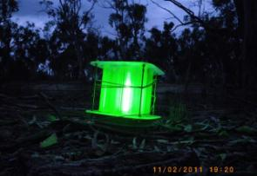 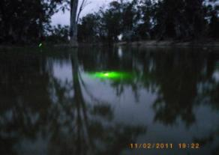

**Plate 3**. Photos of light traps in the Wakool River used to sample larval fish.

1. Results and discussion
   1. Water quality

**Dissolved Oxygen**

Dissolved oxygen (DO) concentrations measured *in situ* on each sample date were above the 4mg/L threshold of concern for aquatic health ([ANZECC water quality guidelines 2000](#_ENREF_3)) throughout the period of September 2011 to April 2012 (Figure 5). Dissolved oxygen data from continuous loggers will provide more detail related to the environmental watering and natural pulses, and may reveal periods during April 2012 when DO levels were close to, or below, critical levels during the blackwater event. The logged data will be fully analysed and presented in the final report.

Overall the measured DO concentrations were similar in the four rivers between September 2011 and February 2012. Yallakool Creek had slightly lower DO concentrations than the other three rivers over this period. Colligen Creek had higher dissolved oxygen levels than all of the other rivers following the February 2012 environmental watering in Colligen Creek. During the blackwater event in April 2012, Colligen Creek, Yallakool Creek and Wakool River all received environmental water as dilution flows via irrigation escapes and maintained higher DO levels than Little Merran Creek that did not receive the dilution flows.

**Figure 5.** Dissolved oxygen levels (DO) mg/L measured *in situ* on each sample date at four river reaches in the Edward-Wakool river system from September 2011 to April 2012.

**Water temperature**

Water temperature was similar between the four river reaches and increased during October 2011 and November and decreased during April 2012, reflecting seasonal temperature changes (Figure 6). Water temperatures were around 15°C in September, rising to just below 20°C at the time of the environmental watering in Colligen Creek in November 2011, and then increased and remained in the low 20’s from December to March 2012.

**Figure 6.** Water temperature (°C) measured *in situ* on each sample date at river reaches in the Edward-Wakool river system from September 2011 to April 2012.

**Turbidity**

Turbidity levels were variable throughout the study period. Levels were consistently highest in Little Merran Creek and tended to be lower in Colligen Creek (Figure 7). There was an increase in turbidity in all rivers during early March 2012 coinciding with a large natural flow event. There are no *in situ* turbidity data for April 2012.

Turbidity levels that are recorded monthly may not reveal the true picture of changes in turbidity during, and immediately following the environmental watering. There may be short-lived increases in turbidity on the peak of watering events that will not be evident in this spot data. Turbidity data from loggers will reveal more detail related to the environmental watering and natural pulses. These data will be analysed and presented in the final report.

**Figure 7.** Turbidity levels (NTU) measured *in situ* on each sample date at four river reaches in the Edward-Wakool river system from September 2011 to March 2012.

**Carbon**

Dissolved organic carbon (DOC) and particulate organic carbon (POC) were measured at two sites within each river reach from September 2011 to April 2012. Data from September 2011 to February 2012 have been processed and are presented here. The remaining samples are undergoing analysis and will be presented in the final report.

For most of the study period the four rivers had very similar DOC levels. The exception was higher levels of DOC in Little Merran Creek during September and into October 2011 (Figure 8) following an extended period of flows higher than 500ML/day in this system during some natural flow events. POC levels remained low throughout the study. There was no notable increase in DOC during or after the environmental watering in Colligen Creek in November 2011 and February 2012.

**Figure 8.** Dissolved organic carbon (DOC) and particulate organic carbon (POC) at river reaches in the Edward-Wakool river system from September 2011 to February 2012.

* 1. Organic matter characterisation

Sample analysis for all dates has been completed, however data analysis is ongoing. Absorbance results for October to December 2011 and fluorescence results for samples collected in November and December 2011 will be presented here. Absorbance scans from February to May 2012 will also be discussed to provide preliminary data relating to the blackwater event observed in autumn 2012 associated with a natural flood event caused by rainfall. Fluorescence data for this event will be included in the final report.

**Environmental Watering in Colligen Creek - November 2011.**

The four absorbance and fluorescence scans for each river were essentially the same on each of the sampling occasions from October to December 2011. Results presented here are from the downstream end of each study reach (upstream of the escapes in the Wakool River and Yallakool Creek).

Absorbance scans of filtered water samples are shown in Figure 9 for samples collected before, during and after the environmental watering in Colligen Creek in November 2011. In these samples, a larger absorbance value indicates a higher concentration of organic compounds dissolved in the water. The shape of an absorbance scan gives an indication of the mixture of sizes of molecules making up the dissolved organic carbon- longer wavelengths indicate larger, more complex molecules. The key features to note in Figure 9 are that the shapes of the scans are very similar across all four rivers, especially in early November, and that the flow pulse in Colligen Creek in November does not appear to have had an impact on the amount and general type of organic matter present in this river compared to the other study reaches. Consistent with the DOC results (Figure 8), there is greater variability between the rivers in October with the rivers generally becoming more similar to each other during November and December. The absorbance in the visible region is quite low, indicating that downstream water users would not find this water to be strongly coloured after filtering.

Figure 10 illustrates representative fluorescence contour plots for each of the sites before, during and after the environmental watering in Colligen Creek in November 2011. The samples collected in early November (Figure 10) do not have particularly strong fluorescence results, and are quite similar to each other. Samples taken at the peak of the flow show no indication of any blackwater event associated with the environmental watering - despite similar absorbance results and organic matter concentrations across all rivers, Colligen Creek appears to have less fluorescent material in general while there is a slight increase in humic and fulvic signal at the other sites. In December 2011 the rivers are again all very similar to each other. Changes to major components of the dissolved organic matter would be indicated by changes to the positions of the major peaks ([Coble 1996](#_ENREF_1)). Increasing fluorescence towards the right of the plot and towards the top of the plot indicates an increasing humic content, i.e. larger, more complex molecules and generally lower carbon bioavailability ([Howitt *et al.* 2008](#_ENREF_2)) and this would normally be observed during a blackwater event.

*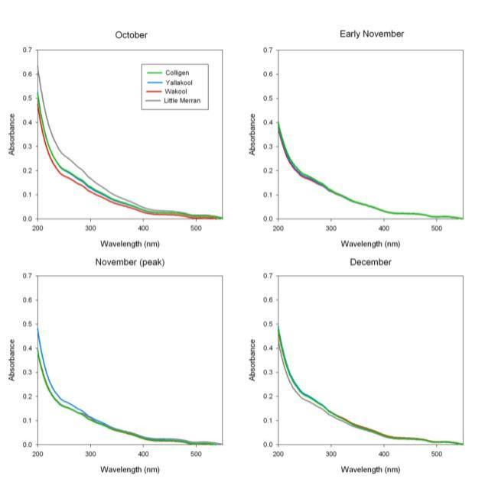*

**Figure 9.** Absorbance scans of filtered water samples for each of the four rivers before, during and after the November 2011 environmental watering in Colligen Creek.

*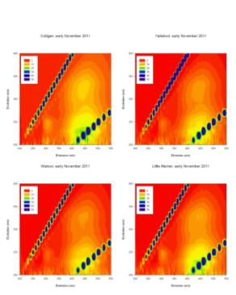 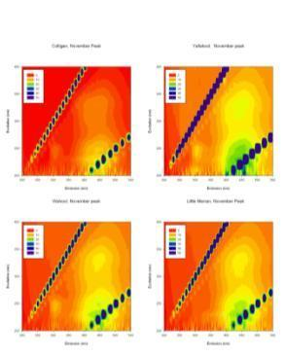* *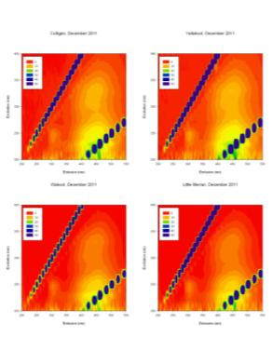*

**Figure 10.** Fluorescence contour plots for each river prior to (Nov 2011), during (November 2011), and after (December 2011) the environmental watering in Colligen Creek in November 2011.

**Blackwater Event, March to April 2012**

Absorbance scans for water samples from February to May 2012 (Figure 11) provide a preliminary indication of the change in water quality associated with the natural flooding event which occurred as a result of rainfall in early March 2012 and impacted all sites. As for the November environmental watering, the absorbance scans reflect the patterns observed in DOC concentrations, which suggests absorbance scans may be used as an indication of changing DOC concentrations in these systems. Note that the scale on the y axis is different to Figure 9 due to the much higher absorbances recorded during this period. In early February 2012 the absorbance scans at all sites were very similar to each other and consistent with earlier results in these rivers (Figure 9).

By 6/3/2012 substantial increases in absorbance at both sites on the Wakool River upstream of the escape and at the uppermost site on Yallakool Creek indicated that water at these sites had been in contact with the floodplain and had collected additional dissolved organic matter, while all other sites had absorbance results which were unchanged from the February samples. Samples collected the following week indicate that all sites were showing signs of blackwater with the highest carbon loadings in Colligen Creek and Little Merran Creek and the sites downstream of the escapes on the Wakool River and Yallakool Creek. Water in the Mulwala Canal was similar to the normal water quality found in the rivers over the summer and was not blackwater impacted.

By 21/3/2012 all sites had a further increase in dissolved organic matter (as indicated by absorbance) and the Mulwala Canal was also showing signs of an input of organic matter from upstream in the system. This may have decreased the effectiveness of water releases from the canal to dilute the blackwater events in the rivers. Consideration may need to be given to the source of organic matter during blackwater events - this flood event, as a result of rainfall, included considerable overbank flooding as far upstream as the Ovens river, and will have influenced water quality in the canal in a way which is unlikely to occur if the source of organic matter was predominantly the Barmah-Millewa forest or other floodplain regions downstream of Lake Mulwala. The absorbance scans at these sites during the peak are slightly higher than those recorded during the December 2010 and January 2011 blackwater event in this system (CSU, unpublished data) but fall within the range of those measured in the Barmah-Millewa forest and the rivers immediately downstream during the February 2005 blackwater event, but are less impacted than the Broken Creek during the 2005 event (Howitt, unpublished data). By early April 2012 the water quality at most sites was approaching normal with the exception of Little Merran Creek, which still had a high organic matter load, consistent with the later peak in the hydrograph for this site. By May 2012 all rivers had returned to normal levels.

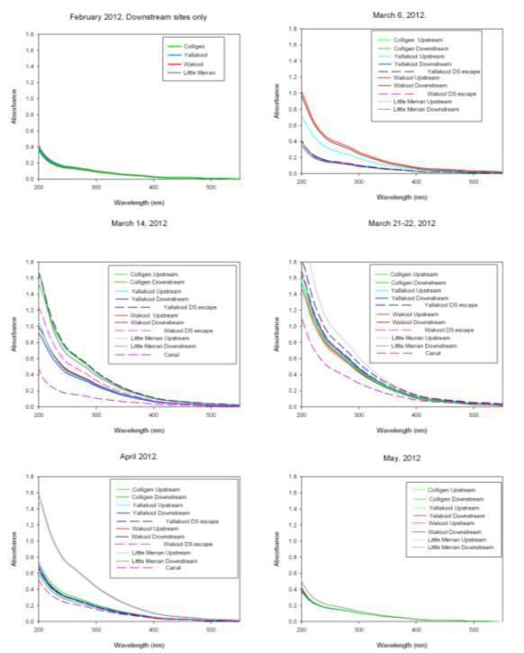

**Figure 11.** Absorbance scans for all sampling dates from February to May 2012. Results from February are presented at the reach scale, for comparison with earlier data. Later results are represented for individual sample sites to illustrate the progression of the blackwater event, as differences were observed between samples from upstream and downstream sites on the same river.

* 1. Phytoplankton biomass

Phytoplankton chlorophyll-a (Chl-a) concentrations in the water from Colligen Creek remained relatively constant after the environmental watering (Figure 12), whereas over the same period the phytoplankton chlorophyll-a concentrations in Yallakool Creek, Wakool River and Little Merran Creek reduced (Figure 12). This suggests that the three rivers that did not receive the environmental water experienced a reduction in the biomass of phytoplankton over this period. Planktonic chlorophyll-*a* concentrations were approximately midway compared to levels reported for phytoplankton populations in other lowland rivers (20–200 mg/m3; Reynolds & Descy 1996).

**Figure 12**. Phytoplankton chlorophyll-*a* concentrations (mg/m3) ± 1 SE in water from Colligen Creek, Yallakool Creek, Wakool River and Little Merran Creek in November 2011 (before environmental watering in Colligen Creek) and December 2011 (after the environmental watering in Colligen Creek).

* 1. Leaf-litter breakdown rates

In relation to hydrological regimes, leaf-litter breakdown rates were similar among the four rivers after three months duration. This may suggest that leaf-litter breakdown rates are not sensitive at indicating changes in hydrological regimes or additions of environmental water, at least over this time scale (Figure 13). However, these results may change after examining the next three months of data (January to March 2012), since increasing summer temperatures potentially increases biological activity (microbial degradation and invertebrate feeding) and therefore breakdown rates.

In comparison to other studies river red gum decay coefficients from the Edward-Wakool river system are similar to values from wetlands and intermediate between a study carried out in the Murray River and a temperate rainforest stream (Table 3). Despite these variations in decay coefficients for river red gum leaves, the current study is similarly categorised with other Australian studies with the “medium” processing category (Table 3).

River red gum leaves had faster breakdown than blackwood leaves after three months duration (Figure 13 c,d). This may suggest that river red gum leaves are a better food resource for microbial decomposers and invertebrates than blackwood leaves. Breakdown rates were only slightly faster in coarse-mesh bags (which allow invertebrate access to the leaves) than fine-mesh bags (microbial degradation) this suggests that microbes may play a greater role in the breakdown of leaf-litter than invertebrates in the Edward-Wakool river system.

**Table 3**. Decay coefficients (-*k*) and half-lives (T50 in days)of Red gum leaves after three month duration compared with published data. Category refers to the processing categories of Petersen and Cummins (1974) “Fast” breakdown groups decay coefficient > 0.010, “medium” groups, 0.005 – 0.010 and “slow” groups < 0.005.

|  |  |  |  |  |  |
| --- | --- | --- | --- | --- | --- |
| River | Mesh (mm) | *-k*(d-1) | T50 (d) | Category  (F, M, S) | Reference |
| Colligen | 10 / 0.5 | 0.009 / 0.007 | 77 / 99 | M | This study |
| Yallakool | 10 / 0.5 | 0.010/ 0.008 | 69 / 92 | M | This study |
| Wakool | 10 / 0.5 | 0.009/ 0.007 | 77 / 99 | M | This study |
| Little Merran | 10 / 0.5 | 0.009/ 0.007 | 77 /99 | M | This study |
| Murray | 10 /0.3 | 0.015 / 0.015 | 47/46 | M | Schulze and Walker 1997 |
| Stream | Leaf pack | 0.006 | 110 | M | Campbell and Fuchshuber 1995 |
| Wetland | Leaf pack | 0.496, 0.003\*  0.687, 0.004\* | 138 autumn  132 winter | M  M | Glazebrook and Robertson 1999 |
| Wetland | 1.5 | 0.007 | 80 | M | Briggs and Maher 1983 |
| Wetland (mesocosms) | Leaf pack | 0.449, 0.005\*  98.51, 0.004\* | 57 sum./aut.  134 spring | M  M | Watkins *et al.* 2010 |
| Wetland | 10 | 10.281, 0.007\* | 70 | M | Janssen and Walker 1999 |

\*Double exponential models used to calculate decay coefficients

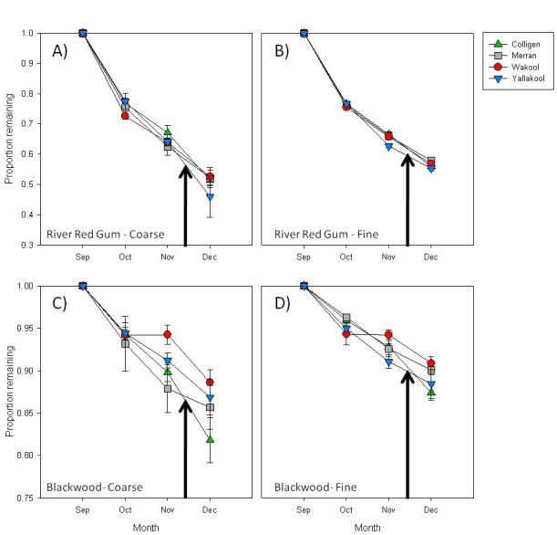

**Figure 13**. Coarse and fine-mesh breakdown of river red gum (A, B) and blackwood leaves (C, D) in four rivers in the Edward-Wakool river system. Individual values were averaged using litter bags as replicates, and the data presented show mean values of litter bags ± 1 SE. Black arrow denotes when environmental watering occurred.

* 1. Biofilms

Analysis of biomass of one month old biofilms has been completed, and processing of remaining samples of one month old and standing stock biofilm samples is on-going. Results for samples collected in November 2011 (prior to the environmental watering in Colligen Creek) and December 2011 (after the environmental watering in Colligen Creek) are presented here. Results of biodiversity of biofilm samples will be included in the final report.

Biofilm total biomass from Colligen Creek increased after the November environmental watering (Figure 14). In contrast, the total biomass of one-month old biofilms in Yallakool Creek decreased and Wakool River remained relatively constant between November and December (Figure 14). Biofilm organic biomass shows no change between November and December 2011 in any of the rivers (Figure 15). Thus, the increase in total biomass in Colligen Creek after the environmental watering is most likely due to an increase in turbidity of the water during the environmental watering that would have resulted in a build-up of sediment on the biofilms.

**Figure 14**. Total dry biomass (g/m2) ± 1 SE of one-month-old biofilms collected from Colligen Creek, Yallakool Creek, Wakool River and Little Merran Creek in November 2011 (before environmental watering in Colligen Creek) and December 2011 (after the environmental watering in Colligen Creek). Biofilm samples could not be retrieved from Little Merran Creek in November 2011.

**Figure 15.** Total organic biomass (g/m2) ± 1 SE of one-month-old biofilms collected from Colligen Creek, Yallakool Creek, Wakool River and Little Merran Creek in November 2011 (before watering flow in Colligen Creek) and December 2011 (after the environmental watering in Colligen Creek). Biofilm samples could not be retrieved from Little Merran Creek in November 2011.

Biofilm algal biomass (chl-*a* concentration) from Colligen Creek was similar after the environmental watering (Figure 16), despite an increase in turbidity and build up of sediment on the biofilms during the environmental watering. In contrast, the algal biomass of one-month old biofilms in Yallakool Creek and Wakool River increased between November and December (Figure 16), with the increase particularly notable in Yallakool Creek where constant discharge and lower turbidity would have created conditions beneficial for algal growth. The chlorophyll-*a* levels did not exceed the 100 mg chlorophyll-*a* /m2 level recommended by Quinn (1991) for nuisance biofilm. However, it should be noted that these results are for biofilms grown for only one month prior to collection. Analysis of standing stock biofilm samples is underway and the results will be presented the final report.

**Figure 16.** Algal biomass (mg/m2 chlorophyll-*a*) of one-month-old biofilms collected from Colligen Creek, Yallakool Creek, Wakool River and Little Merran Creek in November 2011 (before environmental watering in Colligen Creek) and December 2011 (after the environmental watering in Colligen Creek). Biofilm samples could not be retrieved from Little Merran Creek in November 2011.

* 1. Zooplankton

Thirteen taxonomic groups of zooplankton were identified, including rotifers and 12 different groups of microcrustaceans. There was an increase in abundance of most taxonomic groups within Colligen Creek after the environmental watering (Figures 17 and 18), although the increase was also observed in other rivers which did not recieve a natural flow pulse or environmental watering (eg. Yallakool US escape). This indicates that change in abundance may be attributed to other factors such as the seasonal effects of increasing temperature between November and December. It is worth noting that the relative increase in microcrustacean abundance among all rivers was highest in Colligen Creek following the highest flow pulse which peaked at 913 ML/d. The increase in abundance was due largely to nauplii (first stage larvae) of copepods which increased by over eight-fold and the presence of seven rare taxonomic groups not present prior to the environmental watering.

The most numerous groups present only after the environmental watering belonged to Harpacticoida, Ilyocruptus, Macrothrix and Monidae. These were observed in other rivers and in particular a large increase in Macrothrix at the DS escape Yallakool reach. The mean number of taxa observed was typically higher after the environmental watering in all rivers (Figure 19). Similar to abundance, however, this response is likely to be seasonal as changes were also observed in other rivers that did not recieve a flow pulse. The total diversity of zooplankton in Colligen Creek was different from that in other rivers after the environmental watering. In Colligen Creek only four taxa were identified before the environmental watering and 11 were identified afterwards (Figure 19; lower chart), the increase due largely to a small number of rarely sampled taxon. Similarly, rotifers increased in abundance after the environmental watering (Figure 18) but this increase was also observed in rivers that did not recieve a natural flow pulse or environmental watering, further suggesting a seasonal effect. Rotifers as a group were over 10 orders of magnitude more abundant than microcrustacean copepods and cladocerans in all rivers.

The abundance and diversity of the zooplankton community sampled in Edward-Wakool rivers was consistent with other floodplain river systems in the Murray-Darling Basin (Shiel *et al.* 1982). These systems like most others in the Murray-Darling are dominated by rotifers and nauplii of copepods. Zooplankton production generally decreases with increasing discharge due to dilution effects, but subsequent productivity resulted in an increase in abundance within most rivers sampled in this study. Further analyses of zooplankton abundance and diversity following high flow events at different times of the year may help further explain these trends.

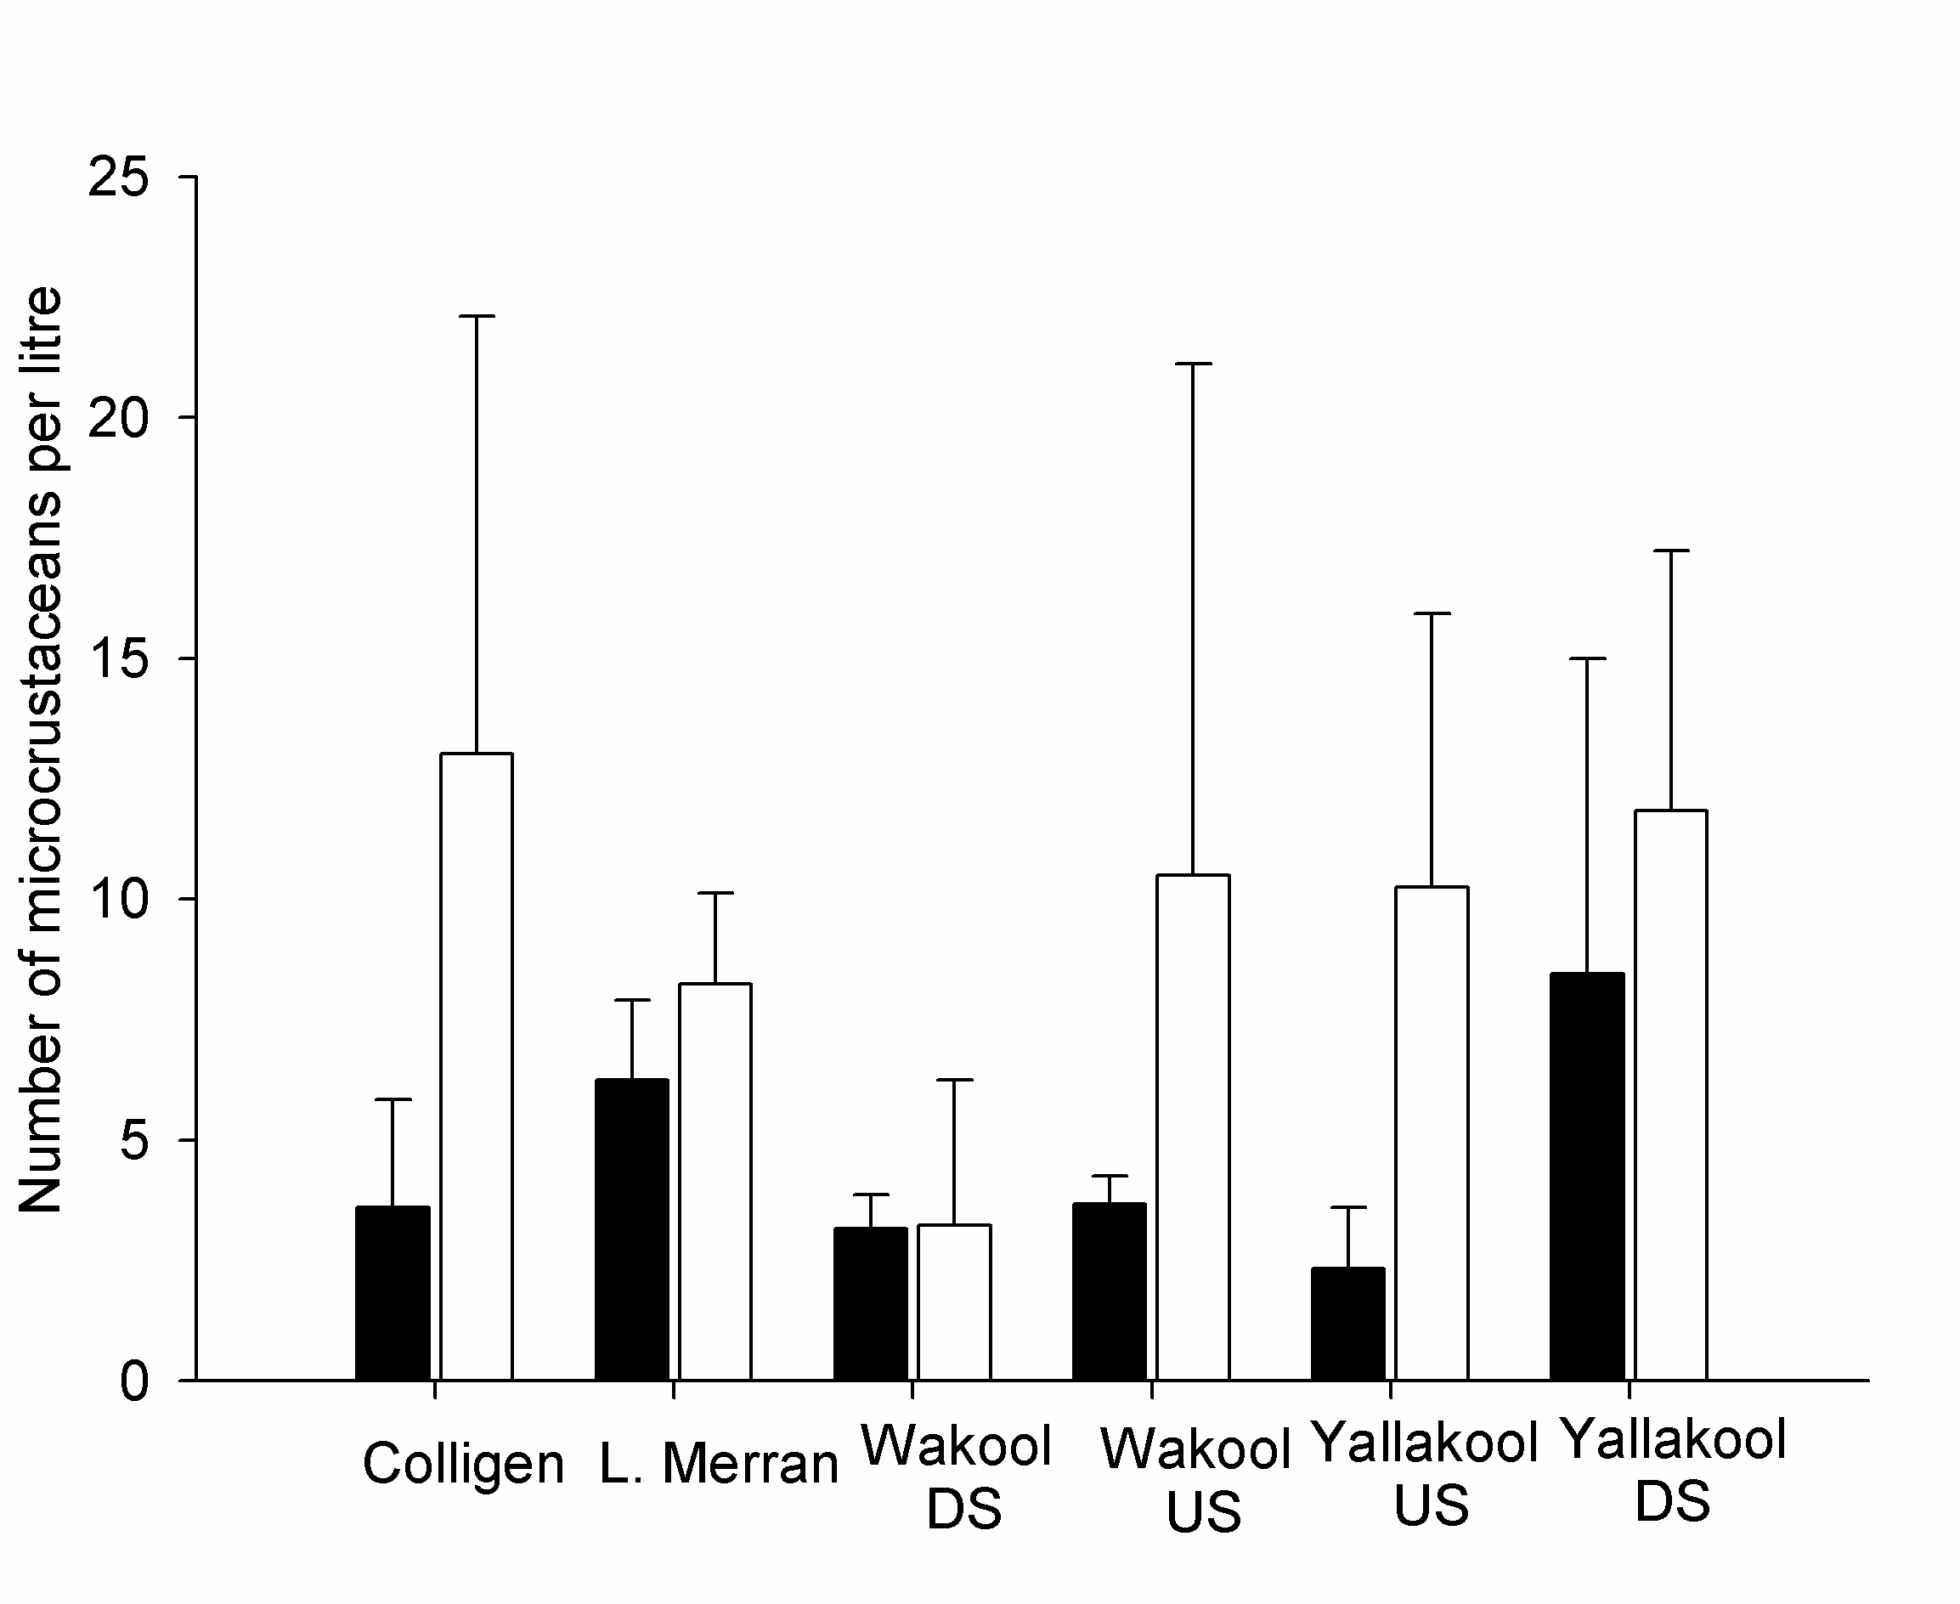

**Figure 17.** Mean abundance ± standard deviation of microcrusteaceans per litre before (black bars, 15/11/2011) and after (white bars, 13/12/2011) an environmental watering in Colligen Creek in November 2011.

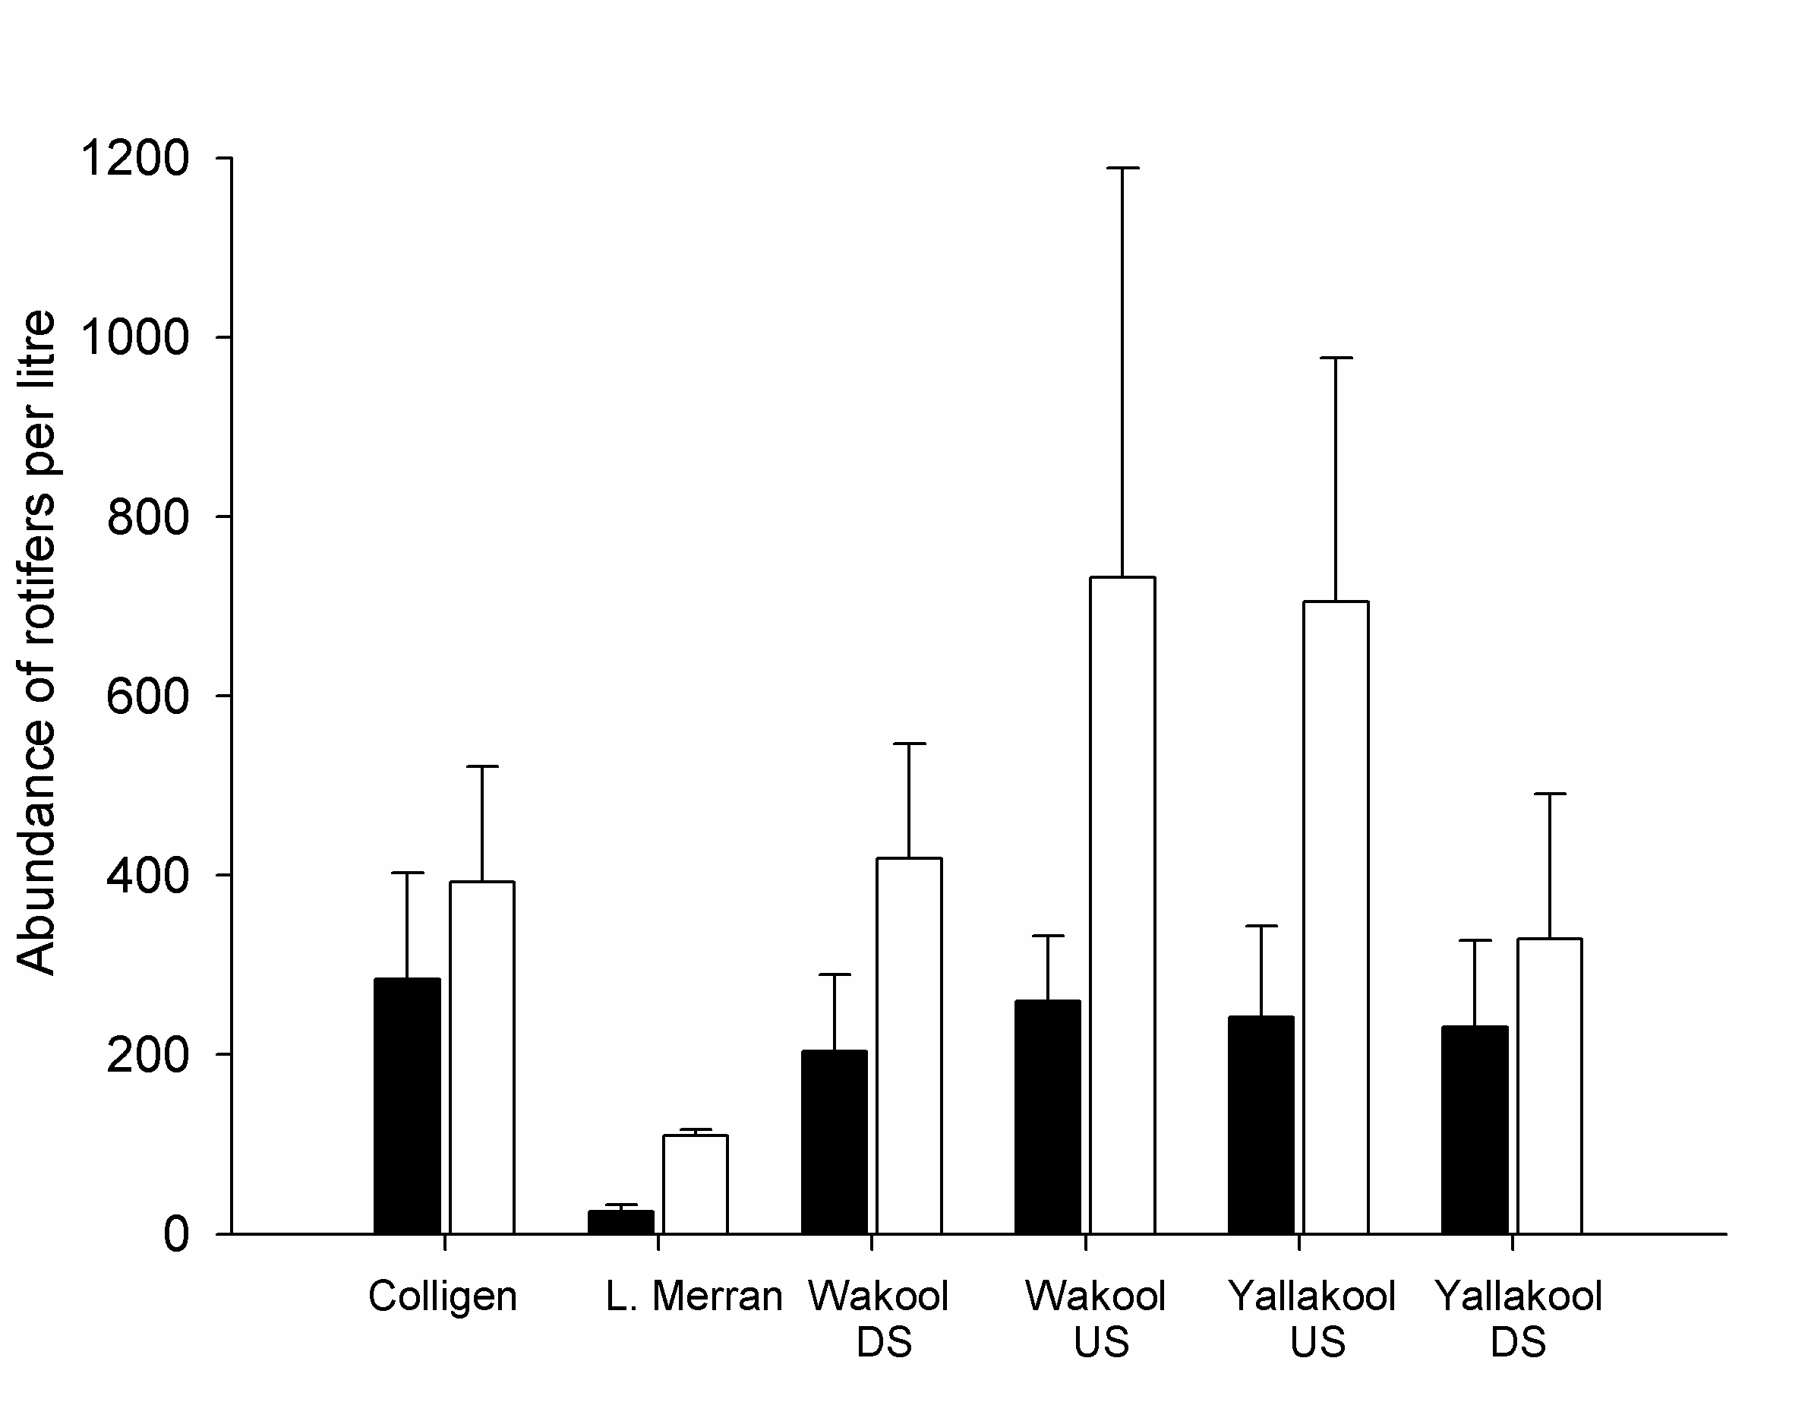

**Figure 18.** Mean abundance ± standard deviation of rotifers per litre before (black bars; 15/11/2011) and after (white bars; 13/12/2011) an environmental watering in Colligen Creek in November 2011.

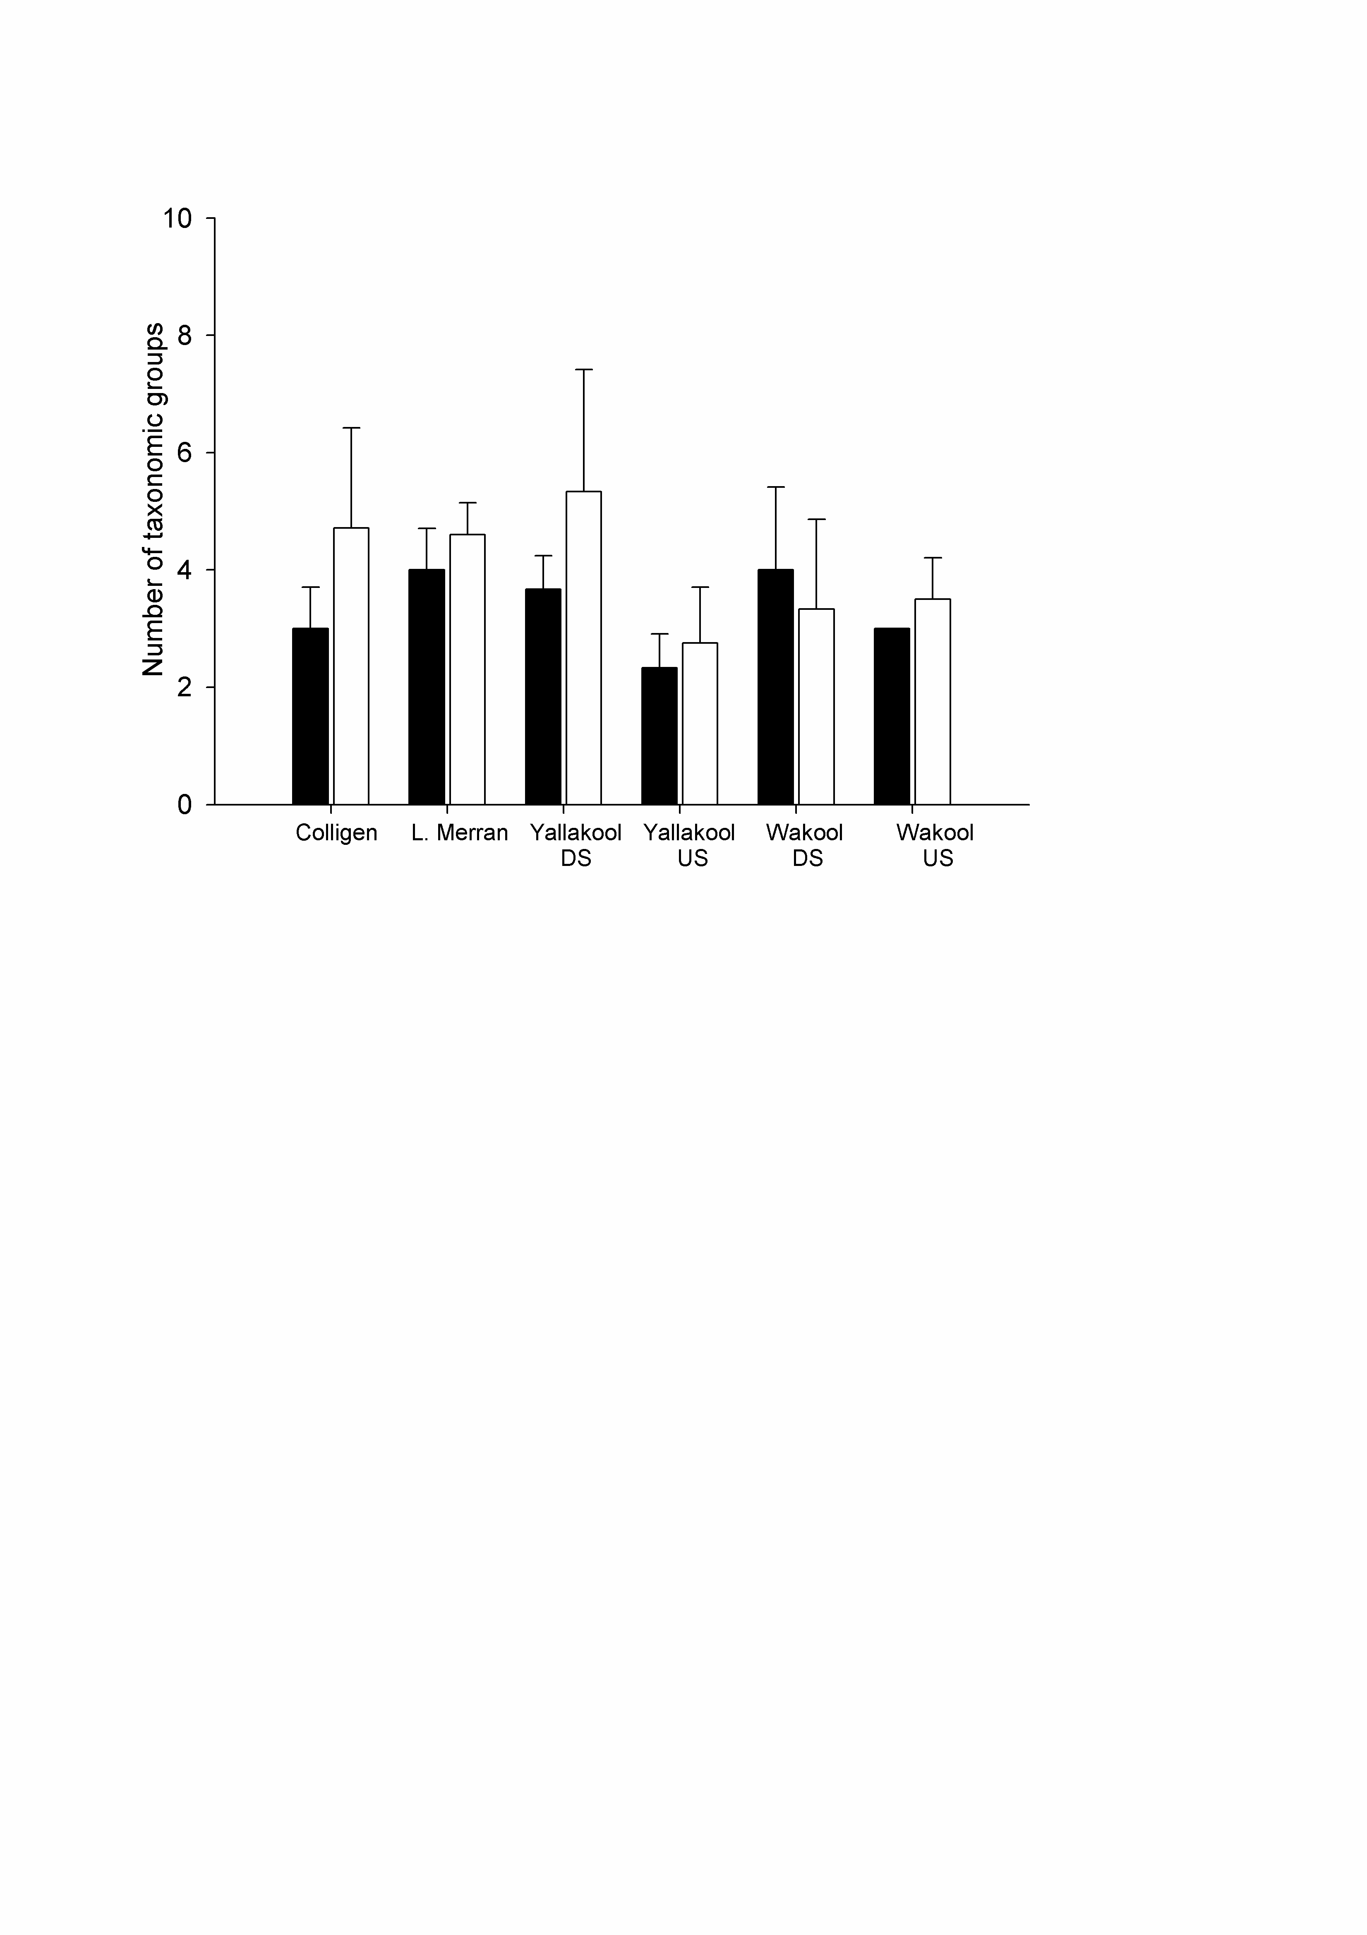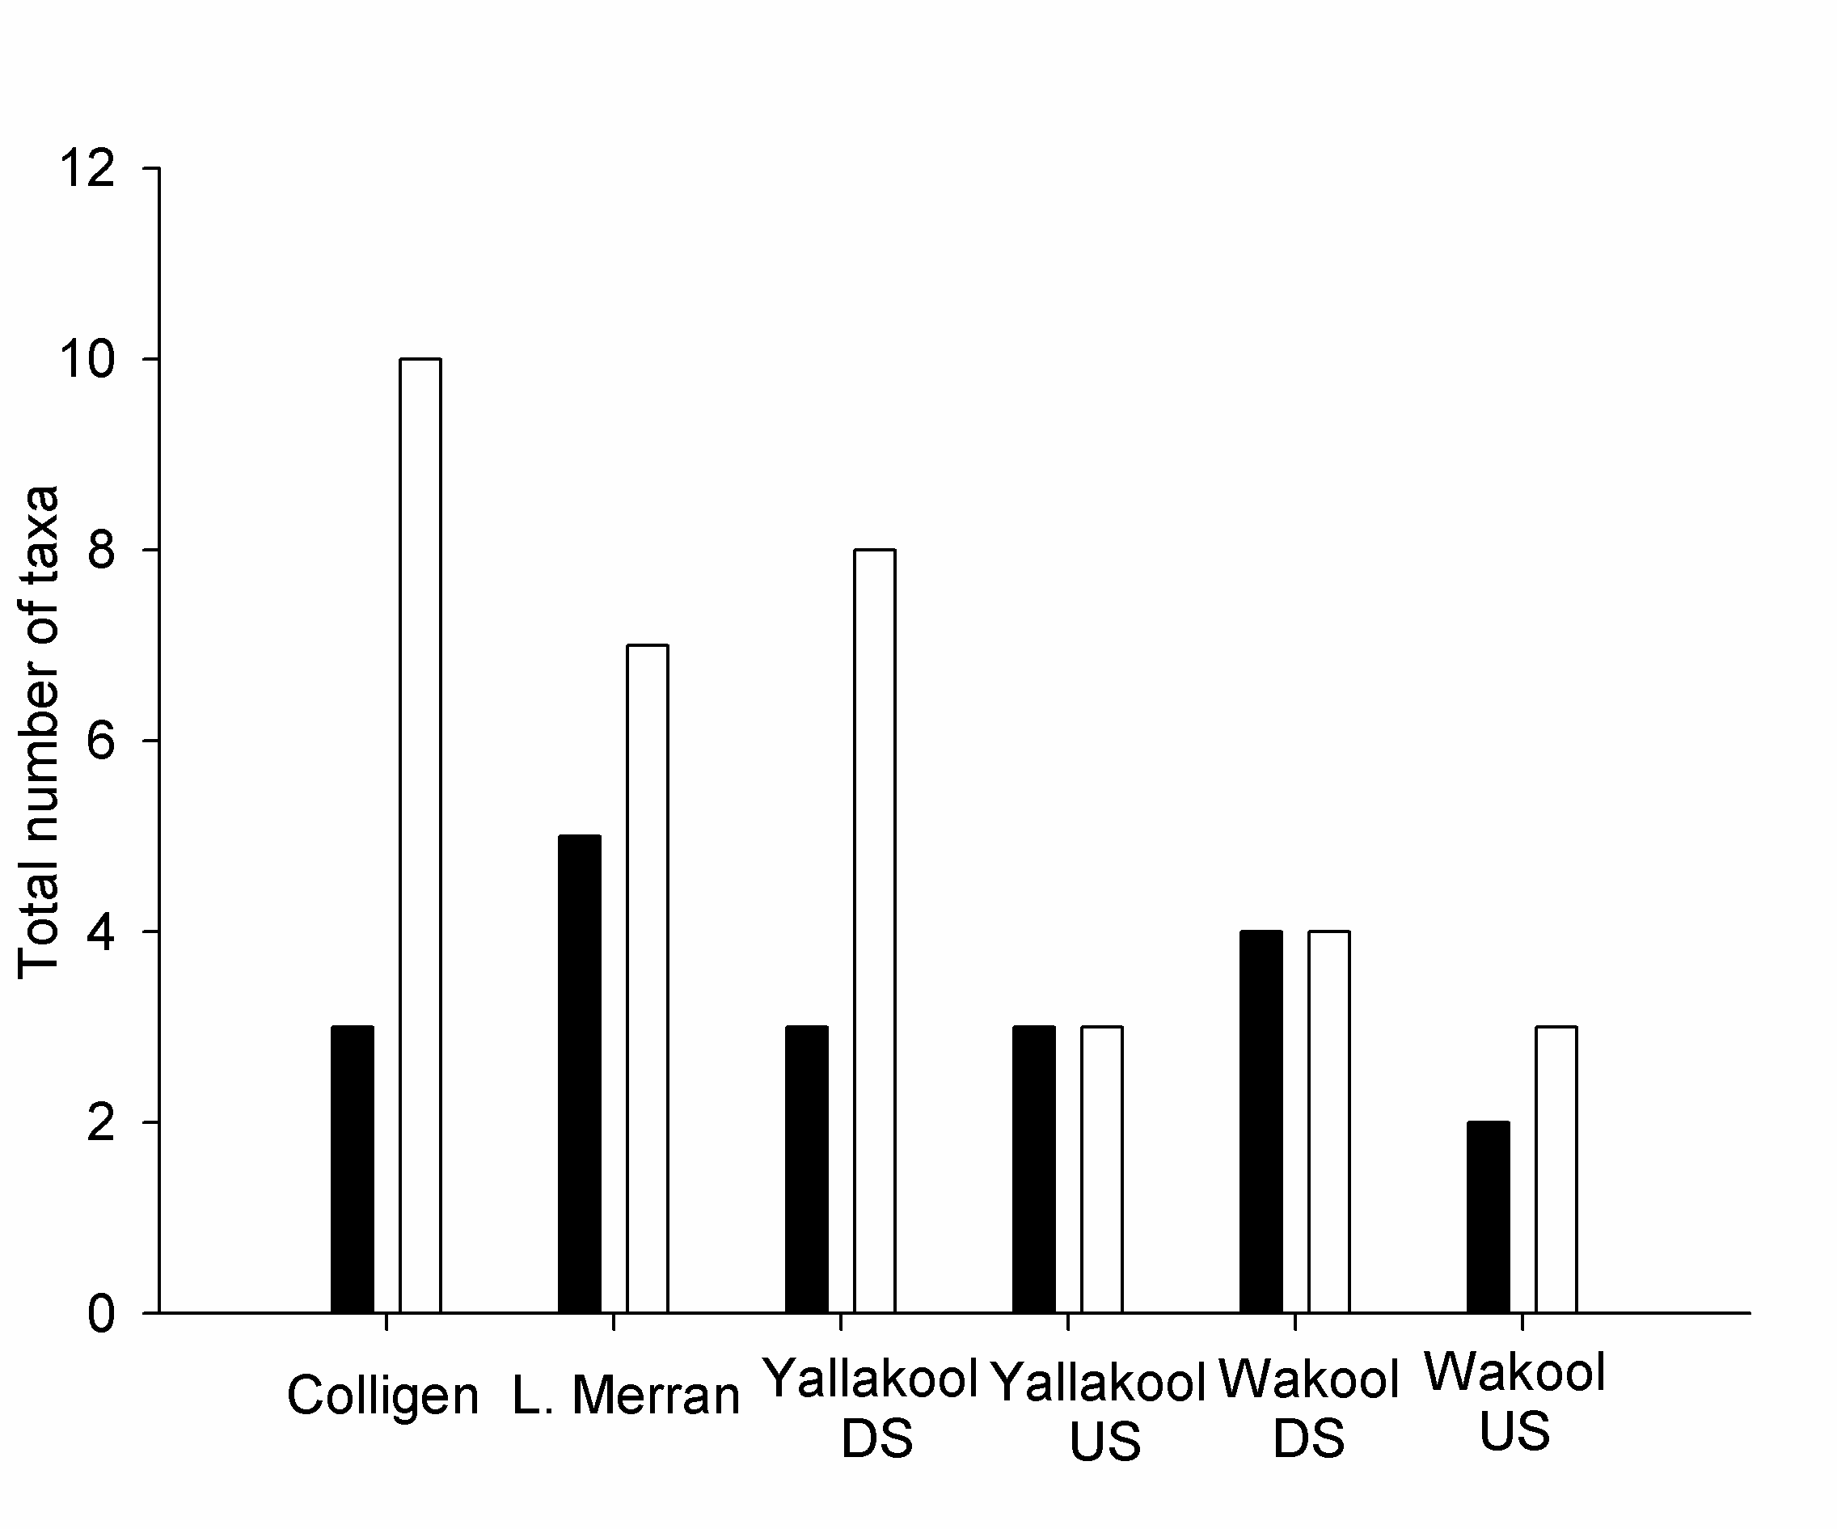

**Figure 19.** Mean number ± standard deviation (top chart) and total number (bottom chart) of zooplankton taxonomic groups present before (black; 15/11/2011) and after (white; 13/12/2011 ) an environmental watering in Colligen Creek in November 2011.

* 1. Macroinvertebrates

Results for macroinvertebrates are preliminary and relate to a small proportion of the samples taken. As such, results are not conclusive and may change as more samples are processed. Preliminary findings suggest macroinvertebrate abundance was similar in the Colligen (pre-environmental watering), Yallakool and Little Merran creeks and higher in the Wakool River in November 2011 (Figure 20). In December 2011 after the environmental watering in Colligen Creek, abundances in Colligen Creek were lower than in the other creeks and the Wakool river. Macroinvertebrate family richness was higher in the Colligen in November than in the other three sites whereas in December family richness seemed similar amongst sites (Figure 21). These patterns may change once more samples are processed.

The observed reduction in macroinvertebrate abundance and richness in Colligen Creek immediately after the environmental watering may be related to the disturbance caused by the environmental watering. Examining longer term trends in invertebrate communities will allow an assessment of whether communities recover from the initial disturbance, and what the broader effects on biodiversity are likely to be. Our findings are similar to a study by Suren and Jowett (2006) that examined flood and low flow events in a gravel-bed river in NZ and found invertebrate densities decreased more after floods than low flows and that the degree of change was proportional to flood magnitude.

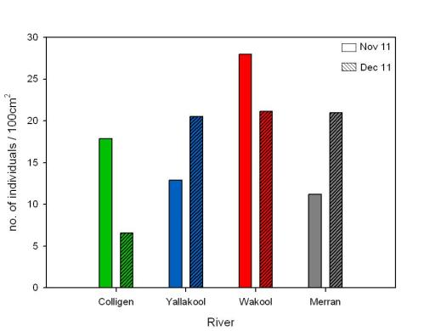

**Figure 20.** Macroinvertebrate abundance on small snags (100cm2) in four rivers in the Edward-Wakool river system in November and December 2011 (n =1 per site / date).

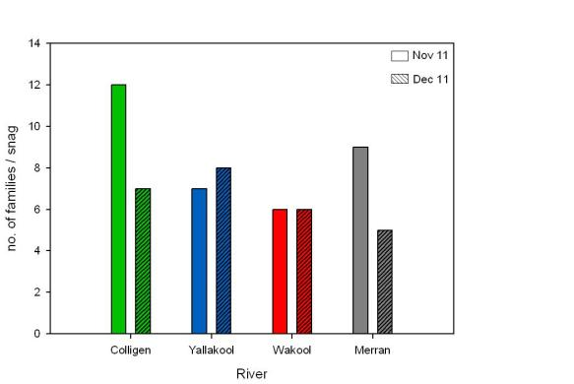

**Figure 21.** Macroinvertebrate family richness on snags in four rivers in the Edward Wakool system in November and December 2011 (n =1 per site / date).

* 1. Frogs

Six species of frog were recorded over the four months survey period. Four species, the Plains froglet (*Crinia parinsignifera*), Spotted marsh frog (*Limnodynastes tasmaniensis*), Barking marsh frog (*Limnodynastes fletcheri*) and Perons tree frog (*Litoria peronii*) were widespread across all four rivers (Figure 22). The relative abundance of each of these species varied between rivers, for example *C. parinsignifera* made up a greater percentage of frogs recorded in the Colligen creek compared with the Little Merran which was dominated by *L. tasmaniensis* and *L. fletcheri*. The two remaining species were restricted to single river systems, the eastern froglet (*C. signifera*) recorded only in Colligen Creek and the eastern banjo Frog (*Limnodynastes dumerilii*) was recorded in Little Merran Creek (Figure 22).

**

**Figure 22.** The composition of frog communities within the four river systems between January and April 2012.

The patterns of abundance varied between species and between rivers (Figure 23). Frog abundance was low in all rivers in January and February 2012. Overall, the abundance of frogs within Colligen Creek did not change in response to the February environmental watering or during the unregulated high flow period in March 2012. In contrast the abundance of frogs increased in March and April in the Yallakool, Wakool and Little Merran Creeks with the most notable change in abundance occurring in Yallakool Creek in March during the unregulated flow (Figure 23).

Overall the four rivers contained a relatively high diversity of frog species, but the abundance of individuals varied considerably between the four rivers. Mean frog abundance was low within the reaches assessed in Colligen Creek (8.5 individuals), Wakool River (14.5 individuals) and Little Merran Creek (15.5. individuals) compared with Yallakool Creek (51 individuals); this is likely to reflect the specific geomorphic and habitat characteristics of the survey reaches. That is, because the response of frogs is often linked to the availability of temporary habitats created during a flow pulse ([Wassens and Maher 2011](#_ENREF_6)), differences in stream geomorphology within and between creek systems can determine the availability of these temporary habitats at specific river heights.

The frog community in Colligen Creek was different to that in the other three rivers (Figure 23). It contained a higher proportion of plains froglets and Peron’s tree frog and fewer spotted marsh frogs. The limited response of frogs at Colligen Creek reaches during both the environmental watering and subsequent unregulated flow (which achieved a far greater increase in river height) is likely to be a function of the specific reach assessed and may not necessarily reflect the frog response through the entire creek system. While abundance in Colligen Creek was low throughout study, the different frog community in this system is likely to reflect specific geomorphic features of the sample reach and may explain why there was not a strong shift in abundance following the environmental watering and subsequent natural flows in March 2012. Previous research in the Wakool River and Yallakool Creek demonstrated that the plains froglet responded to environmental watering if they created shallow temporary habitats adjacent to the creek which contained abundant submerged terrestrial vegetation (Griese, 2011). If these habitats are not present, frog activity is likely to be limited (Griese, 2011). A more comprehensive understanding of frog responses to environmental watering would be gained by increasing the number of sample reaches within each river in order to capture the full extent of geomorphic diversity within each river.

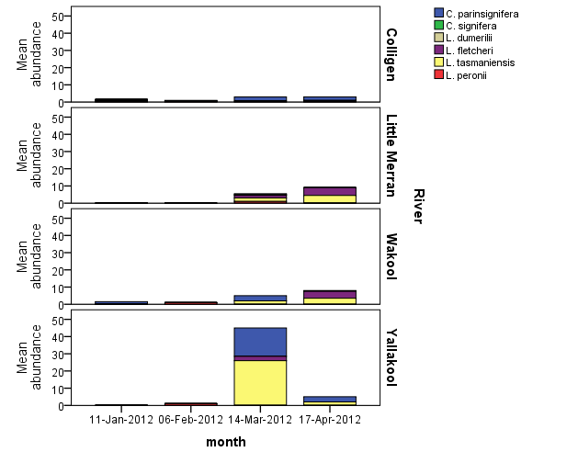

**Figure 23.** The mean number of individuals of each species recorded during 30 minute transect surveys on each of the four surveys occasions

* 1. Fish

Fish were sampled on fifteen fortnightly trips which have thus far resulted in ten species and 1978 individual observations and length measurements (Table 4). Approximately 44% (211/480) of light trap, 10% (24/240) of drift net and 7% (16/240) of fyke net samples have been processed in the laboratory since completion of field sampling on 30 April 2012. All samples from all gear types have been processed for downstream sites before and after the environmental watering in Colligen Creek in November 2011.

**Table 4.** Number (n) of samples processed and fish species collected to date.

|  |  |  |  |  |
| --- | --- | --- | --- | --- |
|  | Sampling gear | | | Total |
| Drift net (n=24) | Light trap (n=211) | Fyke net (n=16) |  |
| Carp gudgeon spp. | 77 | 865 | 236 | 1178 |
| Australian smelt | 2 | 659 | 7 | 668 |
| Murray cod | 23 | 59 | 0 | 82 |
| Common carp | 1 | 11 | 9 | 21 |
| Redfin | 5 | 18 | 0 | 23 |
| Flathead gudgeon | 1 | 6 | 0 | 7 |
| Mosquito fish | 0 | 4 | 0 | 4 |
| Murray hardyhead | 0 | 0 | 2 | 2 |
| Oriental weather loach | 0 | 0 | 1 | 1 |
| Golden perch | 0 | 0 | 1 | 1 |

Spawning activity, as measured by larval abundance, was dominated by the native species carp gudgeon *spp*. and Australian smelt in all rivers, although consistent numbers of Murray cod larvae were present in light traps at all reaches (Figure 24). All three species are native to the Murray-Darling Basin although non-native carp and mosquito fish juveniles were also present (Table 4). Species diversity of larvae ranged from four to six among reaches between September 2011 and January 2012 and from five to three respectively before and after the November 2011 environmental watering in Colligen Creek. All larvae sampled in Colligen Creek after the environmental watering were native species. There were consistent numbers of Murray cod larvae present at all reaches, but no evidence of increased spawning and recruitment of Murray cod in response to the environmental watering in Colligen Creek in November 2011. Despite evidence of silver perch and golden perch adults occurring in the system (J. Conallin, Murray CMA, pers comm.), we did not detect these species spawning in response to the flow with the sampling methodology employed in this project.

Relative abundance of larvae was standardised per light trap and was greatest in Colligen Creek followed by the Wakool River US escape and Little Merran Creek. Fyke nets sampled a different range of species and larger size class of fish than the light traps and drift nets and included golden perch, Murray hardyhead and oriental weather loach. Samples are continuing to be processed for otolith extraction, identification and measurement.

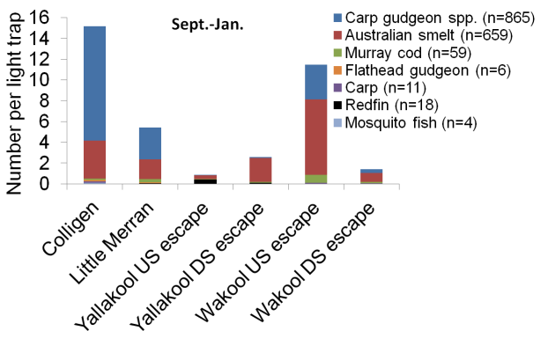

**Figure 24.** Relative abundance of fish larvae sampled in light traps within the Edwards-Wakool river system between September 2011 and January 2012. n = number of individuals.

Larval abundance of the three most dominant species occurred at different times of the year. Australian smelt peaked early in October following high natural flow events in Colligen Creek and Wakool River. Carp gudgeon *spp*. subsequently peaked closely after the Colligen Creek environmental watering in November 2011 (Figure 25). Peak abundance of Murray cod larvae occurred in light traps and drift nets in all rivers between 1/11/2011 and 15/11/2011 which coincided with day time water temperatures ranging from 19.9°C to 25.36°C. The timing of Murray cod larval abundance coincided with carp, although neither coincided with natural flow pulses or environmental watering. Greater than 50% of all Murray cod larvae sampled in drift nets and light traps were collected from the Wakool US escape reach prior the peak flow event in the Wakool River.

Mean larval carp gudgeon abundance notably increased after the environmental watering in Colligen Creek and to a lesser extent in Little Merran Creek which also received a smaller rise peaking at 294 ML/d. Colligen Creek received a peak environmental flow of 913 ML/d in November while the Wakool US and DS reaches also received a rise of 194 ML/d and 394 ML/d respectively but these did not result in an increase in mean larval abundance (Figure 25). The response of carp gudgeon larvae to the environmental watering is a unique observation given that this species is typically considered a flow generalist that does not require high flow events for spawning (Reich *et al.* 2010). Abundance of larvae surrounding other flow events will need to be evaluated in order to assess the repeatability of this response and determine whether it can be attributed directly to the environmental watering.

Fig 25 revised.tif

**Figure 25.** Larval abundance of the three most dominant species sampled light traps within the Edward-Wakool. Dashed lines represent the peak date of natural flow pulse and environmental watering. n = number of individuals.

1. Summary

This project assessed ecological responses to November 2011, February 2012 and April to May 2012 environmental watering in the Edward-Wakool river system. Processing of samples is still underway. A final report on this project will be available later in 2012.

Preliminary findings from the delivery of environmental water to Colligen Creek in November 2011

This report primarily focuses on short-term responses to the November 2011 environmental watering in Colligen Creek by comparing results from samples collected in November 2011 before the environmental watering to those collected in December 2011, immediately after the watering event.

* The primary objective for the November 2011 environmental watering was to initiate spawning and recruitment of large bodied native fish. **There were consistent numbers of Murray cod larvae present at all reaches, but no evidence of immediate increases in spawning of this species in response to the environmental watering in Colligen Creek in November 2011.** Despite evidence of silver perch and golden perch adults occurring in the system, we did not detect these species spawning in response to the environmental watering with the sampling methodology employed in this project. Therefore no conclusion can be made regarding the effect of the environmental watering on spawning of these species.
* **There was an increase in the abundance of carp gudgeon larvae in Colligen Creek following the November environmental watering**. This response may be attributed to the environmental watering because at the same time there was little or no increase in the abundance of carp gudgeon larvae in the Wakool River, Little Merran Creek or Yallakool Creek. All fish larvae sampled in Colligen Creek following the environmental watering were native species. Larvae and juveniles of seven species of fish were sampled, with the dominant species in all rivers being Carp gudgeon *spp*., Australian smelt, and Murray cod.
* **The November 2011 environmental watering had no adverse impacts on water quality in Colligen Creek**. Dissolved oxygen concentrations measured *in situ* in all river reaches were above the 4mg/L threshold of concern for aquatic health and were similar in all four rivers between September 2011 and February 2012. There was no evidence of blackwater associated with the November 2011 environmental watering in Colligen Creek, as dissolved organic matter profiles for the four rivers during November and December 2011 were very similar.
* **There was a** **positive response of phytoplankton biomass (water column chlorophyll-*a* concentrations) to the November environmental watering in Colligen creek**. Chlorophyll-*a* concentrations in the water from Colligen Creek remained relatively constant after the environmental watering, whereas over the same period chlorophyll-*a* levels reduced in Yallakool Ck, Wakool River and Little Merran Creek that did not receive environmental water.
* **There was no apparent response of leaf-litter breakdown rates to the November 2011 environmental watering, as** **breakdown rates were similar among the four rivers**. This suggests that leaf-litter breakdown rates may not be a sensitive short-term response indicator of environmental watering. These results may change after examining samples from January to March 2012, as increasing summer temperatures potentially increases biological activity (microbial degradation and invertebrate feeding) and therefore breakdown rates.
* **There was no change in** **organic biomass of one month old biofilms in Colligen Creek after the November environmental watering, although there was a build up of inorganic sediment on the biofilms over this period.** Further analysis will test whether the environmental watering resulted in a change in the community composition of algal biofilms.
* **There was a** **positive response of biofilm algal biomass (chlorophyll-*a*) to the November environmental watering in Colligen Creek**. **Chlorophyll-*a* concentrations of one month old biofilms from Colligen Creek remained relatively constant in November and December 2011, whereas over the same period chlorophyll-*a* levels of one month old biofilms increased in the Wakool River and increased substantially in Yallakool Creek,** as the constant discharge in these systems created conditions beneficial for rapid algal growth. The chlorophyll-*a* levels in Yallakool Creek in December did not approach nuisance levels outlined by Quinn (1991), but there is the potential for this to occur under more prolonged low flows and increasing summer temperatures. Analysis of samples from January to April 2012 will determine whether environmental watering in Colligen Creek limited algal biomass in biofilms in that system compared to the other rivers.
* **There was a seasonal increase in the abundance of zooplankton from November to December 2011 in all four rivers. This parameter did not appear to respond to environmental watering, as patterns of abundance in Colligen Creek were comparable to the rivers not receiving environmental water.**
* **There was an increase in the** **diversity of zooplankton in Colligen Creek following the November 2011 environmental watering, largely due to increases in a small number of rarely sampled taxon**. This suggests that environmental watering may promote diversity in this group. The robustness of this pattern will be assessed following the processing of the remaining samples and analysis of the entire dataset.
* **Preliminary findings suggest** **macroinvertebrate abundances decreased in Colligen Creek immediately after the environmental watering relative to the other three rivers.** Macroinvertebrate family richness was higher in Colligen Creek prior to the environmental watering than in the other three rivers, but was similar to the other rivers after the environmental watering. This pattern may be related to the initial disturbance caused by the environmental watering. These preliminary findings may change once more data is processed.

Preliminary findings from the delivery of environmental water in February and May 2012

Although this report focuses on short-term responses to the November 2011 environmental watering in Colligen Creek, preliminary results for January to May 2012 are available for water quality, dissolved organic matter characterisation, and frogs. The final report on this project (available later in 2012) will include a detailed assessment of ecosystem responses over this period.

* Dissolved oxygen concentrations measured *in situ* on each sample date reveal that Colligen Creek had higher dissolved oxygen levels than all of the other rivers following the February 2012 environmental watering in Colligen Creek. There was **no evidence of blackwater associated with the environmental watering**, as the dissolved organic matter profiles for the four rivers during February were very similar.
* **During the blackwater event in April 2012, Colligen Creek, Yallakool Creek and Wakool River (rivers that received environmental water as dilution flows via irrigation escapes) had higher dissolved oxygen levels than Little Merran Creek that did not receive the dilution flows.** Dissolved oxygen data from continuous loggers (to be presented in the final report) will provide more detail related to environmental watering and natural pulses.
* Weekly water samples collected during the natural flow events in March 2012 illustrate the progression of the associated blackwater event through all sites, with Little Merran Creek being the only system continuing to be affected by early April and all sites returning to normal levels by May 2012.
* **There was no immediate response of frogs to the environmental watering in Colligen Creek in February 2011.** The abundance of frogs in Colligen Creek did not change in response to the February environmental watering or during the unregulated high flows in March. In contrast the abundance of frogs increased in March and April in Yallakool, Wakool and Little Merran Creeks with the most notable increase occurring in Yallakool Creek. The frog community in Colligen Creek was different to that in the other three rivers. It is not clear whether this was influenced by the environmental watering in Colligen Creek or reflects specific geomorphic features of the study reach. A more comprehensive understanding of frog responses to environmental watering would be gained by increasing the number of sample reaches within each river in order to capture the full extent of geomorphic diversity within each river.

# 6. Acknowledgements

We extend our thanks to the Wakool River Association and landholders in the Edward-Wakool river system for allowing access to their properties and for their keen interest in our project. Field surveys and community liaison were supported by staff at the Murray Catchment Management Authority, with particular thanks to Josh Campbell and Patricia Bowen. Vincent Kelly at the State Water Corporation provided information on river and escapes discharge. We thank Josh Campbell, Anthony Conallin, Philip De Zylva, James Dyer, Vanessa Griese, Elena Griffiths, Stacey Kopf, Chris McCormack, Nathan Ning, Sarah Talbot, Kelsey Tucker, Helen Waudby and Katrina Wilson for assisting with field and/ or laboratory work. Thanks to Simon McDonald from the Charles Sturt University Spatial Analysis Unit for preparing the maps presented in this report. Thanks to Tina Hines and Keralee Browne at the Monash University Water Studies Centre for processing of carbon and nutrient samples and the Murray-Darling Freshwater Research Centre for long-term equipment loans. Fish sampling was carried out under NSW Fisheries license (P11/0003-1.0) and approved by the CSU Animal Care and Ethics Committee (10/101). Frog and tadpole surveys were approved by the Charles Sturt University Animal Care and Ethics (11/040) (Wassens) and were approved under NPWS scientific licenses (S12393). This project was funded by Commonwealth Environmental Water with in-kind contributions from Charles Sturt University, Murray Catchment Management Authority, Monash University. This research also received in-kind support from the Cluster Collaboration Fund and the Ecological Responses to Altered Flow Regimes Research Cluster which represents a collaboration between the CSIRO Water for a Healthy Country Flagship, Griffith University, the University of New South Wales, Monash University, Charles Sturt University, La Trobe University and the Arthur Rylah Institute of the Victorian Department of Sustainability and Environment.

# 7. References

Anstis, M. (2002) 'Tadpoles of South-eastern Australia: a guide with keys.' (Reed New Holland: Sydney)

ANZECC water quality guidelines (2000) 'Australia and New Zealand guidelines for fresh and marine water quality '. In (Australian and New Zealand environment and conservation council and Agriculture and resource management council of Australia and New Zealand) Available at <http://www.mincos.gov.au/publications/australian_and_new_zealand_guidelines_for_fresh_and_marine_water_quality>

Armitage, P.D. (2006) Long-term faunal changes in a regulated and an unregulated stream - Cow green thirty years on. *River Research and Applications* **22**(9), 947-966.

Arthington, A.H., Bunn, S.E., Poff, N.L., and Naiman, R.J. (2006) The challenge of providing environmental flow rules to sustain river ecosystems. *Ecological Applications* **16**(4), 1311-1318.

Arthington, A.H., Naiman, R.J., McClain, M.E., and Nilsson, C. (2010) Preserving the biodiversity and ecological services of rivers: new challenges and research opportunities. *Freshwater Biology* **55**(1), 1-16.

Arthington, A.H., and Pusey, B. (2003) Flow restoration and protection in Australian rivers. *River Research and Applications* **19**(5-6), 377-395.

Baldwin, D.S. (1999) Dissolved organic matter and phosphorus leached from fresh and 'terrestrially' aged river red gum leaves: implications for assessing river-floodplain interactions. *Freshwater Biology* **41**, 675-685.

Baldwin, D.S., and Mitchell, A.M. (2000) The effects of drying and re-flooding on the sediment and soil nutrient dynamics of lowland river-floodplain systems: a synthesis. *Regulated Rivers: Research & Management* **16**, 457-467.

Barbour, M.T., Plafkin, J.L., Bradley, B.P., Graves, C.G., and Wisseman, R.W. (1992) Evaluation of EPA's rapid bioassessment benthic metrics: metric redundancy and variability among reference stream sites. *Environmental Toxicology and Chemistry* **11**, 437-449.

Bateman, H.L., Harner, M.J., and Chung-MacCoubrey, A. (2008) Abundance and reproduction of toads (Bufo) along a regulated river in the southwestern United States: Importance of flooding in riparian ecosystems. *Journal of Arid Environments* **72**(9), 1613-1619.

Bogan, M.T., and Lytle, D.A. (2007) Seasonal flow variation allows 'time-sharing' by disparate aquatic insect communities in montane desert streams. *Freshwater Biology* **52**(2), 290-304.

Briggs, S.V., and Maher, M.T. (1983) Litter fall and leaf decomposition in a river red gum (*Eucalyptus camaldulensis*) swamp. *Australian Journal of Botany* **31**, 308-316.

Burns, A., and D. S. Ryder. (2001) The potential for biofilms as ecological indicators in Australian riverine systems. *Ecological Restoration and Management* **2**, 53-63.

Campbell, I.C., and Fuchshuber, L. (1995) Polyphenols, Condensed Tannins, and Processing Rates of Tropical and Temperate Leaves in an Australian Stream. *Journal of the North American Benthological Society* **14**, 174-182.

Chessman, B.C. (1995) Rapid assessment of rivers using macroinvertebrates: a procedure based on habitat specific sampling, family level identification and a biotic index. *Australian Journal of Ecology* **20**, 122-129.

Coble, P.G. (1996) Characterization of marine and terrestrial DOM in seawater using excitation-emission matrix spectroscopy. *Marine Chemistry* **51**, 325-346.

Commonwealth Environmental Water (2012a Environmental watering in Colligen Creek. http://www.environment.gov.au/ewater/southern/murray/colligen.html {accessed on 24th May 2012]

Commonwealth Environmental Water ( 2012b Environmental watering in the Wakool River and Colligen Creek. http://www.environment.gov.au/ewater/southern/murray/wakool.html {accessed on 24th May 2012]

Commonwealth Environmental Water ( 2012c Environmental watering in the Edward-Wakool river system (fish refuge habitat flows). http://www.environment.gov.au/ewater/southern/murray/edward-wakool.html {accessed on 24th May 2012]

Cross, W.F., Baxter, C.V., Donner, K.C., Rosi-Marshall, E.J., Kennedy, T.A., Hall, R.O., Wellard Kelly, H.A., and Rogers, R.S**.** (2011) Ecosystem ecology meets adaptive management: food web response to a controlled flood on the Colorado River, Glen Canyon. *Ecol Appl* **21**, 2016-2033

Davies, P.E. (2000) Development of a National River Bioassessment System (AUSRIVAS) in Australia In 'Assessing the biological quality of freshwaters'. (Eds JR Wright, DW Sutcliffe and MT Furse) pp. 113-124. (Freshwater Biological Association,: Cumbria)

Ferreira, V., Graca, M.A.S., de Lima, J.L.M.P., and Gomes, R. (2006) Role of physical fragmentation and invertebrate activity in the breakdown rate of leaves. *Archiv Fur Hydrobiologie* **165**, 493-513.

Gehrke, P.C., and Harris, J.H. (2001) Regional-scale effects of flow regulation on lowland riverine fish communities in New South Wales, Australia. *Regulated Rivers-Research & Management* **17**(4-5), 369-391.

Gessner, M.O., and Chauvet, E. (2002) A case for using litter breakdown to assess functional stream integrity. *Ecological Applications* **12**, 498-510.

Gillespie, G., and Hines, H. (1999) Status of temperate riverine frogs in South-Eastern Australia. In 'Declines and Disappearances of Australian Frogs.' (Ed. A Campbell) pp. 109-130. (Environment Australia: Canberra)

Glazebrook, H.S., and Robertson, A.I. (1999) The effect of flooding and flood timing on leaf litter breakdown rates and nutrient dynamics in a river red gum (*Eucalyptus camaldulensis*) forest. *Australian Journal of Ecology* **24**, 625-635.

Griese, V. (2011) Responses of frogs to changing patterns of habitat availability during flooding in two regulated streams. (Thesis submitted to Charles Sturt University for the degree of Environmental Science (Honours): Wagga Wagga)

Growns, J.E., King, A.J., and Betts, F.M. (1999) The Snag Bag: a new method for sampling macroinvertebrate communities on large woody debris. Hydrobiologia **405**, 67-77.

Grubbs, S.A., and Taylor, J.M. (2004) The influence of flow impoundment and river regulation on the distribution of riverine macroinvertebrates at Mammoth Cave National Park, Kentucky, USA. *Hydrobiologia* **520**(1-3), 19-28.

Hale, J and SKM (2011) Environmental Water Delivery: Edward-Wakool river system. Prepared for Commonwealth Environmental Water, Department of Sustainability, Environment, Water, Population and Communities.

Hadwen, W.L., Fellows, C.S., Westhorpe, D.P., Rees, G.N., Mitrovic, S.M., Taylor, B., Baldwin, D.S., Silvester, E., and Croome, R. (2010) Longitudinal trends in river functioning: patterns of nutrient and carbon processing in three Australian rivers. *River Research and Applications* **26**(9), 1129-1152.

Hazell, D., Osborne, W., and Lindenmayer, D. (2003) Impact of post-European stream change on frog habitat: southeastern Australia. *Biodiversity and Conservation* **12**(2), 301-320.

Heard, G.W., Robertson, P., and Scroggie, M.P. (2006) Assessing detection probabilities for the endangered growling grass frog (*Litoria raniformis*) in southern Victoria. *Wildlife Research* **33**(7), 557–564

Hladyz, S., Abjornsson, K., Giller, P.S., and Woodward, G. (2011a) Impacts of an aggressive riparian invader on community structure and ecosystem functioning in stream food webs. *Journal of Applied Ecology* **48**, 443-452.

Hladyz, S., Gessner, M.O., Giller, P.S., Pozo, J., and Woodward, G. (2009) Resource quality and stoichiometric constraints on stream ecosystem functioning. *Freshwater Biology* **54**, 957-970.

Hladyz, S., Watkins, S.C., Whitworth, K.L., and Baldwin, D.S. (2011b) Flows and hypoxic blackwater events in managed ephemeral river channels. *Journal of Hydrology* **401**, 117-125.

Howitt, J.A., Baldwin, D.S., Rees, G.N., and Hart, B.T. (2008) Photodegradation, interaction with iron oxides and bioavailability of dissolved organic matter from forested floodplain sources. *Marine and Freshwater Research* **59**(9), 780-791.

Howitt, J.A., Baldwin, D.S., Rees, G.N., and Williams, J.L. (2007) Modelling blackwater: Predicting water quality during flooding of lowland river forests. *Ecological Modellin*g **203**(3-4), 229-242.

Humphries, P., Serafini, L., and King, A.J. (2002) River regulation and fish larvae: variation through space and time. *Freshwater Biology* **47**, 1307-1331.

Janssen, M.A., and Walker, K.F. (1999) Processing of riparian and wetland plant litter in the River Murray, South Australia. *Hydrobiologia* **411**, 53-64.

Kingsford, R.T., Brandis, K.J., Jenkins, K.M., Nairn, L.C., and Rayner, T.S. (2010) Measuring ecosystem responses to flow across temporal and spatial scales. In 'Ecosystem response modelling in the Murray-Darling Basin'. (Eds N Saintilan and I Overton) pp. 15-36. (CSIRO Pub.: Collingwood, Vic.)

Maier HG, Kingston GB, Clark T, Frazer T and Sanderson A (2004) Risk-based approach for assessing the effectiveness of flow management in controlling cyanobacterial blooms in rivers. *River Research and Application*s **20**:459–471.

Mitrovic SM, Oliver RL, Rees, G, Bowling LC and Buckney RT (2003) Critical flow velocities for the growth and dominance of Anabaena circinalis in some turbid freshwater rivers. *Freshwater Biology* **48**:164–174.

New South Wales Office of Water (2012) NSW Water Information website. Available at http://waterinfo.nsw.gov.au/ [accessed 20/5/2012]

Nilsson, C., Reidy, C.A., Dynesius, M., and Revenga, C. (2005) Fragmentation and Flow Regulation of the World's Large River Systems. *Science* **308**(5720), 405-408.

Niu, S.Q., and Dudgeon, D. (2011) The influence of flow and season upon leaf-litter breakdown in monsoonal Hong Kong streams. *Hydrobiologia* **663**, 205-215.

Petersen, R.C., and Cummins, K.W. (1974) Leaf processing in a woodland stream. *Freshwater Biology* **4**, 343-368.

Poff, L.N., Olden, J.D., Merritt, D.M., and Pepin, D., M. (2007) Homogenization of regional river dynamics by dams and global biodiversity implications. *Proceedings of the national Academy of Sciences Unitied States of America* **104**(14), 5732-5737

Poff, N.L. (2009) Managing for Variability to Sustain Freshwater Ecosystems. *Journal of Water Resources Planning and Management* **135**(1), 1-4.

Poff, N.L., Allan, J.D., Bain, M.B., Karr, J.R., Prestegaard, K.L., Richter, B.D., Sparks, R.E., and Stromberg, J.C. (1997) The Natural Flow Regime. *Bioscience* **47**(11), 769-784.

Poff, N.L., and Zimmerman, J.K.H. (2010) Ecological responses to altered flow regimes: a literature review to inform the science and management of environmental flows. *Freshwater Biology* **55**, 194-205.

Quinn J. M. (1991) Guidelines for the control of undesirable biological growths in water. Consultancy report 6213/2. Water Quality Centre, Hamilton, New Zealand. Cited by ANZECC and AMCANZ (2000) Australian and New Zealand Guidelines for Fresh and Marine Water Quality, Volume 1, The Guidelines. http://www.deh.gov.au/water/quality/nwqms/volume1.html

Reich, P., McMaster, D., Bond, N., Metzeling, L., and Lake, P.S. (2010) Examining the ecolological consequences of restoring flow intermittency to artificially perennial lowland streams: patterns and predictions from the Broken-Boosey Creek system in northern Victoria, Australia. *River Research and Applications* **26**, 529-545.

Reynolds C.S. & Descy J.-P. (1996) The production, biomass and structure of phytoplankton in large rivers. Archiv fuer Hydrobiologie Supplement, **113**, 161–187.

Robertson, A.I., Bunn, S.E., Boon, P.I., and Walker, K.F. (1999) Sources, sinks and transformations of organic carbon in Australian floodplain rivers. *Marine and Freshwater Research* **50**, 813-829.

Robinson CT, Uehlinger U and Monaghan MT (2003) Effects of a multi-year experimental flood regime on macroinvertebrates downstream of a reservoir, *Aquatic Sciences* **65**, 210–222.

Robinson CT, Uehlinger, U and Monaghan MT (2004) Stream ecosystem response to multiple experimental floods from a reservoir. *River Research and Applications* **20**:359–377.

Ryder, D.S. (2004) Response of Epixylic Biofilm Metabolism to Water Level Variability in a Regulated Floodplain River. *Journal of the North American Benthological Society* **23**(2), 214-223.

Sandin, L., and Solimini, A.G. (2009) Freshwater ecosystem structure-function relationships: from theory to application. *Freshwater Biology* **54**, 2017-2024.

Schulze, D.J., and Walker, K.F. (1997) Riparian willow and eucalypt trees and their interactions with littoral invertebrates in the River Murray, South Australia. *Regulated Rivers Research and Management* **13**, 557-577.

Shannon JP, Blinn DW, McKinney, T, Benenati EP, Wilson KP and O'Brien C (2001) Aquatic food base response to the 1996 test flood below Glen Canyon Dam, Colorado River, Arizona. *Ecological Applications* **11**(3):672–685.

Sheldon, F., Boulton, A.J., and Puckridge, J.T. (2002) Conservation value of variable connectivity: aquatic invertebrate assemblages of channel and floodplain habitats of a central Australian arid-zone river, Cooper Creek. *Biological Conservation* **103**(1), 13-31.

Shiel, R. J. (1995) Guide to the identification of rotifers, cladocerans and copepods from Australian inland waters, Co-operative Research Centre for Freshwater Ecology, Identification guide No. 3, Albury, New South Wales.

Shiel, R.J. Walker K.F. Williams W.D. (1982) Plankton of the Lower River Murray, South Australia. Marine and Freshwater Research 33, 301-327.

Sherman BS, Webster IT, Jones GJ and Oliver RL (1998) Transitions between Aulacoseira and Anabaena dominance in a turbid river weir pool‘, *Limnology and Oceanography* **43,** 1902–1915.

Speas DW (2000) Zooplankton density and community composition following an experimental flood in the Colorado River, Grand Canyon, Arizona. *Regulated Rivers: Research & Managemen*t, **16**, 73–81.

Stanley, E.H., Powers, S.M., and Lottig, N.R. (2010) The evolving legacy of disturbance in stream ecology: concepts, contributions, and coming challenges. *Journal of the North American Benthological Society* **29**(1), 67-83.

Statzner, B., Bady, P., Doledec, S., and Scholl, F. (2005) Invertebrate traits for the biomonitoring of large European rivers: an initial assessment of trait patterns in least impacted river reaches. *Freshwater Biology* **50**, 2136-2161.

Suren, A.M., and Jowett, I.G. (2006) Effects of floods versus low flows on invertebrates in a New Zealand gravel-bed river. *Freshwater Biology* **51**, 2207-2227.

Tett, P., Kelly, M. G. & Hornberger, G. M. (1975) Estimation of chlorophyll a and pheophytin a in methanol. *Limnology and Oceanography* **20**, 887-896.

Tonkin, Z., King, A.J., and Mahoney, J. (2008) Effects of flooding on recruitment and dispersal of the Southern Pygmy Perch (*Nannoperca australis*) at a Murray River floodplain wetland. *Ecological Management & Restoration* **9**(3), 196-201.

Townsend, C., Doledec, S. and Scarsbook, M. (2003) Species traits in relation to temporal and spatial heterogeneity in streams: a test of habitat templet theory. *Freshwater Biology* **37**, 367–387.

Townsend, C.R., Scarsbrook, M.R., and Doledec, S. (1997) The intermediate disturbance hypothesis, refugia, and biodiversity in streams. *Limnology and Oceanography* **42**, 938-949

Valdez RA, Hoffnagle TL, McIvor CC, McKinney T and Leibfried WC (2001) Effects of a test flood on fishes of the Colorado River in Grand Canyon, Arizona. *Ecological Applications* **11**(3):686–700.

Vallania, A., and Corigliano, M.D. (2007) The effect of regulation caused by a dam on the distribution of the functional feeding groups of the benthos in the sub basin of the Grande River (San Luis, Argentina). *Environmental Monitoring and Assessment* **124**, 201-209.

Ward, J.V., Tockner, K., and Schiemer, F. (1999) Biodiversity of floodplain river ecosystems: Ecotones and connectivity. *Regulated Rivers-Research & Management* **15**(1-3), 125-139.

Ward, J.V., Tockner, K., Uehlinger, U., and Malard, F. (2001) Understanding natural patterns and processes in river corridors as the basis for effective river restoration *Regulated Rivers: Research and Management* **17** (6), 311-323.

Wassens, S., and Maher, M. (2011) River regulation influences the composition and distribution of inland frog communities. *River Research and Applications* **27**(2), 238-246.

Watkins, S., Quinn, G., and Gawne, B. (2010) Changes in organic matter dynamics and physicochemistry associated with riparian vegetation loss and river regulation in floodplain wetlands of the Murray River, Australia. *Marine and Freshwater Research* **61**, 1207-1217.

Watts R.J., Allan C., Bowmer K.H., Page K.J., Ryder D.S. & Wilson A.L. (2009a) Pulsed flows: a review of environmental costs and benefits and Best practice. Waterlines report, National Water Commission, Canberra. [available at <http://www.nwc.gov.au/resources/documents/Waterlines_report_No_16_-_Pulsed_flows_full_version.pdf>]

Watts R.J., Ryder D.S., Burns A., Wilson A.L., Nye E.R., Zander A. & Dehaan R. (2006) Responses of biofilms to cyclic releases during a low flow period in the Mitta Mitta River, Victoria, Australia. Report to the Murray Darling Basin Commission. Institute for Land Water & Society Report #24, Charles Sturt University, Wagga Wagga, NSW. 30pp. [available at http://www.csu.edu.au/research/ilws/publications/report1Aug.pdf]

Watts, R. J., Ryder, D.S., and Allan, C. (2009b) Environmental monitoring of variable flow trials conducted at Dartmouth Dam, 2001/02-07/08 - Synthesis of key findings and operational recommendations. ILWS Report No. 50. CSU, Albury, NSW. [available at [www.csu.edu.au/research/ilws/research/docs/WATTS\_MITTA\_2008.pdf](http://www.csu.edu.au/research/ilws/research/docs/WATTS_MITTA_2008.pdf)]

Watts, R. J., Ryder, D. S., Burns, A., Zander, A., Wilson, A. L., and Dehaan, R. (2008) Monitoring of a pulsed release in the Mitta Mitta River, Victoria, during the bulk water transfer from Dartmouth Dam to Hume Dam 2007-08. Institute for Land Water and Society Report No. 45. [available at <http://www.csu.edu.au/research/ilws/research/publications/docs/2008report45.pdf>]

Webster, J.R., and Benfield, E.F. (1986) Vascular plant breakdown in freshwater ecosystems. *Annual Review of Ecology and Systematics* **17**, 567-594.

Wedderburn, M.E., and Carter, J. (1999) Litter decomposition by four functional tree types for use in silvopastoral systems. *Soil Biology & Biochemistry* **31**, 455-461.

Young, R.G., Matthaei, C.D., and Townsend, C.R. (2008) Organic matter breakdown and ecosystem metabolism: functional indicators for assessing river ecosystem health. *Journal of the North American Benthological Society* **27**, 605-625.

