**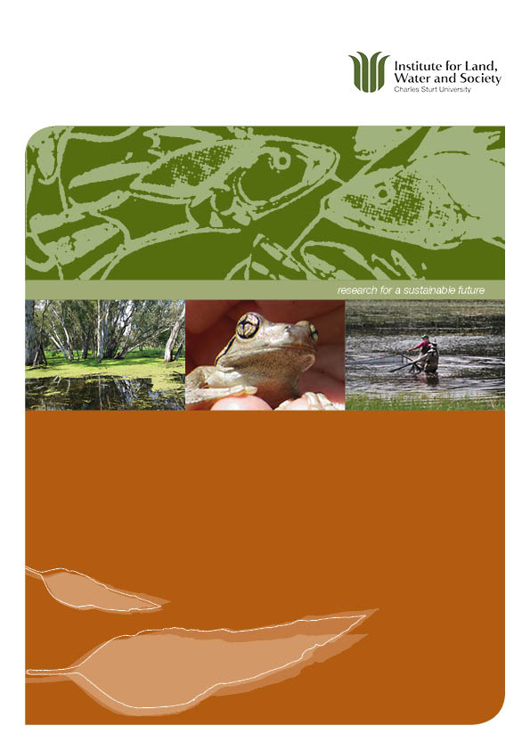**

**Monitoring of ecosystem responses to a major natural flood in Autumn 2012**

**June 2012**

**Wassens, Sa and Spencer, JAb, (2012).** **Monitoring of ecosystem responses to a major natural flood in Autumn 2012. Institute for Land, Water and Society, Charles Sturt University and NSW Office of Environment and Heritage. Report 3.**

**Prepared for Commonwealth Environmental Water.**

a. Institute for Land, Water and Society

Charles Sturt University

Institute for Land, Water and Society

LMB 588, Wagga Wagga, NSW 2678

b. Rivers and Wetlands Unit

NSW Office of Environment and Heritage,

Department of Premier and Cabinet

PO Box A290, Sydney South, NSW 1232

This monitoring project was commissioned and funded by Commonwealth Environmental Water with additional in-kind contribution from the NSW Office of Environment and Heritage.

The views and opinions expressed in this publication are those of the authors and do not necessarily reflect those of the Australian Government or the Minister for Sustainability, Environment, Water, Population and Communities.

While reasonable efforts have been made to ensure that the contents of this publication are factually correct, the Commonwealth does not accept responsibility for the accuracy or completeness of the contents, and shall not be liable for any loss or damage that may be occasioned directly or indirectly through the use of, or reliance on, the contents of this publication.

© Commonwealth of Australia 2011. This work is copyright. Apart from any use as permitted under the Copyright Act 1968, no part may be reproduced by any process without prior written permission from the Commonwealth. Requests and enquiries concerning reproduction and rights should be addressed to Department of Sustainability, Environment, Water, Population and Communities, Public Affairs, GPO Box 787 Canberra ACT 2601 or email [public.affairs@environment.gov.au](mailto:public.affairs@environment.gov.au)

# Contents

[Contents 1](#_Toc329698678)

[Executive Summary 1](#_Toc329698679)

[Background 2](#_Toc329698680)

[Methods 3](#_Toc329698681)

[Sites and hydrology 3](#_Toc329698682)

[Habitat variables 6](#_Toc329698683)

[Frogs 6](#_Toc329698684)

[Tadpoles, fish and turtles 6](#_Toc329698685)

[Waterbirds 7](#_Toc329698686)

[Results and Discussion 8](#_Toc329698687)

[Water quality 8](#_Toc329698688)

[Dissolved organic carbon 9](#_Toc329698689)

[Vegetation 10](#_Toc329698690)

[Vegetation community composition 11](#_Toc329698691)

[Frogs and tadpoles 12](#_Toc329698692)

[Fish and turtle diversity 14](#_Toc329698693)

[Fish recruitment 16](#_Toc329698694)

[Waterbirds 19](#_Toc329698695)

[Conclusions and Recommendations 21](#_Toc329698696)

[Flow management in the 2012-13 water year 21](#_Toc329698697)

[In-stream benefits (downstream of Burrunjuck and Blowering Dams) 22](#_Toc329698698)

[Maximising ecological outcomes in the Murrumbidgee River, mid-Murrumbidgee wetlands and Lowbidgee floodplain 22](#_Toc329698699)

[Monitoring strategy 23](#_Toc329698700)

[Acknowledgements 24](#_Toc329698701)

[References 25](#_Toc329698702)

[Appendix 26](#_Toc329698703)

[Wetland conditions in February and April 2012 after natural flooding in March 2012. 26](#_Toc329698704)

# Executive Summary

In June 2011 the NSW Office of Environment and Heritage managed the delivery of more than 160 gigalitres (GL) of environmental water from the Commonwealth, NSW, The Living Murray Initiative and private donors, to wetlands in the mid-Murrumbidgee region, which included NSW Riverina Red Gum Reserves. A further 98 GL of NSW environmental water was released from the Burrinjuck Dam and Tombullen storage in December 2011 which re-filled a subset of wetlands. These flows were delivered to aid in the long term recovery of the mid-Murrumbidgee wetlands. Charles Sturt University monitored the ecological response the environmental watering. The results can be found at: <http://www.environment.gov.au/ewater/publications/ecosystem-response-monitoring-murrumbidgee-2.html>

Following heavy rainfall in the upper and mid catchment in March 2012, a large flood event occurred, filling many of the wetlands where environmental water was provided in 2011. We undertook surveys of the wetlands from 23-28 April 2012 to:

* identify any further outcomes from environmental watering undertaken in 2011
* better understand the response to a major natural flooding event
* help inform future environmental watering in the Murrumbidgee catchment.

The monitoring showed that the large natural flood event in March 2012 led to substantial changes in:

* fish community composition, with the colonisation of wetlands by exotic carp and native golden perch
* frog breeding activity with the flood event triggering a substantial breeding event by L. tasmaniensis
* breeding in waterfowl and small numbers of colonial waterbirds with small number of active nests observed at Yarrada and Gooragool
* vegetation cover with slight declines due to vegetation being knocked down by the flooding in addition to normal winter senescence of summer growing annuals
* dissolved oxygen (DO) levels at Euroley (C1) with DO declining at this site but water quality was generally stable at all the other sites sampled.

A key result that will inform environmental watering decisions into the future is that wetlands which retained water throughout the year (with the help of environmental water) were more resilient to recruitment by exotic fish.

# Background

The mid-Murrumbidgee region contains nationally important wetlands that have been negatively impacted by river regulation and extended drought which have reduced the frequency and duration of wetland inundation ([Page *et al.*](#_ENREF_4)2005). The mid-Murrumbidgee wetlands were filled during natural overbank flooding in September 2010, and for the majority of wetlands it was the first filling event since 2000, with a small number receiving water in 2005 (Table 1).

In June 2011 the NSW Office of Environment and Heritage managed the delivery of more than 160 gigalitres (GL) of environmental water from the Commonwealth, NSW, The Living Murray Initiative and private donors to target wetlands in the mid-Murrumbidgee region, which included NSW Riverina Red Gum Reserves. A further 98 GL of NSW environmental water was released from the Burrinjuck Dam and Tombullen storage in December 2011 which re-filled a subset of wetlands. These flows were delivered to aid in the long term recovery of the mid-Murrumbidgee wetlands. Monitoring of wetland responses was undertaken by Charles Sturt University and the NSW Office of Environment and Heritage from June 2011 to February 2012. This included assessments of carbon and nutrients, humic character, water quality, frogs, tadpoles and vegetation, fish, turtles and waterbirds ([Wassens *et al.* 2012](#_ENREF_6)).

On-ground monitoring of the responses to environmental flows in 2011-12 indicated that the environmental water releases had a positive impact on dissolved, total and particulate organic carbon in the mid-Murrumbidgee wetlands with an overall decrease in organic carbon levels reducing the risk of black-water events associated with high levels of organic carbon from accumulated leaf litter. The environmental water releases also assisted in the recovery of aquatic vegetation communities and supported frog, waterbird, native fish and turtle breeding in the wetlands. Follow-up watering in December 2011 was crucial for ensuring successful recruitment in these key wetland fauna (see Wassens *et al.* 2012).

Significant natural overbank flooding from the Murrumbidgee River occurred in mid March 2012 re-filling most of the wetlands (see Figure 1). This large flood event was triggered by heavy rainfall in the upper and mid catchment. We undertook follow-up surveys of the wetlands from 23-28 April 2012 to determine the response to this major natural flooding event. We expected marked differences in the response of biota in the mid-Murrumbidgee wetlands following this large flood event compared to results of recent surveys in February 2012 when most sites were drying down. We expected fish communities and water quality, exotic fish abundance and dissolved oxygen in particular, to have changed since our February 2012 surveys in response to the natural flooding. In particular based on our prior sampling experience in the Lowbidgee wetlands ([Spencer & Wassens](#_ENREF_5) 2010) we expected an increase in exotic fish abundance, in particular carp and gambusia following the March 2012 flood event. The aim of the April surveys was to assess the impact of the natural unregulated flood event on wetlands that received environmental water between June 2011 and December 2011.

Methods

### Sites and hydrology

This study was focused on twelve wetlands that make up part of the mid-Murrumbidgee wetland complex between Wagga Wagga and Carrathool (reported previously in Wassens *et al.* 2012). Natural and managed river flows contributed to flows into key wetlands between June 2011 and December 2011. By February 2012 four of the wetlands had either completely or mostly dried (see ). In March 2012 heavy rain across the catchment resulted in a very large flow peak in the Murrumbidgee River (Figure 1). This event created significant natural overbank flows and reconnected wetlands in the mid-Murrumbidgee including those higher on the floodplain such as Euroley (Control 1) (Appendix) which did not receive natural or managed flooding in 2011.

**Figure 1** Discharge in the Murrumbidgee River at Narrandera and Carrathool between May 2010 and May 2012. Yellow vertical lines show environmental releases in 2011 and blue arrows show the timing of natural overbank flooding. Red arrows indicate the timing of wetland sampling for carbon and water quality (WQ) (narrow arrows) and surveys of wetland fauna, vegetation and water quality (bold arrows). Lower horizontal line is commence-to-fill for the lowest lying wetlands, upper horizontal line is the commence-to-fill for the higher wetlands from (Murray 2008).

Nine of the twelve wetlands monitored during this study were inundated by the environmental flow release in June 2011 (Appendix). Due to natural and managed river flows, the same nine wetlands received further natural flooding in late August/September 2011 and five wetlands received environmental water in December 2011 (Table 1). All 12 wetlands received water during the March 2012 flood event. Two types of control wetlands have been included in this study: (1) Control 1 (Euroley) was inundated during the natural flood events in December 2010 and March 2012 but was not inundated by the environmental flows in June 2011 or December 2011; and (2) Control 2 wetlands (Turkey Flats and Yanco Ag, Appendix) were not inundated via the Murrumbidgee River in December 2010 or the 2011 environmental releases but are subject to relatively frequent low level inundation via rainfall run-off and as managed flows through the Murrumbidgee Irrigation Area. Control 2 wetlands were inundated to some extent during the March 2012 flood.

**Table 1** Summary of survey sites and number of surveys completed in each site from June 2011 – April 2012.

|  |  |  |  |  |  |  |  |  |  |
| --- | --- | --- | --- | --- | --- | --- | --- | --- | --- |
|  | **Site name** | **Year of last fill prior to  2010** | **Top-up flows Dec 2011** | **Wet/Dry Status  Feb 2012** | **Carbon** | **Waterbirds** | **Frogs & tadpoles**  **(broad-scale)** | **Fish & turtles** | **Aquatic vegetation** |
| **Flooded Wetland (mid-Murrumbidgee)** | Berry Jerry | 2005 | Yes | Wet | 4 | 6 | 6 | - | 5 |
| Dry Lake | 2000 | **No** | Dry | 4 | 6 | 6 | 3a | 5 |
| Gooragool | 2005  (partial 2007) | Yes | Wet | 4 | 7 | 6 | 4b | 5 |
| Mckennas | 2000 | **No** | Dry | 4 | 7 | 6 | 4c | 5 |
| Molleys | 2005 | Yes | Wet | 4 | 7 | 6 | 5 | 5 |
| Narrandera SF | 2000 | **No** | Mostly Dry | 4 | 6 | 6 | - | 5 |
| Sunshower | 2005 | Yes | Mostly Dry | 4 | 7 | 6 | 5 | 5 |
| Coonacoocabil | 2009 | **No** | Wet | 3 | 6 | 6 | - | 5 |
| Yarrada | 2000  (partial 2005) | Yes | Wet | 4 | 5 | 6 | 5 | 5 |
| **Control 1** | Euroley | 1996 | **No** | Dry | 4 | 6 | 6 | 3 a | 5 |
| **Control 2** | Turkey Flats | Rainfall/  Drainage | **No** | Dry | 4 | 7 | 6 | - | 5 |
| Yanco Ag | Rainfall/  Drainage | **No** | Dry | 4 | 7 | 6 | - | 5 |

a Too shallow to sample December 2011 & February 2012

b Too shallow to sample October 2011

c Too shallow to sample February 2012

The methodology follows that of [Wassens*, et al.* (2012](#_ENREF_6)). Surveys were conducted in the periods June 2nd-4th 2011 (pre-filling), July 5th-7th 2011 (post-filling), and August 30th - September 2nd 2011 (post-flood 2), October 25th-30th 2011, December 14th-18th 2011 and February 14th-18th 2012 and April 24-28th 2012. Additional water quality samples were also collected on the peak June flow (June 20-24th 2011).

### Habitat variables

Water quality was monitored within each of the twelve wetlands and dissolved organic carbon was sampled at a subset of eight wetlands (Molleys, Dry Lake, Sunshower, Gooragool, Yarrada, Mckennas, Coonacoocabil and Euroley (Control 1)) using methodology described in [Wassens*, et al.* (2012](#_ENREF_6)). Field water quality variables (water temperature, conductivity, pH, turbidity, dissolved oxygen and water depth) were measured at each site using a handheld YSI meter. Five filtered 30 ml vials of water were collected per wetland for analysis of dissolved organic carbon levels by the Murray-Darling Freshwater Research Centre. The samples were chilled on collection and frozen within six hours of collection.

Biophysical variables (e.g., aquatic and fringing vegetation aquatic species and percent cover of each wetland plant species along with percent cover leaf litter and bare ground) were measured from within 1 m2 quadrats along three 30 m transects (90 m2 in total) starting at the higher waterline and running into the waterbody with measurement every 1 m.

### Frogs

Adult frogs and metamorphs were surveyed at each wetland after dark using a 3 x 10 minute visual encounter and a 3 x 1 minute audio survey using methodology described in [Wassens*, et al.* (2012](#_ENREF_6)). All individuals encountered were identified to species. Tadpoles and small-bodied fish were surveyed using timed 5 x 1 minute sweeps with soft mesh sweep-net in addition to 3 minute day time visual searches along the water’s edge for egg masses and metamorphs. All tadpoles collected were identified in the field according to [Anstis (2002](#_ENREF_1)) and their developmental stage was recorded. Once identified, all tadpoles were released at the point of capture.

### Tadpoles, fish and turtles

Intensive assessments of fish and tadpole communities were conducted at seven wetlands (Molleys, Dry Lake, Sunshower, Gooragool, Yarrada, Mckennas and Euroley (Control 1), see Appendix) using methodology described in [Wassens*, et al.* (2012](#_ENREF_6)). Intensive surveys of fish and tadpoles were conducted on five occasions August 30th to September 2nd, October 25th-30th, December 14th-18th 2011 and February 14th-18th 2012, and April 24th-28th 2012. A combination of sampling methods targeting different habitats within each wetland were employed to survey for fish and tadpoles. Sweeping netting, seining, bait traps and large and small fyke nets were utilized to survey the seven intensive monitoring sites (Table 1). Five bait traps (dimensions 25 x 10 cm, 5 mm mesh), two large (2 x 10 m wings, 12 mm mesh) and two small (2 x 2 m wings, 2 mm mesh) fyke nets were left overnight at each site. Wing width and depth (m) were recorded at each site. Fish species were identified and measured to the nearest millimetre (standard length). Native fish were returned immediately to the water when possible, but exotic fish were euthanased. The percentage of recruits within the samples was estimated using size limits established by Gilligan (2005). Turtles were identified to species as per Chessman (1978) and the length and width of the carapace was measured to the nearest mm.

### Waterbirds

Ground surveys for waterbirds were carried out in the mid-Murrumbidgee wetlands in June, July, August, October and December 2011, and February and April 2012 using the methodology described in [Wassens*, et al.* (2012](#_ENREF_6)). From August 2011 onwards, replicate ground counts were conducted over two consecutive days (one morning and one afternoon) to estimate maximum waterbird abundance and species diversity. Only single counts were completed during June and July 2011 surveys and at Berry Jerry, Coonancoobil and Narrandera State Forest during each survey period. Birds were observed using binoculars (8 x 30 mm) and a telescope (Swarovski 20 – 60X zoom). Total counts for each waterbird species and any evidence of breeding activity (nesting and/or the presence of young) were recorded during each survey.

Results and Discussion

### Water quality

Overall natural overbank flooding in March 2012 did not lead to a significant change in water quality within the nine filled wetlands (). The majority of wetlands showed a slight improvement in water quality following the March 2012 flood. There was slight decreases in conductivity within filled and control wetlands following the March flood event. The large flow resulted in decreased conductivity levels in Yanco Ag due to dilution and flushing. Dissolved oxygen levels were higher in filled and control 2 wetlands during April compared to February 2012. However the Control 1 (Euroley) (did not receive environmental water in 2011) had very low dissolved oxygen below 4 mg/L after the March 2012 flood (Figure 2).

|  |  |
| --- | --- |
|  |  |
|  |  |
| **Figure 2** Summary of measured water quality variables between June 2011 and April 2012 in filled and control wetlands. | |

### Dissolved organic carbon

Dissolved organic carbon (DOC) levels increased slightly between August 2011 and April 2012 within filled wetlands, this was likely due to the deposition of organic matter in the wetlands as water moved across the floodplain during the March 2012 flood (). In contrast the Control 1 wetland (Euroley) initially had a high concentration of DOC but this declined between August 2011 and April 2012. Despite having relatively similar DOC levels to the filled wetlands Euroley (C1) was the only wetland that experienced low dissolved oxygen in April 2012 (see previous section).

**

**Figure 3** Dissolved Organic Carbon (DOC) levels (mg/L) recorded in the wetlands between June 2011 and April 2012.

### Vegetation

The March 2012 flood event did not lead to a significant change in aquatic vegetation cover, with the percent cover of the most common aquatic species (*Eleocharis acuta*, *E. Spaculata* and *E.* *pusilla*) remaining relatively stable between February and April 2012 in the majority of wetlands (). There was a slight decrease in cover of *E. acuta* in Gooragool lagoon which was mainly due to vegetation being physically knocked down by the floodwaters.



**Figure 4** Change in the percentage cover of common aquatic vegetation species, *Eleocharis acuta* (short spike rush), *E. spaculata* (tall spike rush), and *E. pusilla* (cushion spike rush), in the wetlands over spring and summer months (October 2011- April 2012).

### Vegetation community composition

Vegetation communities (the type and percent cover of each species) changed significantly over the spring and summer months (ANOSIM Global R = *0.322*, p = 0.013). The percentage cover of key aquatic and semi-aquatic vegetation species increased over time from October 2011 to February 2012 at filled and control 2 wetlands and declined at the Control 1 wetland (). In April 2012 aquatic and semi-aquatic vegetation cover had declined at both filled and control 2 wetlands, this was partly due to the scouring effect of the flood water in March which knocked down vegetation at the majority of filled sites and also due to the natural senescence of summer growing annuals such as *Centipeda*. In contrast, aquatic and semi aquatic vegetation cover increased at the Control 1 wetland in March after it had been filled, mainly due to an increase growth of Warrago Summer grass and *Persicaria*.



**Figure 5** Mean percentage cover of common aquatic and semi-aquatic vegetation communities during surveys from October 2011 to April 2012 in control and filled (sites receiving environmental water in 2011) wetlands.

### Frogs and tadpoles

The abundance of *Limnodynastes* tadpoles increased between February and April 2012. This lead to a significant change in the composition of frog and tadpoles communities in April 2012 compared to surveys conducted from October 2011 to February 2012 (ANOSIM Global R = *0.551*, p <0.001) (). This was largely driven by the very large increase in the abundance of *Limnodynastes* tadpoles in April surveys, compared with the spring and summer surveys, along with declining activity of *L. peronii* and *L. fletcheri* with the onset of cooler weather.



**Figure 6** The percent contribution of each frog species (adults, metamorphs and tadpoles) to the frog community observed in the mid-Murrumbidgee wetlands from August 2011 to April 2012.

Tadpoles of *Limnodynastes*, and *L. peronii* were recorded between August 2011 and April 2012 (). The March 2012 flood event lead to a substantial increase in the number of *Limnodynastes* tadpoles recorded per wetland, which had been declining over the summer months (December 2011 – February 2012) as the wetlands dried out.

******

**Figure 7** Mean abundance (+/- standard error) of Limnodynastes spp. and Litoria peronii tadpoles (note the y-axis is log 10 transformed) between August 2011 and April 2012.

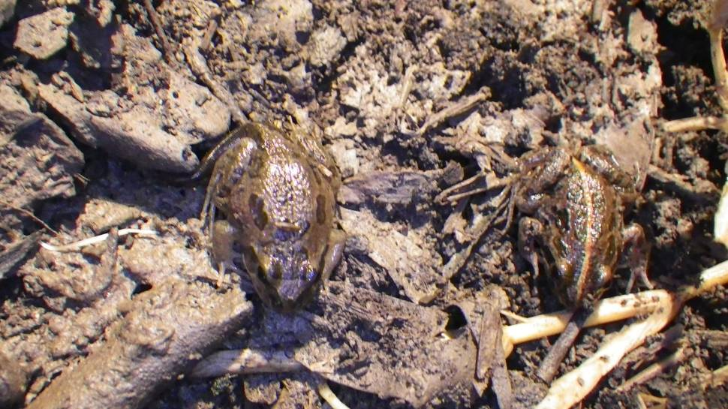

**Plate 1** Recent metamorphs of *L. fletcheri* and *L. tasmaniensis* were recorded at the majority of wetlands after natural overbank flooding in March 2012***.***

### Fish and turtle diversity

Six species of native fish and six exotic species were recorded in April 2012. Importantly adults and juveniles of a new species, golden perch *Macquaria ambigua ambigua* (Plate 4), were recorded in five wetlands (Yarrada, Molleys, Dry Lake, Euroley and McKennas lagoons). Unlike frog communities which had a similar species composition between October 2011 and February 2012, the fish species community composition did change over time (ANOSIM Global R = *0.523*, p < 0.001). The significant flooding in March 2012 led to a major shift in the fish community, with the colonisation of wetlands by golden perch, which had not been recorded previously, and significant increases in the numbers of juvenile carp *Cyprinus carpio* (). The increase in carp numbers was greatest in wetlands that had been mostly dry prior to re-flooding in March 2012 that is Sunshower, McKennas, Dry Lake and Euroley (C1). The remaining wetlands retained water prior to the March flood and typically had a higher proportion of native fish (Figure 8). This provides some evidence that the wetlands that retained water prior to the March 2012 flooding were more resilient to colonisation by exotic fish because of the established native fish populations, which would have provided some predation pressure on juvenile carp and competed with carp for food and other resources.

Four adult long-necked turtles *Chelodina longicollis* were captured in fyke nets at Sunshower lagoon. Juvenile Macquarie River turtle *Emydura macquarii macquarii* were detected at McKennas Lagoon for the first time. In the August 2011 to February 2012 surveys, juvenile Macquarie River turtles were only detected at sites close to the main river channel, including Yarrada and Molleys lagoon.

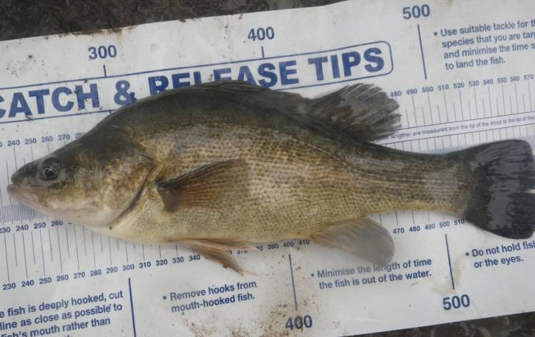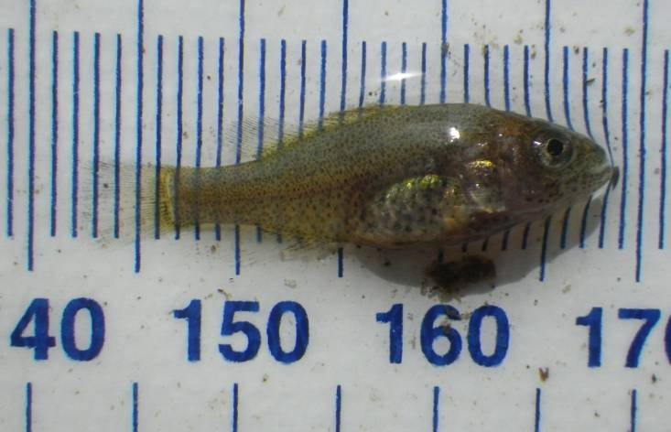

**Plate 2** Golden perch juveniles (left) and adults (right) were recorded at five wetlands in April 2012 after major overbank flooding in March 2012. This species was not detected during previous surveys of the wetlands from August 2011 to February 2012.

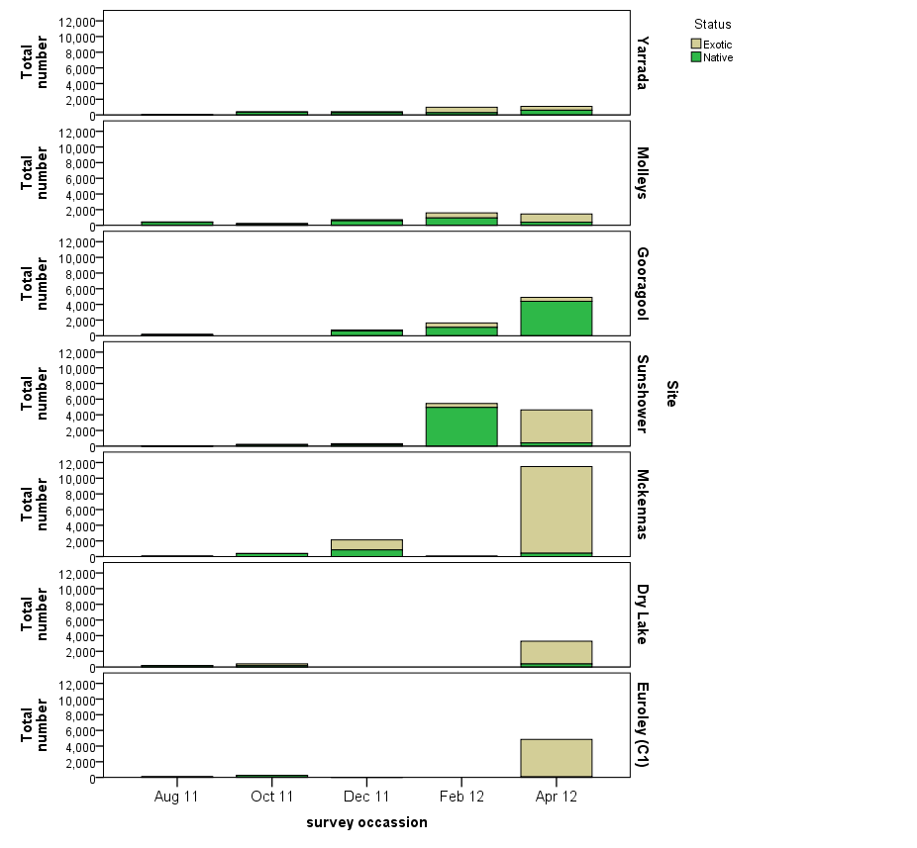

**Figure 8** Relative abundance of native and exotic fish species recorded in the wetlands between August 2011 and April 2012. Note that Euroley (C1) and Dry Lake were dry in December 2011 and February 2012 surveys and McKenna’s Lagoon was too shallow to sample in February 2012.

### Fish recruitment

Overall there was limited evidence of breeding activity triggered by the March 2012 flood events, except for golden perch where the majority of individuals collected were juveniles (min 14 mm, mean 35 mm) although larger individuals up to 275 mm in length were also recorded. The remaining native fish species showed either little change in mean lengths or an overall increase in mean lengths between February and April 2012 (Figure 9). In contrast the March 2012 flood event triggered breeding activity by three exotic fish species; carp, goldfish *Carassius auratus* and Oriental weatherloach *Misgurnus anguillicaudatus*. Mean lengths of all three species decreased between February and April 2012 (). In contrast gambusia *Gambusia holbrooki* juveniles were present throughout the 2011-12 survey seasons. Redfin perch Perca fluviatilis juveniles where only present in October 2011.

|  |  |
| --- | --- |
|  |  |
|  |  |
|  |  |

**Figure 9** Size structure of native fish populations recorded during surveys from August 2011 to April 2012. Bars show highest, lowest and mean values (circle). Horizontal line is the size at one year old or at sexual maturity (from [Gilligan, 2005](#_ENREF_2)). Golden perch have been excluded because they were only detected in April 2012.

|  |  |
| --- | --- |
|  |  |
|  |  |
|  |  |

**Figure 10** Size structure of exotic fish populations recorded during surveys from August 2011 to April 2012. Bars show highest, lowest and mean values (circle). Horizontal line is the size at one year old or at sexual maturity (from [Gilligan, 2005](#_ENREF_2)).

### Waterbirds

In total 25 waterbird species (six breeding) were recorded across the 12 wetlands during the April 2012 surveys. Small numbers of waterfowl (17 broods in total) were breeding in seven of the 12 wetlands surveyed (Table 2). Nesting was also observed in darters *Anhinga melanogaster* (1 nest), little pied cormorants *Phalacrocorax melanoleucos* (2 nests) and little black cormorants *Phalacrocorax sulcirostris* (32 nests) at Yarrada Lagoon. There were also active nests of darters (1 nest) and little pied cormorants (1 nest) at McKennas Lagoon and active little black cormorant nests (3 nests) in Gooragool Lagoon. These sites consistently supported small numbers of nesting cormorants and darters from October 2011 to February 2012. The flooding in early March 2012 most likely triggered further nesting in these species, with breeding (laying to fledging) taking around eight to nine weeks in cormorant species (Rogers 2012).

Dry Lake, Turkey Flats, Sunshower, Gooragool and McKennas lagoons supported the greatest abundance of waterbirds (Table 2). Total numbers of waterbirds increased in all the control and filled sites (sites that received environmental flows in 2011) following the natural flooding in March 2012 (Figure 11). The control sites and winter filled sites had dried down by the December 2011 and February 2012 surveys and subsequently fewer birds were recorded in these sites. On re-flooding in March 2012 there was a large increase in waterbird numbers in Turkey Flats (Control 2 wetland) in particular (Figure 11).

**Figure 11** Mean abundance (+/- standard error) of waterbirds in surveyed wetlands in the mid-Murrumbidgee wetlands (June 2011 - April 2012).

**Table 2.** Maximum counts of waterbirds in the mid-Murrumbidgee wetlands 23-28 April 2012 (^breeding detected, J = JAMBA, C = CAMBA).

|  |  |  |  |  |  |  |  |  |  |  |  |  |  |
| --- | --- | --- | --- | --- | --- | --- | --- | --- | --- | --- | --- | --- | --- |
| **Common name** | **Berry Jerry** | **Coonacoocabil** | **Dry Lake** | **Euroley** | **Gooragool** | **McKennas** | **Molleys** | **Narrandera SF** | **Sunshower** | **Turkey Flat** | **Yanco Ag** | **Yarrada** | **Total** |
| Australasian grebe | 0 | 0 | 0 | 0 | 0 | 0 | 0 | 0 | 1 | 0 | 0 | 0 | 1 |
| Australian pelican | 0 | 0 | 78 | 0 | 50 | 0 | 0 | 0 | 0 | 0 | 0 | 0 | 128 |
| Australian white ibis | 1 | 0 | 0 | 0 | 0 | 0 | 0 | 28 | 41 | 38 | 9 | 0 | 117 |
| Australian wood duck | 2^ | 3 | 16^ | 5 | 8 | 12^ | 60 | 12 | 69^ | 202 | 15 | 54 | 458 |
| Black-fronted dotterel | 0 | 0 | 0 | 0 | 0 | 0 | 0 | 0 | 0 | 2 | 0 | 0 | 2 |
| Chestnut teal | 0 | 0 | 0 | 0 | 0 | 0 | 0 | 0 | 2 | 0 | 0 | 0 | 2 |
| Darter | 0 | 0 | 0 | 0 | 4 | 2 | 1 | 1 | 2 | 0 | 0 | 8^ | 18 |
| Dusky moorhen | 1 | 0 | 0 | 0 | 0 | 0 | 0 | 3 | 0 | 0 | 0 | 0 | 4 |
| Eurasian coot | 0 | 0 | 0 | 0 | 1 | 0 | 0 | 0 | 0 | 0 | 2 | 0 | 3 |
| Great cormorant | 0 | 3 | 0 | 1 | 4 | 0 | 4 | 0 | 0 | 0 | 0 | 1 | 13 |
| Great egret (J, C) | 0 | 0 | 0 | 0 | 0 | 0 | 0 | 0 | 4 | 0 | 0 | 0 | 4 |
| Grey teal | 0 | 2 | 54^ | 0 | 18^ | 14^ | 0 | 5 | 55^ | 68^ | 65 | 8 | 289 |
| Hardhead | 0 | 0 | 0 | 0 | 4 | 0 | 0 | 0 | 0 | 0 | 0 | 0 | 4 |
| Intermediate egret | 0 | 0 | 0 | 0 | 0 | 0 | 0 | 0 | 0 | 8 | 0 | 0 | 8 |
| Little black cormorant | 1 | 0 | 105 | 11 | 4^ | 101 | 1 | 1 | 132 | 12 | 0 | 27^ | 395 |
| Little pied cormorant | 0 | 2 | 62 | 27 | 9 | 54^ | 0 | 14 | 25 | 14 | 0 | 31^ | 238 |
| Masked lapwing | 0 | 0 | 0 | 0 | 0 | 0 | 0 | 0 | 0 | 4 | 0 | 0 | 4 |
| Nankeen night heron | 0 | 3 | 0 | 12 | 0 | 0 | 0 | 0 | 0 | 0 | 0 | 0 | 15 |
| Pacific black duck | 0 | 0 | 23^ | 9 | 7^ | 32 | 0 | 3 | 54^ | 186^ | 12 | 2 | 328 |
| Purple swamphen | 0 | 0 | 0 | 0 | 0 | 0 | 0 | 1 | 0 | 0 | 0 | 0 | 1 |
| Royal spoonbill | 0 | 0 | 0 | 0 | 0 | 0 | 0 | 0 | 11 | 62 | 0 | 0 | 73 |
| Straw-necked ibis | 0 | 0 | 0 | 0 | 0 | 0 | 0 | 2 | 0 | 8 | 1 | 0 | 11 |
| White-faced heron | 0 | 5 | 2 | 2 | 1 | 31 | 0 | 4 | 46 | 9 | 12 | 5 | 117 |
| White-necked heron | 1 | 0 | 0 | 0 | 0 | 2 | 0 | 0 | 12 | 15 | 4 | 0 | 34 |
| Yellow-billed spoonbill | 0 | 0 | 0 | 0 | 0 | 0 | 0 | 0 | 61 | 63 | 0 | 0 | 124 |
| **Maximum count** | **6** | **18** | **340** | **67** | **110** | **248** | **66** | **74** | **515** | **691** | **120** | **136** | **2391** |
| **Total species** | **5** | **6** | **7** | **7** | **11** | **8** | **4** | **11** | **14** | **14** | **8** | **8** | **25** |
| **Number of surveys** | **1** | **1** | **2** | **2** | **2** | **2** | **2** | **1** | **2** | **2** | **2** | **2** | **21** |

Conclusions and Recommendations

The large natural flood event in March 2012 has led to substantial changes in:

* fish community composition, with the colonisation of wetlands by exotic carp and native golden perch
* frog breeding activity with the flood event triggering a substantial breeding event by *L. tasmaniensis*
* breeding in waterfowl and small numbers of colonial waterbirds with small number of active nests observed at Yarrada and Gooragool
* vegetation cover with slight declines due to vegetation being knocked down by the flooding in addition to normal winter senescence of summer growing annuals
* dissolved oxygen (DO) levels at Euroley (C1) with DO declining at this site but water quality was generally stable at all the other sites sampled.

### Flow management in the 2012-13 water year

Assuming no natural top-ups occur over winter 2012 it is likely that the wetlands will dry out by the end of 2012. Environmental releases into the wetlands in spring (October 2012) would likely help:

1. Ensure the continued re-establishment of aquatic vegetation communities in the wetlands which have been substantially degraded over the last decade. The re-establishment of vegetation communities is critical to the health of wetland communities because it influences breeding success for a range of other wetland dependant taxa, for example Odonates (Dragon flies and Damsel Flies) and frogs. It is likely that many of the declines in frog species richness within the mid-Murrumbidgee are due to the loss of supporting aquatic vegetation communities (Wassens and Amos 2011).
2. Trigger frog breeding and increase the potential for Southern bell frogs *Litoria raniformis* to commence breeding at Gooragool and Sunshower Lagoons.
3. Extend wetland flooding to support successful waterbird breeding (if present).
4. Maintain native fish and freshwater turtle populations and allow for some movement between the river and the wetlands.
5. Improve in-stream habitats and support spawning by in-stream fish populations such as Murray cod *Maccullochella peelii peelii* which have specific flow, day length and temperature requirements for spawning in October - November ([Koehn & Harrington, 2006](#_ENREF_3)) and whose populations have become severely depleted in the Murrumbidgee Catchment ([Gilligan, 2005](#_ENREF_2)).

Depending on weather conditions and the extent of natural inflows in 2012-13, additional top-up flows through summer and autumn 2012-13 would likely help return native fish to the Murrumbidgee River, allow for aquatic vegetation to set seeds and to extend the duration of wetland flooding to complete tadpole development and waterbird breeding. Monitoring in 2012-13 could be used to inform the need for these additional top-up flows.

### In-stream benefits (downstream of Burrunjuck and Blowering Dams)

Results from the 2011-2012 monitoring demonstrated the value of pulsed releases in improving river health downstream of the Blowering and Burrinjuck Dams (Wassens *et al.* 2012). It is recommended that the releases planned for spring 2012 are delivered in a manner that maximises potential benefits within the upper catchment ecosystems as well as in-stream habitat further downstream and within the wetlands (see recommendations contained in Wassens *et al.* 2012 for details).

### Maximising ecological outcomes in the Murrumbidgee River, mid-Murrumbidgee wetlands and Lowbidgee floodplain

The Murrumbidgee River catchment consists of a series of wetlands and distributaries channels and as a consequence environmental release will influence ecological conditions across large spatial and temporal scales. Wassens *et al.* (2012) demonstrated that the ecological outcomes of environmental flows can be maximised by releasing flows in a manner that benefits both in-stream and wetland habitats. The Murrumbidgee River, mid-Murrumbidgee wetlands and Lowbidgee floodplain are part of a connected system. For this reason it is likely that these same environmental releases will have consequences for ecological conditions downstream of the mid-Murrumbidgee wetlands in the Lowbidgee floodplain. If monitoring activities were extended to include key wetlands in the Lowbidgee floodplain this would help identify opportunities to improve long-term ecological health throughout the catchment.

### Monitoring strategy

A potential monitoring strategy is outlined below, which could support management decisions around the future delivery of environmental water to the mid-Murrumbidgee. It includes methods employed in previous years in the Murrumbidgee Catchment by Wassens *et al.* (2012) and Spencer and Wassens (2010):

|  |  |
| --- | --- |
| **When** | **Key objectives** |
| August/September (pre-releases) | Assess fish and vegetation communities within the wetlands |
| Identify waterbird breeding activity |
| Identify frog breeding prior to release |
| Assess risk of low dissolved oxygen events (DOC sampling) |
| Determine impact of release in Tumut and Murrumbidgee Rivers (below dams) on biofilm communities (two surveys pre-release) |
| October/November (post-release) | Assess change in fish communities (wetlands) and potentially movement into and out of wetlands |
| Assess in-stream fish communities and spawning activity |
| Determine status of waterbird breeding |
| Assess frog breeding response and monitor for Southern Bell frog |
| Determine impact of release in Tumut and Murrumbidgee Rivers (below dams) on biofilm communities (four surveys post-release) |
| Monitor change water quality, and assess risk for high DOC and low DO |
| December (to advise on needs for additional top-up flows) | Assess change in fish communities (wetlands) and fish recruitment |
| Assess frog breeding response and monitor for Southern Bell frog |
| Monitor change water quality, in particular DOC and DO |
| Assess vegetation community response |
| Determine status of waterbird breeding |
| February/March (to advise on needs for flows to return native fish to the river) | Assess fish communities (wetlands) and fish recruitment |
| Assess frog breeding response and monitor for Southern Bell frog  Assess outcomes of waterbird breeding |
|  |
| Assess vegetation community response |

Acknowledgements

The funding for this wetland monitoring was provided by the Commonwealth Environmental Water Office (Wassens) with additional in-kind contribution from the NSW Office of Environment and Heritage (Spencer). We would like to thank the landowners in the mid-Murrumbidgee catchment for providing access to their properties. Field support was provided by Vanessa Griese, Rachel Croft (CSU), Richard Allman, Jo Ocock (OEH) and Paul Doyle (CEWO). James Maguire and Paul Childs (OEH) provided field site advice and flow information. On-ground surveys were approved under NPWS scientific licenses S12700 and S13080. Waterbird surveys were approved by the OEH Animal Ethics Committee (AEC No. 091214/01). Fish sampling was carried out under NSW Fisheries license F89/1598 (NSW OEH) and P11/0043-1.0 (CSU) and Charles Sturt University Animal Care and Ethics approval (ACEC 11/040).

References

Anstis, M. (2002). Tadpoles of South-eastern Australia: a guide with keys. Sydney: Reed New Holland.

Gilligan, D. M. (2005). Fish communities of the Murrumbidgee catchment: status and trends. New South Wales Department of Primary Industries: Cronulla Fisheries Centre.

Chessman, B.C. (1978). Ecological studies of freshwater turtles in south-eastern Australia. Ph.D. Thesis, Monash University, Melbourne.

Koehn, J. D., & Harrington, D. J. (2006). Environmental conditions and timing for the spawning of Murray cod (Maccullochella peelii peelii) and the endangered trout cod (M. macquariensis) in southeastern Australian rivers. River Research and Applications, 22(3), 327-342. doi: 10.1002/rra.897

Murray, P. (2008) Murrumbidgee wetlands resource book. Murrumbidgee Catchment Management Authority, New South Wales.

Page, K., Read, A., Frazier, P., & Mount, N. (2005). The effect of altered flow regime on the frequency and duration of bankfull discharge: Murrumbidgee River, Australia. River research and applications, 21, 567-578.

Spencer, J. A., & Wassens, S. (2010). Monitoring the responses of waterbirds, fish and frogs to environmental flows in the Lowbidgee wetlands from 2008–10. Final report for the NSW Rivers Environmental Restoration Program. Rivers and Wetland Unit. Sydney and Wagga Wagga.: NSW Department of Environment, Climate Change and Water and Institute for Land, Water and Society, Charles Sturt University.

Wassens, S., Watts, R. J., Spencer, J. A., Howitt, J., McCasker, N. A., Griese, V., Burns, A., Croft, R & Hall, A. (2012). Monitoring of ecosystem responses to the delivery of environmental water in the Murrumbidgee system. Albury: Institute for Land, Water and Society, Charles Sturt University. Report 2.

Appendix

### Wetland conditions in February and April 2012 after natural flooding in March 2012.

|  |  |
| --- | --- |
| 005.JPGNarrandera State Forest (February) | 299.JPG(April) |
| 048.JPGMolleys (February) | 376.JPG (April) |
| 051.JPGDry Lake(February)  IMG_7980Mid_Murrumbidgee0212  Sunshower lagoon (February) | 380.JPG (April)  IMG_8009Mid_Murrumbidgee0412  (April) |
| 064.JPG  Gooragool(February) | 320.JPG (April) |
| 013.JPG  Yarrada (February) | 323.JPG  (April) |
| 022.JPGMckennas (February) | 327.JPG (April) |
| 124.JPG Euroley ( Control 1) (February) | 401.JPG (April) |