ECOSYSTEM SERVICES: KEY CONCEPTS AND APPLICATIONS
Occasional Paper Series No.1

National Library of Australia Cataloguing-in-Publication entry
2009 Commonwealth of Australia
Ecosystem Services: key concepts and applications
Bibliography
ISBN 978-0-9807427-5-6
1 Ecosystem services – Australia 2 Biodiversity

© Commonwealth of Australia 2010
This work is copyright. You may download, display, print and reproduce this material in unaltered form only (retaining this notice) for your personal, non-commercial use or use within your organisation. Apart from any use as permitted under the Copyright Act 1968, all other rights are reserved. Requests and inquiries concerning reproduction and rights should be addressed to: Commonwealth Copyright Administration Attorney General’s Department, Robert Garran Offices, National Circuit, Barton ACT 2600 or posted at http://www.ag.gov.au/cca

Disclaimer
The views and opinions expressed in this publication are those of the authors and do not necessarily reflect those of the Australian Government or the Minister for Environment Protection, Heritage and the Arts or the Minister for Climate Change, Energy Efficiency and Water.

While reasonable efforts have been made to ensure that the contents of this publication are factually correct, the Commonwealth does not accept responsibility for the accuracy or completeness of the contents, and shall not be liable for any loss or damage that may be occasioned directly or indirectly through the use of, or reliance on, the contents of this publication.

Citation
Department of the Environment, Water, Heritage and the Arts (2009). Ecosystem Services: Key Concepts and Applications, Occasional Paper No 1, Department of the Environment, Water, Heritage and the Arts, Canberra.

Acknowledgements
This DEWHA Occasional Paper was written by Dr Anne Close, Dr Charlie Zammit, Jenny Boshier, Kate Gainer and Astrid Mednis. The Paper is based on a detailed review of ecosystem services commissioned by the Natural Resource Management Standing Committee in 2007 and prepared by Dr Steve Cork (then DEWHA), Gary Stoneham (then Victorian Department of Sustainability and Environment) and Dr Kim Lowe (Victorian Department of Sustainability and Environment).

FOREWORD

We are seeing scientists and policy makers making increasing use of the concept of ecosystem services to describe the mix of productive and non-productive benefits that society obtains from our environment. One of their key messages is that holding on to all of these benefits depends very much on how well we look after our unique native plants and animals and the ecological systems that support them. After all, these ecosystems support us. As our environments deteriorate, so do the services they can provide.

The concept of ecosystem services has become part of our approach to managing biodiversity, water, primary industries, human settlements, regional planning and climate change. It is also reshaping thinking around sustainable environmental management and stimulating new ideas for managing landscape resilience.
Although the idea of ecosystem services has been well developed scientifically, debate continues about how to measure, monitor and place a value on many services.

Ecosystem Services: Key Concepts and Applications is the first in a new series of occasional papers being developed by my department to broaden public understanding and to stimulate wider debate on how we might better tackle the many environmental challenges and opportunities facing Australia. It is intended to reach everyone interested in securing an ecologically healthy, sustainable and resilient Australia, and I hope it reaches far and wide.

In this International Year of Biodiversity, we have an opportunity to improve community understanding of the life support services our natural environment provides. This paper makes an important contribution to that task.


The Hon. Peter Garrett AM MP
Minister for Environment Protection, Heritage and the Arts

CONTENTS

SUMMARY 4

1 INTRODUCTION 5
Box 1 Definition of ecosystem services 5

2 KEY CONCEPTS - ECOSYSTEMS, BIODIVERSITY AND RESILIENCE 7
Biodiversity—the engine room of ecosystem services 7
Resilience—the key to sustaining ecosystem services 9

3 IDENTIFYING ECOSYSTEM SERVICES 11
Box 2 Millennium Ecosystem Assessment’s overview of ecosystem services 11
Box 3 Biodiversity’s contribution to ecosystem services 12

4 VALUING ECOSYSTEM SERVICES 13
Box 4 The components of total economic value 13
Box 5 Valuing ecosystem services in the Goulburn Broken catchment 16
Box 6 Inventory of land uses and priority ecosystem services 17

5 MEASURING ECOSYSTEM SERVICES 18
Box 7 International measurement - Millennium Ecosystem Assessment 18
Box 8 National measurement—environmental accounting 18

6 DATA AND INFORMATION FOR ECOSYSTEM SERVICES 19
Provisioning services 19
Supporting services 19
Regulating services 20
Box 9 National carbon measurement and research 21
Cultural services 21

7 ISSUES IN MEASURING ECOSYSTEM SERVICES 23

8 ECOSYSTEM SERVICES IN NATURAL RESOURCE MANAGEMENT 24
Box 10 Policy tools for natural resource management and biodiversity conservation 24
Box 11 The EcoTender pilot program 26

9 THE CENTRAL ISSUES OF ECOSYSTEM SERVICES 29

REFERENCES 30

SUMMARY

There has been a growing public interest in the role and value of natural ecosystems and how they contribute to our quality of life and to human wellbeing. Ecosystems services and their continued provision underpin human existence, health and prosperity.

Governments, communities and natural resource managers are taking a broader ecosystem approach to decision making for natural resource management issues that can achieve multiple benefits for landowners and society. Biodiversity is central to the production of ecosystem services; it is the direct source of services, such as food and fibre, and underpins others, such as clean water and air, through the role of organisms in energy and material cycles.

This paper provides an overview of the concept of ecosystem services and how they are valued. There are both use values and non-use values that comprise the total economic value, including both the intrinsic values of ecosystems and biodiversity and the market values of goods and services.

This paper also addresses new opportunities for developing markets for previously undervalued ecosystem services, and gives examples of where an ecosystem approach has lead to the achievement of multiple outcomes.

1. INTRODUCTION
Human societies have long been aware of their reliance on the goods and services provided by nature, especially food, fuel and fibre. In recent times, the value of less tangible services, such as climate control, water filtration, soil fertility, as well as recreational and cultural services has become more apparent. As understanding deepens about human dependence on natural processes across varying temporal and spatial scales, so too does the need to measure and value these ‘ecosystem services’ within economic and management frameworks.

Box 1 Definition of ecosystem services

Ecosystem services are the benefits provided to humans through the transformations of resources (or environmental assets, including land, water, vegetation and atmosphere) into a flow of essential goods and services e.g. clean air, water, and food (after Constanza et al. 1997).

Historically, humans have modified natural ecosystems to favour those species that yield direct benefits (e.g. agricultural commodities), generally overlooking the unseen but essential ecosystem services (e.g. pollination, soil fertility, insect control and erosion control) that, if lost, are expensive and sometimes impossible to replace.

Some ecosystem services, such as the regulation and stabilisation of climate, water flow, and the movement of nutrients have been even less visible until recent times, when disturbance to these systems has exacerbated climate change, soil erosion or eutrophication. Like all complex systems, ecosystems can appear to be working well until they suddenly collapse, as the supporting base may have eroded without obvious warning symptoms. A well-known example is fisheries, which may abruptly collapse even when the level of catch has been stable for years (Mullon et al. 2005).

Another example is evident in the landscape where crops and pastures have replaced native vegetation. They have shallow root systems that do not use nearly as much of the rain or irrigation water that percolates into the soil as native plants. The excess water finds its way to the groundwater up to 10 times faster. Consequently, groundwater levels slowly rise, dissolving the natural salt in the weathered soils found over vast areas of Australia. It can take from 10 to 100 years for these changes to bring salt to the land surface or into streams (Australian State of the Environment Committee 2001). When this happens, the result can be devastating to production and to biodiversity.

Many ecosystem services have not been easy to observe until they cease to flow, hence they have not been formally counted in economic systems, or the effects of their loss have been counted as ‘externalities.’ However, when these externalities become a significant cost burden to society, such as restoring degraded river systems, it becomes a priority to understand and value ecosystem services and to integrate them into economic frameworks.

Maintenance and restoration of natural ecosystems and the services they provide is therefore essential to sustained community wellbeing, economic prosperity and efficiency. To date, the broad range of biodiversity protection measures, public and private, has been vital in ensuring that ecosystem services continue to flow, even if this has not been their main intention.

This paper explores emerging issues in:

- identifying, measuring and valuing ecosystem services, including explicitly acknowledging the benefits even if we are yet unable to precisely quantify them

- applying this knowledge to environmental and natural resource management and biodiversity conservation.

2. KEY CONCEPTS—ECOSYSTEMS, BIODIVERSITY AND RESILIENCE

An ecosystem is a dynamic community comprising populations of plants, animals, microorganisms and the non-living environment interacting together as a functional unit. Environmental factors, such as soil type, position in the landscape, climate and water availability, determine the presence and distribution of ecosystems. The main inputs to ecosystems are sunlight, soil, nutrients and water, while wastes from one part of the system form fuel for other parts. A key output is biomass (or carbon-based life) regenerating itself.

An ecosystem functions by continually cycling energy and materials through living organisms that grow, reproduce and then die. This cycling of energy and materials through living organisms has evolved in response to a mix of disturbances (eg. fires or floods), stresses (eg. droughts or diseases) and ecological interactions (eg. competition or predation) over millions of years. Recent changes in the frequency and intensity of these disturbances and stresses raises important issues about the ability of species and ecosystems to survive and adapt.

When ecosystems are modified to meet society’s needs, they often require additional inputs, such as fertilisers, pesticides or fuel, which can be both beneficial and harmful. The benefits include the production of commodities while the run-off of nutrients or pesticides into streams can result in impaired water quality. Towns and cities can also be viewed as modified, human-dominated ecosystems that require flows of resource inputs from which energy, water and materials are extracted and used to support human wellbeing and culture, while producing concentrated waste streams that are detoxified and absorbed by nature. Efforts to increase the reuse and recycling of waste materials can be seen as shifting ecosystems into a more cyclic form, closer to the pattern of natural ecosystems.

Biodiversity—the engine room of ecosystem services

Biodiversity—comprising animals, plants and microorganisms, their genetic variation and their organisation into populations that assemble into ecosystems—is fundamental to the provision of ecosystem services. The diversity of organisms is the direct source of many services, such as food and fibre, and underpins others including clean water and air, through the role of organisms in energy and material cycles. Changes in and the loss of biodiversity directly influences the capacity of an ecosystem to produce and supply essential services, and can affect the long term ability of ecological, economic and social systems to adapt and respond to global pressures.

The precise nature of the relationship between biodiversity, the resilience of ecosystems, and the production of ecosystem services is complex and the subject of much active research and ongoing scientific debate (Ridder 2008, Haberl et al. 2005).

Some key issues that have been identified include:

- The combination of species clearly matters in determining the capacity of an ecosystem to produce services. Conserving or restoring the structure and therefore the functioning of ecosystems, rather than just maximising species numbers, is critical to maintaining ecosystem services. The varying structural components of ecosystems change at different speeds and scales under different disturbances or stresses but retaining the underlying structure is vital.

- The degree of biodiversity richness that is necessary to maintain production of ecosystem services is less clear. Ecosystems often include species with a degree of functional redundancy or duplication. However, this does not make those species dispensable or replaceable, lost species diversity is usually difficult or impossible to replace. Hence, retaining richness of biodiversity is likely to provide natural insurance against loss of ecosystem services over time (see Cork et al. 2007).

- Many ecosystem services are not generated by just one ecosystem. Water, for example, will flow through and be affected by many ecosystems, each of which needs to be functionally sound to regulate water quality and volume.

Modified ecosystems can deliver production services, such as food and fibre, although productivity relies on the continuation of the underlying ecosystem services. The extent to which ecosystems are modified to produce services, combined with specific management interventions and the additional use of fertilisers, herbicides, insecticides and water, becomes important when considering the maintenance of all ecosystem services in the long term. An ongoing focus on some services (e.g. food) at the expense of others (e.g. soil formation or nutrient cycling) may eventually compromise the functioning, and hence the sustainability, of the ecosystems that provide these services.

The role of biodiversity in maintaining essential services in human-modified landscapes is often poorly understood and undervalued.

Small patches of native vegetation can provide important ecosystem services, including as stepping stones to larger patches, refugia (survival areas during unfavourable conditions) and as dispersal sources. For example, it has been suggested that such remnants may function as a refugium and source for grassland specialists, potentially facilitating restoration and conservation of grasslands at a landscape scale. In temperate Australia, woodland remnants within agricultural landscapes are considered essential as a seed source for the regeneration of woodland ecosystems (Michaels et al. 2008).

Modified ecosystems are generally ecologically simpler and therefore have less resilience to external pressures (e.g. variations in climate) than complex ecosystems. Hence, they have a greater risk of failure or a greater need for increasing artificial inputs to keep delivering services over the long term (Walker and Salt 2006). The current state of an ecosystem does not necessarily give a clear indication of what the future state is likely to be, especially in the face of changing or extreme conditions or events (Fischer et al. 2006).

Resilience — the key to sustaining ecosystem services

Resilience describes the capacity of a system to maintain its equilibrium in the face of impacts or pressures that arise from natural or human-made interactions or events. ‘Resilience’ comes from the Latin word resilire, which means to ‘leap back’ after adversity. A resilient system has the capacity to absorb disturbance and essentially retain the same function, structure and feedbacks. Resilience thinking is often applied to social—ecological systems where people and the environment are linked together.
Resilience is not a static state and does not imply indestructibility. It has a close relationship to the concept of ‘health’ and is similarly difficult to define. A system can have the capacity to be resilient to changed conditions, yet may reach a point where it is vulnerable to decline or even collapse because the rate and scale of change are too great, or because the system reaches a threshold where its essential processes are changed.

A simple analogy to describe resilience is the bicycle wheel. A wheel can afford to lose some spokes and still function, although not optimally, but once a threshold number of spokes has been lost, the wheel will no longer operate effectively and may pose a danger to the cyclist. Complex systems can have many thousands of ‘wheels’ and the malfunction of one will pass on pressures to the others; often the wheels with the most vital functions are so small as to be almost indiscernible. If the bicycle is travelling down a road where the number of potholes ahead is hard to predict, wheels with fewer spokes will fail sooner.

Ecosystem resilience is thought to be a product of the diversity of ecosystem functional groups, the diversity of species within those functional groups, and diversity within species and populations (Folke et al. 2004). These different aspects of biodiversity maintain ecological and evolutionary phenomena, flows and processes across a spectrum of local and global scales. For example, the presence of high order predator species may make an ecosystem less susceptible to a new invasive species, while the presence of multiple species that fulfil similar functions increases the potential for different responses to human landscape modification and other global changes (Walker and Salt 2006, Fischer et al. 2006).

Resilience has been an important quality of the ecology of Australia’s biodiversity, as ecosystems have had to develop a range of evolutionary strategies to cope with the naturally high variability of rainfall, poor soils, and the long term drying of the continent. Pressures which can affect ecosystems include drought, fire, overgrazing, disease and invasive species.

Coral reefs, for example, have adapted to and survived variations in temperature over millennia, but recent climatic change has resulted in ‘bleaching’ events and death of corals around the globe. Evidence shows that healthy reef ecosystems are better able to provide the conditions required for the recruitment, survival and growth of new corals after established corals have been killed by bleaching. Recovery requires a source of new coral recruits and suitable substrate for the settlement and survival of larval corals. Good water quality, an abundant and diverse community of herbivorous fishes, and high coral cover are key aspects of ecosystem quality that facilitate recovery (Marshall and Schuttenberg 2006).

It is thought that the ability of a reef to recover from bleaching is linked to overall ecosystem health, the dynamics between fish populations, nutrient levels, algae and other animals and plants, and that the loss of capacity to absorb the impacts of a change in temperature can lead a coral reef to slip into a degraded state from which it may not recover (Hughes 2008). The factors that reduce resilience in reef ecosystems include overfishing, excessive nutrient run-off from adjacent land, and climate change.

Connectivity is a key concept in thinking about retaining and linking ecosystem services that maintain resilience (Crooks & Sanjayan 2006). As natural landscapes are transformed for development, remnant areas become isolated from established patterns of ecological and genetic movement across habitats. Inevitably, the mix of ecosystem services is reduced and the overall resilience of the landscape is weakened.

Conserving remnant biodiversity, building connectivity and restoring depleted ecosystems are wise strategies for strengthening long-term resilience, thus ensuring the ongoing provision of ecosystem services into the future.

3. IDENTIFYING ECOSYSTEM SERVICES

Ecosystem services are the many and varied benefits that people obtain from ecosystems. In 2005, the Millennium Ecosystem Assessment identified and categorised ecosystems and their resulting services, identified the links between these services and human societies, and the direct and indirect drivers and feedback loops. The Millennium Ecosystem Assessment framework (see Box 2) identified ecosystem services within four categories:

- provisioning services, such as food and water

- regulating services, such as flood and disease control

- supporting services, such as nutrient cycling, that maintain the conditions for life on Earth, and

- cultural services, such as spiritual, recreational, and cultural benefits.

Box 2 Millennium Ecosystem Assessment’s overview of ecosystem services

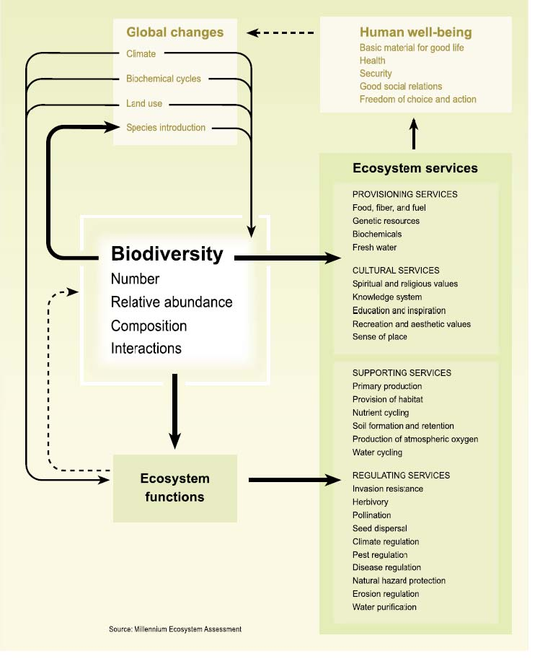

This framework is useful for identifying and analysing the full suite of ecosystem services available within any given geographical area. It also helps us to understand the complexity of dependencies, feedbacks and trade-offs between services and human beneficiaries, and can provide useful information for decision making by:

- explicitly identifying and classifying the benefits that people derive from ecosystems, including market and non-market, use and non-use, tangible and intangible benefits

- describing and communicating these benefits in concepts and language that people can understand

- asking, and trying to answer, ecological, economic and social questions to improve sustainable management of ecosystems and human wellbeing.

Although such analysis may be information intensive, taking an approach which looks for multiple benefits is likely to minimise the risks of compromising the structure, function and services of ecosystems and increase the options for retaining resilience. As outlined in Box 3, a mix of ecosystem services is available from any area of natural or modified ecosystem or habitat. However, the potential for modified ecosystems to provide a full range of ecosystem services over the long term may be limited if ecological or other thresholds are reached.

Box 3 Biodiversity’s contribution to ecosystem services

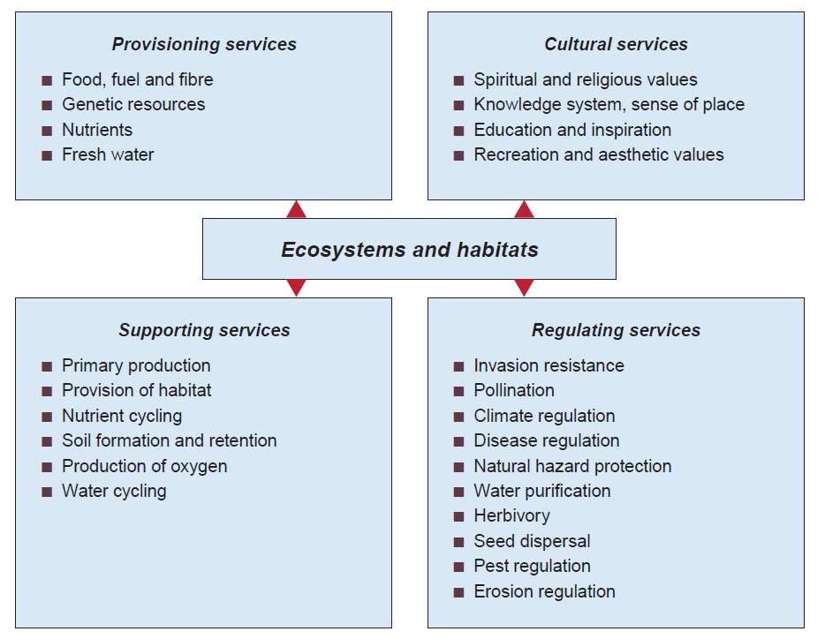

4. VALUING ECOSYSTEM SERVICES

Biodiversity and associated ecosystem services can be thought of as natural capital. We also think about social capital, which is a measure of community intangibles such as networks, cultural pursuits, trust, commitment to local wellbeing and shared values, and physical capital, which is the result of past investments in the conversion of components of natural capital through construction and maintenance, e.g. infrastructure (Beeton 2006). The set of these types of capital forms the foundations of a nation’s wealth.

While many ecosystem service benefits flow either directly or indirectly to markets, the full environmental cost of providing these services is not usually included in the market price signals. If an ecosystem service is regarded as ‘free’, there will be no incentive to value its specific role or use. Hence, the undervaluing of many ecosystems services, and the valuing of only a narrow range of services, has led to patterns of unsustainable resource use resulting in environmental degradation.

Despite early indications of their enormous economic value, ecosystems continue to be lost. A lack of hard data regarding the actual value of the services of particular ecosystems hampers the incorporation of value into business and government decision making. In addition, even when a value can be credibly estimated, it is often an externality—a cost or benefit accruing to society at large, rather than to the individuals or companies responsible—so there is little incentive for those actors to care for the species or ecosystem in question. And finally, the net value of converting an ecosystem may be artificially skewed by subsidies, tax breaks, and other government-sponsored incentives for the conversion These market failures are common drivers of the huge environmental losses of the past half century documented by the Millennium Ecosystem Assessment. — Gardner & Prugh 2008.

The total economic value of ecosystem services, as illustrated in Box 4, includes the ‘intrinsic’ values of our biodiversity, as well as the market value of goods and services, although those values currently in markets form only one part of the full suite of values (see Cork et al. 2007).

Box 4 The components of total economic value

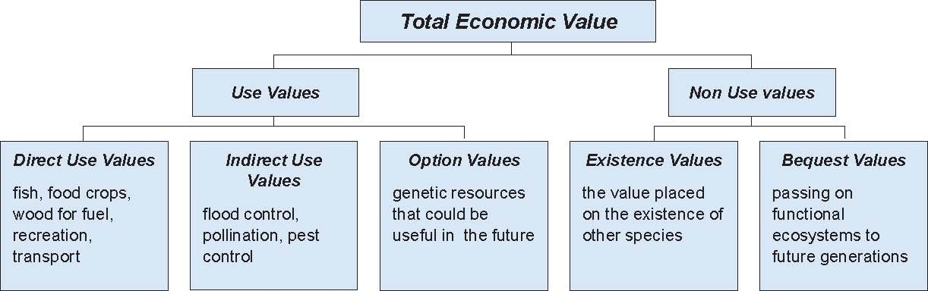

Over time, the accumulated impacts of undervaluing the full range of ecosystem services can result in species extinction, pollution of streams, rivers and air, and declining soil health, with associated impacts on the economy, human livelihoods and well being. The magnitude of some environmental externalities, such as enhanced climate change, fisheries collapse and loss of biodiversity, while difficult to quantify, may, in some cases, approach the size of the markets that inadvertently generated them.

Market failure is particularly common where the impacts of production on ecosystem services are widely or unevenly spread across space and time. For example, dryland salinity has become a major problem in Australia because of the temporal delay between the action of removing deep-rooted vegetation and the impact on hydrological regimes, and also because many small and isolated actions have collectively impacted on entire landscapes.

Until now, the most highly valued ecosystems services have been those that are directly accessible and easily measurable. This is changing as awareness of the importance of other ecosystem services increases and as some previously unpriced services are moving into markets. Ecosystem services can be bundled into four broad classes (refer to Box 2):

- Provisioning services (mostly food and fibre commodities) along with the supporting services that need to be replaced in order for these services to continue to flow, e.g. fertilisers to replace natural soil fertility, pesticides to replace natural pest control, have long been included in market economics.

- Regulating services where some of these services, e.g. pest regulation, seed dispersal, disease regulation and erosion regulation, have been artificially supplied and counted as costs of production. Other services, such as climate control, have been outside the market but are now being priced and integrated into markets, the most notable is carbon sequestration.

- Supporting services of which most have traditionally been unvalued, although their importance has been acknowledged through government investment in soil and biodiversity conservation. Others, such as water for environmental flows, are the subject of emerging markets.

- Cultural services include knowledge of country and place, which is important to Indigenous people. Another example is nature based tourism that has significant economic value. However, many cultural services, whilst clearly valued, have not been explicitly priced or included in markets.

As markets for a wider range of ecosystem services develop, new issues will arise, including securing a range of buyers for ecosystem services, identifying and engaging sellers of ecosystem services (Binning et al. 2001), ensuring markets are linked with strategic environmental and production outcomes, and making sure that market arrangements do not create unintended environmental problems.

Although the role of markets in valuing ecosystem services is increasing, the traditional role of governments in biodiversity conservation for a range of non-market and ‘public good’ reasons remains key to ensuring the flow of ecosystems services. For example, encouraging landholders, through education programs or incentive measures, to protect remnant vegetation or to revegetate land is likely to protect against soil loss and impaired water quality.

The process of valuing the broadest possible range of ecosystem services will generate public and private investment in the long-term supply of these services and provide insurance against system collapse or transformation. It will include both market and non-market services, as well as public and private benefits. This broad ecosystem services approach presents some challenges as identifying services can involve new ways of thinking. Measuring services can be difficult and the relationships between biodiversity, ecological functions, ecosystem services, resilience and human wellbeing are poorly understood for many services (Cork et al. 2007).

The example in Box 5 outlines an Australian pilot project that takes a broad approach to understanding and valuing ecosystems services within a rural catchment in Victoria (Abel et al. 2003).

Box 5 Valuing ecosystem services in the Goulburn Broken catchment

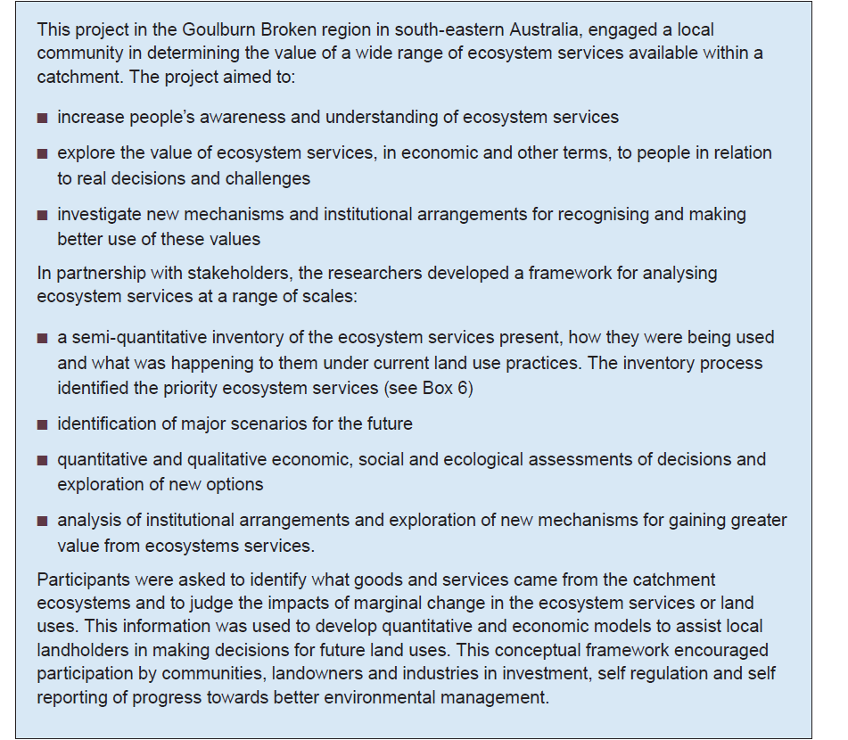

Box 6 Inventory of land uses and priority ecosystem services

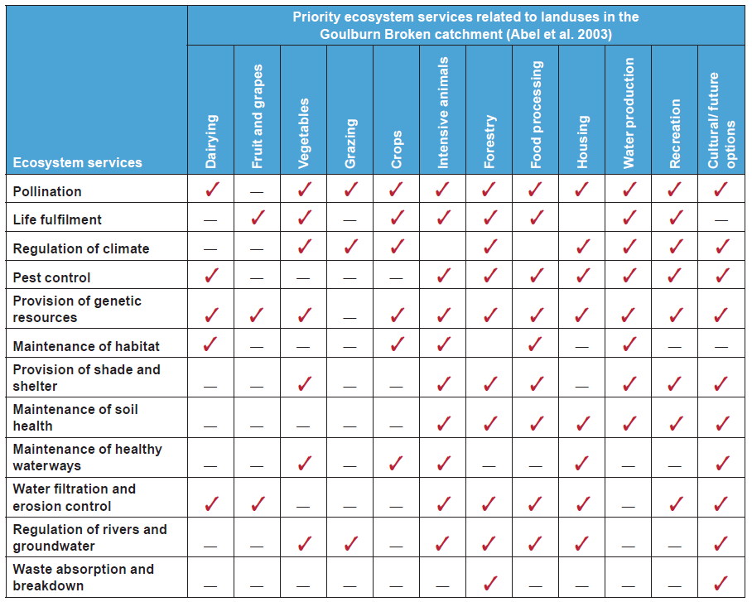

5. MEASURING ECOSYSTEM SERVICES

‘If you can’t measure, you can’t manage’ has been the catchcry of environmental managers for over a decade. While measurement systems exist for some ecosystem services within traditional market settings, measures for many services are still in their infancy as these measures may not include full environmental costs or externalities. There are a range of approaches at international, national and local levels, based on data sources for individual ecosystem services or suites of services (see Boxes 7 and 8 below, EEA undated and USEPA 2009).

Box 7 International measurement — Millennium Ecosystem Assessment

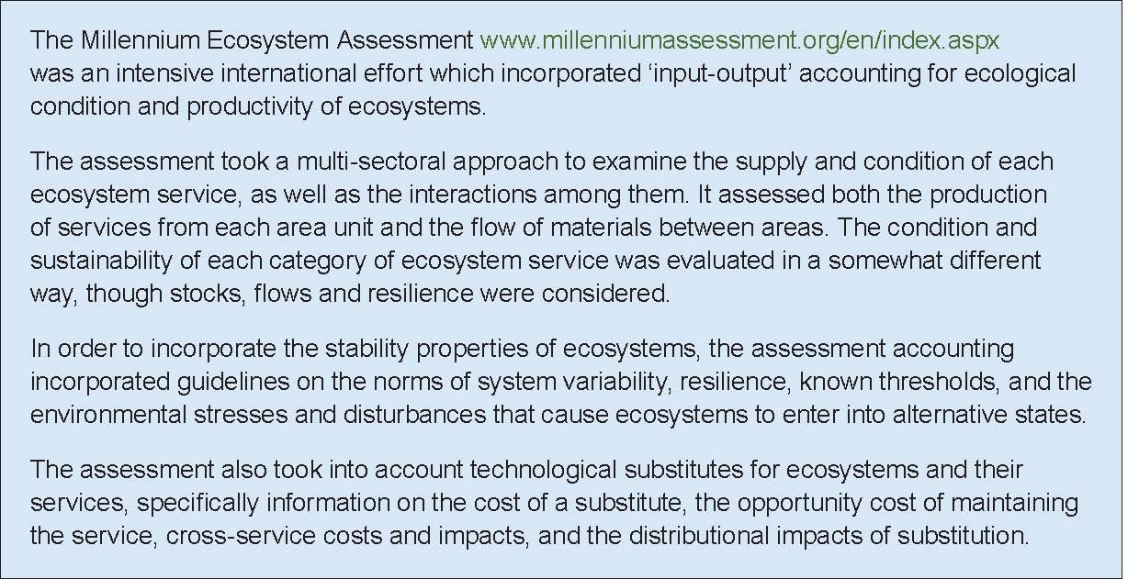

Box 8 National measurement — environmental accounting

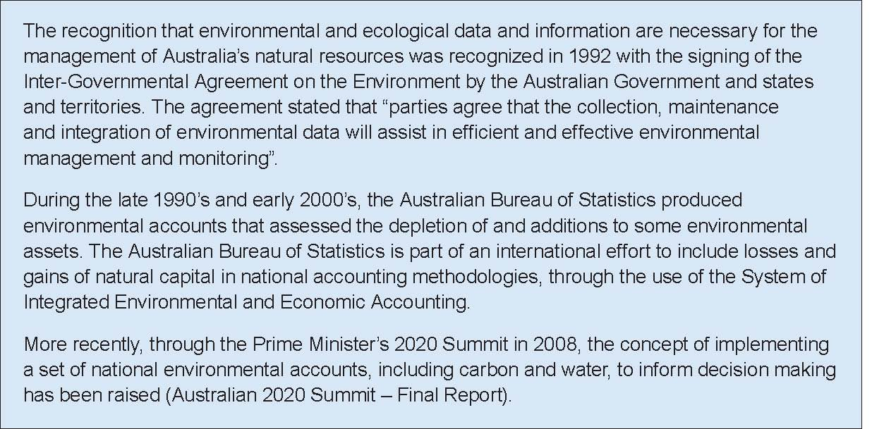

6. DATA AND INFORMATION FOR ECOSYSTEM SERVICES

The availability and sources of data for some ecosystem services are listed below under the four Millennium Ecosystem Assessment categories.

Provisioning services

Data are generally available for services that are currently included in markets, agricultural commodities. However the data will generally not indicate whether production is being maintained at the level of sustainable yield.

- Food, fuel and fibre: agricultural commodities are reported as annual sets of statistics by a range of government agencies, including the Australian Bureau of Agricultural and Resource Economics (ABARE), the Australian Bureau of Statistics and the Bureau of Rural Sciences.

- Nutrient data about agricultural inputs of nutrients, such as nitrogen phosphorus and some trace elements which are the main components of fertilisers, are reported by government agencies, but losses of on-site nutrients following land clearing are recorded only patchily by research agencies.

- Fresh water: the National Water Accounts developed by the Australian Bureau of Statistics are being further developed for the Murray-Darling Basin by the Bureau of Meteorology.

Supporting services

These services include long-term processes, such as soil formation and retention, provision of habitat, nutrient cycling and production of oxygen. Their importance in maintaining life support systems at the most basic level makes it difficult to describe their relative condition.

However, data on some supporting services are available. For example, the provision of habitat has long been associated with the extent of native vegetation. Data for this supporting service are provided by the states and territories to the Australian Government for collation into the National Vegetation Information System (NVIS).

Soil formation and retention is recognised as a fundamental attribute of best practice natural resource management. The Australian Soil Resources Information System (ASRIS) provides online access to the best publicly available information on soil and land resources in a consistent format across Australia.

For many years, ecologists have made estimates of the energy produced by plants during the transformation of solar energy to carbohydrates through photosynthesis. The energy produced is called net primary productivity. Research in the mid-1980s first estimated global net primary productivity consumed by humans to be 42 per cent. This percentage figure sent shock waves through the scientific community about the implications of such consumption of global resources by one species.

Recent refinements in the research methodology have revised the estimate down to around 20-30 per cent. This level of human use of global primary production alters the composition of the atmosphere, levels of biodiversity, energy flows within food webs and the provision of important ecosystem services.

Regulating services

Regulating services, such as pollination, seed dispersal and climate regulation underpin ‘productivity.’ Functional inventories have been undertaken for some services such as pollination, bioturbation (the disturbance of sediment layers by biological activity on the ocean floor), dung burial, water flow regulation, carbon sequestration and leaf decomposition.

Data on some of the regulation services are available. For example, water purification of an ecosystem can be measured as water quality at relevant locations within or at the end of a catchment. Although the water quality data does not indicate exactly where the regulating service was provided, it does give an indication of the ability of an ecosystem to produce this ecosystem service. The service may have been provided by a wetland, in which case assessing the health of the wetland to continue to produce this service can be undertaken. Similarly, whether pollination occurs or not will be assessed by the extent to which crops or trees produce their harvest.

Scientific evidence shows that the ‘climate control’ function that is naturally maintained by cycling of carbon within and between ecosystems has been degraded, resulting in a rapid change in the global energy balance, leading to predictions about future climate change consequences.

Responses aimed at minimising the rate of climate change include measures to reduce emissions of carbon dioxide and other greenhouse gases and to increase carbon sequestration. Methods for measuring carbon storage will underpin carbon offset programs and trading mechanisms to bring about emissions reductions and increased sequestration.

The links between the carbon cycle and other ecosystem services means that the methodologies developed in one context may be applicable to addressing a range of biodiversity conservation issues. The need for measurement of the amount of greenhouse gases emitted from land-based activities has resulted in a system to measure carbon, and research is beginning to emerge on the storage of carbon in the Australian landscape (see Box 9).

Box 9 National carbon measurement and research

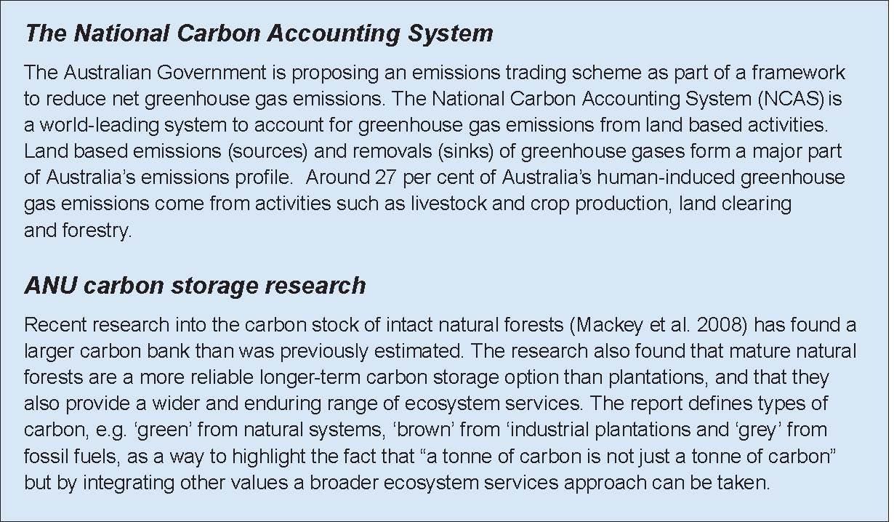

Cultural services

Cultural services include recreational and aesthetic values, heritage values and a sense of place. Cultural services have been included in the concept of ‘intrinsic’ and scientific values of nature. Much philanthropic donation, voluntary work and government funding has gone into conserving biodiversity for these services.

The management of natural and cultural heritage in Australia has occurred because articulating these values provides a context to the management of an area or place.

Cultural values for the Lake Eyre Basin, one of the largest internally draining river systems in the world, have been researched. The basin includes parts of south-west Queensland, north-east South Australia, south-west Northern Territory and far western New South Wales. Much of the area covered by the basin is arid or semi-arid in nature. The major cross-border river systems within the basin—the Cooper Creek and the Georgina-Diamantina river system—are recognised as being some of the last remaining unregulated inland river systems in Australia. This area also supports a range of Indigenous and non-Indigenous cultural heritage values.

There is debate about how to measure many of these values. Tourism data can provide an assessment of the economic value of Australia’s iconic biodiversity through documentation of visitor numbers and expenditure by tourists. Data on the economic value of the Great Barrier Reef indicates that tourism generates significant income.

Various surrogate measures are used to evaluate some cultural services. Real estate pricing can provide some measure of the additional value of property with aesthetic values or close proximity to areas of special geographical or biodiversity value. Real estate pricing may take into account whether the land has been covenanted for long-term biodiversity conservation.

7. ISSUES IN MEASURING ECOSYSTEM SERVICES

The key issues in measuring the range of ecosystem services include:

- Lack of detailed knowledge about ecosystem processes. Attempts have been made in Australia and internationally to measure and model the quantity, distribution and interactions between ecosystem services, which involves modelling biophysical processes and estimating causal relationships between action and outcome. These models are hampered by limited information on many ecological processes. Researchers have used expert judgement models, semi-quantitative models assembled with local input using modules that represent a standard set of ecosystem processes, models based on a mixture of detailed quantitative models and rule sets, and very detailed quantitative models based on hydrology and its impacts on vegetation.

- Variable timeframes. One of the biggest challenges in measuring and collating ecological knowledge and economics in timeframes is that processes can have different cycles and durations, ranging from weeks to millennia. For example, a marine biophysical productivity event off south-eastern Queensland could have effects on the south coast of NSW about four weeks later, whereas an extinction event in the outer reaches of the Coral Sea, off the eastern shore of Queensland, may have effects at Lord Howe island over several centuries.

- The non-transferability of research outcomes across ecosystems. The wide range of ecosystem types produce varying services at differing rates. For example, research outcomes for carbon sequestration or water filtration in one ecosystem will not necessarily be widely applicable.

8. ECOSYSTEM SERVICES IN NATURAL RESOURCE MANAGEMENT

Governments, communities and industries are taking a broader ecosystem approach to decision making about natural resource management issues. There are multiple benefits and trade offs in the process of shifting the decision making approach from ‘protecting ecosystems from development’ to ‘investing in ecosystems for sustainable development’.

A variety of strategies can be used to achieve land, water or ocean management practices and deliver multiple benefits and outcomes. These include the use of market-based approaches, public-private investment strategies and collective arrangements that promote cooperative action in line with landscape-scale outcomes. These strategies build on the traditional government strategies of suasion and extension at one end of the scale and regulation at the other end, by attempting to influence behaviour through changing or creating markets for ecosystem services.
The broadened range of tools can include any combination of financial incentives (e.g. direct grants, price signals and trading mechanisms), non-financial measures (e.g. government extension services) and regulatory frameworks (see Box 10).

Box 10 Policy tools for natural resource management and biodiversity conservation

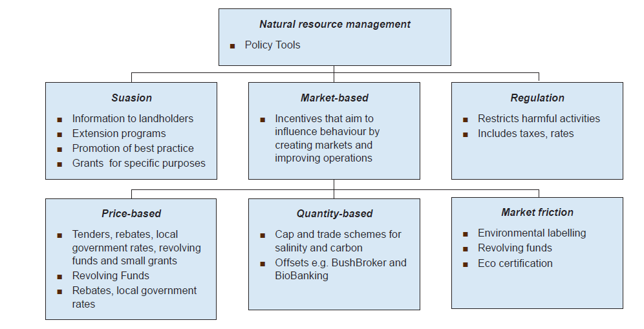

All policy tools which focus on improving biodiversity conservation have the potential to yield multiple ecosystem service outcomes, even if these are not explicitly measured. Market-based approaches are designed to drive investment in a wider range of ecosystem services. Government involvement will often be necessary not only to enable markets by establishing units of trade, property rights, and quantification mechanisms, but also to set monitoring requirements and minimum management standards.

The National Market-Based Instruments Pilot Program www.marketbasedinstruments.gov.au examined the application of policy tools specifically designed to correct for ‘missing’ incentives for supply of ecosystem services. Some of these have been successfully trialled in Australia.
States, territories and the Australian Government continue to build experience to design and use economic tools such as:

- auctions to allocate conservation contracts, e.g. the Australian Government Environmental Stewardship Program, BushTender in Victoria and the Forest Conservation Fund in Tasmania
- biodiversity offset schemes, e.g. BioBanking in NSW, BushBroker in Victoria and the Queensland Government Environmental Offset Policy to offset biodiversity loss through development approvals. The Australian Government has an option to use offsets in considering approvals under the Environment Protection and Biodiversity Conservation Act 1999
- revolving funds where properties with high biodiversity values are purchased and a covenant is placed on the land title before the property is re-sold on the open market
- tradeable emission permits, e.g. Hunter River Salinity Trading Scheme in NSW.

Some of the newer market-based instruments e.g. BushTender and auction programs and the Australian Government and state-based biodiversity offsets schemes include more explicit reference to multiple benefit outcomes. For example, Victoria’s EcoTender program extends the application of market-based instruments to multiple ecosystem services. EcoTender will take account of carbon balance, stream flow, water quality, dryland salinity and habitat (see Box 11 below).

Box 11 The EcoTender Pilot Program

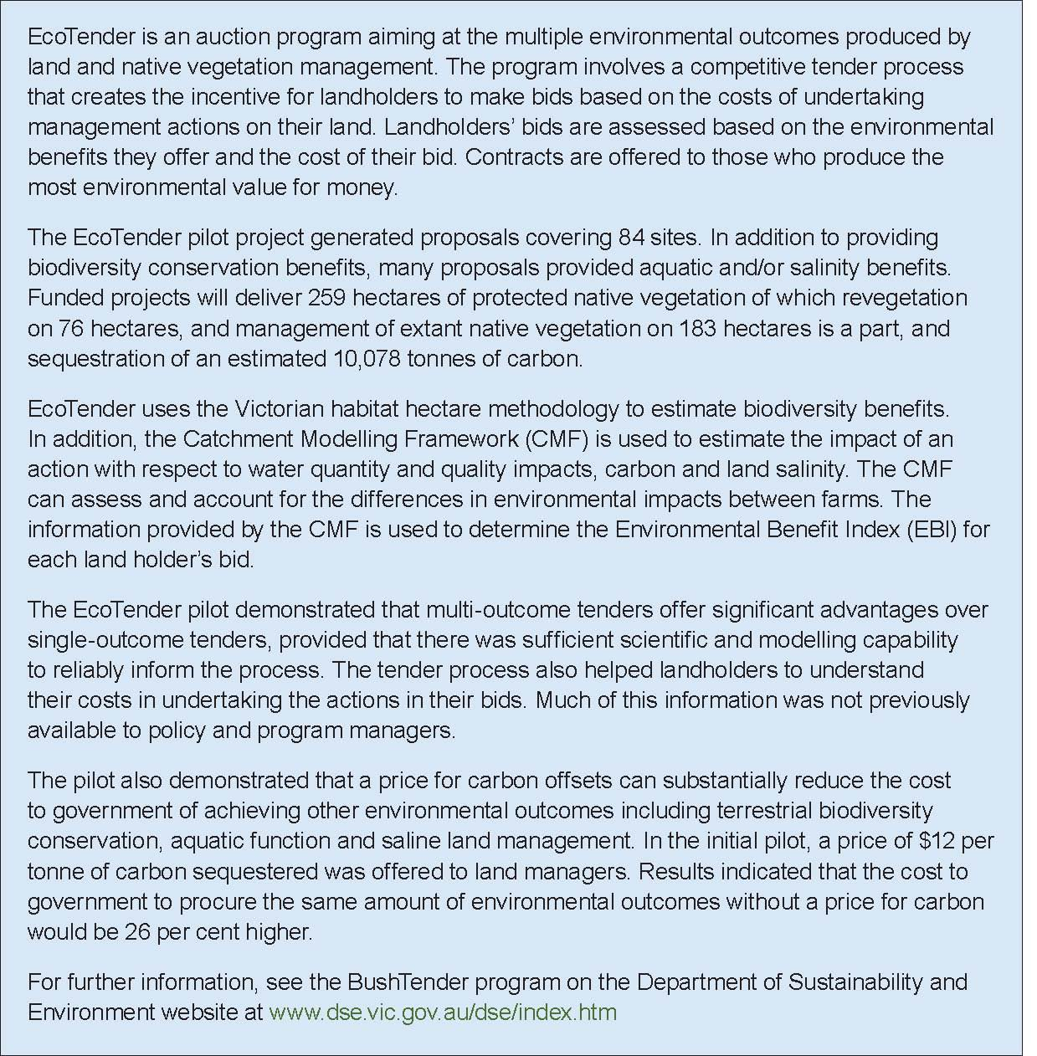

On a practical level, developing and managing multiple outcome programs, such as EcoTender, requires a range of skills and knowledge, including:

- social recognition of the importance of the suite of ecosystem services to human wellbeing

- understanding of the ecological processes that yield ecosystem services

- methods to value and measure ecosystem services

- structures promoting cooperation and motivation for financial or non-financial incentives

- certainty about who should take action and who should bear the cost of action

- skills or training to maintain or restore production of ecosystem services.

Where there is the potential for them to operate, markets in ecosystem services can be an efficient way to mobilise investment in sustainable production and use of ecosystem services. Water markets, for example, internalise the cost of water and boost private investment to improve water-use efficiency.

The role of the private sector in achieving ecological and social sustainability is also important. Strategies which address information failures can be an effective way of shifting consumption behaviour and allowing producers to recoup investment in ecologically sustainable production methods. Examples of such strategies include:

- sector-based codes of practice that are backed by some form of compliance monitoring

- development of voluntary or statutory standards of duty of care for resource use

- use of covenants on title or other mechanisms, such as catchment-based contract arrangements, to secure areas needed for protection of biodiversity or water supply services

- environmental audit, product labelling and certification schemes that allow certified producers to capture a cost premium, e.g. organic produce. Such schemes usually require regulatory controls or organisational structures that are subject to strict accountability and due diligence provisions.

Philanthropic contributions, harnessed through organisations such as Bush Heritage Australia and the Australian Wildlife Conservancy that purchase and manage land in perpetuity, is a significant and growing area of biodiversity conservation. These acquisitions will also ensure the maintenance of critical ecosystem services.

The financial services sector is also playing a role through increased scrutiny of the environmental and annual reports of companies in which their funds are invested, especially through the growth of ‘ethical investment’ and detailed analyses of ‘carbon exposure’ or ‘carbon risk.’ Rating schemes showing the impacts of the activities of companies are being widely accessed by investors, especially large managed funds, including superannuation funds, that use environmental criteria to diversify their investment products or choices.

The Global Reporting Initiative—a cooperative international effort to develop consistent reporting criteria and protocols—has become the international standard for company reporting. Its sustainability reporting framework sets out metrics and reporting guidelines for energy, water and materials consumption, and wastes to air, water and land. However, biodiversity reporting is difficult and the metrics cover only localised impacts, like native vegetation on sites directly owned by companies.

Environmental concerns are becoming more central to the consideration of risk for lenders, while the impacts of climate change has been in the sights of the insurance industry for well over a decade.

9. THE CENTRAL ISSUES OF ECOSYSTEM SERVICES

This paper defines and outlines the range of ecosystem services and highlights the following issues.

- Ecosystem services underpin human existence, health and prosperity.

- Biodiversity is central to the production of ecosystems services.

- The resilience of ecosystems is difficult to define and measure, but is essential to the continued delivery of ecosystem services in the face of significant threats like climate change, land use intensification, habitat fragmentation, and the spread of invasive species.

- The range of ecosystem services have been valued differentially in the past, with some services being priced in markets and others either not priced or underpriced.

- While many ecosystem service benefits flow either directly or indirectly to markets, other services are often undervalued.

- The undervaluing of some ecosystem services has led to patterns of unsustainable resource use resulting in environmental degradation.

- The complexity of ecosystems means that measurement systems for many ecosystem services have been slow to develop.

- An ‘ecosystem services approach’ is one that takes into account the widest possible suite of services in decision making to reduce future market failure.

- Biodiversity and associated ecosystem services can be regarded as natural capital. In addition, there is also social capital and physical capital. The set of these forms of capital forms the foundations of a nation’s wealth.

- New markets are developing for previously undervalued services, e.g. carbon trading biodiversity auctions, environmental flows of water, and offsets. As these markets mature, it will be important to ensure that the ecosystems services that they provide are well aligned to avoid unanticipated market distortions.

- Information and tools to reduce market friction (e.g. labelling, supporting legislation) are being developed.

REFERENCES

Abel N, Cork S, Gorddard R, Langridge J, Langston A, Plant R, Proctor W, Ryan P, Shelton D, Walker B and Yialeloglou M (2003). Natural Values: Exploring Options for Enhancing Ecosystem Services in the Goulburn Broken Catchment, CSIRO, Canberra.

Australian State of the Environment Committee (2001). Australia State of the Environment 2001, Independent Report to the Commonwealth Minister for the Environment and Heritage, CSIRO publishing on behalf of the Department of the Environment and Heritage, Canberra.

Beeton RJS (2006). ‘Society’s forms of capital: A framework for renewing our thinking’. Paper prepared for the 2006 Australian State of the Environment Committee, Department of the Environment and Heritage, Canberra. <www.environment.gov.au/soe/2006/publications/emerging/capital/index.html>

Binning C, Cork S, Parry R and Shelton D (2001). Natural Assets: An inventory of Ecosystem Goods and Services in the Goulburn Broken Catchment. CSIRO, Canberra.

Cork S, Stoneham G and Lowe K (2007). ‘Ecosystem services and Australian natural resource management (NRM) futures’. Paper to the Natural Resource Policies and Programs Committee (NRPPC) and the Natural Resource Management Standing Committee (NRMSC).

Costanza R, d’Arge R, De Groot R, Farber S, Grasso M, Hannon B, Limburg K, Naeem S, O’Neill RV, Paruelo J, Raskin RG, Sutton P and Vandenbelt M (1997). ‘The value of the world’s ecosystem services and natural capital’, Nature 387:253–260.

Crooks KR and Sanjayan M (eds) (2006). Connectivity Conservation, Conservation Biology 14, Cambridge University Press.

Department of Prime Minister and Cabinet (2008). Australia 2020 Summit: Final Report, Department of Prime Minister and Cabinet, Canberra.

Fischer J, Lindenmayer DB and Manning AD (2006). ‘Biodiversity, ecosystem function, and resilience: ten guiding principles for commodity production landscapes’, Front. Ecol. Environment 4(2):80–86. <http://cres.anu.edu.au/dbl/paperjf1.pdf> accessed 19 May 2008.

Folke C, Carpenter S, Walker B, Scheffer M, Elmqvist T, Gunderson L and Holling CS (2004). ‘Regime shifts, resilience, and biodiversity in ecosystem management’, Annual Review of Ecology, Evolution and Systematics 35:557–581.

Gardner G and Prugh T (2008). ‘Seeding the Sustainable Economy’ in: 2008 State of the World Report, Worldwatch Institute.

Haberl H, Erb K-H and Plutzar C (2005). The utility of HANPP as an indicator of socio-economic pressures on Biodiversity. International Human Dimension Programme on Global Environmental Change Open Meeting 2005 Session Biodiversity Conservation. < http://www.iff.ac.at/socec>

Haines-Young R, Potschin M, Groot de RS, Keinmast F and Bolliger J (2009). ‘Towards a Common International Classification of Ecosystem Services (CICES) for Integrated Environmental and Economic Accounting’. Report to the European Environment Agency, contract no. EEA/BSS/7/07.

Hughes TP (2008). Human impact on coral reefs in: The Great Barrier Reef: biology, environment and management. CSIRO Publishing, Collingwood, VIC, Australia,

Mackey BG, Keith H, Berry L and Lindenmayer DB (2008). ‘Green Carbon, the role of natural forests in carbon storage, Part 1: A green carbon account of Australia’s SE Eucalypt forests and policy implications’, ANU E-Press, Canberra.

Marshall P and Schuttenberg H (2006). A Reef Manager’s Guide to Coral Bleaching, Great Barrier Reef Marine Park Authority, Townsville, Australia.

Michaels K, Lacey M, Norton T and Williams J (2008). Vegetation Futures for Tasmania, Veg Futures Conference, Toowoomba.

Millennium Ecosystem Assessment (2005). Ecosystems and Human Well-Being: Our Human Planet: Summary for Decision Makers. The Millennium Ecosystem Assessment Series, Volume 5, Island Press, Washington DC.

Mullon C, Fréon P and Cury P (2005). ‘The dynamics of collapse in world fisheries’, Fish and Fisheries 6(2):111–120.

Ridder B (2008). ‘Questioning the ecosystem services argument for biodiversity conservation’, Biodiversity and Conservation 17(4):781–790.

United States Environmental Protection Agency (USEPA) (2009). ‘Valuing the Protection of Ecological Systems and Services’. A Report of the EPA Science Advisory Board, EPA-SAB-09-012, Washington DC.

Walker B and Salt D (2006). Resilience Thinking — Sustaining Ecosystems and People in a Changing World, Island Press, Washington DC.

Photo Credits

Internal images: Dam (S. Wray) Nourlangle, Kakadu National Park (M. McAulay) Cravens Peak Reserve (N. Rains) Lake Placid (J. Baker)

