

Annual Report 2013

**Co-regulatory Arrangement - National Television and Computer Recycling Scheme**



**Ecycle Solutions Pty Ltd Annual Report 2013**

**Introduction**

The National Television and Computer Recycling Scheme (NTCRS) commenced on 1 July 2012 and is an Australia-wide scheme to recycle e-waste including end-of-life (EOL) waste televisions (TVs), computers and computer products such as printers and scanners. Ecycle Solutions Pty Ltd is an Australian Government Approved Co-regulatory Arrangement within the NTCRS.

Ecycle Solutions’ Annual Report provides information about the company’s collection and recycling activities during the period 1 July 2012 to 30 June 2013. The report covers the following areas:

1. QLS Group Overview
2. Ecycle Solutions Overview
3. Collection Services
4. Recycling
5. Service Providers
6. OHS and Environment

**1. QLS Group Overview**

Ecycle Solutions is a member of the QLS Group, a national warehousing, logistics and distribution business specialising in providing secure and reliable warehousing solutions for bulky white and brown goods. The business has experienced consistent growth from 2009 to 2013 by providing competitively priced solutions for its customers.

A unique feature of QLS’ system is regular visits to retail stores by QLS sales team/agents to seek feedback on delivery performance. QLS employs over 100 people nationally and the four state based warehouses in Melbourne, Sydney, Brisbane and Perth provide 58,800 m2 of storage space. In FY2013 QLS delivered approx. 50,000 tonnes of freight via its modern fleet of 70 company owned vehicles including B double line haul vehicles and team of sub-contractors.

**2. Ecycle Solutions Overview**

A new and innovative method of collecting and recycling e-waste is provided by Ecycle Solutions as a co-regulatory arrangement within the Australian government’s National Television and Computer Recycling Scheme.

Ecycle Solutions provides the general public with a recycling solution for their end-of-life televisions and computers (e-waste) via a free drop-off service at participating retail stores including Harvey Norman, The Good Guys, Radio Rentals, RT Edwards, Bing Lee, Betta Home Living and Bi-Rite. At the heart of Ecycle Solution’s system is QLS’ national transport capability regularly visiting metropolitan, regional, and country retail stores throughout Australia. As QLS drivers deliver white and brown goods to retail stores they collect purpose built e-waste bins full of televisions and computers which are then recycled.

Ecycle Solutions also offers retail stores a collection and recycling service for white and brown goods packaging materials including plastic, cardboard and EPS (polystyrene) thereby increasing recycling within the industry’s supply chain.

**3. Service Providers**

* SRS Recycling Pty Ltd - Recycler
* National E-waste Alliance Pty Ltd - Recycler
* QLS Group – Collections and transport

**4. OHS and Environment**

**OHS and Environment Incidents**

There were no notifiable OHS (Occupational Health and Safety) and Environment incidents during the reporting period.

**Actions**

Actions taken during the year to assess the adequacy of the OHS and Environment policies and procedures as a part of the ongoing adequacy assessment regime included:

* Site inspection of QLS Vic logistics system.
* Site inspection of Surplus Recycling Solutions recycling system.
* Audit of Surplus Recycling Solutions recycling system.

**5. Collection Services**

Ecycle Solutions commenced collection services on 1 July 2012.

Estimate of collection of televisions (kg) by state/territory and area for FY2013.

|  |  |  |  |  |  |
| --- | --- | --- | --- | --- | --- |
| **State/Territory** | **Metro** | **Inner**  **Regional** | **Outer**  **Regional** | **Remote** | **Total** |
| QLD | 54,325 | 993 | 157 | 0 | **55,475** |
| NSW | 7,870 | 959 | 0 | 0 | **8,829** |
| ACT | 0 | 0 | 0 | 0 | **0** |
| VIC | 1,507,047 | 240,117 | 61,600 | 0 | **1,808,764** |
| TAS | 0 | 0 | 0 | 0 | **0** |
| SA | 26,575 | 0 | 0 | 0 | **26,575** |
| WA | 0 | 0 | 119,709 | 0 | **119,709** |
| NT | 0 | 0 | 0 | 0 | **0** |
| **Total** | **1,595,817** | **242,069** | **181,466** | **0** | **2,019,352** |

**5. Collection Services (cont.)**

Estimate of collection of computers (kg) by state/territory and area for FY2013.

|  |  |  |  |  |  |
| --- | --- | --- | --- | --- | --- |
| **State/Territory** | **Metro** | **Inner**  **Regional** | **Outer**  **Regional** | **Remote** | **Total** |
| QLD | 2,198 | 77 | 96 | 0 | **2,371** |
| NSW | 2,458 | 0 | 0 | 0 | **2,458** |
| ACT | 0 | 0 | 0 | 0 | **0** |
| VIC | 320,588 | 0 | 0 | 0 | **320,588** |
| TAS | 0 | 0 | 0 | 0 | **0** |
| SA | 515 | 0 | 0 | 0 | **515** |
| WA | 0 | 0 | 9,784 | 0 | **9,784** |
| NT | 0 | 0 | 0 | 0 | **0** |
| **Total** | **325,759** | **77** | **9,880** | **0** | **335,716** |

**5. Collection Services (cont.)**

Collection activities undertaken for the period 1 July 2012 to 30 June 2013.





**6. Recycling**

**Recycling Activities**

End-of-life televisions and computers (e-waste) were collected by Ecycle Solutions via its unique retail store collection, collection events and other collection activities during FY2013. E-waste was then processed by recyclers involving disassembly/breaking down of all e-waste and sorting of component parts into four main groups:

* Plastic
* Metal
* Lead glass/Non-lead glass
* Other

Materials recovered continued within domestic and international supply chains to be manufactured into other products. Our recyclers have exported materials for manufacturing to Hong Kong, Japan and Korea. No whole units were exported. Materials not recovered were sent to landfill.

**Recycling Outcomes**

Ecycle Solutions complied with all National Television and Computer Recycling Scheme regulations during FY2013. Ecycle Solutions collected and recycled 2,019,352 kg of televisions thereby exceeding the target weight of 1,618,000 kg for televisions as determined by the Australian Government. A further 335,716 kg of computers was collected and recycled even though there was no target for recycling computers for Ecycle Solutions during FY2013. The amount of computers and the surplus televisions of 401,352 kg will be carried forward into the combined television and computer product stream for FY2014.

Recycling by weight (kg) provided by service providers.

|  |  |  |  |  |  |
| --- | --- | --- | --- | --- | --- |
| **SRS Recycling** | | **National E-Waste Alliance** | | **Total** | |
| **Televisions** | **Computers** | **Televisions** | **Computers** | **Televisions** | **Computers** |
| 1,959,352 | 335,716 | 60,000 | 0 | **2,019,352** | **335,716** |

All items of e-waste were disassembled/broken down during the recycling process and no whole items of e-waste were dumped in landfill. Storage of e-waste was at recycling facilities.

Materials recovered and to landfill by weight (kg) of components.

|  |  |  |  |  |
| --- | --- | --- | --- | --- |
| **Components** | **Materials Recovered** | | **To Landfill** | |
|  | **Televisions** | **Computers** | **Televisions** | **Computers** |
| Plastic | 165,364 | 3,357 | 0 | 0 |
| Metal | 310,647 | 206,230 | 3,227 | 0 |
| Lead/Non-Lead Glass | 0 | 0 | 1,143,489 | 0 |
| Other | 396,025 | 126,129 | 600 | 0 |
| **Total** | **872,036** | **335,716** | **1,147,316** | **0** |

QLS-logo.png

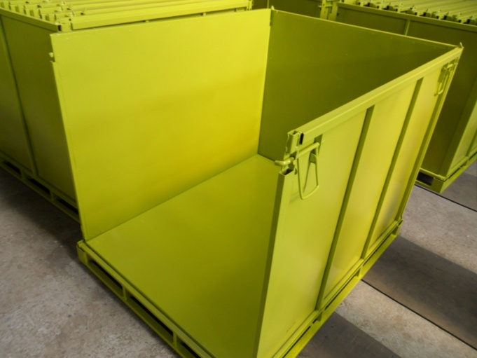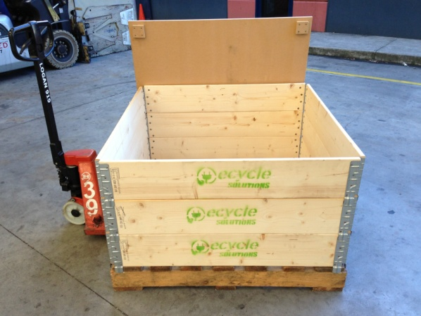

Pallet retainers for collecting e-waste Bins for collecting e-waste

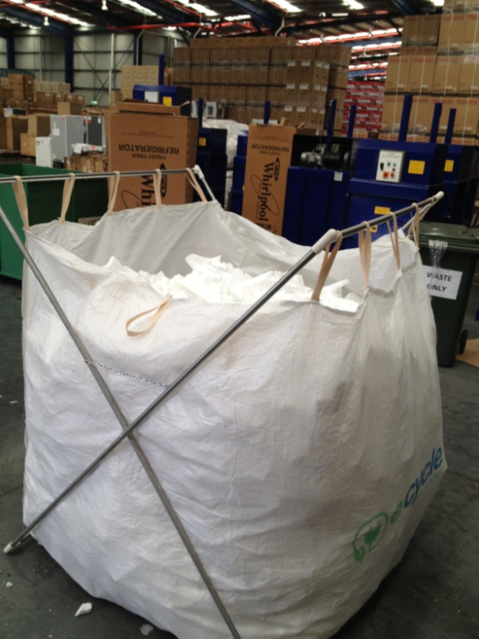

QLS truck and trailer with tailgate

Bags for collecting polystyrene