**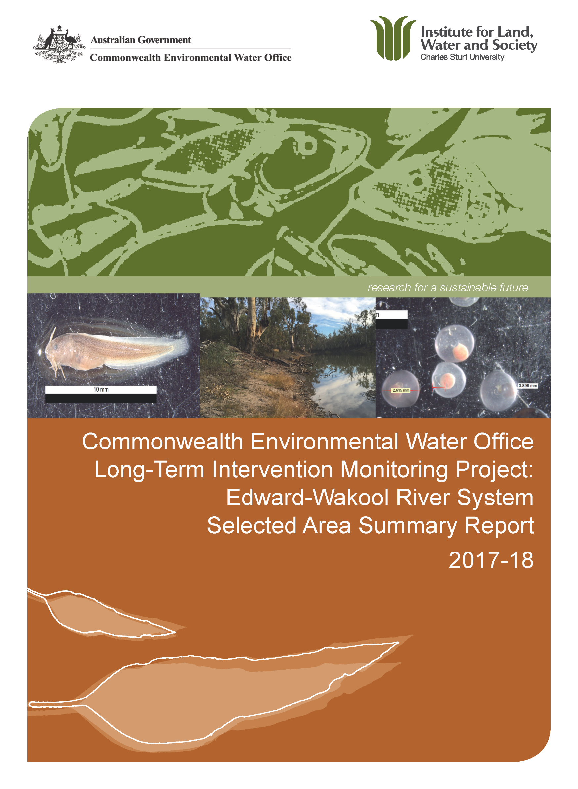**

**Copyright** © Copyright Commonwealth of Australia, 2018



‘Commonwealth Environmental Water Office Long Term Intervention Monitoring Project: Edward-Wakool River System Selected Area Summary Report, 2017-18 is licensed by the Commonwealth of Australia for use under a Creative Commons By Attribution 3.0 Australia licence with the exception of the Coat of Arms of the Commonwealth of Australia, the logo of the agency responsible for publishing the report, content supplied by third parties, and any images depicting people. For licence conditions see: <http://creativecommons.org/licenses/by/3.0/au/>

**Disclaimer:**

The views and opinions expressed in this publication are those of the authors and do not necessarily reflect those of the Australian Government or the Minister for the Environment. While reasonable efforts have been made to ensure that the contents of this publication are factually correct, the Commonwealth does not accept responsibility for the accuracy or completeness of the contents, and shall not be liable for any loss or damage that may be occasioned directly or indirectly through the use of, or reliance on, the contents of this publication.

**Citation:**

Watts R.J., McCasker N.G., Howitt J.A., Thiem J.D., Grace M.R., Trethewie J.A., Healy S., Bond N.R. (2018). ‘Commonwealth Environmental Water Office Long Term Intervention Monitoring Project: Edward-Wakool River System Selected Area Summary Report, 2017-18’. Report prepared for Commonwealth Environmental Water Office. Commonwealth of Australia.

The Commonwealth of Australia has made all reasonable efforts to identify content supplied by third parties using the following format ‘© Copyright.

|  |  |
| --- | --- |
| InstLandWaterSociety Logo RGB | Institute for Land, Water and Society  Charles Sturt University  PO Box789, Albury, NSW 2640 |
| DPI_logo_colour_rgb.jpg | NSW Department of Primary Industries  Narrandera Fisheries Centre,  PO Box 182, Narrandera NSW 2700 |
|  | Water Studies Centre  Monash University  Clayton, Victoria, 3800 |
| OEH2Colour | NSW Office of Environment and Heritage  PO Box 363, Buronga NSW 2739 |
|  | School of Life Sciences  La Trobe University  PO Box 821,Wodonga 3689 |

**Cover photos:**

Left Larval freshwater catfish caught in the Wakool River in December 2017 (Photo: J Trethewie)

Middle Wakool River Barham Bridge (zone 4 site 1) on 8 June 2017 during the winter environmental watering action (Photo: S Healy)

Right Silver perch eggs collected from Yallakool Creek, 6 December 2017 (Photo N McCasker)

**Contents**

[Monitoring and evaluation of environmental water in the Edward-Wakool Selected Area 4](#_Toc23111434)

[Environmental watering in the Edward-Wakool system in 2017-18 6](#_Toc23111435)

[Key outcomes from environmental water use 2017-18 8](#_Toc23111436)

[Recommendations and implications for future management of environmental water 17](#_Toc23111437)

[Acknowledgements 18](#_Toc23111438)

[References 18](#_Toc23111439)

[Appendices 20](#_Toc23111440)

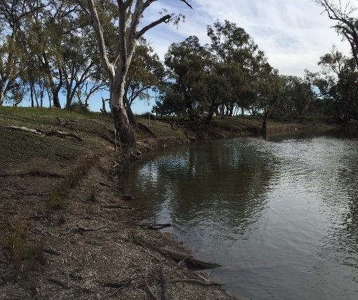 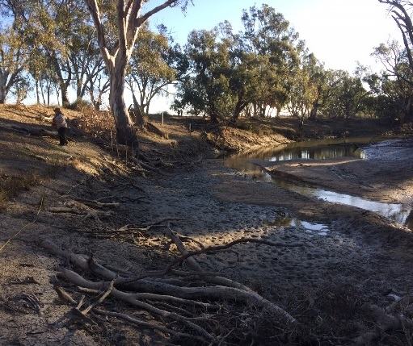

Figure 1. Photos of Yallakool Creek during environmental watering action 2 (spring fresh 5/10/17, 385 ML.d-1), and during the winter operational shutdown (24/5/2018) when the system ceased to flow.

# Monitoring and evaluation of environmental water in the Edward-Wakool Selected Area

**Introduction**

This report summarises the monitoring and evaluation of ecosystem responses to Commonwealth environmental watering in the Edward-Wakool River System Selected Area in 2017-18. It is the fourth annual report of the Long Term Intervention Monitoring (LTIM) Project (2014-2019) funded by the Commonwealth Environmental Watering Office. The project was undertaken as a collaboration among Charles Sturt University (CSU), NSW DPI (Fisheries), Monash University, NSW Office of Environment and Heritage (OEH), and La Trobe University. Field monitoring for the project was undertaken by staff from CSU, NSW Fisheries and OEH.

**Edward-Wakool Selected Area**

The Edward-Wakool system is a large anabranch system of the Murray River in the southern Murray-Darling Basin (MDB), Australia. The system begins in the Millewa Forest and travels north and then northwest before discharging back into the Murray River. It is a complex network of interconnected streams, ephemeral creeks, flood-runners and wetlands including the Edward River, Wakool River, Yallakool Creek (Figure 1), Colligen-Niemur Creek and Merran Creek. Under regulated conditions flows in the Edward River and tributaries remain within the channel, whereas during high flows there is connectivity between the river channels, floodplains and several large forests (Figure 2).

The Edward-Wakool system plays a key role in the operations and ecosystem function of the Murray River and the southern MDB. Some of the water released from Hume Dam is diverted from the Murray River through the Edward-Wakool system to avoid breaching operational constraints in the mid-Murray River. The Edward-Wakool system also plays an important ecological role in connecting upstream and downstream ecosystems. The streams and creeks in this system provide important refuge and nursery areas for fish and other aquatic organisms, and adult fish regularly move between this system and other parts of the Murray River. As some of the rivers in the Edward-Wakool system have low discharge there is a risk of poor water quality, particularly during warm periods. Maintaining good water quality is crucial for both the river ecosystem, the communities and landholders that rely on the water from this system.

**Monitoring sites**

The monitoring in the Edward-Wakool LTIM Selected Area is focussed on four hydrological zones, which together are referred to as the focal zone: Yallakool Creek (zone 1), the upper Wakool River (zone 2) and mid reaches of the Wakool River (zones 3 and 4) (Figure 2). Reaches in zones 1 and 2 are generally more constrained, have steeper riverbanks and fewer in-channel benches than many of the reaches in zones 3 and 4. Additional sites throughout the system are monitored for hydrology, fish movement and fish community.

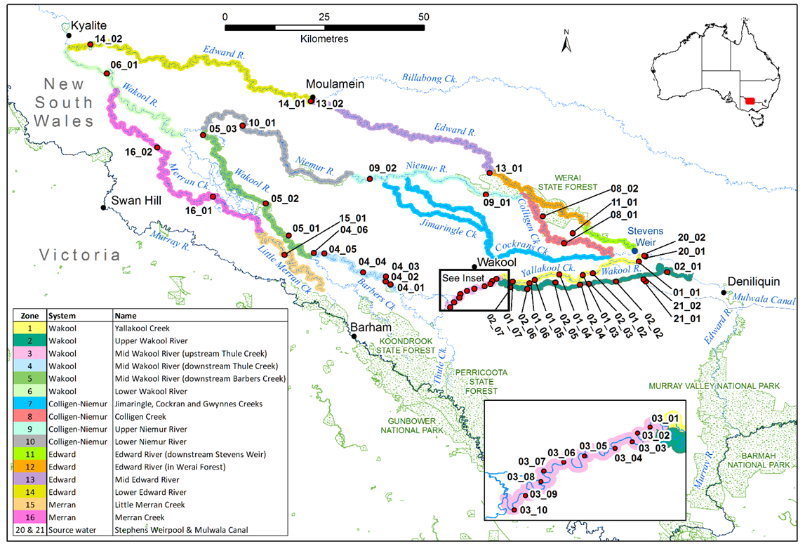

**Figure 2.** Location of monitoring sites for the Edward-Wakool Selected Area for the Long-Term Intervention Monitoring Project. Hydrological gauges are located in Yallakool Creek site 01\_01 (gauge 409020, Yallakool Creek at offtake), Wakool River zone 2 site 02\_01 (gauge 409019, Wakool River offtake), and in the Wakool River zone 4 at site 04\_01 (gauge 409045). Site names are listed in Watts et al. (2018).

**Indicators**

This report documents the monitoring and evaluation of the following indicators:

* River hydrology
* Water quality and carbon
* Stream metabolism
* Riverbank and aquatic vegetation
* Fish movement
* Fish reproduction
* Fish recruitment
* Fish community

Responses to Commonwealth environmental water were evaluated in two ways:

1. Indicators that respond quickly to flow (e.g. hydrology, water quality and carbon, stream metabolism, fish movement, fish spawning) were evaluated for their response to specific watering actions (comparing responses with and without the environmental water).
2. Indicators that respond over longer time frames (e.g. riverbank and aquatic vegetation, fish recruitment) were evaluated for their response to the longer-term watering regime. This was undertaken by comparing responses over multiple years in reaches that have received environmental water (zones 1, 3 and 4) to zone 2 that has received none or minimal environmental water.

# Environmental watering in the Edward-Wakool system in 2017-18

**Practicalities of environmental watering in the Edward-Wakool system**

The main source of Commonwealth environmental water for the Edward-Wakool system is from the Murray River through the Edward River and Gulpa Creek. The main flow regulating structure within the Edward-Wakool system is Stevens Weir located on the Edward River (Figure 2). This structure creates a weir pool that allows Commonwealth environmental water to be delivered to Colligen-Niemur system, Yallakool Creek, the Wakool River, the Edward River and Werai Forest. Water diverted into the Mulwala Canal from Lake Mulwala can also be delivered into the Edward-Wakool system through ‘escapes’ or outfalls managed by the irrigator-owned company Murray Irrigation Limited.

Delivery of instream flows to the Edward-Wakool system are managed within regular operating ranges as advised by river operators to avoid third party impacts. For example, in the Wakool-Yallakool system the operational constraint is 600 ML d-1 at the confluence of the Wakool River and Yallakool Creek. Thus, the types of flow components that can be achieved under current operating ranges are in-channel base flows and freshes. Environmental watering may also be constrained due to the limitations on how much water can be delivered under regulated conditions, as channel capacity is shared with other water users. If the system is receiving higher unregulated flows, there may not be enough capacity to deliver environmental water (Gawne et al. 2013).

**Commonwealth watering actions in the Edward-Wakool system 2009 to 2018**

Commonwealth environmental watering actions have occurred in the Edward-Wakool system since 2009. Between July 2009 and June 2018 Commonwealth environmental watering actions delivered base flows and freshes, contributed to the recession of flow events, delivered water from irrigation canal escapes to create local refuges during hypoxic blackwater events (Watts 2017a), and contributed to flows in ephemeral watercourses (Watts et al. 2018, Table 1). Many of the watering actions in ephemeral creeks were undertaken jointly with NSW OEH. One Commonwealth watering action in 2009-10 for Werai State Forest was undertaken to deliver environmental water to Edward-Wakool forests. To date it has not been possible to deliver large within channel freshes or overbank flows due to operational constraints in the system. In addition to watering actions specifically targeted for the Edward-Wakool system, water from upstream Commonwealth environmental watering actions and actions that are targeted for downstream watering actions transit through the Edward-Wakool system in some years.

**Commonwealth watering actions in 2017-18**

This report focusses on six Commonwealth environmental watering actions in the Edward-Wakool Selected Area from 1 May 2017 (start of watering action 1) until 30 June 2018 (Table 2). Watering actions 1 (Figure 1), 2, 4, 5 and 6 were delivered. Watering action 3 was not delivered due to unregulated flows occurring above channel capacity at the time of this planned action.

**Table 1.** Summary of environmental watering actions and unregulated overbank flows in the Edward-Wakool system from July 2010 to June 2018.

|  |  |  |  |  |  |  |  |  |  |
| --- | --- | --- | --- | --- | --- | --- | --- | --- | --- |
| **Type of watering**  **action** | **Water year** | | | | | | | | |
| **2009-10** | **2010-11** | **2011-12** | **2012-13** | **2013-14** | **2014-15** | **2015-16** | **2016-17** | **2017-18** |
| **In-channel environmental watering actions** | | | | | | | | | |
| Base flows and small freshes |  |  | **✓** | **✓** | **✓** | **✓** | **✓** | **✓** | **✓** |
| Contribute to flow recession |  |  |  |  | **✓** | **✓** | **✓** | **✓** | **✓** |
| Maintain winter base flows |  |  |  |  |  |  |  |  | **✓** |
| Larger within channel freshes1 |  |  |  |  |  |  |  |  |  |
| **In channel environmental watering actions using irrigation infrastructure** | | | | | | | | | |
| Flows from canal escapes during hypoxic events |  | **✓** |  | **✓** |  |  |  | **✓** |  |
| Flows in ephemeral streams2 |  | **✓** | **✓** | **✓** | **✓** | **✓** | **✓** | **✓** | **✓** |
| Watering forests | **✓** |  |  |  |  |  |  |  |  |
| **Unregulated overbank flows** | | | | | | | | | |
| Flooding forests and/or floodplains |  | **✓** |  |  |  |  |  | **✓** |  |

1 Delivery of larger within channel freshes to the Wakool River and Yallakool Creek is not possible under current operational constraints (e.g. constrained to 600 ML/d at the confluence of the Wakool River and Yallakool Creek).

2.Some of the watering actions in ephemeral creeks done jointly with NSW Office of Environment and Heritage

**Table 2.** Planned Commonwealth environmental watering actions in the Edward-Wakool system in 2017-18

|  |  |  |  |  |  |
| --- | --- | --- | --- | --- | --- |
| **Planned watering action** | | **Type of action** | **Dates** | **Rivers** | **Objectives** |
| 1 | Winter watering action | base flow | 1 May - 23 Aug 2017 | Yallakool Creek, mid and lower Wakool River, Colligen Creek-Niemur River | To contribute to reinstatement of the natural hydrograph, connectivity, condition of in-stream aquatic vegetation and fish recruitment |
| 2 | Early spring fresh at beginning of e-flow with flow recession | small fresh and flow recession | 7 Sept - 22 Oct 2017 | Yallakool Creek, upper, mid and lower Wakool River, Colligen Creek-Niemur River | To contribute to connectivity, water quality, stimulating growth of in-stream aquatic vegetation, pre-spawning condition of native fish, spawning in early spawning native fish |
| 3 | Maintain e-flow | small fresh | Not delivered | N/A | To maintain nesting habitat for Murray cod and inundation for aquatic vegetation growth |
| 4 | Summer fresh at end of e-flow with flow recession | small fresh and flow recession | 3 - 29 Jan 2018 | Yallakool Creek, mid and lower Wakool River | To encourage fish movement and assist dispersal of larvae and juveniles of fish species. |
| 5 | Autumn fresh with flow recession | small fresh with flow recession | 28 Mar - 1 May 2018 | Yallakool Creek, upper, mid and lower Wakool River, Colligen Creek-Niemur R | To encourage fish movement and dispersal of juveniles of a number of fish species. |
| 6 | Summer fresh | small fresh | 11 Jan – 11 Feb 2018 | Niemur River | To improve water quality (response to heatwave driven low DO event) |

# Key outcomes from environmental water use 2017-18

**Hydrology**

In 2017-18 there were no flows that exceeded the 600 MLd-1 operational constraint at the confluence of the Wakool River and Yallakool Creek (Figure 3). Despite this, there were several significant hydrological outcomes of the environmental watering actions (Table 3):

* The winter base flow (action 1) maintained longitudinal connectivity right throughout the system, which was in contrast to the winter operational shutdown in previous years
* The early season fresh (action 2) increased the duration of lateral connectivity, hydraulic diversity and duration of recession compared to operational flows
* Watering action 4 increased the maximum, minimum, mean and median discharge in zones 1, 3 and 4 and Colligen Creek compared to operational flows
* The recession of the autumn fresh (action 5) increased the extent and duration of lateral connectivity compared to operational flows
* The summer fresh in Colligen Creek (action 6) Increased the median discharge, the extent of lateral connectivity and the hydraulic diversity compared to operational flows

**Table 3** Hydrological outcomes of environmental watering actions in the Edward-Wakool system in 2017-18

|  |  |
| --- | --- |
| **Indicator** | **Key result** |
| Maximum and minimum discharge | Watering action 1 (winter 2017) and action 5 (autumn fresh) increased the maximum discharge in Yallakool Creek (zone 1), the mid and lower Wakool River (zones 3 and 4). Action 1, 5 and 6 increased the maximum discharge in Colligen Creek. Actions 1, 2, 4, 5 and 6 increased the minimum, mean and median discharge in reaches receiving environmental water compared to operational flows. |
| Flow variability | Watering action 1 (winter 2017) and action 2 (spring fresh) reduced the coefficient of variation of discharge (CV) in Yallakool Creek and the mid- and lower Wakool River (zones 3 and 4). Actions 5 and 6 had no effect on the CV in Yallakool Creek, the mid and lower Wakool River and Colligen Creek. The unregulated flows during November and December 2017 increased the range of discharge in zones 1, 3 and 4 when compared with spring watering actions in previous years. |
| Longitudinal connectivity | Watering action 1 in winter 2017 maintained longitudinal connectivity in Yallakool Creek, the mid and lower Wakool River and Colligen Creek. In contrast, the upper Wakool River zone 2 (no e-watering) experienced 72 days cease to flow in winter 2017. |
| Lateral connectivity | Watering action 2 provided a small in-channel fresh that increased the duration of lateral connectivity in zones 1, 3 and 4 compared to operational flows. Watering action 5 provided a small in-channel fresh that increased the extent and duration of lateral connectivity in zones 1, 3 and 4 and Colligen Creek compared to operational flows. Watering action 6 in Colligen Creek increased the extent of lateral connectivity compared to operational flows. |
| Flow recession | Watering action 2 increased the duration of the recession to 32 days in Yallakool Creek and other downstream reaches compared with what would have been a rapid reduction in discharge from 460 ML/d to 200 ML/d over 3 days under operational flows. Action 5 increased the duration of lateral connectivity in zones 1, 3 and 4 and Colligen Creek compared to operational flows. |
| Hydraulic diversity | Watering actions 2, 5 and 6 increased the hydraulic diversity in reaches receiving environmental water compared to modelled operational flows. |

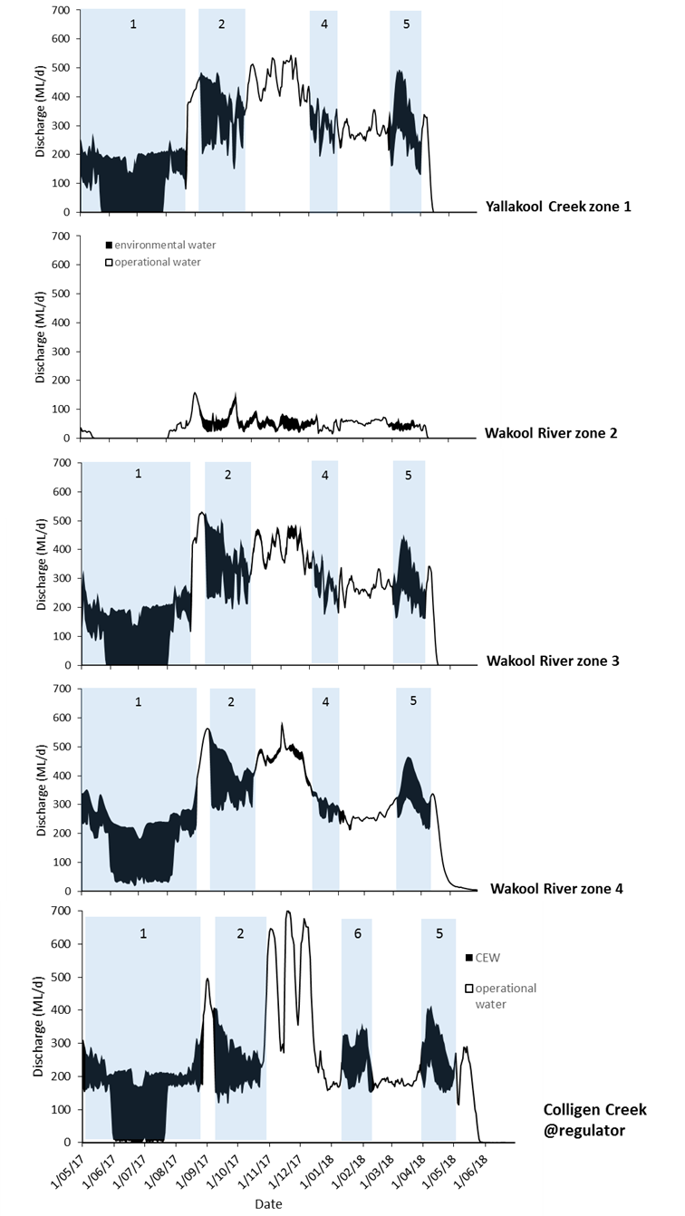

**Figure 3.** Hydrographs of zones 1 Yallakool Creek, and zones 2, 3 and 4 in the Wakool River, and Colligen creek from 1 May 2017 to 30 June 2018. The portion of the hydrographs coloured black is attributed to the delivery of Commonwealth Environmental Water. Numbered blue shaded sections relate to the environmental watering actions listed in Table 1.

**Water quality**

Overall the water quality in the Edward-Wakool selected area during the 2017-18 water year was characterised by a return to normal conditions following two seasons of extreme events (the 2015-16 cyanobacteria bloom and the 2016-17 hypoxic blackwater event) (Figure 4).

|  |  |
| --- | --- |
| **Indicator** | **Key result** |
| Dissolved oxygen concentration | Watering action 6 supported dissolved oxygen concentrations in the Colligen-Niemur system during January and February 2018 by increasing flow to minimise the period where DO concentrations fell below 4 mg/L and prevented DO concentrations falling below 2 mg/L. Over the 4 years of LTIM DO concentrations were consistently higher during late summer and early autumn seasons in zones 1, 3 and 4 receiving environmental water than in zone 2 that has received none or minor environmental watering actions. |
| Nutrient concentrations | There was no detectable effect of environmental watering actions on this indicator in 2017-18. Nutrient concentrations remained within the expected range throughout the system during this sampling season. The absence of overbank flows meant that substantial nutrient inputs were not expected in the system |
| Temperature regimes | None of the watering actions targeted temperature. Water temperatures in the system were primarily controlled by the prevailing weather conditions. |
| Type and amount of dissolved organic matter | There was no detectable effect of environmental watering actions on this indicator in 2017-18. The watering actions in 2017-18 did not specifically target the transport of dissolved organic matter. |

**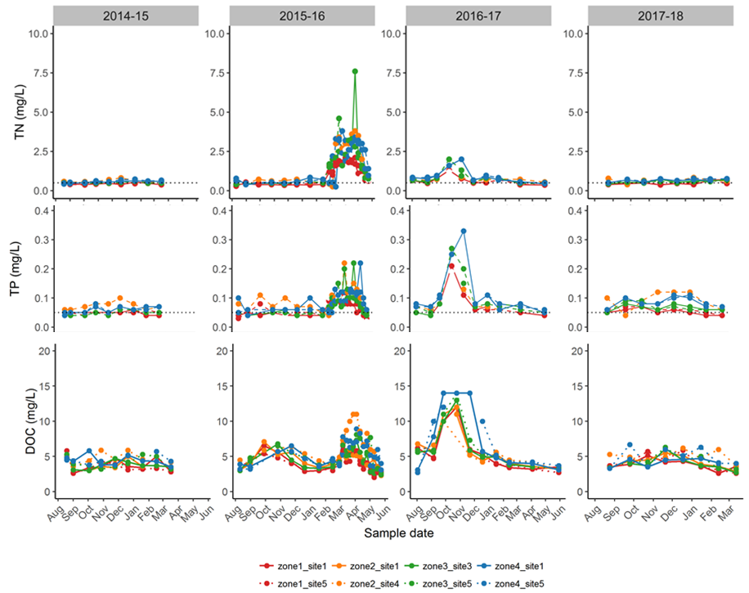**

**Figure 4** Total nitrogen, total Phosphorous and dissolved organic carbon (mg/L) in four LTIM zones over the 2014-15, 2015-16, 2016-17 and 2017-18 water years. There was a cyanobacteria bloom in autumn 2015-16 and an unregulated flood and hypoxic blackwater event in 2016-17.

**Stream metabolism**

Commonwealth environmental water contributed significantly to primary production in reaches where water was delivered. Creating more ‘food’ at the base of the food web and more nutrients from ecosystem respiration (to generate this ‘food’) is a positive outcome of these watering actions, even though water remained well within the defined stream channel at all times. All of the environmental watering actions resulted in increased production of carbon (Figure 5). The total additional production varied depending on i) time of year (i.e. with season), ii) the background flow (i.e. without CEW), iii) the volume of CEW being delivered, and iv) the duration of the CEW watering action.

|  |  |
| --- | --- |
| **Indicator** | **Key result** |
| Gross Primary Production (GPP) and Ecosystem Respiration (ER) | Watering actions decreased the rates of gross primary production (mg O2/L/day) simply through a dilution effect. However, when GPP was calculated as the amount of organic carbon (‘fish food’) produced per day (kg C/day) then watering actions had a beneficial effect (more ‘food’ is better). Carbon production was enhanced by between 1% and 218% per day, with a median across all zones and watering actions of 41% more carbon produced during environmental watering actions compared to no environmental water. |
| Production: respiration (P/R) | Watering actions decreased the rates of ecosystem respiration (mg O2/L/day) simply through a dilution effect. However, when ER was calculated as the amount of organic carbon consumed per day (kg C/day), then watering actions had a beneficial effect. A higher amount of organic carbon consumed means more nutrient recycling and hence greater nutrient supply to fuel GPP. At no stage did the environmental watering actions create so much respiration that dissolved oxygen dropped below ‘safe’ values for aquatic biota. |

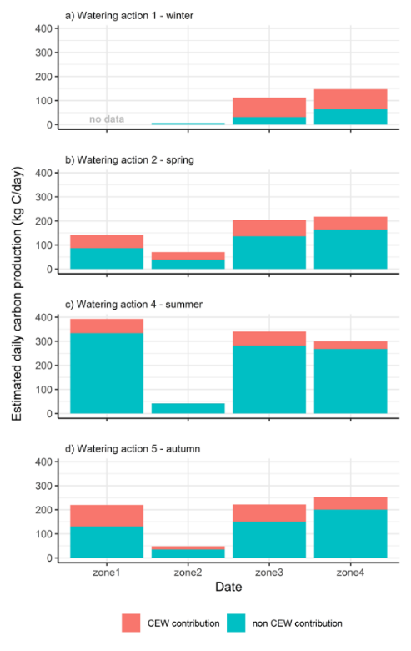 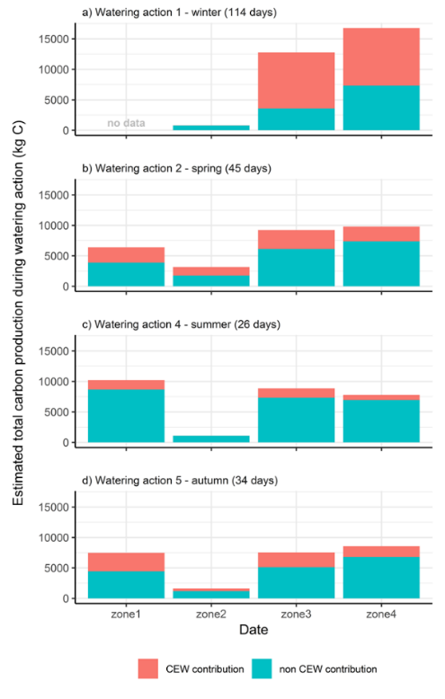

**Figure 5.** Left: The average daily additional production of carbon (kg C/day) during four environmental watering actions. Right: The total additional production of carbon (kg) over the four watering actions. Blue is the production attributed to operational water (non CEW), and orange indicates the production attributed to Commonwealth environmental water.

**Vegetation**

Riverbank and aquatic vegetation in the Edward-Wakool system was considerably impacted by the large unregulated flood in spring 2016. There has been some recovery of riverbank and aquatic vegetation since the flood of 2016, however the total species richness in 2017-18 was lower than in 2015-16 prior to the 2016 flood. Submerged and amphibious vegetation species have recovered faster in river reaches where Commonwealth environmental watering actions have been implemented. In each of the four years of the LTIM program there has been higher total species richness in zones 1, 3 and 4 that received environmental water than in zone 2 that has received none or insignificant environmental watering actions. There is also more amphibious vegetation taxa in zones 1, 3 and 4 that have received environmental water than in zone 2 that has received minimal or no environmental watering (Figure 6).

|  |  |
| --- | --- |
| **Indicator** | **Key result** |
| Total species richness | Riverbank and aquatic vegetation showed some recovery since the flood of 2016, however the total species richness in 2017-18 was lower than in 2015-16 prior to the 2016 flood. Over the 4 years of LTIM there was higher species richness in zones 1, 3 and 4 that received environmental water than in zone 2 that has received none or minor environmental watering actions. |
| Richness of functional groups | There has been some recovery of the richness of submerged and amphibious taxa in 2017-18 but the richness of submerged and amphibious taxa in 2017-18 was lower than in 2015-16 prior to the 2016 flood. There were more amphibious vegetation taxa in zones 1, 3 and 4 that have received base flows and freshes each year since 2014 and have greater lateral connectivity, than in zone 2 that has received minimal or no environmental water. |
| Percent cover of functional groups | The percentage cover of submerged and amphibious taxa in 2017-18 was low compared to 2014-15 and 2015-16 prior to the flood. In 2017-18 there was no difference in cover among the zones. |

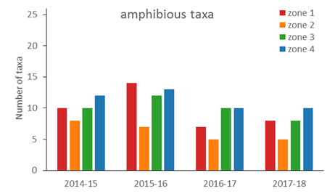 **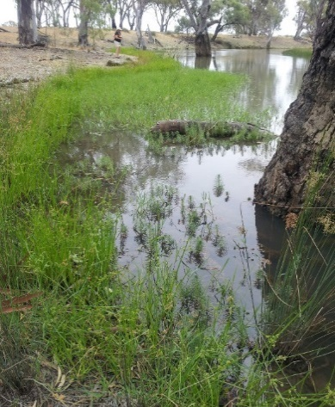**

**Figure 6.** Left: Total richness of amphibious vegetation taxa (those that tolerate wetting and drying, and those that respond to water level fluctuations) monitored monthly across four zones in the Edward-Wakool system between August 2014 and May 2018. Zone 1= Yallakool Creek, zone 2 =upper Wakool River, zone 3 = mid Wakool River upstream of Thule Creek, zone 4=mid Wakool River downstream of Thule Creek. Right: Amphibious vegetation in zone 1 Yallakool Creek

**Fish**

The standardised catch of key taxa, such as Murray cod and golden perch, remained substantially lower in both 2017 and 2018 compared with 2015 and 2016. Nevertheless, there were a number of positive outcomes observed in response to environmental watering suggest the fish community is recovering. While adult populations of Murray cod have not recovered to pre-2016 levels within the system, the presence of a low abundance of adults appears to be translating to successful spawning and recruitment. Silver perch moved substantially larger distances during the winter 2017 watering action 1, in contrast to the same period in 2016 (winter shutdown) (Figure 7). Spawning in silver perch was detected in Yallakool Creek (zone 1) in early December 2017, providing the first contemporary evidence of localised spawning in this species in the study focal area (Figure 8). Freshwater catfish larvae were detected in the Wakool River for the first time in 2017-18 (Figure 9).

|  |  |  |
| --- | --- | --- |
| **Theme** | **Indicator** | **Key result** |
| **Fish movement** | Movement of golden perch and silver perch | The winter base flow facilitated movement of silver perch, which differed from previous years when the winter operational shutdown restricted their movements. Watering actions 2 and 4 facilitated connectivity among LTIM focal zones and enabled movement of golden and silver perch. Tagged adult silver perch were present in Yallakool Creek concurrent with the detection of spawning in December 2017. |
| **Fish spawning** | Larval abundance of equilibrium species | In 2016-17 Murray cod larval counts were very low due to the hypoxic blackwater event. The increase in larval Murray cod counts in 2017-18 suggests that CEW winter base flows in 2017 may have assisted the movement of adult Murray cod back into the system prior to spawning. Freshwater catfish larvae were detected in the Wakool River downstream of Thule Creek (zone 4) for the first time in 2017-18. Winter base flows providing permanency of water throughout river reaches will be important in providing persistence of habitat year round for this species. |
| Larval abundance of periodic species | Silver perch were detected to have spawned in Yallakool Creek, the first time spawning has been detected since monitoring commenced in 2015. The timing of the presence of silver perch eggs coincided with water temperature >21 °C, peak of a fresh where the change in water height was approximately 23 cm over 4 days, full moon, and a large area of channel in Yallakool Creek having fast water velocities (> 0.3 ms-1). |
| Larval abundance of opportunistic species | The abundance of Australian smelt larvae was significantly higher in zones that received watering action 2 an early spring fresh (zones 1, 3 and 4) than in zone 2 (almost no environmental water). |
| **Fish recruitment** | Murray cod, silver perch and golden perch recruitment | Murray cod recruits were detected in 2018 throughout the Edward Wakool system, in contrast to the absence of Murray cod recruits in 2017 following the 2016 hypoxic blackwater event. This suggests there has been some recovery of this species in 2018. There were no silver perch YOY or 1+ recruits detected in 2017-18, whereas there was one recruit in 2014-15 and 25 in 2015-16. Golden perch recruits have not been detected by monitoring during any of the four sampling years in the Edward-Wakool Selected Area. |
| **Fish populations** | Adult fish populations | The relative abundance of large-bodied native fish, including bony herring, golden perch and Murray cod, increased in comparison to 2016-17. Recruits of Murray cod and bony herring were captured at similar proportions to pre-hypoxia (2016 flooding), indicating successful (albeit reduced) spawning and recruitment in 2017-18. |

**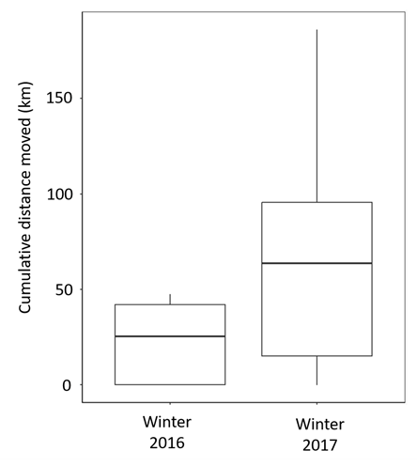**

**Figure 7.** Cumulative distances moved by silver perch during watering action 1 (winter 2017) in comparison with the same period in 2016 (winter 2016). Note that sample sizes vary considerable between the two sample events (n=5 in 2016 and n=18 in 2017) and that data are represented as box (light bars = 25th and 75th percentiles; dark bar = median value) and whisker (5th and 95th percentiles).

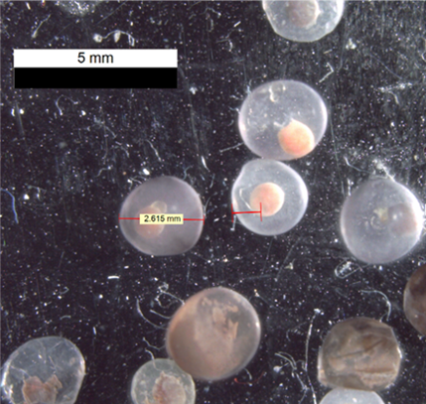

**Figure 8.** Silver perch eggs collected from drift nets deployed in Yallakool Creek, 5-8 December 2017. (Photo N McCasker)

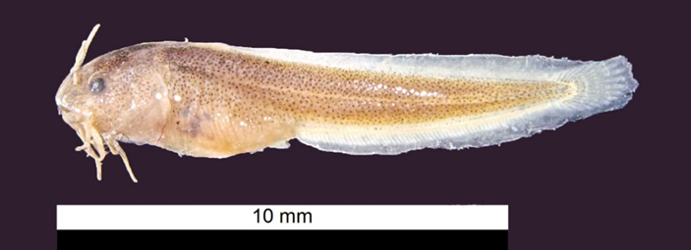

**Figure 9.** Freshwater catfish *(Tandanus Tandanus)* larvae (Photo: john Trethewie)

**Summary of responses to watering actions**

A summary of key outcomes for each of the watering actions in 2017-18 and in response to the longer-term watering regime is presented in the following tables.

Ecosystem responses watering action 1 – winter base flow

|  |  |  |
| --- | --- | --- |
| **Watering action** | | **Key outcomes** |
| 1 | Winter watering action in Yallakool creek and Colligen Creek (base flow) | * Increased maximum, minimum, mean and median discharge in zones 1, 3, 4 and Colligen Creek compared to operational flows * Reduced the coefficient of variation of discharge (CV) in zones 1, 3 and 4 compared to operational flows * Maintained longitudinal connectivity in zones 1, 3, 4 and Colligen Creek * Large increase in carbon production in zones 3 and 4 compared to operational flows * Facilitated movement of silver perch throughout the zones, which is different to previous years when the winter operational shutdown restricted their movement * Increased larval Murray cod counts in 2017-18 suggests that winter flows may have assisted movement of cod back into the system prior to spawning |

Ecosystem responses watering action 2 – winter base flow

|  |  |  |
| --- | --- | --- |
| **Watering action** | | **Key outcomes** |
| 2 | Early season fresh at beginning of e-flow with flow recession | * Increased the minimum, mean and median discharge in zones 1, 3, 4 and Colligen Creek compared to operational flows * Reduced CV in zones 1, 3 and 4 compared to operational flows * Increased the duration of lateral connectivity in zones 1, 3 and 4 compared to operational flows * Increased the duration of the recession to 32 days in Yallakool Creek and other downstream reaches compared with what would have been a rapid reduction from 460 ML/d to 200 ML/d over 3 days under operational flows * Increased the hydraulic diversity in reaches receiving environmental water compared to modelled operational flows * Small increase in carbon production in all zones compared to operational flows * Facilitated movement of golden and silver perch * The abundance of Australian smelt larvae was significantly higher in zones that received this watering action (zones 1, 3 and 4) than in zone 2 |

Watering action 3 – not delivered

Watering action 4

|  |  |  |
| --- | --- | --- |
| **Watering action** | | **Key outcomes** |
| 4 | Summer fresh with flow recession | * Increased the minimum, mean and median discharge in zones 1, 3 and 4 and Colligen Creek compared to operational flows * Small increase in carbon production in zones 1, 3 and 4 compared to operational flows. Zone 2 did not receive environmental water during this action. * Facilitated movement of golden and silver perch |

Watering action 5

|  |  |  |
| --- | --- | --- |
| **Watering action** | | **Key outcomes** |
| 5 | Autumn fresh in Yallakool Creek and Colligen Creek with flow recession | * Increased the maximum, minimum, mean and median discharge in zones 1, 3 and 4 and Colligen Creek compared to operational flows * The recession increased the extent and duration of lateral connectivity in zones 1, 3 and 4 and Colligen Creek compared to operational flows * Increased the hydraulic diversity in reaches receiving environmental water compared to modelled operational flows * Increase in carbon production in zones 1, 3 and 4 compared to operational flows |

Watering action 6

|  |  |  |
| --- | --- | --- |
| **Watering action** | | **Key outcomes** |
| 6 | Summer fresh in Colligen-Niemur system | * Increased the max, min, mean and median discharge compared to operational flows * Increased the extent of lateral connectivity compared to operational flows * Increased the hydraulic diversity compared to modelled operational flows * Supported dissolved oxygen concentrations during January and February 2018 by increasing flow to minimise the period where DO concentrations fell below 4 mg/L and prevented DO concentrations falling below 2 mg/L |

Longer term responses to watering regime (multiple years)

|  |  |  |
| --- | --- | --- |
| **Watering action** | | **Key outcomes** |
|  | Multi-year environmental watering in zones 1,3 and 4 | * Over 4 years DO concentrations were consistently higher during late summer/early autumn in zones 1, 3 and 4 (e-water) than in zone 2 (no or minor e-water) * Over the 4 years of LTIM there was higher total species richness, higher amphibious species richness, and higher percent cover of submerged and amphibious vegetation taxa in zones 1, 3 and 4 that received freshes and a winter base flow in 2017 than in zone 2 that has received none or minor environmental watering actions |

# Recommendations and implications for future management of environmental water

A list of recommendations outlined in previous Edward-Wakool LTIM annual reports (Watts et al. 2015, 2016, 2017b) and the extent to which they have been implemented is provided in Appendix 1. We continue to endorse all of these recommendations. In addition, we outline five recommendations to improve the planning and delivery of environmental water in the Edward-Wakool system. Where applicable, a comment has been included to indicate to what extent the recommendation has already been applied in the Edward-Wakool system.

**Recommendation 1:** Implement environmental watering actions for freshes in spring and early summer (October to December) that include flow variability up to a magnitude of + 125 to 150 ML/d. Undertake trials to improve understanding of the magnitude of variability that provides beneficial ecosystem outcomes.

**Adaptive management:** Watering actions are currently planned for spring 2018 that include multiple pulses in Yallakool Creek with discharge ranging from 430 to 550 ML/d, over a range of approximately 20 cm change in water level.

**Recommendation 2:** Implement a second trial of continuous base winter environmental flow (no winter cease to flow) in the tributaries of the Edward-Wakool system to promote the temporal availability and continuity of instream habitat to benefit fish and other aquatic animals and assist the recovery of submerged aquatic plants in the system.

**Adaptive management:** Following the successful implementation of the winter flow trial in winter 2017, a winter flow could not be delivered in 2018 due to maintenance of Stevens Weir. CEWO have undertaken the discussions with various stakeholder groups regarding the implementation of a winter base flow in 2019, but a final decision regarding the implementation of that has not yet been made and will need to take into account maintenance works planned by WaterNSW on Stevens Weir.

**Recommendation 3:** Trial the delivery of an environmental watering action in the Edward River downstream of Stevens Weir to target golden perch and silver perch spawning, supported with appropriate monitoring.

**Recommendation 4:** In collaboration with stakeholders explore options to implement environmental watering actions that include a short duration flow peak that is higher than the current constraint of 600 ML/d at the Wakool-Yallakool confluence. This would facilitate a test of the hypothesis that a higher discharge in-channel environmental watering action will result in increased river productivity.

**Adaptive management:** A flow trial with discharge of 800 ML/d at the Wakool-Yallakool confluence was implemented in spring 2018 (to be reported in 2018-19 Edward-Wakool LTIM report). The outcomes of the 2018 flow trial will be included on the agenda for future meetings of the Edward-Wakool Environmental Water Reference Group and will underpin discussions of future flow actions. Social research on the communities’ perceptions, concerns and understanding of the flow trial and environmental watering is being undertaken to assist discussions about future watering actions.

**Recommendation 5:** Trial a carefully managed environmental watering action through Koondrook-Perricoota Forest via Barbers Creek to improve the productivity of the mid and lower Wakool River system.

# Acknowledgements

The authors of this report as well as the Commonwealth Environmental Water Office respectfully acknowledge the traditional owners of the Murray-Darling Basin, their Elders past and present, their Nations, and their cultural, social, environmental, spiritual and economic connection to their lands and waters.

We extend our thanks to the Edward-Wakool Environmental Water Reference Group, Wakool River Association, the Colligen and Niemur Group, Edward-Wakool Angling Association, Yarkuwa Indigenous Knowledge Centre Aboriginal Corporation, and landholders in the Edward-Wakool river system for their keen interest in this project and for providing access to monitoring sites on their properties. Fieldwork and/or laboratory work was led by John Trethewie, Chris Smith, Sascha Healy and Xiaoying Liu, with assistance from Shayne Bell, Tom Butterfield, Jonathon Doyle, Ben Edwards, Roseanna Farrant, Tim McGarry, Matt Linn, Nathan McGrath, Jarryd McGowan, Nick O’Brien, Deena Paris, Rohan Rehwinkel, Sam Ryan, Dale Wood and Ian Wooden.

Maps were prepared by Simon McDonald and Deanna Duffy (Charles Sturt University Spatial Analysis Unit), Rod Martin (NSW DPI) and Ian Wooden (NSW DPI). Tina Hines at the Monash University Water Studies Centre processed carbon and nutrient samples. Larval and juvenile fish sampling was carried out under NSW Fisheries license (P14/0004-1.3) and approved by the CSU Animal Care and Ethics Committee (larval fish surveys: A16080, recruitment surveys: A16098). Sampling in the Murray Valley National Park was permitted under the National Parks and Wildlife Act 1974 (Scientific License: SL101403). Adult fish surveys were conducted by DPI Fisheries under Fisheries NSW Animal Care and Ethics permit 14/10. This project was funded by the Commonwealth Environmental Water Office with in-kind contributions from Charles Sturt University, NSW Department of Primary Industries, Monash University, NSW Office of Environment and Heritage, and Murray Local Land Services.

# References

Gawne B, Brooks S, Butcher R, Cottingham P, Everingham P and Hale J (2013) Long-term Intervention Monitoring Project Monitoring and Evaluation Requirements Edward-Wakool river system for Commonwealth environmental water. Final Report prepared for the Commonwealth Environmental Water Office by The Murray-Darling Freshwater Research Centre, MDFRC Publication 01.2/2013, May, 32pp.

Watts R., McCasker N., Thiem J., Howitt J., Grace M., Kopf R., Healy S. and Bond N. (2015) *Commonwealth Environmental Water Office Long Term Intervention Monitoring Project: Edward-Wakool Selected Area Technical Report, 2014-15*. Prepared for Commonwealth Environmental Water Office.

Watts R.J., McCasker N., Howitt J.A., Thiem J., Grace M., Kopf R.K., Healy S., Bond N. (2016) *Commonwealth Environmental Water Office Long Term Intervention Monitoring Project: Edward-Wakool River System Selected Area Evaluation Report, 2015-16.* Report prepared for Commonwealth Environmental Water Office. Commonwealth of Australia.

Watts R.J., Kopf R.K., McCasker N., Howitt J.A., Conallin J., Wooden I. and Baumgartner L. (2017a) Adaptive management of environmental flows: Using irrigation infrastructure to deliver environmental benefits during a large hypoxic blackwater event in the southern Murray-Darling Basin. *Environmental Management*. DOI 10.1007/s00267-017-0941-1.

Watts R.J., McCasker N., Howitt J.A., Thiem J., Grace M., Kopf R.K., Healy S., Bond N. (2017b) *Commonwealth Environmental Water Office Long Term Intervention Monitoring Project: Edward-Wakool River System Selected Area Evaluation Report, 2016-17.* Report prepared for Commonwealth Environmental Water Office. Commonwealth of Australia.

Watts R.J., McCasker N.G., Howitt J.A., Thiem J.D., Grace M.R., Trethewie J.A., Healy S., Bond N.R. (2018). Commonwealth Environmental Water Office Long Term Intervention Monitoring Project: Edward-Wakool River System Selected Area Summary Report, 2017-18. Report prepared for Commonwealth Environmental Water Office. Commonwealth of Australia.

# Appendices

**Appendix 1.** Summary of recommendations from Edward-Wakool 2014-15, 2015-16 and 2016-17 LTIM annual reports, showing year implemented and details of actions undertaken. EWEWRG = Edward-Wakool Environmental Water Reference Group, EWSC=Edward-Wakool Stakeholder Committee, EWOAG= Edward-Wakool Operations Advisory Group. R = recommendation number

|  |  |  |  |
| --- | --- | --- | --- |
| **Recommendation** | **Year(s) recommended** | **Year(s) implemented** | **Details of actions undertaken** |
| 1. Increase the duration of the recession of environmental watering actions relative to the Yallakool Creek environmental watering actions in 2012-13 and 2013-14 | 2014-15 (R1)  2015-16 (R8) | 2015-16  2016-17  2017-18 | Environmental water has consistently been used to increase the duration of recession of small in-channel freshes in the Edward-Wakool system |
| 1. Avoid long periods of constant flows by introducing flow variability into environmental watering actions. | 2014-15 (R2)  2015-16 (R5) | 2015-16  2016-17  2018-19 | **2015-16** was provided the river operator with an ‘operational range’.  **2016-17 and 2017-18** this has been applied by including variability in the watering plan. |
| 1. Consider a trial to increase the delivery of environmental water to the upper Wakool River | 2014-15 (R3)  2015-16 (R6)  2016-17 (R5) | Not implemented | In most years a small volume of environmental water has been delivered to the upper Wakool River. However the regulator limits the delivery of larger volumes of environmental water to this zone. Water can be delivered to part of this zone from the Wakool escape. |
| 1. Consider the delivery of continuous base environmental flows during autumn and winter to promote the temporal availability and continuity of instream habitat | 2014-15 (R4)  2015-16 (R2)  2016-17 (R3) | Winter 2017 | **2016-17:** CEWO held discussions with stakeholder groups and management agencies  **2017-18:** A continuous winter flow was implemented in Yallakool Creek,-Mid & Lower Wakool River and the Colligen -Niemur system.  **2018-19:** Winter watering was discussed during planning for 2018-19 but could not be delivered in 2018 due to maintenance of Stevens weir. |
| 1. Continue to include a water use option in water planning that enables environmental water to be used to mitigate adverse water quality events | 2014-15 (R5)  2015-16 (R7) | 2014-15  2015-16  2016-17  2017-18 | Contingency flows have been made available to contribute to responses to hypoxic blackwater events or other poor water quality events should they occur. This allowance has been used on several occasions to deliver flows. |
| 1. Set watering action objectives that identify the temporal and spatial scale at which the response is expected and are realistic given the magnitude of watering actions proposed | 2014-15 (R6) | ongoing | Water managers have improved objective setting in their water planning. |
| 1. Consider the implementation of a short duration environmental flow trial in late winter/spring 2016 at a higher discharge than the current constraint of 600 ML/d. This would facilitate a test of the hypothesis that larger in-channel environmental watering action will result in increased river productivity. | 2014-15 (R7)  2015-16 (R3) | 2018-19 | **2016-17:** CEWO and Wakool River Association facilitated discussions with stakeholders to trial flows above current operational constraints, up to ~ 800 ML/d at the Wakool/Yallakool confluence.  **2017-18:** Discussions continued and flow trial proposal was planned to proceed in Autumn 2018. However, due to poor water quality in the system the Autumn flow trial was postponed until 2018-19.  **2018-19:** A flow trial up to 800 ML/d is being implemented in Spring 2018. |
| 1. Consider the implementation of an environmental watering action in the Edward River to target golden perch and silver perch spawning. | 2014-15 (R8)  2015-16 (R4)  2016-17 (R4) | Not yet implemented | This recommendation has not yet been implemented nor is there monitoring in place to detect a spawning response if it occurred. |
| 1. Undertake a comprehensive flows assessment for the tributaries of the Edward-Wakool system to better inform future decisions on environmental watering in this system. | 2014-15 (R9)  2015-16 (R1) | Partly undertaken | Some flow assessments have been undertaken by MDBA and NSW OEH but there are still limitations of models in parts of the Edward-Wakool system. These assessments contribute management decisions and long-term water planning by OEH. |
| 1. Collaborate with other management agencies and the community to maximise the benefits of Commonwealth environmental watering actions | 2014-15 (R10) | ongoing | **2014-16:** Engagement through the Edward-Wakool Stakeholder Group (chair Murray LLS).  **2016 - ongoing**: EWEWRG established  **2014 - ongoing**: Edward-Wakool Operations Advisory Group. |
| 1. If there is an imminent hypoxic blackwater event during an unregulated flow and the quality of source water is suitable, water managers in partnership with local landholder and community representatives should take action to facilitate the earlier release of environmental water on the rising limb of the flood event to create local refuges prior to dissolved oxygen concentrations falling below 2 mgL-1. | 2016-17 (R1) | Not yet implemented | The opportunity to action this recommendation has not yet arisen. |
| 1. The installation of a dissolved oxygen logger on a gauge downstream of Yarrawonga and upstream of Barmah-Millewa Forest should be considered a priority. Consideration should also be given to installing dissolved oxygen loggers, both upstream and downstream of other forested areas that influence water quality in the Edward-Wakool system | * 1. (R2) | Not yet implemented |  |
| 1. Undertake in-channel habitat mapping for key reaches of the Edward-Wakool system, which could then be combined with existing hydraulic modelling to facilitate learning about this system | 2016-17 (R6) | Not yet implemented |  |
| 1. The CEWO and other relevant agencies undertake a review of the 2016 flood and subsequent hypoxic blackwater event in the Murray system and support further research into understanding these events | 2016-17 (R7) | 2017 | A review was undertaken in 2017 |