**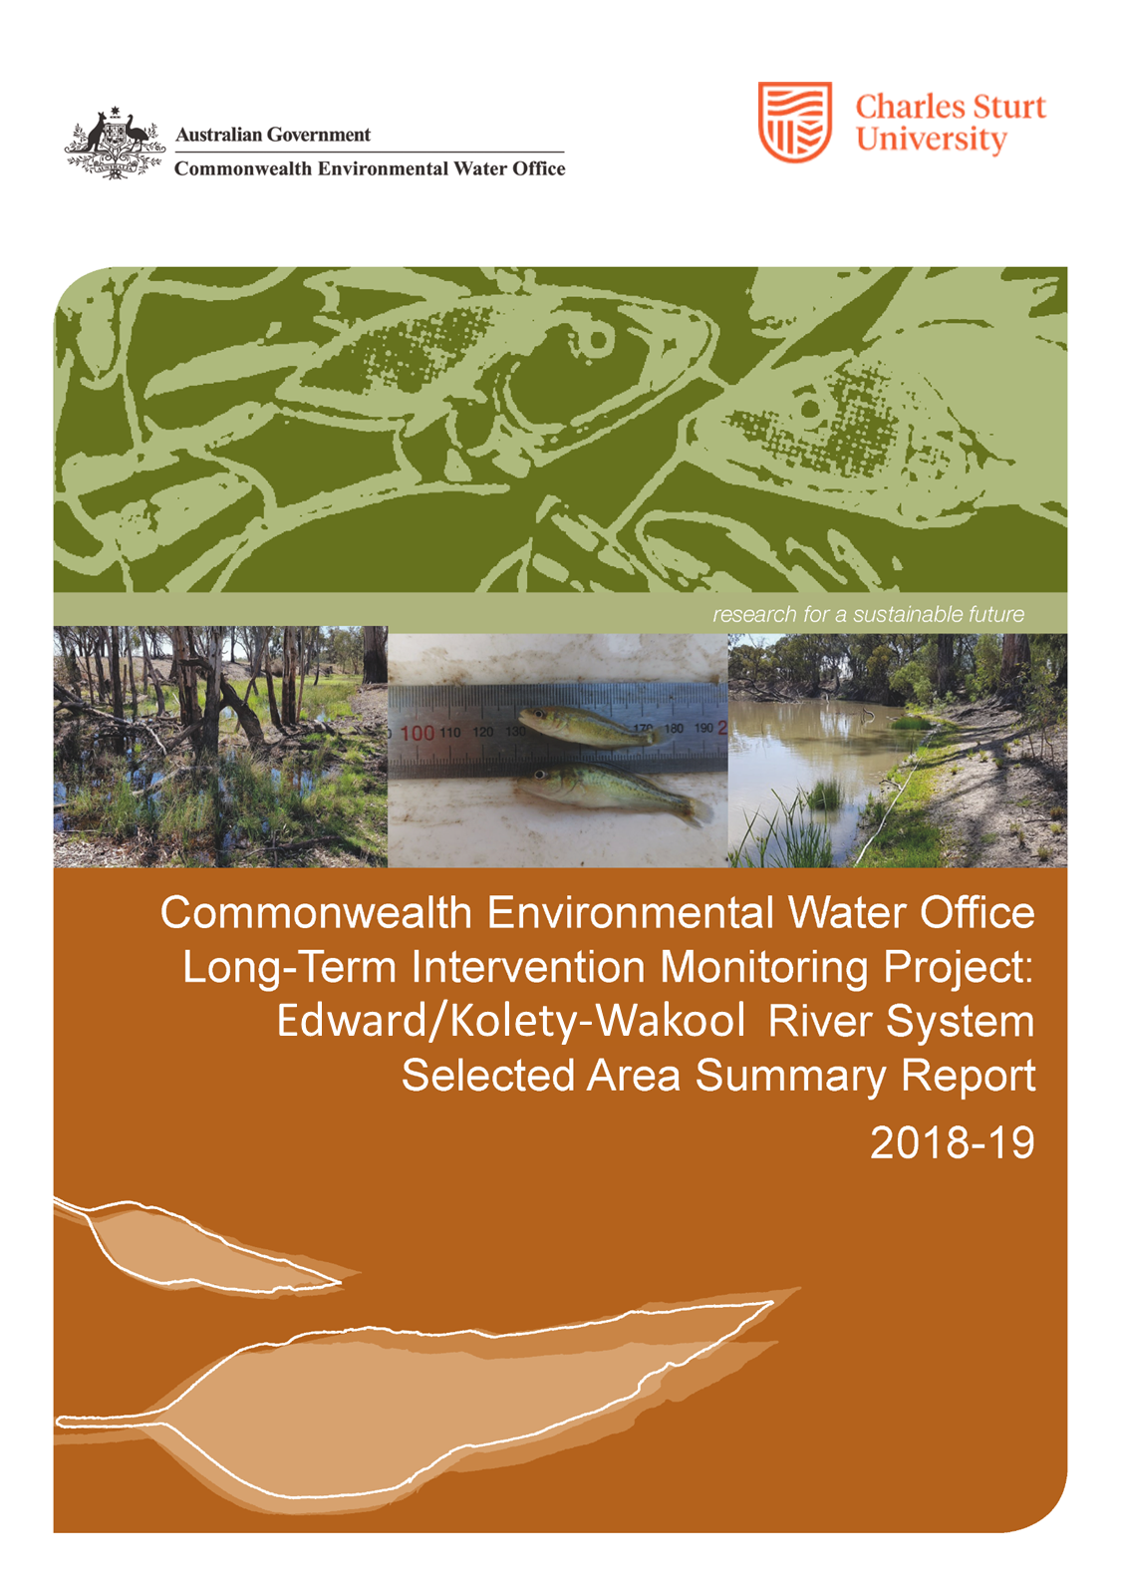**

**Copyright** © Copyright Commonwealth of Australia, 2019



‘Commonwealth Environmental Water Office Long Term Intervention Monitoring Project: Edward/Kolety-Wakool River System Selected Area Summary Report, 2018-19 is licensed by the Commonwealth of Australia for use under a Creative Commons By Attribution 3.0 Australia licence with the exception of the Coat of Arms of the Commonwealth of Australia, the logo of the agency responsible for publishing the report, content supplied by third parties, and any images depicting people. For licence conditions see: <http://creativecommons.org/licenses/by/3.0/au/>

**Disclaimer:**

The views and opinions expressed in this publication are those of the authors and do not necessarily reflect those of the Australian Government or the Minister for the Environment. While reasonable efforts have been made to ensure that the contents of this publication are factually correct, the Commonwealth does not accept responsibility for the accuracy or completeness of the contents, and shall not be liable for any loss or damage that may be occasioned directly or indirectly through the use of, or reliance on, the contents of this publication.

**Citation:**

Watts R.J., Bond N.R, Grace M.R., Healy S, Howitt J.A., Liu X., McCasker N.G., Thiem J.D., Trethewie J.A., Wright D.W. (2019). ‘Commonwealth Environmental Water Office Long Term Intervention Monitoring Project: Edward/Kolety-Wakool River System Selected Area Summary Report, 2018-19’. Report prepared for Commonwealth Environmental Water Office. Commonwealth of Australia.

The Commonwealth of Australia has made all reasonable efforts to identify content supplied by third parties using the following format ‘© Copyright.

|  |  |
| --- | --- |
|  | Institute for Land, Water and Society  Charles Sturt University  PO Box789, Albury, NSW 2640 |
| DPI_logo_colour_rgb.jpg | NSW Department of Primary Industries  Narrandera Fisheries Centre,  PO Box 182, Narrandera NSW 2700 |
|  | Water Studies Centre  Monash University  Clayton, Victoria, 3800 |
|  | NSW Department of Planning, Industry and Environment  PO Box 363, Buronga NSW 2739 |
|  | School of Life Sciences  La Trobe University  PO Box 821,Wodonga 3689 |

**Cover photos:**

Left –Inundated backwater on Bookit Island during the peak of flow trial watering action.

(Photo: R. Watts)

Middle – Young of year Murray cod (*Maccullochella peelii*) from Yallakool Creek (zone 1).

(Photo: J Trethewie)

Right – Riverbank vegetation in the mid Wakool River, December 2018 (Photo: R. Watts)

**Contents**

[Monitoring and evaluation of environmental water in the Edward/Kolety-Wakool Selected Area 4](#_Toc54957304)

[Environmental watering in 2018-19 6](#_Toc54957305)

[Key outcomes from environmental water use 2018-19 8](#_Toc54957306)

[Key outcomes of environmental water delivery 2014 – 2019 15](#_Toc54957307)

[Recommendations and implications for future management of environmental water 19](#_Toc54957308)

[Acknowledgements 20](#_Toc54957309)

[References 20](#_Toc54957310)

[Appendices 21](#_Toc54957311)

**August 2018 Sept 2018 during Feb 2019, after e-water**

**prior to e-water e-watering action 1 during operational flows**

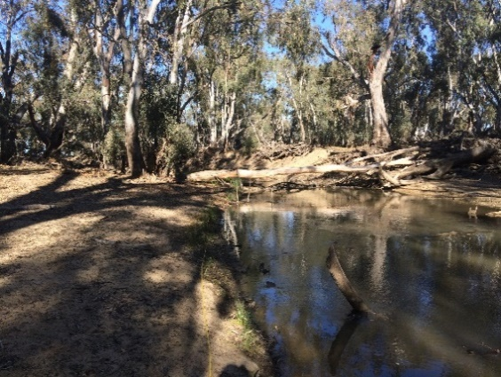 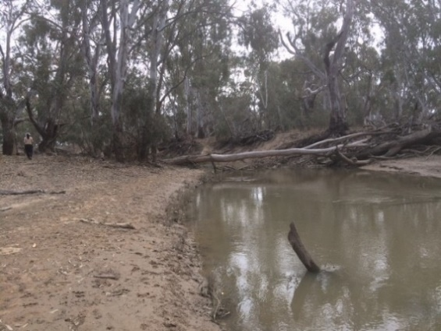 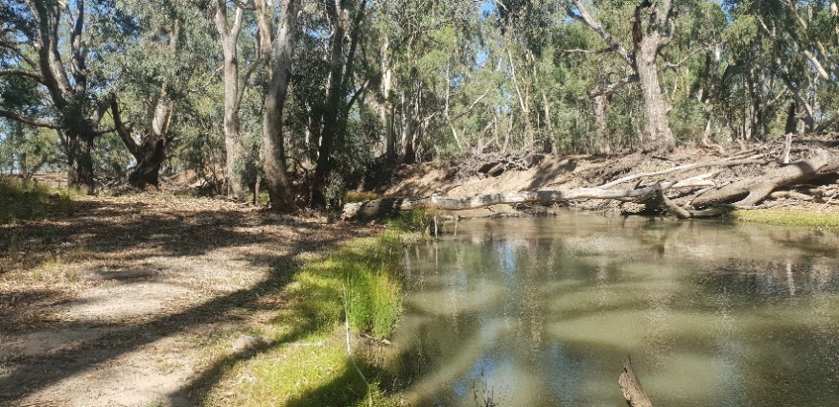

Wakool R (zone 2) 157 ML.d-1 23/8/18 18/09/18, 76 ML.d-1 20/02/19, 51 ML.d-1

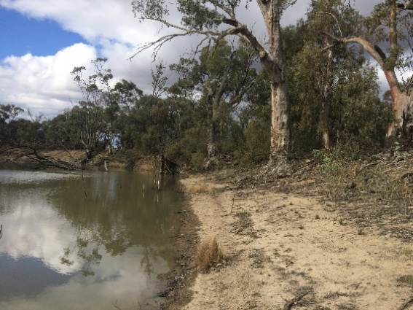 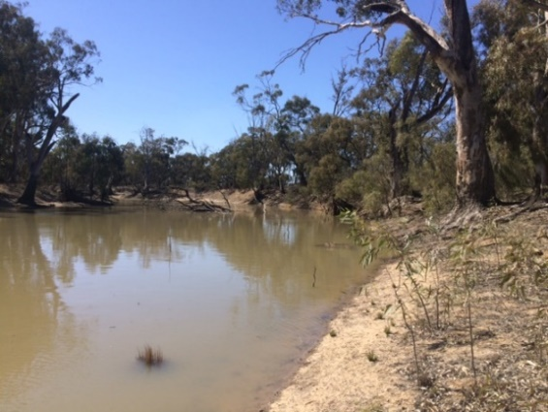 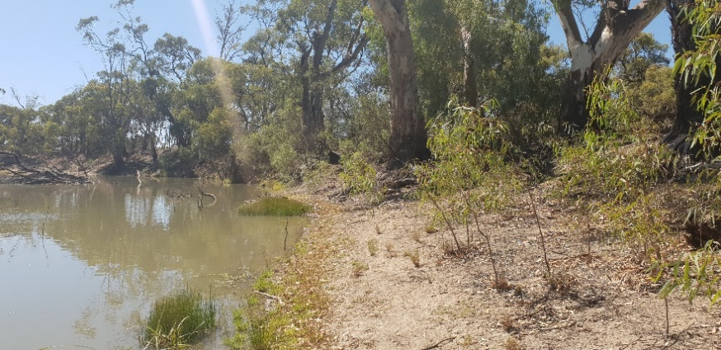

Wakool R (zone 4) 320 ML.d-1- 22/08/17 17/109/18, 623 ML.d-1 (e-flow) 21/02/19, 517 ML.d-1

Figure 1 Photos of study sites in the Edward/Kolety-Wakool system left: August 2018 before environmental watering action 1, middle: September 2018 during watering action 1, and right: February 2019 after watering action 1 and during the operations flows. Top row (Photos Nathan McGrath).

# Monitoring and evaluation of environmental water in the Edward/Kolety-Wakool Selected Area

**Introduction**

This report documents the monitoring and evaluation of ecosystem responses to Commonwealth environmental watering in the Edward/Kolety-Wakool River Selected Area in 2018-19. It also provides a summary of the key findings across the five years of the Long Term Intervention Monitoring (LTIM) Project (2014-2019) funded by the Commonwealth Environmental Watering Office. The project was undertaken as a collaboration among Charles Sturt University (CSU), NSW DPI (Fisheries), Monash University, NSW Department of Planning, Industry and Environment (DPIE), and La Trobe University. Field monitoring for the project was undertaken by staff from CSU, NSW Fisheries and DPIE

**Edward/Kolety-Wakool Selected Area**

The Edward/Kolety-Wakool system is a large anabranch system of the Murray River in the southern Murray-Darling Basin (MDB), Australia. The system begins in the Millewa Forest and travels north and then northwest before discharging back into the Murray River. It is a complex network of interconnected streams, ephemeral creeks, flood-runners and wetlands including the Edward/Kolety River, Wakool River, Yallakool Creek (Figure 1), Colligen-Niemur Creek and Merran Creek. Under regulated conditions flows in the Edward/Kolety River and tributaries remain within the channel, whereas during high flows there is connectivity between the river channels, floodplains and several large forests (Figure 2).

The Edward/Kolety-Wakool system plays a key role in the operations and ecosystem function of the Murray River and the southern MDB. Some of the water released from Hume Dam is diverted from the Murray River through the Edward/Kolety-Wakool system to avoid breaching operational constraints in the mid-Murray River. The Edward/Kolety-Wakool system also plays an important ecological role in connecting upstream and downstream ecosystems. The streams and creeks in this system provide important refuge and nursery areas for fish and other aquatic organisms, and adult fish regularly move between this system and other parts of the Murray River. As some of the rivers in the Edward/Kolety-Wakool system have low discharge there is a risk of poor water quality, particularly during warm periods. Maintaining good water quality is crucial for both the river ecosystem, the communities and landholders that rely on the water from this system.

**Monitoring sites**

The monitoring in the Edward/Kolety-Wakool LTIM Selected Area is focussed on four hydrological zones, which together are referred to as the focal zone: Yallakool Creek (zone 1), the upper Wakool River (zone 2) and mid reaches of the Wakool River (zones 3 and 4) (Figure 2). Reaches in zones 1 and 2 are generally more constrained, have steeper riverbanks and fewer in-channel benches than many of the reaches in zones 3 and 4. Additional sites throughout the system are monitored for hydrology, fish movement and fish community.

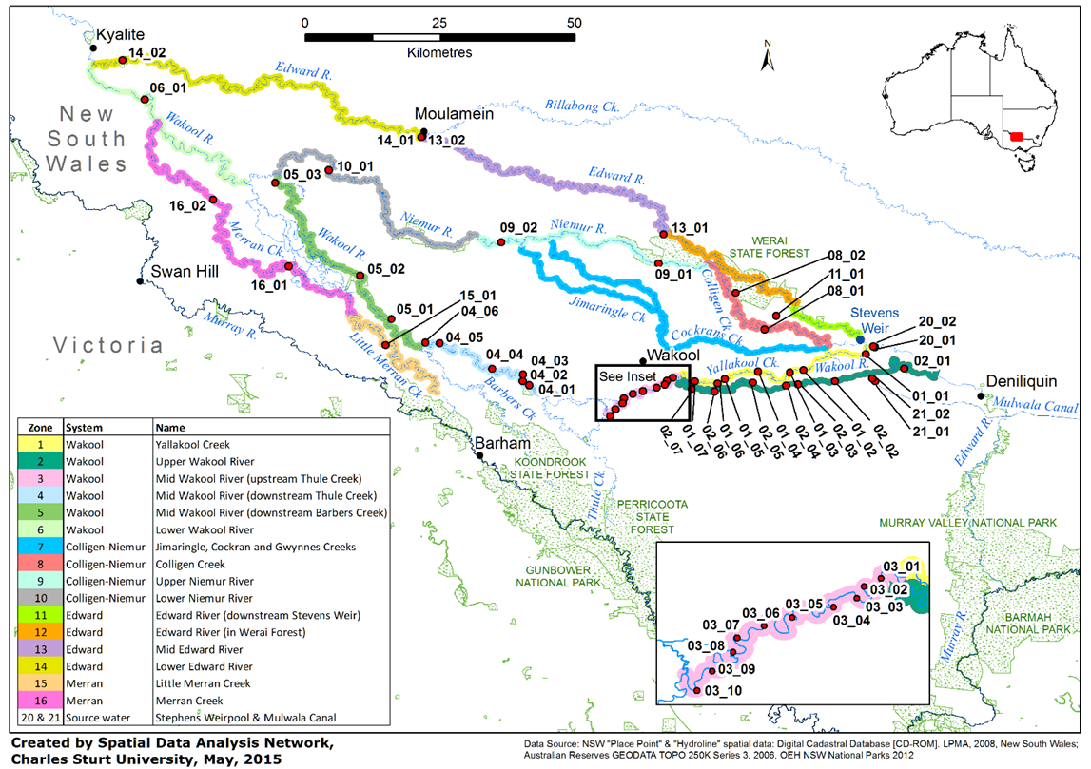

**Figure 2.** Location of monitoring sites for the Edward/Kolety-Wakool Selected Area for the Long-Term Intervention Monitoring Project. Hydrological gauges are located in Yallakool Creek site 01\_01 (gauge 409020, Yallakool Creek at offtake), Wakool River zone 2 site 02\_01 (gauge 409019, Wakool River offtake), and in the Wakool River zone 4 at site 04\_01 (gauge 409045). Site names are listed in Watts et al. (2019).

**Indicators**

This report documents the monitoring and evaluation of the following indicators:

* River hydrology
* Water quality and carbon
* Stream metabolism
* Riverbank and aquatic vegetation
* Fish movement (Murray cod, golden perch and silver perch)
* Fish reproduction
* Fish recruitment (Murray cod, golden perch and silver perch)
* Fish community

Responses to Commonwealth environmental water were evaluated in two ways:

1. Indicators that respond quickly to flow (e.g. hydrology, water quality and carbon, stream metabolism, fish movement, fish spawning) were evaluated for their response to specific watering actions (comparing responses with and without the environmental water).
2. Indicators that respond over longer time frames (e.g. riverbank and aquatic vegetation, fish recruitment) were evaluated for their response to the longer-term watering regime. This was undertaken by comparing responses over multiple years in reaches that have received environmental water (zones 1, 3 and 4) to zone 2 that has received none or minimal environmental water.

# Environmental watering in 2018-19

**Practicalities of environmental watering in the Edward/Kolety-Wakool system**

The main source of Commonwealth environmental water for the Edward/Kolety-Wakool system is from the Murray River through the Edward/Kolety River and Gulpa Creek. The main flow regulating structure within the Edward/Kolety-Wakool system is Stevens Weir located on the Edward/Kolety River (Figure 2). This structure creates a weir pool that allows Commonwealth environmental water to be delivered to Colligen-Niemur system, Yallakool Creek, the Wakool River, the Edward/Kolety River and Werai Forest. Water diverted into the Mulwala Canal from Lake Mulwala can also be delivered into the system through ‘escapes’ or outfalls managed by the irrigator-owned company Murray Irrigation Limited.

Delivery of instream flows to the Edward/Kolety-Wakool system are managed within regular operating ranges as advised by river operators to avoid third party impacts. For example, in the Wakool-Yallakool system the operational constraint is 600 ML d-1 at the confluence of the Wakool River and Yallakool Creek. Thus, the types of flow components that can be achieved under current operating ranges are in-channel base flows and freshes. Environmental watering may also be constrained due to the limitations on how much water can be delivered under regulated conditions, as channel capacity is shared with other water users. If the system is receiving higher unregulated flows, there may not be enough capacity to deliver environmental water (Gawne et al. 2013).

**Commonwealth watering actions in the Edward/Kolety-Wakool system 2009 to 2019**

Commonwealth environmental watering actions have occurred in the Edward/Kolety-Wakool system since 2009. Between July 2009 and June 2019 Commonwealth environmental watering actions delivered base flows and freshes, contributed to the recession of flow events, delivered water from irrigation canal escapes to create local refuges during hypoxic blackwater events (Watts 2018a), and contributed to flows in ephemeral watercourses (Table 1). Many of the watering actions in ephemeral creeks were undertaken jointly with NSW DPIE. To date it has not been possible to deliver large within channel freshes or overbank flows due to operational constraints in the system. In addition to watering actions specifically targeted for the Edward/Kolety-Wakool system, water from upstream Commonwealth environmental watering actions and actions that are targeted for downstream watering actions transit through the Edward/Kolety-Wakool system in some years.

**Commonwealth watering actions in 2018-19**

There were five planned Commonwealth environmental watering actions in the Edward/Kolety-Wakool Selected Area from 1 July 2018 until 30 June 2019 (Table 2). Watering action 1 (spring fresh, 800 MLd-1 flow trial) (Figure 1) is the focus of this report. Watering action 2, 3 and 4 were not implemented because environmental water was suspended between 2 October 2018 and mid-May 2019 due to increased demand in the Murray system and lack of operational capacity to accommodate environmental water in the river due to channel constraints. The winter watering action (number 5) commenced on 16 May 2019. This action will continue into the 2019-20 water year and will be evaluated in the 2019-20 Monitoring Evaluation and Research project report.

**Table 1.** Summary of environmental watering actions and unregulated overbank flows in the Edward/Kolety-Wakool system from July 2010 to June 2019.

|  |  |  |  |  |  |  |  |  |  |  |
| --- | --- | --- | --- | --- | --- | --- | --- | --- | --- | --- |
| **Type of watering**  **action** | **Water year** | | | | | | | | | |
| **2009-10** | **2010-11** | **2011-12** | **2012-13** | **2013-14** | **2014-15** | **2015-16** | **2016-17** | **2017-18** | **2018-19** |
| **In-channel environmental watering actions** | | | | | | | | | |  |
| Base flows and small freshes |  |  | **✓** | **✓** | **✓** | **✓** | **✓** | **✓** | **✓** | **✓** |
| Contribute to flow recession |  |  |  |  | **✓** | **✓** | **✓** | **✓** | **✓** | **✓** |
| Maintain winter base flows |  |  |  |  |  |  |  |  | **✓** |  |
| Larger within channel freshes1 |  |  |  |  |  |  |  |  |  |  |
| **In channel environmental watering actions using irrigation infrastructure** | | | | | | | | | |  |
| Flows from canal escapes during hypoxic events |  | **✓** |  | **✓** |  |  |  | **✓** |  |  |
| Flows in ephemeral streams2 |  | **✓** | **✓** | **✓** | **✓** | **✓** | **✓** | **✓** | **✓** | **✓** |
| Watering forests | **✓** |  |  |  |  |  |  |  |  |  |
| **Unregulated overbank flows** | | | | | | | | | |  |
| Flooding forests and/or floodplains |  | **✓** |  |  |  |  |  | **✓** |  |  |

1 Delivery of larger within channel freshes to the Wakool River and Yallakool Creek is not possible under current operational constraints

2.Some of the watering actions in ephemeral creeks are done jointly with NSW Department of Planning, Industry and Environment

**Table 2** Planned Commonwealth environmental watering actions in the Edward/Kolety-Wakool system in

2018-19. This report focusses on watering action 1 (highlighted). Planned actions 2, 3 and 4 were not implemented. The winter flow action number 5 commenced on 16th May 2019 and continued into the 2019-20 water year. This action will be evaluated in the MER project report in 2020. The MER project (2019-2022) is an extension of the LTIM project that began in 2014 and concluded in 2019.

|  |  |  |  |  |  |
| --- | --- | --- | --- | --- | --- |
|  | **Watering action** | **Action** | **Dates** | **Rivers** | **Objective** |
| 1 | Early spring fresh | small fresh | 22 August to 25 September 2018 | Yallakool Creek, mid- and lower Wakool River, Colligen-Niemur | To provide early season rise in river level to contribute to connectivity, water quality, stimulate early growth of in-stream aquatic vegetation, pre-spawning condition of native fish and/or spawning in early spawning native fish |
| 2 | Late spring action | Higher base flow and small fresh | Planned for late Oct and early Nov 2018.  Not implemented | Yallakool Creek, mid- and lower Wakool River, Colligen-Niemur | To maintain nesting habitat for Murray cod and inundation for aquatic vegetation growth. The variability flow was to prevent a flat river |
| 3 | Summer pulse | small fresh | Planned for late Nov 2018 to early Jan 2019. Not implemented | Yallakool Creek, mid- and lower Wakool River, Colligen-Niemur | To influence and encourage fish movement. May be coordinated with wider Murray River actions to maximise benefit. May also assist with dispersal of larvae and juveniles of a number of fish species. Slow recession for instream plants. |
| 4 | Autumn pulse | Small fresh | Planned for Feb to early May 2019. Not implemented | Yallakool Creek, mid- and lower Wakool River, Colligen-Niemur | To influence/encourage fish movement. May be coordinated with wider Murray River actions to maximise benefit. May also assist with the dispersal of juveniles of a number of fish species. |
| 5 | 2019 winter flow | base flow | Commenced 16 May 2019  (Ongoing) | Yallakool Creek, mid- and lower Wakool River, Colligen-Niemur | To contribute to reinstatement of the natural hydrograph, improve connectivity, condition of in-stream aquatic vegetation and fish recruitment into 2019-20. |

# Key outcomes from environmental water use 2018-19

Watering action 1 was an early spring fresh undertaken from 22 August to 25 September 2018 in Yallakool Creek and the Wakool River (Table 2). The flow trial involved changes to operating rules and practices, the aim being to exceed the maximum daily discharge of 600 MLd-1 at the confluence of Yallakool Creek and the Wakool River under regulated operating rules, with the target maximum discharge being 800 MLd-1. Planning for the action was undertaken over a period of more than one year, with the Wakool River Association, the Edward/Kolety-Wakool Environmental Water Reference Group and landholders engaged and involved in the planning and water delivery. There were some operational limitations to deliver the environmental water via the Yallakool Creek regulator when Steven’s weir pool was low, so some of the environmental water was delivered via the Wakool escape from Mulwala canal.

**Hydrology**

The hydrological outcomes of the 800 MLd-1 flow trial (action 1) summarised in Table 3 were:

* the maximum discharge in zones 1, 2, 3 and 4 increased compared to operational flows
* the variability of discharge in zones 2 and 3 increased compared to operational flows
* longitudinal connectivity was maintained throughout the system, and the higher flows initiated flow in Black Dog Creek, linking the Wakool River near ‘Widgee’ with Yallakool Creek.
* lateral connectivity (measured as wetted area) increased by an average of 10.2% across four study zones compared to modelled operational flows
* hydraulic diversity increased in reaches receiving environmental water compared to modelled operational flows

**Table 3** Hydrological outcomes of environmental watering actions in 2018-19.

|  |  |
| --- | --- |
| **Indicator** | **Key result** |
| Maximum and minimum discharge | Watering action 1 increased the maximum discharge in all zones compared to operational flows. From a water accounting perspective the total discharge of water delivery reached a maximum of 870 MLd-1 on 13 September. However, the discharge did not exceed 800 MLd-1 at any site because water was delivered from different regulators. The maximum daily discharge was 488 MLd-1 in Yallakool Creek (15 September), 398 MLd-1 at Wakool River zone 2 site 4 (13 September), 696 MLd-1 in Wakool River zone 3 (17 September), 652 MLd-1 in Wakool River zone 4 (19 September). The maximum daily operating discharge of 600 MLd-1 was exceeded in zones 3 and 4. The discharge in zone 2 downstream of the Wakool escape was higher than normal operational flows in this zone (40-80 MLd-1). |
| Flow variability | Watering action 1 increased the coefficient of variation of discharge in zones 2 and 3 compared to operational flows. |
| Longitudinal connectivity | Watering action 1 maintained longitudinal connectivity in Yallakool Creek and the Wakool River. The higher flows in the upper Wakool River (zone 2) initiated flow in Black Dog Creek, linking the Wakool River near ‘Widgee’ (zone 2 site 4) with Yallakool Creek to ‘Windra Vale’ near zone 1 site 5. |
| Lateral connectivity | Watering action 1 increased lateral connectivity in Yallakool Creek and the Wakool River. The wetted area increased by an average of 10.2%, ranging from an increase of 3.7% in zone 2 site3 to 30.3% in zone 2 site 4. |
| Hydraulic diversity | Watering action 1 increased the hydraulic diversity in reaches receiving environmental water compared to modelled operational flows. |

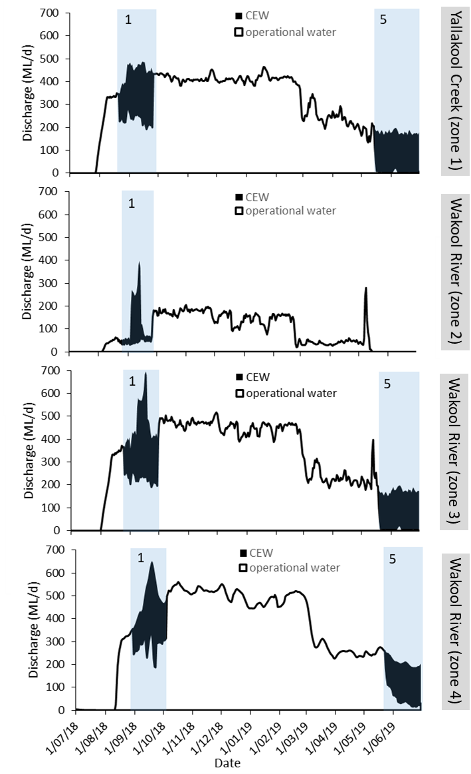

**Figure 3.** Hydrographs of four zones in the Edward/Kolety system from 1st July 2018 to 30th June 2019. The portion of the hydrographs coloured black is attributed to the delivery of Commonwealth Environmental Water. The blue shaded sections relate to the environmental watering actions listed in Table 2. 1: 800 MLd-1 flow trial and 5: 2019 winter watering action.

**Perceptions and third party impacts of flow trial**

The 800 MLd-1 flow trial exceeded the maximum daily discharge of 600 MLd-1 at the confluence of Yallakool Creek and the Wakool River under regulated operating rules. Cameras were installed at 19 sites (including staff gauges, road crossing and low level bridges) to monitor the local impacts of the flows. The 800 MLd-1 discharge inundated one low level bridge in the Bookit Island area in the mid Wakool River and one creek crossing on Black Dog Creek (Figure 4), but landholders stated that inundation this did not limit access to their properties.

Interviews with landholders, water managers, river operators and other community members were undertaken through a complementary project by Charles Sturt University to explore stakeholder’s perceptions of flow trials. In general, the flow trials were perceived by most stakeholders as an opportunity to explore how to act in a complex socio-ecological system. A dominant way that participants framed conversations was in a systems perspective. This emerged alongside other strong framings of engineering, accounting, ecology and power.

|  |  |  |
| --- | --- | --- |
| **Site name** | **Water level prior to watering action** | **Peak of watering action** |
| Mascot bridge  Yallakool Creek |  |  |
| Windra Vale bridge  Yallakool Creek |  |  |
| Bookit Island bridge #1  Wakool River |  |  |
| Bookit Island bridge #2  Wakool River |  |  |
| Crossing on Black Dog Creek |  |  |

**Figure 4** Photos of infrastructure (bridges, weirs and crossings) in the Yallakool-Wakool system taken prior to the watering action and during the peak of the flow trial.

**Water quality and carbon**

The water quality in the Edward/Kolety-Wakool system during the 2018-19 water year was characterised by a return to normal conditions following two seasons of extreme events (the 2015-16 cyanobacteria bloom and the 2016-17 hypoxic blackwater event) (Table 4).

**Table 4** Water quality and carbon outcomes of environmental watering actions in 2018-19.

|  |  |
| --- | --- |
| **Indicator** | **Key result** |
| Dissolved oxygen concentration | Watering action 1 did not result in any adverse water quality outcomes. This action was timed for when water temperatures would be low to reduce the risk of low DO. |
| Nutrient concentrations | There was no detectable effect of environmental watering on this indicator and there were no adverse water quality outcomes. |
| Temperature regimes | None of the watering actions targeted temperature. Water temperatures in the system were primarily controlled by the prevailing weather conditions. |
| Type and amount of dissolved organic matter | There was no detectable effect of environmental watering on this indicator in 2018-19 and there were no adverse water quality outcomes. Dissolved organic carbon was not elevated outside the normal range. |

**Stream metabolism**

Commonwealth environmental water contributed significantly to primary production in reaches where water was delivered (Table 5, Figure 5). Creating more ‘food’ at the base of the food web and more nutrients from ecosystem respiration (to generate this ‘food’) is a positive outcome of these watering actions, even though water remained well within the defined stream channel at all times.

**Table 5** Stream metabolism outcomes of environmental watering actions in 2018-19.

|  |  |
| --- | --- |
| **Indicator** | **Key result** |
| Gross Primary Production (GPP) and Ecosystem Respiration (ER) | Watering action 1 had a beneficial effect on the total amount of primary production. Commonwealth environmental water (CEW) increased organic carbon production in zones 1 to 4 by 36%, 134%, 71% and 38% respectively compared to operational flows. We estimate CEW added an additional 7.27 tonnes of organic carbon to the 13.9 tonnes generated by GPP without the CEW; an overall increase of 52%. This translates to a significant increase in energy available to support aquatic foodwebs. |
| Production: respiration (P/R) | When ER was calculated as the amount of organic carbon consumed per day (kg C/day), the CEW had a beneficial effect on ER. A higher amount of organic carbon consumed means more nutrient recycling and hence greater nutrient supply to fuel GPP. At no stage did the environmental watering actions create so much respiration that DO dropped below critical values for aquatic biota. |

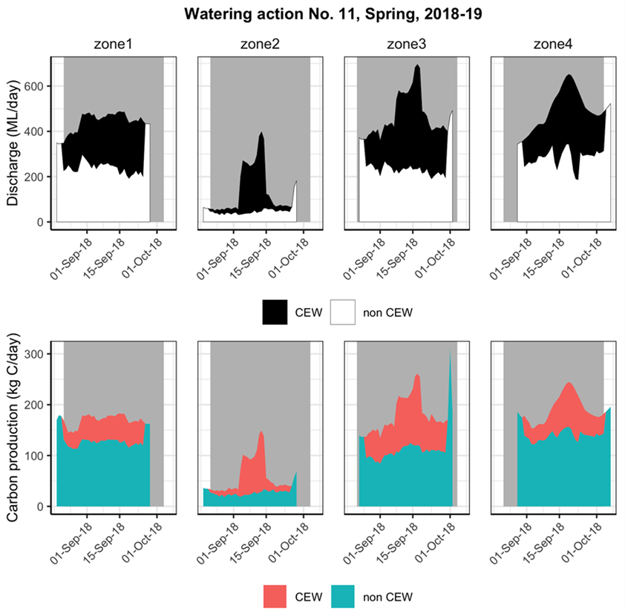

**Figure 5.** Commonwealth environmental water and operational water (non-CEW) contributions to stream flow (MLd-1) and daily organic carbon production (kg C/day) in each zone during the watering action in spring 2018. Blue is the production attributed to operational water (non CEW), and orange indicates the production attributed to Commonwealth environmental water.

**Vegetation**

Riverbank and aquatic vegetation continued to recover following the flood in 2016 (Table 6), however the percent cover of several key taxa including *Potamogeton tricarinatus* (floating pondweed) and *Myriophyllum* *spp* (milfoil) has not yet recovered (Figure 6). A small number of plants of these two species were observed outside the survey transects, suggesting that their recovery could be supported by environmental watering actions. Following watering action 1 there was strong germination on areas of riverbank that were inundated. This suggests that late winter/early spring freshes that inundate slackwater or low lying areas of riverbank within the channel can assist the germination of river bank and aquatic vegetation. Following the recession of flows, the damp banks provide ideal conditions for plant growth prior to the onset of summer. Flows that re-wet these areas can provide conditions that are suitable for amphibious plants to grow and survive the warmer conditions over the summer.

**Table 6** Riverbank and aquatic vegetation outcomes of environmental watering actions in 2018-19.

|  |  |
| --- | --- |
| **Indicator** | **Key result** |
| Total species richness | 65 riverbank and aquatic plant taxa were recorded across sixteen sites. This was the highest number of taxa recorded over the five years of the LTIM project. Between 2014 and 2018 there was higher species richness in zones 1, 3 and 4 that received environmental water than in zone 2 that received minimal or no environmental water. However, in 2018-19 the combined effects of environmental water and higher operational flows in zone 2 increased the total and mean richness of plant taxa in zone 2, so this zone had a similar average species richness as the other zones. |
| Richness of functional groups | The total species richness of submerged, amphibious and terrestrial taxa increased since the 2016 flood. |
| Percent cover of functional groups | The maximum mean percentage cover of submerged taxa and some amphibious taxa increased in 2018-19 and was similar to that in 2014-15 and 2015-16 prior to the flood. However there was minimal recovery of some key amphibious taxa, such as floating pondweed and milfoil since the 2016 flood. |

**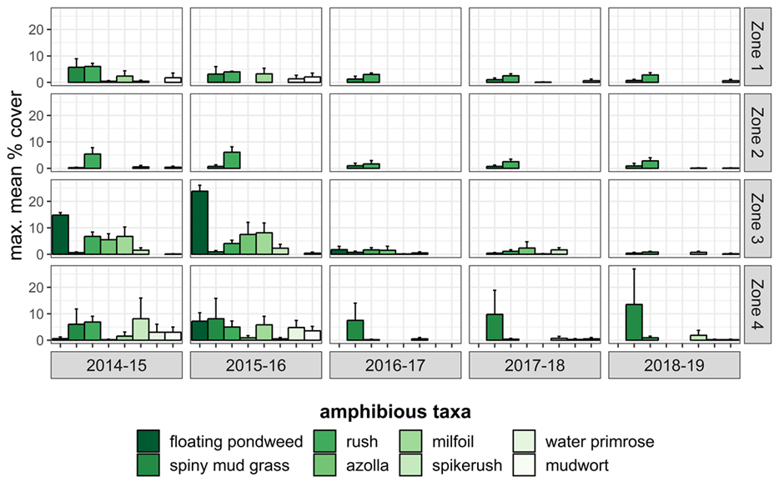 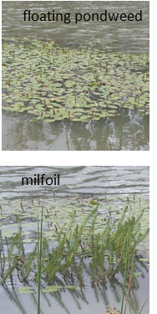**

**Figure 6** Mean percent cover of the eight most abundant amphibious vegetation taxa monitored monthly across four hydrological zones in the Edward/Kolety-Wakool system between August 2014 and May 2019.

**Fish**

There were a number of positive outcomes observed in response to environmental watering suggesting the fish community is recovering (Table 7). For example, there was an increase in the number Murray cod 1+ recruits (Figure 7, 8) detected since the hypoxic blackwater event in 2016. However, the standardised catch of key taxa (e.g. Murray cod and golden perch) remained substantially lower in 2019 compared with prior to the 2016 hypoxic blackwater event. The overall condition of the fish community (measured by the Sustainable River Audit index) was ‘Very poor’ and nativeness was ‘Moderate’ (Figure 9).

**Table 7** Fish outcomes of environmental watering actions in 2018-19.

|  |  |  |
| --- | --- | --- |
| **Theme** | **Indicator** | **Key result** |
| **Fish movement** | Movement of golden perch and silver perch | Watering action 1 in spring 2018 facilitated silver perch and golden perch movements of 57 and 12.2 km (median) respectively. |
| **Fish spawning** | Larval abundance of equilibrium species | Murray cod larvae were detected in greatest numbers in 2018-19 compared to the four previous years of LTIM, with the majority of Murray cod larvae collected from upper Wakool River (Zone 2) that received managed flows of 400 MLd-1 compared to the normal operation flows of 40-80 MLd-1. The larger number of larvae detected in drift nets compared to light traps, suggests that dispersal of larvae downstream may have exceeded local retention, and drifting larvae may contribute to Murray cod populations further downstream in the Wakool River. |
| Larval abundance of periodic species | Silver perch eggs were collected in Yallakool Creek (zone 1) and Wakool River (zone 4) in November and December 2018. This is the second year that silver perch spawning has been detected in the study zones since monitoring commenced in 2015. |
| Larval abundance of opportunistic species | The abundance of Australian smelt larvae was significantly greater in 2018-19 compared to previous years. |
| **Fish recruitment** | Murray cod, silver perch and golden perch recruitment | Murray cod 1+ recruits were detected in highest numbers since the hypoxic blackwater event in 2015-16. Silver perch 1+ recruits were detected for the first time since the hypoxic blackwater event in 2015-16. The absence of young-of-year silver perch suggests that the spawning event did not translate into a strong recruitment outcome within the survey area. Golden perch recruits continue to be absent from system, having been not recorded since the start of the LTIM program in 2015. |
| **Fish populations** | Adult fish populations | In 2018-19 nine native fish species, including silver perch and trout cod, were captured at sites across the Edward/Kolety-Wakool system. |

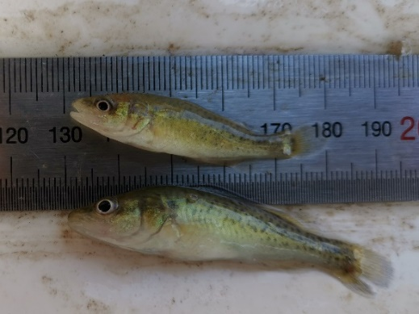 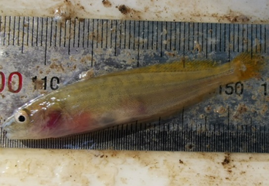

**Figure 7** Left; Juvenile Murray cod (*Maccullochella peelii*) and Right; Juvenile river blackfish (*Gadopsis marmoratus*), from Yallakool Creek (zone 1).

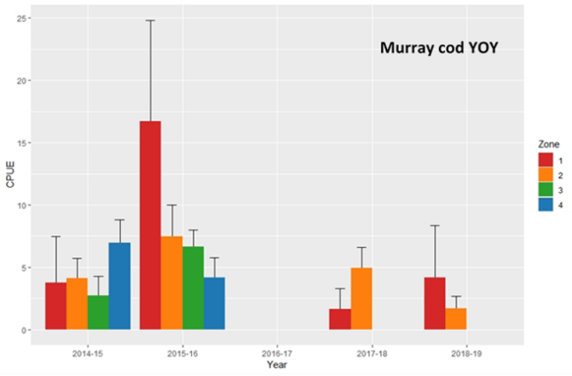 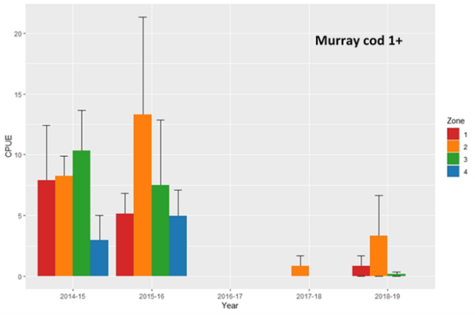

**Figure 8** Mean (+SE) catch per unit effort (CPUE; number of fish caught per 10 000 seconds of backpack electrofishing) of young of year (YOY) and 1+ Murray cod in the Edward/Kolety-Wakool LTIM zones from 2014-2019.

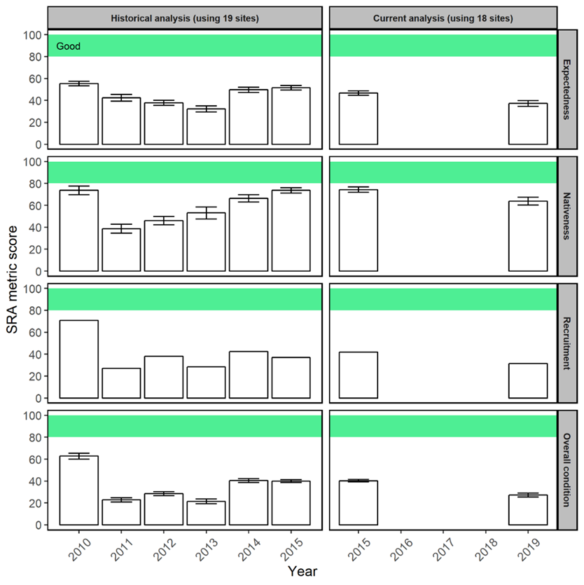

**Figure 9** Sustainable Rivers Audit (SRA) indices, separated among sampling years, in the Edward/Kolety-Wakool river system. Note that data collected from the same 19 in-channel sites were used in a historical analysis of these metrics between 2010-2015, while data from the same 19 in-channel sites were used in a current analysis from 2015-2019. The “good” classification for SRA metric scores is shown with green shading.

# Key outcomes of environmental water delivery 2014 – 2019

The volume of Commonwealth environmental water delivered to the Edward/Kolety-Wakool system across the five years of LTIM program was small in comparison to the large unregulated flow in 2016. However, the environmental water provided a number of small freshes, slowed the recession of operational flows, and maintained connectivity by provision of winter base flows. A list of watering actions evaluated during the LTIM program is summarised in Table 8. These watering actions resulted in a range of positive outcomes for the system summarised in Table 9.

**Table 8** Summary of watering actions evaluated across five years of Commonwealth environmental watering actions in the Edward/Kolety-Wakool system in 2014-19.

|  |  |  |  |  |  |
| --- | --- | --- | --- | --- | --- |
| # | **Year** | **Actions** | **Dates** | **Description** | **Zones** |
| 1 | 2014-15 | small fresh and recession | 12/08/14 to 15/01/15 | Extended in-channel fresh of approximately 500 MLd-1 from Aug until 16 Dec 2014, followed by a recession of about 40cm over 30 days until it reached operational flows in the range of 200 to 240 MLd-1 | 1,3,4 |
| 2 | 2015-16 | base flow and fresh | 10/11/15 to 30/01/16 | Base flow and Fresh. Flow for spring-summer fresh in upper Wakool to have a flow range of between 50 MLd-1 and 100 MLd-1 to enable river operators to provide a level of variability into flows. A flow recession back to base flows of 25 MLd-1 every 14 days was targeted | 2 |
| 3 | 2015-16 | base flow and fresh | 10/11/15 to 30/01/16 | Flow for early fresh to increase from base flow level to peak of 550 MLd-1, receding to 450 MLd-1. Flow for spring-summer fresh to have a flow range of between 450 MLd-1 and 500 MLd-1 to enable river operators to provide a level of variability into flows. Flow recession to reduce from 500 MLd-1 in 25 MLd-1 increments | 1,3,4 |
| 4 | 2016-17 | Wakool River refuge flow | 31/10/16 to 31/12/16 | To provide refuges from hypoxic water for fish and other aquatic biota. Escape flows for hypoxic water refuge at the Wakool escape with flows of up to 500 MLd-1 | 2,3,4 |
| 5 | 2016-17 | Yallakool Creek recession flow | 1/01/17 to 22/05/17 | To prevent a rapid return to base flows following the hypoxic event. To provide recessions to flows of a rate and duration that contributes to ongoing recovery of instream in-stream aquatic vegetation. Autumn pulse and recession also to assist with movement of juvenile native fish. | 1,3,4 |
| 6 | 2017-18 | winter base flow | 1/05/17 to 23/08/17 | To contribute to reinstatement of the natural hydrograph, connectivity, condition of in-stream aquatic vegetation and fish recruitment | 1,3,4 |
| 7 | 2017-18 | small fresh and flow recession | 7/09/17 to 22/10/17 | To contribute to connectivity, water quality, stimulating growth of in-stream aquatic vegetation, pre-spawning condition of native fish, spawning in early spawning native fish | 1,2,3,4 |
| 8 | 2017-18 | summer fresh with flow recession | 3/01/18 to 29/01/18 | To encourage fish movement and assist dispersal of larvae and juveniles of fish species | 1,3,4 |
| 9 | 2017-18 | autumn fresh with flow recession | 28/03/18 to 1/05/18 | To encourage fish movement and dispersal of juveniles of a number of fish species | 1,2,3,4 |
| 10 | 2018-19 | Early spring fresh | 22/08/18 to 25/09/18 | Yallakool/Wakool spring watering action (800 MLd-1 flow trial) | 1,2,3,4 |

**Table 9** Key results across five years of Commonwealth environmental watering actions in the Edward/Kolety-Wakool system in 2014-19.

|  |  |  |
| --- | --- | --- |
| **Theme** | **Indicator** | **Key result** |
| **Hydrology** | Maximum and minimum discharge | All Commonwealth watering actions delivered between 2014 and 2019 increased the maximum discharge compared to operational flows.  The majority of watering actions over the five years were delivered within normal operating ranges as advised by river operators to avoid third party impacts. However, following consultation with landholders, a flow trial in the Wakool-Yallakool system in 2018-19 exceeded the maximum daily operating discharge of 600 MLd-1 in the Wakool River; discharge peaked at 696 MLd-1 in zone 3 and 652 MLd-1 in zone 4. Two flow trials undertaken in the winter of 2017 and 2019 maintained winter base flows |
| Longitudinal connectivity | Some of the watering actions between 2014 and 2019 increased the longitudinal connectivity in the river system. For example, the winter watering in 2017 maintained longitudinal connectivity in over 500 km of river channels in Yallakool Creek, the Wakool River and the Colligen-Niemur River. This provided opportunities for fish movement, dispersal seeds, and maintained critical overwinter habitat for turtles and taxa that have small home ranges. Under normal operations these systems usually experience extended periods of cease to flow during winter. The higher flows in the upper Wakool River (zone 2) in 2018-19 initiated flow in Black Dog Creek, instigating connectivity between the Wakool River and Yallakool Creek. |
| Lateral connectivity | Hydraulic modelling showed that watering actions increased lateral connectivity and increased wetted area by as much as 30% at some sites. |
| Flow recession | Some watering actions increased the duration of the flow recession. For example, in 2017-18 watering action 1 increased the recession over 32 days in Yallakool Creek compared to what would have been a rapid recession from 460 MLd-1 to 200 MLd-1 over 3 days under operational flows. |
| Hydraulic diversity | Based on hydraulic modelling of study reaches, Commonwealth watering actions increased the hydraulic diversity in reaches receiving environmental water compared to modelled operational flows |
| **Water quality and carbon** | Dissolved oxygen concentration | None of the watering actions between 2014 and 2018 resulted in adverse DO outcomes. Several watering actions were specifically targeted to improve DO during poor water quality events; DO concentrations were consistently higher in zones receiving environmental water than in zones receiving none or minimal environmental water. |
| Nutrient concentrations | Nutrient concentrations during watering actions remained within the expected range throughout the system. |
| Temperature regimes | None of the watering actions targeted temperature. Water temperatures in the system were primarily controlled by the prevailing weather conditions. |
| Type and amount of dissolved organic matter | None of the watering actions undertaken between 2014 and 2018 had adverse organic matter outcomes. Some freshes resulted in small increases in organic carbon that had positive outcomes on river productivity. |

**Table 9 (continued)** Key results across five years of Commonwealth environmental watering actions in the Edward/Kolety-Wakool system in 2014-19.

|  |  |  |
| --- | --- | --- |
| **Theme** | **Indicator** | **Key result** |
| **Stream metabolism** | Gross Primary Production (GPP) | Commonwealth environmental watering increased the amount of GPP occurring in the river over the five year period. This increase in GPP translates to greater amounts of energy being created by plants and algae, which in turn are available to support aquatic food webs.  Across all watering actions from 2014 to 2019, the size of the beneficial impact was largely related to the proportion of total flow that came from the watering action rather than the source of water. Carbon production was enhanced by between 0% and 330% over the ten watering actions assessed between 2014 and 2019, with a sum over all zones and watering actions of 52% more carbon produced compared to no Commonwealth environmental water being delivered. This is an important outcome given that competition for food resources can be a significant factor limiting the growth and survival of fish and other aquatic animals. |
| Ecosystem Respiration (ER) | As with GPP, watering actions almost uniformly decreased the rates of ER (mg O2/L/day) simply through a dilution effect. However, when ER was calculated as the amount of organic carbon consumed per day (kg C/day), then watering actions had a beneficial effect, with significant differences between sites. A higher amount of organic carbon consumed means more nutrient recycling and hence greater nutrient supply to fuel GPP. At no stage did the environmental watering actions create so much respiration that DO dropped below ‘safe’ values for aquatic biota. |
| **Riverbank and aquatic vegetation** | Total species richness and cover | Between 2014 and 2016 riverbank and aquatic plant richness and cover was increasing and recovering in response to the millennium drought. However a large unregulated flood in late 2016 considerably reduced the richness and cover and some previously abundant taxa were absent in 2017. Between 2017 and 2019 there was a slow recovery, and in 2019 the highest number of taxa were recorded over the five years since the LTIM project commenced.  Environmental watering played an important role in the richness and health of riverbank and aquatic vegetation. Between 2014 and 2018 there was consistently higher species richness in zones 1, 3 and 4 that received environmental water than in zone 2 that received minimal or no environmental water. However, in 2018-19 the combined effects of environmental water and the period of higher operational flows in the upper Wakool River zone 2 increased the total and mean richness of plant taxa, such that this zone now has similar average species richness as the other zones. The delivery of environmental water in winter maintains aquatic taxa and can prevent potential frost damage to aquatic vegetation rhizomes. |
| Richness and cover of functional groups | The total species richness of submerged, amphibious and terrestrial taxa decreased in 2016 following the unregulated flood. Between 2017 and 2019 there was a slow recovery, and in 2018-19 there were overall more amphibious taxa than prior to the flood. The cover of submerged and amphibious taxa was particularly negatively impacted by the unregulated flow. In 2018-19 the maximum mean percentage cover of submerged taxa and some amphibious taxa increased and was similar to that in 2015-16 prior to the flood. However there has been minimal recovery of some amphibious taxa, such as floating pondweed (*Potamogeton tricarinatus*) and milfoil (*Myriophyllum spp*.). Small plants of these species have been observed outside survey transects, suggesting there is the possibility that these species can recover with support from environmental watering. |

**Table 9 (continued)** Key results across five years of Commonwealth environmental watering actions in the Edward/Kolety-Wakool system in 2014-19.

|  |  |  |
| --- | --- | --- |
| **Theme** | **Indicator** | **Key result** |
| **Fish movement** | Movement of golden perch and silver perch | Watering actions undertaken during the LTIM project supported fish movement. The winter watering in 2017 greatly increased river connectivity and fish moved longer distances than in previous periods of operational shutdown during winter. Spring watering actions facilitated movements of silver perch, golden perch and Murray cod. |
| **Fish spawning** | Larval abundance of equilibrium, periodic and opportunistic species | Over the 5 years of LTIM of 16 fish species (including 4 introduced species) were detected as larvae or eggs in the monitored zones of the Edward/Kolety-Wakool system. Murray cod larvae were detected in greatest numbers in 2018-19 compared to the four previous years of LTIM, with the majority of Murray cod larvae collected from upper Wakool River that for the first time in 2018 received substantial environmental water followed by higher operational flows. The abundance of Australian smelt larvae was significantly greater in 2018-19 compared to previous years, possibly due to increased water velocities during the higher spring fresh. Between 2016-2019 eggs or larvae of silver perch, catfish and obscure galaxias were detected for the first time in this system. It is difficult to confirm to what extent environmental watering contributed to this. However, the spawning of catfish may have been due to increased connectivity, and the spawning of silver perch may have been due to increased velocities or increased variability in some reaches during environmental watering actions. |
| **Fish recruitment** | Murray cod, silver perch and golden perch recruitment | In 2018-19 Murray cod YOY and 1+ fish were detected in highest numbers since LTIM monitoring commenced in 2015. Along with the presence of 1+ silver perch in the system, this suggests that the Edward/Kolety Wakool fish assemblage is showing positive signs of recovery post the 2016-17 hypoxic blackwater event that resulted in large scale fish kills in the southern Murray-Darling Basin. |
| **Fish populations** | Adult fish populations | This project demonstrates the value of the Edward/Kolety-Wakool river system in supporting populations of native freshwater fish, nested within the broader Murray catchment. Throughout this five year study, and utilising a range of sampling techniques, we captured 15 species of native fish representing various life-stages. System-specific trends, indicated through the use of SRA fish ‘health’ indicators, suggest that the health of the Edward/Kolety-Wakool fish community decreased from 2015 to 2019, although we argue that the fish assemblage is in a state of recovery following adverse water quality and associate fish deaths in 2016. A number of flow-related mechanisms may contribute to the recovery of these populations at a local scale. These include 1) the persistence of refuge habitat at low flows or during adverse water quality events, 2) the presence of diverse in-channel and off-channel habitats, and 3) opportunities for movement that enable the re-distribution of individuals and promote emigration and immigration. |
| **Other** | Other observations | The watering actions in the Edward/Kolety River, Wakool River and Colligen-Niemur River 2016-17 during the unregulated flood aimed to create small refuges with higher levels of DO. The local community also installed aerators to create DO refuges. Fish were observed congregating in these refuges, suggesting these actions supported the survival of some fish and other aquatic animals.  During watering action 1 in 2018-19 there was increased frog calling, waterbird activity and invertebrate activity observed in inundated areas around Bookit Island. Similar observations were made throughout the LTIM program during other watering actions that inundated backwaters. |

# Recommendations and implications for future management of environmental water

A list of recommendations outlined in previous Edward/Kolety-Wakool LTIM annual reports (Watts et al. 2015, 2016, 2017, 2018b) and the extent to which they have been implemented is provided in Appendix 1. We continue to endorse all of these recommendations. In addition, we outline five recommendations to improve the planning and delivery of environmental water in the Edward/Kolety-Wakool system. These recommendations are underpinned by monitoring and evaluation results. Where applicable, a comment has been included to indicate to what extent the recommendation has already been applied in the Edward/Kolety-Wakool system.

**Recommendation 1:** Each year plan to deliver at least one flow event with higher than normal operating discharge to the upper Wakool River. This may include delivery of water through the Wakool offtake regulator or via the Wakool escape from Mulwala Canal.

**Adaptive management:** A watering action is planned for spring 2019 that includes increased discharge from the Wakool offtake regulator or via the Wakool escape from Mulwala Canal

**Recommendation 2:** Include variation in the timing of environmental watering actions among water years to promote the temporal availability and continuity of instream habitat to benefit fish and other aquatic animals and assist the recovery of submerged aquatic plants in the system.

**Recommendation 3:** Implement a second flow trial in-channel fresh in late winter or early spring that briefly exceeds the current normal operating rules**,** to increase the lateral connection of in-channel habitats and increase river productivity. The earlier timing of flows would help to prime the system and thus increase the outcomes of subsequent watering actions delivered later in spring or early summer.

**Adaptive management:** A second 800 MLd-1 flow trial in the Wakool-Yallakool system is planned for spring 2019 that will exceed the normal operating limit of 600 MLd-1.

**Recommendation 4:** Explore options to implement in-channel pulses at any time of the year to connect additional in-channel habitats and increase river productivity.

**Recommendation 5:** Explore and develop a range of options for the delivery of environmental water during times of drought to ensure connectivity of habitat and avoid damage to key environmental assets. Inform the community of the factors limiting water delivery in extreme drought.

# Acknowledgements

The authors of this report as well as the Commonwealth Environmental Water Office respectfully acknowledge the traditional owners of the Murray-Darling Basin, their Elders past and present, their Nations, and their cultural, social, environmental, spiritual and economic connection to their lands and waters.

We extend our thanks to the Edward/Kolety-Wakool Environmental Water Reference Group, Wakool River Association, the Colligen and Niemur Group, Edward/Kolety-Wakool Angling Association, Yarkuwa Indigenous Knowledge Centre Aboriginal Corporation, and landholders in the Edward/Kolety-Wakool river system for their keen interest in this project and for providing access to monitoring sites on their properties. Fieldwork and/or laboratory work was led by John Trethewie, Chris Smith, Sascha Healy and Xiaoying Liu, with assistance from Shayne Bell, Tom Butterfield, Jonathon Doyle, Ben Edwards, Roseanna Farrant, Tim McGarry, Matt Linn, Nathan McGrath, Jarryd McGowan, Nick O’Brien, Deena Paris, Rohan Rehwinkel, Sam Ryan, Dale Wood and Ian Wooden.

Maps were prepared by Simon McDonald and Deanna Duffy (Charles Sturt University Spatial Analysis Unit), Rod Martin (NSW DPI) and Ian Wooden (NSW DPI). Statistical analyses of fish movement data was undertaken by Ben Stewart-Koster and Ameneh Shobeirinejad (Griffith University). Tina Hines at the Monash University Water Studies Centre processed carbon and nutrient samples. Larval and juvenile fish sampling was carried out under NSW Fisheries license (P14/0004-1.3) and approved by the CSU Animal Care and Ethics Committee (larval fish surveys: A16080, recruitment surveys: A16098). Sampling in the Murray Valley National Park was permitted under the National Parks and Wildlife Act 1974 (Scientific License: SL101403). Adult fish surveys were conducted by DPI Fisheries under Fisheries NSW Animal Care and Ethics permit 14/10. This project was funded by the Commonwealth Environmental Water Office with in-kind contributions from Charles Sturt University, NSW Department of Primary Industries, Monash University, NSW Office of Environment and Heritage, and Murray Local Land Services.

We also wish to acknowledge Rick Webster who passed away from cancer in March 2019. Rick was an inspirational leader in his field, a fierce champion for the environment, and a great friend to many of us in the Edward/Kolety-Wakool Longer Term Intervention Monitoring Project team.

# References

Gawne B, Brooks S, Butcher R, Cottingham P, Everingham P and Hale J (2013) Long-Term Intervention Monitoring Project Monitoring and Evaluation Requirements Edward-Wakool river system for Commonwealth environmental water. Final Report prepared for the Commonwealth Environmental Water Office by The Murray-Darling Freshwater Research Centre, MDFRC Publication 01.2/2013, May, 32pp.

Watts R.J., Bond N.R, Grace M.R., Healy S., Howitt J.A., Liu X., McCasker N.G., Thiem J.D., Trethewie J.A., Wright D.W. (2019). *Commonwealth Environmental Water Office Long Term Intervention Monitoring Project: Edward/Kolety-Wakool River System Selected Area Technical Report, 2018-19*. Report prepared for Commonwealth Environmental Water Office. Commonwealth of Australia.

Watts R., McCasker N., Thiem J., Howitt J., Grace M., Kopf R., Healy S. and Bond N. (2015) *Commonwealth Environmental Water Office Long Term Intervention Monitoring Project: Edward-Wakool Selected Area Technical Report, 2014-15*. Prepared for Commonwealth Environmental Water Office.

Watts R.J., McCasker N., Howitt J.A., Thiem J., Grace M., Kopf R.K., Healy S., Bond N. (2016) *Commonwealth Environmental Water Office Long Term Intervention Monitoring Project: Edward-Wakool River System Selected Area Evaluation Report, 2015-16.* Report prepared for Commonwealth Environmental Water Office. Commonwealth of Australia.

Watts R.J., Kopf R.K., McCasker N., Howitt J.A., Conallin J., Wooden I. and Baumgartner L. (2018a) Adaptive management of environmental flows: Using irrigation infrastructure to deliver environmental benefits during a large hypoxic blackwater event in the southern Murray-Darling Basin. *Environmental Management* 61, 469-480 DOI 10.1007/s00267-017-0941-1.

Watts R.J., McCasker N., Howitt J.A., Thiem J., Grace M., Kopf R.K., Healy S., Bond N. (2017) *Commonwealth Environmental Water Office Long Term Intervention Monitoring Project: Edward-Wakool River System Selected Area Evaluation Report, 2016-17.* Report prepared for Commonwealth Environmental Water Office. Commonwealth of Australia.

Watts R.J., McCasker N.G., Howitt J.A., Thiem J.D., Grace M.R., Trethewie J.A., Healy S., Bond N.R. (2018b). Commonwealth Environmental Water Office Long Term Intervention Monitoring Project: Edward-Wakool River System Selected Area Summary Report, 2017-18. Report prepared for Commonwealth Environmental Water Office. Commonwealth of Australia.

# Appendices

**Appendix 1.** Summary of recommendations from Edward/Kolety-Wakool LTIM annual reports 2014-15, 2015-16, 2016-17 and 2017-18, showing year implemented. R = recommendation number. EKWEWRG = Edward/Kolety-Wakool Environmental Water Reference Group, EWSC=Edward-Wakool Stakeholder Committee, EKWOAG= Edward/Kolety-Wakool Operations Advisory Group. R = recommendation number

|  |  |  |
| --- | --- | --- |
| **Recommendation** | **Year(s) recommended** | **Year(s) implemented** |
| Small in-channel freshes (within normal river operating rules) | | |
| 1. Consider a trial to increase the delivery of environmental water to the upper Wakool River | 2014-15 (R3)  2015-16 (R6)  2016-17 (R5) | 2018-19 |
| 1. Consider the implementation of an environmental watering action in the Edward River to target golden perch and silver perch spawning. | 2014-15 (R8)  2015-16 (R4)  2016-17 (R4)  2017-18 (R3) | Not yet implemented |
| In-channel freshes (higher than current normal operating rules to connect additional in-channel habitats) | | |
| 1. In collaboration with stakeholders explore options to implement a short duration environmental flow trial in late winter/spring 2016 at a higher discharge than the current constraint of 600 MLd-1 at the Wakool-Yallakool confluence. This would facilitate a test of the hypothesis that larger in-channel environmental watering action will result in increased river productivity. | 2014-15 (R7)  2015-16 (R3)  2017-18 (R4) | 2018-19 |
| Flows that contribute to flow recession | | |
| 1. Increase the duration of the recession of environmental watering actions relative to the Yallakool Creek environmental watering actions in 2012-14 | 2014-15 (R1)  2015-16 (R8) | 2015-16 2016-17, 2017-18 |
| Winter flows | | |
| 1. Consider the delivery of continuous base environmental flows during autumn and winter to promote the temporal availability and continuity of instream habitat | 2014-15 (R4)  2015-16 (R2)  2016-17 (R3) | Winter 2017 |
| 1. Implement a second trial of continuous base winter environmental flow (no winter cease to flow) in the tributaries of the Edward/Kolety-Wakool system to promote the temporal availability and continuity of instream habitat to benefit fish and other aquatic animals and assist the recovery of submerged aquatic plants. | 2017-18 (R2) | Winter 2019 |
| Flow variability | | |
| 1. Avoid long periods of constant flows by introducing flow variability into environmental watering actions. | 2014-15 (R2)  2015-16 (R5) | 2015-16, 2016-17, 2018-19 |
| 1. Implement environmental watering actions for freshes in spring and early summer (October to December) that include flow variability up to a magnitude of + 125 to 150 MLd-1. Undertake trials to improve understanding of the magnitude of variability that provides beneficial ecosystem outcomes. | 2017-18 (R1) |  |
| Flows to mitigate poor water quality events | | |
| 1. Continue to include a water use option in water planning that enables environmental water to be used to mitigate adverse water quality events | 2014-15 (R5)  2015-16 (R7) | 2014-15, 2015-16  2016-17, 2017-18  2018-19 |
| 1. If there is an imminent hypoxic blackwater event during an unregulated flow and the quality of source water is suitable, water managers in partnership with local landholder and community representatives should take action to facilitate the earlier release of environmental water on the rising limb of the flood event to create local refuges prior to DO concentrations falling below 2 mgL-1. | 2016-17 (R1) | Not yet implemented |
| Flows through forests and/or floodplains | | |
| 1. Trial a carefully managed environmental watering action through Koondrook-Perricoota Forest via Barbers Creek to improve the productivity of the mid and lower Wakool River system. | 2017-18 (R5) | Not yet implemented via Barbers Creek |
| Other flow related recommendations | | |
| 1. Set watering action objectives that identify the temporal and spatial scale at which the response is expected and are realistic given the magnitude of watering actions proposed | 2014-15 (R6) | ongoing |
| 1. Undertake a comprehensive flows assessment for the tributaries of the Edward/Kolety-Wakool system to better inform future decisions on environmental watering in this system. | 2014-15 (R9)  2015-16 (R1) | Partly undertaken |
| 1. Collaborate with other management agencies and the community to maximise the benefits of Commonwealth environmental watering actions | 2014-15 (R10) | ongoing |
| 1. The installation of a DO logger on a gauge downstream of Yarrawonga and upstream of Barmah-Millewa Forest should be considered a priority. Consideration should also be given to installing DO loggers, both upstream and downstream of other forested areas that influence water quality in the Edward/Kolety-Wakool system | * 1. (R2) | Not yet implemented |
| 1. Undertake in-channel habitat mapping for key reaches of the Edward/Kolety-Wakool system, which could then be combined with existing hydraulic modelling to facilitate learning about this system | 2016-17 (R6) | Not yet implemented |
| 1. The CEWO and other relevant agencies undertake a review of the 2016 flood and subsequent hypoxic blackwater event in the Murray system and support further research into understanding these events | 2016-17 (R7) | 2017 |