# Electronic certification (eCert) countries and certificate formats

## Introduction

This help card summarises the countries the Department of Agriculture, Fisheries and Forestry currently has an eCert for Imports exchange with. It highlights the country-specific formatting requirements that brokers and importers need to enter when lodging import declarations, and examples of documentary evidence that may be provided.

Further information can be found at agriculture.gov.au/ecertimports.

Queries can be sent to eCertAdministrator@agriculture.gov.au.

## Countries on eCert for Imports

The table below highlights the countries the department currently has an eCert for Imports exchange with. Refer to section 2, Country-specific certificate formats for additional details.

Table 1 Countries with current eCert exchanges with certificate format details

| **Country** | **Government certificate type** | **Document Type** | **Document Number format** | **Status of exchange** |
| --- | --- | --- | --- | --- |
| Indonesia | Phytosanitary | IDPHYTO | 2019123456K10E123456/1234567 | Parallel |
| Sanitary | IDSANITARY | 2019987654K10E987654/9876543 | Parallel |
| New Zealand | Phytosanitary | NZPHYTO | NZL2019/ABCD/123456 | Paperless |
| Sanitary | NZSANITARY | NZL2019/ABCD/987654 | Paperless |

## Country-specific certificate formats

### New Zealand

eCerts are available for phytosanitary and sanitary certificates issued by New Zealand’s Ministry for Primary Industries (NZ MPI). As of 31 August 2020, this is a paperless eCert exchange.

Samples of the copy of the phytosanitary certificate or extract of the sanitary certificate that NZ exporters are able to provide:

* A copy of the phytosanitary certificate or extract of the sanitary certificate will be used for the clearance of goods lodged under Automatic entry processing for commodities (AEPCOMM). Accredited persons utilising AEPCOMM must ensure they obtain this documentation prior to conducting assessments and lodgement under AEPCOMM.
* Importers and brokers submitting entries to the department may request the copy or extract to confirm all import requirements have been met prior to clearance. However, this is not mandatory as the eCert will be received by the department and will be used for import clearance.

#### Sanitary certificates

* Document Type: NZSANITARY
* Document Number (certificate number format): NZL2019/ABCD/987654

Sample of the extract sanitary certificate. This may be provided as an email extract direct from the NZ MPI eCert system or a PDF extract. The status will say approved/acknowledged.

Table 2: Example sanitary certificate extract

|  |  |  |  |
| --- | --- | --- | --- |
| NZL 2020/EFL 123/123096 | This is not an Official Assurance and is for information purposes only.  Extract of Export Certificate data as at 14-Aug-2020 16:18 | | |
| Status: | Approved on 14-Aug-2020 16:16 | | |
| Approved By: | John Smith, Official Inspector | | |
| Header Details | | | |
| Template Id: | AU300.11 – Certificate for Fish or Fish Product Exported to Australia | | |
| Importing Country: | Australia | | |
| Consignor: | EFL123. Nice Fisheries LTD, AUCKLAND 5520 | | |
| Importer Name: | FRESH SEAFOOD LTD | | |
| Importer Address: | Green Street 55 Importer City Melbourne, VICTORIA 3003 Importer | | |
| Post Code: | – | | |
| Importer Country: | Australia | | |
| Means of Transport: | Air | | |
| Carrier Name: | AIR NEW ZEALAND | | |
| Conveyance Reference: | NZ 125 | | |
| Port of Loading: | NZAKL – Auckland [AUK], New Zealand | | |
| Port of Discharge: | AUMEL – Melbourne (VIC), Australia | | |
| Unofficial Commercial Information: | – | | |
| Declarations | – | | |
| Health Attestation | – | | |
| AU300.11/1N | I certify that the products: | | |
| AU300.11/2N | a. were processed in establishments operating in accordance with New Zealand law; | | |
| AU300.11/3N | b. were processed in accordance with New Zealand regulatory requirements for items intended for human consumption; | | |
| AU300.11/4N | c. are of New Zealand origin | | |
| AU300.11/7N | d. were derived from fish caught in New Zealand's Exclusive Economic Zone (EEZ) or in adjacent international waters. | | |
| Official Information: | | | |
| Product Item Details – 3 Product Items (12 in total) | | | |
| Product Item 1 | | | |
| Outermost: 1 Cartons | | CHILLED WHOLE GURNARD | Net Weight: 9.50 kg |
| Species:  Chelidonichthys kumu | | Identification Marks:  1A1B | Container (& Seal) Numbers:  Not Applicable |
| Processing Premises:  PH5000, Green Fisheries Limited, 1 Wagener Place, Epsom, AUCKLAND, New Zealand | | | |
| Product Item 2 | | | |
| Outermost: 8 Cartons | | CHILLED WHOLE JOHN DORY | Net Weight: 71.50 kg |
| Species:  Zeus faber | | Identification Marks:  ABC1 | Container (& Seal) Numbers:  Not Applicable |
| Processing Premises:  PH5000, Green Fisheries Limited, 1 Wagener Place, Epsom, AUCKLAND, New Zealand | | | |
| Product Item 3 | | | |
| Outermost: 3 Cartons | | CHILLED WHOLE RED SCORPION FISH | Net Weight: 58.40 kg |
| Species: | | Identification Marks: | Container (& Seal) Numbers:  Not Applicable |
| Processing Premises:  PH5000, Green Fisheries Limited, 1 Wagener Place, Epsom, AUCKLAND, New Zealand | | | |

#### Phytosanitary certificates

* Document Type: NZPHYTO
* 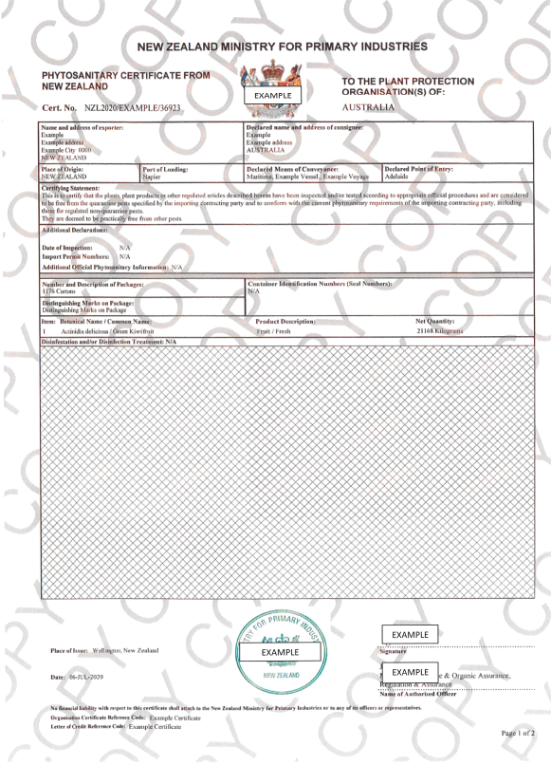Document Number (certificate number format): NZL2019/ABCD/123456

**2 examples of copy phytosanitary certificates**

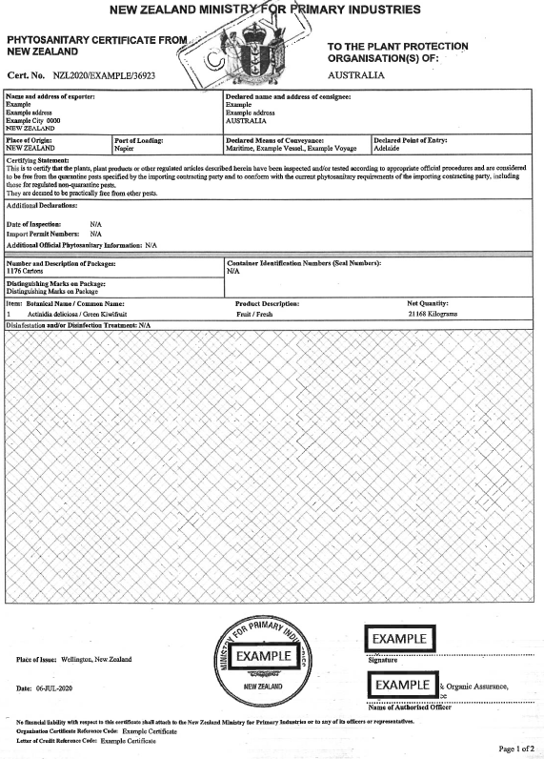

### Indonesia

eCerts are available for government certificates issued by the Ministry of Agriculture, Agency for Agricultural Quarantine. This includes phytosanitary and sanitary certificates. This is currently a parallel exchange.

#### Phytosanitary certificates

* Document Type: IDPHYTO
* Document Number (format): 2019123456K10E123456/1234567

TheDocument Numberis a combination of the certificate number, located under the header, and the serial number, located at the top-right of the certificate. All decimal points are removed, and a ‘/’ (forward slash) is incorporated to connect both components.

Included is a sample of the top portion of the phytosanitary certificate received from Indonesia. This highlights an example of the certificate number and serial number used to form the Document Number.

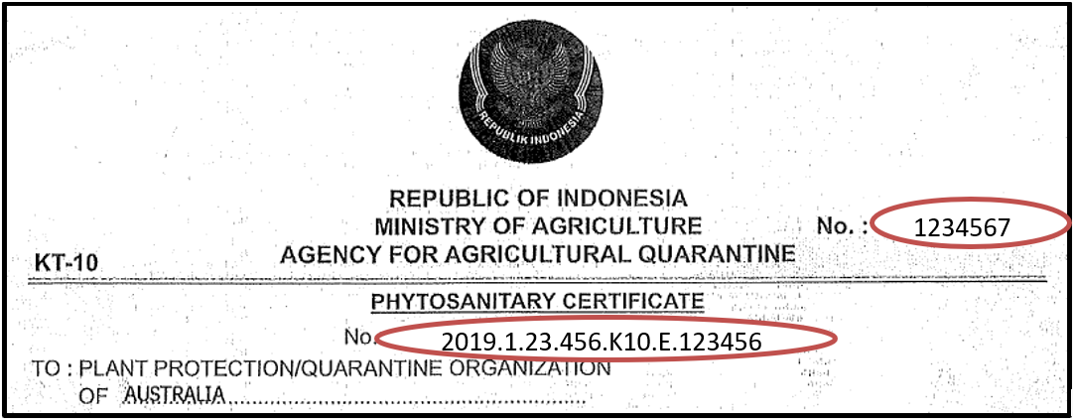

#### Sanitary certificates

* Document Type: IDSANITARY
* Document Number (format): 2019987654K10E987654/9876543

The Document Number is a combination of the certificate number, located under the header, and the serial number, located at the top-right of the certificate. All decimal points are removed, and a ‘/’ (forward slash) is incorporated to connect both components.

Included is a sample of the top portion of the sanitary certificate received from Indonesia. This highlights an example of the certificate number and serial number used to form the Document Number.

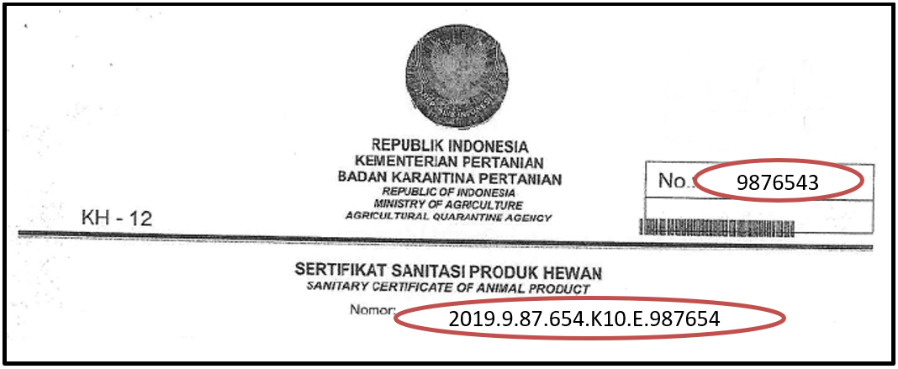

## Contact

* Phone 1800 900 090
* Email ecertadministrator@agriculture.gov.au
* Web agriculture.gov.au/Ecertimports

**Acknowledgement of Country**

We acknowledge the Traditional Custodians of Australia and their continuing connection to land and sea, waters, environment and community. We pay our respects to the Traditional Custodians of the lands we live and work on, their culture, and their Elders past and present.

© Commonwealth of Australia 2022

Unless otherwise noted, copyright (and any other intellectual property rights) in this publication is owned by the Commonwealth of Australia (referred to as the Commonwealth).

All material in this publication is licensed under a Creative Commons Attribution 4.0 International Licence except content supplied by third parties, logos and the Commonwealth Coat of Arms.

The Australian Government acting through the Department of Agriculture, Fisheries and Forestry has exercised due care and skill in preparing and compiling the information and data in this publication. Notwithstanding, the Department of Agriculture, Fisheries and Forestry, its employees and advisers disclaim all liability, including liability for negligence and for any loss, damage, injury, expense or cost incurred by any person as a result of accessing, using or relying on any of the information or data in this publication to the maximum extent permitted by law.