

REFERENCE

# Plant Exports Management System (PEMS) Authorised officer user guide – Empty Container Inspections

**In this document**

This document contains the following topics.

Purpose of this document 2

Initiating the empty container inspection 2

Recording inspection results for empty containers 4

Completing and submitting the inspection record 8

Expiration date for empty container inspection validity 10

Revoking an empty container approval status 13

Related material 16

Contact information 16

Document information 17

Version history 17

## Purpose of this document

This reference outlines how to use PEMS to record empty container inspections.

**Note:** An overview of PEMS and general functions can be found in the Reference: Plant Exports Management System (PEMS) Authorised Officer User Guide – Overview and general functions.

### Initiating the empty container inspection

To initiate an empty container inspection, click the **Home1** PEMS menu tab and then click the **Empty container2** button.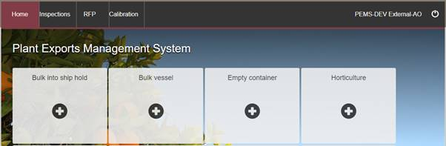

**1**

**2**

The *Create Empty Container Inspection* window will display.

You can create an empty container inspection record in PEMS by selecting either container yard ID or address from the **Create inspection using1** drop down list.

If you choose to create inspection using the container yard ID, then the window will expand and you must enter the **Container yard ID1** number. The container yard ID number must be three or four digits long; for example, 123 or 1234.

Click **Search2**.

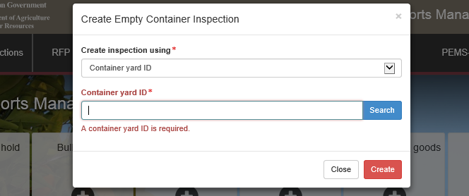

**2**

**1**

The window will expand and display the **Location details1** of the container yard.

Click **Create2** if you wish to proceed.

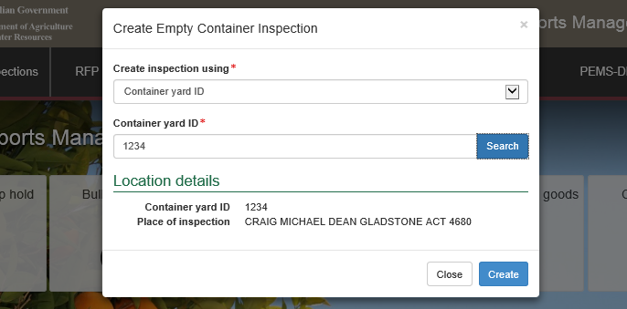

**1**

**2**

If you choose to create inspection using the address, then the window will expand and you must enter the address of the location where the empty container inspection is taking place at in the **Address line 11**, **Postcode2** and **Suburb3** fields, and select the relevant **State4.**

Click **Create5**.

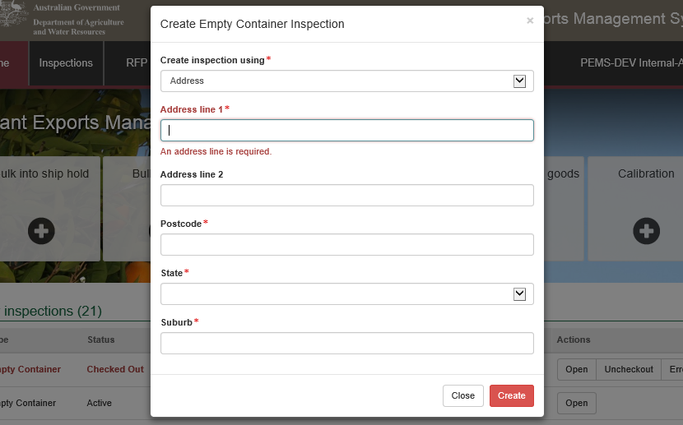

**1**

**4**

**5**

**2**

**3**

The *Empty Container Inspection* page will display by default.

This empty container inspection record will remain **Active1** until the inspection record is withdrawn, submitted, or cancelled.

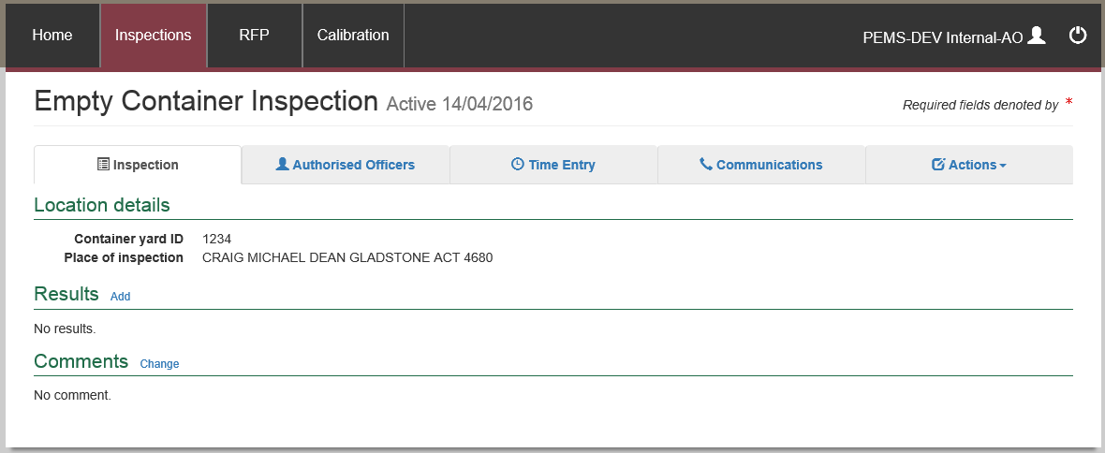

**1**

**!** While the record is active, the date provided at the top of the empty container inspection record is the date the inspection record was initiated.

### Recording inspection results for empty containers

Each empty container that is inspected must have its own inspection result entered.

To add an empty container inspection result to the record, click the **Inspection1** tab and then click **Add2** under the results section**.**

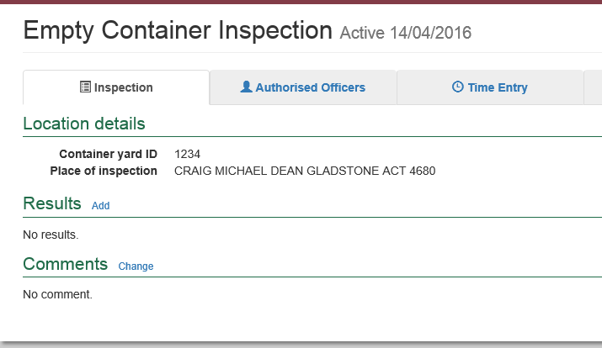

**1**

**2**

The *Inspection Result* window will display.

For each empty container inspected:

* enter the **Container number1** (must include four letters and six or seven digits; for example, ABCD1234567)
* check the container number you have entered is correct by clicking on **Check2**
* enter thealphanumeric **Seal number3** when applicable.
* select an **Inspection level4** of consumable or non-consumable (default inspection level is consumable)
* select the appropriate **Result5** of pass, fail or cancel

if ‘Pass’ is selected as the result, a tick box will appear asking if the container has been Passed after rectification. Click this box if this is the case.

* **RFP number6** allows an RFP to be associated with a particular container number
* if applicable, select one or more applicable **Remarks7** check boxes (mandatory when the container fails or container inspection is cancelled)
* select the **Authorised officer8** who inspected the container. See Section 3.1: Assigning authorised officers in the PEMS AO user guide – Overview and general functions.
* click **Save9**.

**! Check2** performs a two-step validation process via a check digit algorithm and by checking if the container number recorded is available in the *BIC Global Container Database*. This database captures approximately 70% of all containers globally. If the container you have inspected is not captured in the database a warning message is generated encouraging you to double check the details on the container. You will still be able to submit the inspection.

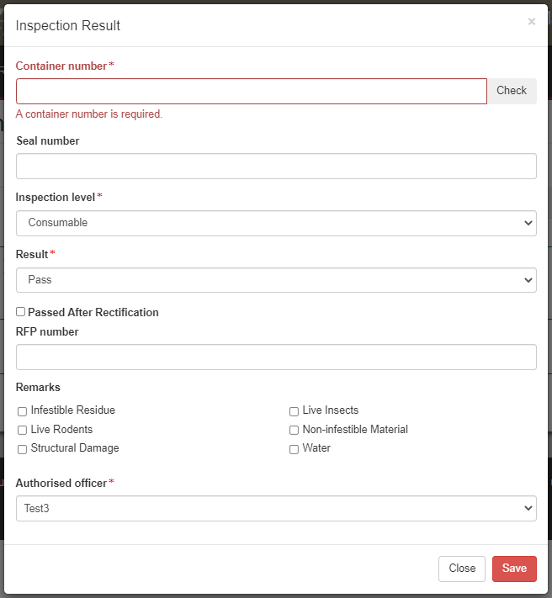

**10**

**9**

**8**

**7**

**6**

**5**

**3**

**4**

**2**

**1**

The empty container inspection page will display the **container inspection result1**.

You can **Open2** the inspection results to change the data or **Remove3** the inspection results up until the inspection record is submitted, cancelled, or withdrawn.

You can see if the container has been associated with an **RFP4**.

Click **Add5** and repeat the instructions above to add additional container inspection results.

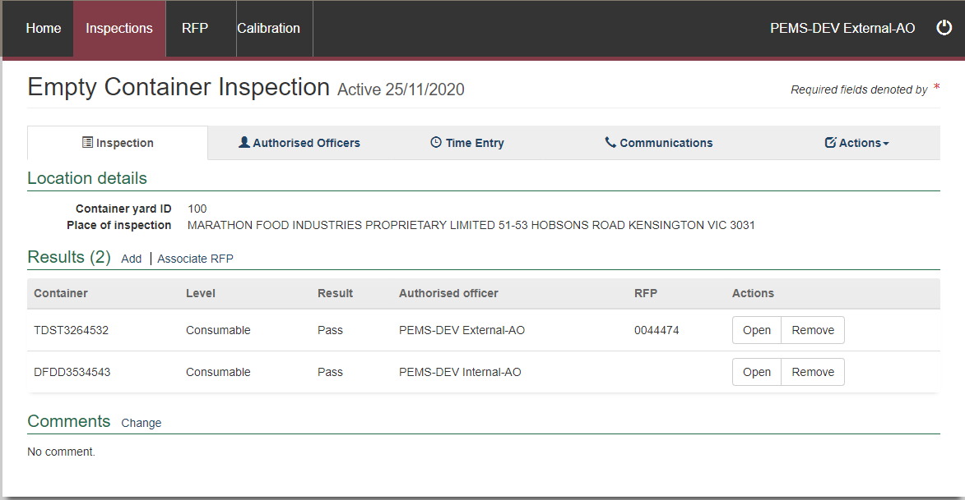

**3**

**5**

**4**

**2**

**1**

### Completing and submitting the inspection record

The empty container inspection record can only be submitted after:

all empty container inspection results are entered

if applicable, any general **Comments1** regarding the inspection are provided (see Section 3.6 Adding comments to an inspection record in the PEMS AO user guide – Overview and general functions)

a **Time Entry2** is provided for all AOs who recorded inspection results

if applicable, all attachments and correspondence are added under the **Communications3** tab.

Details on the Time Entry and Communications tabs can be found in Section 3: General PEMS inspections functions in the PEMS AO user guide – Overview and general functions.

When you are ready to submit the inspection record, click the **Actions4** tab and then click **Submit5**.

For more information on **Downloading** the inspection report, **Cancelling** the inspection and **Withdrawing6** from the inspection, see Section 3.4 Actions tab in the PEMS AO user guide – Overview and general functions.

**!** Once the inspection record is submitted the inspection record will become read-only and you will be unable to make changes to the data provided.

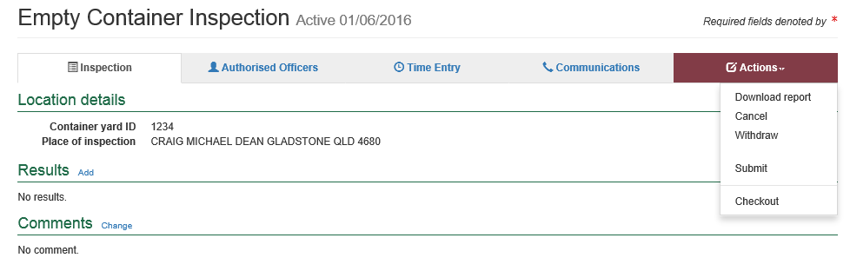

**5**

**4**

**2**

**3**

**6**

**1**

A pop-up window will ask you to confirm that you want to **submit this inspection1**.

It will also ask if you want to **email the exporter/EDI user on the submission of the inspection2.** When selecting this option, the Inspection submit confirmation box will expand.

Enter the **email address3**, this can be multiple email addresses each separated by a comma.

Enter in any **Comments4** that are to be included in the email.

Click **Save5**.

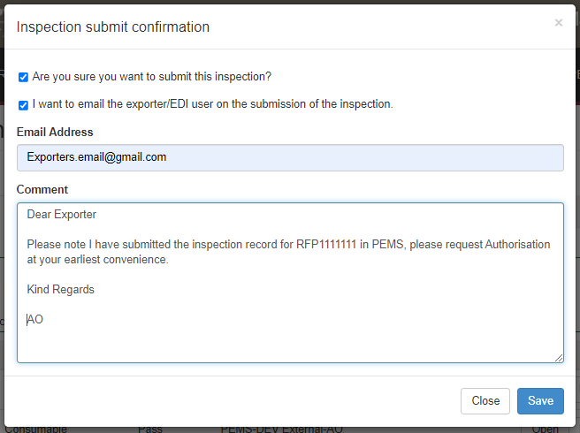

**5**

**4**

**3**

**2**

**1**

Once submitted, the empty container inspection will appear as **Completed1**.

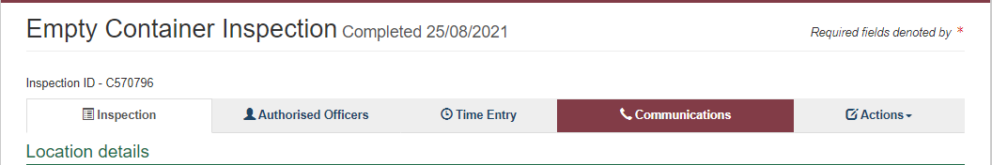

**1**

**!** The date(s) specified on the completed inspection record will be the start date and end date for the inspection. The inspection record date corresponds with the earliest and latest time entry across all AOs for the inspection.

### Expiration date for empty container inspection validity

An expiry date will be allocated to all containers which have passed assessment on the completed inspection record. The expiry date is automatically calculated as 90 days from the first date of the first-time entry. To see the expiration date for containers, click the **Inspection1** tab and an **Expiry date2** will be listed beside the appropriate result records.

If the expiry date for a container is extended, the reason for the expiry date extension can be viewed by clicking **Expiry3** and then clicking **History4.**

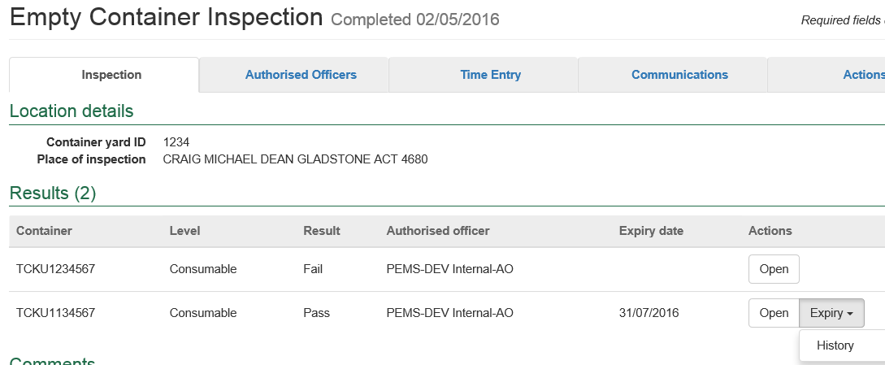

**1**

**2**

**3**

**4**

If you click history, the *Expiry History* window will display.

Click **Close1** to exit the window.

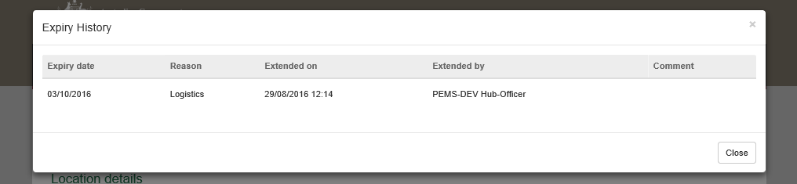

**1**

**Associating an RFP**

An RFP can be associated to the container approval records. Select **Associate RFP1**.

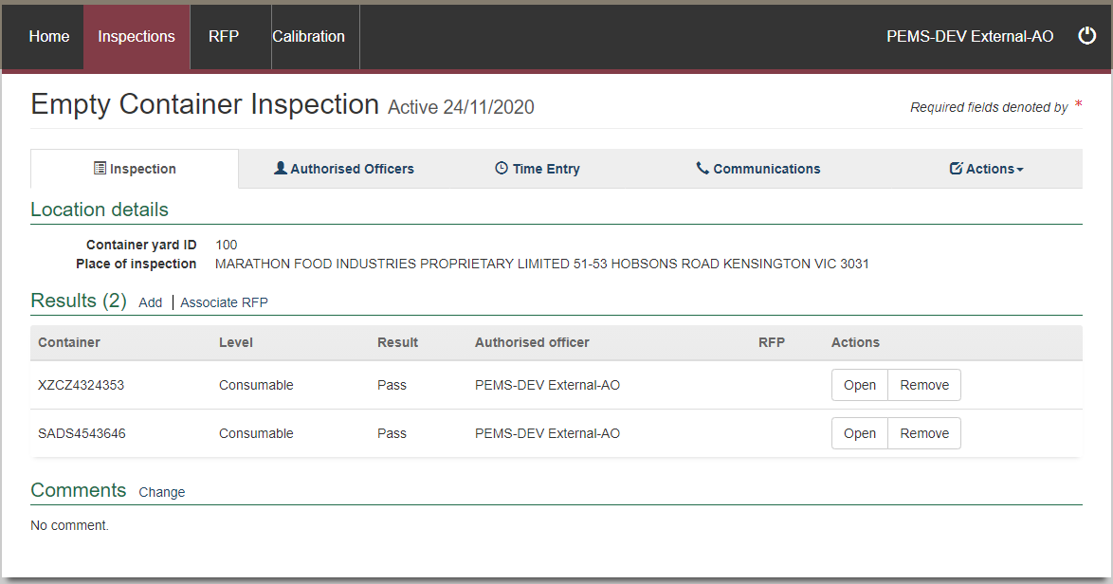

**1**

The *Add RFP details* window will appear.

Enter the **RFP number1** that is associated with all the containers listed and select **Add2**.

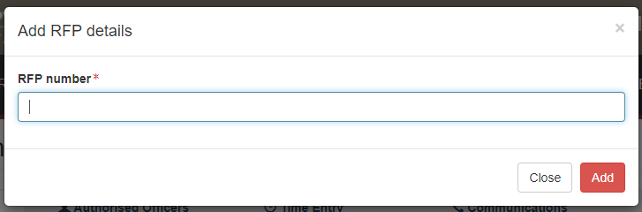

**2**

**1**

The **RFP1 number** will appear for all the containers listed on the *Empty Container Inspection page*.

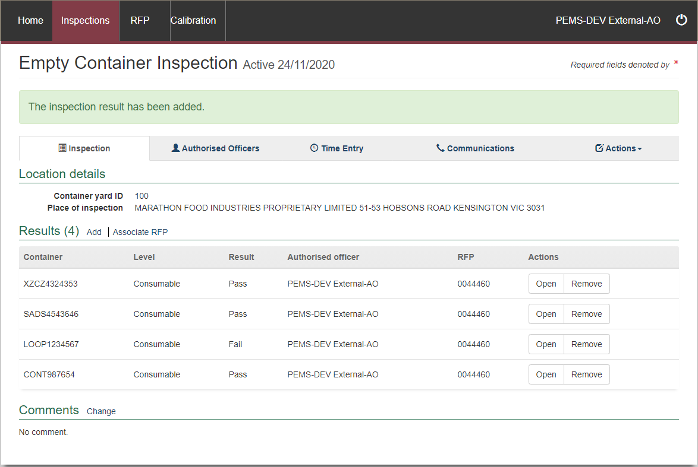

**1**

**!**. When the Empty container inspection has multiple container numbers, containers can be assigned to different RFPs on the provision that all RFPs are from the same exporter number.

**!**. This will extract all the containers associated to that RFP with a pass result ONLY.   
The failed containers will not be extracted to the inspection, despite of their association with the empty containers inspection and they cannot be used.

### Revoking an empty container approval status

If the condition of an empty container has changed from when it was originally passed, and it no longer complies with the department’s requirements, the approval status of the container can be changed from Pass to Revoked. This action can be performed by any authorised officer that has the empty container job function*.*

See *Section 2.1 Inspection search of the PEMS AO user guide – Overview and General Functions* on how to search for a container number. The empty container inspection must be in c*ompleted* status.

All container numbers completed on the Empty Container Inspection will be shown.

Select the container/s that need to be to have the approval status revoked and click **Revoke1**.

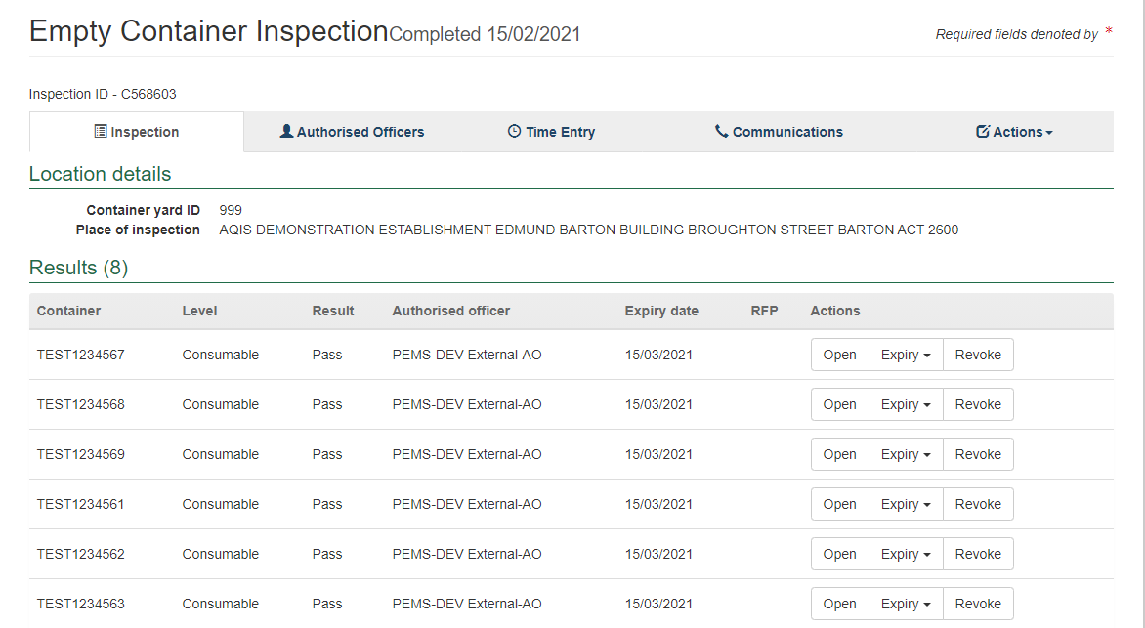

**1**

The *Revoke Container* window opens.

Enter the **Email Address1** of the client to notify them that the container approval has been revoked. Multiple email addresses can be added to the email address field and each address should be separated by a comma and a space.

Select the appropriate **Remarks2**.

Enter the **Reason for Revocation3**. This reason will appear in the body of the email and can be up to 500 characters.

Click **Save4**.

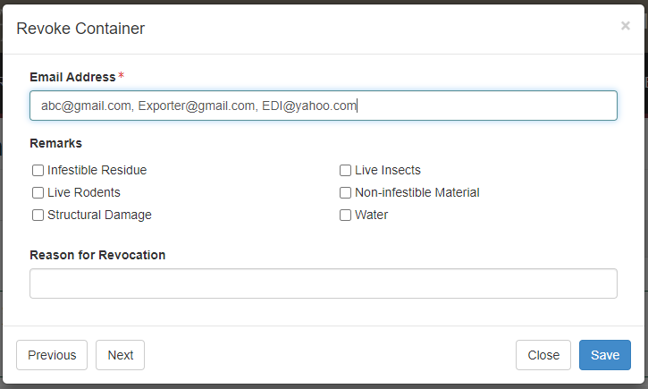

**3**

**4**

**2**

**1**

Confirmation the empty container inspection result has been updated will appear.

The containers that have been revoked will have the Result changed to **Revoked1**. This revocation cannot be removed until a new empty container inspection is completed.

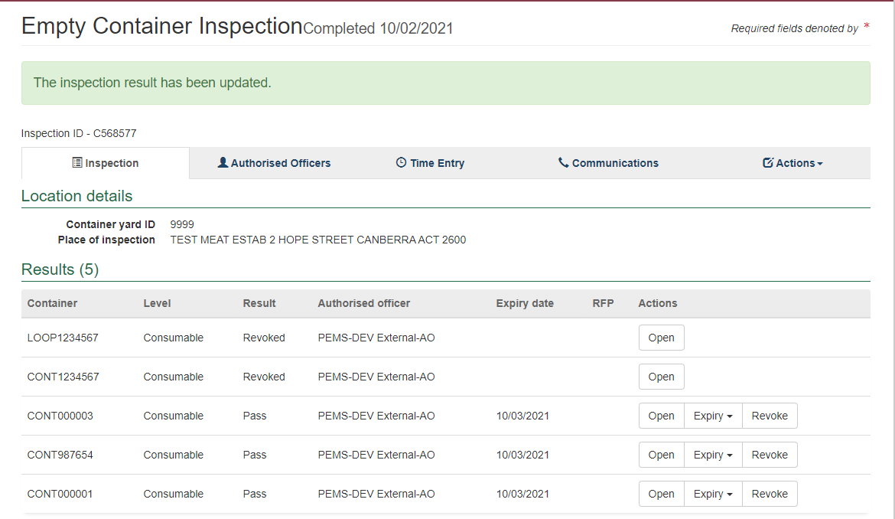

**1**

Example of the email that is sent to the nominated email address/es.

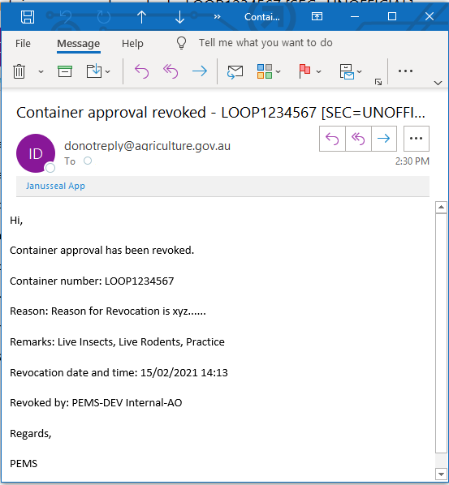

## Related material

The following related material is available on the department’s website:

* Manual of Importing Country Requirements ([Micor](http://micor.agriculture.gov.au/Plants/Pages/Documents.aspx)).
* [Micor Plants](https://micor.agriculture.gov.au/Plants/Pages/default.aspx) (importing country requirements, protocols and work plans)
* [Protocols, work plans](http://micor.agriculture.gov.au/Plants/Pages/Documents.aspx)
* [Plant Export Operations Manual](http://www.agriculture.gov.au/export/controlled-goods/plants-plant-products/plantexportsmanual)
* Reference: *PEMS AO user guide – Overview and General Functions*
* *Grain and Plant Product Inspection*
* *Horticulture inspections*
* *Bulk vessel inspections*
* *Bulk into ship hold inspections*
* *Quality systems recognition inspection*
* *In-transit cold treatment calibration records*

The following related material is available on the department’s [Learnhub](https://learnhub.ssc.gov.au/login/):

* Plant Export Management System (PEMS) video tutorials.

## Contact information

* Authorised Officer Hotline: 1800 851 305
* Authorised Officer Program: PlantExportTraining@awe.gov.au
* PEMS Administration: [PEMS@awe.gov.au](mailto:PEMS@awe.gov.au).

## Document information

The following table contains administrative metadata.

| Instructional Material Library document ID | Instructional material owner |
| --- | --- |
| IMLS-9-7601 | Director, Congestion Busting Program |

## Version history

The following table details the published date and amendment details for this document.

| Version | Date | Amendment details |
| --- | --- | --- |
| 1.0 | 08/07/2016 | New user guide. |
| 1.1 | 12/07/2016 | Minor variations for accuracy and clarity. |
| 2.0 | 30/09/2016 | Complete document restructure.  Addition of sections on:   * Logging into PEMS * Calibration records * Calibration search. |
| 2.1 | 16/12/2016 | Minor variations for accuracy and clarity  Removal of Appendix F – Calibrations and loading  Removal of Section 2.3 – Calibration search |
| 3.0 | 09/10/2018 | AO user guide updated with PEMS v2.1 enhancements. |
| 4.0 | 23/05/2019 | AO user guide updated with PEMS v3.1 and v3.2 enhancements. |
| 5.0 | 4/11/2019 | Updated with PEMS v.3.3 and 3.4 enhancements. |
| 6.0 | 3/06/2020 | Updated with PEMS 3.5 enhancements. |
| 7.0 | 28/08/2020 | Removal of appendices from Plant Exports Management System (PEMS) Authorised Officer user guide to make each its own user guide. |
| 8.0 | 10/12/2020 | Updated with PEMS v3.9a enhancements. |
| 9.0 | 28/03/2021 | Updated for commencement of the *Export Control Act 2020* and associated Plant Rules. |
| 10 | 7/06/2021 | Removed CGI reference. |
| 11 | 13/09/2021 | Updated with PEMS September 2021 release. |
| 12 | 4/04/2022 | Updated with PEMS release in April 2022. |