# Enteric red mouth disease (ERMD)

Also known as infection with Yersinia ruckeri

From Aquatic animal diseases significant to Australia: identification field guide, 5th edition

Figure 1 Characteristic red mouth from ERMD in rainbow trout (Oncorhynchus mykiss)

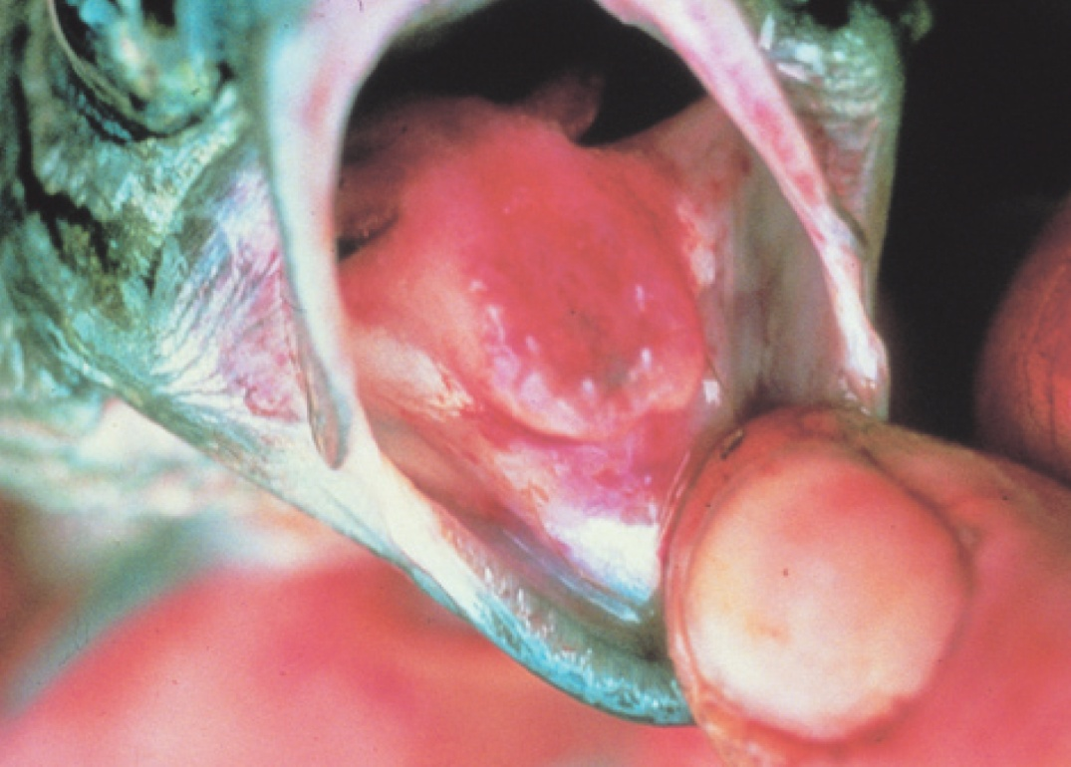

Note: Reddened mouth and tongue.

Source: HJ Schlotfeldt

Figure 2 ERMD in rainbow trout (Oncorhynchus mykiss)

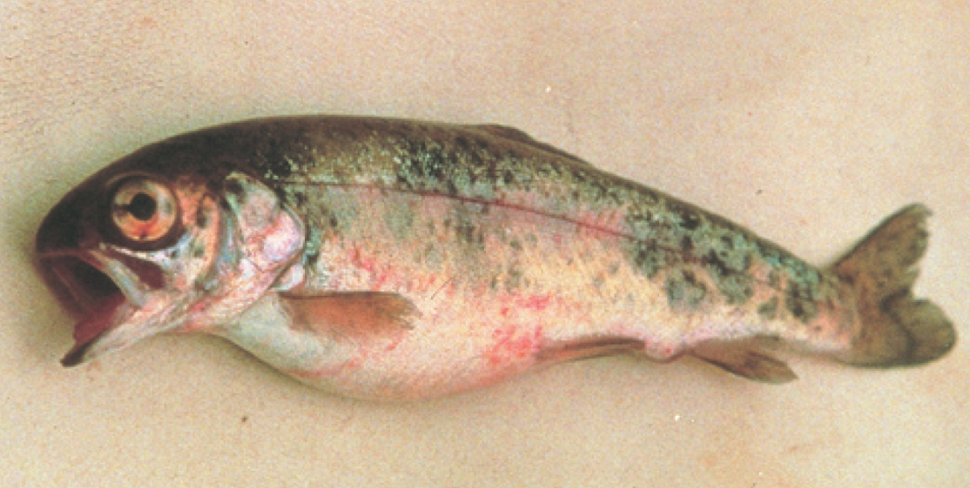

Note: Skin and eye haemorrhages, and swollen abdomen.

Source: HJ Schlotfeldt

## Signs of disease

Important: Animals with this disease may show one or more of these signs, but the pathogen may still be present in the absence of any signs.

Disease signs at the farm, tank or pond level are:

* separation from other fish
* occasional nervous signs
* acute infections in fingerlings (fish of all ages may be affected, usually with sustained low-level mortalities).

Gross pathological signs are:

* dark body colour (seen in atypical infections)
* haemorrhages at base of paired fins and vent
* reddening (subcutaneous haemorrhages) of gill cover, corners of mouth, gums, palate and tongue
* exophthalmos (popeye) and orbital haemorrhages
* loss of appetite
* swollen abdomen
* ascites (fluid in the abdominal cavity)
* petechial (pinpoint) haemorrhages may occur on the surfaces of the liver, pancreas, pyloric caeca, swim bladder and in the lateral musculature
* enlarged, friable spleen is often almost black in colour
* inflamed lower intestine containing thick yellow fluid.

Microscopic pathological signs are:

* generalised haemorrhagic septicaemic inflammatory response of all tissues
* bacterial colonisation of well-vascularised tissue (spleen, liver, heart, gills, kidney)
* necrosis of haematopoietic tissue in the kidney and spleen.

## Disease agent

ERMD is caused by infection with Yersinia ruckeri (Hagerman strain), a member of the family Enterobacteriaceae. There are several serotypes of the bacterium, and classification systems can be based upon whole-cell typing as well as individual cell-wall antigen groupings. The serotype responsible for ERMD is the Hagerman strain, serotype O1a, is considered to be the most virulent.

The enteric red mouth strain of Y. ruckeri (serotype O1a) is exotic to Australia. However, a virulent form of Y. ruckeri (serotype O1b) is endemic in Australia. Serotype O1b produces a septicaemic condition in Atlantic salmon (Salmo salar) known as yersiniosis. A characteristic of this form of the disease is exophthalmia (popeye) and the formation of pronounced haemorrhages in the eye that give rise to the description of blood spot disease. Signs typical of classical ERMD—prominent reddening of the corners of the mouth, gums and palate—do not normally occur in yersiniosis.

## Host range

Table 1 Species found in Australia known to be naturally susceptible to ERMD

| Common name | Scientific name |
| --- | --- |
| Atlantic salmon | Salmo salar |
| Brown trout | Salmo trutta |
| Brook trout | Salvelinus fontinalis |
| Common carp and koi carp | Cyprinus carpio |
| Goldfish | Carassius auratus |
| Rainbow trout | Oncorhynchus mykiss |

Table 2 Species not commonly found in Australia known to be naturally susceptible to ERMD

| Common name | Scientific name |
| --- | --- |
| **Salmonids** | |
| Arctic char | Salvelinus alpinus |
| Chinook salmon | Oncorhynchus tshawytscha |
| Coho salmon | Oncorhynchus kisutch |
| Cutthroat trout | Oncorhynchus clarkii |
| Sockeye salmon | Oncorhynchus nerka |
| Whitefish | Coregonus spp. |
| Whitefish (Muksun) | Coregonus muksun |
| Whitefish (Peled) | Coregonus peled |
| **Non-salmonids** | |
| Bighead carp | Aristichthys nobilis |
| Burbot | Lota lota |
| Channel catfish | Ictalurus punctatus |
| Cisco | Coregonus artedi |
| Common sole | Solea solea |
| Emerald shiner | Notropis atherinoides |
| European eel | Anguilla anguilla |
| Fathead minnow | Pimephales promelas |
| Pike | Esox lucius |
| Siberian sturgeon | Acipenser baerii |
| Silver carp | Hypophthalmichthys molitrix |
| Turbot | Scophthalmus maximus |

Table 3 Non-fish carriers

| Common name | Scientific name |
| --- | --- |
| Freshwater crayfish | Various genera and species |

## Presence in Australia

Exotic disease—not recorded in Australia.

A related disease known as yersiniosis or blood spot disease occurs in Australia.

Map 1 Presence of ERMD, by jurisdiction

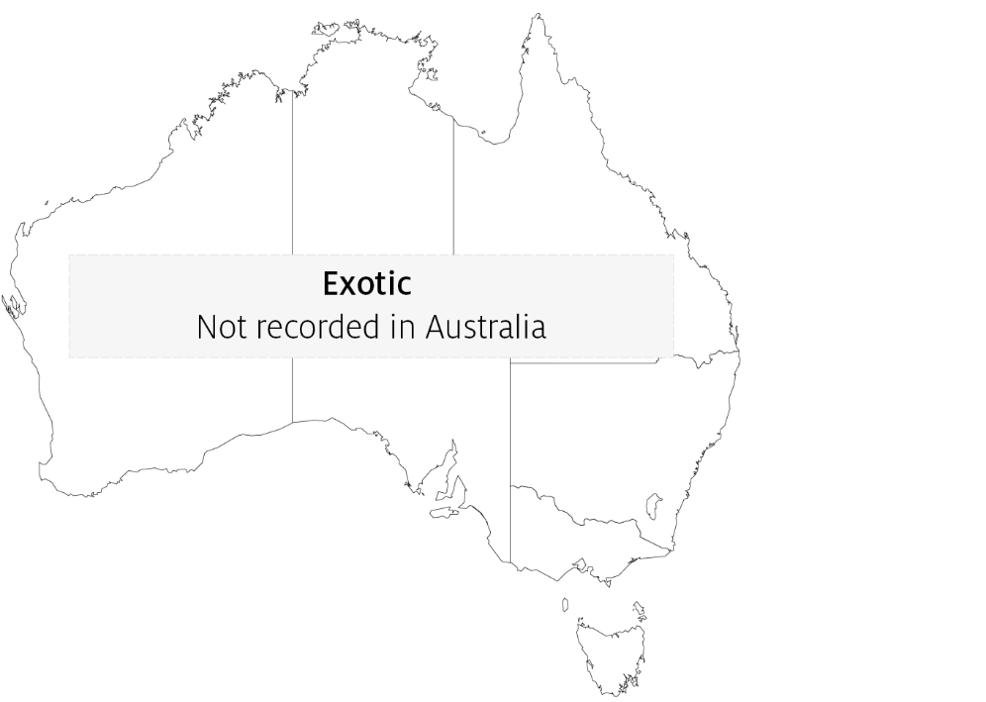

## Epidemiology

* Many other aquatic species are potential carriers but show no signs (some crustaceans, including freshwater crayfish).
* Transmission can be horizontal, via direct contact with infected fish or carriers. Carriers are particularly important sources of infection under stressful situations (such as increasing water temperature).
* Yersinia ruckeri can survive in the environment, with some strains able to form biofilms.
* Vertical transmission (fish to egg) is suggested by the presence of Y. ruckeri DNA in ovarian fluids and unfertilized eggs.
* ERMD causes septicaemia (bacteria are spread through the body via the blood).
* Fish of all ages are affected, and outbreaks usually begin with low mortalities that slowly escalate. The severity of the outbreak depends on the strain and presence of stressors.

## Differential diagnosis

The list of similar diseases in the next section refers only to the diseases covered by this field guide. Gross pathological signs may also be representative of diseases not included in this guide. Do not rely on gross signs to provide a definitive diagnosis. Use them as a tool to help identify the listed diseases that most closely account for the observed signs.

## Similar diseases

Infection with HPR-deleted or HPR0 infectious salmon anaemia virus, infectious haematopoietic necrosis (IHN), spring viraemia of carp (SVC), viral haemorrhagic septicaemia (VHS) and whirling disease.

## Sample collection

Only trained personnel should collect samples. Using only gross pathological signs to differentiate between diseases is not reliable, and some aquatic animal disease agents pose a risk to humans. If you are not appropriately trained, phone your state or territory hotline number and report your observations. If you have to collect samples, the agency taking your call will advise you on the appropriate course of action. Local or district fisheries or veterinary authorities may also advise on sampling.

## Emergency disease hotline

See something you think is this disease? Report it. Even if you’re not sure.

Call the Emergency Animal Disease Watch Hotline on **1800 675 888**. They will refer you to the right state or territory agency.

## Microscope images

Figure 3 Skeletal muscle of rainbow trout (Oncorhynchus mykiss) naturally infected with Yersinia ruckeri

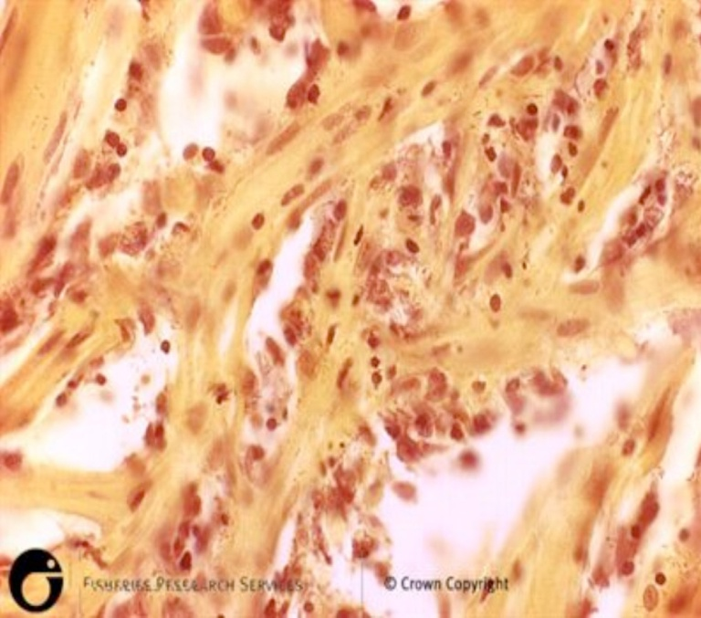

Note: Diffuse haemorrhage evident in sections of skeletal muscle.

Source: Scottish Government

Figure 4 Kidney of rainbow trout (Oncorhynchus mykiss) naturally infected with Yersinia ruckeri

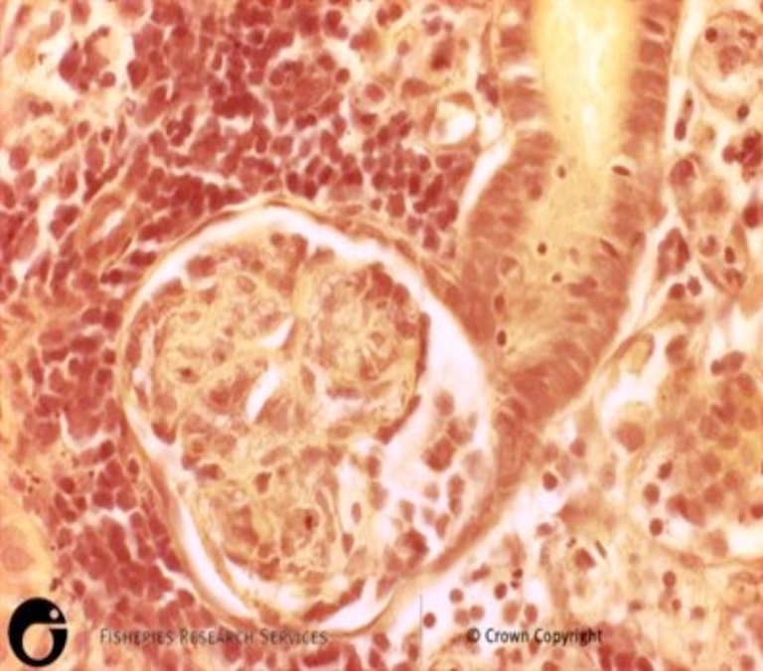

Note: Diffuse haemorrhage evident in sections of kidney.

Source: Scottish Government

## Further reading

CEFAS International Database on Aquatic Animal Diseases [Entric Redmouth](https://www.cefas.co.uk/international-database-on-aquatic-animal-diseases/disease-data/?id=7)

Glenn RA, Taylor PW, Pelton EH, Gutenberger SK, Ahrens MA, Marchant LM, Hanson KC 2015, [Genetic evidence of vertical transmission and cycling of ‘Yersinia ruckeri’ in hatchery-origin fall chinook salmon ‘Oncorhynchus tshawytscha’](https://fwspubs.org/doi/full/10.3996/012014-JFWM-010), Journal of Fish and Wildlife Management.

Kumar G, Menanteau-Ledouble S, Saleh M, El-Matbouli M 2015, [‘Yersinia ruckeri’, the causative agent of enteric red mouth disease in fish](https://www.ncbi.nlm.nih.gov/pmc/articles/PMC4581093/), Veterinary Research.

These hyperlinks were correct at the time of publication.

## Contact details

Emergency Animal Disease Watch Hotline 1800 675 888

Email [AAH@agriculture.gov.au](mailto:AAH@agriculture.gov.au)Website [agriculture.gov.au/pests-diseases-weeds/aquatic](http://www.agriculture.gov.au/pests-diseases-weeds/aquatic)

© Commonwealth of Australia 2020

This work is copyright. It may be reproduced in whole or in part subject to the inclusion of an acknowledgement of the source and no commercial usage or sale.