2025 Environmental Biosecurity Roundtable: Facing the future together
Melbourne Zoo
11 September 2025
The 2025 Environmental Biosecurity Roundtable (the Roundtable) welcomed 68 participants, representing 38 organisations. Together, participants contributed to an engaging, full day event that fostered connection, collaboration and strategic discussion between leaders in environmental biosecurity.
Hosted by the Department of Agriculture, Fisheries and Forestry (DAFF)’s Environmental Biosecurity Office, the Roundtable is a key deliverable of the National Biosecurity Strategy Action Plan. The Roundtable is supported by the Department of Climate Change, Energy, the Environment and Water (DCCEEW)’s Office of the Threatened Species Commissioner.
Break out box no # 1: What did the participants survey say?
- Did this roundtable successfully bring together stakeholders? 100% yes.
- Were you able to connect and network during the event? 100% yes.
- Would you be interested in attending another roundtable? 100% yes.
- Did this roundtable satisfy your expectations? 15% no / 85% yes.
- Would you be interested in presenting at a future roundtable – 50% yes / 50% no.
- Welcome pack useful? 100% yes.

Welcome Address
The Roundtable opened with a welcome from Zoos Victoria CEO, Dr Jenny Gray, followed by a powerful and moving Welcome to Country from Wurundjeri man Colin Hunter Jr Jr. A video message from Minister for Agriculture, Fisheries and Forestry, Julie Collins MP officially opened the event.
Australian Chief Environmental Biosecurity Officer, Dr Bertie Hennecke (DAFF) and Threatened Species Commissioner, Dr Fiona Fraser (DCCEEW), set the tone with an opening address that highlighted the vital role of collaboration and connectedness in protecting Australia’s environment. They outlined that environmental biosecurity is not only about preserving the foundations of our agriculture, economy, and way of life — like clean air, soil, and water—but also about safeguarding our agricultural assets and unique ecosystems.
Their remarks also acknowledged the deep cultural and spiritual ties First Nations Australians hold with Country, reinforcing the broader significance of biosecurity as a shared responsibility.
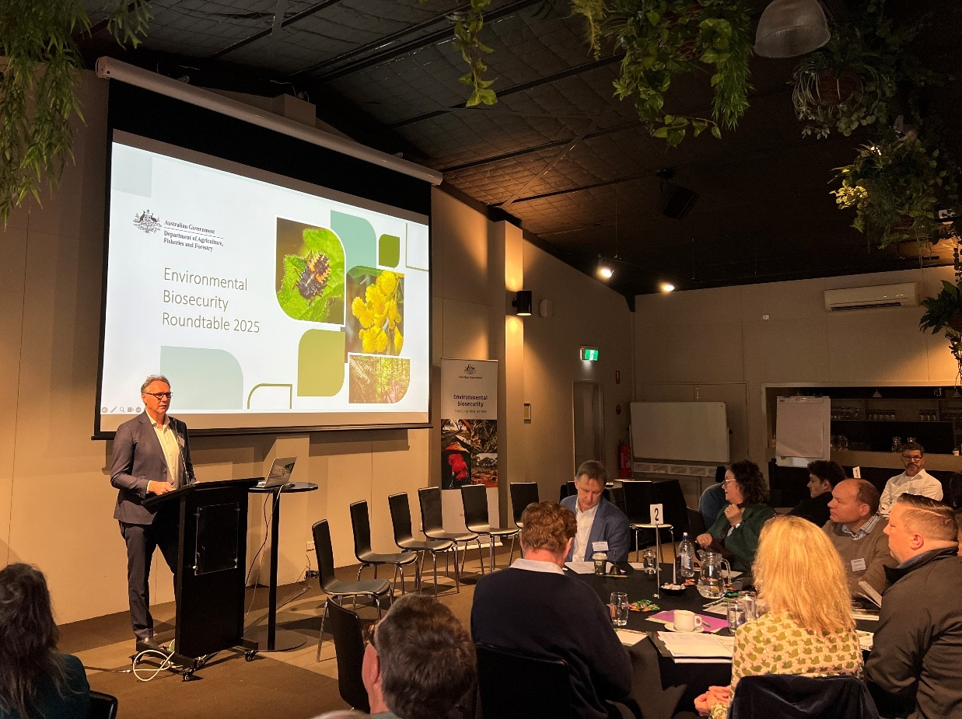
Figure 1. Australia Chief Environmental Biosecurity Officer, Bertie Hennecke, welcoming participants to the Environmental Biosecurity Roundtable.
Panel discussion: Rapid Relay
Panellists (full organisation names listed in the participants table at the end of this document): Penny Fisher DEECA, Annelise Wiebkin PIRSA, Kellie Passeretto DBCA, Enrico Perotti DPI QLD, Justin Bellanger NRM Regions Australia, Shauna Chadlowe CISS, Fiona Fraser DCCEEW
Representatives from government and non-government organisations shared their current priorities, challenges, and opportunities in environmental biosecurity. Topics included managing invasive species, such as the eradication of feral pigs from Kangaroo Island and emerging threats like Polyphagous shot-hole borer.
The panel emphasised the need to clarify roles and responsibilities to support national, coordinated action. Shauna Chadlowe from CISS highlighted four guiding principles—collaboration, coordination, communication, and co-investment—as essential for tackling large-scale biosecurity issues.
The panel agreed that citizen science plays a valuable role in early detection and public engagement, helping to build awareness and support for biosecurity initiatives.
Presentation: National collaboration for abating key threats to biodiversity
Jason Ferris (DCCEEW), presented on work underway on abating key threats to biodiversity, emphasising the importance of national collaboration in addressing key threats to biodiversity.
Effective threat abatement requires collective engagement, coordination, and a One Health approach—recognising the interconnected benefits to biodiversity, agriculture, social amenity, and other sectors.
The role of Threat Abatement Plans (TAPs) as a practical tool for aligning efforts across jurisdictions and sectors was discussed. These plans target key threatening processes and are designed to foster collaboration in managing environmental risks.
Panel discussion: Improving environmental outcomes through effective coordination
Panellists: Tiggy Grillo WHA, Enrico Perotti DPI QLD, Heather Channon - National Feral Pig Management Coordinator APL, Angie Reid NAILSMA, Raghu Sathyamurthy CSIRO
Led by Karen Moloney (DAFF) the panel highlighted the importance of a One Health, multi-agency approach to invasive species management. Panellists emphasised the need for collaboration and communication across government, community, and partner groups to build national awareness and break down silos.
Tiggy Grillo stressed aligning new initiatives with existing frameworks, incorporating First Nations voices, and maintaining trusted relationships to support both preparedness and rapid response. Enrico Perotti outlined the importance of clear governance, accountability, and using tools like emergency response deeds to strengthen coordination. He also highlighted citizen science and multi-agency committees as effective engagement strategies.
Heather Channon shared insights from the National Feral Pig Action Plan, noting that bringing people together through conferences and shared learnings helped overcome isolation and foster collaboration.
Angie Reid discussed the need for stronger engagement with Indigenous ranger groups, emphasising co-design, co-implementation and long-term relationship building, especially in remote areas where lack of culturally appropriate communications and long-term funding can erode trust.
Raghu Sathyamurthy called for outcomes-focused research and greater attention to managing non-eradicable species.
Overall, the panel reinforced that effective, national coordination is essential to advancing environmental biosecurity.
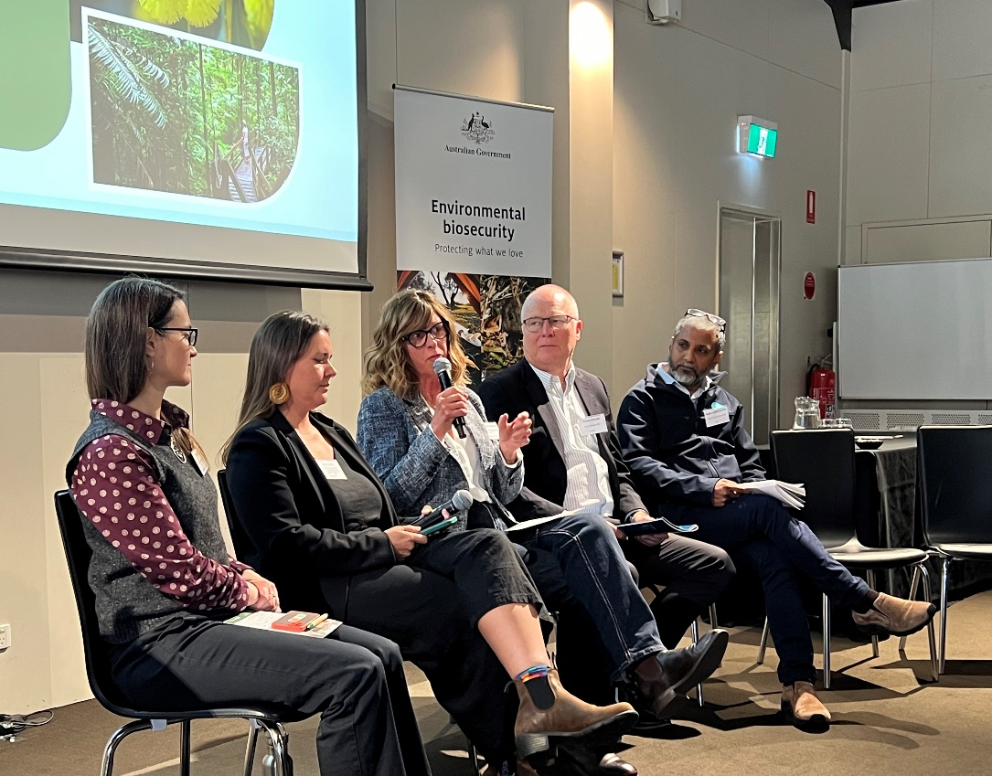
Figure 2. Heather Channon from APL sharing insights to improve environmental outcomes through effective coordination with fellow panel members Tiggy Grillo, Angie Reid, Enrico Perotti and Raghu Sathyamurthy.
Workshop: Strengthening partnerships and expanding networks
Led by Bertie Hennecke, participants explored four key questions focused on strengthening partnerships and expanding stakeholder networks. Working in small groups, they shared examples of effective engagement, identified barriers to collaboration, and proposed strategies for improvement.

Several challenges were identified. Inter-agency communication often lacks transparency, and collaboration is sometimes limited to mandated efforts. To improve collaboration, participants recommended focusing on outcomes rather than actions, better engagement of partner stakeholder groups and more focused working/steering groups/committees. Transparency along with flexible structures underpinned by formal agreements (e.g. MoUs) could help build trust and expand networks.

The inclusion of NGOs and community groups presents more opportunities to partner, co-design and expand committee representation. Strengthening links between agriculture and wildlife professionals was identified as a critical gap.

The workshop reinforced the importance of inclusive, transparent, and outcome-driven collaboration to strengthen Australia’s environmental biosecurity system.
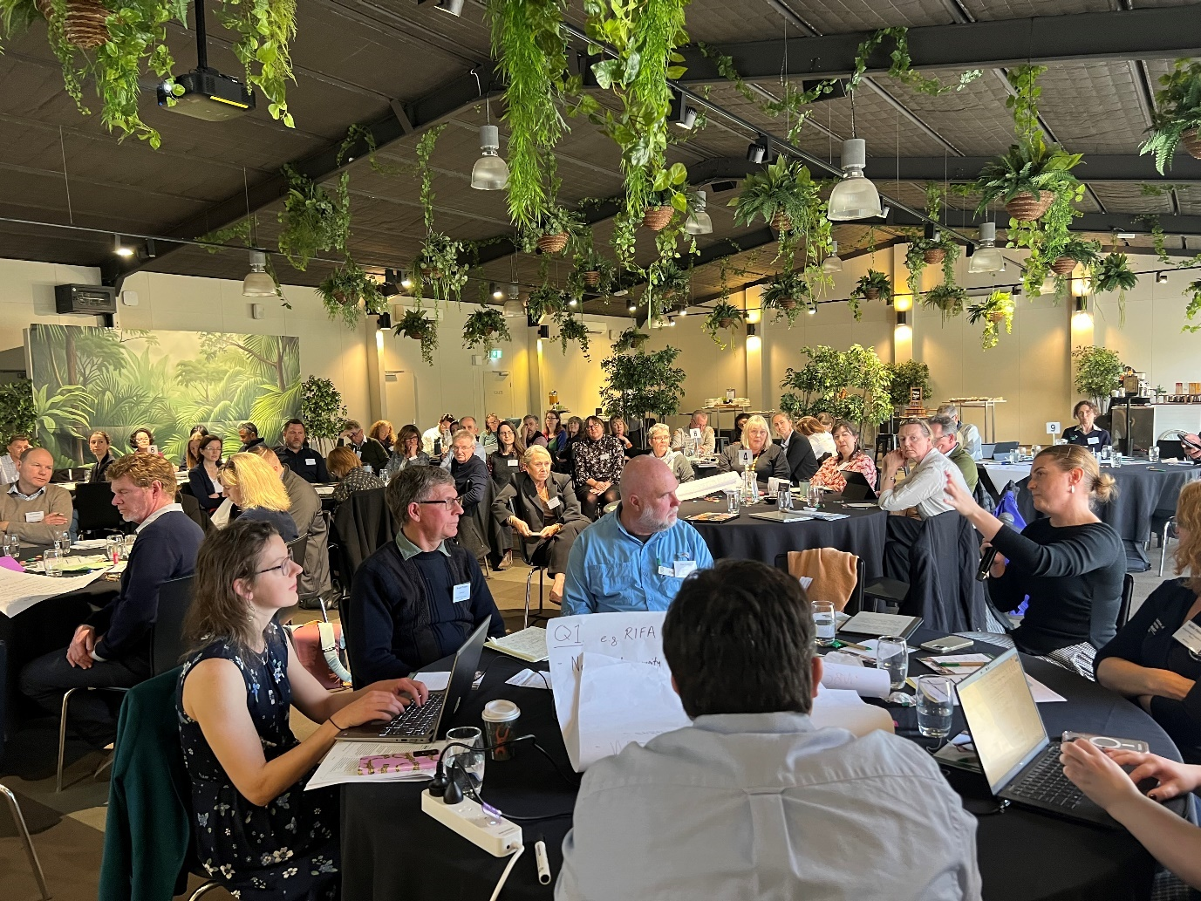
Figure 3. Participants sharing examples of effective communication and identifying barriers to collaboration.
Case Study: Operation DJANGO
Operation DJANGO was presented by Victoria’s Adam Kay (DEECA) as a powerful example of collaborative, cross-agency biosecurity in action.
DJANGO responded to the largest detected network of illegal wildlife trade, breeding, and brokering in Victoria, with links across several Australian states and internationally to Asia. Spanning two years and multiple jurisdictions, the operation highlighted the scale and complexity of biosecurity threats and animal welfare issues.
This important work reduces the potential for diseases that may spread to local wildlife, pets, and even humans, as well as the serious environmental impacts of exotic species that could escape into the environment.
Adam reinforced the importance of national, cross-sector collaboration and the critical role of community awareness and engagement in achieving effective biosecurity outcomes.
Workshop: Culture, Country and Conservation: First Nations and the future of Environmental biosecurity
Led by Corey Williams-Daly (DAFF), participants engaged in meaningful table group discussions exploring how First Nations knowledge and leadership can be more deeply embedded in environmental biosecurity, invasive species management, and conservation efforts. The conversations highlighted both the promise and challenges of fostering genuine partnerships with First Nations People’s and communities.
Key themes shared by participants included the importance of co-designing initiatives that reflect First Nations priorities and ways of knowing, rather than imposing external frameworks. Participants emphasised the need for early and respectful engagement, sustainable relationship building resulting in mutual benefit and long-term outcomes. There was a strong recognition that First Nations people must be supported to lead on their terms, with help to secure adequate and sustained funding.
Several groups shared examples of successful collaborations, including citizen science projects and joint land management programs across various states. These stories showcased the value of Indigenous Ecological Knowledge. However, others acknowledged the gaps – particularly around institutional barriers, limited funding and a lack of knowing what the right way is to engage with First Nations communities and organisations.
Overall, the session reinforced that embedding First Nations voices in the work across sectors, is not just an opportunity but a responsibility. It requires ongoing commitment, listening and it could even include structural change to ensure we can begin working together effectively utilising both traditional knowledge and modern science.
Presentation: Behavioural insights research: H5 bird flu
Fiona Fraser, DCCEEW presented on behalf of the Australian Government High Pathogenic Avian Influenza (HPAI) Taskforce. The Taskforce has commissioned behavioural insights research on public attitudes, awareness, and behaviours related to H5 bird flu. Conducted between April and June 2025, the research included stakeholder interviews, focus groups, surveys with over 4,000 participants.
Findings revealed low public awareness of H5 bird flu, with many perceiving it as an agricultural issue only. Lingering crisis fatigue means people will ignore H5 until it feels personally relevant or urgent.
The presentation closed with an emphasis on pursuing nationally coordinated messaging and communications.

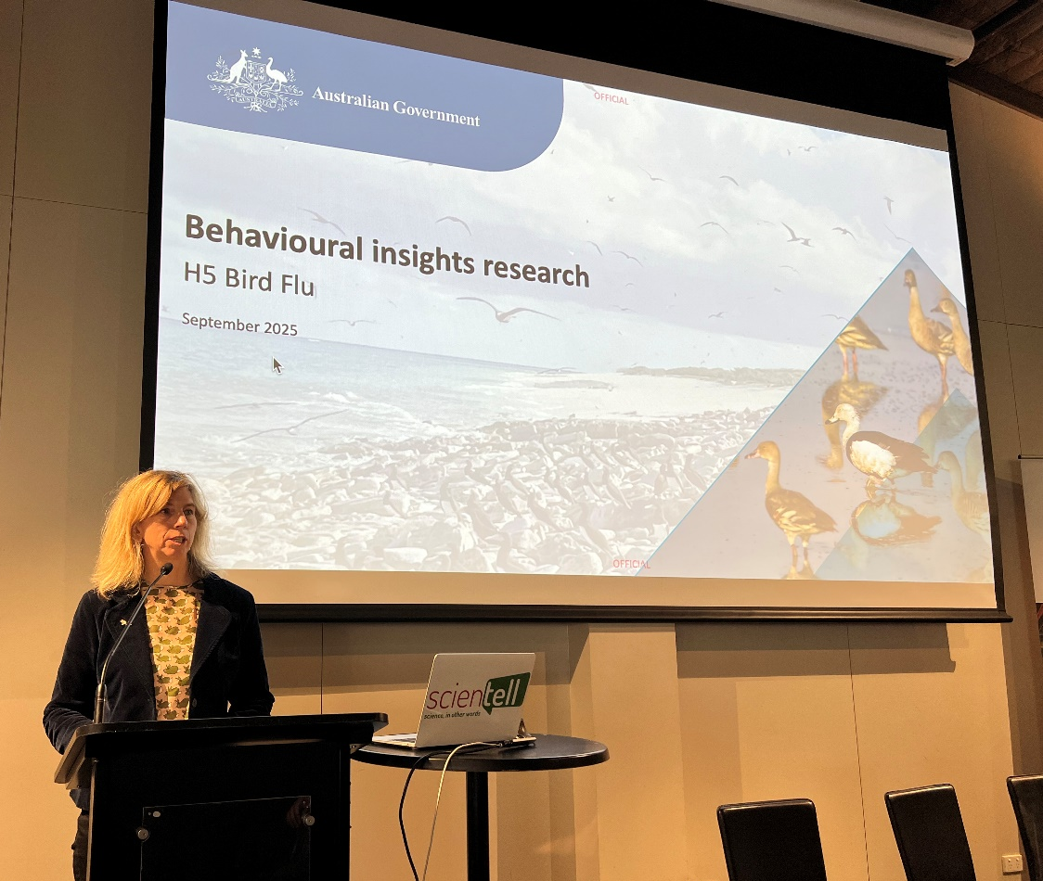
Figure 4. Threatened Species Commissioner, Fiona Fraser, talking about behavioural insights research on public attitudes towards H5 avian influenza.
Panel discussion: From the global to the national: Leadership and partnership in environmental biosecurity and conservation
Panellists: Carol Booth ISC, Shauna Chadlowe CISS, Fiona Fraser DCCEEW
Andy Sheppard, CSIRO, led the panel discussion, focusing on scaling environmental biosecurity from national to international levels. He emphasised Australia’s responsibility to regional neighbours and trading partners, noting biosecurity is a global issue tied to international obligations and targets. He referenced the Intergovernmental Science-Policy Platform on Biodiversity and Ecosystem Services 2023 Assessment of Invasive Alien Species, which highlighted insufficient global policy implementation and the compounding effects of climate change.
While Australia has a strong history of supporting regional neighbours in embedding strong biosecurity practices for agricultural commodities, panellists explored how Australia can improve support to expand to environmental outcomes. Carol Booth stressed advocacy and long-term planning, while Shauna Chadlowe highlighted the importance of co-investment and collaboration, citing New Zealand’s pest-free strategy. Fiona Fraser urged organised action and leveraging ambitious global targets to drive progress.
Q&A comments reinforced the value of One Health approaches, existing Asia-Pacific collaboration, and leveraging current partner efforts without adding unnecessary burden.
Closing address
Bertie Hennecke closed the Roundtable, reflecting on key themes of co-ownership, co-design, co-development, co-implementation and collaboration. He encouraged shifting language from “stakeholders” to “partners” to foster stronger, more inclusive relationships.
Bertie also highlighted the power of shared responsibility in tackling biosecurity challenges and noted the growing concern around misinformation and social licence, suggesting these be addressed collectively and considered by groups including the National Biosecurity Committee’s Environment and Invasives Committee (EIC) and Environmental Biosecurity Advisory Group (EBAG).
Environmental biosecurity in practice
Participants were given the opportunity to join behind the scenes tours of Melbourne Zoo’s biosecurity and species conservation facilities. Tours showcased the corrobboree frog; Lord Howe Island stick insect and tapir programs.
Next steps
Thank you to Melbourne Zoo and everyone who participated in the Roundtable for their time and contributions, especially presenters and panellists who led the broad and engaging agenda. Actions and ideas from the Roundtable will be progressed and continued in partnership with committees such as EIC and within the Environmental Biosecurity Office.
The next roundtable will be held in 2026 - keep an eye on our website for updates. For an invitation, agenda requests or contributions please email us at EBO@aff.gov.au
Some quotes from the survey:
“Great diversity of attendees - excellent opportunity to reconnect with colleagues and expand networks. Great day”.
“It was a great event that drew out important themes for biosecurity. I'd love to see these themes now put to work through forums/ committees. It was valuable to see decision-makers across key sectors engaged in biosecurity attend this event - from private land conservation to government jurisdictions, to research organisations and NGOs.”
“Would love to see more First Nations involvement.”
“It would've been great to have had more representation on topics, such as marine biosecurity, which wasn't discussed in depth. Marine environments are incredibly important but often overlooked when these types of discussions happen.”
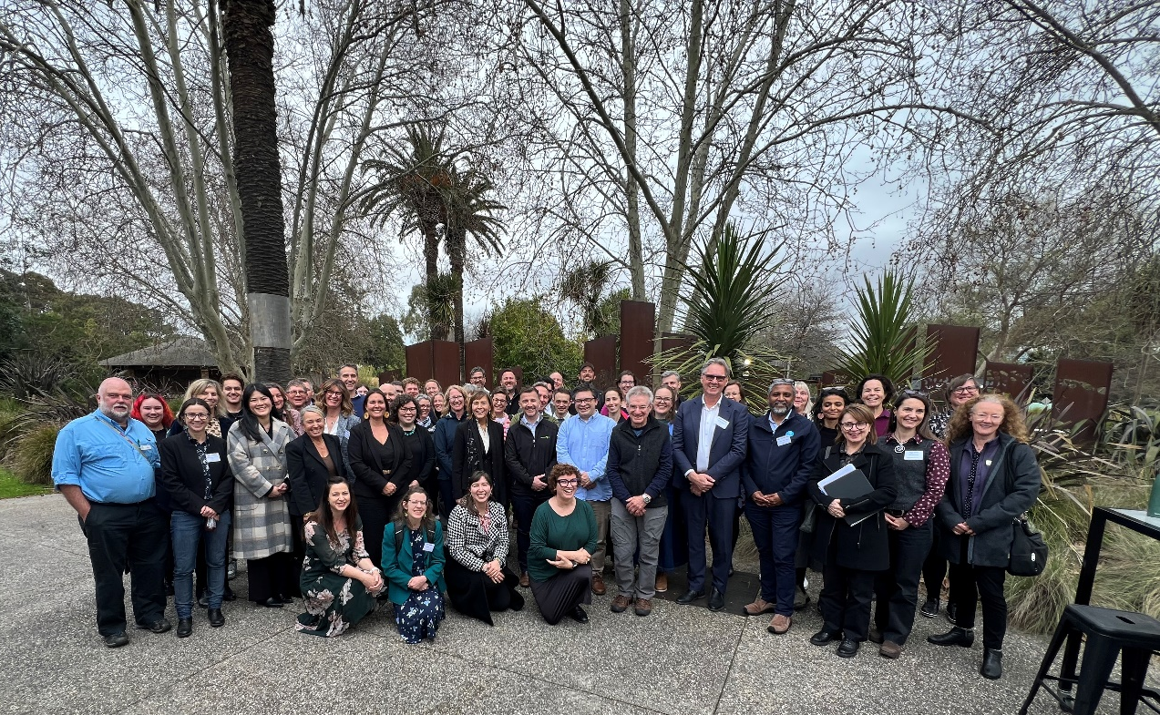
Figure 5. Group photo of participants of the 2025 Environmental Biosecurity Roundtable.

Figure 6. Shown are results from the survey where participants were asked to rank the sessions from the day based on their value. Sessions are listed in order of most valuable to least valuable based on weighted ranking of all survey participants’ results.
Organisations in attendance and their acronyms (if applicable)
 | ACT Government
 | Agriculture Victoria
AHA | Animal Health Australia
ALA | Atlas of Living Australia (CSIRO)
ACSA | Australian Citizen Science Association
ADA | Australian Deer Association
ALGA | Australian Local Government Association
AOL | Australian Organic Limited
APL | Australian Pork Limited
AWC | Australian Wildlife Conservancy
 | Biodiversity Council
 | BirdLife Australia
BHA | Bush Heritage Australia
CISS | Centre for Invasive Species Solutions
CSIRO | Commonwealth Scientific and Industrial Research Organisation
CAWS | Council of Australasian Weed Societies
DAFF | Department of Agriculture, Fisheries and Forestry
DBCA | Department of Biodiversity, Conservation and Attractions
DCCEEW | Department of Climate Change, Energy, the Environment and Water
DEECA | Department of Energy, Environment and Climate Action
DPI QLD | Department of Primary Industries Queensland
RFA | Foundation for Rabbit-Free Australia
GMA | Game Management Authority (VIC)
ISC | Invasive Species Council
 | Landcare Australia
NFF | National Farmers Federation
NFA | Native Fish Australia (VIC)
NRM | Natural Resource Management Regions Australia
NAILSMA | North Australia Indigenous Land and Sea Management Alliance
NSW DCCEEW | NSW Department of Climate Change, Energy, the Environment and Water
NSW DPIRD | NSW Department of Primary Industries and Regional Development
PHA | Plant Health Australia
PIRSA | SA Department of Primary Industries and Regions
 | Scientell
VRAN | Victorian Rabbit Action Network
WHA | Wildlife Health Australia
ZAA | Zoo and Aquarium Association
 | Zoos Victoria

Acknowledgement of Country
We acknowledge the continuous connection of First Nations Traditional Owners and Custodians to the lands, seas and waters of Australia. We recognise their care for and cultivation of Country. We pay respect to Elders past and present, and recognise their knowledge and contribution to the productivity, innovation and sustainability of Australia’s agriculture, fisheries and forestry industries.
© Commonwealth of Australia 2025
Unless otherwise noted, copyright (and any other intellectual property rights) in this publication is owned by the Commonwealth of Australia (referred to as the Commonwealth).
All material in this publication is licensed under a Creative Commons Attribution 4.0 International Licence except content supplied by third parties, logos and the Commonwealth Coat of Arms.
The Australian Government acting through the Department of Agriculture, Fisheries and Forestry has exercised due care and skill in preparing and compiling the information and data in this publication. Notwithstanding, the Department of Agriculture, Fisheries and Forestry, its employees and advisers disclaim all liability, including liability for negligence and for any loss, damage, injury, expense or cost incurred by any person as a result of accessing, using or relying on any of the information or data in this publication to the maximum extent permitted by law.

