**Environmental flows in the Darling River to support native fish populations 2016–17.**

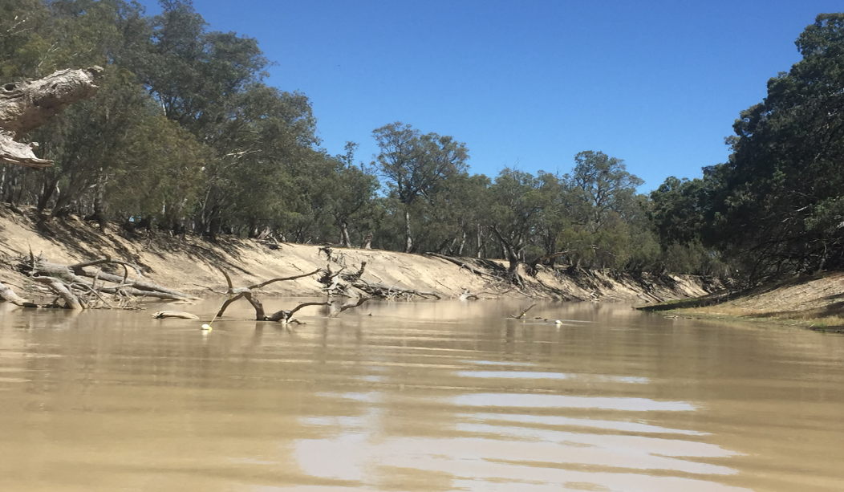



**Citation**:

Sharpe, C. and Stuart, I. (2018). Environmental flows in the Darling River to support native fish populations. CPS Enviro report to The Commonwealth Environmental Water Office.

**Acknowledgements**:

This project was funded by the Commonwealth Environmental Water Office.  From NSW OEH; Paula D’Santos, Sascha Healy and Paul Childs provided tireless leadership in flow planning and coordination to the lower Darling River and Great Darling Anabranch throughout 2016–17 to promote the maintenance and recovery of fish populations in the Darling River and Southern-Connected Basin. From NSW DPI Fisheries; Iain Ellis provided expert ecological input and support to flow planning, agency and community engagement of the project findings.  From CEWO Alana Wilkes, Irene Wegener, Hilton Taylor, Hilary Johnson, and Sean Kelly and from the Murray–Darling Basin Authority, Adam Sluggett, Adam McLean, Kerry Greenwood, John Waterworth and Tristan Skinner provided operational guidelines for hydrograph development and delivery to the lower Darling River and Great Darling Anabranch.  From CPS Enviro, Sheridan Stephens for project administration and Steve Campbell-Brown and Mark Henderson for technical support in field sampling the Darling River (Walgett-Wentworth), Great Darling Anabranch and in the Menindee Lakes. We thank landholders along the Darling River and Anabranch for access through their properties. This work was conducted under NSW Fisheries Permit P12/0004 and Griffith University ACEC ENV0414AEC.

**Disclaimer**:

The results and comments contained in this report have been provided on the basis that the recipient assumes the sole responsibility for the interpretation and application of them. The author gives no warranty, express or implied, or assumes any legal liability or responsibility for the accuracy, completeness or use of the results and comments contained in this report by the recipient or any third party.

**Contact** **Details**:

Commonwealth Environmental Water Office

John Gorton Building

King Edward Terrace

Parkes ACT 2600

Australia

P: +61 2 6274 1111

E: [ewater@environment.gov.au](mailto:ewater@environment.gov.au)

### Executive summary

Prior to August 2016, the lower Darling River (LDR) endured the longest cease-to-flow period in its recorded history, exceeding 500 days. The river and its iconic and nationally threatened Murray cod (*Maccullochella peelii peelii*) and golden perch (*Macquaria ambigua*) populations contracted to a series of small isolated and deteriorating pools. The lack of replenishing flows was a dramatic and significant risk to native fish, particularly Murray cod, which could ill afford to be lost, particularly after the Murray River hypoxic blackwater fish kills of late 2016.

In September 2016, following tropical rainfall in the northern tributaries, significant inflows returned to the LDR. The ecological opportunity that these flows brought prompted NSW OEH to assemble a team of expert fish ecologists and water managers into a ‘Technical Advisory Group’ (TAG) to consider the options for delivering environmental water to the LDR to support its native fish populations. Notably, this would be the first time Commonwealth environmental water, NSW Environmental Water Allocation (EWA) and TLM water holdings would be used specifically to target environmental outcomes for the Lower Darling River. In the absence of environmental water, flow in the LDR would have been managed as minimum entitlement flows to meet basic operational needs as described under the New South Wales water sharing plan.

The TAG identified opportunities to maximise recovery of LDR native fish populations via environmental flows that supported key life-history processes. The objectives were based on conceptual models that distilled the latest scientific understanding of the LDR and Murray–Darling Basins’ (MDB) native fish and flow requirements into clear goals. These were transferred into an operational hydrograph which prescribed the actual flow delivery schedule (i.e. ML/d and rates of river rise and fall) for local river managers to implement (Figure i).

The environmental flow had two main goals;

1. to promote Murray cod and golden perch spawning and recruitment success in the LDR and,
2. to complete the nursery function of the Menindee Lakes by dispersing early juvenile golden perch into the LDR, Great Darling Anabranch (GDA) and Murray River populations.

This report presents the scientific foundations of the successful environmental flow design and the monitoring program that was undertaken to evaluate the fish responses to its delivery. It provides an evaluation of the environmental flows’ success in meeting its objectives and provides recommendations for best practice river management to support fish populations in the LDR, applicable to rivers throughout the MDB, into the future.

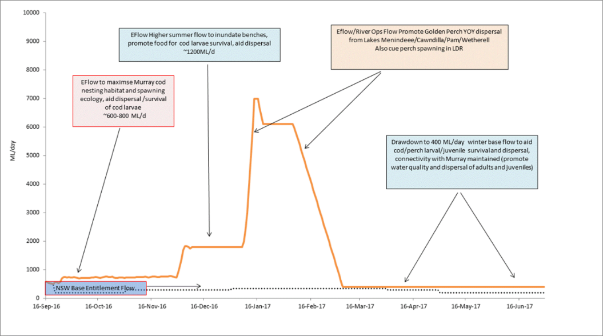

**Figure i.** The ‘LDR fish hydrograph’ that resulted in multi-species outcomes with spawning and recruitment of Murray cod, golden perch and potentially silver perch was based on conceptual models and local knowledge of key life history-flow relationships for fish in the LDR. The dashed line indicates the pattern of release for ‘LDR entitlement flows’ managed by Water NSW under the LDR Water Sharing Plan that would otherwise have prevailed in the absence of environmental water and fish outcomes throughout 2016–17.

**Key findings: Murray cod spawning in the LDR supported by environmental flows**

The LDR environmental flow commenced in September 2016. Flows from September to December were aimed at accommodating Murray cod breeding ecology, supporting courtship, nest selection, spawning and nest retention by avoiding rapid drops and rises in river levels throughout the breeding period. Monitoring for Murray cod spawning was conducted along 500+ km of river, between Menindee and Wentworth during this period. The success of the LDR environmental flow in supporting the first goal of the environmental flow plan can be gauged by a strong spawning response by Murray cod being recorded, with 885 Murray cod larvae collected across three sampling events from late November – early December 2016. The spawning response was considered high relative to other spawning studies conducted in the LDR and elsewhere, in particular to monitoring which occurred in 2014, when conditions in the LDR were not optimised to support spawning, flows were low and oscillating (~150-200 ML/d) and only 26 Murray cod larvae were recorded during the spawning period (Ellis et al. 2015).

The outcomes in 2016 were not limited to Murray cod, with spawning responses from both silver perch (*Bidyanus bidyanus*) and golden perch also recorded in the LDR in response to elements of the environmental flow that were planned to match the life-history requirements of those species. In the LDR, silver perch spawned in early November, during the ‘stable’ flow period of the environmental flow plan (albeit that water velocities across study sites was high, ranging from 0.3 – 0.7 m/s-1), and golden perch spawned in December, on an increase in discharge and water level that was delivered from the time Murray cod spawning was documented to have been completed. This increase in flow had the aim of elevating water levels and inundating littoral habitats, such as low-lying benches, for larvae to shelter and feed (Figure i). This flow plan aimed to promote productivity and food resources to promote the growth and survival of young, recently spawned fish and occurred throughout the 500 km of the LDR from early December. In January 2017, MDBA River Operations releases from Menindee Lakes increased for Murray River demands, which further elevated flows throughout the LDR over the subsequent four months (January 2016-April 2017). There was no monitoring of spawning or other biological elements conducted in the LDR in association the MDBA River Operations release.

Recruitment success in the LDR in relation to the 2016–17 environmental flow plan was evaluated by a census survey of fish populations in the LDR in June 2017. The LDR census showed ‘young of the year’ (YOY) Murray cod less than 12 months old at each LDR site and these represented a significant proportion (~10 per cent) of the population. This finding provides evidence that the goal of promoting Murray cod YOY recruitment with targeted environmental flows was achieved.

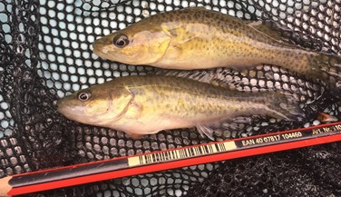

Figure ii. Young of the year (YOY) Murray cod (inset) produced during the 2016–17 environmental flow in the lower Darling River. YOY fish of this cohort represented about 10% of the LDR population across 500 km of the Darling River downstream of Menindee. Their collection demonstrated strong recruitment from spawning in the 2016 breeding season and highlights how targeted environmental flows were successful in supporting major population level outcomes 2016–17. C. Sharpe.

**Golden perch: Environmental flows support major juvenile dispersal events from nursery habitats in the Menindee Lakes to the lower Darling River and Great Darling Anabranch.**

The second goal of the environmental flow program was to support major dispersal migrations of young golden perch from their nursery grounds in the Menindee Lakes to the lower Darling and the Great Darling Anabranch. The monitoring program recorded a major spawning of golden perch in the Border Rivers in October 2016, with early juveniles moving downstream to Menindee with flood waters in spring/summer 2017/18. These were recorded arriving with the flows into the Menindee Lakes from November 2016. The Menindee Lakes is a major golden perch nursery and performs an important hydrological function within the MDB for golden perch recruitment. From there, environmental flows were implemented to enable dispersal of the young golden perch into the LDR and Great Darling Anabranch where the monitoring program demonstrated that they made up a large proportion of the population (i.e. up to 50 per cent).

These findings demonstrate that recruitment of golden perch at very large spatial areas (i.e. 500-1000+ km) can be achieved by using environmental water and that river managers can promote golden perch recruitment at the scale of the southern-connected MDB. With this finding, the goal of completing the nursery function of the Menindee Lakes by dispersing early juvenile golden perch into the LDR, Great Darling Anabranch (GDA) and eventually Murray River populations was achieved.

The successes of the 2016–17 LDR environmental flow was in supporting tangible and significant multi-species outcomes for native fish. With Murray cod spawning and recruitment, dispersal and recruitment of golden perch from their nursery grounds in the Menindee Lakes and spawning of golden perch and the nationally threatened silver perch in the LDR, maintaining the function of the Menindee Lakes and LDR, in large part with environmental water, was excellent value for investment. This will be important in maintaining these nationally significant native fish communities into the future.

# Community engagements associated with the 2016–17 lower Darling River Environmental Flow project

The project team communicated the environmental flow goals and findings from the monitoring and evaluation program at several public presentations, local and national news print articles, local radio interviews, conference forums and inter-governmental agency committees throughout 2016–17. These are summarised as follows;

* Clayton Sharpe (CPS Enviro) presented to representatives from the NSW Engaged Recreational Fishers Network at Millewa Forest in March 2017.
* Clayton Sharpe and Paula D’Santos (NSW OEH) presented to the NSW Floodplain Graziers annual general meeting at Louth NSW during April 2017.
* Clayton Sharpe, Iain Ellis (NSW DPI Fishers), Paula D’Santos and Paul Childs (NSW OEH) presented to a public forum at Pooncarie town hall in May 2017.
* Clayton Sharpe and Ivor Stuart (Kingfisher Research) presented to the Southern Connected Basin Environmental Watering Committee (SCBEWC) in Canberra during May 2017.
* Clayton Sharpe interviewed on ABC Radio Mildura/Swan Hill in May 2017.
* Clayton Sharpe interviewed on ABC Radio NSW Country Hour in July 2017.
* Clayton Sharpe and Paula D’Santos presented to elders at the Barkandji Evaluation Working Group at Kinchega National Park (Menindee) in September 2017.
* Clayton Sharpe and Ivor Stuart presented at the MDBA Native Fish Forum, Canberra September 2017.
* Clayton Sharpe interviewed for NSW Fish and Flows Website in September 2017.
* Clayton Sharpe, Paula D’Santos, Ivor Stuart and Iain Ellis contributed an article to RipRap magazine on the environmental flow goals, scientific foundations, monitoring results and outcomes in October 2017.
* Clayton Sharpe presented the findings of the monitoring program to the Commonwealth Environmental Water Office in Canberra in October 2017.

### List of acronyms

CEWO Commonwealth Environmental Water Office

GDA Great Darling Anabranch

LDR lower Darling River

MDBA Murray–Darling Basing Authority

MDB Murray–Darling Basin

OEH Office of Environment and Heritage

NSW New South Wales

SCB Southern Connected Basin

TLM The Living Murray

TAG Technical Advisory Committee

YOY Young of Year

# INTRODUCTION

In 2015–16, the lower Darling River (LDR) below Menindee ceased to flow for >500 days because of record low rainfall, upstream regulation and water extraction. This cease-to-flow was unprecedented since the Menindee Lakes Scheme was completed (Crabb 1997; Puckridge et al. 1998; Thoms and Sheldon 2000; Sheldon 2017) and even for modelled natural scenarios of the Darling’s pre-regulated flow regime (Thoms et al. 2004).

By summer 2015–16, most of the lower 500 km of the LDR had dried and the entire fish community was forced into isolated water holes of deteriorating quality (Figure 1). There were frequent reports of fish kills as water holes dried and there was concern that the LDRs’ nationally significant fish community and in particular its iconic Murray cod (*Maccullochella peelii peelii*) population, was at risk of being reduced to irrecoverable levels.

In August 2016, there was rain in the tropical north of the Darling catchment and regulated flows were able to be provided to the LDR from the replenished Menindee Lakes. In response, river managers prioritised environmental water for the LDR to ensure that remnant Murray cod populations were supported in terms of breeding, recruitment and survival. In addition, the catchment wide flow event provided an opportunity to manage for recruitment of golden perch (*Macquaria ambigua*) to the LDR, Great Darling Anabranch (GDA) and ultimately the Murray River by facilitating the downstream dispersal of juveniles from nursery grounds in the Menindee Lakes.

This report presents the key scientific objectives and hydrograph of the 2016–17 environmental flow plan for the LDR and details the responses of Murray cod and golden perch populations to the environmental flows delivered. We provide an evaluation of the influence of the environmental flows for >500 km of the LDR in sustaining population level outcomes for native fish and provide recommendations to guide future management to enhance native fish communities, both in the LDR and in other major rivers of the Murray–Darling Basin.

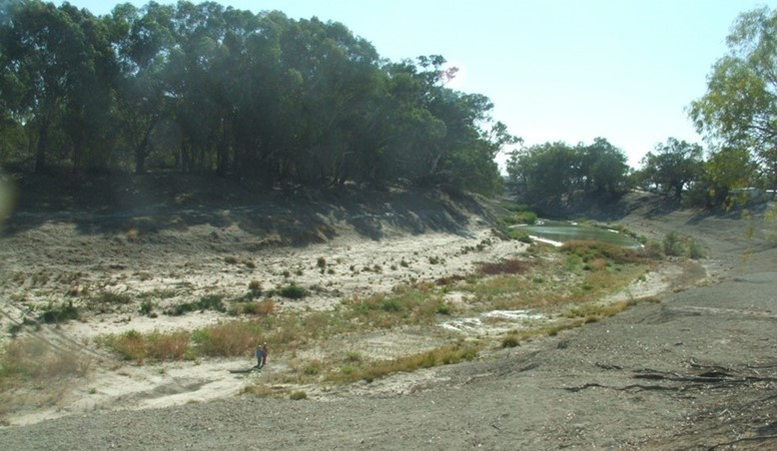**Figure 1.** The lower Darling River ceased to flow from 2015–2016 and dried to a series of isolated waterholes for >500 km. The native fish community retreated to isolated water holes on the river bends (top right). Image: C. Sharpe

# Part 1. Native fish objectives and response to environmental flows delivered to the lower Darling River in 2016–17; hydrograph development.

The environmental flow hydrograph to meet fish objectives in the LDR was based on a five-step framework, outlined below. Essentially, the framework conceptualises the latest science with detailed conceptual models of fish life-history ecology. It culminates in the design of an ecologically optimised hydrograph, prescribing a precise pattern of discharge to guide the actual delivery of water by river operators in the LDR.

We used the following framework to prioritise Murray cod and golden perch population objectives in the LDR. The overarching aim was to promote population recovery from the near catastrophic drying conditions that occurred throughout 2015–16. The specific objectives were to:

1. Prioritise native fish population management interventions for:
   * LDR Murray cod and golden perch.
2. Construct conceptual models for each species life-history ecology and identify local flow management requirements to:
   * Enhance spawning opportunities and juvenile recruitment for Murray cod in the LDR; Facilitate dispersal of golden perch recruits from Menindee Lakes nursery grounds into the LDR (Table 1).
3. Develop locally applicable hydrographs that match fish life-history and flow requirements
   * See Figure 2.

1. Identify the appropriate spatial and temporal scale for application of the hydrograph and identify/implement the key environmental watering actions for:
   * Lower Darling River and Great Darling Anabranch; 2016–17 (Table 1.)
2. Design and undertake event-based monitoring of Murray cod and golden perch, use field observations to guide adaptive management opportunities.
   * See section 2.

**Murray cod conceptual model**

Murray cod are ‘in-channel specialists’ (Baumgartner et al. 2013; Mallen-Cooper and Zampatti 2015; Ellis et al. 2017). They are a nesting species that exhibits annual reproduction during spring and summer. Murray cod are long lived, mature at about five years of age and have relatively low fecundity for their size. Juveniles and adults occupy the same habitats and adults can undertake spawning migrations. The main ecological characteristics of rivers that support strong Murray cod populations are: (i) hydrodynamic diversity (fast- and slow-flowing water), which is largely permanent or with short periods of zero flow outside of the spawning season, (ii) relatively stable flows during spring/summer (October-December) in the spawning season, (iii) largely perennial base-flows in winter, (iv) abundant large woody habitat, and (v) a natural temperature regime. The lack of any of these features, particularly during the spawning period or over winter, results in supressed levels of spawning and recruitment failure (Sharpe and Stuart 2016). A detailed conceptual model of Murray cod life-history is provided in Appendix 1.

Murray cod can complete their life cycle within river reaches, over relatively short spatial scales of 10’s of kilometres, provided the above conditions prevail (Koehn and Harrington 2004; Mallen-Cooper and Zampatti 2015). As part iii) of the five-step process outlined above, the Murray cod conceptual model was transposed into specific hydrograph elements to guide release of environmental water into the LDR in 2016–17 (Table 1, Figure 2). The key considerations for environmental flow planning to support spawning and recruitment opportunities for Murray cod in the LDR were;

* **September-December (spring) 2016 – Spawning;** Increase flow from critical base-entitlement levels (~150 ML/d) to mid-channel capacity (~1000 ML/d), increasing the availability of nesting habitats (snags, undercut banks), supporting nest selection, courtship, spawning, nesting and hatching of larvae.
* **December-January (summer) 2016–17 – Early juvenile recruitment;** increase flow to inundate low-lying benches, promoting riverine productivity and food resources for newly hatched larvae; facilitate larval drift, littoral habitat availability and food resources for early juveniles.
* **January-May (autumn) 2017 – Early juvenile recruitment;** slow attenuation of summer flow to winter baseflow levels (~400 ML/d), promote overwintering habitat selection for early juveniles and sub-adults and adults.
* **May-September (winter) 2017; Early juvenile recruitment, adult conditioning;** elevatedwinter base flows (400 ML/d) – increases in-stream habitat availability from that at critical base entitlement levels (~150 ML/d) enhancing survival for early juveniles, maintains invertebrate prey availability and mitigates thermal stress for all life-stages.

**Golden perch conceptual model**

Golden perch have a very broad geographic distribution and occupy a range of habitats throughout the lowland rivers of the Murray–Darling Basin (MDB). They are a long lived species (>20 years; Stuart 2006) and highly fecund for their size (50 000-700 000 eggs) that spawn pelagic eggs. Key life-history events such as spawning and recruitment occur at catchment scales of 500 to >1000 km. The latest science indicates Darling River golden perch require flow pulses or floods as an obligate cue for mass spawning and strong recruitment occurs when floods transport larvae and early juveniles into optimal nursery areas, such as the Menindee Lakes (Mallen-Cooper and Stuart 2003; King et al. 2009; Sharpe 2011; Sharpe et al. 2015; Koster et al. 2014; 2016).

Dispersal of early juveniles from nursery habitats (e.g. Menindee Lakes) drives recruitment to riverine populations and occurs on follow-up flow pulses, usually 4-18 months post first floodplain colonisation when juveniles respond to inflows and outflows by migrating from the floodplain lakes back to riverine habitats in both upstream and downstream directions (Sharpe 2011). For example, recruitment and dispersal from the Menindee Lakes was recorded in 2004 and again in 2009–10, after spawning on a natural flood pulse occurred in the Darling River upstream of Wilcannia when large numbers of early juveniles colonised the Menindee Lakes. Some 10-12 months later, the juveniles dispersed from the Menindee Lakes into the LDR and the Great Darling Anabranch and Murray River (Sharpe 2011).

The Darling River dispersal events recorded in 2004 and 2009 contributed new golden perch recruits to populations throughout the Murray, Loddon, Edward-Wakool and Goulburn Rivers, where the 2009–10-year class still dominates in distant reaches (e.g. > 80 per cent in lower Murray and >60 per cent in mid-upper Murray; Zampatti and Leigh 2013; Zampatti et al. 2015). It seems increasingly likely that the strongest recruitment events in the Southern Connected Basin (SCB), are largely driven by the mass arrival of juveniles from northern nursery grounds rather than from local spawning (Stuart and Sharpe 2017), although in the years where the Menindee Lakes are dry, then local spawning and artificial stocking still account for a proportion of golden perch within the Murray Valley (Forbes et al. 2015; Baumgartner 2016; Crook et al. 2016). A more detailed description of our conceptual model for golden perch population function in the Darling River is provided in Appendix 2.

In October 2016, there was a flood in the Darling River from northern tributary inflows and in terms of flow planning, our conceptual model predicted that the nursery function of the Menindee Lakes would occur as following: (i) golden perch spawning in the Darling River upstream of Wilcannia and (ii) transport of larvae/juveniles into the Menindee Lakes with the flood pulse. We then predicted that golden perch recruitment to the LDR could be facilitated by managing water releases from the Menindee Lakes, whereby early juvenile dispersal rates from the Lakes to the LDR and GDA would be enhanced relative to discharge at appropriate temporal scales.

A major management opportunity was in recognising that downstream dispersal of golden perch juveniles from the Menindee Lakes nursery grounds to the LDR could occur in parallel with the environmental flow objectives outlined above, for Murray cod. Hence, the dual objectives were incorporated into hydrograph planning.

Our conceptual model and flow planning framework for golden perch population function in the LDR predicted;

* **September-October 2016;** During a flow rise and flood, golden perch spawning would occur in tributaries of the Darling River, well upstream of Menindee.
* **October-December 2016;** Larvae and early juvenile golden perch would be transported downstream and settle into Menindee Lakes which function as an optimal nursery area, resulting in strong survivorship, growth and recruitment.
* **December-April 2016–17;** Flow released to the LDR and GDA would provide a downstream dispersal pathway for juvenile golden perch from the Menindee Lakes into LDR, GDA and eventually, Murray River populations.
  + **NB\*** The higher the volume of water released from the Menindee Lakes, the greater the potential rate and number of juvenile golden perch dispersal to LDR (and GDA)
  + A higher volume of water, if released to the LDR as a rapidly increasing flow spike, would cue adult golden perch in the LDR downstream of Menindee to spawn in summer 2017.

**Flow planning for multi species outcomes**

In September 2016, Commonwealth environmental water holders (CEWO, TLM) delivered ~119 GL to support the objectives identified above for Murray cod and golden perch population recovery in the Lower Darling River (CEWO ~70 GL, TLM ~50 GL). The flow plan was developed as per the conceptual framework outlined above which was transposed to a delivery schedule, or hydrograph, for river operators to implement (Figure 2).

Based on the ecological principals for golden perch population function; (i.e. juvenile dispersal from the Menindee Lakes to downstream receiving populations) a further 100 GL of environmental water (CEWO ~90 GL, NSW OEH ~10 GL) was committed to the GDA, with the primary aim of providing a migration pathway for YOY golden perch from nursery habitats in Lake Cawndilla via the GDA to the southern Murray River population. The allocation of flows to the GDA depended on confirmation that juvenile golden perch recruits were present in Lake Cawndilla which was one objective of the monitoring program presented below.

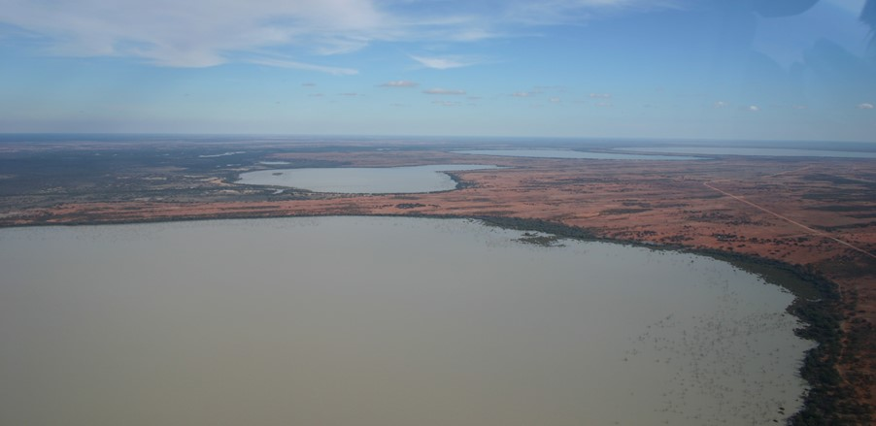

**Plate (i).** The Menindee Lakes Balaka, Bijiji, Tandure and Pamamaroo. C. Sharpe.

**Table 1.** Key elements of the environmental flow plan, based on conceptual models of population function for Murray cod and golden perch in the LDR for 2016–17.

|  |  |  |  |  |  |
| --- | --- | --- | --- | --- | --- |
| Temporal scale (season) | Spatial scale for LDR objectives | Water level | Mean channel velocity | Ecological objectives  Murray cod | Ecological objectives for **Golden perch** |
| Early spring  (early Sep) 2016 | ~500 km  LDR from Weir 32 – Wentworth | Slowly rising (e.g. 0.15 m per day) to ¾ to full channel  No major reductions in water level (e.g. net drop < 0.3 m)  450 ML/d | > 0.4 m/s | * Enable adult fish to move to breeding habitats  * Initiate egg maturation  * Inundate spawning sites including snags, undercut banks, benches and establish littoral macrophytes and food resources for larvae  * Minimise sudden drops to avoid nest abandonment | * YOY golden perch colonise Menindee Lakes with upper Darling flood pulse  * Proportional downstream golden perch YOY dispersal to LDR |
| Mid-spring to late summer (Oct-Feb) | Smooth slowly rising (e.g. 0.15 m per day) to ¾ to full channel  Minimise hydraulic disturbance  No major reductions in water level (e.g. net drop < 0.3m)  600-800 ML/d | > 0.4 m/s | * Nest construction, courtship, mating, egg laying, males to guard nest  * Minimise sudden drops to avoid nest abandonment  * Enhance egg hatching and maintain larval drift and nursery areas | * YOY golden perch colonise Menindee Lakes with inflows  * Proportional downstream golden perch YOY dispersal to LDR |
| Late spring – early summer (Nov-end Dec) | ~600 km  LDR from Weir 32 – Wentworth and Murray River | Increase 800-1200 ML/d, avoid water level reductions | > 0.4 m/s | * Inundate low-lying benches, promote primary and secondary productivity and food for larvae  * Enable YOY to inhabit littoral zone and snag habitats | * Increased proportional downstream dispersal rates of YOY golden perch to LDR from Menindee Lakes  * Inundate low lying benches, promote primary production and food resources for YOY  * Golden perch YOY transport to Murray River |
| Late summer & autumn  (Jan-April) | Slow recession to ¼ full channel  800-6000 ML/d flow pulse | > 0.4 m/s | * Increase littoral habitats for YOY dispersal  * Increase snag habitats for sub-adults and adults  * Inundate low lying benches food resources for YOY | * Increased downstream dispersal rates from Menindee Lakes to LDR  * Promote golden perch YOY movement to Murray River  * Flow pulse to stimulate golden perch spawning in LDR  * Increases riverine productivity, promotes food resources for larvae and YOY |
| Winter  (April to August) | ¼ to full channel  Slow recession to winter base flow (e.g. fall of <0.15 m/24 h)  400 ML/d | > 0.4 m/s | * Enable native fish to move to permanent winter habitats (i.e. deep refuge pools)  * Maintain base flow for survival of YOY juveniles, sub-adults and adults | * Enable adults and YOY to move to permanent winter habitats  * Maintain base flow for survival of YOY juveniles, sub-adults and adults |



**Figure 2.** The ‘LDR hydrograph’ was based on conceptual models and local consideration of key life-history-flow relationships for Murray cod and golden perch in the LDR, outlined in Table 1. The dashed line indicates the pattern of release for ‘LDR entitlement flows’ managed by Water NSW under the LDR Water Sharing Plan that would otherwise prevail in the absence of environmental water delivery throughout 2016–17.

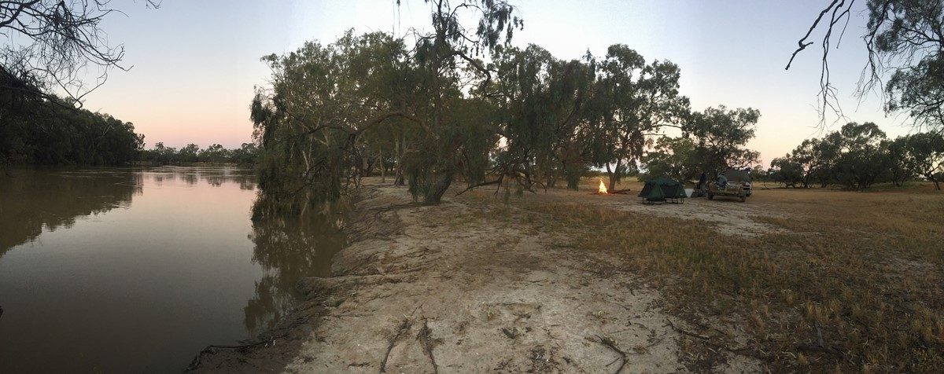

**Plate (ii).** Field camp on the Darling River near Wilcannia in November 2016. C. Sharpe.

# FIELD EVALUATION METHODS

The role of the 2016–17 environmental flow to the LDR in promoting spawning, recruitment and population enhancement for Murray cod and golden perch was evaluated by a three-part monitoring program. The ‘response variables’, or indicators selected for evaluating fish responses to the flow delivery schedule were:

* + the occurrence of Murray cod and golden perch eggs or larvae to indicate spawning success
  + the occurrence, distribution and size of early juvenile recruits to populations in the LDR, Menindee Lakes, Darling River upstream of Menindee and the GDA which indicated recruitment (i.e. survival and population growth).

For conciseness, the methodologies described here are provided as an overview. The full technical details of each monitoring equipment, their deployment methods and standardisation of sampling effort are provided in Appendix 3.

**Part 1** describes the occurrence and spatial distribution of spawning of Murray cod and golden perch and had three components:

**1a.** Spawning of Murray cod and golden perch in the LDR,

**1b.** Transport of golden perch larvae/juveniles into Menindee Lakes nursery habitats from spawning in the Darling River upstream of Wilcannia,

**1c.** Transport of juvenile golden perch into the LDR from recruitment from the Menindee Lakes.

**Part 2** describes the occurrence of YOY golden perch in the nursery habitats of the Menindee Lakes.

Surveys were undertaken in the Menindee Lakes to inform managers of the ecological value in committing environmental water to the LDR and GDA to enhance downstream dispersal migrations and recruitment of YOY golden perch. There were two surveys of the lakes undertaken for Part 2:

**2a.** Survey 1: December 2016; informs value of increasing flow magnitude to enhance dispersal of juvenile golden perch to the LDR and GDA in late summer 2016–17,

**2b.** Survey 2: July-August 2017; informs value of retaining or committing environmental water to a second juvenile golden perch dispersal flow in spring-summer 2017–18.

**Part 3** describes a population census for Murray cod and golden perch in the LDR and GDA.

Two population censuses were undertaken:

**3a.** Survey 1; autumn 2017 population census in the LDR to evaluate if the LDR hydrograph promoted recruitment of YOY to Murray cod and golden perch populations,

**3b.** Survey 2; Examine the occurrence and distribution of golden perch YOY throughout the GDA in autumn 2017 to evaluate the role of flows committed to the GDA in promoting dispersal of juvenile golden perch from Menindee Lakes.

## Part 1a. Spawning of Murray cod and golden perch in the LDR

Sampling to determine occurrence of Murray cod spawning coincided with the delivery of environmental water during the defined spawning period (November and December 2016). The occurrence and spatial distribution of Murray cod spawning was determined by sampling for their larvae using ‘drift nets’ and ‘light traps’ (Figure 6). Six monitoring sites were sampled on five occasions at fortnightly intervals, from 2nd November 2016 - 4th January 2017 (Table 2).

At each site, three replicates each of drift nets and light traps were deployed to catch recently hatched larvae. Drift nets were suspended just below the surface in flowing water to filter larvae drifting downstream and light traps incorporated a ‘glow stick’ to emit light to attract larvae (Figure 3).

Drift nets were deployed from late afternoon, left overnight and collected the following morning. Light traps were deployed late in the evening into slack water areas of the main river channel, where larvae might accumulate, and were collected the following morning. Drift nets and light traps were identical to those used by a variety of spawning and recruitment studies across the MDB (e.g. King et al. 2009), including in the LDR (Sharpe 2011; Sharpe et al. 2015; Ellis et al. 2015).

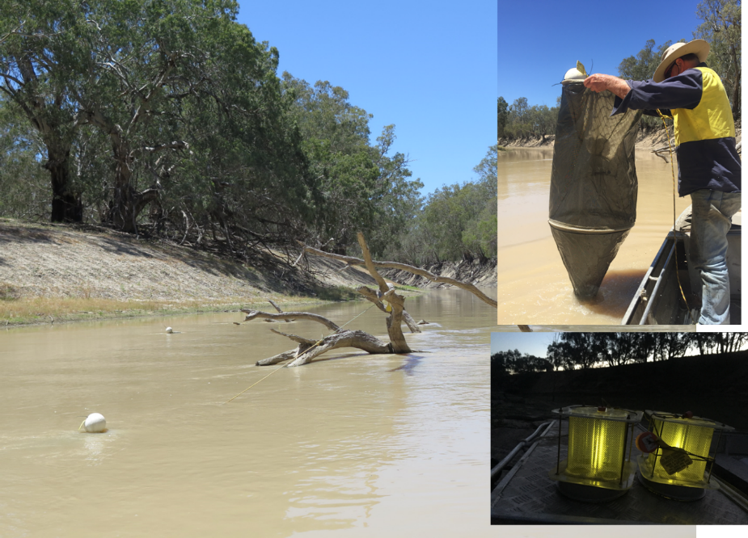

**Figure 3.** A drift net suspended from a snag to catch drifting fish eggs and larvae in the lower Darling River (left) and being retrieved (top right). The contents are sieved and collected as a sample, preserved and sorted in the laboratory. Light traps prior to deployment (bottom right), showing the light emitted from glow sticks that attract fish larvae. Three of each of these nets and traps were deployed overnight on each sampling occasion at six LDR sites from November 2016 to January 2017. C. Sharpe

Six sampling sites were selected for their spatial separation, representing the ~500 km of LDR from Menindee to Wentworth. Sites were ~80 km apart and were located at various pastoral stations;

1. 50 km downstream Weir 32 and downstream of all Menindee water outlets
2. 140 km downstream Weir 32, near the old anabranch offtake
3. 230 km downstream Weir 32, upstream of the influence of Pooncarie Weir
4. 310 km downstream Weir 32, 5 km downstream of Pooncarie Weir
5. 385 km downstream Weir 32, upstream of the influence of Burtundy Weir
6. 475 km downstream Weir 32, upstream of the Lock 10 influence of

**Part 1b. Transport of larvae into Menindee Lakes from spawning upstream**

Three larval monitoring sites were selected in the Darling upstream of Menindee to determine if spawning of Murray cod and golden perch had occurred and if eggs and larvae were being transported into the Menindee Lakes (and nursery habitats) and/or passed directly downstream to the LDR. Sampling events occurred at the same times and frequency as for Part 1a (five events, November 2016 – January 2017) using the same drift nets and light traps (three replicates of each per site per sampling event). Sampling sites were located:

1. 5 km downstream of Wilcannia in the main channel of the Darling River.
2. 100 km downstream of Wilcannia near the upper influence of Lake Wetherell.
3. 200 km downstream of Wilcannia at the inlet to Lake Pamamaroo.

**Part 1c. Transport of larvae to LDR**

A further two larval sampling sites were situated at the outlets from the Menindee Lakes into the LDR to determine the transport of golden perch directly to the LDR. These were at the outlets from;

1. Lake Wetherell (Figure 4).
2. Lake Menindee.

Sampling at these five sites enabled evaluation of fish larvae that were captured by concurrent sampling downstream (Part 1a) to determine their spawning location (i.e. spawned below Menindee, within Menindee or upstream of Menindee).

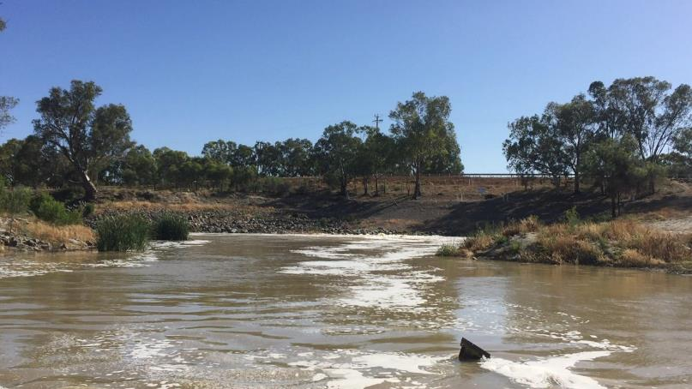

**Figure 4.** The outlet from Lake Wetherell to the Lower Daring River during flow releases in November 2016.

C. Sharpe.

**Sample processing for Parts 1a-c.**

All samples were ‘live picked’ in the field immediately following their collection and findings reported directly back to river managers for adaptive management of flows to optimise fish outcomes. The remaining material from each sample was preserved and processed in the laboratory. All larvae were identified according to published keys and descriptions (Lake 1967b; Serafini and Humphries 2004). Larval developmental stage and length were recorded for each individual. For Murray cod, golden perch and silver perch, developmental stage and length at age was determined to estimate the timing of spawning, after Serafini and Humphries (2004), Brown and Wooden (2007) and Sharpe (2011). Larval catch was reported as raw abundance relative to the soak time of nets and traps at each sampling site and sampling event (range 16-19.5 hrs).

## Part 2. Sampling for YOY golden perch recruits in the Menindee Lakes

**Part 2a.** Lakes Menindee, Cawndilla, Pamamaroo and Balaka were surveyed in December 2016 (5-8/12/2016) to determine if golden perch YOY had colonised with inflows that occurred from October-December 2016, informing decision making for flow delivery to GDA and to LDR to promote the downstream dispersal of YOY golden perch.

Sampling methods included 24 each of small meshed (2 mm) and large meshed (20 mm) fyke nets, set for two nights into each lake, targeting YOY. These nets were designed to catch small free swimming golden perch and have been proven effective at Menindee Lakes by earlier studies (Sharpe 2011). The set and retrieval time for each net was recorded and all fish captured were identified, counted and measured for total length. A sub-sample of golden perch were retained for daily age analysis by Fish Ageing Services and back calculation of spawning time. The technical specifications of the nets and age determinations are provided in Appendix 3.

**Part 2b.** Surveys of the Menindee Lakes targeting YOY golden perch were replicated in August 2017 (7-11/08/2017), at the completion of flows delivered to the GDA, with the aim of determining if golden perch YOY that potentially colonised the lakes in October-December 2016 were still present. This informed spring/summer 2017–18 environmental water planning. The second survey of the lakes applied the same nets and effort at the same lakes as to Part 2a.

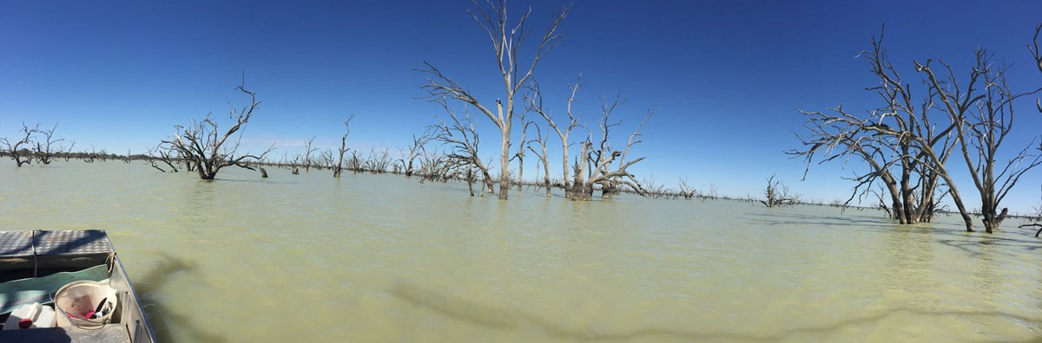

**Plate iii.** Lake Pamamaroo was one of four lakes sampled for golden perch YOY in December 2016 and August 2017 as part of the environmental flow monitoring program. C. Sharpe.

## Part 3. Population census to evaluate Murray cod and golden perch recruitment responses to environmental flows in the LDR and GDA.

**Part 3a. Lower Darling River, June 2017.**

Boat electrofishing and large and small meshed fyke nets were deployed at each of the six LDR sites sampled for the occurrence of larvae (Part 1a). The sampling techniques enabled capture of the largest and smallest fish present in the LDR, providing a census of population structure.

Boat electrofishing followed the Sustainable Rivers Audit (SRA) techniques (12 x 90 second electrofishing power on shots) and fyke nets were the same as those described for Part 2a & b, albeit that 4 x large and 4 x small meshed fyke nets were deployed at each sampling site. All fish captured were identified according to published keys, measured for length and returned to the water at their point of capture. Determination of YOY size classes were inferred by corresponding size to min-max length ranges for age 0+ (i.e. <1 year old) from published size/age relationships for Murray cod (max. 115 mm), golden perch in the Darling River and Menindee Lakes (max. 140 mm) and silver perch (max. 117 mm) (Sharpe and Villizi 2014; Robinson 2014). This enabled determination of which fish within the sample population had been spawned during the preceding 2016 environmental flow year, or in the case for golden perch, from early juveniles transported to the LDR from the Menindee Lakes.

**Part 3b. Great Darling Anabranch, June 2017**.

The same methodology for Part 3a (electrofishing and fyke nets) was used to sample 6 sites in the GDA in June-July 2017 (27/06-04/07 / 2017). Sites were spatially separated from Packers Crossing (20 km downstream of Lake Cawndilla) to 15 km from the junction with the Murray River (i.e. spatial distance of >400 km). Sampling coincided with cessation of environmental flows to the GDA, which were managed as a ‘fish exit strategy’ by NSW OEH to promote a downstream dispersal migration of juvenile golden perch from Lake Cawndilla to the Murray River. The exit strategy was a series of rapid drops and rises in water level managed over 10-14 days, followed by an attenuated recession to cease-to-flow, by 30 June 2017.

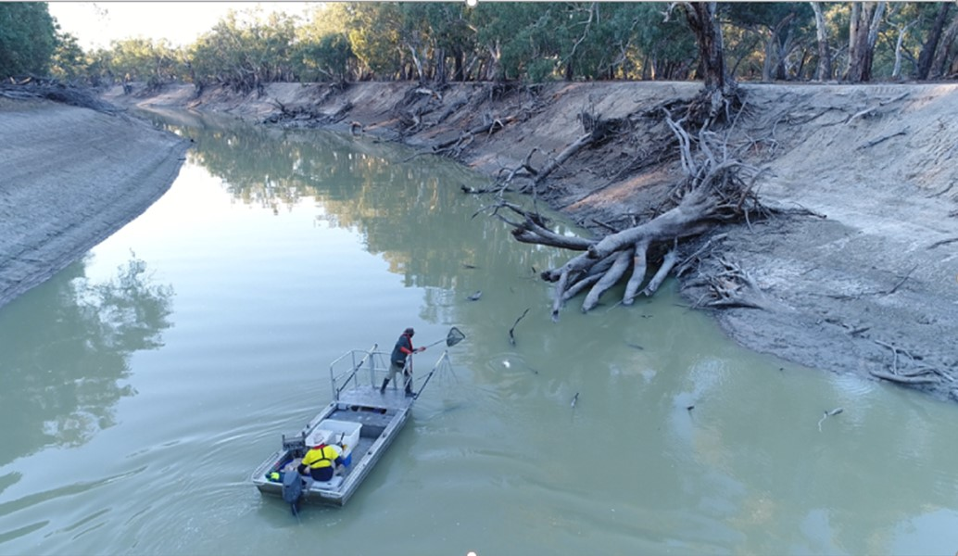

**Plate (iv).** Electrofishing on the lower Darling River for the 2016–17 population census. CEWO 2017.

# RESULTS AND DISCUSSION

## Hydrology

The total amount of water delivered to the LDR throughout 2016–17 consisted of Water NSW LDR base entitlement (150-300 ML/d), NSW and Commonwealth environmental water (119.229 GL; TLM – 47 980.4 ML; CEWO – 71 248.6 ML) and a larger volume (~340 GL) of MDBA River Operations (RO) to meet Murray system demands. This was all incorporated into a delivery schedule to match the LDR delivery plan for native fish objectives. The various water holder groups worked throughout 2016–17 to align their water delivery priorities in the pattern advocated for by the proposed LDR flow plan. The result was that the overall release pattern closely matched the conceptual hydrograph plan (Figure 5).

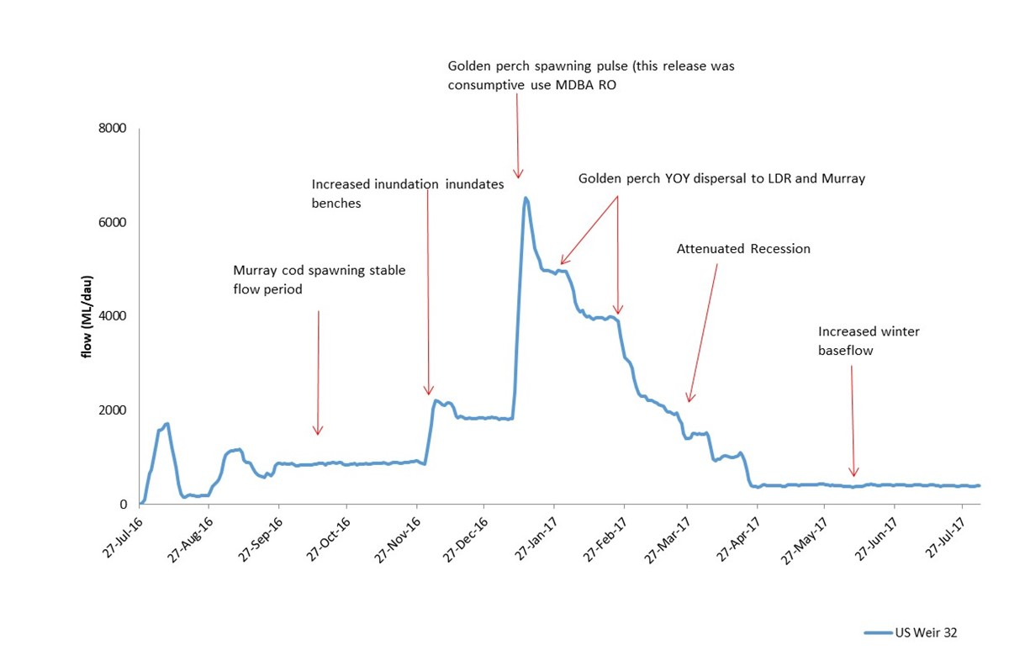

**Figure 5.** Flow (ML/d) recorded in the LDR at Weir 32 (blue line) for the period July 2016 –July 2017. Text highlight the main ecological components targeted by the LDR flow plan.

The initiation of environmental flows to the LDR occurred in early September 2016 as the ramp-up to the ‘*stable flow for Murray cod nesting’* element of the LDR Hydrograph and was maintained at approximately 800 ML/d until the 1st of December 2016 (Figure 5). Sampling for Part 1a-c of the monitoring program (Murray cod and golden perch spawning) coincided with this period of stable flows and commenced 2 November 2016, continuing fortnightly thereafter for a total of five sampling events and was completed 4 January 2017 (Table 2).

## Part 1a. Murray cod, golden perch and silver perch spawning in the LDR November – December 2016.

For clarity, the five sampling events or trips undertaken for Part 1 are defined in time sequence as ‘Trip 1-5’ (T1-T5), with sampling dates for each given in Table 2. The first sampling event (T1) for evidence of spawning in the LDR collected a total of 618 Murray cod larvae across the six sampling sites (Table 2, Figure 6). Murray cod larvae dominated the catch and were the most abundant species collected (Table 2). The most Murray cod larvae were collected at Site 1 (n=219), ~ 50 km downstream of Weir 32 (Table 3, Figure 7). Overall the number of larvae varied among sites but there was no apparent longitudinal pattern in abundance (Table 2). There were no golden perch eggs or larvae collected at any site, but 30-50 viable silver perch eggs were collected from driftnets at Site 1. Those eggs were kept in aerated river water and hatched over subsequent days to confirm them as silver perch (Table 2, Figure7). This collection verified that silver perch spawning occurred in the LDR during the first week of November, during the period of stable flows (average flow at Weir 32 for 1 October-10 November = 859.3 ML/d, range 824-897 ML/d; S.D. 17.3 ML/d) (Figure 6, Figure 8). Other species collected as larvae at T1 were Australian smelt (*Retropinna semoni*), bony herring (*Nematalosa erebi*), carp gudgeon (*Hypseleotris sp*. and carp (*Cyprinus carpio*). (Table 2).

The size of Murray cod larvae collected at T1 ranged from 7.0± mm -13.0±1.0 mm at each site (Figure 7). All were classified as meta-larvae and based on available keys, age was coarsely estimated at 10-14 days and so the time these were spawned was estimated to have occurred during the week of 19 October (±4 days), during the period of steady flow delivery that was intended to accommodate spawning (~800 ML/d).

Concurrent sampling for Part 1b (at the outlets from Lakes Menindee and Wetherell) and at (sites from Wilcannia to the lake Pamamaroo inlet, upstream of Menindee) for Part 1c collected no larvae of Murray cod, golden perch or silver perch at T1. Murray cod larvae and silver perch eggs collected in the LDR at T1 were therefore considered to have been spawned in the upper reach of the LDR, rather than transported from spawning upstream of Menindee or in the lakes. Likewise, the transport of golden perch larvae or early juveniles into the Menindee Lakes (Part 1b) had not occurred at sampling T1.

**Table 2.** Total numbers of larvae collected in the lower Darling River for Part 1a of the monitoring program from five sampling events during 2016.

|  |  |  |  |  |  |  |  |  |  |
| --- | --- | --- | --- | --- | --- | --- | --- | --- | --- |
| Sampling Trip | Date | Flow @ Burtundy ML/d | Murray cod | Golden perch | Silver perch  (eggs) | Australian smelt | Bony herring | Carp gudgeon | Carp |
| 1 | 2-5/11/2016 | 836-879 | 618 | 0 | 35 | 61 | 93 | 132 | 539 |
| 2 | 14-17/11/2016 | 790-799 | 217 | 0 | 0 | 113 | 147 | 52 | 137 |
| 3 | 28/11-02/12/2016 | 747-766 | 50 | 0 | 0 | 6 | 119 | 49 | 19 |
| 4 | 12-17/12/2016 | 1245-1667 | 0 | 20 | 0 |  |  |  |  |
| 5 | 28-30/12/2016 // 02-04/01/2017 | 1400-1423 | 0 | 0 | 0 | 47 | 229 | 79 | 221 |

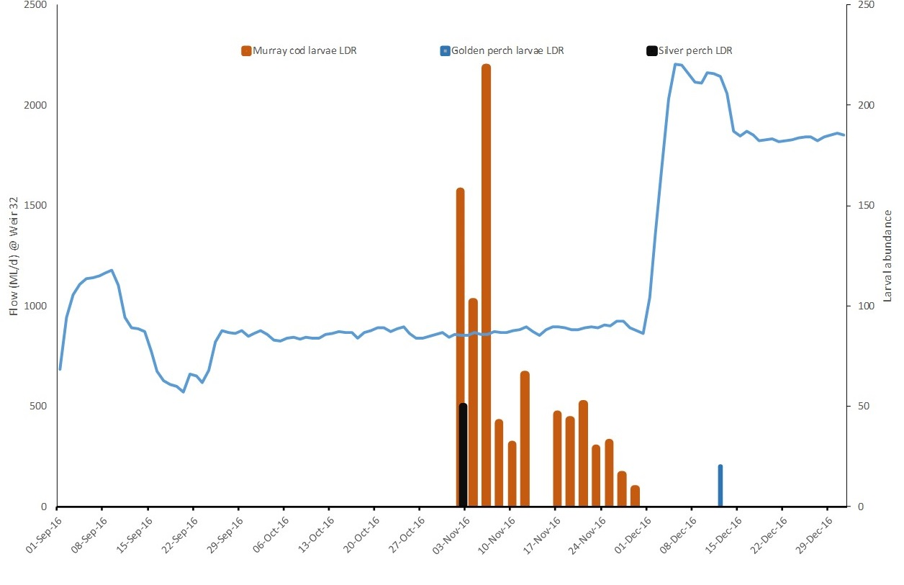

**Figure 6.** The number of Murray cod, golden perch and silver perch larvae (coloured bars) collected from the LDR in spring 2016 in relation to discharge at Weir 32 (blue line) and sampling Trip (T1-5, shaded) during the period of environmental water delivery. Murray cod (orange bars) were collected up to 2 December but not thereafter. Silver perch eggs (black bar) were collected in the first week of November and golden perch larvae, ~10 days old, were collected in the second week of December (13-14 Dec), 5 km downstream of Pooncarie Weir, following the rapid increase in discharge from ~800-2000 ML/d.

**Table 3.** Total number of larvae collected from each site in the lower Darling River for Trip 1.

|  |  |  |  |  |  |  |  |  |
| --- | --- | --- | --- | --- | --- | --- | --- | --- |
| Sampling Trip 1  02-05/11/2016 | Site | Murray cod | Golden perch | Silver perch | Australian smelt | Bony herring | Carp gudgeon | Carp |
| 1 | 219 | 0 | 35 | 11 | 8 | 12 | 51 |
| 2 | 102 | 0 | 0 | 4 | 0 | 28 | 71 |
| 3 | 157 | 0 | 0 | 0 | 17 | 31 | 39 |
| 4 | 42 | 0 | 0 | 45 | 22 | 0 | 117 |
| 5 | 66 | 0 | 0 | 1 | 0 | 27 | 197 |
| 6 | 31 | 0 | 0 | 0 | 46 | 34 | 64 |
| TOTAL |  | 618 | 0 | 35 | 61 | 93 | 132 | 539 |

A further two sampling events occurred during the stable flows period in November and early December 2016 (T2 and T3). Murray cod larvae were collected on both occasions, at relatively low abundance than at T1 (Table 4). While overall abundance was lower at T2, the spatial pattern in abundance was similar, whereby considerably more Murray cod larvae were sampled at sites upstream of Pooncarie than downstream (Table 4). At T3, Murray cod larval abundance was similar across the six sites (Table 4, Figure 6). The lack of Murray cod larvae at sampling T4 and T5 indicated that Murray cod spawning was complete by T4, the first week of December 2016 (Table 4).

While Murray cod spawning was complete at sampling T4, golden perch spawning was occurring. Twenty golden perch larvae ranging in size from 7-11 mm (6-10 days old) were collected at Site 4, ~5 km downstream of Pooncarie Weir (Figure 6). Sampling at T4 and golden perch spawning coincided with the planned rapid increase in flow from ~800-2000 ML/d at Weir 32 at the start of December 2016 (Figure 10). Based on the location and timing of their collection, golden perch spawning is considered to have occurred downstream of Pooncarie Weir near the peak of the flow pulse delivered in early December (Figure 6.). There were no silver perch larvae collected at this time.

**Table 4.** Total number of Murray cod larvae collected from each of five sites in the lower Darling River for Trips 1-5, November 2016-January 2017.

|  |  |  |  |  |  |
| --- | --- | --- | --- | --- | --- |
|  | Murray cod larvae in LDR | | | | |
| Site | Trip 1 | Trip 2 | Trip 3 | Trip 4 | Trip 5 |
| 1 | 219 | 46 | 5 | 0 | 0 |
| 2 | 102 | 43 | 13 | 0 | 0 |
| 3 | 157 | 51 | 4 | 0 | 0 |
| 4 | 42 | 29 | 5 | 0 | 0 |
| 5 | 66 | 32 | 13 | 0 | 0 |
| 6 | 31 | 16 | 10 | 0 | 0 |
| TOTAL | 618 | 217 | 50 | 0 | 0 |

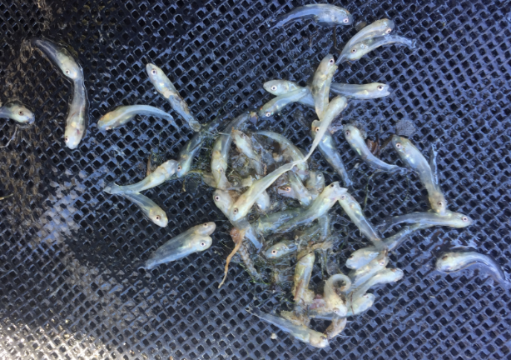

**Figure 7.** A subsample of Murray cod larvae collected from the LDR in a drift net 50 km downstream of Weir 32, on Trip 1 (November 2016). Larvae ranged in size from 7-15 mm and were estimated to be have been approximately 10-14 days old. C. Sharpe.

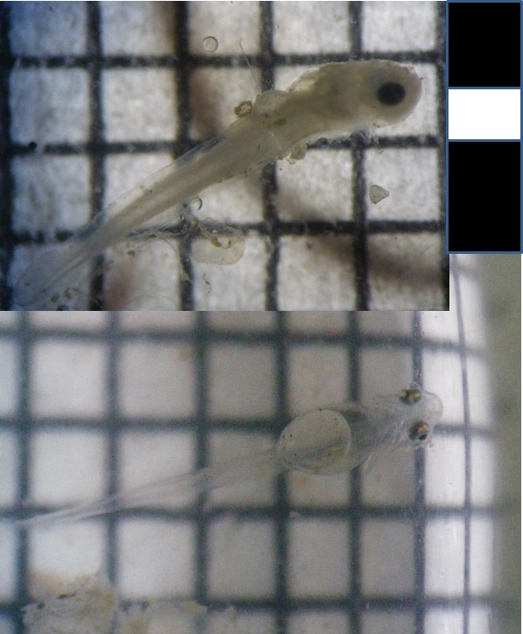

**Figure 8.** Silver perch larvae hatched in the laboratory from eggs caught in drift nets set in the LDR at on Trip 1 (November 2016). I. Ellis 2016.

## Part 1b & c: Patterns of spawning in the Darling River upstream of Menindee

For Part 1b & c of the monitoring program, larvae were sampled for at three sites from Wilcannia to the Menindee Lakes (Sites 7-9) and at the outlets to the LDR from Lakes Menindee and Pamamaroo (Sites 10-11) at the same times and frequency as for Part 1a. There were no larvae of Murray cod, golden perch or silver perch collected at any of those sites at T1 nor at T2, indicating as described above, that Murray cod and silver perch larvae collected in the LDR (sites 1-6) at T1 & T2 were not transferred from upstream but were the result of spawning in the LDR in association with the 2016 environmental flow.

At sampling T3 (28 November-2 December 2016), 47 golden perch larvae were sampled in drift nets upstream of Menindee, at sites 7 and 8, 5 km and ~100 km downstream of Wilcannia respectively (Table 5). Those larvae ranged in size from 29-48 mm and had recently completed transition to early juvenile stage. There were no larvae of Murray cod or silver perch collected at sites upstream of Menindee, nor at sampling sites 10 & 11 at the outlets from Lakes Menindee and Wetherell at T3. Likewise, golden perch larvae and early juveniles were not collected from samples taken at the lake outlets, providing evidence that those larvae collected at sites 7 & 8 were spawned upstream of Menindee, in conjunction with the natural flood pulse that occurred in the river upstream of Brewarrina during October 2016.

## Part 2a: sampling of the Menindee Lakes for early juvenile golden perch: Survey 1.

The capture of golden perch larvae drifting downstream from Wilcannia at T3 (28 November) prompted initiation of Part 2 of the monitoring program; sampling for the occurrence and abundance of early juvenile golden perch in the Menindee Lakes. Sampling of Lakes’ Balaka, Pamamaroo, Menindee and Cawndilla was undertaken 5 days following the collection of early juvenile golden perch in the Darling River downstream of Wilcannia. Our conceptual model had predicted that when detected there, larvae would continue to drift downstream and would then colonise the Menindee Lakes as they were inundated.

Sampling of the lakes was undertaken 4-8 December 2016. A total of 192 golden perch early juveniles (Table 5), ranging in size from 28-58 mm (Average 44.85 mm; S.D. 6.13 mm) (Figure 9) were collected. By far the highest number were captured from Lake Menindee (n=121). Abundances in the other lakes were lower but similar to each other; Balaka (n=34), Pamamaroo (n=21) and Cawndilla (n=16).

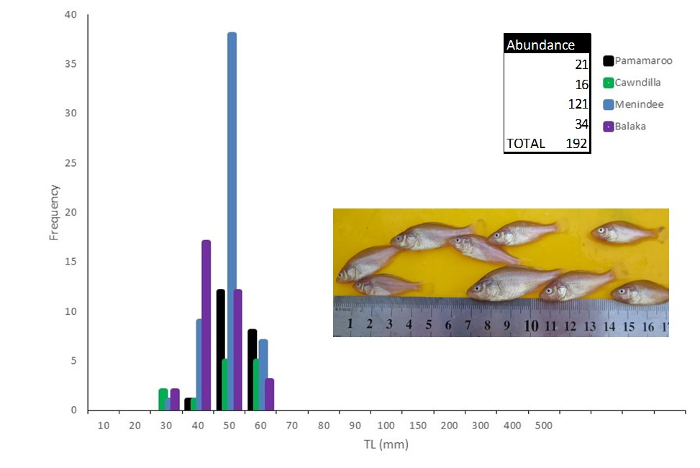

**Figure 9.** Length-Frequency of 192 early juvenile golden perch sampled from the Menindee Lakes during December 2016. Lengths ranged from 18-58 mm. There were no adult sized golden perch collected. Inset: Image of early juveniles captured in Lake Menindee, December 2016. M. Henderson, CPS Enviro.

Forty-five early juvenile golden perch collected across the Menindee Lakes were retained for determination of daily age. The average age across the lakes was 47.24 days (S.D. 4.47 days). The spawning date for those fish was estimated as 16-24th October 2016. When considered in relation to the findings from earlier studies of golden perch spawning ecology in the Darling River (Sharpe 2011; Sharpe et al. 2015) and our conceptual understanding that golden perch spawning occurs in close association with flow pulses and floods, and that larval and early juvenile drift occurs over hundreds of kilometres, the time and predicted location of spawning aligns to the peak of the 2016 flood pulse upstream of Brewarrina and possibly to the Border Rivers (Figure 10).

There are multiple lines of evidence that support the prediction that golden perch sampled from the Menindee Lakes in December 2016 were spawned in the river upstream of Brewarrina (possibly in the Border Rivers area) during October 2016, including:

* + Flow cued spawning ecology of golden perch.
  + The collection in November 2016 (sampling T3 and not before) of early juveniles drifting downstream at Wilcannia.
  + The size range of juveniles at Wilcannia overlapped with those collected in the lakes ~10 days following.
  + The findings from earlier studies that depict similar observations of flood recruitment (Sharpe 2011).

The early juvenile golden perch which presented in the Menindee Lakes during December 2016 were spawned in the river upstream of Brewarrina in close association with the October 2016 flood pulse.

Upon completion of the Lakes survey in December 2016, sampling for the occurrence of spawning in the Darling River upstream and downstream of Menindee resumed for Part 1a-c (12-17 December 2016; sampling T4). Golden perch early juveniles were again collected in the river at sites 7 & 8 upstream of Menindee, albeit at lower abundance (n=34) than at T3 (n=47). Notably, unlike sampling T3, none of those fish were collected in drift nets, but in small fyke nets, indicating that early juveniles had settled from the drift into the rivers’ littoral habitats by sampling T4.

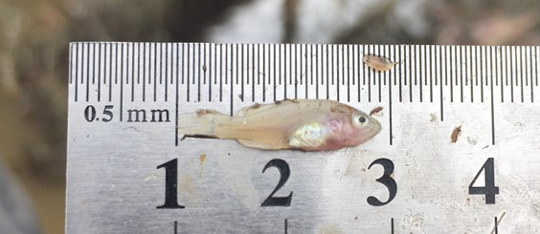

**Plate (v).** Golden perch early juveniles were sampled in the Darling River downstream of Brewarrina. These young fish were transported with the flood pulse ~1000 km into the Menindee Lakes from where they were released downstream into the LDR with environmental water. C. Sharpe

Unlike earlier sampling times, T4 sampling at the outlets from the Menindee Lakes to the LDR (sites 10 & 11) did collect juvenile golden perch being transported downstream; n=12 at the outlet from Lake Wetherell and n=22 at the Lake Menindee outlet. These fish were similar in size to those collected in the survey of the Menindee Lakes the week prior (Figure 9), ranged from 24-58 mm (average 43.5 mm ±9.01 mm). This collection provides evidence that the downstream transport and recruitment of golden perch early juveniles to the LDR from the Menindee Lakes nursery habitats occurred from December 2016.

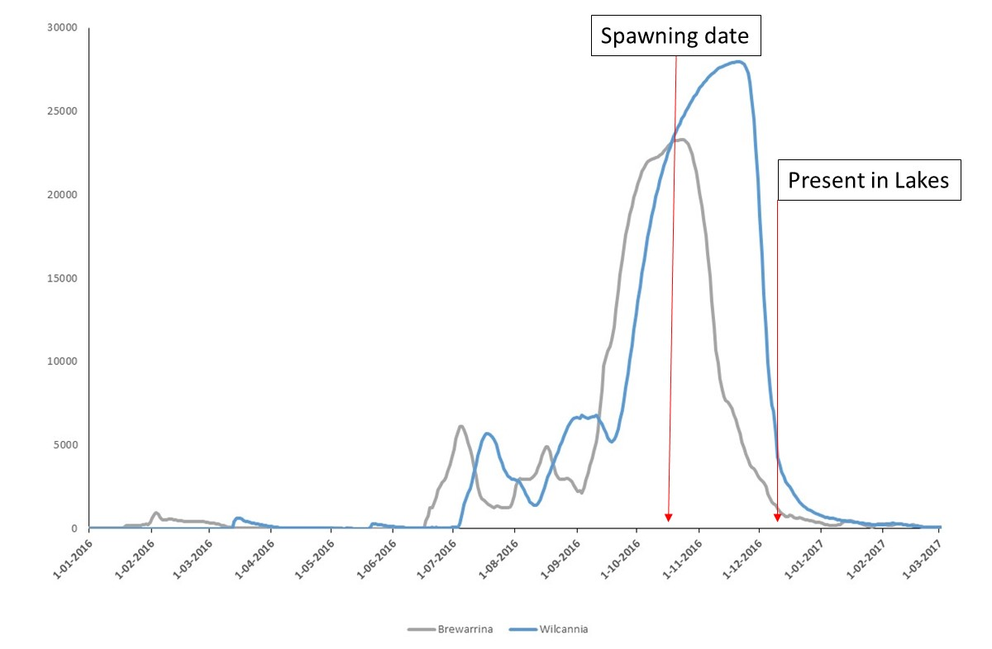

**Figure 10.** Discharge (ML/d) in the Barwon River at Brewarrina and the Darling River at Wilcannia in 2016 and early 2017 depicting the natural flood that occurred in the river during October-December 2016. Golden perch juveniles sampled from the Menindee Lakes 4-8 December were spawned 16-24 October 2016, which coincided with the flow peak upstream of Brewarrina (grey line). Based on our knowledge of golden perch spawning ecology and the multiple lines of evidence presented by this study, it was predicted that the cohort of early juveniles recorded in the Menindee Lakes during December were spawned in the Darling River upstream of Brewarrina (possibly in the Border Rivers area) undergoing larval transition while in the drift.

The findings from T5 sampling were similar to T4 and golden perch early juveniles were again collected at sites 7-9 upstream of Menindee, indicating that the transport of fish from spawning upstream of Wilcannia to the Menindee Lakes was still occurring. The average size of those fish (46.3 ± 5.95 mm) was similar to T4. Concurrent sampling at Lake Pamamaroo Inlet also recorded early juveniles in the drift, with the location of nets indicating those fish were being directed into the lake. The average size (46.4 mm ± 4.9 mm) was similar to those in the river at sites 7-9 (downstream of Wilcannia) and at the Lake Pamamaroo Inlet. Sampling at the Lake Wetherell outlet to the LDR at the same time recorded early juveniles (n=64) being transported from the lakes to the river downstream. The average size of those fish was 43.5 ± 9.01 mm.

The concurrent collections of golden perch at the Menindee Lakes sites and immediately below the lakes for sampling T5 and overlap in size shows that the same cohort of fish was sampled as they moved downstream. It demonstrates that downstream movement from spawning upstream of Brewarrina and colonisation of the lakes was occurring and that a proportion of early juvenile fish were being transported directly downstream to the LDR. Delivery of environmental water to the LDR throughout November and December 2016 likely enhanced the recruitment potential for golden perch in the LDR and the dispersal pathway for recruitment to the Murray River and southern-connected basin population.

It is important to consider that in the absence of environmental water, base-entitlement flows to the LDR were 300 ML/d at the time when golden perch juveniles were detected dispersing from the Menindee Lakes into the LDR. On the assumption that the dispersal of golden perch juveniles from the lakes to the LDR was ‘passive’, the provision of environmental water at this time, which was ~2000 ML/d (6 December 2016 - 8 January 2017; seven times the normal volume), had potential to contribute many more golden perch recruits to the LDR than would otherwise have occurred. Importantly, the environmental water delivery also resulted in higher discharge rates into the Murray River than would otherwise have occurred under base entitlement flows, therefore enhancing the potential for downstream dispersal and recruitment to the Murray River population.

Dispersal of young golden perch from the Menindee Lakes into the LDR was a key outcome of the 2016–17 environmental flow program. It is the first time that environmental water has been used to disperse new recruits from a nursery floodplain to a major river and demonstrates the utility of the planned fish hydrographs.

## Part 2b; sampling of the Menindee Lakes for early juvenile golden perch: Survey 1.

The second sample of the Menindee Lakes was undertaken 7-11/08/2017 and collected a total of 104 golden perch juveniles, ranging in size from 130-365 mm (Figure 11). The average size across lakes was 175.07 mm (S.D. 44.58 mm). By far the majority of fish were within the juvenile 150-200 mm slot size and these fish were approximately 9-10 months old (Figure 11). The highest number were captured from Lake Menindee (n=37) followed by Lake Pamamaroo (n=31). Abundances in the other lakes were lower but similar to each other; Balaka (n=12), and Cawndilla (n=24).

There was no detailed analyses of golden perch growth rates but the progression in size from samples collected in December to those in August 2017 is evident, with average size increasing by 130.27 mm over the nine months between sampling. Relatively fast growth rates are typical for Menindee Lakes golden perch where there are abundant food resources compared to the main river (Sharpe 2011).

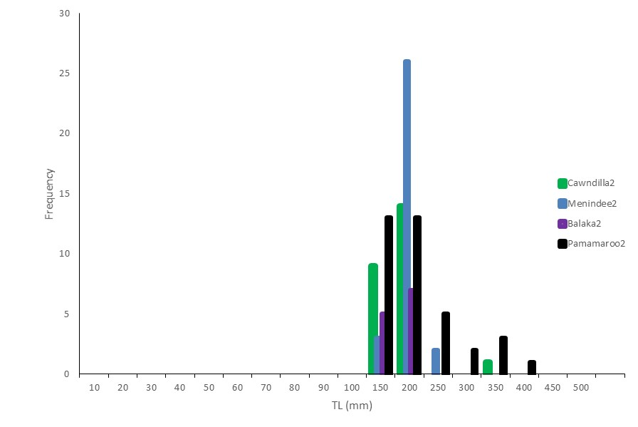

**Figure 11.** Length-Frequency of 104 early juvenile golden perch sampled from the Menindee Lakes during August 2017. Lengths ranged from 130-365 mm and the dominant cohort were 150-200 mm

## Environmental flows allocated to the Great Darling Anabranch

The finding and confirmation that juvenile golden perch were present in Lake Cawndilla (Figure 9) supported the initiation of environmental flows to the GDA in early February 2017. A major aim of the GDA environmental flow was to facilitate the dispersal of early juvenile golden perch from their nursery habitat, in Lake Cawndilla, via the GDA, to the Murray River. This is especially important because during floodplain recession Lake Cawndilla can become isolated from the other lakes and fish resources lost when the lake completely dries. The 2017 environmental flow to the GDA thus provided the only dispersal opportunity for juvenile golden perch to move from the nursery habitat of Lake Cawndilla to the Murray River via the GDA, providing another recruitment opportunity for the receiving Murray River and southern-connected basin populations.

The findings of the 2016–17 environmental flow monitoring presented here demonstrate an important milestone for sustainable river management in the Murray–Darling Basin; that the planning and use of Commonwealth environmental water has achieved the dispersal of juvenile golden perch from the Menindee Lakes nursery grounds to both the LDR and in all likelihood, the Murray River and southern connected basin populations, that might otherwise not have occurred in the absence of environmental water, at base entitlement flows that were set at 300 ML/d. For any organism, the recruitment of new individuals is key to long term population viability and to our knowledge, there was no other recruitment event to golden perch in the Murray River throughout 2016–17. This point illustrates that the use of environmental water in the Darling River in 2016–17 provided unique value to the management and sustainability of one of the Basin’s most enigmatic and socially important animals, in two of its largest and most important rivers.

## Part 3: Population census to evaluate Murray cod and golden perch recruitment responses to environmental flows.

## Lower Darling River

The lower Darling fish community was surveyed at 6 sites from 22-26 June 2017 with boat electrofishing, and small and large fyke nets. A total of 2822 fish, representing 8 species were collected (5 native and 3 introduced) (Table 5.). The most abundant was Australian smelt (68.8%), followed by golden perch (12.8%) and common carp (7.1%).

## Murray cod in the lower Darling River

A total of 117 Murray cod, representing 4.1% of the overall fish community sampled were collected across all sites from 22-26 June 2017 (Table 5). The highest number of Murray cod (n=37) was recorded at Site 3, ~80 km upstream of Pooncarie (~230 km downstream of Weir 32 at Menindee). The number of Murray cod was similar across the remaining sites (Table 5).

**Table 5.** Total number and % contribution to overall community structure for fish in the LDR at six sites sampled by boat electrofishing and fyke netting during June 2017.

|  |  |  |  |  |  |  |  |  |  |
| --- | --- | --- | --- | --- | --- | --- | --- | --- | --- |
| Site | Murray cod | Golden perch | Silver perch | Australian smelt | Bony herring | Common carp | Eastern gambusia | Goldfish | Grand Total |
| 1 | 15 | 105 | 6 | 1 | 22 | 44 |  |  | 193 |
| 2 | 19 | 69 |  | 34 | 49 | 22 | 1 | 1 | 195 |
| 3 | 37 | 67 |  | 21 | 29 | 23 | 23 | 3 | 203 |
| 4 | 17 | 73 |  | 462 | 19 | 40 |  |  | 611 |
| 5 | 22 | 23 |  | 471 | 37 | 31 |  |  | 584 |
| 6 | 7 | 24 | 1 | 952 | 12 | 40 |  |  | 1036 |
| Grand Total | 117 | 361 | 7 | 1941 | 168 | 200 | 24 | 4 | 2822 |
| % | 4.1 | 12.8 | 0.2 | 68.8 | 6.0 | 7.1 | 0.9 | 0.1 | 100.0 |

Of the 117 Murray cod collected, n=94 were measured. Of these, n=13 (14.2%) were YOY sized fish (Figure 12, Figure 13). These were distributed across all sampling sites although the majority were collected at the three sites upstream of Pooncarie (Table 5). The spatial pattern of YOY abundance reflected that for the larvae during the spring 2016 sampling (Part 1a).

The Murray cod population structure was represented by fish across a broad range of size (thus age) classes (Figure 12). Fish ranged in size from YOY size (70 mm) to large adults (1210 mm). For the population structure overall, across all survey sites, each size class and age class was represented (Figure 12). However, fish within the slot size for take by anglers (550-750 mm) appeared somewhat reduced in abundance compared to smaller (<550 mm) and larger (>750 mm) categories, potentially indicating that angling pressure may influence population structure but further analysis is required.

Murray cod within the 115-200 mm size range (fish spawned in 2014 and 2015) were notably less abundant than smaller and larger fish (Figure 12). Those spawning years were most affected by cease to flow and drought conditions in the LDR, resulting in the least favourable conditions for spawning and subsequently low recruitment to the population appears evident (Figure 12). Fish within the 200-300 mm range were the most abundant cohort within the population and this group corresponds to the 2013 spawning season, when consumptive flows released from Menindee Lakes were managed to promote spawning and in particular, Murray cod recruitment (Sharpe et al. 2015). The moderately lower abundance of YOY sized fish, produced in line with the 2016-17 environmental flows, may be an artefact of YOY behaviour rather than actual lower abundance, whereby those fish are notoriously hard to capture using conventional survey methods.

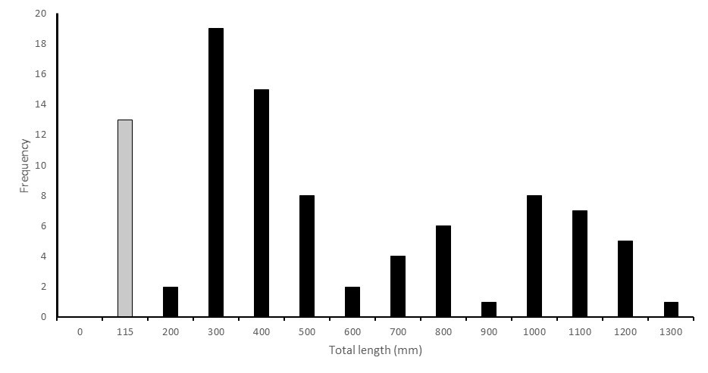

Figure 12. The population structure for Murray cod sampled across six sites and 500 km of the LDR downstream of Menindee in June 2017. Young of year (YOY) sized fish spawned during the previous breeding season (October-December 2016) are represented by fish less than 115 mm in total length (grey bar). All other age classes are represented by black bars.

The June 2017 Murray cod census was the first since 2012 (Sharpe and Villizi 2013) and the first since flow was restored to the river in 2016 following the 500+ day cease-to-flow event. Notably, the population structure demonstrates that despite being exposed to protracted cease-to-flow and being forced into isolated refuge pools throughout 2015–16, the population has maintained a remarkably robust structure. YOY Murray cod are not known to be especially migratory and hence it is highly unlikely that these moved into the LDR from elsewhere (e.g. Murray River). This is exhibited by numerous fish being recorded across the complete range of size classes expected (Figure 12). However, the populations resilience can only be maintained by strong recruitment when conditions are optimal for spawning and YOY recruitment and providing flow to support these elements of population function in the LDR must be promoted annually.

Optimising the flow regime to enhance LDR spawning and recruitment opportunities for Murray cod was the primary aim of the environmental flow plan provided throughout 2016–17 and strong responses for both of those objectives were observed. The schedule of the 2016–17 environmental flow delivered to the LDR was therefore successful; meeting the primary management aim of supporting the LDR Murray cod populations recruitment, thus resilience into the future.

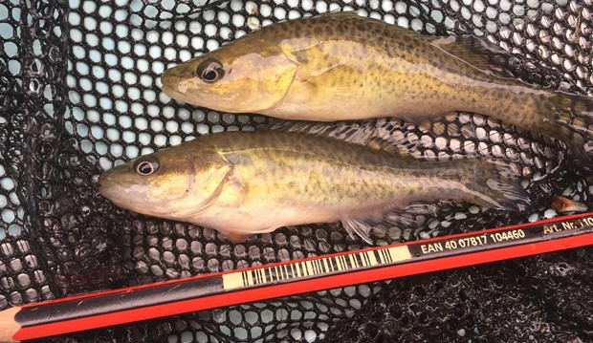

Figure 13. Young of the year (YOY) Murray cod (~80mm) collected in the LDR during June 2017. YOY fish of this cohort represented more than 10% of the LDR population across 6 sites sampled in the river downstream of Menindee. Their collection demonstrates survivorship and strong recruitment potential from spawning that was documented by the project throughout the 2016 spring breeding season and highlights the success of the 2016–17 environmental flow to the LDR for Murray cod population maintenance. C. Sharpe.

## **Golden perch in the LDR**

A total of 379 golden perch were recorded in the June 2017 LDR fish community census. YOY sized fish, or new recruits to the population, accounted for more than one-third (31.1%) of the total number of fish recorded. Among those, there were two distinct age 0+ (YOY) size classes (Figure 14). The first and smaller cohort (<100 mm long) represented 5.4 per cent of the population. While the larger size class (100-150 mm long) represented 25.6 per cent of the overall population structure (Figure 14). The larger YOY cohort are considered to have originated from spawning that was documented in October 2016 upstream of Wilcannia (Part 1b above), the fish which temporarily settled into the Menindee Lakes and then were subsequently transported downstream to the LDR with environmental water from December 2016. The origins of the smaller and second cohort are less clear, although there are four likely scenarios;

1. Spawned in the LDR upon reinstatement of flows from cease to flow in August 2016
2. Spawned in the LDR during early December 2016 when flows rapidly increased from 800 – 2000 ML/d (CEWO eFlow) when golden perch early larvae were collected
3. Spawned in the LDR during late December 2016 when flows rapidly increased from 2000 – 6400 ML/d (MDBA RO flow release)
4. A combination of 2 & 3.

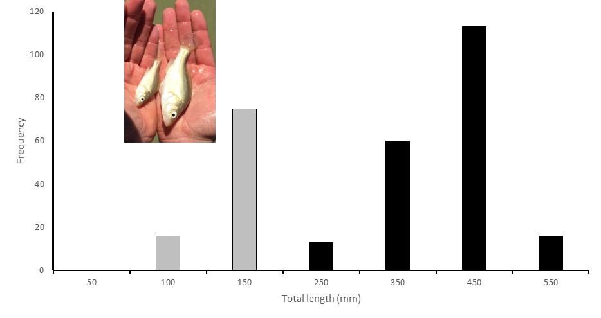

Figure 14. The population structure for golden perch sampled across six sites and 500 km of the LDR downstream of Menindee in June 2017. Young of year (YOY) sized fish represented 27.7% of the overall population structure and are represented by grey bars and older age classes by black bars. Two YOY cohorts were present in the population; fish <115 mm and those 115-150 mm (refer to image inset). These likely represent fish 3 months apart in age; those spawned upstream of Menindee in early October 2016 and transported to the LDR by environmental flows (larger fish), and those spawned in the LDR three months later, during December 2016 (smaller fish), in response to the delivery of environmental and consumptive water in a pattern that was delivered to cue golden perch spawning. Image credit: C. Sharpe.

Scenario 1 is considered least likely, because fish spawned in the river ~10 months prior to their collection would be expected to be considerably larger, as was found in the Darling River upstream of Menindee in 2004 when fish 10 months in age were ≥120 mm (Sharpe 2011).

With regard to scenario 2; golden perch spawning was recorded in the LDR when ~10 day old larvae were collected in early December and the timing of their production (spawning) was aligned to the rapid increase in flow from 800-2000 ML/d provided by environmental water. The size range and estimated age of the second and smaller cohort present in the census in June 2016 likewise aligns to the early December 2016 spawning event.

Regarding scenario 3; although there was no monitoring associated with the MDBA RO flow, the release pattern aligned to the initial flow plan; designed to cue golden perch spawning (Figure 2). The timing of the MDBA RO release occurred one month later than golden perch spawning in the LDR was recorded (Figure 6) and in absence of verifying the actual age (thus spawning time) of the smaller cohort, we consider that scenario 4 (combination of 2 & 3) is most likely to have resulted in the production of the smaller YOY cohort (Figure 14).

The first and larger cohort of golden perch recorded in the LDR census numerically dominated the population structure, accounting for more than 25 per cent of the overall demographic (Figure 13). In contrast, the second and smaller cohort of fish, considered to have been spawned locally in the LDR, rather than transported from the Menindee Lakes, represented ~5 per cent of the overall population abundance (Figure 13). The occurrence and abundance of these two cohorts of YOY fish in the LDR demonstrates that golden perch recruitment can be achieved by the targeted delivery of environmental water and that accommodating downstream dispersal from the Menindee Lakes is very important to recruitment potential for golden perch in the LDR and ultimately, to populations downstream in the southern connected basin.

Golden perch populations in the lower Murray River, mid Murray and connected rivers can be dominated by Darling River derived fish (Zampatti et al. 2015; Stuart and Sharpe 2017). They can account for more than 60 per cent and up to 80 per cent of fish present within those populations depending on high flow/flooding conditions over the past decade in both the Darling and Murray catchments (Zampatti et al. 2015). The findings of the present study demonstrate that transport of YOY juveniles from the Menindee Lakes nursery grounds dominates the recruitment potential to the LDR; more than 80 per cent of new recruits in 2017 were juveniles transported from Menindee Lakes to the LDR. This finding is informative when considering the natal origin of Darling River derived fish throughout the rivers of the southern connected basin, including the Murray and its major tributaries.

This study has also demonstrated that the LDR provides a crucial corridor or pathway for recruits from the Menindee Lakes to the Murray River and its connected tributaries. These considerations highlight the importance of maintaining the function of the Menindee Lakes as nursery areas – and spawning in the Darling River upstream, to support recruitment to golden perch populations throughout the southern-connected MDB. We also highlight that these critical recruitment processes, that potentially influence the status of populations across the southern-connected MDB, can be managed for and promoted by the targeted delivery of environmental water.

## **Golden perch in the Great Darling Anabranch**.

The GDA fish community was surveyed at 7 sites from 27-30 June 2017. A total of 2062 fish, from 12 species were collected (9 native and 3 introduced) (Table 5.). The most abundant was common carp (20.7%), followed by bony herring (17.9%) and Eastern gambusia (15.5%). Golden perch accounted for 1.9% of the overall GDA fish community (Table 6).

**Table 6.** Total number and overall community structure for fish sampled at seven sites in the Great Darling Anabranch (GDA) sampled by boat electrofishing and fyke netting during June 2017. Sites are listed in progression from upstream (Site 1, Packers Crossing) to downstream (Anabranch mouth). The distribution and abundance golden perch is highlighted.

|  |  |  |  |  |  |  |  |  |  |
| --- | --- | --- | --- | --- | --- | --- | --- | --- | --- |
| Common name | Site | | | | | | | |  |
| 1 | 2 | 3 | 4 | 5 | 6 | 7 | TOTAL | % overall |
| Australian smelt | 2 |  |  |  |  | 74 | 101 | 177 | 8.6% |
| Bony herring | 18 | 136 | 3 | 109 |  | 12 | 93 | 371 | 18.0% |
| Carp gudgeon |  |  |  |  |  | 7 | 219 | 226 | 11.0% |
| Dwarf flat-headed gudgeon |  |  |  |  |  |  | 1 | 1 | 0.05% |
| Flat-headed gudgeon |  |  |  |  |  |  | 20 | 20 | 1.0% |
| Golden perch | 12 | 9 | 1 | 13 |  | 4 | 1 | 40 | 1.9% |
| Murray-Darling rainbowfish |  |  |  |  |  |  | 48 | 48 | 2.3% |
| Spangled perch |  |  | 2 | 12 |  |  |  | 14 | 0.7% |
| Un-specked hardyhead |  |  |  |  |  | 1 | 392 | 393 | 19.1% |
| Common carp | 57 | 38 | 1 | 171 | 7 | 132 | 22 | 428 | 20.8% |
| Eastern gambusia |  | 1 |  |  |  |  | 320 | 321 | 15.6% |
| Goldfish | 7 |  |  |  |  |  | 16 | 23 | 1.1% |
| **Grand Total** | **96** | **184** | **7** | **305** | **7** | **230** | **1233** | **2062** | **100**% |

The size range of golden perch in the GDA was 127-325 mm (Average 189.5; S.D 61.3). The population structure was dominated by YOY size fish 100-150 mm (Figure 15), and there were no mature sized individuals recorded (>325 mm for males, 400 mm for females; Mackay 1983). The majority of golden perch were collected at sites upstream of Dam 183 (Sites 1- 4, Table 5) and the few larger fish (>300 mm) were collected at the lower sites, adjacent the Murray River. The size range of fish within the YOY cohort overlapped with those sampled from Lake Cawndilla during August 2017 (Figure 9, Figure 11) and the LDR in June (Figure 14).

The spatial distribution in abundance and fish size indicated that their movement from Lake Cawndilla had occurred throughout the length of the GDA, to its junction with the Murray River (Table 6, Figure 15). The distribution of YOY sized fish being more prevalent at the most upstream sites may indicate that golden perch in the downstream reaches reacted to the fish exit hydrograph applied by the operational flow managers (NSW OEH) and exited to the Murray River, or, responded by moving upstream, attempting to exit the drying GDA, or simply that the downstream distribution was not even.

Regardless of which scenario, the finding of YOY golden perch distributed throughout the length of the GDA indicates that the aim of delivering environmental flows to provide a movement pathway for juvenile golden perch from Lake Cawndilla, to the Murray River, was achieved.

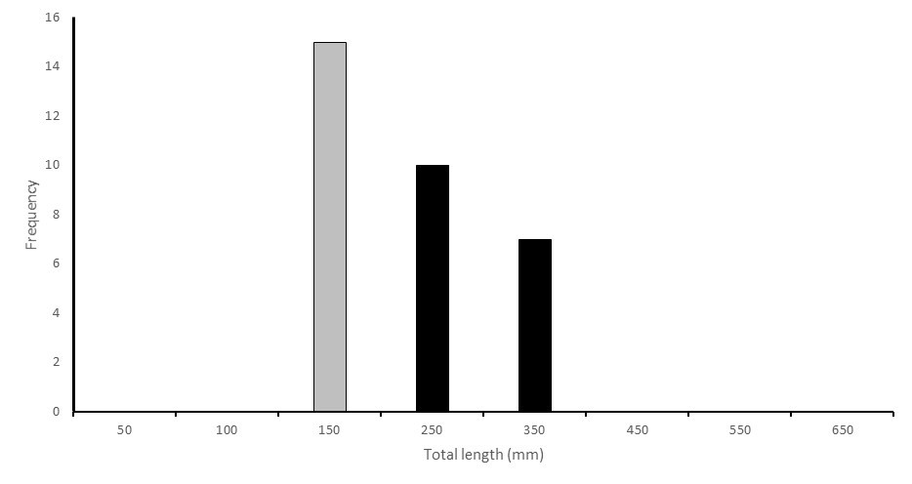

Figure 15. The population structure for golden perch sampled at seven sites across the length of the Great Darling Anabranch (GDA) from Packers Crossing to the junction with the Murray River in June 2017. Young of year (YOY) sized fish (100-150 mm) represented 46.8% of the overall population structure and are represented by grey bars and older age classes by black bars. YOY sized fish correspond to the sizes of fish sampled in Lake Cawndilla sampled during the same period and were considered to have been transported from the lake to the GDA with environmental flows throughout 2017. THE GDA is an important pathway to transport golden perch recruits from Lake Cawndilla to the Murray River.

# Synthesis of findings

The delivery of environmental water to the LDR and GDA throughout 2016–17 was based on supporting the sustainability of two of the Basins’ most valuable fish populations; promoting spawning and recruitment for Murray cod in the LDR and achieving golden perch recruitment. The planned hydrograph built on the ecological function of the Menindee Lakes, as a major golden perch nursery ground, by providing a recruitment pathway from spawning in the Darlings’ northern rivers to dispersal some 2000 km south into the southern connected basin. Both of these aims were achieved in 2016–17, which represents a milestone in the use of environmental water in the MDB; demonstrating that these key population level outcomes can be wholly managed for – with environmental water over large and ecologically relevant spatial scales.

The environmental flow hydrographs delivered to the LDR and GDA throughout 2016–17 were designed using the latest scientific knowledge and principals of population function, synthesised into conceptual models. For Murray cod, flows and hydraulic diversity were provided in a pattern that matched a variety of biological and behavioural ecology traits including for adults (courtship, nesting site selection, spawning and nesting retention) through to the hatching of eggs, accommodating larval drift and promoting riverine productivity and food resources to support larval growth, survival and transition to juvenile recruitment. Flow delivery was adapted throughout the 2016–17 year to support juvenile recruitment into the population which occurred in direct association with the environmental flow delivery schedule.

The recruitment of juveniles to the LDR Murray cod population is key to its long-term viability and resilience to the apparently increasing disturbance pressure of over-extraction and drought that has prevailed in the river over the past decade, and at the time of writing (May 2018), is occurring again. This is an important point for consideration; in the Murray River system, successive hypoxic blackwater (disturbance) events downstream of Barmah have decimated populations (King et al. 2012; McCarthy et al. 2014; Koehn 2015) and without optimising flow conditions to promote recruitment to the population, recovery to pre-blackwater (2011) status will take many years. In the regulated lower Darling River, applying environmental water to ensure that recruitment events are maximised, and populations are resilient enough to recover from disturbance events, should be recognised as a priority for long-term management for one of the last strongholds of Murray cod in the southern connected basin.

The environmental flow objectives for golden perch in the LDR and GDA were based on the principals of providing connectivity in population function over thousands of kilometres of the river system, aligning with a southern connected plan for native fish management in the MDB (Stuart and Sharpe 2017). For golden perch we predicted that spawning would occur in response to the October 2016 flood in the Darlings’ northern tributaries upstream of Brewarrina, with larvae transitioning into early juveniles during a drift over many hundreds of kilometres with the flood pulse before settling into the productive nursery grounds of the Menindee Lakes. Dispersal of young fish, within environmental water released into the LDR and GDA, provided a pathway to complete recruitment into the Murray River population.

The intricate life history model of golden perch was conceptualised by the project team and the environmental flow hydrograph was designed accordingly. When monitoring confirmed that these processes occurred, the environmental flow schedule was adaptively managed and flows increased to the LDR and commenced into the GDA. The objectives of these flow sequences were to maximise the transport of juveniles from the Menindee Lakes into LDR and GDA and as for Murray cod, the overall success of the hydrographs was demonstrated by the 2016 population census. In summary, both the LDR and GDA golden perch populations were dominated, across broad spatial scales, by new recruits that had been transported from the Menindee Lakes throughout 2016–17.

In conclusion, the hydrograph evaluation program undertaken by this study is the only mechanism for which the successes of the 2016–17 environmental flow for native fish can be quantitatively evaluated. We have demonstrated the immense value that environmental water has made to fish populations in one of the Basin’s most operationally challenging river systems. The targeted and sophisticated use of environmental water provides a unique example of excellent environmental value for investment especially because both golden perch and Murray cod are valuable recreational species and are thus important to regional communities.

From a management perspective, we strongly emphasise the need for protecting the small and medium spawning and larval transport flows in the upper Barwon-Darling River system that also support the function of the Menindee Lakes as a key nursery habitat for golden perch which then recruit to southern MDB populations. Finally, the present project also highlights the critical role carefully planned environmental flows can play in supporting Murray cod spawning and recruitment throughout the LDR – a particularly important outcome since the devastating Murray Valley fish kills in the summer of 2016.

# Management considerations

**Transposing conceptual models of life history and population function to hydrographs for local application**

This project has demonstrated that in the lower Darling River, Murray cod spawning and recruitment to YOY juveniles was dramatically enhanced in association with environmental flows. This was achieved by delivering flows to accommodate biological and behavioural traits that underpin the success of reproduction for the species population maintenance. Likewise, recruitment to golden perch populations throughout the LDR and GDA and ultimately the Murray system was achieved based on the same framework, albeit that the ecology of these two species is very different. Nevertheless, the ecological traits and flow requirements for both species were translated into conceptual life history models that were transposed into a flow delivery schedule, or hydrograph for local application in the LDR, and this has proved a successful model for managers to follow.

The same approach was applied in Gunbower Creek, Victoria, where Sharpe and Stuart (2015) and Stuart et al. (in prep) worked with Catchment Managers to restore inter-annual recruitment to a Murray cod population that had exhibited persist recruitment failure for 10 years previous, by embedding environmental flows that matched the species breeding and recruitment requirements into the traditional flow delivery schedule that was otherwise optimised for consumptive use. The use of environmental water in Gunbower Creek and the LDR to meet the life history requirements of Murray cod has had long-lasting influence on the sustainability of both populations and had no perceivable impact on consumptive water users or associated stakeholders. These examples demonstrate that Murray cod population requirements can be met in working rivers; populations can be enhanced and expanded by local application of environmental flows that ameliorate the otherwise negative effects of inappropriate flow delivery (consumptive flow delivery).

The present evaluation of native fish outcomes of environmental flows in the LDR enables a series of high priority recommendations to be made which have the potential to restore Murray cod and golden perch populations across broad areas of their geographic range.

**Key recommendations LDR and GDA**

**Murray cod**

1. Develop a 10-year Murray cod hydrograph for the LDR in consultation with NSW OEH, TLM, MDBA River Ops, WaterNSW. The Murray cod hydrograph should contain wet, average and dry year scenarios.
2. The Murray cod hydrograph should be similar to that used in the present study and specifically address: (i) an annual steady spring flow for spawning and recruitment, (ii) maximising hydrodynamic diversity, water velocity, depth and turbulence throughout the LDR (iii) a spring flow pulse to promote golden perch spawning and recruitment in the LDR; iv) implementation of an annual winter flow (e.g. 700 ML/d) delivery which is well above NSW Water base entitlement flows to maximise over-winter survival of YOY and promote adult conditioning, and (v) reconnection flows following cease-to-flow.
3. Adapt and apply the Murray cod conceptual model and hydrograph presented here to Murray, Murrumbidgee and other NSW rivers (e.g. Yanco Creek, Lachlan River and northern Darling/Barwon tributaries) where fish populations require restoration, with appropriate monitoring to inform and refine delivery.

**Golden perch**

1. Identify and protect flow pulses in the Darling’s northern tributaries (e.g. Barwon/Macintyre rivers and NSW/Qld tributaries) that result in adult golden perch migration and spawning.
2. Identify and protect long-distance (e.g. >1000 km) downstream dispersal flows for early life-stages of golden perch from the northern spawning grounds to the Menindee Lakes nursery areas. These flows include transport of super-rich plankton densities that support golden perch during their downstream travel and inoculate the Menindee Lakes.
3. Better protect base (low) flows in the Darling River from the northern tributaries to Menindee to enable regular fish spawning and enhance local survival conditions.
4. Develop policy that protects the ecological and hydrological function of the Menindee Lakes as a critical nursery habitat for golden perch which will have significant population level benefits for the broader Murray–Darling Basin.
5. Protect the historic hydrological function and pattern of inundation (frequency, magnitude, duration of inundation) that has occurred at Menindee Lakes up to 2001.
6. Maximise the benefit of the Lake Cawndilla golden perch nursery habitat by protecting inflows and increasing the regularity of flows into the GDA to enhance downstream dispersal of golden perch to the Murray River and southern tributaries.
7. Develop an operating plan for Menindee Lakes to maintain and maximise hydraulic function as a priority nursery area for golden perch at the MDB scale.
   1. Include, protection of small/medium re-watering flow events which often follow major floods which are crucial to enable dispersal of YOY golden perch and avoid mass fish-stranding and regular loss of significant fish recruitment potential should the lakes otherwise dry.
8. Identify and prioritise other river-floodplain systems which can have a restored function for golden perch recruitment – where upstream spawning can be enhanced with managed flows, and where there is integrity of downstream drift to floodplain nursery lakes and follow-up dispersal migration. In the Darling Valley and Anabranch this may include: lakes Yartla, Mindona, Travellers, Popitah, Yelta, Nialia, Nearie, Milkengay, Tandou, Woytchugga, Gunyulka, Pollioillaluke, Poopelloe, Wongalara. In the NSW Murray Valley this may include: lakes Yanga, Benanee, Dry, Gol, Caringay, Waldaira and Coomaroop

**References**

Anderson, J.R., Morison, A.K., and Ray, D.J. (1992a). Age and growth of Murray cod, *Maccullochella peelii* (Perciformes: Percichthyidae), in the lower Murray-Darling Basin, Australia, from thin-sectioned otoliths. Marine and Freshwater Research 43(5), 983-1013.

Anderson, J.R., Morison, A.K. and Ray, D.J. (1992b). Validation of the use of thin-sectioned otoliths for determining the age and growth of golden perch, *Macquaria ambigua*, in the lower MDB. Marine and Freshwater Research 43, 1103-1128.

Baumgartner, L. J. (2007). Diet and feeding habits of predatory fishes upstream and downstream of a low‐level weir. Journal of Fish Biology 70(3), 879-894.

Crabb, P. (1997). Murray-Darling basin resources. Murray-Darling Basin Commission Canberra

Baumgartner, L., Reynoldson, N., and Gilligan, D. (2006). Mortality of larval Murray cod (*Maccullochella peelii peelii*) and golden perch (*Macquaria ambigua*) associated with passage through two types of low-head weirs. *Marine and Freshwater Research* 57(2), 187-191

Baumgartner, L.J., Conallin. J, Wooden, I, Campbell, B., Gee, R, Robinson, W.A. & Mallen-Cooper, M. (2013). Using flow guilds of freshwater fish in an adaptive management framework to simplify environmental flow delivery for semi-arid riverine systems. Fish and Fisheries.

Baumgartner, L., Zampatti, B., Jones, M., Stuart, I. and Mallen-Cooper, M. (2014a). Fish passage in the Murray-Darling Basin: not just an uphill battle. Ecological Management and Restoration 15, 28-39.

Boys, C., Baumgartner, L., Robinson, W., Giddings, G. and Lay, C. (2010). Protecting migrating fish at in-stream structures: downstream mortality at weirs and screening water diversions. 2010 Native Fish Forum — Abstracts. Murray-Darling Basin Authority, Canberra. Online at: http://www.mdba.gov.au/system/files/NFS-2010-fish-forum-abstracts_Final.pdf Accessed: 8 November 2011.

Crook, D.A. (2004). Is the home range concept compatible with the movements of two species of lowland river fish? Journal of Animal Ecology 73, 353-366.

Crook, D.A., Robertson, A., King, A.J. and Humphries, P. (2001). The influence of spatial scale and habitat arrangement on diel patterns of habitat use by two lowland river fishes. Oecologia 129, 525-533.

Crook, D.A., O’Mahony, D.J., Gillanders, B.M., Munro, A.R., Sanger, A.C., Thurstan, S. and Baumgartner, L.J. (2016). Contribution of stocked fish to riverine populations of golden perch (Macquaria ambigua) in the Murray-Darling Basin, Australia. Marine and Freshwater Research 67, 1401-1409.

Ebner, B. (2006). Murray cod an apex predator in the Murray River, Australia. Ecology Freshwater Fish 15, 510–520.

Ellis, I., Cheshire, K., Townsend, A., Copeland, C. Danaher, K. and Webb, L. (2017). Fish and Flows in the Murray River Catchment - A review of environmental water requirements for native fish in the Murray River Catchment. NSW Department of Primary Industries, Queanbeyan.

Ferguson, G. and Ye, Q. (2012). 2012 Stock assessment of golden perch for PIRSA Stock Assessment of Golden perch (Macquaria ambigua) Fishery Stock Assessment Report to PIRSA Fisheries and Aquaculture.

Forbes, J., Watts, R.J., Robinson, W.A., Baumgartner, L.J., McGuffie, P., Cameron, L.M. and Crook, D.A. (2015). Assessment of stocking effectiveness for Murray cod (*Maccullochella peelii*) and golden perch (*Macquaria ambigua*) in rivers and impoundments of south-eastern Australia. Marine and Freshwater Research 67, 1410-1419

Henderson, M., Campbell C., Johns, C., Sharpe, S., Kattel, G. and Wallace T. (2009). The Living Murray Condition Monitoring at Lindsay, Mulcra and Wallpolla Islands 2008/09. Report prepared for the Department of Sustainability and Environment by The Murray-Darling Freshwater Research Centre, July, 261pp.

Jones, M.J. and Stuart, I. G. (2008). Regulated floodplains – a trap for unwary fish. Fisheries Management and Ecology 15, 71–79.

King, A.J. and O’Connor, J.P. (2007). Native fish entrapment in irrigation systems: A step towards understanding the significance of the problem. Ecological Management and Restoration 8(1), 32-37

King, A., Z. Tonkin, et al. (2009). "Environmental flow enhances native fish spawning and recruitment in the Murray River, Australia." River Research and Applications 25(10): 1205-1218.

King, A.J., Ward, K.A., O’Connor, P., Green, D., Tonkin, Z. And Mahoney, J. (2010). Adaptive management of an environmental watering event to enhance native fish spawning and recruitment. Freshwater Biology 55, 17-31

Koehn, J.D. and Harrington, D.J. (2005). Collection and distribution of the early life stages of the Murray cod (*Maccullochella peelii peelii*) in a regulated river. Australian Journal of Zoology 53, 137-144.

Koehn, J., McKenzie, J., O'Mahony, D., Nicol, S., O'Connor, J., and O'Connor, W. (2009). Movements of Murray cod (*Maccullochella peelii peelii*) in a large Australian lowland river. Ecology of Freshwater Fish 18(4), 594-602.

Koehn, J.D., King, A.J., Beesley, L., Copeland, C., Zampatti, B. And Mallen-Cooper, M. (2014). Flows for native fish in the Murray-Darling Basin: lessons and considerations for future management. Ecological Management & Restoration 15, 40-50.

Koster, W., Dawson, D., O’Mahony, D., Moloney, P. and Crook, D. (2014). Timing, frequency and environmental conditions associated with mainstem-tributary movements by a lowland river fish, golden perch *Macquaria ambigua*. Journal of Fish Biology, PLoS ONE 9.

Lake, J. (1967b). "Rearing experiments with five species of Australian freshwater fishes. II. Morphogenesis and ontogeny." Marine and Freshwater Research 18(2): 155-176.

Leigh, S.J. and Zampatti, B.P. (2011). Movement and spawning of Murray cod, *Maccullochella peelii* and golden perch *Macquaria ambigua* in response to a small-scale flow manipulation in the Chowilla anabranch system. SARDI report.

Leigh, S.J. and Zampatti, B.P. (2013). Movement and mortality of Murray cod, *Maccullochella peelii*, during overbank flows in the lower Murray River, Australia. Australian Journal of Zoology 6, 160-169.

Lintermans, M. (2007). Fishes of the Murray-Darling Basin: An introductory guide. Canberra, The Murray-Darling Basin Commission.

Lyon, J., Kearns, J., Bird, T., Tonkin, Z, O’Mahony, J., Nicol, S., Hackett, G., Raymond, S., Todd, C. and Kitchingman, A. (2014). Monitoring of Resnagging between Lake Hume and Yarrawonga: Final Report 2014. Arthur Rylah Institute for Environmental Research Unpublished Client Report for the Murray-Darling Basin Authority, The Living Murray Program, Department of Environment and Primary Industries, Heidelberg, Victoria.

Mallen-Cooper, M. (1999). Developing fishways for non-salmonid fishes; a case study from the Murray River in Australia. In ‘Innovations in Fish Passage Technology’. (Ed. M. Odeh.) pp. 173-195. (American Fisheries Society: Bethesda, Maryland.)

Mallen Cooper, M. and I. Stuart (2003). "Age, growth and non flood recruitment of two potamodromous fishes in a large semi arid/temperate river system. River Research and Applications 19 (7): 697-719.

Mallen‐Cooper, M. and Zampatti, B.P. (2017). History, hydrology and hydraulics: rethinking the ecological management of large rivers. Ecohydrology.

Mallen-Cooper M, and Zampatti, B. (2015b). Background Paper: Use of life history conceptual models in flow management in the Murray-Darling Basin. Report prepared for the Murray-Darling Basin Authority. 31 p

Mallen-Cooper, M., Stuart, I.G., Sharpe, C. (2013). A Sustainable Irrigation – Native Fish Recovery Plan; A New Partnership for Working Rivers. Report prepared for the North Central Catchment Management Authority.

National Murray Cod Recovery Team (2010). Background and Implementation Information for the National Recovery Plan for the Murray Cod *Maccullochella peelii peelii*. Department of Sustainability and Environment, Melbourne.

O'Connor, J.P., O'Mahony, D.J., and O'Mahony, J.M. (2005). Movements of *Macquaria ambigua*, in the Murray River, south-eastern Australia. Journal of Fish Biology66, 392-403

O’Connor, J., Mallen-Cooper, M. and Stuart, I. (2015). Performance, operation and maintenance guidelines for fishways and fish passage works. Arthur Rylah Institute for Environmental Research Technical Report No. 262 for the Water and Catchments Group, Department of Environment, Land, Water. Arthur Rylah Institute.

Pritchard, J.C. (2004). Linking fish growth and climate across modern space and through evolutionary time : otolith chronologies of the Australian freshwater fish, golden perch (*Macquaria ambigua*, Percichthyidae). PhD Thesis, Australian National University, Canberra.

Puckridge, J., F. Sheldon, et al. (1998). "Flow variability and the ecology of large rivers. Marine & Freshwater Research 49(1): 55-72.

Reynolds, L.F., (1983). Migration patterns of five fish species in the Murray-Darling River system. *Marine and Freshwater Research*, 34(6), 857-871

Rowland, S.J. (1996). Development of techniques for the large-scale rearing of the larvae of the Australian freshwater fish golden perch, *Macquaria ambigua* (Richardson, 1845). Marine and Freshwater Research, 47(2), 233-242.

Serafini, L. G. and P. Humphries (2004). "Preliminary guide to the identification of larvae of fish, with a bibliography of their studies, from the Murray-Darling Basin. Cooperative Research Centre for Freshwater Ecology, Murray-Darling Freshwater Research Centre, Albury, and Monash University, Clayton. CRCFE Identification and Ecology Guide No. 48

Sharpe, C. P. (2011). Spawning and recruitment ecology of golden perch (*Macquaria ambigua* Richardson 1845) in the Murray and Darling Rivers. PhD Thesis, Griffith School of Environment, Faculty of Science, Environment, Engineering and Technology Griffith University.

Sharpe, C. and Villizi, L, (2013). Lower Murray-Darling Catchment Action Plan: Fish Community Monitoring. Report Card for the 2012/13 Reporting Period. Draft Report for the Murray Catchment Management Authority by CPS Environmental Research, Irymple Victoria

Sharpe, C. and Stuart, I. (2015). Optimising flow in Gunbower Creek to enhance spawning opportunities for Murray cod.Final Report to North Central Catchment Management Authority by CPS Enviro and Kingfisher Research P/L

Sharpe, C., Stuart, I. and Mallen-Cooper, M. (2015). Monitoring of fish spawning in response to variable flow releases in the lower Darling River 2013/14. A summary of findings report for the Murray-Darling Basin Authority by CPS Enviro.

Stuart, I. G. (2006). Validation of otoliths for determining age of golden perch, a long lived freshwater fish of Australia. North American Journal of Fisheries Management 26: 52-55.

Stuart, I. and Sharpe, C. (2017). Towards a Southern Connected Basin Plan: connecting rivers to recover native fish communities. Kingfisher Research and CPS Enviro report to the Murray-Darling Basin Authority.

Thiem, J. D., Wooden, I. J., Baumgartner, L. J., Butler, G. L., Forbes, J. P., and Conallin, J. (2017). Recovery from a fish kill in a semi‐arid Australian river: Can stocking augment natural recruitment processes? Austral Ecology 42, 218-226.

Thoms, M. and F. Sheldon (2000). "Water resource development and hydrological change in a large dryland river: the Barwon-Darling River, Australia." Journal of Hydrology 228(1-2): 10-21.

Tonkin, Z., Stuart, I., Kitchingman, A., Jones, M., Thiem, J., Zampatti, B., Hackett, G., Koster, W. and Koehn, J. (2017). A review of the effects of flow on silver perch population dynamics in the Murray River. Unpublished Client Report for the Murray Darling Basin Authority March 2017. Arthur Rylah Institute for Environmental Research, Department of Environment, Land, Water and Planning, Heidelberg, Victoria.

Ye, Q., Cheshire, K. and Fleer, D. (2008). Recruitment of golden perch and selected large-bodied fish species following the weir pool manipulation in the Murray River, South Australia. SARDI Aquatic Sciences report.

Zampatti, B, and Leigh, S. (2013) Effects of flooding on recruitment and abundance of Golden Perch (*Macquaria ambigua ambigua*) in the lower River Murray. *Ecological Management & Restoration* 14.2 (2013): 135-143.

Zampatti, B.P., Wilson, P.J., Baumgartner, L., Koster, W., Livore, J.P., McCasker, N., Thiem, J., Tonkin, Z. And Ye, Q. (2015). Reproduction and recruitment of golden perch (*Macquaria ambigua ambigua*) in the southern Murray-Darling basin in 2013-14: an exploration of river-scale response, connectivity and population dynamics. SARDI Research Report Series No. 820. 61 pp

## Appendix 1. Conceptual models for Murray cod

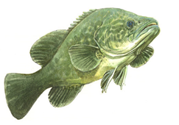Murray cod occasionally grow to 1.5 m long and 50 kg and can live for up to 50 years. Murray cod inhabit many of the waterways of the Murray-Darling Basin (MDB) (ACT, SA, NSW, Qld and Vic) and live in a wide range of aquatic habitats that range from clear, rocky streams to slow flowing turbid rivers and billabongs (Lintermans, 2007).

Conceptual model Murray cod

|  |
| --- |
| Habitat use |
| 1. Prefer permanent flowing river reaches and creeks with hydraulic complexity/diversity. 2. Require woody debris (snags), debris piles and bank side vegetation (Koehn and Harrington 2005). 3. In the southern reaches of the MDB, the status of Murray cod populations is influenced by habitat availability, flow regime, hydrodynamic diversity (water velocity, depth and turbulence) and connectivity (Henderson et al. 2010a,b; Mallen-Cooper et al., 2013; Mallen-Cooper and Zampatti, 2015a; Mallen-Cooper and Zampatti 2017). 4. Recruitment potential may be increased when additional habitat resources such as food and shelter are created as river benches, snags and rocks and riparian zones are inundated by rising flows. 5. Eggs and larvae require a steady flow increase and very little daily variations in water level (e.g. 0.1 m) to maximise spawning success. |
| Diet |
| 1. Diet changes with age with the typical adult diet consisting of spiny crayfish, yabbies and shrimps (National Murray Cod Recovery Team 2010) 2. Predominantly piscivorous and feed on native and exotic fish species e.g. [native species - other cod (*Maccullochella* spp.), golden perch, bony bream (*Nematalosa erebi*), freshwater catfish, western carp gudgeon (*Hypseleotris klunzingeri*)], [exotic species - redfin perch (*Perca fluviatilis*), carp (*Cyprinus carpio*) and goldfish (*Carassius auratus auratus*)]. 3. Less common animals found in the diet include ducks, cormorants, grebes, tortoises, water dragons, snakes, mice, frogs and mussels (Rowland, 1996). 4. Upon hatching, larvae are 5–8 mm long and within 8–10 days can feed on zooplankton. After reaching a length of 15–20 mm, they begin to feed on aquatic insects (King, 2005). |
| Spawning |
| 1. Occurs annually during October, November and December each year (Humphries, 2005; Koehn and Harrington, 2005), occurs during base flows and during river rises (King et al., 2009a; Ye et al., 2008). 2. Display complex pre-spawning courtship behaviour (during winter and spring) and females may spawn with more than one male. 3. Females lay their eggs into nests. The male guards the nest for up to two weeks while the eggs hatch. Juveniles leave the nest and move into littoral or snag habitats. 4. Despite often being classified as a ‘flow independent spawner’ Murray cod do require permanent flowing water for optimal recruitment (Sharpe and Stuart 2015). 5. Can spawn and recruit during low stable flows, rising flows and floods. 6. Floods are not necessary for spawning but in some cases, appear to enhance subsequent recruitment (King et al., 2009a). |
| Recruitment |
| 1. There is high mortality of young fish but those that survive their first summer and winter and grow to 90-140 mm long tend to have a good chance of recruiting into the sub-adult population (250-600 mm long) (Baumgartner et al., 2006). 2. Mature late (3-5 years) and at a reasonably large size (>600 mm long) but females have relatively low egg numbers (fecundity). 3. Long-lived (>40 years) and can grow to a large size (e.g. 1.4 m and 45 kg) where they become the apex aquatic predator (Anderson et al., 1992a; Ebner, 2006). 4. Where riverine stocking occurs there can be significant augmentation of natural populations (Forbes et al., 2016). |
| Movement and migration |
| 1. May move large distances (e.g. up to 120 km) but are usually only a few kilometres (e.g. commonly up to 30 km), (Leigh and Zampatti, 2011; 2013). 2. Move from their home snag to spawning areas in July/August/September on rising water temperature in winter and early spring (Jones and Stuart, 2007; Saddlier et al. 2008). 3. Both adult and juvenile fish are strongly associated with snags with a ‘home’ snag with adult fish often returning to the same snag (Koehn, 2009). 4. In recent years, the need to provide fish passage for Murray cod to escape anoxic black water events has been demonstrated in the lower Murray, most recently in late 2016, when large numbers of fish were killed in the lower and mid-Murray River, Edward-Wakool system, Frenchman’s Creek, Rufus River and Mullaroo Creek (Tonkin et al., 2017). |
| Implications for Victorian environmental flows |
| 1. A specific Murray cod hydrograph should be implemented where population recovery is required (Sharpe et al. 2015; Sharpe and Stuart 2018) 2. Flowing riverine sites can be considered ecological priorities for Murray cod recovery 3. Application of the Murray cod hydrograph, especially high winter base-flows, is required on an annual basis (Sharpe and Stuart 2015; Sharpe and Stuart 2018) |
| Implications for flow monitoring |
| 1. Flow-event monitoring is crucial to identify the specific components of the hydrograph (shape, timing, frequency, duration, height, discharge, velocity) that influence population dynamics. |
| Threats |
| 1. Lack of flowing water habitats with a high density of snags because of past de-snagging, regulation transforming the hydrodynamic nature of many rivers from flowing rivers to weir pools and cold water discharge from high dams (Mallen-Cooper and Zampatti 2017. 2. Loss of permanent flows when rivers and anabranches are de-watered during winter. 3. In many regulated rivers and anabranches (e.g. Gunbower Creek, Gulpa Creek, Edward River, Mullaroo Creek) there are two major hydrological constraints on Murray cod population recovery  * intense fluctuation in river discharge causing rapid decreases in river level and interruption of spawning/recruitment processes, * low or zero winter flows that appear to be population ‘bottlenecks’ because this forces all fish into the deeper refuge pools for up to 3 months each year (Sharpe and Stuart, 2015). |
| Knowledge and data limitations |
| 1. Wide-scale implementation, refinement and evaluation of the Murray cod hydrograph |

## Appendix 2. Conceptual model for golden perch

Golden perch which commonly grow to 600 mm long and 3 kg are widespread throughout the Murray-Darling Basin, especially in the lower and mid reaches, but have severely declined above dams in the upper reaches of most tributaries. They are predominantly found in the lowland, warmer, turbid, slow flowing rivers. Golden perch have a maximum life-span of 25 years and commonly reach 600 mm long.

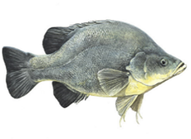

|  |
| --- |
| Habitat use |
| 1. Inhabit a wide variety of aquatic habitats, including slow flowing rivers, fast flowing rivers at landscape scales (e.g. 500 km; Mallen-Cooper and Zampatti, 2015b), lakes, anabranches and billabongs 2. Diverse aquatic habitats are important to provide shelter and a productive food web, especially so these fish can feed in winter. 3. Main river habitats are used for feeding and are also an important refuge and overwintering habitat. 4. Habitat generalists often associated with physical habitat (‘snags’), drop offs and deep water (Crook et al., 2001). 5. Winter is a critical period for young-of-year fish survival (i.e. fish that are less than one year old and the result of spawning in the previous spring. |
| Diet |
| 1. The species is an opportunistic carnivore. The diet of adults consists mainly of shrimps, yabbies, small fish and benthic aquatic insect larvae (Baumgartner 2007). 2. Juveniles consume more of the smaller items such as aquatic insect larvae and microcrustaceans (Lintermans, 2007). |
| Spawning |
| 1. Long-lived, show variable growth and females are highly fecund, they display no parental care (Anderson et al., 1992b; Mallen-Cooper and Stuart, 2003). 2. Spawning occurs in spring and early summer (October-February; >17oC; King et al., 2009a). 3. A rise in water level, or flow pulse (e.g. 0.3 m/s), is the proximate cue to initiate spawning so eggs and larvae can drift downstream (Lake, 1967; King et al., 2009a; Sharpe, 2011). 4. Eggs and larvae drift downstream, where larval transition to early juveniles occurs in the main river channel if sufficient food resources for young fish also occur (Sharpe, 2011). 5. Fish spawn during 1-in-1 year bank full flows that have variability (e.g. 0.15 m/24 h) and during over bank flows. 6. Eggs hatch after 1-2 days and larvae may drift for 10-12 days. Drift aids dispersal from spawning areas to feeding and nursery areas. Much of this drift is along the main river channel (i.e. 300 km drift distance), and larvae are likely to settle along the channel margins. 7. Larval passage through under-shot weir gates results in high mortality (Baumgartner et al. 2006). Irrigation offtakes also receive drifting larvae, depending on the proportion of flow diverted (King and O’Connor, 2007). 8. There is no evidence that golden perch directly use ephemeral floodplains for spawning in the Murray system. 9. Outside of the Murray main river channel (and associated anabranches) spawning has only been recorded in the Goulburn River, with no other confirmed records of spawning in Victorian rivers (e.g. Ovens, Broken and Campaspe rivers). 10. Spawning in the Upper Victorian Murray and lower Goulburn rivers does not appear to result in localised recruitment (King et al., 2009a; Koster et al., 2014) whereby records of late-stage larvae and early juvenile fish are rare. |
| Recruitment |
| 1. Recruitment occurs during within-channel flows and especially during over-bank flows when floodplains are inundated increasing productivity and larval survival (Mallen-Cooper and Stuart, 2003; Ye et al., 2008; Ebner et al., 2009; Zampatti and Leigh, 2013; Sharpe and Stuart 2018). 2. Recent research indicates that the juvenile population, in the lower Murray and at least upstream to Torrumbarry, can be dominated by cohorts spawned in the Darling River, with 1+ fish migrating downstream in the Darling and then upstream in the Murray River (Zampatti et al., 2015; Sharpe and Stuart 2018). 3. The level of recruitment upstream of Torrumbarry Weir is a knowledge gap but may be low. Hence, northern Victorian rivers appear heavily reliant on re-colonisation migrations of juveniles and adults from downstream and connectivity with the Victorian Murray. 4. There is no evidence for enhanced recruitment from deliberate creation of ‘slackwaters’. 5. Young fish settle into off-stream floodplain or littoral riverine nursery habitats. 6. Populations in the Murray River and tributaries are episodic in age structure, often being dominated by only a few distinct year classes. Strong natural recruitment occurs following high flow or flood years (Ye et al., 2008; Mallen-Cooper and Stuart, 2003; Sharpe, 2011; Ferguson and Ye, 2012; Zampatti et al., 2015; Crook et al., 2016). 7. In extreme cases, one year class can represent more than 60% of the adult population in broad reaches of the Murray River (Zampatti et al., 2015). 8. In particular rivers, low-levels of recruitment occur in most years, such as the Goulburn (Zampatti et al., 2015; Crook et al., 2016) but in others such as the Murray and Edward-Wakool (an anabranch of the Murray) there are successive years of recruitment failure and populations are dominated by particular year classes, when strong natural recruitment and emigration has occurred (Ye et al., 2008; Zampatti et al., 2015; Thiem et al., 2017). 9. In those rivers, fragmented demographics have been attributed to a combination of spawning limitations, recruitment failure and barriers to dispersal (Mallen-Cooper and Stuart, 2003; Leigh and Zampatti, 2011, 2013, Stuart et al., 2008; Sharpe, 2011; Sharpe et al., 2015; Zampatti et al., 2015; Thiem et al., 2017). |
| Movement and migration |
| 1. During in-channel flows, especially in tributaries, golden perch often display site fidelity but there can be major home range shifts (Crook, 2004) and there is strong movement between the Murray River and tributaries (Koster et al., 2014). 2. Adults move upstream in the mainstem, often through fishways, of the Murray River in spring and summer and this is often spawning related (Mallen-Cooper, 1999; Stuart et al., 2008; Baumgartner et al., 2014a). 3. Movement is strongly cued by rising/falling flow and water temperature with much less migration in stable flow and in winter. 4. Also move downstream in spring, summer and autumn (O'Connor et al., 2005). 5. Thousands of immature golden perch and silver perch, that are one year and older, migrate upstream, responding to increased flow (e.g. +0.15m/24h) and these migrate into early autumn. 6. Mature and immature fish may aggregate for days or weeks at weirs, if flows provide sufficient stimulus, or they may return downstream to seek alternative migration pathways. Aggregations below barriers can quickly disperse downstream as flows recede. 7. Juveniles make staged re-colonisation migrations, responding to a flow in a movement pulse and then stopping during stable flows. 8. Migrations are usually over the scale of 100s of kilometres although some can be over 10s of kilometres (Reynolds, 1983; O’Connor et al., 2005; 2015). 9. A greater proportion of the fish population migrates during major over-bank flood events such as the 2010/11 floods. For example, major increases in abundances and biomass within the Victorian upper Murray reach were a result of adult immigration from downstream sources (Lyon et al., 2014). |
| Implications for Victorian environmental flows |
| 1. Designing flows to cue fish migration and movement through Victorian fishways is possible by releasing near bank full flows for short periods (days to weeks per event) in spring and summer. 2. Spawning flows can be implemented in the Victorian Murray and lower Goulburn rivers in spring/early summer. Tributary (e.g. Campaspe, Loddon, Gunbower etc) flows are highly unlikely to result in spawning due to the limited spatial scale and low hydraulic diversity. 3. Spawning flows can be 1-in-1 year bankfull style events, with strong variability, and should be based on the natural hydrograph. 4. Prioritising ‘slackwater’ habitats for larvae in these tributaries is highly unlikely to result in enhanced recruitment. 5. Re-colonisation flows in early summer (e.g. January-March) can attract upstream migrating yearlings and juvenile fish into Victorian tributaries and in the Victorian Murray in the Echuca-Yarrawonga reach, especially if synchronised with rising flows in the Victorian Murray (Sharpe, 2011; Stuart and Sharpe, 2015). 6. Using environmental flows to create a hydrodynamic diversity is the major objective for successful golden perch outcomes (Zampatti and Leigh, 2013; Koster et al., 2014; Sharpe et al., 2015). The ‘slackwater’ model has little empirical support. 7. Weir pool lowering can also be used in conjunction with environmental flows to maximise hydraulic diversity over large spatial scales (Ye et al., 2008). 8. Landscape scale planning and monitoring is required to maximise golden perch outcomes, such as providing Victorian re-colonisation flows after high flows in the lower Murray/Darling systems (Sharpe et al., 2015). 9. Protecting the integrity of flows over large spatial scales (e.g. 300-500 km), with a co-ordinated multi-state cooperation is required to enhance golden perch population dynamics. |
| Implications for flow monitoring |
| 1. Flow-event monitoring is crucial to identify the specific components of the hydrograph (shape, timing, frequency, duration, height, discharge, velocity) that influence population dynamics of golden perch. 2. Flow evaluation analysis should target the fish-and-flow event relationship through metrics such as: size/age distribution, emigration, immigration, movement and spawning. Broad-scale analyses of abundance (CPUE) are of very limited use. |
| Threats |
| 1. Loss of connectivity to floodplain nursery habitats 2. River regulation and diversion restricts juvenile and adult movement, prevents dispersal and recolonization of extensive stretches of river and increases risk of localised extinction and fragmentation 3. Weirs may trap eggs and early larvae causing them to settle and die (Baumgartner et al., 2014a) 4. Undershot weirs kill >90% of larvae (Boys et al., 2010) 5. Thermal issues will limit spawning below weirs and possibly increase larvae survivorship 6. Loss of off-channel floodplain nursery habitats 7. Impoundment of riverine flowing water habitats |
| Knowledge and data limitations |
| 1. Implementation of catchment scale flow planning to recover populations 2. Impact of weir pools on egg/larvae survivorship 3. A major knowledge gap is larval drift distance and survival upon entering a weir pool (e.g. larvae from the lower Goulburn River and mid-Murray River drifting into the Torrumbarry Weir pool). |

## Appendix 3

**Larval sampling methods: Part 1**

* + Larval sampling was undertaken at each site for Part 1a­-c by deploying 3 x larval drift nets and 3 x light traps, set overnight. The drift nets and light traps were identical to those used across a variety of spawning studies in the MDB since the 1990’s and have been proven effective at collecting the drifting eggs and larvae of Murray cod and golden perch.
  + The drift nets were 1.5 m long with an opening of 0.5 m in diameter and are constructed of 500 µm mesh that tapers into a removable reducing jar. Drift nets were suspended from snags so as to filter the top 0.5 m of the water column. Light traps were identical to those used by Humphries and Lake (2000) except that a 3.0 mm mesh was fitted across the opening to exclude small predatory fish (Figure 8) (Vilizzi et al. 2008). Light traps were constructed from clear Perspex®, had a removable collecting dish, and included a 24hr yellow cyalumeTM light-stick. Light traps were set overnight within slackwater littoral areas. Set and retrieve time for each net and trap was recorded, with soak times ranging from 16-19 hours.
  + All samples were preserved in 70% ETOH solution and returned to the laboratory for processing. All larval data was presented as raw abundance per sampling site and sampling event relative to soak time.
  + Sample processing for larvae occurred in the laboratory in the days following collection, so that the findings could inform planning for the ongoing schedule for release of environmental water throughout 2016‑17. Larval identification followed Serafini and Humphries (2004) from which developmental stage was determined and used to estimate age hence spawning time.

**Population structure sampling methods: Part 2 and 3.**

* + Fish population surveys were undertaken at each of the sites sampled for larvae in the lower Darling River (six sites) and in Great Darling Anabranch (6 sites) using boat electrofishing and fyke netting.
  + Boat electrofishing followed Sustainable Rivers Audit (SRA) protocols whereby 12 x 90 sec machine time shots were undertaken at each site.
  + Four pairs of large and small fyke nets were set at each survey site. Nets were set in the afternoon and retrieved the following morning with set and retrieval time recorded. Large fyke nets had a central wing (8 m x 0.65 m) attached to the first supporting hoop (= 0.55 m) with a mesh entry (0.32 m, stretched) and a stretched mesh size of 28 mm (Figure 3.3). Small fyke nets had a stretched mesh size of 2 mm, dual wings (each 2.5 m x 1.2 m), with a first supporting hoop ( = 0.4 m) fitted with a square entry (0.15 m x 0.15 m) covered by a plastic grid with rigid square openings (0.05 m x 0.05 m) (Figure 3.4).

**Age determination**

* + Preserved samples of fish from Menindee Lakes were processed for daily age by Fish Ageing Services Pty Ltd. For each fish, a transverse section of one sagittal otolith was prepared using a bidirectional glue and polish method. Sagitta were embedded in Crystal BondTM onto the edge of a glass microscope slide and then ground from the anterior to the posterior end towards the core using 1200-grit wet and dry paper fixed to a variable speed wheel. The polished surface was then flipped onto the flat surface of the microscope slide, glued and the grinding and polishing was performed on the posterior end down to approximately 75 µm thickness. The ground otolith was then polished with 3 µm imperial lapping film and 1 µm diamond paste. Prior to examination, a drop of CrystalbondTM or immersion oil was applied to each section to enhance resolution of otolith growth increments by clearing residual surface scratches.
  + For each prepared otolith, increments were counted from the primordium (nucleus) to the outside edge along a radial transect at 400-1000 X magnification. The mean of two readings from each otolith was considered to represent the age in days for each individual fish.