

Environmental Outcomes Report

2012–13







Cover image: Red-kneed dotterel, Macquarie Marshes Photograph by David Straccione (CEWO)

© Commonwealth of Australia 2013

This report should be cited as ‘Environmental Outcomes Report 2012–13’.

This work is copyright. Apart from any use as permitted under the Copyright Act 1968, no part may be reproduced by any process without prior written permission from the Commonwealth. Requests and enquiries concerning reproduction and rights should be addressed to the Department of the Environment, Public Affairs, GPO Box 787 Canberra ACT 2601 or email public.affairs@environment.gov.au

ISBN: 978-1-921733-90-1

Design by Biotext

Contents

Foreword vi

Use of Commonwealth environmental water in 2012–13 1

Southern Basin outcomes 4

Murray 4

Lower Murray River Valley—Coorong, Lower Lakes and Murray Mouth—South Australia 4

Mid-Murray—Edward-Wakool River and Tuppal, Gywnnes, Colligen, Yallakool, Jimaringle–Cockran and Gunbower creeks—New South Wales and Victoria 9

Murrumbidgee 13

Northern Victoria 17

Broken Creek 17

Campaspe 18

Goulburn 19

Loddon 19

Ovens 20

Northern Basin outcomes 23

Northern Basin regulated catchments 24

Border Rivers 24

Gwydir 24

Lachlan 25

Macquarie 27

Namoi 29

Northern Basin unregulated catchments 29

Barwon–Darling 29

Condamine–Balonne 30

Moonie 31

Resources 32

Acknowledgements 34

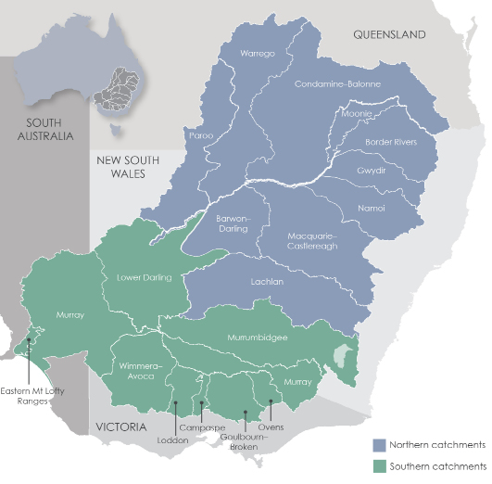

# Foreword

The 2012–13 watering year was particularly important for the Commonwealth Environmental Water Office (the Office). It was the year in which the Basin Plan was made and in which we reached a milestone of 2500 billion litres of Commonwealth environmental water delivered since 2009. I announced the first agreement for the management of Commonwealth environmental water by a non-government organisation, the Nature Foundation South Australia. The intention to place Commonwealth environmental water local engagement officers in regional areas in the Murray–Darling Basin (the Basin) was also announced and negotiations with hosting organisations commenced.

Over the past five years, Commonwealth environmental watering has helped improve the health and resilience of the Basin’s ecosystems by:

Rivers

* improving water quality by flushing salt, sediments and excess nutrients out of the system through the Murray Mouth, and providing refuges to help reduce the impacts of natural blackwater events caused by large rainfall-generated floods
* supporting native fish breeding and recruitment, as well as supporting their food sources

helping to improve the quality of habitat in riverbank areas.

Wetlands

* connecting rivers to wetlands to support nutrient cycling and food chains

inundating vegetation and supporting native plant and animal reproduction and growth including bird breeding events.

Floodplains

* supporting the growth and germination of important plant communities, such as river red gums

connecting rivers to floodplains, thereby supporting food chains and nutrient cycling.

The Office undertakes robust planning to inform my decisions on the use of Commonwealth environmental water. This planning has become more sophisticated over time, with frameworks and approaches being adapted and improved in response to results from monitoring and feedback on the outcomes of environmental watering. The Basin Plan’s environmental watering plan adds another element to our planning. It facilitates the coordination of the annual planning process at a Basin scale and requires the development of long-term watering plans for each catchment. The environmental watering plan also provides environmental objectives, along with targets to measure progress against the objectives. During 2012–13 the Office successfully commenced the transition to meet the requirements of the Basin Plan.

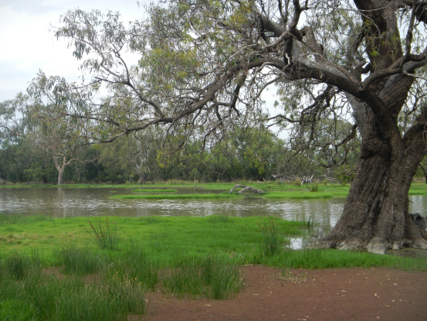

Macquarie River catchment

Photograph by Daniel Rothenfluh (CEWO)

Short-term monitoring by scientists has been commissioned across a range of sites in the Basin where Commonwealth environmental water has been delivered. This Outcomes Report identifies the ecological outcomes of environmental watering based on the results of scientific monitoring prior to 2012–13, as well as findings from operational monitoring and observed outcomes of watering actions. It is not cost effective to monitor every site; for sites without monitoring results, the 2012–13 outcomes have been inferred based on the operational data received and the best available science.

Monitoring projects are not our only source of information about the results being achieved. Local communities, such as those in the Murrumbidgee and mid-Murray, are reporting on the benefits they are observing from the use of environmental water in their area. Some of these views are also reflected in this report.

I am very grateful for the time, expertise and advice provided by our delivery partners, other environmental water holders, members of our advisory panels, regional water management advisory groups and the many landowners who work with us to plan, manage and monitor the use of environmental water in the Basin.

David Papps  
Commonwealth Environmental Water Holder

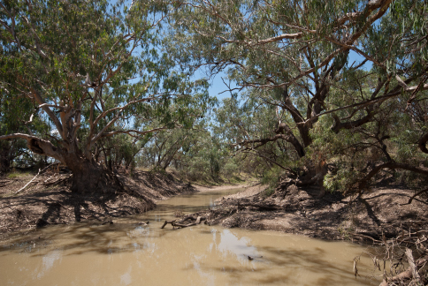

Namoi River catchment

Photograph by Neal Foster (NSW Office of Water)

# Use of Commonwealth environmental water in 2012–13

The 2012–13 year saw a return to drier conditions across most of the Basin. To ensure that the ecological restoration of river and wetland communities that began with the breaking of the drought and the wetter conditions from 2010 to early 2012 continued, Commonwealth environmental watering was used to build on and maintain the momentum of restoration and help build resilience in preparation for the next drought. The planning for annual use and management of Commonwealth environmental water in 2012–13 was undertaken in a robust and comprehensive manner consistent with the Basin Plan as it was being finalised.

Commonwealth environmental water was used in 34 environmental watering actions across 15 Basin catchments in 2012–13. A total of 1,272 billion litres of Commonwealth environmental water was used to:

* provide river flows that supported good water quality for the environment and water users
* connect rivers to floodplains, which helped maintain food chains and supported fish movement

fill wetlands that supported native fish, birds and other native animals.

Over 240 billion litres of the total amount delivered was used to achieve multiple environmental outcomes at multiple sites in the southern connected Basin. This was an efficient use of water that maximised environmental outcomes at both the local and Basin scales. Carryover from the previous year was also used to enable environmental watering early in the season and to supplement annual allocations. By drawing on carryover more water was used in 2012–13 than was received in new allocations.

Commonwealth environmental water was delivered by river operators, usually with water from other environmental water holders including state governments, the Murray–Darling Basin Authority and non-government organisations. Further details of the Office’s activities in 2012–13 are in the Commonwealth environmental water annual report 2012–13.

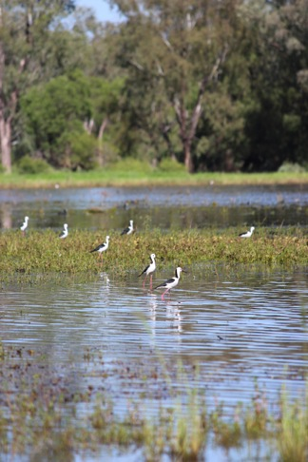

Black-winged stilts, Gwydir catchment

Photograph by Bruce Campbell (CEWO)

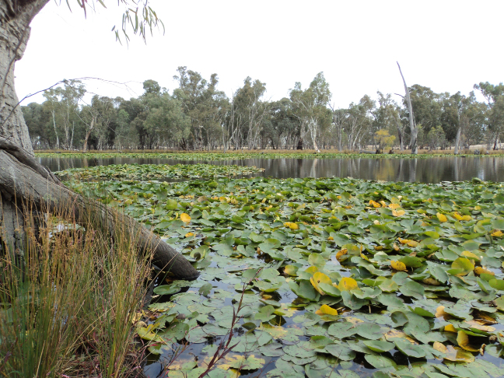

Gunbower Creek, Murray River catchment

Photograph by Alana Wilkes (CEWO)

# Southern Basin outcomes

## Murray

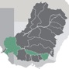

The Murray catchment received 582.9 billion litres of Commonwealth environmental water in 2012–13, in conjunction with water from the New South Wales Office of Environment and Heritage, the Victorian Environmental Water Holder, The Living Murray and the Nature Foundation South Australia. Delivery of Commonwealth environmental water across the Murray catchment contributed to connecting habitats along the river and between the river channel and fringing wetlands. This in turn helped maintain and improve the health of riverbank areas and wetland native plants, and supported the survival and breeding of native fish such as Murray cod, silver perch, golden perch and freshwater catfish. Environmental flows also facilitated the dispersal of nutrients within the system to provide food for aquatic animals, and the flushing of excess sediments and salt from the system to improve water quality.

### Lower Murray River Valley—Coorong, Lower Lakes and Murray Mouth—South Australia

In 2012–13 the Commonwealth provided 548.9 billion litres of environmental water to improve flows and habitat in the lower River Murray channel, the Lower Lakes and the Coorong, and to increase flows through the barrages and out through the Murray Mouth. Additional environmental water for these flows was also provided by The Living Murray program. Environmental watering helped maintain the connections of waterways in these areas, supporting fish movement and the flushing of salt and nutrients from the Basin. This contributed to improved habitat in the Coorong to support native fish, waterbird and plant growth. Watering actions promoted the continued restoration of native plant and animal communities and contributed to building their resilience to possible low inflows in the future.

Environmental watering of a number of South Australian locations, including Whirlpool Corner, Disher Creek and Berri Basin, contributed to improving the health of native riverbank plant communities, such as river red gums and black box. These flows also contributed to increasing the transport of nutrients and salt from the river system and mitigating potential environmental impacts of acid drainage from the Lower Murray Swamps. Environmental water used at these locations was provided from flows that progressed downstream after being delivered in Victoria (see below for benefits to Victorian catchments). The Office also undertook the first use of Commonwealth environmental water as part of a long-term agreement with a non-government organisation, the Nature Foundation South Australia (see focus article on page 6).

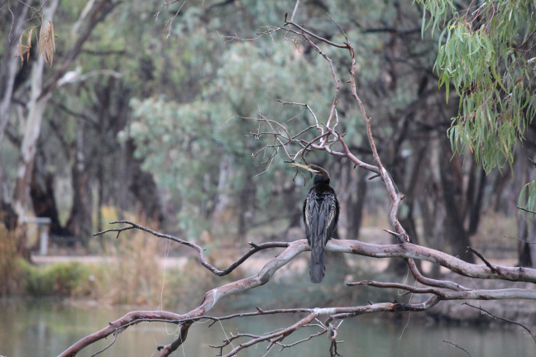

A darter, Murray River catchment near Mildura

Photograph by Suzanne Busch (CEWO)

Focus article: Contributing to the restoration of the Lower Murray, South Australia

Monitoring commissioned by the office in the Lower Murray has shown that:

* in 2011–12, environmental water exported about 18% of the average 2 million tonnes of salt that needs to be exported from the Basin each year to maintain water quality
* in February 2012, Commonwealth environmental water was responsible for removing about 70% of the salt exported from the Basin that month.

These results show that Commonwealth environmental water is helping to maintain ecosystem functions, such as flows through the Murray Mouth, above critical thresholds to improve water quality in the Basin.

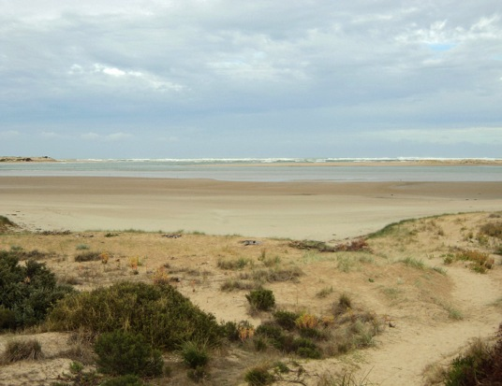

**The view across the Coorong looking towards the Murray Mouth, South Australia**  
Photograph by Alana Wilkes (CEWO)

By helping to manage salinity and maintain water quality and water levels in the Coorong, environmental watering actions have encouraged recruitment of aquatic plants such as Ruppia tuberosa, and of Murray hardyhead populations (a small, endangered native fish) and increased the availability of threatened waterbird habitat in the South Lagoon. Figure 1 shows the contribution that environmental water made to flows in the Lower Murray in 2012–13.

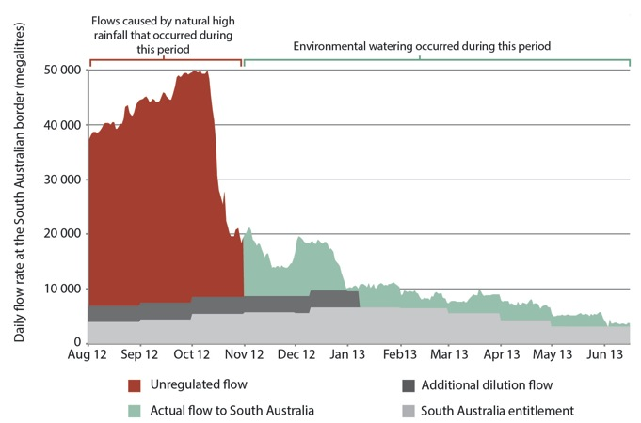

**Figure 1: Hydrograph showing the contribution of environmental water to Lower Murray flows during 2012–13 (includes Commonwealth environmental water and water managed by the Murray–Darling Basin Authority for The Living Murray).**

Focus article: Environmental watering with the Nature Foundation South Australia

In February 2013 the Commonwealth Environmental Water Holder officially launched the first delivery of Commonwealth environmental water in partnership with the Nature Foundation South Australia (a not-for- profit wildlife charity), at Clarks Floodplain near Berri.

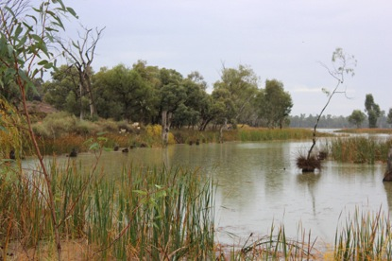

**Murray River catchment near Mildura**Photograph by Suzanne Busch (CEWO)

It was the start of a first-of-its-kind agreement allocating 50 billion litres of Commonwealth environmental water over five years for the Nature Foundation South Australia to use in rehabilitation projects at River Murray floodplains and wetlands in South Australia.

Established during the recent drought, the Nature Foundation South Australia’s Water for Nature program has been helping to redress the damage and stress to River Murray ecosystems and habitats caused by drought, salinity and river regulation. It focuses on urgent intervention to improve the condition of river red gum and black box woodlands, lignum swamps and samphire floodplains (samphire is a native plant that grows on many of southern Australia’s salty river flats) and the many species of threatened and vulnerable birds, fish, frogs and invertebrates for which they provide habitat.

The Nature Foundation South Australia has produced the You Tube video [First Commonwealth Environmental Watering for Nature Foundation](http://www.environment.gov.au/ewater/gallery/video/video-sanf.html) which provides more information about this watering event.

“Now is an excellent time to be doing environmental watering here because we’re following on from two really quite wet years. We’ve had huge flows in the River Murray which we haven’t seen for a long time, we had a drought and now we’ve got a really wet period and we’ve got lots of natural recruitment, little seedlings coming up and we want to keep those alive so that they become part of the woodland and help the woodland recover here on the floodplains of the River Murray.”

Dr Greg Johnston, Conservation Ecologist, Nature Foundation South Australia  
(February 2013)

### Mid-Murray—Edward-Wakool River and Tuppal, Gywnnes, Colligen, Yallakool, Jimaringle–Cockran and Gunbower creeks—New South Wales and Victoria

A total of 33.9 billion litres of Commonwealth environmental water was provided in the mid-Murray River in 2012–13 through watering actions coordinated with the New South Wales (NSW) Office of Environment and Heritage.

At Jimaringle Creek, Cockran Creek, Gwynnes Creek and Tuppal Creek, Commonwealth and NSW environmental water was used to provide flows to maintain and improve water quality, in particular to reduce salinity. This helped maintain and improve the health of native plant communities including river red gum, black box and lignum. These flows also provided good-quality habitats for breeding and recruitment of native animals such as the pobblebonk frog, Peron’s tree frog and wrinkled toadlet.

At Colligen Creek and Yallakool Creek, a number of instream flow pulses in spring and autumn supported the movement, breeding and recruitment of native fish such as Murray cod and golden and silver perch.

Landholders along these creeks continue to be key partners by generously sharing their time, knowledge and experience during the planning, delivery and monitoring of these watering actions. The NSW Office of Environment and Heritage has produced the You Tube videos [Restoring Tuppal Creek](http://www.youtube.com/watch?v=8A9evEHtfz8) and [The Cockran, Jimaringle and Gwynnes Creek systems](http://www.youtube.com/watch?v=ZLS1m65LLrU), which provide more information about these watering events.

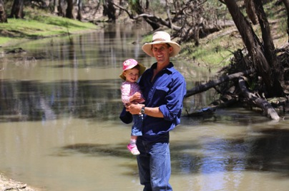

Landholder Jim Macdonald with daughter Grace during the environmental watering of Tuppal Creek in November 2012

Photograph by Vince Bucello, courtesy of NSW OEH

“Since this environmental flow started a couple of months ago we’ve noticed a lot more bird life down here along the creek. The water is of much better quality, it’s clearer and the trees seem to have responded with a lot of fresh growth and they look a lot healthier as well.”

Greg Sandford, Tuppal Creek landholder (May 2013)

Commonwealth environmental water deliveries totalling 2.1 billion litres were provided during 2012–13 to Gunbower Creek, coordinated with additional water from The Living Murray and the Victorian Environmental Water Holder. The environmental water used in Gunbower Creek was provided from flows that were originally part of other environmental watering actions in the northern Victorian catchments. Environmental watering in the catchment contributed to maintaining habitat quality and food sources for native fish— including golden and silver perch, Murray cod and crimson spotted rainbowfish—and assisted them to migrate and grow.

|  |  |
| --- | --- |
|  |  |

Gwynnes Creek, Murray River catchment, before and after environmental watering

Photographs by Josh Campbell (Murray CMA)

Focus article: Environmental responses to the delivery of environmental water in the Edward–Wakool river system and fish monitoring outcomes

Since 2011 the Office has commissioned a number of studies, involving Charles Sturt University and partner agencies including the Murray Catchment Management Authority, to monitor and report on the ecosystem responses to environmental watering in the Edward–Wakool river system. The results from this monitoring are helping inform the future use of environmental water for the benefit of the river.

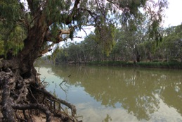

**Edward River near Deniliquin, Murray River catchment**  
Photograph by James Smeeth (CEWO)

Key outcomes identified through the 2011–12 stage of this work (and related monitoring in the Murray River) are that Commonwealth environmental water in the Edward–Wakool river system has:

* contributed to increased breeding of carp gudgeon, a small native fish
* contributed to increasing the food sources for native fish
* provided a refuge for fish and aquatic animals from naturally occurring hypoxic blackwater (low dissolved oxygen levels in the water) in the Edward–Wakool rivers in April 2012, as well as providing refuges downstream in the Murray River.

Monitoring has also been undertaken for the Commonwealth environmental water used in the Edward–Wakool River system during 2012–13. Early results show that when Commonwealth environmental water was delivered:

* there were no blackwater events in the relevant areas
* a variety of native fish—including Murray cod, river blackfish, Australian smelt, carp gudgeon, flathead gudgeon and Murray River rainbowfish—were recorded in all river reaches monitored, with the exception of the Mulwala Canal. This is a good indication that native fish breeding was successful in this system.

## Murrumbidgee

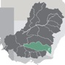

During 2012–13, the Office partnered with the NSW Office of Environment and Heritage to deliver Commonwealth environmental flows totalling 156 billion litres through watering actions targeting native fish health in the Murrumbidgee River channel and the re-establishment and regeneration of native plant communities and habitat in riverbank and wetland areas.

Environmental water deliveries in the mid and lower Murrumbidgee River, targeting in-channel habitat between Gogeldrie Weir (near Leeton) and Hay,contributed to maintaining the inundation of breeding habitat for native fish, particularly Murray cod. The flows ran long enough to help young and adult native fish disperse throughout the river at the end of the breeding season.

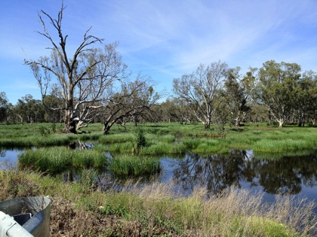

Murrumbidgee River catchment

Photograph by Andrew Lowes (CEWO)

“We kept it carp free with the series of carp screens and the bird life that came in was very large numbers, probably 30,000–40,000 birds of all the duck species. There were a few freckled ducks spotted and countless numbers of black-tailed water hens.”

Peter Morton, Cherax Swamp landholder   
(May 2013)

Environmental watering in areas of the western lower Murrumbidgee floodplain, including Cherax Swamp and Hobblers Lake, promoted the health and regeneration of native plant communities in creeks and wetlands, establishment and growth of native plant communities in locations isolated from the floodplain, and good-quality habitat for native animals including waterbirds, fish and frogs.

The NSW Office of Environment and Heritage has produced the You Tube videos [Helping the Murray cod in the Murrumbidgee](http://www.youtube.com/watch?v=71RkFtUPgVc) and [Cherax Swamp and Hobblers Lake bounce back](http://www.youtube.com/watch?v=c0e3hds6ETI), which provide more information about these watering events.

Focus article: Environmental responses of Commonwealth environmental water delivered to the Murrumbidgee and lower Murrumbidgee rivers

Since 2011 the office has commissioned short-term monitoring projects to provide a scientific assessment of the ecological benefits of Commonwealth environmental water use in the Murrumbidgee River and its wetlands and floodplain.

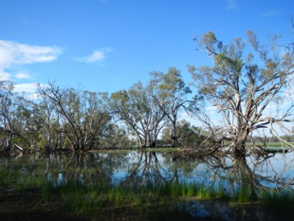

**Murrumbidgee River catchment**  
Photograph by Andrew Lowes (CEWO)

The University of New South Wales and partner agencies monitored the use of Commonwealth environmental water in the lower Murrumbidgee area. Key outcomes identified through this work are that Commonwealth environmental water has contributed to:

* Increased native fish numbers in the rivers and wetlands of the Murrumbidgee catchment including bony bream, carp gudgeon and golden perch
* the productivity and biodiversity of fish and microcrustaceans in the lower Murrumbidgee floodplain and river system
* connecting wetlands and creeks to rivers, which enables native fish and other animals to move around the system and have greater access to food and nesting sites
* ecosystem functions, such as nutrient and carbon cycling, that support food chains in the Basin.

The results from this monitoring are helping inform the future use of environmental water for the benefit of the river.

Monitoring has also been undertaken of Commonwealth environmental water used in the Murrumbidgee during 2012–13. Early results show that after Commonwealth environmental water was delivered:

* native fish out-numbered introduced fish by more than five to one
* in the Murrumbidgee River and Old Man Creek native fish larvae were found, including Murray cod, river blackfish and Australian smelt—a good indicator of breeding
* six types of frogs were recorded, including the southern bell frog, which is listed as vulnerable under the Commonwealth Environment Protection Biodiversity Conservation Act 1999; four types of frogs were recorded breeding: the barking marsh frog, spotted marsh frog, inland banjo frog and plains froglet.

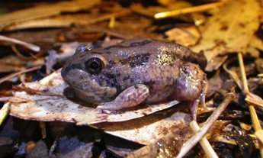

**An inland banjo frog that has almost completed the process (known as metamorphosis) of changing from a tadpole into a frog, Murrumbidgee River catchment**  
Photograph by Skye Wassens (Charles Sturt University)

## Northern Victoria

A total of 251.8 billion litres of Commonwealth environmental water was provided across the northern Victorian catchments during 2012–13. Watering actions were coordinated with the use of environmental water from the Victorian Environmental Water Holder and The Living Murray program. Many of these actions were designed to achieve environmental outcomes at multiple sites in Victoria and downstream in the South Australian River Murray.

### Broken Creek

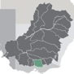

The Broken Creek catchment received 41.2 billion litres of Commonwealth environmental water in   
2012–13. This helped to facilitate the movement of native fish and sustain their habitat, particularly during fish migration and breeding seasons, by maintaining optimal levels of dissolved oxygen and restricting excessive aquatic plant growth. These flows also moved downstream contributing to increased flows to the Lower Murray River channel, Lower Lakes and Coorong that were used to maintain aquatic habitat and ensure adequate lake levels, barrage releases and flows through the barrage fishways.

Watering to support the restoration of the upper Broken Creek included increasing natural flow variability and building the resilience of aquatic habitats for drier periods in the future. These flows also promoted habitat diversity and successional change in native plant and animal communities.

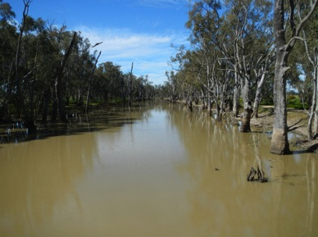

Broken Creek, Goulburn–Broken catchment

Photograph by Simon Hansen (CEWO)

### Campaspe

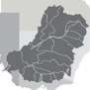

During 2012–13, 6.8 billion litres of Commonwealth environmental water was used in the Campaspe River in combination with additional water provided by The Living Murray program and Goulburn-Murray Water’s Connections project.

Outcomes from environmental watering in the catchment included maintaining the health and extent of native plant communities and supporting river bed and bank habitat to provide breeding and recruitment opportunities for invertebrates and native fish such as Murray cod, golden and silver perch and trout cod. Watering actions contributed to the mobilisation, transport and dispersal of sediment, nutrients and organic matter, which is an important process for maintaining a healthy river system and helping habitat connectivity. These environmental flows also contributed to multiple environmental benefits in the River Murray channel, Lower Lakes and Coorong.

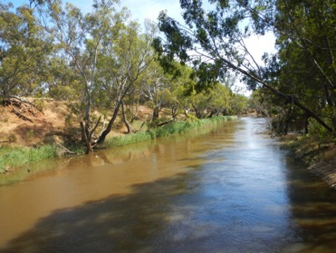

Campaspe River catchment

Photograph by Ryan Breen (CEWO)

### Goulburn



A total of 201.1 billion litres of Commonwealth environmental water was provided to the Goulburn River during 2012–13. Commonwealth environmental water was used in combination with water from The Living Murray program and the Victorian Environmental Water Holder to complement natural flows. Watering actions in the catchment helped support the ongoing restoration of river-dependent native animals and plants. They promoted breeding and recruitment opportunities for native plant and animal communities; assisted with mobilisation, transport and dispersal of sediments and nutrients; and helped improve habitat connectivity along the river to facilitate the re-establishment of native aquatic plants and animal communities. These environmental flows also contributed to multiple environmental benefits in the River Murray channel, Lower Lakes and Coorong.

### Loddon

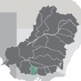

The Loddon River received 2.7 billion litres of Commonwealth environmental water during 2012–13, along with additional water from the Victorian Environmental Water Holder. This helped maintain native plant and animal communities along the river in a healthy, dynamic and resilient condition. Outcomes included enabling native fish movement, maintaining habitat for aquatic invertebrates and improving habitat connectivity.

### Ovens

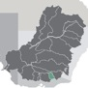

In the Ovens River catchment, 0.02 billion litres of Commonwealth environmental water was used to make a minor contribution to maintaining the health of native plant communities such as river red gums and supporting and connecting the habitat of native animal communities including invertebrates, frogs, turtles and fish such as Murray cod and trout cod.

Focus article: How Commonwealth environmental water use is achieving outcomes for native fish in the Basin

A number of watering actions undertaken by the Office during 2012–13 were planned and delivered to achieve a range of outcomes to benefit native fish in the Basin. Interventions such as habitat restoration, the installation of fishways, avoiding cold water pollution and managing introduced plants and animals can—when combined with environmental flows—work together to achieve the restoration of native fish in the Basin over time. The efficient and effective use of environmental water makes an important contribution to achieving these gains. 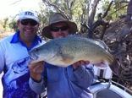

I**an Fisher (left) and John Conallin (right) holding a healthy Murray cod prior to releasing it back into the Edward-Wakool River system**  
Photograph by Ian Fisher, Edward-Wakool Anglers Association

The planning of each Commonwealth environmental watering action includes an assessment of key risks to native fish, including the potential impacts of hypoxic blackwater, cold water pollution and the potential spread and/or population increase of introduced fish such as carp.

Using the best available advice, each watering action is planned to make the most of the connected nature of the rivers, creeks and wetlands, which all play different and important roles in the restoration of native fish in the Basin (see figure 2). For example actions can be timed to coincide with and contribute to improving the breeding season of targeted types of native fish, such as Murray cod. Flows maintain and connect healthy wetlands, creeks and streams to rivers so that the rich sources of food they contain are available to native fish fry.

The monitoring projects commissioned by the office have shown that Commonwealth environmental water has contributed to the:

* reproduction and recruitment of native fish
* availability of food sources required by native fish
* health of habitat required for native fish to shelter, breed and nest
* ability of native fish to compete with introduced fish like carp.

These projects are also providing guidance to environmental water and fisheries managers about how lessons from past watering actions can help improve the outcomes we can achieve for native fish in the Basin.

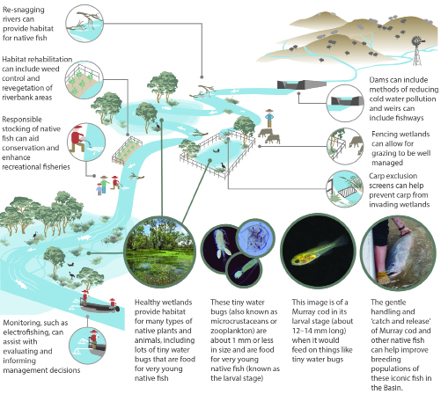

Photographs by (left to right): Erin Lenon (Murrumbidgee CMA), Kim Jenkins/Jordan Iles (University of NSW), Anna Navarro-Cuenca (Charles Sturt University) and J. Hutchison (NSW DPI Fisheries).

**Figure 2 The use of environmental water is just one of many actions that can help local communities restore habitat for our iconic native fish, such as Murray cod.**

# Northern Basin outcomes

Watering actions in the northern Basin in 2012–13 were managed in cooperation with the Queensland Department of Natural Resources and Mines, the NSW Office of Water, the NSW Office of Environment and Heritage, the NSW State Water Corporation, the NSW Department of Primary Industries (Fisheries), local advisory groups, landholders and scientists. Commonwealth environmental water was often delivered with NSW environmental water.

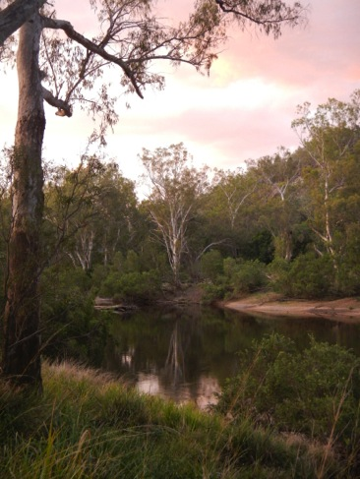

Border Rivers catchment

Photograph by Clare d’Arcy (CEWO)

## Northern Basin regulated catchments

### Border Rivers

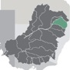

The catchment received 2.6 billion litres of Commonwealth environmental water in 2012–13. This included a flow release out of Pindari Dam targeting the NSW Severn River to stimulate the aquatic food chain and provide food sources and habitat improvements for aquatic plants and animals such as aquatic insects, fish, platypus and birds.

In the Queensland reaches of the Severn River, Commonwealth environmental water contributed to providing a more naturally variable river flow regime, filling and reconnecting waterholes that serve as refuges for fish and aquatic animals during low river flows, promoting suitable conditions for migration and spawning of large-bodied native fish, and encouraging the germination and maintenance of riverbank vegetation.

In the lower Macintyre River, additional environmental watering benefit was provided through the Commonwealth’s unsupplemented entitlement augmenting the planned environmental watering effect. This is expected to have helped support a more naturally variable flow regime, improve access to fish habitat through recruitment and movement opportunities, and promote nutrient cycling through to the end of the river system.

### Gwydir

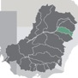

Commonwealth environmental water totalling 27.7 billion litres was delivered with NSW environmental water to contribute to inundation of core wetland areas in the Gwydir catchment. In the Mallowa Wetlands and Gwydir Wetlands, environmental water was used to support and build on the extensive ecological responses of the wet years 2010–12. This included enabling growth, breeding and small-scale recruitment of a diverse range of native plants and animals, promoting connections between the floodplain and rivers, and supporting medium-flow river and floodplain processes such as the distribution of nutrients throughout these areas. Conditions did not trigger large-scale colonial waterbird breeding events during the 2012–13 season. However, the NSW Office of Environment and Heritage report that birdlife was abundant across the wetlands with many juvenile ibis, egret and heron species from the 2011–12 breeding season remaining in the wetlands to feed and grow.

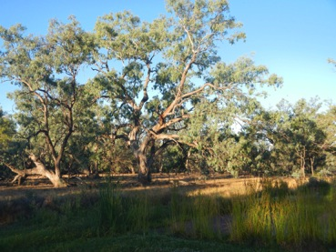

Gwydir River catchment

Photograph by Clare d’Arcy (CEWO)

### Lachlan

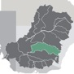

Over 73 billion litres of Commonwealth environmental water was delivered to the Lachlan catchment from July 2012 to the end of July 2013. Combined with NSW environmental water to give a total of 88 billion litres, this watering event was the largest ever use of environmental water held in the Lachlan River system.

Environmental water contributed to improving the overall health of the river system, providing benefits to over 620 kilometres of river system and over 60,000 hectares of floodplain wetlands in the lower Lachlan system downstream of Booligal. Lake Waljeers and Peppermint and Baconian swamps were filled and should retain water throughout summer 2013–14, providing important refuges for native plants and animals. A small volume also reached Lake Ita. Flows in the Great Cumbung Swamp reached their maximum extent, inundating red gums at the margin of the swamp, as well as black box, lignum and other wetland vegetation communities that provide important habitat for wildlife.

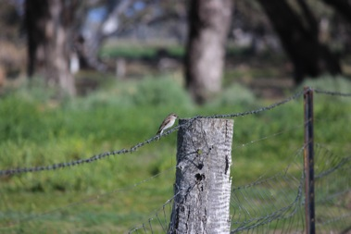

A jacky winter, Macquarie River catchment

Photograph by Louise Armstrong (CEWO)

The delivery of this water was planned in close consultation with landholders and with the regional community. Landholders played an important role in providing advice and information on the use and extent of inundation. The watering was carried out during winter 2013 to maximise the efficiency of delivery and the spread of water in the channel and floodplain areas and limit the impact on farming activities. It is anticipated that this size of watering event will be planned—with ongoing local support and subject to water availability and allocations— for once every four to five years in this part of the catchment.

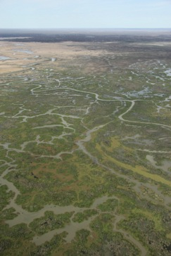

Great Cumbung Swamp, Lachlan River catchment

Photograph by Damian McRae (CEWO)

The Office has produced the You Tube video [A bird’s eye view: Environmental watering in the lower Lachlan River catchment](http://www.youtube.com/watch?v=gF_tZ7MWhp8&feature=c4-overview&list=UU3rz6-O0WRfvRcvtl8Q0R-Q), which provides more information about this watering event.

### Macquarie

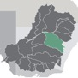

A total of 100 billion litres of Commonwealth environmental water was provided to the Macquarie River and Macquarie Marshes together with 166 billion litres of NSW environmental water.

This was the largest delivery to date of environmental water held by the Commonwealth and NSW governments in the Macquarie catchment. It was also the largest delivered volume to date of Commonwealth environmental water in a single action in the northern Basin.

Environmental outcomes achieved across approximately 50,000 hectares of marshes— parts of which are recognised as wetlands of international importance—included:

* ensuring adequate water to enable ongoing restoration of native wetland plant communities
* maintaining connectivity of watercourses on the floodplain to improve water quality and allow animals to move between different areas

providing the flow types required to support the habitat needs and breeding sites of migratory shorebirds and waterbirds including the glossy ibis, straw-necked ibis, intermediate egret and rufous night heron. The endangered Australian painted snipe was also recorded in the northern part of the Macquarie Marshes Nature Reserve.

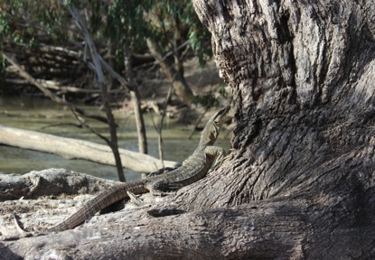

A lace monitor, Macquarie River catchment

Photograph by Louise Armstrong (CEWO)

### Namoi

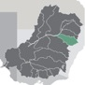

Watering of the lower Namoi River using 7.7 billion litres of Commonwealth environmental water helped to extend periods of wetting of in-channel habitats, maintain water quality and nutrient cycling processes, and support the abundance and diversity of native plants and animals by providing opportunities to access a range of habitats for sheltering, feeding and breeding.

## Northern Basin unregulated catchments

### Barwon–Darling

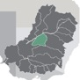

Commonwealth environmental water totalling 25.6 billion litres was used to support a more naturally variable flow regime in the Barwon–Darling system. Commonwealth environmental water contributed to small fresh flows in the system, providing benefits to deep channels and pools, benches, gravel beds, riffle zones and braided channels. These features provide a multitude of habitats for a wide range of aquatic plants and animals and play an essential role in river ecosystem processes.

### Condamine–Balonne

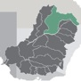

During the year, 64.9 billion litres of Commonwealth environmental water was used to promote a more naturally variable flow regime that assisted with the dispersal of nutrients in the river system and onto floodplains. Commonwealth environmental water was used to help maintain permanent waterholes in the channels of the lower Balonne, and to improve flows to the internationally significant waterbird foraging and breeding wetlands at the Narran Lakes Nature Reserve. These areas provide important refuges for plants and animals during the long periods of low flow or no flow that occur in this system. Many types of fish, waterbirds and invertebrates persist in these areas until larger flows occur that allow them to recolonise the system. Commonwealth environmental water also contributed to downstream flows to the Culgoa River and into the Darling River at the end of the system, supporting hydrological connectivity within the Basin.

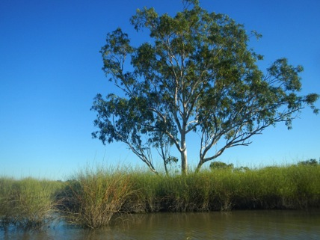

Narran Lakes, Condamine–Balonne catchment

Photograph by Christine Mercer (CEWO)

### Moonie

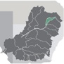

In 2012–13, 1.4 billion litres of Commonwealth environmental water was used to support a more naturally variable flow regime that supported key ecosystem functions. These include the germination and maintenance of riverbank plant communities, the establishment and persistence of waterhole refugia, and carbon and nutrient exchange between the floodplain and the river. These flows also contributed to connecting waterholes, enabling the movement of aquatic plants and animals and providing spawning flows for small-bodied fish such as purple-spotted gudgeon, rainbowfish and carp gudgeon.

# Resources

Bureau of Meteorology (2013). Murray–Darling Rainfall Deciles 1 July 2012 – 30 June 2013. Twelve-monthly rainfall deciles for Murray–Darling Basin [www.bom.gov.au/jsp/awap/rain/index.jsp?colour=colour&time=latest&step=0&map=decile&period=12month&area=md](http://www.bom.gov.au/jsp/awap/rain/index.jsp?colour=colour&time=latest&step=0&map=decile&period=12month&area=md)

Commonwealth of Australia (2012). Basin Plan [www.mdba.gov.au/what-we-do/basin-plan](http://www.mdba.gov.au/what-we-do/basin-plan)

Commonwealth Environmental Water Office (2013). Commonwealth Environmental Water Annual Report 2012–13 www.environment.gov.au/ewater/publications/index.html#ar

Commonwealth Environmental Water Office (2013). A Bird’s Eye View: Environmental Watering in the Lower Lachlan River Catchment [www.youtube.com/watch?v=gF_tZ7MWhp8](http://www.youtube.com/watch?v=gF_tZ7MWhp8)

Murray–Darling Basin Commission (2004). [Native Fish Strategy for the Murray–Darling Basin 2003 – 20](http://www.mdba.gov.au/sites/default/files/Fish-Strat_ful_2003-13.pdf)13 [www.mdba.gov.au/sites/default/files/Fish-Strat_ful_2003-13.pdf](http://www.mdba.gov.au/sites/default/files/Fish-Strat_ful_2003-13.pdf)

Nature Foundation SA (2013). First Commonwealth Environmental Watering for Nature Foundation [www.environment.gov.au/ewater/gallery/video/video-sanf.html](http://www.environment.gov.au/ewater/gallery/video/video-sanf.html)

Nature Foundation SA (2012). Water for Nature [www.waterfornature.org.au/](http://www.waterfornature.org.au/)

State of New South Wales and Office of Environment and Heritage (2013). Helping the Murray Cod in the Murrumbidgee [www.youtube.com/watch?v=71RkFtUPgVc](http://www.youtube.com/watch?v=71RkFtUPgVc)

State of New South Wales and Office of Environment and Heritage (2013). Restoring Tuppal Creek [www.youtube.com/watch?v=8A9evEHtfz8](http://www.youtube.com/watch?v=8A9evEHtfz8)

State of New South Wales and Office of Environment and Heritage (2013). The Cockran, Jimaringle and Gwynnes Creek Systems   
[www.youtube.com/watch?v=ZLS1m65LLrU](http://www.youtube.com/watch?v=ZLS1m65LLrU)

State of New South Wales and Office of Environment and Heritage (2013). Cherax Swamp and Hobblers Lake Bounce Back [www.youtube.com/watch?v=c0e3hds6ETI](http://www.youtube.com/watch?v=c0e3hds6ETI)

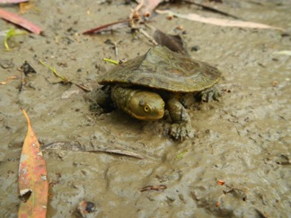

A juvenile turtle at Sunshower Lagoon, Murrumbidgee catchment

Photograph by Iwona Conlan (CEWO)

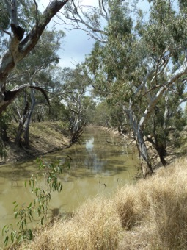

Tuppal Creek, Murray River catchment

Photograph by Emma Wiadrowski (CEWO)

# Acknowledgements

We respectfully acknowledge the Traditional Owners, their Elders past and present, their Nations of the Murray–Darling Basin, and their cultural, social, environmental, spiritual and economic connection to their lands and waters.

We would also like to thank the following environmental water partners and the numerous landholders who have contributed to the management of environmental water through ideas and suggestions, as well as to the delivery of environmental water and the monitoring of the results.

Australian Government

Murray–Darling Basin Authority

The Living Murray program, administered by the Murray–Darling Basin Authority

Queensland

Department of Natural Resources and Mines

New South Wales

Border Rivers–Gwydir Catchment Management Authority

Department of Primary Industries   
(Fisheries New South Wales)

Department of Primary Industries   
(New South Wales Office of Water)

Environmental Contingency Allowance Operational Advisory Committee (Gwydir)

Jimaringle–Cockran Creek Landholder Group

Lachlan Catchment Management Authority

Lachlan Riverine Working Group

Lower Murray–Darling Catchment Management Authority

Macquarie Environmental Flows Reference Group

Murray Catchment Management Authority

Murray Irrigation Limited

Murray–Lower Darling Environmental Water Advisory Group

Murrumbidgee Catchment Management Authority

Murrumbidgee Environmental Water Advisory Group

Namoi Catchment Management Authority

Office of Environment and Heritage

State Water Corporation

Wakool River Association

Victoria

Department of Environment and Primary Industries

Goulburn Broken Catchment Management Authority

Goulburn–Murray Water

Loddon Environmental Water Advisory Group

Mallee Catchment Management Authority

North Central Catchment Management Authority

North East Catchment Management Authority

Victorian Environmental Water Holder

South Australia

Department of Environment, Water and Natural Resources

Nature Foundation South Australia

Healthy Rivers Australia

SA Water

South Australian Murray–Darling Basin Natural Resources Management Board

Research institutions

Charles Sturt University

Commonwealth Scientific and Industrial Research Organisation (CSIRO)

Murray–Darling Freshwater Research Centre

South Australian Research and Development Institute

University of New South Wales

External advice panels

Commonwealth Environmental Water Scientific Advisory Panel

Commonwealth Environmental Water Stakeholder Reference Panel

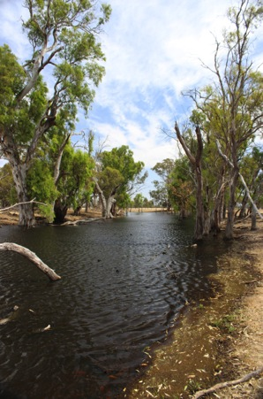

Gwynnes Creek, Murray River catchment

Photgraph by Hayley White (CEWO)

For more information or if you wish to provide suggestions for Commonwealth environmental water use please contact us at [ewater@environment.gov.au](mailto:ewater%40environment.gov.au?subject=) or send us your suggestion by visiting: [www.environment.gov.au/node/18973](http://www.environment.gov.au/node/18973)

WAT278.0313