
Environmental Plantings Pilot Guidance
How to: Apply to register your environmental plantings pilot project
V.01 2021

Contents
Environmental plantings pilot 2
How to navigate this guidance 2
We are here to help! 2
What you will need to apply to register 3
Client Portal account 3
☐ Documents to upload with your project registration application 4
How to: Apply to register your environmental plantings pilot project 5
Section 1. Select a method 5
Section 2. Get started 6
Section 3. Project participants 7
Section 4. Project details 8
Section 5. Area 11
Section 6. Project activities 14
Section 7. Declaration 19
Next steps 19
Pilot project registration assessment 19
Create an Australian National Registry of Emissions Units (ANREU) account 19

Environmental plantings pilot
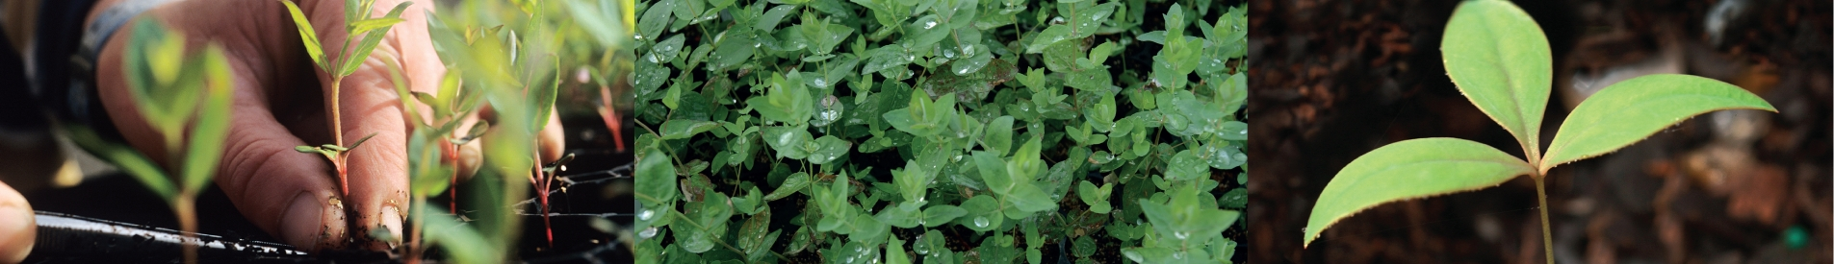
The Clean Energy Regulator has made it easier for farmers and landholders to directly participate in the Emissions Reduction Fund (ERF).
You can now diversify your income and help Australia reduce its emissions by planting trees on your land.
The environmental plantings pilot removes the cost of project audits, simplifies project registration and crediting processes, and introduces an easier way to sell Australian carbon credit units (ACCUs) to the Australian Government.
Before proceeding with the pilot project registration process, we advise that you read the environmental plantings pilot information pack published on the environmental plantings pilot webpage.

How to navigate this guidance
Key | Description
Registration form questions | The grey boxes include the content of each question as you can expect to see them in the environmental plantings pilot registration form.
Mandatory questions* | If a question is mandatory, there will be a red asterisk (*) at the end of the question. You will not be able to progress through the form if you do not complete the mandatory questions.
 | This symbol indicates that the text contained in the blue boxes are additional guidance and how to complete to the question/s above.
 | This symbol indicates that additional documentation is required. A table of the documents that you will need to complete your pilot project registration application may be found on below (p. 3).

We are here to help!
Contact us on 1300 553 542 or land@cleanenergyregulator.gov.au.
Visit our Environmental Plantings Pilot webpage for more information.

What you will need to apply to register
To register a mixed-species environmental plantings project under the environmental plantings pilot, you will need to submit an application via our Client Portal. You will need to outline how the pilot project meets scheme eligibility criteria and is consistent with the method.

Client Portal account

The Client Portal is used to provide access to online forms, Clean Energy Regulator based systems and other important information. To apply to register your environmental plantings pilot project, you will need to create a Client Portal account.
For projects with multiple project proponents, only the nominated nominee should create a Client Portal account and submit the project registration application. However, each project proponent must be identified and assessed through the Client Enrolment process featured in your pilot project registration application form.

How to create a Client Portal account
Step 1. Follow the link to access the Client Portal > select Sign up now on the login page
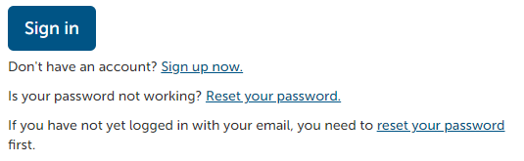
Step 2. You will then be asked to:
- provide some basic identifying details that will be used to create your Client Portal account (name, contact details, and address), and
- enter a password (you will use this password with your email address to login to the Client Portal).
When you submit this information, you will automatically be sent an email to verify the creation of your Client Portal account.
Step 3. Go to your nominated email account and click on the verification link contained in the email. You will be taken back to the Client Portal and asked to enter your password in order to authenticate your account and complete the sign-up process.
Step 4. Once you have completed the sign-up process you can return to the login page, enter your email address and password, and log in.

☐ Documents to upload with your project registration application

There are several forms and documents that you may need to provide with your environmental plantings pilot project registration application form.
 | Documents | Form section | Description
☐ | 100 points of ID | Project participants - Client Enrolment | All documents must be scanned, certified true copies of original, current documents. Applies to each project proponent.
☐ | Australian Federal Police (AFP) National Police Check form | Project participants - Client Enrolment | A completed, printed and signed Australian Federal Police (AFP) National Police Check form. Applies to each project proponent.
☐ | Nominated nominee | Project participants - Client Enrolment | If a project has multiple project proponents, one must be appointed as the nominee for the project and each proponent will need to provide their written consent.
☐ | Regulatory approvals* | Project details | You will need to obtain and supply evidence of all relevant planning or environmental approvals to carry out your project activity.
☐ | Evidence of legal right | Area | Evidence that you have the legal right to carry out project activities on the land nominated as the project area as well as receive ACCUs from these activities, that no other person can lawfully claim.
☐ | Eligible interest holder consent forms* | Area | If another person or entity has an eligible interest in the land in the project area, you must get their consent to the undertake your environmental plantings pilot project.
☐ | Project area boundary – Geospatial file | Area | Provide a map of the entire project area in a single geospatial data file (Shapefile, MapInfo, KML, etc) in accordance with the CFI Mapping Guidelines.
☐ | Permanence plan | Project activities | Explain the steps that will be undertaken to ensure carbon remains stored in the project area for the permanence period in a permanence plan.
*If such documents are required but not provided with your project application, then your project will be conditionally registered until all consents and approvals are provided.

How to: Apply to register your environmental plantings pilot project
The following is a guide on each section in the environmental plantings pilot registration form.

Section 1. Select a method
All ERF projects are registered under legislative instruments called Methodologies (or methods).
To apply to register your environmental plantings pilot project, login to the Client Portal > Click Emissions Reduction Fund > select Register an Environmental Plantings Pilot project.
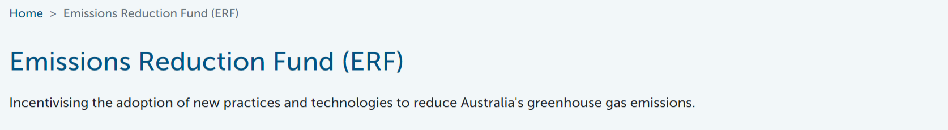
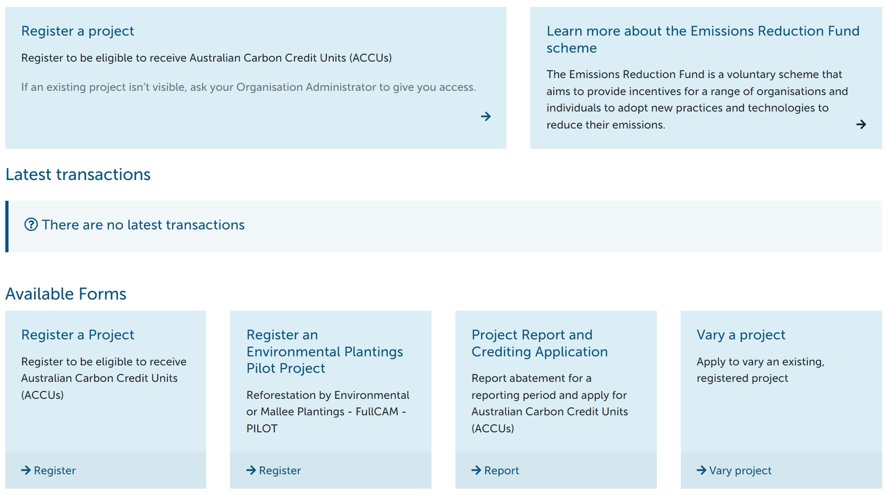
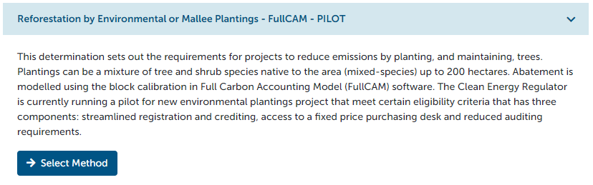

Section 2. Get started
Before completing the questions contained in the registration form, you will need to declare that you meet and will continue to meet the eligibility criteria for the environmental plantings pilot.

Eligibility criteria
Before you start
To be eligible to participate in the environmental plantings pilot, you and your project must meet and continue to meet the following eligibility criteria:*
- The project must be covered by the Carbon Credits (Carbon Farming Initiative) (Reforestation by Environmental or Mallee Plantings-FullCAM) Methodology Determination 2014 (the environmental plantings method).
  - ERF projects undertake activities covered by an approved methodology determination (method), which set out the detailed rules for running a project and calculating carbon abatement.
- You (the project proponent, or nominee of multiple project proponents) are a freehold title holder, leaseholder, or native title holder or registered native title body corporate for all project areas of the project.
- The total anticipated and reported carbon estimation area (CEA) for your project will be no more than 200 hectares.
  - Eligible planting areas are modelled as CEAs for the purpose of calculating carbon abatement. This criteria means that the total area of all plantings areas included in the pilot project must not exceed 200 hectares in size.
- The project will be modelled as a mixed-species block planting using the generic calibration in FullCAM within the meaning of the environmental plantings methodology determination.
  - This means that all planting areas in the pilot project area are established as block plantings and modelled as CEAs using the mixed-species Block ES 2020 FullCAM model.
- The project will be subject to geospatial tool monitoring by the Clean Energy Regulator; and
- You request that this project be an alternative assurance project, within the meaning of subsection 73(7) of the Carbon Credits (Carbon Farming Initiative) Rule 2015 (the CFI Rule)*.
  - Environmental plantings pilot projects are eligible for reduced audit obligations as an alternative assurance project. Instead of scheduled audits, the Clean Energy Regulator will use geospatial tools (the key alternative assurance mechanism) to confirm that the planting activity has happened, verify that abatement is being achieved, and monitor for disturbances.
☐ You agree to, and confirm, you and the project meet the eligibility criteria.

Section 3. Project participants

Add project proponent details – Client enrolment
Please provide details of the participants*
Add primary participant (Client Enrolment)

Each project proponent will need to complete the Client Enrolment process. This includes:
Proof of identity. You must provide 100 points of Identification and all proof of identity documents uploaded must be scanned, certified true copies of original, current documents. This applies to anyone applying to be the project proponent.
Fit and proper person (FPP) assessment. During your application, you will be required to upload a completed, printed and signed Australian Federal Police (AFP) National Police Check form. This is because you will be required to undergo a fit and proper person (FPP) assessment to register your project. This applies to anyone applying to be the project proponent.
Nominated nominee. If a project has multiple project proponents, one must be appointed as the nominee for the project when completing the project registration application form. The nominee will be the primary contract for the project and will be authorised to act on behalf of multiple project proponents. Each project proponent will need to provide their written consent to the appointment of the nominee.

Agent information (if applicable)
Does your project have an agent?
You do not need to have an agent for your project, but you may choose to have one. If there is more than one project participant, the agent will be ‘agent’ for the nominee.

Agents are entities, independent of the Government, that are engaged by a landholder to provide a range of services to assist with ERF participation. An agent could be an individual or an organisation. If you select ‘yes’, then you will be required to include relevant information about the agent.

Primary contact
Who is the contact person in relation to the project?*

You may nominate yourself or someone else as the primary contact for your project (i.e., an agent).
By nominating a contact person other than yourself, you consent to the Clean Energy Regulator sharing any information in relation to yourself and the project with the contact person.

Section 4. Project details

Project name and description
Give your project a name:*
Consider incorporating a locality, property, business or other name to ensure that the project name is unique. For example, XXXXXX Environmental Plantings Pilot Project.

Describe your project in simple language:*
In your view, how does your project work and what makes your project unique? (600 character limit)

Each environmental plantings pilot will have a unique ERF identification number however, we ask that you give your project a name and short description for our public project register to present the benefits of your ERF project to the broader community.
For example, ‘This project establishes permanent plantings of a mix of native tree species on land that was predominantly used for agricultural purposes for at least 5 years prior to project commencement. The tree species are native to the local area’.
In addition to carbon abatement, you may also wish to also include any environmental, social, or cultural co-benefits associated with your project. These could include:
- Providing shelter for livestock and pastures,
- Restore degraded land,
- Improving water quality through reduced pesticide and fertiliser runoff.

Project start date and commencement of crediting period
What start date do you wish to nominate for your project?

Your project start date is either the date your project is successfully registered or a date that you nominate when you apply to register your pilot project based on when you plan to establish your plantings.
The reporting and crediting period for your environmental plantings pilot project will be 25 years from the project start date. Once your project is registered, you may defer your start date up to 18 months after the date of registration by completing a project variation form via Client Portal. However, project start dates can only be varied once.
It is important to note that your project start date and project activity (including site preparation) cannot commence until after the project has been registered.

Project location - Street address
What is the project address?*
All projects require a street address to form part of the project declaration.

The form has a smart address look-up function that will pre-fill additional data required for your project location details.

Regulatory additionality
Are the planned activities, or any part of them, required under a Commonwealth, State or Territory law?*
Answer yes if the activities:
- help you meet a rule of these laws
- are remedial or done to fulfil an undertaking because of non-compliance
- would offset or compensate for the adverse impact of action on vegetation

The regulatory additionality requirement ensures that environmental plantings pilot projects do not receive ACCUs if the plantings are already required by law.
Additionality requirements ensure that all carbon abatement credited for an environmental plantings pilot project is new and additional. Whether a project meets additionality requirements will depend on the circumstances and will be assessed by the Clean Energy Regulator on a case-by-case basis.
An example may be environmental plantings projects that involve planting trees to satisfy the condition of a development approval. This type of project is unlikely to meet the regulatory additionality requirement unless tree planting was discretionary, and other options could have been used to satisfy the requirement, or the plantings go above and beyond what was required and will result in more carbon abatement.
More information (if required) on additionality requirements can be found on our website.

Regulatory approvals
Does the project require any regulatory approvals?*
You can click on the upload icon if you need to provide further information. Clearly identify the nature of any additional documentation or information that you are supplying to support your answer to this question.

You will need to obtain all relevant planning or environmental approvals to carry out your project activity.
This includes any relevant Australian Government, state and territory and local government approvals, permits and licence requirements relating to land use.
If you are unsure if any regulatory approvals are required, you should contact your state planning authority and local government, or your local Natural Resource Management (NRM) group. ERF project registration does not replace or include relevant local, state or Australian Government approvals.
If your project requires any regulatory approvals
For each regulatory approval required, you must provide
- a description of the nature of the approval,
- the aspects of the project to which it relates,
- the name of the regulatory authority responsible for issuing it,
- whether the approval been issued, and
- where relevant, the date the approval was issued and the reference number (or other identifier) for the approval.
The Clean Energy Regulator must be satisfied that the project and each element of it has met all relevant Australian Government, state and territory and local government approvals, permits and licence requirements relating to land use or development, environment and water.
A project will be conditionally registered until all consents and approvals are provided. Conditionally registered projects cannot receive ACCUs.
If your project does not require any regulatory approvals
You will be asked to explain why the project does require regulatory approvals. None may apply.

Section 5. Area

Natural Resource Management (NRM) plans
List the current regional Natural Resource Management (NRM) plan/s that cover the locations of the project*
If the organisation for a region does not appear in the list then use the option ‘other’.
Add NRM Plan
☐ The project is consistent with the relevant NRM plan.

If the project area is covered by a regional natural resource management (NRM) plan, then a proponent must state whether the project is consistent with the plan at the time of project registration and crediting. The Clean Energy Regulator is required to publish this information on the public project register.
If your project is not consistent with the relevant NRM plan, it is will not impact your project’s eligibility for the environmental plantings pilot or project registration.

Location details
What are the location details for your project?*
You must provide location details for all areas included in your project. You can either manually add your location/s or download a template and upload in bulk.

A project area is an area of land on which part, or all, of the environmental plantings pilot project is to be carried out and is nominated before you begin your project activity. Please refer to your Certificate of Title where possible.

Geospatial map of project area
Provide the geospatial data for your project area*
Provide a map of the entire project area in a single geospatial data file.
You must use a common, interchangeable digital GIS format. Shapefile, MapInfo, or KML are all suitable. It should not be an image.

Your total project area may be one or more planting areas, which will later be modelled as carbon estimation areas for the purpose of calculating carbon abatement and earning ACCUs.
When you apply to register your environmental plantings pilot project, you will be required to provide a map of the entire project area in a single geospatial data file in accordance with the Carbon Farming Initiative (CFI) Mapping Guidelines. You must use a common, interchangeable digital GIS format such as, Shapefile, MapInfo, or KML.
Google Earth online is an example of free geospatial software that you may use to map your project area boundary and export a KML file to upload with your project registration application.
For ease, you may want to nominate your project area boundary as the land you hold the legal right to. This means that for the purpose of satisfying your project registration requirements your project area boundary could be the same as your property boundaries per your land title/s. In this instance, you could request a copy of the digital cadastral data for your property from your relevant state or territory Government body.

Legal right
Who owns the area?*
Some projects cross multiple land titles or lease arrangements on many different types of land tenure.
Your answer to this question helps us determine if you have the right to undertake the project and earn the carbon credits (ACCUs) from it.

You will need to demonstrate that you have the legal right to carry out project activities on the land nominated as the project area as well as receive ACCUs from these activities, that no other person can lawfully claim.
Provide evidence of legal right
Upload a copy of the Certificate of Title (land title) to demonstrate that you are the landholder (owner, leaseholder or native title holder) and have the legal right to carry out the project.

Indigenous land use agreement
Does the project area include:*
Other land-rights land may include any land granted, held, or for the benefit of Aboriginal or Torres Strait Islanders. It may also include land that has rights for traditional owners under state or territory legislation.
- Determined Exclusive Possession Native Title land
- Determined non-exclusive possession Native Title land
- Land with a registered, but not yet determined, claim for Native Title
- Other Aboriginal and Torres Strait Islander Land Rights
- None of these apply.

If an indigenous land use agreement is relevant to any land in the project area, then you will need to supply a copy of the agreement.
For more information on native title, please read the Emissions Reduction Fund: Native title, Legal Right and Eligible Interest Holder Consent guidance document on our website.

Eligible interest holder consent
Get consent from any eligible parties that hold an interest in the project area.*
An eligible interest holder could be any party that has an interest in the land. For example, a bank with a mortgage over the property or other investors.

If another person or entity has an eligible interest in the land in the project area, you must get their consent to the undertake your environmental plantings pilot project.
Eligible interest holders may include:
- a bank with a mortgage over the property or other investors,
- anyone with a caveat or encumbrance registered on the land title for the property such as easements,
- other people or parties that share or have ownership or leases of the land,
- Native title — rights Aboriginal and Torres Strait Islander people can hold under traditional laws and customs, and
- for leased Crown land – the Crown Lands Minister needs to provide consent, usually through a relevant state or territory department.
Provide eligible interest holder consent form/s
If you have identified any eligible interest-holders, they must sign a Eligible interest holder consent form.
A project will be conditionally registered until all consents and approvals are provided. Conditionally registered projects cannot receive ACCUs.

Section 6. Project activities

Environmental plantings method requirements
You confirm that:*
☐ Your proposed planting area does not contain woody biomass or an invasive native scrub species that need to be cleared for planting to occur, other than known weed species required or authorised by law to be cleared.
☐ For at least 5 years before the date of the application, your proposed planting area has been clear of forest cover (land has forest cover if the vegetation on the land includes trees that are at least 2 metres in height and provide crown cover of at least 20% of the land).
☐ Your planting will be a mixture of tree and shrub species native to the local area, sourced from seeds.
☐ Your planting will reflect the structure and composition of the local native vegetation community.
For clarity, a monoculture may constitute native vegetation where it can naturally occur within the local vegetation community.
☐ Your project trees to be planted must have the potential to reach at least 2 metres in height and crown cover of at least 20% over the planting area.
For clarity, this mean that they have the potential to reach forest cover as defined by the environmental plantings method.
☐ The seeds that you will source are from within the natural distribution of the species, and are appropriate to the biophysical characteristics of the proposed planting area.
For clarity, you may establish your planting areas via tubestock or direct seeding.
☐ Your planting will consist of more than a single row of stems and have a stocking density of more than 200 stems per hectare and a density that will achieve forest cover.
For clarity, for your pilot project to be eligible you must model your planting areas as CEAs using the mixed-species block planting using the generic calibration in FullCAM (2020). This model requires that each CEA have a stocking density of more than 200 stems per hectare.

Please provide a brief description of the project activity, and how you will meet each of the above eligibility requirements:*
Evidence may include a description of the species, the growth characteristics of the species, or the anticipated height and crown cover when the trees reach maturity.

By declaring and describing how you meet the above requirements, you are demonstrating that you meet the requirements Part 2 and 3 of the environmental plantings method.

Skills and expertise
Do you have the appropriate skills or expertise to undertake this project?*
Please provide a short description in the box below or upload any relevant information that you would like to share:

You are required to describe why you have the appropriate skills, experience, or expertise to be the person or entity responsible for running the environmental plantings pilot project.
If applicable, you can include a description of any assistance you may receive to establish the project and support project maintenance.
You are not required to hold any formal qualifications to carry out an environmental plantings pilot project however, you may upload any relevant information to support your claims.

Permanence obligations
Select the permanence period for the project*
If you choose a 25-year permanence period, your project:
- will only receive credits for 80% of abatement generated, and
- will still contribute 5% of abatement as a risk of reversal buffer
For clarity, all projects are subject to a risk of reversal buffer of 5%. This means that a crediting discount of 5% applies to the number of ACCUs a project is credited. Additionally, if you nominate a 25-year permanence then a 20% crediting discount will also apply.
For more information on permanence period discounts see permanence obligations. For more information on the risk of reversal buffer see risk of reversal buffer.
[Upload Permanence plan]*

Permanence period
An environmental plantings project establishes new and permanent forest cover. This means that you must maintain your environmental plantings as per the method requirements for the duration of the permanence period that you nominate at the time of project registration. It is required that during the permanence period, the carbon stored in the project is maintained.

You are required to nominate either a 25-year or 100-year permanence period at the time of registration. Once your project has been registered, you will not be able to vary your permanence period.
The permanence period for your project starts when you first receive ACCUs. Any carbon that your project is credited for must remain stored for the duration of the permanence period.
Provide permanence plan
As a part of your permanence obligations, you are required to submit a permanence plan that explains the steps that will be undertaken to ensure carbon remains stored in the project area for the permanence period. This must be uploaded with your project registration application and updated twice throughout the project reporting period.
For convenience, a permanence plan template is available to download from the environmental plantings pilot webpage.

Project carbon abatement estimate
What is the forward abatement estimate for the project?*
Total Crediting Period (years) of the project (25 years) (automatically calculates).
Average Annual FAE (automatically calculates).

You are required to provide a forward abatement estimate (FAE) in tonnes of carbon dioxide equivalent (tCO2-e) at the time of project registration.
There is no 'right' way to calculate your FAE, however it is expected that you will estimate the amount of abatement your project is likely to help you make decisions about your project.
For example, LOOC-C is an interactive online tool developed by Centre for Scientific Innovation and Research Organisation (CSIRO). Based on the information you provide, this tool uses FullCAM modelling to quickly estimate the total carbon abatement (tCO2-e) the project may be able to generate over the 25-year crediting period as well as the annual rate of abatement tCO2-e per hectare per year (tCO2-e/ha/y).
LOOC-C will also suggest the co-benefits associated with your project. You may want to include these in the Describe your project in simple language question in the project registration application form.

Newness requirement
You acknowledge that:*
☐ Your project meets the newness requirement.
The newness requirement is a core element of the ERF and requires that the project activity, such as, site preparation and planting, cannot commence before the project is registered. These requirements ensure that the scheme only incentivises projects that would not have otherwise occurred.

‘Newness’ is an additionality requirement under the ERF scheme.
Additionality requirements ensure that all carbon abatement credited for an environmental plantings pilot project is new and additional.
Subsection 27(4C) of the CFI Act provides that a project has begun to be implemented when:
- making a final investment decision in relation to the project,
- acquiring or leasing a tangible asset (other than land) that is for use wholly or mainly for the purposes of the project,
- commencing construction work for the purposes of the project,
- preparing soil for seeding or planting that is for the purposes of the project,
- seeding, planting or fertilising plants that are for the purposes of the project,
- installing an irrigation or drainage system for the purposes of the project.
If any of the above activities have happened, or if the project has otherwise begun to be implemented, the project does not meet the newness requirement.
Subsection 27(4B) of the CFI Act provides that the following activities can be disregarded when deciding whether a project has begun to be implemented:
- conducting a feasibility study for the project,
- planning or designing the project,
- obtaining regulatory approvals for the project,
- obtaining consents relating to the project,
- obtaining advice relating to the project,
- conducting negotiations relating to the project,
- sampling to establish a baseline for the project,
- an activity specified in the legislative rules,
- an activity that is ancillary or incidental to any of the above activities.
If any of the above activities have happened, the project can still meet the newness requirement.
More information (if required) on newness requirements can be found on our website.

Government program requirement
Are the project activities funded in any way under the 20 Million Trees Program, administered by the Australia Government?*
For clarity, project activities included in an environmental plantings pilot project may expand on a non-ERF project that has previously been funded by the 20 Million Trees program but must not currently receive funding from this government program.
The government program requirement is an additionality requirement under the ERF scheme.
Additionality requirements ensure that all carbon abatement credited for an environmental plantings pilot project is new and additional.
More information (if required) on the government program requirement can be found on our website.

Excluded offset projects
Under the Carbon Credits (Carbon Farming Initiative) Regulations 2011 (CFI Regulations), certain types of projects or activities are excluded.
You must declare that your pilot project is not an excluded offsets project, as outlined below.
You confirm that:*
☐ The planting will not be established on land that has been subject to illegal clearing of a native forest, or illegal draining of a wetland.
☐ The planting will not be established on land that has been cleared of native forest or draining of a wetland (that was not illegal clearing or draining) in the last 7 years, or in the last 5 years if there has been a change in ownership of the project area after the clearing or draining happened.
☐ The project will not involve planting a species in an area where it is a known weed species.
☐ The project is a permanent planting that is also an environmental planting and not landscape planting as defined by the Carbon Credits (Carbon Farming Initiative) Regulations 2011.
☐ The project is not a project that protects native forest on freehold or leasehold land, for which a clearing consent or harvest approval plan was granted on the basis that the clearing or harvesting of the native forest would lead to an environmental improvement or benefit, or would maintain an environmental outcome; or was for fire management purposes.
A permanent planting is a planting that is not a plantation and is not harvested other than for the specific purposes listed in the CFI Regulations:
- for thinning for ecological purposes,
- to remove debris for fire management,
- to remove firewood, fruits, nuts, seeds or material used for fencing or as craft materials, if those things are not removed for sale, or
- in accordance with traditional indigenous practices or native title rights, and
- a permanent planting is not a landscape planting.
A landscape planting is a planting in an urban centre, or locality of at least 200 people, in a residential place, on the grounds of factory, or sporting or commercial facility, hospital, school, or other institution, in a car park or cemetery.
Please note that under the environmental plantings method, there are additional restrictions on livestock grazing and removing woody biomass.

Section 7. Declaration
Your application must include a signed declaration that the application and any documents meet the requirements of Division 1 of Part 3 of the CFI Rule, and are true and correct.

Key references
Reference
Governing legislation | Carbon Credits (Carbon Farming Initiative) Act 2011  Carbon Credits (Carbon Farming Initiative) Rule 2015  Carbon Credits (Carbon Farming Initiative) Regulations 2011  Carbon Credits (Carbon Farming Initiative) (Reforestation by Environmental or Mallee Plantings – FullCAM) Methodology determination 2014
Privacy policy | Read our full privacy policy for more information.

Next steps

Pilot project registration assessment
Once you have submitted your pilot project registration form, the Clean Energy Regulator will assess your application to register an environmental plantings pilot project.
The Clean Energy Regulator has up to 90 days to assess and process your environmental plantings pilot project registration. However, under normal business as usual conditions, the Clean Energy Regulator is usually able to process project registrations applications within about 6 weeks or 30 business days.
It is important to make sure that your application is detailed and complete to avoid unnecessary delays. If information is missing or incomplete, we will contact you provide additional information or documentation. Requests for further information are typically sent early in the assessment process.
*Conditionally registered projects
While you do not have to provide relevant consent forms and approvals at the time of project registration, your project will be registered ‘conditional’ upon obtaining those consents and approvals. If your project is conditionally registered, then you will have to submit any identified consents and approvals before submitting your first offsets report and claiming ACCUs.

Create an Australian National Registry of Emissions Units (ANREU) account


Australian National Registry of Emissions Units (ANREU) account
To be issued ACCUs, you will need to set up an Australian National Registry of Emissions Units (ANREU) account. You may do this after you have registered your environmental plantings pilot project.

