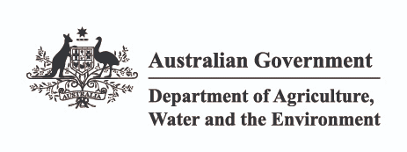

*Environment Protection and Biodiversity Conservation Act 1999*

Condition-setting Policy

March 2020

**© Commonwealth of Australia, 2020.**



*Environment Protection and Biodiversity Conservation Act 1999—Condition-setting Policy* is licensed by the Commonwealth of Australia for use under a Creative Commons By Attribution 4.0 Australia licence with the exception of the Coat of Arms of the Commonwealth of Australia, the logo of the agency responsible for publishing the report, content supplied by third parties, and any images depicting people. For licence conditions see: <http://creativecommons.org/licenses/by/4.0/>

This report should be attributed as ‘*Environment Protection and Biodiversity Conservation Act 1999— Condition-setting Policy*, Commonwealth of Australia 2020’.

The Commonwealth of Australia has made all reasonable efforts to identify content supplied by third parties using the following format ‘© Copyright, [name of third party] ’.

**Disclaimer**

The views and opinions expressed in this publication are those of the authors and do not necessarily reflect those of the Australian Government or the Minister for the Environment.

**Cover images**

(Front) Water lilies, Jenny Tomkins (Department of the Environment and Jenny Tomkins). (Back) Regrowth, Dragi Markovic.

2 / *Environment Protection and Biodiversity Conservation Act 1999*—Condition-setting Policy

# Contents

### Introduction 4

**Regulatory context 5**

Reducing duplication between Commonwealth and state or territory conditions 5

**Condition-setting options 7**Option 1: Single Commonwealth condition 8 Option 2: Custom Commonwealth conditions 8 Option 3: No Commonwealth conditions 8

**Conditions set in accordance with state policy 10****Safeguards and compliance 11****Glossary 12****Appendix A: List of endorsed state and territory policies 13**

Introduction



The Condition-setting Policy (‘**the Policy’**) outlines the Australian Government’s approach to considering state and territory approval conditions when approving a project under the *Environment Protection and Biodiversity Conservation Act*

*1999* (the ‘**EPBC Act’**).

The Policy aims to streamline the regulatory process by avoiding duplicative or unnecessary approval conditions between jurisdictions, in circumstances where state or territory conditions appropriately manage the environmental impacts on a matter of national environmental significance. This will reduce red tape, while ensuring that high environmental standards are maintained.

When a project is subject to state or territory conditions related on a matter of national environmental significance this policy provides guidance and information on how the Australian Government determines whether:

* a single condition to require compliance with particular state or territory conditions is attached to an approval under the EPBC Act;
* custom conditions attached to an approval under the EPBC Act; or
* no conditions attached to an approval under the EPBC Act.

The Policy is part of a wider suite of activities designed to improve the efficiency and effectiveness of the Australian Government’s environmental assessment and approval process, including the ‘One-Stop Shop’ for environmental approvals, which is seeking to accredit state and territory planning systems through approval bilateral agreements under the EPBC Act.

The Policy applies only to projects that require environmental approval under both the EPBC Act and state or territory legislation.

It is important to be note that the Policy is intended to provide guidance for conditions attached to

an approval and does not limit the Australian Government Minister’s discretion under the EPBC Act.

Photo: Black Swans on the Scamander River on the east coast of Tasmania © Nick Rains

# Regulatory context

The EPBC Act is the Australian Government’s primary piece of environmental legislation. Under the EPBC Act actions that have, or are likely to have, a significant impact1 on a matter of national

environmental significance will require approval from the Australian Government Minister (‘the **Minister’**). The Minister will decide whether assessment and approval is required under the EPBC Act.

The matters of national environmental significance protected under Part 3 of the EPBC Act, relevant to the Policy2, are:

* + World Heritage properties
  + National Heritage places
  + wetlands of international importance (listed under the Ramsar Convention)
  + listed threatened species and ecological communities
  + migratory species protected under international agreements
  + the Great Barrier Reef Marine Park
  + the environment, in relation to nuclear actions (including uranium mines)
  + a water resource, in relation to coal seam gas development and large coal mining development.

Section 34 of the EPBC Act specifies the matters protected by a provision of Part 3 of the Act

(the ‘**protected matter**’).

Part 9 of the EPBC Act sets out how the Minister makes decisions on approval and conditions.

In particular, section 134 outlines the types of conditions that the Minister may attach to an approval and the considerations the decision-maker must have when setting conditions.

1. Significant impact guidelines 1.1: matters of national environmental significance: [www.environment.gov.au/ epbc/publications/significant-impact-guidelines-11-matter](http://www.environment.gov.au/epbc/publications/significant-impact-guidelines-11-matters-national-environmental-significance)

Section 134(3)(c) identifies that conditions may be attached to an EPBC Act approval that require the approval holder to comply with conditions made under the law of a state or territory or under another law of the Commonwealth.

Section 134(4)(a) identifies that, in deciding whether to attach a condition to an approval, the Minister must consider any relevant conditions that have been imposed, or are considered likely to be imposed,

by a state or territory or under another law of the Commonwealth.

Further information about EPBC Act, including cost recovery arrangements, is available on the Department’s website at: [www.environment.gov.au/epbc](http://www.environment.gov.au/epbc).

## Reducing duplication between Commonwealth and state or territory conditions

The Productivity Commission3 and the Council of Australian Governments4 have recognised that unnecessary duplication between Australian

Government and state and territory environmental assessment and approval processes results in unnecessary costs to business.

States and territory have a range of legislation relating to land-use planning and environmental regulation. This often results in a degree of overlap between state and territory approval conditions and the conditions applied by the Australian Government under the EPBC Act to manage impacts on matters of national environmental significance. This regulatory overlap can result in unnecessary duplication of effort by the proponent and may also create confusion around regulatory primacy

and responsibilities, in circumstances where approval conditions are not well aligned.

[s-national-environmental-significance](http://www.environment.gov.au/epbc/publications/significant-impact-guidelines-11-matters-national-environmental-significance)

1. State and territory governments cannot apply project conditions for matters protected under the EPBC Act that are in Commonwealth areas, including Commonwealth lands and marine areas.
2. Productivity Commission 2013, *Major Project Development Assessment Processes,* Research Report, Canberra.
3. COAG Meeting Communiqué, 13 December 2013.

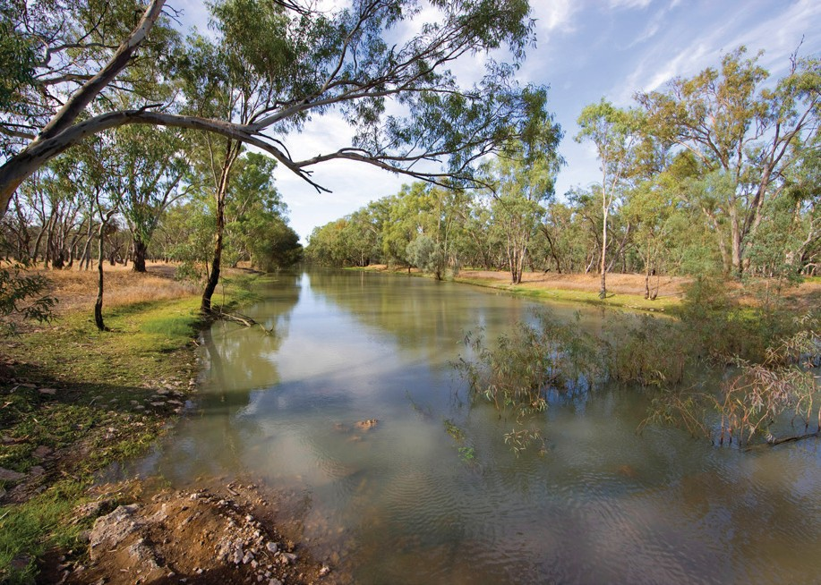

To address this, prior to applying conditions to a project, the Minister will review any state or territory conditions and consider their consistency with the requirements of the EPBC Act and related policies or guidelines. As set out below, the Minister will rely on state or territory conditions to the greatest extent possible when considering what conditions (if any) to attach to a proposed approval. Where the state

or territory conditions do not appropriately manage the impacts on the relevant protected matters under the EPBC Act, the Minister may choose to attach additional custom conditions.

In most cases, the state or territory will have undertaken an environmental assessment for both state/territory issues and the relevant protected matters under an assessment bilateral agreement between the jurisdictions5. Occasionally, a state or territory government may also have assessed and applied conditions to a project outside of a bilateral agreement. This Policy will apply in either case.

1. Information on One-Stop Shop reforms, including bilateral agreements is available on the Department’s website at: [www.environment.gov.au/epbc/one-stop-shop](http://www.environment.gov.au/epbc/one-stop-shop)



Photo: (from top) Regrowth, Dragi Markovic; Healthy river flows in the Yanga National Park after the environmental watering, Dragi Markovic.

# Condition-setting options

The Minister may attach a condition to the approval of the action if he or she is satisfied that the condition is necessary or convenient for the protection of

a relevant protected matter or for the repair or mitigation of damage to a relevant protected matter.

There are three conditions-setting options:

* + a single condition to require compliance with particular state or territory conditions is attached to a project;
  + additional custom conditions are attached to a project; or
  + no conditions attached to a project.

Selecting the appropriate condition-setting option occurs after the environmental assessment has been undertaken. The Minister will decide whether the project should be approved and, if so, whether or not conditions need to be attached to an approval to one or more of the relevant protected matters.

When considering which condition-setting option is most suitable for a project the Minister will consider the particular circumstances of the project. For example:

* + Is the proposed action likely to result in a residual adverse significant impact to a protected matter?
* Do the state or territory conditions appropriately manage the likely impact to the relevant protected matter?
* Are there any further avoidance or mitigation measures identified during the assessment phase which require codifying in Commonwealth conditions?

The Minister would separately consider the appropriate condition-setting option for each of the protected matters relevant to a project. In practice, this may result in a hybrid approach – where custom conditions are applied in relation to one relevant protected matter, but not others.

Under the EPBC Act, the Minister must consult with the proponent and other relevant Australian Government ministers on the proposed conditions, and may also consult with the relevant state or territory government. When finalising conditions for a project, the Minister must take into account any comments received on the proposed decision and proposed conditions.

Figure 1 outlines the process of selecting condition-setting options during the proposed decision stage for a project.

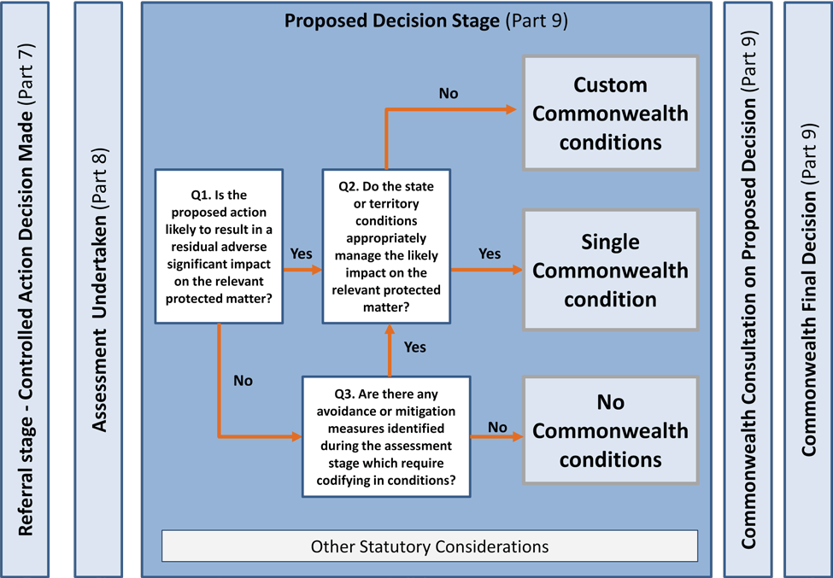

**Figure 1: Selection of condition-setting options within the *Environment Protection and Biodiversity Conservation Act 1999* (Cth) environmental assessment and approval process.**

## Option 1: Single Commonwealth condition

Where the Minister is of the view that a state or territory government’s proposed approval conditions will be sufficient for managing impacts on the relevant protected matters, he/she will seek to avoid attaching identical, duplicative conditions.

The Minister may instead attach a single condition requiring compliance with the state or territory condition/s (that is, those conditions designed to manage the impacts on relevant protected matters).

This approach may be considered appropriate where:

* + there is a likely residual adverse significant impact from the taking of the action on a protected matter
  + the Minister considers that the state or territory conditions are necessary to manage, mitigate or offset these impacts to an acceptable level.

The condition may include standard administrative requirements, such as record-keeping requirements, to ensure that the Australian Government retains visibility of the approval holder’s success in meeting the approval conditions. This will ensure that the Minister has the capacity to take enforcement action under the EPBC Act, as well as the relevant state or territory government under compliance and enforcement activities under their regulatory framework, if there was non-compliance with the relevant state or territory conditions.

## Option 2: Custom Commonwealth conditions

The Minister may still choose to attach additional ‘custom’ conditions under the EPBC Act where:

* + the Minister considers that the relevant protected matters require a greater level of protection, or specificity in conditioning, than set out in the proposed state or territory conditions; or
  + a state or territory government has recommended that the Minister attach additional conditions.

The Minister would only attach custom conditions where such conditions are needed to supplement the conditions already set by the state or territory. This may include circumstances where state or territory conditions are unable to be identified.

Whether the Minister considers it appropriate to impose custom conditions will depend on the relevant statutory considerations under the EPBC Act and

the circumstances of the particular project. This may include factors such as:

* the significance of the impacts on the relevant protected matters;
* the need for clarity, certainty or specificity in how the impacts on relevant protected matters will

be managed;

* the level of scientific rigour and certainty around how the state or territory’s proposed approval conditions will address the impacts on the relevant protected matters; and
* any recommendations from the state or territory to the Australian Government relating to conditions for addressing the impacts on relevant protected matters.

In general, when considering the application of custom conditions, the Minister would take into account any existing Commonwealth policy and guidance around condition-setting, such as the [*EPBC Act Environmental Offsets Policy*](http://www.environment.gov.au/epbc/publications/epbc-act-environmental-offsets-policy) or the

[*EPBC Act Outcomes-based Conditions Policy*](http://www.environment.gov.au/epbc/policy-statements)(currently in development).

## Option 3: No Commonwealth conditions

If it is determined that a project under assessment is unlikely to result in a residual adverse significant impact, then the Minister may choose not to attach conditions to the approval.

This may include projects under assessment which are modified during the assessment, or for which additional information has come to light

demonstrating that impacts on the relevant protected

matter will be lower than originally anticipated. For these projects, no approval conditions may be the most appropriate option on the basis that a condition is not necessary or convenient for protecting a protected matter, as per the requirements of section 134 of the EPBC Act.

When projects are approved with no EPBC Act conditions, the approval holder is still required to undertake the action as described in the documentation provided to the Australian

Government during the assessment process. If the action is not undertaken as described in the assessment documentation, the approval holder may be in breach of the EPBC Act. The approval holder would still

be obliged to undertake the project in accordance with any state or territory legislation and approval conditions. The relevant state or territory government would undertake compliance and enforcement activities under their regulatory framework for any breach of state or territory conditions.

Despite an initial decision not to impose any conditions, the Minister also retains the ability, in certain circumstances, to add conditions after the project has been approved under the EPBC Act to address any unexpected impacts on protected matters.



Photo: (from top) Creamy Candles, Matthew P Bolton (Department of the Environment and Matthew P Bolton); Coastline view of North Keeling Island, Fusion Films (Department of the Environment and Fusion Films).

# Conditions set in accordance with state policy

Where states and territories have a policy or guideline, which corresponds to a non-statutory Australian Government policy, the Australian Government Minister may choose to ‘endorse’ the state or

territory policy where it is consistent with Australian Government standards.

**Appendix A** to the Policy sets out the list of endorsed state and territory policies.

Where a project demonstrates compliance with an endorsed state or territory policy, the proponent will not be required to simultaneously comply with the corresponding Australian Government policy. The Australian Government policy will continue to apply in circumstances where the project does not comply with the endorsed state or territory policy.

Compliance with a state or territory policy can be demonstrated through the state or territory assessment report and recommended approval decisions, in circumstances where the state or territory government is managing the assessment process through a

bilateral agreement.

For projects outside of a bilateral agreement, proponents should discuss their proposed compliance with an endorsed state or territory policy with the relevant officers of the Australian Government Department of Agriculture, Water and the Environment early in the assessment process.

This approach will improve the effectiveness and efficiency of the assessment and approval process by enabling the use of state-specific information, create a simpler regulatory environment for proponents and ensure that the requirements of the EPBC Act and broader Australian Government standards

are maintained.



Photo: Sunset, Andrew Tatnell.

# Safeguards and compliance

Reducing administrative duplication under this Policy does not mean reducing the protection of matters of national environmental significance.

Regardless of the condition-setting option selected, the Minister will retain the power under the EPBC Act

to add or vary the conditions of approval in particular circumstances. Those circumstances include where the action has had, or the Minister believes the action will have, a significant impact on a protected matter that was not previously identified in assessing the action (either in nature or scale), and the Minister believes that a change to the conditions of the approval is necessary or convenient to protect matters from the impact6. This could include situations where the approval holder’s taking of the action resulted in a significant impact which was not foreseen by the state/ territory government or the Australian Government.

The Australian Government and all states and territories have committed to cooperate on monitoring compliance with conditions relevant to EPBC Act protected matters, and to inform each other of any enforcement activities being undertaken in relation

to projects.

A consultation and escalation mechanism for addressing arising issues mainly at the systems level (but also for individual projects where necessary) has been set up under bilateral agreements with each jurisdiction in the form of Senior Officer’s Committees.

The key objectives of the Senior Officer’s Committees are to:

* oversee effective implementation of existing and new bilateral agreements under the EPBC Act
* ensure delivery of the agreed commitments of the Australian Government and state and territory governments, including through the escalated dispute resolution process if required.

The EPBC Act includes a broad range of enforcement mechanisms to manage suspected or identified instances of non-compliance and to review the compliance of referred projects as they relate to matters protected under the EPBC Act. The Australian Government’s approach to maximising compliance with the EPBC Act is outlined in the Department of Agriculture, Water and the Environment’s EPBC Act [Compliance Policy](http://www.environment.gov.au/system/files/resources/7bc85eb4-6cf6-4b9a-ab9f-6a23718d5f2c/files/compliance-policy.pdf). This approach includes proactive compliance measures, as well as a range of enforcement mechanisms to address non-compliance.

Under the EPBC Act, the Australian Government’s compliance and enforcement activities primarily involve interactions with the entities regulated under the EPBC Act and states and territories to ensure

an appropriate and efficient approach is taken on compliance and enforcement matters. The Australian Government aims to maximise compliance with the EPBC Act to ensure the objects of the Act are met.

1. EPBC Act, Section 143

# Glossary

**Approval holder:** The person to whom the EPBC Act project approval is granted and is responsible for compliance with conditions (if any) applied to

a project.

**Australian Government Minister:** The Australian Government Minister (or his/her delegate) responsible for administering the EPBC Act.

**Bilateral agreement:** An assessment bilateral agreement that provides for a single environmental assessment process conducted by the state or territory government. At the completion of the assessment the state provides a report to the Australian Government assessing the likely impacts of the project on matters of national environmental significance. Following the assessment stage, the state/territory and Australian Government each make a decision on project approval and conditions. This policy does not apply to projects assessed and approved in accordance with an approval bilateral agreement.

**Department of Agriculture, Water and the Environment:** The Australian Government department responsible for administering the EPBC Act.

**EPBC Act:** The *Environment Protection and Biodiversity Conservation Act 1999* (Cth).

**Impact:** As per section 527 E of the EPBC Act, an event or circumstance is an ‘impact’ of an action taken by a person if the event or circumstance is

a direct consequence of the action or for an event or circumstance that is an indirect consequence of the action.

**Proponent:** The responsible party for meeting the requirements of the EPBC Act during the assessment process and will generally be the person proposing to take the action if the project is approved under the EPBC Act.

**Protected matter:** As per section 34 of the EPBC Act, the matter protected by a provision of Part 3 of the EPBC Act. For example, the endangered Swift Parrot (*Lathamus discolour*) is a protected matter (listed threatened species).

**Residual adverse significant impact**: The impact expected after avoidance and mitigation measures (identified in the environmental assessment) have been put in place.

**Significant impact:** An impact which is important, notable, or of consequence, having regard to its context or intensity. Whether or not an action is likely to have a significant impact on a matter of national environmental significance depends upon the sensitivity, value, and quality of the environment which is impacted, and upon the intensity, duration, magnitude and geographic extent of the impacts.



Photo: Red-tailed phascogale © Babs & Bert Wells (CALM).

# Appendix A: List of endorsed state and territory policies

* + *New South Wales Biodiversity Offsets Scheme*, published by the Department of Planning, Industry and Environment for the NSW Government in August 2017
  + Rules established under *the Biodiversity Conservation Regulation 2017* (NSW)
  + *NSW Biodiversity Offsets Policy for Major Projects*, published by the Office of Environment and Heritage for the NSW Government in September 2014
  + *Fisheries NSW Policy and Guidelines for Fish Habitat Conservation and Management*

*(2013 update)*, published by the Department of Trade and Investment, Regional Infrastructure and Services for the NSW Government in June 2013

* + Rules established under section 127B of the

*Threatened Species Conservation Act 1995* (NSW)



Photo: South Coast © Andy Heaney.

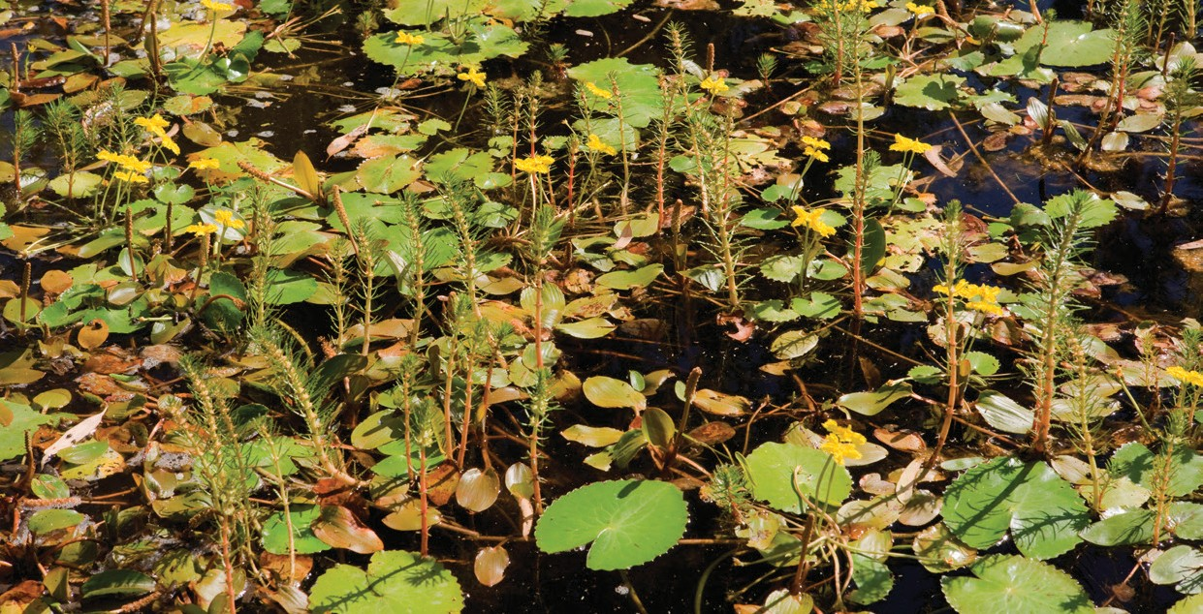

BIO483.1115

**environment**.gov.au