Enhancing Pacific Ocean Governance Evaluation Report

Evaluation of the relevance, effectiveness, efficiency and sustainability of the Australian aid funded Enhancing Pacific Ocean Governance project

June 2018

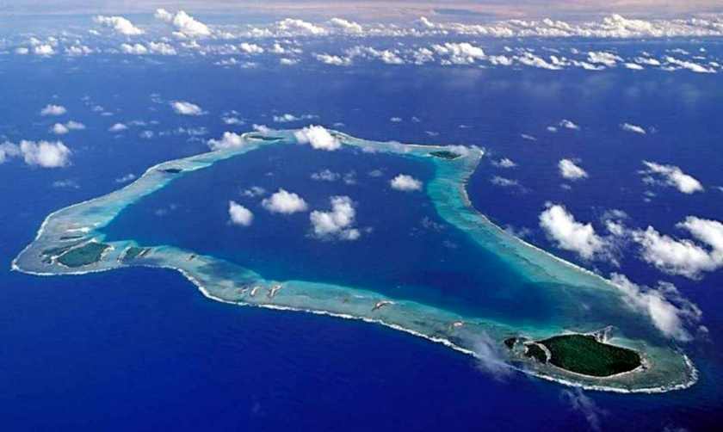

**Acknowledgements**

The Department would like to thank the individuals from Australia and the Pacific who generously gave their time to be interviewed. Without your insights this evaluation would not have been possible. Thanks also to the Department’s evaluation team who provided expert advice on the planning, implementation and reporting of this evaluation.

**© Copyright Commonwealth of Australia, 2018.**

  
The Enhancing Pacific Ocean Governance Evaluation Report is licensed by the Commonwealth of Australia for use under a Creative Commons Attribution 4.0 International licence with the exception of the Coat of Arms of the Commonwealth of Australia, the logo of the agency responsible for publishing the report, content supplied by third parties, and any images depicting people. For licence conditions see: <https://creativecommons.org/licenses/by/4.0/>

This report should be attributed *as Enhancing Pacific Ocean Governance Evaluation Report*, Commonwealth of Australia 2018.

The views and opinions expressed in this publication are those of the authors and do not necessarily reflect those of the Australian Government or the Minister for the Environment and Energy.

While reasonable efforts have been made to ensure that the contents of this publication are factually correct, the Commonwealth does not accept responsibility for the accuracy or completeness of the contents, and shall not be liable for any loss or damage that may be occasioned directly or indirectly through the use of, or reliance on, the contents of this publication.

**Cover image**   
*Palmerston Atoll*, Cook Islands by Peter Townsend, 2013©  
<https://flic.kr/p/fdh599>

Contents

Acronyms and abbreviations iii

Executive summary iv

1. Program Background – Enhancing Pacific Ocean Governance 1

2 Regional Ocean governance 5

2.1 Relevance 5

2.2 Effectiveness 6

2.3 Efficiency 8

2.4 Sustainability 8

3 Maritime boundaries 10

3.1 Relevance 10

3.2 Effectiveness 10

3.3 Efficiency 13

3.4 Sustainability 17

4 Marine Spatial Planning 18

4.1 Relevance 18

4.2 Effectiveness 18

4.3 Efficiency 23

4.4 Sustainability 24

5 Enhanced data management and access 26

5.1 Relevance 26

5.2 Effectiveness 26

5.3 Efficiency 27

5.4 Sustainability 27

6. Lessons learned and Conclusion 29

6.1 Lessons learned 29

6.2 Conclusion 31

Appendix 1: Program logic 32

Appendix 2: Results Table 33

Appendix 3: Supporting information 40

Appendix 4: List of people interviewed 41

Appendix 5: Interview questions 45

# Acronyms and abbreviations

AGD Australian Government Attorney Generals Department

BBNJ Biodiversity Beyond National Jurisdiction

CROP Council of Regional Organisations of the Pacific

CSIRO Commonwealth Scientific and Industrial Research Organisation

DFAT Australian Government Department of Foreign Affairs and Trade

EPOG Enhancing Pacific Ocean Governance

FFA Pacific Islands Forum Fisheries Agency

GA Geoscience Australia

GPFD Government Partnerships for Development

ICT Unit Information and Communication Technology Support Unit, Ministry of Finance and Treasury, Solomon Islands Government

IUCN International Union for Conservation of Nature

PIFS Pacific Islands Forum Secretariat

SDG14 Sustainable Development Goal 14

SDI Spatial Data Infrastructure

SPC Secretariat of the Pacific Community

SPREP South Pacific Regional Environment Program

The Alliance Pacific Ocean Alliance

The Department Australian Government Department of the Environment and Energy

The Ocean Office Office of the Pacific Ocean Commissioner

UNCLOS United Nations Convention on the Law of the Sea

# Executive summary

From 2014 – 2017 Australia committed $5.9 million to support implementation of the Framework for a Pacific Oceanscape through the Enhancing Pacific Ocean Governance (EPOG) project. EPOG was funded under the Australian Aid Government Partnership for Development administered by the Department of Foreign Affairs and Trade (DFAT). The overarching goal of EPOG was to empower Pacific Island Countries and Territories to effectively manage their marine and coastal resources for sustainable economic development whilst supporting productive ecosystems and biodiversity.

There were four key elements to EPOG:

* + Strengthening regional oceans governance
  + Supporting Pacific Island Countries with defining maritime boundaries
  + Supporting marine spatial planning at regional, national and local levels
  + Improving regional data management and coordination.

This evaluation report provides the findings of an internal evaluation of the EPOG project administered by the Department of Environment and Energy (the Department) from 2014 to 2017. The evaluation is a summative, largely qualitative assessment of the ongoing relevance, effectiveness, efficiency and sustainability of the project.

Data sources and evidence used to complete the evaluation included progress reports, published papers, web-based information, and interviews with 48 people from regional agencies, implementing partners, country officials and other stakeholders. The interviews were the primary source of qualitative data for this analysis.

The main audience for this report is departmental executives and DFAT public sector and Pacific program managers. More broadly the report may be useful to implementing partners, Pacific partners and other project stakeholders.

## Relevance

All interviewees rated EPOG’s relevance as high at both the regional and national level. The goals of EPOG were considered even more relevant today than when the project commenced in 2014. Internationally, concern for the health of our oceans has grown due to increasing awareness of pressures on marine resources including habitat destruction, pollution, overfishing, unregulated fishing, and the emerging impacts of climate change. Effective governance mechanisms at a regional level is essential to assist Pacific Island countries with addressing these emerging pressures and for securing marine resources needed for their long-term economic and food security.

## Effectiveness

The analysis found that two components of EPOG—(i) investment in regional ocean governance and (ii) maritime boundaries, were *effective*[1] in achieving the outcomes of the project. The marine spatial planning and data management components were found to be *partially effective[2]*.

*Strengthening regional oceans governance:* All respondents who were familiar with this element of EPOG agreed that an effective contribution was made to strengthening ocean governance throughout the two-year deployment of a technical advisor to the Pacific Ocean Commissioner. Directly funding the Office Pacific Ocean Commissioner for 15 months after the deployment ended was less successful due to the short-term nature of the funding commitment, highlighting the need for ongoing funding to secure permanent technical experts. The advisor was instrumental in building relationships, establishing coordination mechanisms such as the Pacific Ocean Alliance and developing Pacific-wide policies and strategies on oceans. At the close of EPOG in 2017, the Ocean Office was recognised by stakeholders as a credible mechanism within the Pacific regional architecture for leading coordination of ocean advocacy and policy.

*Support with defining maritime boundaries:* Respondents rated the maritime boundaries component as effective. Investment under EPOG catalysed progress with maritime boundaries by providing dedicated technical and legal support for the determination of boundaries and treaty negotiations. At the end of 2017 approximately two-thirds of maritime boundaries in the Pacific had been negotiated with thirteen maritime boundaries remaining to be agreed bilaterally.

*Support with marine spatial planning:* Respondents rated the marine spatial planning component as partially effective. This component of EPOG was designed to complement and strengthen ocean governance and the maritime boundaries work through a regional integrated ocean assessment and technical support to regional agencies and national governments for spatial planning.

At a regional level the coordination role of the Ocean Office was enhanced by the development of a regional marine projects database, and SPREP’s planning capacity was increased with the building of a portal to hold spatial data sets for regional-scale planning and environmental assessment.

Nationally, the capacity of the Solomon Islands and Kiribati grew with training at both a policy and technical level. The countries received support for marine spatial planning tools, intense one-on-one training, group workshops, and technical support for building data sets and creating maps. Kiribati also benefited from a workshop with local communities demonstrating how marine spatial planning can be used for community based resource management. However, the complex nature of spatial planning, including the introduction of new technology, the preparedness of countries and the relatively short length of the project, resulted in the outcomes being only partially met. Respondents indicated that they need ongoing support at both a strategic policy and technical level to implement marine spatial planning at all levels of government.

*Support for regional data management and coordination:* Respondents noted that some progress was made towards achieving the outcomes of this component and overall it was partially effective. EPOG aimed to improve the spatial data infrastructure of regional agencies. Consistent approaches to training on data infrastructure, standards and management were established, and regional agencies are now able to share data through a common, freely available, GIS platform (PacGeo). Realising the broader outcomes of consistent standards for data management and software across all agencies was challenging because there was a wide disparity in capacity, infrastructure, data policies and understanding of the issues.

A significant crosscutting outcome of EPOG which influenced the effectiveness of all elements of the project was the building of relationships and creation of new collaborative networks. Regional ocean governance activities facilitated multi-sectoral, inter agency and country networks. Respondents noted the success of the Ocean Office in breaking down inter agency silos and achieving the milestone of bringing together multi sectors to discuss strategic oceans policy. Maritime boundary activities further strengthened a community of practice across Pacific countries and regional agencies and enhanced bilateral relationships through treaty negotiations. Marine spatial planning and data management activities brought together technical staff of regional agencies to collaborate and work towards shared solutions for improved data access and management. Productive government to government relationships between Australia, Pacific agencies and countries were created and many have continued beyond the life of EPOG. Some partnerships struggled to gain traction due to a disconnect on technical aspects of the project, differing views on priorities and objectives, and insufficient time spent on participatory planning with Pacific partners in the initial establishment phase of the project.

## Efficiency

Departmental respondents thought that the oversighting administrative role of the Department led to a cohesive narrative about Australia’s contribution to ocean governance in the Pacific. The Department’s implementing role also complemented other departmental programs such as the Coral Triangle Initiative, Indian Ocean Rim Association work and other regional engagement.

Respondents generally found the model used for progressing maritime boundaries to be very efficient. Short-term deployments to provide officer-to-officer technical assistance with marine spatial planning were reported to be efficient but additional support through more frequent visits would have improved progress and outcomes.

Respondents also identified some inefficiencies of the project. The Department experienced a high administrative burden in establishing and managing a long-term deployment to Fiji. This was due inexperience and inadequate policy settings to support overseas deployments and associated travel.

Insufficient attention to project scoping and participatory planning for the marine spatial planning element EPOG also hindered progress towards the outcomes. An issue that affected all elements of the project was restrictions on how the program funds could be administered under Government Partnerships for Development funding which disallowed directly funding counterpart agency staff. This potentially slowed progress and hindered commitment and ownership of the project.

## Sustainability

A number of measures were implemented to build sustainable outcomes from the EPOG investment. The most enduring outcome of EPOG is undoubtedly the delimitation of maritime boundaries under international law and associated national legislation. However, there is still a need for Australia’s technical and legal support for regional agencies and countries to build sufficient capacity to be able to self-manage maritime boundary processes. Similarly, while good progress was made with strengthening regional oceans governance and marine spatial planning, continuing support is needed to firmly embed policies and technical capabilities to a sustainable level.

Transitional arrangements for continuing the work of EPOG were planned well in advance of the project ending. From July 2017, DFAT continued to fund Geoscience Australia to lead on maritime boundaries support to the Pacific. From 2018, arrangements commenced for ongoing financial support for the Ocean Office of the Pacific Ocean Commissioner for a further three years. CSIRO’s partnerships with Pacific agencies and Kiribati and Solomon Islands’ government agencies will continue in the short to medium term through the support of other funded projects.

## Lessons learned

1. The Office of the Pacific Ocean Commissioner effectively fills a need for regional coordination of oceans policy and issues.
2. The collaborative model used for maritime boundary activities was efficient and effective.
3. Marine spatial planning is in the formative stages of development in the Pacific region.
4. Marine spatial planning has the potential to break down silos between people and sectors.
5. Progress in oceans governance in the Pacific is dependent on respectful, trusting and collaborative relationships.
6. Capacity building needs a targeted and sustained effort, delivered in partnership with regional counterpart agencies.
7. Data management at a regional level requires ongoing investment.
8. Supporting Pacific neighbours contributes to Australia’s domestic priorities.
9. Administratively efficient measures for implementation of overseas development assistance projects need to be identified before the project commences.

# 1. Program Background – Enhancing Pacific Ocean Governance

In 2010, Pacific Islands Forum leaders endorsed the *Framework for a Pacific Oceanscape* (the framework). The framework identifies strategic priorities and actions for the Pacific region to achieve sustainable development, management and conservation of the Pacific Ocean, including actions designed to support sustainable economic development and food security.

Australia provided support for implementation of the framework through the $5.9 million Enhancing Pacific Ocean Governance (EPOG) project. EPOG was funded by DFAT Official Development Assistance program—$3.65 million through the Government Partnerships for Development (GPFD) and $0.5 million through the Pacific Regional Fund. Implementing agencies also committed around $1.75 million in co-contributions. GPFD was designed to facilitate development partnerships drawing on the expertise of Australian public sector organisations including Commonwealth, State and Territory government agencies and public universities.

EPOG commenced with the signing of a Record of Understanding between DFAT and the Department of the Environment and Energy on 26 March 2014. The primary government implementing partners were Geoscience Australia (GA) and CSIRO. Project activities began in August 2014 and completed at the end of December 2017.

The overarching goal of EPOG was to:

*Empower Pacific Island countries and territories to effectively manage marine and coastal resources for sustainable economic development and food security, while maintaining productive ecosystems and biodiversity*.

EPOG focussed on supporting the implementation of specific priorities and actions under the framework. The project assisted regional organisations and countries to work towards a holistic, cross-sectoral approach to ocean governance. A full outline of the program logic, linking the policy context with the activities and the goals of EPOG, is at Appendix 1.

This report assesses the relevance, effectiveness, efficiency and sustainability of EPOG’s four elements:

1. Regional ocean governance   
   *Strengthening regional leadership and coordination on oceans policy and implementation* by providing technical support to the Pacific Ocean Commissioner (the Commissioner), assisting with the establishment of the Ocean Office to support the role of the Commissioner, and forming the Pacific Ocean Alliance to enable multi-sectoral stakeholder engagement. The Department deployed an oceans advisor to work within the Ocean Office to provide technical support. Following the end of the deployment the Department funded the Ocean Office directly so it could continue to operate and transition to a new funding model over that time.
2. Maritime boundary delimitation   
   *Support countries in establishing their maritime boundaries in accordance with international law* by providing technical and legalassistance to regional agencies and Pacific countries with determining maritime boundaries consistent with the United Nations Convention on the Law of the Sea. Extended workshops for all countries were held in Australia biennially to work through the technical and legal aspects of maritime boundaries for individual countries and to support bilateral treaty negotiations.
3. Marine spatial planning   
   *Assisting regional and national government agencies with marine planning for sustainable use* by providing technical support for marine spatial planning to partner agencies at a regional, national and sub-national level. A regional project data base was developed for the Ocean Office. Marine spatial planning support was provided to the Ocean Office for regional preparations for the BBNJ negotiations and the SDG14. The Solomon Islands and Kiribati were supported with the installation and population of national project databases and a marine spatial planning platform. Eighty staff in the Solomon Islands and sixty staff in Kiribati were trained in the use of geographical information systems and data management. In Kiribati, Tarawa Lagoon was the geographical focus for a workshop to build understanding of marine spatial planning for Community Based Resource Management.
4. Enhanced access to data  
   *Improve capacity to use data needed for ocean governance* bysupporting counterpart agencies with improving access to and usability of data by developing data management processes, establishing a data interface, developing data interpretation tools and providing training to end-users. Three workshops were held with regional agencies to identify what needed to be done to improve and standardise spatial data infrastructure and data management. As a result, agencies were supported with the installation of open source (freely available) software that established a data sharing platform. Geospatial information is now accessible across agencies and to their member countries.

**EPOG funding and governance**

The Department administered the funds and was also an implementing agency. CSIRO and GA were implementing partners, funded under a Memoranda of Understanding with the Department to implement different components of EPOG. A steering committee consisting of all implementing partners was convened twice a year to monitor the project and enable agencies to report on and discuss their activities. Additional reporting was conducted annually under the GPFD requirements. The project was managed internally as a Tier 2 project under the Department’s project management framework which required quarterly reporting to the Project Board of the then Wildlife, Heritage and Marine Division.

**Purpose of Evaluation**

This report provides the findings of an internal evaluation of the EPOG project administered by the Department from 2014 to 2017. The summative, largely qualitative evaluation assessed the ongoing relevance of the project, effectiveness of the program, efficiency of the implementation methods and the sustainability of the outcomes achieved.

The EPOG project had two reporting/evaluation requirements:

* *GPFD Activity Completion Report:* DFAT’s Government Program for Development requires an Activity Completion Report.
* *A departmental project evaluation report:* An evaluation report is a requirement under the Department’s Evaluation Policy (2015-2020).

This report assesses EPOG across a number of key criteria: relevance, effectiveness, efficiency, sustainability and lessons learned.

The objectives of the evaluation were to:

1. Demonstrate whether EPOG has achieved its objectives and outcomes
2. Assess the effectiveness, efficiency and appropriateness of the project
3. Recognise achievements and lessons learned under the EPOG project
4. Provide an open, transparent and evidence-based assessment of EPOG for accountability to DFAT, the Department and for the expenditure of public funds
5. Assess the benefits of EPOG to the Department
6. Assess transitional arrangements including capacity for building on the achievements of EPOG
7. Inform the design of future aid-funded programs that the Department, partners and other agencies may consider.

The primary audiences of the evaluation are departmental executives and DFAT’s public sector and Pacific program managers. More broadly the report may be useful to implementing partners, Pacific partners and other project stakeholders.

**Evaluation Methodology**

The evaluation included collecting qualitative data from interviews with implementing and counterpart agencies, and existing documentation such as:

* meeting records, such as from the EPOG Steering committee
* progress reports provided by implementing partners
* project reports and risk registers
* past annual evaluations and reporting of the program to GPFD
* published papers
* survey of partners and key stakeholders to capture qualitative and quantitative information about key evaluation questions.

A list of supporting information and document sources is provided at Appendix 3.

In addition to written documentation semi-structured interviews were undertaken with 48 people either individually or in groups to gather qualitative information. With the exception of the marine spatial planning component in Kiribati, at least three different perspectives were sought for each component to validate the results and ensure completeness. This included information from implementing agencies, counterpart organisations, participating Pacific Island countries and one non-government organisation (Conservation International).

Departmental officers were able to interview most participants in person. They met with maritime boundary workshop participants in Sydney, in May 2017, and travelled to Samoa, Fiji and Solomon Islands in April/May 2017. Data on the Kiribati component was limited; two written surveys were obtained from government officers.

All interviews were voluntary. Face-to-face interviews were recorded with the permission of participants. Appendix 4 provides a list of people interviewed and interview questions can be found at Appendix 5.

Two simple ratings were applied to describe the effectiveness of each element of the EPOG program:

* **Effective**: The outcomes were realised and the evidence confirmed that the intervention made a crucial contribution.
* **Partially Effective**: The outcomes were realised in part and the evidence confirmed that intervention made an important contribution.

**Implementation partners, counterpart agencies and participating countries**

|  |  |
| --- | --- |
| **Implementation partners** | **Role** |
| Department of the Environment and Energy (the Department) | **Lead agency:** Administered EPOG on behalf of the Australian Government and provided technical and policy support for the Ocean Office of the Pacific Ocean Commissioner |
| Geoscience Australia (GA) | **Implementing partner:** Establishment of maritime boundaries, marine cadastre, management of geo-regulatory information |
| Attorney-General’s Department (AGD) | Supporting partner under GA: International law, legislative drafting, consistency with Australia’s foreign policy |
| The University of Sydney (USyd) | Supporting partner under GA: Geoscientific research and support for establishing maritime boundaries, liaison with Norwegian/UNEP GRID program |
| Commonwealth Scientific and Industrial Research Organisation (CSIRO) | **Implementing partner:** Marine science and analysis for policy and management |
| **Counterpart organisations** | **Role** |
| Pacific Islands Forum Secretariat (PIFS) | **Lead counterpart:** Pacific lead on oceans advocacy and policy; Director General is the Pacific Ocean Commissioner, PIFS hosts the Ocean Office of the Pacific Ocean Commissioner and the Pacific Ocean Alliance |
| Secretariat of the Pacific Community (SPC) | GA counterpart and Pacific lead on maritime boundaries. CSIRO counterpart for geo-spatial planning tools and software |
| Pacific Islands Forum Fisheries Agency (FFA) | Pacific lead on fisheries and support agency for maritime boundaries |
| Secretariat of the Pacific Regional Environment Programme (SPREP) | CSIRO counterpart and Pacific lead on marine spatial planning policy |
| **Participating countries** | **Engagement** |
| Cook Islands | Pacific Ocean Alliance, maritime boundaries |
| Fiji | Pacific Ocean Alliance, maritime boundaries |
| Kiribati | Pacific Ocean Alliance, maritime boundaries, marine spatial planning and community based marine management |
| Marshall Islands, Republic of | Pacific Ocean Alliance, maritime boundaries |
| Micronesia, Federated States of | Pacific Ocean Alliance, maritime boundaries |
| Nauru | Pacific Ocean Alliance, maritime boundaries |
| Niue | Pacific Ocean Alliance, maritime boundaries |
| Palau | Pacific Ocean Alliance, maritime boundaries |
| Papua New Guinea | Pacific Ocean Alliance, maritime boundaries |
| Samoa | Pacific Ocean Alliance, maritime boundaries |
| Solomon Islands | Pacific Ocean Alliance, maritime boundaries and marine spatial planning |
| Tonga | Pacific Ocean Alliance, maritime boundaries |
| Tuvalu | Pacific Ocean Alliance, maritime boundaries |
| Vanuatu | Pacific Ocean Alliance, maritime boundaries |

# 2 Regional Ocean governance

## 2.1 Relevance

***Relevance to the region:*** At a broad level the goal to strengthen ocean governance is even more relevant today than it was at the project’s inception. Internationally the focus on oceans continues to grow and the Pacific has stepped up its oceans priorities. In June 2017 Fiji co-hosted with Sweden, the first UN Oceans conference to support the implementation of SDG 14. The Pacific has actively engaged in international negotiations for a UN treaty on the conservation and sustainable use of marine biological diversity in areas beyond national jurisdiction.

The sustainable use and conservation of oceanic and coastal marine resources, underpins Pacific Island economies, culture and livelihoods. To this end, the framework, which EPOG was designed to implement, remains a current and valid regional policy and is likely to continue to guide high level priorities for the region into the future.

Pacific Island Leaders have also reinforced the importance of oceans through the Blue Pacific statement in 2017, and the Pohnpei Ocean Statement ‘A course to Sustainability’ in 2016. SPREP’s ten year strategic plan adopted in 2016, also identifies oceans as an important cross-cutting theme. At a national level, some Pacific countries are developing and implementing national oceans policies (Vanuatu, Solomon Islands, and Papua New Guinea).

Given the international focus on oceans, regional organisations in particular noted the relevance of the regional ocean governance component.

*Highly relevant –the ocean analyst and any other positions in OPOC* [Office of the Pacific Ocean Commissioner] *they were a game changer* (SPREP employee)

***Relevance to Australia:*** Australia’s regional priorities and commitments align with EPOG’s ocean-related objectives and outcomes. Concetta Fierravanti-Wells, Minister for International Development and the Pacific, stated at the 2017 Pacific Leaders Forum in Apia that "Australia's highest priority … is the stability, security and prosperity of the Pacific”. Pacific leaders agreed in 2017 that the review of the ‘Biketawa Plus’ Pacific security declaration will recognise and prioritise environmental security and regional cooperation in building resilience to disasters and climate change. EPOG has contributed to these priorities by supporting:

* ocean governance and planning for sustainable use of marine resources which is vital for long term environmental security
* delineation of maritime boundaries under international law which underpins regional and economic security and sovereignty over marine resources
* regional agencies and Pacific Island countries with providing a ‘Pacific voice’ on oceans policy internationally (e.g. biodiversity beyond national jurisdiction)
* Pacific development by adapting Australia’s domestic systems for ocean planning at regional and national scales.

***Relevance to the Department:***EPOG provided a mechanism for sharing the Department’s knowledge and expertise in oceans governance within the Pacific region.

* The oversighting administrative role enabled the Department to tell a cohesive narrative about Australia’s contribution to oceans governance in the Pacific. The Department’s implementing role also complemented the Coral Triangle Initiative, the Indian Ocean Rim Association work and engagement in BBNJ and SPREP.
* Sustainable management of marine resources within the Pacific region complemented Australia’s domestic interests in safeguarding marine habitats and species under the Environment Protection and Biodiversity Conservation Act 1999, and in accordance with multi-lateral environment agreements.

## 2.2 Effectiveness

Respondents rated this component as effective because of the achievements outlined in Table 1. EPOG made an effective contribution to strengthening regional ocean governance through an initial two-year deployment of a technical advisor to the Pacific Ocean Commissioner (the Commissioner). The advisor assisted with the establishment of the Office of the Pacific Ocean Commissioner (the Ocean Office)—a semi-autonomous body within the Pacific Islands Forum Secretariat (PIFS) led by the Commissioner, who is also the Director General of PIFS. At the completion of the deployment, the Ocean Office was directly funded for 15 months to cover personnel and operational costs.

The advisor also initiated the first meetings of the Pacific Ocean Alliance (the Alliance)—a multi-sectoral stakeholder group established as a consultative mechanism for oceans policy. The Alliance was successful in collaborating and agreeing on oceans policy to collectively advocate Pacific views on the UN treaty on biodiversity beyond national jurisdictions (BBNJ) and ‘The Ocean Conference’ on Sustainable Development Goal 14 (SDG 14). At the close of this first phase of EPOG in December 2017, the Ocean Office was recognised as a credible mechanism within the Pacific regional architecture for leading coordination of ocean advocacy and policy.

The outputs and outcomes achieved through EPOG supported the PIFS to implement key priority actions of the Framework for a Pacific Oceanscape including:

* establishment of a Pacific Ocean Commissioner with dedicated professional support to provide high-level advocacy and attention to ocean priorities
* establishment of a Pacific Ocean Alliance/Partnership mechanism facilitated by the Commissioner to provide ocean policy coordination, facilitate cooperation for the high seas and support national ocean governance and policy.

*Without EPOG it* [the framework] *would have been just another glossy pamphlet on the table* (SPREP employee)

The deployment of an advisor to PIFS enabled the Commissioner to drive regional coordination on oceans issues more effectively. This is evidenced by a range of outputs produced such as: technical papers to support members on the issues of BBNJ, and various advocacy and communication materials for the Commissioner and the Alliance. The advisor also prepared many interventions for various fora.

The deployee was a highly effective individual and built strong relationships in the region, evidenced by the verbal and written praise she received from multiple stakeholders through the evaluation process.

*… our assistance to countries on oceans governance overall and BBNJ really fired up several notches because the ocean analyst was able to coordinate the input of all the regional agencies and other experts additional to regional agencies to advise countries on the UN negotiation floor. They were extremely successful technical teams we pulled together for those negotiations and ongoing ….… it broke down silos by sheer hard work, persistence and being indefatigable.* …(SPREP employee)

**Table 1 Regional ocean governance achievements**

|  |  |  |  |
| --- | --- | --- | --- |
| Project outcomes | Outcome achieved | Impact | Achievements |
| Office of the Pacific Ocean Commissioner is established and is self-sustaining, strategic and can demonstrate results to garner support of other agencies | Yes | High | The Ocean Office was established and operationalised  The Ocean Office provided strategic direction across the Pacific, which led to stronger Pacific engagement in the international negotiations e.g. a new treaty on marine biodiversity areas beyond national jurisdiction (BBNJ) under the United Nations Convention on the Law of the Sea; Our Ocean Conference on Sustainable Development Goal 14 (SDG14).  The Ocean Office strengthened links and collaboration between regional agencies.  The Ocean Office became a credible identity in the region as an effective coordination mechanism and advocate for regional ocean policy and cross-cutting ocean initiatives.  The Ocean Office was not financially self-sustaining by the end of 2018. Australia is funding the office for a further three years. |
| Pacific Ocean Commissioner has access to advice and support and can engage in oceans policy | Yes | High | The Pacific Ocean Commissioner was supported through the deployment of an Oceans Analyst and technical staff.  The provision of technical support enabled the Commissioner to drive regional coordination on oceans issues more effectively.  The Commissioner engaged in oceans policy at both a regional and international level. |
| Pacific Oceans governance is coordinated in a strategic way, including stakeholder relationships and donors | Yes | High | The Pacific Ocean Alliance was established and brought together all sectors and stakeholders involved in ocean management. Two Alliance workshops were held and a technical working group developed policy for Pacific engagement in BBNJ and SDG14.  The Ocean Office provided strategic direction to the Pacific agencies and countries which led to stronger Pacific engagement in the BBNJ process.  The Ocean Office coordinated a successful meeting with Pacific Small Island Developing States (PSIDS) in New York on marine genetic resources, and strengthened the relationship between PSIDS representatives in New York, regional agencies and Pacific Island countries. |

The Ocean Office built close links between PIFS and other regional agencies, and strengthened collaboration through participation in the Marine Sector Working Group, regular meetings and communications with all stakeholders, and the establishment of the Alliance. The evaluation of EPOG found that the establishment of the Ocean Office and the efforts of the advisor were effective in breaking down silos between regional agencies, and strengthened ownership and stewardship of the framework in the region.

*Having a dedicated person was the key. I’m afraid it will die a slow death unless there is a resource there … we noticed when she* [the deployee] *came and we noticed when she left.* (SPREP employee)

The advisor developed and finalised Alliance management arrangements and drafted concepts for discussion on ocean development opportunities. Her work also laid the foundations for the Ocean Office to support Pacific Island countries and territories on the UN oceans conference in June 2017 and implementing the SDG14 agenda.

CSIRO also contributed to regional coordination and strategic direction by providing technical support to the Ocean Office for their regional preparations in BBNJ negotiations. CSIRO collated regional oceans data on human activities (e.g. shipping, commercial fishing) and conservation values which was accessible through an online mapping tool. The analysis identified significant potential for interaction between industries, as well as between the industries and conservation values. This analysis gave PICTs a deeper understanding of the possible implications of such an international treaty. PIFS valued this work.

## 2.3 Efficiency

Respondents identified a number of efficiencies with the ocean governance element of EPOG. The Department’s oversighting administrative role enabled Australia to tell a cohesive narrative about our contribution to ocean governance in the Pacific. The Department’s implementing role also complemented other similar programs such as the Coral Triangle Initiative, the Indian Ocean Rim Association work and engagement in BBNJ and SPREP.

Although the deployment of officer from the department to support the Ocean Office was highly effective, it proved to be administratively costly. The department lacked systems and protocols to carry out the deployment efficiently resulting in many weeks of work in the lead up to uplift. There was also an ongoing high administrative work load for international and regional travel approvals for the deployee’s travel in the Pacific region and internationally.

## 2.4 Sustainability

Investment in the Ocean Office of the Pacific Ocean Commissioner will have some enduring outcomes, in particular the policy and technical reports that were produced. However, the ongoing tenure of the Ocean Office is not sustainable without ongoing donor support. From 2016, at the end of the advisor’s deployment, the Ocean Office was funded directly by the Australian government. Unfortunately, unsuccessful recruitment of full time personnel due to the short-term nature of the funding slowed momentum of regional coordination demonstrating the need for longer term financial support. Australia and New Zealand have committed to funding the Ocean Office for a further three years from 2018.

*Liz* [the deployee] *was an outstanding success but they haven’t secured core capacity for the long term.* (NGO)

*It’s very important to have that office to champion the cause or otherwise it will just fizzle and die, because if you don’t have a dedicated person and if you don’t have someone to support Dame Meg then she will be unable to do her job [of Pacific Ocean Commissioner].* (SPC employee)

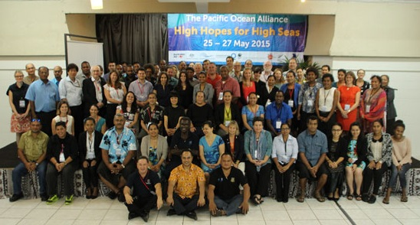

Inaugural Pacific Ocean Alliance workshop – described as a seminal event for setting direction for regional ocean policy

# 3 Maritime boundaries

## 3.1 Relevance

Interviewees rated the maritime boundaries work as highly relevant because it has implications for so many aspects of governance.

*…maritime boundaries have implications for maritime security, enforcement, maritime surveillance, litigation, foreign fishing vessels, deep sea mining.* (Tonga)

*Maritime boundaries is part of UNCLOS, a high priority internationally and regionally….sustainable development goal 14, one of the [SDG14] targets is implementing UNCLOS.* (SPC employee)

## 3.2 Effectiveness

Respondents rated the maritime boundaries component as effective, evidenced by the achievements outlined in Table 2. Investment under EPOG catalysed progress with maritime boundaries by providing dedicated technical and legal support from GA, AGD, USyd and GRID-Arendal to assist SPC with the determination of boundaries and treaty negotiations. At the end of 2017 approximately two-thirds of maritime boundaries in the Pacific have been negotiated with thirteen maritime boundaries remaining to be agreed bilaterally.

EPOG funded the following maritime boundary activities:

* provision of technical expertise from GA, USyd and GRID-Arendal
* provision of legal expertise from a dedicated full-time staff member at AGD
* 4 regional and 1 sub-regional workshops held, including travel costs for participants
* software and hardware
* travel for GA/USyd/AGD staff to provide in-country training and assistance.

The Pacific maritime boundaries work commenced in 2005, but after almost a decade of work, GA were facing funding challenges. Without EPOG funding from 2014 to 2017, this work may not have continued or would have progressed at a much slower rate. EPOG was a catalyst for finalising and progressing a number of maritime boundaries.

Since 2005, the work moved from a technical focus on establishing territorial sea baselines, Exclusive Economic Zone (EEZ) limits and extended continental shelf claims to assisting states to negotiate maritime boundary treaties, review and update their legislation and declare the outer limits of their maritime zones.

The technical and legal nature of defining maritime boundaries means that some components progress slowly e.g. submissions to the Commission on the Limits of the Continental Shelf can be under consideration for many years. Some boundary negotiations involve complex territorial disputes which may take years to resolve. At a national level, the review, drafting and ratification of national maritime boundary legislation can also be a slow process. However, the community of practice that has been built through the process has led to a rapid increase in concluding some maritime boundary agreements because the negotiating teams have developed constructive relationships and a shared understanding of the issues to be resolved.

**Table 2 Maritime boundaries achievements**

|  |  |  |  |
| --- | --- | --- | --- |
| **Project outcomes** | **Outcome achieved** | **Impact** | **Achievements** |
| Pacific Island countries proclaim boundaries and fulfil lodgement requirements under UNCLOS and  Pacific Island countries have defined extended continental shelves and maritime zones | Yes | High | Approximately two-thirds of maritime boundaries in the Pacific have been negotiated.  2 submissions were made to the UN Commission on the Limits of the Continental Shelf with one finalised and the other, (a multi-national submission), ongoing.  5 treaties were negotiated.  3 countries developed/reviewed their domestic maritime zone legislation.  The Government of Kiribati extended the Phoenix Islands Protected Area boundary due to the maritime boundaries work.  The community that has been built through the process led to a rapid increase in concluding some maritime boundary agreements because the negotiating teams have a relationship and a shared understanding of the issues to be resolved. |
| Pacific Island countries have improved skills and confidence in maritime boundary negotiation and delimitation. | Yes | High | The program developed a community of practice across the region which can maintain and share technical knowledge, promote consistent approaches, and drive coordination and strategy in priority areas. |
| Yes | High | Pacific Island countries have experience and increased confidence and competence in preparing and delivering information into international processes. |
| Yes | High | Government officials have been empowered to drive cultural and political change as a result of direct mentoring and networking of experts in both SPC and regional governments. |
| Yes | High | Officers are using geospatial tools and data not accessed previously, including PacGeo. PacGeo is an open source, online platform containing over 170 datasets. SPC developed PacGeo with the support of GA, USyd and GRID-Arendal.  EPOG deployed marine spatial data infrastructure systems in four Pacific Island Countries, based on advice from program partners. EPOG hired a developer to work in SPC Geoscience Division for 6 months to deploy portable servers. This has allowed countries like Vanuatu and Kiribati to access large datasets which were previously inaccessible due to their slow internet connections.  The Forum Fisheries Agency is also using the geospatial information generated for oceanic fisheries management. |

Another success factor was that the countries set their own agenda at each meeting. This gave them ownership of the process and ensured that the outcomes they were working towards their specific circumstances. Not all countries began from the same starting point and some were not ready to engage in 2014. Running the workshops over an extended period allowed countries to engage when it is most appropriate for them.

*Being able to have conversations face to face sometimes facilitates small breakthroughs on difficult negotiations.* (Tonga)

*The workshops have developed a culture of healthy competition between participants – they are motivating each other to achieve more.* (Vanuatu)

#### Unintended outcomes

* Due to the success of the maritime boundary workshops, the format has been replicated in West Africa, with positive outcomes so far.
* The workshops presented a valuable opportunity to recognise and collaborate to address broad regional needs/deficiencies. For example, a number of countries successfully applied for funding through the UN Trust Fund for hardware and software (Geocap software and high-end computers). These resources will be used for other oceans-related work, not just maritime boundaries. The workshop facilitators made officers aware of these funds.
* Approaches, infrastructure, and capability gained through the program have contributed to terrestrial management in some countries.
* A number of un-related projects have commenced due to the relationships/community formed through these workshops. For example, SPC supported the ongoing coordination between Fiji, Papua New Guinea and Vanuatu to instigate a joint Climate Technology Centre and Network (CTCN) proposal to build capacity in geothermal energy and progress the work already done by SPC, the World Bank and others.

#### Challenges

* Challenges faced in the Pacific included diversity of user experience/software accesses and internet access, as well as limited on-site technology, and diversity of largely immature and unstable administrative systems and processes.
* EPOG provided a valuable test environment for Australian Government systems intended for domestic use, as well as international data standards intended for global implementation.

## 3.3 Efficiency

Extended (generally two-week) maritime boundary workshops held in Australia brought Pacific Island countries together to progress and negotiate maritime boundaries. GA, AGD, USyd, GRID-Arendal and sometimes the Commonwealth Secretariat provided technical and legal support. The workshops were highly regarded by country officers, GA, AGD, USyd and SPC as an efficient use of their time.

Three key factors contributed to the efficiency of this model.

1. Holding workshops: The workshops provided a place for technical and legal experts to meet and discuss issues face to face. It would have been less efficient to send the legal and technical experts to each country, and less efficient to separate the technical and legal aspects into different workshops.

*Unlike sitting in a lecture and taking notes, the workshop is participatory and interactive which is a better way to build skills and knowledge.* (Solomon Islands)

*There is value in the range of expertise available – technical, software, legal, Commonwealth Secretariat. The mix of foreign affairs, legal and technical also speeds up the process.* (Tonga)

2. Holding the workshop in Sydney:

* This enabled officers to leave their desks for periods of time (usually two weeks) to focus on this particular work without the pressures of competing demands at home. This fast-tracked the process.
* The workshops on the campus of the University of Sydney also meant that participants had access to the computer labs. This was valued by participants because it provided equal access to technology.

[the workshop] *brings us away from our office and other priorities. This is the only time we can concentrate on maritime boundaries. The ability to print out maps and take it back makes a big difference to demonstrate the progress made. Countries don’t have the equipment back home.* (Samoa)

3. The right mix of people.

* A strong and productive community of practice has developed between Pacific Island country officers, SPC, GA, AGD, USyd and GRID-Arendal. This approach enabled all participants to learn from each other. Respondents described this workshop as doing things the ‘Pacific way’; working cooperatively and building on traditional connections they have with each other.

A treaty template was developed which ensured consistency across the region and sped up the negotiation process.

*In terms of negotiating [boundaries] the template makes things easier and cuts down the issues as parties don’t need to agree on the text. We just need to agree on the coordinates.* (Tonga)

Case study: Maritime boundaries – unintended benefits

The community of practice that has developed through the maritime boundaries work has led to unanticipated positive outcomes for both the region and more broadly.

Within the region, the regular workshops have cultivated a network of technical and legal practitioners working as a community towards a shared purpose. Pacific Island countries and territories began the process from different starting points and with different levels of skills and technology at their disposal. The community has developed a supportive culture with those Pacific Island countries and territories who are more advanced in the process sharing their lessons with others. ‘We share our past experiences with other countries, [like] how we approached the UN. This helps others when they come to the negotiation process.’ In addition, the relationships have led to information sharing on other oceans policy work. For example, Vanuatu has developed a national oceans policy and the Cook Islands have implemented a 50nm exclusion zone for foreign fishing vessels, to protect their national fishing industry. Other Pacific Island countries and territories are now learning from these experiences through the workshop community. ‘You’re not just learning about maritime boundaries, you’re learning about other things. E.g. Cook Islands is developing the 50nm limit. Vanuatu sees that and asks how they can do it too, others learn about Vanuatu’s oceans policy and ask how they can do it too’.

The relationships formed through these workshops also led to a number of un-related projects. With the support of SPC, Fiji, Papua New Guinea and Vanuatu are working together on the instigation of a joint Climate Technology Centre and Network (CTCN) proposal to build capacity in geothermal energy. The Cook Islands has taken over another collaborative CTCN proposal for solar power which was originally prepared for Vanuatu in collaboration with program partners.

For individual countries, the workshop facilitators have made them aware of a UN Trust Fund for hardware and software. A number of countries have been successful in this process, purchasing software and high-end computers which they use for other ocean-related work. Approaches, infrastructure, and capability gained through the program have also contributed to terrestrial management in many countries.

More broadly, the workshops have provided a valuable test environment for the implementation of new global data standards. The S121 maritime boundary data exchange standard continues to be developed through GA and Canadian Government Investment, as well as input from sub-contractors to the EPOG project under GA. S121 is a data standard intended to allow States to communicate official digital representations of their maritime limits and boundaries to the public and international community. The Pacific is just the second region, after Canada, to adopt the s121 standards.

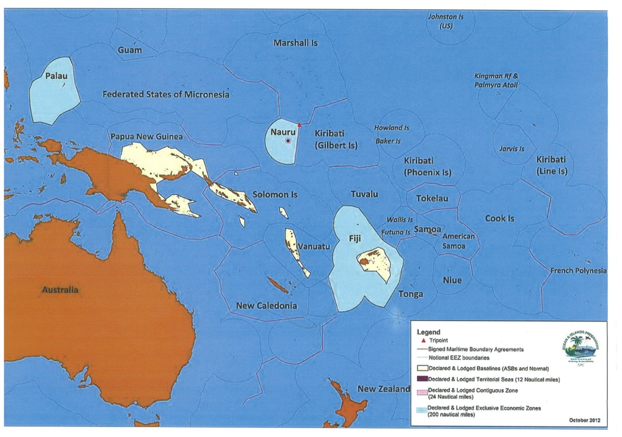

Map showing extent of maritime boundary delimitation in October 2012. The light blue areas represent Exclusive Economic Zones declared and lodged under UNCLOS

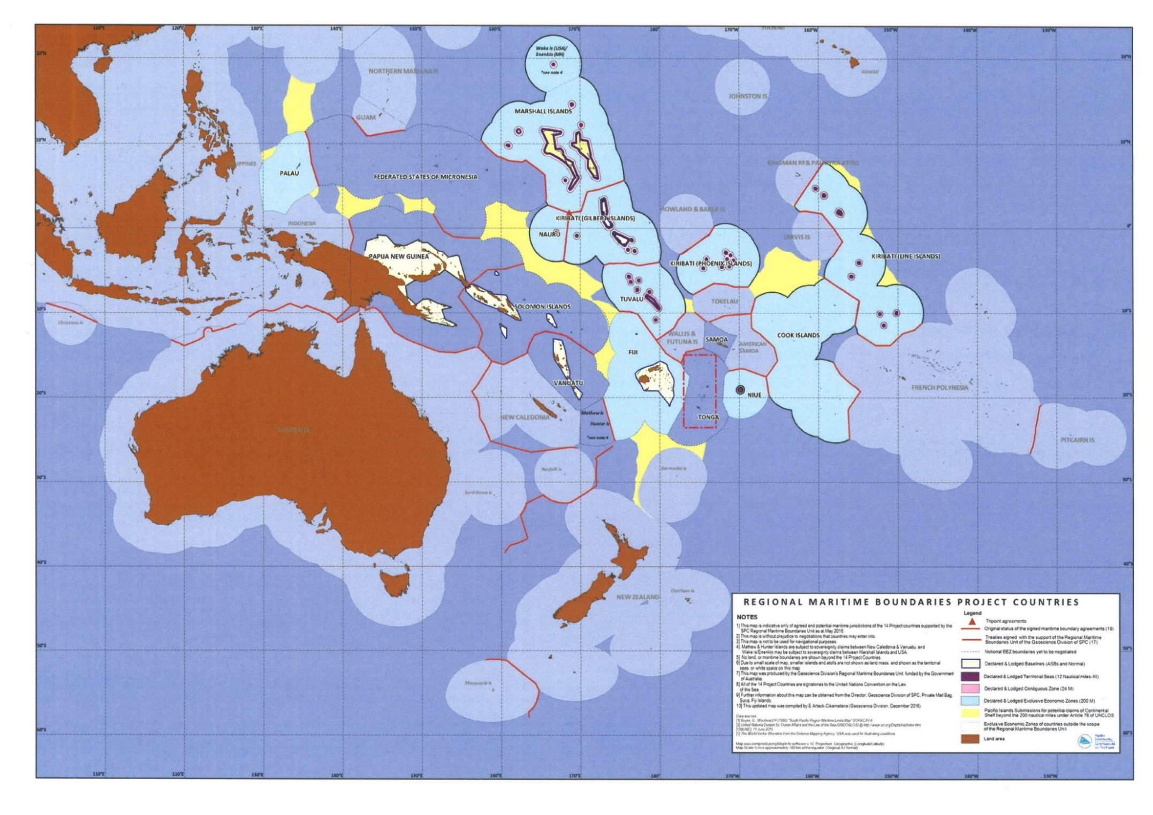

Map showing extent of maritime boundary delimitation by August 2017. The light blue areas represent Exclusive Economic Zones declared and lodged under UNCLOS

## 3.4 Sustainability

The region is in a strong position in terms of legal and technical capacity to maintain momentum provided that agencies have continuing technical and legal support from Australia. DFAT has committed funding to this for a further three years commencing in July 2017.

The program investment in capacity building for SPC and Pacific Island countries means that ongoing boundary work and regional coordination could continue beyond the life of the program. However, about one third of boundaries are yet to be negotiated and finalised and investment to further support maritime delimitations and technical capabilities would allow development of more mature and therefore sustainable systems in the Pacific.

Implementing partners aimed to develop skills in as many people as possible to reduce the consequences of staff turnover within regional and government agencies. Two to three people per country were invited to attend maritime boundary workshops but many states sent and funded larger delegations as they greatly valued the sessions.

In addition, some individuals became champions for new initiatives, sharing acquired skills and knowledge with their colleagues at home. For example, an officer of the Cook Islands took PacGeo home, set it up, demonstrated it to colleagues, and trained others. Many officers in the Cook Islands are now using PacGeo to share information. SPC’s efforts to coordinate and promote use and investment in centrally maintained systems is slowly achieving cultural change. Recognition and demonstration of benefits by the countries has proven to be most effective in driving uptake.

# 4 Marine Spatial Planning

## 4.1 Relevance

Marine spatial planning was considered relevant by respondents as it supported priorities and projects with access to spatial data and was recognised as an important tool for decision making.

*It* [marine spatial planning] *was timely given the Oceans12 process.* (Solomon Islands)

There was a high level of engagement by countries in the marine spatial planning of EPOG. However, there are varying degrees of understanding and knowledge as to why marine spatial planning is important and how to approach it. Training was provided to demonstrate the process backed up by technical support. The Solomon Islands was able to demonstrate the value of marine spatial planning and apply it to a high-level national government oceans policy process—Oceans12.

## 4.2 Effectiveness

Overall, respondents rated this component as partially effective. Marine spatial planning is an essential tool for managing economic, environmental and social values, competing uses of marine resources and integrating multi-sectoral interests. The spatial planning elements of EPOG were designed to complement and strengthen ocean governance and the maritime boundaries work by undertaking a regional integrated ocean assessment, and providing technical support to regional agencies, national governments and at a sub-national level, to build their marine spatial planning capabilities.

At a regional level CSIRO collated regional marine data that is now accessible through a web-based portal managed by SPREP to support regional agencies with strategic planning. CSIRO also supported the Ocean Office by investing in a regional workshop on the blue economy bringing together the Sustainable Ocean Initiative and the Pacific Ocean Alliance to re-emphasize the importance of SDG 14, in particular SDG14.7 which focuses on sustainable economic benefits needed by the region. The workshop encouraged an integrated approach to ocean management at institutional, policy and applied levels.

At a national level, pilot projects were run in the Solomon Islands and Kiribati to develop their marine spatial planning capabilities through training and the provision of geospatial planning tools. Within Kiribati, CSIRO also brought together local communities with national government agencies to investigate marine spatial planning for Tarawa Lagoon as a case study. The achievements are further described in Table 3.

**Table 3. Marine spatial planning achievements**

|  |  |  |  |
| --- | --- | --- | --- |
| **Project outcomes** | **Outcome achieved** | **Impact** | **Achievements** |
| Pacific Island countries have increased capacity to adopt strategic and analytical approaches to marine planning | Yes | Moderate | **Regional level:** CSIRO developed, installed and populated a regional project data base with the Ocean Office at: <http://msp.csiro.au/projects>. They also contributed to regional planning by providing technical support to the Ocean Office for regional preparations for the BBNJ negotiations. CSIRO invested in a regional workshop bringing together the Sustainable Ocean Initiative and the Pacific Ocean Alliance to consider priorities for the SDG14 Ocean Conference.  **National level:** CSIRO installed and populated spatial databases for PacGeo, in Solomon Islands and Kiribati. This included a national project database and a marine information platform (SolGeo and KIGeo). CSIRO trained 80 staff in Solomon Islands and 60 staff in Kiribati in the use of this spatial data infrastructure and information.  **Sub-national level:** Tarawa Lagoon in Kiribati was the geographical focus for a workshop to build understanding of marine spatial planning for Community Based Resource Management. The approach engaged remote villages in marine spatial planning activities, and provided linkages between local people and relevant government agencies. |
| Strategies incorporated into national budgets, work plans, donor investments and policy | Partially | Moderate | Within Solomon Islands, the spatial data infrastructure tools have been used to demonstrate the value of spatial data to decision-making processes.  CSIRO assisted the Solomon Islands ICT Unit, fisheries and environment departments to establish a data-sharing protocol as part of the ongoing maintenance of SolGeo.  Access to the project portal by the Kiribati and Solomon Islands governments, and Ocean Office, is allowing staff to identify opportunities for project coordination and gaps that should be addressed by future investment. |
| Pilot studies used as a basis for marine/coastal resource management | Partially | Moderate | Within Solomon Islands, the spatial tools were used to:   * determine site selection and allocation for seaweed farming, and deployment and management of fish aggregation devices. * inform the implementation of a Protected Areas Policy and management of a near-shore marine protected areas network. The tools were used to consider marine and coastal values in the policy process.   Within Kiribati, spatial tools were used to overlay maritime boundaries with various data sets such as coastal erosion, minerals deposits and the location of aggregate leases. |
| Integrated ocean assessment is adopted and implemented | Yes | Moderate | This component changed throughout the course of the project. The Integrated Ocean Assessment was originally meant to be a static document, but was turned into a data portal in association with SPREP and can be found at <http://msp.csiro.au>. Officers can use the portal to examine interactions at a regional scale between pressures and biological assets, such as between shipping, marine debris, mineral densities and coral bleaching, whales, turtles and biodiversity proxies. It has been used in regional discussions on ocean policy. |

The marine spatial planning component of EPOG faced multiple challenges. Respondents acknowledged the important contribution of marine spatial planning, but noted there was further work to be done. Unlike the other EPOG components, this work started from a relatively low base as there were fewer practitioners and existing regional and national frameworks to work with, and there were varying capabilities across agencies and governments.

Taking this into account, activities and outputs for this component were modified as knowledge of local circumstances improved. Some of the initial planned outputs were considered inappropriate in terms of timing or political support, or were too ambitious. For example, CSIRO had initially intended to undertake an integrated ocean assessment in collaboration with regional agencies. It became apparent that investment in capacity building, data systems and spatial planning tools was a higher priority. Some of the resources allocated to this component were consequently redirected to component 1 – Regional Governance – whereby CSIRO supported BBNJ preparations and the Alliance (discussed in section 2.2).

The Solomon Islands and Kiribati were chosen as test cases for rolling out marine spatial planning training and geospatial planning tools because of their divergent spatial data infrastructure (SDI). The Solomon Islands has centralised Information and Communications Technology (ICT) supported by a centralised ICT Unit within the Department of Finance and Treasury. Two information technology advisors, funded by Australian aid, are embedded within the unit. Kiribati on the other hand, has very little ICT infrastructure and no national or departmental data servers.

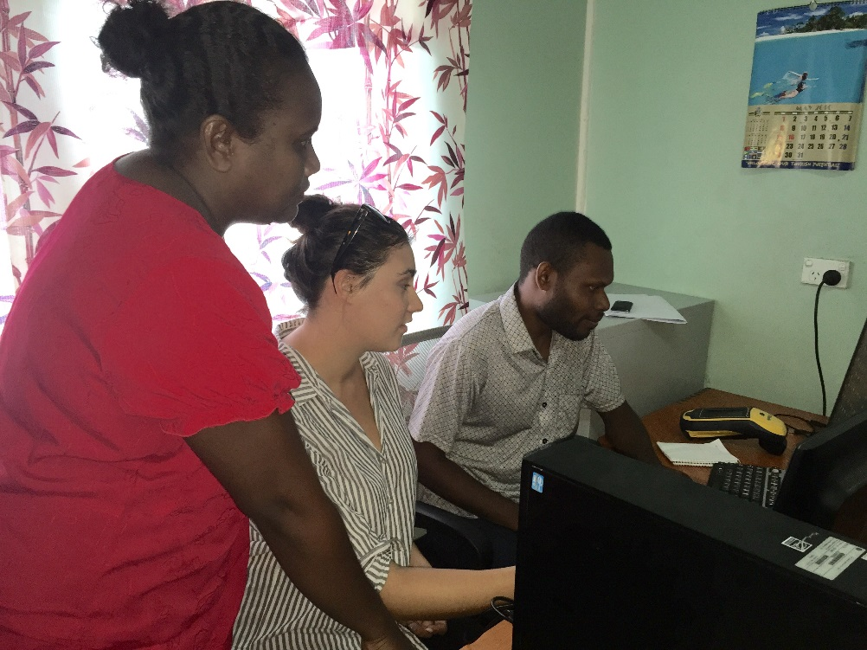

Solomon Islands officers working with CSIRO scientist on   
marine spatial planning mapping and projects data base, Sharon Lane 2016

Case study: Marine spatial planning – National level – SolGeo

CSIRO worked with the Solomon Islands ICT unit to deploy an information portal (SolGeo) using open-source (free on line) software (PacGeo). The SolGeo tool allows officers to collect spatial data layers and view them in one place. CSIRO collated 900 data layers to include in SolGeo covering information on values, pressures and human uses, such as fisheries, climate, environment, human infrastructure. CSIRO trained officers from the environment and fisheries departments as well as the ICT Unit on how to use and maintain this information.

CSIRO also developed and populated a geo-referenced database which spatially maps marine-related projects undertaken in Solomon Islands including programs managed by SPC, SPREP and World Fish. This local spatial information is being used by decision makers in the environment and fisheries agencies and will be a useful tool for donors planning investment in Solomon Islands marine projects.

CSIRO helped the ICT Unit, fisheries and environment departments to establish a data-sharing protocol as part of the ongoing maintenance of SolGeo. However, in the evaluation these departments noted that more needs to be done to develop the overarching governance structures, both within the Solomon Islands government and with SPC.

Everyone needs to get their own house in order before they start sharing information. EPOG is a catalyst for this discussion. People see the maps and then understand their value.

The Solomon Islands have used the SDI tools to:

- determine site selection and allocation for seaweed farming, and deployment and management of fish aggregation devices

- inform the implementation of a Protected Areas Policy, specifically for the management of a near-shore marine protected areas network. The tools were used to consider marine and coastal values in the policy process

- demonstrate the value of spatial data to decision-making processes. One interviewee noted that “many people were surprised by the opportunities SolGeo provides.”

For this pilot project, 80 staff were trained across three government agencies in how to access and use the geospatial tools and information.

Demonstrating how geospatial planning tools can be used for decision making has educated government agencies of the benefits of data, good data management and spatial planning systems.

It has changed a lot of attitudes. There are conversations going on now about what data should and shouldn’t be shared and how to do it.

In the past the question was why do the CROPs have our data? Now we can say here is our data…its localising the data to inform national discussions. Maritime shipping are the most enthusiastic users. When they saw the pollution incidents map it had a large impact.

Case study: Marine spatial planning – National level – KIGeo

Within Kiribati, CSIRO installed and populated KIGeo, a national project data base and a marine information platform. CSIRO established this spatial data infrastructure in Kiribati, using standard software (PacGeo) and they trained 60 officers in the use of SDI and GIS. Technical capabilities in Kiribati are less advanced than the Solomon Islands. Government agencies in Kiribati are separated from each other technologically and geographically. This led to CSIRO establishing two versions of KIGeo within different agencies.

The Minerals Unit within the fisheries department uses the tool to overlay maritime boundaries with their various data sets such as coastal erosion, minerals deposits and the location of aggregate leases.

Separately, the coastal fisheries team identified a need for SDI and marine spatial planning tools late in the project (only in 2016). CSIRO developed a version of KIGeo specifically for this team, as they could not connect to the main server of their department. CSIRO also trained officers in the use of KIGeo. A Senior Fisheries Officer, who completed a masters in Australia, has returned to Kiribati and will continue to champion the implementation of this work within the coastal fisheries team. One fisheries official noted “the most important outcome achieved through EPOG was providing a centralised platform at fisheries for spatial data” and “providing training for staff in spatial data analysis, dataset development and visualisation techniques.”

Access to the project portal by Kiribati government officers has given them an improved understanding of past and current programs and projects. This will allow them to identify opportunities for project coordination and gaps that should be addressed by future investment.

#### Unintended outcomes

* Some of the data management methods, tools and knowledge have been applied to terrestrial management
* Outputs from the Tarawa Lagoon workshop has been used for an honours thesis at the University of Tasmania/AMC by MFMRD staff member Taati Eria.

#### Challenges

* Staff turnover in counterpart agencies and CSIRO was a challenge because it meant that new relationships had to be built.
* CSIRO faced challenges with information technology/internet capacity. Work only progressed when they were physically present on Kiribati and it was difficult to make contact with local staff via email from Australia.

*Providing technically sophisticated tools is ineffective as learning curves are too steep or there are hidden factors…all have found it useful to see what works on the ground, in reality. Some agencies are still working with Excel worksheets.* (Donor agency)

* The diversity of existing knowledge of marine spatial planning across and within Pacific Island countries presented a challenge. The original plan for this component was to take a regional approach, but after some on-ground assessments CSIRO decided to switch to a country-level focus. Another donor agency stated ‘this was the right decision’.

## 4.3 Efficiency

Short-term deployments by CSIRO to provide officer to officer training and technical support was reported to be more efficient than one-off training days. However respondents thought that more frequent visits would have improved progress and outcomes. This point was raised by regional agencies, country officials and a donor agency.

Several factors contributed to the efficiency of this component:

* Building on existing frameworks or governance arrangements: SoIGeo was developed with the Solomon Islands ICT Unit which provides an integrated system with consistent technical support across Solomon Island government agencies. The ICT Unit is supported by Australian-funded advisors who provided guidance and support for SoIGeo implementation.
* The centralised ICT system of the Solomon Islands Government was a more efficient model than the KI pilot project in that where IT systems are disconnected.
* Making in-country visits and sitting with national colleagues at their desk to provide mentoring. This allows people to learn and apply the tools directly to their work.

*Really being on the ground in the country for a period of time, to visit national colleagues in their workplace and sit next to them and mentor them has been much more fruitful, rather than taking people into a training workshop that fails as their work environment is different.* (Donor agency)

*Them [CSIRO] providing technical assistance with MSP was really good. They tried over email to fix technical issues, but really they need to be physically here. If it’s just discussion it works really well. They are trying to do a lot of things at once so resourcing is sometimes an issue… A week at a time was good help, but limitation was a time issue. They are setting up big things and they take time. CSIRO did as much as they could, but would have been good if they could dedicate more time.* (SPREP employee)

* CSIRO identified and pursued synergies with other projects in the region. For example CSIRO coordinated with the Australian Centre for International Agricultural Research and the Australian National Centre for Ocean Resources and Security, who were conducting coastal fisheries and marine planning activities in the Solomon Islands, Vanuatu and Kiribati.

#### Challenges

Efficiency could have been improved if more time was allowed for project planning and building relationships. Interviewees from different groups thought the project would have benefited from more discussions in the beginning to identify strengths and opportunities to build on, rather than start from scratch. This would have also improved CSIRO’s understanding of local needs. The limited planning time led to a lack of ownership amongst some counterparts which will impact the sustainability of the project.

*Communication was missing – one way street. We weren’t equal partners, we were a service provider. We are looking for collaboration partners with a similar vision but we need funding. We need equal footing in a project like this.* (SPC employee)

While country officials preferred hands on training at their desk rather than workshops, they also noted that it can be challenging to find enough time to focus on the task because they have so many responsibilities. This feedback concurs with responses about the maritime boundary workshops (from different parties).

*When EPOG staff visit we often find it hard to concentrate on our training while performing our other duties.* (Kiribati)

## 4.4 Sustainability

The EPOG investment in marine spatial planning processes, spatial data and infrastructure, has generated enthusiasm and appetite to continue this work. However, there are a variety of challenges associated with these disciplines and any ongoing efforts should be developed in close collaboration with national governments through regional agencies. Collaboration should include both high-level Government officials responsible for priority setting and officers who will be implementing the processes and using the tools.

*The project provided good technical resources, stimulated activity but without the broader governance setting it might get a bit lost. ICT is there to help people but without broader government setting it’s a bit of an orphan.* (Solomon Islands ICT Unit)

*You do the training to demonstrate the process, then one example cycle with them so they can get applied. If you don’t have a person there pushing then the wheels will stop.* (SPREP employee)

CSIRO built relationships with regional agencies which could provide an enduring basis for continued collaboration. For example, a new project has commenced between CSIRO, the Global Ocean Biodiversity Initiative and SPREP to conduct a marine bio-regionalisation of the Pacific islands region. This new project will use the spatial data infrastructure developed under EPOG to capture and share bioregional information across regional agencies and Pacific Island countries and territories.

SPC has indicated that ongoing support for SolGeo and KIGeo could be provided on an ad hoc basis as they do not have dedicated resources and have now moved to a full cost-recovery model. SPC’s ongoing support for projects can only be guaranteed with a formal service-level agreement and appropriate funding.

The Solomon Islands ICT Unit has indicated that they value SolGeo and have identified other potential uses for the tool, such as for other natural resource management departments like forestry. However, they would not support scaling up the use of the marine spatial planning tools until a formal governance structure is in place across government and there is a formal plan for its ongoing technical support and maintenance (such as a service level agreement with SPC).

*There is no SLA in place. Users lose confidence if they can’t get timely support.* (ICT Unit Solomon Islands)

The value of SolGeo has been proven through its use in the IUCN-led Oceans 12 process (whole of government ocean policy) to demonstrate to government ministers the value of spatial information for decision making. The Solomon Islands’ environment department indicated that the government needs to decide how and when to use the tool and what mechanisms are needed to support its use. Capacity was also raised as a concern for maintaining the projects’ portal developed for the Solomon Islands.

*A gap is a database officer … someone who is regularly maintaining the database. We have the skills to do this, but current staff don’t have the time.* (Solomon Islands)

Compared to the Solomon Islands, Kiribati has less ICT and SDI infrastructure and capacity. While the capacity of some individual officers in Kiribati has been developed, without ongoing technical support it is likely that this investment will not be sustainable. A lesson from this pilot project is that placing officers in-county for an extended period of time is a more effective way to build technical capacity, rather than short visits over long time periods.

A number of participants noted the lack of coordination between donors and projects, which leads to duplication, inconsistency in approaches and sustainability issues. The regional and national project portals were designed with this challenge in mind, but unless they can be maintained their value will diminish.

Transitional arrangements have been put into place that will help to sustain the marine spatial planning investments in the short to medium term:

* Regional projects database will be transitioned from CSIRO to the Ocean Office in 2018 and be maintained by the Ocean Office from thereon.
* Spatial planning tools and training for SPREP will continue to be maintained and developed by the secretariat.
* Spatial planning tools developed for the Solomon Islands and Kiribati will continue to operate in the short-term but both countries need ongoing technical support and capacity building to sustain them in the medium to longer term. SPC may provide support on an ad hoc basis.

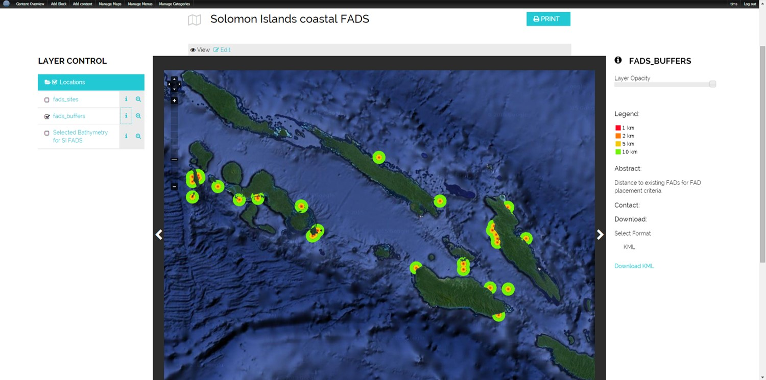

Screenshot showing location map of Solomon Island coastal fish aggregation devices, CSIRO 2016

*‘We use FAD and seagrass layers very often’* Solomon Islands Department of Fisheries.

# 5 Enhanced data management and access

## 5.1 Relevance

Respondents rated this element of EPOG as relevant.

*Tools and systems come and go, but data remains…data standards are crucial …collaboration at a Ministry level and academic level* [is essential].(SPC employee)

*It’s aligned to our mandate* [data custodians] *so it did meet expectations.* (SPC employee)

## 5.2 Effectiveness

EPOG aimed to improve the Spatial Data Infrastructure of regional agencies including technology, policies, standards, institutional arrangements and the capacity necessary to enable the creation, exchange and use of geospatial information. Respondents generally rated this element as partially effective noting that some inroads were made such as shared approaches to training and a common data sharing platform. These are further described in Table 4.

#### The EPOG investment in improved data management and access included:

#### three regional workshops that were held with regional agencies to explore how data management could be improved at a regional level

* an agreed standardised approach to training on data infrastructure, standards and management
* enhancement and instalment of a common data sharing platform (PacGeo) between CROP agencies.

#### The three regional spatial data infrastructure workshops that were held demonstrated a mutual desire to develop and implement common regional data standards. However it was difficult to determine a common vision across CROP agencies (and Divisions within them) due to the diversity of data management practices and policies as well as widely differing views and understanding of the issues. While agreement was reached on the need to establish regional data management standards and processes, the absence of direct funding also made it difficult for regional agencies to engage productively and move forward. GPFD rules prohibited investment in partner agency staff resources and this was potentially a factor that limited progress of this element of EPOG.

*…. taking care of the costs for PacGeo hosting is about $600/month. But I had to look for the funding to host this regional service. Didn’t receive anything for ongoing costs – maintenance, ongoing costs, sustainability...there is nothing given to us.* (SPC employee)

Key achievements of this element of the EPOG was the establishment of consistent approaches to training on data infrastructure, standards and management, and enabling agencies to share data through a common platform—PacGeo. PacGeo is based on open sourced software and was initially developed through SPC. Under EPOG it was rolled out to SPREP, SPC and USP so that data could be shared between CROP agencies and with national government agencies.

*Because we had the backing of these agencies, including CSIRO, we could bring USP into the fold as well. Before different agencies went to ministries independently and might have run different training. But now there is a more streamlined approach to training now as well – for capacity building. It’s not just about building tools and data, but to enable people to maintain data on their own.* (SPC employee)

*CSIRO provided support to set up the first open source GIS server to publish our spatial data to help countries view and download that data for their marine spatial planning projects….it was the start of setting up a consistent open source platform across the Pacific. It was really good as it could publish all our spatial data for countries to view from the web without need specialised GIS software.* (SPREP employee)

*….being able to have sister technological systems to disseminate spatial data so countries can set up the same system as SPC and SPREP … shows a more unified approach.* *Ten to 15 years ago it was all proprietary and not open source. Now it’s open source it can be replicated at CROP, country and desktop level. That’s a clear benefit of the project.* (SPREP employee)

## 5.3 Efficiency

Interviewees valued the spatial data infrastructure working groups and the three workshops that were held. CSIRO was able to use its academic reputation to bring USP into the discussion. However, participation was hindered by a lack of resources (people and funding). It was the right mechanism, but required dedicated funding and resources.

*We had a spatial data infrastructure working group, where we tried to formalise things, but it didn’t go very far – no funding.* (SPC)

*The good thing about EPOG was that we could connect with many other agencies. World Bank is not very technical so* [if it had funded us] *it would have just been SPC doing all the work on its own.* (SPC)

## 5.4 Sustainability

While regional players have the desire and capability to further align regional data infrastructure and policies, further work is subject to funding. Without dedicated resources their capacity to progress this work is limited.

The Ocean Office plans to continue to work closely with SPREP and SPC to ensure the Project Portal remains in a form which can be easily shared through the PacGeo portals as was intended, and to have a utility to the wider members of the Alliance, including PICTs.

*EPOG has opened dialogues between SPC and SPREP to discuss data that would be mutually beneficial for sharing... it’s created a nice conversation between officers of SPREP and SPC.* (SPREP employee)

**Table 4 Enhanced data access achievements**

|  |  |  |  |
| --- | --- | --- | --- |
| **Project outcomes** | **Outcome achieved** | **Impact** | **Achievements and Impact** |
| Data management capacity is improved in regional agencies | Partially | Low | Three spatial data infrastructure (SDI) regional workshops were held that included CSIRO, GA, SPC, SPREP, USyd, PIFS, University of the South Pacific, GRID-Arendal, United Nations Environment Program and IUCN. The purpose of these workshops was to identify common issues relating to data access, interpretation and delivery needs, and data availability within regional agencies.  EPOG resulted in increased collaboration and communication between regional agencies on data standards and capacity building. The collaboration between SPC, USyd and GA has enhanced the SDI in SPCs Geoscience Division. This existing collaboration was leveraged to implement elements of SDI at SPREP and SPCs FAME division. |
| Consistent process for data management implemented across regional agencies and data can be shared between agencies | Partially | Moderate | GA and CSIRO were able to offer technical expertise to SPC that was not available from other donors and support agencies, such as the World Bank. This technical input led to the deployment of a common data management system at SPC, SPREP and USP. Data can now be shared easily between SPC and SPREP via PacGeo and SPREP’s Environmental Spatial Information Server.  This SDI was specifically designed to operate in low bandwidth countries and provide support for in country backup of existing data. |
| Regional agencies have improved capacity to use data needed for ocean governance | Partially | Moderate | Officers are using geospatial tools and data not accessed previously, including PacGeo. PacGeo is an open source, online platform containing over 170 datasets. SPC initially developed PacGeo with the support of GA, USyd and GRID-Arendal.  CSIRO supported SPREP to develop ESIS (<http://gis.sprep.org>) which is a platform to support data management and the delivery of outputs from SPREPs programs. |

# 6. Lessons learned and Conclusion

## 6.1 Lessons learned

1. **The Office of the Pacific Ocean Commissioner effectively fills a need for regional coordination of oceans policy and issues**

* The EPOG project demonstrated that the Ocean Office could be an effective entity for supporting regional coordination on oceans matters including the United Nations treaty on biodiversity beyond national jurisdiction and implementation of Sustainable Development Goal 14.
* The Ocean Office has the potential to play an important role in coordination of regional agencies, national governments and donors to ensure investment in oceans and marine planning is complementary and not duplicative.
* The Ocean Office holds the promise of being an effective mechanism for supporting and coordinating implementation of the Framework for a Pacific Oceanscape at a national scale.

1. **The collaborative model used for maritime boundary activities was efficient and effective**

* The legal and technical support provided to SPC and Pacific Island countries to assist with identifying, negotiating and achieving recognition under international law was highly valued and effective.
* The maritime boundaries workshop model was proven to be highly effective and could be tested for its applicability to marine spatial planning at a national and local levels.
* Investments under EPOG catalysed progress with defining maritime boundary, bilateral treaties and boundary delimitation under international law.

1. **Marine spatial planning is in the formative stages of development in the Pacific region**

* Many countries are engaging with the concept of marine spatial planning and are implementing at least some elements of it. Marine spatial planning is a crowded space with many donors investing in marine spatial planning using different approaches which is potentially confusing for PICs. Finding a mechanism to share lessons learned and provide training would be valuable. This role could be filled by the Ocean Office.
* Marine spatial planning needs further investment over a longer timeframe to build relationships and develop approaches in partnership with regional agencies, national governments, communities and non-government organisations.
* Regional agencies have limited capacity to support Pacific Island countries with their spatial data infrastructure. The effectiveness of EPOG may have been improved by funding staff in regional agencies to their build capacity and ownership.
* The introduction of technological approaches to marine spatial planning in countries that have limited IT infrastructure is challenging and greater benefits may be derived from low technology approaches.
* While new activities like spatial planning may have merit, consideration should be given to the value they will bring within a local context and resourcing implications for participating partners/agencies.
* The Solomon Islands and Kiribati require further technical and policy support for marine spatial planning and data management.
  + The Solomon Islands has the potential to be at the forefront of marine spatial planning in the Pacific due to its investment in high-level decision making processes for ocean policy, an integrated ICT system and uptake of marine spatial planning tools by the environment and fisheries agencies.
  + The Kiribati government agencies understand how to use marine spatial planning as a tool for managing marine resources and now have some technical capacity. Further support is needed to maintain those skills, and to continue to build their capacity and maintain spatial data infrastructure.
  + SPC requires dedicated resourcing to continue to support open-source geospatial systems (PacGeo) currently in use by other regional agencies and Pacific Island countries.

1. **Marine Spatial Planning has the potential to break down silos between people and sectors**

* Rather than trying to standardise a particular model of marine spatial planning, more progress could be achieved by bringing regional agencies, countries, or different levels of government, together to learn from each other and plan together.
* Participatory project planning and implementation must be an essential element of any future investment.
* Countries need to be able to set their own agenda for management of their marine areas.

1. **Progress in oceans governance in the Pacific is dependent on respectful, trusting and collaborative relationships:**

* Relationships take time to build. A self-sustaining outcome that builds relationships, trust and capacity needs a longer term investment than EPOG.
* Investment in the provision of technical support for marine spatial planning has the potential to break down silos by focussing on bringing people from all levels of government and the community together to plan how to use and manage their resources sustainably.

1. **Capacity building needs targeted and sustained effort, delivered in partnership with the counterpart agencies**

Building skills and technical capacity requires ongoing support over long periods of time.

* Capacity building in the Pacific should be planned and funded to ensure that providers can spend the necessary time in-country to build skills, knowledge and confidence.
* Transition arrangements need to be considered well in advance of new arrangements (e.g. 12 months). When the Ocean Office deployment finished, momentum was lost because longer term funding arrangements for dedicated, full-time staff had not been established.
* Investment in building the capacity of regional agencies and provision of resources is likely to be the most effective way to support Pacific Island countries with marine policy, spatial planning and data management.

1. **Data management at a regional level requires ongoing investment**

High quality and accessible data is important for good planning and management.

* Further investment in data management should be through regional agencies with a focus on integrating data standards and strengthening data-sharing arrangements.
* Investment needs to be fit for purpose, noting the technological limitations in the region e.g. low bandwidth.

1. **Supporting Pacific neighbours contributes to Australia’s domestic priorities**

Investing in building the technical and policy capability of the Pacific region to sustainably manage and use marine resources is important for regional security and cooperation.

* Investment in strengthening ocean governance has enabled Pacific Island countries and Australia to participate in strategic policy discussions and bring a Pacific voice to international fora.
* The delimitation of Exclusive Economic Zones is central for Pacific Island countries to have sovereignty over marine resources, and for economic and regional security.
* Sustainable management of marine resources within the Pacific region complements Australia’s domestic interests in safeguarding transboundary and/or migratory marine habitats and species.

**i) Administratively efficient measures for implementation of overseas development assistance projects need to be identified before the project commences**

* A deployment arranged through DFAT’s systems would have led to a more efficient outcome and enabled departmental staff to spend more time on program management and policy advice.

## 6.2 Conclusion

Overall, the evaluation found that the EPOG project was a successful project that largely met its stated outcomes. All elements of the project—regional ocean governance, maritime boundaries, marine spatial planning and data management—were, and continue to be, highly relevant to Pacific intergovernmental agencies and Pacific Island countries.

Regional leadership and coordination of oceans policy was strengthened through investment in the provision of technical support and the establishment of the Office of the Pacific Ocean Commissioner. Pacific Island countries agreed and established a number of maritime boundaries in accordance with international law over the course of EPOG and there is a Pacific-wide commitment to continuing to prioritise this important work. At regional, national and local levels, there is increased capacity for marine spatial planning to better manage marine resources. Regional agencies now have a cost-effective platform for sharing data in PacGeo. Many of EPOG’s initiatives will require ongoing investment to achieve sustained outcomes. The investments made through EPOG have increased the Pacific region’s capacity and provided the impetus for a continuing body of work aimed at sustainable management of ocean and marine resources.

# Appendix 1: Program logic

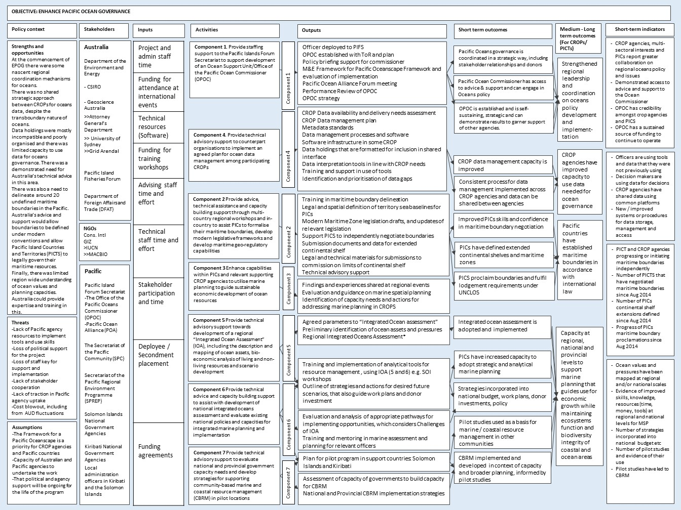

# Appendix 2: Results Table

| **Regional ocean governance** | | | | |
| --- | --- | --- | --- | --- |
| Level of logic | Expected results | Achievements | Evidence (qualitative and indicators) | Data quality (triangulation of 3 groups) |
| Activities | Partner with PIFS to recruit and deploy an ocean analyst  Provide staffing support to PIFS to support development of an ocean support unit/Ocean Office. | * In partnership with PIFS, DoEE deployed an advisor to PIFS in the position of Ocean Analyst for the Ocean Office, for two years. * The Ocean Office coordinated a successful meeting with Pacific Small Island Developing States[3] (PSIDS) in New York on marine genetic resources in 2015 which sought to strengthen the relationship between PSIDS representatives in New York and CROP agencies and representatives in PICs capitals. * In November 2016, in Samoa, the Ocean Office and CSIRO joined forces with the UN Convention on Biological Diversity’s Sustainable Ocean Initiative to hold a Pacific Ocean Alliance workshop on the theme of the Aichi Biodiversity Targets and Sustainable Development Goal 14 (SDG14) Target 7 – that is, ”by 2030, increase the economic benefits to Small Island Developing States and least developed countries from sustainable use of marine resources, including through sustainable management of fisheries, aquaculture and tourism”. The outcomes of this workshop provided material for further regional meetings in the lead up to the UN SDG14 Conference. * A smaller Technical Working Group of the Alliance was formed to provide expert technical advice taking into account the views of the broader Pacific Ocean Alliance. The first working group meeting of 20 technical Alliance partners was held in May 2015 to discuss the proposed BBNJ UN treaty. A technical report was prepared to support stakeholders entering into negotiations. * In early 2017 Ocean Office worked closely with Fiji to co-Chair the regional ‘policy & technical’ preparatory meetings for BBNJ and the UN Ocean Conference on SDG14. This needed and reached out to members of the CROP MSWG and the Pacific Ocean Alliance. * CSIRO also contributed to regional coordination and strategic direction by providing technical support to the Ocean Office in their regional preparations for the BBNJ negotiations. CSIRO collated regional data on conservation values and pressures, to help PICTs to understand the possible role and implications of a treaty on the conservation of biological diversity in areas beyond national jurisdiction. CSIRO collated data on deep sea mining, fishing vessel activity and ecologically or biologically significant areas and displayed them in an online mapping tool. The analysis identified significant potential for the interaction between high seas fisheries vessels and deep sea mining contractors, as well as multiple pressures on an ecologically or biologically significant area. This analysis gave PICTs a deeper understanding of the possible implications of such an international treaty. | Data included meeting reports at: <http://www.forumsec.org/pages.cfm/strategic-partnerships-coordination/pacific-oceanscape/pacific-ocean-alliance/pacific-ocean-alliance-meeting-1.html>  <https://www.cbd.int/meetings/SOIWS-2016-03>  <http://www.forumsec.org/resources/uploads/embeds/file/FINAL%20BBNJ%20Technical%20Paper.pdf>  The advisor enabled the commissioner to drive regional coordination on oceans issues more effectively. This is evidenced by a range of outputs produced such as: a technical report and series of three technical papers to support members on the issues of BBNJ; various advocacy and communication materials for the Pacific Ocean Commissioner; video messaging by the Commissioner in the lead up to COP21; and branding templates designed for the Ocean Office and the Pacific Ocean Alliance. The advisor also prepared many Ocean Office interventions for various forums at regional and global levels. The Ocean Office in 2017 was also able to provide support towards preparations and presentations for the regional pre-UN Ocean Conference (March 2017), UN Ocean Conference (June 2017), pre-COP23 (August 2017), Our Oceans Conference in Malta (October 2017), Arctic Circle Assembly and the Fisheries Exchange with Iceland (October 2017), FAO (November 2017), and COP23 (November 2017).  Specific indicators can be viewed in the Program Logic at Appendix 1 | Data was collected via reports and interviews.  Feedback about this component was provided by:  - deployee  - Ocean Office  - SPREP  - FFA  - NGO  We tried to obtain additional data from country representatives, but were unsuccessful.  Written feedback was provided by the PSIDS Chair, PIF Chair and the Chair of the BBNJ Prepcomm about the deployee. |
| Outputs | Officer deployed to PIFs; Ocean Office established with TOR and plan; Policy briefing and support for Commissioner; M&E Framework for Framework for a Pacific Oceanscape and evaluation of implementation; Pacific Ocean Alliance meeting; Performance review of Ocean Office; Ocean Office strategy | * As a result of the deployment, the Ocean Office became operational and developed a credible identity in the region as an effective coordination mechanism and advocate for regional ocean policy and cross-cutting ocean initiatives and priorities. * Prior to the EPOG project, there was no significant and dedicated means to resource and implement the mechanism for Pacific-wide coordination of ocean policy. The operation of the Ocean Office provided strategic direction to the Ocean community of practice within the Pacific, which led to for example a stronger Pacific engagement in the international negotiations for a new treaty on marine biodiversity areas beyond national jurisdiction (BBNJ) under the United Nations Convention on the Law of the Sea. * The Ocean Office built close links between PIFS and other CROP agencies, and strengthened collaboration through participation in the Marine Sector Working Group, regular meetings and communications with all stakeholders, and the establishment of the Pacific Ocean Alliance (the Alliance). * The advisor developed and finalised the management arrangements for the Alliance and drafted a concept for the next formal discussion on ocean development opportunities. This work also laid the foundations for the Ocean Office to support PICTs on the inaugural UN Oceans Conference held in June 2017 to discuss implementation of SDG14 within the broader Development 2030 Agenda. The advisor supported the Ocean Office with the establishment of the Pacific Ocean Alliance—a multi-sector, open ended group that facilitated regional dialogue between CROP agencies, national government, private enterprise and NGOs. * The inaugural meeting of the Alliance titled ‘High Hopes for the High Seas’ was held in May 2015, in Fiji. It focused on Pacific interests in areas beyond national jurisdiction. Over 100 participants, including national representatives, UN Mission delegates, regional/international inter-governmental organisations, international/regional non-government organisations, private sector, civil society and academics attended. The meeting was successful in drawing together stakeholders that do not usually engage, nor have an existing platform to engage on these regional cross-cutting issues. The purpose of the meeting was to share information and start a regional dialogue on high seas issues in the context of upcoming UN negotiations on biodiversity in areas beyond national jurisdiction. | The regional leadership role that the Ocean Office played in the biodiversity beyond national jurisdiction negotiations was formally recognised in writing by PSIDS Chair (Nauru PRUN HE Marlene Moses); PIF Chair (Papua New Guinea PRUN) and the Chair of the BBNJ Prepcomm (PRUN Trinidad and Tobago HE Eden Charles). The CROP Marine Sector Working Group has also voiced their support of the Ocean Office highlighting the value it adds to the region and to the CROP MSWG on cross-sectoral and cross-jurisdictional leadership.  The 2015 Alliance meeting was highly successful and much acclaimed. During the DOEE evaluation of EPOG, one interviewee described this meeting as ‘one of those rare seminal meetings in which you could trace a logical policy development’.  The Alliance has enabled the Ocean Office to effectively champion regional leadership and coordination of oceans issues. For example, the outcomes of the 2015 Alliance meeting informed the development of a technical report to support PICTS, CROP agencies and other stakeholders engaging in BBNJ processes.  Specific indicators can be viewed in the Program Logic at Appendix 1 |
| Intermediate outcomes | The Ocean Office is established and is self-sustaining, strategic and can demonstrate results to garner support of other agencies.  Pacific Ocean Commissioner has access to advice and support and can engage in Regional Ocean policies.  Pacific Ocean governance is coordinated in a strategic way, including stakeholder relationships, with both donors and partners. | * The Ocean Office was established and operationalised. * The Ocean Office provided strategic direction across the Pacific, which led to stronger Pacific engagement in the international negotiations e.g. a new treaty on marine biodiversity areas beyond national jurisdiction (BBNJ) under the United Nations Convention on the Law of the Sea; Our Ocean Conference on Sustainable Development Goal 14 (SDG14). * The Ocean Office strengthened links and collaboration between regional agencies. * The Ocean Office developed a credible identity in the region as an effective coordination mechanism and advocate for regional ocean policy and cross-cutting ocean initiatives. * The Ocean Office was partially self-sustaining by the end of 2018. Australia is providing funding for a further three years. * The Pacific Ocean Commissioner was supported through the deployment of an Oceans Analyst and technical staff * The provision of technical support enabled the Commissioner to drive regional coordination on oceans issues more effectively. The Commissioner engaged in oceans policy at both a regional and international level. * The Pacific Ocean Alliance was established to bring together all sectors and stakeholders involved in ocean management * Two alliance workshops and a technical working group developed policy for Pacific engagement in BBNJ and SDG14 * The Ocean Office provided strategic direction to the Pacific agencies and countries which led to stronger Pacific engagement in the BBNJ process. * The Ocean Office coordinated a successful meeting with Pacific Small Island Developing States (PSIDS) in New York on marine genetic resources, and strengthened the relationship between PSIDS representatives in New York, regional agencies and Pacific Island countries. |
| Conclusions | To what extent did the program contribute to improvements in oceans governance? | * With effective support from the advisor, the Ocean Office significantly increased coordination of oceans governance in the Pacific. * It is plausible to assume that the project made significant achievements in regional coordination of ocean issues given the consistent feedback and regional engagement in issues such as the BBNJ PrepComm meetings, as well as the inaugural Alliance meeting. However, the effort was not been sustained after the deployee’s position ended as short-term funding led to employment of part-time technical staff which was insufficient. * These conclusions can be read with a high level of certainty because of the amount and quality of data collected to evaluate this component and because the feedback from multiple parties was consistent. | | |

| **Maritime boundaries delimitation** | | | | |
| --- | --- | --- | --- | --- |
| Level of logic | Expected results | Achievements | Evidence (qualitative and indicators) | Data quality (triangulation of 3 groups) |
| Activities | Provide advice, technical assistance and capacity building support through multi-country regional workshops and in-country to assist PICs to formalise their maritime boundaries, develop modern legislative frameworks and develop maritime geo-regulatory capabilities | EPOG funded the following activities:   * provision of technical expertise from GA USyd and GRID-Arendal * provision of legal expertise from a dedicated full-time staff member at AGD * 4 regional and 1 sub-regional workshops held, including travel costs for participants * software and hardware e.g. travel for GA/USyd/AGD staff to provide in-country training and assistance.   A treaty template was developed to improve legal consistency across the region. | Frost R, Hibberd P, Nidung M, Artack E and Bourrel M (2016) Redrawing the map of the Pacific. *Marine Policy* (<https://doi.org/10.1016/j.marpol.2016.06.003>)  Specific indicators can be viewed in the Program Logic at Appendix 1 | Data was collected via reports and interviews.  Feedback about this component was provided by:  - deployee  - SPREP  - SPC (two divisions)  - GA  - USyd  - AGD  - NGO  - Fiji  - Solomon Islands  - Samoa  - Republic of the Marshall Islands  - Tonga  - Vanuatu  - Cook Islands  - Niue  Evidence of outputs is also available on the DOALOS website at <http://www.un.org/Depts/los/LEGISLATIONANDTREATIES/index.htm> |
| Outputs | Training in maritime boundary delineation  Legal and spatial definition of territory sea baselines for PICs  Modern Maritime Zone legislation drafts, and updates of relevant legislation  Support PICs to independently negotiate boundaries  Submission documents and data for extended continental shelf  Legal and technical materials for submissions to commission on limits of continental shelf  Technical advisory support | * Primary investment was in building SPC technical and legal capability which could be maintained within core funding, and developing a model for regional support that was delivered through SPC. The program also included significant direct mentoring of legal and technical officers within countries. * Unreliable internet limits access by some countries to datasets in the cloud. SPC purchased and deployed portable servers for countries to use instead. USyd hired a developer to work in SPC Geoscience Division for a few months to support this work. * EPOG funded the creation of PacGeo (<http://pacgeo.org/>) which is a regional marine spatial planning portal, containing over 170 datasets. |
| Intermediate outcomes (Practice and attitude changes) | PICs proclaim boundaries and fulfil lodgement requirements under the United Nations Convention on the Law of the Sea  PICs have defined extended continental shelves and maritime zones  PICs have improved skills and confidence in maritime boundary negotiation and delimitation. | Milestones achieved between 2014 and 2017 include:   * FSM successfully deposited their maritime boundaries agreements with Marshall Islands, Guam and Papua New Guinea to the United Nations Division for Ocean Affairs and the Law of the Sea (DOALOS) in 2017. * Review of Republic of the Marshall Islands Baselines and proposal for declaring archipelagic baselines was completed and lodged with DOALOS in 2016. * Draft Fiji-Solomon Islands treaty was prepared for executive approval in 2016. * Fiji, Kiribati, Nauru, Niue, Tuvalu and Vanuatu deposited revised maritime boundaries and treaties with the Secretary General of the United Nations (UN) between 2014 and 2016. * Cook Islands deposited treaties and EEZ limits with the Secretary General of the UN in 2014. * Palau has deposited provisional EEZ limits with the UN Secretary General. * A joint submission (Papua New Guinea, Federated States of Micronesia, Solomon Islands) to the UN Commission on the Limits of the Continental Shelf over the Ontong Java Plateau is ongoing (submitted in 2009; updated in 2014). * The Cook Islands’ Manihiki Plateau submission to Commission on the Limits of the Continental Shelf was finalised in August 2016 (submitted in 2009).   Further information is available at:  <http://www.un.org/Depts/los/LEGISLATIONANDTREATIES/depositpublicity.htm>  Treaties have been negotiated between the following countries:   * Tuvalu-Fiji (amendments agreed) (2014) * Tuvalu-France (Wallis & Futuna) (amendments agreed) (2015) * Fiji-France (Wallis & Futuna amendments) (2015) * Samoa and Tonga completed their technical negotiations on their shared boundary in 2017. This will now be submitted for internal governmental approval prior to heads of state signing a treaty. * Vanuatu and Solomon Islands signed a maritime boundary agreement in 2016.   Legislation:   * Reviewed Solomon Islands’ maritime boundary legislation. * Republic of the Marshall Islands Maritime Zones ACT in force in 2016. * Papua New Guinea Maritime Zones ACT in force May 1st 2017. |
| Conclusions | To what extent did the program contribute to improvements in maritime boundary delimitation? | * EPOG resulted in significant progress in formalising maritime boundaries, developing modern legislative frameworks and maritime geo-regulatory capabilities in the Pacific. While some of this progress was made prior to the start of EPOG, it is plausible to accept that the project substantially sped up the process, enabling results to be achieved sooner. * All interviews with stakeholders demonstrate that the project has had a positive and enduring impact on maritime boundary delimitation in the Pacific. DFAT has provided a further three years of funding to continue this work. * These conclusions can be read with a high level of certainty because of the amount and quality of data collected to evaluate this component and because the feedback from all parties was consistent. | | |

| **Marine spatial planning** | | | | |
| --- | --- | --- | --- | --- |
| Level of logic | Expected results | Achievements | Evidence (qualitative and indicators) | Data quality (triangulation of 3 groups) |
| Activities | Enhance capabilities within PICs and relevant supporting CROP agencies to utilise marine planning to guide sustainable economic development of ocean resources.  Provide technical advisory support towards development of a regional “Integrated Ocean Assessment” including the description and mapping of ocean assets, bio economic analysis of living and non-living resources and scenario development.  Provide technical advice and capacity building support to assist with development of national integrated oceans assessment and evaluate existing national policies and capacities for integrated marine planning and implementation.  Provide technical and advisory support to evaluate national and provincial government capacity needs and develop strategies for supporting community-based marine and coastal resource management in pilot locations | Overview   * Some activities and outputs for this component were changed as knowledge on the ground evolved as the initial plans proved inappropriate or too ambitious. These changes are detailed by individual activities below. * Through EPOG, CSIRO invested in the use of marine spatial planning, as an inter-disciplinary platform for increasing understanding of marine ecosystem services and for managing conflicting demands for resource access and management. To do this, the project applied different approaches at regional, national and sub-national levels by targeted capacity building within both PICs and CROP agencies. A range of information products, tools and training were provided to CROP agencies and PICs (Solomon Islands and Kiribati) to build their marine planning capabilities. * At a regional level, preliminary work was undertaken on an integrated ocean assessment and a regional marine information portal. At a national level, pilot projects were run in the Solomon Islands and Kiribati to develop their marine spatial planning capabilities, based on their individual situations. At a sub-regional level, Tarawa Lagoon in Kiribati was the geographical focus for a workshop and is discussed in the next section of this report.   Regional  **Integrated Ocean Assessment** – This component changed throughout the course of the project. The Integrated Ocean Assessment was originally meant to be a static document, but was turned into a data portal in association with SPREP.  **Regional project portal** – CSIRO made an inventory of projects at the regional scale to identify current projects and relevant datasets for natural resource management. This was put into a geo-referenced database (or project portal) and can be viewed at <http://msp.csiro.au/projects>. The Ocean Office assisted in creating the project inventory through the Marine Sector Working Group.  National  CSIRO ran two pilot projects at a national level to trial the development and use of marine spatial planning products. Solomon Islands and Kiribati were selected due to the difference in their existing levels of capacity and policy needs.  **Solomon Islands** - CSIRO collated 900 data layers to include in SolGeo covering information on values, pressures and human uses, such as fisheries, climate, environment, and human infrastructure. CSIRO trained 80 officers from the environment and fisheries departments as well as the ICT Unit on how to use and maintain this information.  CSIRO also developed and populated a geo-referenced database which spatially maps marine-related projects undertaken in Solomon Islands including programs managed by SPC, SPREP and World Fish.  CSIRO helped the ICT Unit, fisheries and environment departments to establish a data-sharing protocol as part of the ongoing maintenance of SolGeo.  **Kiribati** – CSIRO installed and populated KIGeo, a national project data base and a marine information platform. CSIRO established this spatial data infrastructure using standard software (PacGeo) and they trained 60 officers in the use of SDI and GIS. Technical capabilities in Kiribati are less advanced than the Solomon Islands with government agencies separated from each other technologically and geographically. This led CSIRO to establishing two versions of KIGeo within different divisions – the Minerals Unit and the coastal fisheries division.  Sub-regional  **Tarawa Lagoon** - Initial plans for this component were to develop the Tarawa Lagoon Management Plan. In 2016, following a change in government and staff, the Kiribati Ministry of Fisheries and Marine Resources Development (MFMRD) asked for training in how to develop a lagoon management plan, rather than development of the plan itself. CSIRO delivered this training in collaboration with ANCORS in July 2016. It was based on another workshop held in Nauru and integrated ‘Theory of Change’ work undertaken by ANCORS. In the workshop CSIRO, with the assistance of ANCORS, demonstrated how marine spatial planning tools and information can be applied to a strategic assessment of Tarawa Lagoon. | Specific indicators can be viewed in the Program Logic at Appendix 1  Integrated Ocean Assessment can be found at <http://msp.csiro.au>.  Regional project portal can be viewed at <http://msp.csiro.au/projects>.  Tarawa Lagoon workshop report  Department Kiribati trip report  The Solomon Islands environment department is providing information from SolGeo into the IUCN-led Oceans12 process, which has, in turn, generated discussions about what data should and shouldn’t be shared and how to do it. | Data was collected via reports, web portals and interviews.  Feedback about this component was provided by:  - SPREP  - SPC (two divisions)  - CSIRO  - donor agency  - deployee  - Solomon Islands (3 divisions)  - Kiribati (1 division)  - DOEE  - NGO |
| Outputs | Agreed parameters to “Integrated Ocean Assessment”. Preliminary identification of ocean assets and pressures.  Training and implementation of analytical tools for resource management, using IOA (5 and 6) e.g. SOI workshops.  Outline strategies and actions for desired future scenarios, that also guide work plans and donor investment. | Regional  Integrated Ocean Assessment can be found at <http://msp.csiro.au>. This portal provides information that enables users to examine interactions at a regional scale between pressures and biological assets, such as between shipping, marine debris, mineral densities and coral bleaching, whales, turtles and biodiversity proxies.  Regional project portal can be viewed at <http://msp.csiro.au/projects>.  National  **Solomon Islands** - CSIRO worked with the Solomon Islands ICT unit to deploy an information portal (SolGeo) using open-source (free on line) software (PacGeo). The SolGeo tool allows officers to collect spatial data layers and view them in one place. CSIRO also developed a national project portal.  **Kiribati**   * KIGeo, a national project data base and a marine information platform. * Tarawa Lagoon workshop report |
| Intermediate outcomes (Practice and attitude changes) | PICs have increased capacity to adopt strategic and analytical approaches to marine planning  Strategies incorporated into national budgets, work plans, donor investments and policy  Pilot studies used as a basis for marine/coastal resource management in other communities  CBRM implemented and developed in context of capacity and broader planning, informed by pilot studies  Integrated ocean assessment is adopted and implemented. | Access to the project portal by the Kiribati and Solomon Islands governments and the Ocean Office has given officers an improved understanding of past and current programs and projects. This will allow them to identify opportunities for project coordination and gaps that should be addressed by future investment.  The Solomon Islands have used the SDI tools to:   * determine site selection and allocation for seaweed farming, and deployment and management of fish aggregation devices. * inform the implementation of a Protected Areas Policy, specifically for the management of a near-shore marine protected areas network. The tools were used to consider marine and coastal values in the policy process. * demonstrate the value of spatial data to decision-making processes. One interviewee noted “many people were surprised by the opportunities SolGeo provides.”   The Minerals Unit within the Kiribati Ministry of Fisheries and Marine Resources Development uses the tool to overlay maritime boundaries with their various data sets such as coastal erosion, minerals deposits and the location of aggregate leases. With CSIRO support, the coastal fisheries team developed key data sets for the Kiribati coastline, fish attracting devices and marine protected areas which can be visualised on KIGeo.  Tarawa Lagoon workshop: the approach engaged remote villages in Marine Spatial Planning activities, and provided linkages between local people and relevant government agencies. This included officials from regional councils and Kiribati government agencies including MRMRD, Ministry of Finance and Economic Development, Ministry of Environment, Lands and Agriculture Development and the Ministry of Women, Youth and Social Affairs.  The workshop highlighted the fact that the level of knowledge and expertise in marine planning within Kiribati government agencies was extremely limited. For this reason, the decision taken by the EPOG project to reorient the relevant activity component from producing a Tarawa Lagoon management plan to conducting training on how to produce a management plan was appropriate. The workshop also underscored the enthusiasm amongst government agencies to improve their skills in this area. Meeting feedback highlighted the success of the workshop format with respondents stating they would have liked it to be longer and that they appreciated the inclusive, rather than top-down approach. |
| Conclusions | To what extent did the program contribute to increased use of marine spatial planning? | * EPOG resulted in some increased understanding and use of marine spatial planning. At a national level this occurred in Kiribati and Solomon Islands. It should be noted that the national projects were pilot projects to test the theory and concept. * All interviews with stakeholders demonstrate that the projects increased understanding and use of marine spatial planning in the pilot countries. Respondents noted that there were some challenges which could not be overcome in the project timeframe and the work is not finished. Ongoing maintenance and sustainability of the tools was raised as a common concern. * These conclusions can be read with a medium level of certainty because of the amount of data collected to evaluate this component and because the feedback from all parties was relatively consistent. It should be noted that no data was collected from participants of the Tarawa Lagoon workshop or the Minerals Unit within the fisheries department of Kiribati. | | |

|  |  |  |  |  |
| --- | --- | --- | --- | --- |
| **Enhanced data access** | | | | |
| Level of logic | Expected results | Achievements | Evidence (qualitative and indicators) | Data quality (triangulation of 3 groups) |
| Activities | Provide technical advisory support to counterpart organisations to implement an agreed plan for ocean data management among participating CROPs | * This component aimed to improve the Spatial Data Infrastructure (SDI) of CROP agencies. SDI encompasses the technology, policies, standards, institutional arrangements and human resources necessary to enable the creation, exchange and use of geospatial information. It includes the activities necessary to acquire, process, discover, distribute, use and curate spatial data. * Three SDI regional meetings were held that included CSIRO, GA, SPC, SPREP, USyd, PIFS, University of the South Pacific, GRID-Arendal, United Nations Environment Program and IUCN. The purpose of these workshops was to identify common issues relating to data access, interpretation and delivery needs, and data availability within CROP agencies. * CSIRO supported to SPREP to develop ESIS (<http://gis.sprep.org>) which is a platform to support data management and the delivery of outputs from SPREPs programs. * Australia’s National Environmental Information Infrastructure | CROP agencies have shared data using common platforms – data can be shared between ESIS (SPREP) and PacGeo (SPC)  New/improved systems or procedures for data storage, management and access.  “Before different agencies went to ministries independently and might have run different training. But now there is a more streamlined approach to training for capacity building.”  Specific indicators can be viewed in the Program Logic at Appendix 1 | Data was collected via interviews.  Feedback about this component was provided by:  - SPREP  - SPC  - FFA  - CSIRO |
| Outputs | CROP data availability and delivery needs assessment  CROP data management plan  Metadata standards  Data management processes and software  Software infrastructure in some CROPs  Data holdings that are formatted for inclusion in shared interface  Data interpretation tools in line with CROP needs  Training and support in use of tools  Identification and prioritisation of data gaps | GA and CSIRO were also able to offer technical expertise to SPC that was not available from other donors and support agencies, such as the World Bank. This technical input led to the deployment of a common data management system at SPC, SPREP and USP. I.e. Data can now easily be shared between SPC and SPREP via PacGeo and ESIS. The SDI was also specifically designed to operate in low bandwidth countries and provide support for in country backup of existing data. |
| Intermediate outcomes (Practice and attitude changes) | CROP data management capacity is improved  Consistent process for data management implemented across CROP agencies and data can be shared between agencies  CROP agencies have improved capacity to use data needed for ocean governance | * EPOG resulted in some collaboration and communication between CROP agencies on data standards and capacity building. The collaboration between SPC, USyd and GA has enhanced the SDI in SPCs Geoscience Division. This existing collaboration was leveraged to implement elements of SDI at SPREP and SPCs FAME division. * While the workshops demonstrated a mutual desire to address these issues at a regional level, CROP agencies lacked the staff resources required to take action. |
| Conclusions | To what extent did the program contribute to enhanced data access? | * Limited progress was made in this component. While there was a desire to address these issues, CROP agencies lacked the staff resources required to progress work. * There was a limited amount of data about this component because work didn’t progress as planned, but the feedback was consistent. | | |

# Appendix 3: Supporting information

Pacific Ocean Alliance workshop report, November 2016, at <https://www.cbd.int/meetings/SOIWS-2016-03>. More information can be found at <http://forumsec.org/pages.cfm/strategic-partnerships-coordination/pacific-oceanscape/pacific-ocean-alliance/>

Inaugural Pacific Ocean Alliance meeting May 2015 - more information can be found at: <http://www.forumsec.org/pages.cfm/strategic-partnerships-coordination/pacific-oceanscape/pacific-ocean-alliance/pacific-ocean-alliance-meeting-1.html>

Pacific Ocean Alliance Technical Working Group report, May 2015: <http://www.forumsec.org/resources/uploads/embeds/file/FINAL%20BBNJ%20Technical%20Paper.pdf>

Maritime boundaries information: Frost R, Hibberd P, Nidung M, Artack E and Bourrel M (2016) Redrawing the map of the Pacific. *Marine Policy* (<https://doi.org/10.1016/j.marpol.2016.06.003>)

Ambassador Marlene Mosese, Pacific Small Island Developing States chair in New York; Ambassador Eden Charles (Trinidad and Tobago), Chair of the BBNJ Prepcomm; and the Papua New Guinea mission to the United Nations in their capacity as PIF Chair, all formally recognised, in writing, the regional leadership role that the Ocean Office played in the BBNJ negotiations.

Tarawa Lagoon workshop report

SOI workshop report

GPFD progress reports (6 monthly)

# Appendix 4: List of people interviewed

|  |  |  |  |  |
| --- | --- | --- | --- | --- |
| **Name** | **Organisation** | **Organisation type** | **Individual/ group interview** | **EPOG Component** |
| Mike O’Donoghue and Warren Lee Long | Threatened and Migratory Species Advisor and Coastal and Marine Advisor, SPREP | regional agency | Group | MSP and OG |
| Sachindra Singh | Geoscience Division, SPC | regional agency | Individual | MTB, MSP and data |
| Jan Steffen | German Agency for International Cooperation Project director for MACBIO | Other | Individual | MSP |
| Agnetha Vave-Karamui, Environment and Conservation Division | Ministry of Environment, Climate Change, Disaster Management & Meteorology Solomon Islands Government | National government | Group | MSP |
| Rosalie Masu & Ann-Maree Schwarz | Ministry of Fisheries and Marine Resources Solomon Islands Government | National government | MSP |
| Andre Piazza and Aydin Ada, ICT Advisers | Information Communications Technology Support Unit, Ministry of Finance and Treasury, Solomon Islands government | Consultants to national government | Group | MSP |
| Sue Miller-Taei | Pacific Islands and New Zealand Programme Conservation International | Non Government Organisation | Individual |  |
| Ryan Wright, Stuart Chape, Anthony Tahouli | SPREP | regional agency | Group | MSP, OG, data |
| Jens Kruger and Akuila Tawake | SPC Geoscience division | regional agency | Group | MTB, OG |
| Mr Viliami Va'inga Tone, | Secretary for Foreign Affairs Tonga | National government | Group | MTB |
| Mr Taaniela Kula, Deputy Secretary | Ministry of Lands, Environment, Climate Change & Natural Resources, Tonga | National government | MTB |
| Mr James Bruce Lutui, | Attorney General’s Office, Tonga | National government | MTB |
| Mr Malakai Vakautawale, Senior Technical Officer (GIS/Mapping), and Mr Semi Bolalailai, Senior Scientific Officer | Ministry of Lands and Mineral Resources, Fiji | National government | Group | MTB |
| Ms Melania Baba, Multilateral Bureau | Ministry of Foreign Affairs, Fiji | National government | MTB |
| Lt Cr Gerard Rokoua and Lt Jarvis Robinson | Hydrographic Unit, Fiji Navy | National government | MTB |
| Timaima Dimaiwaqa Vakadewabuka | Principal Legal Officer, Solicitor General’s Office, Fiji | National government | MTB |
| Mr David Natogga, Geologist, | Ministry of Mines, Energy & Rural Electrification, Solomon Islands | National government | MTB |
| Mr Daniel Damilea, Senior Crown Counsel | The Attorney Generals Chambers, Solomon Islands | National government | MTB |
| Ms Miriam Lidimani | Ministry of Foreign Affairs and External Trade, Solomon Islands | National government | MTB |
| Hubert Kalauni | Department of Justice, Lands and Survey, Niue | National government | Group | MTB |
| Vaipo Mataora | Manager, Geospatial Ministry of Infrastructure and Planning, Cook Islands | National government | MTB |
| Toney Tevi, National Coordinator, and Ionie Bolenga, Maritime Boundary Delimitation Project, | Department of Foreign Affairs & External Trade, Vanuatu | National government | MTB |
| Constance Rivers | Attorney-Generals, Samoa | National government | Group | MTB |
| Telesia Sila | Ministry of Natural Resources and Environment, Samoa | National government | MTB |
| Matilda Bartley | Ministry of Foreign Affairs and Trade Samoa | National government | MTB |
| Benedict Yamamura, Coastal Fisheries and Information Officer | Marshall Island Marine Resources Authority | National government | MTB |
| Liz Brierley | EPOG deployee | Office of the Pacific Ocean Coordinator | Individual | OG and MSP |
| Alice McDonald | Fisheries Management Advisory, FFA | Regional agency | Individual | OG |
| Chris Schweizer | Australian Government – Department of the Environment | Implementing agency | Individual | EPOG |
| Piers Dunstan | CSIRO | Implementing partner | Individual | MSP, OG, data |
| Kairos Lentumoa | Head of IT and Statistics unit, Fisheries Division, MFMRD, Kiribati government | National government | Individual written survey | MSP |
| Taati Eria | Fisheries Division, MFMRD officer Kiribati government | National government | Individual written survey | MSP |
| Anna Potter | GA | Implementing partner | Written information submitted jointly and group discussion | MTB |
| Robyn Frost and Frances Anggadi | AGD | Implementing partner | MTB |
| Elaine Baker | USyd | Implementing partner | MTB |
| Mark Alcock | GA | Implementing partner | Written information submitted | MTB |
| Cristelle Pratt | Director General of the Ocean Office | Regional agency | Individual | OG |

Components Key: OG = Regional oceans governance MTB = Maritime boundaries; MSP = Marine spatial planning; data = Enhanced data access

# Appendix 5: Interview questions

**Enhancing Pacific Ocean Governance Project Evaluation  
Questions for semi- structured interviews with recipients, beneficiaries and stakeholders**

Please record participants’ names and organisations at the commencement of the interview. Please ask each person interviewed to fill out the Adult Consent form. This form enables the Department of the Environment and Energy to use quotes, photos (if taken) and recordings (if taken) and quotes for the evaluation report.

Please provide an overview / explanation of the EPOG project (see attached overview that can be used for this purpose). Note there are four elements to EPOG but it is likely that participants will be familiar with only one or two of these elements.

**Background information**

Which elements of the Enhancing Pacific Ocean Governance Project have you been involved with or are familiar with?

🞏 Ocean Governance - Regional marine policy coordination – for example support for the Pacific Island Forum Secretariat to establish the Office of the Pacific Ocean Commissioner and the Pacific Ocean Alliance.

🞏 Defining Maritime Boundaries – for example Assisting Pacific Island Countries with the determination of maritime boundaries in accordance with international law.

🞏 Marine spatial planning – for example assisting regional and national government agencies with marine planning for sustainable use. This may involve training or workshops on how to do marine planning and providing technical tools to support marine planning.

🞏 Improving access to data – for example establishing systems so that data can be stored and shared; training on how to store and use data for decision making.

**Question 1 (Overarching question)**

**1(a) From your perspective (your agency’s perspective or your perspective in your professional or personal capacity) what do you think the outcomes of EPOG were? What did EPOG achieve?**

**Question 2 (Relevance)**

2(a) How well did the EPOG protect meet the priorities of your organisation?

**2(b) How would you rate the relevance of EPOG’s support to your organisation   
highly relevant, somewhat relevant, not very relevant, no relevance**

2(c) Did the EPOG project adapt or make any changes to meet the needs of your organisation?

**Question 3 (Effectiveness)**

3(a) What do you think was the most important outcome achieved through EPOG?

3(b) Did EPOG achieve what you expected it to achieve?

**3(c) What were the things that worked well?**

**3(d) What were the things that needed to be improved or done differently?**

**Question 4 (Efficiency)**

4(a) Was there enough time to achieve the outcomes you were expecting from EPOG?

4(b) Was there sufficient funds to achieve the outcomes you expected?

4(c) Could the outcomes of EPOG be achieved using a different approach or mechanisms?

4(d) Did EPOG coordinate with other donors or stakeholders

**Question 5 (Impact)**

5(a) What has happened as a result of EPOG? (consider social, economic, environmental and technical factors)

**5(b) What difference has EPOG made to the Pacific and/or your country / agency?**

5(c) What difference have capacity building activities made at an individual or organisational level? (Capacity building is about buildings skills, knowledge, technical expertise, know-how, and confidence)

**5(d) Were there any unintended or intended (positive and negative) outcomes?**

**5(e) What would have happened if EPOG did not exist?**

5(f) How will the benefits of EPOG last?

**Question 6 (Sustainability)**

6(a) What local systems and processes were used to achieve outcomes or implement activities?

**6(b) How will your organisation continue to build on the work done under EPOG? If yes, what will be done?**

6(c) What level of local leadership was there for EPOG? (e.g. champion within your organisation, by local government etc.)

6(d) How did EPOG build on existing Pacific systems?

1. Effective means that the outcomes were realised and evidence that intervention made a crucial contribution
2. Partially effective means that outcomes were realised in part and evidence that intervention made an important contribution
3. Pacific Small Island Developing States (PSIDS) is a term coined by PSIDS Permanent Representatives to the United Nations in New York, for the grouping of PSIDS. It includes all of the Forum members, excluding Cook Islands and Niue (who are not UN member states), Australia and New Zealand. PSIDS also includes Timor L’Este, who are also members of the PACP grouping.