

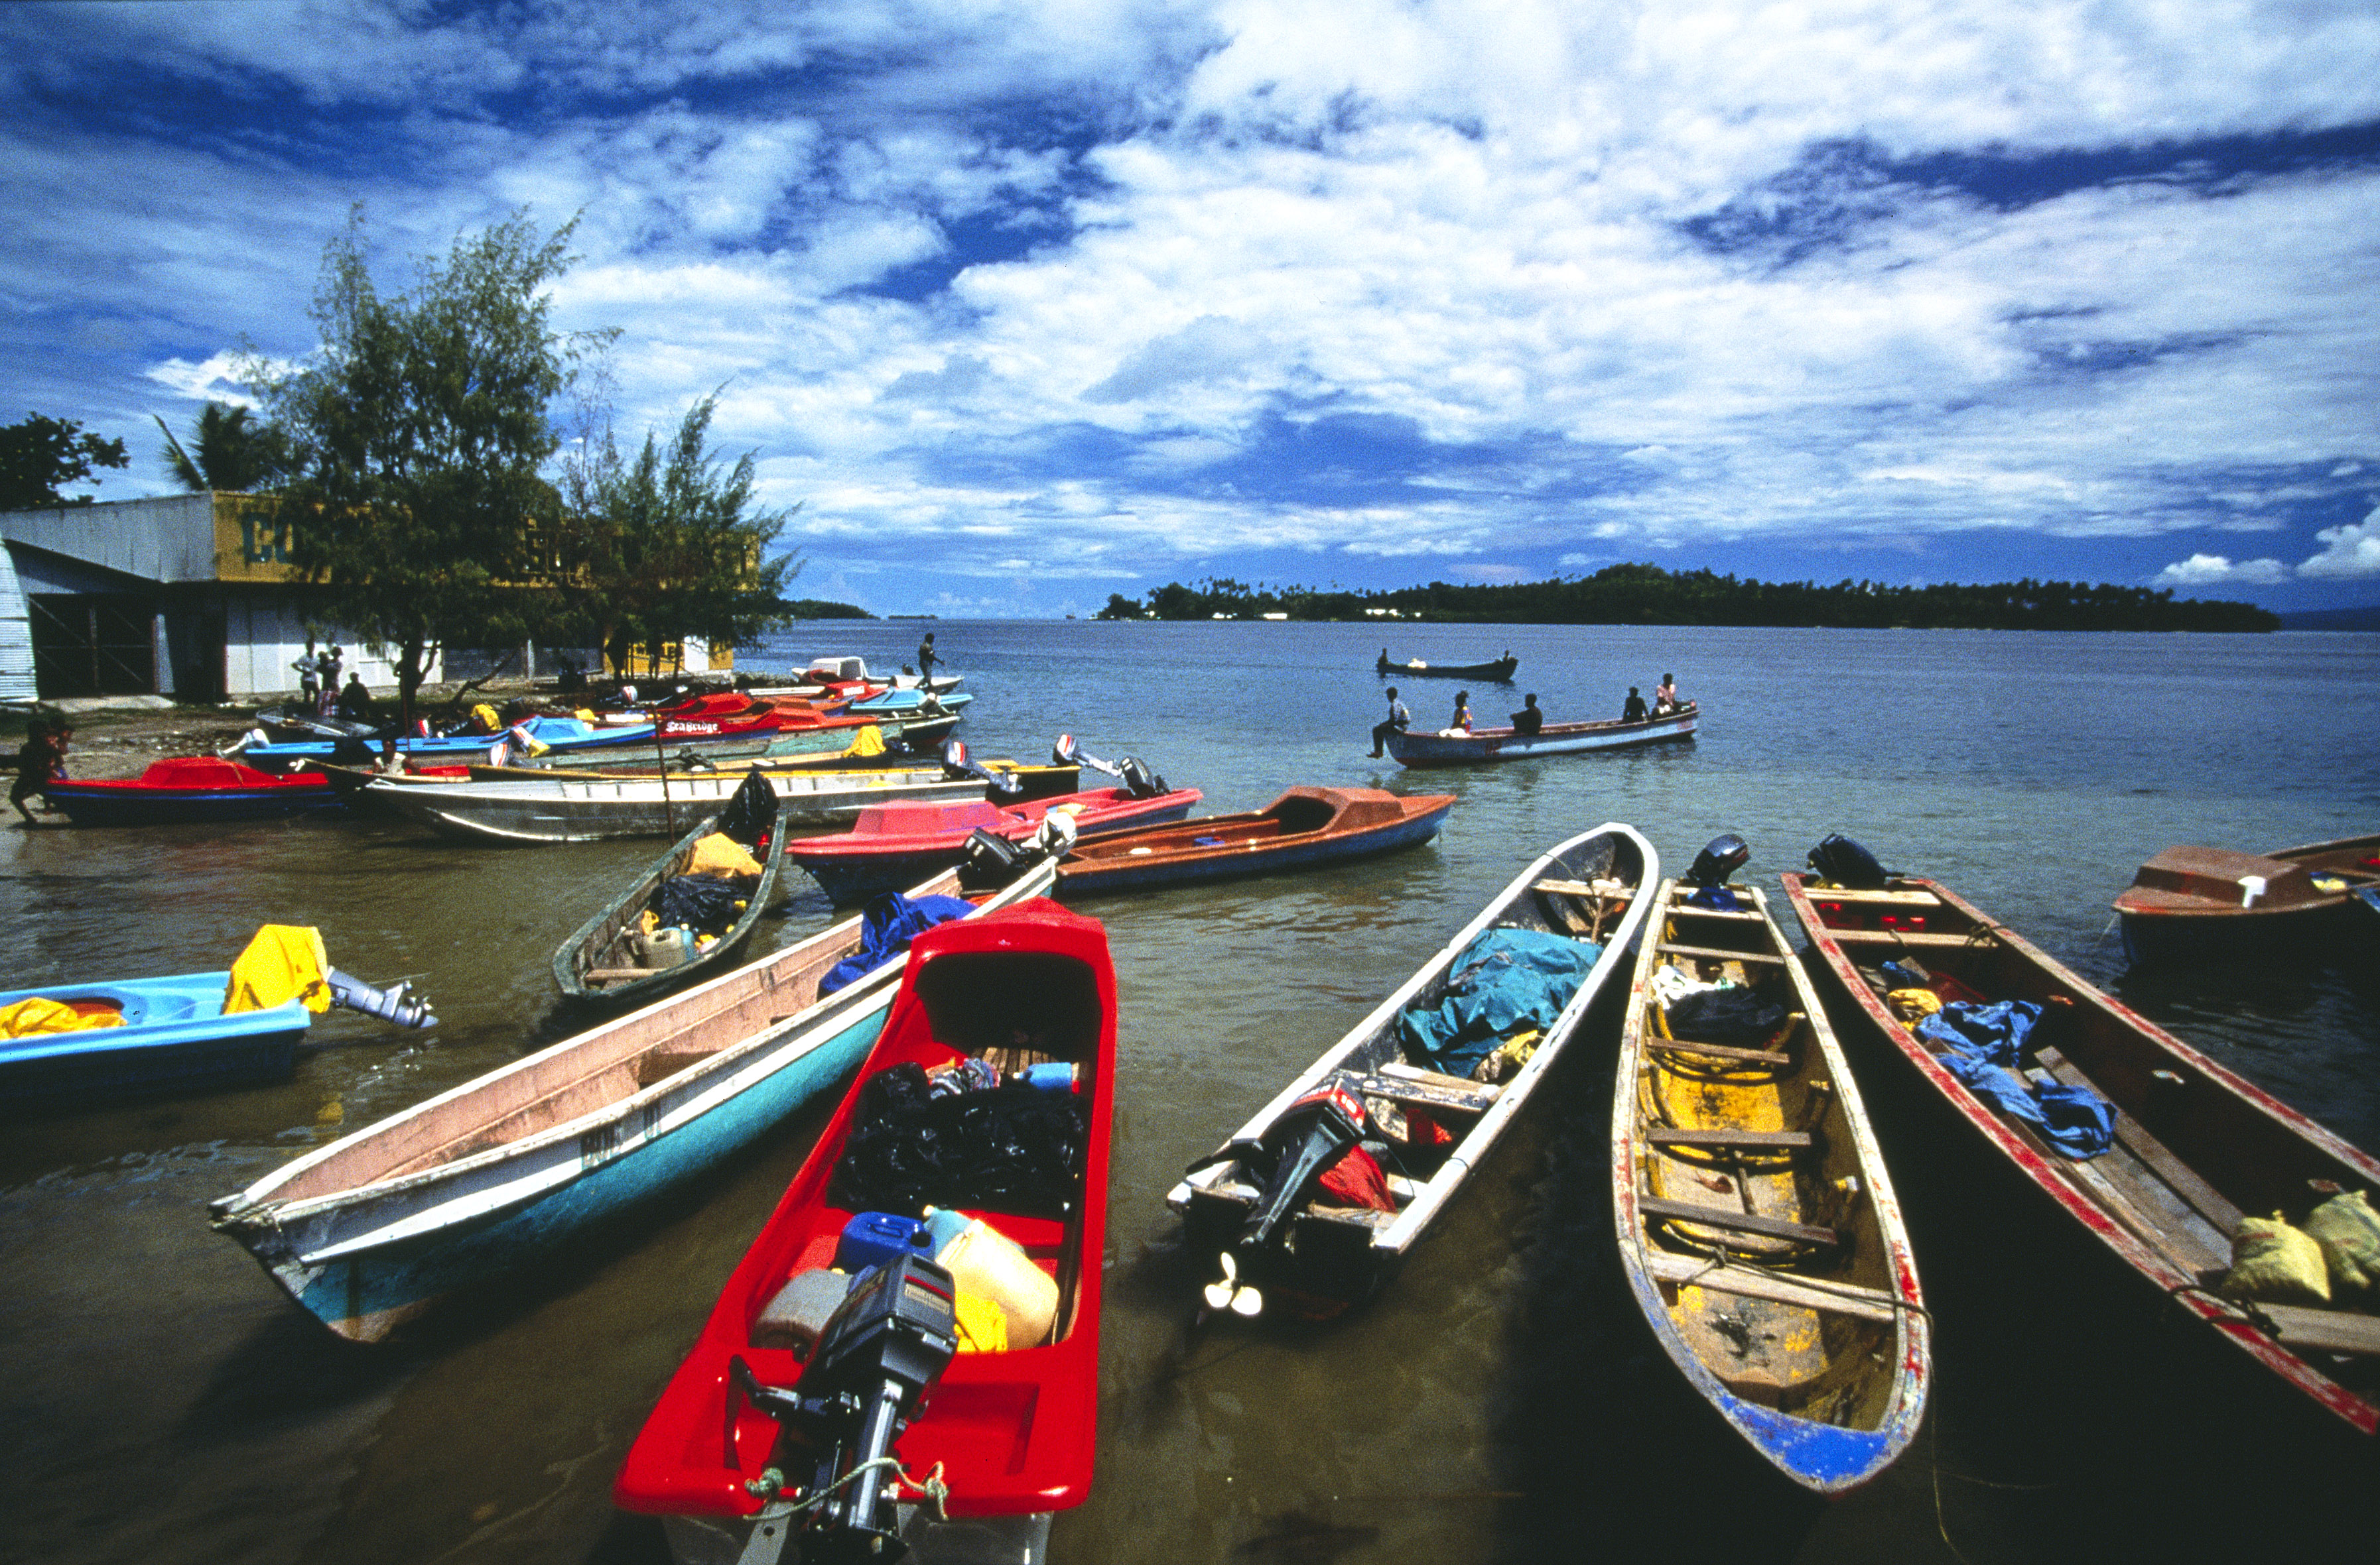Enhancing Pacific Ocean Governance

For the nations of the Pacific region, the Pacific Ocean serves as an important supplier of natural resources. While significant efforts are directed towards fisheries governance, a greater focus needs to be directed to other sectors in the region, the interactions between sectors, and the potential for environmental changes to undermine the resource base.

In response, the Pacific Island Forum leaders in 2010 endorsed the Framework for a Pacific Oceanscape, which identifies strategic priorities and actions throughout the region to achieve sustainable development, management and conservation of the Pacific Ocean—including actions designed to support sustainable economic development and food security in the region.

The Enhancing Pacific Ocean Governance (EPOG) project aims to assist in the implementation of these actions under the Framework. The project’s overarching goal is to empower Pacific Island countries and territories to effectively manage marine and coastal resources for sustainable economic development and food security, while maintaining productive ecosystems and biodiversity. The project will also support regional organisations and countries move towards a more holistic, cross-sectoral approach to ocean governance.

|  |  |
| --- | --- |
| SNAPSHOT | |
| Summary | Enhancing ocean governance for sustainable economic development in the Pacific Islands region by:   * strengthening regional leadership and cooperation on oceans * establishing jurisdictional rights and responsibilities over maritime boundaries * supporting decision-making through improved access to information * conducting marine assessment and planning activities to understand ocean management priorities, mobilise and coordinate action, and monitor progress * building national and regional marine policy, planning, science and geospatial knowledge and capabilities. |
| Who is involved | The project is delivered through a partnership between the following Australian public sector organisations:   * Department of the Environment * Geoscience Australia * Commonwealth Scientific and Industrial Research Organisation (CSIRO) * Attorney-General’s Department * Sydney University/GRID Arendal   These organisations are working with key Pacific regional and national agency counterparts:   * Pacific Islands Forum Secretariat * Secretariat of the Pacific Community * Secretariat of the Pacific Regional Environment Programme * Pacific Islands Forum Fisheries Agency * Targeted Pacific Island countries and territories |
| Implementation | June 2014–June 2016 |
| Funding | The project will receive $5.4 million, comprising:   * $3.65 million from the Australian Aid Government Partnerships for Development funding program * $1.75 million in co-contributions from the participating Australian public sector organisations.   The Government Partnerships for Development funding program supports partnerships between Australian public sector organisations and counterpart national and regional public sector organisations. It aims to draw on Australian public sector expertise to assist organisations to carry out their critical roles in supporting sustainable and inclusive economic growth, and reducing poverty. |

**Implementation plan**

The EPOG project comprises the following interlinked components which specifically support the actions identified by Pacific leaders in the Framework for a Pacific Oceanscape:

Ocean governance

The Australian Government, through the Department of the Environment, is working to enhance regional marine policy coordination by deploying an officer to the Pacific Islands Forum Secretariat to support the Ocean Commissioner in carrying out their regional marine policy coordination role.

Maritime boundary delimitation

The long-running partnership of Geoscience Australia, the Attorney-General’s Department, Sydney University/GRID Arendal, the Pacific Islands Forum Fisheries Agency and the Secretariat for the Pacific Community is continuing to assist Pacific countries in determining their maritime boundaries under international law, consistent with the United Nations Convention on the Law of the Sea.

Enhanced access to data

The CSIRO, Sydney University/GRID Arendal and Geoscience Australia are working with counterpart agencies to improve access to and usability of data held by Council of Regional Organisations in the Pacific (CROP) agencies. This includes developing data management processes, establishing a data interface, developing data interpretation tools and providing training to end-users.

This will build on efforts previously carried out by the Sydney University/GRID Arendal and the Secretariat for the Pacific Community, CSIRO and the Australian Ocean Data Network.

Marine spatial planning

CSIRO, the Department of the Environment and partner agencies are working at a regional, national and sub-national level to support marine planning processes. At a regional level this includes working with CROP agencies to produce a regional integrated ocean assessment and support the use of that assessment to guide regional policy, programs and research.

At a national level the project is exploring and expanding marine spatial planning processes in two pilot countries to achieve economic development and environmental objectives. This will include the development of national integrated ocean assessments to inform the review, and the update of national policies and plans.

CSIRO, Department of the Environment and consultant advisors will work with national and provincial level governments in pilot locations to develop strategies for strengthening the implementation of community-based marine and coastal resource management.

The project is working with country agencies to identify and tailor approaches to marine planning, and identify capacity development needs associated with their use.

For further information

[http://www.environment.gov.au/marine/ international-activities](http://www.environment.gov.au/marine/%20international-activities)

[EPOG@environment.gov.au](mailto:EPOG@environment.gov.au)