EXDOC

Exporter Interface System

Specification

Errata Set 52

Version 9.6

Issue date: 01 March 2022

# Introduction

This document lists amendments that have been identified for Version 9.6 of the Exporter Interface System Specification issued March 2022. It follows Errata Set 51. Please update your copy of the specification as appropriate.

Within the following document where there are changes to segment or data rules the entire segment has been reproduced with the changes to the rules underlined. Where text has been deleted the text is displayed in the sections below with lines through the text. Where text has been added the text is underlined in the sections below.

* + - 1. Reason 13 (Lodge): GR11 FTX (Role – Coded Statement)

Segment Rule: Optional. May be supplied if Commodity Type is set to ‘G’ (Grains) or ‘H’ (Horticulture) otherwise not allowed.

Segment Rule: Multiple repeats are not allowed.

Data Item: *Name:* Text Subject Qualifier, *Element:* FTX 4451

Data Rule: Must equal ZZZ (Coded Statement).

Data Item: *Name:* Statement Number, *Element:* FTX C108/4440

Data Rule: Minimum 1 and maximum 5 repeats.

Data Rule: Free format text.

Data Rule: Content is validated ~~manually~~ by departmental staff.

* + - 1. Reason 13 (Lodge): GR19 PNA (Role – Processing Establishment Number/Name)

Segment Rule: Mandatory. Requires a parent Production Process segment.

Segment Rule: This segment contains either the Establishment Number or the Establishment Name but not both. If data is provided in element C206 (Establishment Number) then no data is allowed to be provided in the C816 element, and vice-versa.

Segment Rule: Mandatory. If free format text Establishment Name is provided and free format text Process Type is ‘CT’ or ‘AQ’.

Data Item: *Name:* Party Qualifier, *Element:* PNA 3035

Data Rule: Must equal MP (Manufacturing Plant).

Data Item: *Name:* Establishment Number, *Element:* PNA C206/7402

Data Rule: Must equal a registered Establishment Number.

Data Rule: Whilst not under the control of the Exporter System, the establishment will be validated by Exdoc to ensure it was able to perform the nominated process for the nominated product in the nominated period.

Data Item: *Name:* Party Identification Details, *Element:* PNA C082

Data Rule: Free format text if required by the combination of commodity and destination.

Data Item: *Name:* Name Component Qualifier, *Element:* PNA C816/3405

Data Rule: Must equal 10 (Full Name).

Data Item: *Name:* Establishment Name, *Element:* PNA C816/3398

Data Rule: Free format text. Must be non-blank.

~~Data Item:~~ *~~Name:~~* ~~Party Identification Details,~~ *~~Element:~~* ~~PNA C082~~

~~Data Rule: Free format text if required by the combination of commodity and destination.~~

1. Exdoc (RFP) Adaptation of SANCRT

**Exdoc (RFP) Adaptation of SANCRT**

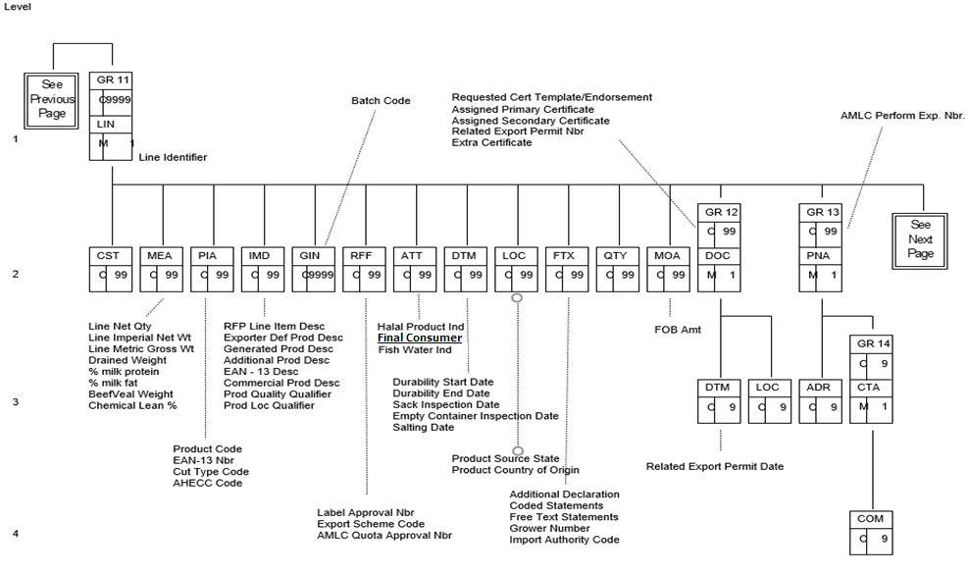

Figure - EXDOC (RFP) Adaptation of SANCRT – Part 3

Appendix D: Data Element Directory Exdoc (RFP) Adaptation of SANCRT

| Data Element | Format | Comments |
| --- | --- | --- |
| Certificate Number | ~~n..7~~  n..8 | All Exdoc generated numbers are greater than 1,000,000. Manually generated numbers are less than 1,000,000. |
|  |  |  |
|  |  |  |
|  |  |  |

Appendix F: Sample Messages

Sample Fish Messages

Lodge RFP

1. Interchange Header UNB+UNOB:2+8+7+990608:0922+3++EXDOC|
2. Message Header UNH+6+SANCRT:D:97B:UN:RF0801|
3. Message Ident BGM+F::AQ:9++13|
4. Loading Port LOC+9+SYD|
5. Discharge Port LOC+12+USWAS|
6. Destination City LOC+8+WASHINGTON|
7. Destination Country LOC+36+US|
8. Prod Source Country LOC+30+AU|
9. Transit Country LOC+49+MX|
10. Cert. Req. Location LOC+91+CBR|
11. Print Region LOC+48+CBR|
12. Exporter Reference RFF+ABE:GJR001|
13. Transhipment Temp MEA+TE+ADE+CEL::-6.5:-1.25|
14. Certificate Print Ind GIS+M::AQ:PHC|
15. Sep Cert Cont Ind GIS+N::AQ:SC|
16. Sep Cert Marks Ind GIS+N::AQ:SM|
17. Sep Cert Packer Ind GIS+N::AQ:SP|
18. Ship Stores Ind GIS+N::AQ:SST|
19. Customs Agent Ind GIS+N::AQ:ACS|
20. Imported Product Flag GIS+N::AQ:IPF|
21. Import Permit Nbr DOC+911+ABC123|
22. Import Permit Date DTM+137:20040315:102|
23. Owner Exporter Nbr PNA+EX+99999|
24. Consignee Name PNA+CN+++++10:CONSIGNEE JOE|
25. Consignee Address ADR++5:1600 PENSYLLVANIA AVE+WASHINGTON++US|
26. Consignee TRACES ID FTX+ZZZ+4+TRACESCONSIGNEEID:160:AQ+12AB34CD+|
27. Transport Details TDT+12+68+1++:::BLUEBOTTLE INDUSTRIES+++:::TITANIC|
28. Departure Date DTM+136:20040420:102|
29. Inspection Process PRC+IN:PP:AQ|
30. Insp Requested Date DTM+318:20040410:102|
31. Inspect Estab Nbr PNA+FO+80|
32. Line Identifier LIN+1|
33. Line Net Quantity MEA+AAA+SQ+TNE:100|
34. Line Imp Net Weight MEA+AAI+AAL+LTN:100|
35. Line Met Gr Weight MEA+AAI+AAE+TNE:120|
36. Product Code PIA+5+CABABP:CC|
37. Cut Type PIA+5+FC0001:BP|
38. ~~Final Consumer ATT+10++Y:FCI:AQ|~~
39. Exporter’s Prod Desc IMD+++UHC:::CHILLED COD BRAIN|
40. Final Consumer ATT+10++Y:FCI:AQ|
41. Fish Water Indicator ATT+10++F:FWI:AQ|
42. Prod Country of Origin LOC+27+AU|
43. Durability Start Date DTM+194:20040120:102|
44. Durability End Date DTM+206:20040122:102|
45. Packaging Details PAC+1+3+CT::AQ|
46. Shipping Marks PCI++MARKS1|
47. Harvest Area Process PRC+HA:PP:AQ|
48. Harvest Start Date DTM+194:20031129:102|
49. Harvest End Date DTM+206:20031201:102|
50. Depuration Date DTM+9:20031202:102|
51. Harvest Area/Lease LOC+48+MYALL LAKES+123B|
52. Depuration Plant PNA+SK+80|
53. Production Process PRC+PC:PP:AQ|
54. Process Start Date DTM+194:20031222:102|
55. Process End Date DTM+206:20031222:102|
56. Processing Estab Nbr PNA+MP+80|
57. Production Process PRC+FV:PP:AQ|
58. Process Start Date DTM+194:20031222:102|
59. Process End Date DTM+206:20031222:102|
60. Processing Estab Nbr PNA+MP++REGID123|
61. Process Estab Addr ADR++STREET1:STREET2+CITY+2066+AU+:::ACT|
62. Process Estab Contact CTA+ZZZ|
63. Process Estab Phone COM+12345657891:TE|
64. Production Process PRC+TV:PP:AQ|
65. Process Start Date DTM+194:20031222:102|
66. Process End Date DTM+206:20031222:102|
67. Processing Estab Nbr PNA+MP++REGID|
68. Process Estab Adr ADR++STREET1:STREET2+CITY+2066+AU+:::ACT|
69. Process Estab Contact CTA+ZZZ|
70. Process Estab Phone COM+12345657891:TE|
71. Production Process PRC+IR:PP:AQ|
72. Process Start Date DTM+194:20031222:102|
73. Process End Date DTM+206:20031222:102|
74. Processing Estab Nbr PNA+MP+81
75. Message Trailer UNT+50+6|
76. Interchange Trailer UNZ+1+3|