**EXDOC**

Exporter Interface System

Specification

Errata Set 54

Version

Issue date: 18 January 2023

**Table of Contents**

5 Introduction 3

5 Message Content Processing 4

5.1 Order RFP 4

5.2 Lodge RFP 5

5.7 Reissue RFP 7

Appendix A: SANCRT Adaptation & Data Item Mapping 9

Exdoc (RFP) Adaptation of SANCRT 10

RFP Data Item Mapping 12

Appendix B: Message/Segment Summary 14

RFP Message/Segment Summary 14

Appendix C: Change Permissions Matrix 15

Updating RFP Details 15

Appendix D: Data Element Directory 16

Appendix E: Code Sets 17

E41 Treatment Active Ingredient 17

E42 Treatment Concentration Unit 17

E43 Product Condition 17

E44 Product Part 17

Appendix F: Sample Messages 18

Sample Grains Messages 18

# Introduction

This document lists amendments that have been identified for Version of the Exporter Interface System Specification issued . It follows Errata Set 53. Please update your copy of the specification as appropriate.

Within the following document where there are changes to segment or data rules the entire segment has been reproduced with the changes to the rules underlined. Where text has been deleted the text is displayed in the sections below with lines through the text. Where text has been added the text is underlined in the sections below.

## 

# Message Content Processing

## Order RFP

### Processing

#### Reason 16 (Order): GR11 IMD (Role – Product Condition)

Segment Rule: Optional. Where present, data elements are validated for format and, if coded, must conform to the relevant Data Rule as specified for Lodge RFP, otherwise not validated.

Segment Rule: An owner LIN must be present.

#### Reason 16 (Order): GR11 IMD (Role – Product Part)

Segment Rule: Optional. Where present, data elements are validated for format and, if coded, must conform to the relevant Data Rule as specified for Lodge RFP, otherwise not validated.

Segment Rule: An owner LIN must be present.

#### Reason 16 (Order): GR18 IMD (Role – Treatment Active Ingredient)

Segment Rule: Optional. Where present, data elements are validated for format and, if coded, must conform to the relevant Data Rule as specified for Lodge RFP, otherwise not validated.

Segment Rule: An owner Treatment Details PRC must be present.

Reason 16 (Order): GR18 MEA (Role – Treatment Concentration)

Segment Rule: Optional. Where present, data elements are validated for format and, if coded, must conform to the relevant Data Rule as specified for Lodge RFP, otherwise not validated.

Segment Rule: An owner Treatment Details PRC must be present.

#### Reason 16 (Order): GR18 MEA (Role – Treatment Duration)

Segment Rule: Optional. Where present, data elements are validated for format and, if coded, must conform to the relevant Data Rule as specified for Lodge RFP, otherwise not validated.

Segment Rule: An owner Treatment Details PRC must be present.

Reason 16 (Order): GR18 MEA (Role – Treatment Temperature)

Segment Rule: Optional. Where present, data elements are validated for format and, if coded, must conform to the relevant Data Rule as specified for Lodge RFP, otherwise not validated.

Segment Rule: An owner Treatment Details PRC must be present.

## Lodge RFP

### Processing

#### Reason 13 (Lodge): GR11 IMD (Role – Product Condition)

Segment Rule: Optional. If Commodity Type is set to ‘G’ (Grain) or ‘H’ (Horticulture), otherwise not allowed.

Segment Rule: Repeatable field up to a maximum of 10.

Data Item: *Name:* Item characteristic, *Element:* IMD C272/7081

Data Rule: Must equal 203 (Condition).

Data Item: *Name:* Item Description Identification, *Element:* IMD C273/7009

Data Rule: Must equal CND (Condition).

Data Item: *Name:* CND Condition, *Element:* IMD C273/7008

Data Rule: Must equal a valid Product Condition code (See Appendix E).

#### Reason 13 (Lodge): GR11 IMD (Role – Product Part)

Segment Rule: Optional. If Commodity Type is set to ‘G’ (Grain) or ‘H’ (Horticulture), otherwise not allowed.

Data Item: *Name:* Item Description Identification, *Element:* IMD C273/7009

Data Rule: Must equal PVP (Product Part).

Data Item: *Name:* PVP Product Part, *Element:* IMD C273/7008

Data Rule: Must equal a valid Product Part code (See Appendix E).

#### Reason 13 (Lodge): GR18 IMD (Role – Treatment Active Ingredient)

Segment Rule: Conditional. An owner Treatment Details PRC must be present. Commodity Type must be set to ‘G’ (Grain) or ‘H’ (Horticulture).

Segment Rule: Repeatable field up to a maximum of 8.

Segment Rule: Must be supplied if required by importing country conditions, otherwise Optional.

Data Item: *Name:* Item Description Identification, *Element:* IMD C273/7009

Data Rule: Must equal TAI (Treatment Active Ingredient).

Data Item: *Name:* TAI Treatment Active Ingredient, *Element:* IMD C273/7008

Data Rule: Must equal a valid treatment Active Ingredient code (See Appendix E).

Reason 13 (Lodge): GR18 MEA (Role – Treatment Concentration)

Segment Rule: Conditional. An owner Treatment Details PRC must be present. Commodity Type must be set to ‘G’ (Grain) or ‘H’ (Horticulture).

Segment Rule: Must be supplied if required by importing country conditions, otherwise Optional.

Data Item: *Name:* Measure Application Qualifier, *Element:* MEA 6311

Data Rule: Must equal CH (Chemistry).

Data Item: *Name:* Measure Unit Qualifier, *Element:* MEA C174/6411

Data Rule: Must equal a valid Treatment Concentration Unit code (See Appendix E).

Data Item: *Name:* Treatment Concentration amount, *Element:* MEA C174/6314

Data Rule: Must be a numeric measurement value as per specified format. Must not be a negative value.

Reason 13 (Lodge): GR18 MEA (Role – Treatment Duration)

Segment Rule: Conditional. An owner Treatment Details PRC must be present. Commodity Type must be set to ‘G’ (Grain) or ‘H’ (Horticulture).

Segment Rule: Must be supplied if required by importing country conditions, otherwise Optional.

Data Item: *Name:* Measure Application Qualifier, *Element:* MEA 6311

Data Rule: Must equal ABV (Unit of Time).

Data Item: *Name:* Measure Dimension Coded, *Element:* MEA C502/6313

Data Rule: Must equal TN (Time Period).

Data Item: *Name:* Measure Unit Qualifier, *Element:* MEA C174/6411

Data Rule: Must equal SEC(Seconds) or MIN(Minutes) or HUR(Hours) or DAY(Days), per UN Recommendation 20.

Data Item: *Name:* Treatment Duration amount, *Element:* MEA C174/6314

Data Rule: Must be a numeric measurement value.

Reason 13 (Lodge): GR18 MEA (Role – Treatment Temperature)

Segment Rule: Conditional. An owner Treatment Details PRC must be present. Commodity Type must be set to ‘G’ (Grain) or ‘H’ (Horticulture).

Segment Rule: Must be supplied if required by importing country conditions, otherwise Optional.

Data Item: *Name:* Measure Application Qualifier, *Element:* MEA 6311

Data Rule: Must equal TE (Temperature).

Data Item: *Name:* Measure Dimension Coded, *Element:* MEA C502/6313

Data Rule: Must equal TC (Temperature).

Data Item: *Name:* Measure Unit Qualifier, *Element:* MEA C174/6411

Data Rule: Must equal CEL (Degree Celsius) or FAH (Degree Fahrenheit).

Data Item: *Name:* Treatment Temperature value, *Element:* MEA C174/6314

Data Rule: Must be a numeric measurement value.

## Reissue RFP

### Processing

#### Reason 18 (Reissue): GR11 IMD (Role – Product Condition)

Segment Rule: Conditional. Is only present if stored on the Exdoc database.

Segment Rule: Subject to above, repeatable.

Data Item: *Name:* Item characteristic, *Element:* IMD C272/7081

Data Rule: Must equal 203 (Condition).

Data Item: *Name:* Item Description Identification, *Element:* IMD C273/7009

Data Rule: Must equal CND (Condition).

Data Item: *Name:* CND Product Condition, *Element:* IMD C273/7008

Data Rule: Is set to the value(s) stored for this data element in Exdoc.

#### Reason 18 (Reissue): GR11 IMD (Role – Product Part)

Segment Rule: Conditional. Is only present if stored on the Exdoc database.

Data Item: *Name:* Item Description Identification, *Element:* IMD C273/7009

Data Rule: Must equal PVP (Product Part).

Data Item: *Name:* PVP Product Part, *Element:* IMD C273/7008

Data Rule: Is set to the value(s) stored for this data element in Exdoc.

#### Reason 18 (Reissue): GR18 IMD (Role – Treatment Active Ingredient)

Segment Rule: Conditional. Is only present if stored on the Exdoc database.

Segment Rule: Subject to above, repeatable.

Data Item: *Name:* Item Description Identification, *Element:* IMD C273/7009

Data Rule: Must equal TAI (Treatment Active Ingredient).

Data Item: *Name:* TAI Treatment Active Ingredient, *Element:* IMD C273/7008

Data Rule: Is set to the value stored for this data element in Exdoc.

Reason 18 (Reissue): GR18 MEA (Role – Treatment Concentration)

Segment Rule: Conditional. Is only present if stored on the Exdoc database.

Data Item: *Name:* Measure Application Qualifier, *Element:* MEA 6311

Data Rule: Must equal CH (Chemistry).

Data Item: *Name:* Measure Unit Qualifier, *Element:* MEA C174/6411

Data Rule: Is set to the value stored for this data element in Exdoc.

Data Item: *Name:* Treatment Concentration amount, *Element:* MEA C174/6314

Data Rule: Is set to the value stored for this data element in Exdoc.

Reason 18 (Reissue): GR18 MEA (Role – Treatment Duration)

Segment Rule: Conditional. Is only present if stored on the Exdoc database.

Data Item: *Name:* Measure Application Qualifier, *Element:* MEA 6311

Data Rule: Must equal ABV (Unit of Time).

Data Item: *Name:* Measure Dimension Coded, *Element:* MEA C502/6313

Data Rule: Must equal TN (Time Period).

Data Item: *Name:* Measure Unit Qualifier, *Element:* MEA C174/6411

Data Rule: Is set to the value stored for this data element in Exdoc.

Data Item: *Name:* Treatment Duration amount, *Element:* MEA C174/6314

Data Rule: Is set to the value stored for this data element in Exdoc.

Reason 18 (Reissue): GR18 MEA (Role – Treatment Temperature)

Segment Rule: Conditional. Is only present if stored on the Exdoc database.

Data Item: *Name:* Measure Application Qualifier, *Element:* MEA 6311

Data Rule: Must equal TE (Temperature).

Data Item: *Name:* Measure Dimension Coded, *Element:* MEA C502/6313

Data Rule: Must equal TC (Temperature).

Data Item: *Name:* Measure Unit Qualifier, *Element:* MEA C174/6411

Data Rule: Is set to the value stored for this data element in Exdoc.

Data Item: *Name:* Treatment Temperature value, *Element:* MEA C174/6314

Data Rule: Is set to the value stored for this data element in Exdoc.

1. SANCRT Adaptation & Data Item Mapping

Exdoc (RFP) Adaptation of SANCRT

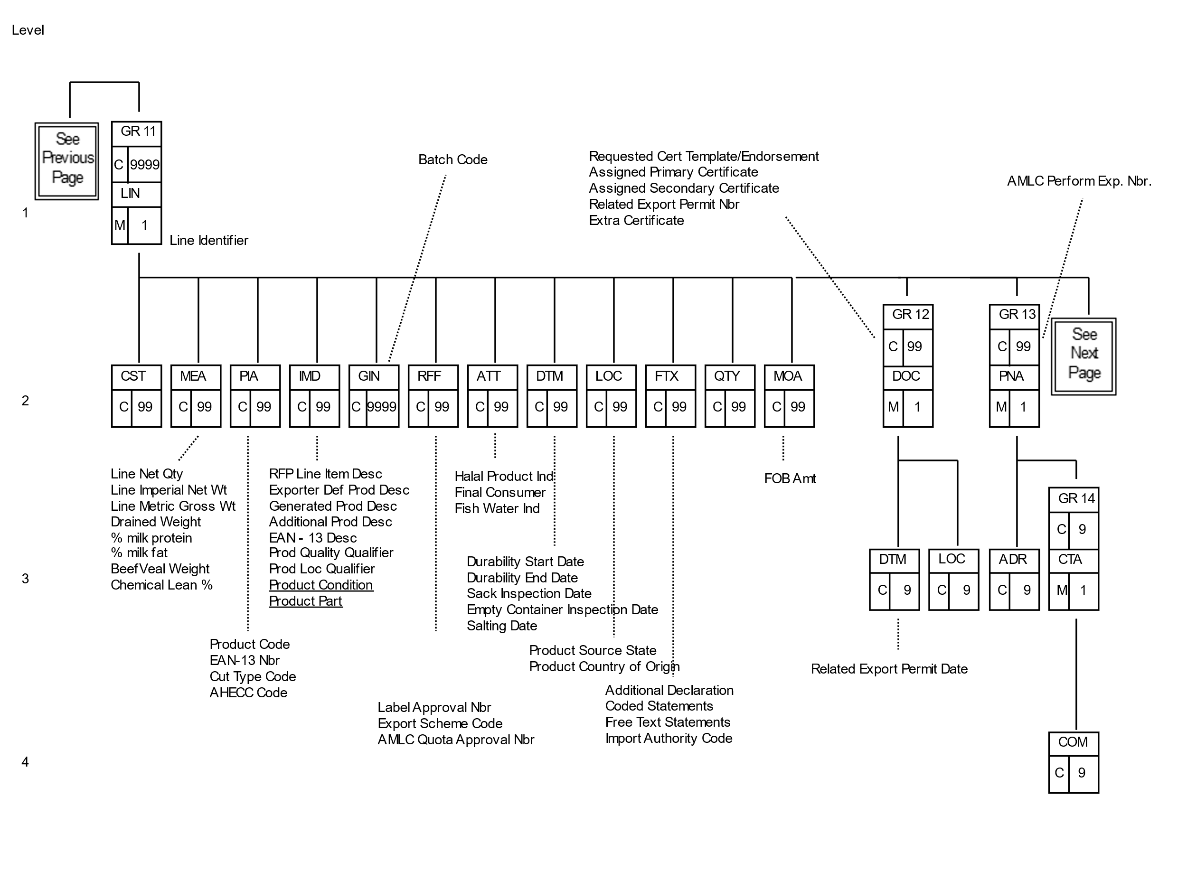

Figure 8 - EXDOC (RFP) Adaptation of SANCRT – Part 3

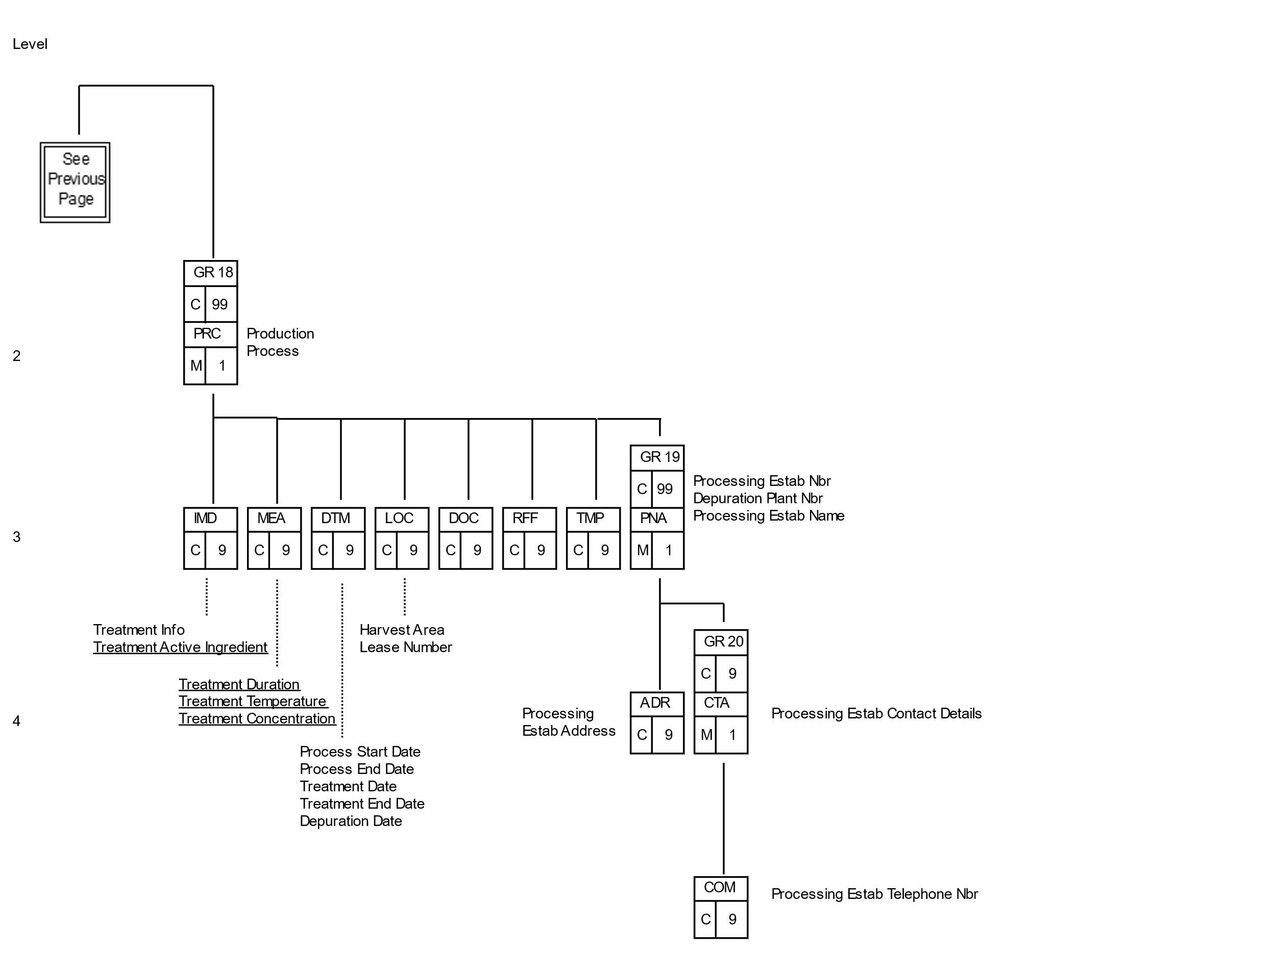

Figure 10 - EXDOC (RFP) Adaptation of SANCRT – Part 5

RFP Data Item Mapping

| Data Item | | |  |  | Group | Seg | Element | Description | Value/Comment |
| --- | --- | --- | --- | --- | --- | --- | --- | --- | --- |
|  |  | **RFP Header** | | | | | | | |
|  | | |  |  |  |  |  |  |  |
| Quota Type | | |  |  | HDR GR0 | FTX | 4451 | Text subject qualifier | ~~Quota Type~~QUT |
|  | | |  |  |  |  | 4453 | Text Function, Coded | Filler (must be blank) |
|  | | |  |  |  |  | C107 | Text Reference | Filler (must be blank) |
|  | | |  |  |  |  | C108/4440 | Quota Type | Free format text value (no repeats) |
|  | | |  |  |  |  |  |  |  |
|  |  | **RFP Line** | | | | | | | |
|  | | |  |  |  |  |  |  |  |
| Product Condition | | |  |  | LIN GR11 | IMD | 7077 | Item Description Type, Coded | Filler (must be blank) |
|  | | |  |  |  |  | C272/7081 | Item Characteristic, Coded | 203 (Condition) |
|  | | |  |  |  |  | C273/7009 | Item description identification | CND (Condition) |
|  | | |  |  |  |  | C273/1131 | Code list qualifier | Filler (must be blank) |
|  | | |  |  |  |  | C273/3055 | Code list responsible agency | Filler (must be blank) |
|  | | |  |  |  |  | C273/7008 | Product Condition code | Product Condition code (Appendix E) |
|  | | |  |  |  |  |  |  |  |
| Product Part | | |  |  | LIN GR11 | IMD | 7077 | Item Description Type, Coded | Filler (must be blank) |
|  | | |  |  |  |  | C272/7081 | Item Characteristic, Coded | Filler (must be blank) |
|  | | |  |  |  |  | C273/7009 | Item description identification | PVP (Product Part) |
|  | | |  |  |  |  | C273/1131 | Code list qualifier | Filler (must be blank) |
|  | | |  |  |  |  | C273/3055 | Code list responsible agency | Filler (must be blank) |
|  | | |  |  |  |  | C273/7008 | Product Part | Product Part code (Appendix E) |
|  | | |  |  |  |  |  |  |  |
| Treatment Active Ingredient | | |  |  | LIN GR18 | IMD | 7077 | Item Description Type, Coded | Filler (must be blank) |
|  | | |  |  |  |  | C272/7081 | Item Characteristic, Coded | Filler (must be blank) |
|  | | |  |  |  |  | C273/7009 | Item description identification | TAI (Treatment active ingredient) |
|  | | |  |  |  |  | C273/1131 | Code list qualifier | Filler (must be blank) |
|  | | |  |  |  |  | C273/3055 | Code list responsible agency | Filler (must be blank) |
|  | | |  |  |  |  | C273/7008 | Treatment Active Ingredient code | Chemical treatment active ingredient code (Appendix E) |
|  | | |  |  |  |  |  |  |  |
| Treatment Concentration | | |  |  | LIN GR18 | MEA | 6311 | Measure application qualifier | CH (Chemistry) |
|  | | |  |  |  |  | C502/6313 | Measure dimension coded | Filler (must be blank) |
|  | | |  |  |  |  | C174/6411 | Measure unit qualifier | Treatment Concentration Unit Code (Appendix E) per UN Recommendation 20. eg: A93, GL, KX, H64, H29, etc.. |
|  | | |  |  |  |  | C174/6314 | Treatment Concentration amount | Value of treatment concentration |
|  | | |  |  |  |  |  |  |  |
| Treatment Duration | | |  |  | LIN GR18 | MEA | 6311 | Measure application qualifier | ABV (Unit of time) |
|  | | |  |  |  |  | C502/6313 | Measure dimension coded | TN (Time Period) |
|  | | |  |  |  |  | C174/6411 | Measure unit qualifier | SEC (Seconds) or  MIN (Minutes) or  HUR (Hours) or  DAY (Days)  (per UN Recommendation 20) |
|  | | |  |  |  |  | C174/6314 | Treatment Duration amount | Value of treatment duration |
|  | | |  |  |  |  |  |  |  |
| Treatment Temperature | | |  |  | LIN GR18 | MEA | 6311 | Measure application qualifier | TE (Temperature) |
|  | | |  |  |  |  | C502/6313 | Measure dimension coded | TC (Temperature) |
|  | | |  |  |  |  | C174/6411 | Measure unit qualifier | CEL (Degree Celsius) or FAH (Degree Fahrenheit) |
|  | | |  |  |  |  | C174/6314 | Treatment Temperature value | Value of treatment temperature |
|  | | |  |  |  |  |  |  |  |
|  | | |  |  |  |  |  |  |  |
|  | | |  |  |  |  |  |  |  |

1. Message/Segment Summary

RFP Message/Segment Summary

| **Grp** | **Tag** | **Role** | 16  Ordr  RFP | 13  Lodg  RFP | 4  Amd  RFP | 5  MiniAmd  RFP | 1  Del  RFP | 11  RFP  Ack | 18  Re-Issue  RFP | 80  Fwd  RFP  Adv | 31  Copy  RFP  Req | 7  Copy  RFP  Adv | 90  Tran  RFP | 91  Tran  RFP  Adv | 92  Acpt  RFP | 93  Acpt  RFP  Adv |
| --- | --- | --- | --- | --- | --- | --- | --- | --- | --- | --- | --- | --- | --- | --- | --- | --- |
| GR11 | IMD | Product Condition | O | C | C |  |  |  | C | C |  | C |  | C |  |  |
| GR11 | IMD | Product Part | O | C | C |  |  |  | C | C |  | C |  | C |  |  |
| GR18 | IMD | Treatment Active Ingredient | O | C | C |  |  |  | C | C |  | C |  | C |  |  |
| GR18 | MEA | Treatment Concentration | O | C | C |  |  |  | C | C |  | C |  | C |  |  |
| GR18 | MEA | Treatment Duration | O | C | C |  |  |  | C | C |  | C |  | C |  |  |
| GR18 | MEA | Treatment Temperature | O | C | C |  |  |  | C | C |  | C |  | C |  |  |

1. Change Permissions Matrix

Updating RFP Details

| **CHANGES PERMITTED BY EXPORTER** | | | | | | |
| --- | --- | --- | --- | --- | --- | --- |
| RFP LINE | | | | | | |
| **DATA ELEMENT** | **ORDR** | **INIT** | **FINL** | **INSP** | **HCRD** | **COMP** |
| Product Condition | GH | GH | GH |  |  |  |
| Product Part | GH | GH | GH |  |  |  |
|  |  |  |  |  |  |  |
| Treatment Active Ingredient | GH | GH | GH |  |  |  |
| Treatment Concentration | GH | GH | GH |  |  |  |
| Treatment Duration | GH | GH | GH |  |  |  |
| Treatment Temperature | GH | GH | GH |  |  |  |

1. Data Element Directory

| Data Element | Format | Comments |
| --- | --- | --- |
| Nature of Commodity | a~~2~~3 | Indicates the nature of the commodity. |
| Product Condition | an..4 | The coded product condition. |
| Product Part | an..4 | The coded product part. |
| Treatment Active Ingredient | an..4 | The coded name of the chemical active ingredient used. |
| Treatment Concentration | n..8 | The rate of application. 6 significant and 2 decimal places, leading zeros may be omitted. |
| Treatment Duration | n..6 | The length of time the product was treated. 4 significant and 2 decimal places, leading zeros may be omitted. |
| Treatment Temperature | n..7 | The temperature applied. 4 significant and 2 decimal places, leading zeros may be omitted. A negative sign can be supplied without effect on the 3 significant digits. For example, -100.5 is valid |

1. Code Sets

E41 Treatment Active Ingredient

Refer to the EXDOC website for a list of Treatment Active Ingredient Codes.

E42 Treatment Concentration Unit

Refer to the EXDOC website for a list of Treatment Concentration Unit Codes.

E43 Product Condition

Refer to the EXDOC website for a list of Product Condition Codes.

E44 Product Part

Refer to the EXDOC website for a list of Product Part Codes.

1. Sample Messages

Sample Grains Messages

Lodge RFP

This lodgement contains the following features:

* Treatment information for the line
* Product Condition
* Product Part

1. Interchange Header UNB+UNOB:2+8+7+990608:0922+3++EXDOC|
2. Message Header UNH+6+SANCRT:D:97B:UN:RF0801|
3. Message Ident BGM+G::AQ:9++13|
4. Loading Port LOC+9+SYD|
5. Discharge Port LOC+12+NZWLG|
6. Destination City LOC+8+WELLINGTON|
7. Destination Country LOC+36+NZ|
8. Prod Source Country LOC+30+AU|
9. Cert. Req. Location LOC+91+BNE|
10. Print Region LOC+48+BNE|
11. Exporter Reference RFF+ABE:GJR999|
12. FOB Currency Unit MOA+63::AUD|
13. Certificate Print Ind GIS+A::AQ:PHC|
14. Customs Agent Ind GIS+Y::AQ:ACS|
15. Decl Estimate Ind GIS+C::AQ:DCT|
16. Decl of Compliance GIS+Y::AQ:DOC|
17. Owner Exporter Nbr PNA+EX+99999|
18. Consignee Name PNA+CN+++++10:CONSIGNEE JOE|
19. Consignee Address ADR++5:1600 PENSYLLVANIA AVE+WASHINGTON++US|
20. Transport Details TDT+12+68+1++:::BLUEBOTTLE INDUSTRIES+++:::ECCLES THE BOAT|
21. Departure Date DTM+136:20040412:102|
22. Inspection Process PRC+IN:PP:AQ|
23. Inspect Estab Nbr PNA+FO+604|
24. Line Identifier LIN+1|
25. Line Net Quantity MEA+AAA+SQ+TNE:100|
26. Line Met Gr Weight MEA+AAI+AAE+TNE:120|
27. Product Code PIA+5+~~XWHTVRGC~~XSTPBG :CC|
28. AHECC Code PIA+5+~~02012020~~23099065:HS|
29. Product Condition IMD++203+CND:::9|
30. Product Part IMD+++PVP:::19|
31. FOB Amount MOA+63:1000|
32. Packaging Details PAC+0+3+VR::AQ|
33. Shipping Marks PCI++MARKS1|
34. Treatment PRC+TR:PP:AQ|
35. Treatment Information IMD++25+~~M HEAT~~FUMIG:::~~90-95 DEGREES CELSIUS AT 40% RELATI:VE HUMIDITY FOR AT LEAST 15 CONTINU:OUS HOURS~~WITH METHYL BROMIDE AT 32GRM/M3 AT :21 DEGREES CELSIUS FOR 24 HOURS|
36. Treatment Active Ingr IMD+++TAI:::52|
37. Treatment Concentr MEA+CH++A93:32|
38. Treatment Duration MEA+ABV+TN+HUR:24|
39. Treatment Temp MEA+TE+TC+CEL:21|
40. Treatment Date DTM+194:20040315:102|
41. Message Trailer UNT+37+6|
42. Interchange Trailer UNZ+1+3|