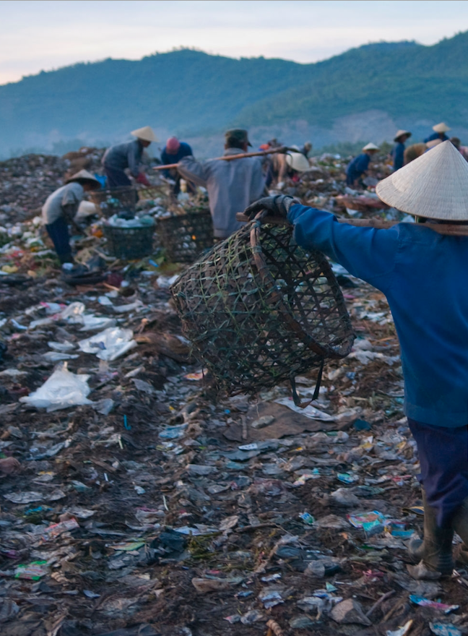
-`+9+9
isf.uts.edu.au
-

Environmentally responsible trade in waste plastics in the Asia Pacific region
Executive Summary
Prepared for the Department of Agriculture, Water and the
Environment by UTS Institute for Sustainable Futures and Asia
Pacific Waste Consultants

August 2020


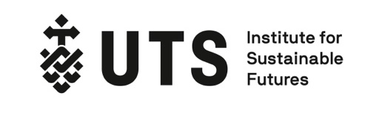


Institute for Sustainable Futures
University of Technology Sydney
PO Box 123 Broadway, NSW, 2007
www.isf.uts.edu.au

Executive summary of the Environmentally responsible trade in waste plastics project undertaken by UTS Institute for Sustainable Futures, Asia Pacific Waste Consultants and The Centre for International Economics.


Research Team
- Dr Monique Retamal (UTS) monique.retamal@uts.edu.au
- Elsa Dominish (UTS) elsa.dominish@uts.edu.au
- Dr Amardeep Wander (APWC) amardeep@apwc.com.au
- Jack Whelan (APWC) jack.whelan@apwc.com.au

Peer Review
- Anne Prince, Asia Pacific Waste Consultants (APWC)
- Phil Manners, the Centre for International Economics (CIE)

Citation
Retamal, M., Dominish, E., Wander, A., Whelan, J., 2020, Environmentally responsible trade in waste plastics in the Asia Pacific region: Executive Summary, prepared for the Department of Agriculture, Water and the Environment, August 2020

Acknowledgments
The authors would like to thank our interviewees for their time and valuable insights. Please see individual reports for a detailed list of interviewees.

Disclaimer
The authors have used all due care and skill to ensure the material is accurate as at the date of this report. ISF and the authors do not accept any responsibility for any loss that may arise by anyone relying upon its contents.
© UTS and APWC August 2020

Project Background
The Environmentally Responsible Trade in Waste Plastics project was commissioned by the Australian Government Department of Agriculture, Water and the Environment (DAWE), and the research was conducted by the UTS Institute for Sustainable Futures (ISF), Asia Pacific Waste Consultants (APWC) and The Centre for International Economics (CIE) during the first half of 2020. The objective of this project was to understand the influence of international trade on the leakage of plastics into the ocean, and whether there are opportunities to ensure that trade in recycled plastics within the Asia Pacific region occurs in an environmentally responsible way.
This document summarises the three reports that were developed for this project. Report 1 seeks to investigate the links between the plastics waste trade and marine plastic pollution. Report 2 analyses capacity gaps and needs to manage plastics within the Asia Pacific region and identifies key interventions. Report 3 presents three in-depth country case studies regarding waste management and trade, in Vietnam, Pacific Island Countries (PICs), and Japan.

Report 1: Investigating the links between international trade and plastic leakage
Pollution from plastic waste is a global environmental problem, with an estimated 100 million tonnes of plastic now found in the oceans. In 2016, more than half of the world’s plastic waste collected for recycling was traded internationally, and the Asian region is the centre of this trade. Following China’s restriction on imports in 2018, the global plastic waste trade has shifted towards Southeast Asia. Subsequently, trade restrictions have been implemented in Southeast Asia, and the UN Basel Convention changes announced in 2019 will further affect plastic waste trade.
The recycled plastics market is dominated by two resin types, PET with 55% and HDPE with 33%. Polypropylene (PP) and low-density polyethylene (LDPE) also have a significant share of the market, both approximately 4%. Current global recycling rates for plastics are between 14 - 18%. Recycled resin is predominantly used by the packaging industry, followed by construction, automotive, textiles and others (see further details in Report 1: Section 2).

Plastic waste trade in Asia Pacific
The top exporters of plastic waste in 2019 were the EU, Japan and the USA, followed by the UK, Hong Kong, Mexico, Canada and Australia. Malaysia was overwhelmingly the largest importer of plastic waste in 2019, followed by Hong Kong, Turkey and the USA. Vietnam, Indonesia, Korea, India, China and Thailand also import significant quantities. Within Pacific Island Countries there is only a small amount of trade reported for Fiji and Palau. (Further charts and maps illustrating the plastic waste trade can be found in Report 1: Section 3.)
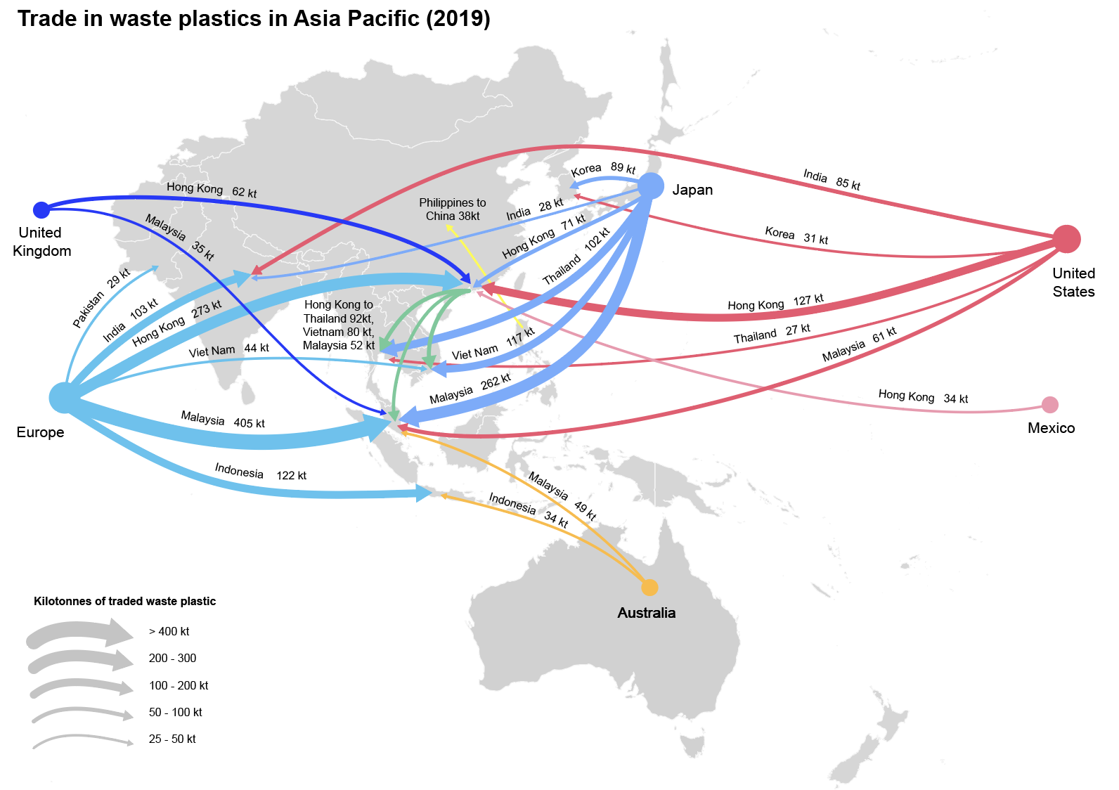
Figure A: Major trade flows of plastic waste in Asia Pacific in 2019 (Data source: Comtrade)

Links between trade and plastic leakage
Estimates of the quantity of plastic leaked into the ocean are still evolving, ranging from approximately 4.8 to 12.7 mega tonnes each year. Land-based sources are estimated to account for 80% of plastics entering the ocean. The 2017 International Coastal Cleanup found that the most common items of ocean litter were all plastic and the majority are not recycled, including: cigarette butts, food wrappers, bottle tops, plastic bags and straws. This means that trade of recyclable waste can only influence a fraction of marine pollution. (See Report 1: Section 4 for a review of the literature regarding plastic leakage and marine pollution).
With very little published information regarding the impacts of trade on leakage, our team undertook a series of interviews with trade experts, consultants, academics, NGOs and recyclers; in Australia, India, Indonesia, Japan, Malaysia, Vietnam and Thailand (see detailed findings in Report 1: Section 5). The informal sector plays a major role in recycling in Southeast Asia, and this causes challenges with respect to accountability and environmental monitoring.
Key drivers for plastic waste leakage of traded plastic scraps include: the disposal of residual, unrecyclable plastics; processing plastics without environmental controls; and inadequate management of transport and stockpiling. Other factors that indirectly link trading processes with plastic leakage include: the quality of bales being exported; false or incorrect labelling of shipments; trading at low or negative prices; and a lack of access to trading options (in the Pacific). In Vietnam, Thailand and India, interviewees indicated that imported recyclables effectively inhibited domestic collection, by reducing the price that waste pickers could receive from collecting and recovering plastics.
According to reports, since trade in waste plastics has shifted from China to Southeast Asia, plastic scrap imports have exacerbated plastic leakage in the region, including in India, Indonesia, Malaysia, the Philippines, Thailand and Vietnam (see Report: Section 6). Where trade has facilitated a reduction in plastic leakage, is primarily in the countries that export. In the case of Palau, an arrangement to ship recyclables for free has facilitated exports of recyclable material, which in turn benefits domestic waste management and leakage. Improving sorting in export countries is likely to be important to facilitate and maintain future trade.

Potential for environmentally responsible trade to reduce leakage
Drawing on interviews and literature reviews, we have proposed six principles and eight practices of environmentally responsible trade (ERT) that are intended to remedy the challenges posed by the plastic scrap trade (see details in Report 1: Section 7).
The ERT practices include: improving collection and sorting in export countries; trading in uncontaminated, pre-sorted plastics; implementing environmental controls; checking destination processing and monitoring capacity; checking shipments at export and import; increasing transparency, accountability; and improving national and regional oversight. These practices suggest a mix of responsibilities, including for importing countries, exporting countries and collectively for the region. With the inclusion of plastic waste under the Basel Convention from 2021, exports of plastic waste will be subject to extensive controls on trade, unless they are shipments of clean, single stream and non-hazardous plastics. The proposed future controls on exports of mixed or contaminated plastics align with many of the ERT practices, such as the need for exporters to receive consent from importing countries for shipments and to ensure environmentally sound management of the waste in the importing country.
ERT practices have potential to reduce leakage from the trade of plastic waste. In particular, trading in mixed plastics or mixed recyclables is more likely to cause leakage in the sorting and recycling process, and trading clean, single stream bales significantly reduces that risk. However, ERT practices will only impact a small portion of the total leakage that occurs in the Asia Pacific region. While there is a lack of data on the sources of leakage, interviewees in importing countries in Asia thought that domestic uncollected waste was a more significant source of leakage than trade. Trade is also only likely to assist with reducing leakage of used beverage containers and certain types of packaging. Other common items that end up as marine plastic pollution are typically unrecyclable, single-use and low value plastics.

Report 2: Capacity gaps and needs for managing plastic waste in the Asia Pacific region
Report 2 of this project aims to provide an overview of the current challenges for the plastic waste management ecosystem in the Asia Pacific region. Following an analysis of existing data and an extensive literature review, complemented by a series of interviews with industry experts, the report identifies potential interventions to reduce marine plastic pollution and improve trade and recycling outcomes. The interventions proposed suggest holistic improvements across the waste management and recycling sector. While not always directly affecting trade, the interventions proposed will improve recycling outcomes and reduce leakage of plastics across the entire waste management supply chain.

Challenges for plastic waste management in Asia Pacific
Falling plastics manufacturing costs have accelerated the production of virgin plastics. However, the current market price of virgin plastic does not represent its full lifecycle costs to nature and society. Most existing recycling systems do not distribute the economic cost of managing post-consumer plastics upstream to producers and users. Insufficient incentives exist to ensure plastic waste is managed properly, let alone re-captured for recycling or reuse. Plastics leakage from mismanaged waste is a direct result of underdeveloped waste management infrastructure and a major challenge in low- and middle-income countries, leading to low collection rates and high rates of open dumping and uncontrolled landfilling. These negative externalities of plastics are tied to a fragile global waste trade and a system that is struggling to adapt to national trade policy reforms in the region.
Sections 2, 3 and 4 of Report 2 explore the capacity gaps and challenges for improved management and recycling of plastic materials across a number of economies in the Asia–Pacific region. It focuses on the barriers that exist within waste management systems and secondary plastics markets, and the economic, technical, environmental and regulatory challenges. As the report considers a broad range of countries across the Asia Pacific, these countries have been broadly divided according to their position in trading relationships and their recycling capacity.
Mature recycling economies are defined as those with well-established waste management systems. These countries in the Asia Pacific region - specifically Australia, Japan and New Zealand, and other major economies, such as those in Europe and the United States - rely on significant infrastructure for sorting and processing of plastic waste by polymer type or as mixed plastics. Key challenges include a dependence on exporting to manage plastic waste; a lack of commercial viability of recycling for some plastics; a wide variety of polymers and additives in plastics; contamination of post-consumer plastics; limited availability of technology for mixed plastics; and a general absence of regulation to standardise plastic packaging polymer types aligned to recovery and recyclability.
Geographically constrained and developing recycling economies include economies such as the Pacific Island Countries (PICs), are generally geographically isolated and have a small land mass. PICs face unique challenges, including limited landfill space and high shipping costs. This category also includes developing recycling economies in Asia with low trade volumes. These economies are characterised by a lack of available finance for collection and sorting services; an absence of source separation; a lack of available finance to fund infrastructure; weak environmental standards; limited legislation to encourage collection and recycling; and regulated transboundary movement of waste.
Importing countries are generally developing recycling economies. Countries importing recyclable plastics are predominantly in Asia, including India, Vietnam, Malaysia, Indonesia and Thailand. The importing countries lack sustainable financing models that promote safe end-of-life disposal; have a large informal sector with high leakage rates; and domestic recyclable plastics often compete with imported plastics for recycling, leading to a reduction in domestic recycling rates.

Potential interventions
A wide range of potential economic, regulatory, technological and industry-led interventions to address the challenge of plastic leakage and enable recycling in the Asia Pacific region are presented in Report 2: Section 5. These potential interventions include economic, regulatory, and technological initiatives that promote clean waste streams, improved collection and processing systems, and innovation in product design.
Given the diversity and scale of the challenges facing markets for recycled plastics, the interventions require close partnership working among multiple stakeholders, including governments, regulators, municipalities, industry and communities. To effectively reduce leakage in both exporting and importing countries it is important that interventions focus on improving waste management processes and promoting circular economy outcomes throughout the supply chain.
The interventions follow the waste management hierarchy and suggest improvements in product design and avoidance; improvements in collection systems and supply chain management; improved sorting and processing capacity; improved trade practices; as well as a range of innovative legislative and policy reforms. Regulatory approaches such as product / recycling targets and environmental levies are proposed with government-led solutions such as container deposit legislation. Interventions to improve the management and recycling of post-consumer plastics require the reinforcement of existing initiatives, such as banning problematic single-use plastics and upgrading national waste management plans.
These interventions, many of which are not directly related to trade, can help to reduce leakage in the trade system through improved waste collection systems that lead to cleaner, high-value waste streams. They can also support the principles of Environmentally Responsible Trade (ERT) by enabling productive recycling of waste materials, thereby avoiding the need to trade where not necessary.
Globally, accountability mechanisms featuring multilateral agreements which outline clear, on-the-ground plans, robust domestic laws, and market-based mechanisms to tackle underlying issues would help distribute the responsibility of plastic waste management appropriately across the plastic life cycle; preventing the transfer of the burden of recycling from exporting to importing countries through trade. Measures need to be put in place to ensure the global price of plastic reflects the full lifecycle cost to nature and society, preventing social or environmental harm at the destination.

Report 3: Case Studies on Plastic Waste Management and Trade in Asia Pacific
In the third report in this series, we present three in-depth case studies regarding waste management and trade in Vietnam, Pacific Island Countries (PICs) and Japan. The case studies have been selected as they provide an indication of the range of challenges and interventions for managing plastic waste in the Asia Pacific region. Vietnam has rapidly increased plastic waste imports since 2018, and its management challenges are illustrative of other Southeast Asian countries that have recently commenced importing. PICs face unique challenges to waste management given their low population and remote locations. Japan has an extensive policy and institutional framework to manage recycling, and its waste management system has had to adapt to recent policy changes in importing countries which limit its ability to export plastics. The three case studies are presented consecutively in Report 3, with Vietnam, then the PICs and then Japan following the same structure.

Key waste management challenges
Both Vietnam and the PICs have similar fundamental challenges with a lack of adequate waste collection and sanitary landfills, which causes problems for leakage and illegal dumping. In addition, a lack of separation for recyclables is a common issue in Southeast Asia and in PICs. Further to this, Vietnam lacks funding to support improved waste systems and recycling, and faces challenges to monitor a large informal recycling sector. In PICs, geographic isolation, limited space, low volumes of waste and high costs create significant challenges for improved waste management. Relative financial disadvantage and a lack of resources and capacity compound these issues.
Both Japan and Vietnam face challenges with fragmented institutional responsibilities for waste, which create inefficiencies and challenges for accountability. In Japan, container deposit schemes have been very successful in achieving high recovery rates for beverage containers, but many other types of plastics remain unrecycled, and single use plastic consumption remains high. Japan faces complexities with separate recycling systems for household waste versus other sources, and the need to meet higher sorting standards with the changes to the Basel Convention. For further information on challenges, see Report 3, sections 2.1, 3.1 and 4.1.

Potential Interventions
Potential interventions to improve waste management and recycling in Vietnam include: increasing collection capacity and waste management fees; implementing source separation of waste streams; investing in more sanitary landfills; improving technology and environmental controls in the recycling sector; increasing support and funds for monitoring trade; removing unrecyclable residuals from traded bales and from domestic products; improving data collection and transparency; and driving markets for recycled materials (see Report 3: Section 2.2).
The development of a Pacific recycling sector and a subsequent reduction in marine plastic pollution cannot be separated from much needed improvements to basic solid waste management services like collection and disposal systems. A very small number of countries have well-resourced collection and treatment systems in place, however for the overwhelming majority the existing in-country solid waste management systems are limited. Appropriate infrastructure, fit-for-purpose technologies and government policies able to sustain the segregation and recovery of recyclable waste materials like plastics from the general waste stream will provide a strong basis for increasing value-added technologies over time (see Report 3, Section 3.2).
Japan has a number of distinctive waste management laws and systems that have been successful in achieving high rates of material and energy recovery. These include a well-established Extended Producer Responsibility framework; voluntary design standards to improve recyclability of products; green public procurement law; high levels of source separation; and advanced recycling processes, however, there is still room for improvement. Potential interventions in Japan include: improving sorting for plastic waste that was previously exported; investing in more recycling facilities within Japan; implementing incentives to increase recycled content in products in Japan; improving data collection; reducing single use plastics and packaging, and; enabling flexibility of recycling of packaging and containers between the EPR and non-EPR collection systems (see Report 3: Section 4.2).

Impacts of interventions
Even the most fundamental interventions, such as increasing collection and sanitary landfill capacity in many Southeast Asian and Pacific Island countries would have major benefits for the environment and natural resources, including by reducing plastic leakage to the ocean. Improving domestic waste management and implementing environmentally responsible trade practices would have significant benefits for Vietnam, by improving air and water quality, visual amenity, protecting natural resources and tourism values, and creating safer jobs for waste industry workers (see Report 3: Section 2.3).
There are some interesting lessons to be learned from plastics initiatives in the PICs. Palau’s container deposit scheme has continually evolved since 2011, with the type of containers that are accepted in the system are increasing as markets and in-country administrative processes become more established. Vanuatu’s yellow bag pre-paid system took six years to establish after several false starts as the local authorities coped with increased administrative demands. The plastic bag ban in Vanuatu that was established in 2018 led to the introduction of new plastic products such as plastic mesh bags as vegetable coverings. The ban had to be extended to include these new materials. The establishment of successful and sustainable systems in the Pacific, as well as in any other region, is reliant on local conditions as well as the appropriate resourcing of administrative, financial and technical services which are currently seen as the key weaknesses throughout the region (see Report 3: Section 3.3).

Risks of perverse outcomes and mitigation measures
Given that such a significant proportion of Vietnam’s recycling sector is informal and consists of small businesses, the risk is that greater monitoring and enforcement with increased administrative requirements will exclude small businesses and result in a loss of livelihoods. Increasing enforcement of environmental regulations needs to be paired with increased investment in the sector, to improve technology and capacity. Effective formalisation of the waste sector needs to happen in an inclusive way to maintain livelihoods and regional income. In order to reduce the risk of plastic waste being shifted across borders to countries with weaker environmental controls, trade experts have recommended regional standards on the quality of recyclables that are traded (see Report 3: Section 2.3).
In seeking to address the challenges and unique circumstances of the Pacific islands’ region, there is a risk of adopting a piecemeal, fragmented or uncoordinated approach. With the identified challenges impacting the region as a whole (including a lack of critical scale, dependence on imported goods, distance from international recycling markets and reliance on international development assistance), there is a need for both a continuation of key bilateral support to improve national strategic waste management systems and a strategic regional approach to achieving a viable and sustainable Pacific recycling sector and a subsequent reduction in marine plastic pollution (see Report 3: Section 3.3). Without such a regional approach to improving these foundations, there is a weaker likelihood of achieving a sustainable regional recycling system.
In Japan, the key risk to manage is that with the focus on maintaining exports and improving recycling, other equally important initiatives are not lost, such as reducing the use of problematic and unrecyclable plastics and reducing consumption and waste overall. Similarly, if improving sorting or developing reprocessing facilities in Japan is not cost competitive, there is a risk of increasing use of waste-to-energy, and a reliance on this rather than waste reduction and material recycling (see Report 3: Section 4.3).

Impact of environmentally responsible trade
Environmentally responsible trade (ERT) practices has the potential to contribute to reducing leakage in each of the case study contexts. In Vietnam, increased funding and capacity building programmes to increase environmental monitoring of facilities and inspection of imports at the port would help minimise leakage in the recycling process. ERT practices implemented by exporting countries would also have significant benefits for Vietnam, and would prevent many of the downstream impacts. For example, if exporting countries improve plastics sorting to eliminate unrecyclable plastics from bales and trade only in uncontaminated, pre-sorted plastics, then the environmental problems associated with managing residual plastics from traded plastics are removed. Improving the quality of exports is the simplest way to mitigate potential downstream problems, and will reduce the burden on the Vietnamese government to monitor and enforce shipments (see Report 3: Section 2.2).
In the Pacific, opportunities to create viable local markets for recycled plastics are extremely low and domestic plastic manufacturing risks further leakage of surplus material through secondary waste streams in highly vulnerable environmental conditions. The practices of environmentally responsible trade (ERT), align with the interventions suggested for the Pacific, with regard to: stimulating local and regional markets for recycled products; offering design solutions for packaging at a regional level; procurement of eco-friendly products; and aggregation of recycling volumes for small-scale local reprocessing (see Report 3: Section 3.2).
With regards to environmentally responsible trade, Japan is playing a leadership role in the Asia Pacific region for a number of initiatives, including proposing the Basel Convention amendment for waste plastics and establishing a regional dialogue to harmonise standards for plastic scrap export quality (see Report 3: Section 4.2).
Collectively, these initiatives have significant potential to reduce the environmental impacts of plastic scraps trade in the Asia Pacific. However, for most countries, domestic waste management practices have a greater impact on leakage and need to be addressed to avoid marine plastic pollution.

OECD (2018) ‘Improving Plastics Management: Trends, policy responses, and the role of international cooperation and trade’, OECD Environment Policy Paper No. 12. [online] Available at: https://www.oecd.org/environment/waste/policyhighlights-improving-plastics-management.pdf [Accessed 21 May 2020].
United Nations Statistics Division, n.d. UN Comtrade Monthly Trade Database [online] Available at: https:// https://comtrade.un.org/data [Accessed 3 May 2020]
Jambeck J., Geyer R., Wilcox C., Siegler T., Perryman M., Andrady A., Narayan R., and Law KL.(2015) ‘Plastic waste inputs from land into the ocean’, Sciencemag, 2015, Vol 347, Issue 6223.
STAP, (2011). Marine Debris as a Global Environmental Problem: Introducing a solution based framework focused on plastic. A STAP Information Document. Global Environment Facility, Washington, DC. Available from Internet: http://www.thegef.org/gef/sites/thegef.org/files/publication/STAP%20MarineDebris%20-%20website.pdf
Global Alliance for Incinerator Alternatives (GAIA), 2019, Discarded: Communities on the Frontlines of the Global Plastic Crisis 2019, Accessed online at: https://www.no-burn.org/wp-content/uploads/Report-April-22.pdf

