# Enhancing Remnant Vegetation Pilot

Application Guide

September 2021

© Commonwealth of Australia 2021

**Ownership of intellectual property rights**

Unless otherwise noted, copyright (and any other intellectual property rights) in this publication is owned by the Commonwealth of Australia (referred to as the Commonwealth).

**Creative Commons licence**

All material in this publication is licensed under a [Creative Commons Attribution 4.0 International Licence](https://creativecommons.org/licenses/by/4.0/legalcode) except content supplied by third parties, logos and the Commonwealth Coat of Arms.

Inquiries about the licence and any use of this document should be emailed to [copyright@awe.gov.au](mailto:copyright@awe.gov.au).



**Cataloguing data**

This publication (and any material sourced from it) should be attributed as: DAWE 2021, *Enhancing Remnant Vegetation Pilot, Application Guide*, Department of Agriculture, Water and the Environment, Canberra, September.

This publication is available at <https://www.agriculture.gov.au/ag-farm-food/natural-resources/landcare/sustaining-future-australian-farming>

Inquiries can be made by email at agstewardship@awe.gov.au.

Department of Agriculture, Water and the Environment

GPO Box 858 Canberra ACT 2601

Telephone 1800 900 090

Web [awe.gov.au](https://www.awe.gov.au/)

**Disclaimer**

The Australian Government acting through the Department of Agriculture, Water and the Environment has exercised due care and skill in preparing and compiling the information and data in this publication. Notwithstanding, the Department of Agriculture, Water and the Environment, its employees and advisers disclaim all liability, including liability for negligence and for any loss, damage, injury, expense or cost incurred by any person as a result of accessing, using or relying on any of the information or data in this publication to the maximum extent permitted by law.

**Acknowledgements**

We thank Professor Andrew Macintosh, Dr Dean Ansell and Dr Don Butler from the Australian National University (ANU) for their assistance in preparing this document.

## Acknowledgement of Country

We acknowledge the Traditional Owners of Country throughout Australia and their continuing connection to land, sea and community. We pay our respects to them and their cultures and to their elders past, present and emerging.

Contents

Acknowledgement of Country 3

1. Role of the Application Guide 5

2. Making an application 6

3. Application form worksheet 1

4. Questions and feedback 19

## Role of the Application Guide

The *Enhancing Remnant Vegetation Pilot: Application Guide* (Application Guide) has been developed to help farmers who want to apply to participate in the Agriculture Stewardship – Enhancing Remnant Vegetation Pilot (ERV Pilot).

All applications to the ERV Pilot must be made through the Agriculture Stewardship web portal: [www.agsteward.com.au](http://www.agsteward.com.au).

See Section 3 for a worksheet that farmers can use to gather information and prepare applications before completing the online application form.

The web portal requires applicants to:

* map the remnant management areas and any proposed revegetation areas on their property;
* provide details of the proposed management activities in each of the remnant management areas and revegetation areas; and
* estimate the cost of the proposed management activities.

The web portal also provides applicants with:

* indicative estimates of the rental component of the biodiversity enhancement payment for each of the mapped remnant management areas and revegetation areas;
* indicative information on the spatial distribution of remnant vegetation on their property and within their Natural Resource Management (NRM) region; and
* indicative information on the regional conservation priority of the native vegetation on their property and in their NRM region, as determined for the purposes of the ERV Pilot.

The Application Guide steps applicants through how to complete an application for the ERV Pilot through the web portal.

Section 2 provides a step-by-step guide to mapping your remnant vegetation areas and revegetation areas and completing the online form.

Section 3 provides a worksheet that you can use while planning your project and gathering the information required to complete the online application form.

Prior to preparing an application, applicants should read the ERV Pilot Guidelines and associated ERV Pilot documentation, including the applicable ERV Management Protocol. These documents are available on the [Agriculture Stewardship Package website](https://www.agriculture.gov.au/ag-farm-food/natural-resources/landcare/sustaining-future-australian-farming/enhancing-remnant-vegetation-pilot).

## Making an application

All ERV applications must be made through the Agriculture Stewardship web portal at: [www.agsteward.com.au](http://www.agsteward.com.au).

There are six main steps involved in making an application.

1. Map your proposed remnant management areas and revegetation areas.
2. Provide your personal details (and the details of the entity on behalf of which you are making the application) and the address of the property on which the project will be located.
3. For each remnant management area:
   1. provide information on the condition of the land and its management history;
   2. nominate the management activities you intend to undertake;
   3. provide details on the nature and intensity of the proposed management activities; and
   4. estimate the cost of the proposed management activities.
4. For each revegetation area:
   1. provide information on the condition of the land;
   2. nominate how you intend to revegetate the area; and
   3. estimate the cost of the proposed revegetation and associated recurrent management costs.
5. If you want to, nominate an alternative initial annual rental payment that is lower than the estimate provided on the web portal (in order to increase the competitiveness of your application).
6. Submit the application.

It is important that the information you submit is as accurate as possible. The submission of inaccurate information could distort the outcomes from the ERV Pilot and undermine its ability to achieve its objectives. The cost estimates are of particular importance as they will be used to generate biodiversity enhancement payment offers and rank projects in the selection process. Due to this, all applicants are asked to:

1. undertake proper project planning before submitting an application through the web portal;
2. give appropriate thought and consideration to the information they submit; and
3. to the extent possible, ensure the cost estimates that are submitted accurately reflect the likely costs associated with undertaking the proposed project.

Please read the box below about the duty of utmost good faith that applies to all participants in the ERV Pilot and the legal implications of submitting false or misleading information.

**Duty to ensure submitted information is accurate**

* You must provide a commitment to act with the utmost good faith in your engagements with the program. By acting in good faith, you are helping us learn important lessons about the trial to improve this scheme in the future.

**Step 1. Map your proposed remnant management areas and revegetation areas**

* The ERV Pilot mapping tool is accessed by clicking on the map of your region at the bottom of the ERV Pilot landing page (see below).

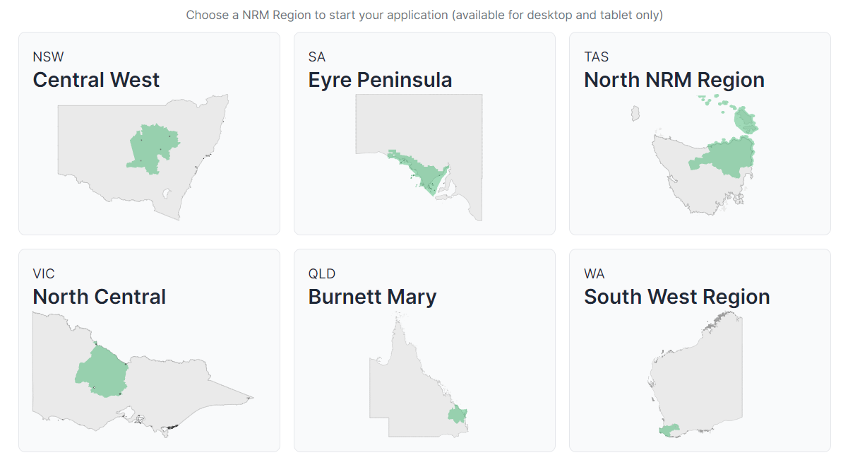

* Once on the mapping page, locate your property using your mouse or by entering your address in the search box shown below.

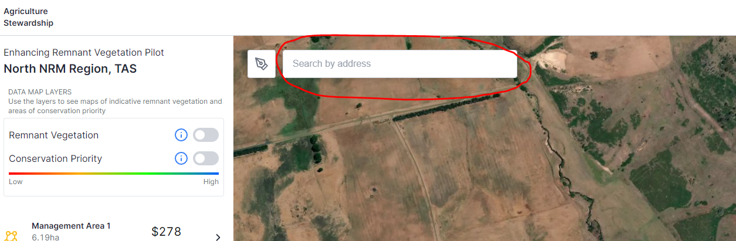

* Having located your property, you can use the data map layers to see indicative information on the spatial distribution of remnant vegetation and the regional conservation priority of the native vegetation on your property under the ERV Pilot.
  + You do this using the toggles that are circled in red in the image below. To see a map layer, move the toggle to the right (you can only see one map layer at a time).
  + In the remnant vegetation layer, indicative areas of remnant vegetation are shown in green (as illustrated in the image below).
  + In the ERV conservation priority layer, areas of high regional conservation priority are shown in blue or green.

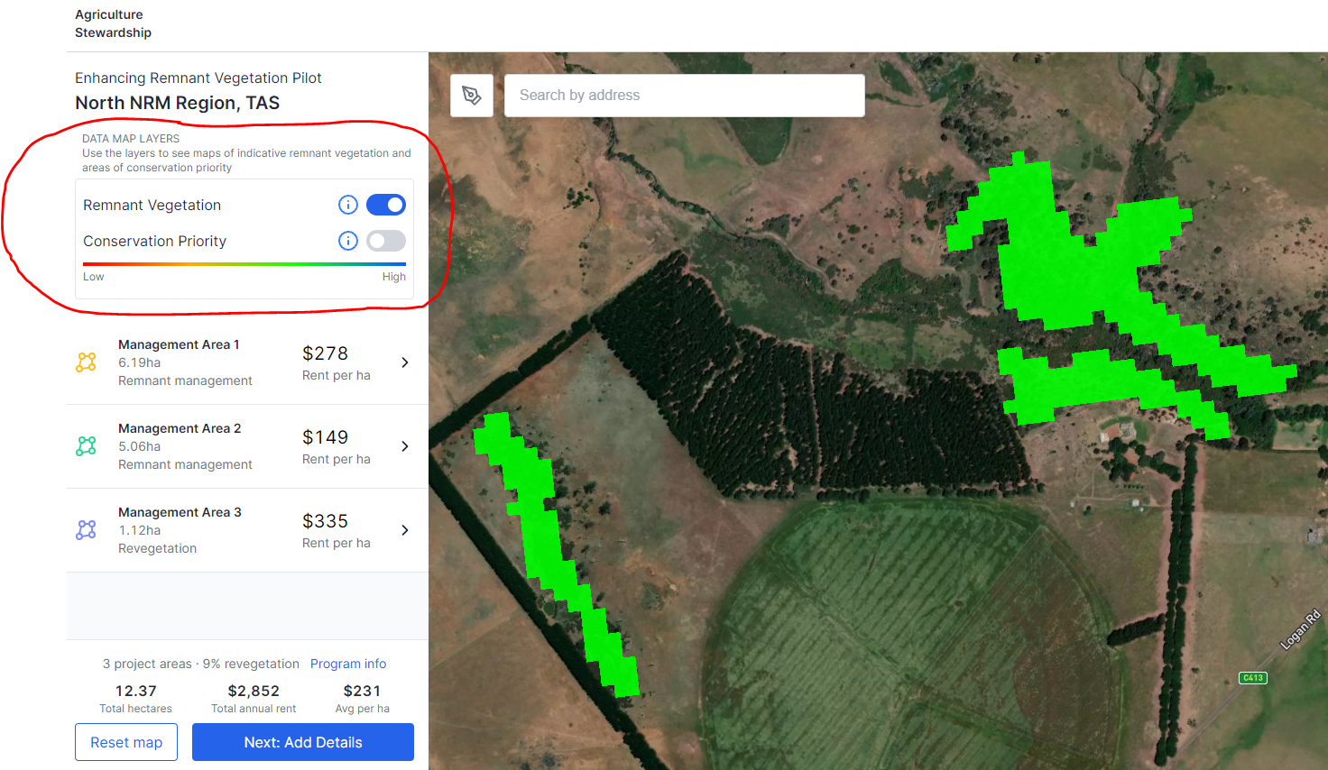

* After planning your project, you need to map your remnant management areas and any revegetation areas. You do this by clicking on the pen icon circled in red in the image below.

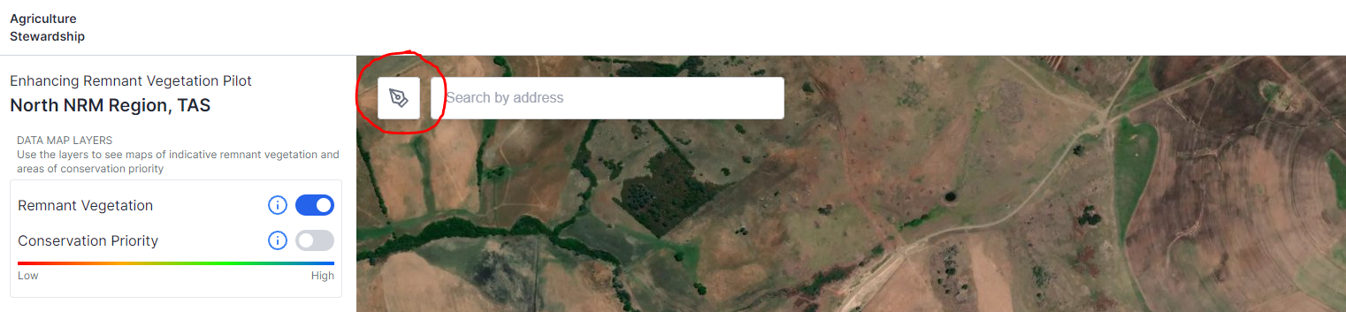

* After clicking on the pen icon, draw a polygon around the proposed management area as shown below. To close the polygon and complete the mapped area, click on the first point. In the example below, the first point is circled in red.

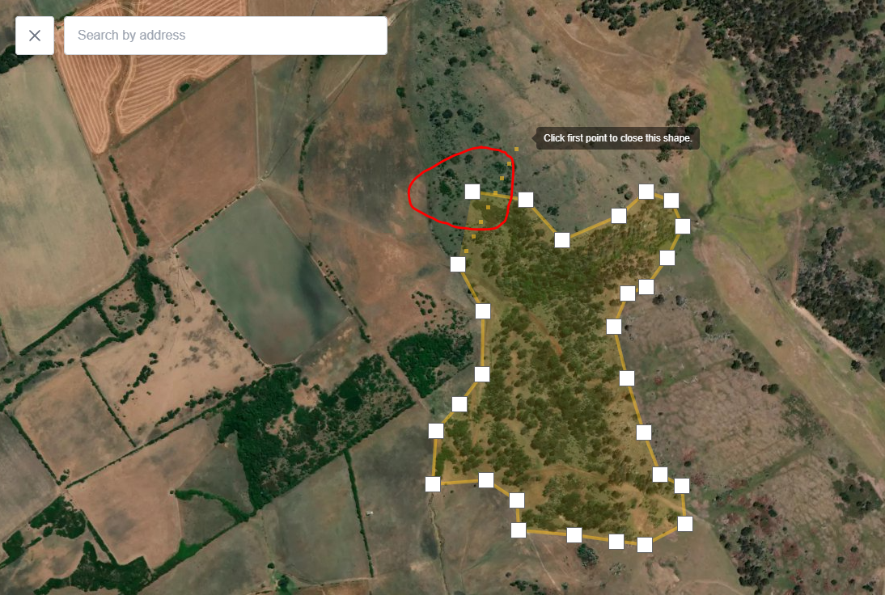

* Once you complete the mapped area, you are shown the box below and need to select whether the mapped area is a remnant management area or revegetation area using the drop down box circled in red.
  + In addition to making this selection, the box shows summary information on the size of the area and provides an estimate of the *indicative initial* annual rental payment for the area (total rent and rent per hectare).
  + Note that the estimates regarding the rental payment are *indicative* and could differ from the amounts offered and that the final rental payments will increase by 3.5% per annum to account for likely increases in land values over the 10-year project term.

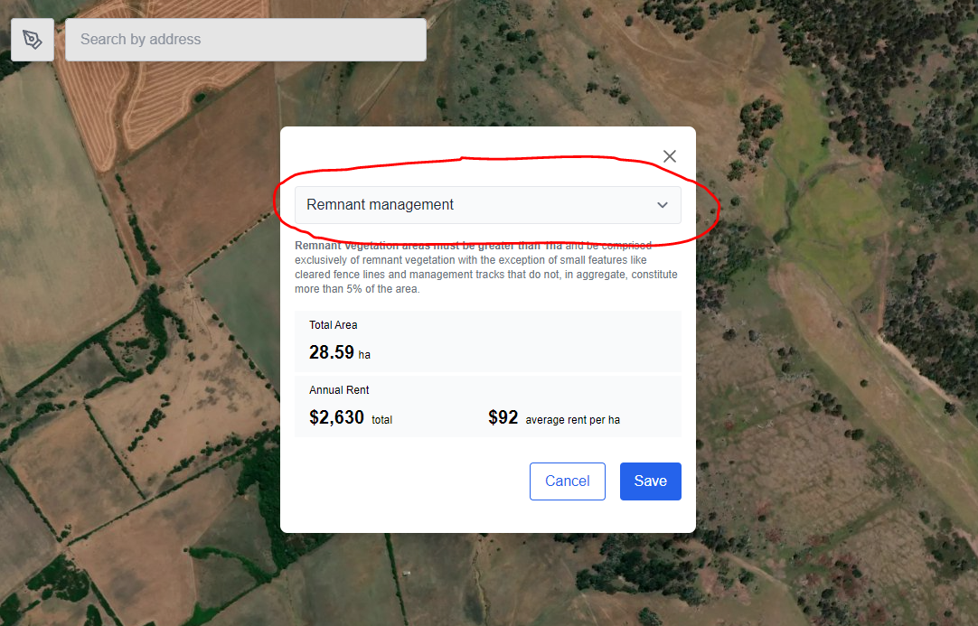

* Repeat the above steps to map all of your proposed remnant management areas and revegetation areas.
* As you map subsequent areas, summary information on each of the new areas will be shown in the column on the left of the mapping page, as indicated in the image below.
* When you have finished mapping your remnant management areas and any revegetation areas, click on the ‘Next: Add Details’ button at the bottom of the column on the left of the mapping page (see below).

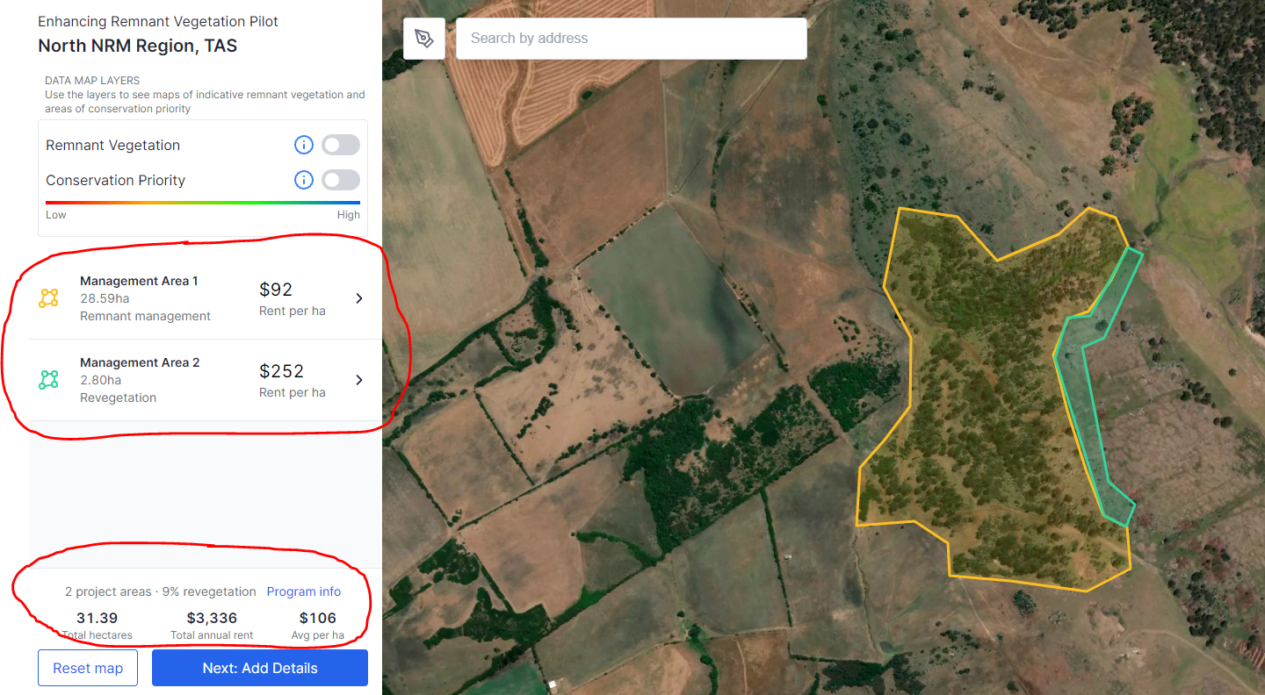

**Step 2. Provide your personal details and the address of the project area**

* Having clicked on the ‘Next: Add Details’, you will be taken to the first part of the ERV Application Form, titled ‘Project info’ (see below). Here, you will be asked to provide the:
  + name and Australian Business Number (ABN) of the applicant;
  + name, email and phone number of the primary contact for the application;
  + name, email and phone number of a secondary contact for the application (optional);
  + address of the property on which the proposed project will be located.

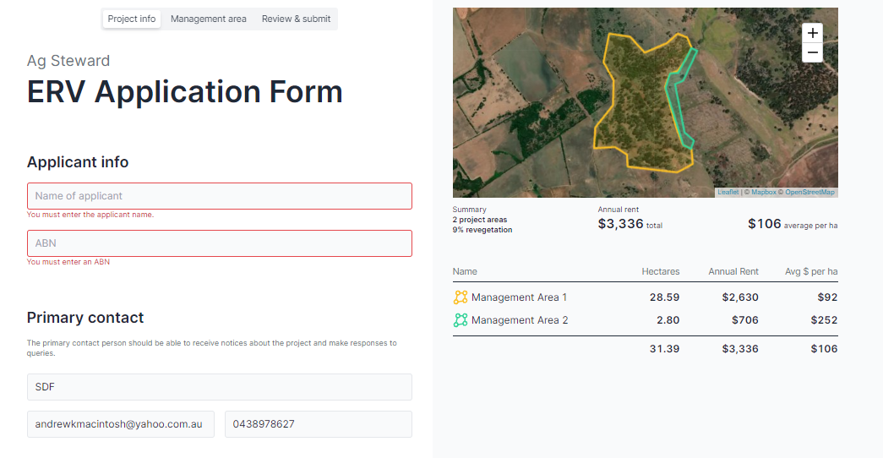

* In addition to providing these contact and project details, you will need to indicate:
  + your commitment to act in good faith in your engagements with the ERV Pilot, including in making the application;
  + whether the proposed project will be located on a property or properties that are predominantly used for agricultural purposes;
  + whether you have the legal right to control how the proposed project area is used (e.g. freehold or leasehold title, or exclusive possession native title, over the land on which the project will be located); and
  + if you hold a lease over the proposed project area, whether there is at least 10 years left on the term of the lease.
* After you have answered these questions, click the ‘Next’ button at the bottom of the page.

**Step 3. Management activities for remnant management areas**

* Having clicked on the ‘Next’ button, you will be taken to the second part of the ERV Application Form, titled ‘Management area’ (see image below).
* Here you are asked questions about each of your proposed remnant management areas and your revegetation areas.
  + The name and type of each management area is shown in the box circled in red in the image below. Answer the questions that follow for the relevant listed management area.
  + Note that the questions are different depending on whether the management area is a remnant management area or revegetation area. The type of management area is noted on the left of the box circled in red in the image below.

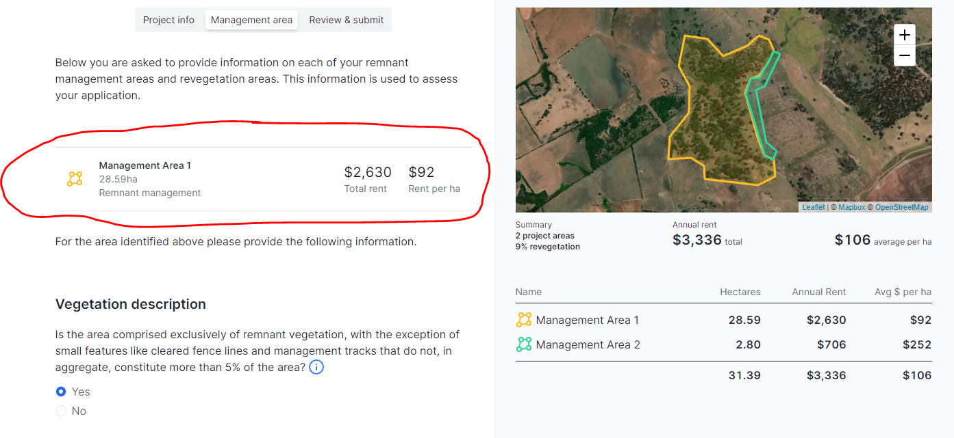

* For each remnant management area, you will be asked to:
  + provide information on the condition of the land and its management history;
  + nominate the management activities you intend to undertake in the area for the purposes of the project;
  + provide details on the nature and intensity of the proposed management activities; and
  + estimate the cost of the proposed management activities.
* Note that the first question you are asked for each remnant management area is whether the area is comprised exclusively of remnant vegetation (see below).
  + Remnant management areas must be comprised exclusively of remnant vegetation, except for small features like cleared fence lines and management tracks that do not, in aggregate, constitute more than 5% of the area?
  + If your remnant management area is not meet this requirement, please remap it so it does.

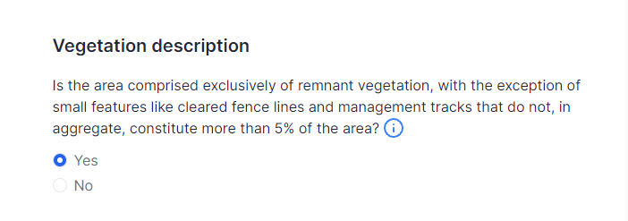

* Please consult the Worksheet in section 3 for further details on the information required for each remnant management area.

**Step 4. Details and costs for revegetation areas**

* After providing the information on remnant management areas, you need to do the same for each of your proposed revegetation areas.
* Broadly, for each revegetation area, you must:
  + provide information on the condition of the land;
  + nominate how you intend to revegetate the area; and
  + estimate the cost of the proposed revegetation and associated recurrent management costs.
* Please consult the Worksheet in section 3 for further details on the information required for each remnant management area.
* After you have provided the required information on your proposed revegetation areas, click ‘Next’ to be taken to the last part of the ERV Application Form.

**Step 5. Alternative initial annual rental payment (optional)**

* The last part of the ERV Application Form is the ‘Review & submit’ page. The page gives you summary information on your project, including the total project area, estimated initial annual rent and estimated initial annual rent per hectare (top left in the image below). A map and summary information on each of your proposed management areas is also provided at the top right of the page.

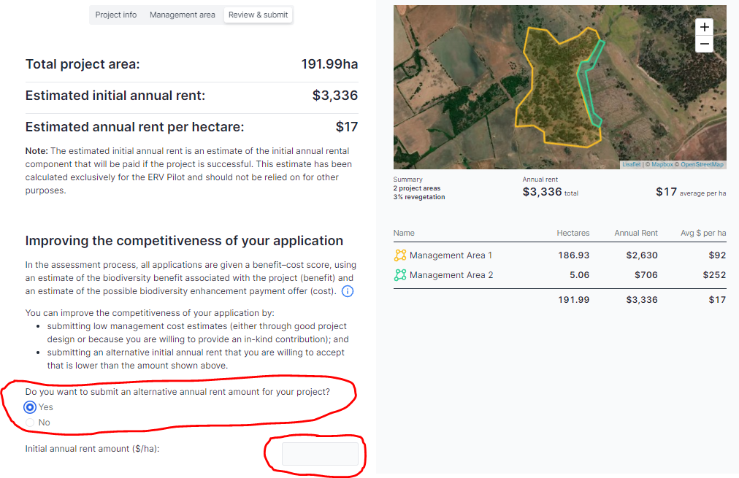

* In addition to the summary information, the ‘Review & submit’ page asks you whether you want to nominate an alternative initial annual rental payment that is lower than the estimate provided on the web portal.
  + Nominating a lower initial annual rental payment can increase the competitiveness of your application, thereby increasing your chances of receiving a biodiversity enhancement payment offer.
  + Nominating an alternative initial annual rental payment is optional – you do not need to provide an alternative.
  + There are three other main ways of improving the competitiveness of your application.
    - Designing projects that will protect and enhance the condition of remnant vegetation that is of high regional conservation priority (e.g. remnant vegetation that is part of a habitat/vegetation type that has been extensively cleared).
    - Undertaking management activities that are likely to generate the greatest improvements in the condition of biodiversity at the lowest cost.
    - Providing in-kind contributions to the project. This can be done by submitting lower cost estimates for nominated management activities in your application (steps 3 and 4 above).
* If you want to nominate a lower initial annual rental payment, click yes in the area indicated in the red circle in the image above. You will then see a box where you can enter your alternative initial annual rent amount. The alternative initial annual rent amount must:
  + be provided on a dollars per hectares basis ($/ha);
  + represent the rental payment you are willing to accept for the first year of the project, noting that, if you are successful, this amount will increase by 3.5% per annum over the 10-year project period; and
  + be lower than the average provided for your project area, as indicated in the summary information at the top of the page (see image above).

**Step 6. Submit application**

* After deciding whether to nominate an alternative initial annual rental payment, there are three final things to do on the ‘Review & submit’ page (see the image below):
  + consent to your personal information in the form being transmitted to, and used by, the Department of Agriculture, Water and the Environment to assess your application;
  + provide any comments you might have on your application that you want the Department of Agriculture, Water and the Environment to consider; and
  + click on the ‘Submit’ button at the bottom of the page.
* After you click on the ‘Submit’ button, you will be asked whether you want to submit your application. You will be warned that, if you click on ‘OK’, you will not be able to modify the application. If you are happy to proceed, click ‘OK’. If not, click ‘Cancel’ and go back and make any required modifications before finalising the submission.

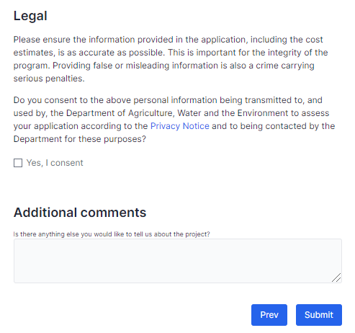

## Application form worksheet

Please note this worksheet is optional. You can choose to use this worksheet while planning your project and gathering the information required to complete the online application form. Having all of your application information prepared in this document will help you complete your online application when you are ready.

**Table 1. Remnant management areas**

|  |  |  |  |  |  |
| --- | --- | --- | --- | --- | --- |
| **Issue or activity** | **Response** | | | | |
| **1. Land condition information** | | | | | |
| Is the area comprised exclusively of remnant vegetation, with the exception of small features like cleared fence lines and management tracks that do not, in aggregate, constitute more than 5% of the area? | If your remnant management area does not meet this requirement, you will need to remap it to exclude non-remnant vegetation. | | | | |
| What are the dominant plant species in the area (up to 5 species)?  *Leave blank if you do not know and cannot get help to identify the species.* | 1.  2.  3.  4.  5. | | | | |
| What proportion of the area has previously been fully cleared for grazing, cropping or other agricultural purposes? [in %] |  | | | | |
| What proportion of the area has had shrubs and undergrowth removed? [in %] |  | | | | |
| What proportion of the area has previously been fully or partially harvested for timber, including for fence posts? [in %] |  | | | | |
| What proportion of the area has had super phosphate or other fertilisers applied? [in %] |  | | | | |
| In an average year, how many months do domestic stock graze the area? [in months] |  | | | | |
| When they have access, how many animals per hectare typically graze in the paddock or paddocks in which the area is located? [in dry sheep equivalent (DSE) or adult equivalent (AE)) | 1. Sheep or goats [DSE per hectare]  2. Cattle [AE per hectare]  3. Horses and other livestock [AE per hectare] | | | | |
| How would you describe grazing pressure from native grazers like kangaroos and wallabies on average across the years? | Circle the option that applies:   * Low (limited impact on ground cover) * Moderate (some impact on ground cover) * High (significant impact on ground cover) | | | | |
| What proportion of the area has bare soil exposed at the driest time of the year? [in %] |  | | | | |
| Estimate the percentage cover of weeds (plants that are not native to the local area) in the area in the ground, shrub and tree layers. [in %] | 1. Ground layer (less than 1.5m tall)  2. Shrub layer (1.5-3m tall)  3. Tree layer (>3m tall) | | | | |
| What are the dominant types of weeds for each layer in the area (if known)?  *Leave blank if you do not know and cannot get help to identify the species.* | 1. Ground layer weeds (less than 1.5m tall)  2. Shrub layer weeds (1.5-3m tall)  3. Tree layer weeds (>3m tall) | | | | |
| What are the dominant types of non-native pests in the area (if known)?  *Leave blank if you do not know and cannot get help to identify the species.* |  | | | | |
| **2. Enhanced grazing control**  ***Only complete this section if your project includes enhanced grazing control as a nominated management activity*** | | | | | |
| On average, how many months of each year do you propose to give domestic stock access to graze the area over the 10 year project period? |  | | | | |
| For the project, what percentage change will you make in the number of animals that graze the area (on a per hectare basis relative to current practice indicated above)? For example, if there is no change insert 100%, to halve the number of stock grazing insert 50%; to double insert 200%. |  | | | | |
| If you want to install new fencing or repair existing fencing as part of the project to control grazing pressure on the remnant vegetation by livestock or feral animals, you will need to provide the details shown in the adjacent column. | **Fencing materials** | | | | |
| *Wire, intermediate posts/pickets and droppers* | Length (in metres) | | Total cost ($) | |
| *Strainer assemblies* | Number of strainers | | Total cost ($) | |
| *Gates* | Number of gates | | Total cost ($) | |
| **Installation** | | | | |
| *Labour and other installation costs (incl GST if applicable)* | Total cost ($) | | | |
| If you want to install new watering points as part of the project to help control grazing pressure on the remnant vegetation by livestock, you will need to provide the details shown in the adjacent column. | **Water point materials** | | | | |
| *Troughs* | Number of troughs | Average capacity (litres) | | Total cost ($) |
| *Tanks* | Number of tanks | Average capacity (litres) | | Total cost ($) |
| *Pumps* | Number of pumps | Average max flow rate (litres per hour) | | Total cost ($) |
| *Piping* | Length (in metres) | Average diameter (mm) | | Total cost ($) |
| **Installation** | | | | |
| *Labour and other installation costs (incl GST if applicable)* | Total cost ($) | | | |
| **3. Enhanced weed control**  ***Only complete this section if your project includes enhanced weed control as a nominated management activity*** | | | | | |
| What weeds are you proposing to target with the proposed management activities? |  | | | | |
| What eligible weed management activities do you intend to undertake in the area? | Eligible woody weed treatments:   * Ripping [Yes/No]: * Pulling [Yes/No]: * Cutting and poisoning of woody weeds [Yes/No]:   Eligible non-woody weed treatments:   * Spraying [Yes/No]: * Manual pulling [Yes/No]: | | | | |
| What proportion of the area will you undertake the weed management activities on? [in %] |  | | | | |
| How many hours of weeding do you propose to undertake in the area in the first 2 years of the project, above what you are already legally required to undertake? [in hours] |  | | | | |
| What is the estimated all-inclusive cost per hour of the proposed weeding in the first 2 years of the project (labour time and materials, including chemicals). [$ per hour] | Note: To calculate this, add the cost of materials and the labour costs, then divide by the total number of hours of additional weeding you intend to undertake in the first 2 years of the project. | | | | |
| On average, how many hours of weeding do you propose to undertake each year in the area in the last 8 years of the project, above what you are already legally required to undertake? [in hours] |  | | | | |
| Estimated all-inclusive cost per hour of the proposed weeding in the last 8 years of the project (labour time and materials, including chemicals – and it should be provided on the basis of what it would currently cost, in 2021 dollar terms). [$ per hour] | Note: To calculate this:   1. estimate the average number of hours of additional weeding you intend to undertake each year as part of the project over the final 8 years of the project; 2. based on what it would currently cost you, estimate the cost of materials and labour costs associated with doing the additional annual weeding task; 3. divide (b) by (a).   For example, if you intend to do 100 hours of additional weeding each year, and the required materials (chemicals) currently cost $1,000 and labour costs $5,000 ($50 per hour), then the all-inclusive cost per hour is $60. The amounts paid to ERV Pilot participants for enhanced weed control will increase annually to account for inflation. | | | | |
| 1. **Enhanced pest control**   ***Only complete this section if your project includes enhanced pest control as a nominated management activity*** | | | | | |
| What pests are you proposing to target with the proposed management activities? [Note, pest control must not target native species] |  | | | | |
| What eligible pest management activities do you intend to undertake in the area? | Baiting [Yes/No]:  Trapping [Yes/No]:  Shooting [Yes/No]:  Fumigation [Yes/No]:  Ripping [Yes/No]: | | | | |
| How many hours of pest control do you propose to undertake in the area in the first 2 years of the project, above what you are already legally required to undertake? [in hours] |  | | | | |
| Estimated all-inclusive cost per hour of the proposed pest control in the first 2 years of the project (labour time and materials, including chemicals). [$ per hour] | Note: To calculate this, add the cost of materials and the labour costs, then divide by the total number of hours of additional pest control you intend to undertake in the first 2 years of the project. | | | | |
| On average, how many hours of pest control do you propose to undertake each year in the area in the last 8 years of the project, above what you are already legally required to undertake? [in hours] |  | | | | |
| Estimated all-inclusive cost per hour of the proposed pest control in the last 8 years of the project (labour time and materials, including chemicals – and it should be provided on the basis of what it would currently cost, in 2021 dollar terms). [$ per hour] | Note: To calculate this:   1. estimate the average number of hours of additional pest control you intend to undertake each year as part of the project over the final 8 years of the project; 2. based on what it would currently cost you, estimate the cost of materials and labour costs associated with doing the additional annual pest control task; 3. divide (b) by (a).   For example, if you intend to do 100 hours of additional pest control each year, and the required materials (chemicals) currently cost $1,000 and labour costs $5,000 ($50 per hour), then the all-inclusive cost per hour is $60. The amounts paid to ERV Pilot participants for enhanced pest control will increase annually to account for inflation. | | | | |
| **5. Infill plantings**  ***Only complete this section if your project includes infill plantings as a nominated management activity*** | | | | | |
| What proportion of the area will you establish infill plantings on? [in %] |  | | | | |
| Soil preparation for plantings  Note: Pre-planting weeding costs should be included in enhanced weed control costs | * How will you prepare the soil for the plantings?   + Manual digging [Yes/No]   + Other [Yes/No] * Estimated cost of soil preparation works, incl GST if applicable? | | | | |
| Infill planting establishment | *How will you establish plants on the site?* | Manual tubestock [Yes/No] | | Hand seeding [Yes/No] | |
| *Seedlings required for planting area* | Number of seedlings | | Cost of seedlings ($) | |
| *Seeds required for planting area* | Kilograms of seed (kg) | | Cost of seed ($) | |
| *Other planting costs (e.g. labour, machine hire, and other materials), incl GST if applicable* |  | | | |
| Infill planting protection  Note: If fencing is used, please include as part of enhanced grazing control | If you intend to use tree guards for the infill plantings and want to claim the costs, please provide:   * the number of guards [no.]; * the cost of the guards [total $]; * the cost of installing the guards [total $]. | | | | |
| Post-establishment watering | If you intend to water the infill plantings after they have been established and want to claim the costs, please estimate the annual watering costs in first 3 years following establishment. [$ per year] | | | | |

**Table 2. Revegetation areas (only for projects that include revegetation areas)**

|  |  |  |  |  |  |  |  |
| --- | --- | --- | --- | --- | --- | --- | --- |
| **1. Land condition** | | | | | | | |
| Land condition | Please estimate the proportion of the planting area that is:   * Native pastures [%]: * Improved pastures [%]: * Crops [%]: * Weeds [%]: * Other [%]: | | | | | | |
| **2. Revegetation method** | | | | | | | |
| How will you revegetate the area?  *Note, you can select more than one option.* | Natural regeneration [Yes/No]:  Manual tubestock [Yes/No]:  Mechanical tubestock [Yes/No]:  Direct seeding [Yes/No]: | | | | | | |
| If you intend to revegetate the area through natural regeneration, what method will you use: | Improved control of grazing pressure (from livestock and feral animals) [Yes/No]:  Improved weed control [Yes/No]:  Cessation of clearing [Yes/No]: | | | | | | |
| **3. Weeding and soil preparation** | | | | | | | |
| Site preparation – non-woody weed treatments (if applicable) | **Type** | **Details of type** | | **Area treated (hectares)** | **No. of treatments** | | **Total cost ($)** |
| *Spot spray* | Not applicable | |  |  | |  |
| *Boom spray* | Not applicable | |  |  | |  |
| *Other* |  | |  |  | |  |
| Site preparation – woody weed treatments (if applicable) | **Type** | **Details of type** | | **Area treated (hectares)** | **No. of treatments** | | **Total cost ($)** |
| *Ripping or pulling* | Not applicable | |  |  | |  |
| *Cutting and poisoning* | Not applicable | |  |  | |  |
| *Other* |  | |  |  | |  |
| Soil preparation for plantings (if applicable) | * How will you prepare the soil for the plantings?   + Manual digging [Yes/No]   + Deep ripping [Yes/No]   + Discing [Yes/No]   + Other [Yes/No] * Estimated total cost of soil preparation works, incl GST if applicable? | | | | | | |
| **4. Planting (if applicable)** | | | | | | | |
| Planting – for plantings that will be established using tubestock or direct seeding | *Seedlings required for planting area* | | Number of seedlings | | | Cost of seedlings ($) | |
| *Seeds required for planting area* | | Kilograms of seed (kg) | | | Cost of seed ($) | |
| *Other planting costs (e.g. labour, machine hire, and other materials), incl GST if applicable* | |  | | | | |
| **5. Planting protection** | | | | | | | |
| Planting protection – fencing (if applicable) | **Fencing materials** | | | | | | |
| *Wire, intermediate posts/pickets and droppers* | | Length (in metres) | | | Total cost ($) | |
| *Strainer assemblies* | | Number of strainers | | | Total cost ($) | |
| *Gates* | | Number of gates | | | Total cost ($) | |
| **Installation** | | | | | | |
| *Labour and other installation costs (incl GST if applicable)* | | Total cost ($) | | | | |
| Planting protection – tree guards (if applicable) | If you intend to use tree guards for the infill plantings and want to claim the costs, please provide:   * The number of guards [no.]: * The cost of the guards [total $]: * The cost of installing the guards [total $]: | | | | | | |
| **6. Recurrent management** | | | | | | | |
| What eligible recurrent management activities do you intend to undertake in the revegetation area? | Weed control [Yes/No]:  Pest control [Yes/No]:  Post-establishment watering [Yes/No]: | | | | | | |
| **Recurrent management – weed control (if applicable)** | | | | | | | |
| How many hours of weeding do you propose to undertake in the area in the first 2 years of the project, above what you are already legally required to undertake? [in hours] |  | | | | | | |
| What is the estimated all-inclusive cost per hour of the proposed weeding in the first 2 years of the project (labour time and materials, including chemicals). [$ per hour] | Note: To calculate this, add the cost of materials and the labour costs, then divide by the total number of hours of weeding you intend to undertake in the first 2 years of the project. | | | | | | |
| On average, how many hours of weeding do you propose to undertake each year in the area in the last 8 years of the project, above what you are already legally required to undertake? [in hours] |  | | | | | | |
| Estimated all-inclusive cost per hour of the proposed weeding in the last 8 years of the project (labour time and materials, including chemicals – and it should be provided on the basis of what it would currently cost, in 2021 dollar terms). [$ per hour] | Note: To calculate this:   1. estimate the average number of hours of weeding you intend to undertake each year as part of the project over the final 8 years of the project; 2. based on what it would currently cost you, estimate the cost of materials and labour costs associated with doing the annual weeding task; 3. divide (b) by (a).   For example, if you intend to do 100 hours of weeding each year, and the required materials (chemicals) currently cost $1,000 and labour costs $5,000 ($50 per hour), then the all-inclusive cost per hour is $60. The amounts paid to ERV Pilot participants for weeding will increase annually to account for inflation. | | | | | | |
| **Recurrent management – pest control (if applicable)** | | | | | | | |
| How many hours of pest control do you propose to undertake in the area in the first 2 years of the project, above what you are already legally required to undertake? [in hours] |  | | | | | | |
| Estimated all-inclusive cost per hour of the proposed pest control in the first 2 years of the project (labour time and materials, including chemicals). [$ per hour] | Note: To calculate this, add the cost of materials and the labour costs, then divide by the total number of hours of pest control you intend to undertake in the first 2 years of the project. | | | | | | |
| On average, how many hours of pest control do you propose to undertake each year in the area in the last 8 years of the project, above what you are already legally required to undertake? [in hours] |  | | | | | | |
| Estimated all-inclusive cost per hour of the proposed pest control in the last 8 years of the project (labour time and materials, including chemicals – and it should be provided on the basis of what it would currently cost, in 2021 dollar terms). [$ per hour] | Note: To calculate this:   1. estimate the average number of hours of pest control you intend to undertake each year as part of the project over the final 8 years of the project; 2. based on what it would currently cost you, estimate the cost of materials and labour costs associated with doing the annual pest control task; 3. divide (b) by (a).   For example, if you intend to do 100 hours of pest control each year, and the required materials (chemicals) currently cost $1,000 and labour costs $5,000 ($50 per hour), then the all-inclusive cost per hour is $60. The amounts paid to ERV Pilot participants for pest control will increase annually to account for inflation. | | | | | | |
| **Recurrent management – post-establishment watering (if applicable)** | | | | | | | |
| Estimated annual watering costs in first 3 years following establishment. [$ per year] |  | | | | | | |

## Questions and feedback

Any questions or feedback about this document should be sent to [agstewardship@awe.gov.au](mailto:agstewardship@awe.gov.au) or you can contact the Department of Agriculture, Water and the Environment on 1800 329 055.