**Enhancing Remnant Vegetation Pilot**

# Management Protocol: Northern Tasmania NRM Region (Tasmania)

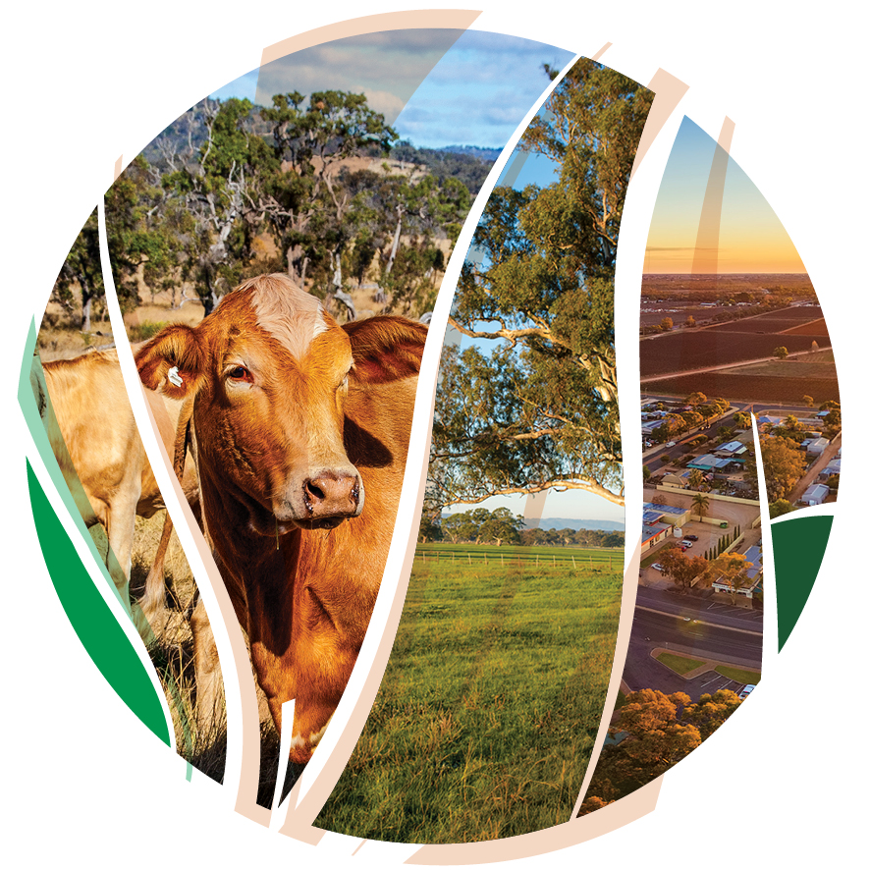

© Commonwealth of Australia 2021

**Ownership of intellectual property rights**

Unless otherwise noted, copyright (and any other intellectual property rights) in this publication is owned by the Commonwealth of Australia (referred to as the Commonwealth).

**Creative Commons licence**

All material in this publication is licensed under a [Creative Commons Attribution 4.0 International Licence](https://creativecommons.org/licenses/by/4.0/legalcode) except content supplied by third parties, logos and the Commonwealth Coat of Arms.

Inquiries about the licence and any use of this document should be emailed to [copyright@awe.gov.au](mailto:copyright@awe.gov.au).



**Cataloguing data**

This publication (and any material sourced from it) should be attributed as: DAWE 2021, *Enhancing Remnant Vegetation Pilot. Management Protocol: Northern Tasmania NRM Region (Tasmania)*, Department of Agriculture, Water and the Environment, Canberra, March. CC BY 4.0.0.

This publication is available at <https://www.agriculture.gov.au/ag-farm-food/natural-resources/landcare/sustaining-future-australian-farming/enhancing-remnant-vegetation-pilot>

Inquiries can be made by email at agstewardship@awe.gov.au.

Department of Agriculture, Water and the Environment

GPO Box 858 Canberra ACT 2601

Telephone 1800 900 090

Web [awe.gov.au](https://www.awe.gov.au/)

**Disclaimer**

The Australian Government acting through the Department of Agriculture, Water and the Environment has exercised due care and skill in preparing and compiling the information and data in this publication. Notwithstanding, the Department of Agriculture, Water and the Environment, its employees and advisers disclaim all liability, including liability for negligence and for any loss, damage, injury, expense or cost incurred by any person as a result of accessing, using or relying on any of the information or data in this publication to the maximum extent permitted by law.

**Acknowledgements**

We thank NRM North and Dr Dean Ansell, Dr Don Butler and Professor Andrew Macintosh from the Australian National University (ANU) for their assistance in preparing this document.

## Acknowledgement of Country

We acknowledge the Traditional Owners of Country throughout Australia and their continuing connection to land, sea and community. We pay our respects to them and their cultures and to their elders past, present and emerging.

Contents

Acknowledgement of Country 3

Introduction 5

Table 1. General conditions 6

Table 2. Remnant Management Area conditions 7

Table 3. Revegetation Areas – design conditions 9

Table 4. Revegetation Areas – establishment conditions 10

Table 5. Revegetation Areas – maintenance conditions 11

Glossary 12

Appendix A: Guidance in identifying the relevant local vegetation communities for your planting 13

Questions and feedback 16

## Introduction

This document details the eligibility, design, establishment and maintenance conditions that apply to projects under the Enhancing Remnant Vegetation Pilot (ERV Pilot). The conditions fall into two categories: mandatory (expressed in the tables as ‘must’ or ‘must not’) and recommended (expressed as ‘should’). All projects **must** comply with the mandatory conditions. Compliance with the recommended conditions is not mandatory.

The information is separated into: general conditions that apply across the *project* *area* as a whole (Table 1); conditions that apply to each *remnant management area* (Table 2); and conditions that apply to each *revegetation area* (Tables 3-5). The Tables contain three columns: column 1 contains a description of the issue covered by the conditions; column 2 provides details on the application of the conditions; and column 3 describes the conditions.

Further advice on any of the conditions listed here can be obtained from the Department of Agriculture, Water and the Environment at [agstewardship@awe.gov.au](mailto:agstewardship@awe.gov.au).

People interested in participating in the ERV Pilot should contact their regional Natural Resource Management (NRM) group for advice. Contact details are available at the end of this document. This document should be read together with the ERV Pilot Guidelines available on the ERV Pilot [website](https://www.agriculture.gov.au/ag-farm-food/natural-resources/landcare/sustaining-future-australian-farming/enhancing-remnant-vegetation-pilot).

## Table 1. General conditions

|  |  |  |
| --- | --- | --- |
| **Issue** | **Application** | **ERV Pilot conditions – NRM North (Tas)** |
| 1.1 Regulatory compliance | All projects | *Projects* **must** be sited, established and managed in accordance with all applicable Commonwealth and State laws relating to planning, environment and heritage.*  *A forest practices plan may be required under the *Forest Practices Act 1985* (Tas) to undertake projects involving plantings. |
| 1.2 Workplace health and safety | All projects | Proponents should prepare a workplace health and safety plan for their *project*. |
| 1.3 Cultural heritage | All projects | In siting, establishing and managing *projects*, proponents should consider cultural heritage impacts and follow relevant Commonwealth and State laws and guidelines concerning the protection and management of cultural heritage sites. Contact your regional NRM group for further information. |
| 1.4 Protection and enhancement of biodiversity values | All projects | Activities that could threaten the protection and enhancement of biodiversity values **must not** be undertaken within the *project area* for the duration of the agreement. |

## Table 2. Remnant Management Area conditions

| **Issue** | **Application** | **ERV Pilot conditions – NRM North (Tas)** |
| --- | --- | --- |
| 2.1 Composition | All *remnant management areas* | *Remnant management areas:*   * **must** consist exclusively of *remnant vegetation*, with the exception of small features like cleared fence lines and management tracks that do not, in aggregate, constitute more than 5% of the area; and * **must not** include utility easements.   *Remnant vegetation* is uncleared native vegetation or regrowth native vegetation that, with appropriate management, could achieve the structure and composition of the original native vegetation community in the next two decades. For the avoidance of doubt, *remnant vegetation* includes natural features such as rock outcrops and wetlands*.*  *Utility easements* are areas of land that utility providers are legally entitled to use and access for the purposes of providing utility services (e.g. electricity, gas, telecommunications and sewerage). |
| * 1. Dimensions | All *remnant management areas* | 2.2.1 Each *remnant management area* **must** be at least 1 hectare.  2.2.2 *Remnant management areas* that do not directly adjoin a larger area of *protected remnant vegetation* **must** have an average minimum width of at least 30m on their short axis.  *Protected remnant vegetation* is remnant vegetation located on a public conservation reserve (e.g. a national park, flora reserve) or on an area of private land where the remnant vegetation is permanently protected under a conservation covenant, conservation agreement or other similar legal agreement that attaches to title (i.e. ‘runs with the land’). |
| * 1. Livestock grazing | All *remnant management areas.*  Note: Where management changes must be made to meet the minimum standards in 2.3.1 and 2.3.2, proponents should select ‘enhanced grazing control’ as a management activity when completing their application. | 2.3.1 Stock **must** be excluded from *remnant management areas* for at least three months of the year, during the primary growing season for native plants in the region.  2.3.2 Livestock grazing **must not** be undertaken in a *remnant management area* that was not subject to livestock grazing in the three years immediately prior to the commencement of the *project*.  2.3.3 Livestock grazing should not be undertaken where it represents a threat to the protection and enhancement of biodiversity values of the *remnant management area*.  Note: Where grazing or other management practices contribute to the degradation of the biodiversity values of a *project area* during the project term, proponents may be required to negotiate in good faith to find ways to mitigate the impacts and reflect any agreed solutions in a revised *management plan*. |
| 2.4 Fencing | *Remnant management areas* involving ‘enhanced grazing control’ | If new fencing is constructed to manage grazing pressure in *remnant management areas*:   * the top strand of wire **must not** be barbed, to reduce the chance of wildlife entanglement; * the fence design and style **must** minimise impacts on the biodiversity of the area, including avoiding impeding the movement of small animals through appropriate selection of mesh size; * disturbance to the *remnant management area* from fence construction and maintenance should be minimised, for example by situating the fence 5m outside the edge of the *remnant vegetation*; * the fence should be inspected regularly to detect any incidence of wildlife entanglement and maintenance requirements; and * fences installed adjacent to riparian areas should be placed in the direction of flow where possible and at least 30m from the current bank of the watercourse.   Note: The costing of fencing is capped under the ERV Pilot at a level that is unlikely to cover the total cost of complex fencing designs. |
| 2.5 Watering points | *Remnant management areas* involving ‘enhanced grazing control’ | 2.5.1 Where fencing or other project activities would remove, or substantially restrict, access to water for stock, watering points may be installed as part of the *project*.  2.5.2 The number and capacity of watering points supported through the ERV Pilot **must not** exceed the number and capacity that is reasonably necessary to meet the watering needs of livestock excluded from the water source(s) by the *project*.  2.5.3 The watering points installed as part of a *project* **must not** increase grazing pressure within the *remnant management area*.  2.5.4 Watering points should be located away from *remnant management area* boundaries to minimise impacts on the native vegetation caused through concentration of livestock. |
| 2.6 Pest control | *Remnant management areas* involving ‘enhanced pest control’ | Pest control:   * **must** be undertaken using one or more of trapping, shooting, baiting or the ripping and/or fumigation of rabbit warrens; * **must not** target native species; * **must** be undertaken in a manner that avoids negative impacts on native species within the *remnant management area*; and * **must** be undertaken in accordance with applicable Commonwealth and State laws. |
| 2.7 Weed control | *Remnant management areas* involving ‘enhanced weed control’ | Weed control:   * **must** not target species that are native to the local area; * **must** be undertaken consistent with applicable Commonwealth and State laws; * **must** be undertaken in a manner that avoids negative impacts on native species within the *remnant management area*; * should avoid the use of residual herbicides (i.e. those that persist in the environment) in riparian areas; and * should prioritise the use of manual control over chemical control methods in environmentally sensitive areas (e.g. near threatened ecological communities and threatened species, and in riparian areas).   . |
| 2.8 Infill plantings | *Remnant management areas* involving ‘*infill* *plantings’* | 2.8.1 *Infill plantings* **must**:   * aim to re-introduce a native plant species or a component of the vegetation’s structure that typically forms part of the local vegetation community or communities (e.g. a shrub layer or perennial tussock grasses); * be limited to specie*s* from the local vegetation community or those communities; * be established by hand using only propagated seedling stock (e.g.tubestock) or by hand sowing of seed (hand broadcast, spot sowing or niche seeding); and * be established within two years of commencement of the project unless explicitly authorised by the Department.   For the avoidance of doubt, *infill plantings* **must not** be established through mechanical direct seeding.  2.8.2 Soil preparation undertaken for *infill plantings*:   * should involve minimal soil disturbance; and * **must not** involve ripping.   2.8.3 All livestock grazing **must** be excluded from an area containing *infill plantings* for the first five years after planting establishment. After that time, livestock grazing in the area:   * **must** be limited to pulse or crash grazing; * **must** not be undertaken if it has a material adverse impact on the survival of the plantings; and * otherwise **must** be undertaken in accordance with the requirements in 2.3.   The area to which the above livestock grazing requirements apply can be a sub-component of a larger *remnant management area* if the area is fenced to a standard that allows for the exclusion of livestock. For example, if a *remnant management area* consists of two adequately fenced paddocks (paddocks A and B), and the *infill plantings* are undertaken in paddock A only, the requirements do not apply to paddock B. If the area containing the *infill plantings* is not separated from the remainder of the *remnant management area* with adequate fencing, the grazing requirements apply to the entire *remnant management area*.  2.8.4 *Infill plantings* should be protected from livestock and other herbivores using fencing or tree guards. See 2.4 for fencing requirements.  2.8.5 Fire **must** not be intentionally introduced to *remnant management areas* that contain *infill plantings*.  2.8.6 Proponents should consider watering *infill plantings* at the time of, and immediately following, establishment.  2.8.7 Remedial *plantings* **must** be established if, after 5 years, the *infill plantings* have not made a material positive difference to the structure and composition of the relevant local vegetation community or communities because of mortality. |
| 2.9 Clearing and thinning | All *remnant management areas* | Native vegetation in *remnant management areas* **must not** be cleared or thinned. |
| 2.10 Fallen timber | All *remnant management areas* | All fallen timber **must** be left within the *remnant management area*. Any fallen timber that is moved from firebreaks, access tracks or fences **must** be placed within the *remnant management area*. |
| 2.11 Fire | All *remnant management areas* | Subject to 2.8.5, fire may be used in the management of *remnant management areas* but **must** be applied in a manner consistent with the conservation of biodiversity values, as indicated in applicable State or local guidelines.  Note: The costs associated with fire are not recoverable under the ERV Pilot. |

## Table 3. Revegetation Areas – design conditions

| **Issue** | **Application** | **ERV Pilot conditions – NRM North (Tas)** |
| --- | --- | --- |
| 3.1 Revegetation establishment method | All *revegetation areas* | Revegetation **must** be undertaken within *revegetation areas* using one or more of the following methods:   * *natural regeneration*; and * *planting* of seed or propagated seedling stock (e.g. tubestock).   *Natural regeneration* is the assisted regeneration of native ecosystems through one of more of:   * the control of livestock and non-native animals; * the control of *weeds*; and * the cessation of clearing and or cultivation. |
| 3.2 Prohibited areas | All *revegetation areas* | 3.2.1 *Revegetation areas:*   * **must not** include mature *remnant vegetation*, being uncleared native vegetation or regrowth native vegetation that has the structure and composition of the original native vegetation community. For the avoidance of doubt, isolated paddock trees are not *remnant vegetation* for the purpose of this protocol; and * **must not** include *utility easements*.   3.2.2 *Natural regeneration* also:   * **must not** occur *in* areas dominated by dense exotic pasture species; and * should not be undertaken in areas that have been intensively fertilised using synthetic fertilisers.   3.2.3 Plantings **must not** add trees and shrubs to areas that did not naturally support trees and shrubs (e.g. grasslands and some wetlands). |
| 3.3 Plant species composition and density | All *revegetation areas* | *Plantings* **must** be either a *local vegetation community planting^*or a*simple mixed native planting*.  A *local vegetation community planting*is a *planting* that:   * as far as practical reflects the structure and composition of the relevant local vegetation community or communities*; and * consists of at least ten specie*s* from that vegetation community or those communities, planted at densities and proportions sufficient to achieve the structure and composition of the relevant local vegetation community or communities*.   A *simple mixed native planting* is a *planting* that:   * as far as practical performs similar ecological functions to the relevant local vegetation community or communities and generates benefits for local native biodiversity; and * consists of at least ten *species* that are native to the local area*#* planted at densities and proportions sufficient to reflect the structure of local vegetation communities*.   ^ *Local vegetation community plantings* will receive higher biodiversity benefit scores, all else being equal.  *See Appendix for resources to assist in identification of relevant vegetation communities.  *#Species that are native to the local area* are plant species that naturally occurred within 100km of the project area, and within the river catchment, prior to European settlement.  Proponents should consider the following with respect to species composition:   * drought resilience and the potential effects of climate changeꭞ; * the availability of tubestock and seed from local nurseries and seed suppliers; * that a diverse and dense mid-storey (where appropriate to the local vegetation type) provides benefits for native birds; and * that ground cover plants require effective control of introduced plant species to achieve high survival rates.   ꭞ For further information on considering climate change in your *plantings* see the publication *Climate ready revegetation: A guide for natural resource managers* available on the [web](https://www.mq.edu.au/__data/assets/pdf_file/0006/807666/Climate-Reveg-Guide-v2-2018.pdf). |
| 3.4 Dimensions of planting | All *revegetation areas* | 3.4.1 Individual *revegetation areas*:   * **must** be at least 0.25 hectare in size; and * **must** have an average minimum width of 30m (stem-to-stem) on their short axis.   3.4.2 In aggregate, the *revegetation areas* included in a *project* **must not** comprise more than 20 per cent of the total *project area.* For example, a proposed project with a *project area* of 5 hectares could not include more than 1 hectare of *revegetation areas*. |
| 3.5 Distance from other vegetation, including plantings | All *revegetation areas* | All *revegetation areas* **must** directly adjoin at least one *remnant management area*. |
| 3.6 Fire risk | All *revegetation areas* | *Revegetation areas*:   * **must not** be within 50m of buildings used for residential or commercial purposes; and * should not be within 50m of any other buildings. |

## Table 4. Revegetation Areas – establishment conditions

| **Issue** | **Application** | **ERV Pilot conditions – NRM North (Tas)** |
| --- | --- | --- |
| 4.1 Site preparation – weed control | All *revegetation areas* | Where weed control is carried out using herbicides, the herbicides **must** be applied in accordance with all applicable Commonwealth and State laws and the manufacturer’s instructions. |
| 4.2 Site preparation – soil | All *revegetation areas* | Soil preparation **must not** be done by ripping in *revegetation areas* with significant biodiversity or natural or cultural heritage values, including areas that contain old native trees, patches of native grass or sites of Indigenous cultural significance. |
| 4.3 Total grazing pressure management | All *revegetation areas* | 4.3.1 All livestock grazing **must** be excluded from *revegetation areas* for the first five years after planting establishment or the commencement of regeneration. After that time, livestock grazing:   * **must** be limited to pulse or crash grazing; and * **must** not be undertaken if it has a material adverse impact on the survival of planting or regeneration in the *revegetation area*.   4.3.2 Total grazing pressure should be managed as necessary to protect the present and future biodiversity value of the site.  4.3.3 Grazing and threats from significant disturbance by vertebrate pests (e.g. rabbits, goats, deer and pigs) and invertebrate pests should be managed where they present a threat to the plantings or regeneration.  4.3.4 Grazing and threats from significant disturbance and overabundant native species (including kangaroos) should be managed where they present a threat to the plantings or regeneration using non-lethal means. |
| 4.4 Timing | All *revegetation areas* | *Revegetation areas* **must** be established within two years of commencement of the project unless explicitly authorised by the Department. |
| 4.5 Planting protection | All *revegetation areas* | 4.5.1 *Plantings* should be protected from livestock and other herbivores.  4.5.2 If new fencing is constructed to manage grazing pressure in *revegetation areas*:   * the top strand of wire around plantings **must not** be barbed, to reduce the chance of wildlife entanglement; * the fence design and style **must** minimise impacts on the biodiversity of the area, including avoiding impeding the movement of small animals through appropriate selection of mesh size; * the fence should be constructed at least 5m from the edge of the revegetation (i.e. from the drip line of the canopy) to minimise impacts of fence construction on the vegetation and reduce maintenance requirements from fallen tree limbs; * the fence should be inspected regularly to detect any incidence of wildlife entanglement and maintenance requirements; and * fences installed adjacent to riparian areas should be placed in the direction of flow where possible and at least 30m from the current bank of the watercourse.   Note: The costing of fencing is capped under the ERV Pilot at a level that is unlikely to cover the total cost of complex fencing designs (e.g. total exclusion fencing). |
| 4.6 Watering | All *revegetation areas* | Proponents should consider watering *plantings* at the time of, and immediately following, establishment. |

## Table 5. Revegetation Areas – maintenance conditions

| **Issue** | **Application** | **ERV Pilot conditions – NRM North (Tas)** |
| --- | --- | --- |
| 5.1 Longevity | All *revegetation areas* | *Revegetation areas* **must** be protected and maintained for at least the duration of the project. |
| 5.2 Remedial planting | All *revegetation areas* | 5.2.1 *Remedial* *plantings* **must** be established in a *revegetation* *area* if:   * it was originally designed to reflect the structure and composition of the relevant local vegetation community or communities; and * mortality results in the *planting* no longer reflecting the structure and composition of the relevant local vegetation community or communities.   5.2.2 *Remedial* *plantings* **must** be established in a *revegetation* *area* if:   * it was originally designed to perform similar ecological functions to the relevant local vegetation community or communities and generate benefits for local native biodiversity; and * mortality results in the *planting* no longer performing similar ecological functions to the relevant local vegetation community or communities and generating benefits for local native biodiversity.   5.2.3 *Remedial* plantings **must** have the same characteristics as that of the original *planting* in the *revegetation area* |
| 5.3 Fallen timber | All *revegetation areas* | All fallen timber **must** be left within the *revegetation area*. Any fallen timber that is moved from firebreaks, access tracks or fences **must** be placed within the *revegetation* *area* or adjoining *remnant management area*. |
| 5.4 Clearing and thinning | All *revegetation areas* | Native vegetation in *revegetation areas* **must not** be cleared or thinned. |
| 5.5 Invertebrate pest control | All *revegetation areas* | 5.5.1 Invertebrate pests should be managed where necessary to protect the present and future biodiversity value of the site.  5.5.2 Where pest control is carried out using pesticides, the pesticides **must** be applied in accordance with all applicable Commonwealth and State laws and the manufacturer’s instructions. |
| 5.6 Fire | All *revegetation areas* | Fire **must** not be intentionally introduced to *revegetation areas*. |
| 5.7 Watering | All *revegetation areas* | Proponents should consider watering *plantings*, particularly tubestock *plantings*, during the first summer after *planting* if there is inadequate rainfall.  Note that the ERV Pilot does not provide funding for watering of *natural regeneration*. |

Glossary

**Defined terms under the ERV Pilot**

***Ground cover plants*** means herbaceous (non-woody) plants, including grasses and forbs.

***Infill planting*** means a *planting* established by hand in a *remnant management area* in accordance with the requirements in Table 2.

***Local vegetation community planting*** means a *planting* that:

* as far as practical reflects the structure and composition of the relevant local vegetation community or communities; and
* consists of at least ten specie*s* from that vegetation community or those communities, planted at densities and proportions sufficient to achieve the structure and composition of the relevant [local vegetation community or communities.

***Management plan*** means the plan annexed to the ERV Pilot agreement between the landholder and the Australian Government that specifies the management activities to be undertaken by the landholder as part of an ERV Pilot project.

***Natural regeneration*** means the assisted regeneration of native ecosystems through one or more of the methods specified in Table 3 (3.1).

***Planting*** means:

1. as a verb, to put or set in the ground tree, shrub and (where relevant) ground cover species using propagated seedling stock or direct seeding; and
2. as a noun, an area of trees, shrubs and (where relevant) ground cover species established using propagated seedling stock or direct seeding.

***Project*** (or ERV project) means a project that aims to protect and enhance the condition of *remnant vegetation* in accordance with an agreement between the landholder and the Australian Government as part of the ERV Pilot.

***Project area*** means the remnant management areas and revegetation areas that are managed as part of a project in accordance with an ERV Pilot agreement between the landholder and the Australian Government.

***Protected remnant vegetation*** is remnant vegetation located on a public conservation reserve (e.g. a national park, flora reserve) or on an area of private land where the remnant vegetation is permanently protected under a conservation covenant, conservation agreement or other similar legal agreement that attaches to title (i.e. ‘runs with the land’).

***Remedial planting*** means a *planting* undertaken to address the mortality of *plantings* in *infill plantings* or *revegetation areas* that meet the requirements in Table 2 (2.8.7) or Table 5 (5.2) respectively.

***Remnant management area*** means an area of *remnant vegetation* that meets the eligibility requirements outlined in Table 2 and that a landholder is required to protect and enhance as part of an ERV project.

***Remnant vegetation*** means uncleared native vegetation or regrowth native vegetation that, with appropriate management, could achieve the structure and composition of the original native vegetation community in the next two decades. For the avoidance of doubt, *remnant vegetation* includes natural features such as rock outcrops and wetlands.

***Revegetation area*** means an area where native vegetation is regenerated through *natural regeneration* or *plantings* (direct seeding or planting propagated seedling stock) in accordance with the requirements in Table 3 as part of an ERV project.

***Shrub*** means a species of woody plant that:

* is generally less than 2m tall if single-*stemmed*; or
* if multi-*stemmed* from the base (or within 20cm from ground level), is generally less than 2m tall or, if more than 2m tall, its largest stem typically has a diameter less than 5cm measured 130cm above the ground.

***Simple mixed native planting*** means a planting that:

* as far as practical performs similar ecological functions to the relevant local vegetation community or communities and generates benefits for local native biodiversity; and
* consists of at least ten *species* that are native to the local area planted at densities and proportions sufficient to reflect the structure of the relevant local vegetation community or communities.

***Species that are native to the local area*** are plant species that naturally occurred within 100km of the project area, and within the river catchment, prior to European settlement.

***Stem***, in relation to the ERV Pilot, means the ascending axis of a plant and is generally the main structural component of the above-ground portion of trees and shrubs.

***Thinning*** means the selective removal of trees or shrubs for any purpose.

***Tree***, in relation to the ERV Pilot, means a species of woody plant that at maturity is generally more than 2m tall and either has a single stem with branches well above the base or, if multi-stemmed from the base (or within 20cm from ground level), its largest stem typically has a diameter greater than 5cm measured 130cm above the ground.

***Utility easement***means an area of land that utility providers are legally entitled to use and access for the purposes of providing utility services (e.g. electricity, gas, telecommunications and sewerage).

**Weeds** in the context of the ERV Pilot means exotic plants as well as Australian plant species that are notnative to the local area*.*

## Appendix A: Guidance in identifying the relevant local vegetation communities for your planting

This Appendix sets out some sources for information on natural vegetation in your region. The sources selected are generally the most up to date, which are accessible online. It is not a comprehensive list, and most parts of Australia are covered by numerous published guides and studies that can also help with plant species selection, particularly for simple mixed native plantings. Sources of native plants and seeds, such as nurseries, can also help, as can your local Natural Resource Management body or Landcare group.

If you have confidence in your understanding of the natural vegetation across the areas in which you are planting you may not need more information to decide on an appropriate species mix. For example, if there are enough paddock trees or roadside patches and other reminders of the native vegetation you might have enough to design a local vegetation community planting that closely reflects local ecosystems.

But even if you know your local plants, the data described here, plus other local sources, should be consulted to confirm natural combinations of species in your region, and also to confirm the scientific names and natural range for species you might know best by a common name. The [Atlas of Living Australia](https://www.ala.org.au/) is a valuable national resource for biodiversity information.

The Tasmanian Government’s “TASVEG” provides comprehensive digital maps that depict the extent of more than 150 vegetation communities across Tasmania. Descriptions of these communities, to be used in conjunction with the mapping, are provided in an accompanying [technical manual](https://dpipwe.tas.gov.au/conservation/flora-of-tasmania/from-forest-to-fjaeldmark-descriptions-of-tasmanias-vegetation).

To access vegetation mapping:

1. Go to <https://dpipwe.tas.gov.au/conservation/development-planning-conservation-assessment/planning-tools/monitoring-and-mapping-tasmanias-vegetation-(tasveg)/tasveg-the-digital-vegetation-map-of-tasmania>

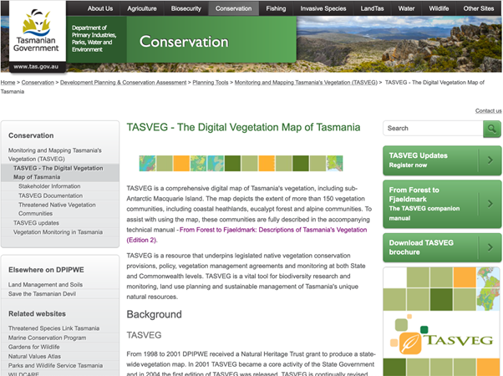

1. Click on the link to LISTmap under the heading “How to access TASVEG” to take you to the mapping viewer at <https://maps.thelist.tas.gov.au/listmap/app/list/map>
2. Use the map controls to locate your area(s).
3. Aerial photography can be added to the map by clicking on “Basemaps” on the right hand side of the screen, select “ESRI Imagery”. To add the TASVEG layer to the map, click on the “Layers” tab on the top right hand side of the page.

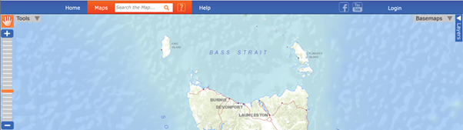

1. Click on “Add Layer +” and navigate down to “Plants and Animals”, expand “Communities” and select “TASVEG 4.0” to add the latest official release to the map. The transparency of this vegetation layer can be adjusted by clicking the small arrow to the left of “TASVEG 4.0” on the right hand side of the screen.

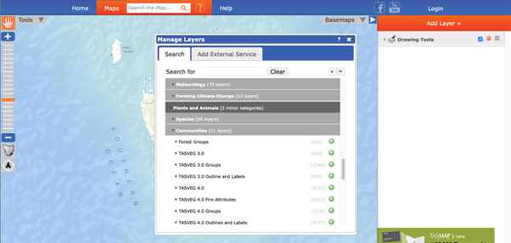

1. Click on areas of vegetation closest to the area you propose to plant to identify the community present.

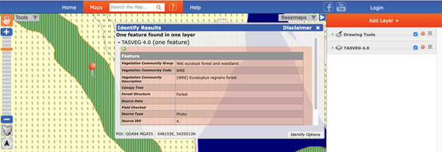

1. A popup box will identify a vegetation community and its code – in the example above this is (WRE) *Eucalyptus regnans* forest.
2. To find a list of species typical of this vegetation community, you must search the [accompanying technical manuals](https://dpipwe.tas.gov.au/conservation/flora-of-tasmania/from-forest-to-fjaeldmark-descriptions-of-tasmanias-vegetation).
3. The description for *Eucalyptus regnans* forest can be found in the Wet Eucalypt and Forest document.

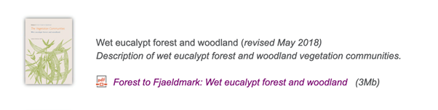

1. A detailed description for WRE *Eucalyptus regnans* forest is provided in the document under the heading “Vegetation composition and structure”.

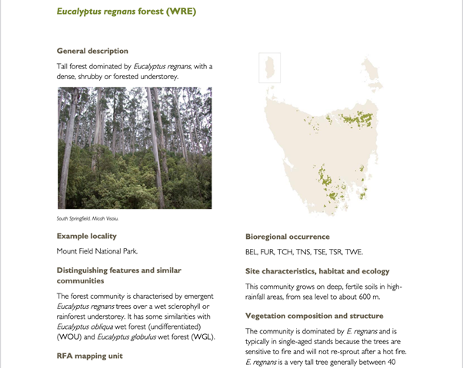

## Questions and feedback

Any questions or feedback about this document should be sent to [agstewardship@awe.gov.au](mailto:agstewardship@awe.gov.au) or you can contact the [Department of Agriculture, Water and the Environment](https://www.agriculture.gov.au/) on 1800 329 055.