Enhancing Remnant Vegetation Pilot

Price Guide
September 2021
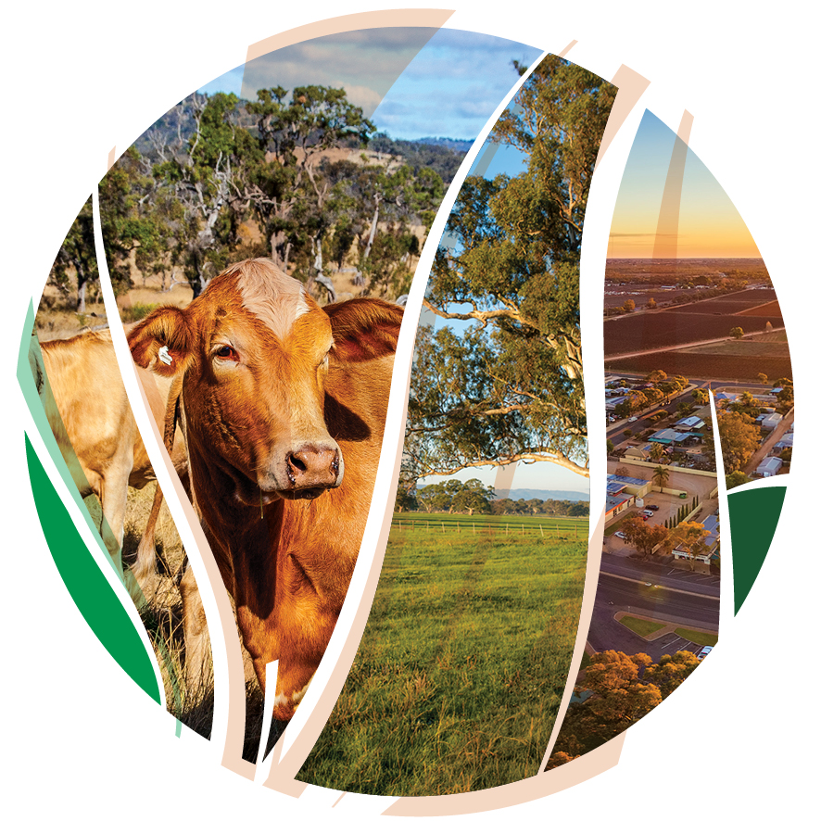
© Commonwealth of Australia 2021
Ownership of intellectual property rights
Unless otherwise noted, copyright (and any other intellectual property rights) in this publication is owned by the Commonwealth of Australia (referred to as the Commonwealth).
Creative Commons licence
All material in this publication is licensed under a Creative Commons Attribution 4.0 International Licence except content supplied by third parties, logos and the Commonwealth Coat of Arms.
Inquiries about the licence and any use of this document should be emailed to copyright@awe.gov.au.

Cataloguing data
This publication (and any material sourced from it) should be attributed as: DAWE 2021, Enhancing Remnant Vegetation Pilot. Price Guide, Department of Agriculture, Water and the Environment, Canberra, September.
This publication is available at https://www.agriculture.gov.au/ag-farm-food/natural-resources/landcare/sustaining-future-australian-farming
Inquiries can be made by email at agstewardship@awe.gov.au.
Department of Agriculture, Water and the Environment
GPO Box 858 Canberra ACT 2601
Telephone 1800 900 090
Web awe.gov.au
Disclaimer
The Australian Government acting through the Department of Agriculture, Water and the Environment has exercised due care and skill in preparing and compiling the information and data in this publication. Notwithstanding, the Department of Agriculture, Water and the Environment, its employees and advisers disclaim all liability, including liability for negligence and for any loss, damage, injury, expense or cost incurred by any person as a result of accessing, using or relying on any of the information or data in this publication to the maximum extent permitted by law.
Acknowledgements
We thank the Natural Resource Management (NRM) Groups from the six pilot regions and Professor Andrew Macintosh, Dr Dean Ansell and Dr Don Butler from the Australian National University (ANU) for their assistance in preparing this document.

Acknowledgement of Country
We acknowledge the Traditional Owners of Country throughout Australia and their continuing connection to land, sea and community. We pay our respects to them and their cultures and to their elders past, present and emerging.

Contents
Acknowledgement of Country 3
1. Role of the Price Guide 5
1.1 Importance of project planning 5
1.2 Improving the competitiveness of your application 5
1.3 Role of Natural Resource Management Groups 6
2. Making an application 7
3. Indicative costs 8
4. Questions and feedback 12

Role of the Price Guide
The Enhancing Remnant Vegetation Pilot: Price Guide (Price Guide) has been developed to help farmers who are considering applying to participate in the Agriculture Stewardship – Enhancing Remnant Vegetation Pilot (ERV Pilot). The Price Guide provides indicative estimates of the costs associated with undertaking eligible management activities. The cost estimates are intended to help farmers in scoping projects and determining whether they want to participate in the Pilot.
Prior to reading the Price Guide and preparing an application, applicants should read the ERV Pilot Guidelines and associated ERV Pilot documentation, including the ERV Management Protocol and ERV Application Guide. These are available on the Agriculture Stewardship Package website.

1.1 Importance of project planning
Before applying to participate in the ERV Pilot, you will need to plan your project and consider how it fits into your existing agricultural business. Amongst other things, when planning the project, you should consider:
- alternative areas for, and designs and types of, remnant management areas and revegetation areas;
- the most cost-effective ways of undertaking relevant management activities; and
- the likely costs associated with undertaking your proposed management activities over the life of the project (i.e. 10 years).
Where necessary, you should seek expert advice from agronomists, financial advisers, service providers and others when planning the project.
The cost estimates contained in Section 3 of the Price Guide can be used as a starting point for project planning to give you a point of reference in considering whether you want to participate in the ERV Pilot. However, it should not be relied on as the sole or primary source of information on the costs associated with undertaking an ERV Pilot project. Project costs are highly variable and depend on a range of factors, particularly the nature of the proposed management activities and how they are undertaken. Applicants are responsible for collecting their own information on project costs and conducting their own analysis of the costs and benefits of participating in the ERV Pilot.

1.2 Improving the competitiveness of your application
The ERV Pilot is a competitive program, meaning not all applicants will receive biodiversity enhancement payment offers. Under the ERV Pilot, projects will be assessed on the basis of their costs and projected biodiversity benefits. Generally, projects that generate the highest biodiversity benefits per dollar invested are more likely to be selected and receive biodiversity enhancement payment offers.
Applicants should be mindful of the competitive nature of the ERV Pilot when designing their projects and submitting an application.
There are four main ways of improving the competitiveness of your application.
- Designing projects that will protect and enhance the condition of remnant vegetation that is of high regional conservation priority (e.g. remnant vegetation that is part of a habitat/vegetation type that has been extensively cleared).
- Undertaking management activities that are likely to generate the greatest improvements in the condition of biodiversity at the lowest cost.
- Providing in-kind contributions to the project. This can be done by submitting lower cost estimates for nominated management activities in your application.
- Nominating an alternative rental payment that is lower than the estimate provided on the ERV web portal (www.agsteward.com.au). You are given the option of doing this in the application form.

1.3 Role of Natural Resource Management Groups
Your regional Natural Resource Management (NRM) group can provide general assistance with project planning and help identify relevant local service providers, including nurseries, and weed, planting and fencing contractors.

Making an application
After completing the project planning, you should be in a position to apply to participate in the ERV Pilot through the web portal at: www.agsteward.com.au. The web portal requires applicants to:
- map the remnant management areas and any proposed revegetation areas on their property;
- provide details of the proposed management activities in each of the remnant management areas and revegetation areas; and
- estimate the cost of the proposed management activities.
The ERV Application Guide summarises the information required in the application form and should be read prior to making an application through the web portal.
It is important that the information you submit on the remnant management areas, revegetation areas and proposed management activities is as accurate as possible. The submission of inaccurate information could distort the outcomes from the ERV Pilot and threaten its ability to achieve its objectives. The cost estimates are of particular importance as they will be used to generate biodiversity enhancement payment offers and rank projects in the selection process. Due to this, all applicants are asked to:
- undertake proper project planning before submitting an application through the web portal;
- give appropriate thought and consideration to the information they submit; and
- to the extent possible, ensure the cost estimates that are submitted accurately reflect the likely costs associated with undertaking the proposed project.
Duty to ensure submitted information is accurate
Applicants are required to act with the utmost good faith in their engagements with the ERV Pilot, including in applying to participate through the web portal. This duty requires proponents to act reasonably, honestly and with propriety, and with due regard to what the Australian Government is trying to achieve with the ERV Pilot.
Knowingly providing inaccurate information in an application is likely to constitute a breach of this duty and could result in your exclusion from the ERV Pilot. It could also result in the termination of any agreement you may be offered under the ERV Pilot.
Applicants should note that making false or misleading statements, or providing false or misleading information, in an application is an offence under Chapter 7 of the Commonwealth Criminal Code, carrying maximum penalties of up to 12 months imprisonment.

Indicative costs
Table 1 contains indicative estimates of the costs associated with relevant management activities. The estimates are provided in relation to the five categories of eligible management activities: enhanced grazing control; enhanced weed control; enhanced pest control; infill plantings; and revegetation. An indicative cost estimate is also provided for freight, which may be required for the transport of project materials (e.g. fencing, water troughs and water tanks).
As noted in Section 1.1 above, the information contained in Table 1 is intended to provide potential applicants with an initial point of reference when considering whether to participate in the ERV Pilot. It should not be relied on as the sole or primary source of information when undertaking project planning or submitting an application to participate in the ERV Pilot.
Should GST be included in the cost estimates submitted through the web portal?
The cost estimates that are submitted through the web portal are required to include GST where it is payable. Do not include GST if it is not payable on the relevant good or service.
For example, for infill plantings, if you intend to use tubestock from a local nursery but plant the seedlings yourself, GST is likely to be payable on the tubestock but not on the amount you cost for your time and labour. Consequently, the cost estimates submitted through the web portal should: (a) include the GST payable on the tubestock; and (b) not include GST in the cost of the labour associated with planting the seedlings.
Note that, if you are registered for GST, GST will be included in any biodiversity enhancement payment offer that you receive.

Table 1. Indicative cost ranges
 | Cost range | Comment
1. Enhanced grazing control
Fencing
Fencing wire, intermediate posts/pickets and droppers | $3.50-$6.00 per metre | Materials only, includes GST.
Strainer assemblies | $100-$150 per assembly | Materials only, includes GST.
Gates | $120-$200 per gate | Materials only, includes GST.
Installation costs | $3.00-$6.00 per metre
Watering points
Water troughs | $300-$1,000 | Price depends on size and type (poly or cement). Includes GST but freight not included.
Water tanks | $2,000-$10,000 | Price depends on size and type (poly or steel). Includes GST but freight not included.
Pump and power | Variable | Depends on size, type and brand.
Pipes | $2.00-$4.00 per metre | Price depends on size, length and brand. Includes GST but freight not included.
2. Enhanced weed control
Labour
Labour cost | $25-$75 per hr | Depends on nature of the weeding and the skills/experience required to safely perform the task.
Chemical cost
Application rate | 0.5-10 L per ha | Highly variable depending on herbicide used, weeds treated and method of treatment.
Chemical cost | $7.50-$25.00 per litre | Variable. Depends type of herbicide, brand and quantity purchased.
3. Enhanced pest control
Labour and materials
Labour and materials for baiting, trapping, shooting and fumigation | $75-$120 per hr | Depends on nature of skills and experience required to safely perform the task.
Ripping (rabbit warrens) | $30-$100 per ha | Depends on extent of infestation, topography and soil type.

4. Infill plantings
Soil preparation
Manual digging - for seedlings | $0.50-$1.50 per seedling | Depends on size of planting, stocking densities and location.
Plants
Tubestock (seedlings) | $0.50-$3.00 per seedling | High variability. Local provenance can increase costs. Specialist/rare species can increase costs significantly. Includes GST.
Seed | $200-$500 per kg | High variability. Local provenance can increase costs. Specialist/rare species can increase costs significantly and there is variability between regions. Includes GST.
Amount of seed per ha | Variable | Depends on site characteristics and nature of infill planting.
Planting
Manual tubestock planting | $0.40-$1.25 per seedling | Depends on size of planting, stocking densities, site characteristics and location.
Hand seeding | Variable | Depends on site characteristics and nature of infill planting.
Tree protection
Guards | $0.30-$2.00 per guard | Depends on type of guard (cardboard milk carton, plastic sleeve, corflute plastic etc.) and quantity purchased. Includes GST.
Guard stakes | <$0.01-$0.50 per stake | Depends on type of stake (e.g. bamboo, hardwood) and quantity purchased. Includes GST.
Guard installation | $0.20-$0.40 per guard | Depends on site characteristics and number and type of stake.
5. Revegetation
Site preparation - weed control
Non-woody weed spot spray | $80-$250 per ha per treatment | Plantings generally require between 0-3 treatments.
Non-woody weed boom spray | $40-$200 per ha per treatment | Plantings generally require between 0-3 treatments.
Woody weed treatments | $100-$500 per ha per treatment | Depends on species, extent of infestation and technique.
Soil preparation
Manual digging - for seedlings | $0.50-$1.50 per seedling | Depends on size of planting, stocking densities and location.
Deep ripping/discing | $40-$300 per ha | Size, remoteness and accessibility are important.

Plants
Tubestock (seedlings) | $0.50-$3.00 per seedling | High variability. Local provenance can increase costs. Specialist/rare species can increase costs significantly. Includes GST.
Seed | $200-$500 per kg | High variability. Local provenance can increase costs. Specialist/rare species can increase costs significantly and there is variability between regions. Includes GST.
Amount of seed per ha | 0.4-1.5 kg per ha | Depends on stocking density, species and site characteristics.
Planting
Manual tubestock planting | $0.40-$1.25 per seedling | Depends on size of planting, stocking densities, site characteristics and location.
Mechanical tubestock planting | $0.50-$1.30 per seedling | Depends on size of planting, stocking densities, site characteristics and location.
Direct seeding | $100-$400 per ha | Depends on size of planting, site characteristics and location.
Tree protection
Fencing - wire, intermediate posts/pickets and droppers | $3.50-$6.00 per metre | Materials only, includes GST
Fencing - strainer assemblies | $100-$150 per assembly | Materials only, includes GST
Fencing - gates | $120-$200 per gate | Materials only, includes GST
Fencing - installation costs | $3.00-$6.00 per metre | Depends on location and difficulty of job.
Guards | $0.30-$2.00 per guard | Depends on type of guard (cardboard milk carton, plastic sleeve, corflute plastic etc.) and quantity purchased. Includes GST.
Guard stakes | <$0.01-$0.50 per stake | Depends on type of stake (e.g. bamboo, hardwood) and quantity purchased. Includes GST.
Guard installation | $0.20-$0.40 per guard | Depends on site characteristics and number and type of stake.
6. Freight
For fencing, water points and other materials | $1.25-$2.75 per km | Depends on nature of freight and distance.

Questions and feedback
Any questions or feedback about this document should be sent to agstewardship@awe.gov.au or you can contact the Department of Agriculture, Water and the Environment on 1800 329 055.

