

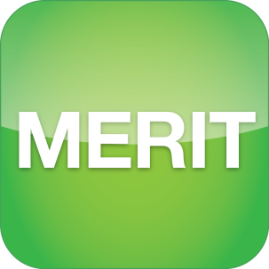

**Monitoring, Evaluation, Reporting and Improvement Tool**

**USER GUIDE**

# Part D – Program Specific Guide

**For projects delivered under the Environmental Stewardship Program (ESP)**

**September 2020**

**Version 2.2**

## Acknowledgement of Traditional Owners and Country

The Department acknowledges the traditional owners of country throughout Australia and their continuing connection to land, sea and community. We pay our respects to them, their cultures and to their elders both past and present.

© Copyright Commonwealth of Australia, 2020



The Monitoring, Evaluation, Reporting and Improvement Tool (MERIT) - Program Specific Guide for activities delivered under the ESP Funding Agreement is licensed by the Commonwealth of Australia for use under a Creative Commons Attribution 4.0 International licence with the exception of the Coat of Arms of the Commonwealth of Australia, the logo of the agency responsible for publishing the report, content supplied by third parties, and any images depicting people. For licence conditions see: <https://creativecommons.org/licenses/by/4.0/>.

This document should be attributed as ‘*Part D - Program Specific Guide for projects delivered under the Environmental Stewardship Program*, version 2.2, Commonwealth of Australia 2020’.

The Commonwealth of Australia is aware of applying details to identify any content supplied by third parties, using the following format ‘© Copyright’. No third-party material has been used in this guide.

Contents

**INTRODUCTION 4**

**HOW TO USE THIS GUIDE 4**

**CONTACTS 5**

1. MERIT Structure for ESP 6

1.1. Navigate to the Environmental Stewardship project 6

1.2. Find assigned Environmental Stewardship projects using ‘My Projects’ 7

2. Reporting 8

2.1. Find the reports 8

2.2. Filling in the reports 8

2.3. Saving and completing your report 8

3. Reporting Requirements 9

3.1. My ESP sites 9

3.2. My Species Records 19

3.3. Dashboard 20

3.4. Photographs 20

3.5. Documents 20

3.6. Annual Report Submission 21

3.7. Download Report 23

**WANT MORE INFORMATION? 24**

**GLOSSARY OF TERMS 24**

## INTRODUCTION

Organisations and individuals who receive funding from Australian Government Natural Resource Management (NRM) programs are required to report on the progress of their activities through the Monitoring, Evaluation, Reporting and Improvement Tool (MERIT). MERIT is an online reporting system that simplifies and streamlines reporting across Australian Government NRM programs.

## HOW TO USE THIS GUIDE

This “Program Specific Guide” (PSG) is designed for projects that are delivering outcomes under the Environmental Stewardship Program (ESP). It is an extension of, and should be read in conjunction with, the ‘[MERIT User Guide - for NRM funding recipients and the public’ (the MERIT User Guide](http://www.nrm.gov.au/publications/merit-user-guide-2020)). The MERIT User Guide will cover generic features of MERIT that are applicable across all programs (i.e. Opening MERIT, how to find projects, Blogs, Admin functions & MERIT workflow). It also covers information relevant for the public.

This PSG Guide should only be used by MERIT users who manage information in MERIT. It will focus on reporting requirements of the ESP and distinct details that only refer to the ESP.

The information in this guide will assist Environmental Stewards with how to track and maintain their projects in MERIT. It can also be used to inform Departmental ‘Project Managers’ on how information should be entered.

|  |  |
| --- | --- |
| Information notice | Important note: If you do not manage a project as part of the Environmental Stewardship Program, please refer to the [MERIT User guide](http://www.nrm.gov.au/publications/merit-user-guide-2020) or another Program Specific Guide for information on relevant MERIT functions. |

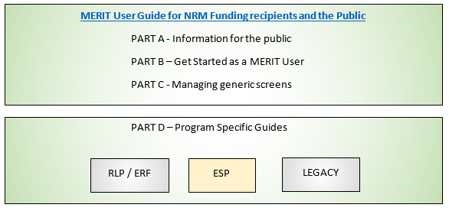

The instructions in this guide will assume the user is logged in and has navigated to the MERIT project (see the [MERIT User Guide; 4. New users: register and log in](http://www.nrm.gov.au/publications/merit-user-guide-2020)).

## Contacts

| **Resource** | **Description** | **Location** |
| --- | --- | --- |
| Departmental Project Manager | Environmental Stewards should contact their departmental Project Manager in the first instance, for any assistance with ESP MERIT. | [EnviroStewardship@environment.gov.au](mailto:EnviroStewardship@environment.gov.au) |
| MERIT Inbox | Contact the MERIT team for technical support or to provide feedback on MERIT. | [MERIT@awe.gov.au](mailto:merit@environment.gov.au) |
| Natural Resource Management Resources | Additional guidance material designed to assist Environmental Stewards with program obligations. | <http://www.nrm.gov.au/national/continuing-investment/environmental-stewardship> |

## 1. MERIT Structure for ESP

**IMPORTANT: This Guide will only advise MERIT users who manage projects for this program. Instructions in this guide will assume the user is logged in and has navigated to the project** **(see the**[**MERIT User Guide; 4. New users: register and log in**](http://www.nrm.gov.au/publications/merit-user-guide-2020)**).**

|  |  |
| --- | --- |
| Information notice | MERIT achieves best performance with recent versions of web browsers such as [Google Chrome](http://www.google.com/chrome/). Internet Explorer and older versions of web browsers do not support efficient use of MERIT. |

### 1.1. Navigate to the Environmental Stewardship project

To find the Environmental Stewardship project use any of the following methods (found on MERIT’s Home page):

**Method A**: Project Explorer button

* Click on ‘Project Explorer’ to expand ‘Topic’ to open ‘Facets’ (to filter on).
* Filter on ‘Program’ heading for ‘Environmental Stewardship’. Check box and click ‘Refine’ button.
* Filter on other facets such as ‘Management Areas’. Check box and click ‘Refine’ button.

**Method B**: Search Bar

* Type ‘Environmental Stewardship’ or the project name in the search bar.

**Method C**: ‘My Projects’ Button

* This function searches for project/s that are assigned to a MERIT User.
* Click on ‘My projects’ (once projects are assigned to you).

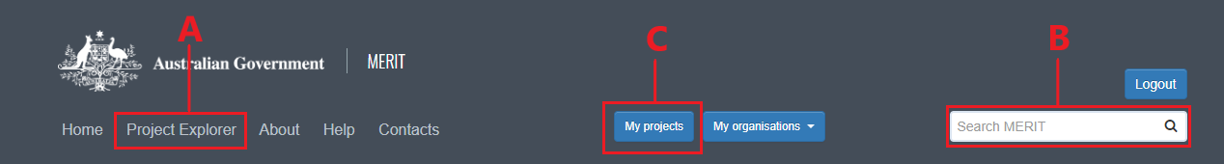

### 1.2. Find assigned Environmental Stewardship projects using ‘My Projects’

The quickest way to find any Environmental Stewardship project assigned to you is to:

1. 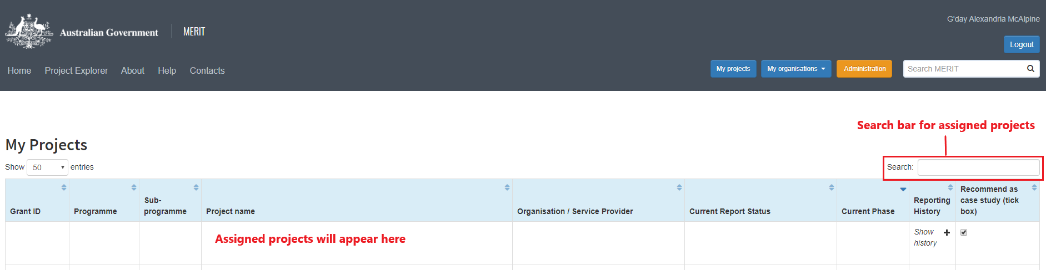Click the ‘My Projects’ button to open a table of projects. It will take a minute to generate the list of projects allocated to you. The screen will display:
2. Click on the project link and a project overview screen will open. This screen allows you to navigate between the following tabs:



|  |  |
| --- | --- |
| Information notice | If you can’t see your project, contact your departmental Project Manager or [merit@awe.gov.au](mailto:merit@awe.gov.au) for access. |

## 2. Reporting

Reporting is a requirement of the Environmental Stewardship Program to track the progress of an ESP project as per the contract (funding agreement). Reports are maintained in MERIT for the duration of each project. Environmental Stewards are required to complete an annual report and the due date is outlined in the funding agreement.

### 2.1. Find the reports

Reports are activated once the ESP contract is submitted and approved and reporting periods are set. To find the ESP reports:

* Ensure you are logged into MERIT and navigate to your ESP project.
* Click on the ‘My ESP Sites’ tab. Each of your ESP sites is shown on the map. Hovering over the ESP site with your cursor will provide a pop-up with the site details.
* Click on an ESP site to access the ESP activity reporting form for that site.
* Once all ESP site activity reports are complete the ‘Annual Report Submission’ tab will appear.

Further information on reports is covered in section 3 – Reporting Requirements.

### 2.2. Filling in the reports

Complete the report for an ESP site as required. Further information on each part of the report can be found in section 3.1 - My ESP Sites.

Once ESP reports are complete for each site the colour of that site will change from red to green on the map. When all sites are green, you can fill in and submit your annual report through the ‘Annual Report Submission’ tab.

|  |  |
| --- | --- |
| Information notice | Please note multiple sections of the property on your map may be attributed to a single reporting form. If you attempt to click on a site on your property map and it does not take you to the report for that site, please try another. |

### **2.3. Saving and completing your report**

**Saving your report**

To save ESP activity site reports or the annual report, click on the ‘Save changes’ button at the bottom of the page. You can save your report at any point and your progress will be saved. This means you can complete sections of your report at any time throughout the year.

**Completing your report**

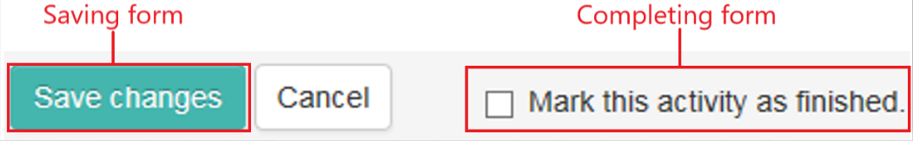When you have fully completed your reporting for a site, tick the box next to ‘Mark this activity as finished’ and save changes. The report for this site is now complete.

Once all site reports are marked as finished you will be able to complete the annual report found in the ‘Annual Report Submission’ tab.

## 3. Reporting Requirements

Reporting requirements or management actions are listed under sub-headings to make it easier to navigate. Sub-headings are based on the types of management actions you undertake for your Environmental Stewardship site.

|  |  |
| --- | --- |
| Information notice | In MERIT, all mandatory fields in the ESP site report are marked with a red asterisk. Mandatory fields must be completed before the report can be marked as finished. |

### **3.1.** **My ESP sites**

This segment provides step-by-step instructions on how to complete the report for each ESP site. To open the site report, go to the ‘My ESP Sites’ tab and click on a site on the map to fill out the report for that site.

Please ensure that you enter the details of the number and cost once only. They can be entered in either as:

1. a single total record, encompassing the details and costs of this activity across all your sites, or
2. as separate entries for each site.

|  |  |
| --- | --- |
| Information notice | Green sites signify the reporting requirements have been finished (saved and completed). Red sites have unfinished reports. |

#### **3.1.1. Livestock grazing management**

|  |  |
| --- | --- |
| Information notice | Enter in these details for each period of grazing undertaken over the reporting period. |

To report on any livestock grazing management you have undertaken over a reporting period you should:

1. Tick the box ‘Not an agreed management action’ if grazing is not a contracted management action.
2. Select ‘Yes’ or ‘No’ if the ESP site is divided up into multiple paddocks. If this ESP site is comprised of a single paddock, select ‘No’.
3. Select ‘Yes’ or ‘No’ if grazing exclusion is a management action in your funding agreement. If grazing exclusion is a management action for you, but you haven’t grazed at all, delete the row that asks for further details on paddock grazing. You can do this by clicking the bold '**x**’ on the far-right hand side of the row. Then use the text box at the bottom of the section to explain why you didn’t graze.
4. Record all grazing periods for the site. You will need to add in a new row for each paddock that had stock run in it, including those run at the same time. To do this:
   1. Click the box under ‘Start Date’ and select the date from the calendar. Repeat this for end date. You will need to add in a separate row for each different date range you ran stock.
   2. Click on the drop-down arrow under ‘Type of Stock’ and select the type of stock you ran. You will need to add in a separate row for each different type of stock you ran.
   3. Click on the drop-down arrow under ‘Type of Grazing’ and select the type of grazing activity you undertook.
   4. Click on the drop-down arrow under ‘Production Type’ and select the option that is most accurate. You will need to add in a separate row for each different production type.
   5. Click on the drop-down arrow under ‘Growth Stage’ and select the option that is most appropriate. You will need to add in a separate row for each different growth stage.
   6. Click into the box under ‘No. Individuals’ and add in the number of animals.
   7. 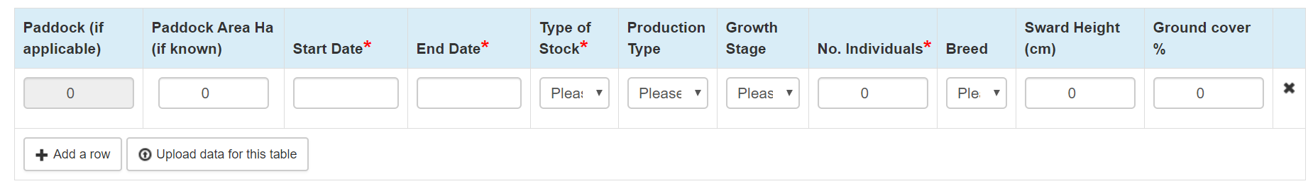Click on the drop-down arrow under “Breed” and select the option that is most accurate. You will need to add in a separate row for each different breed, including those run at the same time.
5. Record the ‘Sward Height’ and ‘Ground cover %’ at the end of your grazing periods.

For ESP projects with large sites containing numerous paddocks, entering in the above data for each paddock can be too time consuming. In this situation, you can do the following:

1. First delete any rows by clicking on the bold ‘**x**’ at the far right of the row.
2. Report on the grazing activities that you have undertaken in the past year using the text box at the bottom of the section.

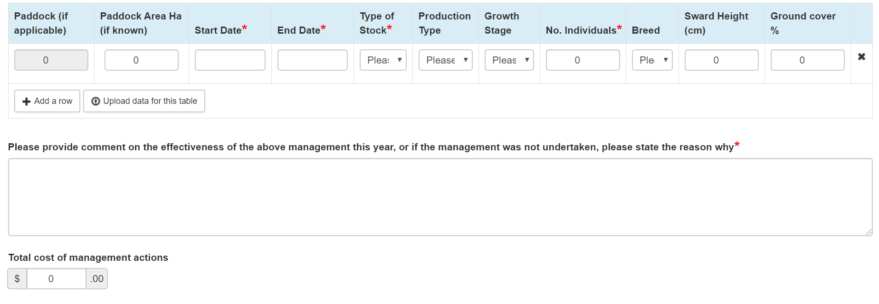

To record a cost against any of these actions, click into the box under ‘Total cost of management actions’ and enter in a cost.

#### **3.1.2. Sward height**

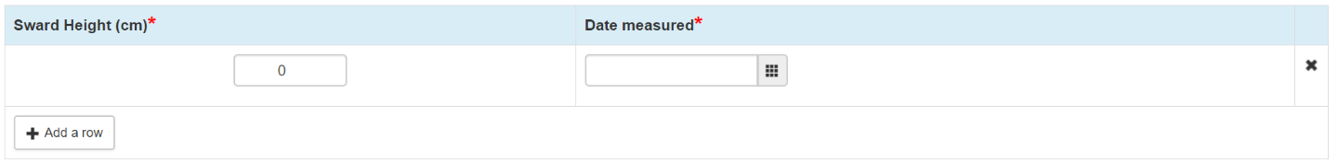If you undertake grazing, please record sward height at the end of your grazing periods (in the table under “Livestock Grazing Management). If you do not undertake grazing record sward height here. Sward height should be measured at the same time that you take the photo-point photograph for this site.

|  |  |
| --- | --- |
| Information notice | You only need to record sward height once per year, at the same time that you take the photo-point photograph for this site. Please ensure that this is done at the same time each year. A ‘how-to’ guide detailing the method for measuring sward height can be found here: <http://www.nrm.gov.au/publications/measuring-sward-height>. |

#### **3.1.3. Ground cover (%) estimate**

If you undertake grazing, please record ground cover at the end of your grazing periods (in the table under ‘Livestock Grazing Management’). If you do not undertake grazing record ground cover (%) estimate here. Ground cover should be recorded at the same time that you take the photo-point 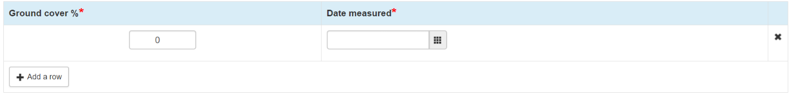photograph for this site.

|  |  |
| --- | --- |
| Information notice | You only need to record an estimate of ground cover % once per year, at the same time that you take the photo-point photograph for this site. Please ensure that this is done at the same time each year. A ‘how-to’ guide detailing the method for estimating ground cover percentage can be found here: <http://www.nrm.gov.au/publications/estimating-ground-cover-percentage>. |

#### **3.1.4. Native herbivore management**

To report on any activities to monitor and/or manage native herbivores during this reporting period you should:

1. Tick the box ‘Not an agreed management action’ if native herbivore management is not a contracted management action.
2. Click on the drop-down arrow under ‘Species’ and select the species managed. You will need to add in a separate row for each different species you managed.
3. Click on the drop-down arrow under ‘Season observed / managed’ and select the season.   
   If you have monitored or managed the same species but in different seasons add them in on separate rows.
4. Click in the box under ‘Management Action(s)’ and select the most appropriate option(s). You can enter in multiple options under this heading.
5. Click on the drop-down arrow under ‘Reason for management’ and select the most appropriate option.
6. Click into the box under ‘If applicable, no. culled (if known)’ and enter in the number of animals culled.
7. 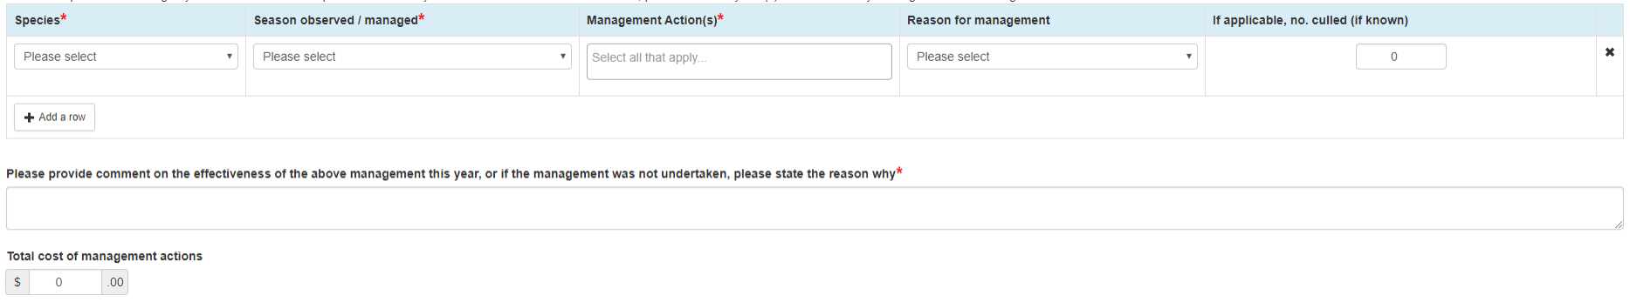To record a cost against these actions, click into the box under ‘Total cost of management actions’ and enter in a cost.

#### **3.1.5. Feral animal management**

To report on any activities to monitor and/or manage feral animals during this reporting period:

1. Tick the box ‘Not an agreed management action’ if feral animal management is not a contracted management action.
2. Click on the drop-down arrow under ‘Species’ and select the species managed. You will need to add in a separate row for each different species you managed. E.g. if you have monitored or managed two different species in the same season add them in on separate rows.
3. Click on the drop-down arrow under ‘Season observed / managed’ and select the season. You will need to add in a separate row for each different season. E.g. if you have monitored or managed the same species but in different seasons add them in on separate rows.
4. Click in the box under ‘Management Action(s)’ and select the most appropriate option(s). You can enter in multiple options under this heading.
5. Click on the drop-down arrow under ‘Reason for management’ and select the most appropriate option.
6. Click into the box under ‘If applicable, no. culled (if known)’ and enter in the number of animals culled.
7. 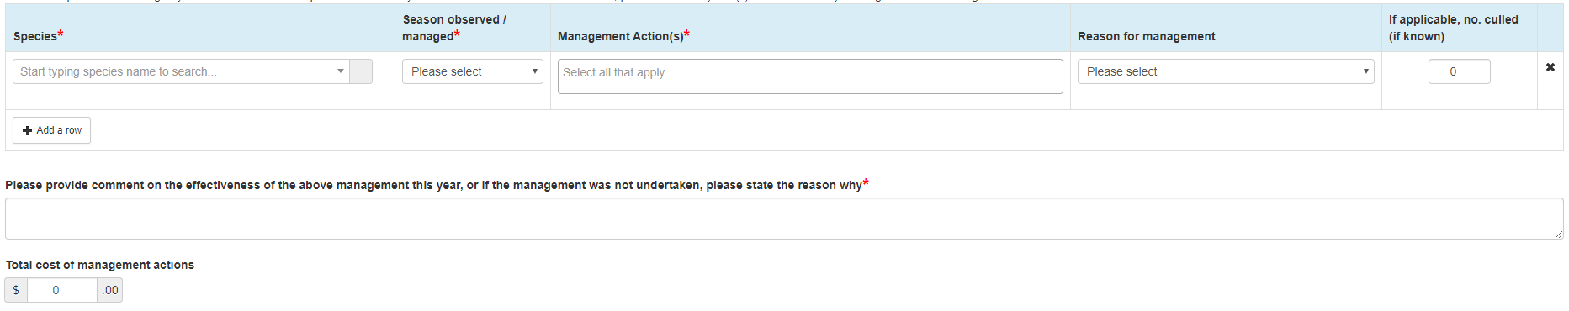To record a cost against these actions, click into the box under ‘Total cost of management actions’ and enter in a cost.

#### **3.1.6. Weed management**

To report on any activities to monitor and/or manage weeds during this reporting period:

1. Tick the box ‘Not an agreed management action’ if weed management is not a contracted management action.
2. Click on the drop-down arrow under ‘Species’ and select the species managed. You can also type the name of the species you managed into the text box. You will need to add in a separate row for each different species you managed.

|  |  |
| --- | --- |
| Information notice | When selecting a weed species from the comprehensive list you may need to scroll through the first few options that appear in order to find the correct species. |

1. Click on the box under ‘Treatment Method’ and select the most appropriate option(s). You can enter in multiple options under this heading. E.g. if you have monitored or managed the same species using different treatment methods add them in on separate rows.
2. Click in the box under ‘Approximate area treated (Ha)’ and enter in the area treated.
3. Click on the drop-down arrow under ‘Density’ and select the most appropriate option.
4. Click on the drop-down arrow under ‘Control Status’ and select the most appropriate option.
5. 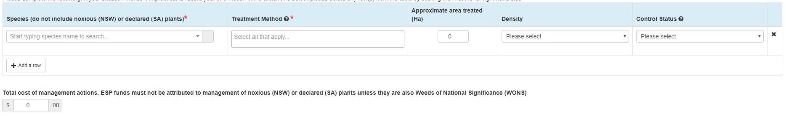To record a cost against these actions, click into the box under ‘Total cost of management actions’ and enter in a cost.

**Noxious weeds (in NSW), declared weeds (in SA) or Weeds of National Significance (WONS)**

Activities undertaken to control weeds that are noxious (NSW), declared (SA) or Weeds of National Significance (WONS) are a legal obligation and thus cannot have a cost recorded against them. However, we would like to know if you are taking measures to control these weeds on your ESP site(s). If you have undertaken activities to manage noxious or declared weeds, follow the below steps.

|  |  |
| --- | --- |
| Information notice | For a list of noxious (NSW) weeds click [here](https://weeds.dpi.nsw.gov.au/), for a list of declared (SA) weeds click [here](https://pir.sa.gov.au/biosecurity/weeds_and_pest_animals/weeds_in_sa), and for a list of Weeds of National Significance (WONS) click [here](https://www.environment.gov.au/biodiversity/invasive/weeds/weeds/lists/wons.html). |

1. Click on the drop-down arrow under ‘Species’ and select the species managed. You can also type the name of the species you managed into the text box. You will need to add in a separate row for each different species you managed.
2. Click on the box under ‘Treatment Method’ and select the most appropriate option(s). You can enter in multiple options under this heading. You will need to add in a separate row for each different treatment used.
3. Click in the box under ‘Approximate area treated (Ha)’ and enter in the area treated.
4. Click on the drop-down arrow under ‘Density’ and select the most appropriate option.
5. 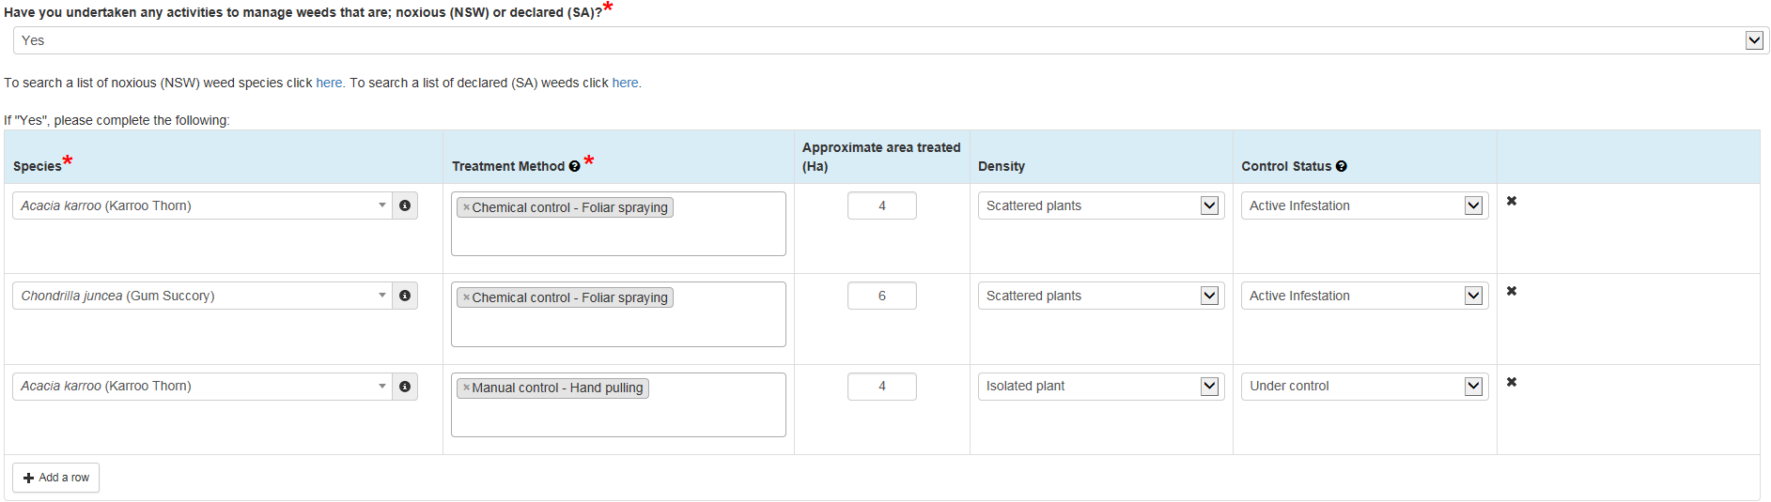Click on the drop-down arrow under ‘Control Status’ and select the most appropriate option.

#### **3.1.7. Biomass control measures**

To report on any activities to control biomass during this reporting period:

1. Tick the box ‘Not an agreed management action’ if biomass control measures aren’t a contracted management action.
2. Click on the drop-down arrow under ‘Biomass control activity’ and select the most appropriate option. You will need to add in a separate row for each activity undertaken.
3. Click in the box under ‘Purpose’ and select the most appropriate option(s). You can choose multiple options under this heading. E.g. if you have undertaken both thinning and a small-scale ecological burn add each in on a separate row. If you have undertaken the same action, but for a different purpose please add each in on a separate row.
4. Click in the box under ‘Area treated (Ha)’ and enter in the area treated.
5. 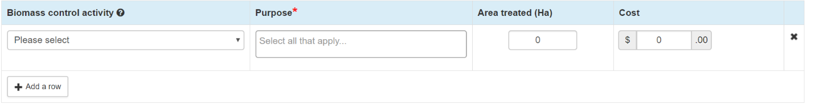To record a cost against an action, click into the box under ‘Cost’ and enter in a cost. You will need to add in a cost against each separate control activity undertaken.

#### **3.1.8. Revegetation**

To report on any revegetation activities during this reporting period you should

1. Tick the box ‘Not an agreed management action’ if revegetation activities are not a contracted management action.
2. Click on the drop-down arrow under ‘Revegetation Activity’ and select the most appropriate option. You will need to add in a separate row for each activity undertaken.
3. Click on the drop-down arrow under ‘Species planted’ and begin typing the species name, you can then choose from the list. If the species is not listed, then manually enter the name. You can choose multiple options under this heading.

|  |  |
| --- | --- |
| Information notice | When selecting a plant species from the comprehensive list you may need to scroll through the first few options that appear in order to find the correct species. |

1. Click in the box under ‘Number planted (if known)’ and enter in the number of individuals planted.
2. To record a cost against an activity, click into the box under ‘Cost’ and enter in a cost. You will need to add in a cost against each separate activity undertaken.

To record details of species planted in previous years:

1. Click in the box under ‘Year planted’ and select the year that the activity was undertaken.
2. Click on the drop-down arrow under ‘Species planted’, begin typing the species name then choose from the list. If the species is not listed, then type in species name. You can choose multiple options under this heading.
3. When recording details of revegetation actions undertaken in previous years, please add in a separate row for each species planted and each year they were planted. If you have planted both a gum species and a wattle species add each in on a separate row.
4. Click in the box under ‘Number planted (if known)’ and enter in the number of individuals planted.
5. 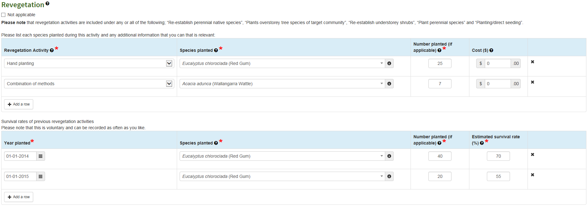Click in the box under ‘Estimates survival rate (%)’ and enter in an estimated percentage of the plants that have survived.

#### **3.1.9. Regeneration**

To report on any activities that contribute to regeneration during this reporting period:

1. Tick the box ‘Not an agreed management action’ if regeneration activities are not a contracted management action.
2. Click on the drop-down arrow under ‘Species Observed Regenerating (if known)’ and begin typing the species name, you can then choose from the list. If the species is not listed, then manually enter the name. You will need to add in a new row for each species observed regenerating.

|  |  |
| --- | --- |
| Information notice | When selecting a plant species from the comprehensive list you may need to scroll through the first few options that appear in order to find the correct species. |

1. Click on the drop-down arrow under ‘How widespread is the regeneration’ and select the most appropriate option. E.g. if you have observed both wattle and red gum regenerating on your ESP site add each in on a separate row.
2. 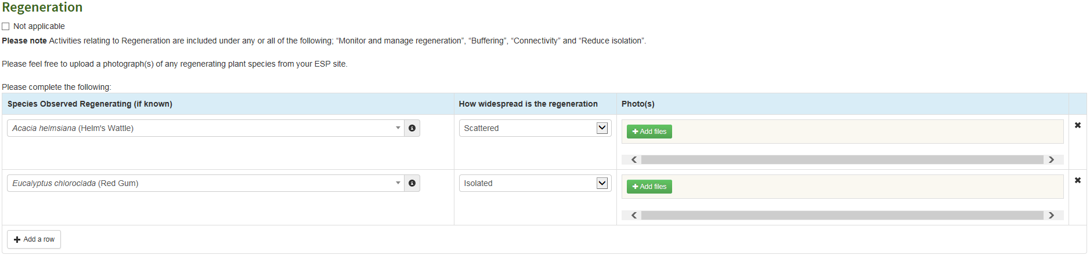Click on the ‘Add files’ button to open a window allowing you to select and upload a photograph of any regenerating species.

#### **3.1.10. Restoration of habitat features**

To report on any activities used to restore habitat features during this reporting period you should

1. Tick the box ‘Not an agreed management action’ if restoration activities are not a contracted management action.
2. Click on the drop-down arrow under ‘Have you placed any of the following habitat features on your site?’ and select the most appropriate option. You will need to add in a new row for each habitat featured added. If the habitat feature you have added does not appear in the list, please use the text box entitled “Habitat Feature (if Other)” to tell us about it.
3. Click on the box under ‘Number of habitat features added’ and enter in the number of habitats features you have added in. E.g. if you have added both nest boxes and woody debris to your ESP site each will need to be added in on a separate row.
4. 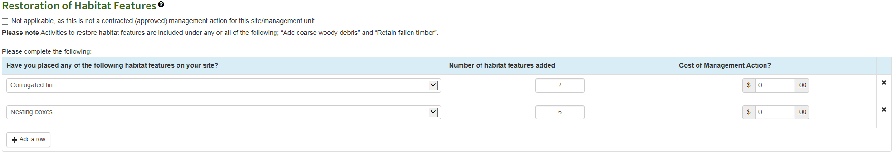To record a cost against a habitat feature, click into the box under ‘Cost of Management Action?’ and enter in a cost. You will need to add in a cost against each separate habitat feature you have added in.

#### **3.1.11. Secondary Management Unit (SMU) sites only**

The below steps are only to be followed if you are reporting for a Secondary Management Unit (SMU).

1. **Control of Agrochemicals.** To report on any activities used to reduce the impact of nutrients and agrochemicals during this reporting period follow the steps below.
   1. Tick the box ‘Not an agreed management action’ if you have not undertaken any activities to reduce the impact of nutrients and agrochemicals across your site in this reporting period.
   2. Click on the drop down under ‘Did you undertake actions to reduce the movement of water-borne agrochemicals across your site this year’ and select either ‘Yes’ or ‘No’.
   3. Click on the drop down under ‘Did you undertake actions to reduce the movement of wind-borne agrochemicals across your site this year’ and select either ‘Yes’ or ‘No’.
   4. If you have selected ‘Yes’ for either question, please provide us with details of the actions you undertook in the appropriate textbox.
2. **Tree root disturbance**. To report on any activities used to reduce disturbance to tree roots during this reporting period follow the steps below.
   1. Tick the box ‘Not an agreed management action’ if you have not undertaken any activities to reduce disturbance to tree roots across your site in this reporting period.
   2. Click on the drop down under ‘Did you undertake actions to disturbance to tree roots on your site this year?’ and select either ‘Yes’ or ‘No’.
   3. If you have selected ‘Yes’ please provide us with details of the actions, you undertook in the appropriate textbox.
3. **Fencing paddock trees.** To report on any activities used to fence paddock trees during this reporting period follow the steps below.
   1. Tick the box ‘Not an agreed management action’ if you have not undertaken any activities to fence paddock trees across your site in this reporting period.
   2. Click on the drop down under ‘Did you undertake any activities relating to the fencing of Paddock trees on this site this year?’ and select either ‘Yes’ or ‘No’.
   3. Click on the drop-down arrow under ‘Type of Fencing Activity’ and select the most appropriate option. You will need to add in a new row for each different type of fencing activity undertaken.
   4. Click on the box under ‘Area fenced (approximate m2)’ and type in an estimate of the area fenced.
   5. To record a cost against an activity, click into the box under ‘Cost’ and enter in a cost. You will need to add in a cost against each separate activity undertaken. E.g. If you have repaired an existing fence and put up new fencing add each action in a separate row.

#### **3.1.12. Photo Points**

Please take and upload a photograph from the fixed point on your site.

1. **Taking a photograph.** The photograph must be taken from exactly the same location, direction and when possible at the same month and time of year.
2. **Uploading a photograph.** Click on ‘+ Attach Photo’ and select the photograph from your computer.

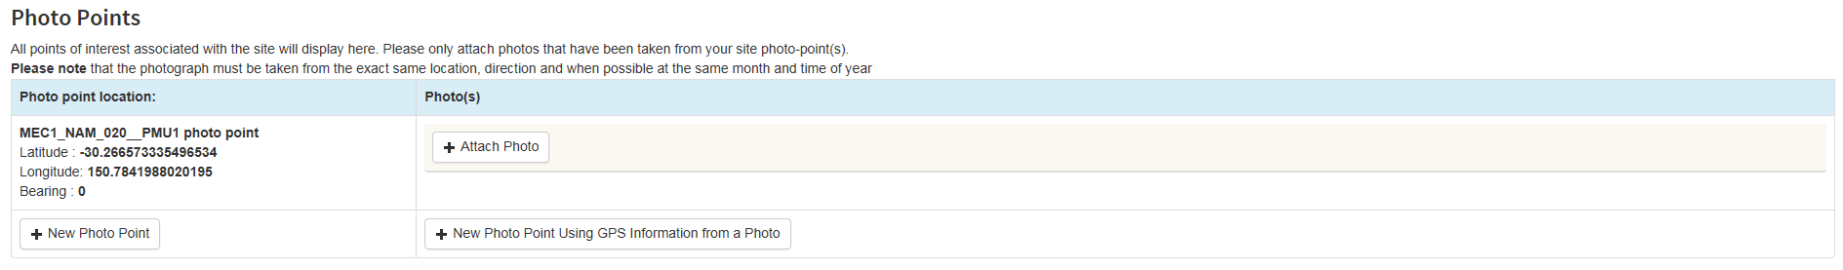

### 3.2. My Species Records

You can use this tab to record observations across the whole of your property, not just your Environmental Stewardship sites. Recording observations of native plants and animals that appear on your site is an excellent way to track the long-term health of your Environmental Stewardship sites and your property in general.

Activities under this tab are voluntary. If you do not wish to report native species observed on your property, please check the “Not applicable” box at the top of the tab.

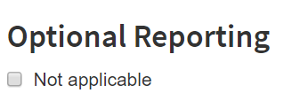

To record native plants or animals observed on your ESP site(s) follow these steps:

1. To record a species, click on the drop-down arrow and start typing the species name. Species are listed with scientific names and appear with photographs to help you identify them. For each additional species observed you will need to add in another row.

|  |  |
| --- | --- |
| Information notice | When selecting a species from the comprehensive list you may need to scroll through the first few options that appear in order to find the correct species. |

1. To add a photograph of a native plant or animal that you have observed click the green ‘Add file’ button and select the photograph from your computer.
2. Click into the text box to add in any additional details, including: the number of individuals seen; if this is the first time they’ve been seen on your property; or if the species isn’t present in the dropdown list.
3. 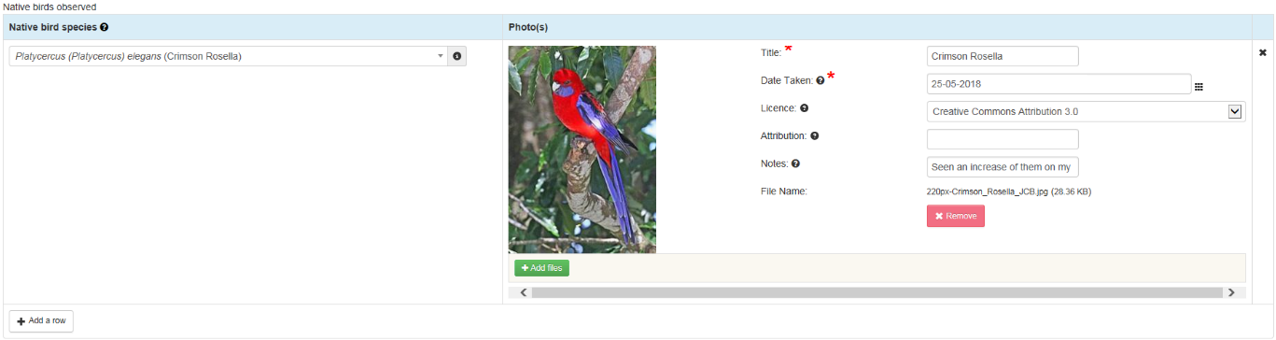Each time you have finished adding in details of new species observed click on the ‘Save Changes’ button at the bottom of the screen. Failing to do this will result in any new data being lost.

### 3.3. Dashboard

The dashboard function is not used for Environmental Stewardship Programs.

### 3.4. Photographs



This page collects and displays all the photographs attached to your Environmental Stewardship Program site(s). This includes photographs loaded through ‘My Species Records’ tab and site photo-points.

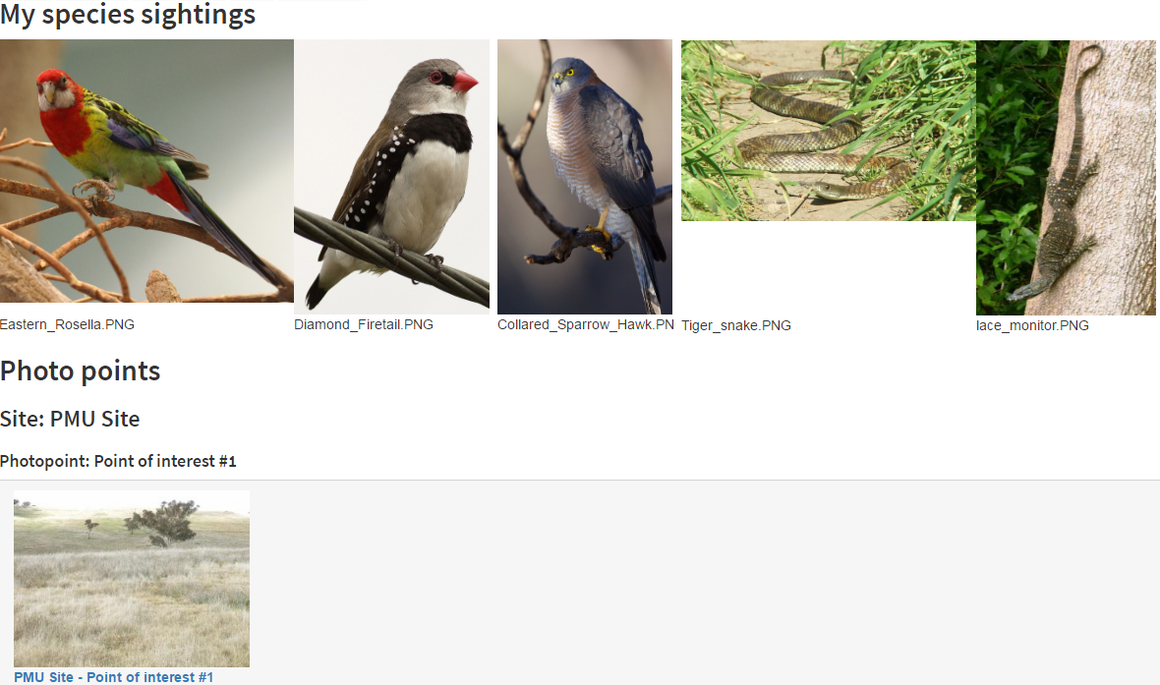

### 3.5. Documents



The ‘Documents’ tab collects, displays and provides access to relevant documents uploaded for your Environmental Stewardship program. Examples of useful documents to have access to include how-to guides and the results of any flora or fauna surveys conducted on your site(s).

You can download and save a copy of any of the documents by clicking on the download icon beside the document name (as shown below).

If you want a document added to this tab please contact your grant manager, provide them with a copy of the document and they will upload it for you.

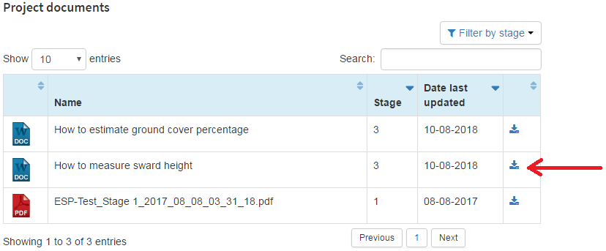

### 3.6. Annual Report Submission



The ‘Annual Report Submission’ tab is only visible once you have done the following:

1. completed or ticked N/A to all the reporting sections in each Program Management Unit (PMU), Secondary Management Unit (SMU) or Zone, and
2. ticked the box ‘Mark this activity as finished’ and hit ‘Save changes’ at the bottom of each PMU, SMU or Zone reporting form.

Once you have completed the above you will be able to submit your annual report.

#### **3.6.1. Report status**

The status of the report can be:

* **Finished**. Indicates that the report has been completed and is ready for submission.
* **Planned**. Indicates that the report is not yet complete, and you are not yet able to submit your annual report.

|  |  |
| --- | --- |
| Information notice | If you have completed all your reporting and the questions in this tab are not yet visible, please try refreshing the page. |

#### **3.6.2. Recording additional activities**

Although you are only contracted to undertake particular management actions as outlined in your Environmental Stewardship contract, we are still interested in knowing about all the activities you are undertaking on your ESP site. This will help us to understand how additional activities affect your sites. Please use this section to tell us about any additional activities, including:

* opportunity costs
* costs against time taken to complete monitoring and reporting
* extreme disturbances and/or weather events
* links to the templates for financial documents
* general observations
* prohibited actions.

|  |  |
| --- | --- |
| Information notice | Recording of any opportunity costs associated with ESP management is voluntary. |

#### **3.6.3. Submitting your report**

Follow these steps to submit your report:

1. 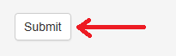When you have completed all sections in the ‘Annual Report Submission’ tab, click the ‘Submit’ button.

1. After clicking ‘Submit’ you will get a pop-up message on your screen with a statutory declaration. Please read this before ticking the box at the bottom right of the screen and hitting ‘Submit’.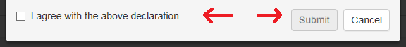
2. You will receive a message saying that your report has been submitted for assessment.
3. Your report will now be assessed by a Departmental officer, you will be advised once it has been approved. Please note that you may be contacted by a Departmental officer to clarify details of your annual report.

|  |  |
| --- | --- |
| Information notice | If any of the required fields have not been filled out, you will be unable to submit your annual report. |

### 3.7. Download Report



The ‘Download Report’ tab allows you to download any reports you have submitted. To do so, select the financial year you wish to download the report from and the PDF orientation.

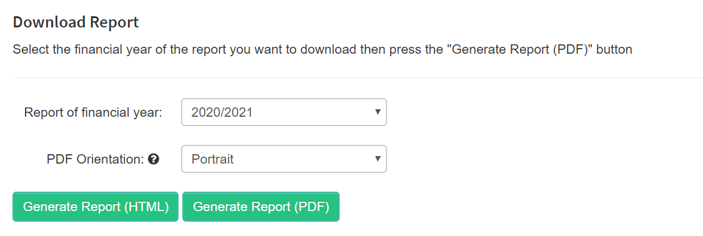

## Want more information?

The MERI Team are currently undergoing updates to their sites and will identify information as it becomes available. Here is a list of links that were current in June 2020.

<http://www.nrm.gov.au/regional-land-partnerships>

## Glossary of terms

The terms below refer to general terms used for the ESP program.

|  |  |
| --- | --- |
| Term | Definition |
| Department: | The Australian Government Department administering the NRM funding. |
| Evaluation: | Analysing the monitoring data and assessing what it means. Based on this, informed judgements can be made about the success of a project or programme and improvements can be identified. |
| Improvement: | Using this information to improve the way things are done. |
| MERI: | Simple concepts (Monitoring, Evaluation & Reporting Improvement) that, when applied, help us understand what is being achieved and help identify possible improvements, for projects and programmes. |
| MERIT user: | Refers to roles of Editors, Admin or Project Managers (identified as Grant Manager in MERIT). These users review submitted project information in MERIT. |
| Monitoring: | The collection of data and information. |
| NRM program: | Refers to Australian Government funded Natural Resource Management program, such as National Landcare Programme. |
| Outputs: | Are the tangible (measurable and practical), immediate and intended results to be produced through NRM investment (e.g. area (ha) of revegetation completed). |
| Photo points: | A marker for a specific geographic location which can be added through the ‘sites’ tab of a project page in MERIT or via a Reporting form. Funding recipients can use this to mark a range of features which will be useful to them such as the location of specific plantings within a larger site or the location of threatened species. |
| Project Manager (Grant manager in MERIT): | A departmental officer who manages procurement projects funded by Australian Government NRM programs in cooperation with the Environmental Steward. |
| Activities: | Action/s identified in the Funding Agreement, that are undertaken to achieve project outputs, that will deliver towards outcomes. |
| Reporting: | Communicating what we have found out through monitoring and evaluation. It is about sharing information, including achievements and lessons learnt. |
| Environmental Steward (recipient): | Landholder that has received funding to deliver project/s through the ESP Australian Government NRM program. Also referred to as a Grantee. |
| Funding Agreement: | An agreement made between the Department and the Grantee to manage the specified area of land for conservation purposes in accordance with the approved plan of management as set out in the Funding Agreement. |
| Site: | A defined geographic location relevant to a project. It can be defined using the mapping tools available in the ‘sites’ tab or the drawing tool in the Outputs Reports (Reporting Tab). Environmental Stewards can create sites to represent their project. In some instances, it may be preferable to identify a site as a whole project area, or alternatively as several more specific smaller areas. |
| Project Title: | The title that identifies your project. |
| Work, Health & Safety: | Identifies work safety risks, strategies and actions associated with the delivery of Core Services and Projects. Outlines how they will be implemented. These risks should be reviewed on a regular basis. |

**Acronyms**

ALA: Atlas of Living Australia

MERI: Monitoring, Evaluation, Reporting and Improvement

MERIT: online Monitoring, Evaluation, Reporting and Improvement tool

NRM: Natural Resource Management

ESP: Environmental Stewardship Program

PMU: Program Management Unit

SMU: Secondary Management Unit