# Ethyl formate fumigation methodology

# Version 1.0

© Commonwealth of Australia 2025

**Ownership of intellectual property rights**

Unless otherwise noted, copyright (and any other intellectual property rights) in this publication is owned by the Commonwealth of Australia (referred to as the Commonwealth).

**Creative Commons licence**

All material in this publication is licensed under a [Creative Commons Attribution 4.0 International Licence](https://creativecommons.org/licenses/by/4.0/legalcode) except content supplied by third parties, logos and the Commonwealth Coat of Arms.

**Cataloguing data**

This publication (and any material sourced from it) should be attributed as: DAFF 2025, *Ethyl formate fumigation methodology*, Department of Agriculture, Fisheries and Forestry, Canberra. CC BY 4.0.

This publication is available at [agriculture.gov.au/biosecurity-trade/import/arrival/treatments/treatments-fumigants](https://www.agriculture.gov.au/biosecurity-trade/import/arrival/treatments/treatments-fumigants#methyl-bromide-fumigation).

Department of Agriculture, Fisheries and Forestry

GPO Box 858 Canberra ACT 2601

Telephone 1800 900 090

Web [agriculture.gov.au](https://www.agriculture.gov.au/)

**Disclaimer**

The Australian Government acting through the Department of Agriculture, Fisheries and Forestry has exercised due care and skill in preparing and compiling the information and data in this publication. Notwithstanding, the Department of Agriculture, Fisheries and Forestry, its employees and advisers disclaim all liability, including liability for negligence and for any loss, damage, injury, expense or cost incurred by any person as a result of accessing, using or relying on any of the information or data in this publication to the maximum extent permitted by law.

**Acknowledgement of Country**

We acknowledge the Traditional Custodians of Australia and their continuing connection to land and sea, waters, environment and community. We pay our respects to the Traditional Custodians of the lands we live and work on, their culture, and their Elders past and present.

## Purpose

This methodology sets out the minimum requirements for treatment providers performing ethyl formate fumigations on import and export consignments for Quarantine and Pre‑Shipment (QPS) purposes. Compliance auditing of treatment providers is performed against the requirements in this methodology to gain assurance QPS treatments are performed effectively.

Treatment providers required to perform fumigations in accordance with this methodology must have the:

* equipment
* facilities
* trained personnel and
* administrative procedures necessary to comply with these requirements.

Importing jurisdictions may impose more stringent treatment requirements to address specific biosecurity risks. In such cases, those additional requirements, referred to in this document as import conditions, take precedence over the requirements of this methodology and must be complied with to the satisfaction of the relevant authority of the importing jurisdiction.

## General

All requirements in this methodology must be performed to ensure:

* target pests are killed
* the people performing the treatment remain safe and are not harmed
* all people in the area around the treatment area remain safe and are not harmed
* the goods or commodities being treated are not damaged or adversely affected.

Use and handling of ethyl formate must not contravene any instructions on the product label, safety data sheet, local regulations or relevant licence requirements.

## How to use this document

This document outlines the minimum set of requirements for performing ethyl formate fumigation treatments.

This document outlines the use of ethyl formate in combination with a secondary gas, which may act as a carrier (inert) or a synergist.

The [Guide to packaging suitability for performing QPS treatments](https://www.agriculture.gov.au/biosecurity-trade/import/arrival/treatments/treatments-fumigants#methyl-bromide-fumigation_2:~:text=Guides%20for%20QPS%20Treatments) provide information that may assist in meeting packaging requirements.

It is important treatment providers and compliance auditors understand the purpose of the requirements of this methodology, the outcomes they are intended to achieve and the circumstances in which they apply.

The technical terms used in this methodology are defined in the glossary. For all terms not defined in the glossary, refer to the definition used by the [Macquarie Dictionary](https://www.macquariedictionary.com.au/).

Contents

Purpose 3

General 3

How to use this document 3

1 Fumigator readiness 7

1.1 Fumigation personnel 7

1.2 Fumigation equipment 7

1.3 Site suitability 7

2 Safety 7

2.1 Safety considerations 8

2.2 Risk assessment 8

2.3 Personal protective equipment (PPE) 8

3 Consignment suitability 9

3.1 Target of fumigation 9

3.2 Impermeable packaging or wrappings 9

4 Fumigation enclosures 10

4.1 All enclosures 10

4.2 Sheeted enclosures 10

4.3 Fumigation chambers 10

4.4 Pressure testing a fumigation chamber 11

5 Preparing to fumigate 11

5.1 Gas concentration monitoring equipment 11

5.2 Gas concentration monitoring locations 12

5.3 Temperature monitoring instrument locations 13

5.4 Supply pipes 14

5.5 Heaters and fans 14

6 Temperature prior to the fumigation 14

6.1 Ambient temperature fumigations 15

7 Temperature during the exposure period 15

7.1 Ambient temperature fumigations 15

7.2 Controlled temperature fumigations 15

8 Performing the fumigation 16

8.1 Calculating the enclosure volume for dosing 16

8.2 Calculating the dose for pre-mixed applications 16

8.3 Calculating the dose for mix onsite applications 16

8.4 Injecting gas into the fumigation enclosure 17

8.5 Checking for leaks 17

8.6 Even gas distribution 17

8.7 Exposure period 18

9 Monitoring the fumigation 18

9.1 Gas concentration monitoring 18

9.2 Gas concentration monitoring – multiple sea containers in a sheeted enclosure 19

10 Topping-up gas levels 19

10.1 Topping-up during the exposure period 19

11 Ventilating the fumigation enclosure 20

11.1 Threshold limit value (TLV) 20

11.2 Releasing gas from the enclosure 21

11.3 Releasing the consignment from the control of the fumigator-in-charge 21

12 Documentation 22

12.1 Retainment of fumigation documents 22

12.2 Record of fumigation 22

12.3 Fumigation treatment certificate 23

Appendix 1: Example record of fumigation 25

Appendix 2: Example fumigation treatment certificate 26

Glossary 27

**Figures**

Figure 1 Monitoring locations for a single container enclosure 12

Figure 2 Monitoring locations for a sheeted enclosure with more than one sea container 13

## Fumigator readiness

**Note**: Prior to fumigation, the fumigator must ensure they have trained personnel, suitable equipment, and a suitable site to conduct fumigations.

### Fumigation personnel

The fumigator-in-charge must ensure the requirements of this methodology are complied with.

The fumigator-in-charge must comply with the treatment schedule, as set by the relevant authority, for the goods being treated.

### Fumigation equipment

The equipment used for performing a fumigation must be fit for purpose and in good working order.

Electronic instruments used to measure temperature, measure gas concentration, or to detect the presence of gases, must be calibrated and serviced in accordance with the manufacturer’s instructions. If the manufacturer’s instructions do not specify calibration frequency, equipment must be calibrated every 12 months.

Gas concentration measuring instruments must be fitted with any filters as specified by the manufacturer to suit the circumstances of the fumigation.

Equipment must be used in accordance with the manufacturer's instruction manual.

Temperature monitoring instruments must be accurate to within +/-1°C.

### Site suitability

The fumigation site must:

1. allow for safe ventilation; and
2. be on a flat and even surface; and
3. be well ventilated; and
4. have power available, either via mains or a generator.

## Safety

**Note:** Local jurisdictions may have safety legislation and regulations that govern the safe performance of a fumigation. The requirements contained in Section 2 may differ from the local laws, the fumigator-in-charge must comply with the laws relevant to where the fumigation is being performed.

### Safety considerations

**Note:** Pure ethyl formate is explosive between 2.8% (lower explosive limit) and 16.0% (upper explosive limit) in a normal atmosphere. Maintain a safe distance between ethyl formate and potential ignition sources. For safe storage and disposal of ethyl formate, refer to the product label.

* + 1. If a fumigation is performed in a jurisdiction that does not have legislation or local regulations for the safe performance of a fumigation section 2 Safety applies.

Ethyl formate and secondary gases must be handled in a manner consistent with instructions on the product label, safety data sheet or relevant licence requirements.

### Risk assessment

Before commencing fumigation, a risk assessment must be carried out to identify the risk of ethyl formate and secondary gas exposure to:

1. fumigation personnel; and
2. people in the vicinity; and
3. occupants of surrounding buildings.

Before commencing fumigation, safety measures must be put in place to minimise all the risks identified in the risk assessment. These safety measures must minimise the risk of ethyl formate and secondary gas exposure to:

1. fumigation personnel; and
2. people in the vicinity; and
3. occupants of surrounding buildings.

### Personal protective equipment (PPE)

Respiratory protection equipment must be worn, at all times, by any person coming into contact with ethyl formate at levels at or above the Threshold Limit Value (TLV) of 100 parts per million (ppm).

Respiratory protection equipment must be worn, at all time, by any person coming into contact with carbon dioxide at level at or above the Threshold Limit Value (TLV) of 5000 ppm.

Full-face respirators must be:

1. operated in accordance with the manufacturer’s instructions; and
2. fitted with a gas filter canister suitable for use with ethyl formate and secondary gases and replaced in accordance with the manufacturer's instructions; and
3. maintained in accordance with the manufacturer's instructions, with all valves clean and intact; and
4. able to form an airtight seal against the face of the fumigator.

Self-contained breathing apparatus must be:

1. operated in accordance with the manufacturer's instructions; and
2. used only by properly trained personnel; and
3. maintained in good working order and in accordance with the manufacturer's instructions.

## Consignment suitability

### Target of fumigation

**Note:** The fumigator-in-charge must determine if the consignment and target of fumigation is suitable for fumigation with ethyl formate and secondary gas. To be considered suitable, consignments must meet the requirements of section 3 Consignment suitability.

The fumigator must record the target of fumigation on the record of fumigation (see section 12 Documentation).

If the consignment is not suitable for fumigation, remedial action must be taken to make the consignment suitable prior to fumigation. If the consignment cannot be made suitable, the consignment must not be fumigated with ethyl formate.

If the target of fumigation includes the exterior of a sea container, the fumigation must be performed as a sheeted enclosure in accordance with section 4.2 Sheeted enclosures or otherwise made suitable for fumigation.

If the target of fumigation is inside a sea container, and the sea container is not sufficiently gas tight (in accordance with Section 4.1 All Enclosures), the fumigation must be performed as a sheeted enclosure in accordance with section 4.2 Sheeted enclosures or otherwise made suitable for fumigation.

If the target of fumigation is a vehicle or machine with an internal cabin, the cabin must be opened or exposed to ensure even gas distribution in one of the following ways:

1. one door ajar
2. two doors ajar
3. cabin windows open, or
4. boot open (sedans: back seats folded).

### Impermeable packaging or wrappings

The target of fumigation must not be covered by impermeable packaging or wrappings that impede ethyl formate and secondary gas distribution.

Impermeable packaging and wrappings that impede ethyl formate and secondary gas distribution to the target of fumigation must be removed, opened, slashed or made pervious prior to fumigation in accordance with the specifications set out at 3.2.3 and 3.2.4.

To be considered pervious, wrappings must have at least:

1. 4 holes of 6 mm diameter per 100 mm x 100 mm surface area, or
2. 5 holes of 5 mm diameter per 100 mm x 100 mm surface area, or
3. 6 pinholes per 10 mm x 10 mm surface area.

Pervious wrappings must be in a single layer, so the perforations are not blocked by the wrapping overlapping itself.

## Fumigation enclosures

### All enclosures

All fumigation enclosures must be:

1. sufficiently gas-tight to retain the ethyl formate and secondary gas for the duration of the exposure period; and
2. prepared to safely inject and ventilate ethyl formate and secondary gas; and
3. sealed to minimise ethyl formate and secondary gas escape; and
4. prepared to ensure even ethyl formate and secondary gas distribution throughout the enclosure and the target of fumigation; and
5. monitored for temperature if applicable.

Each individual enclosure is a separate fumigation and must be recorded on its own record of fumigation.

### Sheeted enclosures

Section 4.2 requirements apply to sheeted enclosures.

Surfaces on which sheeted enclosures are constructed must be impermeable to ethyl formate and the secondary gas or covered with a gas-proof sheet to make it impermeable.

Fumigation sheets must be weighed down to seal it against the surface and hold it securely in place. The seal must be:

1. created using materials that can follow the contour of the surface; and
2. arranged so there are no gaps or breaks in the seal around the entire enclosure.

All sea containers fumigated in a sheeted enclosure must have at least one door fully open during the fumigation.

If multiple sea containers are fumigated in a sheeted enclosure the fumigation must be monitored in accordance with section 5.2 Gas concentration monitoring locations.

### Fumigation chambers

Section 4.3 requirements apply to fumigation chambers.

A fumigation chamber must:

1. be permanently sealed along all joins between the walls, ceiling and floor; and
2. be gas-tight once the door is closed without the need to use tape, sealant, sand or water snakes or any other means; and
3. not have anything, such as concentration sampling tubes, supply pipes or electrical leads, enter the chamber that will interfere with the seal; and
4. have an inbuilt extraction system that actively removes ethyl formate and secondary gases from the enclosure; and
5. pass a pressure test at least every six months in accordance with section 4.4 Pressure testing a fumigation chamber.

### Pressure testing a fumigation chamber

Pressure testing must be performed with all concentration sampling tubes, supply pipes and electrical leads in place as they would be for fumigation.

To perform a pressure test, the pressure within the enclosure must be raised by 250 pascals (Pa) relative to atmospheric pressure. To pass the pressure test, it must take 10 seconds or more for the pressure in the enclosure to fall from 200 Pa to 100 Pa relative to atmospheric pressure.

If the pressure falls from 200 Pa to 100 Pa in less than 10 seconds, the enclosure has not passed the pressure test.

A record of the pressure test must be completed for every pressure test and kept for a minimum of two years.

All following information must be recorded on a record of pressure test:

1. Location – the site address where the pressure test is performed.
2. Chamber identification details.
3. Time and date the pressure test is performed.
4. The name and signature of the person who performed the pressure test.
5. The time taken for the pressure in the enclosure to fall from 200 Pa to 100 Pa.

A record of pressure test must be completed accurately.

## Preparing to fumigate

### Gas concentration monitoring equipment

Gas concentration monitoring equipment used to monitor ethyl formate must be able to detect ethyl formate concentrations within the treatment dose range for all treatment schedules applied and be in good working order.

Gas concentration monitoring equipment used to monitor carbon dioxide must be able to detect carbon dioxide gas concentrations within the treatment dose range for all treatment schedules applied and be in good working order.

Gas concentration monitoring instrument must be operated, calibrated and serviced according to the manufacturer’s instructions.

If using concentration sampling tubes that extend outside the enclosure, each concentration sampling tube must:

1. be clearly identified according to their location within the enclosure; and
2. be free from kinks and blockages; and
3. be of a diameter suitable to fit the inlet of the concentration measuring instrument.

If gas concentration monitoring instruments are placed within the enclosure each instrument must:

1. allow for readings to be read outside of the enclosure; and
2. be clearly identified according to their location within the enclosure.

### Gas concentration monitoring locations

Enclosures less than 30 m³ in volume must have at least one gas concentration monitoring location. The monitoring location must be on the top-centre of the goods.

Enclosures equal to or greater than 30 m³ but less than 1000 m³ in volume must have at least three gas concentration monitoring locations. The monitoring locations must be:

1. on top of the goods within 2 metres of the end of the enclosure; and
2. no more than 250 mm above the floor of the enclosure and within 2 metres of the opposite end from the top gas concentration monitoring location; and
3. in the middle centre of the enclosure among the goods and at least 2 metres from the other gas concentration monitoring locations.

Figure 11 Monitoring locations for a single container enclosure

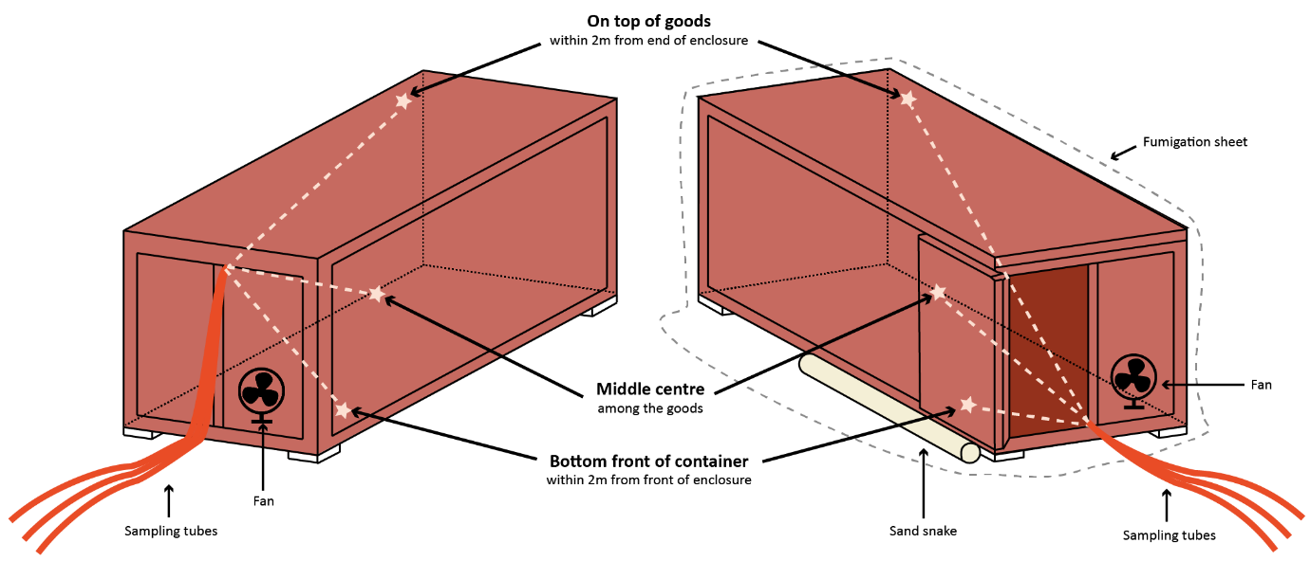

If a sheeted enclosure contains multiple sea containers, each sea container must have at least three gas concentration monitoring locations in accordance with requirement 5.2.2.

Figure 22 Monitoring locations for a sheeted enclosure with more than one sea container

Large enclosures equal to or greater than 1000m3 can be used as fumigation enclosures if they meet the enclosure requirements in 4.1.1.

Large enclosures must have a minimum of four gas concentration monitoring locations. The monitoring locations must be:

1. within the goods closest to the bottom corner of the enclosure; and
2. within the goods closest to the top corner of the enclosure, opposite from the bottom gas concentration monitoring location; and
3. within the goods closest to the middle centre of the enclosure; and
4. in the free airspace of the enclosure, in a corner not already monitored by the other locations.

If the enclosure is a large enclosure and monitoring lines can be placed within the goods, gas concentration readings must be taken from within the goods.

If the enclosure is a large enclosure and monitoring lines cannot be placed within the goods, gas concentration readings must be taken from the air space directly above or below the goods.

If the enclosure is a large enclosure and the top layer of goods does not extend to the corner of the enclosure, then an extra gas monitoring location should be added to ensure the top layer is monitored.

### Temperature monitoring instrument locations

Section 5.3 requirements apply to controlled temperature fumigations.

The temperature of the enclosure must be monitored with a digital thermometer in at least one location within the enclosure.

If heaters are used, the temperature monitoring instruments must be placed within the enclosure as far away as practical from the heat source.

Temperature monitoring instruments must:

1. allow for readings to be read outside of the enclosure; and
2. be identified.

### Supply pipes

All enclosures must have at least one supply pipe placed in the enclosure.

The supply pipe(s) must be able to supply fumigant to achieve the required concentration in the treatment rate and allow even distribution throughout the enclosure.

If a sheeted enclosure contains multiple sea containers, at least one supply pipe must be placed in each sea container.

For sheeted enclosure fumigations, the supply pipes must be left in position for the duration of the exposure period.

Supply pipes left in place must be sealed once the ethyl formate and secondary gas has been injected.

### Heaters and fans

**Note:** To assess the fan's ability to provide even gas distribution, evaluate the time it takes to reach equilibrium. Fans must be evenly distributed within the enclosure to ensure uniform gas distribution.

If fans are used to circulate the gas, a minimum of one fan must be used in each enclosure.

If fans are used to circulate the gas, fans must have an airflow rate that can circulate air throughout the entire enclosure.

If a single fan does not meet section 5.5.2, then multiple fans must be used.

Multiple sea containers fumigated in a single enclosure must have at least one fan placed in each container.

If heaters are used, they must be positioned in such a way to raise and maintain the air temperature throughout the entire enclosure above the minimum temperature in the treatment schedule.

All ignition sources must be removed, disabled, or relocated outside the fumigation enclosure.

## Temperature prior to the fumigation

### Ambient temperature fumigations

Section 6.1 requirements apply to ambient temperature fumigations.

A weather forecast for the location closest to the fumigation site must be obtained from a verifiable weather source to determine the forecast temperature during the fumigation exposure period.

The forecast minimum temperature must be sourced no earlier than the previous day of the start of the exposure period and a record of the source of the information must be retained with the fumigation documentation.

The forecast minimum temperature must be recorded on the record of fumigation.

**Note:** If the ambient temperature is forecast to be below the minimum temperature as specified in the treatment schedule, the fumigation cannot be performed as an ambient temperature fumigation. The temperature of the enclosure will need to be raised and maintained meaning the controlled temperature fumigation requirements will apply.

## Temperature during the exposure period

### Ambient temperature fumigations

Section 7.1 requirements apply to ambient temperature fumigations.

The minimum ambient temperature must be obtained using:

1. a verifiable weather source, or
2. temperature monitoring equipment compliant with section 1.2 Fumigation equipment.

If the temperature falls below the minimum required at any point during the exposure period, the fumigation has failed.

**Note**: If the temperature obtained during the exposure period is equal to or below the minimum temperature as specified in the treatment schedule, the fumigation has failed.

### Controlled temperature fumigations

Section 7.2 requirements apply to controlled temperature fumigations.

The temperature within the enclosure must be monitored with a minimum of one temperature instrument.

The temperature within the enclosure must be monitored and recorded at least once every 15 minutes for the entirety of the exposure period. These records must be retained with the fumigation documentation.

The minimum temperature recorded within the enclosure during the exposure period must be recorded on the record of fumigation.

## Performing the fumigation

Application methods:

There are two application methods for dosing an enclosure with ethyl formate and secondary gas.

* **Pre-mix** refers to the method of applying a dose of ethyl formate and a secondary gas that are supplied already combined in a single cylinder (or vessel).
* **Mix on-site** refers to the method where ethyl formate and a secondary gas are supplied separately in individual cylinders (or vessels) and are combined only at the point of use. The gases are mixed together on site immediately prior to application, rather than being pre-mixed by the supplier.

### Calculating the enclosure volume for dosing

If the fumigation is performed as a sheeted enclosure, the external dimensions of the enclosure must be measured prior to each fumigation and used to calculate the enclosure volume.

If the fumigation is performed in a fixed-sized enclosure, the internal dimensions or the manufacture’s stated volume must be used to determine the enclosure volume.

### Calculating the dose for an application of pre-mixed fumigant

If ethyl formate and secondary gas is applied from a pre-mixed cylinder, the weight of ethyl formate needed to achieve the prescribed concentration must be calculated by multiplying the ethyl formate dose rate by the volume of the enclosure and the percentage of the ethyl formate in the cylinder. The formula for calculating the dose of a pre-mixed cylinder is:

**Dose (g) = Enclosure Volume (m3) x Ethyl Formate Dose Rate (g/m3) ÷ (percentage of ethyl formate ÷ 100)**

Once the dose has been calculated, the injected dose must be rounded up to the next increment that can be accurately measured by the equipment used to dispense ethyl formate and the secondary gas.

### Calculating the dose for an application of fumigant mixed onsite

If ethyl formate and the secondary gas are mixed onsite, the weight of ethyl formate and secondary gas needed to achieve the prescribed concentration must be calculated by multiplying the dose rate by the volume of the enclosure and the ratio of the ethyl formate and the secondary gas. **The formula for calculating the dose of ethyl formate and the secondary gas separately when mixing on-site is:**

**Ethyl Formate Dose (g) = Enclosure Volume (m3) x Ethyl Formate Dose Rate (g/m3)**

**Secondary Gas Dose (g) = Enclosure Volume (m3) x Secondary Gas Dose Rate (g/m3)**

Once the dose has been calculated, the injected doses must be rounded up to the next increment that can be accurately measured by the equipment used to dispense the ethyl formate and secondary gas.

### Injecting gas into the fumigation enclosure

Ethyl formate and the secondary gas must be applied to the fumigation enclosure using a system that will turn ethyl formate and the secondary gas from liquid to gas.

Ethyl formate and the secondary gas must be applied to the fumigation enclosure using a system that complies with the product label.

Where a vaporiser is used, it must maintain a water temperature of at least 85°C while the ethyl formate and secondary gas is being injected into the enclosure.

A fan(s), or alternate way of evenly distributing the gas, must be used while injecting the ethyl formate and secondary gas into the enclosure.

The time the ethyl formate and secondary gas injection is completed must be recorded on the record of fumigation.

### Checking for leaks

During the injection of ethyl formate and the secondary gas, the supply system must be checked for leaks. If a leak is detected the problem must be rectified before continuing to inject the dose.

The fumigation enclosure must be checked for leaks (unless the fumigation is being performed in a pressure tested enclosure). If leaks are detected, they must be rectified.

### Even gas distribution

The ethyl formate and secondary gas must be evenly distributed throughout the enclosure. This is verified by equilibrium.

Equilibrium is achieved when the highest concentration reading is within 15% of the lowest concentration reading.

If the fumigation is an ethyl formate and carbon dioxide fumigation, equilibrium must be calculated separately for both ethyl formate and carbon dioxide.

**Note:** Equilibrium result is expressed as a percentage and is equal to the highest concentration reading minus the lowest concentration reading, then divided by the lowest concentration reading, then multiplied by 100. The calculation for equilibrium is pictured:

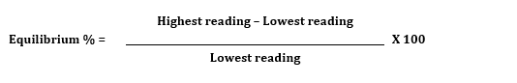

If the result of this calculation is more than 15%, equilibrium has not been achieved and additional time must be added to allow the ethyl formate and secondary gas to further distribute throughout the enclosure.

**Note:** Once equilibrium has been achieved it is not required at any other time.

### Exposure period

The fumigation exposure period must not start until:

1. all concentration readings are equal to or above the start point concentration as specified in the treatment schedule, and
2. equilibrium has been achieved in accordance with section 8.6 Even gas distribution*.*

If additional ethyl formate and secondary gas is added to the enclosure before the start of the exposure period, the time the injection of additional ethyl formate and secondary gas is completed becomes the new injection time for determining the required start time concentration.

The elapsed time between the start time and the end time of the fumigation must not be less than the exposure period prescribed in the treatment schedule.

After the specified exposure period has elapsed, final concentration readings must be taken from all monitoring locations. The readings and the time they are taken must be recorded on the record of fumigation.

At the end of the exposure period all concentration readings must be equal to or above the end point concentration as specified in the treatment schedule.

## Monitoring the fumigation

### Gas concentration monitoring

Fans used to circulate the ethyl formate and secondary gas must be turned off before taking gas concentration readings.

If the fumigation is an ethyl formate and carrier gas fumigation, ethyl formate concentration readings must be taken from all gas concentration monitoring locations at the start of the exposure period and at the end of the exposure period.

If the fumigation is an ethyl formate and carbon dioxide fumigation, ethyl formate and carbon dioxide concentration readings must be taken from all gas concentration monitoring locations at the start of the exposure period and at the end of the exposure period.

All gas concentration readings must be recorded on the record of fumigation at the time they are taken. This includes readings taken prior to achieving start time or optional readings during the exposure period. Readings from additional concentration monitoring locations that are mandated by import conditions must also be recorded.

The time each set of concentration readings is taken must be recorded. If there is more than one reading in a set, the time the last reading is completed must be the time recorded.

**Note:** The ethyl formate and secondary gas concentrations must not fall below the minimum concentration as specified in the treatment schedule at any point during the exposure period. Additional readings can be taken at any time during the exposure period to check concentrations are equal to or above the levels required for an effective treatment.

### Gas concentration monitoring – multiple sea containers in a sheeted enclosure

Section 9.2 applies if:

1. the fumigation enclosure is a sheeted enclosure with multiple sea containers, and
2. the target of the fumigation is contained wholly inside the sea containers.

The fumigator may fail one single container in the sheeted enclosure, and pass the remainder of the sea containers in that enclosure, if:

1. concentration readings fall below the minimum concentration as specified in the treatment schedule in one single container, and,
2. the enclosure is not, or cannot be, topped up in compliance with the topping up requirements, and
3. all other concentration readings in all other containers are above the minimum concentration as specified in the treatment schedule for all other concentration readings during the exposure period.

## Topping-up gas levels

### Topping-up during the exposure period

Additional ethyl formate and secondary gas may be added to the enclosure at any time during the exposure period if:

1. all the concentration readings are equal to or above the minimum concentration as specified in the treatment schedule, and
2. the treatment schedule allows top-ups.

Multiple top-ups are permitted during the exposure period.

Top ups are not permitted if the exposure period is 5 hours and 30 minutes or longer.

If the fumigation is an ethyl formate and carrier gas fumigation, after the additional ethyl formate is introduced and circulated, a concentration reading must be taken from the monitoring location that recorded the lowest ethyl formate concentration prior to topping-up. The concentration reading taken after topping-up must be equal to or greater than the minimum ethyl formate concentration as specified in the treatment schedule.

If the fumigation is an ethyl formate and carbon dioxide fumigation, after the additional ethyl formate and carbon dioxide is introduced and circulated, concentration readings must be taken from the monitoring locations that recorded the lowest ethyl formate and carbon dioxide concentrations prior to topping-up. The concentration readings taken after topping-up must be equal to or greater than the minimum ethyl formate and carbon dioxide concentrations specified in the treatment schedule.

Top-up details (amount, time and concentration readings) must be recorded on the record of fumigation.

If top-ups are performed, calculating equilibrium is not required.

## Ventilating the fumigation enclosure

### Threshold limit value (TLV)

The TLV is 100 parts per million (ppm) for ethyl formate unless a lower concentration is imposed by the relevant authorities in the jurisdiction where the fumigation takes place or the consignment destination.

The TLV is 5000 ppm for carbon dioxide unless a lower concentration is imposed by the relevant authorities in the jurisdiction where the fumigation takes place or the consignment destination.

The equipment used for measuring ethyl formate TLV must be able to measure the actual concentration, not just the presence of ethyl formate, to at least 100 ppm.

The equipment used for measuring carbon dioxide TLV must be able to measure the actual concentration, not just the presence of carbon dioxide, to at least 5000 ppm.

If stain tubes are used to detect gas concentrations, they must be used:

1. in accordance with the manufacturer’s instructions; and
2. in conjunction with the sampling pump specified by the manufacturer; and
3. before the expiry date.

### Releasing gas from the enclosure

At the end of the exposure period, the enclosure must be fully ventilated in a controlled and safe manner.

A risk assessment must be performed to manage the ventilation process and ensure it is safe by considering:

1. prevailing wind direction; and
2. location and proximity of unprotected personnel.

Personnel who are not wearing PPE (in accordance with section 2.3 Personal protective equipment (PPE)) are not permitted to enter areas where the ethyl formate and secondary gas concentrations are above the TLV, until the fumigator-in-charge verifies the concentration in the area and throughout the enclosure is at or below the TLV.

The enclosure must be ventilated until the concentration of ethyl formate and secondary gas within the enclosure remain at or below the respective TLV.

If the consignment is fumigated in the sea container(s) that will be used to transport the goods, each container must be checked individually to verify concentration at or below the TLV.

If the consignment is fumigated in an un-sheeted sea container, the sea container must not be moved until the ethyl formate and secondary gas concentration inside the enclosure is at or below the TLV.

The TLV readings and the time they are taken must be recorded on the record of fumigation.

### Releasing the consignment from the control of the fumigator-in-charge

Following a fumigation, the consignment can only be released from the control of the fumigator-in-charge once the following requirements have been met:

1. the fumigation complies with the requirements of this methodology and the ethyl formate and secondary gas concentrations have been verified at or below the TLV, or
2. the fumigation has failed, and it is subsequently unsuitable for further fumigation with ethyl formate and the ethyl formate and secondary gas concentrations have been verified at or below the TLV.

## Documentation

### Retainment of fumigation documents

The treatment provider must keep a copy of all fumigation documentation for a minimum of two years.

### Record of fumigation

A record of fumigation must be produced to demonstrate the fumigation complied with the requirements of this methodology.

The record of fumigation must be completed on the fumigation site as the tasks are performed.

The record of fumigation must be retained by the treatment provider for a minimum of two years.

False or misleading information must not be recorded on a record of fumigation.

At a minimum the record of fumigation must include:

1. treatment provider identification
2. client name
3. start date and time of the fumigation
4. location – the site address where the fumigation is performed
5. a description of the consignment
6. the target of fumigation
7. consignment identification - container number(s), bill of lading, silo/shed number or other means to clearly identify the consignment
8. a declaration that the treatment complies with all requirements of the Ethyl formate fumigation methodology, the treatment schedule and treatment specific import conditions type of enclosure used
9. enclosure volume
10. the specified treatment schedule - dose rate, exposure period, and temperature
11. formula used - percentage of ethyl formate and percentage of secondary gas
12. calculated dose – dose rate used multiplied by the enclosure volume, expressed as weight of ethyl formate
13. amount of ethyl formate applied - the actual volume of ethyl formate injected into the enclosure, expressed as weight of ethyl formate
14. the time the ethyl formate injection into the enclosure is complete
15. the ethyl formate concentration readings from each concentration monitoring location, expressed in g/m3, and the time they are taken
16. result of the equilibrium calculation for ethyl formate
17. serial number of the gas concentration monitoring device(s) used (minimum last 4 digits of the serial number)
18. the ethyl formate TLV readings and the time and date they are taken
19. the name and signature of the fumigator-in-charge
20. initial or signature of the fumigator at each concentration reading stage and TLV reading.

If the fumigation is an ethyl formate and carbon dioxide fumigation, the record of fumigation must include:

1. the calculated dose – dose rate used multiplied by the enclosure volume, expressed as weight of carbon dioxide
2. the amount of carbon dioxide applied - the actual volume of carbon dioxide injected into the enclosure, expressed as weight of carbon dioxide
3. the carbon dioxide concentration readings from each concentration monitoring location, expressed in g/m3, and the time they are taken
4. the result of the equilibrium calculation for carbon dioxide
5. the carbon dioxide TLV readings and the time and date they are taken.

If the fumigation is an ambient temperature fumigation (section 6.1 Ambient temperature fumigations), the forecast minimum temperature must be recorded on the record of fumigation.

If the fumigation is a controlled temperature fumigation (section 6.2 Controlled temperature fumigations), the minimum temperature achieved within the enclosure must be recorded on the record of fumigation.

If additional fumigant is added to the fumigation (in accordance with section 10 Topping up gas levels), the top-up amount, time and concentration must be recorded on the record of fumigation.

If additional fumigant is added (in accordance with section 8.7 Exposure period), the additional amount and time injected must be recorded on the record of fumigation.

**Note:** An example record of treatment is provided at Appendix 1: Example record of fumigation.

### Fumigation treatment certificate

A fumigation treatment certificate is issued once the fumigator-in-charge determines the fumigation has complied with requirements of this methodology.

False or misleading information must not be recorded on a fumigation treatment certificate.

At a minimum the fumigation treatment certificate must include:

1. treatment provider’s letterhead including name and physical address
2. treatment provider’s identification (AEI if an AEI is required by the treatment scheme or import conditions)
3. certificate number
4. name of fumigant
5. target of fumigation
6. description
7. quantity
8. consignment link (such as container number, bill of lading, invoice number)
9. country of origin
10. port of loading
11. country of destination
12. formula used - percentage of ethyl formate and percentage of secondary gas
13. date and time fumigation commenced
14. date and time fumigation completed
15. place of fumigation (site registration number if applicable)
16. type of enclosure used
17. treatment schedule [prescribed dose rate/specified dose rate (g/m3)]
18. exposure period (hours)
19. forecast minimum temperature (˚C) or minimum temperature achieved in the enclosure or commodity core temperature.
20. final ethyl formate TLV reading (ppm)
21. a declaration that the treatment complies with all requirements of the Ethyl Formate Fumigation Methodology, the treatment schedule and treatment specific import conditions the signature of the fumigator-in-charge and date of signing
22. date the certificate is endorsed and issued.

**Note:** An example fumigation treatment certificate is provided at Appendix 2: Example fumigation treatment certificate

If the fumigation is an ethyl formate and carbon dioxide fumigation, the final carbon dioxide TLV reading (ppm) must be recorded on the treatment certificate.

The treatment provider must make all fumigation documentation available on request, by the relevant authorities, for audit and registration purposes.

The fumigation treatment certificate must be clearly linked to the consignment.

Appendix 1: Example record of fumigation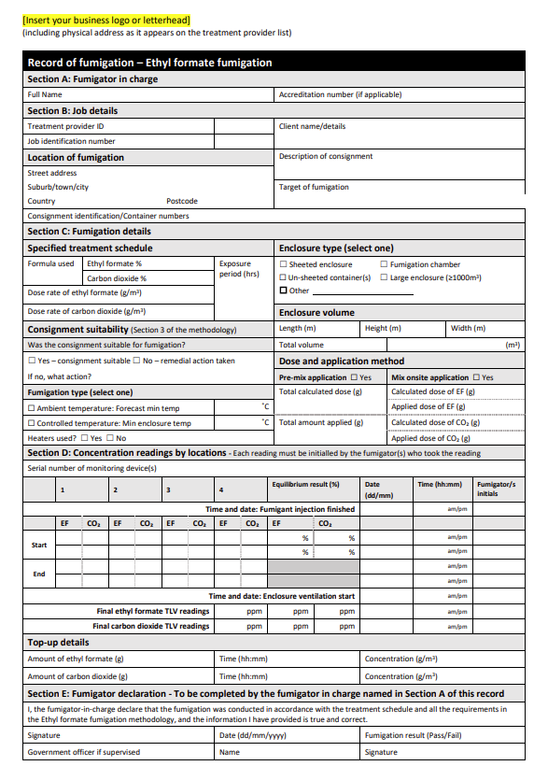

## Appendix 2: Example fumigation treatment certificate

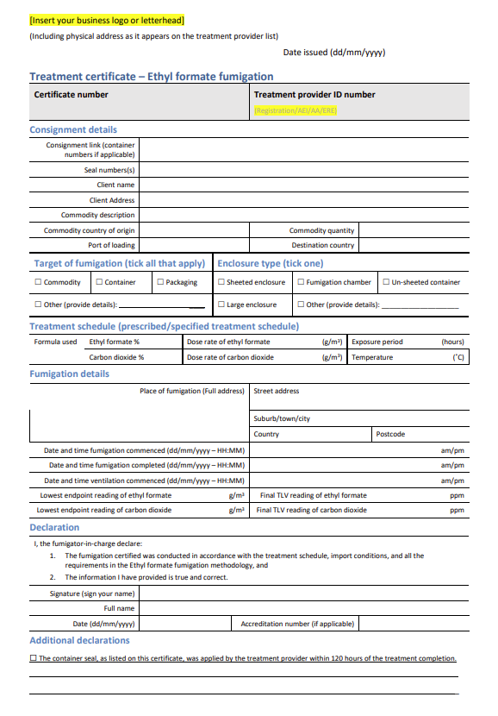

## Glossary

| **Term** | **Definition** |
| --- | --- |
| AEI | The Entity Identifier (AEI) is a unique code assigned to treatment providers used to track and manage the offshore treatment certification that accompanies consignments entering Australia. |
| Ambient temperature | The air temperature of the surrounding area where the fumigation will be performed. |
| Ambient temperature fumigation | When the enclosure being fumigated is subject to environmental ambient temperatures or outdoors. |
| Carrier gas | An inert gas used to stabilise and/or distribute ethyl formate during fumigation. |
| Commodity | The item or goods that are being exported or imported. |
| Concentration | The amount of ethyl formate present at a certain point in the fumigation enclosure, usually expressed as grams per cubic metre (g/m³). |
| Concentration sampling tube | A small diameter tube used to draw a sample of gas/air mixture from within a fumigation enclosure to measure the ethyl formate concentration. |
| Consignment | Refers collectively to the commodity, any packing materials used and the mode of transport such as sea container. |
| Controlled temperature fumigation | When an artificial heat source is used to heat and maintain the temperature of an enclosure during a fumigation. |
| Dose | The amount of ethyl formate injected to a fumigation enclosure. |
| Dose rate | The prescribed concentration of ethyl formate to be used per unit of volume and the exposure period (temperature adjusted if applicable). |
| Enclosure | Any gas-tight space intended to contain sufficient concentrations of ethyl formate for a period of time. Common examples of fumigation enclosures used for QPS fumigations are (but not limited to) un-sheeted sea containers, semi-permanent or permanent structures, sheeted enclosures, silos and bunkers. |
| End point concentration | The minimum allowable end point concentration of a particular gas as specified by the treatment schedule. |
| Equilibrium | An even distribution of ethyl formate throughout the enclosure. |
| Ethyl formate | A volatile ester used as the active fumigant chemical. |
| Fit for purpose | Equipment that is suitable and appropriate for its intended use. That is, capable of measuring ethyl formate or temperature specifically and in the concentration or temperature ranges necessary to meet the requirements of this methodology. |
| Fumigant | A chemical, which at a particular temperature and pressure can exist in a gaseous state in sufficient concentration and for sufficient time to be lethal to insects and other pests. |
| Fumigation chamber | A gas-tight fumigation enclosure with an inbuilt extraction system. All requirements for fumigation chambers specified in section 4.3 Fumigation chambers. |
| Fumigation documentation | Documents and records associated with particular fumigations that is not a record of fumigation (such as temperature logs or scratch paper). May be hardcopy or softcopy. |
| Fumigation sheets | A sheet (or tarpaulin) used to create a sheeted enclosure that is made of material impermeable to ethyl formate. |
| Fumigator | An individual responsible for conducting fumigation activities under the supervision of the fumigator-in-charge. |
| Fumigator-in-charge | The licenced and/or accredited individual that is responsible for the conduct of the fumigation at the time specific fumigation activities are undertaken. |
| Gas concentration monitoring location | The specified location where gas must be drawn from for the purpose of determining the gas concentration at that location. This is location where concentration sampling tubes or gas concentration sampling equipment is placed. |
| Goods | Goods includes an animal, a plant, a sample or specimen, a pest, mail or any other article, substance or thing (including, but not limited to, any kind of moveable property). |
| Good working order | State of an item, system or equipment is deemed to be functioning properly, without significant defects or impairments that hinder its intended operations or performance. |
| Impermeable package and wrappings | Intact and solid plastic films and wrappings that prevent or impede gas exchange. |
| Inert carrier gas | An inert gas used to stabilise or transport a chemical used for a fumigation, as specified in an APVMA-approved formulation. |
| Large enclosure | Any gas-tight space equal to or greater than 1000m3 in volume that is intended to contain sufficient concentrations of ethyl formate for a period of time. Large enclosures can include one or more internal, gas-permeable separations running horizontally or vertically, either partially or fully across the space. |
| Manufacturer’s instructions | Specific details on equipment produced by the equipment manufacturer. May include instruction manuals, operating instructions, conditions of use or calibration information. |
| Pascal (Pa) | The standard international unit for pressure. Standard atmospheric pressure is 101.325 kPa. |
| Pest | Any animal, plant or other organism that may pose a threat to the community or the natural environment. |
| Quarantine pest | A pest of potential economic and/or environmental importance to an area where it is not yet present or is present but not widely distributed and is being officially controlled. |
| Quarantine and Pre-shipment (QPS) | 1) ‘Quarantine applications’, with respect to ethyl formate, are treatments to prevent the introduction, establishment and/or spread of quarantine pests (including diseases), or to ensure their official control, where:  a) Official control is that performed by, or authorised by, a national plant, animal or environmental protection or health authority.  b) Quarantine pests are pests of potential importance to the areas endangered thereby and not yet present there, or present but not widely distributed and being officially controlled.  2) ‘Pre-shipment applications’ are those non–quarantine applications applied within 21 days prior to export to meet the official requirements of the importing country or existing official requirements of the exporting country. |
| Record of fumigation | An official document or electronic record that records the information of section 12 to demonstrate the fumigation complied with requirements. |
| Relevant authority | The government department, ministry or agency responsible for animal and plant biosecurity in the importing or exporting jurisdiction. |
| Risk Assessment | An assessment performed and recorded according to any instructions on the product label, safety data sheet or jurisdictional licence requirements. In the absence of this, a visual inspection to meet the requirements of this methodology that the fumigator-in-charge can verbally describe. |
| Secondary gas | A gas used in combination with ethyl formate to support or enhance its fumigant action. This includes carrier gases, which are inert but aid in dispersing ethyl formate, and synergist gases (carbon dioxide), which enhance its effectiveness. Only secondary gases approved by the department may be used. |
| Sea container | Standardised transportation units that can be moved from one mode of transport to another without needing to unload the contents. |
| Sheeted enclosure | An enclosure created under a gas-proof sheet that is covering/enclosing the commodities to be fumigated. |
| Supply pipe | A supply pipe is a system used to deliver the fumigant from a source (such as a gas cylinder or fumigation system) to an enclosure. |
| Start point concentration | The minimum allowable initial concentration of a particular gas as specified by the treatment schedule. |
| Synergist gas | A gas used in combination with ethyl formate to stabilise the ethyl formate and enhance its fumigant efficacy, typically by increasing its penetration, action speed, or effectiveness against target pests (for example, carbon dioxide). |
| Target of fumigation | The specific object or area that is intended to be treated through the fumigation process. The target of fumigation may be the commodity, packaging material, container, or conveyance or combination of these. |
| Threshold limit value (TLV) | TLV is the maximum concentration of fumigant that a person can be repeatedly exposed to in the workplace without harmful effects. This figure is based on an 8-hour day, 40-hour working week. |
| Treatment | Application of a set of specified requirements intended to kill pests and diseases that may be associated with a consignment. |
| Treatment provider | An entity or company that is responsible for the effective conduct of a QPS treatment. |
| Treatment schedule | Specific treatment rates, exposure period and rules as imposed by the relevant authority – usually the importing jurisdiction. |
| Treatment temperature | The temperature at which the applied dose rate is calculated. |
| Vehicle | A machine, usually with wheels and an engine, used for transporting people or goods. |
| Verifiable weather source | Reliable source of weather data that can be independently confirmed and validated at audit. |