NATIONAL RECOVERY PLAN
FOR THE MONGARLOWE MALLEE
Eucalyptus recurva

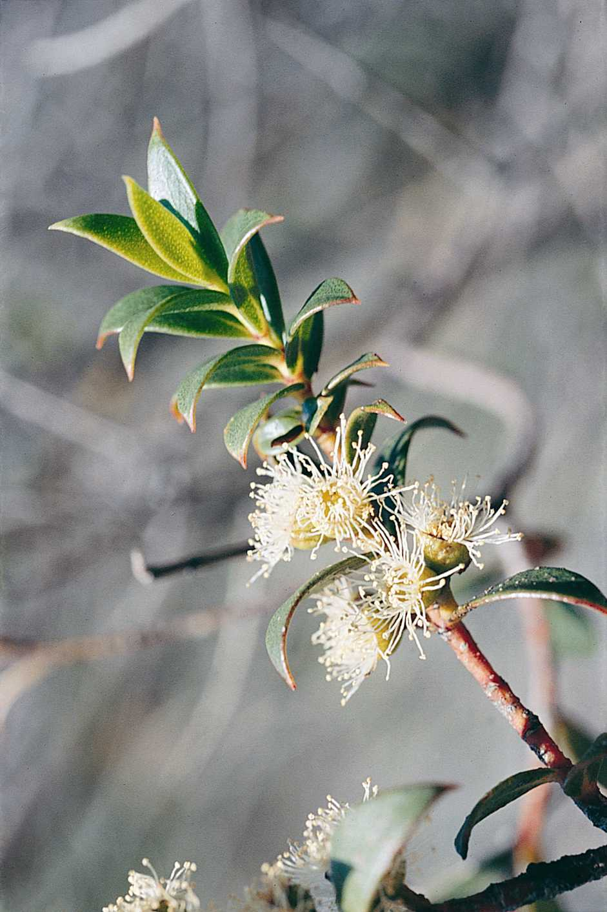
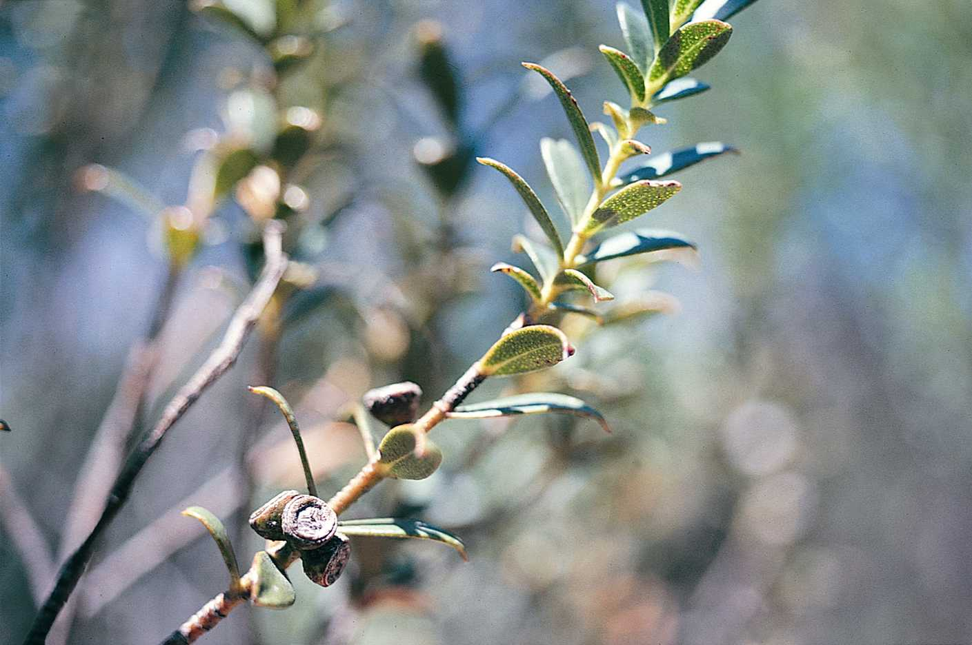

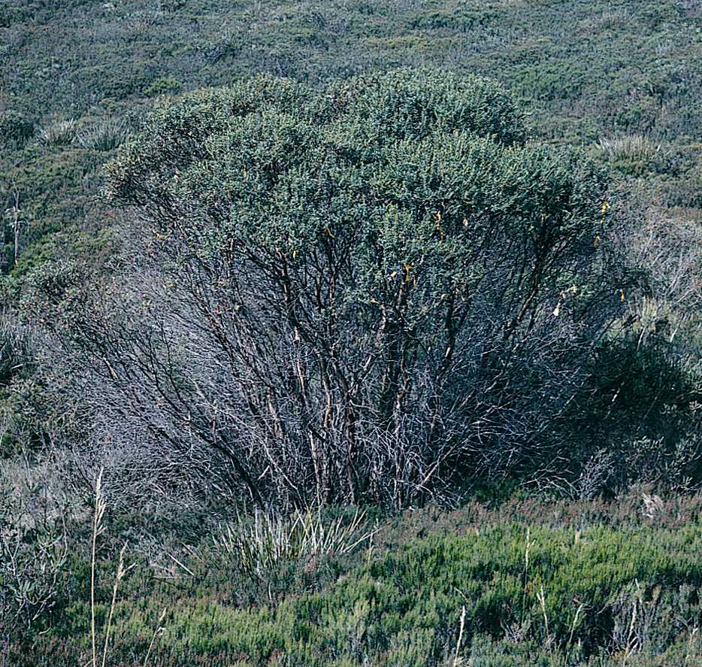
© Office of Environment and Heritage (NSW), 2011.
This work is copyright. However, material presented in this plan may be copied for personal use or published for educational purposes, providing that any extracts are fully acknowledged. Apart from this and any other use as permitted under the Copyright Act 1968, no part may be reproduced without prior written permission from the Department of Environment and Climate Change (NSW).

Prepared by:
Biodiversity Conservation Section
Environment Protection and Regulation Group
Office of Environment and Heritage (NSW)
PO Box 733
Queanbeyan NSW 2620
Tel: 02 62297000
Prepared in accordance with the Commonwealth Environment Protection and Biodiversity Conservation Act 1999 and the New South Wales Threatened Species Conservation Act, 1995.
This plan should be cited as follows:
Department of Environment and Climate Change (NSW) 2010. National Recovery Plan for Eucalyptus recurva, Department of Environment and Climate Change (NSW), Hurstville.

ISBN: 978 1 74232 844 7 OEH 2010/573

Cover photographs: Flowering and fruiting branchlets of the Mongarlowe Mallee, and one of the Mongarlowe Mallee plants from near Mongarlowe.
Photographer: J. D. Briggs

DISCLAIMER
The attainment of objectives and the provision of funds may be subject to budgetary and other constraints affecting the parties involved, and may also be constrained by the need to address other conservation priorities. Approved recovery actions may be subject to modifications due to changes in knowledge and changes in conservation status.

Summary
This document constitutes the formal National Recovery Plan for the Mongarlowe Mallee. The plan considers the conservation requirements of the species across its known range, identifies the actions to be taken to ensure its long-term viability in nature and the parties who will undertake these actions.
The Mongarlowe Mallee is listed as Critically Endangered under the Threatened Species Conservation Act 1995 (TSC Act), and Endangered under the Commonwealth Environment Protection and Biodiversity Conservation Act 1999 (EPBC Act).
The Mongarlowe Mallee is a mallee which grows to 4.2 m tall and which has distinctive small, opposite, outwardly curved leaves. The species is only known from four sites on the Southern Tablelands of NSW, three near Mongarlowe and one near Windellama. Three of these sites each support only single plants and the other site has three individuals. The sites are all privately owned.
The overall objective of this Recovery Plan is to ensure that the current natural population of the Mongarlowe Mallee is maintained.
The future Recovery Actions detailed in this Recovery Plan include:
- Monitor individuals
- Sites are protected in the long-term
- Complete genetic studies
- Undertake additional combinations of hand pollination
- Trial new vegetative propagation techniques
- Establish ex-situ populations
- Erect fencing at Windellama
- Lower the maximum water level of the dam at Windellama
- Revegetate the berm adjacent to the Windellama plants

Abbreviations used in this Plan
OEH Office of Environment and Heritage, New South Wales
EP&A Act Environment Planning and Assessment Act, 1979 (NSW)
EPBC Act Environment Protection and Biodiversity Act 1999 (Commonwealth)
IUCN International Union for the Conservation of Nature
TSC Act Threatened Species Conservation Act 1995 (NSW)

Species information and general requirements

Description
The Mongarlowe Mallee (Eucalyptus recurva) is a few- to many- stemmed mallee eucalypt, with individuals varying from 1.5 m to 4.2 m in height. The stems have smooth, orange-brown to grey bark and arise from a substantial (up to 7.5 m x 12 m in diameter) lignotuberous rootsystem. Seedling leaves are opposite, broad elliptic to obovate, 1.3 –3.0 cm long and 0.7-1.6 cm wide, the leaf tip blunt. Adult leaves are opposite, each pair arranged at right angles to the next, narrow-elliptic, tapered to both ends and the tips conspicuously recurved, to 2.8 cm long and 0.7 cm broad, with abundant oil glands. Flowers are white, arranged in clusters of three on a common stalk to 5.5 mm long. Buds are broad-ovoid, up to 6 mm long and 5 mm broad. Fruits are depressed-hemispherical woody capsule 2.5 – 3.5 x 4.5 – 6 mm. There are 3 or 4 valves just below the capsule summit. Flowering occurs for a period of about 2 weeks, normally commencing in the second week of January.
The size of the six known plants varies considerably. The largest individual near Windellama has 78 stems over 2 cm diameter, ranging from 1.5 to 2.8 m in height. The stems arise from an extensive lignotuber occupying an oblong area of 7.5 m x 12 m. The smallest plant (also near Windellama) has only five stems, with the tallest being about 1 metre high. Another plant nearby has seven stems and is currently 1.9 m in height. It is not known whether the three plants near Windellama (two are about 10 m apart, 40 m from the other) are genetically different, or whether they may have originated in the distant past from a common lignotuber.
The sizes of the three plants located near Mongarlowe are:
(a) 20 stems to 2 m high and a lignotuber spread of 5 x 3 m.
(b) 50 stems to 4.2 m high in the mid-1990s, but these had all died by 2009. The plant is resprouting from the lignotuber, which covers an area 2.8 m x 1.8 m.
(c) 6 stems to 1.5 m high from a lignotuber 1 m across.

Distribution
The Mongarlowe Mallee is known from four sites on the Southern Tablelands of NSW, three near Mongarlowe and one near Windellama (Figure 1). Three of these sites support what are believed to be single plants, whilst the other has three individuals present. All occurrences are within largely uncleared country that is unsuitable for agriculture. It therefore appears that the species is naturally rare, rather than having been reduced in numbers through human activities.
The first botanical specimen of this species was collected from one of the Mongarlowe plants by a local landholder in August 1985. The species was subsequently described in 1988 by M.D. Crisp. A second plant in the Mongarlowe area was discovered in 1990 by a botanical consultant undertaking a vegetation survey in relation to the then proposed Welcome Reef Dam. A third plant which is located north of Mongarlowe was detected during a targeted aerial survey conducted by NPWS in January 2001.
It was not until 1994 that the larger of the Windellama plants was found. This find was made during a flora and fauna study being undertaken prior to a mining company submitting a Development Application for an extension to a clay mining operation. A smaller plant near the larger Windellama plant was not found until 2001. The third plant at Windellama was found in 2010, only about 10 m from the smaller plant. The stems are all fairly small, being up to 10 mm in diameter, and show evidence of having been broken or browsed in the past.
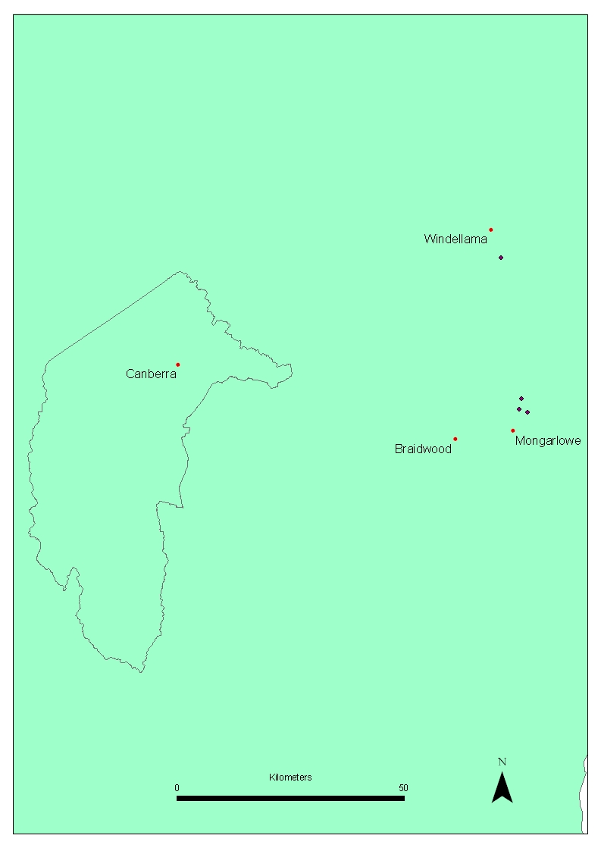
Figure 1. Map showing the four sites of Mongarlowe Mallee
Habitat
The species is found in low heathland and in some cases at the margins of the heathland and adjacent low woodland. The woodlands are dominated by Brittle Gum (Eucalyptus mannifera) and Snow Gum (E. pauciflora), but scattered Candlebark (E. rubida) and Broad-leaved Peppermint (E. dives) trees are also nearby at some sites. In the Mongarlowe area the heathland is dominated by Stunted Sheoak (Allocasuarina nana) with emergent shrubs of Finger Hakea (Hakea dactyloides), a Tea-tree (Leptospermum sp.) and Hairpin Banksia (Banksia spinulosa). Other associated species include Trigger Plant (Stylidium graminifolium), Boronia rhomboidea, Isopogon prostratus, Lepidosperma laterale, Mirbelia oxylobioides, Purple Flag (Patersonia sericea var. longifolia), Petrophile pulchella, and a Speargrass (Austrostipa sp.).

At Windellama the heathland is more diverse and dominated by a sedge (Restio sp.) and a prostrate Kunzea (Kunzea sp. nov.). Other associated species include Oxylobium sp., Common Fringe Myrtle (Calytrix tetragona), Allocasuarina sp., Bracken Fern (Pteridium esculentum), Geebung (Persoonia sp.), Lepidosperma laterale, Gahnia sp., Two-spiked Rush (Lomandra longifolia), Purple Flag (Patersonia sericea), Trigger Plant (Stylidium graminifolium), Juncus sp., Sowerbaea juncea and several grasses, including Lovegrass (Eragrostis brownii), Purple Wire-grass (Aristida ramosa), Tussock Grass (Poa sieberiana) and a Wallaby Grass (Notodanthonia sp.).

All sites are on gentle slopes, with the site aspects ranging from easterly to northerly to westerly. The Mongarlowe plants occur from mid to upper slope, whilst the Windellama plants are on the lower part of a gentle slope.
At all sites the soil is a shallow, pale-grey sandy loam overlying white or grey clay.
Site tenure
All four sites are on freehold land, owned privately.
Biology and ecology

Life Cycle
No seedling establishment has been observed at any of the known sites and survival of the species in the wild currently appears dependent on the survival of the existing adults, most of which appear to be already of a great age.
The extent of flowering among the six known individuals is highly variable. The first known Mongarlowe plant has flowered prolifically every year it has been observed since its discovery. The second plant found near Mongarlowe also flowered prolifically until it suffered major die-back of most of its stems sometime between 1995 and 2000. The third plant near Mongarlowe flowered prolifically in 2001, 2002 and 2003, and budded for flowering in January 2004. This plant has not been visited since then. The larger of the Windellama plants had not been observed to flower from the time of its discovery in 1994 until 2001. That plant then flowered in 2001 and 2002 and had buds present for another flowering in 2003. However, most of the bud crop aborted by November 2002, possibility due to the prevailing drought conditions. In 2010 several green fruits were observed, probably from the 2009 flowering season. Flowering and budding has however, only occurred within two small sections of this large mallee clump, and the reasons for this patchy flowering pattern are not evident. The smaller plant at Windellama has not budded or flowered since its discovery.
The Mongarlowe Mallee is almost certainly insect pollinated, as are most species of eucalypts. Prolific visitation of the flowers by several species of beetles, moths, flies, hover flies and native bees has been observed during the flowering period (Briggs, pers. comm.).
Rates of natural seed set are extremely low. Only a small number of fruit capsules have been found on the various plants at the time of their discoveries. The most recently discovered plant near Mongarlowe had relatively more capsules per branchlet than the other plants. These naturally pollinated capsules contained an average of only 0.6 viable seeds per capsule (Briggs, pers. comm.).

Reproductive ability
Germination rates of naturally produced seed have been about 80%, but the vigour of the resulting seedlings has been highly variable and the progeny has shown marked morphological segregation (Briggs, unpublished data), indicating extensive hybridisation is occurring. In 1992, 47 seedlings were successfully raised by the CSIRO Centre for Plant Biodiversity Research (CPBR) to a size of 10 cm or more in height from naturally produced seed collected from the two plants known at that time. In 1993, 32 of these progeny were planted into an arboretum at the CSIRO Division of Plant Industry Research Station at Gininderra, Canberra. All eight plants with leaf morphology closely resembling the parent Mongarlowe Mallee plants died within a year of planting. Seedlings raised in 2002 from naturally produced seed on the large Windellama plant and the newly discovered plant near Mongarlowe have also shown considerable morphological variation and variation in vigour, with few plants closely resembling the leaf morphology of the adult Mongarlowe Mallee plants. Of a batch of seven surviving seedlings from each of these parents, the foliage of only one plant from each parent shows a close resemblance to that of the adults. This is again strong evidence of natural hybridisation occurring with these plants, and the seedlings of poor vigour are probably the result of self-pollinated flowers. The very low level of seed production by all individuals is likely to be a major reason why recruitment in the wild, even of hybrid progeny, is not occurring.
The reasons for such a lack of seed set could be simply due to the individual plants being physically too far apart for transfer of pollen by natural pollinators (all plants are at least 2 km from any other), or the reasons could be more complex. Previous natural loss of genetic diversity and/or inbreeding could have lead to inherent infertility of individuals or pollination incompatibility between the surviving plants due to them being too closely related.

Pollination trials
Hand pollination trials conducted by NPWS in 2001 and 2002 (see Previous Recovery Actions for more details) resulted in a substantial (several hundred percent) increase in the rate of fruit set on two of the Mongarlowe Mallee plants. Progeny grown from these crosses has produced an approximately equal number of plants that appear to be hybrids and plants believed to be ‘pure’ Mongarlowe Mallee (Briggs, unpublished data). The apparently ‘pure’ Mongarlowe Mallee plants raised from the seed produced by the hand pollinations have so far shown moderate vigour (Briggs, pers. com.). This positive result suggests that for some of the Mongarlowe Mallee plants, physical separation and lack of pollen from unrelated individuals of this species may be the major cause of low natural seed production. However, the almost total failure of another plant to set fruit as a result of pollination from either of the other two plants that were themselves successfully pollinated using pollen from it suggests the situation is complex.

Population Structure
Only six mature individuals are known. Four of these plants are known to have flowered in at least some years and two have not yet been observed to flower or bear fruit capsules. No seedlings have been observed in the wild.
There are a number of factors that suggest the surviving individuals of the Mongarlowe Mallee are very long-lived. The extensive spread of the lignotubers of the two largest plants (one 7.5m x 12 m, the other 5 m x 3 m) indicates that these two plants are of a great age. There is also a possibility that the two plants near Windellama, located 40 m apart, are identical genotypes that originated from a common rootstock that separated and spread in different directions.
The species occurs in habitat that has remained largely unaltered since European settlement. The current rarity of the Mongarlowe Mallee, with about a 2 km separation between each of the three individuals at Mongarlowe and 30 km to the plants near Windellama therefore appears to have been the result of natural causes. The decline in the species has possibly been caused by changes in the environment that were unfavourable to this species. Such a decline is therefore likely to have been over many hundreds or thousands of years and the result of a general failure of the species to adapt to the changing conditions. Perhaps the last survivors of this species are those that possessed the advantage of a particularly strong persistent lignotuberous rootsystem that has enabled them to repeatedly regenerate vegetatively in the absence of sexual reproduction. Loss of reproductive ability appears in part, at least, to have resulted from physical separation from other individuals. It is not possible to know how long ago sexual reproduction ceased, but it was presumably a gradual process with successful pollination events becoming more infrequent as the distance between surviving individuals increased.

Disturbance Regimes
The three largest individuals have a substantial lignotuberous rootstock and these plants currently have young shoots sprouting from their lignotubers. Notably, the vigour of resprouts from the lignotubers is greatest on parts of the lignotuber closest to where stems have recently died. This is a strong indication that, like other mallee eucalypts, the Mongarlowe Mallee would have a strong capacity to resprout from the lignotuber following a fire. Indeed, given the apparent great age of the plants and lack of seedling recruitment, the surviving plants have without doubt survived many fire events in the past. A dieback event of most stems of the tallest of the Mongarlowe Mallee plants between 2002 and 2010 is possibly a reflection of a long absence of fire. In the absence of fire, the stems may have reached a height that the plant could no longer support. This plant is now resprouting vigorously from the lignotuber, and also from low down on some partially dead stems. Similar dieback has been observed (Briggs, pers. comm.) in other mallee species that have grown tall in cultivation.
Legal Status
The Mongarlowe Mallee is listed as Critically Endangered under the Threatened Species Conservation Act 1995 (TSC Act), the Endangered under the Commonwealth Environment Protection and Biodiversity Conservation Act 1999 (EPBC Act).
International obligations
The species is not listed under International agreements. However, this plan is consistent with the aims and recommendations of the Convention on Biological Diversity, which has been ratified by Australia, and will assist in meeting Australia’s responsibilities under that convention.
Role and interests of indigenous people
The Batemans Bay and Pejar Local Aboriginal Land Councils represent the indigenous people in the areas where the Mongarlowe Mallee occurs. They were sent a copy of the draft Recovery Plan and invited to comment. While no comments were received, it is the intention of the Recovery Team to consider the roles and interests of these indigenous communities in the implementation of the recovery actions identified in this Plan.
Habitat critical to the survival of the species
Given the small number of extant populations and the low population size at most sites, all individuals and the habitat they occupy are critical to the survival of the Mongarlowe Mallee. OEH and the Recovery team consider that all habitat within a 500 m radius of the known individuals is critical to the survival of this species. Habitat within this distance of the individuals provides important protection to the plants in terms of reducing exposure to wind, minimization of soil erosion, filtering of potential sediments or pollutants that might be deposited within the sub-catchments upslope of the individuals and is likely to provide important habitat for their insect pollinators. These areas are mapped as buffers around the locations of the three plants near Mongarlowe, and as a single buffer around the three plants at Windellama.

Biodiversity Benefits
The preparation and long term implementation of Recovery Plans for threatened species, populations and ecological communities, contributes to, and highlights the importance of, conserving biodiversity. The conservation of biodiversity has a number of wider community benefits. These include providing and maintaining a range of ecosystem functions and landscape health. Bossiaea oligosperma is the only other threatened plant species known to occur close to any of the Mongarlowe Mallee plants and therefore benefit directly from its protection. Mongarlowe Mallee does not co-occur with any listed threatened ecological communities.
Social and economic impacts
The owners of two of the sites near Mongarlowe are highly supportive in the protection of the habitat of the Mongarlowe Mallee on their properties and the continued protection of these sites will incur no social or economic costs. The site near Windellama is owned by a company that is uses the property for clay mining, and subsequently waste disposal. The protection of the two individuals at this site will impose some operational costs on the company, but these activities are obligatory under the Conditions of Consent attached to the landfill approval.
Plan review and evaluation
OEH will evaluate the performance of the recovery plan against the criteria identified below. The Plan will be formally reviewed within five years from the date of its adoption under the EPBC Act.
Threats
Visitation
A major threat to the plant that was first found near Mongarlowe is visitation from those wishing to see the plant and collect specimens from this botanical curiosity. The impact of visitation pressures includes the collection of plant material, soil compaction, and other associated habitat damage. Vehicle damage is also a threat to this plant, since a track occasionally used by fishermen passes adjacent to the plant and vehicles have previously damaged shoots sprouting from the lignotuber. Such visitation and vehicular traffic poses the risk of introduction of soil-borne fungal pathogens such as Phytopthera cinnamomi. Previous attempts to block the track have lead to the forging of new tracks around the barriers so that the fishing track can continue to be used.
Habitat decline and loss
At the Windellama site, the main threat to the two plants has been past habitat loss and degradation associated with clay mining and associated activities that have operated since 1995. Major concerns include altered drainage, silt deposition near and around the base of the plants and dust deposition on the foliage. Earthworks have changed drainage patterns around both clumps of plants, increasing runoff, and in the case of the smaller clump subjecting the soil within a few metres of the plant to extended periods of inundation. Remediation measures have included replanting, silt traps and lowering the overflow pipe on the dam to prevent complete inundation of the small clump.
Stochastic events
Because the population is reduced to just a few individuals, the species is extremely vulnerable to extinction through disturbances such as severe drought, and other unforeseen stochastic events. Fortunately the current dry period (2002-2010) does not appear to have caused major stress on most of the plants so far. However, a lack of vigorous new growth and an absence of flower bud production on the larger plant near Windellama in 2002/3 could be the result of moisture stress. In 2006 the larger Windellema plant showed further signs of drought stress in that the foliage became very sparse and some of the finer branchlets died, however this plant was again looking healthy by January 2010.
Potential threats
Although the exact locations of most of the Mongarlowe Mallee plants are currently not widely known, threats associated with increased visitation pressures are likely to occur if visitation is not controlled. Whilst most of the owners of the properties on which this species occurs are supportive of protecting the species, potential future subdivisions of the properties near Mongarlowe could increase the level of threat to the species. In particular, inappropriate placement of property boundaries/fences or buildings, or changes in current land use could threaten the individuals.

Environmental Assessment
Although this recovery plan cannot prescribe decision-making under Commonwealth or State legislation, it is clear that all plants are critical to the long-term survival of the species. To avoid significant impacts on the species, any of the following management practices or on ground works in the vicinity of the Mongarlowe Mallee individuals require assessment:
- Clearing
- Herbicide and pesticide spraying
- Grazing
- Burning
- Removal of vegetation;
- Extensions to the clay mine and landfill that could impact Mongarlowe Mallee, or affect water flow to the plants
- Increased vehicle access

Recovery Objectives and criteria

Ability of Species to Recover
Given the low number of individuals of this species, the small genetic base, and the lack of recruitment due to low levels of seed production and poor seedling vigour, the prospect of the population of this species increasing naturally is remote. Given that this species appears to be in a slow natural decline, the appropriate aim of this Recovery Plan should primarily be to protect the existing individuals, since they all may continue to live several hundreds of years in the absence of threats resulting from human activity. It is not considered appropriate to interfere with natural processes by attempting to establish new genotypes at known sites in order to initiate reproductive success and increase the number of individuals at existing sites.
The success of the hand-pollination work in 2001 and 2002 in producing apparently pure Mongarlowe Mallee seedlings has greatly increased the prospect that ex-situ collections could be established in appropriate sites away from known occurrences, and that the species may also be successfully introduced into cultivation. Although this will not increase the chances of survival of the existing populations, the establishment of additional populations in suitable habitat will help guard against total extinction in the wild.

Objectives
Over the life of this Recovery Plan:
- to ensure that the six known individuals of Mongarlowe Mallee persist and remain in a healthy state

Performance Criteria
Over the life of this Recovery Plan:
- that the six known individuals of Mongarlowe Mallee have persisted and remained in a healthy state

recovery actions

Previous Recovery Actions
- In 1992 approximately 30 seedlings each from naturally produced seed collected from the two plants then known from the Mongarlowe area were raised by the CSIRO Centre for Biodiversity Research, (CPBR). The vast majority of these seedlings proved to be hybrid progeny. Most of these seedlings were then planted into an arboretum, where only the hybrid progeny survived beyond the first year (Briggs, pers. comm.).
- In 1992 and 1993 the CPBR undertook some trial cross-pollination between the two individuals known near Mongarlowe at that time. This trial was unsuccessful, as the gauze bags over selected flowering branchlets to exclude foreign pollen apparently caused the leaves and developing fruit on these bagged branchlets to be shed. This is a standard technique commonly applied successfully to other eucalypt species.
- Also in 1992, the then CSIRO Division of Forestry trialled tissue culture and grafting to propagate the existing genotypes. Neither technique was successful on that occasion.
- In January 2001, six hours of helicopter survey of potential habitat was undertaken to locate other possible individuals of the species. One new plant was found near Mongarlowe.
- In January 2001, hand pollination work was undertaken on four of the five individuals of the Mongarlowe Mallee. This work resulted in the production of significant quantities of fruit on two of the Mongarlowe Mallee plants (one near Windellama and one near Mongarlowe).
- A Recovery Team was established by the then NSW NPWS in August 2001.
- Seedlings from naturally set seed collected from the larger of the two plants at Windellama and the third plant from near Mongarlowe (approximately 15 seedlings from each) were grown by the then NPWS in 2002.
- In January 2002 further hand pollinations were undertaken on the three individuals that flowered that year. Again, a significant quantity of fruit was set on two of the Mongarlowe Mallee plants (one near Windellama and one near Mongarlowe).
- In early 2002 NPWS engaged a native plant nursery with expertise in grafting of eucalypt species to attempt to graft shoots of the Mongarlowe Mallee onto rootstock of a selection of four other eucalypt species. Both branchlet tips and shoots from the lignotubers were tried. A total of 40 grafts (ten shoots each from three of the Mongarlowe Mallee plants) were made onto seedlings of Small-leaved Gum (Eucalyptus parvula), Black Gum (E. aggregata), Narrow-leaved Sally (E. moorei) and Blue Mountains Mallee Ash (E. stricta). Only two grafts were successful, both from the first discovered plant near Mongarlowe and were both grafts onto Small-leaved Gum. In 2009, only one of the grafted individuals is still alive.
- In 2002 NPWS grew the first batch of seedlings from the seed produced from the 2001 hand pollinations. This seed was harvested from the larger of the two plants at Windellama and the most recently discovered plant near Mongarlowe. Both of these plants were mainly pollinated from pollen sourced from the first discovered plant located near Mongarlowe. Approximately 50 seedlings from each of the two parent plants were raised. These seedlings will be sampled as part of the proposed genetic studies. The seedlings will then be used for the proposed ex-situ plantings and some will be distributed to appropriate botanic gardens, providing the purity of the seedlings is confirmed by the proposed genetic studies. The genetic studies have taken some time to finalise, so none of the plants have been planted in the wild. About 15 of the progeny appear to be ‘pure’ Mongarlowe Mallee.
- In March 2002 NPWS engaged a contractor to commence seed collection and propagation of associated native plant species in connection with rehabilitation works at the Windellama site.
- In late 2002 NPWS commenced discussions with the Sydney Catchment Authority (SCA) regarding selection and use of sites for the establishment of an ex-situ population within suitable habitat. Field survey has already identified some options and additional investigation was conducted in 2003.
- In 2004 as one of the Conditions of Consent for a proposed Landfill operation at the site near Windellama, the operator prepared an Environmental Monitoring Manual that includes appropriate management and protection of the Mongarlowe Mallee plants.
- Sections of the landfill site adjacent to the Mongarlowe Mallee plants at Windellama have been revegetated, and an Environmental Monitoring Manual was prepared. This plan specifically addresses issues such as visitation, changes in groundwater, incidental damage, dust, and the introduction of pathogens.
- Investigations into the genetic diversity of the existing individuals and of progeny from the successful hand cross-pollinations were commenced in 2005.
- In 2008 the overflow pipe to a dam adjoining the smaller of the Mongarlowe Mallee plants at Windellama was realigned by the mining company to prevent over-filling of a water storage dam that had been previously observed to inundate the smaller plant following heavy rain events.
- An impermeable lining to the landfill pit adjoining the area supporting the Mongarlowe plants has been installed by the mining company. This was a requirement detailed in the Environmental Management Manual.
- Another water quality monitoring bore additional to that required by the Environmental Monitoring has been installed upslope of the Mongarlowe Mallee plants.
- A dust monitoring station has been placed close to the larger of the Mongarlowe Mallee plants. This was a requirement of the Environmental Management Manual. The road adjacent to the landfill is watered when trucks are entering the landfill to minimise dust movement.
- High Quality control access to the site, and keep records of all visitors. People without reason to visit the plants are refused access.

Proposed recovery actions

1. Monitor populations
All individuals will be visited annually to detect any decline in their health or the adjoining habitat condition and to detect any new threats.

Responsibility: OEH
Cost: $5000

2. Sites are afforded long term protection.
The OEH will consult with the four private landholders with the Mongarlowe Mallee on their properties and develop site-specific management actions and the timescale for implementation. In the longer term, formal protection of the sites on private land will be sought through the promotion of Voluntary Conservation Agreements or other mechanisms.
Responsibility: OEH
Cost: In kind

3. Complete studies using appropriate genetic research techniques such as the use of DNA sequencing to determine:
(1) genetic characteristics of the six known individuals,
(2) confirm that the progeny resulting from the hand pollination work that morphologically resemble the parent Mongarlowe Mallee plants is genetically pure, and
(3) identify the other eucalypt species which have hybridized with the Mongarlowe Mallee during the hand pollination work.
It is believed that about 50% of the seedlings raised from the seed produced by the hand pollinations undertaken in 2001 and 2002 are ‘pure’ Mongarlowe Mallee, i.e. that both parents are Mongarlowe Mallee individuals. Since no ‘pure’ out-crossed Mongarlowe Mallee seedlings have ever been observed or described prior to the recent propagation work, it is important that appropriate genetic investigations are undertaken to demonstrate that these seedlings are indeed ‘pure’ Mongarlowe Mallee.
Many seedlings of obvious hybrid origin have been grown, both from seed that originated from naturally pollinated flowers and from hand pollinated flowers. The morphology of these hybrid seedlings varies considerably and there appears to be more than one other eucalypt species involved in producing these hybrid progeny. It is of scientific interest that those other eucalypt species that are hybridizing with the Mongarlowe Mallee be determined with certainty.
Leaf samples from all five mature individuals and from a selection of progeny resulting from the hand pollinations have been collected and are in low temperature storage at CSIRO Division of Plant Industry, Canberra. Samples from several different clusters of stems forming the larger plants were also collected. CSIRO is currently in the process of undertaking a genetic study of these samples
Responsibility: OEH & CSIRO.
Cost: $30 000

4 Undertake additional combinations of hand pollination between the four flowering individuals.
Hand pollination efforts have successfully produced significant quantities of seed on two Mongarlowe Mallee individuals in 2001 and 2002. At this stage most of the seed was produced with pollen sourced from a third Mongarlowe Mallee individual, and a small quantity of seed has resulted from a cross between the two main seed-producing plants. In order to increase the genetic diversity of the current seed collection it is desirable that further cross-pollinations be undertaken in an attempt to include the genetic diversity from the other flowering plants. It is also desirable to increase the proportion of seed resulting from crosses between the two main seed-producing plants.
The success and timing of the proposed additional cross-pollinations will be largely dependent on the extent of flowering of the various individuals over the next few years. The extent of flowering on two of the plants has been highly variable over the last seven years. Seed from the crosses will be stored in an appropriate facility to maximise longevity.
Responsibility: OEH, Mount Annan Botanic Gardens
Cost: $6000

5. Trial new vegetative propagation techniques
As an insurance against loss of the existing individuals, vegetative propagation and ex-situ populations are desirable. Over recent years unsuccessful attempts have been made to propagate the species through grafting and tissue culture. The technology for vegetative propagation of Eucalyptus advances rapidly, due to the importance of clonal propagation for silvicultural purposes. Recent advances justify further attempts at propagating the Mongarlowe Mallee using new grafting and tissue culture technologies. If possible, vegetative propagation of individuals from all six individuals will be undertaken.
Responsibility: OEH, CSIRO
Cost: $10 000

6. Establish ex-situ populations within suitable natural habitat.
The establishment of a genetically diverse ex-situ population within suitable natural habitat is considered desirable in order to have a healthy seed-producing population (seed orchard) from which future propagating material would be available, particularly for introducing the species into the nursery trade. Any such ex-situ population should be sufficient distance from the naturally occurring plants that there will be little chance of pollen from the plantings being transferred to the natural plants. If this were to happen then this could potentially affect natural processes (a 2 km separation has proven a sufficient distance to prevent pollen exchange between the existing individuals).
Suitable sites on land owned by the Sydney Catchment Authority will be investigated as a priority, with sites on private land being a second option. Replication of sites for the ex-situ planting is seen as desirable to improve the chances of the mico-environment of selected sites being favourable to the growth and survival of at least some of the plantings and to reduce the risk of disturbances such as wildfire damaging the entire ex-situ population.
Responsibility: OEH, SCA
Cost: $6000
- Establish ex-situ populations in Botanic Gardens
The Mongarlowe Mallee is not currently represented in any Botanic Gardens. Now that relatively vigorous, apparently ‘pure’ Mongarlowe Mallee plants are likely to be available from the successful hand pollination work it should be possible to distribute a selection of these to appropriate Botanic Gardens. If vegetative propagation is successful, any plants grown could be used as well. The Australian National Botanic Gardens and Mount Annan are suggested as two Botanic Gardens with suitable climate for the maintenance of the Mongarlowe Mallee. Before any seedlings are distributed the ‘purity’ of selected progeny resulting from the hand pollination work will need to be confirmed by the genetic studies outlined in Action 3.
Responsibility: OEH, Mount Annan and ANBG
Cost: $6000

8. Inclusion of Advisory Note on Section 149 Certificates
OEH will encourage relevant local government authorities to include an advisory note recording the presence of this species on Section 149 Certificates for the relevant properties Although the current landowners are aware, and are supportive of the protection of these species on their land, it is important that future potential purchasers of the properties are made aware of the presence of these species at an early stage. Council staff also change over time and it is also important that local government is automatically alerted to the presence of these species should any Development Applications be submitted which might affect them. The recording by local government of the presence of these species on section 149 Certificates under the provisions of the Local Government Act will assist in achieving this.

Responsibility: OEH, Goulburn Mulwaree Council & Pallerang Shire Council
Cost: In kind
9. Fencing around the population at Windellama
The population at Windellama occurs in a patch of remnant bushland. A fence around the perimeter of this remnant will prevent accidental damage from vehicles and potentially stock in the event of a change in land management.
Responsibility: Land owner/manager
Cost: $5000

10. Lower the dam level at Windellama by 30 cm.
At maximum capacity the water level of a dam is within a couple of metres of one of the clumps at Windellama. It is likely that the soil around the plants is close to saturation while the dam is at maximum capacity. Sedges appear to be increasing in abundance in the vicinity of the clump. Elevated soil moisture could prove to be detrimental if wet conditions persist for some time. To minimise this potential threat it is proposed to lower the dam level by 30 cm by installing an additional overflow pipeline of 150 mm diameter.
Responsibility: Land owner/manager
Cost: $10 000

11. Revegetation
The berm adjacent to the Windellama populations is partially revegetated. Further work is required to complete the task.
Responsibility: Land owner/manager
Cost: $5000

12. Co-ordinate recovery team
An effective recovery team is required to assist management of the population, given the range of stakeholders and community interest in the recovery of the Mongarlowe Mallee.
Responsibility: OEH
Cost: In kind.

Table 1: Summary of costs and actions identified in the Recovery Plan
Action No. | Action Title | Cost Estimate ($1000s/year) |  |  |  |  | Total Cost ($) | Responsible Party | Priority
Action No. | Action Title | Year 1 | Year 2 | Year 3 | Year 4 | Year 5 |  |  | Priority
1 | Monitor individuals | 1 | 1 | 1 | 1 | 1 | 5 | OEH | 1
2 | Sites are afforded long term protection |  |  |  |  | 0 |  | OEH | 2
3 | Complete genetic studies | 30 | 0 | 0 | 0 | 0 | 30 | OEH | 1
4 | Undertake additional combinations of hand pollination between the four flowering individuals |  | 2 | 2 | 2 |  | 6 | OEH | 2
5 | Trial new vegetative propagation techniques |  |  | 5 | 5 |  | 10 | OEH | 1
6 | Establish ex-situ populations in suitable habitat |  |  | 2 | 2 | 2 | 6 | OEH | 3
7 | Establish ex-situ populations in Botanic Gardens |  |  | 2 | 2 | 2 | 6 |  | 3
8 | Section 149 Certificates |  |  |  |  |  |  | OEH | 2
9 | Fencing at Windellama | 5 |  |  |  |  | 5 |  | 2
10 | Lower dam at Windellama | 10 |  |  |  |  | 10 |  | 1
11 | Revegetate the berm | 5 |  |  |  |  | 5 |  | 2
12 | Recovery team |  |  |  |  |  |  | OEH | 2
Total |  | 51 | 3 | 12 | 12 | 5 | 83

Affected Interests
Stakeholders and those involved in implementing the plan include:
- NSW DECC
- Hi-Quality Group (Landholder)
- Goulburn Mulwaree Council
- Mount Annan Botanic Gardens
- Australian National Botanic Gardens
- Nadigomar Action Committee

References
Crisp, M.D. (1988). Eucalyptus recurva (Myrtaceae), a new species from the Southern Tablelands of New South Wales, Telopea 3(2), 223-230.

Acknowledgments
The following members of the Recovery Team and their respective agencies/organisations are thanked for their assistance with the preparation of this Recovery Plan and with the implementation of Recovery Actions to date.
Paul Alessi (Nadgigomar Action Committee)
John Briggs (NSW OEH)
Carina Clarke (Nadgigomar Action Committee)
Kylie Coe (Tallaganda Shire Council)
Tina Dodson (Mulwaree Shire Council)
Vijay Kumar (Landholder representative)
Stewart Llyod (Goulburn Mulwaree Council)
Ken Moran (Nadgigomar Action Committee)
Garry Stafford (Hi-Quality)
Genevieve Wright (NSW OEH)
The following Recovery Team Members are also thanked for their assistance with the protection of the Mongarlowe Mallee in their capacity as representatives of the Environmental Monitoring Panel, established by the owners of the Windellama site as one of the conditions of consent for a landfill operation at the site: Paul Alessi, John Briggs, Carina Clark, Tina Dodson and Vijay Kumar.
Until mid 2002 Keith Allen represented Mulwaree Shire Council (MSC) on the Recovery Team and on the Environmental Monitoring Panel and he is thanked for his contributions prior to leaving MSC.
Michael and David Wood from Tarrawood Native Nursery are thanked for their work in trialling propagation of the Mongarlowe Mallee using specialist grafting techniques.
The successful implementation of Recovery Actions for this species will be largely dependent on the ongoing cooperation of those landholders with individuals of the Mongarlowe Mallee growing on their land. The cooperation of these landowners to date has greatly assisted the Recovery Program.

Funding for the preparation of this plan was provided by the Australian Government.




