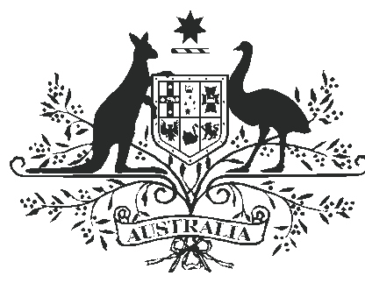

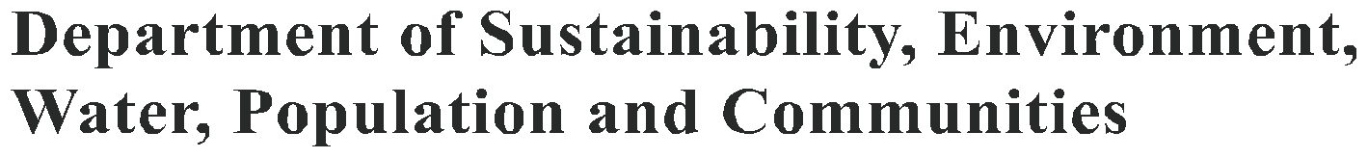

EUROPEAN RED FOX
(VULPES VULPES)

Since they were introduced for recreational hunting in the mid-1800s, foxes have spread across most of Australia. They have played a major role in the decline of a number of species of native animals and they also prey on newborn lambs. Control of foxes relies heavily on conventional techniques such as shooting, poisoning and fencing. In the future, a combination of biological and conventional control methods may
be able to reduce the damage foxes cause.

History

The European red fox was deliberately introduced to Australia for recreational hunting in 1855 and fox populations became established in the wild in the early 1870s. Within 100 years, the fox had spread across most of Australia, although it currently does not occur in the tropical north and some off-shore islands remain fox free. In response to growing evidence of a low-density, widely distributed fox presence in Tasmania, eradication efforts began in Tasmania in 2002..
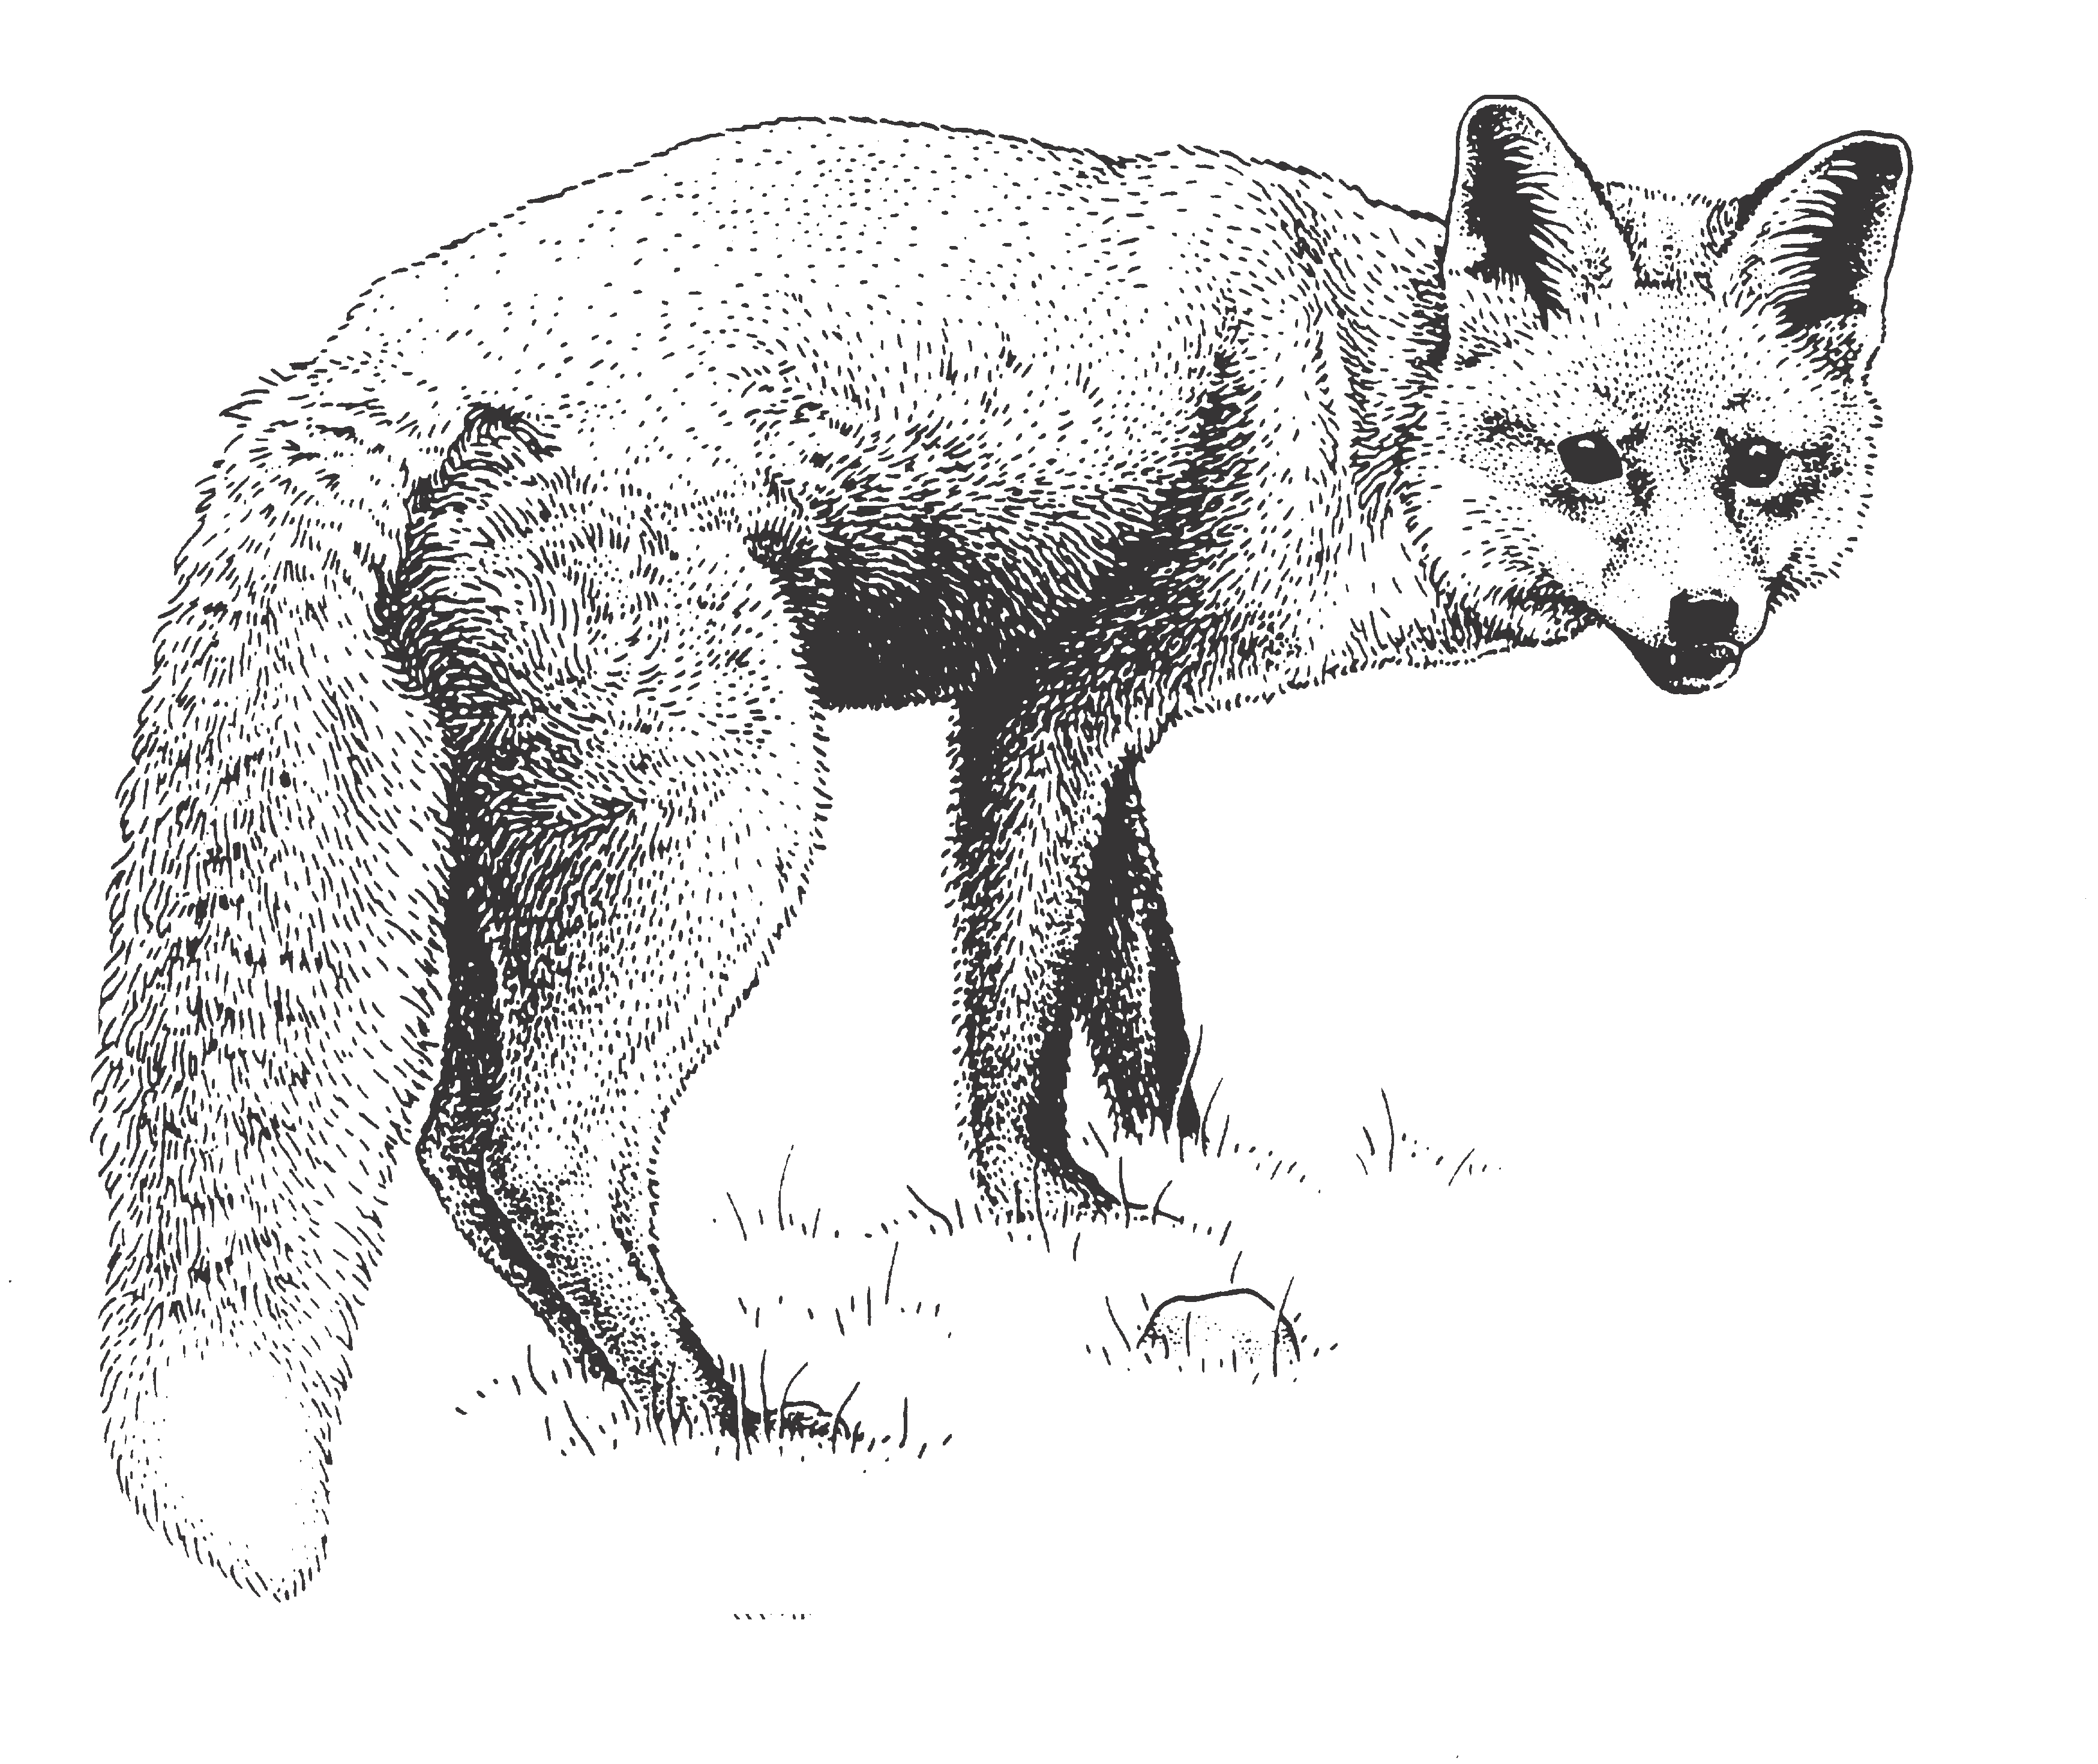

Ecology

The fox survives in many different habitats, including urban, alpine and arid areas. Outside urban areas, it appears to be most abundant in lightly wooded areas that are typically found in agricultural landscapes offering a wide variety of shelter and food.

During the day, the fox sleeps in dens, logs and other shelter — it is mainly active at night. The
fox eats almost anything, scavenging and preying on whatever is available. Its main food source is small animals, but it also eats insects and fruit, particularly in summer when preferred prey is less abundant.

Both males and females are sexually mature at the age of one year. Litters, averaging four cubs, are born during August and September, and emerge from the den in late spring. The cubs move away from the family territory in late summer or autumn.

Causes of fox mortality include shooting, trapping and predation by dingoes. Diseases such as mange and distemper may also be a significant cause of death in fox populations.

Distribution of european red fox in Australia

Sources: National Land & Water Resources Audit (2008) Assessing invasive animals in Australia 2008, NLWRA, Canberra./SEWPaC (2010) Feral animals on offshore islands database located at http://www.environment.gov.au/ biodiversity/invasive/ferals/islands/
Tasmanian Department of Primary industries, Parks, Water and Environment (2010) Locations of Fox Activity in Tasmania updated May 2010, located at http://www.dpiw.tas.gov.au/inter.nsf/Attachments/MMAN-86X4RB/$FILE/ Fox%20Activity%20Map_28MAY10.pdf

Impact

The fox has played a major role in the decline of ground-nesting birds, small to medium sized mammals such as the greater bilby, and reptiles such as the green turtle. While land use change is cited as one of the key reasons for decline in many native species, predation by foxes has also been
a significant contributor to native animal decline and continues to undermine recovery efforts for
threatened species as the malleefowl, the bridled nail-tail wallaby and the night parrot.

The fox causes significant economic losses to farmers by preying on newborn lambs, kid goats and poultry.

The fox could also act as a carrier of rabies, should the disease accidentally be introduced into Australia. Rabies mostly affects members of the dog family, but can also be passed on to humans, livestock and native mammals.

Control

In the past, bounties have been paid to remove foxes from the wild, but these have rarely been effective in reducing the damage caused by foxes. Similarly, hunting does not seem to have had a significant or lasting impact on fox numbers or the damage they cause.

Preventing the introduction of foxes to new areas, such as islands, is a high priority. Islands are often refuges for animals no longer found on the mainland.

In south-west Western Australia, fencing and broad scale fox control with 1080-poison baits has been used successfully, allowing populations of some native mammals to begin to recover and return to former habitats. Similar control activities have been undertaken in eastern Australia. The use of poison baits for fox control must take into account possible effects of the baits on other animals. Burying baits reduces the likelihood of the baits being taken
by native animals, and foxes can still find them. Such control efforts can ease the pressure on populations of native animals, but it is expensive and must be maintained indefinitely.

Scientists are investigating ways to improve conventional fox control methods to make them more effective and humane, and less likely to harm non-target animals including the use of an alternative toxin to 1080.

Foxes are less common where dingoes are present, and this may be another form of biological control. Researchers are looking at the interactions between foxes, dingoes, wild dogs and feral cats; their findings could help in integrating fox, wild dog and feral cat control.
How the Australian Government is dealing with a national problem

‘Predation by the European red fox’ is listed as a key threatening process under the Commonwealth Environment Protection and Biodiversity Conservation Act 1999 (the EPBC Act). Under
the EPBC Act, the Australian Government, in consultation with the states and territories, has developed the Threat Abatement Plan for Predation by the European Red Fox.

The threat abatement plan aims to reduce the impact of predation by foxes by:
• Preventing foxes occupying new areas in Australia and eradicating foxes from high- conservation-value ‘islands’;

• Promoting the maintenance and recovery of native species and ecological communities that area affected by fox predation;

• Improving knowledge and understanding of fox impacts and interactions with other species and other ecological processes;

• Improving the effectiveness, target specificity, integration and humaneness of control options for foxes; and

• Increasing awareness of all stakeholders of the objectives and actions of the threat abatement plan, and of the need to control and manage foxes.

Fox control programs need to be coordinated with other activities that may be taking place, including the on-ground protection of threatened plants and animals, and control of other invasive species such as feral rabbits and feral cats. The plan
provides a framework that enables the best use of the resources available for fox management. The Australian Government works with the states and territories to deal with this national problem.

BIO53.0610

More information about the Threat Abatement
Plan for Predation by the European Red Fox
can be found at http://www.environment.gov.au/ biodiversity/threatened/publications/tap/foxes08. html

Further reading:

Improving Fox Management Strategies in Australia (2007) Saunders, G. and McLeod, L. Bureau of Rural Sciences, Canberra.

For further information, contact:

Department of Sustainability, Environment, Water, Population and Communities

GPO Box 787
Canberra ACT 2601
Phone: 1800 803 772
Web site http://www.environment.gov.au/
biodiversity/invasive/index.html

InvasiveSpecies@environment.gov.au

Photo credits in order: Illustration of European fox (Karina Hansen McInnes), Fox with animal in mouth (C.Marks), European fox (Daryl
Panther), Fox in trap (SEWPaC), Fox eating baited rabbit (SEWPaC)

© Commonwealth of Australia 2010

This work is copyright. You may download, display, print and reproduce this material in unaltered form only (retaining this notice) for your personal, non-commercial use or use within your organisation. Apart from any use as permitted under the Copyright Act 1968, all other rights are reserved. Requests and inquiries concerning reproduction and rights should be addressed to Commonwealth Copyright Administration, Attorney General’s Department, Robert Garran Offices, National Circuit, Barton ACT 2600 or posted at www.ag.gov.au/cca.

Disclaimer

The views and opinions expressed in this publication are those of the authors and do not necessarily reflect those of the Australian Government or the
Minister for Sustainability, Environment, Water, Population and Communities.

