SEPTEMBER 2017

Evaluating long- term outcomes of project investments

Final Report

Department of the Environment and Energy

Level 1, 357 Camberwell Rd, Camberwell, Victoria 3124

(03) 9882 2670 – rmcg.com.au

Table of Contents

Executive Summary 1

1 Introduction 7

1.1 background 7

1.2 PROJECT OBJECTIVES 8

1.3 about this report 8

2 Evaluation method 8

2.1 data collection framework 8

2.2 Data collection methods 10

2.3 Projects Reviewed 10

3 Key findings 11

3.1 achievement of long-term outcomes 11

3.2 Case study 1 16

3.3 case study 2 20

4 Investment program design 25

4.1 case study 3 34

4.2 case study 4 36

5 Conclusions and recommendations 39

Appendix 1: Data collection framework 43

Appendix 2: Data collection form 45

Appendix 3: Projects reviewed 49

Executive Summary

The Australian Government has a long history of investment in the environment, delivered through multi-year programs such as the Natural Heritage Trust (NHT) and Caring for our Country (CfoC). This project stepped outside that program cycle to examine the long-term outcomes of past project investments (from 5-15 years ago) to determine whether the identified long-term outcomes of projects were actually achieved, and what project and program design factors can influence long term success or failure.

The findings of this review are intended to guide future funding program design.

Data collection for this evaluation was conducted in two stages. Stage 1 focused on compiling a report on the effectiveness, appropriateness and short-term impact of each selected project. Stage 2 focused on assessing the long-term impact of each project through a series of site visits, interviews and further background research to test and validate assumptions identified in the program logic (or other model of change).

A total of 44 projects from across Australia were reviewed. This included 29 site visits and 15 semi-structured interviews conducted over the phone. The projects reviewed:

* were delivered by a range of proponents including regional natural resource management (NRM) bodies, community groups, state government departments, non-government organisations and Aboriginal Corporations
* were funded through a range of Australian Government funding sources including Natural Heritage Trust, Caring for our Country, Envirofund and Biodiversity Fund
* varied in funding amount from $5,000 to $27 million, and
* varied in duration from 1 to 5 years.

achievement of long-term outcomes

The review revealed mixed results regarding the extent to which projects have achieved their long-term outcomes. There was also significant variation in the amount and quality of evidence to support these claims.

In terms of their progress towards outcomes, we found that projects generally fell into three categories:

* Demonstrating achievement of long-terms outcomes – 20% of the sample
* On a trajectory towards achieving long-term outcomes – 64% of the sample
* Partially achieving or unclear if achieving outcomes – 16% of the sample

Similarly, the evidence that projects provided to support their claims of progress towards outcomes can also be categorised into three groups:

* Direct measures of outcomes (i.e. based on monitoring or research) – 27% of the sample
* Indirect measures, typically of established indicators of positive change – 54% of the sample
* No outcome evidence or anecdotes only – 19%

Factors that explained this finding were funding for monitoring long-term outcomes, project planning (particularly MER), measurability of long-term outcomes, the impact of project focused investment and organisational priority given to monitoring.

The most common reason amongst the projects reviewed for not collecting direct evidence on the achievement of long-term outcomes was “we are not funded to do it”. Even so, there were projects that did manage to fund this type of monitoring. In most cases this funding was pooled from a range of sources including organisational base funding (e.g. regional base allocation funding for NRM regions), research grants, co-contributions from research partners (e.g. universities) and project funds (where additional investment had been secured to continue or expand the project). There were other cases where long-term monitoring was conducted by community groups and volunteers, often engaging with research organisations for expert advice.

Investment program design

Over the course of the review of the 44 projects, investment program design features were specifically examined. This included discussing how factors like funding levels, project duration, project planning and the various requirements of each investment program influenced delivery of the projects.

The findings from this part of the review have been categorised into the ten factors that we found had the most influence or impact on project success. While these factors apply to projects, they have been noted here because they are strongly influenced by program design. That is, program design can drive project success by supporting:

* Rigorous planning
* Outcome focused indigenous engagement
* Strategic partnerships
* Community engagement
* Landholder agreements and follow up
* Maintenance and monitoring regimes
* Stages of a project
* Reaping the benefits of investments in capacity building
* Maturity of groups delivering NRM works
* Level of prescription in investment

conclusions and Recommendations

The conclusions reached through this review, and the associated recommendations relating to future investment programs are presented in three categories:

* 1. Improving projects
  2. Improving investment programs
  3. A framework for better monitoring and reporting

1. Improving projects

The review found that program design has a significant influence on project design. This was particularly evident in three fundamental areas – project planning, partnerships and community engagement. Among the projects reviewed there were cases where program requirements did not appear to support these foundations of good project management. For example, programs that focussed on on-ground works or that would not support resources for a planning or review phase, sent a signal that this type of activity was not valued. In many cases the program design did not seem able to accommodate the fact that well planned and managed projects naturally move through different phases and this has implications for resourcing, activities and outputs.

The recommendations relating to these conclusions are:

* The Australian Government needs to place more value on having detailed project plans (this includes project and MERI planning). Funding programs could adjust the allocation of funding within a project based on what phase the project is in:
* **Initiation** – small, short-term amounts
* **Planning** – small-medium amounts, short-term (e.g. 6-12 months)
* **Implementation** – larger and over longer terms
* **Review and renewal** – small-medium amounts, short-term (e.g. 6-12 months).
* Continue to facilitate and encourage the formation of strategic partnerships in future investment programs. Critical elements of the partnership approach should include:
* Shared interest in project outcomes and mutual benefits as a result of their effective delivery;
* Complementary knowledge and skills with roles and responsibilities tailored to the strengths of each partner;
* Long-term relationships based on trust and equity;
* Shared responsibility and accountability for project delivery (i.e. true sharing of risks and benefits as a result of the project);
* Open and regular communication.
* Continue to facilitate and encourage community engagement in future investment programs. Critical elements of engagement should include:
* Early engagement at the project outset, with follow-up engagement over the life of the project;
* Engagement that is appropriately pitched to the target audience;
* Clear, and multiple, opportunities for participation.

1. Improving investment programs

This group of conclusions and recommendations relate to specific design features of investment programs. The review found that the focus on long-term outcomes is strongly supported, but that in some cases constraints driven by the program design did not always support that focus. This was most evident in the cases where specific actions necessary to achieve long-term outcomes were not be supported. This included situations where those particular actions had not been anticipated at the start of a project, or they were not among those actions that are traditionally supported. This brings into question the degree of flexibility in project delivery that an outcome focussed approach should accommodate.

We also found that many of the most effective projects reviewed are using two relatively simple approaches to improve the quality and longevity of their results – agreements with participants (particularly private landholders) combined with regular follow-up contact. These practices are in use widely enough for them to be considered standard practice (at least for projects working with private landholders).

Other conclusions reflect the fact that various NRM investment programs have now been operating for over 20 years and the sector is maturing. Benefits from early investments in capacity building and foundational work are evident in many projects. There are opportunities to capitalise further on the capacity and knowledge that has been built over these decades of investment.

The recommendations relating to these conclusions are:

* In principle, funding programs should give project proponents the most flexibility possible and support use of the funding for whatever actions are necessary to achieve the outcome. The obvious exceptions to this are legal requirements (including things like animal welfare, pollution, community safety and welfare).
* In considering applications for funding, identify which stage a project is (initiation, planning, implementation, review and renewal) and how this aligns with their funding request.
* Identifying where a project stands with respect to its foundational work could be valuable for understanding the type of outputs that are achievable in the project funding period. It can also assist in determining whether a project matches the particular scope of an investment program. For example, if the program has an on-ground focus, then projects that have their foundational work in place could be better options.
* Investment programs should require landholder agreements. These agreements should be for as long as practically possible without severely discouraging participation. Project staff should be encouraged to include the possibility of covenants (i.e. permanent on-title agreements) with landholders where there has been a substantial investment. Landholder agreements should be a specific focus of the project design.
* In light of the strong experiential learning and evidence on the value of regular follow up with landholders, a condition of funding should be a commitment from the applicant to resource follow up for the term of the landholder agreement (as a minimum). Follow-up of participants should be a specific focus of the project design.
* Sites where there has been a long history of work can offer particular benefits for investment. For example, they are often cost-effective because the foundational work and capacity building has already occurred (perhaps through previous investment programs) and the opportunity now is to capitalize on that ‘overhead’ investment.
* The lack of continuity of funding presents major challenges at all levels of NRM work. For instance, the issues being managed are often require sustained effort over the long-term, retaining skilled staff is extremely difficult with no security of funding, and the short and interrupted funding cycles waste funds due to the rapid scaling up and down required. It seems likely that funding cycles will continue to vary in length and size, there is more that could be done in the program design phase to explicitly identify cases where continuity of funding offers particular benefits.

**Indigenous engagement**

* Indigenous engagement must be coordinated, sustained and leave a meaningful legacy. Place a stronger requirement on project proponents to ensure that Indigenous engagement is delivered in a coordinated way. Consider requiring Indigenous wellbeing outcomes in addition to employment e.g. education, health, closing the gap.

1. A framework for better monitoring and reporting

This review found that among the projects examined, monitoring and reporting was recognised as a critical element of their work. We found excellent examples of project level monitoring and reporting driven by good systems of collecting and reporting activities and outputs. Despite this, there were still cases where fundamentals were missing. For example, many projects were unable to identify their baseline data or measure that they could use to gauge their impact. Some projects did not appear to have allocated resources to monitoring. Similarly, many project teams still seem to be in two minds regarding the effort required to meet reporting obligations versus the value they receive from the reporting. However, there were certainly cases where the reporting was clearly disproportionate to the size of the project.

Measuring and reporting on long-term outcomes was mixed. We did find that there are opportunities to improve how long-term outcome measurement is approached. For example, some outcomes were poorly worded or were (arguably) not long-term outcomes. For other projects, it was not possible or practical to measure long-term outcomes and indicators were more appropriate. Overall, expectations regarding outcome statements need clarification, as does the associated question of whether projects should be focussing on direct or indirect (indicators) measures. This centres on the fact that there are mis-matches between project duration (maximum of five years) and scale, versus the time required before outcomes can be measured, and the scale at which they should be measured. Based on this, we have concluded that they should be separated in time and space. That is, long-term outcome measurement warrants a separate dedicated approach that is strongly linked to projects (i.e. it aims to measure the long-term impacts of a set of projects operating across an area). This approach would involve engaging the specialist expertise required at the appropriate time and spatial scale given the outcomes.

The recommendations relating to these conclusions are:

**Project level**

* At the project level, we recommend that project deliverers identify a baseline measure(s) relevant to the intended outcome of the project and measure it at the beginning and at the end of the funding period, and report on it. This would be in addition to monitoring and reporting on activities and outputs delivered.
* The project level MERI Plan is critical to the question of monitoring long-term outcomes. It identifies the long-term outcome for a project, and needs to define how it should be monitored. If a MERI plan has not already been developed, projects need to allocate resources (e.g. funding and expertise) to it preparation. If a MERI plan has been prepared, resources should be allocated to up-dating it.
* Each project must identify a long-term outcome that it will contribute to, but the Australian Government should clarify what is considered to be a long-term outcome. More emphasis needs to be placed on these outcomes being ‘SMART’.
* Measurement of outcomes at the project level should be encouraged, but it should only be part of project monitoring and reporting if there are clear and simple measures or indicators that can be monitored at reasonable cost, and where deliverers have the capability and commitment to do so. The highest priority for monitoring should be given to baseline measures, and activity to output monitoring.
* Reporting requirements should be tailored to the project size. For small short-term projects (e.g. 12-18 months) activity and output reporting is adequate. For projects of over three years, reporting should be extended to include short- to medium-term results. And were possible, reporting could cover long-term outcomes (with the provisos noted in the recommendations above).
* Ensure all projects specify a budget for collecting monitoring data.

**Long-term outcomes**

* Encourage multi-region collaboration on long-term outcome monitoring at a landscape scale as an efficient way to measure long-term outcomes. Instead of focussing on measuring outcomes on a project by project basis, this approach measures the impact of the collective investment in biodiversity outcomes across regions. The findings and key lessons can then be shared and used by all organisations working in that area (including the regional NRM bodies, government departments, research institutions and community groups) to facilitate evidence based investment and more effective program and project design.
* Explore options to develop partnerships with states and NGOs to co-fund long-term monitoring projects covering areas where there is active project investment. In addition to the objectives of projects operating in a given area, this approach could draw on existing plans that have long-term ecological objectives, such as threatened species recovery plans or ecological character descriptions (for Ramsar wetlands). Though they would be managed as discrete projects, it is critical that these monitoring projects are directly linked to the project work occurring in that same area. This is a means of ensuring both the relevance of the monitoring work and that the results from the monitoring are used to shape project investments. It could also be a means for the states to set the standards for monitoring and fulfil their reporting requirements for things State of the Environment or catchment condition reporting.

# Introduction

## background

The Australian Government has a long history of investment in the environment delivered through multi-year programs such as the Natural Heritage Trust (NHT) and Caring for our Country (CfoC). This funding model presents two particular challenges for measuring the impact of these investments.

The first is that the program model (typically comprising 5 years) means that evaluations are undertaken during, and soon after, program completion. This timing is usually at odds with the nature and timescale of changes in environmental systems, so measuring and reporting on long-term outcomes from this public investment is challenging. This has flow-on effects for demonstrating accountability and value for money, which then influences the ability to justify on-going support for these programs.

The second is that the relatively short time periods involved mean that project planning is often dependent on assumptions that describe how long-term impacts are expected to develop over time (Figure 1‑1). The question of whether these assumptions played out as expected has a critical influence on long term success of a project. Similar to the long-term outcomes, assumptions usually cannot be usefully assessed within the project delivery period.



Figure ‑: Simplified logic for a project

This project stepped outside the multi-year program cycle to examine the long-term outcomes of past project investments (from 5-15 years ago) to determine:

* whether the identified long-term outcomes of projects were actually achieved, and
* what project and program design factors can influence long term success or failure.

The information resulting from this review is intended to guide future funding program design.

This project was delivered by RMCG on behalf of the Department of the Environment and Energy (DoEE) Monitoring and Reporting group in the Biodiversity Conservation Division.

## PROJECT OBJECTIVES

The objectives of this evaluation were to:

* Evaluate the long-term outcomes achieved by the selected projects against the original project, and program, outcomes or objectives.
* Evaluate how the project’s design and delivery approach influenced the achievement of the intended outcomes and/or legacy.
* Evaluate if the proposed project outcome was measurable, appropriate and realistic within the project timeframe and budget.
* Evaluate the maintenance and monitoring regime post project completion.
* Compile a narrative of each project that covers design through to long-term outcomes achieved. The review should highlight failings and succusses. These will be used by the Department as case studies.
* Compile up-to-date photos of project sites and, if possible, collate a photo history of the projects.

## about this report

This report outlines the key findings, conclusions and recommendations from this evaluation of long-term outcomes of project investments. The report is presented in the following chapters:

* Evaluation method – briefly describes the methodology used to collect data for this evaluation and the number of projects reviewed.
* Key findings – presents the findings from the data collection in two key result areas; achievement of long-term outcomes and design and delivery factors that influence success.
* Conclusions and recommendations – presents a synthesis of all of the findings and provides recommendations for consideration in the design of future Australian Government funding programs.

# Evaluation method

## data collection framework

Data collection for this evaluation was conducted in two stages. Stage 1 focused on compiling a report on the effectiveness, appropriateness and short-term impact of each selected project (Table 2‑1). This information was drawn from background data including the project funding application, project plan, program logic, evaluation plan, project reports and evaluation reports (where available).

Table ‑: Stage 1 data collection

| What was assessed | How it was assessed |
| --- | --- |
| **Effectiveness**: were the activities and outputs achieved | Effectiveness was assessed by examining the extent to which the project had completed each of the specified activities and associated targets.  If activities/targets had not been completed/achieved, an explanation of why was provided where possible. |
| **Appropriateness**: were the activities and outputs suitable for the local environment, community and achieved the desired outcomes | Appropriateness was assessed by examining qualitative data on the following:   * + Utilisation of delivery approaches that were supported by the local community   + Utilisation of delivery approaches that facilitated the achievement of short-term outcomes and targets   + Adaptive management of project delivery. |
| **Short-term impact**: the extent to which the activities and outputs contributed to the short-term outcomes | Assessing short-term impact combined the data reported under effectiveness with information about the assumptions included in the program logic. The aim was to determine whether the cause and effect relationships documented in the program logic are valid, and the extent to which evidence shows that short-term impacts have occurred. |

Stage 2 focused on assessing the long-term impact of each project through a series of site visits, interviews and further background research to test and validate assumptions identified in the program logic (or other model of change) (Table 2‑2). The aim of Stage 2 was to determine whether the cause and effect relationships documented in the program logic are valid, and the extent to which evidence shows that anticipated outcomes have been achieved. The program design and delivery factors that influenced long term success or failure were also investigated.

Table ‑: Stage 2 data collection

|  |  |
| --- | --- |
| What was assessed | How it was assessed |
| **Long-term impact**: the extent to which the activities, outputs and short-term outcomes have contributed to the long-term outcomes | Assessing long-term outcomes brought together all data from Stage 1. The aim was to determine whether the cause and effect relationships documented in the program logic are valid, and the extent to which evidence shows that anticipated outcomes have been achieved.  In order to test assumptions we:   * + Visited the project to determine the extent of biophysical change   + Interviewed the project leader and/or project participants to determined the extent of capacity, practice and/or attitudinal change   + Reviewed relevant documentation used to validate assumptions such as existing literature, primary research and evaluations.   The objective was to identify and test assumptions critical to delivery of long-term outcomes. |

More detailed information in the data collection framework is provided in Appendix 1.

## Data collection methods

Data was collected from each project in three ways:

* an initial scoping telephone interview,
* review of background information, and
* site visits or semi-structured interviews (conducted over the phone).

A detailed data collection form was developed and used to guide consistent and methodical data collection across all of the projects reviewed (Appendix 2).

## Projects Reviewed

A total of 44 projects from across Australia were reviewed during June and July 2017. This included 29 site visits and 15 semi-structured interviews conducted over the phone. A breakdown of project numbers by state is provided in Table 2‑3.

Table ‑: Number of projects reviewed by state

|  |  |
| --- | --- |
| State/Territory | Number of projects reviewed |
| Queensland | 6 |
| New South Wales/Australian Capital Territory | 7 |
| Northern Territory | 2 |
| South Australia | 8 |
| Tasmania | 5 |
| Western Australia | 6 |
| Victoria | 10 |
| **Total** | **44** |

The projects reviewed were delivered by a range of proponents including regional natural resource management (NRM) bodies, community groups, non-government organisations, state government departments and Aboriginal Corporations (Table 2‑4).

Table ‑: Number of projects reviewed by proponent type

|  |  |
| --- | --- |
| proponent type | Number of projects reviewed |
| Natural resource management (NRM) bodies | 33 |
| Community groups | 5 |
| Non-government organisations | 4 |
| State government departments | 1 |
| Aboriginal Corporations | 1 |
| **Total** | **44** |

The scale of the funding amount varied significantly across the 44 projects reviewed. The sample included projects funded for $2,000 to $30,000,000 with Australian Government investment. A breakdown of projects by size of investment in provided in Table 2‑5. The projects reviewed were funded through a range of Australian Government funding sources including Natural Heritage Trust, National Action Plan for Salinity and Water Quality, Caring for our Country, Envirofund and Biodiversity Fund and varied in duration from 1 to 5 years.

Table ‑: Number of projects reviewed by size of investment

|  |  |
| --- | --- |
| Size of investment | Number of projects reviewed |
| <$20,000 | 1 |
| $20,000 - $99,999 | 6 |
| $100,000 - $499,999 | 15 |
| $500,000 - $999,999 | 8 |
| $1,000,000 - $1,999,999 | 8 |
| $2,000,000 - $9,999,999 | 4 |
| $20,000,000 - $30,000,000 | 2 |
| **Total** | **44** |

A full list of the 44 projects reviewed is provided in Appendix 3.

# Key findings

## achievement of long-term outcomes

The review of 44 projects across Australia revealed mixed results regarding the extent to which projects have achieved their long-term outcomes. There was also significant variation in the amount and quality of evidence to support these claims.

In terms of their progress towards outcomes, we found that projects generally fell into three categories:

* Demonstrating achievement of long-terms outcomes,
* On a trajectory towards achieving long-term outcomes, or
* Partially achieving or unclear if achieving outcomes.

Similarly, the evidence that projects provided to support their claims of progress towards outcomes can also be categorised into three groups:

* Direct measures of outcomes (i.e. based on monitoring or research),
* Indirect measures, typically of established indicators of positive change, or
* No outcome evidence or anecdotes only (i.e. projects were relying solely on assumptions to demonstrate the cause and effect relationship between activities and outcomes over time. Some had anecdotes based on personal accounts.)

An overview of the type of evidence being collected by each project is provided in Table 3‑1. Our results show that 27% of projects had direct evidence of their progress towards long-term outcomes. A further 54% of projects used indicators to demonstrate progress towards long-term outcomes. This was most common across all of the projects reviewed. The reasons for this are discussed in more detail in the next section.

Table 3‑1 also shows our overview of the proportion of projects that appear to be achieving their long-term outcomes. Importantly, these estimates suggest that only 17% of projects do not appear to be either achieving their outcomes or showing strong signs that they are on a trajectory to do so.

The data in Table 3‑1 should be carefully interpreted. While it is desirable to directly measure outcomes, there are many cases where this is not possible or practical. Similarly, it is not necessarily the case that projects that are only able to provide anecdotal evidence are inadequate. Evidence type must be matched to the individual project, and there are cases where the three types of evidence listed – direct outcome measurement, indicator measurement and anecdotes – are both appropriate and useful measures. This is based on two key factors that strongly influence outcome monitoring:

* Some outcomes only become evident after very long time periods (e.g. decades), so direct measurement may be impossible. In this case, indicators may be the best option
* Direct measures can be complex and costly to measure; therefore, indicators may be more appropriate. Similarly, there could be situations where indicator measurement is disproportionately expensive, and therefore anecdotes or just simply stating the assumptions underpinning the work might be appropriate.

Specific information on each project’s achievement of long-term outcomes is included in the narratives project (accompanying report). These narratives describe the project design, results at the end of the contract period and the type of evidence made available to describe the long-term outcomes that have been or will be achieved.

Table ‑: Summary of the projects reviewed by monitoring evidence type and achievement of outcomes

| type of evidence | | level of outcomes achievement | |
| --- | --- | --- | --- |
| Directly measuring outcomes | 12 projects | Achieving outcomes | 9 projects |
| Directly measuring indicators | 21 projects | On a trajectory to achieving outcomes | 25 projects |
| Assumptions or anecdotes | 8 projects | Partially achieving or unclear | 7 projects |
| Total | 41 projects  (3 not classified) | Total | 41 projects  (3 not classified) |

Whilst this review focused on projects that were nominated by those involved in their delivery and/or were recommended as successful investments, it was found that despite the time passed, the majority of projects did not have direct evidence of the achievement of their long-term outcomes or there had been insufficient time since implementation.

Over the course of the review, it has been possible to identify a set of factors that contributed to this finding. These include funding, project planning (particularly MER), measurability of long-term outcomes, the impact of project focused investment, and organisational priority. Each of these factors are discussed in more detail below.

**Funding**

The most common reason amongst the projects reviewed for not collecting direct evidence on the achievement of long-term outcomes was “we are not funded to do it”. Projects cited financial limitations as one of the most significant barriers to establishing and implementing a monitoring program of sufficient rigour, scale and duration to effectively measure the achievement of long-term outcomes.

*“We stopped monitoring at the end of the project. We are seeing change but we don’t know whether this is sustained and significant. We have the infrastructure in place and a baseline assessment to compare to, but to date we have not had any success in attracting funding to support a follow up assessment of the impact of this work. All we can use is assumptions and anecdotal evidence”*

~ Little River Landcare

Even so, there were projects that managed to fund monitoring of long-term outcomes. In most cases this funding was pooled from a range of sources including organisational base funding (e.g. regional base allocation funding for NRM regions), research grants, co-contributions from research partners (e.g. universities) and project funds (where additional investment had been secured to continue or expand the project). There were other cases where long-term monitoring was conducted by community groups and volunteers, often engaging with research organisations for expert advice.

**MER Planning**

Another significant factor influencing the ability of projects to measure long-term outcomes was whether long-term outcomes had been defined for the project. This depended on the level of planning conducted at the beginning of the project, particularly whether a monitoring, evaluation and reporting framework had been developed.

Detailed MER planning was not evident in most of the projects reviewed. The main barriers to this kind of planning were financial constraints and internal capacity. Projects noted that planning of this kind takes a significant amount of time, expertise and resources, which is often not supported through funding programs (i.e. where the focus is on ‘on-ground works’ only). Projects also noted limited internal knowledge and skills to undertake this kind of detailed MER planning.

The projects that did prepare detailed MER plans were, in most cases, highly successful. Among the critical elements of their plans were:

* clear and measurable (SMART) long-term outcome statements,
* a description of the cause and effect relationships between activities, short-term outcomes and long-term outcomes over time (e.g. program logic),
* documentation of the critical assumptions identified in these cause and effect relationships,
* identification of appropriate indicators to measure change at all levels of the program logic, and
* establishment of baseline data via a process that is representative and repeatable to facilitate project evaluation at different points in time (e.g. end of contract period or 10 years beyond that).

MER planning has certainly improved over time with the change of Australian Government funding program guidelines (i.e. requirement to produce MERI Plans as part of CfoC). However, this has been a gradual improvement. For instance, while MER planning was a key requirement introduced during CfoC, it did not always result in clear and measurable long-term outcomes being defined.

“*We spent a year in the planning process for this monitoring program, In the early phases there was a lot of engagement with key partners to ensure that we designed a program to answer both short-term questions and long-term change. We have also involved statisticians in the project team from the very beginning to ensure that our research approach was going to enable statistically significant results”*

~ Murray Local Land Services

**Measurable long-term outcome statements**

Even when long-term outcomes for a project had been identified, they were sometimes not measurable. A common reason for a reliance on anecdotal evidence to describe the achievement of long-term outcomes was that the project’s long-term outcome was not measurable. These poor-quality outcome statements (i.e. those that are not SMART – specific, measurable, achievable, realistic and time-bound) were the result of things like:

* The outcome statements were prescribed in the funding program guidelines or business plan,
* The outcomes statements were deliberately over-ambitious in an attempt to secure funding, and
* The outcomes statements were prepared without adequate project planning and/or experience in project design, evaluation and reporting.

In some cases it seemed that there had never been any serious intention (or expectation) that these long-term outcomes would be monitored and reported against. As a result, no priority was placed on reviewing these outcomes statements for evaluation purposes. For example, some projects were focussed on enhancing the population of critically endangered EPBC listed species, on the premise that including these priority species would help secure federal investment. This was despite project leads knowing that actually achieving these overly ambitious outcomes was unrealistic.

Some of the other common pitfalls in relation to outcomes statements included:

* Outcomes were pitched at a medium-term rather that long-term level. This often made them easier to measure, but did not enable to the project to effectively demonstrate their impact over longer periods of time
* Outcome statements were not prepared as part of a program logic of theory of change. This made it difficult to map the relationships between activities, outputs and longer-term outcomes
* The assumptions used to explain or justify the transition across outcomes over time were not always clearly documented or tested. This also made it difficult to make a strong case of long-term outcome achievement in the evaluation process.

Some example outcome statements are provided in Table 3‑2. Statements are provided at short, medium and long-term time scales to demonstrate the relationship between these outcomes over time. Examples have also been provided for three different project types; weeds, pest animals and revegetation.

Table ‑: Example outcome statements at short, medium and long-term time scales

| Outcome type | Example for a weed project | example for a pest animal project | example for a revegetation project |
| --- | --- | --- | --- |
| Short-term | Implement woody weed control across 400 hectares of remnant native vegetation within the Murray Ramsar site by 2020. | Implement rabbit control across 2200 hectares of the Little Desert National Park by 2020. | Revegetate 315 hectares using endemic species that facilitate structural complexity and floristic diversity appropriate for the Holbrook catchment by 2020. |
| Medium-term | Reduce woody weed cover to less than 5% in 400 hectares of remnant native vegetation within the Murray Ramsar site by 2025. | Reduce rabbit populations to one rabbit per spotlight kilometre across 2200 hectares of the Little Desert National Park by 2020. | Achieve 95% survival of all planted species in the Holbrook catchment by 2025. |
| Long-term | Improve the average habitat hectare score of 400 hectares of remnant native vegetation by 10% within the Murray Ramsar site by 2035. | Increase the regeneration of semi-arid non-eucalypt woodland species by 25% across 2200 hectares of the Little Desert National Park by 2035. | Increase the extent of native vegetation by 300 hectares in the Holbrook catchment by 2035. |

**Impact of project focused investment**

The focus on short-term projects also has a significant impact on efforts to monitor and measure a project’s long-term outcomes. Project managers are primarily focused on delivery against the current investment contract (i.e. activities and short-term outcomes that must be delivered by the project end date), and quickly move on to a new project or contract at the completion of the last. This cycle, together with staff turnover and organisational restructures, means that knowledge of previous projects (and the long-term outcomes they are seeking) can be lost.

This was experienced firsthand during this review. Some of the nominated contacts had great difficulty accessing project documentation or identifying the intended long-term outcomes for the projects being reviewed.

**Organisation priority given to outcome reporting**

To date, the Australian Government has been inconsistent with respect to requiring project proponents to account for and report back on the achievement of long-term outcomes. This, together with the difficulties experienced by many projects in securing funding for this kind of work, has created a perception that the Australian Government places a low priority on long-term monitoring.

Despite this, there were projects monitoring their long-term outcomes. These efforts tended to be driven by internal factors like:

* A desire to demonstrate good governance and responsible investment of public funds,
* Their own commitment to quantifying their impact at a landscape or catchment scale, and
* The value of this information as a marketing tool to demonstrate their skills, track record and suitability for further investment.

In addition, they were invariably supported from the highest levels of their organisation e.g. board, management committees or senior management.

*“We did measurements against a reference condition because we wanted to know what impact we were having and it was important for when we were looking for the next round of funding”.*

~ Skyline Tier Restoration project

## Case study 1

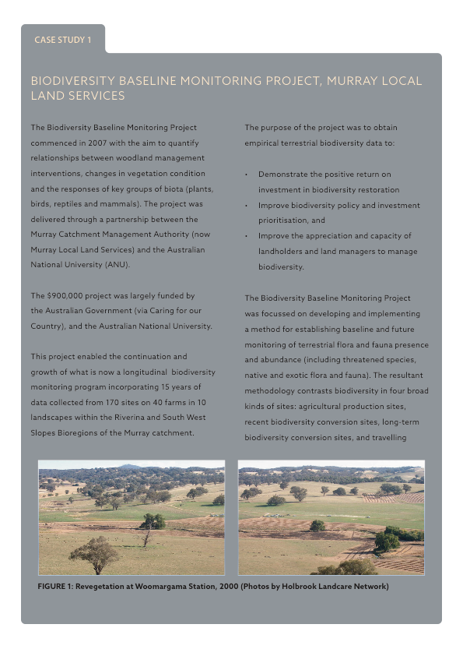

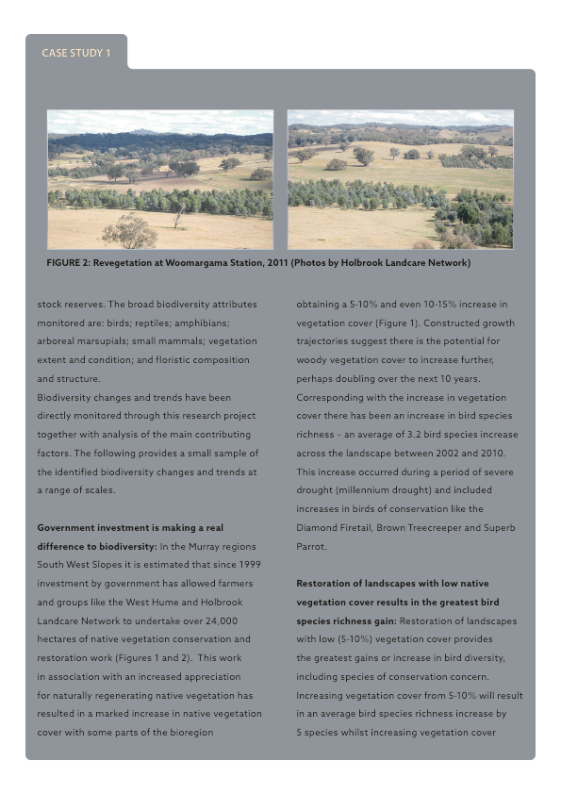

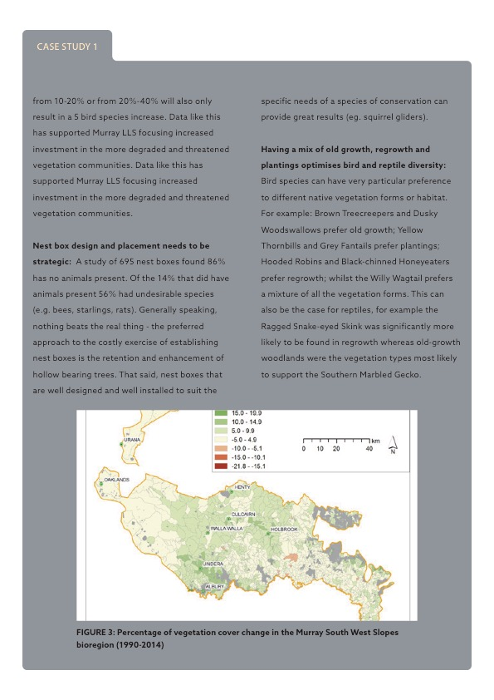

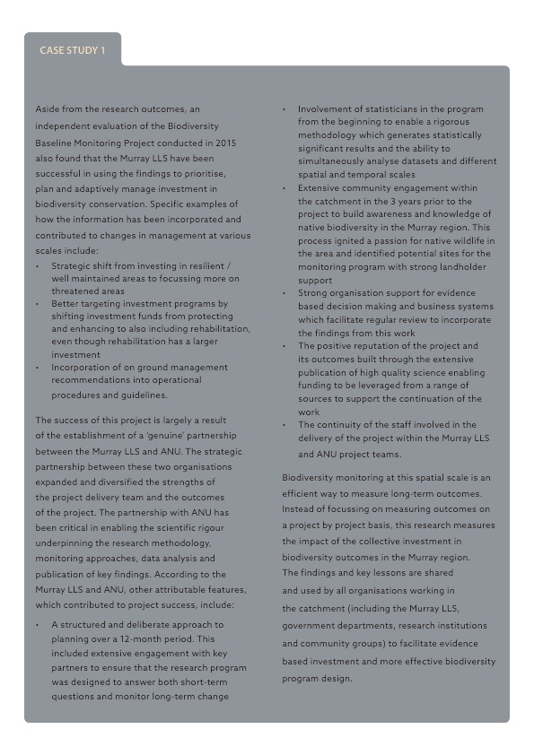

## case study 2

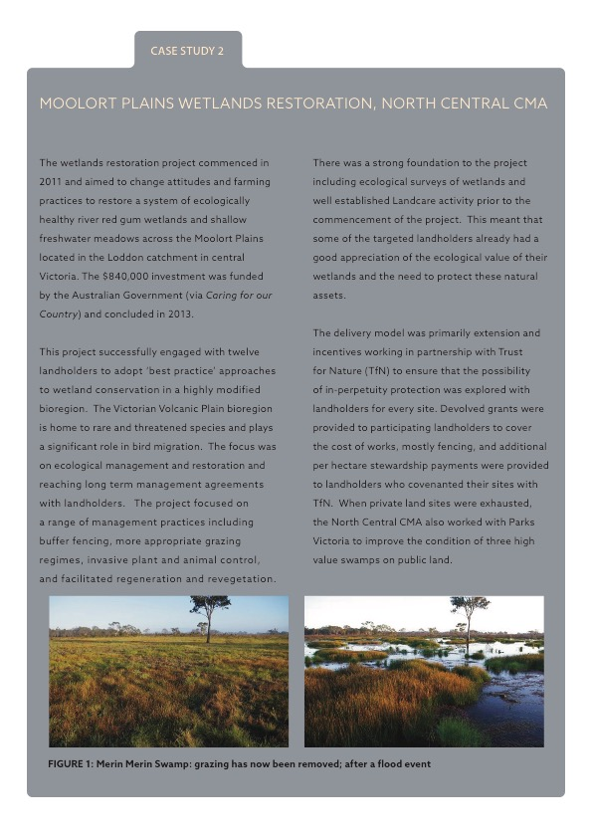

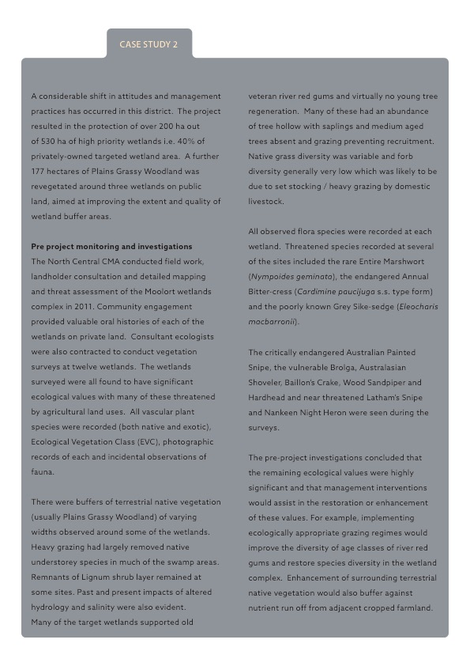

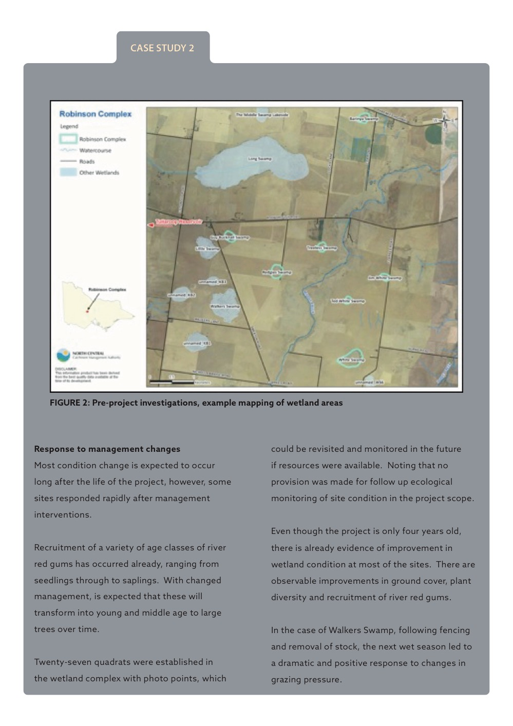

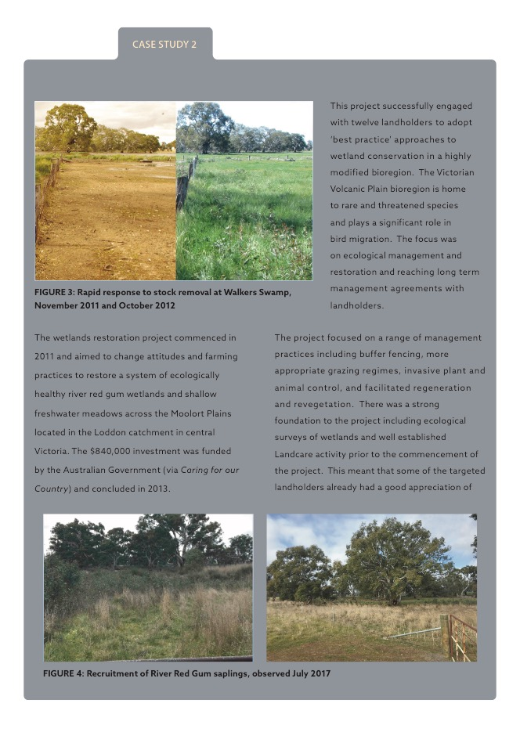

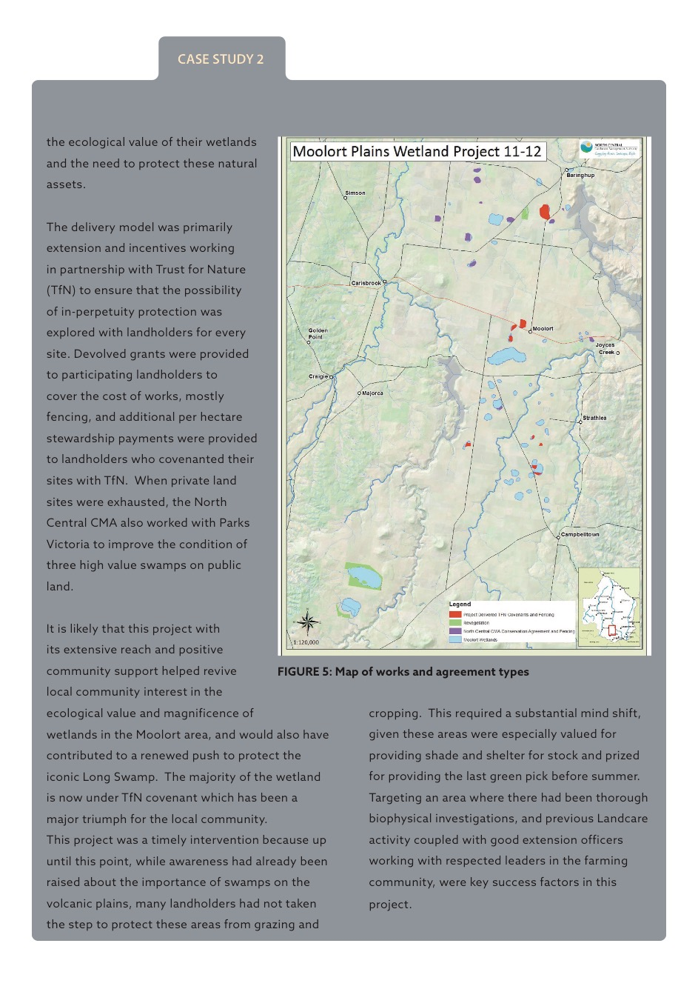

# Investment program design

Over the course of the review of the 44 projects, investment program design features were specifically examined. This included discussing how factors like funding levels, project duration, project planning and the various requirements of each investment program influenced delivery of the projects (see the data collection form in Appendix 2).

In this section, the findings from this part of the review are presented. They have been categorised into the ten factors (Table 4‑1) that we found had the most influence or impact on project success. While these factors apply to projects, they have been noted here because they are strongly influenced by program design. Each of the ten are discussed below.

Table ‑: Project design and delivery factors

|  |  |
| --- | --- |
| No. | Design and delivery factors |
| 1  2  3  4  5  6  7  8  9  10 | Rigorous planning  Outcome focused indigenous engagement  Strategic partnerships  Community engagement  Landholder agreements and follow up  Maintenance and monitoring regimes  Stages of a project  Reaping the benefits of investments in capacity building  Maturity of groups delivering NRM works  Level of prescription in investment |

* 1. **Rigorous planning**

Rigorous project planning sets the foundation for successful project delivery and was a common feature amongst the more successful projects reviewed in this study. The best of those projects had completed project planning either before the funding was provided or it was an early deliverable. Most importantly, this planning includes identifying the intended outcomes of the project, the monitoring and reporting framework, the implementation activities and resources required to achieve the end goal. The planning process is often undertaken collaboratively, driven by the project lead with buy-in from project partners.

The aspects of good planning, as demonstrated by the projects observed, typically included:

* A measurable goal (outcome) that was realistic and achievable within the project timeframe,
* A program logic that links project activities to outputs and outcomes,
* A Monitoring, Evaluation, Reporting and Improvement (MERI) plan to track project progress and overall effectiveness of the project,
* A robust monitoring protocol, as part of the MERI plan, and
* Good project governance established at the project outset.

Strong project planning was evident across the spread of projects, regardless of factors like the scale of investment or timeframe. In some cases project planning was completed despite a lack of explicit support for this activity from the investment program involved.

For example, the Gnaraloo Turtle Monitoring Program was a small ($20,000) one-year investment that progressed into a very successful monitoring program that continues to operate today. Despite the small scale of the initial project, a robust planning, monitoring and governance framework was developed that allowed them to demonstrate accountability and achievement of their intended goal. This provided a foundation that has been instrumental in seeing this work continue to grow to the point where it is now larger than it has ever been but is funded from non-government sources.

* 1. **Outcome focused indigenous engagement**

In some of the Australian Government funding programs (e.g. Caring for our Country), all projects had to demonstrate how they would contribute to employment outcomes for Indigenous Australians. This created a scenario where a very large number of projects were seeking to engage Indigenous Australians in the planning and delivery of NRM. Where this was managed in a coordinated way (either by a regional NRM organisation or an Indigenous organisation) it was successful in facilitating genuine partnerships and creating a lasting legacy for the individuals involved (i.e. employment, health and wellbeing).

For example, the Buffel Grass Control Project in the Alinytjara Wilurara NRM Region was successful in engaging with the Oak Valley community to improve their skills and knowledge in buffel grass spread and its control. This has now led to the region successfully resourcing and contracting Aboriginal crews to do this work.

Similarly, the Yarkuwa Indigenous Knowledge Centre Aboriginal Corporation have played a vital role in coordinating access to education, training and employment for Indigenous people in the Deniliquin area. The Corporation have been successful in pooling financial resources from a range of sources to enable continuous programs of mentoring and support.

*“Since 2003 we have had 17 people go through our training and work programs. All of these people have now gone on to secure permanent employment in a range of organisations, or have gone on to have families”*

~ Yarkuwa Indigenous Knowledge Centre Aboriginal Corporation

There were also instances where this was managed poorly and resulted in perverse outcomes for the individuals involved. For example, Indigenous employment in work crews delivered on the driver for increased Indigenous employment. However, in some instances this work could only be sustained for a short period. There are also examples where little priority was placed on training participants involved in these programs to increase their future employment prospects.

*“There should be better outcomes for the individuals involved in some work crews. Some of these projects are long-term and pay really high rates. They end up with a lot of money at the end of it and no qualification and no future employment. We have seen first hand how this can impact on the health and wellbeing of the people involved”*

~ Yarkuwa Indigenous Knowledge Centre Aboriginal Corporation

The requirement for projects to contribute to employment outcomes for Indigenous Australians has, in some cases, resulted in goal displacement. It has driven a focus on providing employment of any type for Indigenous community members. Numbers employed has become the measure of success rather than focussing on how employment has contributed to the long-term outcomes, which relate to community health and wellbeing.

* 1. **Strategic partnerships**

The formation of strategic partnerships has been a critical driver of long term success for some projects.

The structure, establishment, duration, and maintenance of partnerships came in all shapes and sizes across the projects reviewed. The nature of the partnership didn’t appear to have a significant impact on success. Whether or not the partnership was viewed as ‘genuine’ by those involved was far more important. The characteristics of genuine partnerships cited through this review included:

* Shared interest in project outcomes and mutual benefits as a result of their effective delivery
* Complementary knowledge and skills with roles and responsibilities tailored to the strengths of each partner
* Long-term relationships based on trust and equity
* Shared responsibility and accountability for project delivery (i.e. true sharing of risks and benefits as a result of the project)
* Open and regular communication.

Projects that were able to demonstrate long term success had used strategic partnerships to expand and diversify the strengths of the project delivery team and the outcomes of the project. Examples include:

* Murray Local Land Services partnered with Australian National University to deliver a scientifically rigorous monitoring program to measure changes in biodiversity over time.
* Little River Landcare partnered with NSW Department of Environment, Climate Change and Water (DECCW) for specialist technical skills in the management of salinity in the complex hydrogeological landscapes unique to their catchment.
* The Central Murray State Forests Wetlands project engaged Indigenous work crews to deliver components of the on-ground works on the basis of mutual interest in environmental outcomes and the potential to provide capacity building and employment outcomes for the Indigenous community.
* The long running Feral Animals Management and the Glossy Black Cockatoo (GBC) Recovery programs on Kangaroo Island have forged strong partnerships with the whole community, evidenced by an enormous volunteer contribution over several decades, towards on-ground works, monitoring and surveillance, which have achieved tremendous results in eradicating goats and deer, and a directly measured recovery in the GBC population.
* The Eco-Fire prescribed burn program in the central Kimberly was administered as a partnership between Rangelands NRM and the Australian Wildlife Conservancy (AWC). This proved very successful, as AWC had an existing, strong presence in the region and a history of engaging with private pastoralists and the Aboriginal community. They also had the capacity to undertake ecological monitoring, which formed an important component of the project.

Across the 44 projects reviewed, time to build the relationship and to develop trust between the parties was a critical factor. Investment programs generally seek to identify partnerships and regard them as a positive feature of a project. The way that these partnerships need to be presented in the project documentation can cause problems, particularly if things like valuations of in-kind support are required.

* 1. **Community engagement**

Community engagement is a core component of most projects and, when done well, contributes significantly to the achievement of project outcomes, particularly their persistence over time. This was observed across the suite of projects, where invariably the more successful projects were underpinned by a strong community engagement plan. Common features of a successful community engagement approach included early engagement at the project outset, with follow-up over the life of the project, engagement that is appropriately pitched to the target audience and repeated opportunities for participation.

Sufficient time to develop engagement approaches and foster community relationships was also commonly cited as important. This was particularly evident amongst the long running projects, where there was time to deliver genuine community engagement and establish strong relationships.

Such is the case with the Corangamite CMA Plains Tender and Saltmarsh Tender programs, where longevity was identified as a key success factor in engaging with landholders and building lasting relationships. The CMA tender programs were founded on a strong community engagement approach, which included:

* Providing tailored forums, such as field days and extension activities, to engage landholders at the Project outset and over the project life,
* Designing a simple application process that was inclusive and limited unnecessary paperwork,
* Providing individualised site assessments and management plans,
* Conducting a schedule of follow up site visits, and
* Employing field staff that were skilled in community engagement and extension, in addition to technical expertise.

The treatment of community engagement in investment programs has varied. In most cases it has been supported but there has been some confusion over whether it is only supported because it is a ‘means to an end’ (that being things like adoption of a land management change) or whether it is an end in itself.

* 1. **Strong landholder agreements and follow up**

The strength of landholder agreements was found to have had positive effects on the long-term outcomes of project investments. Broadly, there were two types of legally binding agreements between landholders and the delivery agencies relating to the future management of sites. Projects where there were landholder agreements were typically either:

*1. Contractual binding agreements with the local NRM body – not on title*

This was frequently in the form of a letter or document which was signed by the landholder and the NRM body specifying conditions about maintenance requirements, and sometimes reporting obligations, for a period of between three and ten years (for example, Moolort Plains swamp restoration and Fleurieu Peninsula stewardship projects).

Or

*2. Contractual binding agreements – on title*

These took a number of forms, for example, in Victorian projects the options adopted included:

* Conservation Covenant under the *Victorian Conservation Act 1972*, administered by Trust for Nature (TfN) (for example, Moolort Plains swamp restoration, Bush Returns landscape restoration trial).
* Section 69 Agreement under the *Conservation, Forests and Land Act 1987,* administered by state government i.e. Department of Environment, Land, Water and Planning (for example, Bush Returns landscape restoration trial).

There were comparable types of agreements in use in other state jurisdictions across Australia.

The review highlighted how some NRM bodies are grappling with the most cost-effective way of securing government investment in NRM.

A Conservation Covenant administered by TfN (in the case of Victoria) was commonly viewed as the gold standard in securing NRM investment because these agreements are on title, in perpetuity. For these sites, a management plan is prepared and regular stewardship visits are scheduled by TfN personnel, usually every three to five years. A proportion of the funding or cost of the covenant was placed “in trust” to support the ongoing relationship with the landholder.

Agreements on title were always a voluntary arrangement but there was usually some understanding that additional incentives would be provided in exchange for an on title agreement. In Victoria, one project offered additional stewardship payments in exchange for covenanting with TfN (Moolort Plains swamp restoration) while another gave a higher score or rating when assessing expressions of interest (EOIs) during the tender process (Bush Returns).

Not all landholders were willing to participate in projects where agreements on title were a condition of the project. However, it was also found that some project staff assumed that landholders would not be receptive to on title agreements or in perpetuity covenants so did not pursue or attempt to negotiate these types of agreements. This perception of limited interest among landholders may not be as widespread as some believed. For instance, in Tasmania, the state government’s covenanting program has a lengthy waiting list of landholders from across the state (including many farmers) who are seeking covenants.

NRM bodies were found to be looking for the best type of agreements that provided security with the least administrative burden. In some states the administrative costs of a covenant or other types of on-title agreements can be prohibitive, particularly for smaller sites or projects.

*“We insist on securing an on title agreement with all landholders for projects over $50,000, and more recently we are using Section 89 Caveats [under the Transfer of Land Act 1958] administered by a local solicitor, which we find to be less costly”*

~ Goulburn Broken CMA

This cost may depend on the degree of familiarity with this tool. Tasmania’s covenanting program has been operating for almost 20 years, so the process is not considered costly because it has long been part of routine business for the Department of Primary Industries, Parks, Water and Environment in Tasmania.

The review found that standard contractual agreements (not on title) were in widespread use and ranged between three to ten years in duration. A consensus view amongst NRM professionals interviewed was that regular contact and follow-up is the most important influence on landholder’s behaviour in meeting their obligations contained in agreements, whether they are “on-title” or not.

*“Landholders want to know that someone else cares, they want to show you the progress with their project and they always appreciate any follow up – at all – even a phone call is better than nothing.”*

~ North Central CMA

*“We consider that a ten year agreement is sufficient time for landholders to see significant positive change at their sites so will be motivated to continue to maintain the project into the future.”*

*~ Goulburn Broken CMA*

Some agreements required landholders to report annually on progress and provide photo points, for example, Goulburn Broken CMA’s Bush Returns Landscape Restoration Trial. The results from the photo point monitoring was found to be rarely useful but the real value in this requirement was the yearly contact with each of the participants in the trial.

It was found that several NRM bodies now have processes in place (funded internally) aimed at checking on the security of government on-ground investments. These included:

* Every landholder with an agreement being followed up at least once per year (either by telephone or a visit)
* A good sample of projects with landholder agreements visited and audited each year.

One NRM body reported that they no longer apply for project funding to do on-ground works for projects where they can’t internally resource follow up and monitoring at some level.

* 1. **Maintenance and monitoring regimes**

The review found that some projects had put in monitoring systems that have potential to directly measure outcomes (short and longer term). For several projects, it was found that not only was there no system in place to measure long-term outcomes, there was no expectation of doing this. This approach was not widespread, and was not confined to any particular proponents, project type or investment size.

*During project monitoring*

Many projects had some form of monitoring in place to assess progress within the lifespan of the project. The approach to this was inconsistent across projects. Many projects had good data on whether works were delivered effectively at each site and whether they were still in place at the end of the project (e.g. vegetation established at a given site). Fewer projects had established a solid baseline using some form ecological measures, at the beginning of the project. And fewer still had then assessed those same measures at the close of the project period. This approach to monitoring, where a baseline is set and then revisited at the conclusion of the project, was considered appropriate for all projects, even though it was not routinely used.

*Post project monitoring*

The study also found that condition monitoring for long-term measures like biodiversity and habitat quality was best undertaken at a landscape or regional scale across multiple sites (or even jurisdictions) rather than this being incorporated into project level monitoring. There was also strong evidence that monitoring was best designed by individuals and organisations with specialist ecological and monitoring knowledge. Where partnerships had been formed with universities (for example, Australian National University for the Murray LLS biodiversity monitoring and University of Adelaide for the Adelaide Hills and Mt Lofty Ranges CRL projects) there was robust science underpinning the monitoring approaches, data analysis and reporting of key findings. For example, conceptual models linking species-habitat-landscape systems were used to determine the goals, assumptions and questions to be answered by the monitoring.

To assess biodiversity outcomes, monitoring needed to be performed over an extended time frame and scale which was not practical or feasible for many of the reviewed projects.

* 1. **Stages of a project**

Projects have natural cycles or stages. They could be said to move through an initiation period, into a planning phase, which is followed by implementation. Under ideal conditions, after some period of implementation, there would be a review and renewal phase that sees the lessons from the previous phase move into a new iteration of the project (Figure 4‑1).

Planning

Review & renewal

Implementation

Initiation

Figure ‑: A simple representation of the stages of a project

On average, the time periods and resources associated with each of these project stages were:

* **Initiation** – small amounts, short-term (e.g. 6 months)
* **Planning** – small-medium amounts, short-term (e.g. 12 months)
* **Implementation** – large amounts, long-term (e.g. 3-5 years)
* **Review and renewal** – small-medium amounts, short-term (e.g. 6-12 months)

On examining the 44 projects covered in this review, it became apparent that funding did not come into these projects when they were at their initiation or planning stage, but at any point in that cycle. For some projects, that timing had a significant influence on their ability to report on outcomes. In the extreme example, a project that is only in its initiation phase may not have even identified the long-term outcomes until it has the opportunity to complete at least one planning phase. This can be a deficiency that carries through the whole life of the project, and results in the project not being able to clearly articulate its long-term outcomes, let alone report on them. Some of the projects that were best able to describe their contribution to long-term outcomes had moved through this cycle multiple times.

* 1. **Reaping the benefits of investments in capacity building**

For many projects, their ability or capacity to deliver long-term outcomes is, at least in part, a product of years of foundational work, some of which was funded by government NRM investment programs. Many of the projects reviewed highlighted that they were drawing on research work, planning (including MERI Plans) or previous projects that had developed skills or knowledge among landholders in their community.

This could be a natural product of the NRM sector maturing. In simplified terms, over time (as the sector has matured) the proportion of effort dedicated to direct on-ground works (and therefore outcomes) increases as the foundational work comes into play.

The significance of this for NRM investment relates to the timing of investment. If the investment arrives in the early phase, when there are knowledge gaps to fill and or planning required, then it may not appear to be delivering outcomes. Alternatively, if the investment happens to fall in the latter phase, it may be that little investment in foundational work is needed, and the project may appear to be much more effective and efficient at delivering on-ground results, when it is actually reaping the benefits of that foundational work. Figure 4-2 illustrates conceptually how the relative proportion of resources invested in on-ground works increases as a project matures.



Figure ‑2: Illustration of how the relative effort shifts over time from foundational work to on-ground activities. (This is a conceptual model only and not based on empirical data.)

**Maturity of the NRM sector**

NRM investment through regional bodies (and through community-based groups like Landcare) has been occurring for many years now. For instance, the Trees for the Evelyn and Atherton Tablelands group, or TREAT, have been operating since 1982; and in Victoria, the Catchment Management Authorities are celebrating their 20th year.

The sector or, more specifically, the organisations and groups involved in NRM, are developing depth and experience. While this is not universal or uniform across Australia, some of the projects examined during this review demonstrated this. They were able to point out multiple iterations of their on-ground work and could identify specific lessons incorporated into each successive phase.

In some cases, this history also meant they had a very realistic understanding of what they, and their communities, were capable of delivering. For instance, some of the experienced community groups could identify an ’ideal’ level of funding for their group (e.g. a $20,000 project over two planting seasons). Larger amounts of funding were not attractive to them because, for example, they understood (and were not interested in) the associated challenges and requirements that come with larger and longer projects. The factor that these mature groups were more concerned by was the short timeframes for their projects.

Many of the project proponents interviewed strongly supported the lengthening of funding cycles (i.e. from annual cycles to five year cycles). A number of benefits as a result of longer-funding cycles were cited including:

* Greater organisational certainty which influences staff retention and capacity
* The ability to plan for and deliver larger scale and more complex NRM projects
* Better efficiency for NRM project delivery through a reduction in administrative processes associated with applying for, planning for, reporting on and acquitting projects on an annual basis.

The significance of this for NRM investment relates to maintaining flexibility in the scale (budget) and length of funding contracts. This flexibility allows project proponents to match investment to their goals, capacity and maturity. There is also scope to further lengthen funding contracts, which might be achieved by providing certainty for funding contracts across the planning, implementation and review phases of the project cycle. Project teams recognise that funding of projects is unlikely to match the timeframes for the changes being sought, (e.g. 10-15 years or more), but there may be ways to create that continuity via successive projects on the same site.

* 1. **Level of prescription in investment programs**

Over the years, investment programs have varied widely with respect to how prescriptive they are. At times, programs have been very specific about what can or cannot be funded (such as ‘on-ground works only’). This review found that this has created confusion about the level of support for things like project planning and research. It has also created potentially conflicting advice about the outcome focus of the programs. For instance, projects could identify that a particular action is critical for them to be able to deliver an outcome, however, the rules of an investment program mean that action cannot be funded. This can appear to contradict the focus on outcomes.

There have also been cases where this issue has arisen as a result of an interpretation of investment program guidelines, at either the local level or at the officer level among Australian government staff. For example, in a dairy industry project in Victoria, the project team were advised that they were not able to use Australian government funding for audits dairy effluent systems, but they were able to fund extension and advice relating to actions that might be required as a result of the audits. This appears to have been a misinterpretation of the investment guidance for that program, based on concerns about state regulations.

Across the projects we reviewed one of the factors that many project teams highlighted as a key to their success, was having the flexibility to use the funding to deliver whatever actions were required to achieve the goal. Project teams appreciated that this could not be completely unconstrained, but the ability to easily adjust their approach to match circumstances and opportunities was considered to be very important.

However, the review did find that the degree to which prescriptiveness is a problem depends on the project or group and their circumstances. For instance, an on-ground focus was not a problem for projects that had already completed their planning and were in their implementation phase. However, if the project or team was not in this position, an on-ground focussed investment program did present a challenge. One of the likely results from this scenario is that project teams are faced with the choice of missing the funding opportunity or pressing on with their on-ground works while knowing they are not in an ideal position.

One of the many ways this can manifest in problems is in relation to long-term outcomes. Project proponents may not have had the time and support to clearly identify their long-term outcomes, and the links to the on-ground activities that are the focus of the funding.

## case study 3

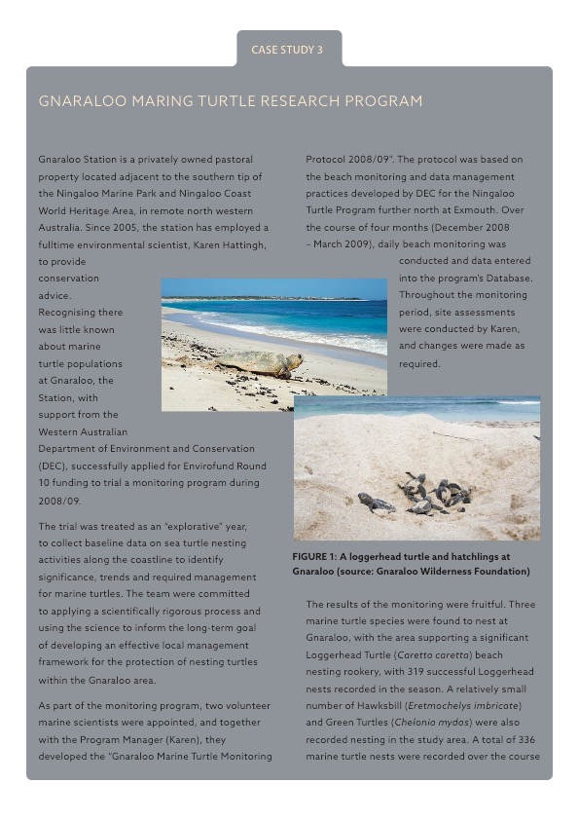

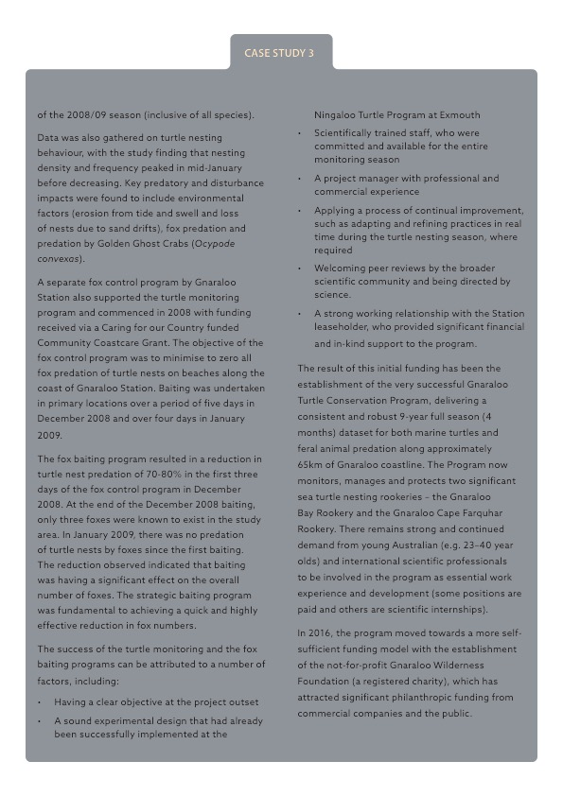

## case study 4

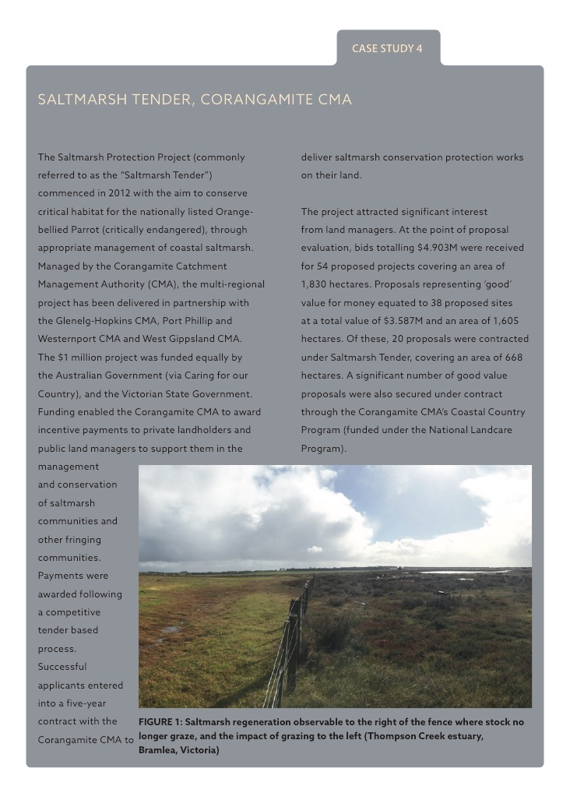

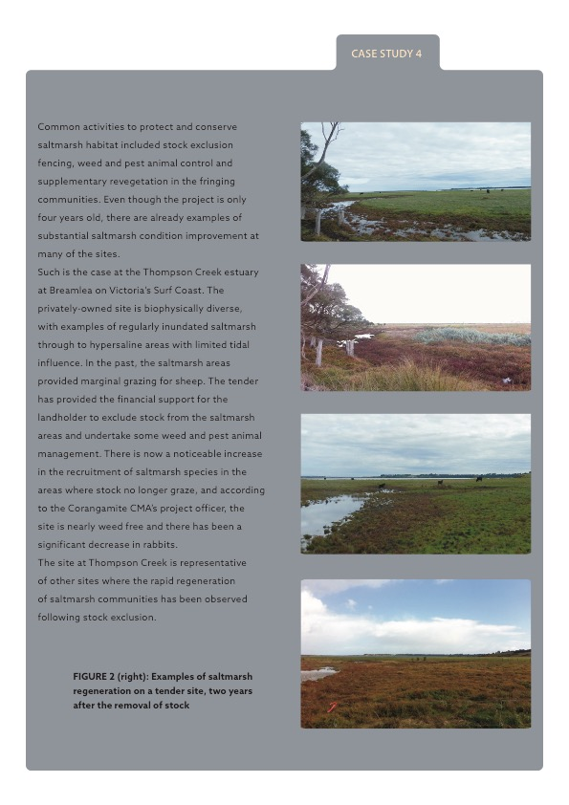

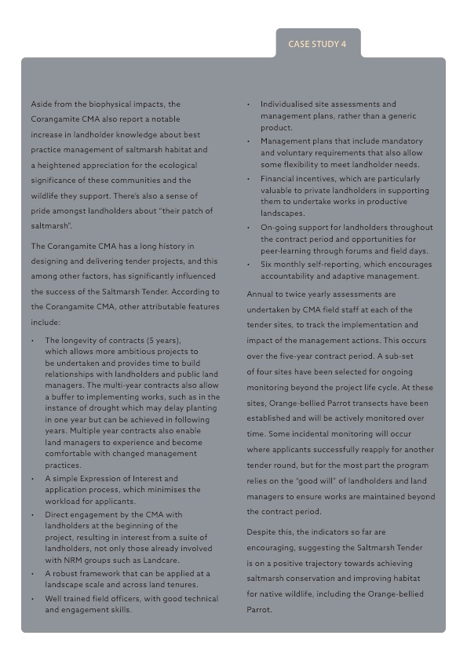

# Conclusions and recommendations

In this section, we have summarised the conclusions reached through this review, and provided a set of recommendations relating to future investment programs. These conclusions and recommendations are presented in three categories:

* 1. Improving projects
  2. Improving investment programs
  3. A framework for better monitoring and reporting

1. Improving projects

The review found that program design has a significant influence on project design. This was particularly evident in three fundamental areas – project planning, partnerships and community engagement. Among the projects reviewed there were cases where program requirements did not appear to support these foundations of good project management. For example, programs that focussed on on-ground works or that would not support resources for a planning or review phase, sent a signal that this type of activity was not valued. In many cases the program design did not seem able to accommodate the fact that well planned and managed projects naturally move through different phases and this has implications for resourcing, activities and outputs.

The recommendations relating to these conclusions are:

* The Australian Government needs to place more value on having detailed project plans (this includes project and MERI planning). Funding programs could adjust the allocation of funding within a project based on what phase the project is in:
* **Initiation** – small amounts, short-term (e.g. 6 months)
* **Planning** – small-medium amounts, short-term (e.g. 12 months)
* **Implementation** – large amounts, long-term (e.g. 3-5 years)
* **Review and renewal** – small-medium amounts, short-term (e.g. 6-12 months)
* Continue to facilitate and encourage the formation of strategic partnerships in future investment programs. Critical elements of the partnership approach should include:
* Shared interest in project outcomes and mutual benefits as a result of their effective delivery;
* Complementary knowledge and skills with roles and responsibilities tailored to the strengths of each partner;
* Long-term relationships based on trust and equity;
* Shared responsibility and accountability for project delivery (i.e. true sharing of risks and benefits as a result of the project);
* Open and regular communication.
* Continue to facilitate and encourage community engagement in future investment programs. Critical elements of engagement should include:
* Early engagement at the project outset, with follow-up engagement over the life of the project;
* Engagement that is appropriately pitched to the target audience;
* Clear, and multiple, opportunities for participation.

1. improving investment programs

This group of conclusions and recommendations relate to specific design features of investment programs. The review found that the focus on long-term outcomes is strongly supported, but that in some cases constraints driven by the program design did not always support that focus. This was most evident in the cases where specific actions necessary to achieve long-term outcomes were not be supported. This included situations where those particular actions had not been anticipated at the start of a project, or they were not among those actions that are traditionally supported. This brings into question the degree of flexibility in project delivery that an outcome focussed approach should accommodate.

We also found that many of the most effective projects reviewed are using two relatively simple approaches to improve the quality and longevity of their results – agreements with participants (particularly private landholders) combined with regular follow-up contact. These practices are in use widely enough for them to be considered standard practice (at least for projects working with private landholders).

Other conclusions reflect the fact that various NRM investment programs have now been operating for over 20 years and the sector is maturing. Benefits from early investments in capacity building and foundational work are evident in many projects. There are opportunities to capitalise further on the capacity and knowledge that has been built over these decades of investment.

The recommendations relating to these conclusions are:

* In principle, funding programs should give project proponents the most flexibility possible and support use of the funding for whatever actions are necessary to achieve the outcome. The obvious exceptions to this are legal requirements (including things like animal welfare, pollution, community safety and welfare).
* In considering applications for funding, identify which stage a project is (initiation, planning, implementation, review and renewal) and how this aligns with their funding request.
* Identifying where a project stands with respect to its foundational work could be valuable for understanding the type of outputs that are achievable in the project funding period. It can also assist in determining whether a project matches the particular scope of an investment program. For example, if the program has an on-ground focus, then projects that have their foundational work in place could be better options.
* Investment programs should require landholder agreements. These agreements should be for as long as practically possible without severely discouraging participation. Project staff should be encouraged to include the possibility of covenants (i.e. permanent on-title agreements) with landholders where there has been a substantial investment. Landholder agreements should be a specific focus of the project design.
* In light of the strong experiential learning and evidence on the value of regular follow up with landholders, a condition of funding should be a commitment from the applicant to resource follow up for the term of the landholder agreement (as a minimum). Follow-up of participants should be a specific focus of the project design.
* Sites where there has been a long history of work can offer particular benefits for investment. For example, they are often cost-effective because the foundational work and capacity building has already occurred (perhaps through previous investment programs) and the opportunity now is to capitalize on that ‘overhead’ investment.
* The lack of continuity of funding presents major challenges at all levels of NRM work. For instance, the issues being managed are often require sustained effort over the long-term, retaining skilled staff is extremely difficult with no security of funding, and the short and interrupted funding cycles waste funds due to the rapid scaling up and down required. It is clear that the funding cycles will continue to vary in length and size, there is more that could be done in the program design phase to explicitly identify cases where continuity of funding, offers particular benefits.

**Indigenous engagement**

* Indigenous engagement must be coordinated, sustained and leave a meaningful legacy. Place a stronger requirement on project proponents to ensure that Indigenous engagement is delivered in a coordinated way. Consider requiring Indigenous wellbeing outcomes in addition to employment e.g. education, health, closing the gap.

1. A framework for better monitoring and reporting

This review found that among the projects examined, monitoring and reporting was recognised as a critical element of their work. We found excellent examples of project level monitoring and reporting driven by good systems of collecting and reporting activities and outputs. Despite this, there were still cases where fundamentals were missing. For example, many projects were unable to identify their baseline data or measure that they could use to gauge their impact. Some projects did not appear to have allocated resources to monitoring. Similarly, many project teams still seem to be in two minds regarding the effort required to meet reporting obligations versus the value they receive from the reporting. However, there were certainly cases where the reporting was clearly disproportionate to the size of the project.

Measuring and reporting on long-term outcomes was mixed. We did find that there are opportunities to improve how long-term outcome measurement is approached. For example, some outcomes were poorly worded or were (arguably) not long-term outcomes. For other projects, it was not possible or practical to measure long-term outcomes and indicators were more appropriate. Overall, expectations regarding outcome statements need clarification, as does the associated question of whether projects should be focussing on direct or indirect (indicators) measures. This centres on the fact that there are mis-matches between project duration (maximum of five years) and scale, versus the time required before outcomes can be measured, and the scale at which they should be measured. Based on this, we have concluded that they should be separated in time and space. That is, long-term outcome measurement warrants a separate dedicated approach that is strongly linked to projects (i.e. it aims to measure the long-term impacts of a set of projects operating across an area). This approach would involve engaging the specialist expertise required at the appropriate time and spatial scale given the outcomes.

The recommendations relating to these conclusions are:

**Project level**

* At the project level, we recommend that project deliverers identify a baseline measure(s) relevant to the intended long-term outcome of the project and measure it at the beginning and at the end of the funding period, and report on it. This would be in addition to monitoring and reporting on activities and outputs delivered.
* The project level MERI Plan is critical to the question of monitoring long-term outcomes. It identifies the long-term outcome for a project, and needs to define how it should be monitored. If a MERI plan has not already been developed, projects need to allocate resources (e.g. funding and expertise) to it preparation. If a MERI plan has been prepared, resources should be allocated to up-dating it.
* Each project must identify a long-term outcome that it will contribute to, but the Australian Government should clarify what is considered to be a long-term outcome. More emphasis needs to be placed on these outcomes being ‘SMART’.
* Measurement of long-term outcomes at the project level should be encouraged, but it should only be part of project monitoring and reporting if there are clear and simple measures or indicators that can be monitored at reasonable cost, and where deliverers have the capability and commitment to do so. The highest priority for monitoring should be given to baseline measures, and activity to output monitoring.
* Reporting requirements should be tailored to the project size. For small short-term projects (e.g. 12-18 months) activity and output reporting is adequate. For projects of over three years, reporting should be extended to include short- to medium-term results. And were possible, reporting could cover long-term outcomes (with the provisos noted in the recommendations above).
* Ensure all projects specify a budget for collecting monitoring data.

**Long-term outcomes**

* Encourage multi-region collaboration on long-term outcome monitoring at a landscape scale as an efficient way to measure long-term outcomes. Instead of focussing on measuring outcomes on a project by project basis, this approach measures the impact of the collective investment in biodiversity outcomes across regions. The findings and key lessons can then be shared and used by all organisations working in that area (including the regional NRM bodies, government departments, research institutions and community groups) to facilitate evidence based investment and more effective program and project design.
* Explore options to develop partnerships with states and NGOs to co-fund long-term monitoring projects covering areas where there is active project investment. In addition to the objectives of projects operating in a given area, this approach could draw on existing plans that have long-term ecological objectives, such as threatened species recovery plans or ecological character descriptions (for Ramsar wetlands). Though they would be managed as discrete projects, it is critical that these monitoring projects are directly linked to the project work occurring in that same area. This is a means of ensuring both the relevance of the monitoring work and that the results from the monitoring are used to shape project investments. It could also be a means for the states to set the standards for monitoring and fulfil their reporting requirements for things State of the Environment or catchment condition reporting.

Appendix 1: Data collection framework

| Time-frame | Level of the program logic | What will be assessed | How will it be assessed | How information will be gathered |
| --- | --- | --- | --- | --- |
| **Stage 1** | | | | |
| Delivered during the life of the project | Short-term outcomes,  Outputs,  Activities | **Effectiveness**: were the activities and outputs achieved | Effectiveness will be assessed by examining the extent to which the project has completed each of the specified activities and associated targets.  If activities / targets have not been completed / achieved, an explanation of why will be provided where possible. | **Background data:** project plan, program logic, evaluation plan, project reports, evaluation. |
| **Appropriateness**: were the activities and outputs suitable for the local environment, community and achieved the desired outcomes | Appropriateness will be assessed by examining qualitative data on the following:   * + Utilisation of delivery approaches that were supported by the local community   + Utilisation of delivery approaches that facilitated the achievement of short-term outcomes and targets   + Adaptive management of project delivery |
| **Short-term impact**: the extent to which the activities and outputs contributed to the short-term outcomes | Assessing short-term impact will combine the data reported under **effectiveness** with information about the **assumptions** included in the program logic. The aim is to determine whether the cause and effect relationships documented in the program logic are valid, and the extent to which evidence shows that short-term impacts have occurred. |
| **Stage 2** | | | | |
| 15 years | Long-term outcomes | **Long-term impact**: the extent to which the activities, outputs and short-term outcomes have contributed to the long-term outcomes | Assessing long-term outcomes will bring together data from Stage 1. The aim is to determine whether the cause and effect relationships documented in the program logic are valid, and the extent to which evidence shows that anticipated outcomes have been achieved.  In order to test assumptions we will:   * + Visit the project to determine the extent of biophysical change   + Interview the project leader and/or project participants to determined the extent of capacity, practice and/or attitudinal change   + Review relevant documentation used to validate assumptions such as existing literature, primary research and evaluations.   The objective is to identify and test assumptions critical to delivery of long-term outcomes. | **Site visit**  **Interviews**  **Background data**: literature, primary research, evaluations. |

Appendix 2: Data collection form

Data%20collection%20form%20for%20Appendix%202%201.pdf

Data%20collection%20form%20for%20Appendix%202%202.pdf

Data%20collection%20form%20for%20Appendix%202%203.pdf

Data%20collection%20form%20for%20Appendix%202%204.pdf

Appendix 3: Projects reviewed

| project Number | Project Title | project proponent | data collection method |
| --- | --- | --- | --- |
| South Australia | | | |
| 1 | Community engagement and on-ground works for the Goolwa Coast | Goolwa to Wellington Local Action Planning Assoc. | Site |
| 2 | Glossy Black Cockatoo Recovery Program | Natural Resources Kangaroo Island | Phone |
| 3 | Feral Animals Management Program | Natural Resources Kangaroo Island | Phone |
| 4 | EMU – Ecosystem Management Understanding | Natural Resources SA Arid Lands Region | Site |
| 5 | Swamps of the Fleurieu Peninsula stewardship | Natural Resources Adelaide and Mount Lofty Ranges | Site |
| 6 | Creating Resilient Landscapes | Natural Resources Adelaide and Mount Lofty Ranges | Site |
| 7 | Bufflel Grass Management Project | Natural Resources Alinytjara Wilurara | Site |
| 8 | The Dreamweaver Project | Natural Resources Alinytjara Wilurara | Site |
| Western Australia | | | |
| 9 | Eco-Fire – Protecting Biodiversity and Productivity in the east Kimberley | Rangelands NRM Coordinating Group Inc | Phone |
| 10 | *Phytophthora cinnamomi*: mapping the threats and building the capacity to manage them | South Coast NRM Inc. | Phone |
| 11 | Gnaraloo Turtle Project | Rangelands NRM Coordinating Group Inc | Site |
| 12 | Wind Erosion Project | Northern Agricultural Catchment Council Inc. | Phone |
| 13 | Restore habitat and manage threats to Lake Clifton's listed thrombolites and species | Peel Harvey Catchment Council | Site |
| 14 | Regional Foundation and Delivering Covenants | Wheatbelt NRM Council Inc. | Site |
| Victoria | | | |
| 15 | Plains Tender | Corangamite Catchment Management Authority | Site |
| 16 | Red Tailed Black Cockatoo Tender | Wimmera Catchment Management Authority | Phone |
| 17 | Bush Returns landscape restoration trial | Goulburn Broken Catchment Management Authority | Site |
| 18 | Protecting the Lower Glenelg River High Ecological Value Aquatic Ecosystem | Glenelg Hopkins Catchment Management Authority | Phone |
| 19 | Restoring the Moolort Wetlands | North Central Catchment Management Authority | Site |
| 20 | Saltmarsh Protection Tender | Corangamite Catchment Management Authority | Site |
| 21 | Corner Inlet Connections | West Gippsland Catchment Management Authority | Site |
| 22 | Water quality improvement for Swan Bay | Corangamite Catchment Management Authority | Site |
| 23 | Gippsland Lakes Nutrient Reduction – CORE4 | West Gippsland Catchment Management Authority | Site |
| 24 | Sustainable Farming Practices – Soil Carbon | North East Catchment Management Authority | Phone |
| New South Wales | | | |
| 25 | Improving management practices on salt affected lands | Little River Landcare | Site |
| 26 | The Lord Howe Island Weed Eradication Program | Lord Howe Island Board | Phone |
| 27 | RAMSAR Central Murray State Forests Wetlands | Murray Local Land Services | Phone |
| 28 | Yarkuwa Indigenous Knowledge Centre | Yarkuwa Indigenous Knowledge Centre Aboriginal Corporation | Site |
| 29 | Rebirding the Holbrook Landscape to Mitigate Dieback | Holbrook Landcare Network | Site |
| 30 | Biodiversity Baseline Monitoring Project | Murray Local Land Services | Site |
| 31 | Fish River Project | Central Tablelands Local Land Services | Site |
| Queensland | | | |
| 32 | Reef Rescue program | Reef Catchments | Phone |
| 33 | Kin Kin Catchment Restoration | Healthy Land and Water | Site |
| 34 | Mon Repos Loggerhead Turtle Protection | Burnett Mary Regional Group for Natural Resource Management Inc. | Site |
| 35 | Fencing to Protect Subtropical and Temperate Coastal Saltmarsh and Water Mouse Habitat | Burnett Mary Regional Group for Natural Resource Management Inc. | Site |
| 36 | Lot 66 – Cassowary Habitat | Terrain Natural Resource Management | Phone |
| 37 | Atherton Tablelands Corridors | Terrain Natural Resource Management | Site |
| Northern Territory | | | |
| 38 | Territory Conservation Agreements | Territory NRM | Phone |
| 39 | A Coordinated response to on-ground control of Mimosa pigra in the Daly and Moyle Catchments | Territory NRM | Phone |
| Tasmania | | | |
| 40 | Skyline Tier Restoration | Environment Tasmania | Site |
| 41 | Tasmanian Government Covenanting Program | Department of Primary Industries, Parks, Water and Environment | Site |
| 42 | Rivers and Water for Life program: Ringarooma Wetland Management | NRM North | Site |
| 43 | Linking Farm Management and Biodiversity | Cradle Coast NRM | Site |
| 44 | Tasmanian Landcare Grants | Landcare Tasmania | Phone |

This report has been prepared by:



RM Consulting Group Pty Ltd trading as RMCG

Level 1, 357 Camberwell Rd, Camberwell, Victoria 3124

(03) 9882 2670 — rmcg.com.au — ABN 73 613 135 247

Offices in Bendigo, Melbourne, Torquay and Penguin (Tasmania)

Key Project Contact

Shayne Annett

0427 679 049 — shaynea@rmcg.com.au

Document review and authorisation

Job Number: 16-D-32

|  |  |  |  |  |  |  |  |
| --- | --- | --- | --- | --- | --- | --- | --- |
| Doc Version | Final/Draft | Date | Author | Reviewed by | Quality checked | Release approved by | Issued to |
| 1.0 | Draft | 11/08/17 | S. Annett  S. Drum  J. McRobert  J. Scally | S. Annett | P. Mawson | J. McRobert | A. Westcott |
| 2.0 | Final | 14/09/17 | S. Annett  S. Drum  J. McRobert  J. Scally | S. Annett | P. Mawson | J. McRobert | A. Westcott |