Event-based mechanisms in the Lower Balonne: Implementation Overview

**Commonwealth Environmental Water Office**

**Department of the Environment and Energy**

| Marsden Jacob Associates |
| --- |

Prepared for the Commonwealth Environmental Water Office

April 2020

Marsden Jacob Associates

ABN 66 663 324 657  
ACN 072 233 204

economists@marsdenjacob.com.au

Authors

Rod Carr—Marsden Jacob Associates

Simo Tervonen—Marsden Jacob Associates

David Rogers—Marsden Jacob Associates

Owen Droop – OD Hydrology

About us

Established in 1996, Marsden Jacob Associates has grown to be Australia’s leading dedicated natural resource economics, policy and strategy advisory. We employ talented economists and policy advisers who specialise in solving practical, real-world problems relating to water, energy, environment, natural resources, agriculture, earth resources, public policy and transport. We work with a wide range of cross-disciplinary partner firms to deliver the best project outcomes for our clients.

www.marsdenjacob.com.au

**Disclaimer**

The views and opinions expressed in this report do not necessarily represent the views of the Commonwealth Environmental Water Office (CEWO). This publication does not indicate commitment by Commonwealth government to a particular course of action nor has the CEWO made any decision on options identified in this study.

The CEWO reserves the right to, in the future, further consider any of the options proposed in the report or options in addition to those identified.

The content of this report does not constitute advice to any third party. Although due care and skill has been applied in the preparation and compilation of the information and data in this publication, no reliance may be placed on it by any other party. No representation expressed or implied is made as to the currency, accuracy, reliability, completeness or fitness for purpose of the information contained in this publication. The reader should rely on their own inquiries to independently confirm any information and comment on which they may intend to act.

The Commonwealth of Australia, its officers, employees, agents and the other parties involved in creating this report disclaim, to the maximum extent permitted by law, responsibility to any other party for any liability, including liability for negligence, loss howsoever caused, damage, injury, expense or cost incurred by any person as a result of accessing, using or relying upon any of the information or data in the report.

# Event based mechanisms implementation overview

## Introduction

Marsden Jacob Associates (Marsden Jacob) and OD Hydrology were engaged to develop a way forward for implementing event based mechanisms (EBMs) in the Lower Balonne informed by previous work, and with consideration of the operational arrangements, regulatory context and water market in the Lower Balonne. This work has a focus on Narran Lakes and the Culgoa River system.

Marsden Jacob notes that members of the CEWO have advised that they will now need to develop a delivery plan that include the development of an approach to market (for EBM sellers and possible in-river weir operators), contractual arrangements and decision support processes that could be applied in real time. Marsden Jacob’s analysis has been prepared to provide a way forward for implementing EBMs. The delivery plan will also need to identify what success ‘looks like’ when an EBM is activated, because success depends on the EBM addressing a high or critical environmental demand that would not otherwise have been addressed through both planned and held environmental water.

## Objectives

In developing this implementation plan for the CEWO we have focused on the following key criteria:

1. Value for Money
2. Timeliness
3. Demonstrable and measurable benefit to the environment
4. Risk minimisation

## Why should EBMs be implemented?

EBMs come with a number of advantages over the permanent acquisition of water, including:

* Flexibility – EBMs are scalable mechanisms that can be tailored to augment either magnitude or duration of an event to meet the environmental demand that presents at the time of an unregulated flow event, and from our engagement it is clear that there are a number of irrigators in the Lower Balonne would willingly participate in EBMs.
* Targeted – Where EBMs are used strategically and occasionally (at times when the CEWO decides this is beneficial), they can be considerably more cost-effective than permanent acquisition of entitlement. However, if implemented indiscriminately, they can be relatively expensive or result in minimal additional environmental outcomes
* Availability and control – The CEWO does not have control over entitlement purchase decisions associated with the Basin Plan recovery targets[1] as these are handled by the Commonwealth Department of Agriculture. Nor can the CEWO know when and where entitlements will become available for purchase from willing sellers.

## EBMs are not a replacement for permanent purchase

The CEWO is pursuing the development of EBMs as a measure as required within the workplan that underpins the Intergovernmental Agreement (IGA) on Implementing Water Reform in the Murray-Darling Basin, under which Queensland and New South Wales have committed to working with the CEWO on a work-plan for developing a suitable framework for EBMs. This IGA enables work to proceed on the implementation of the toolkit of environmental works and measures, including that the Commonwealth will work with the NSW and Queensland governments to implement environmental works and measures identified in the Northern Basin Review, including:

* arrangements to protect environmental flows
* targeted recovery of water
* event-based mechanisms (such as options for pumping and store-and-release)
* improvements to the coordination and delivery of environmental water.

Based on our discussions with the CEWO, we understand that development of EBMs as a mechanism represents a no-regrets step that can support enhanced environmental outcome in the right flow circumstances. The implementation of EBMs can also be a no-regrets action in some circumstances. The CEWO may prefer permanent purchase, particularly in LBU-05 upstream of Narran Lakes. While there is a cap on purchase of water entitlements, recovery is almost at target levels for the Lower Balonne catchment[2], and while government policy on acquisition is not managed by the CEWO it is anticipated that direct permanent purchase may not be possible as a measure for several years to come.

Furthermore, it should also be noted that EBMs are not a ‘gap-bridging’ measure because they are a discretionary measure that are only intended to be used strategically and occasionally so they have no measurable long-term average annual yield (LTAAY) value. The Murray-Darling Basin Plan sets out a local water recovery target for each SDL resource unit area along with shared water recovery targets for SDL resource units within a zone. The recovery target must be met by recovering water from within that SDL resource unit area and must be fully recovered in order to successfully ‘bridge the gap’. These include Commonwealth and State contracted water recoveries against these targets[3].

## EBMs are not without risk

At this outset it is important to note that EBM actions cannot be implemented with zero risk. This is because the response of environmental assets and the performance of unregulated river systems cannot be prescriptively defined at the time that decisions need to be made, with imperfect information. Judgement can be in retrospect with better information. The CEWO portfolio has been contributing to unregulated flow events since 2011, and thus the CEWO have been engaging with these risks. This implementation plan has been designed to mitigate key risks to the CEWO and put in place a continuous learning and improvement framework so that the management of risks improves over time. We are also recommending that the CEWO commence with EBM options that have lower implementation and compliance risk, and over time as the knowledge and information base matures considers transitioning to more complex EBM if required.

Delay also contributes to both ecological and reputation risks. For instance, at the time of writing it has been over 1,000 days since some of the core rookery habitat was inundated and more than 2,200 days since the 50 GL target was met. So, acquisition of water through EBMs across a broad range of flow criteria, would represent a no-regret measure for all but a very large flow event.

## Which EBMs should be implemented?

Based on our analysis of the EBM options, Marsden Jacob recommends that the CEWO should initially focus on two EBM options with the least risk:

1. Seasonal assignment during a flow event: this mechanism provides a flexible approach to influence flow event between the base trigger for low flow rules and an upper threshold, thus potentially allowing the CEWO to enhance a flow event by 10-30 GL to ensure a flow reaches Narran or to expand an event to ensure that fringing vegetation gets watered)
2. Release of irrigator’s water from storage following agreement: in addition to increasing the magnitude (similar to seasonal assignment) the mechanism could be used to extend the duration of a flow event to supporting a specific outcome or expand an event to help increase the area of vegetation that is effectively watered.

Queensland has indicated that it is prepared to investigate arrangements for the seasonal assignment of Instantaneous Volumetric Limit (IVL) Unsupplemented Allocations. This is significant as it may open opportunities for entitlement holders in the Lower Balonne by the end of June 2020. However, because the arrangements are still under development by the Queensland Government, it is also recommended that the no-pump EBM option also be included in the implementation planning[4].

## A five-stage implementation process is proposed

Because this is an unregulated system the CEWO needs to be in a position to respond quickly to flow events, Marsden Jacob has developed a five-stage implementation process. As per the IGA on Implementing Water Reform in the Murray-Darling Basin, Queensland and NSW have committed to working with the CEWO on a workplan for developing a suitable framework for EBMs. This broader work will inform implementation of the five-stage process.

The stages comprise:

* **Stage 1**: Planning and development of materials to enable prequalification
* **Stage 2**: Prequalification of suppliers under Standing Offer agreements
* **Stage 3**: Planning when a flow event occurs to consider whether an EBM should be implemented
* **Stage 4**: If yes (to Stage 3), then prequalified suppliers are invited to submit an application form. The application form may be accepted or rejected by the CEWO, this would be a short form with price (per ML) and EBM conditions (such as dates and flow thresholds) stated by the supplier. In the case of a seasonal assignment a separately seasonal assignment form would also be completed. If it is accepted, the application form become a schedule to the Standing Offer, that together forms the contract or the ‘contractual arrangements’
* **Stage 5**: Review and refine the implementation plan

Each of the tasks in these stages are summarised below.

Figure 1: Implementation Plan Overview

## Stage 1: Planning and development of prequalification arrangements

Stage 1 involves liaison with Department of Natural Resources, Mines and Energy (DNRME) to support monitoring and surveillance, and the planning and development of materials to enable the prequalification of:

* EBM sellers across the Lower Balonne. As the CEWO’s environmental interest encompass assets such as Narran Lakes and the Culgoa River, it is recommended that potential sellers of EBMs to the CEWO be prequalified (Standing Offers) from across zones LBU-02, 03 and 05. Other zones are not recommended because the ability to manage flows from these regions in the direction of the environmental assets is constrained (LBU-01), do not have large enough water holdings (LBU-04) or simply not possible as there is no connectivity to Narran or Culgoa (other zones). Any changes to the bifurcations would change this.
* Private weir owners to formalise arrangements to enable the protection of environmental water (the main risk being that they draw down their weir in the days before the flow arrives, which may be allowed based on their licence conditions, potentially diminishing the benefit of an EBM), and
* Hydrological and water market experts to support the EBM action (if required).

At this time, it will be important to reinforce the message to potential sellers of EBMs that the CEWO only plans to occasionally and strategically enter the market.

## Stage 2: Prequalification and notification

In Stage 2, the documents that have been developed by the CEWO are publicly advertised and Standing Offer arrangements are agreed with EBM sellers and Standing Agreements are agreed private weir operators. Furthermore, if an agreement is reached with DNRME to support environmental flow protection through monitoring, surveillance and compliance (if required) then stakeholders should be notified of the agreement. This will further incentivise them to deliver upon their requirements.

Figure 2: Implementation tasks in Stages 1 and 2

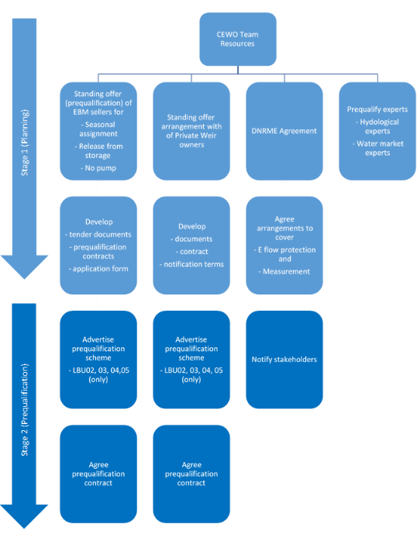

*Note: There may be times when implementing EBMs are no regrets, have adequate expertise without external hydrological experts or water market experts.*

## Stage 3: Planning when a flow event occurs

A number of information sources will be available to support the early analysis of EBM opportunities when the flow event emerge. These include upstream gauges (to assess flow magnitude and timing), downstream gauges (to assess antecedent conditions), prior extraction records (to assess whether irrigators are likely to take or leave the water), and dam and weir storage levels (to assess how much flow might be captured in storages).

However, even before this assessment is undertaken it will be critical that the CEWO team is appropriately resourced to support the EBM action. We have not undertaken a specific assessment of the staff resources that would be required; however, we note that some CEWO staff members will need dedicate a significant proportion their time to implementing an EBM when a flow event occurs.

In this stage several tasks need to be undertaken (refer to Figures 3 and 4), including:

* Hydrological analysis of the flow to assess whether the flow would benefit from either magnitude or duration augmentation, that is progressively refined as the flow progresses through the system so that the CEWO can minimise the amount of EBM water that needs to be purchased to support the achievement of the desired environmental outcome.
* The event management rules set out in the Condamine-Balonne Water Plan provide a useful indicator for whether an EBM is required because they indicate when there is a strong environmental demand.
* To secure sufficient volumes of water to meet at least one of the ecological demands (e.g. waterhole replenishment) there will need to be at a minimum several days of harvesting announced in what would likely entail a medium sized access window for the majority of the event.
* If overland flow harvesting is likely to be triggered most ecological demands would be met by the current event management rules combined with the Commonwealth’s portfolio. However, in some circumstances, a release from storage may still be required to meet duration requirements for large scale colonial nesting waterbird breeding in the Narran Lakes or to meet in channel ecological demands in the Darling River.
* Market analysis so that the CEWO can a) assess the volumes that may become available and b) propose an upper limit price to sellers of EBMs and thus facilitate a value for money outcome. This is important because there are very few potential sellers in the Lower Balonne, for instance there are only three key sellers of EBMs in the context of Narran Lakes. So, this makes it difficult to establish a competitive market dynamic, so instead (i) a tool has been developed as part of this project that would now be updated to assess the opportunity cost of the water to irrigators, and (ii) it is also proposed that market prices for temporary trades within Lower Balonne or in comparable markets should also be reviewed.

The market should be notified that the CEWO is considering initiating an action. This notification to go to prequalified EBM sellers, private weir operators and DNRME. In this project a decision process (matrix) has been developed which is discussed below.

Figure 3: Key decision points

## Stage 4: Agreeing terms with EBM suppliers

In Stage 4 the CEWO will approach prequalified EBM suppliers. Because they are prequalified it is proposed that a very simple (ideally one-page) form is sent out that it pre-completed with (i) their entity details, (ii) information on the type of EBM and minimum amount of water that the CEWO requires to proceed with an EBM action and (iii) maximum price that the CEWO is willing to pay. They will need to nominate how much water they would be willing to sell and their price. The form will then need to be signed by the authorised representatives of the entity.

Following this the CEWO will need to:

1. quickly assess the bids (which should be easy because the form will be very simple),
2. enter contractual arrangements with sellers
3. initiate monitoring, surveillance and compliance (when an alleged breach has been reported or observed) actions

## Stage 5: Review, report on the outcome and refine the implementation plan

Finally, in Stage 5, the CEWO will review and report on the outcome of the EBM and based on the lessons learnt refinements should be made to improve the implementation process.

Figure 4: Implementation tasks in Stages 3, 4 and 5

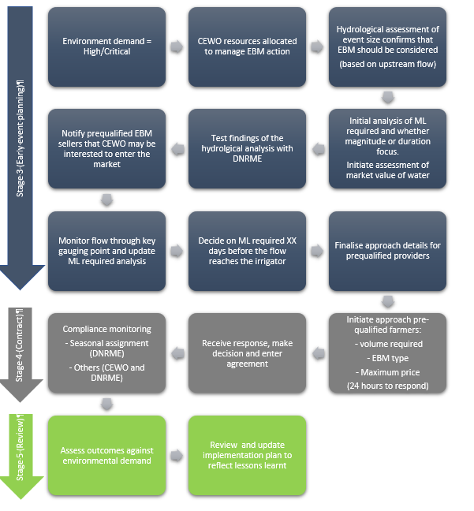

1. The CEWH has flexibility to buy entitlements (reconfigure portfolio) separate to the Basin Plan recovery. However, this is likely to follow the completion of water reqcover..
2. At the time of writing this report there was 12.6GL of long‐term diversion limit equivalent (LTDLE) to be recovered, but Marsden Jacob understands most of this will be recovered through infrastructure and efficiency measures, including voluntary contributions from the Cubbie Station (more details here: <https://www.mda.asn.au/Source/ckfinder/files/Cubbie%20Media%20Release%20August%202,%202019.pdf>)
3. <http://www.agriculture.gov.au/water/mdb/progress-recovery>
4. For instance, a no-pump arrangement could be used to pilot an IVL/MYA independent water accounting treatment.