**Environmental Water Delivery: Namoi River**

**March 2012 v1.0**

**Image credits:**

The Namoi River near Walgett

© MDBA; Photographer Arthur Mostead

River red gum

© MDBA; Photographer John Baker

Barma Water Resources, Thurtell, L and Wettin, P (2012). Environmental Water Delivery: Namoi River. Prepared for Commonwealth Environmental Water, Department of Sustainability, Environment, Water, Population and Communities, Canberra.

ISBN: 978-1-921733-50-5

Commonwealth Environmental Water acknowledges the following individuals and organisations that have been consulted in the preparation of this document:

* F. Andreoni (Namoi CMA)
* C. Cahill (State Water)
* K. Gee (State Water)
* S. Samarawickrama (State Water)
* W. Mahwinney (NSW Office of Water)
* N. Foster (NSW Office of Water)
* S. Powell

Published by the Commonwealth Environmental Water Office for the Australian Government.

© Commonwealth of Australia 2012.

This work is copyright. Apart from any use as permitted under the Copyright Act 1968, no part may be reproduced by any process without prior written permission from the Australian Government. Requests and enquiries concerning reproduction and rights should be addressed to Department of Sustainability, Environment, Water, Population and Communities, Public Affairs, GPO Box 787, Canberra ACT 2601 or email <[public.affairs@environment.gov.au](mailto:public.affairs@environment.gov.au)>.

Information presented in this document may be copied for personal use or published for education purposes, provided that any extracts are fully acknowledged.

The views and opinions expressed in this publication are those of the authors and do not necessarily reflect those of the Australian Government or the Minister for Sustainability, Environment, Water, Population and Communities.

While reasonable efforts have been made to ensure that the contents of this publication are factually correct, the Australian Government does not accept responsibility for the accuracy or completeness of the contents, and shall not be liable for any loss or damage that may be occasioned directly or indirectly through the use of, or reliance on, the contents of this publication.

**Environmental Water Delivery: Namoi River**

Increased volumes of environmental water are now becoming available in the Murray-Darling Basin and this will allow a larger and broader program of environmental watering. It is particularly important that managers of environmental water seek regular input and suggestions from the community as to how we can achieve the best possible approach. As part of the consultation process for Commonwealth environmental water we are seeking information on:

* community views on environmental assets and the health of these assets
* views on the prioritisation of environmental water use
* potential partnership arrangements for the management of environmental water
* possible arrangements for the monitoring, evaluation and reporting (MER) of environmental water use.

This document has been prepared to provide information on the environmental assets and potential options for environmental water use in the Namoi catchment. As the first version of the document, it is intended to provide a starting point for discussions on environmental water use. As such, suggestions and feedback on the document are encouraged and will be used to inform planning for environmental water use and future iterations of the document.

The Namoi catchment supports significant conservation values including numerous threatened native flora and fauna, as well as bird species protected under international migratory bird agreements. Potential water use options for the Namoi River include contributing to baseflows along the river channel to maintain in-stream refuges and aquatic habitat for native fish; provisions of inflows to support water plants for wetland habitat condition in anabranches between Mollee and Gunidgera Weirs and in Duncans Warrambool; and provision of freshes to trigger native-fish spawning and recruitment in river channel and creeks.

A key aim in undertaking this work was to prepare scalable water-use strategies that maximise the efficiency of water use and anticipate different climatic circumstances. Operational opportunities and constraints have been identified and delivery options prepared. This has been done in a manner that will assist the community and environmental water managers in considering the issues and developing multi-year water-use plans.

The work has been undertaken by consultants on behalf of the Australian Government Department of Sustainability, Environment, Water, Population and Communities. Previously prepared work has been drawn upon and discussions have occurred with organisations such as the NSW Office of Water, Namoi CMA and State Water.

Management of environmental water will be an adaptive process. There will always be areas of potential improvement. Comments and suggestions including possible partnership arrangements are very welcome and can be provided directly to: [ewater@environment.gov.au](mailto:ewater@environment.gov.au). Further information about Commonwealth environmental water can be found at [www.environment.gov.au/ewater](http://www.environment.gov.au/ewater).

Commonwealth Environmental Water  
Department of Sustainability, Environment, Water, Population and Communities  
GPO Box 787, Canberra ACT 2601  
Tel: +61 2 6275 9245

Contents

Part 1: Management Plan 7

1.0 Overview 7

1.1 Scope and purpose 7

1.2 Catchment and river system overview 8

1.3 Overview of river operating environment 10

1.4 Environmental water policy on the Namoi River 11

1.5 Water Sharing Plan provisions for environmental water 12

1.6 Flow characteristics 14

1.7 Irrigation demands 18

1.8 Flow monitoring sites 20

1.9 Hydrology modelling 20

2.0 Ecological Values, Processes and Objectives 21

2.1 Summary of ecosystem values for Namoi River 21

2.2 Ecological objectives 24

3.0 Watering Objectives for Water Dependent Assets 31

3.1 Asset environmental watering objectives 31

3.2 Development of ecological and watering objectives for Namoi Assets and Water Management Areas 31

3.3 Water availability under each climate scenario 41

Part 2: Water Use Strategy 45

4.0 Environmental watering requirements 45

4.1 Watering requirements 45

5.0 Operating Regime and Water Delivery Strategies 50

5.1 Delivery considerations 50

5.2 Water orders for Namoi environmental Assets 54

6.0 Governance and Planning Arrangements 65

6.1 Delivery partners, roles and responsibilities 65

6.2 Approvals, licences, legal requirements 65

6.3 Relevant trading rules and constraints 66

7.0 Risk Assessment and Mitigation Strategies 69

8.0 Environmental Water Reserves 73

8.1 Environmental water provisions and holdings 73

8.2 Available Water Determinations and seasonal allocations 73

8.3 Storage accounting rules 73

8.4 Bulk water transfer between Split Rock and Keepit Dams 74

8.5 Chaffey Dam Stimulus Flow 75

Part 3: Monitoring and Future Options 76

9.0 Monitoring, Evaluation and Improvement 76

9.1 Current monitoring and reporting 76

9.2 Possible monitoring and reporting 78

10.0 Operational Constraints and Opportunities 82

10.1 General 82

10.2 Opportunities 82

11.0 Bibliography 83

Appendix 1 Environmental Flow Rules for Peel River 86

Appendix 2 Water dependent species of the Namoi River 90

Appendix 3 Namoi Asset/WMA Delivery Description 96

Appendix 4 Probability of Unregulated Flows in the Namoi River at Wee Waa 124

Appendix 5 Water Order Form 130

Appendix 6 SEWPaC Risk Matrix 131

Appendix 7 Operational Monitoring Report.................................................................135

**Figures**

Figure 1: Namoi catchment 11

Figure 2: Namoi River at Boggabri flow duration curve 17

Figure 3: Namoi River at Wee Waa flow duration curve 17

Figure 4: Namoi River at Walgett flow duration curve 18

Figure 5: Combined Bugilbone and Pian Creek seasonal flow curves 19

Figure 6: End of system seasonal flow curves 19

Figure 7: Land uses of the Namoi catchment 21

Figure 8: Location of Split Rock Dam to Keepit Dam reach 92

Figure 9: Location of Keepit Dam to Carroll reach 94

Figure 10: Location of Carroll to Boggabri reach 96

Figure 11: Location of Boggabri to Wee Waa reach 98

Figure 12: Satellite image of Barbers Lagoon. 99

Figure 13: Satellite image of Namoi Anabranches upstream of Mollee Weir. 102

Figure 14: Analysis of flows at Namoi River and Narrabri Creek at Narrabri 103

Figure 15: Satellite image of Namoi River from Mollee Weir to Gunidgera Weir . 103

Figure 16: Location of Wee Waa to Walgett reach 105

Figure 17: Satellite image of Gunidgera Weir to Weeta Weir 107

Figure 18: Satellite image for Duncans Warrambool. 108

Figure 19: Satellite image for Duncans Junction to Bugilbone 110

Figure 20: Satellite image of Bugilbone to Goangra 113

Figure 21: Satellite image downstream of Goangra 115

**Tables**

Table 1: Ecological values of geomorphic zones of the Namoi and Peel rivers 25

Table 2: Ecological and management objectives for environmental water use under different water-resource availability scenarios 27

Table 3: Broad-scale system and asset ecological objectives for targeted environmental water use in the Namoi catchment 30

Table 4: Namoi asset environmental watering objectives for ecological objectives 34

Table 5: Namoi catchment allocation systems 42

Table 6: Likely allocation and volume available to the environment from Commonwealth environmental water entitlements. 43

Table 7: Watering requirements for water-dependent species of the Namoi River 45

Table 8: Release rate for trial bulk water transfer from Split Rock to Keepit Dam 51

Table 9: Water charges for Namoi water entitlements and use 53

Table 10: Water orders to meet environmental watering objectives for Namoi assets and water management areas 55

Table 11: Risk associated with environmental water delivery in the Namoi catchment 67

Table 12: Environmental water entitlements on the Namoi River 69

Table 13: Possible monitoring options for environmental watering. 75

Table 14: Bird species of significance in the Namoi catchment 88

Table 15: Other species of significance in the Namoi catchment 90

Table 16: Commence-to-flows (Q) for Keepit Dam to Gunnedah (Keepit Dam to Carroll reach) 95

Table 17: Commence-to-flows (Q) for Carroll to Gunnedah (Carroll to Gunnedah reach) 97

Table 18: Commence-to-flows for Boggabri to Wee Waa (Barbers Lagoon) 100

Table 19: Commence-to-flows for Boggabri to Wee Waa (Mollee to Gunidgera Weirs) 104

Table 20: Commence-to-flows for Gunidgera Weir to Weeta Weir 108

Table 21: Commence-to-flows for Duncans Warrambool 109

Table 22: Commence-to-flows for Duncan’s Junction to Bugilbone 112

Table 23: Commence-to-flows for Bugilbone to Goangra reach 115

Table 24: Commence-to-flows downstream Goangra 116

Table 25: Indicative commence-to-fill requirements of in-stream benches and distributary effluents of the Regulated Peel River 118

Table 26: Probabilities of unregulated flows under extreme dry conditions—Wee Waa 122

Table 27: Probabilities of unregulated flows under dry conditions—Wee Waa 122

Table 28: Probabilities of unregulated flows under median conditions—Wee Waa 124

Table 29: Probabilities of unregulated flows under wet conditions—Wee Waa 124

Table 30: Probabilities of unregulated flows under extreme wet conditions—Wee Waa 126

**Plates**

Plate 1: Barbers Lagoon 100

Plate 2: Duncan’s Junction 110

Plate 3: Namoi River (Wetland) upstream Bugilbone. 111

Plate 4: Namoi River (Wetland) upstream Goangra 113

Plate 5: Peel River immediately downstream of Chaffey Dam. 119

Plate 6: Peel River upstream of the Piallamore Anabranch. 120

Plate 7: Peel River in the vicinity of the Piallamore Anabranch. 120

**Abbreviations**

|  |  |
| --- | --- |
| **Acronym** | **Meaning** |
| AEW | Adaptive Environmental Water |
| AEMP | Adaptive Environmental Management Plan |
| CAMBA | China-Australia Migratory Bird Agreement |
| CEWH | Commonwealth Environmental Water Holder |
| CMA | Catchment Management Authority |
| CSIRO | Commonwealth Scientific and Industrial Research Organisation |
| DECCW | Department of Climate Change and Water (NSW) |
| DEWHA | Department of Environment, Water, Heritage and the Arts (Cwth) |
| DIPNR | Department of Planning Infrastructure and Natural Resources (NSW) |
| DLWC | Department of Land and Water Conservation (NSW) |
| DOC | Dissolved organic carbon |
| DPI | Department of Primary Industries (NSW) |
| d/s | Downstream |
| ECA | Environmental Contingency Allowance |
| EEC | Endangered Ecological Communities |
| EPBC | *Environmental Protection and Biodiversity Conservation Act 1999* (Cwlth) |
| EW | Environmental water |
| GAB | Great Artesian Basin |
| GIS | Geographic Information System |
| GL/d | Gigalitres per day |
| IMEF | Integrated Monitoring of Environmental Flows |
| IQQM | Integrated Quantity and Quality Model |
| ISRAG | Independent Sustainable Rivers Audit Group |
| IUCN | International Union for Conservation of Nature |
| JAMBA | Japan-Australia Migratory Bird Agreement |
| LTAAEL | Long-term average annual extraction limit |
| LTEL | Long-term extraction limit |
| MDBA | Murray-Darling Basin Authority |
| ML/d | Megalitres per day |
| NCMA | Namoi Catchment Management Authority |
| NOW | NSW Office of Water |
| NSW | New South Wales |
| OEH | Office of Environment and Heritage (NSW) |
| RCA | Riverine Condition Assessment |
| RERP | Rivers and Environment Restoration Program |
| ROKAMBA | Republic of Korea-Australia Migratory Bird Agreement |
| SEWPAC | Department of Sustainability, Environment, Water, Population and Communities (Cwth) |
| SRA | Sustainable Rivers Audit |
| u/s | Upstream |
| WMA | Water Management Area |
| WSP | Water Sharing Plan (for the Upper Namoi and Lower Namoi Regulated River Water Sources 2003 (New South Wales)) |
| WUP | Water Use Plan |

Part 1: Management aims

### 1.0 Overview

#### 1.1 Scope and purpose

Information provided in this document is intended to help establish an operational framework that provides scalable strategies for environmental water use based on the watering needs of selected assets.

This document outlines the processes and mechanisms that will enable water-use strategies to be implemented in the context of river operations and delivery arrangements, water trading and governance, constraints and opportunities. It specifically targets large-scale water-use options for the application of large volumes of environmental water.

To maximise the system’s benefit, three scales of watering objectives are expressed:

1. Water management area (individual wetland features/sites within an asset).
2. Asset objectives (related to different water-resource scenarios).
3. Broader river system objectives across and between assets.

Information provided focuses on the environmental watering objectives and water use options for the Namoi River in New South Wales.

As part of this project, assets and potential watering options have been identified for regions across the Murray-Darling Basin. This work has been undertaken in three steps:

1. Existing information for selected environmental assets has been collated to establish asset profiles, which include information on hydrological requirements and the management arrangements necessary to deliver water to meet ecological objectives for individual assets.
2. Water use options have been developed for each asset to meet watering objectives under a range of volume scenarios. Use of environmental water will aim to maximise environmental outcomes at multiple assets, where possible.
3. Processes and mechanisms required to operationalise environmental water delivery have been documented and include:
   * delivery arrangements and operating procedures
   * water-delivery accounting methods (in consultation with operating authorities) that are either currently in operation at each asset or methodologies that could be applied for accurate accounting of inflow, return flows and water ‘consumption’
   * decision triggers for selecting any combination of water-use options
   * approvals and legal mechanisms for delivery and indicative costs for implementation.

#### 1.2 Catchment and river system overview

The Namoi River is one of the Murray-Darling Basin’s major NSW sub-catchments. It covers a total area of about 42,000 square kilometres from the Great Dividing Range near Tamworth to the Barwon River near Walgett (Figure 1). The Peel River is a major regulated tributary to the Namoi with a catchment area of around 4,700 square kilometres (Figure 1). It contributes an average annual volume of approximately 280,000 megalitres to the Namoi River (Green et al. 2011).

The Namoi catchment borders the Gwydir and Castlereagh catchments and is bounded by the Great Dividing Range in the east, the Liverpool Ranges and Warrumbungle Ranges in the south, and the Nandewar Ranges and Mount Kaputar to the north. Elevations range from over 1,500 metres to the south and east to just 100 metres on the alluvial floodplain of the lower catchment west of Narrabri. Stretching from Bendemeer in the east to Walgett on the western boundary, the Namoi catchment is over 350 kilometres long (Green et al. 2011).

Major tributaries of the Namoi River include Cox’s Creek and the Mooki, Peel, Manilla and McDonald Rivers joining the Namoi River upstream of Boggabri with Pian, Narrabri, Baradine and Bohena Creeks joining below Boggabri. Major tributaries of the Peel River are Goonoo Goonoo Creek, Cockburn River, and Dungowan Creek (Green et al. 2011).

A number of minor unregulated tributaries, originating from the Kaputar area, also provide high-volume storm flows which can contribute significantly to the Namoi River. The most significant of those is Maules Creek.

Streamflows in the Namoi catchment are regulated by Keepit Dam on the Namoi River, Split Rock Dam on the Manilla River and Chaffey Dam on the Peel River. The regulated section of the Peel River and the regulated section of the Namoi River between Split Rock and Keepit Dams have historically been managed as separate allocation schemes to the Namoi regulated river below Keepit Dam and operationally the management of Chaffey Dam is independent of the other storages on the Namoi (Green et al. 2011).

The annual regional output for the region is valued at over $1 billion, with dryland and irrigated agricultural production representing approximately half this amount. Major industries include cotton, livestock production, grain and hay, poultry, horticulture and forestry. The region’s local councils also depend on the Namoi and Peel Rivers to meet the urban water requirements of the many urban centres with the most notable being the major centre of Tamworth whose water supply is provided from the Peel River (Green et al. 2011).

Approximately 100,000 people currently live within the Namoi catchment, mostly along the Namoi River and its tributaries between Tamworth and Narrabri. Tamworth, located on the Peel River, is the largest urban centre in the catchment with a population of nearly 33,500 people living in town. Gunnedah, on the Namoi River, has a population of 7,500 people, and Narrabri, also on the Namoi, has a population of 6,100 people. A number of smaller towns throughout the catchment, such as Barraba, Manilla, Quirindi, Walgett, Wee Waa and Werris Creek, support between 1,000 and 3,000 people (Green et al. 2011).

|  |
| --- |
|  |

Figure 1: Namoi catchment (SEWPaC 2011)

The lower Namoi riverine plains have an elevation of approximately 150 metres above sea level and consist almost entirely of recent alluvium on flat topography. This flat topography facilitates the development of floodrunners, anabranches and warrambools (overflow channels which contain water only during flood times), throughout the lower Namoi (Foster 1999).

Narrabri Creek, originally a natural anabranch of the Namoi River, begins just upstream of Narrabri and rejoins the Namoi River just below the town. It is a significant feature of the lower catchment which has been significantly modified and now takes a majority of the flow, with the Namoi River only flowing when flow rates of 25,000 to 30,000 ML/d are reached on the Narrabri. Narrabri Creek is highly degraded and is actively widening through bank erosion and river bed aggradation. It has limited aquatic environmental value.

Downstream of Wee Waa, the Namoi River progresses into a distributary zone (Thoms et al. 1999). Small tributary creeks draining the Pilliga scrub to the south often contribute large volumes of water to the Namoi River and its adjacent floodplain wetlands. Near the town of Pilliga, the Namoi River splits into two channels for a distance of six kilometres. At this point in the catchment, Duncan’s Warrambool, the northern channel, carries two-thirds of the river flow. This section of the Namoi River contains small areas of intact remnant riverine and wetland ecosystems. Between the Namoi River to the south and Pian Creek to the north are a number of ephemeral watercourses that flow westward across the floodplain.

From where Pian Creek leaves the Namoi River to the junction of the Namoi River with the Barwon River, the riverine and wetland environments are characterised by a complex pattern of anabranches, effluent channels, in-stream benches and small floodplain wetlands which are subject to extensive flooding, often inundated for many weeks. The riverine plain of this part of the Namoi merges with the floodplains of the neighbouring Gwydir and Castlereagh Rivers, and with the Barwon floodplain near Walgett.

The lower reaches of the Namoi River are dominated by coolibah (*Eucalyptus coolabah)*, river red gum (*Eucalyptus camaldulensis*) and river cooba (*Acacia stenophylla)* vegetation communities.

#### 1.3 Overview of river operating environment

The following section identifies the main river-regulating structures and their purpose on the Namoi River.

Keepit Dam was completed in 1960 as the major irrigation storage for the Namoi catchment and has a storage capacity of 426,000 megalitres. It also supplies town water, provides for flood mitigation, and generates hydropower.

Split Rock Dam, on the Manilla River, has a capacity of 397,000 megalitres and was completed in 1987 to augment the supply from Keepit Dam as well as supplying users along the Manilla River. The two dams are operated as a joint water-supply system for the Namoi catchment (section 6 provides more details on how the stored water is jointly operated).

Chaffey Dam has a capacity of 62,000 megalitres and is approximately 45 kilometres south-east of Tamworth. Its prime purpose is to regulate the flow of the Peel River and for water supply for Tamworth. Tamworth City Council also owns and operates Dungowan storage for its water supply. An enlargement of Chaffey Dam has recently been approved to provide additional town water supply security for Tamworth and to improve the dam’s flood safety. This enlargement will increase the current maximum storage to 100,000 megalitres.

Flows in the Namoi River are highly regulated: Split Rock Dam regulates 93 per cent of all inflows and Keepit Dam regulates 77 per cent of all inflows. Flows in the Peel River are less regulated with Chaffey Dam currently regulating 41 per cent of all inflows (CSIRO 2007).

There are three weirs situated on the Namoi River downstream of Narrabri. Mollee Weir has a storage capacity of 3,300 megalitres and is designed to hold and re-regulate flows to improve the delivery of water to the lower valley.

Gunidgera Weir is located just downstream of Wee Waa and has a storage capacity of 1,900 megalitres. The main function of the weir is for the control of regulated flows into Gunidgera and Pian Creeks.

Weeta Weir has a capacity of 280 megalitres to provide storage for downstream irrigators. However, a number of ongoing problems with the weir have prevented it being used for storage and it is currently being decommissioned.

There are also a number of small weirs on Pian Creek (Hazeldean, Greylands and Dundee Weirs) and Gunidgera Creek (Knights Weir) which assist in the provision of water for local water users.

#### 1.4 Environmental water policy on the Namoi River

The key water legislation in NSW—the *Water Management Act 2000*—provides water for the environment in two ways: planned environmental water and adaptive environmental water. Planned environmental water is water prescribed for use under the rules of a Water Sharing Plan. Adaptive environmental water is water allowed to be taken and used for the environment under water access licences, where these licences have a condition specifying they are to be used for environmental purposes. The condition may be amended or revoked by the minister at the request in writing of the holder of the access licence, except as provided by the regulation.

The provision of water for the environment on the Namoi River has solely relied on unregulated/supplementary flows and restrictions on access to these flows for irrigation pumping. These rules were first implemented with the 1998 Namoi River Flow Rules and were subsequently formalised under the Water Sharing Plan for the Upper Namoi and Lower Namoi Regulated River Water Sources (see section 1.5.1). As such there is no history of using held water for environmental outcomes. Similarly, on the Namoi River there is no existing governance framework for advice and decision-making on the use of held environmental water as exists on other river systems such as the Gwydir and Macquarie Rivers, and no held planned environmental water under the Water Sharing Plan.

Section 8E (7) of the Water Management Act requires that water access licenses proposed for use as adaptive environmental water are to have suitable conditions applied. To meet these conditions, NSW RiverBank has prepared Water Use Plans for river systems where they hold entitlements. There are no water use plans for adaptive environmental water in the Namoi River.

The use of held environmental water will require ’water orders‘ to be placed with the NSW State Water Corporation to trigger dam releases. Some possible locations for accounting of water orders have been included in this document (see section 6.2), however accounting points will need to be negotiated with State Water, considering the location of environmental watering points (C Cahill [State Water] 2011, pers. comm., 26 August). An example of this is if environmental water is delivered with an objective of wetting benches below Narrabri, then it is likely the Narrabri gauge would be used as the accounting point.

**1.5 Water Sharing Plan provisions for environmental water**

**1.5.1 The Water Sharing Plan for the Upper Namoi and Lower Namoi Regulated River Water Sources**

The Water Sharing Plan (WSP) for the Upper Namoi and Lower Namoi Regulated River Water Sources commenced in July 2004 and will apply for 10 years until 30 June 2014. The upper Namoi includes the regulated river sections between Split Rock and Keepit Dams. The lower Namoi includes the regulated river sections downstream of Keepit Dam to the Barwon River, including the regulated sections of the Gunidgera/Pian Creeks system (the latter terminates at Dundee Weir) (DLWC 2003, NRRMC 2001).

The plan sets a long-term extraction limit of 238,000 megalitres per year for the Namoi River, above which all flows are protected for the environment. This limit aims to ensure that approximately 73 per cent of the long-term average annual flow in these water sources is protected for environmental health (DIPNR 2004).

Under this WSP the major environmental provisions for the regulated Namoi water source are:

* All flows above the long-term average extraction limit are reserved for the environment.
* Minimum flows of 21 ML/d in June, 24 ML/d in July and 17 ML/d in August are targeted at Walgett when Split Rock and Keepit dams hold more than 120 gigalitres.
* The volume of water that may be made available for extraction under supplementary water access licences during a supplementary water event may not exceed 10 per cent of the supplementary event volume for events occurring between 1 July and 31 October, and 50 per cent of the supplementary event volume for events between 1 November and 30 June.
* The limits to supplementary wateraccess licences in the lower Namoi also provide environmental benefits by protecting water level rises, maintaining inundation and flow variability.

These environmental flows rules were established to:

* ensure there is no erosion of the long-term average volume of water available to the environment during the life of the plan
* maintain flows in the lower reaches of the river, which have been significantly affected by river regulation and extraction, to ensure that flows in these reaches are more reflective of the natural flow patterns
* restrict access to high flows in order to protect important rises in water levels, maintain wetland and floodplain inundation and retain natural flow variability
* contribute to maintenance of water quality in the water sources included in the Water Sharing Plan.

Extraction of water under supplementary water access licences is only permitted in accordance with announcements made by the NSW Office of Water. These announcements specify when water can be taken and the maximum volume that may be taken over the period. Extractions are only permitted:

* from unregulated flows
* when flows are in excess of those required to provide specified replenishment flows
* when flows are in excess of those needed to meet the requirements of the Interim Unregulated Flow Management Plan for the North West
* when flows are in excess of the thresholds specified in the WSP[1].

The WSP also provides for the supply of water to towns, riparian landholders, irrigation and other industry for the benefit of rural communities in the Namoi River system. In order to meet these objectives, replenishment flows are managed by State Water according to the rules outlined in the plan.

Replenishment flows, as defined in the WSP, are “flows provided to refill pools and water holes in effluent river systems downstream of the water source and provide water for household and town use and stock”. While this water is not strictly identified as ‘environmental water’ (planned environmental water or held environmental water), benefits to environmental values may accrue and improved delivery efficiency can be achieved when operational flows and environmental flows are managed in concert with each other.

**1.5.2 Peel Regulated, Unregulated, Alluvial and Fractured Rock Water Sources**

The Water Sharing Plan for the Peel Regulated, Unregulated, Alluvial and Fractured Rock Water Sources commenced on 1 July 2010 and applies until 30 June 2020. The plan recognises that the water resources of the Peel Valley are interlinked and would therefore benefit from being managed collectively (NOW 2010). The plan includes extraction of all surface water connected alluvial and fractured rock aquifers in the Peel Valley.

The current environmental water rules (see Appendix 1) require a ‘stimulus flow’ of up to 1,600 megalitres to be provided if the Chaffey storage exceeds 50,000 megalitres at the start of the water year. The purpose of a stimulus flow is to achieve environmental benefits by stimulating the ecosystems downstream of the dam. There are also provisions for a stimulus flow if the storage is less than 50,000 megalitres at the start of the water year (see section 8.5 and Appendix 1). The plan also has rules for when Chaffey Dam is enlarged which involves the creation of up to a 5,000 megalitres of environmental contingency allowance (see Appendix 1).

**1.5.3 Other Water Sharing Plans**

There are other Water Sharing Plans for the Namoi catchment but they are of less relevance to this environmental water delivery document. These plans are explained below.

**Phillips Creek, Mooki River, Quirindi Creek and Warrah Creek Water Sources**

The Water Sharing Plan for the Phillips Creek, Mooki River, Quirindi Creek and Warrah Creek Water Sources commenced in July 2004 and applies until 30 June 2014. These water sources are unregulated tributaries which enter the regulated reach of the Namoi River through the Mooki River upstream of Gunnedah. The water sources are ephemeral and highly variable, and the development of these catchments has resulted in alterations to natural river flows through the extraction of water for irrigation and domestic and stock purposes.

**Upper and Lower Namoi Groundwater Sources**

The Water Sharing Plan for the Upper and Lower Namoi Groundwater Sources establishes extraction limits for each groundwater source for a 10-year period from its commencement in November 2006. The plan covers three categories of groundwater access licences: Local Water Utility Access Licences, Aquifer Access Licences and Supplementary Water Access Licences. The Local Water Utility Access Licences are held by local government and are for town water supply purposes. The plan provides for a total of 4,407 megalitres for town water supply in the lower Namoi and 6,787 megalitres in the upper Namoi groundwater source.

**NSW Great Artesian Basin Water Sources**

The Water Sharing Plan for the NSW Great Artesian Basin (GAB) Water Sources commenced on 1 July 2008 and will apply for a period of 10 years. The Great Artesian Basin underlies the western half of the Namoi catchment. The plan covers all water contained in the sandstone aquifers of the NSW portion of the GAB.

#### 1.6 Flow characteristics

An indication of the impact of development on the flow regime of the Namoi River can be seen by assessing the flow duration curves at the sites of Boggabri, Wee Waa and Walgett. These are presented in to for pre-development and current conditions. Flow information for both the pre-development regime and the current regime have been made available by the NSW Office of Water (NOW). As can be seen from the figures, for all but very low flows, the flow regime under current development is lower than that under pre-development. While the graphs would seem to indicate the alteration in daily flows is small, the change in annual flow volumes is significant in some locations. For example, at Wee Waa average annual flows have been reduced by over 20 per cent. Differences in flow volume alterations at Boggabri which is upstream of the majority of irrigation is considerably less at approximately 5 per cent.

For much of the time, flows under both pre and current development are very small, with large flows (such as greater than 5,000 ML/d) only being experienced in 10 per cent or less of the time.

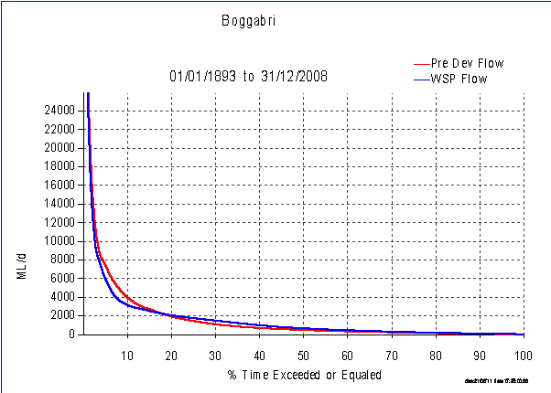

Figure 2: Namoi River at Boggabri flow duration curve (NSW Office of Water IQQM)

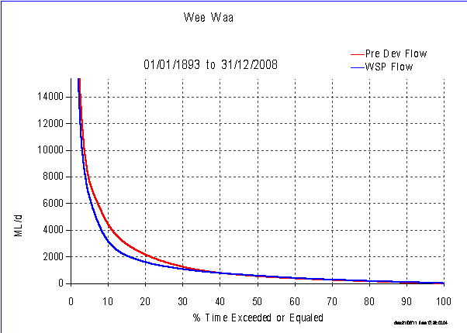

Figure 3: Namoi River at Wee Waa flow duration curve (NSW Office of Water IQQM)

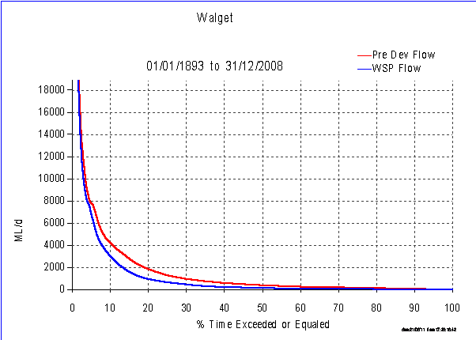

Figure 4: Namoi River at Walgett flow duration curve (NSW Office of Water IQQM)

The alteration of seasonality and monthly magnitude of mid-catchment and end-of-system flows is shown in

Figure **5** and respectively (CSIRO 2007). This shows that whilst seasonality has been maintained despite development upstream there has been an overall reduction in flows across all months from pre-development.

For example, prior to development of the Namoi River, end of system cease to flow periods were likely to occur around 5 per cent of the time. Following river regulation, the frequency of cease to flow periods at the end of the system has increased to 13 per cent of the time (CSIRO 2007).



**Figure 5: Combined Bugilbone and Pian Creek seasonal flow curves under pre-development scenarios (P), Current Development Scenario (A), and middle (Cmid) Climate Change Scenario (CSIRO 2007)**



Figure 6: End of system seasonal flow curves under pre-development scenarios (P), Current Development Scenario (A), and middle (Cmid) Climate Change Scenario (CSIRO 2007)

#### 1.7 Irrigation demand

The distribution of land uses in the Namoi catchment is shown in . Over half of the catchment area is used for dryland agriculture. The floodplains of the lower valley consist of heavy black and grey clays that are well-suited to irrigated agriculture. Irrigation development has occurred quite rapidly since the early 1960’s and up to 112,400 hectares is now used to grow crops such as cotton, cereals and horticulture (CSIRO 2007).

Current levels of extraction are governed by the long-term extraction limit (LTEL) and the Murray-Darling Basin Cap, with the maximum volume that may be taken from a general security access licence in a single year in the Lower Namoi equivalent to 1.25 megalitres per unit share[2]. Extraction in any one year is likely to be above or below the LTEL, however, if extraction is shown to be in excess of the LTEL or Cap, restrictions on allocations and hence extractions are put in place (refer section 8.3 for complete water use limitations as outlined in the Water Sharing Plan). To date, there has been no Cap breach action taken in the Namoi catchment and all LTELs on NSW Murray-Darling Basin rivers are below the cap limit.

Water usage in the valley is for riparian[3], stock and domestic and agricultural use and is available from both the surface and groundwater resource (Kelly et al. 2007). Usage is either from pumping or gravity-fed surface water, extraction from groundwater bores or through the taking of surface water from flows travelling across the floodplains (floodplain harvesting). Only regulated river surface water and groundwater usage is metered. Usage for riparian purposes, floodplain harvesting, and unregulated usage is currently not metered.

The region uses 2.6 per cent of the surface water diverted for irrigation in the Murray-Darling Basin, while the groundwater resources of the region are the most intensively developed in NSW (CSIRO 2007). An average daily flow of 1,922 megalitres is maintained in the Namoi River at Gunnedah, downstream flows decrease to around 1,500 megalitres per day due to the significant irrigation extractions and diversions into effluent channels (Green et al. 2011). Apart from Keepit and Split Rock Dams delivering water for irrigation purposes, major irrigation diversions are also made from Mollee and Gunidgera Weirs.

Chaffey Dam, on the Peel River, supplies town water, stock and domestic, irrigation and environmental flows. The dam provides water supplies and drought security to Tamworth and significant irrigation along the Peel Valley, used for the production of cotton, wheat, lucerne, vegetables, fruit trees, oil seeds and fodder as well as pastures for sheep and cattle (State Water 2009). There are 192 licences with 48,292 megalitres of entitlement including high-security/industry entitlements of 804 megalitres, general-security entitlements of 30,900 megalitres, stock and domestic requirements of 177 megalitres and town water supplies of 16,400 megalitres (State Water 2009).



Figure 7: Land uses of the Namoi catchment (CSIRO 2007)

The major water users in the Namoi catchment are general-security licence holders with a total annual entitlement of 254,976 megalitres of which 9,724 megalitres is located on the upper Namoi between Split Rock and Keepit Dams.

Total share components for all users issued for the regulated Namoi River total nearly 379,000 megalitres as per the following, inclusive of both the upper and lower sections (Green et al. 2011):

* domestic and stock—1,821 megalitres
* domestic and stock (stock) —263 megalitres
* domestic and stock (domestic) —28 megalitres
* local water utility—2,421 megalitres
* general security—245,946 megalitres
* high security—3,498 megalitres
* high security (research)—486 megalitres
* supplementary—115,469 megalitres.

Supplementary water access is declared according to the Water Sharing Plan rules so that water users can divert water from the river without debit to their water account. There is a total licensed supplementary cap of 110,000 megalitres per year with all supplementary licences being located in the lower Namoi.

#### 1.8 Flow monitoring sites

There is a large number of flow monitoring stations along the regulated Namoi River. The NSW Office of Water’s real-time website provides information on the sites on the Namoi and also a wide range of flow data and water quality information: <http://realtimedata.water.nsw.gov.au/water.stm>.

#### 1.9 Hydrology modelling

The NSW Office of Water’s Namoi Integrated Quantity and Quality Model (IQQM) is used to represent flow relationships and evaluate water-planning decisions for the regulated section of the Namoi River. The model can be used for a wide range of scenarios for different water sharing and distribution arrangements and has been used in this document for assessing the impact of development on flows and forecasting account volumes for different categories of licenses.

### 2.0 Ecological values, processes and objectives

## 2.1 Summary of ecosystem values for the Namoi River

The aquatic and terrestrial environments of the Namoi catchment provide habitat for a number of threatened species and ecological communities that are protected under the *Threatened Species Conservation Act 1995* (NSW) and the *Environment Protection and Biodiversity Conservation Act 1999* (Cwlth)(EPBC Act). The Namoi has been included as part of the endangered aquatic ecological community in the natural drainage system of the lowland catchment of the Darling River, under the *Fisheries Management Act* (NSW)(NSW Scientific Committee 2004).The community is known to occur in lowland riverine environments with meandering channels and a variety of aquatic habitats including deep channels and pools, wetlands, gravel beds and floodplains (Green et al. 2011). Four aquatic fauna species which are known to occur within the Namoi catchment are listed as endangered under the *Fisheries Management Act 1994* (NSW): the river snail (which has recently been found in the Pilliga region), freshwater catfish, purple spotted gudgeon, and the olive perchlet. Other species of significance include the silver perch which is listed as vulnerable in NSW, and Murray cod which is listed as vulnerable under the EPBC Act (refer to Appendix 2).

The Namoi catchment supports a number of species protected under state and federal legislation. This includes 28 threatened plant species, with 11 of these being listed as endangered, and 66 threatened fauna species that include four species of amphibians, nine bats, 37 birds, 11 mammals and five reptiles (Green et al. 2011). Threatened species associated with riverine environments have been listed in Appendix 2.

Within the Namoi catchment, Lake Goran is a nationally significant large wetland complex listed under *A Directory of Important Wetlands of Australia* (Environment Australia 2001). The lake is land locked, and as such cannot benefit from environmental watering. The floodplain downstream of Narrabri supports many small lagoons, wetlands, and anabranches, as well as flood runners and extensive areas of floodplain woodlands. Six broad vegetation communities have been associated with the lower Namoi floodplain (Cotton Catchment Communities CRC 2009) and include:

* carbeen woodlands on flats and gentle slopes, often associated with ancient watercourses
* riparian woodland (Coolibah in association with river red gum or black box) on frequently flooded areas of the floodplain
* coolibah or black box woodland on higher areas of the floodplain
* bimble box woodland on elevated floodplains and ridges
* river red gum forest and woodland along riverbanks and river flats
* weeping myall on flats or gentle rises that are above inundation.

Native vegetation communities within the Namoi catchment are known to be generally degraded and are protected under the *Native Vegetation Act* *2003* (NSW). The endangered ecological community coolibah-black box woodland (protected under the EPBC Act) has been extensively cleared for cropping or modified by grazing and is now at around two-thirds of its original extent within NSW. Other floodplain vegetation communities include river red gum (*Eucalyptus camaldulensis*), which is also supported along the Peel River; river cooba (*Acacia stenophylla)*; and cooba (*Acacia salicina)*, whichgrows along major watercourses on the slopes and plains and floodplains that receive sufficient flooding for an extended period. The floodplain complex of coolibah (*E. coolabah*), black box (*E. largiflorens*) and lignum (*Muehlenbeckia florulenta*) also requires frequent flooding and may be subject to occasional prolonged inundation.

The Peel River, as part of the Namoi catchment, supports various sedges, rushes and reeds in-stream. Riparian vegetation includes river oaks (*Casuarina cunninghamiana*,) rough-barked apple (*Angophora floribunda)*, river red gum*,* *Callitris sp.*, and *Lomandra sp*. Associated waterbirds include straw-necked ibis (*Threskiornis molucca*), often observed on floodplain areas. The area downstream of the confluence of the Cockburn River is characterised by a well-formed floodplain and the formation of an anabranch system directly downstream of Tamworth. The unregulated Peel Anabranch is highly degraded due to long-term gravel extraction operations.

Eco Logical Australia (2008) mapped a total of 2,766 wetlands in the valley totalling 46,398 hectares. Of these, 1,829 were identified as natural wetlands and 937 were artificial wetlands (dams, weir pools and other storages). Notable Namoi wetlands include Barbers Lagoon and Gulligal Lagoon.

Barbers Lagoon, which has been studied under the Integrated Monitoring of Environmental Flows program (IMEF), is a wetland site located near Boggabri on a travelling stock reserve. It consists of a straight, deep channel which retains water for long periods. Both banks support river red gums, and Warrego summer grass (*Paspalidium jubiflorum*) dominates the higher bank areas with water couch (*Paspalum distichum*) found on the water’s edge. As water recedes there is minimal colonisation by plants, apart from weed species. Aquatic macrophytes have not been recorded in the deeper water areas (W Mawhinney [NOW], 2011, pers. comm.).

The Namoi River channel provides important habitat for aquatic species and connectivity with the Barwon-Darling River. In-channel habitats include important geomorphic features such as river benches. These benches are sites for the contribution of organic carbon to the aquatic system which provides energy sources for food production for many aquatic species (NRRMC 2001).

The river downstream of Keepit Dam (the lower Namoi) has been described in four geomorphic zones by Thoms et al. (1999) (). Immediately downstream of Keepit and the Peel River tributary confluence is a mobile zone linking into a meander zone to just upstream of Boggabri. From Boggabri to Wee Waa is an anabranching zone while Pian Creek and Namoi River downstream is primarily a distributary zone.

Lampert and Short (2004) provide a detailed assessment of the river styles and condition of the Namoi catchment. Classifications and condition of the Namoi catchment provided from this assessment are summarised in Appendix 3.

Table 1: Ecological values of geomorphic zones of the Namoi and Peel rivers

|  |  |  |
| --- | --- | --- |
| **Zone** | **Characteristics of zone** | **Ecological values and habitat** |
| Mobile | Very active channel and bed sediments, sediment transfer area. | Sandy gravel deposits are important habitat. |
| Meander | Active channel with common bank erosion. | Benches  Meander cutoff channels  Floodplain connectivity |
| Anabranch | Relatively stable, multi channels during floods. | Billabongs, anabranches  Floodplain connectivity  Benches |
| Distributary | Multi-channelled. | Floodplain connectivity  Billabongs, anabranches  Benches |

Source: Thoms 1998.

For all of the zones presented in there are three important features that can be linked to specific commence-to-flow ranges (provided in section 5):

* Within bank benches: these features are important for organic matter transfer and are generally wetted at relatively low within-bank flows. They may also be important riparian zones.
* Cutoff channels and small billabongs are a feature of the lower Namoi River and may connect to the river at different commence-to-flow values. Once the commence-to-flow is reached, the billabong will fill and may flush, with a pool left behind after the flows recede providing habitat for some months.
* There is a riparian/floodplain strip along much of the lower Namoi River; a considerable portion of this is managed as Crown land stock reserve and is heavily grazed. This area generally requires higher flows and out-of-channel flows to fully inundate. There is also likely to be some interaction with channel flows and bench and billabong inundation.

Other important features of the lower Namoi River are the anabranches which can take a considerable proportion of the flow. An example of this is Duncans Warrambool, located near Pilliga where the Namoi River splits in two for a distance of 6 kilometres. The northern channel, known as Duncans Warrambool, carries two-thirds of the flow. There are also a number of ephemeral watercourses that flow westward across the lower Namoi floodplain, including Drildool, Cubbaroo, Dead Bullock and Chambers Warrambools.

Lake Keepit supports one of NSW’s most important recreational fisheries. Native species present included golden perch (*Macquaria ambigua)*, freshwater catfish (*Tandanus tandanus)*, Murray cod (*Maccullochella peelii* ) and silver perch (*Bidyanus bidyanus* ) (Battaglene & Callanan 1991). During the mid-1980’s Lake Keepit also supported a diverse and abundant waterbird population. A study between 1982 and 1985 revealed 38 waterbird species using the lake, often in large numbers (Wettin unpublished and cited in Green & Dunkerley 1992). Birds feeding on fish and invertebrates dominated the waterbird community but duck species were also common. Species observed in large numbers (greater than 1000 individuals) were black duck (*Anas superciliosa)*, grey teal (*Anas gracilis)*, wood duck (*Chenonetta jubata)*, Australian pelican (*Pelecanus conspicillatus)*, little black cormorant (*Phalacrocorax sulcirostris)*, great crested grebe (*Podiceps cristatus)*, Eurasian coot (*Fulica atra*) and silver gull (*Chroicocephalus novaehollandiae)*. Over the period of the study 11 species of waterbird were observed breeding.

The Namoi River is very important to the flows in the Barwon-Darling River, contributing on average some 30 per cent of the flow of the Darling River upstream of Bourke under current development conditions (Webb, McKeown & Associates 2007a,b). The importance of this contribution is recognised in the Water Sharing Plan which has placed limits to lower Namoi supplementary water access when flows are needed to meet the requirements of the Interim Unregulated Flow Management Plan for the North West. The latter interim plan has flow requirements for the Barwon-Darling River to reduce the incidence of blue-green algal blooms in weir pools and to provide weir drown-outs to permit greater fish passage.

#### 2.2 Ecological objectives

There are a range of ecological objectives which have been developed to guide environmental water use in the Namoi River. The following section outlines the pre-existing ecological objectives that have been used as the basis for the development of ecological and water-delivery objectives for the assets/water-management areas of the Namoi River.

**System-wide objectives**

For the purpose of this document, the following system-wide objectives are being adopted to guide environmental water use:

* reduce duration of time between flow events
* provide for a natural drying cycle in channels and wetlands
* provide in-channel drought refuge for native fish species and waterbirds
* support wetland vegetation and waterbird breeding
* improve hydrologic connectivity between river channel and floodplain
* increase hydrological variability through increased flow volumes in high flow events and freshes.

**2.2.1 Environmental watering objectives to meet ecological objectives under a range of climate scenarios**

The Department of Sustainability, Environment, Water, Population and Communities has outlined a number of key ecological and management objectives under different water availability scenarios (Table 2). These objectives take into account climate variability and the required change in aims and actions governed by the amount of water available.

Table : Ecological and management objectives for environmental water use under different water-resource availability scenarios

|  |  |  |  |  |
| --- | --- | --- | --- | --- |
|  | **Extreme dry** | **Dry** | **Median** | **Wet** |
| **Ecological watering objectives** | Avoid damage to key environmental assets. | Ensure ecological capacity for recovery. | Maintain ecological health and resilience. | Improve and extend healthy and resilient aquatic ecosystems. |
| **Management objectives** | * Avoid critical loss of threatened species and communities. * Maintain key refuges. * Avoid irretrievable damage or catastrophic events. | * Support the survival and growth of threatened species and communities including limited small-scale recruitment. * Maintain diverse habitats. * Maintain low-flow river and floodplain functional processes in sites and reaches of priority assets. | * Enable growth, reproduction and small-scale recruitment for a diverse range of flora and fauna. * Promote low-lying floodplain-river connectivity. * Support medium-flow river and floodplain functional processes. | * Enable growth, reproduction and large-scale recruitment for a diverse range of flora and fauna. * Promote higher floodplain-river connectivity. * Support high-flow river and floodplain functional processes. |
| **Management**  **actions** | * Water refugia and sites supporting threatened species and communities. * Undertake emergency watering at specific sites of priority assets. * Use carryover volumes to maintain critical needs. | * Water refugia and sites supporting threatened species and communities. * Provide low-flow and freshes in sites and reaches of priority assets. * Use carryover volumes to maintain follow-up watering. | * Prolong inundation/high-flow duration at key sites and reaches of priority assets. * Contribute to the full-range of in-channel flows. * Use carryover to provide optimal seasonal flow patterns in subsequent years. | * Increase flood/high-flow duration and extent across priority assets. * Contribute to the full range of flows including over-bank. * Use carry over to provide optimal seasonal flow patterns in subsequent years. |
|  | *Damage avoidance* | *Capacity for recovery* | *Maintained health and resilience* | *Improved health and resilience* |

Source: DEWHA 2009.

**2.2.2 River system-wide objectives**

There are also a number of pre-existing river system-wide objectives related to environmental outcomes for the Namoi catchment.

**Murray-Darling Basin Authority**

The Murray-Darling Basin Authority (MDBA) have identified the Namoi River to be a key environmental asset for the Namoi Region, with five hydrological indicator sites for key ecosystem functions being listed, namely:

* Peel River downstream of Chaffey Dam
* Peel River at Piallamore
* Namoi River downstream of Keepit Dam
* Namoi River at Mollee
* Namoi River at Goangra.

The following broad objectives have been established by the MDBA for hydrologic indicator sites:

* creation and maintenance of habitats for use by plants and animals
* transportation and dilution of nutrients, organic matter and sediment
* provision of connections along the river and downstream for migration and recolonisation by plants and animals
* provision of connections across floodplains, adjacent wetlands and billabongs for foraging, migration and recolonisation by plants and animals.

**The Namoi River Water Sharing Plan**

The Water Sharing Plan rules (DIPNR 2004) limit total extractions from lower Namoi supplementary water during periods when flows are above specified thresholds. These include uncontrolled flows, flows in excess of those required for replenishment flows, flows greater than those needed to meet the North-West Interim Unregulated Flow Management Plan[4] and flows in excess of the thresholds specified in the Water Sharing Plan. These rules contribute to the following interim river flow objectives[5]:

* protecting important rises in water levels
* maintaining wetland and floodplain inundation
* maintaining natural flow variability.

**The Namoi Catchment Action Plan**

The Draft 2011–2020 Catchment Action Plan, recently developed by the Namoi Catchment Management Authority, provides strategic direction for natural resource management within the Namoi catchment. The latest plan uses a ‘resilience thinking’ approach to determine important thresholds in the catchment and actions required to prevent progression below these thresholds.

Water critical thresholds developed in the draft Catchment Action Plan include:

* surface water flow, including quantity, is at 66 per cent of natural (pre-development) condition with a sensitivity to natural frequency and duration
* geomorphic condition is good (against benchmark condition)
* recruitment of riparian vegetation is higher than attrition of individual trees, shrubs or groundcover species
* agricultural and urban supply aquifers do not cross into lower levels of beneficial use regarding quality
* alluvial aquifers are not drawn down below long-term historical maximum drawdown levels
* groundwater is within 30 metres of surface where there are identified groundwater-dependent ecosystems
* wetlands are not drained, dammed or otherwise physically modified.

Catchment water targets related to preventing progression below the water critical thresholds include:

* Catchment Water Target 1—by 2020 there is an improvement in the condition of those riverine ecosystems that have not crossed defined geomorphic thresholds as at the 2010 baseline.
* Catchment Water Target 3—by 2020 there is an improvement in the condition of regionally important wetlands and the extent of those wetlands is maintained.

The river reach between Boggabri and Narrabri has also been established as a demonstration reach under the Native Fish Strategy (see Appendix 3 for details). A state government initiative, the 120-kilometre demonstration reach has resulted in the modification or removal of 16 priority fish barriers and the improved management of riparian land (DPI 2006).

Additionally, there has been a study focussing on the improved management of irrigation off-takes to reduce adverse impacts on native fish.

**2.2.3 Broad-scale system objectives for the use of environmental water**

Broad-scale system objectives for the use of environmental water in the Namoi catchment are described in Table 3. The objectives seek to provide guidance as to how water should be used under different climatic and flow conditions and often in conjunction with other water reserves to meet ecological objectives related to Namoi environmental assets. These objectives are incorporated into the delivery scenario objectives presented in section 3.2.

Table : Broad-scale system and asset ecological objectives for targeted environmental water use in the Namoi catchment

|  |  |  |
| --- | --- | --- |
| **Broad-scale system objective** | **Water management area** | **Asset ecological objectives** |
| Provide **baseflows** to avoid damage to ecological assets. This will reduce the duration of time between flow events and provide in-channel drought refuge for native fish and waterbirds in order to:   * avoid critical loss of threatened species and communities * maintain key refuges * avoid irretrievable damage or catastrophic events. | Permanent regulated river section (Regulated Namoi and Peel rivers). | Maintain in-stream refuges and aquatic habitat for native fish species along the river channel.  Prevent fish stranding and allow the completion of critical life cycle processes such as spawning, seed setting and dormant stages along the river channel and in Pian Creek.  Promote productivity to maintain food webs and ecosystem function for in-channel flora and fauna.  Maintain water quality within channels and pools. Prevent stratification in deep pools. |
| Provide **minor inflows** to ensure ecological capacity for recovery. This will support wetland vegetation and native fish spawning, as well as improve hydrologic connectivity between river channel and floodplain in order to:   * support the survival and growth of threatened species and communities * maintain diverse habitats * maintain low-flow river and floodplain functional processes. | Riverine assets with low commence-to-flow or structures for water delivery (e.g. low commence-to-flow benches and point bars in all reaches and Duncans Warrambool). | Provide habitat for native fish species through wetting of low-level point bars and the riparian zone to provide connectivity between river channel and low-elevation floodplain wetlands.  Inundate low-level benches to promote species diversity.  Establish and maintain native water plants for improved water quality and wetland habitat in anabranches between Mollee Weir and Gunidgera Weir and in Duncans Warrambool.  Support in-channel geomorphic structure and organic matter inputs in the river channel and anabranches.  Contribute to the ecological requirements of the Barwon-Darling River through increased end-of-system flows in the river channel between Wee Waa and Walgett. |
| Provide **medium inflows** to maintain ecological health and resilience. This will increase hydrological variability through increased flow volumes in floods and freshes, improve hydrologic connectivity between river channel and floodplain and support wetland vegetation and waterbird breeding in order to:   * enable growth, reproduction and small-scale recruitment of a diverse range of flora and fauna * support medium-flow river and floodplain functional processes. | End of system at Walgett.  Provide full bank flow to the Namoi River channel; inundate wetlands.  Piggyback on end-of-system flows; medium commence-to-flow anabranches/warrambools (e.g. Barbers Lagoon and point bars). | Using pulsed flows, inundate low commence-to-flow riparian wetlands and mid-level benches along the river channel and anabranches to support riparian vegetation condition.  Provide wetting of medium-level benches along the river channel and anabranches to promote connectivity with riparian assets and adjacent floodplain.  Provide pulsed freshes to trigger native fish spawning (e.g. silver perch, golden perch and Murray cod) in river channel, Narrabri Creek, Pian Creek and Barbers Lagoon.  Maintain water quality and support in-channel geomorphic structure and organic matter inputs in the river channel and anabranches.  Provide nesting and foraging habitat for waterbirds such as ibis, freckled duck, blue-billed duck, egrets and herons in anabranches, Barbers Lagoon and Duncans Warrambool.  Contribute to the ecological requirements through piggybacking on baseflow and freshes of the Barwon-Darling through increased end-of-system flows in the river channel between Wee Waa and Walgett.  Provide adequate wetting to support river red gum, black box, river cooba and coolibah communities associated with channel and low commence-to-flow habitats. |
| Provide **high inflows** to improve and extend healthy and resilient aquatic ecosystems. This will increase hydrological variability through increased flow volumes in high flows and freshes, improve hydrologic connectivity between river channel and floodplain and support wetland vegetation and waterbird breeding in order to:   * enable growth, reproduction and small-scale recruitment of a diverse range of flora and fauna * support high-flow river and floodplain functional processes. | End-of-system flows at Walgett.  Inundate wetlands requiring greater volumes and high commence-to-flow.  Support end-of-system flows and higher commence-to-flow warrambools and lagoons including backwaters. | Using pulsed flows, inundate higher commence-to-flow riparian wetlands and mid-level benches along the river channel and anabranches to support riparian vegetation condition and promote productivity.  Provide wetting of high-level benches along the river channel and anabranches to promote connectivity with riparian assets and adjacent floodplain and productivity.  Support condition of river red gum, black box, coolibah and river cooba communities along the river channel and anabranches by increasing connectivity between floodplain and river channel and by providing adequate inundation flows to lagoons.  Maintain water quality and support in-channel geomorphic structure and organic matter inputs in the river channel and anabranches.  Maintain open water areas by providing adequate inundation flows to lagoons (e.g. Barbers Lagoon).  Provide nesting and foraging habitat for waterbirds such as ibis, freckled duck, blue-billed duck, egrets and herons in anabranches, Barbers Lagoon and Duncans Warrambool.  Contribute to the ecological requirements through piggybacking on baseflow and freshes of the Barwon-Darling through increased end-of-system flows in the river channel between Wee Waa and Walgett. |

* 1. **Watering objectives for water-dependent assets**

#### 3.1 Asset environmental watering objectives

There are several key considerations involved in developing the asset watering objectives. Consideration has been given to the climate sequence scenarios and broad-scale system objectives (Tables 2 and 3) in developing the environmental watering objectives for each asset or water-management area (WMA). Under each climate scenario different volumes of environmental water would be available and therefore will be able to achieve correspondingly more or less environmental watering outcomes.

In reality, the climate scenarios are part of a constant continuum and only the current circumstances can be assessed in relation to the past few years to determine which scenario applies. Forecasting the future climate scenario is currently problematic although short-term probabilities are provided by the Bureau of Meteorology.

**3.2 Development of ecological and watering objectives for Namoi assets and water management areas**

The general system-wide objectives used for developing the asset watering objectives in Table 4 for each climate scenario are to:

* reduce duration of time between flow events
* provide for a natural drying cycle
* provide drought refuge for native fish species and waterbirds
* support wetland vegetation and waterbird breeding
* improve hydrologic connectivity between channel and floodplain
* increase hydrological variability through increased flow volumes in floods and freshes.

The ecological and watering objectives provided in Table 4 have been developed using available reports and additional analysis. Appendix 3 provides more details for each asset/WMA. Most of the reports have identified commence-to-fill levels for in-channel benches and billabongs, namely from Foster (1999, 2004). No previous report has identified the specific environmental flow requirements for these features or in-channel habitats, particularly in terms of the required duration and seasonality. Consequently, professional judgement has been used to determine the water requirements for these objectives (Table 10). It has also been assumed that irrigation and other consumptive water orders, particularly from September to February, will meet the environmental water requirements for in-channel assets.

As indicated above, the environmental flow requirements of water-dependent features of the Namoi River require further investigation to determine more specific environmental watering orders.

Table : Namoi asset environmental watering objectives for ecological objectives

Notes:

1. See broad-scale objectives in Table 3. Ecological objectives may change as water is accrued for each climate scenario as per Table 6.

2. Appendix 3 provides the background for the development of these objectives. Operational detail is provided in Table 11.

| Asset | WMA | Climate sequence scenario | Ecological objectives1 | Asset environmental watering objective2 |
| --- | --- | --- | --- | --- |
| **Split Rock Dam to Keepit Dam** | River channel | Extreme dry | Maintain in-stream refuges and aquatic habitat for native fish species and platypus in pools.  Maintain water quality within channels and pools.  Prevent fish stranding and allow biota to complete flow-driven critical life cycle processes such as spawning, seed setting and dormant stages. | Contributing to baseflow to maintain in-stream refuges and aquatic habitat. |
| Dry | Maintain habitat for native fish species and platypus in pools and connectivity through wetting of low-level point bars and riparian zone.  Reset in-stream biofilms and maintain water quality within channels and pools.  Promote diversity outcomes by flooding low-level benches. | Contributing to baseflow to maintain in-stream refuges and aquatic habitat. Bulk water transfer to provide connectivity and freshes. Inundate low-level benches. |
| Median | Inundate low commence-to-flow riparian wetlands and mid-level benches; protect platypus breeding habitat. Reset in-stream biofilms and maintain water quality within channels and pools.  Provide triggers for fish-spawning opportunities. | Provide pulse flows to inundate medium-level benches and riparian assets. |
| Wet | Inundate higher commence-to-flow riparian wetlands and mid-level benches; protect platypus breeding habitat. Reset in-stream biofilms and maintain water quality within channels and pools. Increase connectivity between floodplain and channels to promote primary productivity and support water-dependent species. | Provide pulse flows to inundate high-level benches, riparian assets and connectivity with adjacent floodplain through pulsed flows. |
| **Keepit Dam to Carroll** | River channel | Extreme dry | Maintain in-stream refuges and aquatic habitat for native fish species.  Maintain water quality within channels and pools.  Prevent fish stranding and allow biota to complete flow-driven critical life cycle processes such as spawning, seed setting and dormant stages. | Contribute to baseflow to maintain in-stream refuges and aquatic habitat. |
| Dry | Maintain in-stream refuges and aquatic habitat, maintain in-channel geomorphic structure and organic matter inputs. Maintain water quality within channels and pools. Promote diversity outcomes by flooding low-level benches. | Contribute to baseflow to maintain in-stream refuges and aquatic habitat. Provide pulsed flows for wetting and connectivity with low-level benches and point bars. |
| Median | Support riparian vegetation and maintain in-channel geomorphic structure and organic matter inputs. Maintain water quality within channels and pools. Provide triggers for fish-spawning opportunities. | Provide pulse flows for wetting and connectivity with medium-level benches, point bars and riparian zone. |
| Wet | Support riparian vegetation and floodplain river red gum woodland. Maintain in-channel geomorphic structure and organic matter inputs. Maintain water quality within channels and pools. Increase connectivity between floodplain and channels to promote primary productivity. | Provide pulse flows for wetting and connectivity with higher level benches, point bars and riparian zone. |
| **Carroll to Boggabri** | River channel | Extreme dry | Maintain in-stream refuges and aquatic habitat. Maintain water quality within channels and pools. Prevent fish stranding and allow biota to complete flow-driven critical life cycle processes such as spawning, seed setting and dormant stages. | Contribute to baseflow to maintain in-stream refuges and aquatic habitat. |
| Dry | Maintain in-stream refuges and aquatic habitat. Maintain in-channel geomorphic structure and organic matter inputs. Maintain water quality within channels and pools. Promote diversity outcomes by flooding low-level benches. | Contribute to baseflow to maintain in-stream refuges and aquatic habitat. Provide pulsed flows for wetting and connectivity with low-level benches, point bars and riparian zone. |
| Median | Support riparian vegetation and maintain in-channel geomorphic structure and organic matter inputs. Maintain water quality within channels and pools. Provide triggers for fish-spawning opportunities. | Provide pulse flows for wetting and connectivity with medium-level benches, point bars and riparian zone. |
| Wet | Support riparian vegetation and floodplain red gum woodland. Maintain in-channel geomorphic structure and organic matter inputs. Maintain water quality within channels and pools. Increase connectivity between floodplain and channels to promote primary productivity. | Provide pulse flows for wetting and connectivity with higher level benches, point bars and riparian zone. |
| **Boggabri to Wee Waa** | Narrabri Creek Channel | Extreme dry | Maintain in-stream refuges and aquatic habitat.  Maintain water quality within channels and pools.  Prevent fish stranding and allow biota to complete flow-driven critical life cycle processes such as spawning, seed setting and dormant stages. | Contribute to baseflow to maintain in-stream refuges and aquatic habitat. |
| Dry | Maintain in-stream refuges and aquatic habitat, maintain in-channel geomorphic structure and organic matter inputs. Maintain water quality within channels and pools. Promote diversity outcomes by flooding low-level benches. | Contribute to baseflow to maintain in-stream habitat. Wet low-level benches and point bars through pulsed flows. |
| Median | Support riparian vegetation and maintain in-channel geomorphic structure and organic matter inputs. Maintain water quality within channels and pools. Provide triggers for fish-spawning opportunities. | Provide pulse flows for wetting and connectivity with medium-level benches, point bars and riparian zone. |
| Wet | Support riparian vegetation and floodplain river red gum woodland. Maintain in-channel geomorphic structure and organic matter inputs. Maintain water quality within channels and pools. Increase connectivity between floodplain and channels to promote primary productivity. | Provide pulse flows for wetting and connectivity with higher level benches, point bars and riparian zone. |
| Namoi River upstream Mollee Weir | Extreme dry | Maintain aquatic habitat. Maintain water quality within channels and pools. Prevent fish stranding and allow biota to complete flow-driven critical life cycle processes such as spawning, seed setting and dormant stages. | Contribute to baseflow to maintain in-stream aquatic habitat. |
| Dry | Provide in-stream aquatic habitat. Maintain in-channel geomorphic structure and organic matter inputs. Maintain water quality within channels and pools. Promote diversity outcomes by flooding low-level benches. | Contribute to baseflow to maintain in-stream aquatic habitat. Provide pulse flows for wetting and connectivity with low-level benches and point bars. |
| Median | As above.  Provide triggers for fish breeding opportunities. | As above |
| Wet | Support riparian vegetation and floodplain river red gum woodland. Maintain in-channel geomorphic structure and organic matter inputs. Maintain water quality within channels and pools. Increase connectivity between floodplain and channels to promote primary productivity. | Provide pulse flows for wetting and connectivity with higher level benches, point bars and riparian zone. |
| Anabranches from Mollee Weir to Gunidgera Weir | Extreme dry | Support natural drying cycle and habitat for native fish. Maintain in-channel geomorphic structure and organic matter inputs. | Contribute to baseflow to maintain in-stream aquatic habitat. |
| Dry | Provide in-stream aquatic habitat, maintain in-channel geomorphic structure and organic matter inputs. Maintain native water plants for improved water quality and wetland habitat outcomes. Promote diversity outcomes through wetting associated riverine areas. | Contribute to baseflow to maintain in-stream habitat. Support wetting and connectivity with low-level benches and point bars through pulsed flows. |
| Median | Support riparian vegetation and maintain in-channel geomorphic structure and organic matter inputs.  Provide triggers for fish-spawning opportunities.  Provide nesting and foraging habitat for waterbirds such as ibis, freckled duck, blue-billed duck, egrets and herons. | Provide pulsed flows for wetting and connectivity with medium-level benches, point bars and riparian zone. |
| Wet | Support riparian vegetation and floodplain river red gum woodland. Maintain in-channel geomorphic structure and organic matter inputs. Increase connectivity between floodplain and channels to promote primary productivity and support floodplain vegetation. | Provide pulse flows for wetting and connectivity with higher level benches, point bars and riparian zone. |
| Barbers Lagoon | Extreme dry | Provide natural drying cycle. |  |
| Dry | As above. |  |
| Median | Support riparian vegetation and maintain refuge pools. Provide triggers for fish-spawning opportunities.  Provide nesting and foraging habitat for waterbirds such as ibis, freckled duck, blue-billed duck, egrets, herons. | Provide pulsed flows for wetting and connectivity with low-level benches, point bars and riparian zone. |
| Wet | Support riparian vegetation and floodplain river red gum woodland. Increase connectivity between floodplain and channels to promote primary productivity. Provide adequate flooding regime to support vegetation associated with channels and floodplains. Maintain open water areas by providing adequate flooding flows. Provide nesting and foraging habitat for waterbirds such as freckled duck, blue-billed duck, egrets, herons. | Provide wetting of riparian zone and floodplain red gums through higher flows. |
| **Wee Waa to Walgett** | River channel | Extreme dry | Maintain in-stream aquatic habitat. Maintain water quality within channels and pools. Prevent fish stranding and allow biota to complete flow-driven critical life cycle processes such as spawning, seed setting and dormant stages. | Contribute to baseflow to maintain in-stream aquatic habitat. |
| Dry | Contribute to ecological requirements through piggybacking flows to the Barwon-Darling. Maintain in-stream aquatic habitat, maintain in-channel geomorphic structure and organic matter inputs. Maintain water quality within channels and pools. Promote diversity outcomes by flooding low-level benches. | Contribute to baseflow to maintain in-stream aquatic habitat. Provide pulsed flows for wetting and connectivity with low-level benches and point bars. Increase end-of-system flow to Barwon-Darling. |
| Median | Contribute to ecological requirements through piggybacking flows to the Barwon-Darling. Support riparian vegetation and maintain in-channel geomorphic structure and organic matter inputs. Maintain water quality within channels and pools. Provide triggers for fish spawning opportunities. | Provide pulsed flows for wetting and connectivity with medium-level benches, point bars and riparian zone. Increase end-of-system flow to Barwon-Darling. |
| Wet | Contribute to ecological requirements through piggybacking flows to the Barwon-Darling. Support riparian vegetation and floodplain river red gum woodland. Maintain in-channel geomorphic structure and organic matter inputs. Maintain water quality within channels and pools. Increase connectivity between floodplain and channels to promote primary productivity. | Provide pulsed flows for wetting and connectivity with higher level benches, point bars and riparian zone. Increase floodplain connectivity and reach commence-to-flow targets for warrambools. Increase end-of-system flow to Barwon-Darling. |
| Duncans Warrambool | Extreme dry | Maintain in-stream aquatic habitat. Maintain water quality within channels and pools. Prevent fish stranding and allow biota to complete flow-driven critical life cycle processes such as spawning, seed setting and dormant stages. | Contribute to baseflow to maintain in-stream aquatic habitat. |
| Dry | Provide in-stream aquatic habitat, maintain in-channel geomorphic structure and organic matter inputs. Maintaining native water plants for improved water quality and wetland habitat outcomes. Promote diversity outcomes through wetting associated riverine areas. | Contribute to baseflow to maintain in-stream aquatic habitat. Provide pulsed flows for wetting and connectivity with low-level benches and point bars. |
| Median | Support riparian vegetation and maintain in-channel geomorphic structure and organic matter inputs.  Provide triggers for fish-spawning opportunities.  Provide nesting and foraging habitat for waterbirds such as ibis, freckled duck, blue-billed duck, egrets, herons. | Provide pulsed flows for wetting and connectivity with medium-level benches, point bars and riparian zone. |
| Wet | Support riparian vegetation and maintain in-channel geomorphic structure and organic matter inputs.  Increase connectivity between floodplain and channels to promote productivity. Provide adequate flooding regime to support vegetation associated with channels and floodplains. Maintain open water areas by providing adequate inundation flows to lagoons. Provide nesting and foraging habitat for waterbirds such as freckled duck, blue-billed duck, egrets, herons. | Provide pulsed flows for wetting and connectivity with higher level benches, point bars and riparian zone. |
| **Pian Creek** | Channel | Extreme dry | Baseflow to maintain in-stream aquatic habitat.  Maintain water quality within channels and pools.  Prevent fish stranding and allow biota to complete flow driven critical life cycle processes such as spawning, seed setting and dormant stages. | Contribute to baseflow to maintain in-stream aquatic habitat. |
| Dry | Baseflow to maintain in-stream aquatic habitat. Provide wetting and connectivity with low-level benches. Maintain water quality within channels and pools. Promote diversity outcomes by flooding low level benches. | Contribute to baseflow to maintain in-stream aquatic habitat. Provide pulsed flows for wetting and connectivity with low-level benches and point bars |
| Median | Provide wetting and connectivity with medium-level benches, point bars and riparian zone. Maintain water quality within channels and pools. Provide triggers for fish spawning opportunities. | Provide pulsed flows for wetting and connectivity with medium-level benches, point bars and riparian zone |
| Wet | Provide wetting and connectivity with higher level benches, point bars and riparian zone. Maintain water quality within channels and pools. Increase connectivity between floodplain and channels to promote primary productivity. | Provide pulsed flows for wetting and connectivity with higher level benches, point bars and riparian zone |
| **Peel River** |  | Extreme dry | Baseflow to maintain in-stream refuges and aquatic habitat.  Maintain water quality within channels and pools.  Prevent fish stranding and allow biota to complete flow-driven critical life cycle processes such as spawning, seed setting and dormant stages. | Contribute to baseflow to maintain in-stream refuges and aquatic habitat. |
| Dry | Baseflow to maintain in-stream aquatic habitat. Provide wetting and connectivity with low-level benches. Maintain water quality within channels and pools. Promote diversity outcomes by flooding low level benches. | Contribute to baseflow to maintain in-stream aquatic habitat. Provide pulsed flows for wetting and connectivity with low-level benches and point bars Increase flow variability. |
| Median | Provide wetting and connectivity with medium-level benches, point bars and riparian zone. Maintain water quality within channels and pools. Provide triggers for fish spawning opportunities. | Provide wetting and connectivity with medium-level benches, point bars and riparian zone. Provide pulsed flows for wetting and connectivity with low-level benches and point bars. Increase flow variability. |
| Wet | Provide wetting and connectivity with higher level benches, point bars and riparian zone. Maintain water quality within channels and pools. Increase connectivity between floodplain and channels to promote primary productivity. | Provide wetting and connectivity with higher level benches, point bars and riparian zone. Provide pulsed flows for wetting and connectivity with low-level benches and point bars. Increase flow variability. |

**3.3 Water availability under each climate scenario**

The allocation systems for the different types of water access licenses in the Namoi catchment are presented in .

Table : Namoi catchment allocation systems

|  |  |  |  |
| --- | --- | --- | --- |
| Upper Namoi River | Domestic and stock | Annual allocation | Normally allocated 1 ML/unit share each year. |
| Local water utility | Annual allocation | Normally allocated 1 ML/unit share each year. |
| Regulated river (high security) | Annual allocation | Normally allocated 1 ML/unit share each year. |
| Regulated river (general security) | Annual allocation with carryover | Carry over of up to 0.5 ML/unit share but limit of 1 ML/unit share in account at any time. Allocations depend on level in Split Rock Dam, which also services entitlements in the lower Namoi. |
| Supplementary water | Annual allocation | 1 ML/unit share. |
| Lower Namoi River | Domestic and stock | Annual allocation | Normally allocated 1 ML/unit share each year. |
| Local water utility | Annual allocation | Normally allocated 1 ML/unit share each year. |
| Regulated river (high security) | Annual allocation | Normally allocated 1 ML/unit share each year. |
| Regulated river (general security) | Continuous accounting | Maximum in account at any time: 2 ML/unit share. Maximum allowable account volume for all regulated river entitlements equals approximately 80% of maximum allocable storage. |
| Supplementary water | Annual allocation | 1 ML/unit share. |

An indication of the volumes that would be available to general and high-security access licences in the Namoi water accounts under each climate scenario is provided in Table 6. The volumes represent the water available in an account at a particular time of year, and do not represent the water likely to be allocated over the course of a water year. As a consequence the volumes decrease from October to April reflecting both the usage from the account and the inflows to the accounts over this time period. At the time of developing this document Commonwealth environmental water was the only licensed environmental water in the Namoi catchment (see Section 8.1). For this reason modelling for this report has been based solely on Commonwealth environmental water holdings.

This information has been derived using the NSW Office of Water’s Namoi IQQM model, which is based on a ‘typical’ irrigation demand pattern. As an environmental user’s pattern of demand may be quite different to this, the account volumes may vary from those presented in Table 6. To better reflect the allocations available to an environmental water user would require a reconfiguration of some demand patterns in the Namoi hydrology model. In addition, Commonwealth environmental water holdings are subject to change – current figures can be found at: http://www.environment.gov.au/ewater.

Table : Likely allocation and volume available to the environment from Commonwealth environmental water entitlements

|  |  |  |  |  |  |  |  |  |  |  |
| --- | --- | --- | --- | --- | --- | --- | --- | --- | --- | --- |
|  |  |  | **October allocation** | | | | **April allocation** | | | |
| **Holder** | **Licence volume** | **Entitlement category** | **Very dry** | **Dry** | **Median** | **Wet** | **Very dry** | **Dry** | **Median** | **Wet** |
| General security access licence allocation (%) |  |  | 2 | 55 | 98 | 141 | 0 | 29 | 76 | 124 |
| High security access licence allocation (%) |  |  | 100 | 100 | 100 | 100 | 100 | 100 | 100 | 100 |
| Commonwealth environmental water (ML) | 6,203 | General | 148 | 3,430 | 6,072 | 8,734 | 0 | 1,786 | 4,689 | 7,717 |

Analysis of IQQM data indicates that under an extremely dry or dry climate the watering of Namoi assets using stored environmental water has limited feasibility with only 2–55 per cent of general-security entitlement volume available in the water account in October and 0–29 per cent available in April (Table 6). Based on Commonwealth environmental water entitlements (as at September 2011), there would be a maximum of 1,786 megalitres in the general-security account under a dry-climate sequence in April (Table 6). On its own, this volume would be sufficient to water a limited number of in-channel assets, with more watering options dependent on piggybacking opportunities.

Under a median or wet climate the watering of more Namoi assets would be feasible with the available general-security account volumes (Table 6), and particularly with piggybacking opportunities. Forecasts indicate that between 98–141 per cent of general-security entitlement would be available in the account under median-to-wet conditions in October and 76–124 per cent in April (Table 6). Based on Commonwealth environmental water entitlements (as at September 2011) between 4,689 megalitres and 8,734 megalitres of general-security water would potentially be available for use.

The probability of unregulated stream flows in the Namoi River at Wee Waa are presented under different climate scenarios in Appendix 4.

There are currently no Commonwealth environmental water-licenced entitlements for the Peel River. However, as described in section 1.5.2, current environmental water rules require up to a 1,600-megalitre stimulus flow to be provided when the Chaffey storage exceeds 50,000 megalitres at the start of the water year. The Water Sharing Plan for the Peel River provides for the creation of a 5,000-megalitre environmental contingency allowance when the capacity of Chaffey Dam is enlarged to 100,000 megalitres (currently 62,000 megalitres).

# Part 2: Water use strategy

### 4.0 Environmental water requirements

#### 4.1 Watering requirements

Asset environmental watering objectives were presented in the previous section. The associated watering requirements and delivery regimes to meet these objectives are presented below (Table 7). Watering requirements for wetland-dependent vegetation and ecological components have been documented in a number of reports including Roberts and Marston (2000), Davis et al. (2001) and Rogers and Ralph (2010). Fish-specific requirements have been extracted from Lintermans (2007) and NSW Fisheries Guidelines (2001). While this list is not exhaustive it provides detailed information on a number of important features associated with Namoi assets.

These watering requirements have been used to determine appropriate water-delivery regimes for Namoi assets/WMAs (section 5 and Table 10).

Table : Watering requirements for water-dependent species of the Namoi River

| Water dependent component | Ideal frequency | Ideal duration | Max duration | Ideal timing | Max timing | Ideal depth | Max depth | Ideal dry spell | Max dry spell |
| --- | --- | --- | --- | --- | --- | --- | --- | --- | --- |
| **Plant survival and maintenance** |  |  |  |  |  |  |  |  |  |
| River red gum | 1-3 years | 2-8 months | 24 months | Winter- spring | Winter-early summer | N/A | N/A | 5-15 months | 36-48 months |
| Black box | 1 in 2-5 years | 2-4 months | 5 months | Any | Any | N/A | N/A | Variable | Unknown |
| Lignum | 3-10 years | 1-6 months | 12 months | Spring-early summer | Not critical | 0-60 cm | Generally <1m | 1- 10 years | Unknown |
| Common reed | 1-2 years | ~6 months | 12 months or permanent | Spring | Any | 20- 50 cm | 2 m | Few months | 12 months |
| **Waterbird breeding** |  |  |  |  |  |  |  |  |  |
| Great and intermediate egret | Not known | 12 months  3-4 months breeding | N/A | Nov-May | Sept-May | Deep- slow fall | N/A | Not listed | Not listed |
| Little egret | Not known | 6 months  3-4 months breeding | N/A | Oct- March | Not listed | Deep- mod fall | N/A | Not listed | Not listed |
| Straw-necked ibis | Not known | 9-12 months  3 months breeding | N/A | Sept- Feb | Any time | 0.5-1 m slow fall | N/A | Not listed | Not listed |
| Glossy ibis | Not known | 2 months breeding | N/A | Oct- Feb | Not listed | Deep  slow fall | N/A | Not listed | Not listed |
| Grey teal | Not known | 4-5 months  3-4 breeding | N/A | June-Feb | Any time | Unknown  Mod fall | N/A | Not listed | Not listed |
| Freckled duck | Not known | 5 months  3 months breeding | N/A | June- Dec | Anytime | Unknown mod- slow fall | N/A | Not listed | Not listed |
| Brolga | Not known | 3-4 months |  | July-Nov | May-March | 0.24-0.72 m | N/A | Not listed | Not listed |
| **Native fish**[6] |  |  |  |  |  |  |  |  |  |
| Purple spotted gudgeon | Annually | Not listed | Not listed | Spring when temp. ≥20o | Not listed | To achieve bed scouring; Wetland inundation | Not listed | Nil for in-channel | Nil for in-channel |
| Murray cod | Min. 1 in every 5 to 10 years | Min. 4 weeks | Not listed | Spring when temp. ≥16o | Not listed | Fluctuations to aid spawning, dispersal and food production | Commence-to-flow to achieve floodplain inundation | Nil for in-channel | Nil for in-channel |
| Golden perch | Min. 1 in every 3 to 5 years | Min. 3 weeks | Not listed | Spring & summer when temp. ≥23o | Not listed | Fluctuations to aid spawning, dispersal and food production | Commence-to-flow to achieve floodplain inundation | Nil for in-channel | Nil for in-channel |
| Silver perch | 1 in 5-10 years | Min. 4 weeks | Not listed | Spring when temp. ≥23o | Not listed | 20-100mm fluctuations | Not listed | Nil for in-channel | Nil for in-channel |
| Freshwater catfish | Annually | Not listed | Not listed | Spring when temp. ≥24o | Not listed | Ensure sufficient to refresh wetlands. | Not listed | Nil for in-channel | Nil for in-channel |
| Olive perchlet | Not listed | Not listed | Not listed | Spring when temp >25° | Not listed | Inundate backwaters; 1m with no flow | Not listed | Nil for in-channel | Nil for in-channel |
| Unspecked hardyhead | Not listed | Not listed | Not listed | Oct-Feb | Not listed | Not listed | Not listed | Not listed | Not listed |
| Northern river blackfish | Not listed | Not listed | Not listed | Oct- Jan | Not listed | Not listed | Not listed | Not listed | Not listed |
| River snail | Frequent fluctuations | Not listed | Not listed | Not listed | Not listed | Wetted and dried perimeter cycles | Not listed | Not listed | Not listed |
| Frogs |  |  | Tadpoles |  |  |  |  |  |  |
| Eastern froglet | <3 months- permanent | Not listed | 2-4 months | Summer-Autumn | Not listed | Not listed | Not listed | Not listed | Not listed |
| Perons tree frog | <3 months- permanent | Not listed | 3-4 months | Summer | Not listed | Not listed | Not listed | Not listed | Not listed |
| Southern bell frog | 3 months- permanent | Not listed | 3-5 months | Summer | Not listed | Not listed | Not listed | Not listed | Not listed |

Source: Modified from Rogers and Ralph 2010; Lintermans 2007; NSW Fisheries 2001.  
Note: Rogers and Ralph (2010) also provides additional information on other outcomes such as reproduction and regeneration requirements and a functional classification for floodplain plants.

### Operating regimes and environmental water delivery strategies

In order to achieve the environmental watering objectives for an asset and WMA, flows need to be delivered at an appropriate volume, duration and time. For successful water delivery there are many factors that need to be considered in terms of determining the requirements of the ‘environmental water order’. The combination of these factors forms the operational delivery regime. The main considerations and the resulting likely water orders for assets on the Namoi and Peel rivers are provided below.

State Water Corporation is the river operator within the Namoi catchment and has responsibility for addressing the operational considerations and determining the dam release requirements to meet environmental water orders. Section 5.2 and Table 10 provide possible water orders for each asset/WMA.

The modest volume of environmental water currently held in the Namoi catchment limits how this water can be effectively used on its own to meet the water orders provided in Table 10. Consequently, there is likely to be high reliance on piggybacking delivery arrangements to meet the proposed water objectives.

#### 5.1 Delivery considerations

##### 5.1.1 Travel time for delivery of environmental water

The length of time it takes for environmental water to reach a targeted asset from a water storage is an important consideration when planning environmental watering events. The following approximate travel times are relevant but can vary depending on the antecedent conditions of the channel. The longer delivery times are for when the river channel is dry prior to the release:

* Chaffey–Namoi: 3 to 4 days
* Split Rock–Keepit: 4 to 5 days
* Keepit Dam–Boggabri: 3 to 6 days
* Boggabri–Narrabri: 2 to 4 days
* Narrabri–Wee Waa: 2 to 4 days
* Wee Waa–Walgett: 15 to 30 days
* Wee Waa–end Pian Creek regulated (Dundee weir): 10 to 20 days.

##### 5.1.2 Storage release capacities

The following information on release capacities applies to each storage at maximum storage levels (DLWC 2002). Any order for environmental water needs to consider limitations that arise from storage release capacity, which will decrease as the storage level drops. Other water orders may also affect possible valve and channel capacity sharing. Storage release capacities are:

* Split Rock Dam has a maximum release capacity of 6,000 ML/d, however, due to the following environmental reasons the discharge has been limited to a maximum of 4,500 ML/d:
  + possible drowning of platypus colonies
  + damage to the river channel
  + native fish kills due to large releases (resulting from trapping in trash rack due to high flow velocities)
  + cut-off access to some landholders
* Keepit Dam maximum fixed outlet release capacity is 4,000 ML/d.
* Keepit Dam also has flood mitigation gates which become operational at storage levels above 25 per cent (spillway crest wall height 318.595 metres). The following releases can be achieved via these gates, however, it should be noted that the operation of these gates at lower discharges is more complex and there will be less precision with the volumes than via the dam outlet valves:
  + 25 per cent (storage height 318.65 metres)—minimal release possible (State Water has advised that the release rate from Keepit Dam at this storage height is very small and difficult to quantify (S Samarawickrama [State Water] 2011, pers. comm.)
  + 30 per cent (storage height 319.86 metres)—maximum release 20 GL/d
  + 40 per cent (storage height 321.88 metres)—maximum release 90 GL/d
* Chaffey Dam maximum release capacity is 1,100 ML/d.

The Water Sharing Plan takes into account the total reserves of Split Rock and Keepit Dams, and when reserves in Keepit Dam cannot satisfy the water usage requirements for irrigators downstream of the dam it may be necessary to transfer reserves from Split Rock. The volumes of water required for bulk transfers can vary depending on the conditions in both Split Rock and Keepit dams and the predicted demands.

A trial release of approximately 26,350 megalitres was undertaken over 19 days in September 2000 (see Table 8) to assess the potential impact of proposed bulk water transfers from Split Rock Dam on the hydrology and environment of the Manilla River. The trial release was also designed to develop operational criteria to protect against adverse environmental impacts downstream (Foster 2001).

This trial release found that there were no detrimental effects on the in-stream environment of the Manilla River. Visual assessment of the flows during the release indicated that no inconvenience or damage was incurred to irrigation operations or infrastructure during the period of the trial (Foster 2001). As the assessment was only undertaken over one release, no conclusions could be drawn on the longer term effects of the flow regime which was designed to mimic a natural flow event (Foster 2001). Rules associated with these transfers are discussed in section 8.4.

Table 8: Release rate for trial bulk water transfer from Split Rock to Keepit Dam

|  |  |
| --- | --- |
| **Day** | **Volume of release from Split Rock Dam (ML/d)** |
| 1 | 150 |
| 2 | 200 |
| 3 | 300 |
| 4 | 600 |
| 5 | 2,000 |
| 6 | 3,500 |
| 7 | 4,500 |
| 8 | 4,100 |
| 9 | 2,100 |
| 10 | 1,200 |
| 11 | 2,300 |
| 12 | 1,900 |
| 13 | 1,200 |
| 14 | 800 |
| 15 | 600 |
| 16 | 500 |
| 17 | 300 |
| 18 | 100 |
| 19 | Repeat cycle as necessary |

Source: Foster 2001.

##### 5.1.3 Channel capacities

Generally, the Namoi channel is capable of containing the maximum release of 4,000 ML/d from Keepit Dam, while the channel capacity between Split Rock and Keepit Dam is estimated at 4,500 ML/d. Channel capacity for the Peel River has not been defined (S Samarawickrama [State Water] 2011, pers. comm.).

The parts of the system which have channel capacity limitations for regulated water delivery purposes are:

* Pian Creek, with a maximum channel capacity estimated at 2,000 ML/d
* Gunidgera off-take, which regulates flows into Pian Creek, has a capacity of 1,250 ML/d.

Moderate-to-major flooding at Gunnedah occurs at volumes above 48,500 ML/d. Similar volumes result in flooding at Boggabri and Narrabri (S Samarawickrama [State Water] 2011, pers. comm.).

##### 5.1.4 Availability of conveyance water

Conveyance water is provided to ’run the river‘ and provide for natural water losses which occur along the river/creek channels due to “water evaporation and seepage from surface water sources and man-made water transportation features, such as irrigation channels” (NWC 2011). On most parts of regulated rivers, water orders for extractive or environmental use (orders) are provided ’on top of‘ the conveyance water. In NSW the volumetric requirements to provide for conveyance water are shared among all users and is accounted for when the annual and progressive water resource assessment is undertaken by the NSW Office of Water in conjunction with State Water.

There is no constant conveyance baseflow provided on the Namoi.

##### 5.1.5 Piggybacking opportunities

The Namoi River maintains an average daily flow of 1,922 ML/d at Gunnedah, while downstream flows decrease to around 1,500 ML/d due to the significant irrigation extractions and diversions into effluent channels (Green et al. 2011). The long-term average annual flow in the Namoi River at Gunnedah is 696,000 megalitres. At the time of preparing this report, the most recent flooding occurred in August and December 2010 when peaks of 30,000 megalitres and 54,000 megalitres per day respectively were recorded at Gunnedah (Green et al. 2011). These volumes resulted in minor-to-moderate flooding in the Gunnedah area. The bulk of irrigation flows tend to be delivered in summer months.

The existence of conveyance water in parts of the Namoi catchment provides for piggybacking opportunities to assist the efficiency of delivery of environmental water orders. Other water in the river also provides opportunities for piggybacking including stock and domestic replenishments, other (irrigation, bulk water orders from Split Rock) water orders and unregulated flow events.

In this context the supplementary water rules for extraction in the Water Sharing Plan are repeated here, as they provide different opportunities to use held environmental water allocation in conjunction with supplementary events. This would improve operational flexibility and ensure the greatest environmental benefit from environmental releases through improved management of supplementary flows:

* During a supplementary water event, extraction may not exceed 10 per cent of the supplementary event volume for events occurring between 1 July and 31 October, and 50 per cent of the supplementary event volume for events between 1 November and 30 June.

##### 5.1.6 Water delivery costs

The water charges which apply to water entitlements and water use in the Namoi catchment are listed in Table 9.

Table 9: Water charges for Namoi River water entitlements and use

|  |  |  |
| --- | --- | --- |
| **Charges from 1 July 2011 to 30 June 2012\*** | **High Security** | **General security** |
| **State Water** | | |
| Entitlement charge ($/ML) | $13.56 | $9.00 |
| Usage charge ($/ML) | $19.55 | $19.55 |
| **Resource Management (NSW Office of Water)** | | |
| Entitlement charge ($/ML) | $1.84 | $1.84 |
| Usage charge ($/ML) | $1.26 | $1.26 |

*Charges rise progressively, indexed to the consumer price index, until June 2014 when the next IPART determination is made.

Costs incurred for infrastructure maintenance by State Water are covered by these charges.

At this time there is no pumping of water to assets on the Namoi River and therefore no costs associated with this.

#### 5.2 Water orders for Namoi environmental assets

The information in Table 10 provides guidance for the water order which would be required to meet the water requirements for each asset/WMA presented in Table 4. The water orders in Table 10 consider the essential parameters that would be provided to State Water as per their water order application form (see Appendix 5). The extraction details for bulk orders required under the order form are:

* start date
* number of days pumping (or duration of the flow for environmental assets)
* volume per day in megalitres.

A form for the use of multiple licenses for the water order can be obtained from State Water at: <http://www.statewater.com.au/_Documents/Customer%20Service%20library/multiple%20licence%20order%20form.pdf>.

The delivery and accounting locations relating to water orders are subject to meeting conditions detailed under Section 8E of the *Water Management Act 2000* (NSW) (see section 6.2).

The determination of the delivery requirements for the water-dependent assets of the Namoi River will be subject to the conditions which exist at the time of watering in addition to delivery constraints, some of which are outlined above (see section 5.1). The actual water-delivery specifications will be determined by State Water.

Where available, pre-existing information on the riverine assets of the Namoi River has been used to develop the water orders outlined below. However, for the in-channel assets there is very little information available to develop the water orders and consequently the current minimum conveyance flows have been used as the basis for the development of water orders. This assumes that other water releases, such as minimum-flow deliveries and replenishment flows under very dry to dry conditions and irrigation water supply under median and wet conditions, are generally sufficient to meet baseflow requirements.

Water orders for higher elevation floodplain assets have not been included in this document as delivery to these sites would require large volumes beyond that currently held as environmental water. In addition, delivery to many of these assets is not feasible given current delivery constraints.

Table : Water orders to meet environmental watering objectives for Namoi assets and water management areas

Notes:

1. The water orders presented in Table 10 are approximations of the delivery regime that would be required to meet the ecological objectives presented in Table 4. Water orders will be developed further with river operators, to account for operating rules and delivery constraints.

2. Because the durations of flows to meet the ecological objectives are not known, the water orders provided are for a range of requirements from 1 to 5 days. Environmental water order does not include conveyance or piggybacking water requirements, although some indication of these requirements are given where known. The baseflows and water for consumptive use (e.g. replenishment flows) are not to be substituted by held environmental water. In instances when these flows are not provided, additional water may need to be provided from held environmental water to meet the watering objectives. In some systems this may not be feasible given the volume that would be required. Regardless of this, the water order parameters for the baseflows or water for consumptive use are provided. Due to current delivery constraints (outlined above), achieving target flow rates will be dependent on conditions at the time of watering, including tributary inflows.

| Asset | WMA | Climate scenario (from Table 5) | Asset environmental watering objective1 | Environmental water order2 |
| --- | --- | --- | --- | --- |
|
| **Split Rock Dam to Keepit Dam** | River channel | Extreme dry | Contribute to baseflow to maintain in-stream refuges and aquatic habitat. Maintain water quality. Reset in-stream biofilms. Prevent fish stranding and allow biota to complete critical life cycle. | Current minimum releases from Split Rock are about 5 ML/d. It is not known if these releases meet the watering objective. |
| Dry | Contribute to baseflow to maintain in-stream refuges, aquatic habitat and water quality; reset in-stream biofilms; bulk water transfer to provide connectivity and freshes. Inundate low-level benches. | The volumes of water required for bulk transfers can vary depending on the conditions in both Split Rock and Keepit storages and the predicted demands (see section 5.1.2). Transfers are made to mimic natural flows and involve gradual increases and falls in the hydrograph with a maximum daily release of 4,500 ML/d from Split Rock Dam. |
| Median | Contribute to baseflow to maintain in-stream refuges, aquatic habitat and water quality; reset in-stream biofilms. | As above. |
| Wet | Contribute to baseflow to maintain in-stream refuges, aquatic habitat and water quality; reset in-stream biofilms. | As above. |
| **Keepit Dam to Carroll** | River channel | Extreme dry | No water delivered under extremely dry conditions. | None. Water requirements are likely to be met by other regulated releases. |
| Dry | Contribute to baseflow to maintain in-stream refuges, aquatic habitat and water quality. Provide wetting and connectivity with low-level benches and point bars. | Contribute to baseflow of 72 ML/d at Boggabri gauge.  A total volume of 4,000–20,000 ML to maintain flows at 4,000 ML/d for 1 to 5 days at Gunnedah Gauge would achieve this objective. Commence-to-flow for benches and point bars (2,000–4,000 ML/d) could be delivered via the use of the flood gates when the storage is above 23% and with piggybacking on unregulated flows.  Flows of >4,600 ML/d are required at Boggabri to inundate low commence-to-flow wetlands. |
| Median | Provide wetting and connectivity with higher level benches, point bars and riparian zone. Maintain water quality. | Contribute a total volume of 7,000–35,000 ML to maintain flows at 7,000 ML/d for 1 to 5 days at Gunnedah gauge (commence-to-flow for higher level benches 4,000–7,000 ML/d)—see above.  Flows of >4,600 ML/d are required at Boggabri to inundate low commence-to-flow wetlands. |
| Wet | Provide wetting and connectivity with higher level benches, point bars and riparian zone. Maintain water quality. | As above. |
| **Carroll to Boggabri** | River Channel | Extreme dry | No water delivered under extremely dry conditions. | None. Water requirements are likely to be met by other regulated releases. |
| Dry | Contribute to baseflow to maintain in-stream refuges, aquatic habitat and water quality. Provide wetting and connectivity with low-level benches. | Baseflow is likely to be provided by other regulated releases. Maintain flows of 72 ML/d at Boggabri to provide low-flow season for native fish. Flows of 215 ML/d at Boggabri would provide high-flow season for native fish.  Contribute a total volume of 5,000–25,000 ML to maintain flows at 5,000 ML/d for 1 to 5 days at Gunnedah gauge (commence-to-flow for low level benches is 5,000–8,000 ML/d).  Flows of >4,600 ML/d are required at Boggabri to inundate low commence-to-flow wetlands. |
| Median | Provide wetting and connectivity with medium-level benches, point bars and riparian zone. Maintain water quality. | Contribute between 8,000–40,000 ML to maintain flows of 8,000 ML/d for 1 to 5 days at Gunnedah gauge—(commence-to-flow 5,000–8,000 ML/d).  Flows of 1,400–2,870 ML/d at Boggabri between Sep–Dec for a minimum of 7 days are required to support native fish spawning/recruitment. |
| Wet | Provide wetting and connectivity with higher level benches, point bars and riparian zone. Maintain water quality. | Contribute between 15,000–75,000 ML to maintain flows of 15,000 ML/d for 1 to 5 days at Gunnedah gauge—(commence-to-flow for higher benches and riparian zone is15,000 ML/d). |
| Flows of 1,400–2,870 ML/d at Boggabri between Sep–Dec for minimum of 7 days are required to support native fish spawning/recruitment. |
| **Boggabri to Wee Waa** | Narrabri Creek Channel | Extreme dry | No water delivered under extremely dry conditions. | None. Water requirements are likely to be met by other regulated releases. |
| Dry | Contribute to baseflow to maintain in-stream refuges, aquatic habitat and water quality. Provide wetting and connectivity with low-level benches. | Baseflow is likely to be provided for by other regulated releases.  Flows of 72 ML/d at Boggabri are required to provide low-flow season for fishery purposes. Flows of 215 ML/d are required at Boggabri to provide high-flow season for native fish.  Commence-to-flow of in-channel, low-elevation floodplain to achieve this not known. |
| Median | Provide wetting and connectivity with medium-level benches, point bars and riparian zone. Maintain water quality. | Commence-to-flow to achieve this not known. This part of the river is used extensively for recreation.  Flows of 1,400–2,870 ML/d at Boggabri between Sep–Dec for a minimum of 7 days are required to support native fish spawning/recruitment. |
| Wet | Provide wetting and connectivity with higher level benches, point bars and riparian zone. Maintain water quality. | Commence-to-flow to achieve this not known. This section of the river is used extensively for recreation.  Flows of 1,400–2,870 ML/d at Boggabri between Sep—Dec for minimum of 7 days are required to support native fish spawning/recruitment. |
| Namoi River u/s of Mollee Weir | Extreme dry | No water delivered under extremely dry conditions. | None. Water requirements are likely to be met by other regulated releases. |
| Dry | Provide in-stream refuges, aquatic habitat and maintain water quality, in-channel geomorphic structure and organic matter inputs. | Contribute between 1,600–8,000 ML to maintain flows at 1,600 ML/d for 1 to 5 days at Narrabri gauge (commence-to-flow 1,600 ML/d). As above. |
| Median | Wet in-stream low-level benches and maintain water quality. | Contribute between 2,000–10,000 ML to maintain flows at 2,000 ML/d for 1 to 5 days at Narrabri gauge (commence-to-flow >1,600 ML/d). |
| Wet | Environmental water delivered to wet floodplain assets and maintain water quality. | Contribute between 8,200–41,000 ML to maintain flows at 8,200 ML/d for 1 to 5 days at Narrabri gauge (commence-to-flow 8,200 ML/d). |
| Anabranches from Mollee Weir to Gunidgera Weir | Extreme dry | No water delivered under extremely dry conditions. | None. Water requirements are likely to be met be other regulated releases. |
| Dry | Contribute to baseflow to maintain in-stream refuges, aquatic habitat and water quality. Provide wetting and connectivity with low-level benches. | Baseflow is likely to be provided by other regulated releases. To provide wetting of benches and connectivity a total volume of 4,000–20,000 ML may be required to maintain flows at 4,000 ML/d for 1 to 5 days d/s Mollee Weir (commence-to-flow 4,000 ML/d). |
| Median | Provide wetting and connectivity with low-level benches, point bars and riparian zone. Maintain water quality. | Contribute between 4,000–55,000 ML to maintain flows at 4,000–11,000 ML/d for 1 to 5 days d/s Mollee Weir (commence-to-flow 4,000–11,000 ML/d). |
| Wet | Environmental water delivered to support riparian vegetation, floodplain red gum woodland and wet mid-level benches and point bars. Maintain water quality. | Contribute between 4,000–55,000 ML to maintain flows at 4,000–11,000 ML/d for 1 to 5 days d/s Mollee Weir (commence-to-flow 4,000–11,000 ML/d) |
| Barbers Lagoon | Extreme dry | No water delivered under extremely dry conditions. | None. Water requirements are likely to be met by other regulated releases. |
| Dry | Contribute to baseflow to maintain refuges and aquatic habitat. Provide wetting and connectivity with low-level benches. | Baseflow requirements are likely to be met by other regulated releases. |
| Contribute between 4,600–23,000 ML to maintain flows at 4,600 ML/d for 1 to 5 days at Boggabri gauge (commence-to-flow 4,600 ML/d).  Flows of >4,600 ML/d are required at Boggabri to inundate low commence-to-flow wetlands. |
| Median | Provide wetting and connectivity with low-level benches, point bars and riparian zone. | As above. |
| Wet | Provide wetting of riparian zone and floodplain red gums. | Contribute between 5,000–25,000 ML to maintain flows at 5,000 ML/d for 1 to 5 days at Boggabri gauge (commence-to-flow >4,600 ML/d).  Flows of >4,600ML/d are required at Boggabri to inundate low commence-to-flow wetlands. |
| **Wee Waa to Walgett** | River channel | Extreme dry | Contribute to baseflow to maintain in-stream refuge, aquatic habitat and water quality. | Up to 24 ML/d is required to maintain in-stream refuge, aquatic habitat and end-of-system flows. The current estimates of 75% of the natural 95th percentile daily flow in the Namoi River at Walgett are 21 ML/d in June, 24 ML/d in July, and 17 ML/d in August. |
| Dry | Contribute to baseflow to maintain in-stream refuges, aquatic habitat and water quality. Provide wetting and connectivity with low-level benches and point bars. Increase end-of-system flow to Barwon-Darling. | Contribute between 1,900–9,500 ML to maintain flows at 1,900 ML/d for 1 to 5 days at Bugilbone gauge (commence-to-flow 1,900 ML/d).  Flows of >4,500ML/d at Bugilbone are required to inundate low commence-to-flow wetlands.  Flow target to meet low-flow targets for native fish is 105 ML/d at Wee Waa. Flow target to meet high-flow targets for native fish is 260 ML/d at Wee Waa.  Flows of between 8,000–9,000 ML/d for 5 days between Sep-Dec at Wee Waa provide fish passage over weirs. |
| Median | Contribute to baseflow to maintain in-stream refuges, aquatic habitat and water quality. Provide wetting and connectivity with low-level benches and point bars. Increase end-of-system flow to Barwon-Darling. | Contribute between 4,500–22,500 ML to maintain flows of 4,500 ML/d for 1 to 5 days at Bugilbone gauge (commence-to-flow 4,500 ML/d).  Flows of over >4,500 ML/d at Bugilbone is required to inundate low commence-to-flow wetlands.  Flows of 1,550–3,150 ML/d at Wee Waa between Sep–Dec for minimum of 7 days are required to support native fish spawning/recruitment. Flow target to meet high-flow targets for native fish is 260 ML/d at Wee Waa.  Flows of between 8,000–9,000 ML/d at Wee Waa provide fish passage over weirs. Timing is for 5 days between Sep–Dec.  End-of-system flows increase in addition to that above, if any required. |
| Wet | Contribute to baseflow to maintain in-stream refuges, aquatic habitat and water quality. Provide wetting and connectivity with low-level benches and point bars. Increase end-of-system flow to Barwon-Darling. | Contribute between 6,300–31,500 ML to maintain flows of 6,300 ML/d for 1 to 5 days at Bugilbone gauge (commence-to-flow 6,300 ML/d).  Flows of 1,550–3,150 ML/d at Wee Waa between Sep–Dec for minimum of 7 days are required to support native fish spawning/recruitment. Flow target to meet high-flow targets for native fish is 260 ML/d at Wee Waa.  Flows between 8,000–9,000 ML/d at Wee Waa provide fish passage over weirs. Timing is for 5 days between Sep–Dec. |
| Contribute between 14,000–70,000 ML to maintain flows at 14,000 ML/d for 1 to 5 days at Bugilbone gauge (commence-to-flow 14,000 ML/d).  End-of-system flow increase in addition to that above, if any required. |
| Duncans Warrnambool | Extreme dry | No water delivered under extremely dry conditions. |  |
| Dry | Provide wetting and connectivity with low-level benches and point bars. Maintain water quality. | Contribute between 4,000–20,000 ML/d to maintain flows at 4,000 ML/d for 1 to 5 days at Bullawa gauge (commence-to-flow 4,000 ML/d). |
| Median | Provide wetting and connectivity with low-level benches, point bars and riparian zone. Maintain water quality. | Contribute between 4,500–22,500 ML/d to maintain flows at 4,500 ML/d for 1 to 5 days at Bullawa gauge (commence-to-flow >4,000 ML/d at Bullawa). |
| Wet | Provide wetting and connectivity with higher level benches, point bars and riparian zone. Maintain water quality. | Contribute between 5,500–27,500 ML/d to maintain flows at 5,500 ML/d for 1 to 5 days at Bullawa gauge (commence-to-flow >4,000 ML/d). |
| **Pian Creek** | Channel | Extreme dry | Contribute to baseflow to maintain in-stream refuges, aquatic habitat and water quality. | Current baseflow will achieve extreme dry objectives. Arrangements are for two replenishment flows per water year, not exceeding a combined total volume of 14,000 ML, to provide a visible flow 5 or more consecutive days at Waminda gauge. The flows are provided not more than 7 months apart. |
| Dry | Contribute to baseflow to maintain in-stream refuge, aquatic habitat and water quality. Provide wetting and connectivity with low-level benches. | Current baseflow will achieve dry objectives.  Contribute between 2,000–10,000 ML/d to maintain flows at 2,000 ML/d for 1 to 5 days (max. channel capacity 2000 ML/d). |
| Median | Maintain water quality. Provide wetting and connectivity with low-level benches, point bars and riparian zone. | As above. |
| Wet | Maintain water quality. Provide wetting and connectivity with higher level benches, point bars and riparian zone. | Contribute between 3,000–15,000 ML/d to maintain flows at 3,000 ML/d for 1 to 5 days (max. channel capacity 2,000 ML/d). |
| **Peel River** | River channel—Chaffey Dam to Cockburn River | Extreme dry | Contribute to baseflow to maintain in-stream refuges, aquatic habitat and water quality. Prevent fish stranding and allow biota to complete critical life cycle. | Current minimum releases from Chaffey Dam are 3 ML/d. It is not known if these releases meet the watering objective. |
| Dry | Baseflow to maintain in-stream refuges, aquatic habitat and water quality; provide connectivity and freshes. Inundate low-level benches and increase flow variability. | Releases made in accordance with the “Stimulus Flow Rule” (see section 8.5) may meet this objective. The maximum daily release of Chaffey Dam is 1,100 ML/d. Inundation of low level in-stream benches requires flows of approximately 500 ML/d. |
| Median | Maintain in-stream refuges, aquatic habitat and water quality; provide connectivity and freshes. Inundate medium-level benches and increase flow variability. | As above. Inundation of higher level benches requires flows of between 1,000 and 4,000 ML/d. |
| Wet | Maintain in-stream refuges and water quality; provide connectivity and freshes. Inundate medium-level benches and increase flow variability. | As above. Benches higher in elevation in the reach directly downstream of Chaffey Dam require flows greater than the discharge capacity of dam outlet. Inundation of these occurs only when dam spills. Some benches further downstream require volumes of 2,000–5,000 ML/d to inundate. |

.

### Governance and planning arrangements

#### 6.1 Delivery partners, roles and responsibilities

The partners involved in environmental water delivery in the Namoi system include:

* NSW Office of Water as the administrators of the Upper and Lower Namoi Water Sharing Plan and its environmental water provisions. There is an informal inter-agency agreement that has resulted in NSW Office of Water being responsible for rules-based environmental water and NSW Office of Environment and Heritage being responsible for discretionary (held) environmental water. However, the latter does not currently apply under the Water Sharing Plans for the Upper and Lower Namoi and the Peel (N Foster [NOW] 2011, pers. comm.)
* NSW Office of Environment and Heritage
* NSW State Water Corporation, as the water-delivery authority, is responsible for operational aspects of the river management and water delivery.

#### 6.2 Approvals, licences, legal requirements and other administrative issues

If NSW water entitlements are to be recognised as Adaptive Environmental Water (AEW) under the *Water Management Act 2000* (NSW), Section 8E (7) of the Actrequires NSW AEW access licences to have suitable conditions applied.

The licence holder can choose to commit the licence as adaptive environmental water as well as the associated conditions relating to its delivery. These conditions have to be agreed to by the NSW water minister.

The licence holder can choose to uncommit the licence from AEW conditions at any time, except as provided by the regulations.

The NSW RiverBank program has followed the AEW process and have prepared water use plans for river systems where they hold entitlements, which does not include the Namoi.

Based on the RiverBank Water Use Plans, the following elements are generally included:

* identification of the water source(s)
* aims and objectives of the plan and as they relate to specific sites
* plan area and the locations where water use is authorised
* watering priorities
* conditions of water use including measuring points and works
* rules for accounting water use
* access licence dealing rules
* monitoring, evaluation and amendment requirements
* reporting arrangements
* management responsibilities.

As indicated in section 1.4, there is generally no history for use of held environmental water in the Namoi. Similarly, there is no history or existing governance framework for advice and decision-making on the use of held environmental water. The exception to this is the Peel River Water Sharing Plan, which does allow for some environmental flows once certain inflows are achieved at Chaffey Dam.

Delivery points

Environmental water delivery points for water order accounting purposes are likely to be dependent on the location of the target for environmental water but may include:

* Chaffey Dam—measurement of stimulus flow rule
* Keepit Dam—measurement of bulk water transfers
* Namoi River at Gunnedah (419001)—measurement of flows to Carroll to Boggabri reach
* Namoi River at Narrabri (419002)—measurement of flows to Boggabri to Mollee Weir reach
* Namoi River downstream of Mollee Weir (419039A)—measurement of flows to anabranches from Mollee Weir to Gunidgera Weir
* Namoi River at Bugilbone (419021)—measurement of flows to Wee Waa to Walgett Reach
* Namoi River at Bullawa (419095)—measurement of flows to Duncans Warrambool
* Namoi River upstream of Walgett (419091)—measurement of end-of-system flows
* Pian Creek at Waminda (419049)—measurement of flows to Pian Creek.

#### 6.3 Relevant trading rules and constraints

##### 6.3.1 Water dealings

The Water Sharing Plan for the Upper and Lower Namoi River sets out rules that are relevant to environmental water delivery. These include:

* Restrictions on the volumes of general-security and high-security share components and account water that can be traded into the Gunidgera/Pian system until extraction components have been amended in accordance with clause 47 of the Water Sharing Plan. A dealing is prohibited if it would result in:
  + the total number of unit shares in share components of supplementary water access licences, which nominate water supply works in the Gunidgera/Pian Creek system, exceeding the total number of unit shares at the commencement of the Water Sharing Plan; or,
  + the total volume of water allocations assigned to supplementary water access licences, nominating water supply works on the Gunidgera/Pian system exceeding the total volume of water allocations assigned from supplementary water licences, within that system to access licences nominating water supply works not on the Gunidgera/Pian system during the water year.
* Other water dealings which are prohibited on the Namoi River include:
  + the assignment of water allocations from a supplementary water access account to or from an access licence of any other access licence category
  + any dealing that results in an increase in the total share components of high-security access licences nominating water supply works downstream of the Namoi River at Mollee Weir.
* The ability to transfer share components between the upper Namoi and lower Namoi water sources and other water sources, although conversion factors and other rules may apply. Rules for transferring between water sources include that:
  + the access-licence dealing rules in the other water source permit such a dealing
  + a conversion factor that protects environmental water, domestic and stock rights, native title rights and the reliability of supply to all other access licences in these water sources has been applied
  + the share component of a new access licence issued is to be equal to the share component of the cancelled access licence.
* Rules specifically relating to water allocation assignments between Split Rock and Keepit Dam include that:
  + Water allocations cannot be assigned from the water allocation account of an access licence in the Upper Namoi Regulated River Water Source to the Lower Namoi Regulated River Water Source if there is a significant risk that the rate at which water can be released from Keepit Dam water storage during the remainder of the water year will be insufficient to meet likely water orders.
  + The assignment of water allocations from access licences in the Lower Namoi Regulated River Water Source to access licences in the Upper Namoi Regulated River Water Source is prohibited unless the sum of available water determinations made for general security access licences in the Upper Namoi Regulated River Water source during the water year is equal to the maximum percentage permissible under available water determinations and there is sufficient water available in Split Rock Dam to supply the assigned water allocations.

These restrictions may not be applicable in relation to environmental uses of water, but would need to be reviewed if it was intended to use water in these lower reaches.

Rules relating to water allocations and dealings in the Peel River that may be relevant to environmental water delivery include that:

* the sale, rental or transfer of the ownership of an access licence is permissible
* sale of the share or extraction component (see WMA 2000, section 56) of an access licence is allowed, as is the sale of account
* the conversion of an access licence is permitted
* change in the location from which a water access licence can extract water from a water source is also permissible.

##### 6.3.2 Operations

Operational considerations which may impact on water availability and delivery include that sufficient volumes of water must be set aside from assured inflows into Split Rock Dam, Keepit Dam or other water storages to provide replenishment flows of up to a total volume of 14,000 megalitres in any water year to Pian Creek downstream of Dundee Weir.

Another operational consideration are bulk transfers which occur between Split Rock and Keepit Dam. Rules associated with these transfers and their possible impact on environmental water delivery are described in section 8.4.

### Risk assessment and mitigation strategies

Risks associated with the delivery of environmental water in the Namoi catchment are summarised in Table 11. It should be noted that risks are not static and require continual assessment to be appropriately managed. Changes in conditions will affect the type of risks, the severity of their impacts and the mitigation strategies that are appropriate for use. As such, a risk assessment must be undertaken prior to the commencement of water delivery. A matrix for assessing risks has been developed by SEWPaC and is included at Appendix 6.

Table : Risk associated with environmental water delivery in the Namoi catchment

| Risk | Description | Likelihood | Consequence | Risk level | Mitigation |
| --- | --- | --- | --- | --- | --- |
| **Water quality** | | | | | |
| Salinity | Salinity, particularly in relation to floodplains, is considered a major issue in the Namoi catchment (Thoms et al. 1999). Delivering environmental water to floodplains could result in salt mobilisation. | Possible | Moderate | Medium | Continued investigation and monitoring of the impact of environmental water on floodplains. Information should be incorporated through adaptive management. |
| Salinity may also increase in weir pools during low flow or no flow periods. | Continuous flows during summer months. |
| Blue-green algae | Blue-green algal blooms may occur during low-flow periods (N Foster [NOW] 2011, pers. comm.). | Possible | Moderate | Medium | Maintaining flows during summer months could reduce the risk of these events occurring. There should be regular monitoring and a warning system in place. |
| Blackwater | Blackwater events may occur with the release of water after prolonged dry or low-flow periods where there has been build-up of organic material in channels and on floodplains. Blackwater events have not been recorded for the Namoi River. | Unlikely | Major | Medium | Delivery of flows during cooler months may reduce the likelihood of blackwater events. Dilution flows may also reduce blackwater impacts. Monitoring responses to inflows entering previously dry areas is also required to inform management actions. |
| **Hydrology** | | | | | |
| Flooding of infrastructure | Flooding and isolation of properties, roads and irrigation pumps during environmental water delivery. The maximum release rate from Keepit Dam is within the river channel capacity and very unlikely to result in adverse flooding. The use of piggybacking onto unregulated flows may present some risk, therefore any additional environmental water delivery must remain below flood thresholds. | Rare | Moderate | Medium | Ensure water levels do not exceed flooding thresholds; communicate increases in water level to landholders and local councils. |
| Stream bank/ channel erosion | Delivery of environmental water may result in erosion of stream banks and channels, particularly if rapid changes in water level occur. | Likely | Moderate | Medium | Design water delivery profile to avoid impacts on stream banks and channels. |
| Water loss/inefficient delivery | Water delivery to the lower Namoi River may result in significant losses during transmission. This may result in a reduction in inundation area or duration, thereby not meeting environmental water objectives. | Likely | Moderate | Medium | Timing delivery to coincide with operational flows in late winter/early spring will generally reduce losses. |
| **Ecology** | | | | | |
| Cold water releases | Cold water release from Keepit Dam is known to affect the downstream environment for at least 100 kilometres. | Likely | Moderate | Medium | The dam is being upgraded to include a multi-level off-take to reduce this impact. Completion expected 2013. |
| Inappropriate inundation of floodplain vegetation | Floodplain inundation of inappropriate duration resulting in the drowning or drying of vegetation. | Possible | Moderate | Medium | Monitor and adjust floodplain inundation regimes as required. |
| Invasive species | Carp have been identified as a major pest species in the Namoi River and breeding may be supported by environmental flows. | Likely | Moderate | Medium | Ensure the timing of water delivery favours native fish species. NSW Fisheries to provide support. |
| Lippia presents an environmental threat and is found in most wetlands and riparian areas throughout the Namoi catchment. It can cause severe bank erosion, degradation of soil and water and displacement of native plant species. It is difficult to control once established (Mawhinney 2004). | Likely | Moderate | Medium | Inundation of wetlands for appropriate length of time to ’drown‘ lippia. Promote complementary land management practices (e.g. grazing regime) that may assist in protecting native vegetation. |
| Drowning platypus burrows | The bulk water transfer between Split Rock and Keepit Dam may threaten platypus burrows. | Possible | Moderate | Medium | Ensure bulk water transfer undertaken prior to the platypus nesting season. |
| Fish stranding | Cease to flow within river and creek channels or rapid fall in wetland water levels can lead to fish strandings, which may significantly reduce fish populations. | Possible | Major | High | Manage flows to prevent weir pool drying. |
| **Climatic** | | | | | |
| Climate variability | Rainfall and inflows are highly variable in the Namoi catchment, resulting in unpredictable flow rates. Climate change is likely to increase frequent extreme weather conditions, such as drought. | Possible | Moderate | Medium | Watering options to take into account best available weather models/information. |

### Environmental water reserves

#### 8.1 Environmental water provisions and holdings

Environmental water entitlements for the Namoi River are summarised in Table 12.

Table 12: Environmental water entitlements on the Namoi River

|  |  |  |
| --- | --- | --- |
| **Holder** | **High security** | **General security** |
| Commonwealth | 0 | Upper Namoi—105 ML  Lower Namoi—6,098 ML |
| NSW | 0 | 0 |
| Others | 0 | 0 |

#### 8.2 Available water determinations and seasonal allocations

The NSW Office of Water administers the following rules of the Water Sharing Plan for high and general-security entitlements with assistance from State Water.

In the upper Namoi and lower Namoi River, available water determinations are made for each access licence category at the start of the water yearand, if required, during the course of the year. The water made available to high-security licences is 1 megalitre per one unit share in all but exceptional drought years. Available water determinations for general security access licences in the upper Namoi River vary from year-to-year depending upon the amount of water held in Split Rock Dam and whether more water becomes available during the year. The water made available to general security access licences in the lower Namoi River is reviewed monthly and depends upon the amount of water held in Split Rock and Keepit Dams. Updates on available water determinations in the Namoi Valley are available from the NSW Office of Water at: <http://registers.water.nsw.gov.au/wma/DeterminationSearch.jsp?selectedRegister=Determination>.

#### 8.3 Storage accounting and carryover rules

Different rules apply to water accounts on the upper and lower Namoi River. These were presented in Table 5 and are described in the following section.

The accounts of all high security, stock and domestic and local water utility licences in the upper Namoi River are managed on an annual basis. Water remaining in an account at the end of each water year is forfeited, with the account receiving a new allocation of water in the next water year. The limit to available water determinations for these access licences is 100 per cent or 1 megalitre per unit share.

General security access licences in the upper Namoi River are managed on an annual allocation with carryover basis. Carryover of unused allocation of up to 0.5 megalitres per unit share is permitted with an account limit of 1 megalitre per unit share at any time.

Extraction of uncontrolled flows without debit to the account is permitted when the sum of the available water determinations are equal to or less than 0.6 of a megalitre per unit share.

For the lower Namoi River, the maximum volume that may be held in high-security, local-water utility and stock-and-domestic access licence accounts is equal to 1 megalitre per unit share and water cannot be carried over from one water year to the next.

For general-security licences in the lower Namoi River, continuous accounting rules apply and carryover is allowed for any water remaining in the account from one water year to the next. The maximum volume that may be held in the water account of a general-security access licence in the lower Namoi River, at any time, is equivalent to 2 megalitres per unit share. The maximum volume in the lower Namoi River that may be extracted under a general-security access licence or assigned from it in any water year is limited to 1.25 megalitres per unit share, or 3 megalitres per unit share over any consecutive three years. These limits can be increased by water allocations assigned from another access licence.

For Chaffey Dam, high-security access licences and other high-priority licence categories (e.g. stock and domestic, local-water utilities) for the regulated river provide allocations equal to 100 per cent of the share component volume in all but exceptional drought years. Available water determinations for general-security access licences in the regulated river are made per unit share, and dependent on the resources available in the dam at the start of the year. Further available water determinations may be made throughout the water year following subsequent inflows into the dam. A maximum available water determination for regulated Peel River licences of less than 1 megalitre per unit share may also be made if average extraction in previous years exceeds the long-term average annual extraction limit (LTAAEL).

In the regulated Peel River, no carryover is permitted and accounts are managed on an annual basis with the maximum use limited to the allocations accrued each water year. General-security access licences also have access to no-debit water from uncontrolled unregulated and environmental flows in the regulated river. The use of no-debit water plus the allocation in their accounts is limited to the maximum available water determination in that water year for these licences.

**8.4 Bulk transfer rules between Split Rock and Keepit Dams**

The following information is provided on bulk transfer rules, as on occasions a proportion of the Australian Government’s water allocations for the lower Namoi River will be held in Split Rock Dam. Bulk transfers provide an opportunity for Commonwealth environmental water to be transferred from Split Rock Dam to Keepit Dam in a manner that provides environmental benefits to the riverine environment between the two storages. Rules associated with the transfer include that:

* any bulk transfer of water from Split Rock Dam water storage to Keepit Dam water storage should be carried out in a manner that minimises adverse environmental impacts
* prior to making any bulk transfer from Split Rock Dam water storage to Keepit Dam water storage the NSW water minister should:
  + determine an appropriate pattern of release from Split Rock Dam, taking into consideration the volume and time requirements of the bulk transfer and the need to minimise downstream environmental impacts
  + consult with water users on the upper Namoi and Manilla rivers regarding the pattern of release
  + provide a minimum of 14 days notice of the intended release to water users between Split Rock Dam and Keepit Dam water storage
  + conduct appropriate monitoring
  + advise the community regarding the intended water releases through media releases.

**8.5 Chaffey Dam Stimulus Flow Rule**

Environmental release rules for the Stimulus Flow (as described in section 1.5.2) from Chaffey Dam are outlined in Appendix 1. A summary of these rules prior to the storage capacity increasing to 100,000 megalitres include:

* The volume of water in Chaffey Dam at the start of the water year must be greater than 50,000 megalitres before the next 1,600 megalitres of inflows are set aside for the purpose of releasing a stimulus flow.
* If the volume of water in the dam at the start of the water year is equal to or less than 50,000 megalitres then, when it increases to more than 50,000 megalitres, the next 1,600 megalitres of inflows will be set aside for the purpose of a stimulus flow.
* Stimulus flows should be released from Chaffey Dam between 1 July and 31 August or between 1 March and 30 June in the following calendar year, if a flow of 500 ML/d or more has not occurred in the Peel River at Piallamore in the preceding 90 days.
* A stimulus flow release should continue for a period of seven days with a total volume of 1,600 megalitres and a peak of 500 ML/d occurring on the second day.
* Extraction of the stimulus flow under general-security access licences is permitted under the conditions stipulated in the Water Sharing Plan (see Appendix 1).

Following the enlargement of Chaffey Dam, an environmental contingency allowance (ECA) will be set aside in the storage and managed in accordance with the following rules (see Appendix 1 for details):

* An account of the ECA water is to be kept.
* Whenever an available water determination for general security is made, a volume of water equivalent to 5,000 megalitres multiplied by the available water determination should be allocated to the ECA account.
* Water in the ECA account should be released to return some of the natural flow variability to the upper reaches of the Peel River.
* Where the capacity to release water from Chaffey Dam is insufficient to meet all water requirements, then access-licence water orders shall have priority.
* The ECA account will be deducted by an amount equal to the volume of water released from Chaffey Dam, and any unused water remaining in the ECA account at the end of the water year cannot be carried over.
* Extraction of the stimulus flow under general security is permitted under the conditions stipulated in the Water Sharing Plan (see Appendix 1).

Under stimulus flow rules a minimum daily release of 3 megalitres is required to be delivered downstream of Chaffey Dam.

Part 3: Monitoring and future options

### Monitoring, evaluation and improvement

A number of hydrological and ecological monitoring programs are operating throughout the Namoi catchment. Further detail is provided below.

#### 9.1 Current monitoring and reporting

##### 9.1.1 Water quality and ecological reporting

*Routine monitoring*

The NSW Office of Water carries out monitoring of basic water quality indicators such as nutrient and algae across the Namoi catchment. Water quality monitoring programs include the:

* Key Sites Program, which monitors basic water quality variables at sites across the state
* Central and North West Water Quality Monitoring Program
* Storage Water Quality Program
* some pesticide monitoring throughout the catchment.

Both river and storage water quality information can be found on the NSW Water Information Site which also includes continuous electrical conductivity monitoring at five sites throughout the Namoi catchment: <http://waterinfo.nsw.gov.au/wq/namoi.shtml>

*Intervention/hypothesis-based monitoring*

Further to the water quality monitoring undertaken by the NSW Office of Water, the Integrated Monitoring of Environmental Flows (IMEF) program commenced in the Namoi catchment in 1997 and ceased in 2011. This program, supported by NSW Fisheries and researchers, assessed the ecological benefits of the environmental flow rules. The objectives of the IMEF program were:

* to investigate relationships between water regimes, biodiversity and ecosystem processes in the major regulated river systems, and the Barwon-Darling River
* to assess responses in hydrology, habitats, biota and ecological processes associated with specific flow events targeted by environmental flow rules
* to use the resulting knowledge to estimate likely long-term effects of environmental flow rules and provide information to assist in future adjustment of rules.

Within the Namoi catchment, the IMEF program specifically investigated the benefit of environmental flows for wetland habitat and biodiversity in the Namoi River. The IMEF carbon hypothesis, conducted within the Namoi catchment, focused on the role that wetting of riparian litter may play in stimulating riverine food webs (DWE 2008). Environmental flows may increase the amount of dissolved organic carbon (DOC) entering river environments by transporting DOC associated with benches and floodplains to the river (DWE 2008). It proposed that those flow rules that protect a proportion of freshes and high flows will result in more frequent wetting of river banks, benches and floodplains, increasing transport of DOC into the river system and so support aquatic food chains. Results obtained during flooding showed that the wetting of riparian zones and floodplains can inject substantial quantities of DOC into aquatic ecosystems.

*Mapping and assessments*

Namoi CMA has also been involved in a number of studies including the assessment and prioritisation of wetlands within the Namoi catchment. Their investigations included comprehensive mapping of wetlands from satellite imagery, wetland inundation assessment and the development of a prioritisation and monitoring framework (Hale et al. 2006; Eco Logical 2008).

Another study was commissioned by the Namoi CMA and the Cotton Catchment Community CRC to develop a framework for evaluating and mapping the condition of native riparian and floodplain vegetation in the Namoi catchment. This framework measured vegetation condition using a combination of landscape metrics derived from remotely sensed data and a sampling program capturing ecological data. These metrics were then rated against established benchmarks to identify and prioritise areas for protection and restoration (Eco Logical 2009).

##### 9.1.2 Sustainable Rivers Audit

The MDBA’s Sustainable Rivers Audit (SRA) is a systematic assessment of the health of river ecosystems in the Basin. It is overseen by a panel of independent ecologists (the Independent Sustainable Rivers Audit Group (ISRAG)) and carried out by a number of agencies including NSW Office of Water and Industry and Investment NSW. Quantitative information on environmental indicators is collected at pre-determined sites within valleys throughout the Basin. The indicators provide baseline and trend information for particular components of the river ecosystems. The first stage of the SRA used three themes: hydrology, fish and macroinvertebrates.

The SRA studies have found that overall, the Namoi catchment was generally in a poor condition; see <<http://www.mdba.gov.au/sustainable-rivers-audit/>>. The SRA fish assessment rated the catchment in poor condition in terms of native fish populations, with 12 native and five alien fish species captured. Macroinvertebrate condition was also poor in the Namoi River. In contrast the hydrological condition was assessed as good through all zones, but there had been changes in volume, seasonality and high flows in response to regulation and diversions (Davies et al. 2008).

The next SRA report is currently in preparation and will use five themes to assess the health of river ecosystems. These are hydrology, fish, macroinvertebrates, vegetation and physical form.

##### 9.1.3 Hydrological monitoring, reporting and modelling

NSW Office of Water has an extensive hydrographic network which records river water levels and flows, storage elevations, volumes and discharges and continuously monitors electrical conductivity from locations across New South Wales. This provides critical information which is used to determine and define the flow characteristics of watering events.

The Integrated Quantity and Quality hydrological model (IQQM) has been developed to support water-management planning, including the allocation and management of environmental water. IQQM runs simulate ‘undeveloped’ long-term flow conditions as well as current river-flow scenarios.

CSIRO, in collaboration with other groups, has been developing and linking hydrological models to provide support for integrated surface water planning across the Basin, including modelling of river flows and water availability to support MDBA planning. CSIRO has linked models to assist the MDBA to evaluate alternative scenarios and has included environmental water demands in the models.

#### 9.2 Operational water delivery monitoring

As explained in the previous section and section 1.8, the NSW Office of Water has an extensive hydrographic network that provides critical information used to determine and define the flow characteristics of watering events. A description of the network and available data is given in the NSW Strategic Water Information Monitoring Plan (NOW 2011), and is available on the NSW Office of Water website at: <http://www.water.nsw.gov.au/>.

Gauging stations on the Namoi River that are likely to be used as accounting points and that can provide information to inform water delivery are detailed in section 6.2.

The Department of Sustainability, Environment, Water, Population and Communities has developed a pro forma operational monitoring report for use in environmental watering actions (see Appendix 7).

#### 9.3 Possible monitoring and reporting

Table 13 lists possible monitoring options to measure and report on environmental watering of assets included in this document.

Table : Possible monitoring options for environmental watering

| River system | WMA | Ecological and/or hydrological objective | Hypotheses | Flow component | Indicator(s) | Monitoring sites | Frequency | Linkages and other considerations |
| --- | --- | --- | --- | --- | --- | --- | --- | --- |
| Namoi | Whole of river channel | Provide fish refuge during low-flow periods. | Low-flow channels within confines of larger Namoi channel will support native fish species during low/no-flow periods. | Baseflow | Native fish abundance and diversity. | Key fisheries sites associated with proposed monitoring actions. | To coincide with low flows. | Complement monitoring undertaken by NSW Fisheries. |
| Split Rock to Keepit Dam | Maintain in-stream refuges and aquatic habitat. | Freshes will inundate benches and increase connectivity, benefiting refuges and in-stream habitat. | Medium to high flows. | Water level; energy transfer. | Existing NOW sites plus complementary sites. | Prior to, during and following bulk environmental water transfers. | Complement existing NOW and State Water monitoring programs. |
| Whole of river channel | Provide habitat and breeding opportunities for native fish. | Sufficient flows will provide habitat and breeding opportunities for native fish. | Under all flow conditions. | Native fish abundance, diversity and, condition. Successful breeding events. | Existing NSW Fisheries’ sites. | 1-3 years | Existing NSW Fisheries’ monitoring. |
| Lower Namoi floodplain | Transport of sediments, nutrients and energy. Unrestricted movement of aquatic biota. | Hydrologic connectivity through the periodic inundation of anabranches and floodplain wetlands will achieve energy exchange and allow movement of aquatic biota. | Medium-to-high flows. | **Water level and timing, magnitude and flow frequency.**  **Inundation area (mapping).** | Anabranch and wetland sites. | Flow-dependent | NOW and community monitoring. |
| Channels and anabranches | **Maintain or improve water quality.** | Appropriate flow management will assist in maintaining and/or improving water quality. | Under all flow conditions. | Physicochemical responses to environmental flows. | Existing NOW water quality sites. Existing IMEF sites. | Dependent on season and inundation. | NOW, State Water quality sampling. |
| Floodplain vegetation | Maintain and/or enhance floodplain vegetation and support waterbird populations. | Appropriate flow regimes will assist in maintaining or improving floodplain vegetation (e.g. river red gum, black box, Coolibah) provide important feeding, breeding and refuge habitats. | Under all flow conditions. | The condition and extent of floodplain vegetation communities. | Existing or previously investigated sites and key water delivery targets. | Pre and post-inundation | Previous NOW and Namoi CMA funded studies. |
| Floodplain wetlands | Provide habitat and breeding opportunities for frogs. | Sufficient depth and extent of inundation that will provide habitat and breeding opportunities for frogs. | Moderate-to-high flows. | Frog abundance, diversity and condition. Successful frog breeding events. | Floodplain wetland sites. | Inundation events. | Existing OEH monitoring. |
| Peel | Channel | Provide connectivity and freshes. | Freshes will inundate benches and increase connectivity. | Medium-to-high flows. | Water level; energy transfer. | Existing NOW sites. | Prior to, during and following releases. | Complement existing NOW and State Water monitoring programs. |

### Operational constraints and opportunities

#### 10.1 General

The operational constraints for delivering water in the lower parts of the Namoi catchment are largely covered in previous sections, however, the following points should be re-emphasised:

* the maximum release from Chaffey Dam is currently 1,100 ML/d
* the Namoi channel can accommodate a maximum release of 3,500 ML/d from Keepit Dam
* the maximum channel capacity of Pian Creek is estimated at 2,000 ML/d
* Gunidgera off-take, which regulates flows into Pian Creek, has a capacity of 1,250 ML/d
* volumes of general and high-security share components and account water that can be traded into the Gunidgera/Pian system are currently restricted
* Weeta Weir, which has a capacity of 280 megalitres, cannot be used for storage due to on-going problems. It has been decommissioned and will not be used for re-regulatory purposes.

#### 10.2 Opportunities

As previously outlined, while there is a stimulus flow of up to 1,600 megalitres available in the Peel River under certain inflow conditions, there is no held planned environmental water in the Namoi River under the current Water Sharing Plan. However, the protection of flows above the long-term average extraction and minimum flows at Walgett during June, July and August provide some opportunity to piggyback flows with environmental water. This may allow the delivery of pulsed freshes to inundate benches and anabranches.

There is also the opportunity to use environmental water to improve end-of-system flows at Walgett and therefore improve some of the flow-related dependent ecology of the Barwon-Darling River. Under the Water Sharing Plan it is a requirement to supply an end-of-system flow at Walgett during the months of June, July and August when the combined volume at Keepit Dam and Split Rock Dam is greater than 120,000 megalitres. CSIRO (2007) have given a ‘best’ estimate that there would be a 5 per cent reduction in water availability and an 8 per cent reduction in end-of-system flows under a 2030 climate scenario. As such, environmental water may provide an opportunity to increase end-of-system flows. This could be achieved through piggybacking on unregulated flows, increasing the height or extending the length of freshes, thereby wetting benches, increasing connectivity or extending wetting duration.

**11.0 Bibliography**

Battaglene, SC & Callanan, MD (1991). *Lake Keepit fish study*. NSW Fisheries, Fisheries Research Institute final report to the NSW Department of Water Resources, Sydney.

Boys, C, Miles, N & Rayner, T (2009). *Scoping options for the ecological assessment of cold water pollution mitigation downstream of Keepit Dam, Namoi River*. Murray-Darling Basin Authority, Canberra. MDBA Publication No. 20/09.

Cotton Catchment Communities CRC (2009). *Common plants of grazing pastures on the Lower Namoi Floodplain*. The Cotton Catchment Communities CRC and Namoi Catchment Management Authority, Narrabri.

CSIRO (2007). *Water availability in the Namoi.* Summary report to the Australian Government from the CSIRO Murray-Darling Basin Sustainable Yields Project, Canberra.

Davis, JA, Froend, RH, Hamilton, DP, Horwitz, P, McComb, AJ & Oldham, CE (2001). *Environmental Water Requirements to Maintain Wetlands of National and International Importance*. Environmental Flows Initiative Technical Report Number 1, Commonwealth of Australia, Canberra.

Davies, PE, Harris, JH, Hillman, TJ & Walker, KF (2008). *SRA Report 1: A report on the ecological health of rivers in the Murray-Darling Basin, 2004–2007*. Prepared by the Independent Sustainable Rivers Audit Group for the Murray-Darling Basin Ministerial Council, Canberra.

DIPNR (2003). *Integrated Monitoring of Environmental Flows State Summary Report 1998–2000*. NSW Department of Infrastructure, Planning and Natural Resources, Sydney.

DIPNR (2004). *A guide to the Water Sharing Plan for the Upper Namoi and Lower Namoi regulated water sources*. NSW Department of Infrastructure, Planning and Natural Resources, Sydney.

DEWHA (2009). *A framework for determining Commonwealth Environmental Watering Actions*. Department of Environment, Water, Heritage and the Arts, Canberra.

DLWC (2002). *Water Quality in the Namoi Catchment*. Department of Land and Water Conservation, Tamworth.

DLWC (2003).*Water Sharing Plan for the Upper Namoi and Lower Namoi Regulated River Water Sources 2003*. NSW Department of Land and Water Conservation, Sydney.

DNR (2005). *Water Quality in the Namoi Catchment 2003–2004*. Department of Natural Resources, Sydney.

DPI (2006). *The assessment and modifications of barriers to fish passage in the Namoi Catchment*. Report to the Namoi Catchment Management Authority, Department of Primary Industries, Tamworth.

DWE (2008). Integrated Monitoring of Environmental Flows wetting terrestrial organic matter: IMEF Phase 1, 1998–2005. NSW Department of Water and Energy, Sydney.

DWR (1992). *Interim unregulated flow management plan for the North-West*. NSW Department of Water Resources, Parramatta.

Eco Logical Australia (2008). *Namoi Wetland Assessment and Prioritisation Project.* (Project No. 125-005). Draft report prepared for Namoi Catchment Management Authority, Gunnedah.

Eco Logical Australia (2009). *Riverine Vegetation in the Namoi Catchment: An Assessment of Type and Condition*. (Project No. 222-001.) Final report for Cotton Catchment Communities CRC, Namoi Catchment Management Authority, Gunnedah.

Environment Australia (2001). *A Directory of Important Wetlands in Australia, Third Edition.* Environment Australia, Canberra.

Foster, N (1999). *An assessment of the commence-to-flow levels of wetlands of the Lower Namoi Valley*. Department of Land and Water Conservation, Sydney.

Foster, N (2001). *Bulk water transfers from Split Rock*, unpublished memorandum, NSW Department of Land and Water Conservation, Sydney.

Foster, N (2003). ‘Peel River aerial survey’, unpublished report. NSW Government, Sydney.

Foster, N (2004). ‘Namoi River, evaluation of billabongs and anabranches: an assessment of relative lengths of billabongs potentially wetted during flow events of 4000–5000 ML/d’, unpublished report. Department of Infrastructure and Planning, Tamworth.

Foster, N & Lewis, A (2009). *Ecological Features of the Regulated Peel River*. NSW Department of Water and Energy, Sydney.

Green, D & Dunkerley, G (1992). *Wetlands of the Namoi Valley Progress Report*. Department of Water Resources, Sydney.

Green, D, Petrovic, J, Moss, P & Burrell, M (2011). *Water resources and management overview: Namoi catchment*. NSW Office of Water, Sydney.

Hale, J, Kobryn, H, Butcher, R & Phillips, B (2006). *Namoi Catchment wetland inventory and mapping*. Report to the Namoi Catchment Management Authority, Gunnedah.

Kelly, B, Merrick, N, Boyd, D, Milne-Home, W & Yates, D (2007). *Groundwater Knowledge and Gaps in the Namoi Catchment Management Area*. National Centre for Groundwater Management, University of Technology, Sydney.

Lampert, G & Short, A (2004). *Namoi River Styles Report: River Styles, Indicative Geomorphic Condition and Geomorphic Priorities for River Conservation and Rehabilitation in the Namoi Catchment, North-West, NSW*. Namoi River Catchment Management Authority, Gunnedah.

Lintermans, M (2007). *Fishes of the Murray-Darling Basin: An introductory guide*. Murray-Darling Basin Commission, Canberra.

Mawhinney, M (2004). *Priority environmental weeds in the Namoi Catchment*. Namoi Catchment Management Authority, Gunnedah.

National Water Commission (2011). *Water Dictionary*. A dictionary containing definitions of specific water terms and acronyms, National Water Commission, viewed on 25 November 2011: <http://dictionary.nwc.gov.au/water_dictionary/index.cfm>.

NCMA (2009). *State of the environment report 2008 - 2009: Namoi Region*. Prepared by Hyder Consulting on behalf of Namoi Catchment Management Authority, Gunnedah.

NOW (2011). *New South Wales Strategic Water Information and Monitoring Plan: Final Report 2011*. NSW Office of Water, Sydney.

NOW (2010). *Water Sharing Plan for the Peel Valley Regulated, Unregulated, Alluvium and Fractured Rock Water Sources 2010*. NSW Office of Water, Sydney.

NOW (undated). IMEF Namoi wetland replenishment operations manual. Part 3. Site descriptions. Draft report. NSW Office of Water, Tamworth.

NRRMC (2001). Water Sharing Plan- *Compendium report-* Ecological features for the Regulated Namoi River. Namoi Regulated River Management Committee report to the Minister for Land and Water Conservation, Sydney.

NSW Fisheries (2001). *NSW Fisheries development of Water Sharing Plans*. Guidelines for NSW Fisheries Staff. NSW Fisheries, Sydney.

NSW Scientific Committee (2004). *Final Recommendation: Aquatic ecological community in the natural drainage system of the lowland catchment of the Darling River*. Fisheries Scientific Committee. Ref. Nos. FR 22; File No. FSC 01/10. New South Wales Department of Primary Industries, viewed 20 December 2011:

http://www.dpi.nsw.gov.au/__data/assets/pdf_file/0010/208297/FR22-Darling-River-EEC.pdf.

Preece, RM (2004). *Cold water pollution below dams in New South Wales*. Water Management Division, Department of Infrastructure, Planning and Natural Resources, Sydney.

Preece, RM & Jones, HA (2002). ‘The effect of Keepit Dam on the temperature regime of the Namoi River, Australia’, *River Research and Applications*, vol. 18, pp. 397–414.

Roberts, J & Marston, F (2000). *Water regime of wetland and floodplain plants in the Murray-Darling*. CSIRO, Canberra.

Rogers, K & Ralph, TJ (2010). *Floodplain Wetland Biota in the Murray-Darling Basin: Water and Habitat Requirements*. CSIRO, Canberra.

State Water (2009). *Chaffey Dam*, information brochure, State Water, viewed on 15 August 2011: <<http://www.statewater.com.au/_Documents/Dam%20brochures/Chaffey%20Dam%20Brochure.pdf>>.

SEWPaC (2011). ‘Namoi Catchment description’. Department of Sustainability, Environment, Water, Population and Community, Canberra.

Thoms, MC (1998). *The condition of the Namoi river system*. Cooperative Research Centre for Freshwater Ecology Technical Report, University of Canberra.

Thoms, M, Norris, R, Harris, J, Williams, D & Cottingham, P(1999). *Environmental scan of the Namoi River Valley*. *Report prepared for the Department of Land and Water Conservation and Namoi River Management Committee*. Cooperative Research Centre for Freshwater Ecology, Canberra.

Webb, McKeown & Associates (2006). *Carroll-Boggabri Floodplain Management Plan*. NSW Department of Natural Resources, Sydney.

Webb, McKeown & Associates (2007a). *State of the Darling - Interim Hydrology Report*. Publication 07/07. Murray-Darling Basin Commission, Canberra.

Webb, McKeown & Associates (2007b). *Darling River water saving project hydrology of key options*. Prepared for Maunsell/AECOM, Fortitude Valley.

Appendix 1 Environmental flow rules for the Peel River

The information below has been taken from the *Water Sharing Plan for the Peel Regulated, Unregulated, Alluvial and Fractured Rock Water Sources 2010* (NSW). This plan commenced on 1 July 2010. (References to ‘the Act’ are to the *Water Management Act 2000* (NSW)).

(1) Until the storage capacity of Chaffey Dam has been enlarged to 100,000 megalitres the following rules shall apply:

* if at the start of a water year the volume of water in Chaffey Dam water storage is greater than 50,000 megalitres, then the next 1,600 megalitres of inflows to Chaffey Dam shall be set aside in Chaffey Dam for the purpose of releasing a flow called a stimulus flow from Chaffey Dam
* if at the start of a water year the volume of water in Chaffey Dam water storage is equal to or less than 50,000 megalitres then the first time during that water year the volume of water in Chaffey Dam water storage increases to more than 50,000 megalitres, then the next 1,600 megalitres of inflows to Chaffey Dam shall be set aside for the purpose of releasing a flow called a stimulus flow from Chaffey Dam;

1. after 1,600 megalitres has been set aside under paragraph (a) or (b) for a stimulus flow, it shall be released from Chaffey Dam between 1 July and 31 August or between 1 March and 30 June in the following calendar year, if a flow of 500 ML/d or greater has not occurred in the Peel River at Piallamore in the preceding 90 days;
2. a stimulus flow release made under paragraph (c) should continue for a period of seven days with a total volume of 1,600 megalitres and a peak of 500 ML/d occurring on the second day; and
3. extraction of the stimulus flow under regulated river (general security) access licences is permitted to the extent specified in clause 62.

2) After the storage capacity of Chaffey Dam has been enlarged to 100,000 megalitres or greater, an environmental contingency allowance (hereafter ECA) is to be set aside in Chaffey Dam water storage and managed in accordance with the following:

* an account of the ECA water that is set aside in Chaffey Dam is to be kept;
* whenever an available water determination for regulated river (general security) access licences is made, a volume of water in megalitres that is equivalent to 5,000 multiplied by that available water determination shall be allocated to the ECA account;
* water in the ECA account shall be released to return some of the natural flow variability to the upper reaches of the Peel River which have been adversely affected by river regulation;
* where the capacity to release water from Chaffey Dam is insufficient to meet the ECA release requirements plus access licence water orders for that same day then access licence water orders shall have priority;
* the ECA account shall be deducted with a volume of water equal to the amount released from Chaffey Dam under paragraph (c);
* any unused water remaining in the ECA account at the end of the water year cannot be carried over to the following water year; and
* extraction of ECA releases under regulated river (general security) access licences is permitted to the extent specified in clause 62.

(3) A minimum daily release will be made from Chaffey Dam that is equal to 3 megalitres except when a release of greater than 3 ML/d is required to meet basic landholder rights and access licence extractions or when a release is being made under subclauses (1) or (2).

**Section 62: Taking of uncontrolled flows, stimulus flow and ECA releases under regulated river (general security) access licences**

(1) An order under section 85A of the Act may only be made for a regulated river (general security) access licence nominating metered water supply works and must be made in accordance with the provisions of this clause.

(2) An order under section 85A of the Act and subclause (1) may authorise the taking of water from uncontrolled flows that arise from:

(a) unregulated inflows to the water source, or

(b) stimulus flow or ECA that has been released from Chaffey Dam, and that have not been credited to a regulated river (general security) access licence water allocation account in the Peel Regulated River Water Source.

(3) The following rules apply to the taking of uncontrolled flows that arise from unregulated inflows to the water source under subclause (2) paragraph (a):

(a) announcements may be made by the NSW Office of Water for the following sections of the water source only:

(i) Chaffey Dam to Paradise Weir,

(ii) Paradise Weir to Attunga Creek, and

(iii) Attunga Creek to the Namoi River,

(b) when the sum of available water determinations for regulated river (general security) access licences in the Peel Regulated River is less than 0.35 megalitres per unit of share component in the water year, then the taking of water from uncontrolled flows shall:

(i) only be permitted to commence when the uncontrolled flow in the Peel River at Caroll Gap is equal to or greater than 40 ML/d, and

(ii) cease within each section of the water source specified in subclause (3) paragraph (a) when the uncontrolled flow in the Peel River at any river gauging station within the respective section falls below 5 ML/d, and

(c) when the sum of available water determinations for regulated river (general security) access licences in the Peel Regulated River is equal to or greater than 0.35 megalitres per unit of share component in the water year, then the taking of water from uncontrolled flows shall:

(i) only be permitted to commence when the uncontrolled flow in the Peel River at Caroll Gap is equal to or greater than 50 ML/d,

(ii) cease when the uncontrolled flow in the Peel River at Caroll Gap is less than 50 ML/d.

(4) The following rules apply to the taking of uncontrolled flows that arise from stimulus flow or ECA that has been released from Chaffey Dam under subclause (2) paragraph (b):

(a) announcements may be made by the NSW Office of Water for the following sections of the water source only:

(i) Chaffey Dam to Piallamore gauging station, and

(ii) downstream of Piallamore gauging station to the Namoi River,

(b) the taking of water from uncontrolled flows that arise from stimulus flow or ECA between Chaffey Dam and Piallamore gauging station shall:

(i) only be permitted to commence when the stimulus flow or ECA water is equal to or greater than 50 ML/d at Piallamore gauging station, provided the water taken is used to directly irrigate crops and is not pumped into an on-farm storage, and

(ii) cease when the stimulus flow or ECA water is less than 50 ML/d at Piallamore gauging station,

(c) when the sum of available water determinations for regulated river (general security) access licences in the Peel Regulated River is less than 0.35 megalitres per unit of share component in the water year, then the taking of water from uncontrolled flows under a regulated river (general security) access licence downstream of Piallamore gauging station shall:

(i) only be permitted to commence when the uncontrolled flow in the Peel River at Caroll Gap is equal to or greater than a forecast flow rate of 40 ML/d, and

(ii) cease within each section of the water source specified in subclause (4) paragraph (a) when the uncontrolled flow in the Peel River at any river gauging station within the respective section falls below 5 ML/d, and

(d) when the sum of available water determinations for regulated river (general security) access licences in the Peel Regulated River is equal to or greater than 0.35 megalitres per unit of share component in the water year, then the taking of water from uncontrolled flows under a regulated river (general security) access licence downstream of Piallamore gauging station shall:

(i) only be permitted to commence when the uncontrolled flow in the Peel River at Caroll Gap is equal to or greater than a forecast flow rate of 50 ML/d, and

(ii) cease when the uncontrolled flow in the Peel River at Caroll Gap is less than 50 ML/d.

(5) In any uncontrolled flow event that arises from unregulated inflows to the water source under subclause (2) paragraph (a), total extraction of uncontrolled flow under subclause (3) in each section of the water source specified in subclause (3) paragraph (a) under regulated river (general security) access licences is not permitted to exceed an amount that is equal to 50 per cent of the forecast uncontrolled flow volume above:

(i) 5 ML/d of uncontrolled flow as measured at the most downstream gauge for each section of the water source specified in subclause (3) paragraph (a), when the sum of available water determinations for regulated river (general security) access licences in the Peel Regulated River is less than 0.35 of a megalitre per unit of share component in the water year, or

(ii) 50 ML/d of uncontrolled flow as measured at Caroll Gap, when the sum of available water determinations for regulated river (general security) access licences in the Peel Regulated River is equal to or greater than 0.35 of a megalitre per unit of share component in the water year.

(6) In any water year, the total amount of uncontrolled flow that may be taken under each regulated river (general security) access licence is limited to an amount that is equal to the difference between:

(a) the sum of available water determinations for that water year for regulated river (general security) access licences, and

(b) the maximum sum of available water determinations that can be made for regulated river (general security) access licences under Division 2 of Part 7 of this Plan.

(7) The amount of uncontrolled flow taken under each regulated river (general security) access licence shall be recorded in the water allocation account of the regulated river (general security) access licence.

(8) Regulated river (general security) access licence holders must supply State Water with meter readings taken immediately prior to and after the taking of uncontrolled flow within 7 days of ceasing to take uncontrolled flow.

(9) If the total amount of uncontrolled flow extracted under a regulated river (general security) access licence exceeds the limits specified in subclause (6) then a volume equivalent to the exceedance shall be debited from allocations credited to the access licence water allocation account in that water year.

Appendix 2 Water-dependent species of the Namoi River

The following tables list species associated with the Namoi catchment and include their status in relation to the NSW *Threatened Species Conservation Act 1995,* NSW *Fisheries Management Act 1994* and Commonwealth *EPBC Act 1999.*

Table : Bird species of significance in the Namoi catchment

| Birds | | | | | |
| --- | --- | --- | --- | --- | --- |
| Common name | Scientific name | EPBC Act listing | NSW statusi | Wetland dependentii | Presence |
| Great egret | *Egretta alba or Ardea alba* | Migratory |  | Yes | Knowniii |
| Glossy ibis | *Plegadis falcinellus* | Migratory |  | Yes | Known |
| Latham's snipe | *Gallinago hardwickii* | Migratory |  | Yes | Known |
| Marsh sandpiper | *Tringa stagnatilis* | Migratory |  | Yes | Known |
| Common greenshank | *Tringa nebularia* | Migratory |  | Yes | Known |
| Sharp-tailed sandpiper | *Calidris acuminata* | Migratory |  | Yes | Known |
| Caspian tern | *Hydroprogne caspia or Sterna caspia* | Migratory |  | Yes | Known |
| White-throated needletail | *Chaetura caudacuta or Hirundapus caudacutus* | Migratory |  | Yes | Known |
| Clamorous reed-warbler | *Acrocephalus stentoreus* | Migratory |  | Unknown | Known |
| Superb parrot | *Polytelis swainsonii* | Vulnerable | Threatened | Breeds in long-lived riverine trees. | Known |
| Australasian bittern | *Botaurus poiciloptilus* |  | Vulnerable | Yes | Knowniv |
| Barking owl | *Ninox connivens* |  | Vulnerable |  | Known |
| Black-breasted buzzard | *Hamirostra melanosternon* |  | Vulnerable |  | Known |
| Black-necked stork | *Ephippiorhynchus asiaticus* |  | Endangered | Yes | Known |
| Black-tailed godwit | *Limosa limosa* |  | Vulnerable | Yes | Known |
| Blue-billed duck | *Oxyura australis* |  | Vulnerable | Yes | Known |
| Brolga | *Grus rubicunda* |  | Vulnerable | Yes | Known |
| Diamond firetail | *Stagonopleura guttata* |  | Vulnerable | Often found in riparian vegetation. | Known |
| Freckled duck | *Stictonetta naevosa* |  | Vulnerable | Yes | Known |
| Gilbert's whistler | *Pachycephala inornata* |  | Vulnerable | Unknown | Known |
| Magpie goose | *Anseranas semipalmata* |  | Vulnerable | Yes | Known |
| Painted snipe | *Rostratula benghalensis* |  | Endangered | Yes | Known |
| Red goshawk | *Erythrotriorchis radiatus* |  | Critically endangered |  | Known |
| Regent honeyeater | *Xanthomyza phrygia* |  | Endangered |  | Known |
| Grey falcon | *Falco hypoleucos* |  | Vulnerable |  | Predicted |
| Square-tailed kite | *Lophoictinia isura* |  | Vulnerable |  | Known |
| Turquoise parrot | *Neophema pulchella* |  | Vulnerable |  | Known |

i. Status in NSW is available from the NSW Department of Environment and Conservation, 1 September 2005, <http://threatenedspecies.environment.nsw.gov.au/tsprofile/browse_veg.aspx> (search by habitats ‘forested wetlands’, ‘freshwater wetlands’).

ii. For EPBC-listed species, wetland dependency was determined using MDBA recommendations. For NSW-listed species this was determined from species information supplied from the NSW Department of Environment and Conservation, 1 September 2005 http://threatenedspecies.environment.nsw.gov.au.

iii. Cleland, ED (2008). Identifying habitat requirements for birds on cotton farms in the Lower Namoi. Cotton Catchment Communities Cooperative Research Centre, Narrabri.

iv. NSW Department of Environment and Conservation, 1 September 2005, http://www.threatenedspecies.environment.nsw.gov.au/tsprofile/profile_data.aspx?id=10105&cma=Namoi.

Table : Other species of significance in the Namoi catchment

|  |  |  |  |  |  |
| --- | --- | --- | --- | --- | --- |
| Aquatic species | | | | | |
| Common name | Scientific name | EPBC Act listing | NSW status | | Presence |
| River snail | *Notopala sublineata* |  | Endangered | | Known |
| Purple spotted gudgeon | *Mogurnda adspersa* |  | Endangered | | Known |
| Silver perch | *Bidyanus bidyanus* |  | Vulnerable | | Known |
| Olive perchlet | *Ambassis agassizii* |  | Endangered | | Known |
| Murray cod | *Maccullochella peelii peelii* | Vulnerable |  | | Known |
| Freshwater catfish | *Tandanus tandanus* |  | Endangered | | Known |
| *Aquatic ecological community in the natural drainage system of the lowland catchment of the Darling River.* | This community includes 21 native fish species and hundreds of native invertebrate species, many of which have not been comprehensively studied. |  | Endangered ecological community | | Known |
| Non-aquatic species | | | | | |
| Common name | Scientific name | EPBC Act listing | NSW status | Wetland dependentv | Presence |
| Booroolong frog | *Litoria booroolongensis* | Endangered | Endangered | Yes | Known (outside where entitlements are held). |
| The Bell’s turtle | *Elseya belli* | Vulnerable | Vulnerable | Yes | Known (outside where the Commonwealth has entitlements). |
| Brush-tailed phascogale | *Phascogale tapoatafa* |  | Vulnerable | Often found around swamps. | Predicted |
| Davies tree frog | *Litoria daviesae* |  | Vulnerable | Yes | Known (outside where the Commonwealth has entitlements—Walcha Plateau). |
| Glandular frog | *Litoria subglandulosa* |  | Vulnerable | Yes | Known (outside where the Commonwealth has entitlements—Walcha Plateau). |
| Greater broad-nosed bat | *Scoteanax rueppellii* |  | Vulnerable | Forages along rivers. | Known |
| Five-clawed worm-skink | *Anomalopus mackayi* | Vulnerable | Endangered | No—inhabits damp places. | Known |
| Pale-headed snake | *Hoplocephalus bitorquatus* |  | Vulnerable | No—often found in streamside areas. | Known |
| Sloane’s froglet | *Crinia sloanei* |  | Vulnerable | Yes | Knownvi |
| Squirrel glider | *Petaurus norfolcensis* |  | Vulnerable | Unknown–utilises RRG forest as habitat. | Known |
| Stripe-faced dunnart | *Sminthopsis macroura* |  | Vulnerable | Unknown—often found along drainage lines. | Known |

v For EPBC-listed species, wetland dependency was determined using MDBA recommendations. For NSW-listed species this was determined from species information supplied by the NSW Department of Environment and Conservation, 1 September 2005, http://threatenedspecies.environment.nsw.gov.au.

vi This has been confirmed by Namoi CMA officers through email correspondence with Ms S Eagan, 9 July 2009.

Appendix 3 Namoi Asset/WMA detailed information for watering orders

Unlike large wetland complexes, such as those found in the Gwydir, Macquarie and Lachlan catchments where duration and total flow volumes over weeks or months are important, the Namoi water-dependent ecosystems are largely driven by the daily (or even instantaneous) flows that link the benches, cutoff channels, anabranches and floodplains. The Namoi ecological assets are linked to reaches and are based on maintaining the processes for river health such as organic carbon transfer and nutrient cycling, as well as direct impact on vegetation condition and habitat availability.

The following information provides the source of the determination of the water orders in Table 11. The River Style analysis, which assessed around 10,000 kilometres of stream, found 23 different River Styles in the Namoi catchment (Lampert & Short 2004). These have been divided into four broad categories based on valley morphology including confined, partly-confined, laterally-unconfined and discontinuous. The determination of River Style and indicative condition of assessed streamlines in the Namoi catchment provided a geomorphic basis for prioritising river conservation and rehabilitation efforts (Lampert & Short 2004).

Other information sources are cited and additional analyses undertaken by consultants.

**Asset—Split Rock Dam to Keepit Dam**

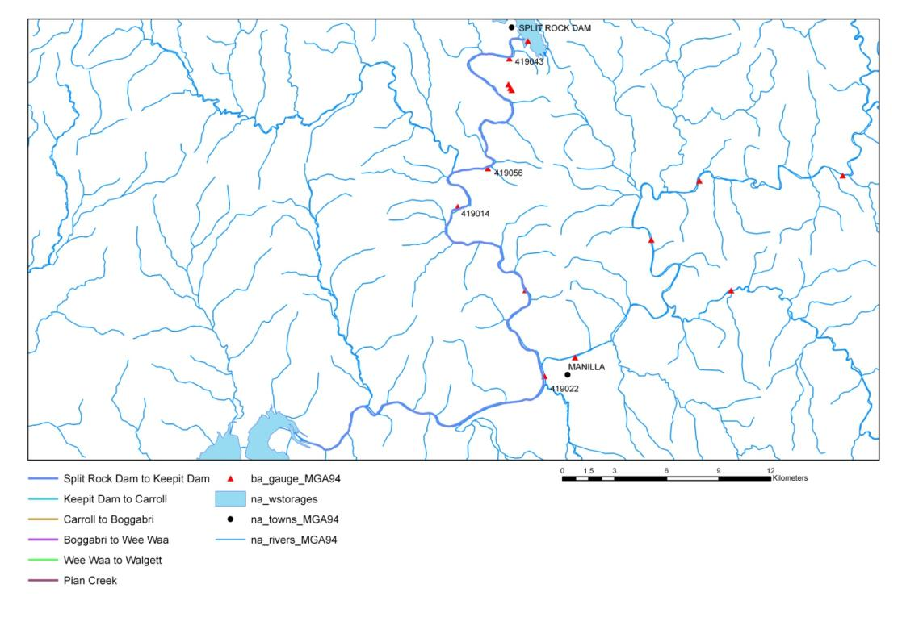 Figure 8: Location of Split Rock Dam to Keepit Dam reach (DIPNR (2004) Barwon Region shapefiles)

* Zone (Thoms 1998): mobile.
* River Styles (Lampert & Short 2004): partly confined, bedrock controlled, gravel.
* Length of main channel reach: 52.3 kilometres.

Summary description

The major water storages in the region include Keepit Dam on the Namoi River with a capacity of 425 gigalitres and the Split Rock Dam on the Manilla River, 28 kilometres from the township of Manilla, with a capacity of 397 gigalitres. Major irrigation development followed the completion of Keepit Dam on the Namoi River in 1961 and Split Rock Dam on the Manilla River in 1988. Split Rock Dam was designed to supply water for irrigation for licensees between Split Rock and Keepit Dam and to provide an augmentation supply to Keepit Dam during periods of drought. On the upper Namoi River, 9,724 megalitres of entitlement is located between Split Rock and Keepit Dams.

The Upper Namoi Regulated Water Source applies to the Manilla River downstream of Split Rock Dam and the Namoi River from the junction of the Manilla River downstream to Keepit Dam (Figure 8). Annual surface water use is strongly influenced by the seasonal rainfall patterns which cause inflows into the Keepit and Split Rock Dams and the access by irrigators to supplementary water during periods of high river flow. Surface water diversions in 2000 for the combined Namoi and Peel River systems were 315 gigalitres, including an estimated 42 gigalitres of use by unregulated stream licenses.

The Barwon Region Riverine Assessment Unit undertook macroinvertebrate sampling at a number of locations during the period leading up to the bulk water transfer trial between Split Rock and Keepit Dams. The same sites were sampled again during the trial release and further sampling was undertaken during the subsequent spring/summer period.

Of particular concern was the potential impact of high flows of extended duration and magnitude on platypus (*Ornithorynchus anatinus*) which are known to inhabit the area. During their breeding season (September–January) there is a potential for drowning either the eggs or hatchlings unable to escape burrows during periods of inundation from high flows. Although platypus are not generally considered an endangered species, there is a potential threat to their security at specific locations. The bulk water transfer trial and subsequent bulk transfer was initiated as soon as possible prior to the platypus breeding season to reduce the anticipated impacts on breeding pairs by ‘forcing’ them to adjust their brood burrows at a higher level in the riverbank thus reducing the possibility of drowning eggs or juvenile platypus during the high flow episode of the trial.

Foster (2001) provided draft guidelines for transferring water between Split Rock and Keepit Dams. The guidelines outlined transfer restrictions (i.e. river crossings, pumps and other infrastructure) as well as ecological restrictions (such as platypus requirements during breeding), and provided indicative volumes/hydrographs for bench wetting, streambed scouring and the prevention of streambank slumping.

**Water Management Areas**

* River channel
* River banks

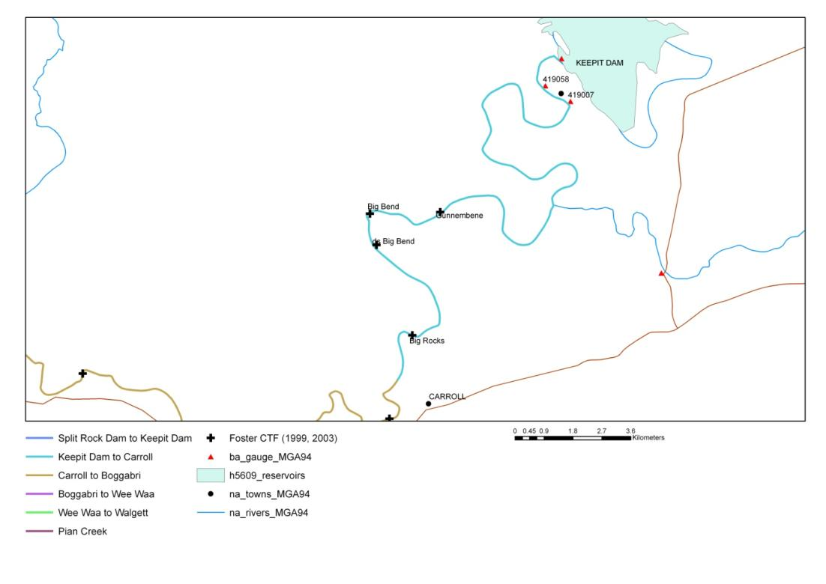Asset—Keepit Dam to Carroll

Figure 9: Location of Keepit Dam to Carroll reach (DIPNR (2004) Barwon Region shapefiles)

* Zone (Thoms 1998): mobile.
* River Styles (Lampert & Short 2004): partly confined, bedrock controlled, gravel.
* Condition (Lampert & Short 2004): moderate
* Length of main channel reach: 28.7 kilometres.

Summary description

Keepit Dam is situated approximately 60 kilometres west of Tamworth and 40 kilometres north-east of Gunnedah on the Namoi River (Figure 9). The catchment area for the dam is 41,350 square kilometres and it provides a reliable water source for downstream irrigators, industry and towns.

Keepit Dam has a capacity of 423,000 megalitres, a maximum depth of 40 metres, a mean depth of 9.6 metres and covers an area of 44 square kilometres (Preece 2004). Completed in 1960, the dam was built to regulate flow for irrigated crop production (principally cotton) in the Namoi River. Regulated discharges are made via a fixed level off-take structure positioned approximately 24 metres below full supply level (Preece 2004). The Keepit Dam Upgrade incorporates two measures to improve downstream environmental conditions—a multi-level off-take and a fishway.

The largest discharges from the dam coincide with peak irrigator demand and occur from December to February (Preece & Jones 2002, Boys et al. 2009). Median January discharge during the peak irrigation period is approximately 2,000 ML/d, and outside the irrigation period minimum flows approximate 10 ML/d. The current belief is that during the peak irrigation season a 5 °C depression in river temperature occurs 2 kilometres downstream of Keepit Dam, with the impact being largely eliminated by 40 kilometres downstream (Preece & Jones 2002).

Temperature suppression downstream of Keepit Dam is observed from September to March and the largest differences between upstream and downstream temperatures are observed between October and January (Preece & Jones 2002). The maximum annual temperature immediately downstream of Keepit Dam occurs in February, which is several weeks later than expected naturally (Preece & Jones 2002).

Table 16 indicates possible commence-to-flow values for in-stream and floodplain features between Keepit Dam and Gunnedah.

Table 16: Commence-to-flows (Q) for Keepit Dam to Gunnedah (Keepit Dam to Carroll reach)

|  |  |  |  |  |
| --- | --- | --- | --- | --- |
| **Site no.** | **Site** | **Description** | **Height (m)** | **Estimated Q (ML/d) at Gunnedah Gauge (419001)** |
| 1 | Gunnembene Crossing | Bench | 2.3 | 8,000–9,000 |
|  |  | Bench | 1.3 | 3,000–4,000 |
|  |  | Point Bar | 1.7 | 5,000–7,000 |
| 2 | Big Bend | Bench | 5.1 | 20,000–25,000 |
|  |  | Point Bar | 2.0 | 7,000–8,000 |
| 3 | D/S Big Bend | Bench | 1.9 | 5,000–6,000 |
|  |  | Billabong | 3.5 | 14,000–16,000 |
| 4 | Phantom Rock | Point Bar/Bench | 1.1 | 2,000–4,000 |
|  |  | Backwater | 3.5 | 15,000–17,000 |

Source: Foster 2003.

Note: No hydraulic analysis has been undertaken and the commence-to-flow values are only estimates based on flows at Gunnedah Gauge (419001).

**Asset—Carroll to Boggabri**

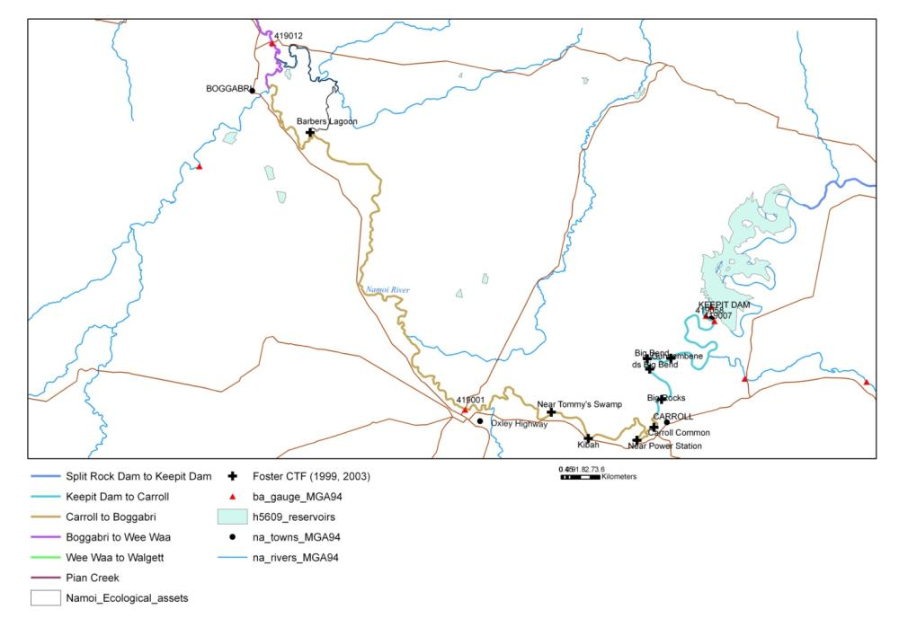

Figure 10: Location of Carroll to Boggabri reach (DIPNR (2004) Barwon Region shapefiles)

* Zone (Thoms 1998): meander.
* River Styles (Lampert and Short 2004): laterally unconfined, low sinuosity, gravel.
* Condition (Lampert and Short 2004): moderate.
* Length of main channel reach: 89.1 kilometres.

Summary description

This asset section commences at the village of Carroll, downstream of the confluence of the Peel and Namoi Rivers, and extends north and west, past Gunnedah, to the town of Boggabri (Figure 10). The Namoi River between Keepit Dam and Boggabri and the catchments of Mooki River and Coxs Creek form the region known as the Liverpool Plains. The Namoi River has a catchment area at the village of Carroll of 10,500 square kilometres and 17,000 square kilometres at the town of Gunnedah (Webb, Mckeown & Associates 2006).

Gulligal Lagoon, located in this reach, fills as a result of flooding and the extensive catchment areas of ephemeral streams, with Collygra Creek and Deadman’s Gully as important contributors. Gulligal Lagoon has been known to fill when the Namoi River at Gunnedah is at 5 metres, a height at which most of the river does not break its banks.

Possible commence-to-flow values for features between Carroll and Gunnedah is indicted in the table below.

Table 17: Commence-to-flows (Q) for Carroll to Gunnedah (Carroll to Gunnedah reach)

|  |  |  |  |  |
| --- | --- | --- | --- | --- |
| **Site no.** | **Site** | **Description** | **Height (m)** | **Estimated Q (ML/d) at Gunnedah Gauge (419001)** |
| 5 | Carroll Common | Bench | 2.1 | 7,000–8,000 |
|  |  | Bench | 3.5 | 15,000–17,000 |
|  |  | Bench | 5.0 | 23,000–25,000 |
| 6 | Near power substation | Floodrunner | 1.8 | 5,000–7,000 |
| 7 | Near Tommy’s Swamp | Backwater/anabranch | 2.1 | 7,000–8,000 |
| 8 | Kibah | Anabranch | 7.2 | 40,000 |
|  |  | Abandoned channel | 6.0 | 28,000–30,000 |

Source: Foster 2003.

Note: No hydraulic analysis has been undertaken and the commence-to-flow values are only estimates based on flows at Gunnedah Gauge (419001).

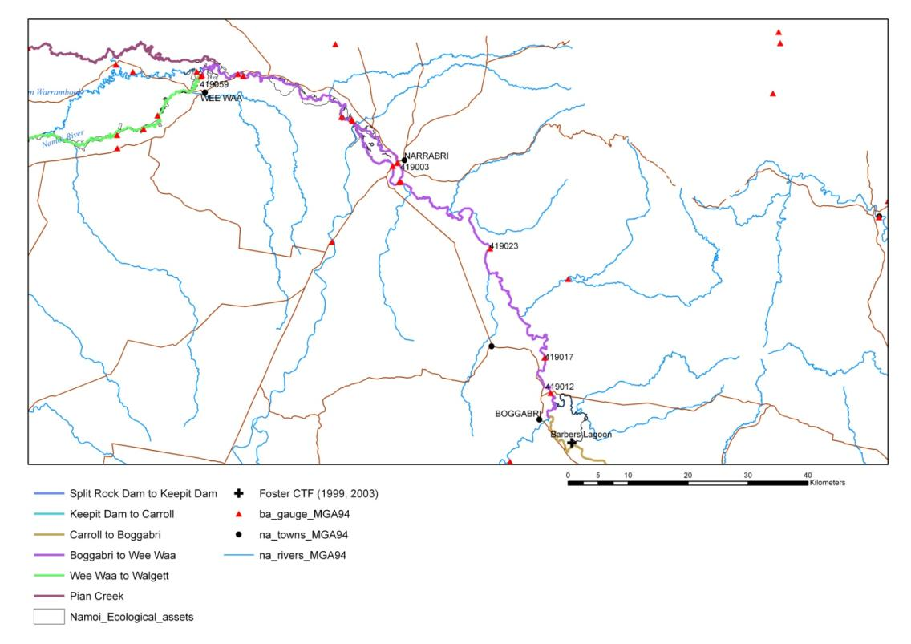**Asset—Boggabri to Wee Waa**

Figure 11: Location of Boggabri to Wee Waa reach (DIPNR (2004) Barwon Region shapefiles)

* Zone (Thoms 1998): anabranch.
* River Styles (Lampert and Short 2004): laterally unconfined, low sinuosity, gravel (Boggabri to u/s Pian Creek off-take).
* Condition (Lampert and Short 2004): moderate.
* Length of main channel reach: 140.6 kilometres.

Summary description

Major tributaries to the Namoi are located upstream of Boggabri (Figure 11). The reach between Boggabri and Narrabri is characterised by long, narrow lagoons that are prior channels of the Namoi River (Green et al. 2011). This includes Barbers Lagoon, a major anabranch within that reach. Downstream of Narrabri, the carrying capacity of the Namoi River is significantly reduced, and subsequently, floodwaters spread out through an effluent system over a vast floodplain. This area is considered the start of the true riverine zone of the Namoi catchment due to the increased frequency of lagoons, the low gradient of the channel and the development of anabranches and effluent channels. There are large numbers of lagoons in this reach, although most are small and require overbank flooding for inundation (Green & Dunkerley 1992). Two major weirs, Mollee and Gunidgera, are located downstream of Narrabri and are used to regulate water for irrigation, stock and domestic users in the lower Namoi (Green et al. 2011).

A significant feature of the river system at Narrabri is Narrabri Creek. This creek is a modified anabranch of the Namoi River which now takes a large proportion of the flow. Narrabri Creek starts just upstream of Narrabri and rejoins with the Namoi River downstream of the town, travelling 5–8 kilometres. The Narrabri Creek channel is highly degraded and actively widening through bank erosion and river bed aggradation. A remnant Namoi River channel remains and will flow when the Namoi River exceeds 25,000 to 30,000 ML/d.

Twelve native fish species, including the threatened silver perch and endangered populations of olive perchlet and purple-spotted gudgeon are known and expected to inhabit this asset reach. The inundated floodplain provides a nursery habitat for these fish, particularly golden and silver perch, that spawn in response to flooding. These species have a migratory response to flooding and spawn their eggs on or near the floodplain where larvae can readily access flood sources.

The Namoi demonstration reach is located between Narrabri and Boggabri and forms part of the Namoi Aquatic Habitat Initiative. This collaborative project between the Namoi Catchment Management Authority (CMA), Murray-Darling Basin Authority (MDBA), NSW Fisheries and land owners focuses on restoration activities including revegetation, fencing, erosion control, de-stocking and removal of fish barriers.

The demonstration reach highlights habitat restoration techniques and encourages native fish back into the waterways. Actions include remediating or removing priority barriers so that fish can move freely along the waterways, planting local native vegetation on stream banks, introducing large woody debris (snags) into the water and managing environmental flows to suit native fish.

**Water Management Areas**

1. Barbers Lagoon (Figure 12 and Plate 1)
2. Namoi River and Anabranches u/s Mollee Weir
3. Namoi River Red Gum corridor Mollee Weir to Gunidgera Weir (Wee Waa)

**a) Barbers Lagoon**

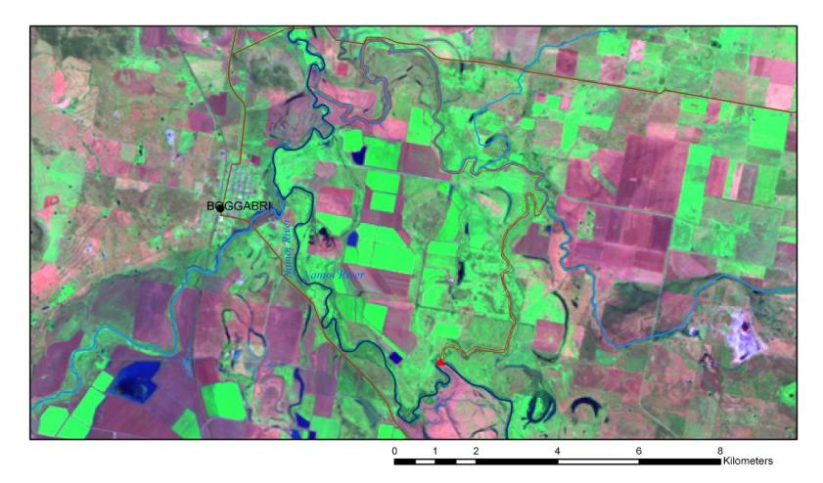

Figure 12: Satellite image of Barbers Lagoon 27/1/2004 (NASA Landsat Program, Landsat TM, Level 1 GeoTIFF, LT50910812004027, downloaded from [www.glovis.usgs.org](http://www.glovis.usgs.org/) 30 June 2011. Displayed as MGA94, Enhanced True colour). Lagoon shown in red.

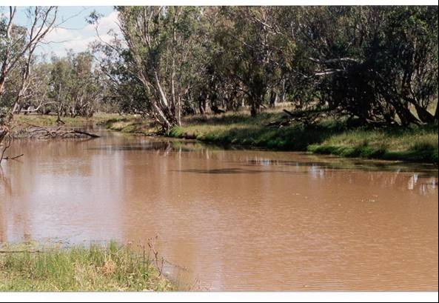

Plate 1: Barbers Lagoon (photo courtesy of NOW, undated)

Barbers Lagoon (shown above in Plate 1 and in red on the satellite image in Figure 12) is a 22-kilometre anabranch of the Namoi River located near Boggabri covering an area of approximately 134 hectares.

The lagoon also has inflow tributaries so may receive runoff water from local rainfall as well as from Namoi River flows. At the downstream end, adjacent to a road reserve, is the deepest pools in the lagoon, which was also monitored as an IMEF site by the former DLWC from 2000–2004. There is a mix of intact riparian vegetation and areas that have been cleared and cultivated. The estimated commence-to-flow (from Namoi River @ 419012) is 4,600 ML/d based on the information below (Table 18).

Table 18: Commence-to-flows for Boggabri to Wee Waa (Barbers Lagoon)

|  |  |  |  |
| --- | --- | --- | --- |
| **Date** | **Flow at 419021 (ML/d)** | **Remote sensing analysis\*** | **IMEF water depth max (m)** |
| 15/3/2001 | 8,200 | Possible isolated pools | 1.2 |
| 13/01/2002 | 3,250 | Possible isolated pools | 1.2 |
| 01/02/2003 | Dry | Dry | 0 |
| 06/04/2003 | 4,000 | 1km pool | No data |
| 27/01/2004 (Figure 12) | 7,600 | 8km wet d/s end | 1.5 |
| Commence-to-flow upstream of off-take (Foster 1999) | 4,602 @ 419012 |  |  |

Source: Foster 2003.

* Total length is 22 kilometres.

**b) Namoi River and anabranches upstream Mollee Weir**

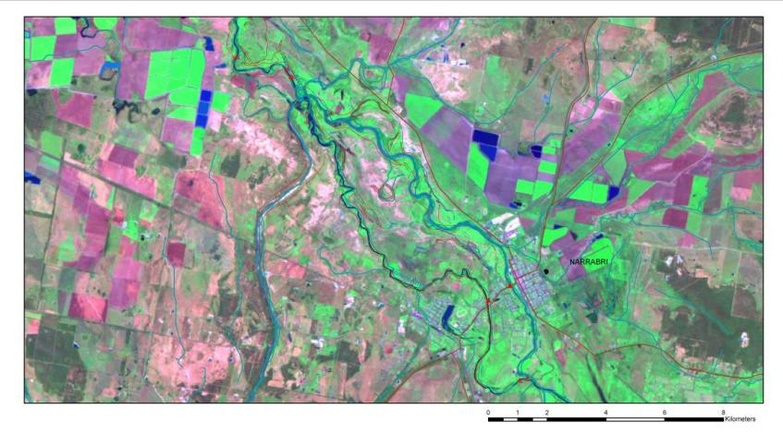

Figure 13: Satellite image of Namoi Anabranches upstream of Mollee Weir (NASA Landsat Program, Landsat TM, Level 1 GeoTIFF, LT50910812004027, downloaded from [www.glovis.usgs.org](http://www.glovis.usgs.org/) 30 June 2011. Displayed as MGA94, Enhanced True colour).

* Total area: 930 hectares.
* Values: anabranch, riparian corridor, cutoff channels, floodplain.

Summary description

The Namoi River splits into the Namoi River and Narrabri Creek upstream of Narrabri (Figure 13). Most low flows pass through Narrabri Creek with Namoi River flowing at higher flows only. Mollee Weir, located downstream of Narrabri, backs up water into a weir pool along both Narrabri Creek and the Namoi River. Between the two watercourses lie some floodplain features that inundate at moderate-to-high flows. This ‘asset’ includes the riparian channel and some floodplain wetlands covering a total area of approximately 930 hectares. Predominant land uses for this area is urban and grazing. The ecological value of this reach appears to be limited.

The gauges at Narrabri Creek (419003) and Namoi River (419002) are shown above as red triangles within Narrabri township (Figure 13). Comparison of the two gauges over the same time period (1990–1995) of low flows suggests a commence-to-flow for Namoi River in the order of 1,250 ML/d, however, there is a large degree of uncertainty due to backwater effects from Mollee Weir. The low-flow events between 1993 and 1995 suggest a commence-to-flow of between 1,500 ML/d (peaking in February 1994 in Narrabri Creek which did not result in flow in Namoi River) and 1,650 ML/d (peaking in August 1993). Remote sensing analyses suggest that the commence-to-flow for floodplain features is greater than the highest flow assessed of 8,200 ML/d, although local rainfall may fill some features (Figure 14).



Figure 14: Analysis of flow rates (ML/d) at Namoi River and Narrabri Creek at Narrabri

Estimated commence-to-flow (measured at 419002): 1,600 ML/d (channel), greater than 8,200 ML/d (floodplain features).

**c) Namoi River Red Gum Corridor, Mollee Weir to Gunidgera Weir**

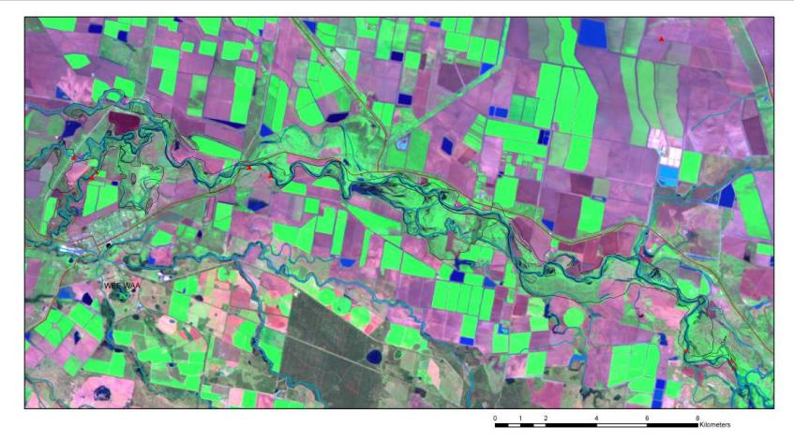

Figure 15: Satellite image of Namoi River from Mollee Weir to Gunidgera Weir 27/1/2004 (NASA Landsat Program, Landsat TM, Level 1 GeoTIFF, LT50910812004027, downloaded from [www.glovis.usgs.org](http://www.glovis.usgs.org/) 30 June 2011. Displayed as MGA94, Enhanced True colour).

* Total area: 3,194 hectares.
* Length of main channel reach: 40 kilometres.
* Values: main channel, riparian corridor, cutoff channels, floodplain.

Summary description

This reach contains relatively small lagoons, with most requiring overbank flooding for inundation (Figure 15). While some appear to be in a natural state, others contain groups of dead trees indicating their probable use as water storages (DIPNR 2003). Lagoons include:

* Reedy Lagoon—a narrow lagoon with a fringe of river red gums. Several shallow depressions nearby which are largely cultivated.
* Gurleigh Lagoon and Sheep Station Creek—forms a short anabranch of the river. The lagoon is connected to the creek and both are deep narrow channels dominated by river red gum. The creek has been dammed at either end since 1972 in order to retain stock and irrigation water. Minor floods are required to fill the creek and lagoon.
* Wirebrush Lagoon—the largest wetland in the area, characterised as a broad shallow depression. The lagoon is semi-permanent and is considered to possess significant habitat value due to the surrounding vegetation of coolibah and river cooba with occasional river red gum. It receives water from the river during high surplus flows via the Myall Vale Channel.
* Wee Waa Lagoon—a long, narrow lagoon located on the eastern side of Wee Waa. It is subject to flooding from the Namoi system, as well as from local flows from the Pilliga Scrub area. The Wee Waa levee abuts the lagoon.
* Possible commence-to-flow values for features in this reach are indicated in the table below.

Table 19: Commence-to-flows for Boggabri to Wee Waa (Mollee to Gunidgera Weirs)

|  |  |  |
| --- | --- | --- |
| **Date of imagery** | **Flow (419039) peak prior to imagery (ML/d)** | **Remote sensing analysis (anabranches and billabong features)** |
| 15/3/2001 | 11,237 | Partially wet with water in anabranches and some features. |
| 13/01/2002 | 3,546 | Partially wet in anabranch, most features dry. |
| 01/02/2003 | 2,973 | Most features dry, possibly some water in anabranch. |
| 06/04/2003 | 3,958 | Most features dry, possibly some water in anabranch. |
| 27/01/2004 (Figure 15) | 19,108 | Many features wet (as per above image). |

Source: Foster 2003.

Note: The large anabranch and wet area in the middle of the image above may be used as water storage or water diversions.

**Asset—Wee Waa to Walgett**

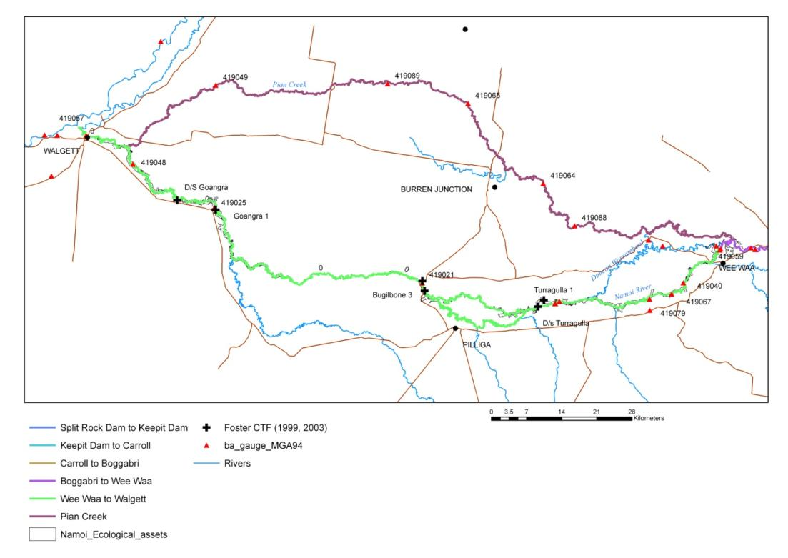

Figure 16: Location of Wee Waa to Walgett reach (DIPNR 2004, Barwon Region shapefiles)

* Zone (Thoms 1998): distributary.
* River Styles (Lampert & Short 2004): laterally unconfined, anabranching, meandering fine grained.
* Condition (Lampert & Short 2004): moderate.
* Length of main channel reach: 280.7 kilometres.

Summary description

Downstream of Wee Waa, the Namoi River progresses into the distributary zone where development of many anabranches and flood runners occur (Figure 16). Small tributary creeks draining the Pilliga Scrub to the south often contribute large volumes of water to the Namoi River and its adjacent floodplain wetlands. Near the town of Pilliga, the Namoi River splits into two channels for a distance of 6 kilometres. Duncans Warrambool, the northern channel, carries two-thirds of the flow. This section of the Namoi River contains small areas of intact remnant riverine and wetland ecosystems. Between the Namoi River to the south and Pian Creek to the north are a number of ephemeral watercourses that flow westward across the floodplain. They include Drildool, Cubbaroo, Dead Bullock and Chambers Warrambools and Coolibah Watercourse. This area is characterised by very flat terrain with elevations dropping approximately 1 metre per 1,500 metres (0.067 per cent) generally in an east-to-west direction. Small variations in contours are associated with drainage lines and alluvial depositions along stream courses.

Following the construction of Keepit Dam in 1960 and the introduction of cotton, the Namoi River Valley experienced a major shift in agriculture from low-intensity to high-intensity land use. The area of irrigated cotton in the valley expanded from 25 hectares in 1961 to approximately 30,000 hectares in 1984. The majority of landholders in the Narrabri–Wee Waa system now practice cropping, with the dominant system being cotton and cereal crop rotation. Some grazing still occurs but is gradually becoming less common.

The natural vegetation on the floodplains has been cleared to make way for cultivation. Several significant areas of vegetation mapped in 1985 had obviously been cleared. Nonetheless, this mapping indicates that vegetation within the area is typified by the following vegetation communities. River red gum forests are associated with major rivers and clay plains along streamlines and ox-bows. Coolibah is often dominant along minor streamlines. Significant vegetation communities located in this area include:

* Coolibah/poplar box woodlands—the remnant type typically occurs north of Wee Waa on the interzone between the black soil dominated alluvial plains and the more elevated earthy soils dominating the peneplain. It comprises elements of both coolibah and poplar box in a complex mosaic.
* Open coolibah woodlands with degraded understorey located on flats and banks on alluvial plains.
* Coolibah/river red gum woodland—associated with broad floodplain areas and often containing shallow depressions and streamlines. These remnants are typified by coolibah woodlands with a herbaceous understorey.
* Brigalow shrubland—typified by the dominance of brigalow, this remnant type also contains pockets dominated by belah and poplar box and is usually found on flats. The upper stratum species dominance seems to relate to site-drainage characteristics, the belah favouring the poorer-drained sites and the poplar box favouring the better-drained sites.

**Water Management Areas**

1. Namoi River Red Gum Corridor Gunidgera Weir to Weeta Weir
2. Duncans Warrambool (Turragulla)
3. Namoi River Red Gum Corridor downstream Duncans Junction to Bugilbone
4. Namoi River Red Gum/Coolibah Corridor Bugilbone to Goangra
5. Namoi River Red Gum/Coolibah Corridor downstream Goangra.

**a) Namoi Billabongs, Gunidgera Weir to Weeta Weir**

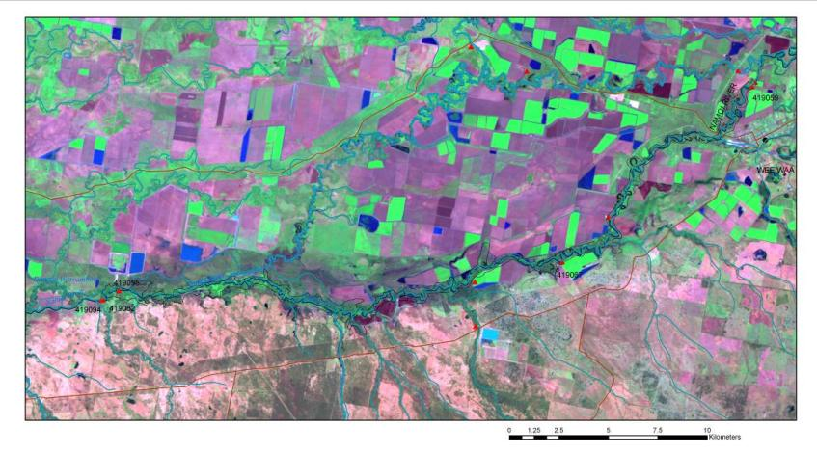

Figure 17: Satellite image of Gunidgera Weir to Weeta Weir 27/1/2004 (NASA Landsat Program, Landsat TM, Level 1 GeoTIFF, LT50910812004027, downloaded from [www.glovis.usgs.org](http://www.glovis.usgs.org/) 30 June 2011. Displayed as MGA94, Enhanced True colour).

* Zone (Thoms 1998): distributary.
* River Styles (Lampert & Short 2004): anabranching, meandering fine grained.
* Condition (Lampert & Short 2004): moderate.
* Total area: 2003 hectares.
* Length of main channel reach: 45 kilometres.
* Values: main channel, riparian corridor, cutoff channels/billabongs, floodplain.

Summary description

The Namoi River between Gunidgera and Weeta Weirs is an area of floodplain that has been extensively cleared with few wetland areas identified (Figure 17). A few small u‑shaped lagoons within the riverine zone offer the only natural wetland habitat in this section of the river.

Gunidgera Creek has extensive floodplain development and, as such, the only natural wetland areas available have been hydrologically modified in some way.

1. Cudgewa Storage and Lagoon is located in the channel of a floodway that previously flowed between Gunidgera Creek and Pian Creek. The storage is leveed on all sides and water is pumped into the storage from Gunidgera Creek. Many dead trees occur within the storage along the line of the original water level. The lagoon is a part of the old watercourse downstream of the storage and becomes inundated during flood events.
2. Woodlands Billabong is part of a u-shaped lagoon that has been cut in half by a leveed irrigation channel. Surplus flows are pumped into the storage from Gunidgera Creek and floodwaters may also flow over the levee and into the storage. The vegetative fringe of the storage consists mainly of river red gum. Water is stored for stock and wildlife.
3. “Weeta Waa” Lagoon is a large meander of Gunidgera Creek that has been cut off from the rest of the creek by dams at either end. The dominant vegetation is cumbungi, with coolibah, river cooba and lignum. The water stored is primarily used for irrigation.

Possible commence-to-flow values for features associated with this reach are indicated in the table located below.

Table 20: Commence-to-flows for Gunidgera Weir to Weeta Weir

|  |  |  |  |
| --- | --- | --- | --- |
| **Date of imagery** | **Flow (419021) peak prior to imagery (ML/d)** | **Remote sensing analysis (Billabongs)** | **Approx. surface area wet (Billabongs) (Ha)** |
| 15/3/2001 | 8,200 | Some wet | 10 |
| 13/01/2002 | 3,250 | Dry | 0 |
| 01/02/2003 | Dry | Dry | 0 |
| 06/04/2003 | 4,000 | Dry | 0 |
| 27/01/2004 (Figure 17) | 7,600 | Mostly wet | 17 |

Source: Foster 2003.

**b) Duncans Warrambool (Turragulla)**

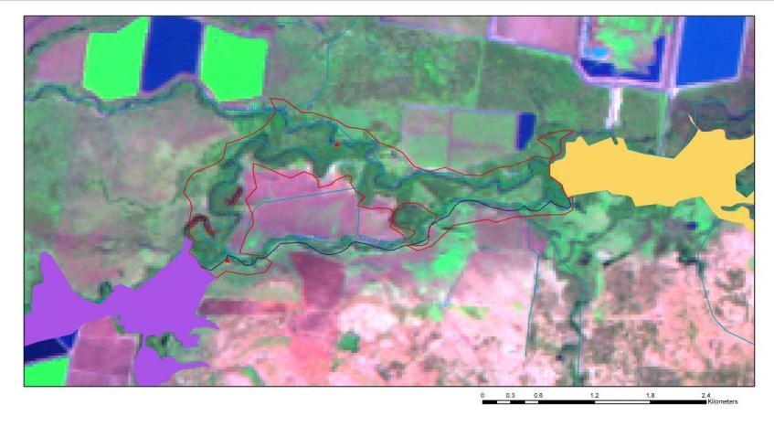

Figure 18: Satellite image for Duncans Warrambool 27/1/2004 (NASA Landsat Program, Landsat TM, Level 1 GeoTIFF, LT50910812004027, downloaded from [www.glovis.usgs.org](http://www.glovis.usgs.org/) 30 June 2011. Displayed as MGA94, Enhanced True colour).

* Zone (Thoms 1998): distributary.
* River Styles (Lampert & Short 2004): anabranching, meandering fine grained.
* Condition (Lampert & Short, 2004): moderate.
* Total area: 300 hectares.
* Values: anabranch, riparian corridor, cutoff channels/billabongs, floodplain.

Summary description

The Namoi River splits into two channels near Pilliga for a distance of 6 kilometres. The northern channel, known as Duncans Warrambool, carries two-thirds of the flow (Figure 18).

Table 21: Commence-to-flows for Duncans Warrambool

|  |  |  |
| --- | --- | --- |
| **Date of imagery** | **Flow (419021 and 419095) peak prior to imagery (ML/d)** | **Remote sensing analysis (anabranch)** |
| 15/3/2001 | 8,200–20,420 | Wet |
| 13/01/2002 | 3,250 | Dry |
| 01/02/2003 | Dry–600 | No data (cloud) |
| 06/04/2003 | 4,000–3,936 | Dry |
| 27/01/2004 (Figure 18) | 7,600–18,817 | Wet |
| **Commence-to-flow analysis** | **Foster (1999)** |  |
| Anabranch (u/s) | 3,230@419082 |  |
| Bench | 1,740@419082 |  |
| Anabranch (d/s) | 3,300@419082 |  |

Note: 419082 (Namoi River u/s Duncans Junction) was moved to 419095 (Namoi @ Bullawa) around 2000. No data available for 419082, approximate flows for remote sensing analysis were taken from 419095.

Remote sensing analysis could not confirm the commence-to-flow as indicated by Foster (1999) but does indicate that commence-to-flow is greater than 3,940 ML/d at 419095.

It is suggested that 4,000 ML/d should be used as the commence-to-flow for this anabranch as an interim measure, but this requires confirmation***.***

**c) Namoi River Red Gum Corridor downstream Duncans Junction to Bugilbone**

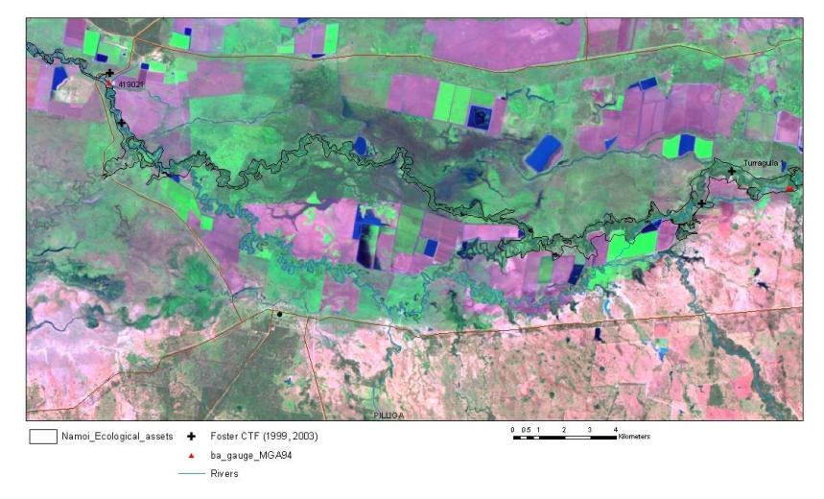

Figure 19: Satellite image for Duncans Junction to Bugilbone 27/1/2004 (NASA Landsat Program, Landsat TM, Level 1 GeoTIFF, LT50910812004027, downloaded from [www.glovis.usgs.org](http://www.glovis.usgs.org/) 30 June 2011. Displayed as MGA94, Enhanced True colour).

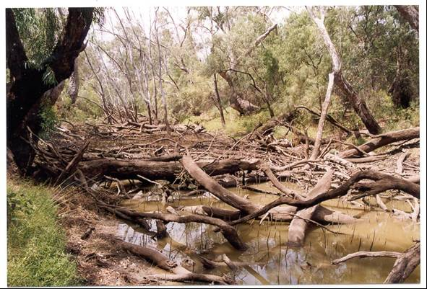

Plate 2: Duncan’s Junction (photo courtesy of NOW, undated)

* Zone (Thoms 1998): distributary.
* River Styles (Lampert & Short 2004): anabranching, meandering fine grained.
* Condition (Lampert & Short 2004): moderate.
* Total area: 1,122 hectares.
* Values: anabranch, riparian corridor, cutoff channels/billabongs, floodplain.

Summary description

The main vegetation community in this area is the endangered coolabah—black box woodlands which are found throughout the sub-catchment. Other areas are dominated by Myall woodlands and bimble box—belah woodlands, with many wetlands and billabongs found along the river.

Land use is predominantly dryland farming and grazing due to a lower rainfall. Irrigated farming and cotton production are also practised in this area but only on a small scale. The issues within this area are invasive vegetation regrowth, dryland salinity, pasture degradation and riparian management (NCMA 2009).

Duncan’s Junction is located in an abandoned channel of the Namoi River approximately 20 kilometres upstream of Pilliga (Figure 19; Plate 2). This wetland is filled from the Namoi River via the downstream end. This allows the wetland to fill slowly, minimising the impact of high-velocity scouring flows which affect some of the other wetland sites. Water is held in deeper pools for long periods, resulting in azolla *(Azolla filiculoides*) and slender knotweed (*Persicaria decipiens*) dominating the water habitat. Cane grass (*Eragrostis australasila*) is also common in areas with high soil moisture, while Warrego summer grass (*Paspalidium juibiflorum*) dominates the drier areas. River cooba *(Acacia stenophylla)* and river red gums dominate the overstorey (IMEF information, NOW).

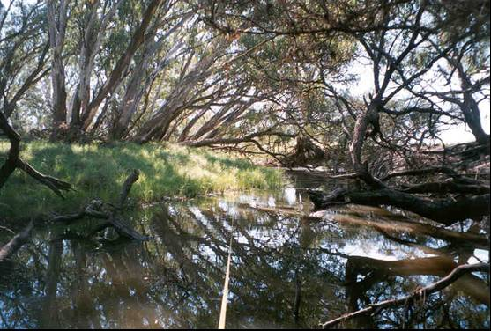

Plate 3: Namoi River (Wetland) upstream Bugilbone (source: NOW, undated).

Wetlands in this section are frequently dominated by *Cynodon dactylon* (couch grass), the most dominant grass species along with *Paspalidium juibiflorum* (Warrego summer grass). *Paspalum distichum* (water couch) is the principal aquatic species, inhabiting the edge of pools when they were filled by floodwater (IMEF information, NOW) (Plate 3). Table 22 shows commence-to-flow values for this reach.

Table 22: Commence-to-flows for Duncan’s Junction to Bugilbone

|  |  |  |
| --- | --- | --- |
| **Date of imagery** | **Flow (419021) peak prior to imagery (ML/d)** | **Remote sensing analysis (anabranch)** |
| 15/3/2001 | 8,200 | No features discernable at landsat resolution (30 m). |
| 13/01/2002 | 3,250 |  |
| 01/02/2003 | Dry |  |
| 06/04/2003 | 4,000 |  |
| 27/01/2004 (Figure 19) | 7,600 |  |
| **Commence-to-flow analysis** | **Foster (1999)** |  |
| Anabranch | 4,496@419021 |  |
| Bench 1 | 3,921@419021 |  |
| Bench 2 | 1,780@419021 |  |
| Bench 3 | 3,724@419021 |  |

Foster (1999) commence-to-flow estimates:

* Low-level bench 1,800 ML/d @ 419021
* Mod-level bench 4,000 ML/d @ 419021
* Anabranches 4,500 ML/d @ 419021

**d)** **Namoi River Red Gum/Coolibah Corridor Bugilbone to Goangra**

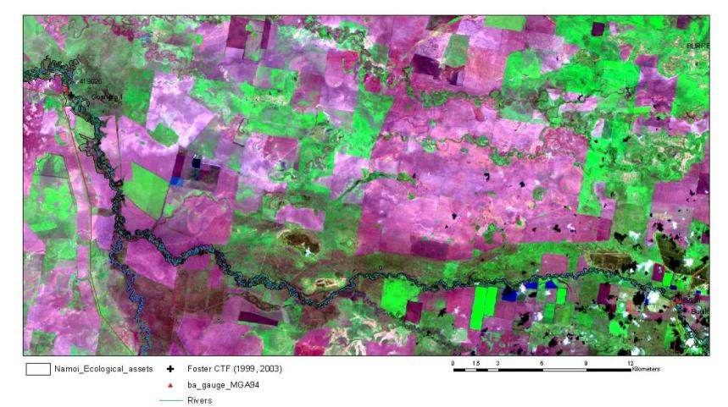

Figure 20: Satellite image of Bugilbone to Goangra 27/1/2004 (NASA Landsat Program, Landsat TM, Level 1 GeoTIFF, LT50910812004027, downloaded from [www.glovis.usgs.org](http://www.glovis.usgs.org/) 30 June 2011. Displayed as MGA94, Enhanced True colour).

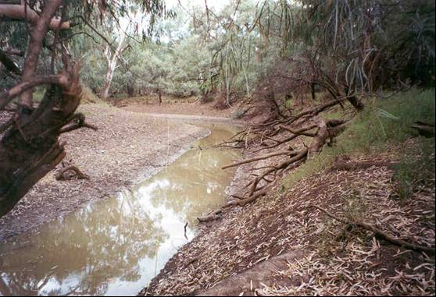

Plate 4: Namoi River (Wetland) upstream Goangra (source: NOW, undated)

* Zone (Thoms 1998): distributary.
* River Styles (Lampert & Short 2004): anabranching, meandering fine grained.
* Condition (Lampert & Short 2004): moderate.
* Total area: 1,690 hectares.
* Values: anabranch, riparian corridor, cutoff channels/billabongs, floodplain.

Summary description

Figure 20 and Plate 4 illustrate features of this reach. Minor increases in flow can result in wetland sites in this reach being inundated, filling the large pool in the middle of the wetland. Riparian vegetation often consists of river red gum though vegetation can be sparse in this area. Lesser joyweed (*Alternanthera denticulata*) and Warrego summer grass are often the most common plants (IMEF information, NOW).

Table 23: Commence-to-flows for Bugilbone to Goangra reach

|  |  |  |
| --- | --- | --- |
| **Date of imagery** | **Flow (419021) peak prior to imagery (ML/d)** | **Remote sensing analysis (anabranch)** |
| 15/3/2001 | 8,200 | No features discernable at landsat resolution (30 m). |
| 13/01/2002 | 3,250 |  |
| 01/02/2003 | Dry |  |
| 06/04/2003 | 4,000 |  |
| 27/01/2004 (Figure 20) | 7,600 |  |
| **Commence-to-flow analysis** | **Foster (1999)** |  |
| Low-flow bench | 1,865@419026 |  |
| Moderate-flow bench | 6,277@419026 |  |
| High-flow bench | 13,766@419026 |  |

**e) Namoi River Red Gum/Coolibah Corridor d/s Goangra**

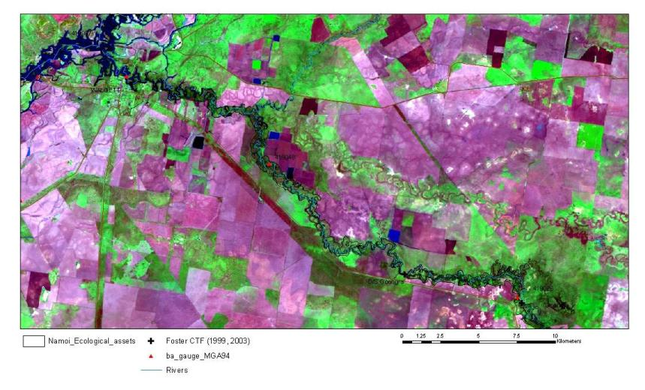

Figure 21: Satellite image downstream of Goangra 27/1/2004 (NASA Landsat Program, Landsat TM, Level 1 GeoTIFF, LT50910812004027, downloaded from [www.glovis.usgs.org](http://www.glovis.usgs.org/) 30 June 2011. Displayed as MGA94, Enhanced True colour).

* Zone (Thoms 1998): distributary.
* River Styles (Lampert & Short 2004): anabranching, meandering fine grained.
* Condition (Lampert & Short 2004): moderate.
* Total area: 1,880 hectares.
* Values: anabranch, riparian corridor, cutoff channels/billabongs, floodplain.

Figure 21 illustrates features of the area downstream of Goangra. Table 23 shows likely commence-to-flow values for this reach.

Table 24: Commence-to-flows downstream Goangra

|  |  |  |
| --- | --- | --- |
| **Date of imagery** | **Flow (419021) peak prior to imagery (ML/d)** | **Remote sensing analysis (anabranch)** |
| 15/3/2001 | 8,200 | No features discernable at landsat resolution (30 m). |
| 13/01/2002 | 3,250 |  |
| 01/02/2003 | Dry |  |
| 06/04/2003 | 4,000 |  |
| 27/01/2004 (Figure 21) | 7,600 |  |
| **Commence-to-flow analysis** | **Foster (1999)** |  |
| Low flow bench | 2,148@419026 |  |

**Asset—Pian Creek**

(See Figure 16)

* Zone (Thoms 1998): distributary.
* River Styles (Lampert and Short 2004): anabranching, meandering fine grained.
* Condition (Lampert & Short 2004): moderate.
* Length of main channel reach: 222.0 kilometres.

Summary description

In the vicinity of Wee Waa, floodwater leaves the Namoi River via a series of anabranches, with two being Pian Creek and Gunidgera Creek. These creeks are both used to distribute regulated irrigation supplies to properties along their reaches. During major flood events all of the country west of Wee Waa is inundated, with the exception of high ridges adjacent to and north of Pian Creek. Pian Creek continues flowing westwards until it rejoins the Namoi River upstream of Walgett, while Gunidgera Creek rejoins the river approximately 25 kilometres downstream of the off-take. Pian Creek has only a few discrete wetlands due to extensive floodplain development and the loss of a number of natural wetlands due to cultivation in this area. The main wetlands include:

1. Krui Swamp—a shallow depression surrounded by coolibah woodland. The main source of water is local drainage, filling only after intense rain.
2. Wilgamere—a very shallow lagoon and floodway. Water spills out of Pian Creek to the west of Merah North, flows along a shallow floodway and ponds in the floodway at “Wilgamere” forming a shallow lagoon. The lagoon would dry relatively quickly after flooding.

State Water provides two replenishment flow events, up to a combined total volume of 14,000 megalitres in a water year, to Pian Creek. These flows are to provide a visible flow for five or more consecutive days at Waminda gauge (419049). One replenishment flow must be delivered in the first half of the water year and the other in the second half of the water year, at intervals of no more than seven months apart under most circumstances. Releases to Pian Creek downstream from the Gunidgera off-take should meet the following conditions:

1. daily supply volumes in Pian Creek do not exceed 1,600 ML/d for no more than 10 per cent of days in any month in a water year; and
2. the maximum daily supply volume in Pian Creek does not exceed 2,000 ML/d.

**Asset—Peel River**

Summary Description

“The Peel River, directly downstream of Chaffey Dam, is a confined channel that is narrowing and becoming invaded by riparian vegetation due to the lack of high velocity flows. The lack of high velocity flows has also resulted in in-stream gravel becoming immobile and encrusted with filamentous algal mats and biofilms during summer.

Riverine vegetation supported by the Peel River includes emergent aquatic plants and river oaks, rough-barked apple and river red gum. Straw-necked ibis are often observed on floodplain areas in this zone.

A more natural flow regime which includes variability, frequency and magnitude downstream of Chaffey Dam is likely to improve in-stream foodwebs and physical channel habitats. This could be achieved by better management of regulated irrigation release or by the application of a stimulus flow rule. However, due to the outlet capacity restrictions of the dam, high velocity and increased volumes are difficult to achieve. Rules such as dam translucency and/or transparency may achieve some benefit without compromising irrigator reliability.” [Foster (2003); Foster and Lewis (2009)]

Table 25 indicates possible requirements for features in the Peel River.

Table : Indicative commence-to-fill requirements of in-stream benches and distributary effluents of the Regulated Peel River

|  |  |  |  |
| --- | --- | --- | --- |
| **Site** | **Description** | **Estimated discharge required to wet benches (ML/d)** | **Relevant gauge** |
| D/S Chaffey 1 | In-stream benches | 450  650  3,960  5,580 | D/S Chaffey  419045 |
| D/S Chaffey 2 | In-stream benches | 1,913  7,943  11,207 | D/S Chaffey  419045 |
| Woolomin | In-stream benches | 240  550  2,280 | D/S Chaffey  419045 |
| D/S Woolomin | In-stream benches | 500  420  700 | D/S Chaffey  419045 |
| D/S Dungowan | In-stream benches | 320  730  1,412 | Piallamore  419015 |
| Peel River upstream of Cockburn River | In-stream benches | 85  740  890  2,390  2,350  10,000 | Piallamore  419015 |
| Appleby Gauge | In-stream benches  Floodrunner | 600  7,300  9,000  10,275 | Appleby Crossing  419073 |
| Carroll Gap | In-stream benches | 4,580  16,200  30,900 | Carroll Gap  419006 |

Source: Foster 2009.

**Water Management Area**

Peel River—Chaffey Dam to Cockburn River

Features include in-stream benches and gravel point bars. The features in the zone between the dam wall and the Cockburn River are generally in good condition with some grazing impacts (Plates 5). This area also provides a good source of litter and organic matter.

The low-level in-stream benches require volumes of approximately 500 ML/d to inundate (NOW 2009), with higher level benches requiring between 1,000 and 4,000 ML/d. Benches higher in elevation in the reach, directly downstream of Chaffey Dam, require flows greater than the discharge capacity of the dam outlet. Inundation of these benches only occurs when the dam spills. Some benches further downstream require volumes of 2,000–5,000 ML/d to inundate.

The river channel in the zone downstream of Chaffey Dam to below the confluence of Dungowan Creek would most benefit from an increase in higher flows achieved through either a translucent or stimulus flow regime. Inundation of higher bench height thresholds could also be achieved by piggybacking dam releases onto high flows from Dungowan Creek. Extensive in-stream pool habitats are also contained in this area.

The area around Piallamore Anabranch to upstream of the confluence with the Cockburn River features a wide floodplain (plates 6 and 7). The Piallamore Anabranch, on the eastern side of the floodplain, runs for many kilometres. This anabranch is filled during high flows, however, water levels are mostly replenished by overland flows derived from adjacent hills. The channel is wider and deeper and riparian vegetation condition has suffered from grazing pressure and clearing. Lateral erosion of the banks through channel migration and avulsion may also have contributed to the reduction of vegetation in this area. More willows appear in these downstream reaches and these often cause stream blockages which results in bank erosion.

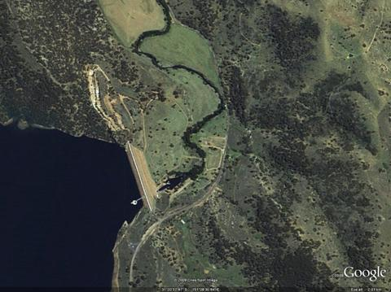

Plate 5: Peel River immediately downstream of Chaffey Dam (Foster 2003).

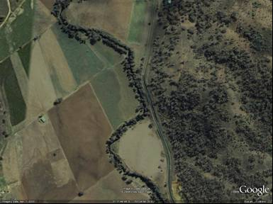

Plate 6: Peel River upstream of the Piallamore Anabranch (Foster 2003).

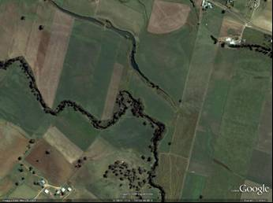

Plate 7: Peel River in the vicinity of the Piallamore Anabranch (Foster 2003).

Appendix 4 Probabilities of unregulated flows in the Namoi River at Wee Waa

Daily flows for various exceedance percentiles at Wee Waa have been determined. These are presented for each month for extreme-dry to extreme-wet scenarios. These results are based on an analysis of more than 100 years of modelled flows for current development and Water Sharing Plan rules. Annual flow totals were firstly ranked. Years corresponding to a particular climatic condition were then extracted and daily flows were then analysed to produce information on the percentage of time a flow threshold was exceeded together with the average duration (Avg D) of days above the flow threshold. This was undertaken for each month. For example, in Table 26, a January flow of 201 ML/d will be exceeded for 20 per cent of the time, with events exceeding 201 ML/d for an average duration of two days. January flow will be at least 0 ML/d (i.e. 100 per cent probability of being exceeded) with a maximum flow of about 17,778 ML/d.

It is recommended that further analysis of these events be undertaken at several sites to determine potential threshold events for the possible use of held environmental water via piggybacking.

Table : Probabilities of unregulated flows under extreme dry conditions—Wee Waa

|  |  |  |  |  |  |  |  |  |  |  |  |  |  |  |  |  |  |  |  |  |  |  |  |  |
| --- | --- | --- | --- | --- | --- | --- | --- | --- | --- | --- | --- | --- | --- | --- | --- | --- | --- | --- | --- | --- | --- | --- | --- | --- |
|  | **Jan** |  | **Feb** |  | **Mar** |  | **Apr** |  | **May** |  | **Jun** |  | **Jul** |  | **Aug** |  | **Sep** |  | **Oct** |  | **Nov** |  | **Dec** |  |
|  | **Flow** | **Avg D** | **Flow** | **Avg D** | **Flow** | **Avg D** | **Flow** | **Avg D** | **Flow** | **Avg D** | **Flow** | **Avg D** | **Flow** | **Avg D** | **Flow** | **Avg D** | **Flow** | **Avg D** | **Flow** | **Avg D** | **Flow** | **Avg D** | **Flow** | **Avg D** |
| **100%** | 0 |  | 0 |  | 36 | 31 | 21 | 30 | 15 | 31 | 33 | 30 | 0 |  | 0 |  | 0 |  | 0 |  | 2 | 30 | 0 |  |
| **90%** | 50 | 9 | 39 | 27 | 46 | 21 | 30 | 30 | 19 | 31 | 44 | 30 | 74 | 28 | 71 | 23 | 37 | 13 | 40 | 23 | 41 | 23 | 111 | 20 |
| **80%** | 61 | 7 | 44 | 22 | 53 | 20 | 30 | 11 | 20 | 31 | 55 | 30 | 91 | 10 | 78 | 16 | 57 | 10 | 42 | 18 | 54 | 40 | 149 | 10 |
| **70%** | 70 | 6 | 54 | 9 | 59 | 16 | 31 | 15 | 22 | 31 | 60 | 24 | 127 | 10 | 96 | 14 | 86 | 7 | 50 | 22 | 88 | 13 | 178 | 10 |
| **60%** | 83 | 5 | 60 | 6 | 80 | 12 | 33 | 15 | 26 | 31 | 61 | 14 | 143 | 9 | 123 | 23 | 101 | 6 | 67 | 19 | 130 | 18 | 196 | 8 |
| **50%** | 125 | 4 | 76 | 9 | 105 | 11 | 40 | 19 | 30 | 31 | 65 | 16 | 165 | 10 | 149 | 10 | 107 | 6 | 92 | 13 | 192 | 13 | 231 | 7 |
| **40%** | 145 | 3 | 131 | 7 | 114 | 11 | 47 | 15 | 37 | 19 | 78 | 11 | 201 | 6 | 154 | 9 | 123 | 8 | 118 | 9 | 233 | 8 | 275 | 6 |
| **30%** | 167 | 3 | 191 | 7 | 182 | 9 | 82 | 9 | 60 | 11 | 90 | 11 | 219 | 7 | 194 | 16 | 134 | 6 | 165 | 6 | 264 | 8 | 315 | 5 |
| **20%** | 201 | 2 | 550 | 6 | 310 | 13 | 156 | 6 | 77 | 10 | 441 | 10 | 259 | 5 | 207 | 16 | 189 | 15 | 277 | 10 | 422 | 30 | 384 | 4 |
| **10%** | 452 | 4 | 743 | 2 | 543 | 7 | 431 | 8 | 109 | 8 | 1,551 | 3 | 346 | 8 | 664 | 8 | 588 | 5 | 468 | 5 | 1,009 | 3 | 785 | 5 |
| **0%** | 17,778 | 1 | 2,610 | 1 | 4,701 | 2 | 2,130 | 1 | 286 | 1 | 21,398 | 1 | 815 | 1 | 4,672 | 1 | 638 | 1 | 809 | 1 | 1,486 | 1 | 1,355 | 1 |

Table : Probabilities of unregulated flows under dry conditions—Wee Waa

|  |  |  |  |  |  |  |  |  |  |  |  |  |  |  |  |  |  |  |  |  |  |  |  |  |
| --- | --- | --- | --- | --- | --- | --- | --- | --- | --- | --- | --- | --- | --- | --- | --- | --- | --- | --- | --- | --- | --- | --- | --- | --- |
|  | **Jan** |  | **Feb** |  | **Mar** |  | **Apr** |  | **May** |  | **Jun** |  | **Jul** |  | **Aug** |  | **Sep** |  | **Oct** |  | **Nov** |  | **Dec** |  |
|  | **Flow** | **Avg D** | **Flow** | **Avg D** | **Flow** | **Avg D** | **Flow** | **Avg D** | **Flow** | **Avg D** | **Flow** | **Avg D** | **Flow** | **Avg D** | **Flow** | **Avg D** | **Flow** | **Avg D** | **Flow** | **Avg D** | **Flow** | **Avg D** | **Flow** | **Avg D** |
| **100%** | 0 |  | 0 |  | 0 |  | 0 |  | 19 | 578 | 0 |  | 54 | 31 | 0 |  | 0 |  | 27 | 31 | 98 | 30 | 113 | 31 |
| **90%** | 211 | 23 | 86 | 26 | 201 | 24 | 41 | 23 | 25 | 91 | 64 | 30 | 84 | 31 | 104 | 28 | 204 | 30 | 134 | 31 | 261 | 30 | 268 | 31 |
| **80%** | 407 | 15 | 311 | 19 | 305 | 13 | 54 | 13 | 35 | 33 | 77 | 24 | 109 | 31 | 186 | 20 | 337 | 16 | 186 | 21 | 364 | 30 | 507 | 21 |
| **70%** | 545 | 9 | 426 | 12 | 350 | 11 | 73 | 14 | 55 | 19 | 89 | 17 | 202 | 18 | 265 | 12 | 438 | 14 | 220 | 14 | 436 | 19 | 642 | 14 |
| **60%** | 661 | 7 | 561 | 10 | 421 | 10 | 97 | 10 | 72 | 13 | 101 | 11 | 250 | 12 | 279 | 9 | 512 | 12 | 278 | 15 | 536 | 14 | 796 | 17 |
| **50%** | 842 | 5 | 653 | 7 | 525 | 9 | 119 | 8 | 90 | 12 | 117 | 9 | 283 | 10 | 317 | 8 | 598 | 10 | 313 | 9 | 615 | 12 | 1,001 | 16 |
| **40%** | 1,023 | 7 | 738 | 5 | 617 | 8 | 153 | 9 | 110 | 12 | 137 | 9 | 324 | 10 | 380 | 7 | 698 | 7 | 333 | 9 | 761 | 10 | 1,225 | 10 |
| **30%** | 1,226 | 4 | 837 | 5 | 719 | 6 | 198 | 9 | 159 | 10 | 166 | 9 | 372 | 8 | 495 | 7 | 745 | 6 | 405 | 6 | 909 | 6 | 1,435 | 9 |
| **20%** | 1,399 | 3 | 1,046 | 4 | 898 | 5 | 258 | 9 | 201 | 9 | 244 | 6 | 574 | 7 | 840 | 8 | 824 | 6 | 474 | 4 | 1,055 | 5 | 1,672 | 11 |
| **10%** | 1,679 | 2 | 1,342 | 4 | 1,561 | 6 | 443 | 11 | 322 | 7 | 403 | 7 | 1197 | 7 | 1,437 | 4 | 1,119 | 4 | 587 | 4 | 1,453 | 5 | 2,034 | 7 |
| **0%** | 17,083 | 1 | 10,883 | 1 | 16,709 | 1 | 2,508 | 1 | 6,580 | 1 | 1,183 | 1 | 22,252 | 1 | 16,045 | 1 | 4,984 | 1 | 1,821 | 1 | 12,230 | 1 | 3,442 | 1 |

Table : Probabilities of unregulated flows under median conditions—Wee Waa

|  |  |  |  |  |  |  |  |  |  |  |  |  |  |  |  |  |  |  |  |  |  |  |  |  |
| --- | --- | --- | --- | --- | --- | --- | --- | --- | --- | --- | --- | --- | --- | --- | --- | --- | --- | --- | --- | --- | --- | --- | --- | --- |
|  | **Jan** |  | **Feb** |  | **Mar** |  | **Apr** |  | **May** |  | **Jun** |  | **Jul** |  | **Aug** |  | **Sep** |  | **Oct** |  | **Nov** |  | **Dec** |  |
|  | **Flow** | **Avg D** | **Flow** | **Avg D** | **Flow** | **Avg D** | **Flow** | **Avg D** | **Flow** | **Avg D** | **Flow** | **Avg D** | **Flow** | **Avg D** | **Flow** | **Avg D** | **Flow** | **Avg D** | **Flow** | **Avg D** | **Flow** | **Avg D** | **Flow** | **Avg D** |
| **100%** | 0 |  | 0 |  | 0 |  | 3 | 30 | 10 | 2696 | 19 | 30 | 57 | 31 | 24 | 31 | 16 | 30 | 27 | 31 | 24 | 30 | 173 | 31 |
| **90%** | 228 | 18 | 188 | 25 | 107 | 31 | 84 | 30 | 71 | 52 | 103 | 30 | 106 | 31 | 79 | 31 | 91 | 30 | 74 | 31 | 194 | 30 | 521 | 31 |
| **80%** | 399 | 15 | 318 | 18 | 186 | 27 | 128 | 30 | 107 | 37 | 138 | 30 | 201 | 17 | 201 | 31 | 276 | 30 | 274 | 31 | 369 | 30 | 730 | 20 |
| **70%** | 523 | 10 | 458 | 17 | 354 | 17 | 174 | 26 | 154 | 33 | 176 | 21 | 234 | 12 | 289 | 15 | 422 | 19 | 292 | 18 | 450 | 29 | 923 | 16 |
| **60%** | 679 | 9 | 633 | 10 | 453 | 16 | 245 | 20 | 187 | 29 | 256 | 22 | 279 | 12 | 338 | 13 | 562 | 16 | 331 | 16 | 509 | 25 | 1,117 | 14 |
| **50%** | 920 | 11 | 699 | 8 | 552 | 13 | 328 | 21 | 227 | 19 | 306 | 17 | 309 | 11 | 423 | 13 | 668 | 12 | 389 | 12 | 567 | 14 | 1,317 | 11 |
| **40%** | 1,176 | 7 | 830 | 6 | 652 | 10 | 445 | 19 | 281 | 19 | 452 | 22 | 600 | 20 | 692 | 12 | 783 | 9 | 541 | 14 | 676 | 10 | 1,565 | 11 |
| **30%** | 1,435 | 5 | 914 | 7 | 769 | 9 | 602 | 13 | 402 | 15 | 702 | 11 | 1,078 | 15 | 842 | 10 | 891 | 7 | 750 | 12 | 722 | 8 | 1,843 | 10 |
| **20%** | 1,780 | 5 | 1,148 | 6 | 959 | 9 | 1047 | 11 | 770 | 12 | 1,097 | 8 | 1,519 | 8 | 1,311 | 10 | 1,245 | 4 | 1,117 | 9 | 866 | 8 | 2,103 | 6 |
| **10%** | 2,530 | 4 | 1,982 | 5 | 1,908 | 5 | 2,289 | 6 | 2,371 | 9 | 1,840 | 3 | 2,407 | 7 | 2,735 | 5 | 1,809 | 3 | 2,100 | 7 | 1,343 | 5 | 4,031 | 9 |
| **0%** | 22,500 | 1 | 22,009 | 1 | 21,252 | 1 | 8357 | 1 | 16,027 | 1 | 4,032 | 1 | 11,998 | 1 | 6,819 | 1 | 6,085 | 1 | 15,030 | 1 | 4,974 | 1 | 22,126 | 1 |

Table : Probabilities of unregulated flows under wet conditions—Wee Waa

|  |  |  |  |  |  |  |  |  |  |  |  |  |  |  |  |  |  |  |  |  |  |  |  |  |
| --- | --- | --- | --- | --- | --- | --- | --- | --- | --- | --- | --- | --- | --- | --- | --- | --- | --- | --- | --- | --- | --- | --- | --- | --- |
|  | **Jan** |  | **Feb** |  | **Mar** |  | **Apr** |  | **May** |  | **Jun** |  | **Jul** |  | **Aug** |  | **Sep** |  | **Oct** |  | **Nov** |  | **Dec** |  |
|  | **Flow** | **Avg D** | **Flow** | **Avg D** | **Flow** | **Avg D** | **Flow** | **Avg D** | **Flow** | **Avg D** | **Flow** | **Avg D** | **Flow** | **Avg D** | **Flow** | **Avg D** | **Flow** | **Avg D** | **Flow** | **Avg D** | **Flow** | **Avg D** | **Flow** | **Avg D** |
| **100%** | 360 | 31 | 0 |  | 22 | 705 | 28 | 30 | 15 | 31 | 63 | 30 | 275 | 31 | 39 | 31 | 129 | 30 | 83 | 31 | 115 | 30 | 10 | 31 |
| **90%** | 762 | 22 | 282 | 27 | 313 | 22 | 123 | 27 | 42 | 31 | 118 | 30 | 410 | 31 | 541 | 31 | 397 | 30 | 152 | 31 | 267 | 30 | 602 | 31 |
| **80%** | 937 | 8 | 532 | 20 | 382 | 16 | 149 | 23 | 71 | 31 | 162 | 30 | 750 | 31 | 671 | 31 | 713 | 29 | 258 | 31 | 399 | 30 | 987 | 31 |
| **70%** | 1,041 | 7 | 675 | 12 | 450 | 15 | 188 | 24 | 108 | 28 | 197 | 30 | 1,745 | 27 | 1,003 | 31 | 869 | 19 | 449 | 27 | 494 | 21 | 1,233 | 14 |
| **60%** | 1,211 | 9 | 834 | 8 | 531 | 13 | 232 | 23 | 172 | 39 | 230 | 30 | 2,420 | 15 | 1,320 | 26 | 1,017 | 28 | 630 | 21 | 577 | 17 | 1,334 | 12 |
| **50%** | 1,447 | 10 | 960 | 7 | 649 | 10 | 299 | 18 | 322 | 25 | 519 | 24 | 2,926 | 10 | 1,870 | 19 | 1,356 | 14 | 884 | 16 | 727 | 13 | 1,441 | 9 |
| **40%** | 1,783 | 8 | 1,103 | 6 | 734 | 9 | 443 | 18 | 567 | 20 | 659 | 13 | 3,549 | 9 | 2,314 | 14 | 1,563 | 10 | 1,181 | 11 | 1,147 | 10 | 1,656 | 8 |
| **30%** | 1,992 | 4 | 1,280 | 6 | 868 | 6 | 631 | 18 | 827 | 17 | 1,237 | 14 | 5,116 | 10 | 2,702 | 10 | 1,699 | 9 | 1,544 | 9 | 1,664 | 11 | 1,894 | 6 |
| **20%** | 2,304 | 4 | 1,758 | 8 | 1,388 | 8 | 1,124 | 9 | 1,492 | 12 | 2,565 | 7 | 7,076 | 8 | 3,667 | 8 | 1,858 | 7 | 2,250 | 9 | 2,592 | 8 | 2,201 | 9 |
| **10%** | 4,125 | 5 | 3,535 | 6 | 2,952 | 6 | 2,298 | 7 | 5,176 | 6 | 5,609 | 7 | 18,257 | 6 | 5,857 | 7 | 3,694 | 8 | 4,475 | 6 | 4,789 | 7 | 3,991 | 9 |
| **0%** | 32,741 | 1 | 19,425 | 1 | 86,582 | 1 | 85,728 | 1 | 21,071 | 1 | 61,315 | 1 | 69,042 | 1 | 42,100 | 1 | 17,715 | 1 | 23,950 | 1 | 16,527 | 1 | 36,213 | 1 |

Table : Probabilities of unregulated flows under extreme wet conditions—Wee Waa

|  |  |  |  |  |  |  |  |  |  |  |  |  |  |  |  |  |  |  |  |  |  |  |  |  |
| --- | --- | --- | --- | --- | --- | --- | --- | --- | --- | --- | --- | --- | --- | --- | --- | --- | --- | --- | --- | --- | --- | --- | --- | --- |
|  | **Jan** |  | **Feb** |  | **Mar** |  | **Apr** |  | **May** |  | **Jun** |  | **Jul** |  | **Aug** |  | **Sep** |  | **Oct** |  | **Nov** |  | **Dec** |  |
|  | **Flow** | **Avg D** | **Flow** | **Avg D** | **Flow** | **Avg D** | **Flow** | **Avg D** | **Flow** | **Avg D** | **Flow** | **Avg D** | **Flow** | **Avg D** | **Flow** | **Avg D** | **Flow** | **Avg D** | **Flow** | **Avg D** | **Flow** | **Avg D** | **Flow** | **Avg D** |
| **100%** | 237 | 31 | 195 | 27 | 136 | 31 | 170 | 30 | 172 | 31 | 152 | 30 | 37 | 31 | 47 | 31 | 65 | 30 | 22 | 31 | 435 | 30 | 431 | 31 |
| **90%** | 538 | 12 | 340 | 27 | 388 | 31 | 571 | 30 | 234 | 31 | 311 | 30 | 150 | 18 | 173 | 28 | 342 | 23 | 312 | 31 | 534 | 30 | 1,092 | 18 |
| **80%** | 698 | 9 | 543 | 27 | 840 | 24 | 697 | 17 | 316 | 31 | 339 | 30 | 234 | 31 | 308 | 31 | 417 | 17 | 381 | 31 | 845 | 30 | 1,241 | 13 |
| **70%** | 896 | 10 | 685 | 27 | 1,368 | 16 | 744 | 26 | 371 | 31 | 381 | 26 | 344 | 27 | 341 | 21 | 527 | 21 | 518 | 29 | 1,769 | 18 | 1,327 | 10 |
| **60%** | 1,128 | 11 | 871 | 14 | 2,019 | 14 | 922 | 18 | 548 | 31 | 683 | 23 | 443 | 31 | 587 | 19 | 667 | 15 | 626 | 22 | 2,142 | 13 | 1,478 | 7 |
| **50%** | 1,717 | 8 | 1,281 | 18 | 2,770 | 15 | 1,088 | 15 | 872 | 26 | 1,071 | 19 | 1,006 | 16 | 869 | 16 | 747 | 10 | 807 | 28 | 2,776 | 15 | 1,591 | 6 |
| **40%** | 1,977 | 6 | 8,594 | 14 | 3,582 | 15 | 1,286 | 12 | 1,141 | 16 | 3,101 | 20 | 1,305 | 8 | 1,980 | 13 | 865 | 10 | 2,517 | 21 | 3,434 | 8 | 1,680 | 5 |
| **30%** | 2,217 | 4 | 22,481 | 8 | 6,116 | 12 | 1,765 | 8 | 7,404 | 16 | 4,159 | 11 | 1,693 | 7 | 2,719 | 12 | 1,755 | 8 | 3,288 | 7 | 4,167 | 9 | 1,819 | 4 |
| **20%** | 2,980 | 6 | 54,669 | 7 | 8,260 | 9 | 2,371 | 8 | 12,363 | 5 | 5,635 | 8 | 2,031 | 6 | 6,428 | 16 | 5,000 | 16 | 5,164 | 6 | 5,754 | 5 | 2,006 | 6 |
| **10%** | 6,235 | 3 | 104,613 | 5 | 35,148 | 6 | 5,186 | 8 | 22,001 | 4 | 10,717 | 4 | 3,317 | 6 | 23,447 | 5 | 18,426 | 15 | 8,029 | 5 | 8,133 | 4 | 2,604 | 3 |
| **0%** | 35,449 | 1 | 285,310 | 1 | 307,390 | 1 | 25,862 | 1 | 76,317 | 1 | 42,423 | 1 | 219,580 | 1 | 136,120 | 1 | 87,837 | 1 | 66,181 | 1 | 47,993 | 1 | 4,990 | 1 |

Appendix 5 Water order application form



Appendix 6 SEWPaC risk matrix

|  |  |  |  |  |  |
| --- | --- | --- | --- | --- | --- |
|  | **CONSEQUENCE** | | | | |
| **Insignificant** | **Minor** | **Moderate** | **Major** | **Critical** |
| **LIKELIHOOD** | No environmental damage. | Minor instances of environmental damage that could be reversed. | Isolated but significant instances of environmental damage that might be reversed with intensive efforts. | Severe loss of environmental amenity and danger of continuing environmental damage. | Major widespread loss of environmental amenity and progressive irrecoverable environmental damage. |
| **Almost certain**  Is expected to occur in most circumstances. | **Low** | **Medium** | **High** | **Severe** | **Severe** |
| **Likely**  Will probably occur in most circumstances | **Low** | **Medium** | **Medium** | **High** | **Severe** |
| **Possible**  Could occur at some time | **Low** | **Low** | **Medium** | **High** | **Severe** |
| **Unlikely**  Not expected to occur | **Low** | **Low** | **Low** | **Medium** | **High** |
| **Rare**  May occur in exceptional circumstances only | **Low** | **Low** | **Low** | **Medium** | **High** |

|  |  |  |
| --- | --- | --- |
| ***Commonwealth Environmental Watering Program***  ***Operational Monitoring Report***  *Please provide the completed form to <insert name and email address>, within two weeks of completion of water delivery or, if water delivery lasts longer than two months, also supply intermediate reports at monthly intervals.*  Final Operational Report Intermediate Operational Report Reporting Period: From To | | |
| **Site name** |  | **Date** |
| **Location** | GPS Coordinates or Map Reference for site (if not previously provided) | |
| **Contact name** | *Contact details for first point of contact for this watering event* | |
| **Event details** | *Watering Objective(s)* | |
| *Total volume of water allocated for the watering event*  *Commonwealth Environmental Water:*  *Other (please specify):* | |
| *Total volume of water delivered in watering event*  *Commonwealth Environmental Water:*  *Other (please specify):* | *Delivery measurement*  *Delivery mechanism:*  *Method of measurement:*  *Measurement location:* |
| *Delivery start date (and end date if final report) of watering event* | |
| *Please provide details of any complementary works* | |
| *If a deviation has occurred between agreed and actual delivery volumes or delivery arrangements, please provide detail* | |
| *Maximum area inundated (ha) (if final report)* | |
| *Estimated duration of inundation (if known)[7]* | |
| **Risk management** | *Please describe the measure(s) that were undertaken to mitigate identified risks for the watering event (e.g. water quality, alien species); please attach any relevant monitoring data.*  *Have any risks eventuated? Did any risk issue(s) arise that had not been identified prior to delivery? Have any additional management steps been taken?* | |
| **Other Issues** | *Have any other significant issues been encountered during delivery?* | |
| **Initial Observations** | *Please describe and provide details of any species of conservation significance (state or Commonwealth- listed threatened species, or listed migratory species) observed at the site during the watering event?* | |
| *Please describe and provide details of any breeding of frogs, birds or other prominent species observed at the site during the watering event?* | |
| *Please describe and provide details of any observable responses in vegetation, such as improved vigour or significant new growth, following the watering event?* | |
| *Any other observations?* | |
| **Photographs** | *Please attach photographs of the site prior, during and after delivery[8]* | |

Appendix 7 Operational monitoring report

1. These thresholds vary depending on river sections, time of year and the volume of water in general security accounts, details are available from the Water Sharing Plan.
2. The LTEL is set at the volume of extraction that existed in 1999/2000, the share components existing at the commencement of the plan and the application of the water management rules defined in the plan. Compliance with the limit is determined using the IQQM for the Upper Namoi and Lower Namoi Regulated Rivers. If this indicates that LTEL from these water sources, plus 95 per cent of the growth in extractions by Tamworth City Council, are in excess of the limit then the volume of water made available to supplementary water access licences will be reduced until extraction returns to the limit.
3. There are specific riparian water use high-security access licences which allow for irrigation of up to 2 hectares for domestic gardens. These extractions are not metered as the associated volumes are quite small when compared to large-scale irrigation extraction.
4. The Namoi River is one of a number of Barwon-Darling tributary rivers covered by the North-West Interim Unregulated Flow Management Plan. This plan was developed in 1992 to introduce targets in the Barwon-Darling for riparian, algal suppression and fish-migration flows to take precedence over normal license conditions when required by the then NSW Department of Water Resources. Flow targets in the Barwon-Darling specified under the plan may, at times, be met by flows coming from other rivers or may require contributions of flow from tributary rivers such as the Namoi.
5. The interim river flow objectives were determined in the late 1990’s as part of a statewide process by the then NSW Environment Protection Authority. The OEH has current information <http://www.environment.nsw.gov.au/ieo/index.htm>.
6. Ideal frequency for native fish refers to floodplain or anabranch inundation; NB native fish require regular seasonal instream freshes for population maintenance.
7.
8. For internal use. Permission will be sought before any public use.