Murray-Darling Basin Environmental Water Knowledge and Research Project

Food Webs Theme Research Report

MDB EWKR Food Webs Theme Co-ordinator: Paul McInerney (CFE)

MDB EWKR Food Webs Theme Leadership Group:

Nick Bond (CFE), Rebecca Lester (DU), Darren Ryder (UNE), Ross Thompson (UC), Keller Kopf (CSU)

A tree next to a body of water

Description generated with very high confidence

May 2019

**Final Report**

**CFE Publication 224**

**June 2019**

Murray‒Darling Basin Environmental Water Knowledge and Research Project  
Food Webs Theme Research Report

Report prepared for the Department of the Environment and Energy, Commonwealth Environmental Water Office by La Trobe University, Centre for Freshwater Ecosystems (formerly Murray–Darling Freshwater Research Centre).

Department of the Environment and Energy, Commonwealth Environmental Water Office  
51 Allara St  
Canberra ACT 2601  
Ph: (02) 6274 1111

For further information contact:

**Nikki Thurgate Paul McInerney  
Project Co-ordinator Theme Co-ordinator**

Centre for Freshwater Ecosystems   
(formerly Murray‒Darling Freshwater Research Centre)   
PO Box 821   
Wodonga VIC 3689   
Ph: (02) 6024 9647 (02) 6024 9649  
Email: [n.thurgate@latrobe.edu.au](mailto:n.thurgate@latrobe.edu.au) p.mcinerney@latrobe.edu.au

Web: <https://www.latrobe.edu.au/freshwater-ecosystems/research/projects/ewkr>

Enquiries: [cfe@latrobe.edu.au](mailto:cfe@latrobe.edu.au)

**Report Citation:** McInerney P, Bond N, Kopf K, Lester R, Ryder D, Thompson R, Baldwin D, Brandis K, Butler G, Drouart R, Frost L, Gawne B, Growns I, Holt G, Koster W, MacNally R, Macqueen A, McGinness H, , Petrie R, Robson B, Rolls R, Thiem J, Thurgate N, Watson G and Zampatti B. (2019) Murray‒Darling Basin Environmental Water Knowledge and Research Project — Food Webs Theme Research Report. Report prepared for the Department of the Environment and Energy, Commonwealth Environmental Water Office by La Trobe University, Centre for Freshwater Ecosystems (formerly Murray‒Darling Freshwater Research Centre), CFE Publication 224 June 2019 28p. [Appendices 119p.]

**Cover Image:** Floodplain wetland adjacent to the Ovens River near Peechelba

**Photographer:** Rochelle Petrie

**Traditional Owner acknowledgement:**

La Trobe University Albury–Wodonga and Mildura campuses are located on the land of the Latje Latje and Wiradjuri peoples. The Research Centre undertakes work throughout the Murray–Darling Basin and acknowledge the traditional owners of this land and water. We pay respect to Elders past, present and future.

**Acknowledgements:**

We acknowledge all members of the food-web theme and contributing scientists.

Contents

Executive Summary 1

1 Food web Theme: Introduction 3

2 Individual Research Activity Summaries 6

2.1 Review and conceptualisation 6

2.2 Fish field program 9

2.3 Waterbird food requirements research program 12

2.4 Basal resource transfer efficiency between a range of basal resources and to first-order consumers (mesocosm experiments) 15

2.5 Basin scale trophic niche indicator 17

2.6 Modelling bioenergetics within identified production sites 19

3 Theme Synthesis 22

3.1 Key outcomes from activities: 22

4 Management Relevance 24

5 Knowledge Status 26

5.1 Knowledge Status 26

5.2 Identification of Knowledge gaps 26

6 References 27

7 List of appendices 29

Glossary/Key terms

|  |  |
| --- | --- |
| Term | Definition |
| Food chain | A linear sequence of organisms through which nutrients and energy pass as one organism eats another. |
| Food web | A representation of the many interconnected food chains that represent the predator prey interactions and patterns of energy flow in an ecosystem. |
| Fatty acid | Fatty acids are both important dietary sources of fuel for animals and they are important structural components for [cells](https://en.wikipedia.org/wiki/Cell_(biology)). A carboxylic acid consisting of a hydrocarbon chain and a terminal carboxyl group, especially any of those occurring as esters in fats and oils. |
| Seston | The organisms (bioseston) and non-living matter (abioseston or tripton) swimming or floating in a water body. |
| Stable isotope | An isotope of an element that shows no tendency to undergo radioactive breakdown. Relative abundance of such stable isotopes can be measured experimentally ([isotope analysis](https://en.wikipedia.org/wiki/Isotope_analysis)), yielding an isotope ratio that can be used as a research tool. |
| Zooplankton | Small floating or weakly swimming organisms that drift with water currents and, with [phytoplankton](https://www.britannica.com/science/phytoplankton), make up the planktonic food supply upon which higher aquatic consumers are dependent. |
| Detritus | Organic matter produced by the decomposition of organisms. In particular the fallen leaves from terrestrial vegetation is a major source of detritus in rivers. |
| DOC (dissolved organic carbon) | The fraction of [total organic carbon](https://en.wikipedia.org/wiki/Total_organic_carbon) in water operationally defined as that which can pass through a filter size that typically ranges in size from 0.22 and 0.7 [micrometres](https://en.wikipedia.org/wiki/Micrometre). |
| Trophic niche | A fundamental dimension of food web structure that is determined by energy availability, energy transfer and the diversity of carbon and nutrients in ecosystems. |
| Cyanobacteria | Also known as Cyanophyta, are a phylum of bacteria that obtain their energy through photosynthesis and are the only photosynthetic prokaryotes able to produce oxygen. |
| Hydrology | The branch of science concerned with the properties of the earth's water, and especially its movement in relation to land. |
| Trophic dynamics | Govern the movement of carbon, nutrients, and energy among organisms in an ecosystem. |

Executive Summary

Key outcomes

* The quality and quantity of food resources for consumers such as fish vary considerably among habitats and through time in response to flow variability (Section 2.1.3)
* Floodplains support the generation of high concentrations of high-quality food resources for consumers. The concentration of some essential fatty acids necessary for survival and growth of consumers were found in higher concentrations in the water column of wetlands and anabranches than in the river channel (Section 2.3.3)
* While the importance of floodplain inundation is well known, our work suggests that reconnection of floodplain habitats to the main channel following the initial inundation may comprise an important management application. Floodplain–river connectivity is important to: 1) mobilise high quality food resources to the main channel; and 2) to afford riverine consumers the opportunity to access to high quality resources by moving onto the floodplain. (Section 2.2.2)
* It is important to recognise that bird species that primarily feed in surface waters (e.g. spoonbills) require different foraging-habitat provision and management to species with more terrestrially reliant diets (e.g. ibis) (Section 2.3.3)
* Essential fatty acids from green algae were traced through Food Webs from green algae to invertebrates to fish (Section 2.4.3)
* We show that hydrology can regulate basal of the food web by encouraging the growth of green algae and providing resources of high quality. Food quality is transferred through the food web and determines the response of higher order consumers, ultimately regulating the success of fish recruitment (Section 2.3.3, Section 2.4.3)
* We developed a trophic niche indicator that is useful to assess how food resources for fish respond to the delivery of environmental flows. We show how a trophic niche indicator may be useful for assessing fish populations and determining if flow deliveries are benefiting fish recruitment and food web structure, ultimately leading to more productive populations of top predators (Section 2.5.3)
* By targeting shifts in diet composition and producer quality, watering events can be designed to disproportionately benefit fish. Green algae have the potential for high production rates and can contribute a large proportion of the energy used by fish. For example, by focussing environmental watering activities on locations with food webs that are primarily fuelled by green algae in place of DOC, it may be possible to generate higher fish biomass (Section 2.4.3, Section 2.6.3)

The Murray-Darling Basin Plan (<https://www.mdba.gov.au/basin-plan/plan-murray-darling-basin>) seeks to protect and restore biodiversity in the Basin’s aquatic ecosystems. Food webs are one of several critical ecosystem functions believed to be important for sustaining diversity, along with connectivity and nutrient cycling. It is anticipated that improved understanding of the influence of stream flow on food webs will complement our understanding of the influence of flow on habitat and connectivity and that, in combination, this knowledge will enable better management of environmental flows within the Basin.

Flow has three major functions in riverine systems;

* disturbance acting to influence community composition and dynamics,
* providing cues for major life-history events, and
* as an influence on energetics through transferring materials longitudinally along the river, laterally between the river and its margins, and vertically between the sediment and the water column.

The EWKR food web theme identified that the relationship between flow variability and the provision of resources for consumers at critical life stages was a key knowledge gap in the management of environmental flows. The first phase of the EWKR food web theme (the conceptualisation phase) reviewed existing conceptual models and empirical research to assess our current knowledge status and the knowledge gaps surrounding the influence of flow on lowland river food webs. This work generated three scientific manuscripts that identified a framework for monitoring the effects of hydrological regimes on food webs, evaluated a range of analytical methods suitable for their assessment and highlighted that consideration of food web-hydrology interactions will improve environmental flow planning.

Empirical research carried out within the EWKR food web theme set out to address knowledge gaps identified within the conceptualisation phase. This work was undertaken at three scales: 1) mesocosm (an outdoor experimental system that examines the natural environment under controlled conditions) 2) river and 3) basin. Mesocosm experiments showed that green algae are a key basal resource for consumers, providing a high-quality food source. Essential fatty acids were traced from green algae through Food Webs from invertebrates to fish. Dissolved organic carbon (DOC) based Food Webs by contrast, provided the lowest invertebrate density, richness and lowest fish growth and survival.

Patterns observed in mesocosms were reinforced by observations made at the river scale. Although floodplain inundation is known to be important for riverine productivity, field experiments suggest that reconnection of floodplain habitats to the main channel following initial inundation may be an important management application. Wetland and anabranch habitats contained higher concentrations of essential fatty acids in the water column than river habitats. Differences in food quality between habitats were attributed to a higher concentration of green algae in the water column within floodplain habitats. River scale research also showed that consideration of specific waterbird species trophic requirements is important when tailoring management of environmental watering to maximise food availability to support waterbird recruitment.

Basin scale research conducted by the food web theme has led to the development of a monitoring tool for managers that evaluates changes in the trophic position of fish communities in the Murray-Darling Basin. The trophic niche indicator provides a cost-effective annual monitoring tool that can assess the influence of environmental flows on food sources of native fishes.

Foundational, mesocosm, river and basin scale activities informed development of a model of energy pathways from water provision through to larval fish that builds on our current understanding of trophic responses to environmental watering. Our work shows that by targeting shifts in diet composition and producer quality, watering events can be designed to disproportionately benefit fish.

# Food web Theme: Introduction

The Basin Plan seeks to protect and restore biodiversity in the Basin’s aquatic ecosystems. Food webs are one of several critical ecosystem functions believed to be important for sustaining patterns of diversity along with connectivity and nutrient cycling. Improved understanding of the influence of flow on food webs will complement our understanding of the influence of flow on habitat and connectivity and that in combination, this knowledge will enable better management of environmental flows within the Basin.

Flow has three major functions in riverine systems;

* disturbance acting to influence community composition and dynamics,
* providing cues for major life-history events, and
* as an influence on energetics through transferring materials longitudinally along the river, laterally between the river and its margins, and vertically between the sediment and the water column (Poff and Zimmerman 2010).

In the Murray–Darling Basin, the role of flow in disturbance dynamics and as a trigger of life-history events (such as breeding or dispersal) is well known (e.g. Greet *et al.* 2011; Humphries *et al.* 1999). Over several decades, we have gained an understanding that low flow can reduce the biomass and change the composition of ecological communities, which contributes to biodiversity loss (Mac Nally *et al.* 2011; Thomson *et al.* 2012; Wedderburn *et al.* 2012). Flooding in the years following the Millennium Drought (2000-2010) has allowed a greater understanding of the role of high flow disturbance which can have a myriad of effects on biota (Mac Nally *et al.* 2014). Similarly, work on a range of taxa including native fish, floodplain vegetation, woodland birds, small mammals and amphibians has shown that flow events are important triggers for life-history events such as flowering, seed set and breeding (Capon 2003; King *et al.* 2009; Kingsford and Auld 2005).

Much less clear is the role of flow in generating the required resources for key life-history events, which result in recruitment of plants and animals into breeding populations (Shenton *et al.* 2012). For example, there are several documented cases of bird breeding triggered by flow events where birds have either aggregated and then not nested, or nested and failed to raise chicks to independence. Once breeding has been initiated, the key currency in determining success is based on energetics; the condition of the animals at the time of breeding, the size of the eggs and offspring, and availability of the correct resources that allow all the life-stages to be completed. Similarly, even where fish breeding is initiated by a flow event, we have limited evidence that the resulting fish larvae have access to the resources needed to allow them to grow to sexual maturity and therefore recruit into the population.

The food web theme has identified the relationship between environmental flows and the provision of resources at critical life stages to be a serious knowledge gap in the Murray–Darling Basin.

This emphasis on resource availability has led us to take a bioenergetics approach to investigating the effect of environmental flows on all parts of the food web. Bioenergetics describes ecological systems as a series of ‘stocks’ of energy (the biomass of plants or animals) and ‘fluxes’ between those stocks. A food web is the most complete representation of bioenergetics, and at its most complex describes the biomass of all species and the amount of energy moving between them. However full food web analysis is extremely labour intensive and highly complex (see Figure 1 A). Combining species into ‘functional units’ based on size, similar feeding techniques or close taxonomic relationships can simplify these systems into the main flow paths for energy (Figure 1 B).

A screenshot of a cell phone

Description generated with very high confidence

Figure 1 Examples of describing food webs A) using species and links, illustrating the complexity and associated challenges in dealing with species interactions within an ecosystem and B) using a simpler bioenergetic representation.

The EWKR Food web Theme identified the following key questions that require further exploration:

1. *What flow regimes best support food webs that transfer energy to support recruitment of native fish and waterbirds?*
2. *How do other stressors (e.g. land use change, invasive species) impact on food web processes and the achievement of native fish and waterbirds outcomes?*

Environmental flows directly impact on energy flow via a number of mechanisms (e.g. Davies *et al.* 2014). These include affecting the productivity and distribution of different types of resources that form the basis of food webs (e.g. aquatic plants, algae, and phytoplankton). Increased flows can wet substrates that allow algal, fungal and bacterial growth, and cause resuspension of organic matter from upstream, in-channel benches or from the floodplain. Flow can also ‘wash out’ phytoplankton, and concentrate resources into microhabitats, for example backwater eddies. There are likely to be spaces in the landscape that are disproportionally important in space and time for primary and/or secondary production of resources with their location and productivity being influenced by flow.

Numerous studies of large systems around the world and in Australia have shown that the movements of energy associated with flow are a critical factor influencing fish and waterbird recruitment. The use of a bioenergetics framework for studying the effects of environmental flows has two additional advantages. Firstly, it is highly amenable to acting as an integrating element across all the EWKR Themes (Figure 2). Secondly it allows development of simple models through the aggregation of species into functional groups.

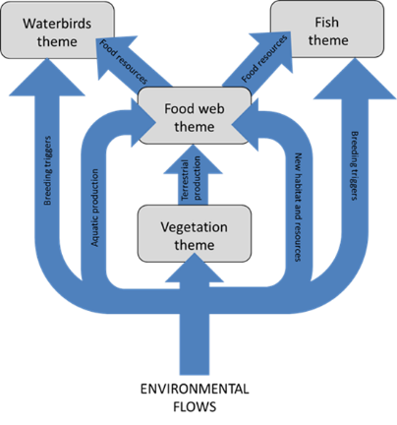

Figure 2 Conceptual diagram illustrating the effects of environmental flows on the movement of energy and resources across and between the four Themes of MDB EWKR.

# Individual Research Activity Summaries

## Review and conceptualisation

Darren Baldwin, Ben Gawne, Nick Bond, Rebecca Lester, Darren Ryder, Ross Thompson, Barbara Robson, Garth Watson, Rob Rolls, Romain Drouart and Paul McInerney.

### Research Question

Review and conceptualisation formed the first phase of the food web themes research activity and identified our current knowledge status and critical knowledge gaps surrounding the influence of flow on lowland river food webs. The activity centred on development of three peer reviewed journal articles (see Appendix 1.1 for full article details) to inform and direct future research planning for the EWKR food web theme.

The first article comprised a global literature review of research investigating the influence of flow on lowland river food webs (Rolls *et al*. In prep). The review aimed to inform development of a conceptual model, identify critical knowledge gaps, and provide the logic and rationale for the research activities proposed in the theme’s research plan.

The second article reviewed potential food web indicators that could be incorporated into the monitoring and evaluation of environmental flows (Rolls *et al.* 2017). The review sought to address a management need to evaluate ecosystem function outcomes of environmental flows.

The third article reviewed approaches to modelling predictive capacity (Robson *et al.* 2017). The review sought to inform the development of the theme’s research plan by identifying the most appropriate approaches to modelling food web responses to environmental flows and thereby underpinning predictions of how changes in flow would affect food webs.

### Research Outcomes Summary

**Article 1** – Rolls, R. J, Baldwin, D. S,, Ryder, D. S, Bond, N. R, Gawne, Lester, R. E, McInerney, P. J, Robson, B J, Thompson, R. M. Hydrological drivers of trophic dynamics in river and floodplain ecosystems as a basis for process-based restoration using environmental flows. In Prep.

Article 1 identified:

* four primary questions that future EWKR food web research should address:

1. the sources and production of organic matter
2. transport and accessibility of energy throughout river and floodplain systems
3. nutritional value of energy resources for consumers
4. the transfer of energy through food chains to higher consumers;

* a need to distinguish interactions between hydrology and trophic dynamics;
* that more work is needed to understand context-dependency and spatial and temporal scales of the effects of hydrology on trophic dynamics in river and floodplain systems.

**Article 2** – Rolls, R.J., Baldwin, D.S., Bond, N.R., Lester, R.E., Robson, B.J., Ryder, D.S., Thompson, R.M., and Watson, G.A. (2017) A framework for evaluating food-web responses to hydrological manipulations in riverine systems. *Journal of Environmental Management* 203, 136-150.

Article 2 identified:

* a framework for monitoring the effects of hydrological regimes on riverine trophic dynamics
* that meaningful indicators are dependent on a conceptual model of food web drivers
* analytical methods to quantify trophic dynamics are evaluated
* challenges and opportunities for integrating trophic dynamics in monitoring

**Article 3** – Robson, B.J., Lester, R.E., Baldwin, D.S., Bond, N.R., Drouart, R., Rolls, R.J., Ryder, D.S., and Thompson, R.M. (2017) Modelling food-web mediated effects of hydrological variability and environmental flows. *Water Research* 124, 108-128.

Article 3 identified:

* variations in hydrologic regime affect food-web structure and function
* approaches to modelling and their utility in predicting food-web change
* 11 model features that enable prediction of food-web outcomes of hydrological variability
* that no current model includes all these features (Figure 3); a mix of approaches is indicated
* that consideration of food web-hydrology interactions will improve environmental flow planning.

A screenshot of a cell phone

Description generated with very high confidence

Figure 3 Application of common food-web modelling approaches to different aquatic ecosystem types from (Robson *et al.* 2017). Models are arranged from most common to least common. Note that individual models could be categorised as more than one model type and many papers contained multiple models including either multiple ecosystem types (18%) and/or multiple examples per ecosystem type (22%). The category ‘simulated or theoretical’ is used for entirely artificial food web models that, in many instances, do not specify species types and are designed to run simulations testing specific hypotheses about food-web properties.

### Water Management Application

The three foundational articles collectively provide the following management recommendations:

* the use of approaches that consider trophic dynamics across spatial and temporal scales to guide management of hydrological regimes
* ensure that the data used are comparable in terms of spatial and temporal scale
* use of the generic framework outlined in Article 2 for developing monitoring and evaluating plans to incorporate trophic dynamics into environmental watering plans
* a better integration of food-web and hydraulic models, taking physiologically-based approaches to food quality effects, and better representation of variation in space and time that may create ecosystem control points

The three foundational articles collectively identify the following research knowledge gaps:

* A better understanding of the four principles adapted from Beechie *et al.* (2010):

(1) Explicit consideration of hydrology in studies of trophic dynamics in river and floodplain systems

(2) Context-dependence of trophic dynamic responses to hydrology

(3) Identification of the spatial scales at which trophic dynamics operate in response to hydrology

(4) Integration of trophic dynamics into experimental monitoring of hydrological manipulations to determine timeframes for recovery

* Understanding complexity of trophic dynamics of whole ecosystems
* Context-dependency and spatial and temporal scales of the effects of hydrology on trophic dynamics in river and floodplain systems

## Fish field program

Paul McInerney, Rebecca Lester, Ross Thompson, Barbara Robson, Darren Ryder, Nick Bond, Darren Baldwin, Ben Gawne, and Rochelle Petrie

### Research Question

Understanding the flow of energy through ecosystems and among sub-habitats is critical to understanding patterns of biodiversity and ecosystem function. The EWKR fish theme evaluated the fundamental triad concept, which proposes that fish recruitment is dependent on habitats that provide nutrient enrichment, concentration and retention of both food and fish larvae. The food web theme supported this work by investigating critical basal resources supporting fish recruitment and tracing the flow of energy in the same three habitat types - river channels, anabranches and wetlands - as the fish theme. The work was carried out on the Ovens River floodplain in Victoria, a system renowned for its near natural hydrology. Fish and food web themes agreed that an improved understanding of energy dynamics in a natural system would provide the greatest benefit for improving our knowledge of food web responses to environmental flows more broadly. These habitats are of interest, as there is substantive management effort to connect these habitats using environmental flows, which aim to restore critical functional components of natural hydrological regimes, including such connections. A combination of stable isotopes and fatty acids were used to determine the source of energy and energy pathways through food webs across the three habitats.

A close up of text on a white background

Description generated with high confidence

Figure 4 Schematic describing (a) the importance of seston as a food resource to floodplain consumers, (b) the higher relative concentration of essential fatty acids in the seston of anabranch (A) and wetland (W) habitats than in the river channel (RC) and (c) the higher density of zooplankton subsequently supported in wetland and anabranch habitats than in the river channel.

### Research Outcomes Summary

Clear differences in the quality of basal resources between the river channel and floodplain habitats were discovered (Appendix 1.2, McInerney *et al*. Under review, Figure 4 b). Floodplains were characterized by food resources with higher concentrations of essential fatty acids (Table 1).

Importantly, this work showed that inundation of floodplains and subsequent reconnection to the river is critical to: 1) mobilise high quality food resources to the main channel; and 2) to afford riverine consumers the opportunity to access to high quality resources by moving onto the floodplain (Figure 5). This research demonstrates the importance of determining both the quantity and quality of organic matter fluxes into food webs, and the potential role of targeted environmental flows to re-establish critical energy pathways in riverine ecosystems.

Table 1 Summary of key observations and implications from the food web – fish theme field activity

|  |  |  |
| --- | --- | --- |
|  | Observation | Implication |
| Seston chlorophyll concentrations | Higher in wetlands and anabranches than in the main river channel | Greater production of essential fatty acids in wetlands and anabranches |
| Essential fatty acids in basal resources | High in wetlands and anabranches, low in the main river channel | Wetlands may be an important source of high-quality food |
| Essential fatty acids in consumers | Similar across all habitats | Consumers require similar fatty acid profiles to thrive, regardless of basal resource composition |
| Primary zooplankton food source | Litter and biofilm | Heterotrophic (e.g. decomposition of leaf litter) pathways are important |
| Zooplankton population density | Much higher in wetlands than the main river channel | Zooplankton density in river channels may be limited by availability of fatty acids |
| Fatty acids in fish *(G. holbrooki)* | Higher than in their primary food source, seston | Selective grazing or selective assimilation allows fish to aggregate fatty acids |
| δ13C (Carbon isotope) | Depleted in wetlands | Likely assimilation from groundwater |

### Water Management Application

The importance of floodplain inundation for riverine productivity (e.g. Junk et al. (1989) is a central paradigm of freshwater ecology. Here, we identify a mechanism by which that relationship may exist – inundation of floodplains appears to be influence productivity by providing higher quality food resources than are available in the river channel (Figure 5). While the importance of floodplain inundation is well known, our work suggests that reconnection of floodplain habitats to the main channel following the initial inundation may be an important management application. Specifically, consideration of the following inundation aspects should inform management of environmental flows:

1. Optimum connection/disconnection of habitats to maximise essential fatty acid synthesis
2. Optimum flooding duration to maximise fatty acid synthesis
3. Season (microbial activity temp/light sensitive) i.e. will inundation produce the desired result at a specific time point
4. Timing (e.g. to target fish larvae of a given species at a given time)
5. Management of reconnection and blackwater events- are too many nutrients coming into the system?
6. A better understanding of essential fatty acid limitation within riverine fish populations

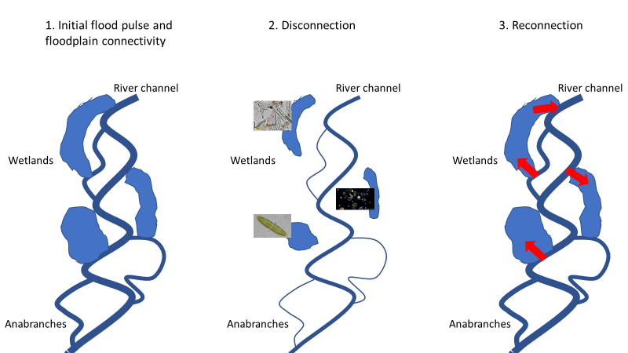

Figure 5 Conceptual diagram summarizing mechanisms by which floodplains may influence essential nutrient dynamics in riverine food webs: 1. Initial flood pulse and floodplain connectivity – liberation of DOC from litter and nutrients from floodplain sediments 2. Disconnection – DOC and nutrients drive microbial activity on floodplain, including synthesis of essential nutrients by algae and bacteria 3. Reconnection – Consumer access to high quality basal resources and transport of high-quality food back to river.

## Waterbird food requirements research program

Paul McInerney, Heather McGinness, Ralph Mac Nally, Kate Brandis, Rebecca Lester, Ross Thompson, Darren Ryder and Nick Bond.

### Research Question

The use of environmental water within the Basin has often been focused on supporting the completion of waterbird breeding events at key colonial nesting sites (Arthur *et al.* 2012; Brandis *et al.* 2011). However, managers and policy-makers are becoming increasingly conscious of the need to also manage feeding sites, that complement breeding sites, at Basin scales to ensure healthy waterbird populations. Providing the right amounts of water to the right places at the right times will increase recruitment and, hopefully, elevate the long-term persistence of waterbird populations in changing climates. To understand how environmental water provision (ewater) can support important dietary components of colonial waterbirds, we must first better understand their feeding requirements. This activity set out to answer three primary questions:

1. What are Australian ibis and spoonbills eating (diet composition)? (From regurgitate and feather samples)

2. What is the energy value of different types of ibis and spoonbill food sources? (From regurgitate samples)

3. Which food sources appear to be assimilated best? (From isotopic feather analysis)

A close up of a map

Description generated with very high confidence

Figure 6 Proportion of prey taxa (total dry weight (g)) from combined regurgitate from all locations of (a) Royal spoonbills and (b) Straw–necked ibis.

### Research Outcomes Summary

Diets of Royal spoonbills and Straw necked ibis are significantly different. Royal spoonbills fed predominately on fish and yabbies (71% and 15% of total diet respectively, Figure 6). In contrast Straw–necked ibis fed primarily on beetles (49%), centipedes (11%) and other indeterminate insects (11%). Overall, the calorific value of the primary diet sources for each species were similar (Fish ~ 5761 calories/gm dry weight compared to beetles ~ 5556 calories/gm dry weight). Stable isotope ratios of δ15N and δ13C from feathers suggest that for both species, regurgitate contents largely correspond to what food items the birds are assimilating. However, for Royal spoonbills isotopic analyses indicated that yabbies and prawns were under represented in regurgitate samples compared to tissue assimilation and for Straw–necked ibis, frogs and crickets were under represented in regurgitate samples compared to tissue assimilation (Figure 7).

### Water Management Application

Our results suggest that consideration of specific waterbird species trophic requirements is important when tailoring management of environmental watering to maximise food availability to support waterbird recruitment. For example, if Royal spoonbills are known to breed in a location, watering should be targeted to maximise the abundance of aquatic food resources, such as small fish, yabbies and prawns. If, however the location is known to support Straw necked ibis colonial breeding, environmental water might be better used to promote diverse terrestrial/riparian foraging habitat that supports a diverse array vertebrate and invertebrate habitat.

A picture containing text

Description generated with high confidence

Figure 7 Diet composition of Royal spoonbills at (a) Barmah-Millewa, (b) Kerang wetlands and Straw–necked ibis at (c) Barmah-Millewa, (d) Kerang wetlands and (e) Kow Swanp, derived from mixing models using stable isotopes ratios of nitrogen (δ15N) and carbon (δ13C).

## Basal resource transfer efficiency between a range of basal resources and to first-order consumers (mesocosm experiments)

Ivor Growns, Lindsey Frost, Paul McInerney, Rebecca Lester, Ross Thompson, Barbara Robson, Nick Bond, Darren Baldwin, Ben Gawne and Darren Ryder.

### Research Question

Understanding the way that basal resources are assimilated into the food web and the efficiency with which this material is transferred through the food web will improve our ability to predict the outcomes of environmental flows. For this activity mesocosm experiments were conducted to address three primary questions:

1. What food webs supports the growth of Murray Cod larvae and Carp Gudgeon in floodplain wetlands?
2. How is their survival and growth affected if we constrain the food sources available?
3. What does this mean for the use of e-water in regulating food webs in floodplain wetlands?

### Research Outcomes Summary

Green algae were found to be a key basal food resource (see Appendix 1.3 for draft manuscripts with full details) for both fish species. Within mesocosms, largest fish and greatest survival of fish was recorded in where algae and biofilm provided key dietary components through photosynthesis. Essential fatty acids from green algae were traced through food webs from basal sources to invertebrates to fish. Treatments where dissolved organic carbon was the basis of the food web had lowest invertebrate density, richness and lowest fish growth and survival. High quality algal feeding non-biting midge larvae (Daphnid) were found to be an important food resource for fish (Figure 8) and were targeted when they moved into the water column at the commencement of their pupal stage.

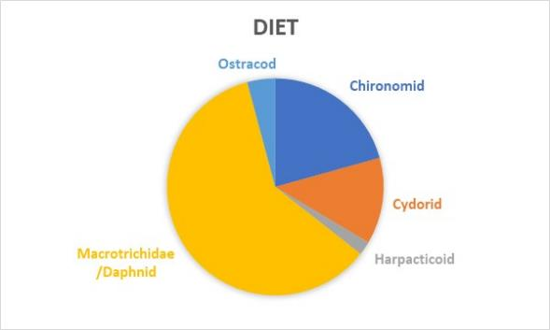

Figure 8 Diet proportions of food sources consumed by Murray cod larvae in mesocosm experiments

### Water Management Application

Mesocosm experiments conducted by the EWKR food web theme have demonstrated that:

* Hydrology can regulate basal source and quality
* Food quality is transferred through the food web
* Food quality determines the response of higher order consumers
* Food quality can regulate the success of fish recruitment

Environmental water can be used to regulate wetland energy subsidies that will determine food web responses and carrying capacity for wetland fish and bird recruitment (e.g. less water can be used to target inundation of areas known to support higher densities of high-quality green algae in seston, Figure 9).

A close up of a map

Description generated with high confidence

Figure 9 An example of how information generated from the EWKR food web mesocosm experiments can be used to inform management decisions. Under scenario (a) a large area known to support poor quality basal resources (in this case detritus (quality reflected by arrow width) is inundated with environmental water resulting in a relatively low fish biomass due to poor nutrition. Under scenario (b), less water is used to target inundation of areas known to support higher densities of high-quality green algae in seston. Under scenario (a) poor quality food results in an inefficient food web (top blue pyramid) with large gaps, where energy is lost through increased respiration (R) and excretion (Ex). While the quantity of food is the same in each example (width of pyramid base), the food web in scenario (b) supports more fish biomass (pyramid height) because food quality is better and the food web is more efficient, supporting an extra trophic level (depicted by different colours in the pyramid) than scenario (a).

## Basin scale trophic niche indicator

Keller Kopf, Rebecca Lester, Ross Thompson, Darren Ryder, Nick Bond, Paul McInerney, Brenton Zampatti, Jason Thiem, Wayne Koster, Gavin Butler

### Research Question

Trophic niche is a fundamental dimension of food web structure (Layman *et al.* 2007) and it is determined by energy availability, energy transfer and the diversity of carbon and nutrients in ecosystems.  Organisms have a trophic niche in which they consume resources from other organisms and their environment and provide energy to other consumers. Plots of stable isotopes of nitrogen (δ15N) and carbon (δ13C) can provide a representation of ‘trophic niche width’ (Layman *et al.* 2007), and can be evaluated to assess ecological changes, including responses to management or restoration actions such as eflows. Since river flow regimes are drivers of energy production and influence how different sources of nutrients and carbon enter food webs (Humphries *et al.* 2014; Thorp and Bowes 2017), this activity aims to develop and test the usefulness of a trophic niche width indicator for monitoring, using the Murray-Darling Basin fish community. The focus is on large-bodied Murray cod and Golden Perch which are considered top predators in rivers of the Murray-Darling, but other species (e.g. Common carp, Silver perch, Eel-tailed catfish and Bony herring) have been included.

### Research Outcomes Summary

The trophic niche indicator was developed from fish community and basal resource sampling carried out at Long Term Intervention Monitoring (LTIM <https://www.environment.gov.au/water/cewo/monitoring/ltim-project>) selected areas (Murrumbidgee, Lower Murray, Edward-Wakool, Goulburn and the Lachlan River; Figure 10) between March and May 2018.

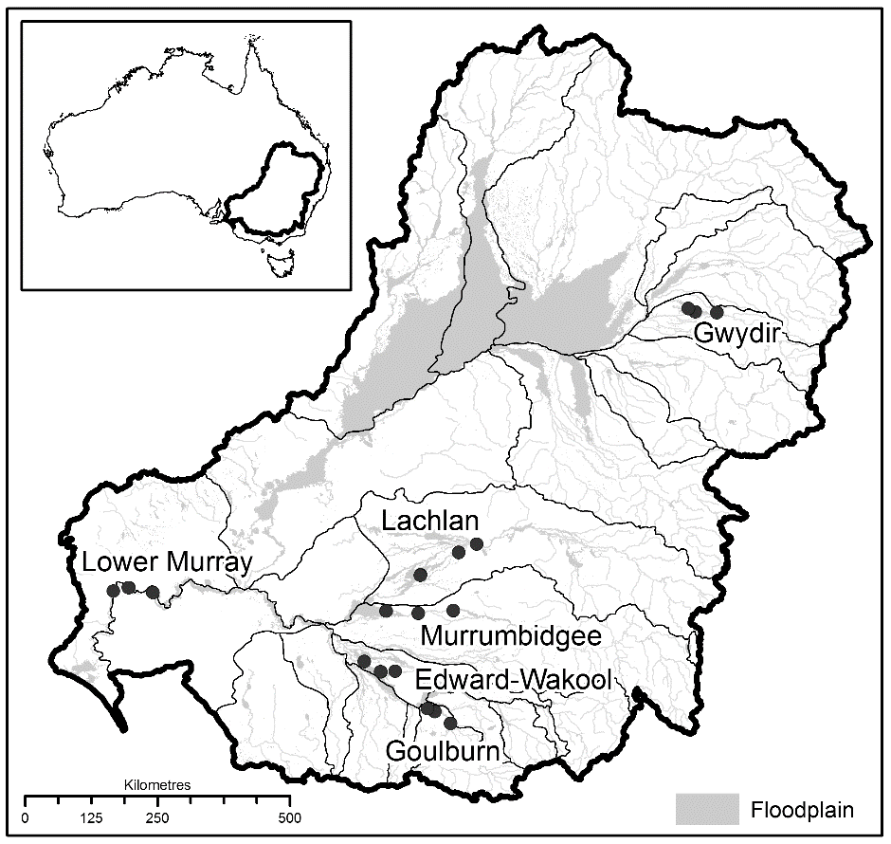

Figure 10 Map of the Murray-Darling showing locations of basal resource sampling and regions where fish community sampling was undertaken. Note, fish community samples were unavailable from the Gwydir.

Fin-clips from fish were analysed for stable isotopes of nitrogen (δ15N) and carbon (δ13C) and included 15 species ranging in length from 25 mm to 1100 mm total length, including small-bodied and large-bodied native and invasive fishes. Five basal resource types (grasses; macrophytes (large aquatic plants); periphyton (organisms clinging to plants); seston; terrestrial plants) were sampled at each of the six LTIM selected areas. Basal resource types varied significantly in their δ15N and δ13C isotope signatures, but geographic differences were not detected. Variation in δ15N values provided a useful baseline to estimate the trophic niche of native fishes (Appendix 1.4). The trophic niche of fishes varied depending on species, body size and LTIM selected area.

### Water Management Application

The methods developed here provide a monitoring tool for managers to evaluate changes in the trophic position of fish communities in the Murray-Darling Basin. The trophic niche indicator provides a cost-effective annual monitoring tool relevant to the CEWO watering objective of enhancing ‘ecosystem function’ and The Basin Plan ‘to protect and restore the ecosystem functions of water-dependent ecosystems’ (Basin Plan, Chapter 8, Part 2, 8.04(b)). The trophic position of the fish community is expected to increase if there are more large native predators in the system and will decrease if there are more invasive common carp.

This tool provides a measure of the food sources and their diversity supplying native fishes. Given multi-year datasets, the trophic niche indicator could be further developed to evaluate the direct effects of flow metrics (e.g. Sabo et al. 2010), and therefore environmental flows, on the trophic niche of fishes and other consumers including waterbirds. The trophic niche indicator can tell us whether the delivery of flows is providing the food resources needed for recruitment and for maximising the production of adult fish populations.

There is a need to develop strategies for environmental flows which supply the necessary food resources, at the right times, for adult spawning and subsequent recruitment of larvae to adults. Using the trophic niche indicator, managers could assess whether the delivery of environmental flows are changing the food resources supplying fish populations and how, or if, flow deliveries are benefiting fish recruitment and food web structure leading to more productive populations.

## Modelling bioenergetics within identified production sites

Galen Holt, Ashley Macqueen, Ross Thompson, Darren Ryder, Nick Bond, Barbara Robson, Paul McInerney, Ben Gawne, Darren Baldwin, Rebecca Lester.

### Research Question

While most major theoretical models of river ecosystems propose food webs as a critical ecosystem function, our knowledge of the influence of flow on food webs is not robust enough to make specific predictions about how flow influences outcomes such as the production of larval fish biomass. Our primary goal was to link individual management decisions about environmental watering to potential ecological outcomes by developing a model of energy pathways from water provision through to larval fish. We sought to integrate knowledge arising from the EWKR project, LTIM data and local area knowledge, while accounting for uncertainty in that knowledge and identifying knowledge gaps.

Using our model, we then pursued two interrelated lines of investigation:

1. Ranking environmental watering scenarios in terms of their trophic-dependent fish outcomes; and
2. Identifying and quantifying the main knowledge gaps within the model that may affect our ability to rank management scenarios based on fish outcomes.

### Research Outcomes Summary

We developed a simulation-based quantitative food web model (Appendix 1.5) that uses characteristics of environmental watering events as inputs and ranks those watering events based on simulated larval fish biomass, using the Gwydir wetlands as a test case. The model was developed as a series of compartmentalized sub-models, including; inundation, production, carbon transfer through the food web, fish production and scenario comparison (illustrated conceptually in Figure 11). Each of these sub-models was based on available data, particularly those collected by EWKR and LTIM (Figure 11).

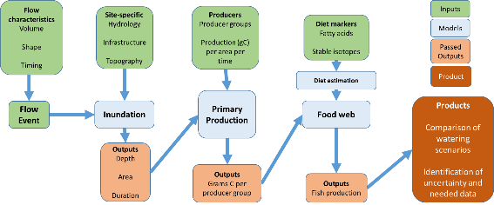

Figure 11 Structure of the food web model developed including inputs (green), sub-models (blue), outputs (beige) and the final product: a ranking of individual watering events and assessment of uncertainty associated with the inputs and outputs.

We used our model to compare a set of watering scenarios guided by local water managers for the Gwydir to provide information and illustrate the sorts of questions the model can address. For a given amount of environmental water, increasing the inundation duration yielded better fish outcomes than increasing the daily flow rate. Increases in the total amount of environmental water provided tend to have diminishing returns, likely due to the shape of the floodplain, tending to explain why longer durations were more effective in producing fish biomass than higher daily flow rates. Similarly, topographical differences between catchments yielded different fish biomasses depending on the proportion of water delivered to each catchment.

Our model yielded several key general findings, all related to how primary production or diet differed among scenarios (Figure 12 , Appendix 1 A4):

1. Fish biomass was proportional to the area and duration of inundation if diet quality and composition did not change among scenarios (Figure 12 a);
2. For any given inundation area and duration, fish biomass could vary widely, based on uncertainty associated with production rates and diet composition (Figure 12);
3. Absolute biomass produced by a given scenario was more variable than the overall scenario rankings. This uncertainty was driven by shifts in the mix of producers (diet quality) or fish diet (composition) among scenarios (illustrated in the extreme in Figure 12b).

**(a)**

**(b)**

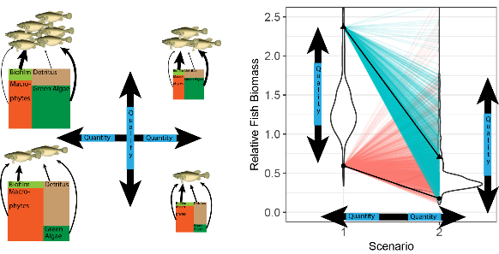

Figure 12. Potential variability around each of two fish biomass scenarios is represented by violin plots (b), with widths indicating the number of different producer mixes and diet compositions that yield a given fish biomass. If inundation varies between scenarios, there is an overall shift in the quantity of production, illustrated in the left panel (a) as a change in size of the producer boxes, and seen in the right panel as an average difference in the height of the violins (quality). The coloured lines illustrate where quality changes among scenarios (as it might if different areas were inundated under different scenarios).

Ecological data (the inputs to our model) are always uncertain and these uncertainties influence the outputs of each sub-model and then propagate to affect the distribution of possible fish outcomes from a given watering scenario. Exploring this uncertainty identified two critical knowledge gaps which, if filled, would provide greatest benefit for comparing management actions.

1. The structure of the food web itself, which determines diet composition, and whether that food web changes with the type of environmental watering.
   * For example, does the dominant source of carbon for fish change if production shifts from being dominated by green algae to being dominated by macrophytes?
2. Rates of production by primary producer groups, and specifically how they might change in different areas or among different watering scenarios.
   * For example, if low open herb lands are inundated, do you get a different mix of producers (analogous to diet quality) compared with when club rushes are inundated instead?

### Water Management Application

Our key finding was that the ranking of watering scenarios depended on whether the diet quality or composition changed with environmental watering scenario or not (Figure 12). Thus, untangling whether the diet quality or composition change with different watering scenarios is critical to the use of this model to support management. By targeting shifts in diet composition and producer quality, watering events can be designed to disproportionately benefit fish. Green algae have the potential for high production rates and can contribute a large proportion of the energy used by fish. While we currently have few data to target watering events to the production of green algae, it is likely that managers on the ground may have local knowledge to achieve this. These results, highlighting the importance of green algae, complement findings from the Ovens and Gwydir.

# Theme Synthesis

## Key outcomes from activities:

### Conceptualisation phase

Work conducted during the foundational phase of the EWKR food-web theme emphasized that use of process-orientated approaches that consider trophic dynamics across spatial and temporal scales are critical for guidance in the management of hydrological regimes. A better integration of food-web and hydraulic models, taking physiologically based approaches to food quality effects, and better representation of variations in space and time that may create ecosystem control points is required.

It is important to ensure that the data used are comparable in terms of spatial and temporal scale and to use a generic framework for developing monitoring and evaluating plans to incorporate trophic dynamics into environmental watering plans.

### Field studies have identified the key resources and trophic links within river channels and anabranches

While the importance of floodplain inundation for river productivity is well known (e.g. Junk *et al.* 1989), our work suggests that reconnection of floodplain habitats to the main channel following the initial inundation may comprise an important management application. Anabranches and wetlands were found to contain higher concentrations of high-quality food resources than the river channel. Reconnection is important to: 1) mobilise high quality food resources on the floodplain to the main channel; and 2) to afford riverine consumers the opportunity to access to high quality resources by moving onto the floodplain.

### Field studies have identified some key resources for waterbird chicks by species

Our results suggest that consideration of specific waterbird species requirements is important when tailoring management of environmental watering to maximise food availability to support waterbird recruitment.

### Experimental work has identified which basal resources are of the highest quality in supporting fish growth

Work undertaken in mesocosm experiments reinforced patterns observed in field experiments. Green algae are a key basal resource for consumers, providing a high-quality food. Essential fatty acids from green algae were traced through food webs from invertebrates to fish. Dissolved organic Carbon based food webs provide the lowest invertebrate density, richness and lowest fish growth and survival (Figure 13).

A close up of a device

Description generated with high confidence

Figure 13. Schematic outlining how fish biomass may be increased by targeting environmental watering to areas known to be supported by high quality autotrophic food webs (where Ex = energy lost through excretion, R = energy lost through respiration, pyramid height represents fish biomass, pyramid width represents food quantity, and change in colour represents trophic levels.)

### A basin-scale tool has been developed to assess fish communities

The methods developed in the trophic niche activity provide a monitoring tool for managers to evaluate changes in the trophic position of fish communities in the Murray-Darling. The trophic niche indicator provides a cost-effective annual monitoring tool relevant to CEWO watering objective ‘ecosystem function’.

### An energetics-based model has been developed to characterise key links between basal productivity and higher consumers

The modelling work was informed by empirical data from mesocosm, site and basin scale experimental work, and builds on our current understanding of trophic responses to environmental watering. By targeting shifts in diet composition and producer quality, watering events can be designed to disproportionately benefit fish. Green algae have the potential for high production rates and can contribute a large proportion of the energy used by fish.

# 

# Management Relevance

|  | Resource Availability Scenarios |  |  |  |
| --- | --- | --- | --- | --- |
|  | Very dry | Dry | Moderate | Wet to Very Wet |
| BWES Management objective | Avoid irretrievable loss of or damage to, environmental assets | Ensure environmental assets maintain their basic functions and resilience | Maintain ecological health and resilience | Improve health and resilience of water dependent ecosystems |
| Scale | Site, reach | Site, reach, segment | Site, reach, segment, catchment | Site, reach, segment, catchment, basin |
| Potential basal resource quality outcomes | No or limited river floodplain connectivity, potential drying of all floodplain wetlands. No contribution to riverine food quality from floodplain derived sources. | Intermittent river floodplain connectivity at some locations, potential drying of some floodplain wetlands. Reduced frequency and duration of floodplain inundation where it occurs. Small contribution to riverine food quality from floodplain derived sources. | Moderate river floodplain connectivity at catchment scale, floodplain wetlands receive water. Moderate frequency and duration of floodplain inundation where it occurs. Moderate contribution to riverine food quality from floodplain derived sources. | Large scale river floodplain connectivity at basin scale, floodplain wetlands receive water. Potential for high frequency and duration of floodplain inundation. Large contribution to riverine food quality from high quality algal derived sources. |
| Risks | Cyanobacteria blooms, low quality food resources, potential essential nutrient limitation of food webs | Low quality food resources, potential essential nutrient limitation of food webs | Potential for blackwater events, dependent of flooding history, potential for poor quality DOC fuelled food webs | Potential for blackwater, high disturbance, potential for frequency and duration of flooding to be too high |
| Key considerations | Limit extraction, focus on habitat maintenance/restoration. Monitoring of critical refuges to avoid loss of source adult populations. | Limit extraction, provision of top-up flows to key refuge areas to maintain water quality and depth. Monitoring of critical refuges to avoid loss of source adult populations. | Connection to floodplain via anabranches; connection to wetlands if possible. Duration of connection to enable consumer access to high quality resources. Timing of flows to maximise appropriate temperature regimes. Location of flows based on capacity for dispersal, retention and hydraulic diversity at the reach to segment scale and capacity for dispersal of equilibrium species at the catchment scale. | Prioritisation of watering decisions based on knowledge of basin-wide sources of recruitment of periodic species. Timing of flows to maximise appropriate temperature regimes. Longitudinal connectivity to provide capacity for large-scale movements of periodic species. |
| Knowledge requirements | Location of critical refuge habitats at catchment scales. Habitat heterogeneity to maximise high quality biofilms and green algae. Critical habitat attributes that create appropriate refugia. | Location of critical refuge habitats at catchment scales. Critical habitat attributes that create appropriate refugia. | Potential for nutrient and energy inputs (longitudinal and lateral). Degree and variability of physical//hydraulic complexity. | Potential for nutrient and energy inputs (longitudinal and lateral). Sources of recruitment. Movement pathways. |

# 

# Knowledge Status

## Knowledge Status

Conceptual, mesocosm, reach and basin scale research conducted by the EWKR food web theme has improved the current understanding of two primary aspects of how environmental water can be used to enhance productivity and consumer responses. This work has emphasised the critical importance of:

1) Managing for high quality resources spatially and temporally

2) Targeting flows to support basal resources

## Identification of Knowledge gaps

While the EWKR food web theme has gone a long way in improving our understanding the relationship between environmental flows and food webs that transfer energy to support recruitment of native fish and water birds, the work has also identified several knowledge gaps that require further investigation.

Areas that require further attention include:

* Explicit consideration of hydrology in studies of trophic dynamics in river and floodplain systems
* Context-dependency of trophic dynamic responses to hydrology
* Identification of the spatial scales at which trophic dynamics operate in response to hydrology
* Integration of trophic dynamics into experimental monitoring of hydrological manipulations to determine timeframes for recovery
* Understanding complexity of trophic dynamics of whole ecosystems
* Improved understanding of factors influencing the optimisation of the nutritional quality of basal resources (synthesis of essential fatty acids) including:
  + connection/disconnection dynamics
  + flooding duration
  + season (microbial activity temp/light sensitive)
  + timing (e.g. to target fish larvae of a given species)
  + managing reconnection and blackwater
  + essential fatty acid limitation within riverine fish populations

# References

Arthur, A.D., Reid, J.R.W., Kingsford, R.T., McGinness, H.M., Ward, K.A., and Harper, M.J. (2012) Breeding flow thresholds of colonial breeding waterbirds in the Murray-Darling Basin, Australia. *Wetlands* **32**(2), 257-265.

Beechie, T.J., Sear, D.A., Pess, G.R., Moir, H., Buffington, J.M., Olden, J.D., Pollock, M.M., and Roni, P. (2010) Process-based Principles for Restoring River Ecosystems. *BioScience* **60**(3), 209-222.

Brandis, K.J., Kingsford, R.T., Ren, S., and Ramp, D. (2011) Crisis water management and ibis breeding at Narran Lakes in arid Australia. *Environmental Management* **48**(3), 489-498.

Capon, S., J (2003) Plant community responses to wetting and drying in a large arid floodplain. *River Research Applications* **19**(5‐6), 509-520.

Davies, P.M., Naiman, R.J., Warfe, D.M., Pettit, N.E., Arthington, A.H., and Bunn, S.E. (2014) Flow–ecology relationships: closing the loop on effective environmental flows %J Marine and Freshwater Research. **65**(2), 133-141.

Greet, J., Angus Webb, J., and Cousens, R.D. (2011) The importance of seasonal flow timing for riparian vegetation dynamics: a systematic review using causal criteria analysis. *Freshwater Biology* **56**(7), 1231-1247.

Humphries, P., Keckeis, H., and Finlayson, B. (2014) The river wave concept: integrating river ecosystem models. *BioScience* **64**(10), 870-882.

Humphries, P., King, A.J., and Koehn, J.D. (1999) Fish, flows and flood plains: links between freshwater fishes and their environment in the Murray-Darling River system, Australia. *Environmental biology of fishes* **56**(1-2), 129-151.

Junk, W.J., Bayley, P.B., and Sparks, R.E. (1989) The flood pulse concept in river-floodplain systems. *Canadian special publication of fisheries and aquatic sciences* **106**(1), 110-127.

King, A.J., Tonkin, Z., and Mahoney, J. (2009) Environmental flow enhances native fish spawning and recruitment in the Murray River, Australia. *River Research and Applications* **25**(10), 1205-1218.

Kingsford, R.T., and Auld, K.M. (2005) Waterbird breeding and environmental flow management in the Macquarie Marshes, arid Australia. *River Research Applications* **21**(2‐3), 187-200.

Layman, C.A., Quattrochi, J.P., Peyer, C.M., and Allgeier, J.E. (2007) Niche width collapse in a resilient top predator following ecosystem fragmentation. **10**(10), 937-944.

Mac Nally, R., Cunningham, S.C., Baker, P.J., Horner, G.J., and Thomson, J.R.J.W.R.R. (2011) Dynamics of Murray‐Darling floodplain forests under multiple stressors: The past, present, and future of an Australian icon. **47**(12).

Mac Nally, R., Nerenberg, S., Thomson, J.R., Lada, H., Clarke, R.H.J.G.E., and Biogeography (2014) Do frogs bounce, and if so, by how much? Responses to the ‘Big Wet’following the ‘Big Dry’in south‐eastern Australia. **23**(2), 223-234.

Poff, N.L., and Zimmerman, J.K.H. (2010) Ecological responses to altered flow regimes: a literature review to inform the science and management of environmental flows. **55**(1), 194-205.

Robson, B.J., Lester, R.E., Baldwin, D.S., Bond, N.R., Drouart, R., Rolls, R.J., Ryder, D.S., and Thompson, R.M. (2017) Modelling food-web mediated effects of hydrological variability and environmental flows. *Water research* **124**, 108-128.

Rolls, R.J., Baldwin, D.S., Bond, N.R., Lester, R.E., Robson, B.J., Ryder, D.S., Thompson, R.M., and Watson, G.A. (2017) A framework for evaluating food-web responses to hydrological manipulations in riverine systems. *Journal of environmental management* **203**, 136-150.

Shenton, W., Bond, N.R., Yen, J.D., and Mac Nally, R. (2012) Putting the “ecology” into environmental flows: ecological dynamics and demographic modelling. *Environmental Management* **50**(1), 1-10.

Thomson, J.R., Bond, N.R., Cunningham, S.C., Metzeling, L., Reich, P., Thompson, R.M., and Mac Nally, R.J.G.C.B. (2012) The influences of climatic variation and vegetation on stream biota: lessons from the B ig D ry in southeastern A ustralia. **18**(5), 1582-1596.

Thorp, J.H., and Bowes, R.E.J.E. (2017) Carbon Sources in Riverine Food Webs: New Evidence from Amino Acid Isotope Techniques. **20**(5), 1029-1041.

Wedderburn, S.D., Hammer, M.P., and Bice, C.M.J.H. (2012) Shifts in small-bodied fish assemblages resulting from drought-induced water level recession in terminating lakes of the Murray-Darling Basin, Australia. **691**(1), 35-46.

# List of appendices

* Appendix 1: Research Activity Reports
* Appendix 1.1 Review and conceptualisation
* Appendix 1.2 Fish field program
* Appendix 1.3 Basal resource transfer efficiency between a range of basal resources and to first-order consumers (mesocosm experiments)
  + 1.3.1 The basal food sources for Murray cod (*Maccullochella peelii*) in wetland mesocosms.
  + 1.3.2 The use of fatty acids in freshwater ecological research
  + 1.3.3 Patterns of invertebrate emergence and succession in flooded wetland mesocosms.
* Appendix 1.4 Basin scale trophic niche indicator
* Appendix 1.5 Modelling energy flow from environmental water
* Appendix 2: Theme Data Inventory
* Appendix 3: Theme Outputs
* Appendix 4: Theme Engagement and Communications Activities