Murray-Darling Basin Environmental Water Knowledge and Research Project

Waterbird Theme Research Report

MDB EWKR Waterbird Theme Co-ordinator: Heather McGinness (CSIRO)

MDB EWKR Waterbird Theme Leadership Group:

Richard Kingsford (UNSW), Veronica Doerr (CSIRO), Ralph Mac Nally (UC)

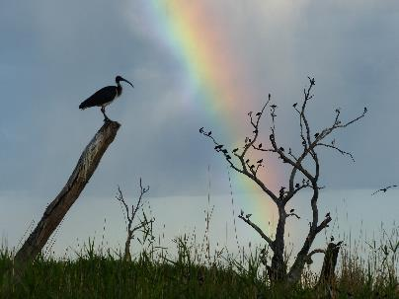

May 2019

**Final Report**

**CFE Publication 225**

**June 2019**

Murray‒Darling Basin Environmental Water Knowledge and Research Project  
Waterbird Theme Research Report

Report prepared for the Department of the Environment and Energy, Commonwealth Environmental Water Office by CSIRO and La Trobe University, Centre for Freshwater Ecosystems (formerly Murray–Darling Freshwater Research Centre).

Department of the Environment and Energy, Commonwealth Environmental Water Office  
51 Allara St  
Canberra ACT 2601  
Ph: (02) 6274 1111

For further information contact:

**Nikki Thurgate Heather McGinness  
Project Co-ordinator Theme Co-ordinator**

Centre for Freshwater Ecosystems CSIRO  
(formerly Murray‒Darling Freshwater Research Centre) Land and Water  
PO Box 821 GPO Box 1700   
Wodonga VIC 3689 Canberra ACT 2601   
Ph: (02) 6024 9647 (02) 6246 4136  
Email: [n.thurgate@latrobe.edu.au](mailto:n.thurgate@latrobe.edu.au) [heather.mcginness@csiro.au](mailto:heather.mcginness@csiro.au)

Web: <https://www.latrobe.edu.au/freshwater-ecosystems/research/projects/ewkr>   
<https://research.csiro.au/ewkrwaterbirds/>

Enquiries: [cfe@latrobe.edu.au](mailto:cfe@latrobe.edu.au)

**Report Citation:** McGinness HM, Brandis K, Robinson F, Piper M, O’Brien L, Langston A, Hodgson J, Wenger L, Martin J, Bellio M, Callaghan D, Webster E, Francis R, McCann J, Lyons M, Doerr V, Kingsford R, Mac Nally R (2019) Murray‒Darling Basin Environmental Water Knowledge and Research Project — Waterbird Theme Research Report. Report prepared for the Department of the Environment and Energy, Commonwealth Environmental Water Office by CSIRO and La Trobe University, Centre for Freshwater Ecosystems, CFE Publication 225 June 2019 44p. [Appendices 422p]

**Cover Image:** Straw-necked ibis in the Macquarie Marshes

**Photographer:** Heather McGinness

**Traditional Owner acknowledgement:**

La Trobe University Albury–Wodonga and Mildura campuses are located on the land of the Latje Latje and Wiradjuri peoples. The Research Centre undertakes work throughout the Murray–Darling Basin and acknowledge the traditional owners of this land and water. We pay respect to Elders past, present and future.

**Acknowledgements:**

The Waterbird Theme of MDB EWKR drew on the expertise of scientists from the CSIRO, University of NSW, and University of Canberra, aiming to fill knowledge gaps with new data that will assist environmental water managers. It was co-ordinated by Heather McGinness (CSIRO) with a leadership group comprising Richard Kingsford (UNSW), Veronica Doerr (CSIRO) and Ralph Mac Nally (UC) providing research direction and design advice. The Waterbird Theme benefited from co-investment by CSIRO Land and Water and from in-kind support from the Royal Botanic Garden Sydney (RBGS; John Martin), NSW OEH and the Goulburn-Broken Catchment Management Authority (Keith Ward).

Waterbird Theme Research Implementation was led by Heather McGinness and Kate Brandis.

Satellite transmitters and ABBBS bands were fitted in Barmah-Millewa Forest by Heather McGinness, John Martin, Melissa Piper and Emily Webster, with assistance from Freya Robinson, Micah Davies and Keith Ward. Satellite transmitters and ABBBS bands were fitted in Kow Swamp and Kerang Wetlands by Heather McGinness, John Martin and Freya Robinson with assistance from Melissa Piper. Satellite transmitters and ABBBS bands were fitted in the Macquarie Marshes by John Martin, Heather McGinness, Micah Davies, and Freya Robinson (CSIRO). Ray Jones kindly showed us his snaring method, shared his knowledge and lent us three of his snares and his camo net in the Macquarie Marshes. We thank Tim Hosking and Paul Keyte (NSW OEH) for assisting with information and access in the Macquarie Marshes and James Rees, Emily Webster and Bill Johnson for being flexible about timing of access to various sites in the Marshes using the UNSW Argo.

Processing, mapping and analysis of satellite tracking data from the 62 Geotrak GPS transmitters was conducted by Art Langston and Heather McGinness (CSIRO). Processing, mapping and analysis of satellite tracking data from the 11 Ecotone GSM transmitters was conducted by Emily Webster (UNSW).

Nest monitoring cameras in Barmah-Millewa Forest were installed and maintained by Melissa Piper and Freya Robinson (CSIRO), with assistance from Tamara Potter, Alexandra Paton, Lauren O’Brien, Lucy Wenger, Jaslyn Allnutt, Micah Davies and Heather McGinness (CSIRO) and Emily Webster (UNSW student), John Martin and Lisa Harvey (USyd student). Monitoring camera image data extraction and analysis was led by Heather McGinness, Melissa Piper, Freya Robinson and Jessica Hodgson (CSIRO). Compilation of the chick field guide was done by Lucy Wenger and Heather McGinness (CSIRO). Chick allometry and energy requirements modelling was conducted by Lauren O’Brien (CSIRO summer scholarship student) under the supervision of Heather McGinness.

On-ground tagged nest and water quality monitoring in Barmah-Millewa Forest were done by Maria Bellio (UNSW subcontractor), Emily Webster (UNSW student), Diane Callaghan (nee Harshbarger), Roxane Francis, and Kate Brandis (UNSW) and other volunteers. Drone surveys of Reed Beds Swamp and associated nest counts were done by Justin McCann and Mitchell Lyons (UNSW).

We are grateful to Keith Ward (Goulburn-Broken CMA), Rick Webster (Murray Wetlands Working Group), Alison Borrell (NSW OEH), Danielle McAllister (NSW OEH), Tim Hosking (NSW OEH), CEWO local engagement officers, NSW NPWS staff, CMA and LLS staff and Murray Water staff for their assistance with site access and transmitter recovery and for sharing their knowledge. We are also grateful to all other individuals who went out of their way to facilitate observations, recovery and deployment of satellite transmitters, including Andrew McDougall, Tim Reid, Tim Barlow, Collin Tate, Jo Ocock, Fiona Robertson, Cassie James, Steve Mackay, Mal Carnegie, Tim Henderson, Mark Southwell, Danielle McAllister, Clayton Anderson, Mark Henderson, Anthony Wilson, Felicity Hatton, Richard Mintern, Sarah Wells, Jodie Hay, Ruth Bakogianis and other landowners and managers, and NSW, VIC, QLD, SA and ACT government staff.

Contents

Executive Summary 1

1 Waterbird Theme: Introduction 1

1.1 Objectives 3

1.2 Research Activities 4

2 Individual Research Activity Summaries 5

2.1 Literature review: Waterbird responses to flooding, stressors and threats 5

2.2 Satellite-tracking ibis and spoonbill movements – ARGOS GPS transmitters 8

2.3 Satellite-tracking ibis movements - GSM network transmitters 13

2.4 Quantifying ibis and spoonbill egg and chick survival rates and mortality drivers using monitoring cameras 14

2.5 Monitoring ibis and spoonbill nest success through on-ground tagged nest and water depth surveys 18

2.6 Ibis breeding responses to flow and depth thresholds in Barmah-Millewa Forest 20

2.7 Ibis and spoonbill nest and colony mapping using drone imagery 21

2.8 Ibis chick diet 22

2.9 Ibis and spoonbill chick energy source assimilation 23

2.10 Ibis and spoonbill chick energy requirements 25

3 Theme Synthesis 27

3.1 Where and what are the critical foraging habitats for recruitment? 27

3.2 What are critical nesting habitat characteristics we need to maintain? 29

3.3 What have we learned about waterbird recruitment and drivers of waterbird mortality? 30

3.4 Where do waterbirds fit in the food web and what food/energy sources do they need for recruitment? 31

4 Management relevance 33

5 Knowledge Status 35

6 List of Appendices 37

Executive Summary

Key outcomes

* While the maintenance of waterbird populations and diversity are critical targets for environmental flows in Australia, there is little data on their survival, demographics, movements, and interactions, making modelling and prediction of the effects of management actions and climate change difficult (Section 2.1).
* Satellite tracking of waterbird movements has emphasised the need for Basin scale thinking and coordination in planning environmental water allocations and in managing expectations regarding waterbird responses. There is clearly population connectivity between the northern Basin and the southern Basin – and birds can move very quickly from north to south and vice versa (Section 2.2, 2.3).
* The discovery of a common movement route between the northern and southern Basin suggests that for maximum impact, water and site management for foraging and stopover (refuelling) could be embedded within this route. Additional tracking of species dependent on surface water to feed, will provide further information about key sites and movement routes that can be managed with environmental water (Section 2.2).
* Satellite-tracking of bird movements has revealed distinct variation in movement behaviour between and within species, with varying degrees of resident, nomadic and migratory behaviour. Planning and response predictions may need to account for varying population movement strategies and for differences between species (Section 2.2, 2.3).
* Relatively few of the satellite-tracked birds moved to the east coast or to central Australia after nesting. The majority stayed within the Murray-Darling Basin, emphasising the importance of the Basin for these populations (Section 2.2, 2.3).
* Foraging habitat availability needs management both during and between breeding events. For example, satellite tracking suggests that ibis and spoonbills target watered foraging sites within 1-3 km of appropriate roosting or nesting habitat. Environmental water could be used to increase the number or area of foraging sites available after breeding, potentially extending watering for foraging into autumn and winter and possibly staggering inundation of foraging sites to maximise food productivity over a period of months to support juvenile survival (Section 2.2, 2.3).
* Satellite tracking has revealed the importance of extended duration of water availability for foraging by juvenile royal spoonbills. Use of environmental water to extend nest and adjacent site flood duration during and after nesting beyond just the ‘fledging’ time threshold may facilitate increased juvenile survival (Section 2.2).
* Management of over-wintering sites and foraging habitats may also be important for juvenile survival. Overwintering occurs in both the north and south of MDB, yielding a range of opportunities for using environmental water to create or sustain foraging habitats and food sources. This may be particularly important in areas where irrigated agriculture and other water sources effectively ‘dry up’ over winter (Section 2.2).
* With ongoing declines in waterbird populations, it is important that we understand how many birds are being produced by breeding events, together with what is affecting those numbers (Section 2.4, 2.5).
* Nest abandonment is more likely during the egg stage than the chick stage, however it is still important to maintain water levels late in the breeding season, for two reasons: 1) Maintaining food and foraging habitat availability; and 2) Preventing feral predator access. In addition to provision of environmental water for breeding sites, provision of water to support nearby foraging sites and food before, during and after a breeding event is likely to affect the size and success of the event (Section 2.4, 2.5).
* It is important to recognise that species such as spoonbills feeding in surface waters require different foraging-habitat provision and management to species with mixed terrestrial and aquatic diets such as ibis (Section 2.2, 2.8, 2.9, 2.10).
* There is a lack of data available describing the growth and energy requirements of ibis and spoonbill species (Threskiornithidae). This study has begun filling some of these knowledge gaps, through the extraction and synthesis of the best available data globally on Threskiornithid energetics, growth, and biometrics, and by creating the first growth model for Royal Spoonbill chicks and developing the first predictive energetic models of Australian waterbird chick energy requirements (Section 2.10)
* Overall, increased knowledge of the interaction of waterbirds with their environment, their movements and their life histories is important for both basic understanding of their responses but also for informing policy and management decisions and predictions aimed at increasing waterbird abundance and maintaining waterbird diversity across the Basin (Section 3).

Waterbird numbers in Australia and worldwide are in decline and their populations are now also facing a changing climate. Waterbirds play a critical and highly visible ecological role and we have obligations to protect them and their habitats, including international agreements and treaties such as the Ramsar Convention (<https://www.ramsar.org/>). Australia’s Murray-Darling Basin Plan and Basin Environmental Watering Strategy contain key objectives specifically for waterbirds, including increasing waterbird populations and maintaining waterbird diversity. However, waterbird populations continue to decline despite management efforts and the drivers of and links between site, basin and national scale responses and trends are poorly understood.

Waterbird diversity, populations, and breeding, foraging and refuge sites are managed through decisions affecting water, habitat and other pressures that are made by Federal government agencies, State agencies and other land and water holders. Environmental watering events in the Murray-Darling Basin are frequently targeted at supporting completion of waterbird breeding. Yet while knowledge exists regarding key breeding locations in the Basin and the flows required to trigger and complete nesting events, there is relatively limited knowledge about nest success, bird movements, demographics (including juvenile and adult mortality rates) and associated drivers – particularly in terms of the relative influence of flow variables, habitat variables, pressures and threats.

These knowledge gaps exist even for common and conspicuous taxa such as colonially-nesting waterbirds that are often thought to be relatively well-understood. They are particularly severe for cryptic and uncommon species. Filling these knowledge gaps will assist managers to:

* Identify, maintain, and/or restore key habitats – especially critical foraging habitats
* Better understand the spatial and temporal scales at which key habitat characteristics are required
* Better target water, vegetation and threat management actions to ensure ‘event readiness’ at nesting sites between flooding events and to maximise recruitment
* Better predict the effects of water management and threats

Doing so will improve our capacity to more effectively target land and water management actions and predict their effects.

The research conducted by the MDB EWKR Waterbird Theme has produced new information to assist managers to better target water, vegetation and waterbird management to ensure ‘event readiness’ at sites between flooding events and to maximise recruitment. Maximising recruitment into the adult population depends on optimising the number of birds that nest, the number of chicks that fledge from each site, and the survival of those birds as juveniles, sub-adults and breeding adults. Information is needed quantifying these variables and what affects them – however the mobility of waterbirds and lack of information on their movements makes this difficult. Therefore, the MDB EWKR Waterbird Theme research activities included: detailed movement and habitat-use studies of individual birds over the duration of the EWKR project using tracking devices (satellite GPS transmitters); motion-sensing and time-lapse camera nest monitoring; on-ground tagged-nest and water depth monitoring; colony mapping; analysis of chick diet and energy sources; and modelling of chick energy requirements.

# Waterbird Theme: Introduction

Waterbird numbers in Australia and worldwide are in decline and their populations are now also facing a changing climate. Waterbirds play a critical and highly visible ecological role and we have obligations to protect them and their habitats, including international agreements and treaties such as the Ramsar Convention (<https://www.ramsar.org/>). Australia’s Murray-Darling Basin Plan and Basin Environmental Watering Strategy contain key objectives specifically for waterbirds, including increasing waterbird populations and maintaining waterbird diversity (MDBA 2014). However waterbird populations continue to decline despite management efforts and the drivers of and links between site, basin and national scale responses and trends are poorly understood.

Waterbird diversity, populations, and breeding, foraging and refuge sites are managed through decisions affecting water, habitat and other pressures that are made by the Federal Government (e.g. through agreements such as the Ramsar Convention), CEWO, MDBA, State agencies and other land and water holders. Environmental watering events in the Murray-Darling Basin are frequently targeted at supporting completion of waterbird breeding. Whilst knowledge exists regarding key breeding locations in the Basin and the flows required to trigger and complete nesting events, there is relatively limited knowledge about nest success, bird movements, demographics (including juvenile and adult mortality rates) and associated drivers – particularly in terms of the relative influence of flow variables, habitat variables, pressures and threats.

Flow regimes, water management and threats such as habitat change and habitat loss affect the availability (quantity and distribution) and quality of both breeding and foraging sites at multiple scales. These in turn will affect the survival of birds and consequently population sizes and species diversity. However data describing drivers and bird responses are scarce, limiting our ability to predict the effects of changes in water management and threats to habitat.

A recent literature review (McGinness 2016) confirmed that the largest of these gaps in knowledge are:

1. **Demographics**

* Survival and mortality rates, especially of fledglings and juveniles (and therefore recruitment)
* Population age structures and sex ratios
* Population and sub-population boundaries

1. **Movements**

* Immediately following and between breeding events – timing, distances travelled, differences between juveniles and adults, site fidelity, key foraging habitat locations and characteristics, effects of habitat availability, quality and productivity on bird condition and survival
* During breeding events – distances travelled, habitat characteristics, effects of habitat availability, quality and productivity on breeding site choice, site fidelity, event size and success
* Mechanisms, cues or drivers behind bird movements and choices and how these interact

1. **Effects of interactions between flow-related drivers of waterbird responses and other stressors, pressures or threats, especially:**

* Habitat loss, fragmentation and change
* Predation - rates, species, and timing
* Climate change and adverse or extreme weather

These knowledge gaps exist even for common and conspicuous taxa such as colonially-nesting waterbirds that are often thought to be relatively well-understood. They are particularly severe for cryptic and uncommon taxa.

Filling these knowledge gaps will assist managers to:

* Identify, maintain, and/or restore key waterbird habitats – especially critical foraging habitats
* Better understand the spatial and temporal scales at which key habitat characteristics are required
* Better target water, vegetation and threat management actions to ensure ‘event readiness’ at nesting sites between flooding events and maximise waterbird recruitment
* Better predict the effects of water management and threats

Doing so will improve our capacity to more effectively target land and water management actions and predict their effects.

Direct consultation with water managers confirmed that these are important knowledge gaps. In particular, managers highlighted:

* Population movements and boundaries
* Important routes, foraging trip distances and other key movement limitations and preferences
* Critical foraging, roosting and stopover sites
* Priority habitat characteristics to maintain
* Recruitment-limiting stressors, threats, pressures

The MDB EWKR Waterbird theme consequently designed and prioritised its research to begin filling these knowledge gaps.

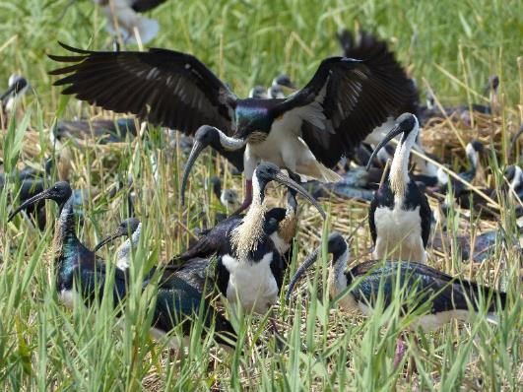

Straw-necked ibis nesting in the Macquarie Marshes (H. McGinness)

## Objectives

Two main sets of research activities were conducted by the Waterbird Theme to address critical knowledge gaps relating to those described above. These were identified through consultation with environmental water managers and scientists and review of existing literature.

*Critical Knowledge Gap 1: Where and what are the critical foraging habitats during and after breeding events for recruitment? How might these be affected by environmental flows and threats such as habitat change?*

Flow regimes, water management and threats, such as habitat change and habitat loss, affect the availability (quantity and distribution) and quality of foraging sites at multiple scales. These, in turn, will affect the survival of young birds and consequently recruitment. However, data describing waterbird foraging preferences, locations and movements (and how these affect survival) are scarce, limiting our ability to predict the effects of changes in water management and threats to habitat.

*Critical Knowledge Gap 2: What are the critical nesting habitat characteristics we need to maintain and how do these affect recruitment? How might environmental flows, vegetation management and pressures and threats, such as predation, interact with nesting habitat characteristics to affect recruitment?*

This research aims to produce information that will allow managers to better target water, vegetation and animal management to ensure ‘event readiness’ at sites between events and to maximise recruitment during breeding. Maximising recruitment into the adult population depends on optimising the number of birds that fledge. Protection and maintenance of appropriate nesting sites is crucial for optimising recruitment, and requires knowledge of the influence of habitat type, condition, and configuration on species site choice, predation impacts, and nest success.

Colonially-breeding waterbird species are the primary targets for data collection, because:

* they are one of the main target groups for environmental flows management and policy
* recruitment response variables are more easily measured for these than for other species, because breeding events and nests for these species are easier to locate and survey.
* surveys of recruitment for these species are likely to cover a greater proportion of each population than for other species (e.g. ducks) where breeding is widely distributed
* the effects of predation and other threats on these species are likely to be more easily measured because their nests, eggs and fledglings are more visible
* there is good evidence that this group of waterbirds provides a reasonable model for understanding relationships between environmental flows and waterbird recruitment.

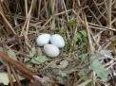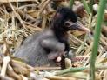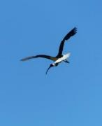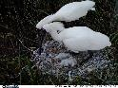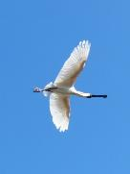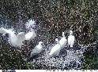

Straw-necked ibis eggs, chick and adult (left) and royal spoonbill adults and chicks (right) (H. McGinness)

## Research Activities

* Review and synthesis of the literature
* Known waterbird responses to flows and flooding in Australia, with an emphasis on the Murray-Darling Basin and knowledge gaps
* International literature regarding how various other stressors and threats affect waterbirds (habitat loss, fragmentation and change, predation, climate change, pollution, disease, human disturbance, competition), and how these interact with the effects of flows.
* Detailed movement and habitat-use studies of individual birds over the duration of the EWKR project using solar-powered GPS tracking devices
* Three species: Straw-necked Ibis, Royal Spoonbill and Australian White Ibis
* Adults and juveniles
* Movement distances
* Routes and important areas
* Timing and rates
* Habitat characteristics: Foraging, roosting, travelling
* Survival rates
* Motion-sensing and time-lapse camera nest monitoring
  + Quantification of egg and chick development and survival
  + Monitoring of predation (species, impacts, timing, location)
  + Quantification of nest characteristics and exposure (e.g. species, nest position, nest materials, water depth, vegetation type, nest density, exposure).
* On-ground tagged-nest and water depth monitoring
  + Nest counts, monitoring of egg and chick numbers at nesting clumps
  + Water depth measurements
* Colony mapping
  + Drone survey and mapping
  + Quantification of nesting colony habitat characteristics
* Analysis of chick diet/energy sources (what do they eat?) based on regurgitate and scat samples
* Stable isotope analysis of chick energy source assimilation (what do their bodies use?)
* Measurement of chick biometrics and modelling of chick energy requirements (how much food is required?)

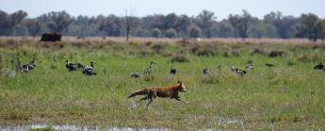

A feral red fox flees past straw-necked ibis in the Macquarie Marshes (F. Robinson)

# Individual Research Activity Summaries

## Literature review: Waterbird responses to flooding, stressors and threats

*Heather McGinness*

During the first phase of the Murray-Darling Basin Environmental Water Knowledge and Research Project (MDB EWKR), a review of current knowledge was conducted in order to inform development of priority questions for research (McGinness 2016). The review summarises known waterbird responses to flows and flooding in Australia, with an emphasis on the Murray-Darling Basin, and synthesises knowledge gaps highlighted in the literature. It also reviews the international literature regarding how various other stressors and threats affect waterbirds (habitat loss, fragmentation and change, predation, climate change, pollution, disease, human disturbance, competition), and how these interact with the effects of flows. While the effects of flows on waterbirds had been reviewed previously by various authors with important knowledge gaps and research priorities identified, the role of other stressors and threats is much-neglected in Australian literature and practice.

*Please see Appendix 1 for the full report:* McGinness, H. M. (2016) Waterbird responses to flooding, stressors and threats. CSIRO, Australia.

### Research Questions

The review was conducted in two main stages.

**Part 1:** Construction of a summary table of known and unknown relationships between waterbird responses and flows/flooding in Australia, with specific reference to the Murray-Darling Basin, based on previous reviews; **Part 2:** Synthesis of the international literature on waterbird responses to other stressors, including habitat loss, predation, climate change, pollution, disease, and human disturbance, the likely mechanisms behind these responses and interactions with responses to flows/flooding

Both stages endeavoured to establish: 1) What is known, with reference to the quality of the evidence and our present ability to develop quantitative models, conceptual models, hypotheses supported by evidence, or speculative hypotheses; 2) Knowledge gaps and suggestions for ways forward identified by previous reviews. The review also produced conceptual models of connections between environmental, management and waterbird variables (e.g. Figure 1).

### Research Outcomes Summary

Flow-related variables that affect waterbirds include:

* **Flow regime – local to basin scales**
  + Location, frequency, volume, duration, timing
  + Separation of environmental flow component from natural and regulated flows
* **Flood regime – local to basin scales**
  + Location, frequency, extent, duration, timing, depth, rate of change in depth, interflood period (dry duration)
* **Local and catchment rainfall, evaporation and temperature**

These interact with pressures such as:

* habitat loss, fragmentation and degradation
* predation (native, introduced)
* competition
* disease and parasites
* pollution
* human disturbance and hunting
* climate change

At different spatial and temporal scales, these interactions affect the following cues/factors:

* food abundance or availability
* habitat availability, distribution and quality (breeding (courtship, nesting), foraging, roosting, refuge)
* connectivity between habitats/sites and within the population
* condition of critical individual sites (nesting, foraging, roosting and refuge)
* catchment condition

These variables affect waterbird abundance, through their influence on bird condition, breeding initiation (courtship, nesting and egg-laying), and recruitment of juveniles into the adult population. Some of these can be measured by the number of pairs/nests, the number of eggs laid, egg survival, chick survival, juvenile survival, sub-adult and adult survival, individual and population movements, population size and age structure, and hence waterbird diversity.

For individual flow events at local scale, the critical waterbird response variables are: Numbers of nests and breeding pairs per species; Egg and chick survival (fledging rates, taking into account repeat-nesting – i.e. nest success); and juvenile survival (recruitment). For population maintenance/growth at Basin to continental scales, sub-adult and adult survival and the frequency of breeding initiation are also important. Finally, the evolutionary adaptations, life histories and associated varying requirements of individual birds, species and guilds all affect waterbird responses - including bird memory, experience, behavioural characteristics and site attachment. These may vary considerably even within species.

*Knowledge gaps*

While the maintenance of waterbird populations and diversity are critical targets for environmental flows in Australia, there is a dearth of data on their survival, demographics, movements, and interactions, making modelling and prediction of the effects of expensive management actions and climate change difficult. Information regarding local abundance and aspects of breeding, especially nesting, is far more common and readily available than information regarding population parameters such as survival / mortality and movements associated with foraging and dispersal between breeding events. Data are especially scarce for juveniles, whose recruitment is critical for long term population persistence. Major knowledge gaps are:

1. **Demographics**

* Survival and mortality rates, especially of fledglings and juveniles (and therefore recruitment)
* Population age structures and sex ratios
* Population and sub-population boundaries

1. **Movements**

* Immediately following and between breeding events – timing, distances travelled, differences between juveniles and adults, site fidelity, key foraging habitat locations and characteristics, effects of habitat availability, quality and productivity on bird condition and survival
* During breeding events – distances travelled, habitat characteristics, effects of habitat availability, quality and productivity on breeding site choice, site fidelity, event size and success
* Mechanisms, cues or drivers behind bird movements and choices and how these interact

1. **Effects of interactions between flow-related drivers of waterbird responses and other stressors, pressures or threats, especially:**

* Habitat loss, fragmentation and change
* Predation - rates, species, and timing
* Climate change and adverse or extreme weather

These knowledge gaps exist even for common and conspicuous taxa such as colonially-nesting waterbirds that are often thought to be relatively well-understood. They are particularly severe for cryptic and uncommon taxa.

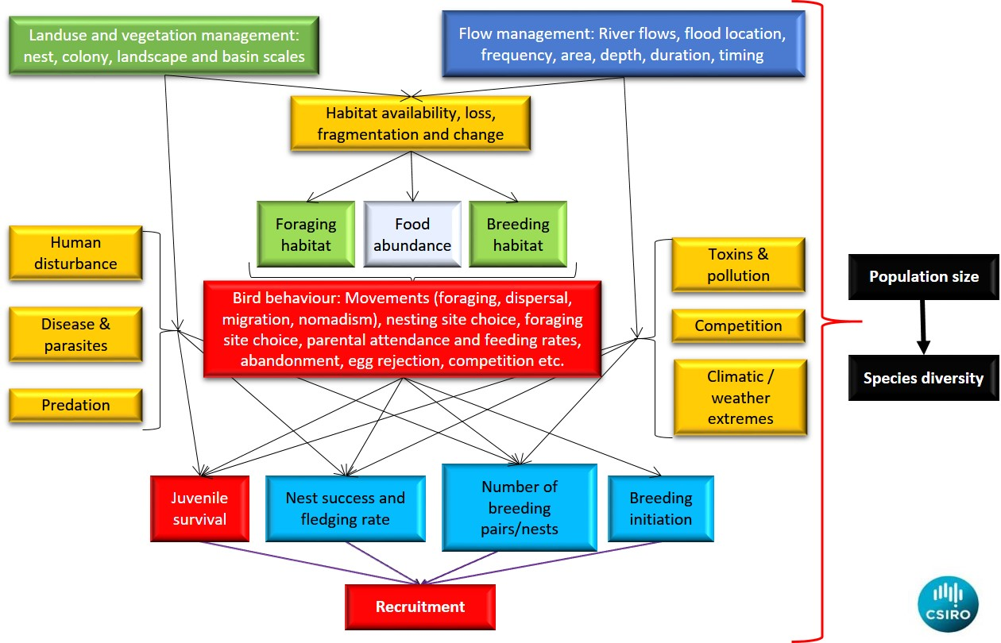

Figure 1 Conceptual model of variables influencing waterbird recruitment, population size and species diversity.

### Water Management Application

Literature reviews such McGinness (2016) do three things useful for management:

1. They bring together, summarise and synthesise what is known, making knowledge more accessible

2. They identify what isn’t known and why

3. They prioritise which knowledge gaps should be filled first for maximum benefit to management

Filling these knowledge gaps will assist managers to:

* Identify, maintain, and/or restore key waterbird habitats – especially critical foraging habitats
* Better understand the spatial and temporal scales at which key habitat characteristics are required
* Better target water, vegetation and threat management actions to ensure ‘event readiness’ at nesting sites between flooding events and maximise waterbird recruitment
* Better predict the effects of water management and threats

Doing so will improve our capacity to more effectively target land and water management actions and predict their effects.

## Satellite-tracking ibis and spoonbill movements – ARGOS GPS transmitters

*Heather McGinness, Freya Robinson, Melissa Piper, Art Langston, John Martin*

*Please see Appendix 2 for detail. A full manuscript is in preparation for submission to a scientific journal for publication:* McGinness, H.M., Langston, A., Robinson, F., Piper, M., and Martin, J. (draft) Satellite-tracking ibis and spoonbill movements and habitat choices.

### Research Question

One of the largest waterbird ecology and management knowledge gaps is waterbird movements and their drivers, including: timing; distances travelled; differences between juveniles and adults; key foraging habitat locations and characteristics; effects of habitat availability; quality and productivity on site choice, bird condition and survival; site fidelity; and mechanisms, cues or drivers inducing movements and choices and how these interact. To begin filling these knowledge gaps, we used solar-powered GPS satellite transmitters to track the movements of colonial-breeding wading birds in the Threskiornithidae family – including straw-necked ibis (*Threskiornis spinicollis*), Australian white ibis (*T. molucca*), and royal spoonbills (*Platalea regia*). These species are of particular interest for management and policy decision-makers and are good representatives of colonial-breeding wading birds dependent on environmental water.

Specifically, the research aimed to address the following questions:

* How far, how often, and when do these species move? (Movement statistics)
* What are the characteristics of foraging and roosting habitats selected? (Habitat statistics)
* What are the characteristics of movement routes? (Mapping)
* Are there differences in the above between species, age categories, capture sites or years?

### Research Outcomes Summary

Satellite transmitters were deployed on 64 birds of three species over two years: 42 Straw-necked Ibis (*Threskiornis spinicollis*), 15 Royal Spoonbill (*Platalea regia*), and seven Australian White Ibis (*Threskiornis molucca*).

In the first year, 2016-2017, 20g GeoTrak ARGOS GPS tracking transmitters were fitted to straw-necked ibis; 10 adults and 10 juveniles. Five transmitters were fitted to adults in the Macquarie Marshes, northern NSW. Five transmitters were fitted to adults at Barmah-Millewa Forest, on the NSW/VIC border, together with10 transmitters fitted to juveniles. The decision to deploy five transmitters in the Macquarie Marshes in 2016-2017 was driven by a major breeding event occurring there, which was unlikely to occur again during the life of the project and was an opportunity to gain some information about where ibis from the Macquarie Marshes go versus where ibis from the Barmah-Millewa Forest go in the same year (northern Murray-Darling Basin vs southern Murray-Darling Basin).

Another 30 22g GeoTrak ARGOS transmitters were deployed during the 2017-2018 season. Also, 14 recovered transmitters were re-deployed. In total, 22 straw-necked ibis, 15 royal spoonbills, and seven Australian white ibis were fitted with transmitters in 2017-2018. All of the ibis were captured in Kow Swamp and Kerang Middle Lake in Victoria, while 13 of the royal spoonbills were captured in Barmah-Millewa Forest and two were captured in Kerang Middle Lake. The 2017-2018 season was more restricted than 2016-2017 in numbers of breeding locations and breeding birds. Breeding commenced later in the year at most known sites.

Transmitters were solar-powered and recorded hourly diurnal location fixes 0700-1900 and a midnight fix, usually with a resolution of <26 m. Ground checks found that resolution of stationary transmitters was frequently better than 15 m. Location fixes were recorded and stored for 36 hours, and then transmitted during an 8-hour window via the ARGOS satellite system. The ARGOS satellite system provides continual full coverage within Australia and worldwide, with no recapture or base station required, thereby avoiding issues with phone network coverage in inland Australia and providing data suited to highly nomadic species. It also allows transmitters to be located and recovered when they eventually fall off the bird or if the bird dies.

#### Nest site departures and directions post-breeding

Nest site departures post-breeding were temporally clustered for both adults and juveniles. Royal spoonbills departed nest sites months laterthan straw-necked ibis and white ibis. Tracking showed that spoonbills forage for extended periods (weeks to months) in and around the nesting site – particularly juveniles who have just left the nest. In contrast, straw-necked ibis and Australian white ibis typically left the nest site not long after starting to fly.

Straw-necked ibis and Australian white ibis left nesting sites in the Murray River region in December, January and February. In contrast, royal spoonbills left the same nesting sites in March and April. Tracked straw-necked ibis adults left the Macquarie Marshes in early to mid-November. Data were insufficient for quantitative analysis of departure date relationships with water levels; however knowledge of departure dates is useful as an indicator of minimum periods for which environmental water may be required.

Straw-necked ibis adults and juveniles tracked from Barmah-Millewa, Kow Swamp and Kerang flew mostly north-east or east within the first week of leaving their nest sites, while the five Macquarie Marshes straw-necked ibis adults all flew south. Distances covered post-departure were highly variable. Post-breeding, the adult male royal spoonbill flew north directly to Queensland. One juvenile royal spoonbill flew NE, another flew S, and other flew ESE. Juvenile royal spoonbills from Barmah-Millewa did not travel long distances on leaving the nest site, however one of the juvenile spoonbills from Kerang dispersed north overnight to Lake Cargelligo and then continued north past the Macquarie Marshes, where transmissions ceased. Australian white ibis juveniles did not travel far from the nesting site and flew in a range of directions. None of the tracked birds flew SW and very few flew west – those that did didn’t travel far and were simply foraging near the nesting sites.

#### Long-distance movements vs limited movements

Tracking bird movements revealed distinct variation in movement behaviour between and within species.

Of the 40 individual straw-necked ibis tracked (adults and juveniles), some individuals remained relatively resident (or sedentary) in one area, while others moved nomadically across a region or sub-catchment, and others moved thousands of kilometres up and down the Murray-Darling Basin - with one behaving in the same way an ‘obligate’ migrant might, moving seasonally at the same times to the same places each year. This mixed movement behaviour within species or populations is known as ‘partial migration’. Partial migration is common among birds and is thought to be a strategy that copes at the species level with spatial and temporal variation in resources, environmental conditions and their predictability.

In general, birds were most mobile after leaving the nesting site and during autumn and spring. No long-distance movements were observed during winter. All tracked individuals of all species, ages and sexes ‘settled down’ from autumn to winter, using highly localised over-wintering areas often of only a few square kilometres or less. The locations and site characteristics of these over-wintering sites varied. Some were in the northern Murray-Darling Basin; others were in the south. One adult female straw-necked ibis was tracked seasonally migrating from Victoria to Queensland, back to Victoria, and then returning to exactly the same Queensland over-wintering site, showing site fidelity. This bird is still active.

There were distinct temporal patterns in departure times and dates for longer trips. Straw-necked ibis typically departed on long-distance journeys at approximately 10am and travelled throughout the day, stopping at approximately 4-5pm. In contrast, royal spoonbills typically departed at approximately 6pm, travelling through the night. Weather changes appear to be associated with long-distance movements, including temperature drops, rainfall, and shifts in wind direction. Further analyses are planned to explore these associations.

In general, the tracked Australian white ibis were far more ‘resident’ than the straw-necked ibis and royal spoonbills post-dispersal from the nest site. Most remained in the region of the nesting site, roosting and foraging around irrigated dairy farms or irrigated cropping. None of the tracked white ibis moved to the east coast.

#### Common long-distance routes for different individuals *and species*

A common long-distance NE-SW route was used in both years by straw-necked ibis juveniles and adults and by juvenile and adult royal spoonbills (Figure 2). This route was used in both directions, even by the same birds, from both northern basin and southern basin sites. The route is broad but generally avoids dry, high elevation, or forested areas and corresponds with climatic / bioregional zones. It follows zones or zonal boundaries that are temperate to sub-tropical, with no distinct ‘dry season’, high soil moisture, and low elevation. The route generally follows areas with low to moderate rainfall variability that have a mean annual rainfall of ~600-700mm (ranging between 400-1000mm). Approximately 25% of tracked birds have used this common route to-date; 15% of tracked birds used it flying to Queensland.

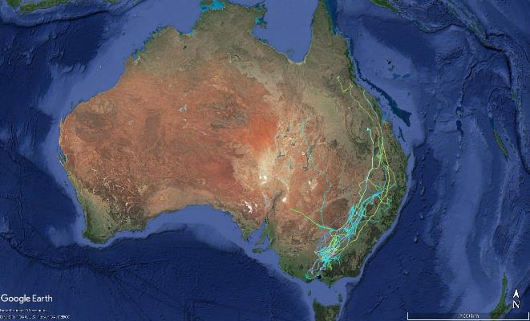

Figure 2 Tracked ibis and spoonbill movements across eastern Australia; each coloured line is an individual bird.

#### Foraging distances and foraging and roosting habitats

Examination of bird movement tracks and fixes together with satellite imagery revealed a distinct ‘pairing’ between roosting habitats and foraging habitats. Straw-necked ibis usually actively forage during the day and sleep during the night, coming in to roost at around sunset. The most commonly used foraging habitats have adjacent remnant vegetation, with trees for roosting that are next to or overhang water. Straw-necked ibis use these trees mostly for sleeping at night but also for taking shelter from the weather during the day. When resident in an area, adult straw-necked ibis most commonly foraged within approximately 2 km of their roosting trees (median 2.21 km); while juvenile straw-necks foraged slightly closer to their roosts (median 1.34 km). Royal spoonbill habits are less predictable than those of straw-necked ibis. They often actively forage at night and during the morning, and sleep during the afternoon. Royal spoonbills prefer tall roosting trees next to or overhanging water; however will also rest in dense wetland vegetation such as rushes or on wetland banks. To-date, tracking data for royal spoonbills is dominated by juveniles, with only one adult tracked; therefore trends are biased by juvenile movements being mostly within the nesting site and high juvenile mortality rates. The most common maximum distance travelled by the adult from wherever he was at midnight each day was 2.66 km; while the median distance travelled by juveniles was 259 m. In contrast, Australian white ibis frequently roost away from water and in or on farm buildings and do not travel as far to forage. All of the tracked white ibis were juveniles, with a median foraging distance from their roosts of 1 km.

During nesting, adult straw-necked ibis may travel greater distances to forage than when not nesting, with mean maximum foraging distances of 6 to 44km, depending on the nesting site. In contrast, the tracked nesting royal spoonbill foraged exclusively within or close to the nesting site (mean maximum distance of 4km). Foraging habitats used when nesting differed substantially from those used when not nesting for all but one of the birds for which data were available. Landuses when nesting also varied between and within species. Overall, during nesting the tracked royal spoonbill spent more time foraging in marsh/wetland environments close to the nesting site (median 2.5km) than tracked nesting straw-necked ibis. Differences in landuses among nesting straw-necked ibis were generally associated with which landuses surrounded the nesting site. Foraging habitats used by nesting straw-necked ibis included marsh/wetland environments, nature conservation areas, grazing pastures (native and modified, irrigated and dryland), rivers, ‘other minimal use’ areas, cropping, ‘transport and communication’ (mostly roadsides), production native forests (including parts of Barmah-Millewa Forest). Overall, foraging distances were lower in Barmah-Millewa Forest than in other sites, suggesting that birds find suitable foraging habitat closer to the nesting site in Barmah-Millewa and therefore do not have to expend as much energy travelling as when they are nesting at other sites.

Straw-necked ibis juveniles and adults foraged in similar habitats after breeding events, including grazing pastures (native and modified, irrigated and dryland), marsh/wetland environments, nature conservation areas, and cropping. Royal spoonbill juveniles foraged in marshes/wetlands and other habitats with surface water, including rivers, irrigation channels, irrigated cropping, and grazing pastures. The adult royal spoonbill tracked flew to Queensland after breeding, foraging mostly in ‘grazing native vegetation’ landuses, reservoirs/dams, and marsh/wetlands. Australian white ibis foraged mostly in areas classified as grazing pastures (modified, irrigated), marsh/wetland environments, nature conservation areas, and cropping.

Tracking showed re-use of some sites by different birds at different times. For example, during the wet 2016-2017 water year, sites within the flooding mid-Lachlan River near Condobolin, NSW 2016-2017 were used by multiple tracked birds for feeding. In contrast, in the dry 2017-2018 water year, irrigated dairy farms in northern VIC were used extensively. Key foraging and stopover areas varied by species, individuals, total time tracked, season, and year. The intensity of use may also be biased by capture location, i.e. with most birds captured in the mid-Murray area, most location fixes and movements were concentrated around this area and may not reflect habitat use by the whole population across the Basin. Further tracking of individuals captured at different sites across the Basin will clarify key foraging and stopover areas.

#### Juvenile and adult mortality drivers

Satellite tracking of movements has for the first time allowed preliminary investigations into the relative importance of various drivers of mortality for juveniles and adults. The main factors associated with mortality in the 38 deceased satellite-tracked birds were: Heat exhaustion / cold / exposure (weather extremes) (28%); Predation (e.g. raptors, foxes) (26%); Shooting (6%); Disease (e.g. botulism, widespread in 2016–17) (4%); Vehicle impact (4%); and unknown (26%) causes. Mortality drivers that may fall into the ‘unknown’ class may include any of the above causes, or other diseases, poisoning and toxins, starvation / malnutrition, parasites and entanglement in fencing or powerlines. Often it is not possible to determine what has occurred or birds go missing. Interactions are likely – e.g. starvation or toxins/disease increasing susceptibility to predation or weather extremes. An evidence scoring system is in development using data downloaded from the satellite transmitters (e.g. temperature, activity, solar recharge), the condition of the satellite transmitters when recovered, other on-ground evidence and weather data. Preliminary analyses indicate that associations between weather extremes and mortality or missing status are strongest where there is a shift from heat to cold and windy conditions within two days. Such conditions are likely to affect bird thermoregulation and can result in immune system depression and increased susceptibility to diseases, toxins and parasites. Juveniles are more susceptible than adults to these pressures, at least in part because they are naïve, are still learning to feed themselves and find shelter, use a lot of energy on first leaving the nesting area, and require high-quality food.

### Water Management Application

Satellite tracking of waterbird movements has emphasised the need for Basin scale thinking and coordination in planning environmental water allocations and in managing expectations regarding responses. There is clearly population connectivity between the northern Basin and the southern Basin – and birds can move very quickly from north to south and vice versa. Planning and response predictions may need to account for varying population movement strategies such as nomadism, residency and possibly migration – and also for differences between species.

The discovery of a common movement route between the northern and southern Basin suggests that for maximum impact, water and site management for foraging and stopover (refuelling) could be embedded within this route. However individual sites differ in importance among years and species and we don’t yet fully understand this variation. Additional tracking of species dependent on surface water to feed will provide further information about key sites and movement routes that can be managed with environmental water.

Foraging habitat availability needs management both during and between breeding events. For example, tracking suggests that ibis and spoonbills target watered foraging sites within 1-3 km of appropriate roosting or nesting habitat. Environmental water could be used to increase the number or area of foraging sites within 10 km of nest sites after breeding, potentially extending watering for foraging into autumn and winter and possibly staggering inundation of foraging sites to maximise food productivity over a period of months to support juvenile survival.

At nesting sites used by royal spoonbills, satellite tracking has revealed the importance of extended duration of water availability for foraging by juveniles. Use of environmental water to extend nest and adjacent site flood duration during and after nesting beyond just the ‘fledging’ time threshold may facilitate increased juvenile survival. It is important to recognise that species such as spoonbills feeding in surface waters require different foraging-habitat provision and management to species with mixed terrestrial and aquatic diets such as ibis.

Management of over-wintering sites and foraging habitats may also be important for juvenile survival. Tracking indicates that over winter, even small habitat areas may be important, and there may be some site fidelity for such sites. Overwintering occurs in both the north and south of MDB, yielding a range of opportunities for supporting juveniles and sub-adults using environmental water to create or sustain foraging habitats and food sources. This may be particularly important in areas where irrigated agriculture and other water sources effectively ‘dry up’ over winter. This highlights the need for real time data on genuine habitat condition and availability.

Overall, increased knowledge of the interaction of waterbirds with their environment, their movements and their life histories is important for both basic understanding of their responses but also for informing policy and management decisions and predictions aimed at increasing waterbird abundance and maintaining waterbird diversity across the Basin.

## Satellite-tracking ibis movements - GSM network transmitters

*Emily Webster (Honours student), Kate Brandis, Richard Kingsford, John Martin.*

*Please see Appendix 9 for detail*

### Research Question

To examine foraging movements during a breeding event and identify key foraging areas for straw-necked and Australian white ibis. This study was designed to be a short-term movement study examining the daily movements of ibis between a colony site and foraging sites.

### Research Outcomes Summary

Ten adult birds (6 straw-necked ibis and 4 Australian white ibis) and one juvenile Australian white ibis were captured for GSM network tracking. A single bird of each species (Australian white ibis (Reed Beds) and straw-necked ibis (Kerang Wetlands)) displayed breeding behaviour, frequently returning to known breeding colonies in 2016/17. They remained relatively close to the capture site compared to other birds (non-breeding), with maximum travel distances of 26 km (straw-necked ibis in Kerang wetlands) and 9 km (Australian white ibis in Reed Beds) during breeding, and dispersal 50 km and 42 km from the breeding site post-breeding.

There was a consistent difference between movements of non-breeding straw-necked ibis and Australian white ibis. Straw-necked ibis dispersed further on average from the capture site, and in all directions post-release, while Australian white ibis primarily dispersed north and south. Both species exhibited multidirectional localised movements as well as periodic long flights, however both localised movement and long flights were further for straw-necked ibis than Australian white ibis. Non-breeding straw-necked ibis dispersed an average maximum of 151.7 km (SE=52.55) from the capture site. Non-breeding Australian white ibis dispersed an average maximum of 122.8 km (SE=54.91) from the capture site.

Agricultural landscapes, including pasture and irrigated crops, were frequently visited by straw-necked ibis, while Australian white ibis utilized land subject to inundation and wetlands (swamps).

### Water Management Application

The movement of ibis to foraging sites can assist in our understanding of what habitats, other than wetlands, are important for ibis in the landscape. For example, the importance of agricultural lands as a foraging site for straw-necked ibis, while the more aquatic habitats were used by Australian white ibis. This knowledge has implications for water and wetland managers. For straw-necked ibis, which forage in agricultural lands, which are frequently beyond the management scope for water and wetland managers, it highlights the life history stage for which water management is most important in supporting straw-necked ibis. Due to the specific water requirements that straw-necked ibis need for successful breeding, it is during this life history stage that water management is most critical. For Australian white ibis, the water requirements for breeding appear to be less stringent than those for straw-necked ibis, however the provision of aquatic habitat for foraging is also important in supporting breeding events.

## Quantifying ibis and spoonbill egg and chick survival rates and mortality drivers using monitoring cameras

*Heather McGinness, Freya Robinson, Melissa Piper, Jessica Hodgson*

*Please see Appendix 3 for detail: Manuscript in preparation for submission to a scientific journal for publication.* McGinness, H.M., Robinson, F., Piper, M., and Hodgson, J. (in prep) Quantifying ibis and spoonbill egg and chick survival rates and mortality drivers using motion-sensing and time-lapse cameras.

### Research Question

The research aimed to: 1) to quantify survival rates and the relative impacts of drivers e.g. predation for the species concerned; 2) to explore and test a range of methodologies and options for camera use in colonial-nesting waterbird colonies for various types of data collection.

Rapid reductions in flood depth or reductions below a threshold depth can cause nest abandonment and reduce the proportion of successful nests. Consequently, significant management resources are frequently allocated to maintaining water levels at breeding sites using ‘environmental water’. While the impacts of managed watering on breeding initiation, numbers of nests and nest abandonment are frequently monitored and reported, egg and chick survival rates and their drivers during environmental watering events are less commonly quantified. Such basic biological data are particularly scarce in Australia, even for relatively common species. Quantifying egg and chick survival rates allows better understanding of the population outcomes of the resources invested in supporting completion of a breeding event. It provides information on how many chicks are produced by the nesting event that (if they survive the juvenile and sub-adult stages) may consequently become recruits into the adult population. Using monitoring cameras to capture such data also facilitates explanation of perceived failures, by providing additional information describing the effects of other pressures, stressors or threats such as predation, disturbance, starvation, competition and other bird behaviour. This study used automatic wildlife cameras to monitor nests during three managed environmental water events for three colonial nesting waterbird species in the Threskiornithidae family.

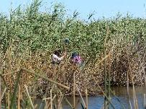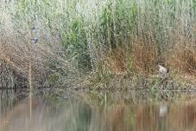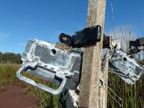

Monitoring camera installations in Barmah-Millewa Forest (H. McGinness)

### Research Outcomes Summary

Median clutch sizes were 2 eggs for straw-necked ibis, 2-3 eggs for Australian white ibis, and 3-4 eggs for royal spoonbills. Hatching and chick survival rates varied between seasons and species. Approximately 20-50% of all eggs laid survived, while 75-97% of all hatched chicks survived. Royal spoonbills had significantly higher hatching and survival rates than the two ibis species. Straw-necked ibis had the lowest chick survival rates.

Drivers of egg and chick mortality captured by monitoring cameras varied between years and species. Some mortalities could not be definitively assigned drivers based on the information available (16% overall). These included instances where the camera field of view changed or stopped working temporarily and when the view was restored the eggs or chicks were no longer present. Overall, other than the unknown causes of mortality, the greatest driver of mortality in the 2015-16 pilot study was predation of eggs by raptors. In the 2016-17 survey year, the leading cause of mortality was abandonment of eggs, with the cause of abandonment often unclear or mixed. In the 2017-18 survey year the leading cause of mortality was again predation of eggs. Other documented factors influencing mortality included nest exposure, anthropogenic disturbance, egg rejection, conspecific damage, competition, and starvation.

Since all predators captured by cameras as taking eggs or chicks were avian and water level is irrelevant to their access to nests, no relationship was found between water depth and predation impacts. The frequency of avian predation was better correlated with timing in the breeding cycle than with water depth, with high impacts on eggs and low impacts on chicks. However when water levels were low, land-based mammalian predators including pigs, foxes and cats (all feral species) were observed more frequently in images around nests. These species were not directly captured in images depredating any eggs or chicks in Reed Beds Swamp and consequently data were insufficient to quantify any relationship between water depth and the direct impacts of these species. Despite this, their presence in the colony indicates some level of mammalian predation or disturbance pressure; feral pigs were documented by cameras at a separate site across the river eating eggs from Australian white ibis nests during the late 2017-2018 breeding season. Rakali (water rats; *Hydromys chrysogaster*) were also present in the colony and have been known to consume waterbird eggs and chicks.

Abandonment of eggs occurred far more frequently than of chicks; indeed chick abandonment only occurred once throughout the study. Abandonment was the leading known primary cause of egg mortality for Australian white ibis but was not observed for either of the other two species until 2017-2018. The cause of abandonment was often difficult to ascertain, partly due to insufficient data, but abandonment was sometimes a secondary cause of mortality after an anthropogenic disturbance, or after clear egg rejection or egg loss due to some factor not attributable to predation, conspecifics or human disturbance (e.g. sometimes eggs would ‘sink’ into the nest substrate). Abandonment could not be quantitatively correlated with water depth at the nests, however there appears to be an association between a decrease in water depth and some nest abandonment events (Figure 3). It is likely that there are interactions between the effects of water depth change, predation pressure, breeding stage, disturbance and other factors. For example, a fall in water level during the egg stage may be more likely to trigger abandonment than a fall in water level during the chick stage. Adding predation or disturbance at the same time may increase the chances of abandonment.

Nest exposure measures such as nest aspect, nesting group shape, nest exposure to open water and nest vegetation wall protection had varying effects on total egg loss and chick survival. Nests with a north-west or south-east aspect had the highest average egg losses over all species. In summer, these aspects are the most exposed to heat and the most exposed to cold respectively. The number of surviving chicks was significantly lower in nests with a western aspect and nests with a south-west aspect also had a relatively low mean number of surviving chicks, suggesting that sun exposure during the hottest part of the day may be a risk factor for chicks. The mean number of surviving chicks was highest in nests with a NNE, S or E aspect, all of which receive sun in the early morning and shade in the afternoon. Nests with the lowest vegetation wall protection had the highest mean egg loss, and the number of surviving chicks was significantly higher in nests with the highest vegetation wall protection.

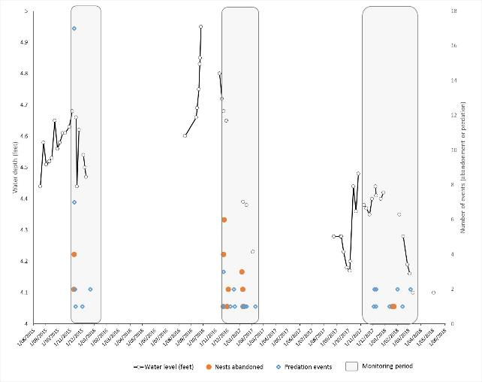

Figure 3 Water depth at the Gulpa Gauge and the number of nest abandonment and predation events per day at monitored nests in the Reed Beds wetland over time.

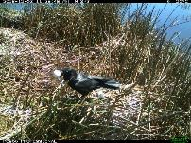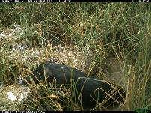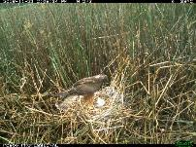

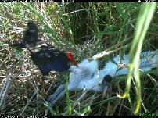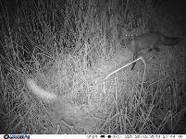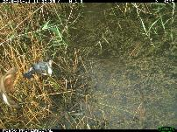

Examples of egg and chick predators: Australian Raven; Pig; Swamp Harrier; Purple Swamphen; Red Fox (CSIRO)

### Water Management Application

With ongoing declines in waterbird populations, it is important that we understand how many birds are being produced by breeding events, together with what is affecting those numbers. Using monitoring cameras to capture such data facilitates explanation of perceived failures, by providing additional information describing the effects of other pressures, stressors or threats such as predation, disturbance, starvation, competition and other bird behaviour.

Water management actions to support survival of eggs and chicks include provision and maintenance of water within breeding habitats. It is well known that rapid or early declines in water levels can trigger nest abandonment. Abandonment is more likely during the egg stage than the chick stage, however it is still important to maintain water levels late in the breeding season, for two primary reasons: 1) Maintaining food and foraging habitat availability; and 2) Preventing feral predator access. In addition to provision of environmental water for breeding sites, provision of water to support nearby foraging sites and food before, during and after a breeding event is likely to affect the size and success of the event.

Actions that can be taken to complement environmental flows, reduce pressure on adults, eggs and chicks, and increase egg and chick survival include: Feral predator control (pigs, foxes and cats); Habitat modification and maintenance to provide a range of vegetation types and configurations to choose from; and disturbance control. It is likely that these pressures vary between different locations and will therefore require different levels of effort and investment across the Basin.

There are also several possible drivers of egg and chick mortality occurring at breeding sites that are difficult to quantify visually through surveys or camera monitoring. These include toxins, diseases, parasites, and interactions between these and other pressures. Evaluating the roles of these factors in affecting egg and chick survival will require testing of swabs, blood or other samples collected in the field. Data quantifying waterbird fledging rates and their drivers in Australia are scarce, with some exceptions for particular species or groups in certain locations such as egrets. These data can be difficult to collect in the field, however detailed, long-term monitoring is essential if we are to build better quantitative models that allow assessment of the potential quantity and timing of water required to ensure successful fledging.

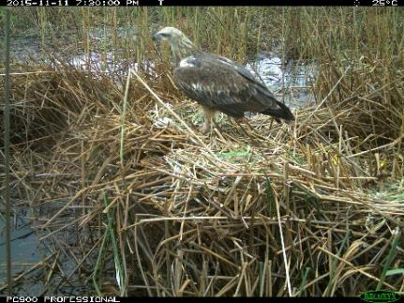

A juvenile White-breasted Sea-eagle eating ibis eggs, Barmah-Millewa Forest (CSIRO)

## Monitoring ibis and spoonbill nest success through on-ground tagged nest and water depth surveys

*Kate Brandis, Maria Bellio, Diane Callaghan, Emily Webster, Roxane Francis*

*Please see Appendix 4 for detail*

### Research Question

What is the variability in annual breeding responses and success by colonial waterbirds at Reed Beds in relation to water depths?

### Research Outcomes Summary

Colonial waterbirds nested in Reed Beds in each of the three years 2015–2018. Nesting period was generally October – February. Ibis nests were built primarily on *phragmites australis* with royal spoonbill also nesting in *Eleocharis* spp. along channel edges. Australian white ibis were consistently the most abundant nesters at Reed Beds over the three breeding seasons 2015 – 2017. Australian white ibis and Royal spoonbill nested in all years surveyed, while Straw-necked ibis nested in 2 out of the 3 years (2015, 2016/17).

Surveys undertaken in 2015 were part of a pilot project for method testing and development. Consequently, only three surveys were completed. During the first survey (T1) in early November only nests with eggs of Australian white ibis were present (cohort 1). During survey 2 (T2), in early December there were additional Australian white ibis nests (cohort 2), and new royal spoonbill and straw-necked ibis nests. Reproductive success varied between stages of development corresponding with nest surveys, with losses highest during egg and chick stages (T1 – T2). Australian white ibis had the highest reproductive success rate observed during these limited surveys. Australian white ibis that nested later (cohort 2) were more successful than birds that nested early (cohort 1).

Five surveys were undertaken in 2016/17. During the first survey Australian white ibis and straw-necked ibis were nesting. Royal spoonbill began nesting in the interval between surveys T1 and T2. Reproductive success varied between surveys which corresponded with chick development stages. Australian white ibis had the highest success rates for cohort 1 while cohort 2 had lower rates for T1-T2 (egg/chick), but higher rates for T2-T3. Reproductive success rates for straw-necked ibis were higher for early nesters (cohort 1) than later nesters (cohort 2). Royal spoonbill had consistently high reproductive success rates (>60%) for each stage of nesting.

Two colonial species nested at Reed Beds in 2017/18, Australian white ibis and royal spoonbill. 2017/18 was a protracted nesting season with 3 nesting cohorts for Australian white ibis and 4 nesting cohorts for royal spoonbill. To account for this a total of seven nest surveys were completed. Australian white ibis early nester (cohort 1) had the highest reproductive success rates (>70%) at each survey interval while royal spoonbill later nesters (cohort 3) had the highest reproductive success rates.

**Water depth**

Water depth at the start of nesting was deepest in 2016/17 with a median depth of 80cm (2015 – 70 cm; 2017/18 – 57cm). Water levels fell throughout the nesting period in 2015 and 2016/17, but remained stable during 2017/18, although relatively shallow when compared to other years

Analysis of water depths and reproductive success in 2015 and 2016/17 found that relationships between reproductive success and water depths were strongest for straw-necked ibis. Offspring success of straw-necked ibis was significantly lower than that of Australian white ibis, with greatest loss occurring at young chick and egg stages. Straw-necked ibis responded later to flow thresholds triggering breeding, nesting later than Australian white ibis.

### Water Management Application

This study has demonstrated that Reed Beds is a colony site that is used annually by colonially breeding waterbirds. Australian white ibis and royal spoonbill bred in each of the three years, while straw-necked ibis bred in two years. The role of regular small breeding events is likely to be a key contributor to maintaining populations. While unlikely to be contributing to population growth, they are important in maintaining genetic diversity in the population and providing some new recruits each year.

Further analysis of the interactions between water depth and reproductive success will inform water managers of what water depths in the colony site are optimal for successful reproductive success.

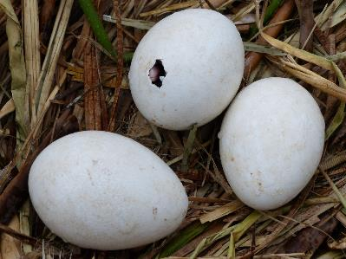

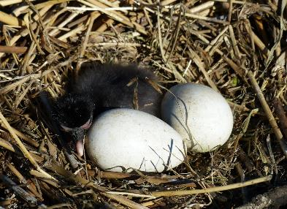

Straw-necked ibis eggs and chicks (H. McGinness)

## Ibis breeding responses to flow and depth thresholds in Barmah-Millewa Forest

*Emily Webster (Honours student), Kate Brandis, Richard Kingsford, John Martin*

*Please see Appendix 9 for detail*

### Research Question

What are the relationships between river flow volumes in the Murray River and the breeding responses of ibis in Barmah-Millewa?

### Research Outcomes Summary

Water depths in Reed Beds were positively correlated with flows at Yarrawonga, and relationships between reproductive success and water depths were strongest for straw-necked ibis.

In 45 years, both species bred about every 7 years in 10, triggered when high flow thresholds were met, but also breeding in 2014/15 and 2015/16 when flows were small. Larger flows in 2016/17 triggered a breeding event 88.15% larger than in the previous year. Offspring success of straw-necked ibis was significantly lower than that of Australian white ibis, with greatest loss occurring at young chick and egg stages. Straw-necked ibis responded later to flow thresholds triggering breeding, nesting later than Australian white ibis.

There was a positive linear relationship between the 2 flow thresholds for breeding, total volume July-December >2,300,000 ML and >30 consecutive days > 15,000 ML day-1. Breeding occurred in all years, when both thresholds were met (n=25 years) (1961-2017): 24 years when both species bred and in the year when only Australian white ibis bred in 1981. Neither threshold was met in 2014/15, or 2015/16 but both species bred. When only the daily flow threshold was met, breeding occurred in all years. When only the total volume threshold was met, breeding occurred in all but one year (1968). For the 11 years where breeding data were missing (1961-2017), this strong relationship predicted likely breeding in 1970. This meant that breeding frequencies for straw-necked ibis and Australian white ibis in the Barmah-Millewa Forest were respectively 29 and 30 times since 1961 (1961-2017), about 7 times in every 10 years for both species, coinciding with periods of high flow in the River Murray.

### Water Management Application

This study supports the identified flow requirements for colonial waterbird breeding at Reed Beds with a positive linear relationship between the 2 flow thresholds for breeding, total volume July-December >2,300,000 ML and >30 consecutive days > 15,000 ML day-1. Australian white ibis and straw-necked ibis bred on average 7 out of 10 years, coinciding with periods of high flow in the River Murray. This long-term study presents a baseline and target against which long term water management plans can be developed.

## Ibis and spoonbill nest and colony mapping using drone imagery

*Kate Brandis, Justin McCann, Mitchell Lyons*

*Please see Appendix 5 for detail*

### Research Question

Can accurate nest counts and colony boundaries be derived from high resolution imagery of the colony area? Can these data inform our understanding of how waterbirds are utilizing the colony area i.e. nest placement?

### Research Outcomes Summary

Drone imagery allowed for the accurate counting and locating of nests throughout the Reed Beds colony site. Mapping of nests using this method allows for the accounting of nests that are not accessible by ground counts i.e. those surrounded by vegetation. It also allows for the mapping of vegetation in the colony sites. Drone imagery provide data from which we can derive information about how waterbirds are using the colony area, such as a preference for positioning of nests adjacent to open water areas.

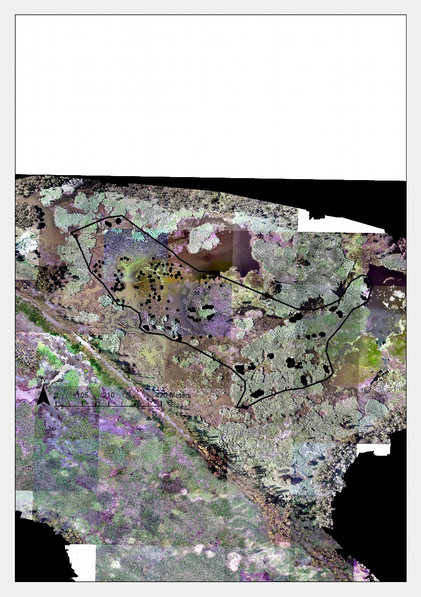

Figure 4 **Nest mapping and colony boundary mapping from drone survey 2016. Each dot represents an individual nest (1,645 nests).**

### Water Management Application

The Reed Beds colony site is a traditional nesting site used each year. The data collected from the drone data analysis provides insights into the habitat layout that the birds are utilising for nesting. This helps inform water managers to ensure that these characteristics can be maintained or enhanced. Provision and maintenance of suitable nesting habitat at Reed Beds would be a priority as birds are reusing the site. Site knowledge by birds may result in increased reproductive success. Therefore, ongoing provision of suitable nesting habitat at this site may result in more successful breeding events. Visual analysis of nest distribution shows that nests are frequently located near areas of open water. This assists water and wetland managers in vegetation management and watering decisions to prevent the infilling of channels and open water areas.

## Ibis chick diet

*Emily Webster (Honours student), Kate Brandis, Richard Kingsford, John Martin*

*Please see Appendix 9 for detail*

### Research Question

To examine chick diet in relation to 1) differences between straw-necked ibis and Australian white ibis, and 2) chick age.

### Research Outcomes Summary

The composition of chick scats suggested a preference of terrestrial invertebrates as prey by straw-necked ibis, and aquatic invertebrates by Australian white ibis. In particular, orthoptera or grasshoppers were abundant in the scats of straw-necked ibis chicks, contrasting an abundance of decapoda for Australian white ibis: the former primarily occupies terrestrial habitats and the latter, aquatic. Coleoptera were abundant in chick scats collected from both species. The relative lack of hemiptera, fish and decapoda in straw-necked ibis scats, and the presence of araneae, not represented in Australian white ibis, further suggests reliance on terrestrial rather than aquatic habitats.

There was also a higher diversity of prey items in Australian white ibis scats, compared to those of straw-necked ibis, which could either indicate a higher diversity of prey within aquatic habitats than terrestrial habitats, or that Australian white ibis are more generalists. These analyses are similarly indicative, as scat samples did not adequately reflect dietary intake, given mastication and differential digestion of prey. For example, straw-necked ibis feed on freshwater snails, however no soft-bodied prey was represented in their scat. In support of the patterns found, voluntarily regurgitated boluses obtained from sampled chicks of both species contained complete bodied prey, confirming the identification of some parts observed in scats.

There were no significant patterns in chick age (stage) and prey items consumed.

### Water Management Application

The dietary differences between straw-necked ibis (terrestrial feeders) and Australian white ibis (more aquatic feeders) illustrate niche partitioning between two closely related species to avoid interspecific competition. The implications for water management include:

* Recognising that waterbird species differ in their dietary requirements,
* Different diets are sourced from different foraging habitats,
* Ensuring that a mosaic of habitats is available for foraging,
* Not all waterbirds forage in wetland areas, managing these terrestrial foraging sites is often beyond the remit of the water manager.

## Ibis and spoonbill chick energy source assimilation

*Please see Appendix 6 for detail: Manuscript in early stages of preparation for submission to a scientific journal for publication. Authorship to be confirmed. Current authors include: Paul McInerney, Kate Brandis, Heather McGinness, Ralph Mac Nally.*

### Research Question

The use of environmental water within the basin has often been focused on supporting the completion of waterbird breeding events at key colonial nesting sites. However, managers and policy-makers are becoming increasingly conscious of the need also to manage feeding sites at basin scales. Providing the right amounts of water to the right places at the right times will increase recruitment and, hopefully, elevate the long-term persistence of waterbird populations in changing climates. To understand how environmental water provision (‘ewater’) can support important dietary components of colonial waterbirds, we must first better understand their feeding requirements. This activity set out to answer three primary questions:

1. What are Australian ibis and spoonbills eating (diet composition)?

2. What is the energy value of different types of ibis and spoonbill food sources?

3. Which food sources appear to be assimilated best?

### Research Outcomes Summary

Based on regurgitate sampling (the fresh contents of a bird’s crop), diets of Royal spoonbills and Straw necked ibis are significantly different. Royal spoonbills fed predominately on fish and yabbys (71% and 15% of total diet respectively, Figure 5). In contrast straw–necked ibis fed primarily on beetles (49%), centipedes (11%) and other indeterminate insects (11%). These results from regurgitates form an interesting contrast with diet results based on scats (Section 2.8), suggesting that sample type is important for diet assessment.

Overall, the calorific value of the primary diet sources for each species were similar (Fish ~ 5761 compared to beetles ~ 5556 calories/gm dry weight), though slightly higher for Royal spoonbills. Stable isotopes ratios of δ15N and δ13C from feathers suggest that for both species, regurgitate contents largely correspond to what food items the birds are assimilating. However, for Royal spoonbills isotopic analyses indicated that yabbys and prawns were under represented in regurgitate samples compared to tissue assimilation and for Straw–necked ibis, frogs and crickets were under represented in regurgitate samples compared to tissue assimilation (Figure 6).

### Water Management Application

Our results suggest that consideration of specific waterbird species trophic requirements are important when tailoring management of environmental watering to maximise food availability to support waterbird recruitment. For example, if royal spoonbills are known to breed in a particular location, watering should be targeted to maximise the abundance of aquatic food resources, such as small fish, yabbies and prawns. If however if a location is known to support primarily straw necked ibis colonial breeding, environmental water might be better used to promote diverse floodplain, riparian and terrestrial foraging habitats that support a diverse array of vertebrate and invertebrate prey.

A close up of a map

Description generated with very high confidence

Figure 5 Proportion of prey taxa (total dry weight (g)) from combined regurgitate from all locations of (a) Royal spoonbills and (b) Straw–necked ibis.

A close up of a map

Description generated with high confidence

Figure 6 Diet composition of Royal spoonbills at (a) Barmah-Millewa, (b) Kerang wetlands and Straw–necked ibis at (c) Barmah-Millewa, (d) Kerang wetlands and (e) Kow Swanp, derived from mixing models using isotopes ratios of δ15N and δ13C.

## Ibis and spoonbill chick energy requirements

*Lauren O’Brien and Heather McGinness*

*Please see Appendix 7 for detail: Manuscript submitted to Wetlands Ecology and Management scientific journal for publication 6/12/2018; reviewed and edited version resubmitted 29/5/2019.* O’Brien, L. and McGinness, H.M. (in review) Ibis and spoonbill chick energy requirements: Implications for wetland management.

### Research Question

Colonial-nesting waterbirds such as ibis and spoonbills (Threskiornithidae) can account for a significant proportion of energy flow through wetlands, particularly during large breeding events. Raising young may double the daily energy requirement of parent birds. However when food availability is reduced, chicks may starve and adults may abandon nests. If the energy required to rear chicks could be calculated, data quantifying prey energy value and availability could be used to develop landscape scale management targets to ensure that food requirements are met to support chicks until they attain independence.

We calculated ibis and spoonbill chick biometrics and energy requirements through a) an international literature review, extracting and synthesising the best available growth and energy data; b) new measurements of ibis and spoonbill chick biometrics for selected species; and c) analysis of the resulting databases to construct growth curves and predict energy requirements for selected species.

### Research Outcomes Summary

There is a paucity of data available describing the growth and energy requirements of ibis and spoonbill species (Threskiornithidae). This study has begun filling some of these knowledge gaps, through the extraction and synthesis of the best available data globally on Threskiornithid energetics, growth, and biometrics, and by creating the first growth model for Royal Spoonbill chicks and developing the first predictive energetic models of Australian waterbird chick energy requirements. The general agreement between modelled predictions and measured values for other species suggests that these models and predictions could be extrapolated to other similar regions and species.

The total energy estimated to raise a single Royal Spoonbill chick from hatching to independence was 71,290 kJ and for an Australian White Ibis chick was 67,160 kJ. Using prey energy values from the literature, extrapolations indicate that for either species, a nesting event of 1000 nests producing three chicks per nest would require an estimated ten tonnes of freshwater crayfish (*Cherax destructor*) or eight tonnes of small fish to support chicks from hatching to independence. Effective water and wetland management is therefore critical to optimise both energy availability in foraging sites and breeding success.

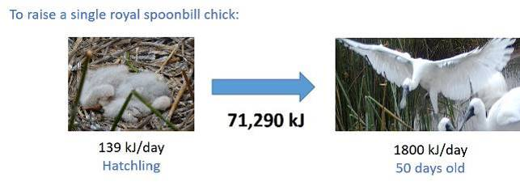

### Water Management Application

The predictions from the energy models developed in this study can be used to assess how much food is required to support colonial-nesting waterbird breeding events and the role of spoonbill and ibis breeding events in wetland ecosystem energy flow. Results can be incorporated into ecological models to meet management targets. This type of modelling will support efforts to meet specific biological and food web function targets in wetland ecosystem and waterbird population management, particularly when combined with measurement of adult bird energy requirements.

Both nesting and foraging habitats must be carefully managed during and after breeding to optimise energy source availability and quality. However at present we have limited knowledge regarding the biomass or availability of appropriate food sources for waterbirds, spatially or temporally, or how these are affected by environmental flows and other pressures. The primary food sources for which this information is needed include: small fish (including juvenile large fish) such as smelt, gudgeons, carp, goldfish, gambusia, redfin; frogs and tadpoles; crustaceans such as yabbies, crayfish, crabs, shrimp, prawns, amphipods, isopods; molluscs such as shellfish, bivalves and snails; aquatic invertebrates such as dragonfly nymphs, bugs, beetles; and terrestrial invertebrates such as spiders, locusts, crickets, beetles, caterpillars, grubs, centipedes and earthworms; Figure 7).

If we can quantify prey energy value and availability, this information could be used together with chick energy requirements and food web information to develop landscape scale management targets to ensure that food requirements are met to support chicks until they attain independence.

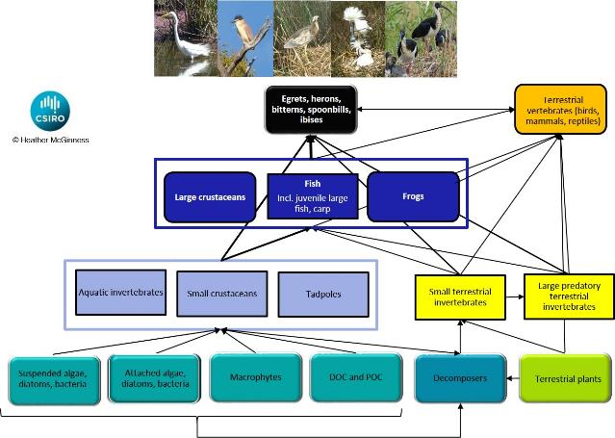

Figure 7 Food (energy) sources supporting ibis, spoonbills, bitterns, herons and egrets

# Theme Synthesis

## Where and what are the critical foraging habitats for recruitment?

Flow regimes, water management and threats to waterbirds, such as habitat change and habitat loss, affect the availability (quantity and distribution) and quality of foraging sites at multiple scales. These, in turn, will affect the survival of young birds and consequently recruitment. However, data describing waterbird foraging preferences, locations and movements (and how these affect survival) are scarce, limiting our ability to predict the effects of changes in water management and threats to habitat.

Species physical adaptations, dietary preferences and foraging techniques are important determinants of the suitability of foraging habitats. For example, royal spoonbills have a specialised bill with which they forage in shallow water for fish, crustaceans and aquatic invertebrates. In contrast, straw-necked ibis are able to forage in both terrestrial environments and shallow water, using their bill to probe damp soil, litter and logs and to take terrestrial or aquatic prey from the ground, vegetation or water. Straw-necked ibis will also take advantage of events such as locust plagues, consuming large quantities of locusts or other prey types as they become available. Consequently foraging habitats and diets vary by species, location and timing.

### Where do adults forage *during* nesting?

During nesting, adult straw-necked ibis may travel greater distances to forage than when not nesting, with mean maximum foraging distances of 6 to 44km, depending on the nesting site. In contrast, the tracked nesting royal spoonbill foraged exclusively within or close to the nesting site (mean maximum distance of 4km).

Foraging habitats used when nesting differed substantially from those used when not nesting for all but one of the birds for which data were available. Landuses when nesting varied between and within species. Overall, the tracked nesting royal spoonbill spent significantly more time foraging in marsh/wetland environments (94%) close to the nesting site (median 2.5km) when nesting than tracked straw-necked ibis.

Differences in landuses among nesting straw-necked ibis were generally associated with which landuses surrounded the nesting site. Foraging habitats used by nesting straw-necked ibis included marsh/wetland environments, nature conservation areas, grazing pastures (native and modified, irrigated and dryland), rivers, ‘other minimal use’ areas, cropping, ‘transport and communication’ (mostly roadsides), production native forests (including parts of Barmah-Millewa Forest). Overall, foraging distances were lower in Barmah-Millewa Forest than in other sites, suggesting that birds find suitable foraging habitat closer to the nesting site in Barmah-Millewa and therefore do not have to expend as much energy travelling as when they are nesting at other sites.

### How long do adults and juveniles forage in or around the nesting area?

Straw-necked ibis and Australian white ibis left nesting sites in the Murray River region in December, January and February. In contrast, royal spoonbills left the same nesting sites in March and April. Tracking showed that spoonbills forage for extended periods of weeks to months in and around the nesting site – particularly juveniles who have just left the nest. In contrast, straw-necked ibis and Australian white ibis typically left the nest site not long after starting to fly. Tracked straw-necked ibis adults left the Macquarie Marshes in early to mid-November.

Straw-necked ibis adults and juveniles tracked from Barmah-Millewa, Kow Swamp and Kerang flew mostly north-east or east on leaving their nest sites, while the five Macquarie Marshes straw-necked ibis adults all flew south. Post-breeding, the adult male royal spoonbill flew north directly to Queensland. One juvenile royal spoonbill flew NE, another flew S, and other flew ESE. Juvenile royal spoonbills from Barmah-Millewa did not travel long distances on leaving the nest site, however one of the juvenile spoonbills from Kerang dispersed north overnight to Lake Cargelligo and then continued north past the Macquarie Marshes, where transmissions ceased. Australian white ibis juveniles did not travel far from the nesting site and flew in a range of directions. None of the tracked birds flew SW and very few flew west – those that did didn’t travel far and were simply foraging near the nesting sites.

### Where do juveniles and adults forage *after* a breeding event?

After breeding events, ibis and spoonbill adults and juveniles may travel hundreds of kilometres in a matter of days – or they may not. For example, within the 40 individual straw-necked ibis tracked, there were at least three movement patterns. Some individuals remained relatively resident (or sedentary) in one area, while others moved nomadically across a region or sub-catchment, and others moved thousands of kilometres up and down the Murray-Darling Basin - with one behaving in the same way an ‘obligate’ migrant might, moving seasonally at the same times to the same places each year. This mixed movement behaviour within species or populations is known as ‘partial migration’. Partial migration is common among birds and is thought to be a strategy that copes at the species level with spatial and temporal variation in resources, environmental conditions and their predictability. Within partially migratory species, the movement behaviour of an individual may remain rigid or fixed over its life, or may change or be flexible.

Straw-necked ibis juveniles and adults foraged in similar habitats after breeding events, including grazing pastures (native and modified, irrigated and dryland), marsh/wetland environments, nature conservation areas, and cropping. Royal spoonbill juveniles foraged in marshes/wetlands and other habitats with surface water, including rivers, irrigation channels, irrigated cropping, and grazing pastures. The adult royal spoonbill tracked flew to Queensland after breeding, foraging mostly in ‘grazing native vegetation’ landuses, reservoirs/dams, and marsh/wetlands. Australian white ibis foraged mostly in areas classified as grazing pastures (modified, irrigated), marsh/wetland environments, nature conservation areas, and cropping.

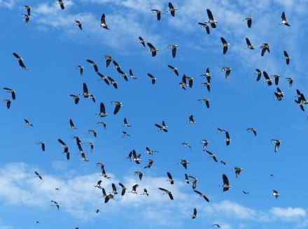

Straw-necked ibis in flight (H. McGinness)

## What are critical nesting habitat characteristics we need to maintain?

Establishing which nesting habitat characteristics are important allows managers to better target water, vegetation and bird management to ensure ‘event readiness’ at sites between flooding events and to maximise recruitment during breeding. Maximising recruitment into the adult population begins with optimising the number of birds that fledge from each site. Protection and maintenance of appropriate nesting sites is crucial for optimising recruitment, and requires knowledge of the influence of habitat type, condition, and configuration on species site choice, predation impacts, and nest success.

### What are the characteristics of preferred nesting sites?

Vegetation types chosen for nesting by ibis and spoonbills vary across the basin depending on the site. In the Macquarie Marshes and Barmah-Millewa Forest, straw-necked ibis and Australian white ibis most commonly select common reed (*Phragmites australis*), whereas in the Booligal Wetlands and Narran Lakes they use lignum (*Duma florulenta*) and in the Coorong and Lower Lakes are known to nest in thornbushes. Royal spoonbills nest in giant rush (*Juncus ingens*) in Barmah-Millewa Forest but nest in lignum or trees at other sites. The common features of nesting sites include surface water surrounding or under the nesting vegetation, vegetation structure substantial enough to support the weight of multiple birds and nests, and a patchy vegetation to surface water configuration.

### How do nesting habitat characteristics influence the numbers of fledglings produced?

Nesting habitat characteristics may influence the numbers of fledglings produced through variation in physical accessibility or visibility to predators and through nest exposure to weather extremes.

Physical accessibility to predators will vary between sites and over time depending on vegetation type and configuration, water levels, and the dominant predators. In Barmah-Millewa forest, where camera monitoring was focused, the dominant predators were native raptors (birds of prey), which access nests from the air and are therefore not affected by water level. While it appears that nest position and nesting group shape may affect predation and mortality/survival rates due to aerial accessibility, numbers were generally too low for a statistical relationship to be established. Similarly, while land-based predators such as foxes and pigs appeared more frequently in camera images as water levels dropped, there were so few records that quantitative analysis was not possible. It is likely that at other sites in the Murray-Darling Basin, where feral predators are more abundant, that their impacts may be greater (e.g. anecdotal reports of large-scale pig impacts in the Macquarie Marshes) however such impacts have not been quantified to-date.

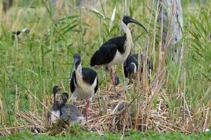

Straw-necked ibis adults with chicks (H. McGinness)

## What have we learned about waterbird recruitment and drivers of waterbird mortality?

Studies outside of Australia have suggested that most nest mortality involves eggs rather than chicks (though the latter is rarely measured). Evidence from our nest monitoring supports this, showing that while egg loss rates may be high due to predation and abandonment, chick survival (fledging) rates to the point where they leave the nest are also high. However there is growing evidence that high juvenile and sub-adult mortality may be a potential bottleneck in population growth for straw-necked ibis and royal spoonbills in Australia. Some of this evidence includes:

* Declines in populations despite the occurrence of large breeding events
* Juveniles being rarely observed, even after very large breeding events
* Low ABBBS band recovery and resighting rates
* High mortality rates among tracked juveniles

Mortality rates or drivers for young Australian ibis and spoonbills outside of the nest have never been quantified before.

Outside of Australia, mortality rates for first year and younger birds are high. Only two species have documented rates of mortality for birds less than 6 months old that have left the nest: glossy ibis and Eurasian spoonbill, ranging from 56% to 90% mortality. Sub-adult glossy ibis, Eurasian spoonbill and white-faced ibis aged 6 months to 3 years have mortality rates ranging from 20% to 87%. Predation of juveniles and sub-adults is dominated by raptors, and other documented causes of mortality include: collisions with power lines and vehicles; disease/toxins including botulism; extreme weather including hailstorms and storms; hunting by humans (food, plumage, sport); migration complications – disorientation, lack of experience, starvation, many unknowns; parasites; starvation during the over-wintering period; and interactions with climate and habitat loss. Mortality rates have been documented for adults of three species: Eurasian spoonbill, white-faced ibis, and Australian white ibis (Sydney), ranging from 1% to 82% mortality and 74% -90% survival. Documented causes of mortality for adults include predation (raptors and mammals); hunting/shooting; disease; parasites; poisoning/toxins; collisions with vehicles, power lines, and aircraft; storms/hailstorms; competition for food with other species and starvation during migration. Most of these rates are based on band recovery data or natal site fidelity data.

Satellite tracking of waterbird movements by the EWKR project has for the first time allowed preliminary investigations into the relative importance of various drivers of mortality for juveniles and adults. The main factors associated with mortality in the EWKR satellite-tracked birds were: Heat exhaustion / cold / exposure (weather extremes) (28%); Predation (e.g. raptors, foxes) (26%); Shooting (6%); Disease (e.g. botulism, widespread in 2016–17) (4%); Vehicle impact (4%); and unknown (26%) causes. Mortality drivers that may fall into the ‘unknown’ class may include any of the above causes, or other diseases, poisoning and toxins, starvation / malnutrition, parasites and entanglement in fencing or powerlines. Often it is not possible to determine what has occurred or birds go missing for no apparent reason. Interactions are likely – e.g. starvation or toxins/disease increasing susceptibility to predation or weather extremes. An evidence scoring system is in development using data downloaded from the satellite transmitters (e.g. temperature, activity, solar recharge), the condition of the satellite transmitters when recovered, other on-ground evidence and weather data. Preliminary analyses indicate that associations between weather extremes and mortality or missing status are strongest where there is a shift from heat to cold and windy conditions within two days. Such conditions are likely to affect bird thermoregulation and can result in immune system depression and increased susceptibility to diseases, toxins and parasites. Juveniles are more susceptible than adults to these pressures, at least in part because they are naïve, are still learning to feed themselves and find shelter, use a lot of energy on first leaving the nesting area, and require high-quality food.

## Where do waterbirds fit in the food web and what food/energy sources do they need for recruitment?

As group, waterbirds consume a wide variety of foods and are in turn consumed by a range of predatory and scavenging birds, mammals and reptiles (Figure 8). Waterbirds of different species vary in their diets, and due to size and diet differences, will also vary in their energy requirements and their positions in the food web. Large colonial-nesting waterbirds such as ibis and spoonbills may account for a significant proportion of energy flow through wetlands, particularly during large breeding events. However when food availability is reduced, chicks may starve and adults may abandon nests.

Diets of royal spoonbills, Australian white ibis and straw necked ibis differ (Table 1). Royal spoonbill regurgitates contained predominately fish and yabbies (71% and 15% of total diet respectively). In contrast straw–necked ibis regurgitates contained primarily beetles (49%), centipedes (11%) and other insects (11%). Key taxa identified in Australian white ibis scats were coleoptera and decapoda.

Overall, the calorific values of the primary diet sources for royal spoonbills and straw-necked ibis were similar. Stable isotopes ratios of δ15N and δ13C from feathers suggest that for both species, regurgitate contents largely correspond to what food items the birds are assimilating. This is an important outcome for interpretation of future studies. However, for royal spoonbills isotopic analyses indicated that yabbies and prawns were under represented in regurgitate samples compared to tissue assimilation and for straw–necked ibis, frogs and crickets were under represented in regurgitate samples compared to tissue assimilation.

While straw-necked ibis, Australian white ibis and royal spoonbills all differ in their diets, their overall energy requirements are likely to be similar. Using ibis and spoonbill chick biometrics, growth curves and energy models, the total energy estimated to raise a single Royal Spoonbill chick from hatching to independence was 71,290 kJ and for an Australian White Ibis chick was 67,160 kJ. Using prey energy values from the literature, extrapolations indicate that for either species, a nesting event of 1000 nests producing three chicks per nest would require an estimated ten tonnes of freshwater crayfish (*Cherax destructor*) or eight tonnes of small fish to support chicks from hatching to independence. Consequently both nesting and foraging habitats must be carefully managed during and after breeding to optimise energy availability and breeding success. Data quantifying prey energy value and availability could be used to develop landscape scale management targets and modelling to ensure that food requirements are met to support chicks until they attain independence, thereby maximising recruitment.

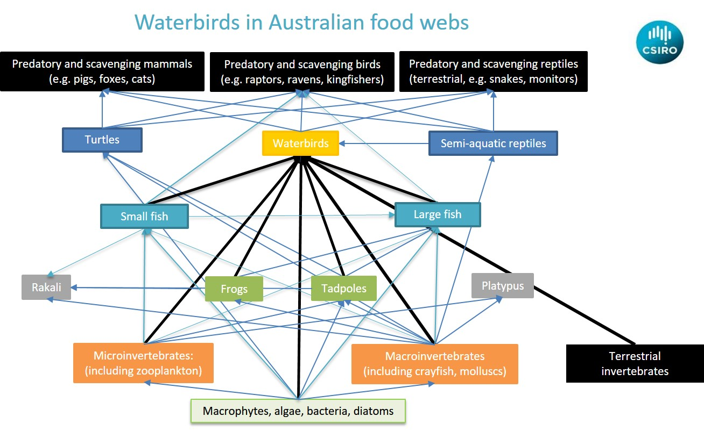

Figure 8 Conceptual model of waterbirds in an Australian foodweb (H. McGinness, CSIRO).

Table 1 Components of the diets of royal spoonbills, straw-necked ibis and Australian white ibis based on the literature and EWKR research. Primary sources for all species are the published compilations of data by Barker and Vestjens (1989); and Marchant and Higgins (1990). Brackets indicate components not listed by name in sources but likely to be consumed considering other known food items, feeding techniques, foraging habitats, and gape size. Examples of sources consumed most by weight and frequency are presented in bold. (H. McGinness, CSIRO).

|  |  |  |  |
| --- | --- | --- | --- |
| Food source | Royal Spoonbill | Australian White Ibis | Straw-necked Ibis |
| Fish | **Small fish including small carp, smelt, goldfish, gambusia, redfin, gudgeons** | **Small fish including gambusia, redfin** | Y |
| Tadpoles | (Y) | (Y) | (Y) |
| Frogs | (Y) | **Spotted marsh frogs, toadlets** | **Spotted marsh frogs, toadlets** |
| Aquatic invertebrates | Dragonfly nymphs, bugs, beetles | Dragonfly nymphs, bugs, beetles | **Beetles** |
| Crustaceans | **Shrimp, amphipods, isopods, crayfish, yabbies, crabs** | **Crayfish, shrimp, isopods** | Crayfish, crabs, shrimp |
| Molluscs | Y | Mussels, shellfish | Y |
| Terrestrial invertebrates | Y | **Beetles, crickets, grasshoppers** | **Spiders, crickets, grasshoppers, locusts, beetles, caterpillars, centipedes, earthworms** |
| Reptiles |  | Y | Y |
| Mammals |  | Y | Y |
| References | Dorn (2011); Barker and Vestjens (1989); Marchant and Higgins (1990) | Carrick (1959); Barker and Vestjens (1989); Marchant and Higgins (1990) | Carrick (1959); Barker and Vestjens (1989); Marchant and Higgins (1990) |

# Management relevance

*Heather McGinness*

Critical waterbird foraging and nesting habitats are affected by both environmental flows and threats such as habitat change. There is significant potential for environmental flows to be managed to better support foraging habitats and food sources, especially during and immediately following breeding events. There is also potential for other management actions to support the effectiveness of environmental flows and ultimately waterbird recruitment. Environmental flows, vegetation management and pressures and threats such as predation, interact with habitat characteristics to affect juvenile and sub-adult movements, condition, growth, survival and mortality and to affect adult breeding initiation and frequency. Some factors influencing progression of waterbirds from one life stage to the next are independent of usual natural resource management (NRM), while others are influenced by both flow and other NRM, or only by other NRM, or by flow alone (Figure 9).

Flow and other NRM actions and their effectiveness vary depending on resource availability scenarios (Table 2), most of which are driven by interactions between climatic cycles such as El Nino / La Nina, weather conditions, politics, funding and other constraints such as land tenure and consumptive water demands. Historically, management actions for waterbirds have focused heavily on breeding event completion, with an emphasis on moderate to wet or very wet season when breeding events are large. Introduction of management actions that take into account the need to support life stages beyond the nest, egg or chick and in addition also promote survival of juveniles, sub-adults and adults has the potential to significantly improve recruitment outcomes and consequently to improve the chances of reaching waterbird population, abundance and diversity targets.

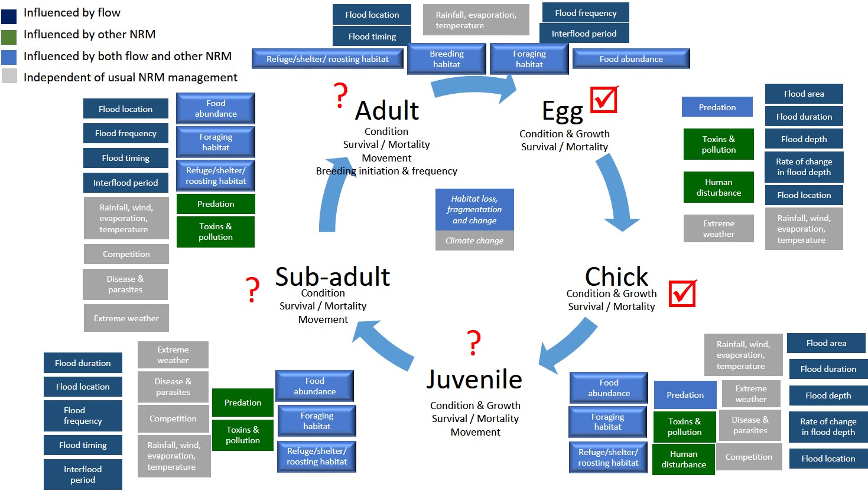

Figure 9 Major factors influencing progression of waterbirds from one life stage to the next (H. McGinness, CSIRO).

Table 2 Resource availability scenarios and associated waterbird outcomes, risks, considerations and knowledge requirements

|  |  |  |  |  |
| --- | --- | --- | --- | --- |
|  | Resource Availability Scenarios |  |  |  |
|  | **Very dry** | **Dry** | **Moderate** | **Wet to Very Wet** |
| BWES objective | Avoid irretrievable loss of or damage to, environmental assets | Ensure environmental assets maintain their basic functions and resilience | Maintain ecological health and resilience | Improve health and resilience of water dependent ecosystems |
| Scale | Site, reach | Site, reach, segment | Site, reach, segment, catchment | Site, reach, segment, catchment, basin |
| Potential waterbird recruitment outcomes | Breeding skipped or only in small numbers, restricted to sites permanently inundated. Very low survival of juvenile and sub-adult waterbirds due to insufficient food resources and high competition rates = very low recruitment. | Breeding skipped or only in small numbers, restricted to sites permanently inundated or receiving irrigation or environmental flows. Low survival of juvenile and sub-adult waterbirds due to insufficient food resources and high competition rates = low recruitment. | Potential for moderate recruitment at Basin scale. Breeding by in moderate numbers at multiple sites, including both permanent and ephemeral sites. Moderate survival of juvenile and sub-adult waterbirds, providing sufficient foraging habitats within range and food resource abundance are available and other drivers of mortality are minimised. | Potential for high recruitment rates at Basin scale. Breeding in high numbers at multiple sites, including both permanent and ephemeral sites. Relatively high survival of juvenile and sub-adult waterbirds, providing sufficient foraging habitats within range, and food resource abundance are available and other drivers of mortality are minimised. |
| Risks | Very high concentration of predation pressure on smaller numbers of eggs and chicks in the nest. Higher risk of abandonment due to insufficient flood duration, depth or extent. High risk of chick, juvenile and adult starvation. High risk of toxin-related mortality as fat stores are mobilised. | High concentration of predation pressure on smaller numbers of eggs and chicks in the nest. Higher risk of abandonment due to insufficient flood duration, depth or extent. High risk of chick, juvenile and adult starvation. High risk of toxin-related mortality as fat stores are mobilised. | Moderate predation pressure on eggs and chicks in the nest. Moderate risk of abandonment due to insufficient flood duration, depth or extent. Moderate risk of chick, juvenile and adult starvation. Potential for botulism and other disease-related mass mortality events. | Potential for high predation pressure on eggs and chicks in the nest as predator populations boom in response to food availability, but low impact on overall recruitment due to high numbers of waterbirds breeding. Low risk of abandonment due to insufficient flood duration, depth or extent. Low risk of chick, juvenile and adult starvation Potential for botulism and other disease-related mass mortality events. |
| Key considerations | Avoid triggering breeding; focus on breeding and foraging habitat maintenance/restoration. Support of critical foraging locations, food sources and refuges to avoid mortalities. | Avoid triggering breeding; focus on breeding and foraging habitat maintenance/restoration. Support of critical foraging locations, food sources and refuges to avoid mortalities. | If breeding commences, support with water as necessary to the point where juveniles depart nest site. Also support provision of foraging sites and food sources within 10km of nest site during nesting and post-nesting to increase chances of juvenile and subadult survival and to assist adults to rebuild body condition post-breeding. | If breeding commences, support with water as necessary to the point where juveniles depart nest site. Also support provision of foraging sites and food sources within 10km of nest site during nesting and post-nesting to increase chances of juvenile and subadult survival and to assist adults to rebuild body condition post-breeding. |
| Knowledge requirements | Location of critical foraging and refuge habitats at Basin Scale, particularly for juveniles and subadults. Quantifying and maintaining food requirements and availability. Quantifying toxin burdens and risks. | Location of critical foraging and refuge habitats at Basin Scale, particularly for juveniles and subadults. Quantifying and maintaining food requirements and availability. Quantifying toxin burdens and risks. | Location of critical foraging and refuge habitats at Basin Scale, particularly for juveniles and subadults. Movements and mortality rates post-fledging. Quantifying and maintaining food requirements and availability. Quantifying other drivers of mortality such as toxins, diseases. | Location of critical foraging and refuge habitats at Basin Scale, particularly for juveniles and subadults. Quantifying and maintaining food requirements and availability. Quantifying other drivers of mortality such as toxins, diseases. Movements and mortality rates post-fledging. |

# Knowledge Status

*Heather McGinness*

Waterbird populations are important targets for water management and policy worldwide, however knowledge gaps exist that affect our ability to manage water for waterbirds at appropriate scales.

Australia’s Murray-Darling Basin Plan and Basin Environmental Watering Strategy contain key objectives specifically for waterbirds, including increasing waterbird populations and maintaining waterbird diversity. Managed environmental water is frequently allocated to support completion of waterbird breeding, however waterbird populations continue to decline and the drivers of and links between site, basin and national scale responses and trends are poorly understood. Water policy makers and managers need to know how site scale responses are linked to basin and national scale drivers in order to set realistic targets and appropriately allocate water to the right places at the right times. Improving understanding of waterbird population movements and demographics will help managers to increase or maintain populations and explain waterbird responses or lack of response.

Some possible explanations for continued population declines and lack of response to management actions include:

* **Demographics:** Are more birds dying each year than are recruited following breeding events? If so, which age groups, why, where, and when? What can we do about it?
* **Bird movements, choices and cues**: What are the drivers of waterbird movements, site choices and breeding initiation? Are managed watering events occurring without appropriate cues? Are waterbirds moving in such a way that they are unable to detect and/or unwilling to respond to managed watering?
* **Bird movements and detectability**: Are waterbirds are moving in such a way that count methods currently used are missing many of them?
* **Foraging habitat and food availability**: Are available foraging habitats and food sources simply no longer sufficient to support viable waterbird populations? Are there particular times or places or life history stages for which foraging habitat and food availability are insufficient?
* **Breeding event frequency and size**: Are breeding events not occurring with sufficient frequency and/or with sufficient numbers to maintain the population size?
* **Lags in population recovery processes**: Is population recovery just slow or affected by lags? If so, why?
* **Genetic limitations and processes**: Are populations or sub-populations affected by genetic constraints?

These knowledge gaps exist even for common and conspicuous taxa that are often thought to be relatively well-understood (e.g. spoonbills and ibis). They are particularly severe for cryptic and uncommon species. Rectifying them will assist managers to:

* Identify, maintain, and/or restore key waterbird habitats and food sources
* Better understand the spatial and temporal scales at which habitats and food sources are required
* Better target water, vegetation and threat management actions to ensure ‘event readiness’
* Better predict the effects of water management and threats

Recent developments in technology and continued investment in new approaches to data collection, analysis and interpretation have the potential to assist with filling these knowledge gaps and improve water management for waterbirds. Future research should use the latest in technology and novel, complementary approaches to capitalise on waterbird movement datasets and samples collected as part of the Murray-Darling Basin Environmental Water Knowledge and Research project. Potential complementary techniques include machine learning, analysis of genetics; environomics; e-dna; isotopic analyses; pathology; and citizen science.

**There are three main knowledge gaps that should be targeted:**

### 1. Pressures on population growth and drivers of mortality.

Our knowledge is improving for eggs and chicks, but relatively poor for juveniles, subadults and adults. We need better data for a wider range of species (including managed species, aquatic prey specialists and declining/listed species) describing:

* Population dynamics and life history, including mortality rates and drivers
* The relative influence of drivers including: Spatio-temporal water availability (rainfall, flooding, env flows, irrig, dams); Food availability and quality (Starvation); Water quality; Toxins; Diseases; Landuse; Predation (native vs feral); Shooting; Disturbance; Extreme weather events; Climate change; Parasites; and other factors (vehicle impact, entanglement etc.)

### 2. Waterbird diet, energy needs and food source availability, bringing together:

* Food availability - how much is out there? Spatial and temporal variability.
* How much energy is needed for a wider range of waterbird guilds and species
* What are various foods worth (energy)? Expanding our databases of food energy value in different habitats and at different times, for use in modelling of additional species/guild requirements.
* Are some foods better quality than others? Expanding our databases of food quality in different habitats and at different times, for use in modelling of additional species/guild requirements.
* Which foods are better assimilated than others (vs. ingested)? Expanding our databases of food assimilation, for use in modelling of additional species/guild requirements.
* How have diets and energy sources changed over time?
* How do diets and energy sources and their availability vary by location?
* What are the implications of potential broad scale changes driven by factors such as climate change or carp control?

### 3. Waterbird movements, including a wider range of species dependent on water to feed as well as breed, including species known or suspected to be in decline or at risk, and incorporating multiple breeding sites across the Basin

* Critical foraging, roosting and stopover sites and routes – locations and spatial and temporal variation
* Critical habitat characteristics (nesting, foraging, roosting, stopover)
* Foraging trip distances – how close to foraging habitats need to be from roosting or nesting sites?
* Sub-population boundaries/connectivity/existence, ranges
* Philopatry and natal philopatry; and postfledging care of juveniles
* Movement cues and modifiers – e.g. flooding characteristics, thermals, weather
* Variation among individuals, sexes, and age categories
* Timing of departures and arrivals and relationships with other factors
* Physical and behavioural changes as birds age (e.g. moulting and how to 'age' them more accurately)
* Characteristics, preferences and limitations – e.g. paths, directions, distances, timing (foraging, breeding, dispersal, seasonal movements etc.)
* Movement cues and modifiers for a range of species – e.g. flooding characteristics, thermals, weather, food availability; timing of departures and arrivals and relationships with other factors

# List of Appendices

**Appendix 1**

McGinness, H. M. (2016) Waterbird responses to flooding, stressors and threats. CSIRO, Australia. Technical literature review report. *Available directly from* [*Heather.McGinness@csiro.au*](mailto:Heather.McGinness@csiro.au) *or from the MDB EWKR website.*

**Appendix 2**

McGinness, H.M., Langston, A., Robinson, F., Piper, M., Martin, J., Doerr, V.A.J., Kingsford, R., and Mac Nally, R. Satellite-tracking ibis and spoonbill movements and habitat choices. *Manuscript in preparation for submission to a scientific journal for publication.*

**Appendix 3**

McGinness, H.M., Robinson, F., Piper, M., and Hodgson, J., Kingsford, R., Mac Nally, R. and Doerr, V.A.J. Quantifying ibis and spoonbill egg and chick survival rates and mortality drivers using motion-sensing and time-lapse cameras. *Manuscript in preparation for submission to a scientific journal for publication.*

**Appendix 4**

Brandis, K., Bellio, M., Callaghan, D., Webster, E., Francis, R. Monitoring ibis and spoonbill nest success through on-ground tagged nest and water depth monitoring.

**Appendix 5**

Brandis, K., McCann, J., Lyons, M. Ibis and spoonbill nest and colony mapping using drone imagery.

**Appendix 6**

Ibis and spoonbill chick energy source assimilation. Authorship to be confirmed. Current authors include: Paul McInerney, Kate Brandis, Heather McGinness, Ralph Mac Nally. *Manuscript in early stages of preparation for submission to a scientific journal for publication.*

**Appendix 7**

O’Brien, L. and McGinness, H.M. (in review) Ibis and spoonbill chick energy requirements: Implications for wetland management. *Manuscript submitted to Wetlands Ecology and Management scientific journal for publication 6/12/2018; reviewed and edited version resubmitted 29/5/2019.*

**Appendix 8**

Lucy Wenger and Heather McGinness (2018) *Waterbird Chick Development: A Visual Guide to Selected Australian Species*. CSIRO, Australia. *Available for preview and purchase (at cost) here:* [*http://au.blurb.com/bookstore/invited/7714996/2775e42c847608953b28c7020e788bd36b9f0770*](http://au.blurb.com/bookstore/invited/7714996/2775e42c847608953b28c7020e788bd36b9f0770)

**Appendix 9**

Webster, E. (2017) Similarities and differences in breeding ecology of straw-necked ibis Threskiornis spinicollis and Australian white ibis T. moluccus in response to environmental flows. *Honours thesis, UNSW.*

**Appendix 10**

Theme Data Inventory

**Appendix 11**

Theme Outputs

**Appendix 12**

Theme Engagement and Communications Activities

|  |  |  |
| --- | --- | --- |
|  | | |
|  |  | For further information  Dr Heather McGinness  t +61 2 62464136  e Heather.McGinness@csiro.au  w [**https://research.csiro.au/ewkrwaterbirds/**](https://research.csiro.au/ewkrwaterbirds/) |