Executive Summary
Future Drought Fund
First Nations Market Research


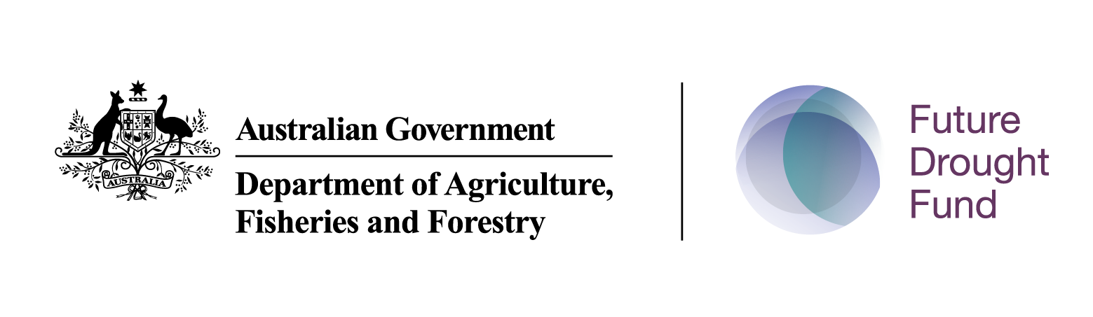

Executive Summary
The Australian Department of Agriculture, Fisheries and Forestry (DAFF) commissioned Winangali Pty Ltd to undertake culturally relevant market research to better understand how the Future Drought Fund (FDF) can improve engagement with First Nations people and communities and increase First Nations participation in drought resilience programs and funding. The research sought to understand First Nations perspectives on drought and drought resilience, identify community priorities, and explore more effective approaches to communication, engagement and program design.
The research included a desktop review, design stage interviews with 23 stakeholders involved in drought resilience, agriculture and First Nations engagement, and On-Country consultations with 107 First Nations participants across eight locations in Western Australia, South Australia, Queensland and New South Wales. The research was undertaken in accordance with AIATSIS ethical principles and Indigenous Data Sovereignty, with a strong emphasis on cultural safety, self-determination and community-led participation.

Key Findings

Drought is understood through culture, Country and community
The research found that First Nations people often understand drought through a broader lens than environmental or agricultural impacts alone. While drought is commonly associated with reduced rainfall, water shortages and environmental change, participants frequently described drought as a disruption to relationships with Country, culture, waterways, food systems and community wellbeing.
Water was consistently described as much more than a resource. Rivers, wetlands, waterholes and waterways were viewed as places of cultural learning, healing, recreation, food gathering and community connection. Consequently, the impacts of drought were often experienced through reduced access to Country, declining environmental health and loss of opportunities to maintain cultural practices and intergenerational knowledge transfer.
Participants commonly linked drought resilience with the broader concept of ‘healthy Country, healthy people’, emphasising that environmental, cultural, social and economic wellbeing are interconnected.

Language matters
The research identified significant variation in language preferences across regions. While some participants were comfortable using the term ‘drought’, many preferred terms such as ‘dry times’, ‘dry season’ or locally specific language.
For many participants, ‘dry times’ was considered less technical and more reflective of lived experience. In several locations, drought was also understood as an issue of access to water rather than simply a lack of water. Participants highlighted concerns about water governance, water allocations, irrigation systems and barriers to accessing cultural water.
The findings suggest that communication about drought resilience should be flexible, locally relevant and informed by community preferences rather than relying on a single national message.

Drought impacts extend beyond agriculture
Across all locations, participants described drought as having wide-ranging impacts on families and communities.
Common impacts included:
• Increased food prices and cost-of-living pressures.
• Financial stress for families and Elders on fixed incomes.
• Reduced access to waterways and culturally significant places.
• Impacts on mental health, wellbeing and social connection.
• Loss of opportunities for fishing, swimming, gathering food and spending time on Country.
• Environmental decline, including reduced river flows, poor water quality and impacts on
wildlife and vegetation.
• Challenges maintaining cultural practices and transferring cultural knowledge to younger
generations.
Many participants described drought as amplifying existing social and economic disadvantage. Housing pressures, unemployment, limited transport and infrastructure constraints often reduced communities’ ability to prepare for or respond to drought conditions.

Communities are generally responding rather than preparing
A consistent finding across consultations was that most participants viewed drought preparation as reactive rather than proactive.
Many people reported limited access to practical information about preparing for drought and often relied on personal experience, family networks and community organisations when conditions worsened. Participants indicated that immediate concerns such as housing, employment and cost-of-living pressures often take precedence over longer-term planning.
Despite this, communities identified many opportunities to strengthen preparedness, including:
• Early warning systems and practical information.
• Community education programs.
• School-based learning about water and environmental management.
• Ranger programs and On-Country activities.
• Water infrastructure such as tanks, filtration systems and storage.
• Community-owned gathering places and culturally safe spaces.
• Local drought resilience planning and leadership.
Participants consistently emphasised that preparedness activities should be community-led and grounded in local cultural knowledge and priorities.

Awareness of the Future Drought Fund is extremely low
One of the strongest findings from the research was the very low level of awareness of the FDF among participants.
Most people had never heard of the FDF or had only limited awareness through indirect channels. Many participants perceived drought funding as primarily targeting farmers, agricultural businesses or local governments rather than First Nations communities.
Even where participants were interested in funding opportunities, they described significant barriers including:
• Lack of awareness of funding opportunities.
• Complex application processes.
• Limited organisational capacity.
• Short funding timeframes.
• Difficulty navigating government systems.
• Limited access to grant writing support.
Participants frequently expressed frustration that government programs often fail to reach community members directly and that information is not communicated through trusted channels.

Trust, relationships and local leadership are critical
The importance of trust emerged as a dominant theme across both stakeholder interviews and community consultations.
Participants consistently stated that effective engagement requires long-term relationship building, visible local presence and genuine partnership rather than one-off consultations. Many communities expressed fatigue from repeated consultation processes that do not result in visible outcomes or ongoing engagement.
Trusted intermediaries included:
• Aboriginal Community Controlled Organisations (ACCOs) and Aboriginal Community Controlled
Health Organisations (ACCHOs).
• Aboriginal Medical Services.
• Land Councils.
• Elders and respected community leaders.
• Local schools and youth organisations.
• Ranger programs and Traditional Owner organisations.
Participants strongly preferred engagement approaches that involve First Nations facilitators, local champions and community-controlled organisations wherever possible.

First Nations knowledge is a strength, not a stakeholder input
The research reinforced the importance of recognising First Nations knowledge systems as essential to drought resilience and climate adaptation.
Participants highlighted the value of traditional land management practices, cultural burning, water knowledge, environmental monitoring and caring for Country. There was strong support for approaches that bring together First Nations knowledge and Western science while protecting Indigenous Cultural and Intellectual Property and respecting Indigenous Data Sovereignty.
Many participants expressed a desire for greater First Nations leadership in drought resilience initiatives, including increased support for ACCOs, Land Councils, Traditional Owner groups and First Nations businesses.

Implications for the Future Drought Fund
The findings indicate that improving First Nations engagement with and participation in the FDF will require more than targeted communications or increased promotion. It will require a shift toward place-based, community-led approaches that recognise drought resilience as a cultural, social, environmental and economic issue.
Participants consistently called for:
• Greater First Nations involvement in decision-making and governance.
• Flexible and accessible funding models.
• Long-term investment rather than short-term project funding.
• Capacity building and organisational support.
• Improved communication through trusted local networks.
• Greater recognition of water as cultural infrastructure and a foundation for community wellbeing.
• Stronger integration of drought resilience with existing community priorities such as ranger
programs, environmental management, health, wellbeing and cultural revitalisation.

Conclusion
The market research demonstrates that First Nations communities possess significant knowledge, capability and interest in building drought resilience, but continue to face structural barriers to participation in drought programs and funding. Low awareness of the FDF, limited organisational capacity, complex grant application processes and insufficient engagement have constrained participation to date.
The consultations also revealed strong opportunities for reform. Communities consistently identified practical pathways forward, including stronger First Nations leadership, place-based investment, culturally safe communication, long-term partnerships and greater recognition of the relationship between healthy Country and healthy communities.

