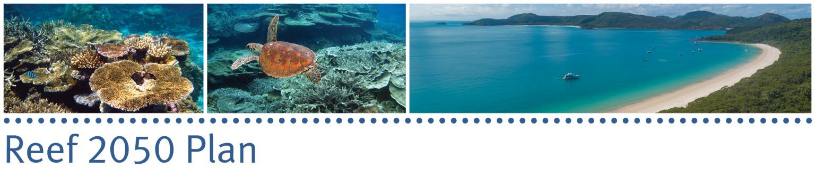

The Hon Sussan Ley MP Minister for the Environment

The Hon Meaghan Scanlon MP

Minister for the Environment and the Great Barrier Reef, Minister for Science and Youth Affairs

Dear Ministers

On 10 December 2021, Minister Scanlon wrote to the Panel to seek advice on what additional actions could be considered by governments; Minister Ley wrote to the Panel on 27 January 2022, to seek further advice from the Panel on actions to implement the Reef 2050 Plan.

The Independent Expert Panel (IEP) met on 28 February 2022 and discussed your requests. We focused on the additional actions that could be taken to protect and conserve the Great Barrier Reef (GBR) that will support or complement actions outlined in the 2050 Plan.

As we have advised on multiple occasions, climate change (or global warming driving climate change) is the biggest threat confronting the GBR. The IEP members are pleased that this has been acknowledged at Ministerial level. But as we have advised on other occasions, it is undeniably in Australia’s national interest for the countries of the world to reduce their use of fossil fuels. That requires leadership, and leadership is exactly what Australia should provide.

There is the perennial argument that we are a small percentage of global emissions so any action we take would be inconsequential. In fact, the net reduction in global emissions will be based on what individual countries do; and each of those will be based in part on the sum of the actions that individual citizens, and groups of citizens, take.

The GBR provides Australia with the opportunity to develop techniques, technologies and policies that will be of benefit locally but will also show what can be done to manage and protect marine and coastal ecosystems.

In that light, we suggest that:

# Climate-related activities

* + Make the GBR formally a hub of climate action.
  + Consult first then judiciously adopt measures to support communities along the Queensland coast to be active in reducing their contribution to greenhouse gas

emissions. Examples could include the use of renewable energy to drive water quality technologies – local treatment plants, storm water; (renewable energy- based) electrification of ferries.

* + Facilitate wetland restoration and rehabilitation; remove regulatory barriers to restoration/ rehabilitation.
  + Focus restoration on all Reef habitats and the whole ecosystem - in addition to the work with coral.
  + Review the Queensland land-clearing laws and policies to reduce land clearing.
  + Comprehensively assess the impact of global warming on the waters of the GBR lagoon and its ecosystem. In particular, support research to understand in detail the impact of warming on ocean currents, and the consequential impact on local weather conditions, and on the distribution of species along the coast. Such knowledge will be invaluable in informing what mitigation and adaptation actions should be prioritised, and where.

# Assessment and evaluation:

A feature of the present ‘environment’ is the rapidity of change. Many strategies presently driving policy assume, however, a stability that no longer applies. We should therefore note the past, monitor the present and adapt actions to the best projections of the future.

* + Ensure policies and actions are flexible and can accommodate change in relatively short time frames.
  + Comprehensively, critically and continually evaluate impact of previous and existing projects to plan and prioritise future investment, using detailed empirical data.
  + Undertake scenario analyses to identify changes that will result from a rapidly changing environment, identify signs of those changes early, develop and implement interventions promptly.

# Fisheries

On Friday 4 March, the Reef Advisory Committee (with some members of IEP in attendance) focussed a 5-hour session on fisheries and allowed officials, managers, and multiple stakeholders to engage. The IEP discussion was not in such depth. Accordingly, we highlight here the ‘headlines’ raised at IEP. The Reef Advisory Committee will doubtless offer more detailed advice on this topic.

* + Fisheries managers of a World Heritage Area have a special responsibility that must be acknowledged in strategies and policies that impact the GBR.
  + Ensure the Queensland Fisheries Strategy addresses the values of Aboriginal cultural fishing.
  + Improve coordination between the Queensland Departments of Environment and Agriculture and Fisheries with regards to GBR matters.
  + Consider introducing a licence for recreational fishers and hypothecating revenue for environmental support to benefit all fishers.
  + Consider the sustainability of commercial coral harvesting on the Reef in the light of rapidly growing threats to the GBR and its corals energised by rapid climate change.

# Communications and engagement strategy

We must provide a bridge between science, policy, and the community – especially as the science evolves and eventually will lead to policy change.

* + A well-designed, targeted and implemented communications strategy is essential if stakeholders are aware of, and willing to act on, issues relevant to their regions.
  + Conduct a pilot study in priority regions to build effective communication products for each location and its stakeholder group.

The IEP would be pleased to help flesh out any or all of these actions should you be interested in taking them further.

Yours sincerely,



Em Professor Ian Chubb AC FAA FTSE FACE FRSN 9 March 2022

CC: The Hon Warren Entsch, MP The Hon Penny Wensley AC