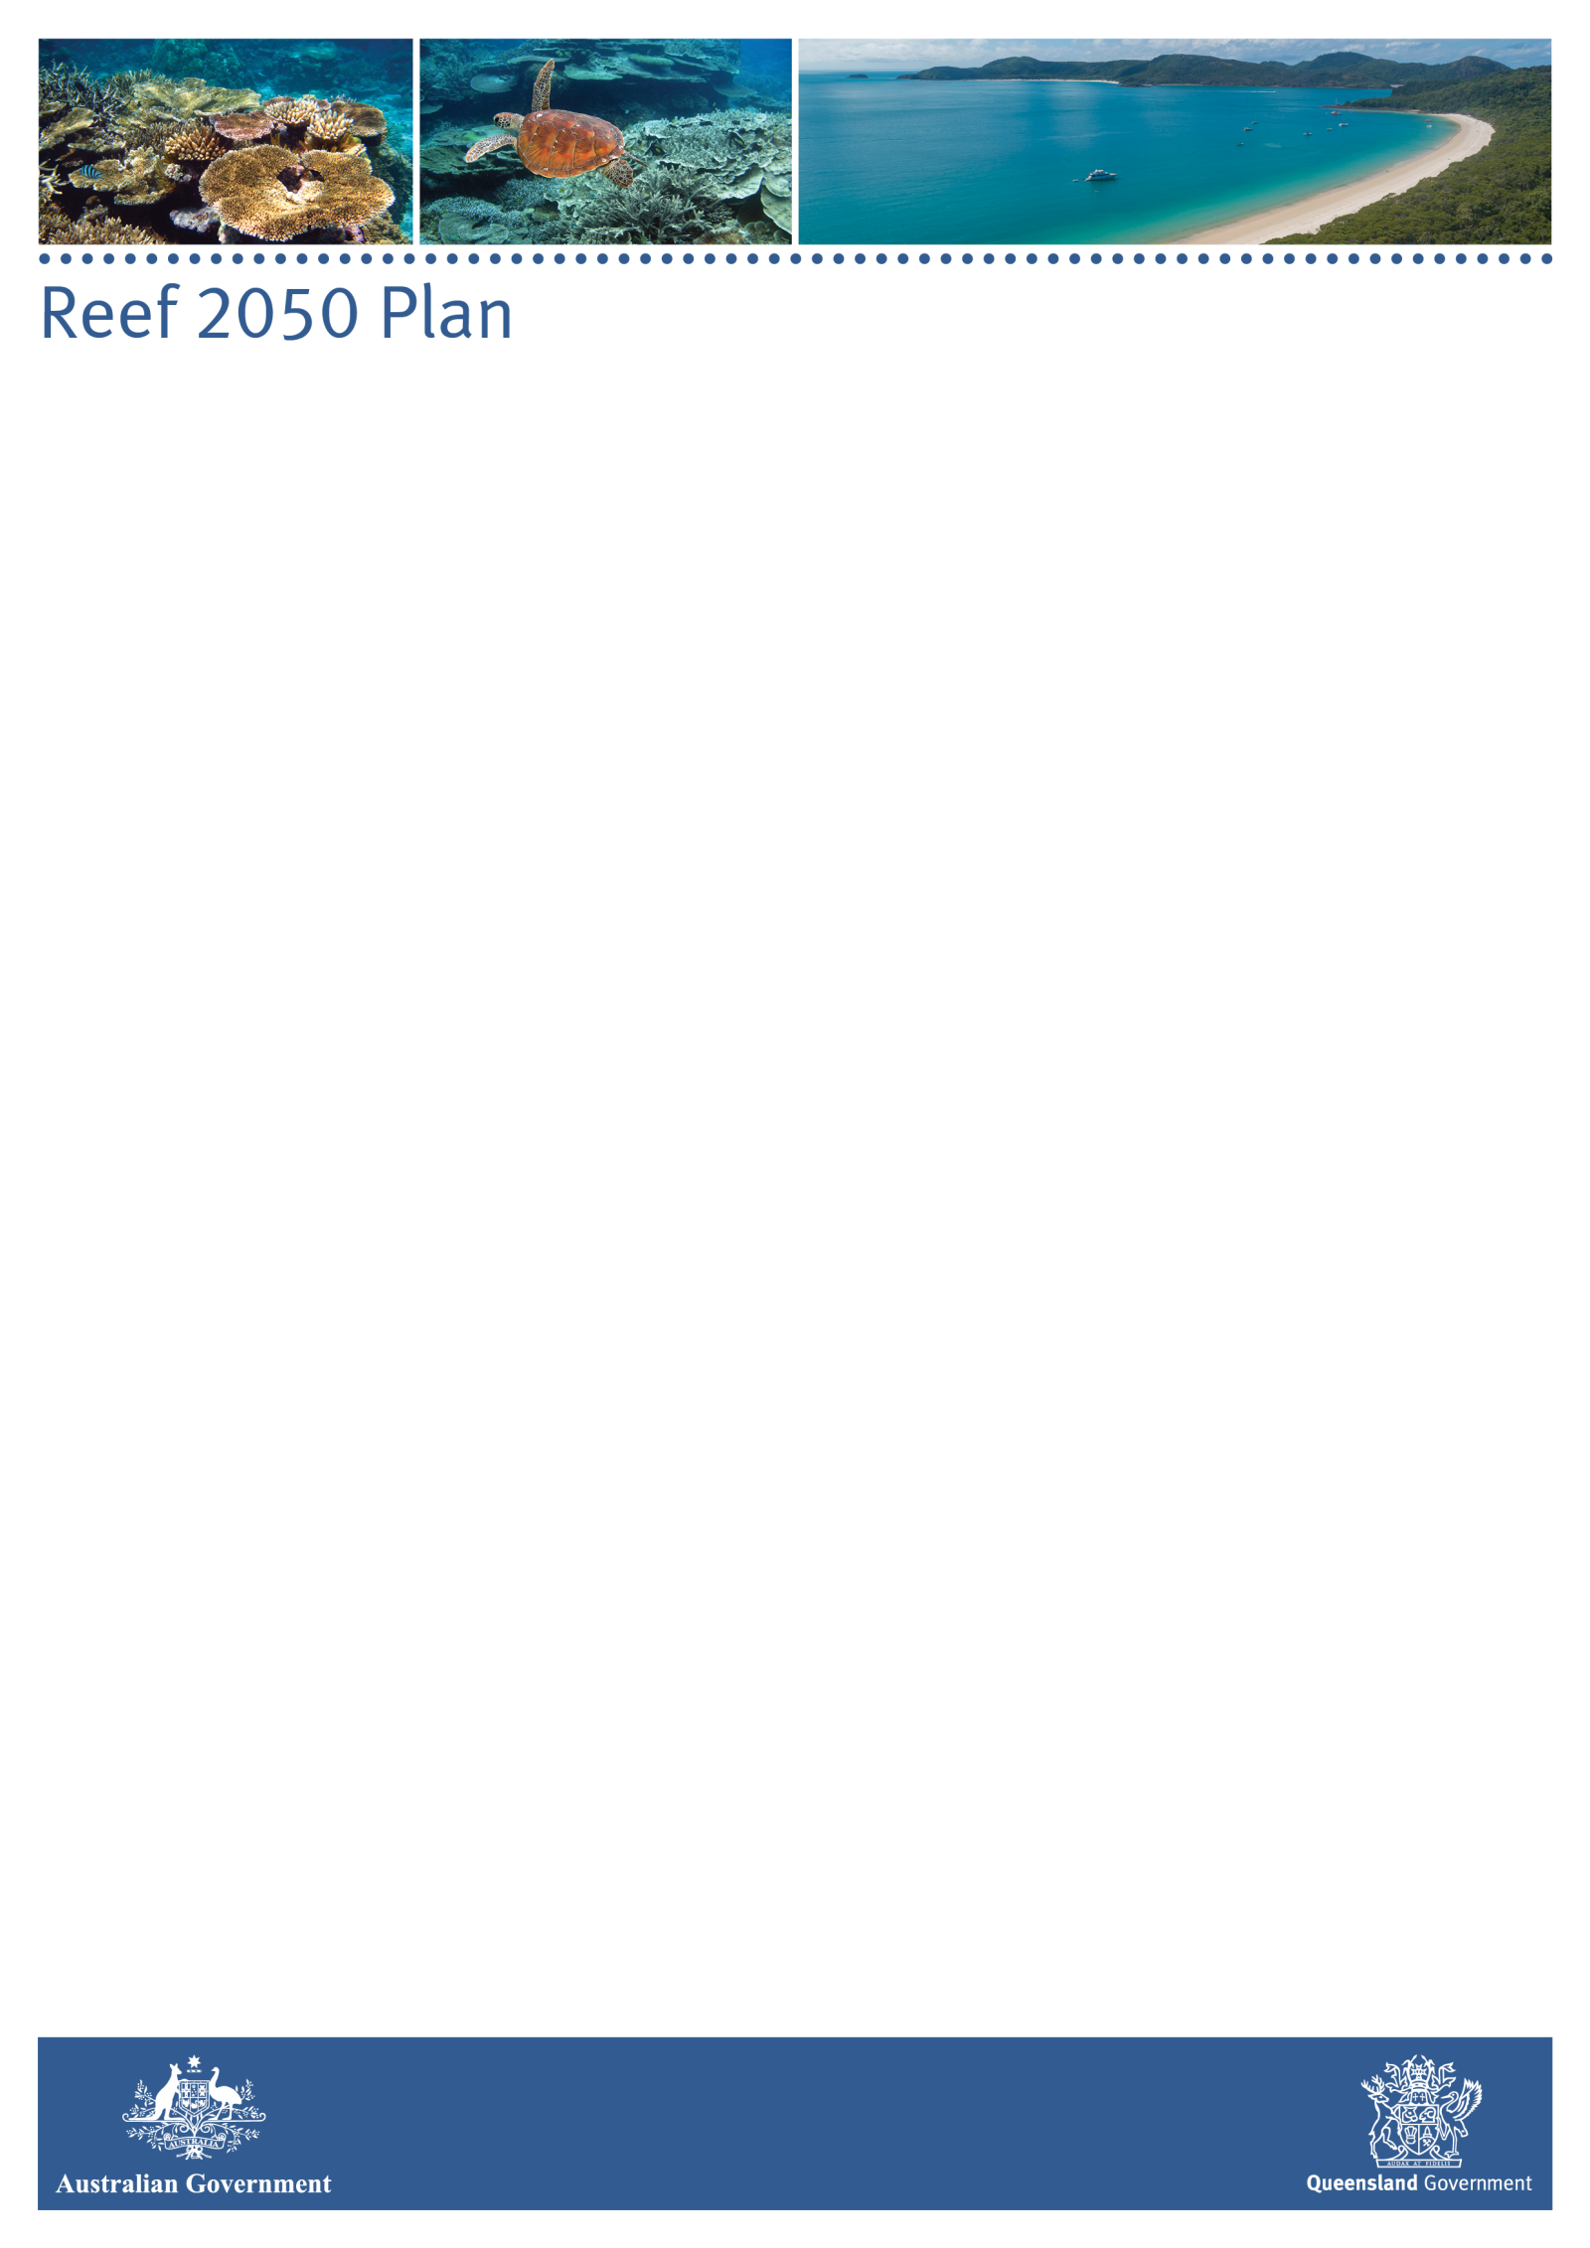

**INDEPENDENT EXPERT PANEL - MINUTES**

|  |  |
| --- | --- |
| **Date:** | Friday, 19 November 2021, 10:00am – 3:45pm AEDT |
| **Venue:** | Videoconference |

**ATTENDEES**

|  |  |  |
| --- | --- | --- |
| *Members* | | |
| Prof Ian Chubb AC, Chair  Dr Andrew Ash  Dr Richard Brinkman  Prof Damien Burrows  Dr Romy Greiner  Prof Ove Hoegh-Guldberg  Prof Terry Hughes  Prof Catherine Lovelock | | Prof Helene Marsh  Dr Russell Reichelt  Adj Assoc Prof Stephan Schnierer  Dr Britta Schaffelke  Dr Stuart Whitten  Ms Jane Waterhouse  Prof Kerrie Wilson |
| *Other attendees* | | | |
| Mr Craig Rosner-Moore | A/g Assistant Secretary, Department of Agriculture, Water and the Environment (DAWE) | | |
| Dr Simon Banks | First Assistant Secretary, DAWE *(items 1-6)* | | |
| Ms Miranda Robertson | A/g Director, DAWE | | |
| Dr Will Howard | Assistant Director, DAWE | | |
| Ms Milica Milanja | Secretariat, DAWE | | |
| Ms Elisa Nichols | Executive Director, Office of the Great Barrier Reef, Department of Environment and Science (DES) | | |
| Ms Louise Smyth | Director, Office of the Great Barrier Reef, DES | | |
| Dr David Wachenfeld | Chief Scientist, Great Barrier Reef Marine Park Authority (GBRMPA) | | |
| Dr Teena Browning | Director, GBRMPA | | |
| Dr Rachel Pears | Assistant Director, GBRMPA | | |
| Dr Roger Shaw | Chair, Reef Water Quality Independent Science Panel *(items 7 & 8)* | | |
| Ms Nyssa Henry | Chief Scientific Officer, Office of the Great Barrier Reef, OGBR *(item 7)* | | |
| Mr Graeme Bolton | Deputy Director General, Queensland Department of Agriculture and Fisheries *(item 6)* | | |
| Ms Kimberly Foster | Director, Queensland Department of Agriculture and Fisheries *(item 6)* | | |
| Ms Lara Johnson | Reef 2050 Section, DAWE *(item 6)* | | |
| Ms Chrissy Grant | Kuku Yalanji and Mualgal Traditional Owner, Reef 2050 Advisory Committee member *(item 9)* | | |
| Mr Malcolm Mann | Darumbal Traditional Owner, Chair Indigenous Reef Advisory Committee *(item 9)* | | |
| Ms Kirsten Macey | Office of the Great Barrier Reef, DES *(item 9)* | | |
|  |  | | |
| **1. Acknowledgement of Country** | | | |
| The Chair acknowledged the traditional custodians of the lands on which the meeting was held, and paid respects to their Elders past, present and emerging. | | | |
| **2. Welcome to Members** | | | |
| The Chair welcomed members to the meeting and outlined the main items of business on the agenda, including discussion of World Heritage Committee matters, fishing in the Great Barrier Reef World Heritage Area, Reef water quality, climate change impacts on the Reef, and Reef 2050 Traditional Owner Aspirations. | | | |
| **3. Conflict of Interest** | | | |
| Panel members declared actual and perceived conflicts and the Chair outlined actions to manage potential conflicts in accordance with the Panel’s protocol. | | | |
| **4. Panel Business** | | | |
| The Panel endorsed the minutes of Meeting 20, held on 25 August 2021, and noted they would be published on the Panel’s page of the Department of Agriculture, Water and the Environment website shortly after this meeting.  The Panel discussed actions arising from previous meetings. Dr David Wachenfeld, Chief Scientist of the Great Barrier Reef Marine Park Authority (GBRMPA) provided an update on the action from the August 2021 Panel meeting, at which the Panel discussed the need for more ‘plain English’ information pieces explaining several issues, including a description of what coral cover means, the proportion of the Reef comprised of coral, how coral cover is measured and reported, and historical changes in coral growth rates. Dr Wachenfeld explained that as summer approaches, GBRMPA will be restarting its weekly public reports about conditions on the Reef, and as part of this weekly reporting, they will produce a series of background ‘explainer’ videos covering the topics on the Panel’s list. It is expected that by the end of the 2021/22 summer, all the issues highlighted as needing further explanation will have been addressed and made available on the GBRMPA website.  The Panel noted one item finalised out-of-session following the previous meeting: a letter to the Australian and Queensland government ministers with responsibility for the environment, outlining the Panel’s concerns about potential adverse effects of commercial and recreational fishing on the Great Barrier Reef World Heritage Area (GBRWHA). Members noted that responses had not yet been received, but that the topic would be explored further under item 6.  A members’ only session was held as part of this item. At the conclusion of the closed session, the Chair advised that Panel members had discussed the updated Reef 2050 Plan and had agreed to write to Ministers urging its immediate release in its current form, with the condition that it can be amended as more information or evidence becomes available. | | | |
| **5. World Heritage Committee Update** | | | |
| Dr Simon Banks provided the Panel with an update on the recent World Heritage Committee decision on the state of conservation of the Great Barrier Reef, including:   * Australia’s proposed amendments to the INF.11: Updated Policy Document on climate action for World Heritage * Work underway to prepare the State Party Report on the State of Conservation of the Great Barrier Reef World Heritage Area * Minister Ley has invited a joint World Heritage Centre / IUCN Reactive Monitoring Mission to visit the Reef, with timing and details of the visit to be confirmed.   Members sought clarification on some of the proposed amendments to the World Heritage climate policy, which the General Assembly of States Parties to the World Heritage Convention was scheduled to consider on 24-25 November 2021. This included references to Traditional knowledge and indigenous science, and limiting global warming to 1.5°C. | | | |
| **6. Fishing in the Great Barrier Reef World Heritage Area** | | | |
| Mr Graeme Bolton and Ms Kimberly Foster from the Queensland Department of Agriculture and Fisheries provided the Panel with a presentation on the Queensland government’s *Sustainable Fisheries Strategy 2017‑2027* (Strategy)including an outline of the reform process, work undertaken and key achievements to date.  The Panel noted that continuing challenges include data validation, climate change impacts, threats to protected species and the increase in recreational fishing.  The Panel:   * discussed the importance of addressing how the Reef is changing due to thermal stress and ocean acidification in plans and processes * raised concerns around the approach to Aboriginal cultural fishing practices, noting Traditional Owner views that they should be considered as part of (not an impact on) the ecosystem * acknowledged that the Strategy is a significant reform, but recommended that it needs to overtly acknowledge that the fisheries are in a World Heritage Area, and should be managed accordingly * raised concerns about the lack of knowledge and robust data on bycatch and the threats posed to species of conservation concern, and discussed the need to systematically roll out independent validation of data * discussed issues around compliance and data in the recreational fishing sector * noted that more emphasis is needed on climate change and on planning for a future which will see a decline in live coral cover, which will affect the entire ecosystem * urged implementation of the Strategy and associated policies at the best possible rate * noted concerns around globally threatened species * encouraged ongoing cooperation between the state and commonwealth agencies responsible for managing fishing in the marine park   The Panel agreed to write to ministers noting concerns around the carrying capacity of the Reef, the ecosystem changes that are occurring due to climate change and the consequences for a variety of species, the threats to globally threatened species, and concerns around the lack of regulation in the recreational fishing sector.  The Panel noted that while the information presented was interesting and comprehensive, it would be useful for a follow-up presentation to expand on next steps and high risks in fisheries management. | | | |
| **7. Reef Water Quality** | | | |
| Dr Roger Shaw, Chair of the Reef Water Quality Independent Science Panel (Reef ISP), joined the meeting. The Panel noted the written updates from the September and October meetings of the Reef ISP.  Ms Jane Waterhouse provided an update on the the process and timeframes for the 2022 Scientific Consensus Statement project, including the overview of the approach to question setting and summary of evidence synthesis methods that had been circulated to members ahead of the Panel meeting, along with a draft list of questions for consultation.  Panel members provided feedback to Ms Waterhouse, noting that the scientific consensus statement needs to:   * include a holistic view of the interconnected systems and the world heritage values * consider climate change (hotter droughts, more intense wet seasons etc) throughout the document and not just as a separate section * use consistent terminology and have a clear narrative, noting that people can interpret the same data in different ways   The Panel were complimentary of the approach and transparency of the process to date and noted the invitation to provide contributions following this meeting  The Panel noted progress on the independent review of the Reef 2050 Water Quality Improvement Plan land management target for agricultural practice adoption. | | | |
| **8. Climate change, ocean changes and impacts on the ecosystem** | | | |
| At the Panel meeting on 25 August 2021, the Chair asked members to consider the following questions in the context of climate and water quality interactions:   1. What do we currently know? 2. What could we know if we asked the right questions? 3. What do we want to know that would change what we’re currently doing? What are the critical information gaps? 4. What is the desired state of conservation for the Reef from your perspective?   The Chair noted that the Reef ISP had also considered these questions (at their October 2021 meeting) and their feedback would be considered alongside that of the Panel.  Feedback from the Panel included:   * the focus will be on the GBR lagoon and World Heritage Area * the emerging central theme is how climate change will impact the GBRWHA ecosystem, and how the ecosystem will respond as a whole * the importance of acknowledging that changes due to climate change are already well underway, so current impacts need to be considered as well as future scenarios * the analysis should identify what we need to know and why (how will it change what is currently being done) * future projections need to be communicated in a way that will speak to a wide audience to increase the public’s understanding of the future impacts and how they will affect society and the values derived from the Reef.   The Chair noted that he will work with a small sub-group of the Panel to identify the key issues under each of the four questions and write a short essay on each. A draft will be circulated to the Panel for input. The resulting document will be used to inform Ministers of the Panel’s priorities and guide its forward work plan. | | | |
| **9. Reef 2050 Traditional Owner Implementation Plan Project** | | | |
| Ms Chrissy Grant, Kuku Yalanji and Mualgal Traditional Owner, Reef 2050 Advisory Committee member and Mr Malcolm Mann, Darumbal Traditional Owner, Chair Indigenous Reef Advisory Committee, joined the meeting to discuss the Reef 2050 Traditional Owner Implementation Plan Project.  Ms Grant and Mr Mann outlined the objectives, timeline and stages for delivering the project, noting that:   * Traditional knowledge as well as the best available scientific knowledge is needed for effective Reef management * Traditional Owners want to set their own research agenda and management priorities * Traditional Owners are collaborating with research organisations on how to best include and utilise traditional knowledge, noting its importance not just for Reef and world heritage in Australia, but across the globe.   The Panel discussed the presentation and noted that this is an underrated and underestimated area of work. The Panel:   * sought feedback from the presenters on the challenges around engaging all the Traditional Owner groups, given there are 70-75 groups in the GBR region * inquired about the availability of guides for researchers that want to communicate with Traditional Owners in a way that's interesting and culturally appropriate * discussed the nexus around science and traditional knowledge and the importance of engaging Traditional Owners from the start of a project to help build capacity of communities and break down the barriers of communication and understanding.   The Panel thanked Ms Grant and Mr Mann and encouraged continuing engagement on the Project. | | | |
| **10. Reef 2050 Governance Review – Update of IEP governance documents** | | | |
| Ms Miranda Robertson updated the Panel on proposed changes to the Reef 2050 Plan Independent Expert Panel’s Terms of Reference (TOR) and Operating Protocols. The Panel noted that the updates had been made to provide clarity around processes and reporting, remove repetition and contemporise the documents, and respond to recommendations from the Independent Review of Reef 2050 Governance.  The Panel endorsed the changes to the documents, with one change to the Terms of Reference (separating ‘blue economy’ and ‘oceans’ in section 4.2).  The Panel noted that changes to the Terms of Reference required joint approval from the Australian and Queensland environment ministers. The updated Operating Protocols would apply when the document has been agreed by the Chair, Secretariat and members. | | | |
| **11. Panel Business Continued** | | | |
| The Panel agreed that a communiqué would be finalised out-of-session and published on the Department of Agriculture, Water and the Environment’s website.  Members discussed timing for meetings in 2022, including a possible joint event with the Reef 2050 Advisory Committee in February/March 2022.  The Panel discussed their forward agenda and agreed it would be useful to receive a briefing on work being done by the Department of Agriculture, Water and the Environment and the Western Australian government on a shared environment analytic framework designed to improve the efficiency, repeatability and transparency of environmental assessments and build cumulative impacts into environmental decision making. The Panel agreed to invite GBRMPA to provide a briefing on RIMREP as part of this session.  The Panel did not raise any other business.  The meeting closed at 3.30pm. | | | |