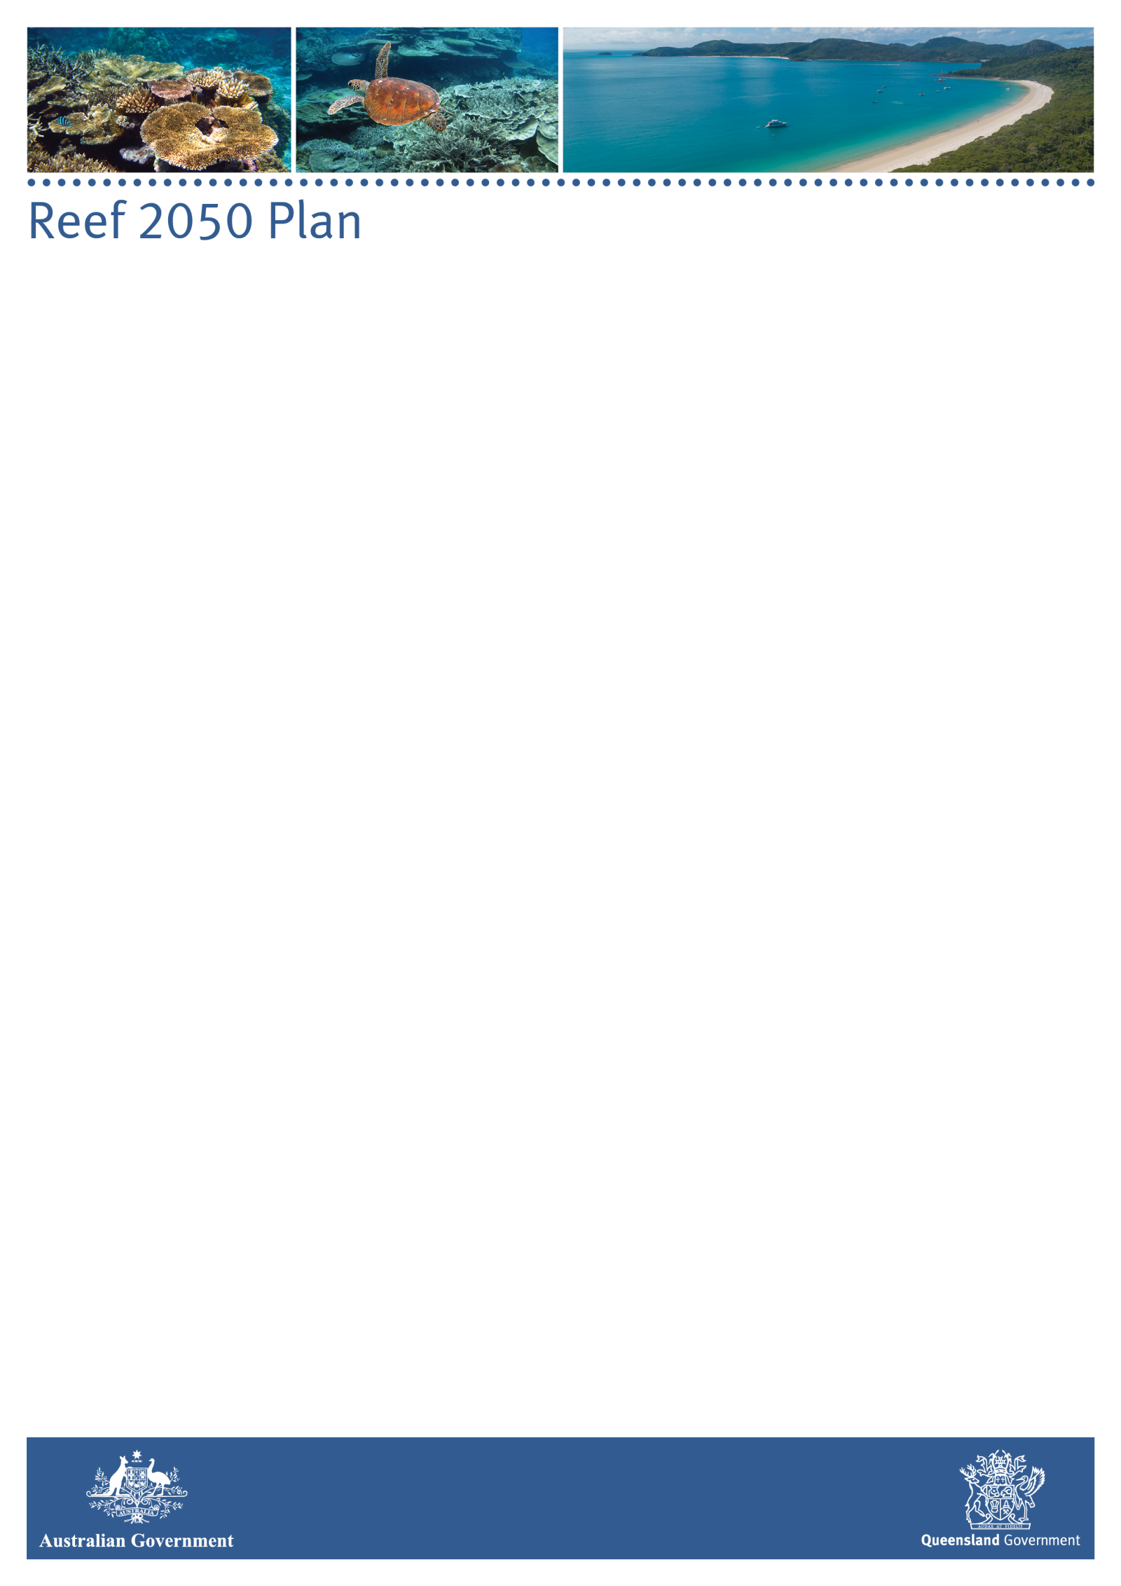

**INDEPENDENT EXPERT PANEL - MINUTES**

|  |  |
| --- | --- |
| **Date:** | Wednesday, 25 August 2021, 10:00am – 3:15pm AEDT |
| **Venue:** | Videoconference |

**ATTENDEES**

| *Members* | |
| --- | --- |
| Prof Ian Chubb AC, Chair  Dr Andrew Ash  Dr Richard Brinkman  Prof Damien Burrows  Dr Romy Greiner  Prof Ove Hoegh-Guldberg  Prof Terry Hughes | Prof Catherine Lovelock  Prof Helene Marsh  Adj Assoc Prof Stephan Schnierer  Dr Britta Schaffelke  Dr Stuart Whitten  Ms Jane Waterhouse  Prof Kerrie Wilson |

***APOLOGIES***

|  |  |  |
| --- | --- | --- |
| Dr Russell Reichelt | |  |
| *Other attendees* | | |
| Ms Paula Perrett | Assistant Secretary, Department of Agriculture, Water and the Environment (DAWE) | |
| Dr Simon Banks | First Assistant Secretary, DAWE | |
| Ms Rebekah Hamed | Director, DAWE | |
| Mr Craig Moore | Director, DAWE | |
| Dr Will Howard | Assistant Director, DAWE | |
| Ms Milica Milanja | Secretariat, DAWE | |
| Ms Elisa Nichols | Executive Director, Office of the Great Barrier Reef, Department of Environment and Science (DES) | |
| Ms Louise Smyth | Director, Office of the Great Barrier Reef, DES | |
| Dr David Wachenfeld | Chief Scientist, Great Barrier Reef Marine Park Authority (GBRMPA) | |
| Dr Teena Browning | Director, GBRMPA | |
| Dr Rachel Pears | Assistant Director, GBRMPA | |
| Dr Roger Shaw | Chair, Reef Water Quality Independent Science Panel *(items 8 & 9)* | |
| Dr Cedric Robillot | Executive Director, Reef Restoration and Adaptation Program *(item 10)* | |
| The Hon Sussan Ley MP | Australian Government Minister for the Environment *(item 4)* | |
| Mr James Thomas | Deputy Chief of Staff, Office of the Hon Sussan Ley *(item 4)* | |
| The Hon Meaghan Scanlon MP | Queensland Government Minister for the Environment and the Great Barrier Reef and Minister for Science and Youth Affairs *(item 4)* | |
| Mr Nick Heath | Chief of Staff, Office of the Hon Meaghan Scanlon MP *(item 4)* | |
| **1. Acknowledgement of Country** | | |
| The Chair acknowledged the traditional custodians of the lands on which the meeting was held, and paid respects to their Elders past, present and emerging. | | |
| **2. Welcome to Members** | | |
| The Chair welcomed members to the meeting and noted apologies from Dr Russell Reichelt.  The Chair outlined the main items of business on the agenda, which would include discussion on the implications of the World Heritage Committee decision on the Great Barrier Reef, the status and steps needed to finalise the Reef 2050 Plan, and how climate change is expected to impact Reef water quality. | | |
| **3. Conflict of Interest** | | |
| Panel members did not have any new or updated conflicts of interest to declare at this meeting. | | |
| **4. Updates from Ministers** | | |
| The Chair and members welcomed the Honourable Sussan Ley MP, Australian Government Minister for the Environment, and the Honourable Meghan Scanlon MP, Queensland Minister for the Environment and Great Barrier Reef and Minister for Science and Youth Affairs to the meeting.  Minister Ley provided an update on developments in relation to the World Heritage Committee (WHC) meeting, including its decision not to place the Great Barrier Reef (GBR) on the List of World Heritage in Danger, and the next steps in the process. The Minister noted that a draft Climate Policy was due to be considered by the WHC General Assembly of State Parties in November, and that Australia was at the forefront of its development. When accepted, the policy would be applied to all World Heritage properties affected by climate change. Minister Ley discussed the status of the updated Reef 2050 Plan, which she commended as a strong document that she had approved for public release on 6 July 2021.  Minister Scanlon acknowledged the importance of the Panel and its work, before providing an update on financial commitments made by the Queensland Government to protect the environment and the GBR Reef and climate programs. The Minister noted that she welcomed feedback from members on priorities for investment. Minister Scanlon outlined the Queensland government’s view to release the updated Reef 2050 Plan as an ‘operational draft’ so that it can be further updated in response to the future findings of the World Heritage reactive monitoring mission.  Both Ministers expressed their appreciation to Panel members for keeping the Government informed about the threats to the health and resilience of the Reef and their valuable contributions to the development of the updated Reef 2050 Plan.  At the conclusion of this item the Chair thanked both Ministers for attending the meeting and for their insights. | | |
| **5. Panel Business** | | |
| The Panel endorsed the minutes of Meeting 19, held on 16 April 2021, and noted they would be published on the Panel’s page of the Department of Agriculture, Water and the Environment website shortly after this meeting.  The Panel discussed actions arising from previous meetings and agreed that there was still a need to develop an information piece to explain how coral cover is measured and reported, as the issue was still causing confusion. Members noted a general misconception in the community that the Great Barrier Reef is entirely composed of coral and agreed this should also be addressed.  The Panel noted that the Great Barrier Reef Marine Park Authority (GBRMPA) already invests in communicating to the public about the health of the Reef and their website has a range of primers and ‘Reef 101’ information in various formats. The Panel accepted GBRMPA’s offer to review and, if necessary, update relevant existing communication materials to include further detail addressing:   * the proportion of the Reef that is coral and how coral cover is measured and reported * clarification of what coral cover means in terms of the Reef’s overall resilience * historical changes in coral growth rates.   Other issues that the Panel viewed as important to communicate included that:   * although coral cover may increase in a particular year, the overall downward trend has not changed (as noted in the AIMS Long-Term Monitoring Program report for 2020-21) * corals that are recovering quickly are often the ones most susceptible to bleaching, so the Reef’s medium-term resilience is being undermined.   The Panel suggested that threats to the Reef (for example, bleaching) should be expressed in a more proportional and consistent manner in explanatory material, by specifying how much/which part of the Reef is affected by various disturbances. Members also noted the importance of highlighting social and economic impacts in addition to ecological facts.  The Panel finalised one out of session item since the previous meeting, which was the Panel’s advice on the Reef Trust Partnership Draft Annual Work Plan (**Attachment 1**).  A members’ only session was held as part of this item. At the conclusion of the closed session, the Chair noted that the key messages arising from those discussions related to a number of agenda items and would be covered over the course of the day. | | |
| **6. World Heritage Committee update** | | |
| Ms Paula Perrett provide the Panel with an update on the World Heritage Committee decision on the state of conservation of the Great Barrier Reef, including:   * that Australia did not dispute the technical assessment of the IUCN and World Heritage Centre, but was concerned that UNESCO’s engagement with Australia ahead of its decision to recommend an immediate in-danger listing was inconsistent with its own operational guidelines – a concern shared by other nations * the next steps in the process, including for a state of conservation (SoC) report be provided to the World Heritage Centre by 1 February 2022 and for Australia to request a reactive monitoring mission to occur over the next 12 months, with a date to be determined * as noted by Minister Ley, the World Heritage Committee is due to consider an updated Policy Document on Climate Action for World Heritage (Climate Policy) at the 23rd session of the General Assembly of States Parties to the Convention in November 2021 – once adopted, the principles of the Climate Policy will be translated into operational procedures to enable its consistent application across all World Heritage climate affected properties.   Members sought more detail on how they could be involved in contributing to the state of conservation report and reactive monitoring mission and noted that further updates would be provided at the next Panel meeting. | | |
| **7. Reef 2050 Plan and Traditional Owner Implementation Plan – progress updates** | | |
| **7a. Reef 2050 Plan – progress update**  Ms Elisa Nichols provided the Panel with an update on progress with the Reef 2050 Plan. The Panel noted that, as discussed under Item 4, public release of the Plan was contingent on approval by the Queensland Government, which has a preference to release it as an operational draft, primarily to allow for it to be updated following the World Heritage Committee’s reactive monitoring mission.  The Panel expressed concern about the delays and agreed unanimously that the updated Plan should be released immediately in its current form, noting that a lot of effort has gone into its development and that public consultation occurred a year ago. The Panel noted that the Plan is already designed as an adaptive management tool that can be updated based on significant new information or policy.  **7b. Reef 2050 Traditional Owner Implementation Plan**  Ms Nichols provided an update on the work of Traditional Owners to progress with implementation of Reef 2050 Traditional Owner aspirations.  Panel members noted that the ‘Traditional Owner Implementation Plan’ project aims to identify a path for Traditional Owners to engage collectively with the Australian and Queensland governments as part of the ongoing design and delivery of the Reef 2050 Plan.  Members agreed to invite Traditional Owner representatives to the next Panel meeting, to discuss Reef 2050 Traditional Owner aspirations in further detail. | | |
| **8. IPCC Sixth Assessment Report – implications** | | |
| Dr Roger Shaw, Chair of the Reef Water Quality Independent Science Panel, joined the meeting.  Professor Ove Hoegh-Guldberg led a discussion on the IPCC Sixth Assessment Report (AR6) and its implications for the Reef, including that:   * this is the first of three AR6 reports, with two more due next year (covering impacts and vulnerability and mitigation) * key implications for the Reef include faster warming, impacts from underwater heatwaves in coastal waters (including at depth), an intensifying water cycle, rising seas, increasing droughts, changes in ocean chemistry and larger but less frequent storms. * evidence for tipping points and irreversible change is increasing rapidly and of growing concern   Panel members noted that even if global warming is limited to 1.5°C above pre-industrial levels, residual impacts – such as more frequent and severe marine heatwaves, increase in floods, impacts on water quality, more cyclones – are expected to continue and the Panel’s focus should be on what that means in terms of Reef protection and how best to deploy resources.  Members discussed changes to currents and ocean circulation and the implications of a weakening of the Atlantic Meridional Overturning Circulation (AMOC) which plays a key role in moving heat around the planet. | | |
| **9. Reef Water Quality** | | |
| The Panel noted the update from Dr Shaw on the June 2021 meeting of the Reef Water Quality Independent Science Panel (ISP).  Dr Shaw provided an overview of the ISP’s preliminary prioritisation of ‘big ideas and issues for ISP’ and highlighted a number of issues that had been ranked as high priority. Members discussed the priorities and provided feedback on the ranking of some priorities, noting that ‘how to express risk and uncertainty’ was a higher priority for the Panel.  The Panel discussed water quality in the context of global warming, including how changes in weather, sea temperature and ocean currents will affect the lagoon waters and its contents as the planet warms. Issues raised during the course of discussion included:   * how global warming is impacting the patterns of droughts and floods and how this can be reflected in modelling using various scenarios * how periods of drought, which in the past were a time of recovery for coral due to less disturbances from floods and cyclones, are likely to be replaced with periods of marine heatwaves instead * that changes to weather patterns will increase vulnerability of coastal landscapes to seawater intrusion – and intense rainfall extended flooding will result in more runoff – though revegetation of waterways and surrounding areas would help attenuate this risk * that the next review of the Reef Water Quality Improvement Plan will look at the management options for these peak events * questions relating to the achievability of current targets for water quality * the desired state of conservation of the Reef given the uncertainty and pace of climate change.   The Chair asked Panel members to consider the following questions in the context of climate and water quality interactions:   1. What do we currently know? 2. What could we know if we asked the right questions? 3. What do we want to know that would change what we’re currently doing? What are the critical information gaps? 4. What is the desired state of conservation for the Reef from your perspective?   The Chair requested written responses addressing these questions, noting the feedback would help to identify priorities and areas for further focus by the Panel. | | |
| **10. Reef Restoration and Adaptation Program – update on interventions** | | |
| Dr Cedric Robillot, Executive Director of the Reef Restoration and Adaptation Program joined the meeting to provide the Panel with an update on the Program, including its governance, partnership arrangements with Traditional Owners, and progress with research and development. Dr Robillot provided an update on possible interventions the program is looking at to help the Reef, such as cooling and shading, rubble stabilisation, moving corals, coral cryopreservation, enhanced corals, mass aquaculture and establishing reference reefs for ecological monitoring.  Panel members raised a number of issues for consideration:   * what the release of the IPCC Sixth Assessment Report will mean for models developed during the original feasibility study that used the Fifth Assessment Report * the economic methods of assessment of benefits across different values and what non-market valuation research had been conducted * how non-market values of the Great Barrier Reef were considered in decision-making – noting that value increases as scarcity does * the approach to deploying rubble stabilisation given it is not cost-effective at large scale * whether cloud brightening is feasible at a large scale * the economic evaluation of the various techniques, and the need more expertise on the steering group to undertake economic evaluation to critique and provide oversight. * in the spirit of the RRAP remaining agile, other work in the Reef space (such as the updated Reef 2050 Plan, the reactive monitoring mission and the state party report) should be considered when undertaking the mid-2022 review of RRAP projects.   The Panel thanked Dr Robillot for a useful discussion. | | |
| **11. AIMS Long Term Monitoring Program 2020/21** | | |
| Dr Britta Schaffelke led a discussion on the AIMS Long-Term Monitoring Program Annual Summary Report of Coral Reef Condition 2020/2021.  Panel members noted that it was a good report, which conveyed a balanced summary of the current state of the Reef. Members discussed a number of issues including monitoring of inshore reefs, mapping between river plumes and coral communities, and locations of bleaching. | | |
| **12. Panel Business Continued** | | |
| The Panel agreed that a communiqué would be finalised out-of-session and published on the Department of Agriculture, Water and the Environment’s website.  Members noted that a preferred date for the November Panel meeting would be determined via a scheduling poll. The Chair noted it may be useful to schedule a separate, supplementary meeting this year to discuss the outcomes of the water quality and climate change task and other issues. The need for this would be determined in consultation with the Joint Secretariat and advised in due course.  Under other business, Professor Marsh raised several points related to fishing in the Great Barrier Reef World Heritage Area (GBRWHA), noting that both commercial and recreational fishing have the potential to adversely affect the region’s Outstanding Universal Value and its resilience to climate change. The Panel agreed to raise these concerns in a letter to the Australian and Queensland government ministers with responsibility for the Reef. Members noted that this was particularly important, given fisheries issues are likely to be of interest to the World Heritage Centre/IUCN Reactive Monitoring Mission.  The meeting closed at 3.30pm. | | |

**Attachment 1**

Dr John M Schubert AO

Chairman

Great Barrier Reef Foundation

Dear Dr Schubert

I write on behalf of the Reef 2050 Plan Independent Expert Panel to provide our advice on the Reef Trust Partnership Draft 2021-2022 Annual Work Plan. The Panel received a briefing on the Work Plan from Ms Anna Marsden and Ms Theresa Fyffe of the Great Barrier Reef Foundation at a meeting on 19 May 2021. We appreciated the briefing, and the work being done by the Foundation in these difficult times.

This advice on the Work Plan reflects largely on ensuring the continuing legacy of this investment, and the adaptability of the programs to adjust expenditures to needs, if or when circumstances change.

It is worth noting that a question raised by members related to whether we shouldn’t be seeing outcomes from the investment by now. Members were advised that the Foundation has published information on the Partnership on its website, including the Monitoring and Evaluation Plan and dashboards that provide a snapshot of the Partnership’s progress. It would be very useful for the Work Plan to refer to these companion documents and describe how they relate to and guide the proposed schedule of activities. The average reader would benefit from having the path laid out.

**Demonstrating an integrated approach to program delivery:** Further detail to explain how the multiple components and various work streams fit together would be useful. The Panel sees a lot of programs in the Work Plan, but it is not clear what they will deliver to the Great Barrier Reef (GBR) as a whole when combined. In other words, what they will collectively contribute to better understanding of the GBR, and of the risks to its long-term ecological function.

**Open and integrated data management:** Ensuring an integrated approach to the delivery of the multiple data and data-management processes being developed is essential in realising the benefits of the Partnership. Open access principles should continue to be considered and applied to the collection and management of data, to ensure compatibility across multiple systems. Data will be a continuing legacy of the Partnership and ready access to it is fundamental.

**Impacts of interventions**: It is important to consider the effects that interventions undertaken to benefit one component of the Reef may have on other parts of the system. For example, concepts involving shading parts of the Reef could influence multiple parts of the ecosystem and consideration should be given to all consequences that could arise, including possible negative ones. It is not to avoid risk, but to identify potential risk, and manage it. Consideration should also be given to the timescales within which such consequences might be detected.

**Traditional Owner component:** The Panel appreciates the work undertaken by the Foundation on Traditional Owner engagement and the investment in Traditional Owner-led projects and capacity building. The capacity-building activities and formation of meaningful partnerships will be an important enduring legacy from the program. The Panel notes, though, that the distributed nature of these investments, while important, emphasises the desirability of an overarching statement of anticipated learnings and benefits.

**Agile and adaptable arrangements:** The Panel reiterates its previous advice to the Foundation that contractual arrangements should be designed appropriately to enable flexibility to respond to circumstances as they evolve. The Foundation should continue to consider the practicability, scalability and effectiveness of projects, with mechanisms to monitor progress, and the flexibility to change course if projects are not delivering as expected. A mid-point evaluation of the Partnership’s progress would be useful.

The Panel recognises that the components and funding allocated to each component were decided at the start of the Partnership, but sees benefit in the Foundation being able to respond to emerging circumstances with some flexibility including being able to change the funding allocation between components.

**Fundraising and philanthropy:** The Panel looks forward to gaining a better understanding of the status and future prospects for pursuing the fundraising and philanthropic goals of the Partnership given challenges including the impacts of the ongoing COVID-19 pandemic.

The Panel appreciates the work done by the Foundation to date and we look forward to continued engagement. I will be forwarding this advice to the Australian and Queensland Government Ministers with responsibility for the Great Barrier Reef.

Yours sincerely

Em Professor Ian Chubb AC FAA FTSE FACE FRSN

Chair, Reef 2050 Plan Independent Expert

28 May 2021

CC Ms Anna Marsden

Ms Theresa Fyffe

Dr Paul Greenfield AO