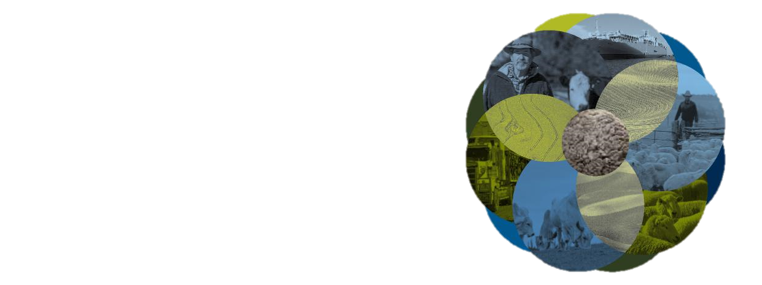
Export Meat Operational Guideline:

16.1 Meat hygiene assessment – product monitoring (3rd Edition)
July
2026
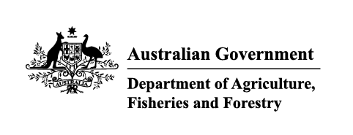

Purpose
The purpose of this guideline is to outline meat hygiene assessment-product monitoring procedures undertaken at export-registered establishments. These procedures provide for the assessment and control of the macroscopic condition of meat and meat products, including risk mitigation of zero tolerance defects (faeces, milk and ingesta).
This document replaces Part 2 (product monitoring) of the Meat Hygiene Assessment Manual: Objective methods for the monitoring of process and product (2nd Edition).
Scope
Product monitoring applies to establishments producing meat or meat products for export and includes the following:
- abattoirs, including fully integrated (slaughter, boning, chilling/freezing and storage) establishments
- independent boning rooms
- meat processing establishments
- wild game meat establishments
- rabbit and ratite meat establishments.
Legislative basis
Under the Export Control Act 2020 ('the Act') and its subordinate legislation the requirements of the relevant Australian Standard must be met.

In this document
16.1 Meat hygiene assessment – product monitoring (3rd Edition) 1
In this document 2
Principles 4
Slaughter floor or skinning room-carcases, sides, and quarters 5
Outcome 5
Sample plan 5
Sample size 5
Monitoring and determination of lot size 5
Additional comments - Assessment of samples 6
Minimum requirements for meat assessment facilities 6
Defects and ratings 6
Classification of carcase defects 6
Recording 7
Calculation of the defect rating 8
Corrective action 8
Immediate corrective action 8
Hot boning 8
Hot bagging of carcases 8
Load out and cold bagging 9
Load-in product 9
Boning room 10
Outcome 10
Sample plan 10
Defect ratings 10
Corrective action 10
Offal 11
Outcome 11
Sample plan 11
Product types subject to monitoring 11
Sample size and monitoring 11
Defects and ratings 11
Classification of defects 11
Recording and calculation of the defect rating 12
Corrective action 12
Immediate corrective action 12
Carton meat 12
Outcome 12
Sample plan 12
Product types to monitor 12
Exclusions 13
Sample plan 13
Defect ratings 14
Classification of carton meat defects 14
Determining product acceptability 14
Corrective action 14
Immediate corrective action 14
Records 15
Related material 15
Appendix 1: Roles and responsibilities 16
The department 16
The occupier 16
Field Operations Managers (FOM) 16
Area Technical Manager (ATM) 16
Departmental authorised officers 16
Appendix 2: Carcase scanning lines 17
Horse and bovine scanning lines 17
Sheep and goat scanning lines 18
Pig scanning lines 19
Appendix 3: Example monitoring forms 19
Carcase defect monitoring form 20
Carton meat assessment defect recording forms 20
Offal defect monitoring forms 21
Appendix 4: Calculating defect ratings 22
Defect rating example calculation 22
Calculating prevalence of low and high-risk products 22
Using the CMA form for high-risk products 23
Monitoring trends 23
Appendix 5: Definitions 24
Version history 26

Principles
Product monitoring provides standardised methods to assure consistency in the outputs from monitoring programs for macroscopic contamination. It provides an objective approach to assessing meat hygiene and guidance on preventive and corrective actions.
Importantly, meat hygiene assessment-product monitoring assists establishments in the implementation of Hazard Analysis Critical Control Point (HACCP) plans and Quality Assurance (QA) systems and underpins regulatory and international market confidence in the production of wholesome meat and meat products.
Product monitoring applies a risk-based approach to:
- Confirm that each product type meets the outcomes defined by critical limits.
- Describe corrective and preventive actions when monitoring indicates that critical limits have been exceeded. Critical limits must include - zero tolerance (ZT) defects, pathology defects and contamination-related criteria considered to be Major or Critical defects.
The MHA 3 protocol as represented in this guideline differs from the current product monitoring system in that it:
- Is risk-based, offering the opportunity for an establishment to identify those products that require more, or less monitoring.
- Focuses on ZT defects, pathology defects and contamination related criteria that were previously considered to be Major or Critical defects as part of MHA 2.
- Eliminates non-food safety defects (for example, manufacturing and defects previously considered to be minor) in the calculation of the defect rating.
Defects are classified according to their food safety risk. This information is then condensed to a single value called a defect rating.
The defect rating provides an overall picture of the wholesomeness of meat and verifies the adequacy of process controls associated with its production. Corrective action is required when the defect rating exceeds defined critical limits or when zero tolerance detections are made.

Slaughter floor or skinning room-carcases, sides, and quarters

Outcome
Each unit of product will leave the slaughter floor or skinning room free of ZT defects, visible pathology and contamination that may affect the wholesomeness of the product.

Sample plan

Sample size
The minimum number of samples required for a statistical assessment of product is dependent on the number of items processed (Table 1); these are based on Australian Standard AS 1199.1 Sampling Procedures and Tables for Inspection by Attributes. The unit size is described in Table 2.
Table 1: Sample numbers
Number of animals in a lot | Sample size (units)¹
1-25 | 5
26 – 50 | 8
51 – 90 | 13
91 – 280 | 20
281 – 500 | 32
> 500 | 50
¹ The number of carcases monitored for the ZT CCP is always as per the approved HACCP plan.
Table 2: Sample unit
Species sampled | Sample unit
Horses / cattle / camel | A side or fore- and hind-quarter combined
Pigs / ratites | A whole carcase or the 2 sides when split
Lambs / sheep / goat / deer / rabbits / bobby calves/ wild game | A whole carcase

Monitoring and determination of lot size
Establishments may define the cohort of product over which the monitoring sequence is conducted into production lots. This should be done in consultation with the establishment Area Technical Manager (ATM) and departmental authorised officer.
- Production lots may represent the entire production for a shift or any part thereof. In establishments where there is a small throughput for a particular species, the production lot will most likely be the entire kill during a shift.
- Selection of samples must be random and representative of the category or type of stock within the lot.
- Lots can be adjusted daily to reflect changes in the category or type of stock.
- The entire lot is subject to any necessary corrective action.
- Independent boning rooms will treat consignments from different abattoirs as separate lots.
- Where a unit of product is divided into sections for assessment, all defects from each section must be added to determine the defect score for that unit.
- Assessment must be performed in a consistent manner using a scanning method defined in the approved arrangement. See Appendix 2: Carcase scanning lines for examples.
- The same criteria are applied regardless of the processing method, for example, pre-evisceration wash.

Additional comments - Assessment of samples
It is acceptable to assess part carcases/sides at random to achieve the required sample size. For example, assess a run of beef hindquarters on the high stand and complete the monitoring from the low stand with a later run of forequarters; high speed chains may need to divide the carcase into even smaller sections.

Minimum requirements for meat assessment facilities
Facilities must be available and adequate to allow a thorough examination of all surfaces of the sample carcases and to perform correction action, as necessary.
Lighting at the assessment point must be at least 600 lux.
Adequate time must be allocated to ensure a thorough examination of product.

Defects and ratings

Classification of carcase defects
Defects are classified to reflect their effect on the safety and suitability (wholesomeness) of the product. Defect classification is detailed in Table 3, below.
Table 3: Classification of carcase contamination defects
Defect criterion | Detection of a likely food safety relevant defect
Faeces, Milk, Ingesta (ZT)¹ | Any amount
Pathology² | Any
Contamination – urine | Any amount
Contamination – rail dust, specks, hide dust and wool dust | ≥ 11
Contamination – smears and stains (including bile, oil and grease) | ≥ 1 cm diameter
Contamination – hair³ and wool strands | ≥ 11 strands  Pigs only when found in clusters of multiple adjacent hairs; single and scattered hair strands are not scored as food safety defects in pigs.
Contamination – hair and wool clusters, hide, scurf, toenails | ≥ 2  Hide ≥ 1 cm diameter
Contamination – foreign objects | Any non-animal material
¹ Retained lactating udder fragments are evidence of milk contamination. Gut segments, including oesophagus and rectal mucosa, are classified with faeces, ingesta and milk. For a defect to be rated as a ZT defect it must be clearly identifiable to the naked eye as faeces, ingesta or milk.
² Abscesses and inflamed grass seeds are classified as pathology. Food suitability defects such as bruises and uncomplicated grass seeds are not scored as part of the MHA assessment.
³ Short attached shaved bristles (<5mm) on pigs and skin-on goats are exempt as hairs.
A ZT detection on carcases selected for monitoring after the final trim, automatically rates the lot as unacceptable. The affected lot is subject to further investigation and corrective action as described in the section ‘Corrective Action’. Corrective action must be verified after implementation to assess effectiveness and records should be kept of that verification.
Common defects and their locations are described in Table 4. Establishments may wish to develop their own comprehensive lists.
Table 4: Common defects
Zone | Area included | Common
Hock | Hock, shank, hook hole | Hair, wool, scurf, hide, grease, rail dust, stains, toenails
Hindquarter outside | Tail area, back, flank | Rust, grease, hair, wool, hide, scurf, faeces, inoculation abscesses
Forequarter outside | Plate, ribs, chuck, neck, outside brisket fore, shank | Hair, wool, hide, grease, stains, nodules, inflamed grass seeds, scurf, ingesta, inoculation abscesses
Forequarter inside | Diaphragm, thorax, spine, neck, jugular groove, inner forearm end of shank, brisket, pleura | Hair, hide, grease, stains, nodules, inflamed grass, seeds, scurf, ingesta
Hindquarter inside | Inside round, aitch bone pelvic canal, spine, cod fat, lumbar area, kidney, abdominal surfaces, pizzle, peritoneum | Hair, wool, hide, grease, rust, faeces, blood clots, mature udder fragment

Recording
Carcase/sides assessment must include the following:
- A record of the assessment of samples in the appropriate columns on a recording sheet by inserting the result for multiple sample units in each column. Other details such as the establishment identifier; species; date and time of sample checking; name, position and signature of the person undertaking the check should also be recorded. For electronic monitoring forms this may be a digital signature (see
Appendix 3: Example monitoring forms).
- Non-scoring defects are not recorded but they must be removed by trimming.

Calculation of the defect rating
- Any detection of a ZT defect during sampling will automatically rate the lot as unacceptable. If a ZT defect has been detected, a defect rating is still required to be calculated and recorded within the Meat Export Data Collection (MEDC) system.
- The total number of defects is divided by the number of samples to establish the defect rating.
- The defect ratings are categorised as described in Table 5.
Table 5: Defect rating limits for carcases/sides before they leave the slaughter floor and pre-boning boning room inspection
Area | Defect rating | Rating
Slaughter / skinning floor | ≤ 0.25 | Acceptable
Slaughter / skinning floor | > 0.25 | Unacceptable
Pre-boning room inspection | ≤ 0.1 | Acceptable
Pre-boning room inspection | >0.1 | Unacceptable

Corrective action
- Corrective action must address both immediate (for the affected lot) and the longer-term preventive measures.
- Immediate corrective action is required with unacceptable product and ZT findings.
- The written procedure for corrective action must be contained in the establishment’s approved arrangement.
- The corrective action must be recorded, the effectiveness of the action verified, and the verification recorded.

Immediate corrective action
- All defects shall be trimmed immediately.
- Where a ZT is identified, part of the corrective action shall include a review to determine the root cause and correction of the process controls. Records must be made of actions taken.
- An additional trim on all related product (carcases/sides in the monitoring lot) in the failed lot will be undertaken. Where product is boned on the same establishment, intensify the pre-boning trim by placing special emphasis on identified problem areas, according to the procedures described in the approved arrangement.
- The effectiveness of this trim must be verified by sampling of the trimmed product and the results of this verification recorded.

Hot boning
Where carcases are passing directly from the slaughter floor to the boning room, it may not be possible to re-trim a lot assessed unacceptable on the slaughter floor.
In these cases, lots failing assessment on the slaughter floor are subject to a double intensity of carton meat sampling, i.e., inspection of high-risk carton meat product is increased to every 30 minutes.
These samples are recorded separately and continued until 5 consecutive average monitoring sequences from carcases are rated acceptable.

Hot bagging of carcases
Lots bagged straight from the slaughter floor and assessed as unacceptable are subject to further assessment.

Load out and cold bagging
All carcases (sides and quarters) shall be assessed prior to bagging. Unacceptable lots shall be trimmed in accordance with the corrective action procedure for carcases described in the establishment’s approved arrangement.

Load-in product
- All carcases (quarters/sides) entering independent boning rooms shall be assessed using the criteria described above for carcase, sides, and quarters.
- Samples shall be assessed from all different establishments of origin and all individual loads.
- Unacceptable lots shall be trimmed in accordance with the corrective action procedure for carcases described in the establishment’s approved arrangement.
- For unacceptable lots, details of the defects should be reported to the establishment of origin.

Boning room

Outcome
Each unit of product will enter the boning room (after pre-boning trim) free of ZT defects, pathology and significant contamination.

Sample plan
- Using the defect criteria described in Table 3, examine at least 10 carcases/sides per lot to assess the effectiveness of the pre-boning trim.
- A production lot is the number of carcases/sides over which a monitoring sequence is conducted. It may represent the entire production for a shift or any part thereof.
- Selection of samples must be random and spread over every defined lot.
- The entire lot represented by the sample is subject to any necessary corrective action.
- The affected lot is subject to further investigation and corrective action as described in the above section on Corrective action.

Defect ratings
- The total number of defects is divided by the number of samples to establish the defect rating.
- An acceptable defect rating is ≤ 0.1, see Table 5.
- All defects identified during inspection should be trimmed immediately.
- A ZT detection on carcases/sides selected for monitoring after the pre-boning trim, automatically rates this lot as unacceptable. It also triggers immediate corrective action in the form of increased monitoring and adjustment of the operation.
- If a ZT defect has been detected, a defect rating must still be calculated and recorded within the MEDC system.

Corrective action
If the further investigation confirms that pre-trim has failed and contaminated product has entered the boning process, the establishment must implement the approved corrective action immediately. This may include but not be limited to the following:
- Identification and cleaning of all contaminated facilities, and
- Contaminated product in the room that has not yet been packaged should be subject to re-trimming, and
- Packaged product back to the last clear check should be re-examined and reworked if necessary, and
- Feedback provided back to the slaughter/skinning floor to ensure that any necessary corrective action is taken.

Offal

Outcome
Each container of offal will leave the offal packing room free of ZT and food safety relevant defects.

Sample plan
Offals (excluding green offal) are assessed following final processing.

Product types subject to monitoring
- Establishments will categorise their product types into low and high-risk categories according to the likelihood of finding contamination defects (see Table 6 for defect classifications).
- Determination of the high-risk category is based on a number of criteria, including:
- historical performance of their inspection results
- market and customer requirements
- customer complaints/advice
- point of entry detections
- knowledge about the type of product and degree of processing All other products are classified as low risk.
- A product’s category may change, according to several factors which are outlined in point 2 (above). Establishments must be able to justify the re-categorisation and provide supporting data and information.
- This classification process will be verified by the department, and both low and high-risk products may be randomly sampled as part of the department’s verification process.

Sample size and monitoring
- For high-risk products, a sample size of 12 pieces of offal from each high-risk offal type will be selected at random and assessed for every lot. The aim should be to select samples at least three different times during each lot.
- For the low-risk products, sampling must cycle through the all products in the low-risk category. 12 offal pieces per lot will be drawn and assessed.
Lighting at the assessment point must be at least 600 lux and adequate time must be allocated to ensure a thorough examination of product.

Defects and ratings

Classification of defects
Table 6: Classification of offal defects
Offal defect | Detection of a likely food safety relevant defect
Faeces, milk, ingesta (ZT)¹ | Any Amount
Pathology² | Any incidence
Contamination – smears and stains (including bile, oil & grease) | ≥ 1 cm (GD³)
Contamination – hair and wool strands | ≥ 11
Contamination – hair and wool clusters | ≥ 2
Contamination – foreign objects | Any non-animal material
¹ Gut segments, including oesophagus, are classified along with faeces, ingesta and milk.
² Urine retention cysts are considered pathology.
³GD: Greatest dimension

Recording and calculation of the defect rating
- High risk category - monitoring data will be collected and recorded separately for each offal type.
- Low risk category - monitoring data will be collected and recorded as a group.
- The product types sampled, and the time of sample monitoring will be recorded.
- Any detection of a ZT defect during sampling will automatically rate the lot as unacceptable.
- The total number of defects is divided by the number of samples to establish the defect rating. The defect rating limits are described in Table 7.
Table 7: Defect rating limits for offal from all species and risk categories
Defect rating | Rating
< 0.084 | Acceptable
≥ 0.084 | Unacceptable

Corrective action
- Corrective action must address both immediate and the longer-term preventive measures for ZT affected product or an unacceptable defect rating.
- The written procedure for corrective action must be contained in the approved arrangement.
- The corrective action must be recorded, its effectiveness verified, and the verification recorded.

Immediate corrective action
- All defects shall be trimmed immediately.
- Where ZT is identified:
- Part of the corrective action shall include re-inspection of all available offal in the room associated with the finished product type.
- All associated product shall be rejected for human consumption unless retrimmed according to the approved program for dropped offal.
- If no defects according to the classification in Table 6 are found, no further action is required.
- If one or more defects according to the classification in Table 6 are found, the offending offal type (back to the last clear check) is subjected to re-inspection.
- Assess the selected cartons based on the classification in Table 7.
- Any unacceptable cartons must be re-worked (impose an additional trim on the unacceptable offal) and re-inspected until all affected product is rendered acceptable and fit for human consumption.

Carton meat

Outcome
Each carton of boneless manufacturing meat and bulk and layer packs will leave the boning room free of ZT defects and food safety relevant defects.

Sample plan

Product types to monitor
- Establishments must categorise their product types into low and high-risk categories according to the historical performance and likelihood of finding contamination defects (see Table 9 for defect classifications).
- The establishment will establish the high-risk category based on a number of criteria, including:
- historical performance of their inspection results
- market and customer requirements
- customer complaints / advice
- point of entry detections
- knowledge about the type of product and degree of processing (for example, denuded products and those without external carcase surfaces might be considered low risk).
- All other products are classified as low risk.
- A product’s category may change, according to several factors that are outlined in point 2 (above). Establishments must be able to justify re-categorisations and provide supporting data and information.
- This classification process will be verified by the department and both low and high-risk products may be sampled as part of the department’s verification process.

Exclusions
Offal packs, primals and bone packs are excluded from the carton meat assessment, except for the following products:
- boneless and bone-in necks
- briskets
- shins
- shanks
- intercostals
- sheep primals that include saw cuts (shoulder, breast, rack, loin and leg).

Sample plan
The sample frequency and volume required for carton meat assessment is detailed in Table 9.
Table 9: Carton meat sampling
Risk category | High risk category product | Low risk category product
Sample frequency | 1 sample of each high-risk product type¹ every 60 minutes | 1 sample from the low-risk group every 60 minutes, cycling through product types
Sample volume | Whole carton following completion of packing | Whole carton following completion of packing
¹ Product type means each product line bearing either a different trade description statement or a different trade description cipher (for example, different chemical lean statements are different trade descriptions).
- Sampling should only occur at set intervals during periods when the product is produced. That is, production breaks, including work breaks, should not be included in the calculation of the sampling interval.
- Where combo bins are packed, the mass sampled and the intervals between sampling will be determined by the establishment. These should be at a comparable amount / frequency of product packed in cartons.
- Lighting at the assessment point must be at least 600 lux.
- Adequate time must be allocated to ensure a thorough examination of product.

Defect ratings

Classification of carton meat defects
Table 10: Classification of carton meat defects
Defect type | Detection of a likely food safety relevant defect
Faeces, milk, ingesta (ZT) | Any Amount
Pathological lesions | Any lesion including inflamed seeds¹
Contamination – rail dust, specks, hide & wool dust | ≥ 11
Contamination – stains, discoloured areas | 1× > 4cm GD² or More than 5× 1-4 cm GD²
Contamination – hair, wool, hide | ≥ 11 strands  Hide > 1cm diameter
Foreign objects | Any non-animal material
¹ Food suitability defects such as bruises and uncomplicated grass seeds are not scored as part of the MHA assessment.
Criteria for defect classifications refer to totals recorded in a sample from one carton.
²GD: greatest dimension

Determining product acceptability
- Product is deemed acceptable if no ZTs are detected or no more than one non-ZT defect is detected per product type or low-risk group in a shift.
- Monitoring data will be collected and recorded separately for each product in the high-risk category and for the low-risk products as a group.
- The product type sampled, and the time of sample checking will be recorded.
- For each sample, the number of defects must be recorded (example forms are in Appendix 3) according to the defect classification above (Table 10).
- A trained and competent establishment employee must be assigned to conduct and record the results of monitoring in real time.

Corrective action
- Corrective action must address both immediate (for the affected product) and the longer-term preventive measures.
- Immediate corrective action is required with unacceptable product.
- The work instruction for corrective action must be contained in the approved arrangement.
- The corrective action must be recorded, the effectiveness of the action must be verified, and the verification recorded.

Immediate corrective action
- All available meat in the room associated with the product type and restricted to specific products is to be re-inspected. For low-risk products, all contributing product types need to be re-inspected.
- If no defects according to the classification in Table 10 are found, no further action is required.
- If one or more defects are found, the offending product (back to the last clear check) is subject to re-inspection.
- Where possible, the samples for re-inspection shall be selected from cartons which have not entered the freezing process; frozen product will be thawed for re-inspection.
- The department authorised officer will randomly select 6 cartons or if less than 6, all cartons of the offending product that has been produced and arrange for 5.5 kg samples to be removed, from each.
- The selected samples are assessed based on the classification in Table 10. The assessment is conducted under the supervision of a department authorised officer. If the assessment finds any ZT tolerance defects, pathology or contamination defects in any carton, the re-inspection is unacceptable.
- If the re-inspection is found unacceptable, all unacceptable cartons of the offending product since the last clear check must be re-worked/treated until all affected product is rendered acceptable and fit for human consumption. The effectiveness of the re-work/treatment must be verified by sampling and the results of verification recorded.
- All meat pieces with a ZT defect in a fresh meat pack shall be rejected as unsuitable for human consumption unless restored by employing the approved procedure for dropped meat.
- Where a ZT defect is detected in a thawed meat pack, the entire pack shall be rejected for human consumption.
- Any non-ZT defects identified are to be trimmed and removed.

Records
Under the conditions prescribed by the Export Control Act and its subordinate legislation, records of monitoring and verification must be made. These records must be retained by the occupier of a registered establishment for at least 2 years from the day the record is made.
All export-registered slaughter, boning establishments and department personnel are required to enter Product hygiene indicator (PHI) data into MEDC. The monthly PHI data must be entered within 10 working days of the following month.

Related material
The following related material is available on the department's website:
- Webpage: ELMER 3 – Electronic legislation, manuals and essential references
- Webpage: Approved arrangement guidelines – Meat
- Webpage: Approved arrangement guidelines – Wild game meat
- Webpage: Approved arrangement guidelines – Poultry
- Webpage: Product Hygiene Indicators Program - DAFF (agriculture.gov.au)
The following related material is available on the internet:
- Webpage: Export Control Act 2020
- Webpage: Export Control (Meat and Meat Products) Rules 2021
- Webpage: Export Control (Wild Game Meat and Wild Game Meat Products) Rules 2021
- Webpage: Export Control (Rabbit and Ratite Meat and Rabbit and Ratite Meat Products) Rules 2021
- Webpage: Export Control (Poultry Meat and Poultry Meat Products) Rules 2021
- Webpage: Meat Hygiene Assessment 3-An Industry trial
- Webpage: Process Monitoring for the Australian meat Industry- A Comparative Industry Trial

Appendix 1: Roles and responsibilities

The department
- Manage the approved arrangement significant variations approvals as described in departmental policy.

The occupier
- Comply with the establishment approved arrangement.
- Comply with relevant export legislation, importing country requirements and Australian standards as reflected in the establishment's approved arrangement.
- Implement corrective and preventive action within agreed timeframes.
- Maintain records as prescribed under the Export Control Act.

Field Operations Managers (FOM)
- Provide technical oversight of a group of ATMs and regulatory supervision over export establishments and OPVs.
- Support and enforce the regulatory framework under AEMIS. Underpinning AEMIS are objective hygiene and performance standard which are continually monitored.
- Verify the performance and effectiveness of system audits by assessing audit reports and periodically observing the performance of auditors.
- Undertake Critical incident response audits (CIRA).

Area Technical Manager (ATM)
Establishment ATM
- Review and approve establishments approved arrangement procedures.
- Liaise with establishments in their area of responsibility on product categorisation.
Export meat system audit program (EMSAP) ATM
- Verify technical performance and compliance.

Departmental authorised officers
- Undertake MHA verification activities at the frequency set out in the Meat Establishment Verification System (MEVS).
- Undertake the MHA verification activities as described in the relevant departmental work instructions.
- Verify that the establishment is complying with their approved arrangement.
- Ensure non-compliance by the establishment is handled and reported in the departmental record management system.
- Report PHI data into the MEDC system.

Appendix 2: Carcase scanning lines

Horse and bovine scanning lines
Carcase assessment must be performed in a consistent manner using a scanning method defined in the approved arrangement. Examples of horse and bovine carcase scanning lines are displayed in Figure 1.

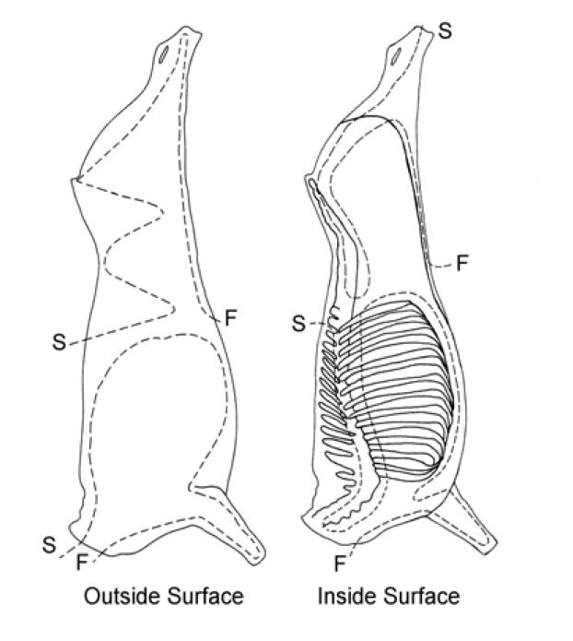
Figure 1: Horse and bovine scanning lines

Sheep and goat scanning lines
Carcase assessment must be performed in a consistent manner using a scanning method defined in the approved arrangement. Examples of sheep and goat carcase scanning lines are displayed in Figure 2.

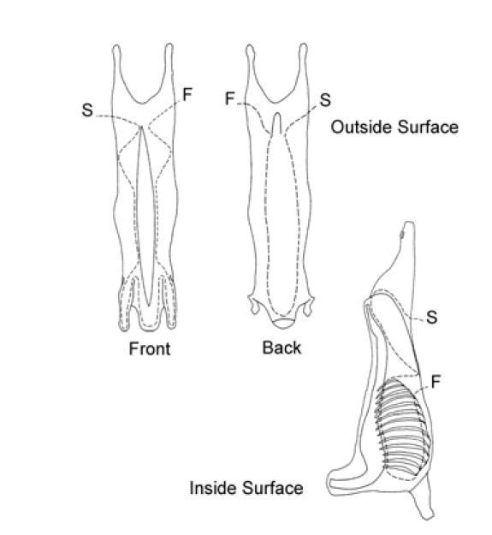
Figure 2: Sheep and goat scanning lines

Pig scanning lines
Carcase assessment must be performed in a consistent manner using a scanning method defined in the approved arrangement. Examples of pig carcase scanning lines are displayed in Figure 3.

Figure 3: Pig scanning lines

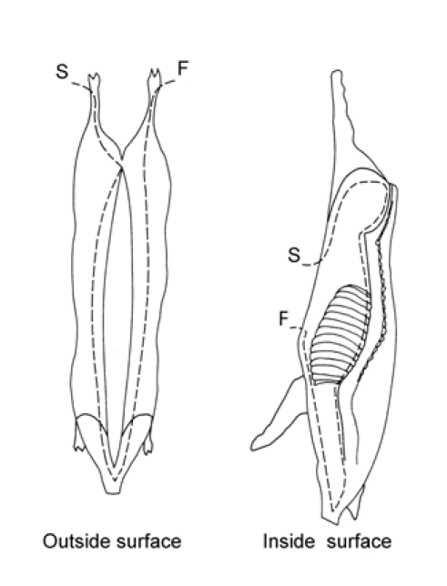
Appendix 3: Example monitoring forms

Carcase defect monitoring form
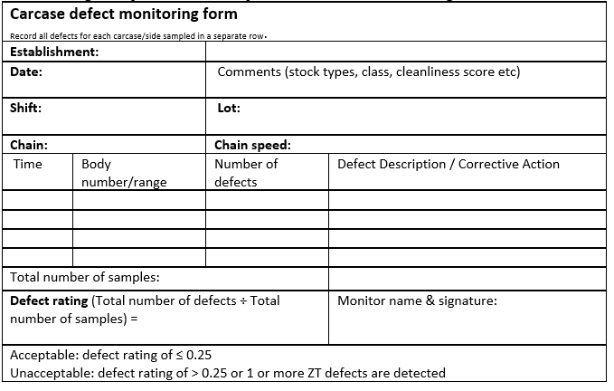
The following table provides an example of carcase defect monitoring form.

Carton meat assessment defect recording forms
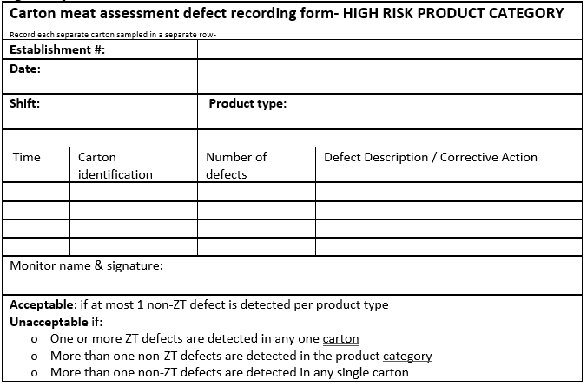
The following table provides an example of a carton meat assessment defect recording form for high-risk products.

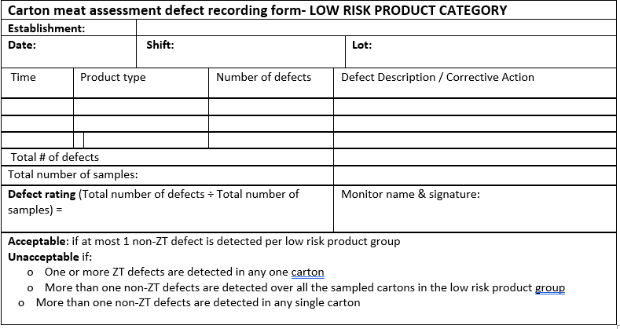
The following table provide an example of a carton meat assessment defect recording form for low-risk products.

Offal defect monitoring forms
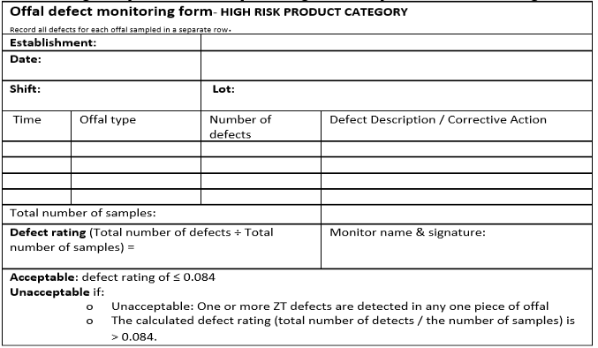
The following table provides an example of a high-risk offal product defect recording form.

Appendix 4: Calculating defect ratings

Defect rating example calculation
The following table provides an example of a carcase defect monitoring form with defect rating calculations.
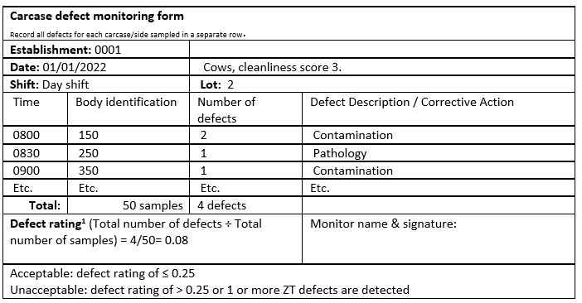
¹The defect rating is the total number of contamination and pathology defects divided by the number of checks = (3+1) / 50 = 0.08.
Any detection of a ZT defect during sampling will automatically rate the lot as unacceptable. If a ZT defect has been detected, a defect rating is still required to be calculated and recorded.

Calculating prevalence of low and high-risk products
1. Based on historical data, calculate the number of checks, the number of contamination defects and the number of pathology defects for each product type.
2. Divide the total number of contamination and pathology defects by the number of checks to give a prevalence.
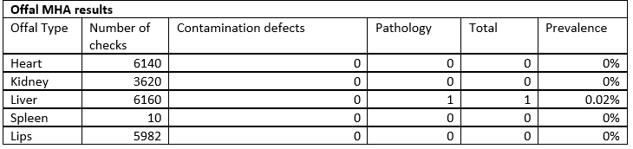
As an example, the offal results for one establishment from the trial are shown in table below:

Based on these results and other considerations, the establishment might decide to classify all products with a prevalence > 0% (at least on defect detection) as High-risk, even though the prevalence is quite low. They might also decide to classify only Lips as High-risk as these are head offal items and for this establishment, potentially pose a greater risk with their customers.

Using the CMA form for high-risk products
Consider an establishment producing lamb shanks (a High-risk product for the establishment). Therefore, lamb shanks are monitored every 60 minutes of their production.
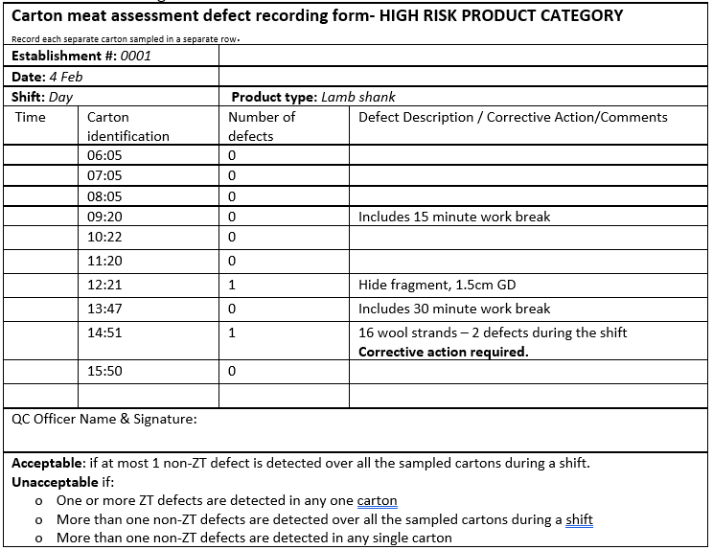
The table below is an example of the assessment form completed for 4th of February for high-risk carton meat products.
The first detection of a defect (at 12:21) does not result in corrective action as no defect had been detected in the previous cartons of lamb shanks checked during the shift. However, a second defect is detected at 14:51 at which point, corrective action is required as there are now two defects detected during the shift.

Monitoring trends
Trends in the average daily defect rating should be monitored and an analysis used in determining the overall rating of the establishment.

Appendix 5: Definitions
Australian Export Meat Inspection System (AEMIS)
The Australian Export Meat Inspection System (AEMIS) is an integrated set of controls specified and verified by Government that ensure the safety, suitability and integrity of Australian meat and meat products. Underpinning AEMIS are objective hygiene and performance standards which are continually monitored.
Approved arrangement (AA)
An approved arrangement under Chapter 5 of the Export Control Act 2020.
An arrangement for a kind of export operations in relation to a kind of prescribed goods approved by the secretary.
An approved arrangement:
- documents the controls and processes to be followed when undertaking export operations in relation to prescribed goods for export
- enables the secretary to have oversight of specific export operations.
Area Technical Manager (ATM)
A Commonwealth authorised officer with veterinary qualifications who has responsibility for the supervision, technical performance, assessment and verification of technical standards and operations in a defined group of export meat establishments.
Establishment ATM
- ATM with day-to-day on-plant responsibilities, on-plant staff technical review responsibilities and an establishment critical incident response audit (CIRA) audit role.
- Approves the establishment's approved arrangement and/or any amendments made to it.
EMSAP ATM
- ATM conducting the EMSAP audit at the establishment. This individual has not been the ATM with day-to-day on-plant responsibilities at the establishment being audited during the previous two years (i.e. held the establishment ATM role).
Audit Management System (AMS)
The department's Audit Management System used to manage, monitor, and report on the performance of export-registered establishments.
Authorised officer
An authorised officer is a person authorised by the Secretary (or a delegate of the Secretary) of the Department of Agriculture, Fisheries and Forestry under the Export Control Act 2020 (the Act) Section 291.
Carcase
Means the body of a slaughtered animal after bleeding.
Departmental authorised officer
For the purposes of this document, department authorised officers refers to the following: on-plant veterinarians, food safety meat assessors and food safety assessors.
Food Safety Meat Assessor (FSMA)
Commonwealth authorised officer who has meat inspection qualifications and works on export-registered slaughtering establishments.
Food Safety Assessor (FSA)
A Departmental authorised officer who undertakes verification and audit of export-registered establishments.
Green offal
The organs of the digestive tract. Including the stomach (for example: rumen, reticulum, omasum and abomasum in ruminants), small intestines, large intestines, and colon.
Hazard analysis critical control point (HACCP)
As defined in the AS 4696:2023 means Hazard Analysis Critical Control Point which is a system which identifies, evaluates and controls hazards that are significant for food safety.
Meat Export Data Collection System (MEDC)
An interactive web portal used to record a range of information gathered about export meat.
This portal combines previous data collection programs such as; the Establishment Production and Condemnation Statistics (EPACS), the Microbial Sample Results Database (ESAM), the Product Hygiene Indicators Database (PHI), Point of Entry detections (POE) and Species Testing (Species).
Non-compliance
A failure to comply with legislative or importing country requirements.
Occupier
As defined in section 19 of the Export Control Act:
- The occupier of a registered establishment is the person in whose name the establishment is registered.
- An occupier of an establishment (other than a registered establishment) where export operations in relation to goods are, were or will be carried out, is:
- the person that operates, operated or will operate the business of carrying out export operations in relation to goods at the establishment; or
- a person that manages or controls, managed or controlled or will manage or control export operations carried out in relation to goods at the establishment.
Offal
The organs of the thoracic and abdominal cavities, the brain, the muscular tissues of the head, the tissues of the diaphragm, the tail, the feet or tendons.
On-Plant Veterinarian (OPV)
A Commonwealth authorised officer with veterinary qualifications registrable in a state or territory of Australia who is based on an export-registered slaughtering establishment and undertakes verifications of the establishment’s approved arrangement.

Point-of-entry violation
This is a formal notification to the department from an importing country authority advising that re-inspection or testing of product at point of entry does not meet their requirements. For example: USA point of entry defects include macroscopic (faeces, ingesta, milk, off condition, chemical or physical hazards) and microscopic defects.
Product Hygiene Indicator
A weighted score out of 100 generated from agreed KPIs that is used to compare the performance of a plant against similar establishments and as an input into risk-based government oversight.
Product Hygiene Indicator Program
Measures hygienic meat production at individual establishments through the collection and analysis of individual KPIs.
Zero tolerance
A zero tolerance (ZT) is faeces, ingesta or milk detected during department verification of carcases, offal, or carton meat.

Version history
Version | Date | Amendment details
3rd Edition (version 1) | 13 April 2023 | First publication of revised MHA 3 procedure.  New Export operational guideline format.
3rd Edition (version 1.1) | July 2026 | Updated porcine carcase meat hygiene assessment criteria for the scoring of hair clusters.  Minor updates:  - Inoculation abscess included in Table 4 under ‘forequarter outside’.  - Formatting and editorial revisions.

