February 2026

NEXDOC Client Group Fact Sheet
Purpose

This fact sheet provides detailed guidance on what a Client Group is in NEXDOC, why it is required, and

how to register one.

Client Groups Registration:
- A Client Group is a registration type within NEXDOC that enables you to link your business to the NEXDOC system when using third-party software.
- Electronic Data Interface (EDI) users currently registered in EXDOC who submit meat-related Requests for Permits (RFPs) via third-party software must register a Client Group in NEXDOC to continue lodging these requests after the transition. Note: RFPs are now referred to as Requests for Export (REXs) in NEXDOC.
- Once registered, administrators can add multiple users under one Client Group, assign roles and permissions, and manage access centrally.

Who needs to apply
Any business that raises requests for export documentation via third party software.

Step-by-step process
- Create an Online Services account.
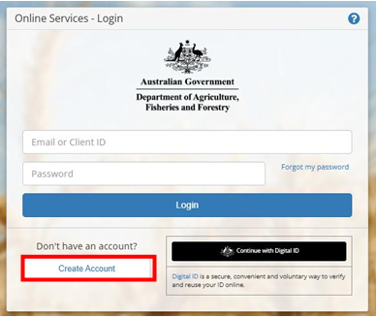

- Log in and access the NEXDOC portal.
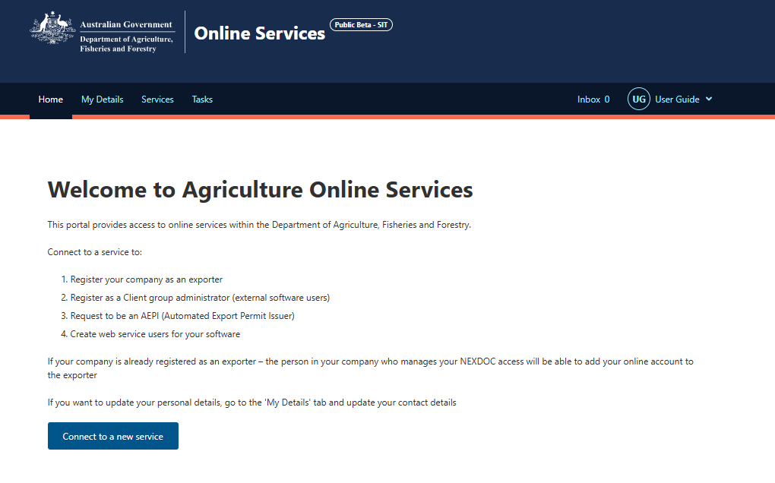

- Register a Client Group Administrator.
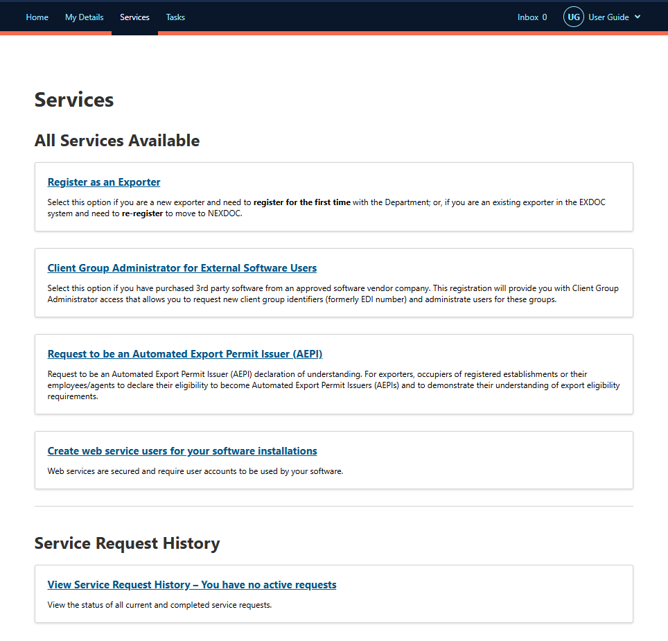

- Add your business details such as your ABN, trading name address, commodity, contact person and my printer access.
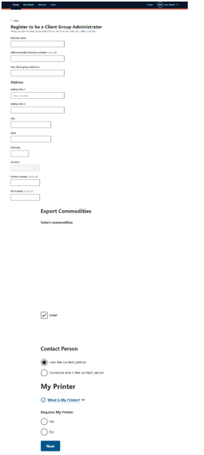

- Review the declaration and privacy notice and select submit.
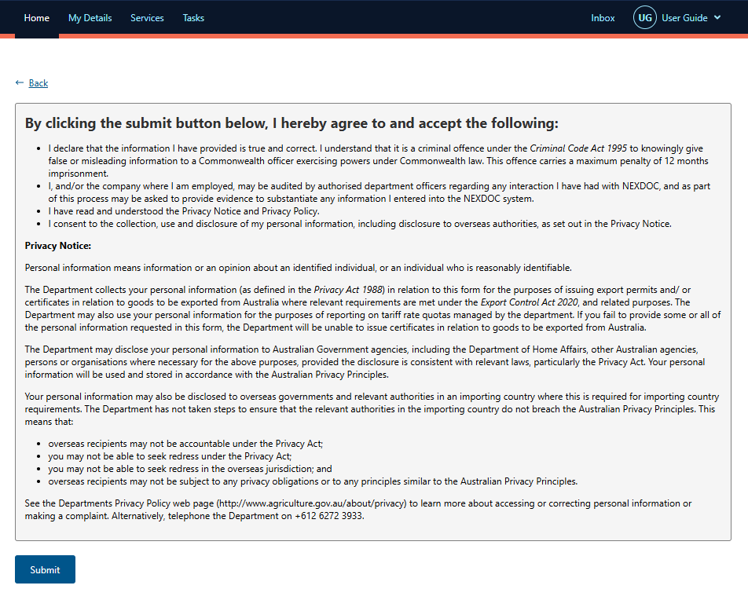

- Your request is now lodged with the department, who will review your application and advise of an outcome to finalise your registration.
- Once approved, you can invite additional users to be added to the Client Group after they have completed step 1 and created their Online Services account.
Please be advised that the department will soon transition from Online Services to the Export Service. We strongly recommend verifying your identity with myID when registering for Online Services. This will assist in a smoother transition when the time comes to register on the Export Service to connect to NEXDOC.

Important notes
- Early registration is essential to ensure you can continue to export meat and meat products.
- You must engage with your software provider prior to NEXDOC transition to ensure you are set up appropriately and understand their requirements.
- If you raise documentation via third party software, and also own the goods, you will also need to register as an exporter.

FAQs
Q1. Can I lodge export requests without a Client Group?
Yes, you can within the NEXDOC portal provided your user account has been added to the Exporter profile by the Exporter. A Client Group is only needed for software integration. Note, not all functionality that is available via your software will be available via the NEXDOC portal, including the ability to transfer REXs to another entity.
Q2. When should I apply?
Early registration is essential to avoid delays and ensure you can keep exporting meat and meat products.
Q3. Do I need a Client Group if I use an agent?
No, if your agent lodges on your behalf via their own Client Group. You only need one if you also lodge via your own software.
Q4. How many users can I add to a Client Group?
You can add multiple users and assign roles based on responsibilities. Administrators manage permissions.
Q5. What happens if I don’t register a Client Group but try to lodge via software?
Your submissions will be rejected because NEXDOC cannot connect to your software without a Client Group.
Q6. Do I need to register both a Client Group and an Exporter?
If you own the goods and lodge via software you will need to register as both a client group and an exporter. Exporter registration identifies you as the legal owner, while Client Group registration enables software integration.
Q7. I would like more support in registering?
For information on how to register in NEXDOC or attend a webinar, please go to the NEXDOC help webpage or email mailto:NEXDOC@aff.gov.au

More information
Learn more about NEXDOC on our website
Email mailto:NEXDOC@aff.gov.au
Acknowledgement of Country
We acknowledge the continuous connection of First Nations Traditional Owners and Custodians to the lands, seas and waters of Australia. We recognise their care for and cultivation of Country. We pay respect to Elders past and present, and recognise their knowledge and contribution to the productivity, innovation and sustainability of Australia’s agriculture, fisheries and forestry industries.
© Commonwealth of Australia 2026
Unless otherwise noted, copyright (and any other intellectual property rights) in this publication is owned by the Commonwealth of Australia (referred to as the Commonwealth).
All material in this publication is licensed under a Creative Commons Attribution 4.0 International Licence except content supplied by third parties, logos and the Commonwealth Coat of Arms.
The Australian Government acting through the Department of Agriculture, Fisheries and Forestry has exercised due care and skill in preparing and compiling the information and data in this publication. Notwithstanding, the Department of Agriculture, Fisheries and Forestry, its employees and advisers disclaim all liability, including liability for negligence and for any loss, damage, injury, expense or cost incurred by any person as a result of accessing, using or relying on any of the information or data in this publication to the maximum extent permitted by law.

