February 2026

NEXDOC Exporter Registration Fact Sheet
Purpose

This fact sheet provides detailed guidance on what an Exporter registration is in NEXDOC, why it is required, and how to register.
Exporter Registration:
- Exporter registration identifies your business as the legal owner of goods for export. It ensures your details (ABN, trading name) are correctly linked to and printed on export documentation.
- Those who are registered as exporters of meat in the EXDOC system and are active must complete Exporter registration in NEXDOC prior to the NEXDOC transition.
- Exporter registration also enables you to lodge requests via the NEXDOC portal if you choose to do so.

Who needs to apply
All businesses that need to be identified as the owner of the goods on meat export documentation.

Step-by-step process
- Create an Online Services account.
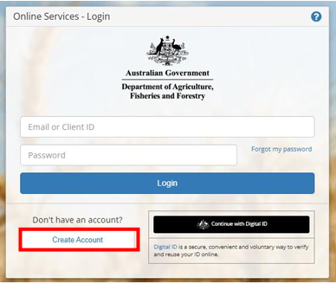

- Log in and access the NEXDOC portal.
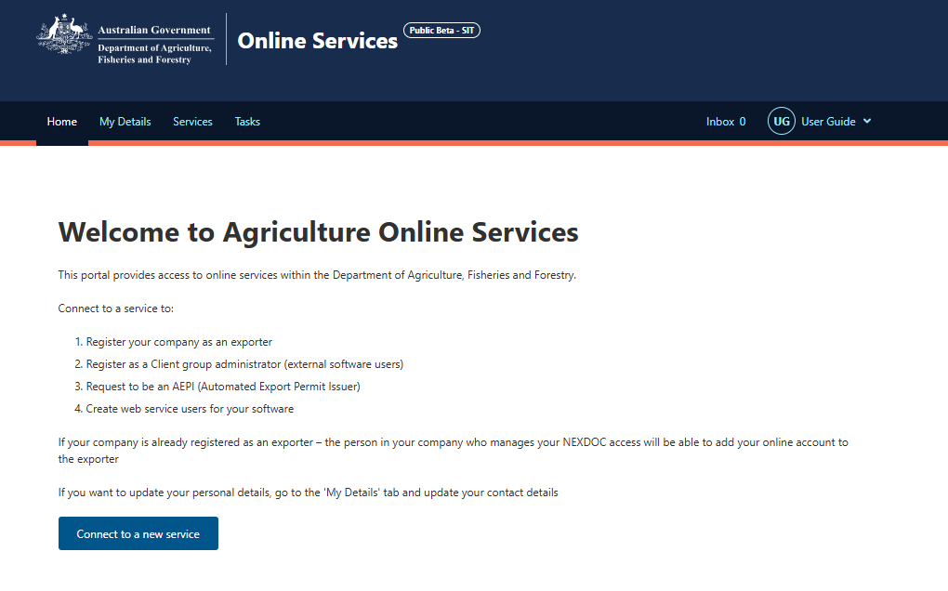

- Register as an exporter.
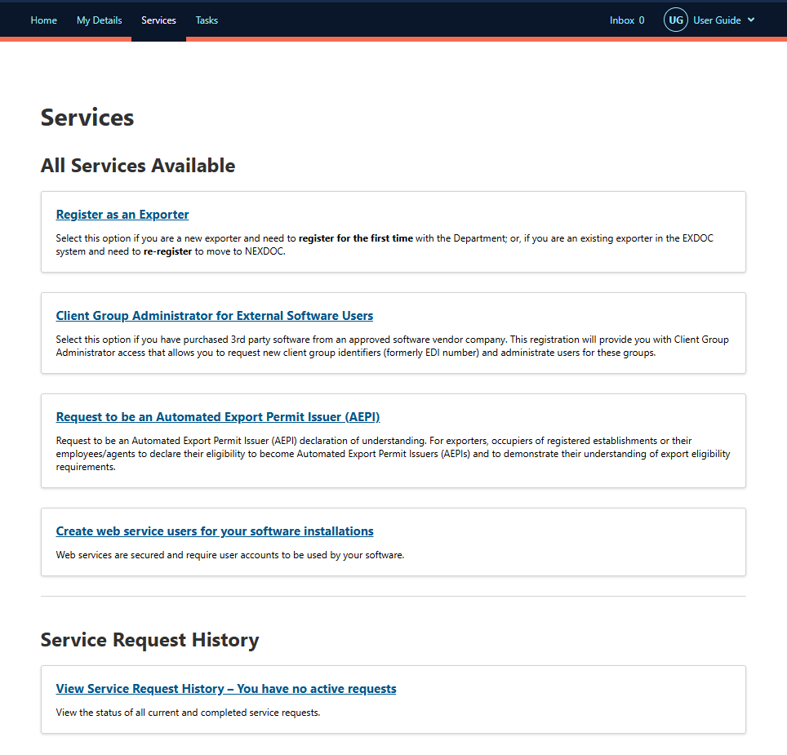

- Register for meat commodity
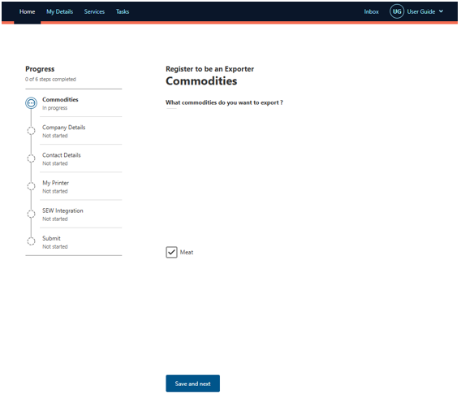
- Add your business details such as by providing ABN, trading name and address.
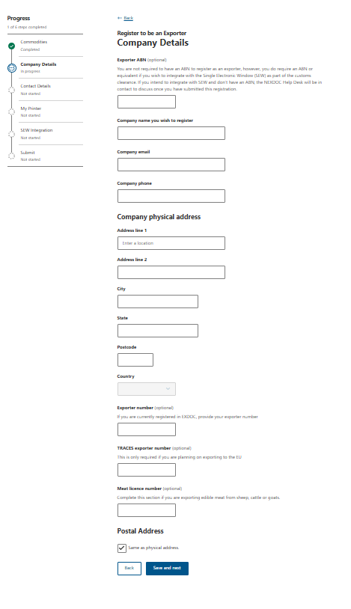
- Add your contact details
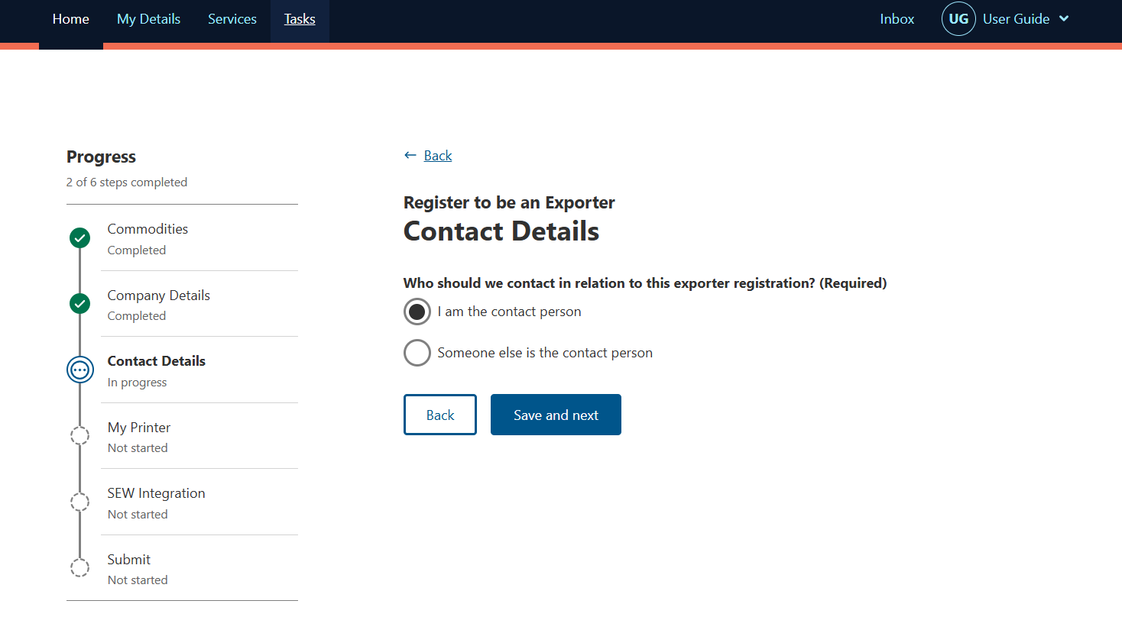
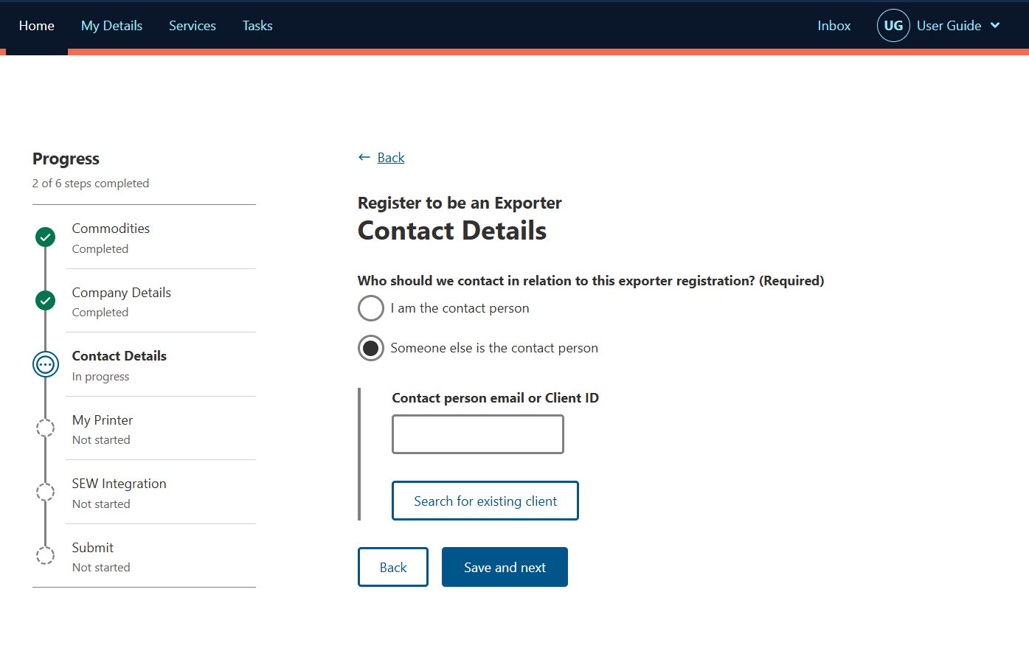

- Request your My Print permission to print certificates in your own office where applicable.
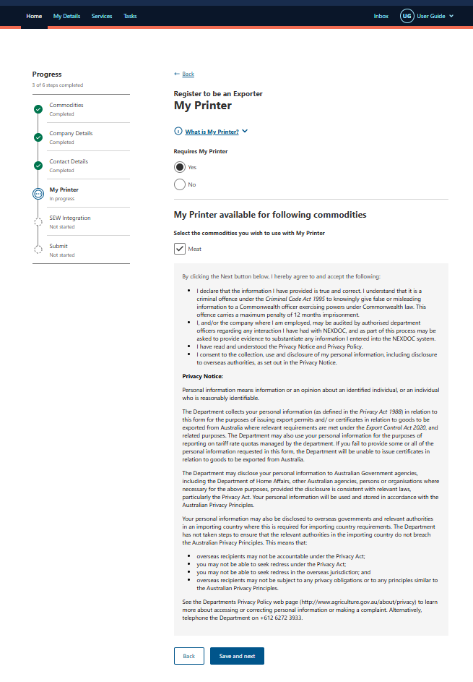

- Request integration with the single electronic window (SEW) in NEXDOC which provides exporters with a single data entry for export clearance from both the Department of Agriculture, Fisheries and Forestry and the Department of Home Affairs.
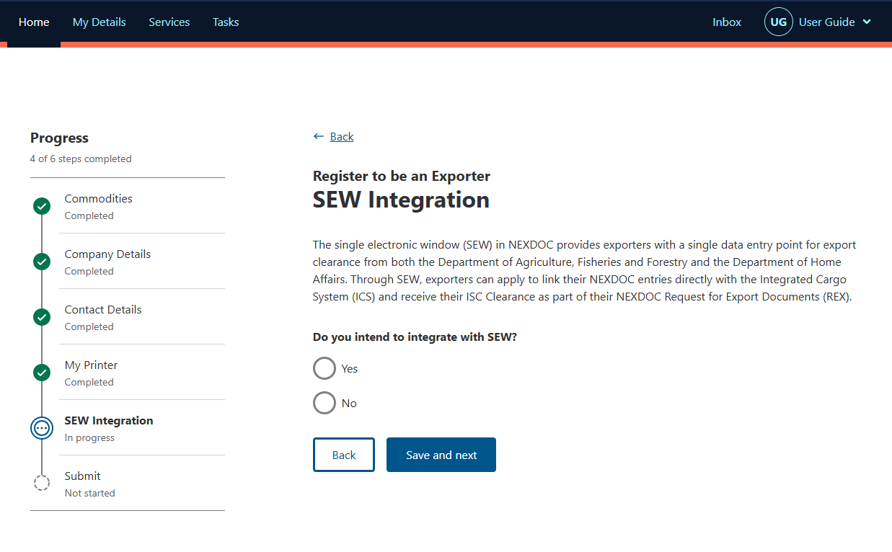

- Register to be an exporter. Read the declaration and privacy notice and if you agree select I agree and submit.
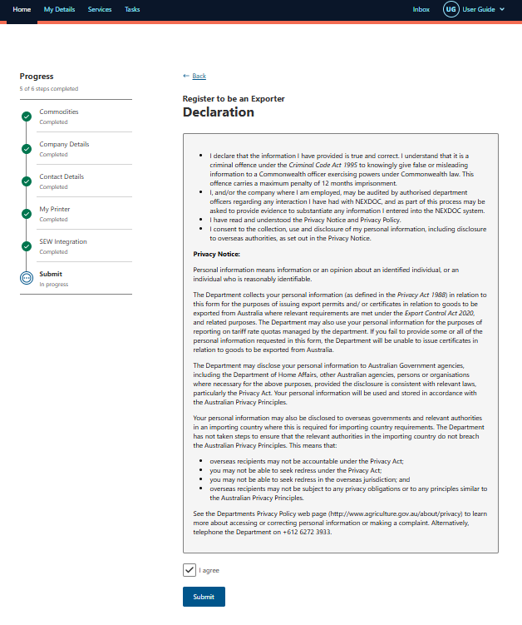
- Your request is now lodged with the department, who will review your application and advise of an outcome to finalise your registration. Only once this request is finalised will you be able to add other users to your exporter registration.
- Add other users to the exporter registration once they have created their own Online Services accounts.
Please be advised that the department will soon transition from Online Services to the Export Service. We strongly recommend verifying your identity with myID when registering for Online Services. This will assist in a smoother transition when the time comes to register on the Export Service to connect to NEXDOC.

Important notes
- Early registration is essential to and ensure you can keep exporting meat and meat products.
- If you raise documentation via third party software, you must also register as a client group.

FAQs
Q1. Why do I need to register as an exporter in NEXDOC?
Exporter registration identifies your business as the legal owner of goods and ensures your details appear correctly on export documentation.
Q2. What happens if I don’t register as an exporter?
Export documentation will not be able to be generated with your business name. This includes if you obtain documentation via a third party such as an agent. This means that from 20 April 2026 you will not be able to export meat and meat products. EXDOC will be available for in-flight RFP’s which will need to be completed closely after 20 April 2026.
Q3. What is the NEXDOC portal and how do I access it?
The NEXDOC portal is the Department of Agriculture, Fisheries and Forestry’s new online platform for managing export documentation. It allows exporters to lodge Requests for Export (REX) directly with the department, generate certificates, track consignments, and manage user access.
Note: The NEXDOC portal is available to all exporters but will not contain all of the functionality available via third party software including the ability to transfer or forward REXs.
Q4. When should I apply?
As soon as possible. Late applications will mean that you risk not being able to export. The registration process can take time including for the department to manually confirm your registration. Do not wait to register.
Q5. Can I add multiple users to my exporter account?
Yes. NEXDOC allows exporter registrations to have multiple users. Once people have registered for online services, you can add them as users to your exporter account. All users who have been added to the exporter account can raise and view REXs in the NEXDOC portal for that exporter.
Q6. I lodge via third party software, do I only register as an Exporter?
No, if you are an exporter and need to lodge via third party software, you must register as both an exporter and a client group. See the client group registration fact sheet for more details.
Q7. I would like more support in registering?
For information on how to register in NEXDOC or attend a webinar, please go to the NEXDOC help webpage.
Q8. I cant register my users what do I do?
There is information available on NEXDOC help webpage. Ensure the users you want to add have set up their Online Service account. If you require further assistance email NEXDOC@aff.gov.au

More information
Learn more about NEXDOC on our website
Email NEXDOC@aff.gov.au
Acknowledgement of Country
We acknowledge the continuous connection of First Nations Traditional Owners and Custodians to the lands, seas and waters of Australia. We recognise their care for and cultivation of Country. We pay respect to Elders past and present, and recognise their knowledge and contribution to the productivity, innovation and sustainability of Australia’s agriculture, fisheries and forestry industries.
© Commonwealth of Australia 2026
Unless otherwise noted, copyright (and any other intellectual property rights) in this publication is owned by the Commonwealth of Australia (referred to as the Commonwealth).
All material in this publication is licensed under a Creative Commons Attribution 4.0 International Licence except content supplied by third parties, logos and the Commonwealth Coat of Arms.
The Australian Government acting through the Department of Agriculture, Fisheries and Forestry has exercised due care and skill in preparing and compiling the information and data in this publication. Notwithstanding, the Department of Agriculture, Fisheries and Forestry, its employees and advisers disclaim all liability, including liability for negligence and for any loss, damage, injury, expense or cost incurred by any person as a result of accessing, using or relying on any of the information or data in this publication to the maximum extent permitted by law.

