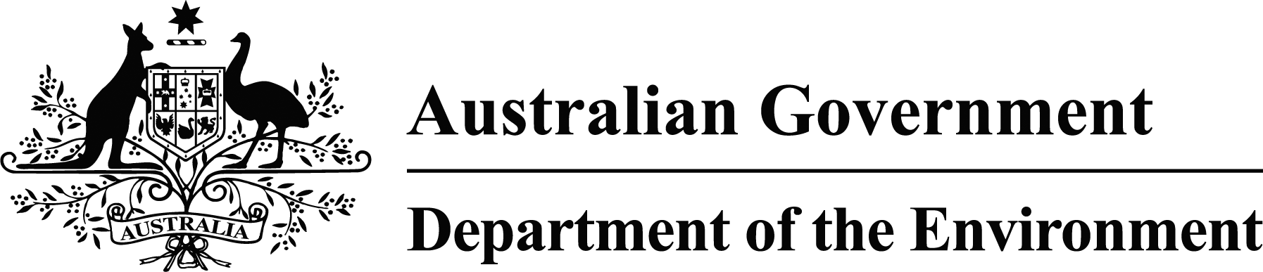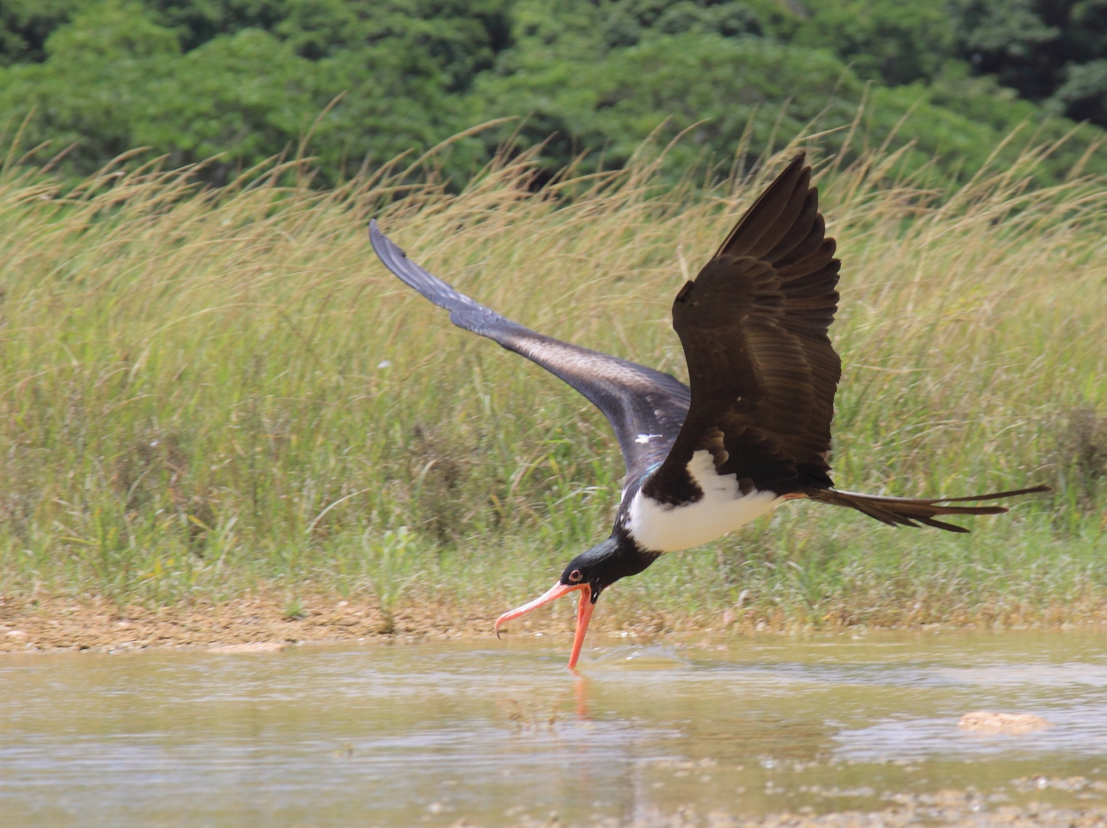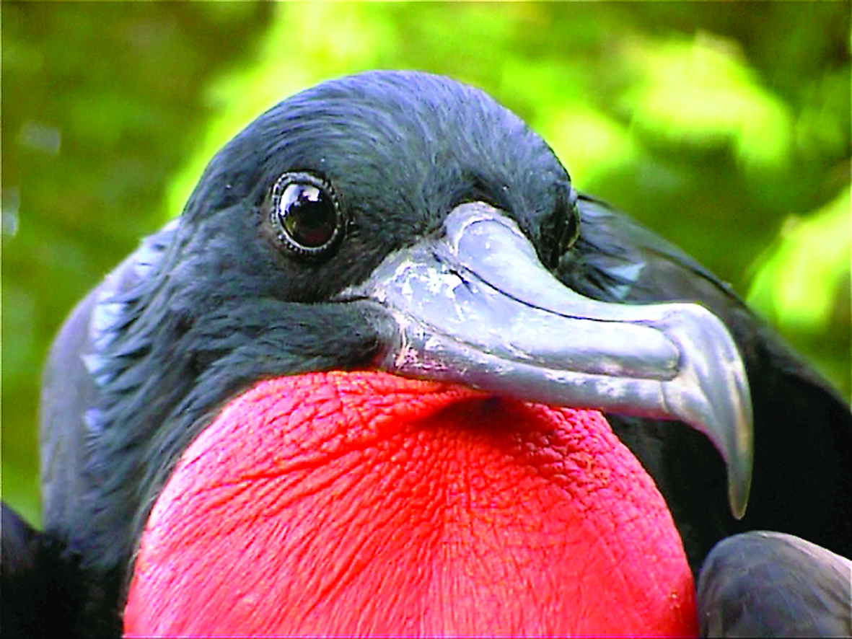

*© Max Orchid*

additional initiative

|  |  |
| --- | --- |
| About | The Christmas Island frigatebird is the ninth most evolutionary distinct and globally endangered bird in the world. Australia shares this bird with Indonesia. Christmas Island is its home and the only place in the world where it breeds and nests in the forest canopy. The male frigatebird has a bright red throat pouch called a ‘gular’, that it blows up like a fancy balloon to attract females during the mating season. It takes at least 15 months for a pair of Christmas Island Frigatebirds to raise one chick to independence, and the birds can live as long as 50 years. Frigatebirds primarily forage in the ocean for food, scooping marine organisms such as fish and squid. Over-fishing in its south-east habitat effects food availability for the frigatebird, contributing to the decline of the species. |
| Action | The Australian Government has mobilised $500,000 and commenced an ambitious feral cat eradication program on Christmas Island, which will significantly reduce the impacts of predation by feral cats on the frigatebird. Parks Australia staff are working side by side with researchers to monitor the spread of yellow crazy ants and conduct extensive baiting to reduce the feral ants’ impacts on the frigatebird and other island species. The Australian Government, through Parks Australia, has also been working with the Christmas Island community to develop a long term recovery plan to manage and protect Christmas Island’s unique threatened species, including the Christmas island Frigatebird.  **The Additional Initiative for the frigatebird will involve a four point action plan to:**   * invest in science through the National Environmental Science Programme to better understand its ecology * update its EPBC Act status and update its recovery plan through the Threatened Species Scientific Committee * investigate possible marine conservation options * once these actions are underway, engage with Indonesian Government officials on other measures that could be taken to secure the bird’s future |

|  |  |
| --- | --- |
| **Status** | IUCN critically endangered |
| **Found in** | Christmas Island, surrounding waters and Indonesia |
| **Main threats** | Over-fishing, yellow crazy ants, feral cats and rats |

christmas island frigatebird

*© Andrew Silcocks*