# GRAIN STORAGE ASSETS AND MANAGEMENT STANDARD – a shared goal

Grain Trade Australia (GTA) and the Department of Agriculture, Water and the Environment (department) are developing a Standard to help maintain Australia’s reputation as a reliable supplier of safe and high-quality grain.

## An industry-led Standard

GTA has a comprehensive strategy to make the Australian grain industry more competitive through to 2030. A key part is to develop a Grain Storage Assets and Management Standard (Standard) for Australian grain industry participants. The Standard recognises that specifications for storage facilities are needed by both the domestic and export grain market. This will meet expectations in terms of grain quality, food safety and phytosanitary reputation.

## Role of the department

The department regulates grain exported from Australia. The department’s role is to ensure that Australian grain exports are:

* fit for purpose
* accurately described
* free of live stored grain insects
* free of any other pests or contaminants of quarantine concern to importing countries.

The department has released a Plant Export Operations Strategic Plan for 2030. Both GTA’s and the department’s strategies aim to modernise and increase efficiencies in the grain industry supply chain. We can achieve that by working together.

## How the Standard will work

Both GTA and the department are pursuing a shared goal to deliver efficiencies to Australian grain industry participants through recognition of the Standard to meet the department’s regulatory requirements. We both believe this will deliver efficiencies to Australian grain industry participants.

The Standard will set out how industry will meet the department’s regulatory goals. The department must be able to assess the Standard against the Commonwealth’s legislative export requirements for entities involved in the grain export supply chain. This will provide increased clarity, simplicity, and confidence in the export grain supply chain, from both a commercial and a regulatory perspective.

While the Standard will be voluntary, through defining the requirements for compliance via different levels of operation, the Standard will also be able to be adopted by the domestic industry. In those instances, the requirements of the department will not be applicable.

## Using new technology for better outcomes

Additionally, as part of other government initiatives, the project to develop the Standard has highlighted opportunities for industry to adopt new technology to sample and test grain for quality and phytosanitary purposes. This will help make assessment more accurate, improve confidence in the inspection process and could also reduce costs to industry and the department. This Standard will include elements of that technology adoption that may be realised during the project timeline by industry and the department, or alternatively after the project.

Longer term the Standard will be the basis for an alternative assurance arrangement, in which the department recognises the GTA Standard and the proposed auditing and assurance framework in meeting the regulatory requirements. The department will consider intervening less as the level of assurance increases. Industry will show higher levels of assurance through:

* meeting the standards
* using nationally recognized technology
* the compliance history of establishments
* industry quality management systems.

## Benefits

Industry assured grain storages with improved processes and procedures for grain management as outlined in the Standard will provide benefits for industry and the department, including:

* Strengthen the confidence of overseas and domestic consumers in the quality of Australian grain.
* A greater level of assurance and confidence for the department in Export Registered Establishments (EREs) and their storage, management, and quality systems in the export grain supply chain.
* A tool for demonstrating greater assurance to the department on industry compliance, which can lead to a reduction in the department’s level of regulatory intervention.
* Greater confidence for the financial services industry leading to improved access to finance and insurance.
* Better interface with the logistics supply chain and reduced remediation cost for out of specification grain.
* Decreased exposure to inventory loss and contractual risk.
* Providing [evidentiary] records that will support quality control and niche marketing opportunities.
* Demonstrated compliance with WH&S and other regulatory requirements.

## A tiered approach for using the Standard

The following diagram shows the tiered approach for the Standard. The department progressively intervenes less in regulating export grain when industry shows enhanced industry quality assurance systems. As noted above, the department does not regulate domestic grain.

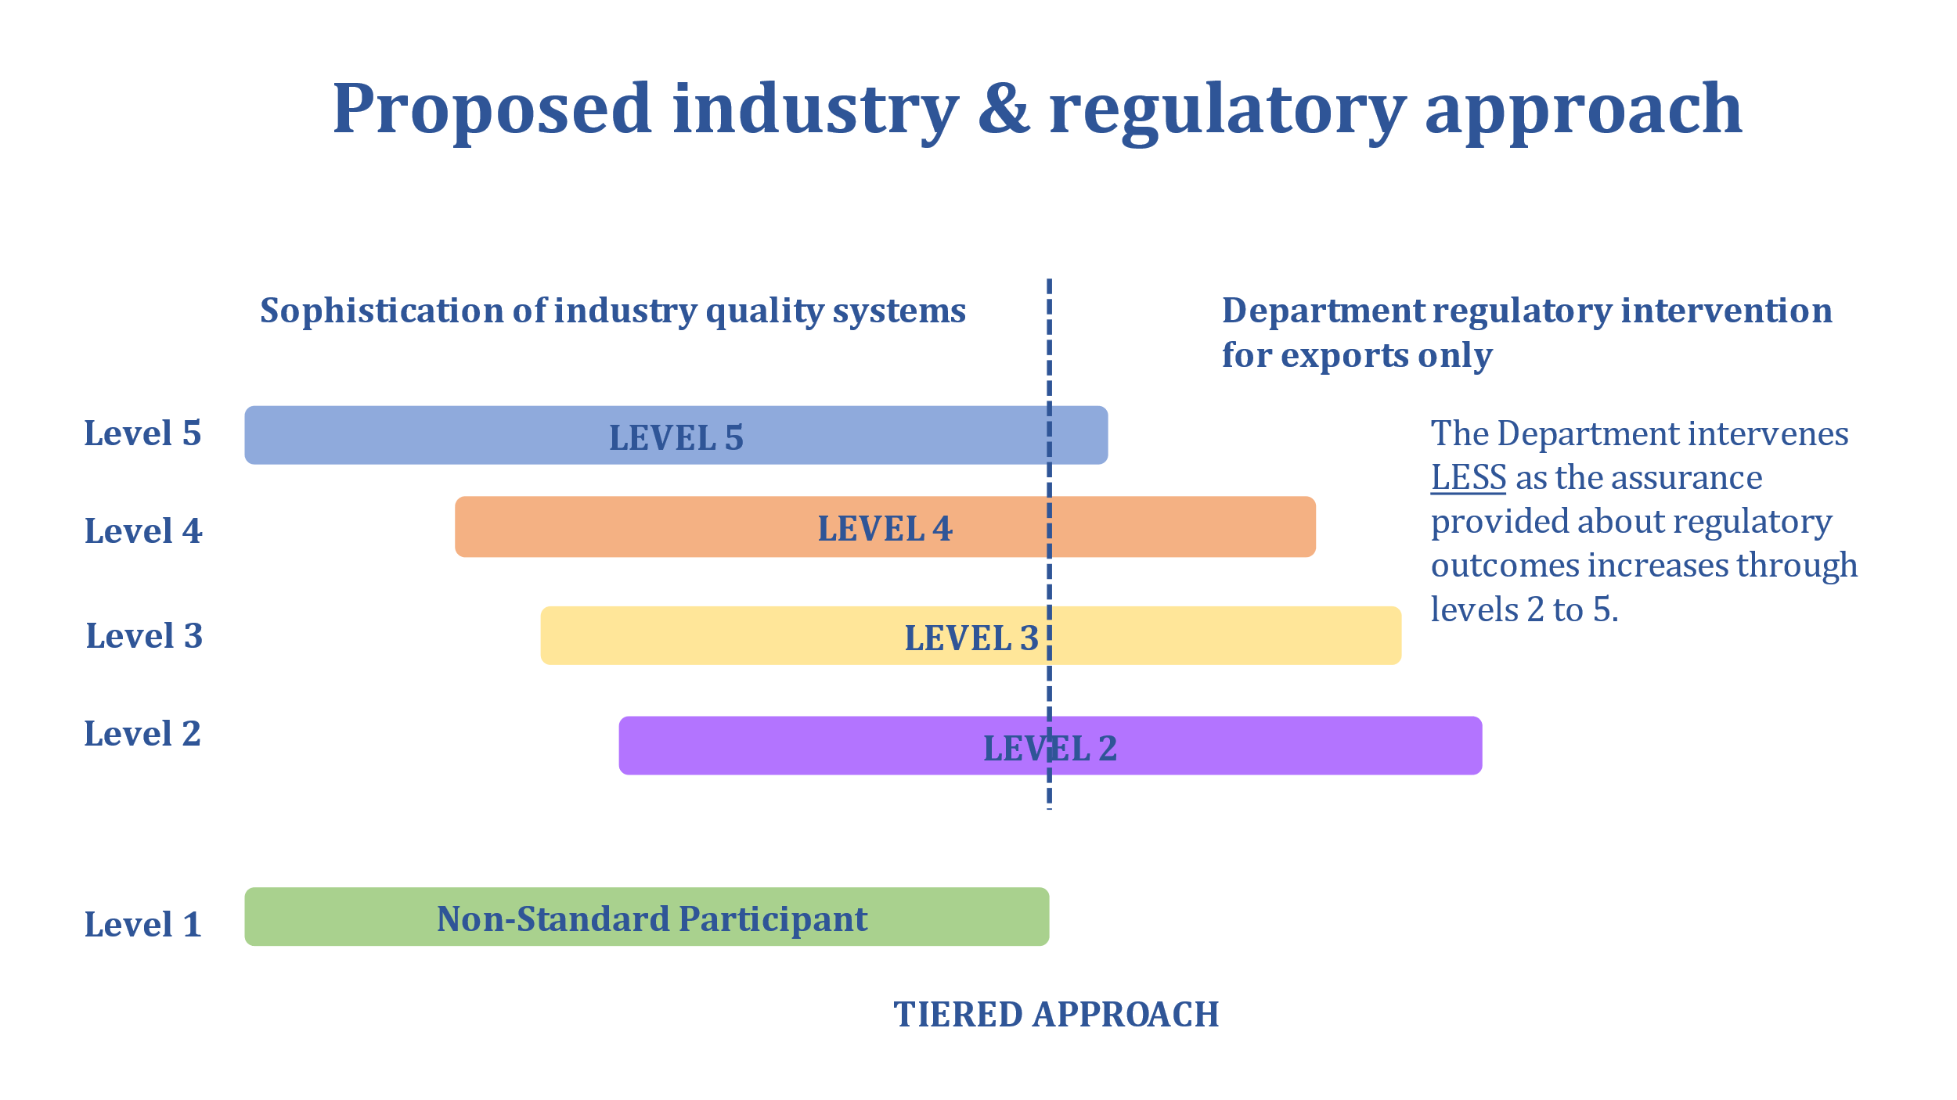

## More information

This joint project to develop the Standard and a supporting assurance framework is being funded under the Australian government’s Busting Congestion for Agricultural Exporters package. The package started in 2020–21 and runs until 2023–24.

For enquiries please contact: <congestionbustingplant@agriculture.gov.au>