**Department of Agriculture, Water and the Environment**

**Department of Agriculture**



|  |  |
| --- | --- |
| **Importing fresh solanaceous produce into Christmas Island**  **and the Cocos (Keeling)**  **Islands from Western Australia** |  |

**2020**

New conditions are in effect for fresh solanaceous fruit and vegetables purchased in Western Australia and imported into the Indian Ocean Territories (IOT) of Christmas Island and the Cocos (Keeling) Islands.

**Key facts**

* **Change:** New import conditions for fresh solanaceous produce into the IOT if purchased from Western Australia (WA).
* TPP is a destructive plant pest that affects fresh solanaceous produce.
* Solanaceous fruit and vegetables purchased in WA must be commercially produced and sourced from retail stores. Importers must have evidence of proof of purchase.
* Solanaceous produce will NOT be permitted in IOT if sourced from backyard gardens.

These conditions have been put in place to reduce the likelihood of the spread of tomato‑potato psyllid (TPP) associated with the movement of the following fresh fruit and vegetables:

* Capsicum
* Cape Gooseberry
* Chillies
* Eggplant
* Pepino (Melon Pear)
* Tamarillo
* Tomatillo
* Tomato (including cherry tomatoes)

**Import conditions**

All fresh solanaceous produce purchased in Western Australia may be imported under one of the following two options:

**1.** Goods must be commercially produced and sourced from a retail store.

Each consignment must be accompanied by an invoice or receipt which includes the name of the retail source as evidence of where the goods were purchased. Goods without sufficient source evidence will be exported back to the port of origin or disposed of.

**Note:** Produce ***is not*** permitted if sourced from backyard gardens or directly from farmers’ markets, or if there is insufficient proof of purchase.

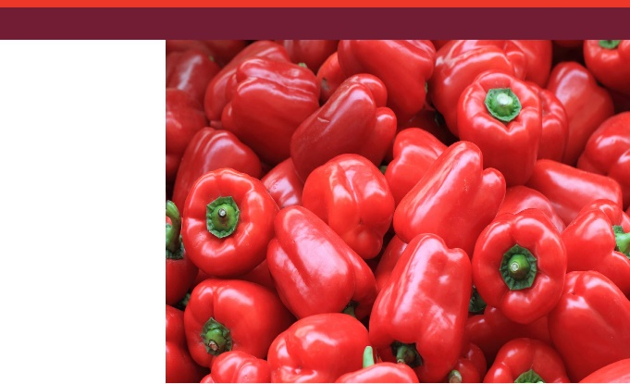**2.** Goods must be commercially produced and fumigated with methyl bromide at one of the following rates prior to shipment:

|  |  |  |
| --- | --- | --- |
| **Temperature** | **Minimum initial dose** | **Exposure period** |
| 21°C or above | 32 g/m³ | 2 hours |
| 16 °C to 20.9 °C | 40 g/m³ | 2 hours |
| 11 °C to 15.9 °C | 48 g/m³ | 2 hours |
| 10 °C to 10.9 °C | 56 g/m³ | 2 hours |

**Note:** Fumigation is not permitted if the ambient minimum temperature falls below 10 °C.

To demonstrate compliance with this requirement, importers must present an acceptable fumigation certificate at the time of clearance.

An acceptable fumigation certificate must include:

1. Details of the treatment (including dosage, fumigant, temperature and duration)
2. A description and quantity of the items treated
3. The date of fumigation
4. The name of the fumigation facility
5. A plastic wrap declaration containing one of the following statements:
6. Plastic wrapping has not been used in this consignment; or
7. This consignment has been fumigated before application of plastic wrapping; or
8. Plastic wrapping used in this consignment conforms to the Wrapping and Perforation Standard as found in the Australian Fumigation Accreditation Scheme (AFAS) fumigation requirements.

Produce must be securely packed in clean packaging.

**Packaging requirements**

All fresh solanaceous produce must be securely packaged (fully enclosed) using one or more of the following secure packaging options:

1. **Integral cartons** - produce may be packed in integral (fully enclosed) cartons (packages) with boxes having no ventilation holes and lids tightly fixed to the bases.
2. **Ventilation holes of cartons covered** - cartons (packages) with ventilation holes must have the holes covered/sealed with a mesh/screen of no more than 1.6 mm pore size and not less than 0.16 mm strand thickness. Alternatively, the vent holes could be taped over.
3. **Polythene liners** - vented cartons (packages) with sealed polythene liners/bags within are acceptable (folded polythene bags are acceptable).

The following examples of packaging are acceptable.

* + - Cartons/packages
    - Ziplock plastic bags
    - Zipped cooler bags
    - Esky, or other suitable enclosed container

**Produce transiting through Western Australia**

Produce grown and packed outside of Western Australia may ‘transit’ through Western Australia to IOT, provided it remains secure in original packaging. Importers must provide the department with information on the source and packaging for approval prior to shipment.

All consignments are subject to inspection on arrival in IOT to verify compliance with import conditions prior to release.

**Contacts**

For more information, please contact the department’s Christmas Island office on 08 9164 7456 or via email [Christmas.Island@agriculture.gov.au](mailto:Christmas.Island@agriculture.gov.au).