27 March 2025

Khapra beetle treatments for Australian imports

# Upcoming changes to treatment and certification requirements

Australia currently has emergency measures in place to manage the risk of khapra beetle (*Trogoderma granarium*) in goods imported into Australia. This includes mandatory pre-border treatment of   
[high-risk plant products](https://www.agriculture.gov.au/biosecurity-trade/pests-diseases-weeds/plant/khapra-beetle/plant-products#list-of-highrisk-plant-products) and certain [sea containers](https://www.agriculture.gov.au/biosecurity-trade/pests-diseases-weeds/plant/khapra-beetle/sea-container-measures) that are packed in [khapra beetle target-risk countries](https://www.agriculture.gov.au/biosecurity-trade/policy/legislation/list-target-risk-countries-host-khapra-beetle).

On **28 May 2025**, new requirements for khapra beetle treatments and phytosanitary certification will be introduced. There will be **three key changes**:

1. Revised additional declaration on the phytosanitary certificate to certify compliance with gas-permeable packaging requirements for treatments of high-risk plant products.
2. Mandatory supervision by the exporting government’s National Plant Protection Organisation (NPPO) of certain treatment providers. A new additional declaration will be required on the phytosanitary certificate to certify compliance with this requirement.
3. Removal of the fourth concentration sampling tube requirement for methyl bromide fumigation of sea containers.

Further detail on these changes is provided on pages 2-4.

*Images 1–3 (top row) show khapra beetle adults and juvenile larvae on plant products. Images 4–6 (bottom row) show instances of khapra beetle detected on products, packaging and shipping containers imported into Australia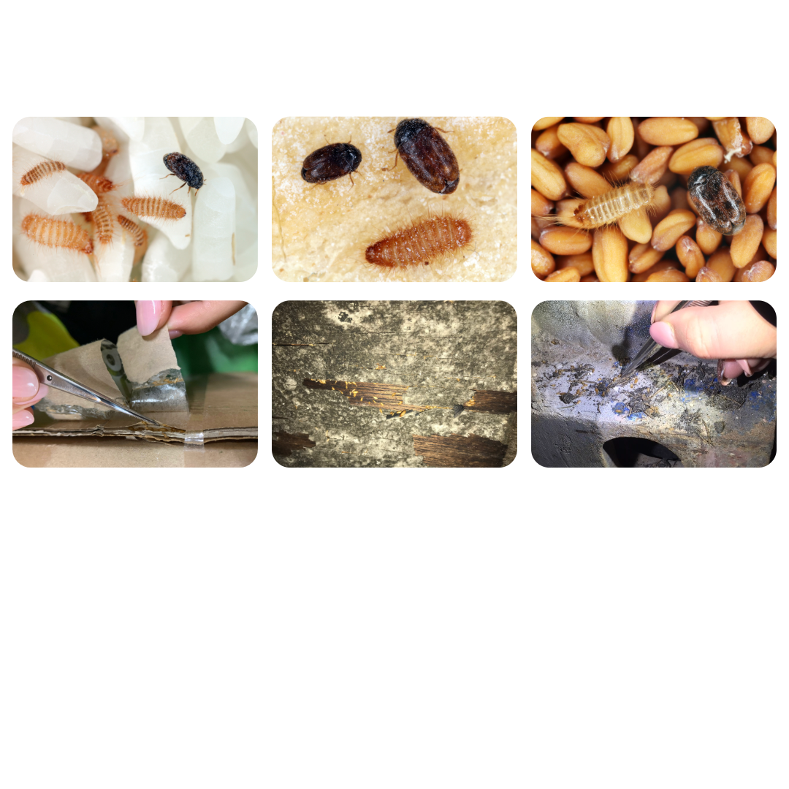.*

## Change 1: Revised wording for gas permeable packaging additional declaration

From 28 May 2025, the wording of the additional declaration used to certify compliance with packaging permeability requirements will change. The new wording is detailed in **Table 1** below.

This applies to [high-risk plant products](https://www.agriculture.gov.au/biosecurity-trade/pests-diseases-weeds/plant/identify/khapra-beetle/plant-products#list-of-highrisk-plant-products) from khapra beetle [target-risk countries](https://www.agriculture.gov.au/biosecurity-trade/policy/legislation/list-target-risk-countries-host-khapra-beetle) [treated](https://www.agriculture.gov.au/biosecurity-trade/pests-diseases-weeds/plant/identify/khapra-beetle/plant-products#measures-for-highrisk-plant-products-imported-via-all-commercial-pathways) with methyl bromide or controlled atmosphere.

Table 1: Current and new additional declarations regarding permeable packaging

|  |  |  |
| --- | --- | --- |
| Import type | Current additional declaration | New additional declaration from 28 May 2025 |
| [High-risk plant products](https://www.agriculture.gov.au/biosecurity-trade/pests-diseases-weeds/plant/identify/khapra-beetle/plant-products#list-of-highrisk-plant-products) packed in a khapra beetle [target-risk country](https://www.agriculture.gov.au/biosecurity-trade/policy/legislation/list-target-risk-countries-host-khapra-beetle) | * “*The goods were fumigated in* [*gas permeable packaging*](https://www.agriculture.gov.au/sites/default/files/documents/guide-to-packaging-suitability-performing-qps-treatments.pdf).” **OR** * “*The goods were fumigated prior to packing.”* **OR** * *“*[*Impermeable packaging*](https://www.agriculture.gov.au/sites/default/files/documents/guide-to-packaging-suitability-performing-qps-treatments.pdf) *was open during fumigation.”* | * *“The goods were fumigated in* [gas permeable packaging](https://www.agriculture.gov.au/sites/default/files/documents/guide-to-packaging-suitability-performing-qps-treatments.pdf).*”*   ***OR***   * *“The goods were fumigated prior to being sealed in gas* [*impermeable packaging.”*](https://www.agriculture.gov.au/sites/default/files/documents/guide-to-packaging-suitability-performing-qps-treatments.pdf) |

This change is to clarify that product packaging must be gas permeable at the time of treatment. It does not introduce a new requirement.

As per existing requirements, [high-risk plant products](https://www.agriculture.gov.au/biosecurity-trade/pests-diseases-weeds/plant/khapra-beetle/plant-products#list-of-highrisk-plant-products) treated with methyl bromide or controlled atmosphere must be in one of the following at the time of treatment:

* **Bulk** (unpackaged)
* **Gas permeable packaging** (e.g. porous or perforated materials) before outer packaging is applied (e.g. shrink wrap)
* **Impermeable packaging** that is **open.**

For examples of suitable and unsuitable packaging types, refer to the [***Infographic: Fumigation of high-risk plant products - Packaging requirements***](https://www.agriculture.gov.au/sites/default/files/documents/methyl-bromide-fumigation-high-risk-plant-products-packaging-requirements.pdf).

## Change 2: New government supervision requirement and additional declaration for certain treatment providers

At present, khapra beetle treatments are accepted from treatment providers of any status, when endorsed on a phytosanitary certificate. From 28 May 2025, khapra beetle treatments must be directly supervised by the exporting government’s NPPO if they are conducted by a treatment provider that is listed as:

* **Suspended**, **Under Review** or **Withdrawn** on Australia’s [list of registered treatment providers](https://www.agriculture.gov.au/biosecurity-trade/import/before/prepare/treatment-outside-australia/offshore-treatment-providers)
* **Unacceptable** or **Under Review** on Australia’s [list of unregistered treatment providers](https://www.agriculture.gov.au/biosecurity-trade/import/before/prepare/treatment-outside-australia/offshore-treatment-providers#unregistered-providers).

This requirement will apply to treatments of:

* [High-risk plant products](https://www.agriculture.gov.au/biosecurity-trade/pests-diseases-weeds/plant/identify/khapra-beetle/plant-products#list-of-highrisk-plant-products) exported from a khapra beetle [target-risk country](https://www.agriculture.gov.au/biosecurity-trade/policy/legislation/list-target-risk-countries-host-khapra-beetle)
* Full Container Load (FCL)/Full Container Consolidated (FCX) sea containers packed in a khapra beetle [target-risk country](https://www.agriculture.gov.au/biosecurity-trade/policy/legislation/list-target-risk-countries-host-khapra-beetle) that are either:
  + packed with [high-risk plant products](https://www.agriculture.gov.au/biosecurity-trade/pests-diseases-weeds/plant/identify/khapra-beetle/sea-container-measures#measures-for-sea-containers-packed-with-highrisk-plant-products), or
  + will be [unpacked in a rural khapra risk postcode](https://www.agriculture.gov.au/biosecurity-trade/pests-diseases-weeds/plant/identify/khapra-beetle/sea-container-measures#measures-for-sea-containers-unpacked-in-a-rural-khapra-risk-postcode) of Australia.

The phytosanitary certificate accompanying these consignments must contain a new additional declaration to certify compliance with the requirement in accordance with the **Table 2** below.

**Note:** Treatments conducted by treatment providers that are listed as ‘**Approved**’ on the   
[list of treatment providers](https://www.agriculture.gov.au/biosecurity-trade/import/before/prepare/treatment-outside-australia/offshore-treatment-providers) or ‘**Generic**’ on the [list of unregistered treatment providers](https://www.agriculture.gov.au/biosecurity-trade/import/before/prepare/treatment-outside-australia/offshore-treatment-providers#unregistered-providers) are **not affected** by this change and should continue to follow existing requirements.

Table 2: Current and new additional declarations for treatments performed by providers listed as Suspended, Under Review, Withdrawn or Unacceptable.

|  |  |  |
| --- | --- | --- |
| Import type | Current additional declaration | New additional declaration from 28 May 2025 |
| [High-risk plant products](https://www.agriculture.gov.au/biosecurity-trade/pests-diseases-weeds/plant/identify/khapra-beetle/plant-products#list-of-highrisk-plant-products) packed in a khapra beetle [target-risk country](https://www.agriculture.gov.au/biosecurity-trade/policy/legislation/list-target-risk-countries-host-khapra-beetle) | For methyl bromide fumigation: *“The goods were fumigated with methyl bromide in accordance with Australia’s methyl bromide fumigation methodology as per the attached methyl bromide fumigation certificate [insert treatment certificate number.]”* For heat treatment:  *“The goods were treated in accordance with Australia’s heat treatment methodology as per the attached heat treatment certificate [insert certificate number].”* | For methyl bromide fumigation: *“****The monitoring of start and end point concentration readings were conducted under direct NPPO supervision,*** *and the treatment was performed in accordance with Australia’s methyl bromide fumigation methodology as per the attached methyl bromide fumigation certificate [insert certificate number].”* For heat treatment:  *“****The temperature sensors were placed under direct NPPO supervision****, and the treatment was performed in accordance with Australia’s heat treatment methodology as per the attached heat treatment certificate [insert certificate number].”* |
| [FCL/FCX sea containers](https://www.agriculture.gov.au/biosecurity-trade/pests-diseases-weeds/plant/identify/khapra-beetle/sea-container-measures)  packed in a khapra beetle [target-risk country](https://www.agriculture.gov.au/biosecurity-trade/policy/legislation/list-target-risk-countries-host-khapra-beetle) and either [packed with high-risk plant products](https://www.agriculture.gov.au/biosecurity-trade/pests-diseases-weeds/plant/identify/khapra-beetle/sea-container-measures#measures-for-sea-containers-packed-with-highrisk-plant-products) OR will be [unpacked in a rural khapra risk postcode](https://www.agriculture.gov.au/biosecurity-trade/pests-diseases-weeds/plant/identify/khapra-beetle/sea-container-measures#measures-for-sea-containers-unpacked-in-a-rural-khapra-risk-postcode) of Australia | NA: there is no existing declaration | *For methyl bromide fumigation:* *“****The monitoring of start and end point concentration readings were conducted under direct NPPO supervision,*** *and the treatment was performed in accordance with Australia’s methyl bromide fumigation methodology as per the attached methyl bromide fumigation certificate [insert certificate number].”*  *For heat treatment:*  *“****The temperature sensors were placed under direct NPPO supervision****, and the treatment was performed in accordance with Australia’s heat treatment methodology as per the attached heat treatment certificate [insert certificate].”* |

## Change 3: Removal of fourth concentration sampling tube requirement for container fumigations

At present, methyl bromide fumigations of sea containers to manage khapra beetle require a fourth concentration sampling tube positioned underneath the container. Sampling tubes are used by treatment providers performing fumigation treatments to ensure the fumigant concentration is reached and maintained for the full exposure period of the treatment.

From 28 May 2025**, the fourth concentration sampling tube underneath the container will no longer be required** for container fumigations.

Following a review of the effectiveness of the fourth concentration sampling tube, it was found that the small difference in concentration readings taken from inside the container compared with underneath the container remains within the threshold for equilibrium and minimum required concentration. Therefore, three sampling tubes are sufficient to ensure effective penetration of gas under the container floor. This change will align khapra beetle fumigations with standard fumigation practices and simplify treatments.

## Commencement date and transitional period

The revised conditions will apply to consignments that are accompanied by a phytosanitary certificate issued on or after 28 May 2025. A transitional period will be provided to facilitate compliance. During this period, phytosanitary certificate declarations that meet the old requirements will still be accepted. Once the transitional period ends, all khapra beetle treatments must comply with the updated requirements. The dates for the transitional period are yet to be finalised but will be published on our website once confirmed.

**More information**

Learn more about Australia’s [khapra beetle measures](https://www.agriculture.gov.au/biosecurity-trade/pests-diseases-weeds/plant/identify/khapra-beetle/urgent-actions)

View our lists of [pre-border biosecurity treatment providers](https://www.agriculture.gov.au/biosecurity-trade/import/before/prepare/treatment-outside-australia/pre-border-biosecurity-treatment-providers)

Email [offshoretreatments@aff.gov.au](mailto:offshoretreatments@aff.gov.au)

**Acknowledgement of Country**

We acknowledge the continuous connection of First Nations Traditional Owners and Custodians to the lands, seas and waters of Australia. We recognise their care for and cultivation of Country. We pay respect to Elders past and present, and recognise their knowledge and contribution to the productivity, innovation and sustainability of Australia’s agriculture, fisheries and forestry industries.

© Commonwealth of Australia 2025

Unless otherwise noted, copyright (and any other intellectual property rights) in this publication is owned by the Commonwealth of Australia (referred to as the Commonwealth).

All material in this publication is licensed under a [Creative Commons Attribution 4.0 International Licence](https://creativecommons.org/licenses/by/4.0/legalcode) except content supplied by third parties, logos and the Commonwealth Coat of Arms.

The Australian Government acting through the Department of Agriculture, Fisheries and Forestry has exercised due care and skill in preparing and compiling the information and data in this publication. Notwithstanding, the Department of Agriculture, Fisheries and Forestry, its employees and advisers disclaim all liability, including liability for negligence and for any loss, damage, injury, expense or cost incurred by any person as a result of accessing, using or relying on any of the information or data in this publication to the maximum extent permitted by law.