February 2023

How to register for the Plant Export Management System (PEMS) as an External Executive (EDI/Exporter/Establishment) user
This factsheet explains how to complete the registration process for access to the department’s Plant Exports Management System (PEMS) as an External Executive (EDI/Exporter or Establishment) user.
To access PEMS you must first be confirmed as a user in the department’s EXDOC system, and these details are used to confirm your access to PEMS. Where there is not a direct and obvious relationship between the entity and the registration request, we may require further clarification or declarations to be provided before access can be granted.

Types of users - How do I decide which role I need?

PEMS Exporter or EDI Executive
- These roles have the same access and allow EDI users or Exporters, to create Request for Permits (RFP) extracts from information in EXDOC, attach pre-inspection documents to the extract, view their in-progress or completed RFPs in PEMS, and to upload any post-inspection supporting documentation, directly into the system.
- Note: all messages and emails will refer to the overarching Exporter Executive role.

PEMS Establishment Executive
- For Export Registered Establishments, this role allows users to search via RFP numbers, container numbers, International Maritime Organisation (IMO) numbers and establishment name or number to view records for their establishment. The user can view the PEMS record in its entirety in a read only format. The user can also download inspection records and related calibration certificates from inspections conducted at their establishment. You can use one profile to access more than one establishment.

You have an EDI number and would like to access information across several entities, or you act as an agent for several entities:
If you have an EDI number (provided at the time of registration for the EXDOC system) and you create RFPs for more than one business entity, then you should apply for the EDI Executive role and provide your EDI number at registration. You will be able to access all PEMS records associated to your EDI number.

You are in management and control at a Registered Establishment:
If you would like to oversee the operations of activities which are conducted at your establishment then you should apply for the Establishment Executive role. You must be recorded as a person in management and control in EXDOC or provide a declaration from such a person to be approved for this role. You will need to provide the Establishment number at registration. Once you have access to one establishment role, you can apply to PEMS admin to link additional establishments under the one profile, where appropriate evidence is provided to demonstrate the relationship between these entities.

If you need access to one entity only:
If you only require access across one business entity, and you do not have an EDI number, then you should choose the Exporter executive role and provide your Exporter number at registration.

Step 1 - Create an account in the Self-Service portal
- Click on the following link to open the PEMS registration page https://online.agriculture.gov.au/selfservice.
- From the log in page, select Create an account¹.
- The department’s Self-Service page will display (see next page, first image).
- Complete the required information with your full name, not company details.
(Note your username and password and keep them secure).
- You will be asked to complete a series of challenge questions. (Make note of the answers you provide as you will need them if you forget your password).
- Read and Accept the terms of use² and select the Register³.
- A page will display stating User account created successfully⁴ (see next page - bottom image).
- Click Close⁵.
1

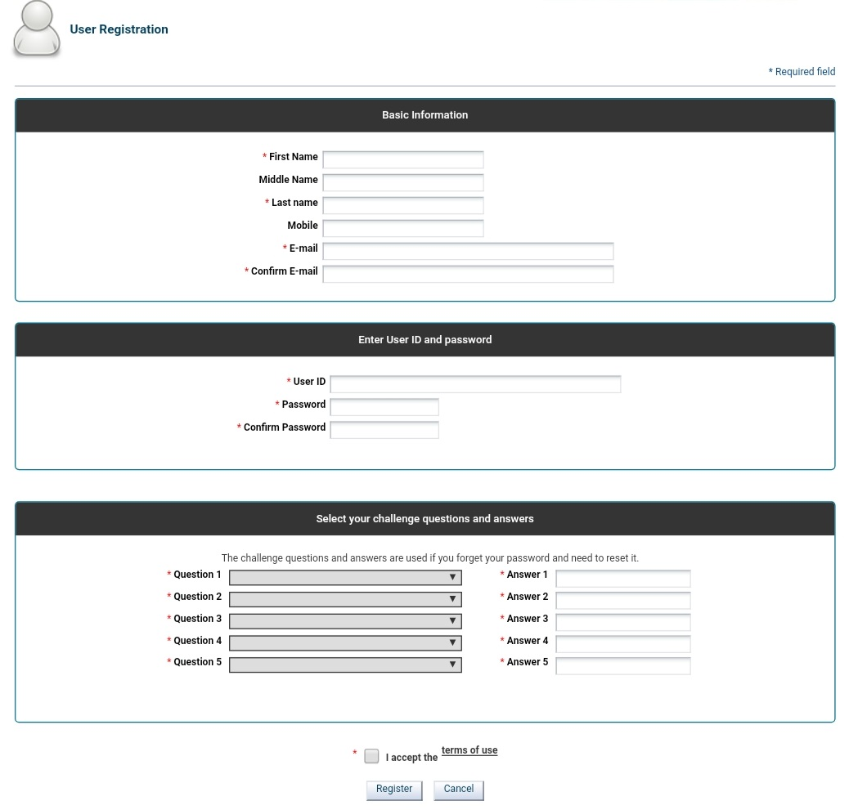
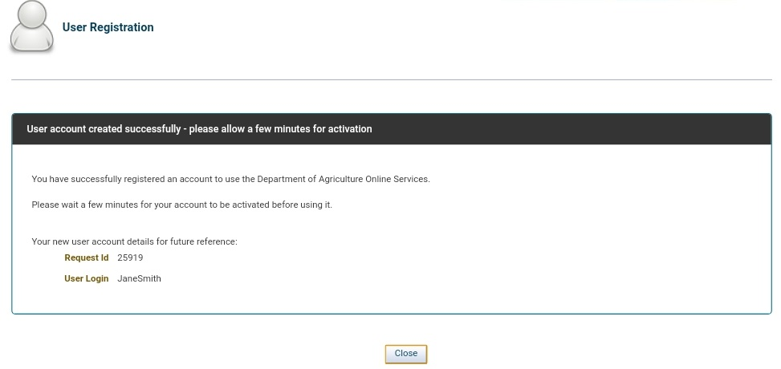
5
4
3
2
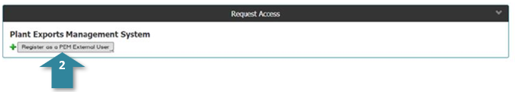
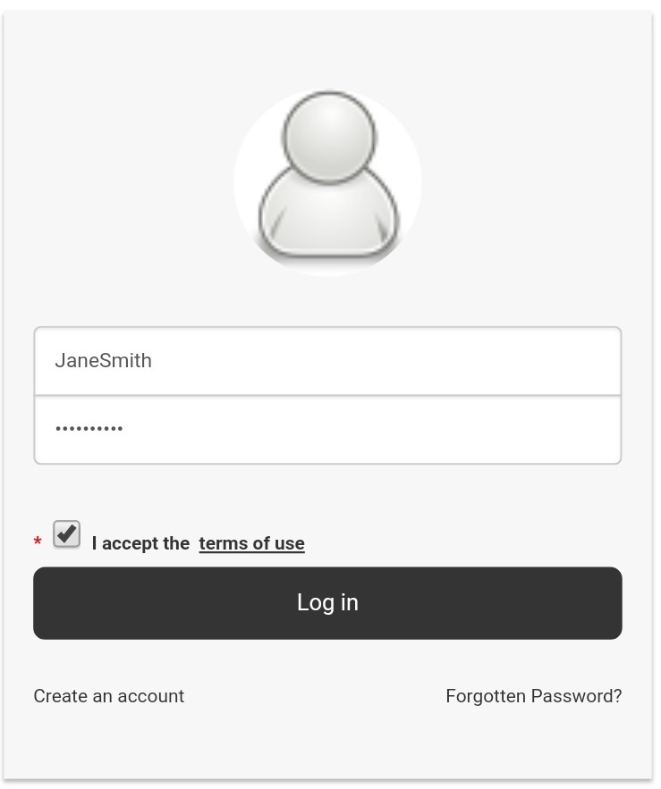

Step 4 - Register for access to PEMS
- The PEMS registration page will display (image below).
- Complete the required information¹ with your information. The email address you nominate should match the company domain where possible. If you cannot provide a domain name, you may be required to provide further clarification or declarations before access can be granted.
- Select the appropriate PEMS user role² that best describes your work/role from the information above.
  - You will be asked to enter the EDI/Exporter or Establishment number³ that relates to the role selected.
  - This number is provided in an email from EXDOC Help Desk when successfully registering as an exporter in EXDOC. If the client would like this information to be resent, an email needs to be sent to EXDOC.HelpDesk@agriculture.gov.au.

1

Step 2 - Log in to your new account
The log in page will appear again.
Log in¹ to your new account using the username and password you just created.

Step 3 - Open the PEMS registration page
- The PEMS Access Request page will display (below).
- Select Register as a PEMS External User².

- Click Submit⁴.
- NOTE: Once you have one role in PEMS accepted (confirmed by email) you can repeat Steps 2 -4 to request further PEMS roles as you may be eligible for both the Exporter/EDI role (both the same functionality) and the establishment role (overview functionality).
- BEWARE: You cannot hold an External Executive role in PEMS under the same profile as an Authorised Officer (AO) role. To allow access to both roles in PEMS you will need to provide a different user ID and email address for each profile.
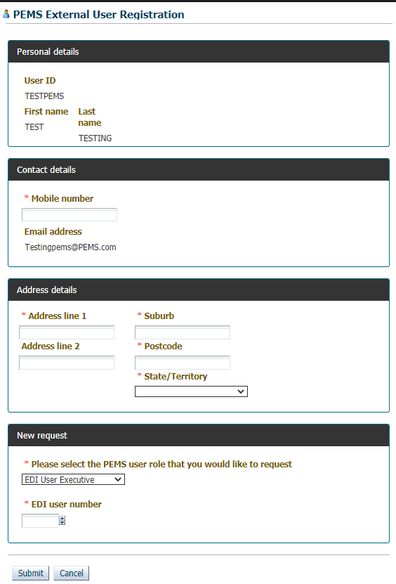

Application complete
- A confirmation message will display to inform you that your registration application has been submitted successfully and a confirmation email will be sent to your inbox (see image on next page).
3
4
2
1
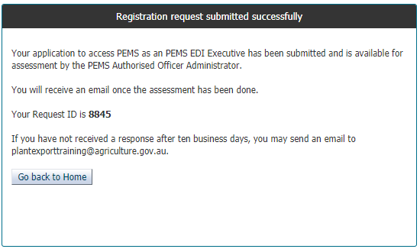

Processing your request
Important: Please submit your PEMS registration with sufficient time for your application to be processed and user profile established by the department, as this could take up to 10 business days.
- Upon receiving your registration application, the department will assess your request.
- The department will notify you via email when your registration is complete, and your account is ready to use.
If you forget your login details, select Forgotten Password? This will take you to the challenge questions to answer that were set up when registering. If this does not work then email PEMS with your details to reset your password.

More information
- For more information on PEMS visit agriculture.gov.au/pems
- For PEMS registration enquiries and technical support contact PEMS@agriculture.gov.au.
If you forget your login details then you should email PEMS to retrieve that information.

Acknowledgement of Country
We acknowledge the Traditional Custodians of Australia and their continuing connection to land and sea, waters, environment and community. We pay our respects to the Traditional Custodians of the lands we live and work on, their culture, and their Elders past and present.
© Commonwealth of Australia 2023
Unless otherwise noted, copyright (and any other intellectual property rights) in this publication is owned by the Commonwealth of Australia (referred to as the Commonwealth).
All material in this publication is licensed under a Creative Commons Attribution 4.0 International Licence except content supplied by third parties, logos and the Commonwealth Coat of Arms.
The Australian Government acting through the Department of Agriculture, Fisheries and Forestry has exercised due care and skill in preparing and compiling the information and data in this publication. Notwithstanding, the Department of Agriculture, Fisheries and Forestry, its employees and advisers disclaim all liability, including liability for negligence and for any loss, damage, injury, expense or cost incurred by any person as a result of accessing, using or relying on any of the information or data in this publication to the maximum extent permitted by law.

