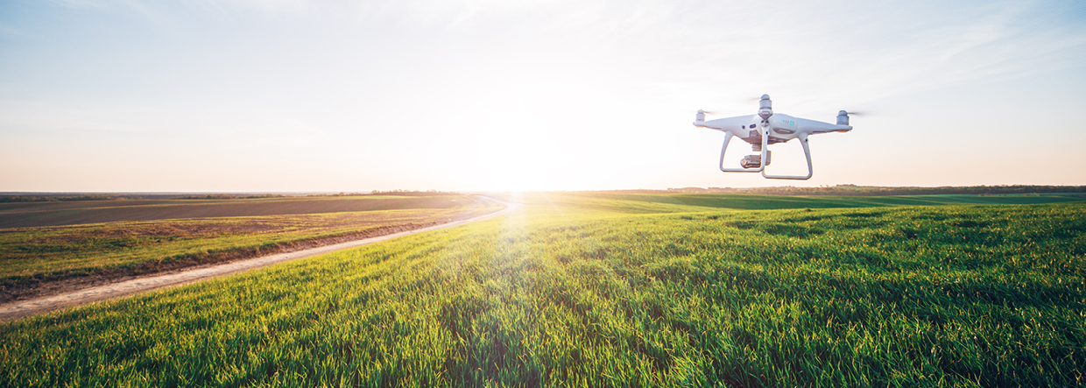

Supporting agricultural innovation

The Australian Government is providing $20 million in additional funding to the Drought Resilience Adoption and Innovation Hubs to expand their role to support the National Agricultural Innovation Agenda and deliver regionally focused and responsive agricultural innovation.

**Drought Resilience Adoption and Innovation Hubs**

Eight Drought Resilience Adoption and Innovation Hubs have been established to support drought preparedness and resilience. In support of the National Agricultural Innovation Agenda, the new funding will support the Hubs to expand their mandate to catalyse agricultural innovation, which will drive commercialisation and create jobs.

The new funding builds on the government’s existing $66 million investment through the Future Drought Fund, which established the Hubs in April 2021. This investment leveraged an additional $114 million in co‑contributions with a total of 143 partner organisations. It is also creating ‘shopfronts’ in over 40 locations across Australia, which will give farmers easily accessible, locally adapted information and services.

The Hubs provide an important physical platform for stakeholders from across the agricultural innovation system to come together and translate research and knowledge to make a real impact on the ground.

The existing Hubs are located in regional areas that reflect the key agricultural and climatic zones across the country, building connections and drive an uptake in agricultural innovation that is adapted to local needs. The Hubs are located in:

* + Southern NSW
  + Southern Queensland/Northern NSW
  + South-West WA
  + Victoria
  + Northern WA/NT
  + Tropical North Queensland
  + South Australia
  + Tasmania.

**Next steps**

The existing Hubs have already been working through a co-design process to develop suitable activities and strategies with relevant stakeholders. With this new investment, Hubs will be supported to include additional stakeholders from the broader agricultural innovation system into that process, as they broaden their role beyond drought resilience. This will help the Hubs expand into wider agricultural innovation activities and outcomes that meet the needs of their region.

The Department of Agriculture, Water and the Environment will work with the Hubs in late 2021 to expand their roles in support of the National Agricultural Innovation Agenda.

Why is this important

We are expanding our support for agricultural innovation to make sure Australia’s agriculture industry remains at the forefront of modern technology and can leverage all opportunities for growth. The new investment will encourage development, extension, adoption and commercialisation of innovation and digital technologies across industry and the supply chain. It will also support Hubs to build connections and encourage collaborations between researchers, technology developers, investors, producers and agribusinesses to drive innovation and digital technology uptake.

Increased innovation in our agriculture industry will create jobs in regional areas, and support agri-businesses to maximise their efficiencies and improve their productivity.

How much will this cost

The program will provide an additional $20 million over 18 months to July 2023 to allow the Hubs to engage in activities which will lead to practical uptake of innovation by producers, stimulate collaboration and increase commercialisation outcomes. The funding will also support investment in innovation for fisheries and aquaculture.

More information

For more information about our commitments to agricultural innovation, visit awe.gov.au/innovation