

20 birds by 2020

*© Andrew Silcocks*

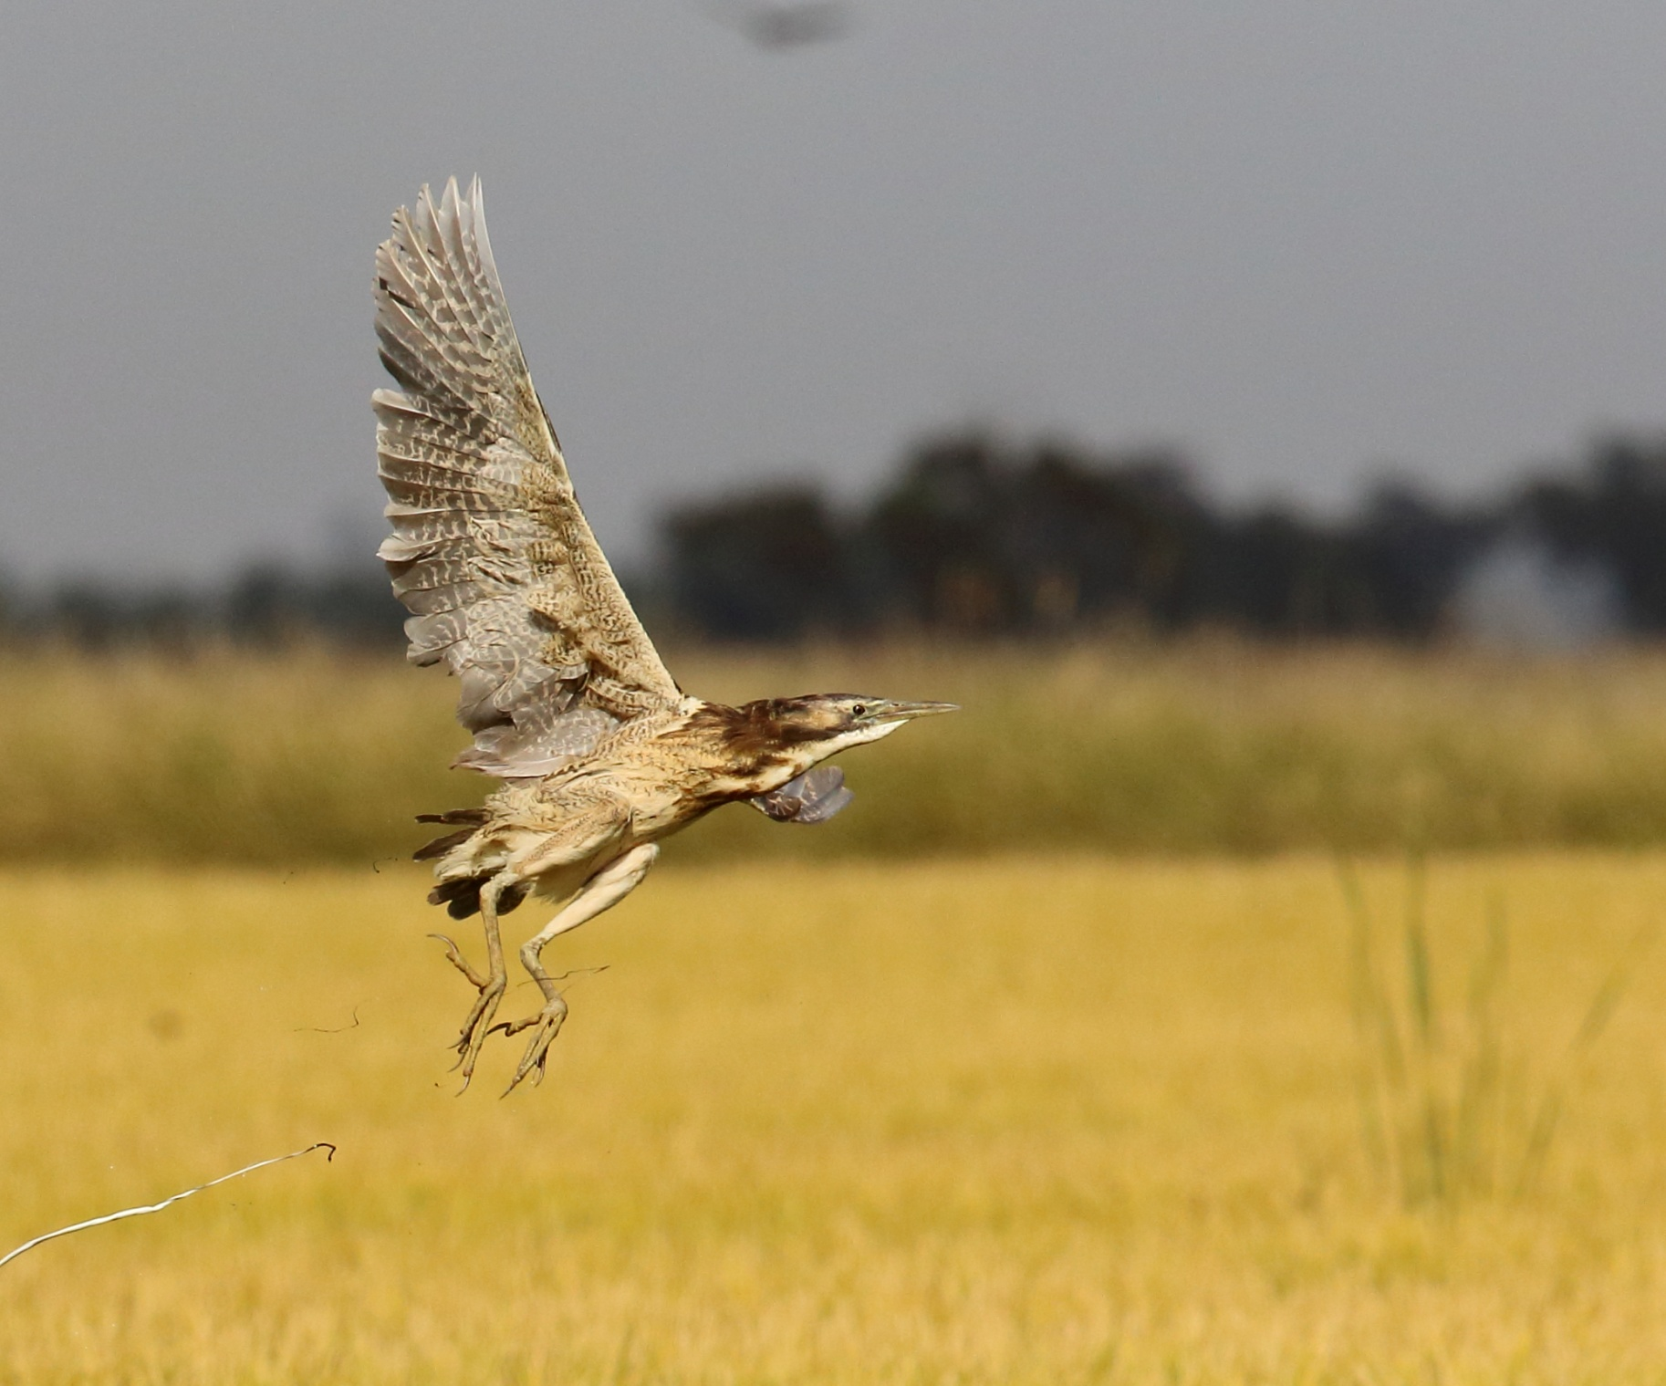Australia’s Threatened Species Strategy was launched by Minister for the Environment Greg Hunt MP on the 16 July 2015 at the Threatened Species Summit in Melbourne. The Strategy sets out the Australian Government’s bold, action‑based approach to protecting and recovering our threatened animals and plants. It includes commitments to improve trajectories of 20 threatened birds by 2020. When launched, the Strategy identified the first 12 birds for priority conservation:

* Mallee emu-wren
* Night parrot
* Regent honeyeater
* Hooded plover
* Yellow chat
* Western ground parrot
* Norfolk Island boobook owl
* Eastern bristlebird
* Helmeted honeyeater
* Plains wanderer
* Norfolk island green parrot
* Orange-bellied parrot

You can read more about the 12 priority birds here: <http://environment.gov.au/biodiversity/threatened/publications/threatened-species-strategy-action-plan-2015-16-20-birds-2020>

eight more birds

## The Strategy commits to announcing, in Year 1, the remaining eight priority birds. Like the original 12, these species were identified by the Office of the Threatened Species Commissioner through consultation with some of Australia’s leading bird scientists, the Threatened Species Commissioner’s informal advisers, the state and territory governments, key environmental NGOs and the Threatened Species Scientific Committee. Species were considered against the Principles for Prioritisation in the Strategy. The remaining eight priority birds are:

* Southern Cassowary
* Swift parrot
* Australasian bittern
* White-throated grasswren
* Golden-shouldered parrot
* Malleefowl
* Eastern curlew
* Red-tailed black cockatoo (south-eastern)

meet the 8 birds

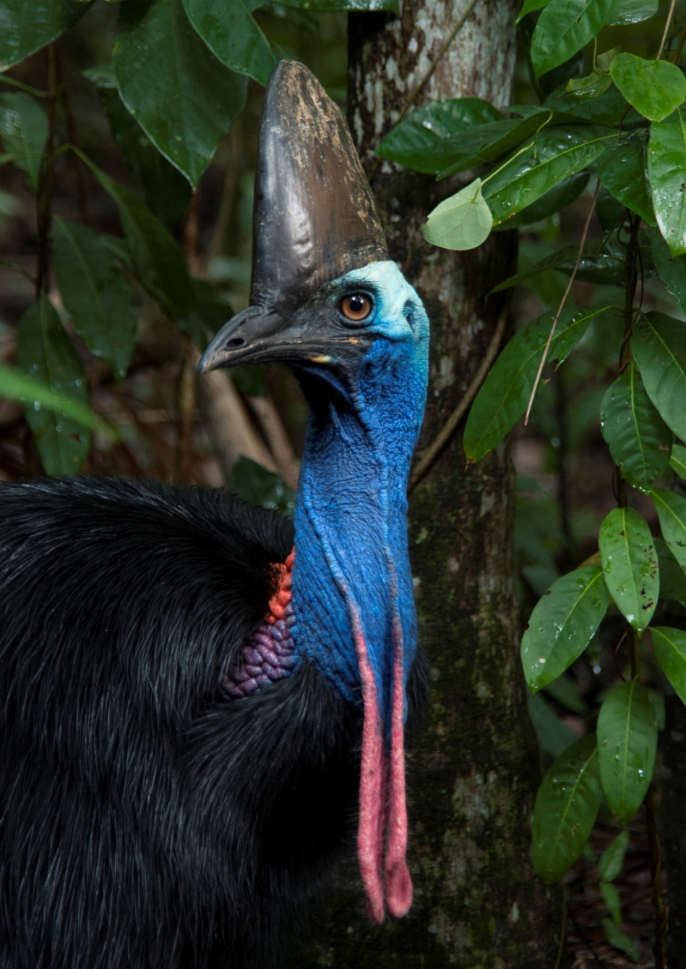

|  |  |
| --- | --- |
| EPBC Status | Endangered |
| Found in | Queensland |
| Main threats | Habitat loss, vehicle strikes and dog attacks |
| About | The southern cassowary is a flightless bird and the largest native animal in Australian rainforests. Adults have a tall helmet on their head (called a ‘casque’) which may help them to sense low vibrating sounds made by other cassowaries and also acts like a bike helmet to protect their head when they are running through the jungle. Cassowaries are very territorial and mostly solitary. Cassowaries eat fleshy fruits of over 200 species of plants, dispersing seeds long distances in the process. This makes them a keystone species in the World Heritage listed rainforests of tropical Queensland. |
| Action | The Australian Government has secured over  $10 million in initiatives supporting the southern cassowary, including. Eighteen Green Army teams and $6 million in projects that directly protect and restore its habitat. |

*© Liz Gallie*

en

southern cassowary

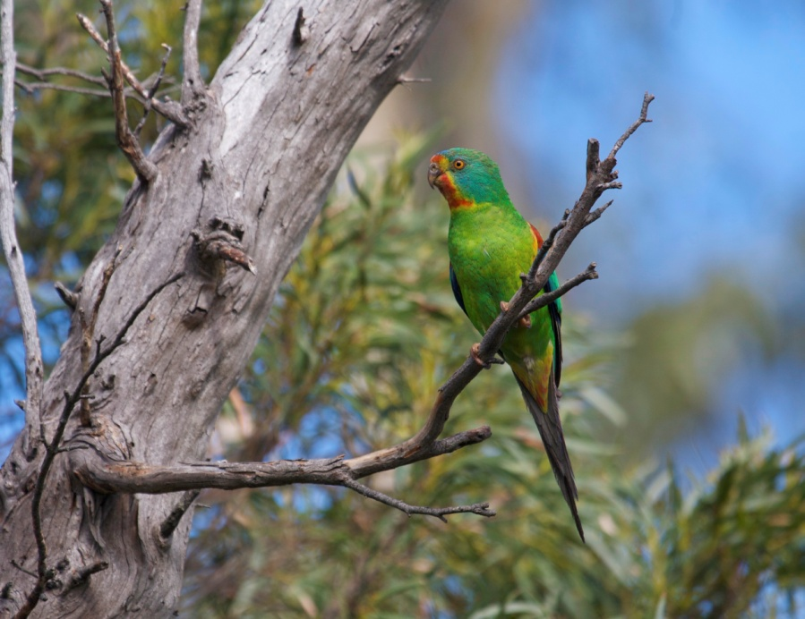

|  |  |
| --- | --- |
| EPBC Status | Endangered |
| Found in | Tasmania and south-eastern mainland Australia. |
| Main threats | Predation by sugar gliders, habitat loss and collision mortality |
| About | This small parrot (only slightly bigger than a budgie) earned its name for its rapid, agile flight. Swift parrots are one of only three migrating parrot species in the world. They breed in Tasmania and fly across the Bass Strait in winter to feed on flowering plants across south-eastern Australia. |
| Action | The Australian Government has secured over $3 million for projects that support recovery of the swift parrot. Thirteen projects through the 20 Million Trees Programme are restoring its habitat. The Australian Government is funding a dedicated project through the NESP programme to tackle the threat of invasive predators. |

swift parrot

en

*© Dejan Stojanovic*

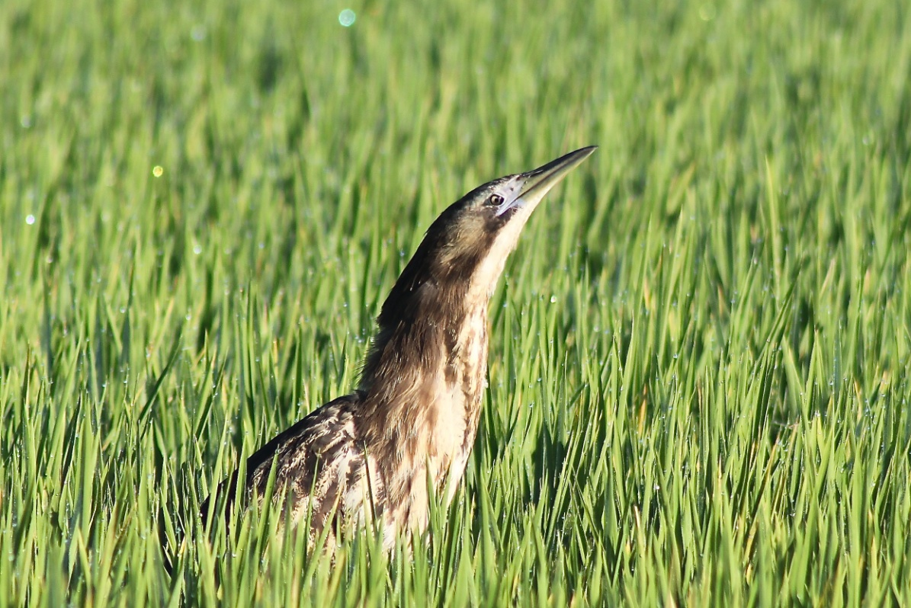

|  |  |
| --- | --- |
| EPBC Status | Endangered |
| Found in | South-eastern Australia, including south-east Queensland, Tasmania and in south-west Western Australia. They also occur in New Zealand and New Caledonia. |
| Main threats | Diversion of water away from wetlands, habitat loss, feral cats, foxes and grazing |
| About | The Australasian bittern is a secretive, stocky, heron-like bird, living in wetlands where it forages. Bitterns are very well camouflaged and can be difficult to spot in the reeds and rushes. On occasion they will even sway in time with reeds to blend into their surroundings. Their distinctive booming call of males gives them away. |
| Action | The Australian Government currently supports funding for seven projects through the National Landcare Programme to help restore bittern habitat. Recent environmental water flows, including water supplied by the Commonwealth Environmental Water Holder, are resulting in a small population boom for bitterns nesting in the Barmah-Millewa forest. |

*© Matt Herring – Bitterns in Rice Project*

en

australasian bittern

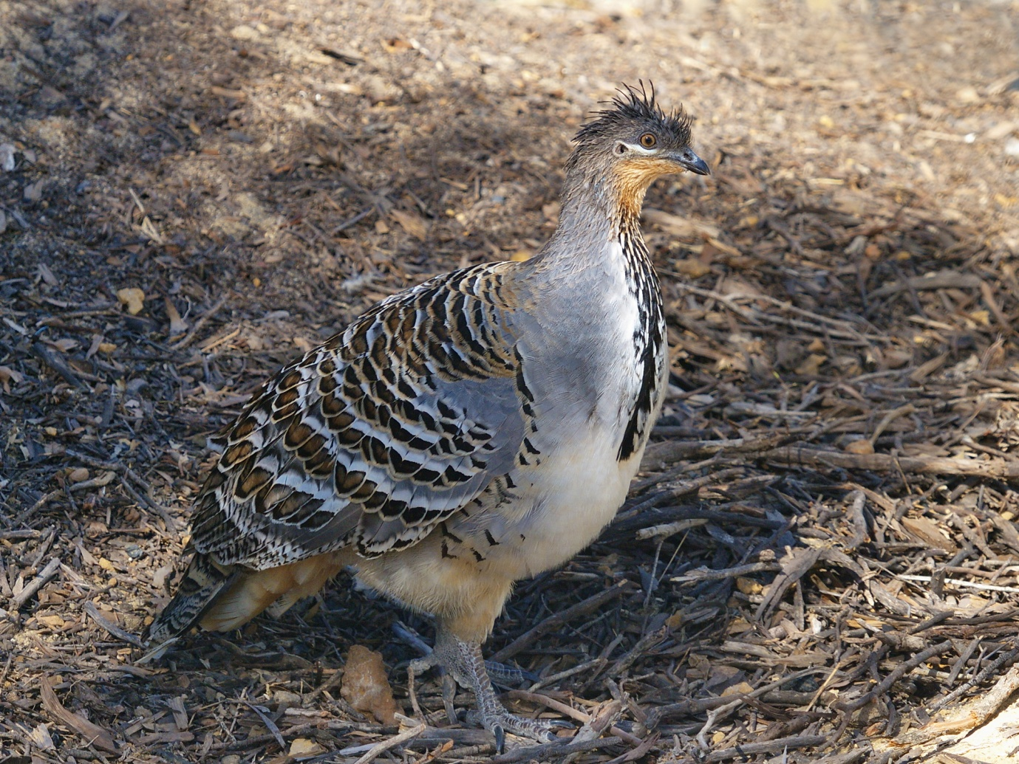

|  |  |
| --- | --- |
| EPBC Status | Vulnerable |
| Found in | All states, except Queensland and Tasmania |
| Main threats | Habitat loss, foxes, feral cats, grazing by introduced animals and fire |
| About | The malleefowl gets its name from its habitat (scrublands and woodlands dominated by mallee and wattle species).This ground-dwelling bird is famous for its ability to build enormous mounds. The male and female mate for life and take months working together to build their nest. The eggs are incubated in sand or soil by the sun or mounds of rotting leaves. While the male continues to patch-up the nest during the incubation, the parents take no part in chick rearing, with chicks emerging from the mound completely self sufficient. |
| Action | The Australian Government is funding over 25 projects through the National Landcare Programme to undertake recovery practices such as pest control and restoring malleefowl habitat. |

*© Alan Danks*

vu

malleefowl

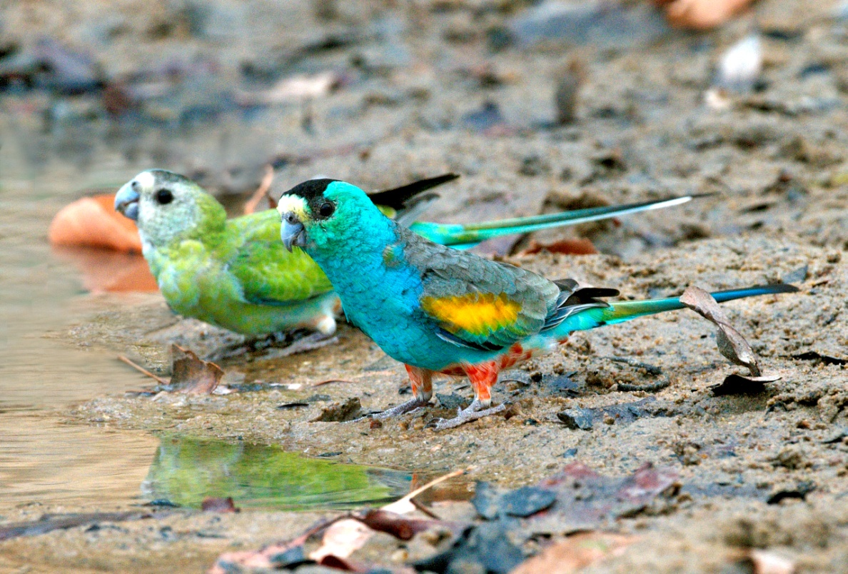

|  |  |
| --- | --- |
| EPBC Status | Endangered |
| Found in | Queensland |
| Main threats | Fire, feral pigs, grazing, illegal trapping, altered land use and feral cats |
| About | The golden-shouldered parrot, or alwal, is a significant cultural species for the Olkola people of Cape York. This brilliantly coloured little parrot lives in tropical savanna woodland, spending much of its time on the ground feeding on grass seeds. Alwal have the unusual habit of nesting in old termite mounds which makes them vulnerable to feral pigs and cats. |
| Action | Actions needed to recover this species include protecting termite mounds and associated foraging habitat, controlling feral pigs and feral cats and implementing suitable burning regimes. The Olkola Aboriginal Corporation, Bush Heritage and landholders are working together with Queensland Parks and Wildlife Service to implement actions from the recovery plan. |

*© Graeme Chapman*

en

golden-shouldered

parrot

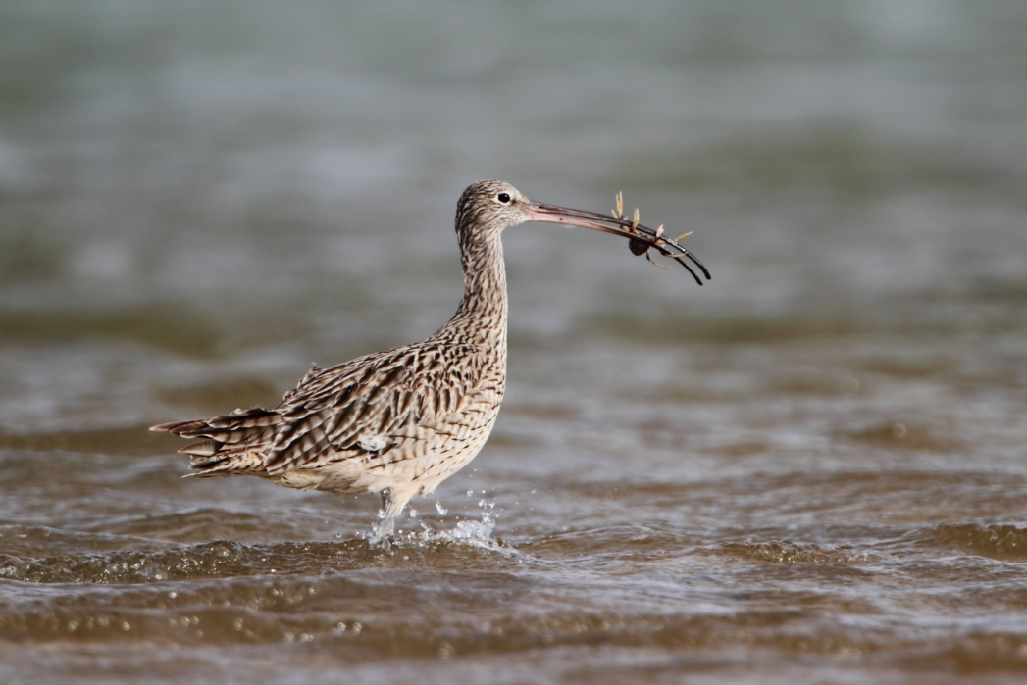

|  |  |
| --- | --- |
| EPBC Status | Critically endangered |
| Found in | Coastal regions across all Australian states and territories |
| Main threats | Human disturbance, habitat loss, degraded water quality and hunting |
| About | The eastern curlew is Australia’s largest shorebird and a long-haul flyer. It is easily recognisable, with its long, down-curved bill. The eastern curlew takes an annual migratory flight to Russia and north-eastern China to breed, arriving back home to Australia in August to feed on crabs and molluscs in intertidal mudflats. It is extremely shy and will take flight at the first sign of danger. |
| Action | The Australia Government plays an important role in building international cooperation to conserve migratory birds and is a member of the East‑Asian – Australasian [Flyway Partnership](http://secure.environment.gov.au/biodiversity/migratory/waterbirds/flyway-partnership/index.html). Five projects are helping to restore eastern curlew habitat through the National Landcare Programme. Actions to protect eastern curlew will benefit many other migratory shorebirds including the bar-tailed godwit. |

*© Dean Ingwersen*

cr

eastern curlew

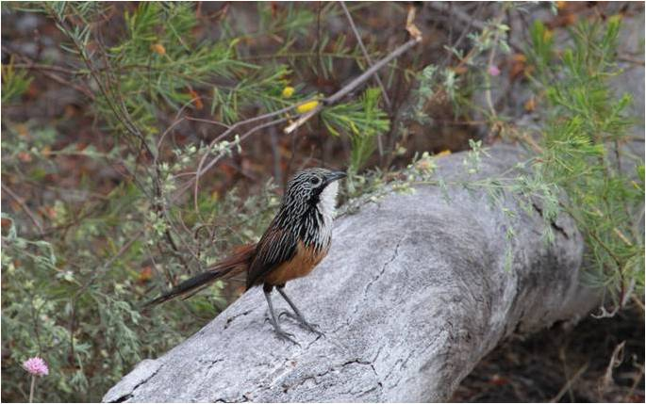

|  |  |
| --- | --- |
| EPBC Status | Vulnerable |
| Found in | Northern Territory |
| Main threats | Fire, weeds, feral cats, feral pigs and climate change |
| About | It’s difficult to catch a glimpse of this small, shy ground-dwelling bird but its distinctive call, a mixture of complex trills and chirps, often gives it away. It lives in spinifex among rocky escarpments and feeds on seeds and insects. White-throated grasswrens hang out in small family groups and are thought to engage in cooperative parenting, where additional adults assist in raising the young. It is known as yirlinkirrkirrin the local Indigenous language. |
| Action | White-throated grasswrens are a priority threatened species in Kakadu National Park. Parks staff are working together with Indigenous Ranger groups to implement traditional fire management programs that enhance habitat quality and to tackle feral cats and pigs in the bird’s habitat. |

*© Peter Cooke*

white-throated

grasswren

vu

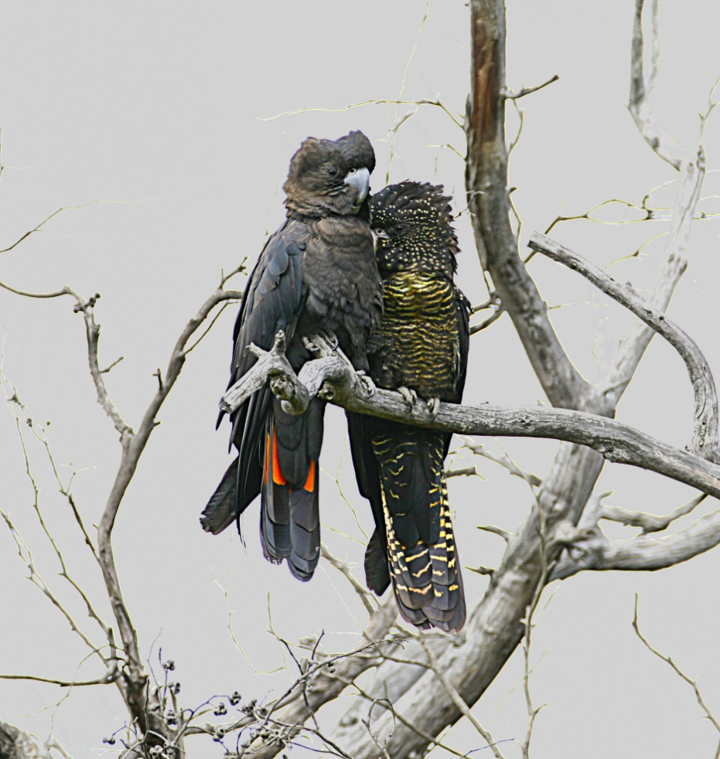

|  |  |
| --- | --- |
| EPBC Status | Endangered |
| Found in | South Australia and Victoria |
| Main threats | Habitat loss and inappropriate fire regimes |
| About | These large iconic birds were the mascot for the 2006 Commonwealth Games in Melbourne. Their glossy black plumage is set off by their stunning red tail feathers. The south-eastern sub-species has an estimated population of just 1000, making it the rarest and most at risk of extinction. Extremely fussy eaters, feeding exclusively on the seeds of stringybark and buloke trees, these birds pair and nest over spring and early summer, laying only one egg in a deep hollow of an old eucalypt tree. Chicks required a lot of parenting and take three months to fledge. They are often fed by their parents for a further six months after fledging. |
| Action | The Australian Government is funding eight projects through the National Landcare Programme. These projects are working to connect and expand habitat for this species. This includes the “Cockies planting trees for Cockies” project which has seen 80 landholders planting food trees on their properties. |

en

*© Bob McPherson*

red-tailed

black cockatoo

south-eastern