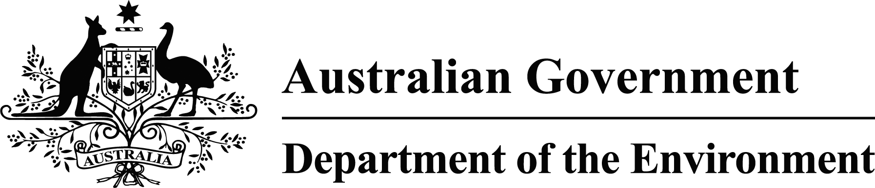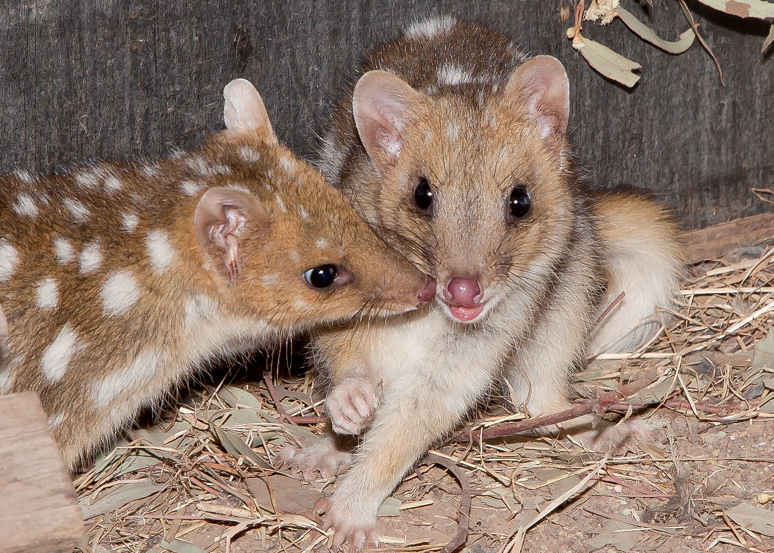

*© Annette Rypalski*

20 mammals by 2020

Australia’s Threatened Species Strategy was launched by Minister for the Environment Greg Hunt MP on the 16 July 2015 at the Threatened Species Summit in Melbourne. The Strategy sets out the Australian Government’s bold, action‑based approach to protecting and recovering our threatened animals and plants. It includes commitments to improve trajectories of 20 threatened mammals by 2020. When launched, the Strategy identified the first 12 mammals for priority conservation:

* Numbat
* Mala
* Mountain pygmy-possum
* Bilby
* Golden bandicoot
* Brush-tailed rabbit-rat
* Eastern bettong
* Western quoll
* Kangaroo Island dunnart
* Eastern barred bandicoot
* Leadbeater’s possum
* Central rock-rat

You can read more about the 12 priority mammals here: <http://environment.gov.au/biodiversity/threatened/publications/factsheet-threatened-species-strategy-action-plan-2015-16-20-mammals-by-2020>

eight more mammals

## The Strategy commits to announcing, in Year 1, the remaining eight priority mammals. Like the original 12, these species were identified by the Office of the Threatened Species Commissioner through consultation with some of Australia’s leading mammals scientists, the Threatened Species Commissioner’s informal advisors, the state and territory governments, key environmental NGOs and the Threatened Species Scientific Committee. Species were considered against the Principles for Prioritisation in the Strategy. The remaining eight priority mammals are:

* Gilbert’s potoroo
* Western ringtail possum
* Black-footed rock-wallaby
* Eastern quoll
* Woylie
* Northern hopping mouse
* Christmas Island flying-fox
* Mahogany glider

meet the 8 mammals

C:\Users\a18512\AppData\Local\Microsoft\Windows\Temporary Internet Files\Content.IE5\JFO3I8LT\Gilberts Potoroo Name To Be Confitmed.tiff

|  |  |
| --- | --- |
| EPBC Status | Critically endangered |
| Found in | Western Australia |
| Main threats | Feral cats, foxes and fire |
| About | Gilbert’s potoroo is the world’s rarest marsupial and one of Australia’s most threatened mammals. It is one of the most fungi dependant mammals in the world and has expensive taste, with truffles from underground fungi making up 90% of its diet. The species was believed to be extinct for more than 50 years until it was rediscovered on Mount Gardner, Two Peoples Bay Nature Reserve, in 1994. It was recently impacted by bush fires at Two Peoples Bay. Today, less than 100 animals exist. |
| Action | The Australian Government is already acting to recover the Gilbert’s potoroo. In partnership with the Western Australian Government, the Australian Government provided $1.7 million towards feral cat control to help protect the species. A $128 000 contribution to a project under the National Environmental Science Programme (NESP) and a Green Army team are also assisting. |

cr

gilbert's potoroo

*© Dick Walker and Gilbert’s Potoroo Action Group*

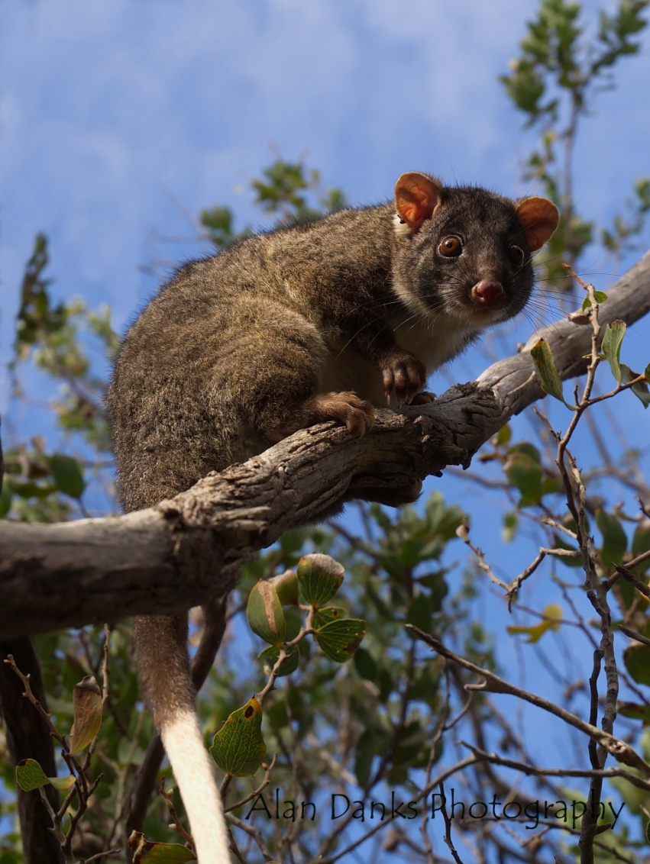

|  |  |
| --- | --- |
| EPBC Status | Vulnerable |
| Found in | Western Australia |
| Main threats | Climate change, foxes, feral cats, fire and habitat loss |
| About | The western ringtail possum is a nocturnal species that roams through the trees at night, feeding on leaves of eucalypt, marri and peppermint trees and other fruits and flowers. It differs from the more frequently seen common brushtail possum by being smaller in size and an exclusive herbivore, whereas brushtail possums will eat small mammals. It has a long, thin tail with a white tip that helps it to move through the trees and carry nesting material. It is only found in the south-west of Western Australia and can thrive in urban gardens that have suitable food trees planted and are free from roaming predators, such as cats. |
| Action | In partnership with the Western Australia Government, the Australian Government has provided $1.7 million towards feral cat control to help protect the species. Two projects under Round 4 of the Green Army Programme are also supporting its recovery. |

*© Alan Danks*

western ringtail

possum

vu

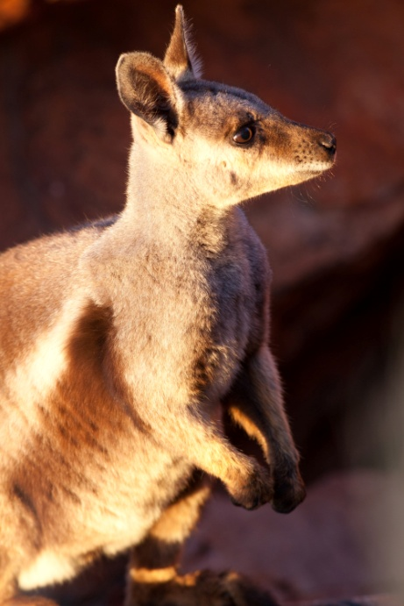

|  |  |
| --- | --- |
| EPBC Status | Vulnerable |
| Found in | Western Australia, Northern Territory and South Australia |
| Main threats | Foxes, feral cats, habitat degradation and fire |
| About | The black-footed rock-wallaby is Australia’s own intrepid mountaineer. It is incredibly agile and bounds across the rough terrain and rocky outcrops it calls home with ease. It is well adapted to life on steep rocks, with very textured feet that help it grip and a long, strong tail to give it balance. Four sub‑species of black-footed rock-wallaby are listed under the EPBC Act and action under the Threatened Species Strategy will focus on improving them all. |
| Action | The Australian Government, in partnership with the Western Australian, South Australian and Northern Territory Governments, has provided $2.27 million towards action to control feral cats in black-footed rock-wallaby habitat. Two projects under Round 4 of the Green Army Programme and two projects under the NESP are supporting its recovery. Australian Government contributions under the NESP are worth $2.8 million. |

vu

black-footed   
rock‑wallaby

*© Peter MacDonald*

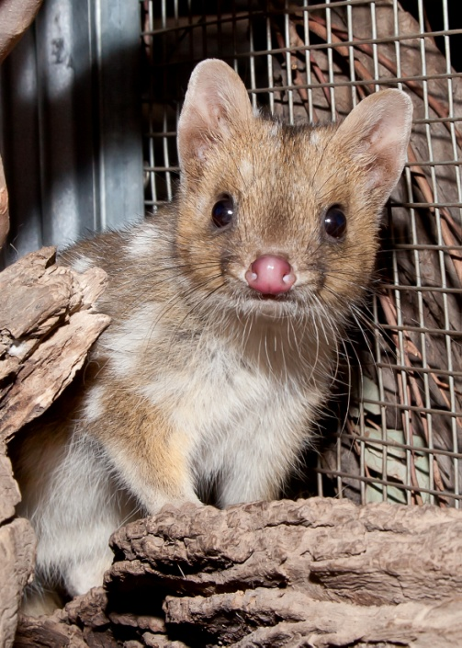

|  |  |
| --- | --- |
| EPBC Status | Endangered |
| Found in | Tasmania |
| Main threats | Feral cats and disease |
| About | The eastern quoll was once widespread across south-eastern Australia. It disappeared from the mainland in the 1960s. Today, it is only found in the wild in Tasmania, but does exist in a mainland safe haven in Victoria. It is mostly solitary and is active at night: hunting for prey such as insects, small mammals, birds and reptiles. Eastern quolls have a thick coat, which can be either fawn or black, with white spots. Both fawn and black young can be born in the same litter. Fawn quolls are much more common. |
| Action | The Australian Government, in partnership with the Australian Capital Territory Government, has contributed $600 000 towards the expansion of a sanctuary that with act as another safe haven for the species on the mainland. The NESP is supporting recovery of the eastern quoll with a contribution of $1.2 million towards a project to improve knowledge on the species. |

*© Annette Rypalski*

en

eastern quoll

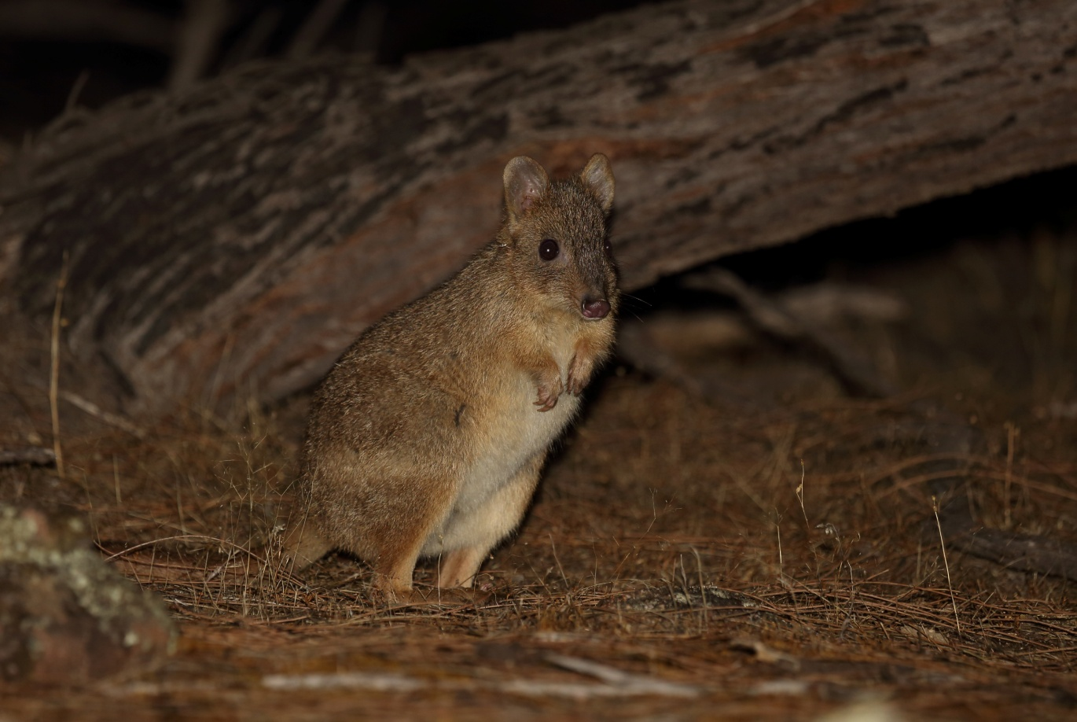

|  |  |
| --- | --- |
| EPBC Status | Endangered |
| Found in | Western Australia, South Australia and New South Wales |
| Main threats | Feral cats, foxes and fire |
| About | The woylie, or brush-tailed bettong, is a small member of the marsupial family, weighing up to 2kg. Like many other Australian mammals, it is nocturnal and spends its nights looking for food. It has a talented tail and uses it to bundle up long grass, bark and twigs for its nest. The woylie population has reduced by more than 90% over the past 15 years. |
| Action | In partnership with the Western Australian Government, the Australian Government has provided $1.7 million towards feral cat control to help protect the species. The Australian Government has invested $100 000 towards development of new technology to control feral cats and protect the woylie: the feral cat grooming trap. The NESP is assisting the recovery of the woylie with a contribution of $1.6 million towards a project to benefit the species. |

woylie

en

*© Rob McLean*

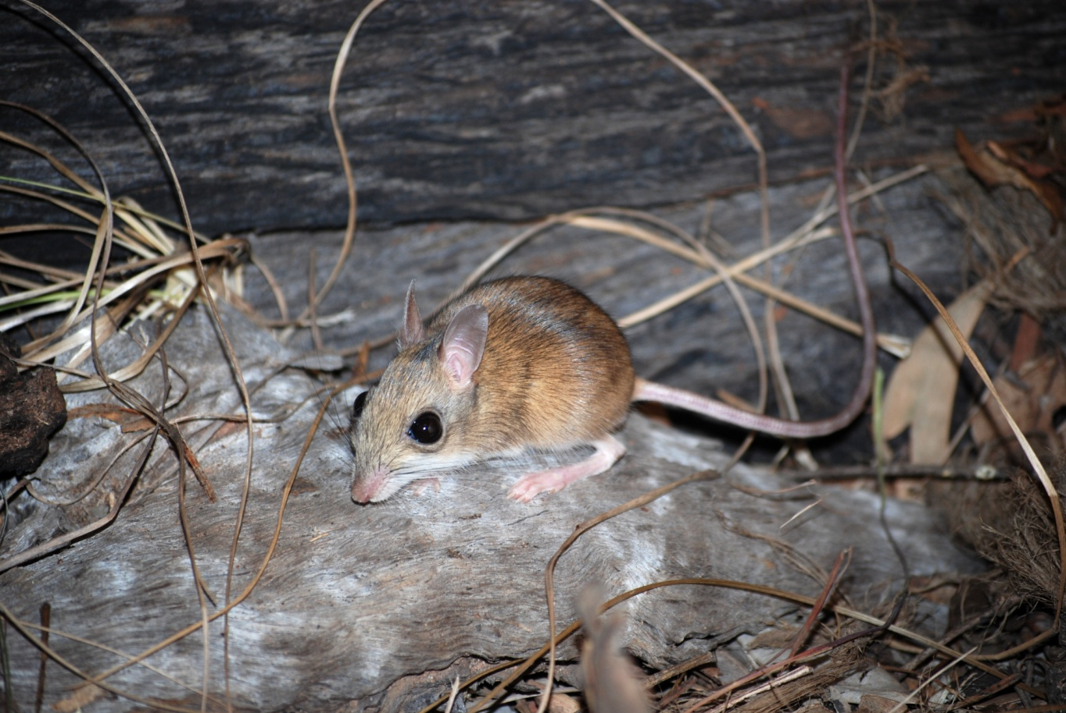

|  |  |
| --- | --- |
| EPBC Status | Vulnerable |
| Found in | Northern Territory |
| Main threats | Feral cats and fire |
| About | The northern hopping mouse is a small, shy native rodent with large eyes and an amazing talent for building burrows. Females dig out complex burrows up to five metres long. It is a grand architect and expertly constructs multiple hidden entry and exits holes that provide escape routes and a source of confusion for predators. Despite being a rodent, the northern hopping mouse lives up to its name by standing up and hopping around on its two hind legs, like a tiny kangaroo. It also has an extremely long tail that can be up to 1.5 times its body length. |
| Action | The Australian Government has provided $235 000, in partnership with the Northern Territory Government, to begin feral cat eradication from Groote Eylandt with the goal of turning the island into a safe haven for the northern hopping mouse. |

*© Rebecca Diete*

vu

northern hopping

mouse

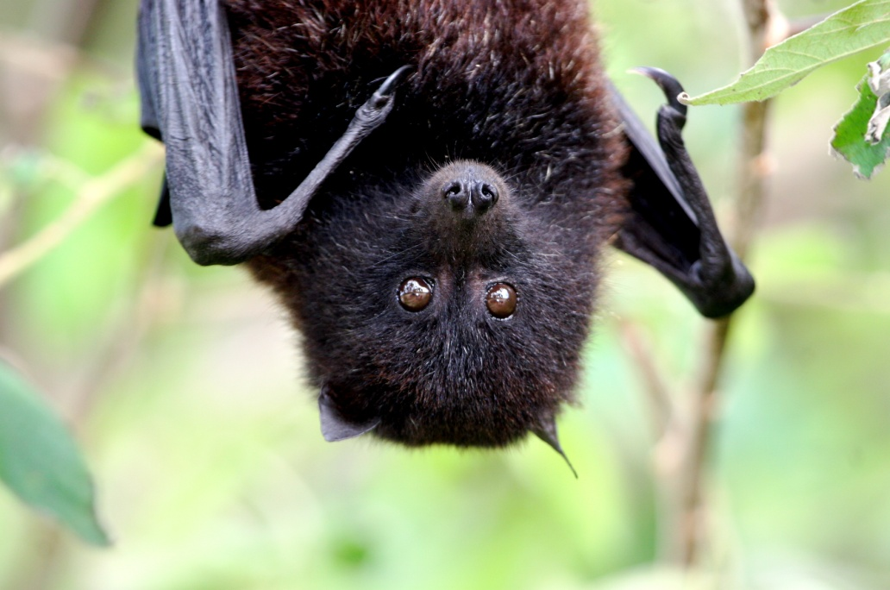

|  |  |
| --- | --- |
| EPBC Status | Critically endangered |
| Found in | Christmas Island |
| Main threats | Feral cats, disease and yellow crazy ants |
| About | The Christmas Island flying-fox is thought to be the last remaining native mammal on Christmas Island. It has undergone a steady decline since feral species arrive there. Today it roosts at only two main camps, in large, communal groups, down from the seven it used just a few years ago. The Christmas Island flying-fox is unique from other bats in that it is active during the day and can sometimes be seen flying and foraging in the mid-afternoon. It feeds on a wide variety of fruit and nectar, including coconut palms. |
| Action | The Australian Government, through Parks Australia, has contributed $500 000 towards eradication of feral cats on Christmas Island. This project is also tackling rats and crazy ants. The NESP is supporting the recovery of the flying‑fox with a contribution of $1.7 million towards two projects that it. |

cr

christmas island

flying‑fox

*© Inger Vandyke*

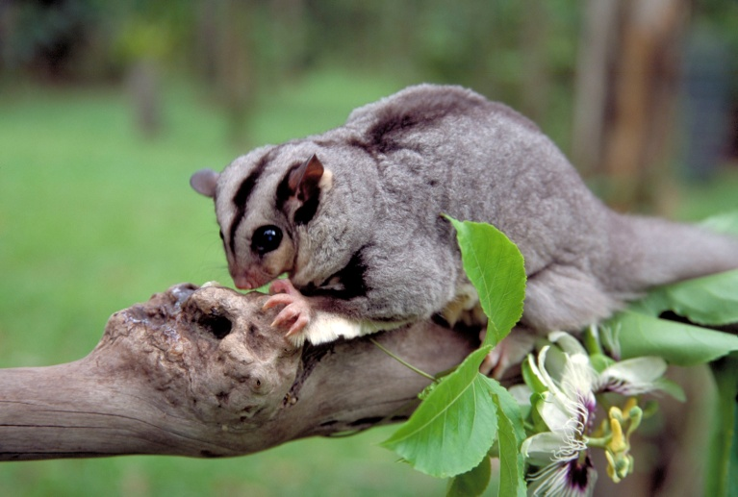

|  |  |
| --- | --- |
| EPBC Status | Endangered |
| Found in | Queensland |
| Main threats | Habitat loss and degradation, fire and entanglement in fencing |
| About | The mahogany glider is only found in a narrow 122km long strip of the southern Wet Tropics of north Queensland. It soars through the open forests and woodlands, using a membrane that extends from its wrist to its ankle, and can travel up to 60m in one glide. The glider prefers open forests as the habitat allows for uninterrupted gliding paths between trees. The species was first recorded in the 1880s, but disappeared until it was rediscovered and formally named almost 100 years later, in 1989. The habitat of the mahogany glider was significantly impacted by Tropical Cyclone Yasi in 2011 and work is continuing to repair the damage, including setting up nest boxes. |
| Action | The Australian Government is acting to recover the mahogany glider and has provided $30 000 toward connecting habitat to link isolated populations of gliders. Two projects under the Green Army Programme are supporting its recovery. |

en

mahogany glider

*© Wet Tropics Management Authority - QLD*

*© Annette Rypalski*