May 2026

NEXDOC

Certification for importers and exporters – FAQs

Why is the Australian Government updating its export certification system?
The Department of Agriculture, Fisheries and Forestry is upgrading its certification system, ensuring it is streamlined and adaptable to meet future needs. The new system is called the Next Export Documentation (NEXDOC) System, and it includes enhanced certification features.
What changes are there to the certification?
The new certificates contain unique Quick Response (QR) codes. The QR codes provide consignment specific information that border officials can use to confirm the authenticity of a certificate in real-time.

This feature means that the blue security paper will no longer be required, and all NEXDOC issued certificates will be issued on plain paper.
Following the transition to NEXDOC, some products will continue to require manual certification. This certification will be progressively transitioned to NEXDOC in stages after the initial implementation date.
For information on which certificates are transitioning, MICOR will be updated accordingly. For queries, please contact nexdoc@aff.gov.au
To verify the QR code, border officials scan the code through their smart phone camera. More detailed instructions are below.

Verifying certificates using the QR code
Step 1. Certificate presented at port and official wishes to validate authenticity.  Step 2. Official can use smart phone camera to scan code. | 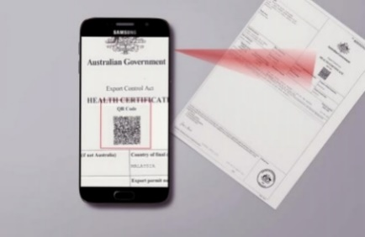
Step 3. Important certificate information is displayed and can be matched to document. | 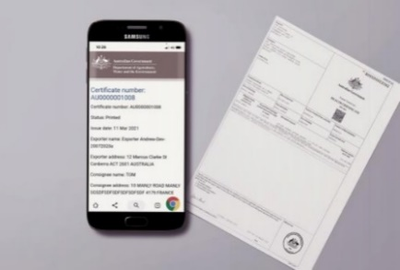
Step 4. The web address will confirm the certificate’s authenticity.  https://api.agriculture.gov.au/ | 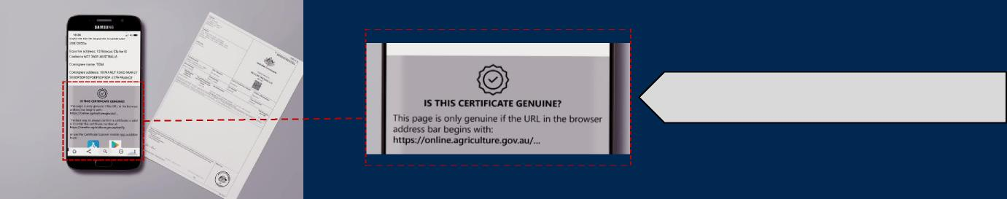
When will NEXDOC be implemented?
NEXDOC is being released incrementally by commodity. Currently Dairy, Eggs, Fish, Wool, Skins, Hides, Animal by-products, Other Goods and some Honey product certification is being issued through NEXDOC.
Have importing countries been notified of the changes?
The department works closely with importing countries ahead of the release of NEXDOC certificates. Depending on the structure of the release, this can include direct correspondence to the importing countries including copies of the NEXDOC certificates as well as World Trade Organisation notifications.
The department is also working with importing countries on transition requirements for certification issued in the previous system. Advice on this will be issued via Meat notices - DAFF

How can you help?
Despite the department’s best efforts, some border officials may not be aware of the transition to NEXDOC certificates. You can assist by working with your importer to make them aware of the NEXDOC certificates using points from this communication and the published Industry Advice Notices.

