January 2026

Climate-related financial disclosures: what does it mean for farm businesses?
Contents
Summary ii
Climate-related financial disclosures decision tree ii
Introduction 1
What are climate-related financial disclosures? 1
Why are climate-related financial disclosures now mandatory? 1
Climate-related risks impact financial performance of businesses 1
Are only large businesses required to prepare a sustainability report? 2
When do the new disclosure requirements commence? 2
How will greenhouse gas emissions be reported? 3
What are scope 1, 2 and 3 emissions? 3
Scope 1 – Direct emissions 3
Scope 2 – Indirect energy emissions 3
Scope 3 – Value chain emissions (upstream and downstream) 4
Implications for farm businesses 4
How do I know if the reporting requirements apply directly to my farm business? 4
For sole traders, partnerships and trusts 4
For companies 4
Will the reporting requirements apply indirectly to my farm business? 5
What should I do if I am asked to provide farm-level emissions data under the new requirements? 5
Am I obligated to provide farm-level data? 5
Other commercial considerations 5
What tools can I use to estimate on-farm emissions? 6
What practical insights can farmers gain from sustainability reports? 6
How do I benefit from ‘knowing my number’? 7
Where can I access professional advice? 7

Summary
Public companies are already required to disclose material information about financial risks to their business as part of their annual and continuous disclosure obligations under the Corporations Act 2001.
Many large companies had already started disclosing their climate risks and opportunities in response to demands from their investors.
In 2024, Australia introduced requirements for large businesses and financial institutions to disclose material information on climate-related financial risks and opportunities.
These disclosures must be contained in a ‘sustainability report’ and lodged with the Australian Securities and Investments Commission (ASIC) as part of the annual reports. Investors and others who rely on financial reports can use this information to support their decisions.
The new requirements are being phased-in over three years. They have already commenced for the largest entities for the financial years beginning on or after 1 January 2025.
ASIC has published a regulatory guide alongside a host of information on sustainability reporting requirements on their website. This information may assist business owners and other stakeholders that wish to learn more about the new requirements.
Businesses that do not have to lodge an annual financial report with ASIC under Chapter 2M of the Corporations Act are not required to prepare a sustainability report.
This means that the vast majority of Australian farmers will not have any direct legal obligations under the climate-related financial disclosure rules.
Farmers are however asking questions about the requirement for scope 3 emissions reporting in climate-related financial disclosures. Scope 3 greenhouse gas emissions are those that occur in the value chain of an entity, such as emissions associated with purchased goods.
Reporting entities are permitted to estimate scope 3 emissions using industry averages or secondary data. In some cases, reporting entities may choose to request ‘primary data’ from entities in the value chain to help develop estimates.
If a farmer is asked for information to support scope 3 emissions reporting under the new requirements, they can note that the use of farm-level data is not mandatory. They can also ask whether the customer or supplier has considered using industry averages or secondary data.

Climate-related financial disclosures decision tree
Following the steps in the decision tree (Figure 1) may help you understand what the climate-related financial disclosures regime could mean for you and your farming business. This focuses only on the reporting thresholds for companies (including any consolidated subsidiaries). For the complete list of reporting thresholds, refer to ASIC’s Regulatory Guide 280 sustainability reporting.
Figure 1 climate-related financial disclosures decision tree
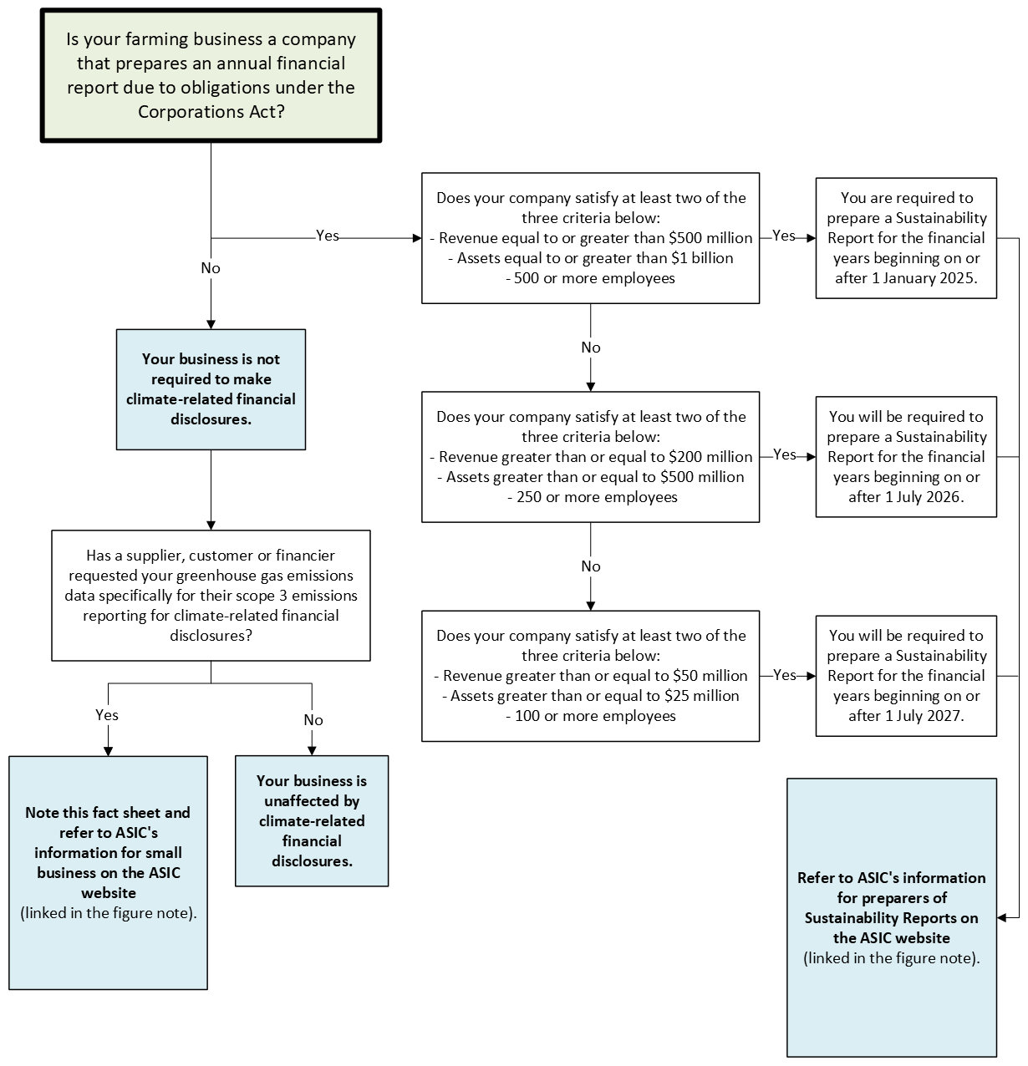
Note: This fact sheet includes general information that is focused on small-to-medium sized businesses. This fact sheet draws on ASIC’s guidance for small business. As a small-to-medium sized business, you may also choose to obtain your own advice about the new sustainability reporting requirements, and how they may impact you. Larger businesses, and any entities captured by the mandatory climate-related financial disclosure regime, should refer to ASIC’s regulatory guide. If your business is or will be required to prepare a sustainability report, you may refer to ASIC’s information for preparers of sustainability reports.

Introduction

What are climate-related financial disclosures?
Climate-related financial disclosures refer to information about an entity’s climate-related risks and opportunities.
The information explains how climate risks and opportunities are managed and measured to investors, regulators and other stakeholders. This includes disclosures about an entity’s governance, strategy, risk management, and metrics and targets (such as emissions) that affect its financial performance and future prospects.
Internationally, there is an increasing focus on the quality and standardisation of climate-related financial disclosures. Australia has contributed to the development of global standards since the establishment of the Task Force on Climate-related Financial Disclosures in 2015 and, more recently, the International Sustainability Standards Board in 2021.
More information is available on ASIC’s sustainability reporting page.

Why are climate-related financial disclosures now mandatory?
Public companies are already required to disclose material information about financial risks to their business as part of their annual and continuous disclosure obligations under the Corporations Act.
Many large companies had already started disclosing their climate risks and opportunities in response to demands from their investors.
In 2024, Australia introduced mandatory climate-related financial disclosures for some companies. This will require certain entities to prepare a sustainability report alongside annual financial statements. The introduction of standardised reporting clarifies how disclosures apply for the purpose of climate-related risks.
The new requirements in Australia reflect similar changes underway in many other countries. Climate-related financial disclosures aim to improve the quality of information available for decision making to help keep Australia an attractive place to invest.
Mandatory climate-related financial disclosures will:
- help investors and stakeholders understand which companies are most exposed to climate risks and opportunities and how they are responding
- standardise information disclosed by companies to enable readers to compare them
- provide material information on the climate-related financial risks and opportunities that can inform investor decision making
- enable international comparability by aligning Australia’s reporting requirements with international standards
- give greater transparency over the emissions footprint of large companies and any targets they may have to reduce them.

Climate-related risks impact financial performance of businesses
Businesses that operate in the Australian and global agri-food supply chain may be particularly exposed to climate-related risks.
Climate-related physical risks (such as natural disasters, droughts and heatwaves) and climate-related transition risks (such as technology disruption, changing consumer preferences and shifts in export markets) could impact many aspects of an entity’s financial performance. Material information should be disclosed to investors and stakeholders, including on business assets, liabilities, cash flows, operating models and longer-term strategies.
Further information about climate-related risks in Australia – including for Australia’s agriculture, fisheries and forestry sector – can be found in Australia's National Climate Risk Assessment.

Are only large businesses required to prepare a sustainability report?
Yes. Only those businesses that are required to lodge an annual financial report with ASIC under Chapter 2M of the Corporations Act and meet additional size or emission thresholds will be required to prepare a sustainability report.
This means that the vast majority of Australian farmers will not have any direct legal obligations under the climate-related financial disclosure rules.
The Australian Securities and Investments Commission (ASIC) administers the mandatory sustainability reporting obligations. ASIC has published a regulatory guide alongside a host of information on sustainability reporting requirements. This may help businesses that are seeking further information about the new requirements.

When do the new disclosure requirements commence?
The new disclosure requirements are being phased-in over three years according to the size of the reporting entity. Reporting entities will be required to report on scope 3 emissions in their second year of reporting.
Table 1 groups and timing for climate disclosures
Group | Satisfies at least two out of the following three criteria | Begins reporting
Group 1 | - Revenue equal to or greater than $500 million  - Assets equal to or greater than $1 billion  - 500 employees or more | Financial years beginning on or between 1 January 2025 to 30 June 2026.  Reports lodged from 2026.
Group 2 | - Revenue equal to or greater than $200 million  - Assets equal to or greater than $500 million  - 250 or more employees | Financial years beginning on or between 1 July 2026 to 30 June 2027. Reports lodged from 2027.
Group 3 | - Revenue equal to or greater than $50 million  - Assets equal to or greater than $25 million  - 100 or more employees | Financial years beginning on or from 1 July 2027. Reports lodged from 2028.
Note: this table is designed to support small businesses to better understand the size thresholds, however it does not include all reporting entities and thresholds. Large businesses, financial institutions and entities reporting under the National Greenhouse Energy Reporting Act 2017 should refer to ASIC’s Regulatory Guide 280: sustainability reporting where the grouping and phasing of requirements are described in full.

How will greenhouse gas emissions be reported?
The Australian Sustainability Reporting Standards on Climate-related Disclosures (also referred to as AASB S2) includes disclosure requirements on climate-related metrics and targets. These align with international reporting standards by requiring material information relating to:
- a company’s scope 1, 2 and 3 greenhouse gas emissions
- any quantitative and qualitative climate-related targets a company has set and progress towards these targets
- the amount of assets or business activities vulnerable to physical and transitional climate risks or aligned to climate-related opportunities, and the amount of capital deployed towards them.
Reporting on emissions and any targets is relevant to climate risk disclosure because it:
- helps to quantify transition risks and signals preparedness for the net zero transition
- provides capital markets with information to price transition risks into valuations and inform lending decisions
- provides transparency over ambitions and progress and how they link to corporate governance and executive performance
- enables comparison and scenario analysis by banks, insurers, rating agencies and government.
Further information about climate-related financial disclosure requirements, including metrics and targets, is available in the AASB S2 Climate-related Disclosures Standard.

What are scope 1, 2 and 3 emissions?
Greenhouse gas emissions are categorised into three ‘scopes’ to ensure everyone accounts for and reports emissions on the same basis.
Since 2009, companies that have large scope 1 and 2 emissions or are large energy consumers or producers are required to report under the National Greenhouse and Energy Reporting (NGER) Scheme administered by the Clean Energy Regulator.

Scope 1 – Direct emissions
Direct greenhouse gas emissions that occur from sources that are owned or controlled by an entity.
Example:
For a food processor, scope 1 emissions would include emissions from boilers, refrigeration gases and company trucks.
Large companies are already required to report scope 1 emissions through the National Greenhouse and Energy Reporting (NGER) Scheme administered by the Clean Energy Regulator.

Scope 2 – Indirect energy emissions
Indirect greenhouse gas emissions from the generation of purchased or acquired electricity, steam, heating or cooling consumed by an entity.
Example:
The embedded emissions in a supermarket’s electricity bills.
Large companies are already required to report scope 2 emissions through the National Greenhouse and Energy Reporting (NGER) Scheme administered by the Clean Energy Regulator.

Scope 3 – Value chain emissions (upstream and downstream)
Indirect greenhouse gas emissions (not included in scope 2 greenhouse gas emissions) that occur in the value chain of an entity. This includes both upstream and downstream emissions, such as what a business buys, sells or finances.
Examples:
For businesses like supermarkets and food manufacturers, scope 3 emissions may include emissions associated with:
- the production of food and products they buy from farms and suppliers
- the transportation, processing, packaging, and storage of products after purchase
- the waste generated from their operations and products
- other purchased goods and services
- business travel and employee commuting.
For banks, scope 3 emissions include financed emissions – these are the emissions generated by the projects and activities the bank finances through loans and investments.

Implications for farm businesses

How do I know if the reporting requirements apply directly to my farm business?
The vast majority of Australian farmers will not have any direct legal obligations under the climate-related financial disclosure rules.
Only those businesses that are required to lodge an annual financial report with ASIC under Chapter 2M of the Corporations Act and meet size or emission thresholds will be required to prepare a sustainability report (Table 1). These obligations are being phased in over three years.

For sole traders, partnerships and trusts
If you operate your farming business as a sole trader or through a partnership or trust, the sustainability reporting requirements will not directly apply to you.

For companies
The new reporting requirements will not directly apply to small-to-medium sized businesses, as these businesses are not required to lodge an annual financial report with ASIC under Chapter 2M of the Corporations Act.
If you operate your farming business using a company structure, these reporting requirements will only apply to you if your company (including any consolidated subsidiaries) satisfies at least two of the following criteria at the end of the financial year:
- the company has earned revenue of $50 million or more
- the company has assets of $25 million or more
- the company has 100 or more employees.
The decision tree (Figure 1) may also help you determine if and how the new requirements apply to your business.
If your company meets two or more of these criteria you should consider the information on ASIC’s sustainability reporting page, which explains how and when the new requirements apply in addition to existing corporate annual reporting requirements.

Will the reporting requirements apply indirectly to my farm business?
The new reporting rules do not require large businesses or financial institutions to collect farm-level data from their suppliers and customers to meet the reporting requirements.
Reporting entities are allowed to use industry averages and secondary data to estimate and disclose scope 3 emissions. Scope 3 emissions may also be estimated via data collected from entities in the value chain (‘primary data’).

What should I do if I am asked to provide farm-level emissions data under the new requirements?
Many of Australia’s largest companies already make climate-related financial disclosures and have been doing so for many years on a voluntary basis. This has included large companies – such as supermarkets and food companies – estimating scope 3 emissions drawing on industry average data.
Sometimes companies have estimated their scope 3 emissions using a sample of farm businesses that have participated in a voluntary program.
The Australian Sustainability Reporting Standards on Climate-related Disclosures enable secondary data (such as industry average data) to be used by reporting entities to estimate scope 3 emissions.
Farm-level data is not a requirement for reporting entities to estimate scope 3 emissions.
If you are asked by a customer or supplier for farm-level data to support their climate-related financial disclosures, you may wish to:
- note that farm-level data is not required for scope 3 reporting as part of climate-related financial disclosures
- ask whether the customer or supplier has considered using secondary data (such as industry averages) instead of farm-level data
- clarify with the customer or supplier the type of documents or records they are seeking from you.

Am I obligated to provide farm-level data?
No. There is no legislative or regulatory requirement to provide farm-level data to another entity that does meet the reporting thresholds. The other entity is able to use secondary data (such as publicly available industry-level estimates) to comply with the Australian Sustainability Reporting Standards.
If your farm business is a large company that meets the reporting thresholds (refer here), you will need to consider AASB S2 and ASIC’s regulatory guidance to understand your reporting obligations.

Other commercial considerations
While Australia’s legislative arrangements underpinning climate-related financial disclosures have been designed to minimise the cost or burden of reporting scope 3 emissions, there may be other commercial reasons a company may request farm-level data. Often in these instances, farm-level data is aggregated across a larger group of producers.
Examples of these commercial arrangements may include:
- industry certification schemes or brand commitments that include claims around emissions
- emissions targets set by companies in the domestic or global supply chain that require emissions data from suppliers
- sustainability-linked loans and access to finance that include emissions-related criteria
- industry sustainability programs that track progress against a range of environmental, social and governance criteria, including emissions
- gaining a competitive advantage – including in export markets – where lower emissions credentials for a food and fibre product may be commercially advantageous.
A number of industry organisations, large companies and financial institutions in the agri-food supply chain have programs and initiatives to support farm businesses to estimate farm-level emissions. These are sometimes part of broader training programs offered to farmers.
Some businesses have set voluntary emissions reduction targets, including for their scope 3 emissions. Reporting emissions reduction against these targets over time may require specific data, such as farm-level data.
Even before climate-related financial disclosures were made mandatory, some businesses estimated their scope 3 emissions based on a sample of farmers who were interested or incentivised to opt-in to voluntary programs. In other cases, businesses have focussed on their largest suppliers or customers to estimate their scope 3 emissions.

What tools can I use to estimate on-farm emissions?
Australia’s agriculture industry has been investing in technologies and practices needed to understand their emissions and manage climate risk for many years. There are several industry-led calculators available to farmers to calculate greenhouse gas emissions for a range of commodities, including beef, sheep, grains, cotton, pork, poultry, eggs and sugar. A number of software developers have built add-ons for common accounting platforms to support emissions reporting using existing data.
The Department of Climate Change, Energy, the Environment and Water (DCCEEW) is developing voluntary emissions estimation and reporting guidelines for the agriculture, fisheries and forestry industries to improve the quality and consistency of greenhouse gas estimation methods and the various tools used by the industry. For more information on the guidelines visit DCCEEW’s Voluntary emissions estimation and reporting standards webpage.
The Government is providing $6.4 million to Agricultural Innovation Australia (AIA), in partnership with the Zero Net Emissions Agriculture CRC, to help greenhouse gas calculators and accounting tools align with the voluntary guidelines. This will improve the consistency of calculators, give farmers greater confidence in their business’ emissions profile and help inform their actions to reduce on-farm emissions. For more information on the funding to AIA, visit the Department of Agriculture, Fisheries and Forestry’s Improving Consistency of On-farm Emissions Estimates Program webpage.
The Carbon Farming Outreach Program is also supporting Australian farmers and land managers to understand and manage their emissions.

What practical insights can farmers gain from sustainability reports?
Your farming business may be able to use these reports to better understand the approach larger customers, suppliers and competitors are taking to climate change.
For example, you may be able to see:
- how your insurance company is positioned to respond to extreme weather events and how this could impact your future insurance arrangements
- the climate-related risks and resilience of an important customer, supplier or key piece of infrastructure your farming business relies on. This information might help you take steps to build a more resilient business
- the climate-related opportunities being pursued by large businesses and financial institutions, which may create opportunities for small business to generate new income streams
- any potential longer-term structural changes in the industry in which you operate, providing information to help you to ‘future-proof’ your farming business.
A number of companies and financial institutions in the agri-food sector have programs and initiatives in place to support farmers estimate and understand their on-farm emissions.

How do I benefit from ‘knowing my number’?
Knowing and understanding the emissions profile of your business is a fundamental first step to managing emissions. ‘Knowing your number’ allows farmers to build a connected picture of production emissions, carbon storage and energy use. This information allows you to make informed business decisions. For example, a producer that has a lower emissions intensity of production may be well-placed to negotiate preferential supply contracts and lower cost finance.

Where can I access professional advice?
Your accountant, tax agent or other professional advisor may be able to provide you with some information on the likelihood of your farming business crossing into a reporting threshold in the future and, if so, what it means for you and your business.
If your farming business is large enough to meet the threshold for mandatory climate-related financial reporting, you will already be preparing and lodging a financial report with ASIC. These reports are generally prepared by the company’s accountant or tax agent.
Figure 1 may also help you understand how the sustainability report regime (incorporating climate-related financial disclosures) might apply to your business.

Acknowledgement of Country
We acknowledge the continuous connection of First Nations Traditional Owners and Custodians to the lands, seas and waters of Australia. We recognise their care for and cultivation of Country. We pay respect to Elders past and present, and recognise their knowledge and contribution to the productivity, innovation and sustainability of Australia’s agriculture, fisheries and forestry industries.
© Commonwealth of Australia 2025
Unless otherwise noted, copyright (and any other intellectual property rights) in this publication is owned by the Commonwealth of Australia (referred to as the Commonwealth).
All material in this publication is licensed under a Creative Commons Attribution 4.0 International Licence except content supplied by third parties, logos and the Commonwealth Coat of Arms.
The Australian Government acting through the Department of Agriculture, Fisheries and Forestry has exercised due care and skill in preparing and compiling the information and data in this publication. Notwithstanding, the Department of Agriculture, Fisheries and Forestry, its employees and advisers disclaim all liability, including liability for negligence and for any loss, damage, injury, expense or cost incurred by any person as a result of accessing, using or relying on any of the information or data in this publication to the maximum extent permitted by law.

