Future Drought Fund Annual Report 2021–22

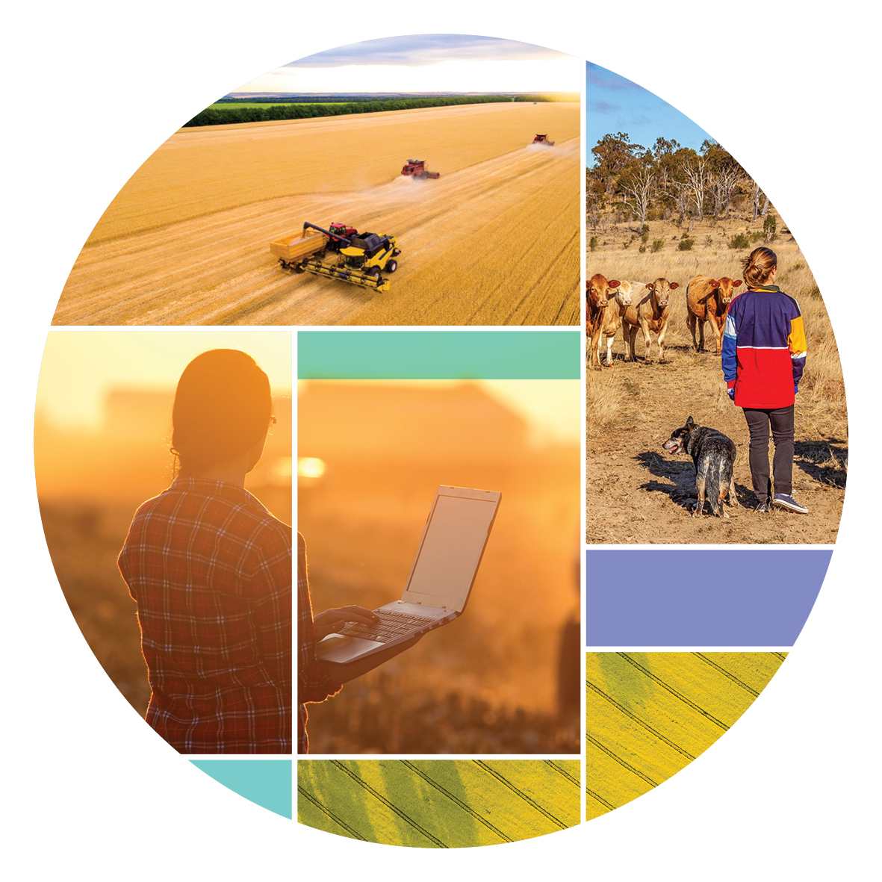
November 2022
© Commonwealth of Australia 2022
Ownership of intellectual property rights
Unless otherwise noted, copyright (and any other intellectual property rights) in this publication is owned by the Commonwealth of Australia (referred to as the Commonwealth).
Creative Commons licence
All material in this publication is licensed under a Creative Commons Attribution 4.0 International Licence except content supplied by third parties, logos and the Commonwealth Coat of Arms.
Inquiries about the licence and any use of this document should be emailed to copyright@awe.gov.au.

Cataloguing data
This publication (and any material sourced from it) should be attributed as: Future Drought Fund Annual Report 2021-22 Department of Agriculture, Fisheries and Forestry, Canberra, November 2022. CC BY 4.0.
This publication is available at agriculture.gov.au/publications.
Department of Agriculture, Fisheries and Forestry
GPO Box 858 Canberra ACT 2601
Telephone 1800 900 090
Web agriculture.gov.au
Contact Us
Email droughtresilience@agriculture.gov.au
Web https://haveyoursay.agriculture.gov.au/future-drought-fund
Disclaimer
The Australian Government acting through the Department of Agriculture, Fisheries and Forestry has exercised due care and skill in preparing and compiling the information and data in this publication. Notwithstanding, the Department of Agriculture, Fisheries and Forestry, its employees and advisers disclaim all liability, including liability for negligence and for any loss, damage, injury, expense or cost incurred by any person as a result of accessing, using or relying on any of the information or data in this publication to the maximum extent permitted by law.
Acknowledgements
The authors thank interview and case study participants for their input and ongoing engagement with the Future Drought Fund. The FDF would also like to acknowledge our diverse range of key stakeholder for their enduring support.
Acknowledgement of Country
We acknowledge the Traditional Custodians of Australia and their continuing connection to land and sea, waters, environment, and community. We pay our respects to the Traditional Custodians of the lands we live and work on, their culture, and their Elders past and present.
Printed on 100% recycled paper.

Minister's Message
Australian agriculture is currently a thriving and resilient sector but achieving that requires effective management of the many risks facing our farmers.
Our farmers have long faced the harsh cycle of extreme drought and extreme rainfall.
Currently, we are experiencing a La Nina event, but inevitably there will be another drought.
We also know that the changing climate is likely to mean more frequent, longer lasting, and intense droughts. We can't have a resilient agriculture sector and thriving regional communities without managing this reality of Australia's changing climate.
This is why the Future Drought Fund is so important. It supports proactive efforts to build preparedness and resilience to inevitable future droughts - and by extension, to the changing climate.
Having recently been appointed as the Minister for Agriculture, Fisheries and Forestry, it's been pleasing to see the work being done under the Future Drought Fund - as set out in this Annual Report.
It shows growing momentum and activity, with an increasing number of farmers, regions and communities building drought resilience. Importantly, they are being supported to find solutions that work for their particular context.
We will soon kick off a review of the Fund, as required under its legislation. We'll use it to talk with people to understand what we've learnt from this first phase and to help shape a second Funding Plan to set the future direction of this Fund.
I'm pleased to see that our work under the Future Drought Fund is underpinned by strong partnerships. State and territory governments, farmers, rural communities, First Nations people, the agricultural and finance industries, and the not-for-profit sector know they share the responsibility to build Australia's capacity to withstand drought.
I welcome the time, resources, and expertise they have committed so far, and will in turn commit to working closely with all involved. We will achieve more together than any one of us can alone.


Senator the Hon Murray Watt
Minister for Agriculture, Fisheries and Forestry
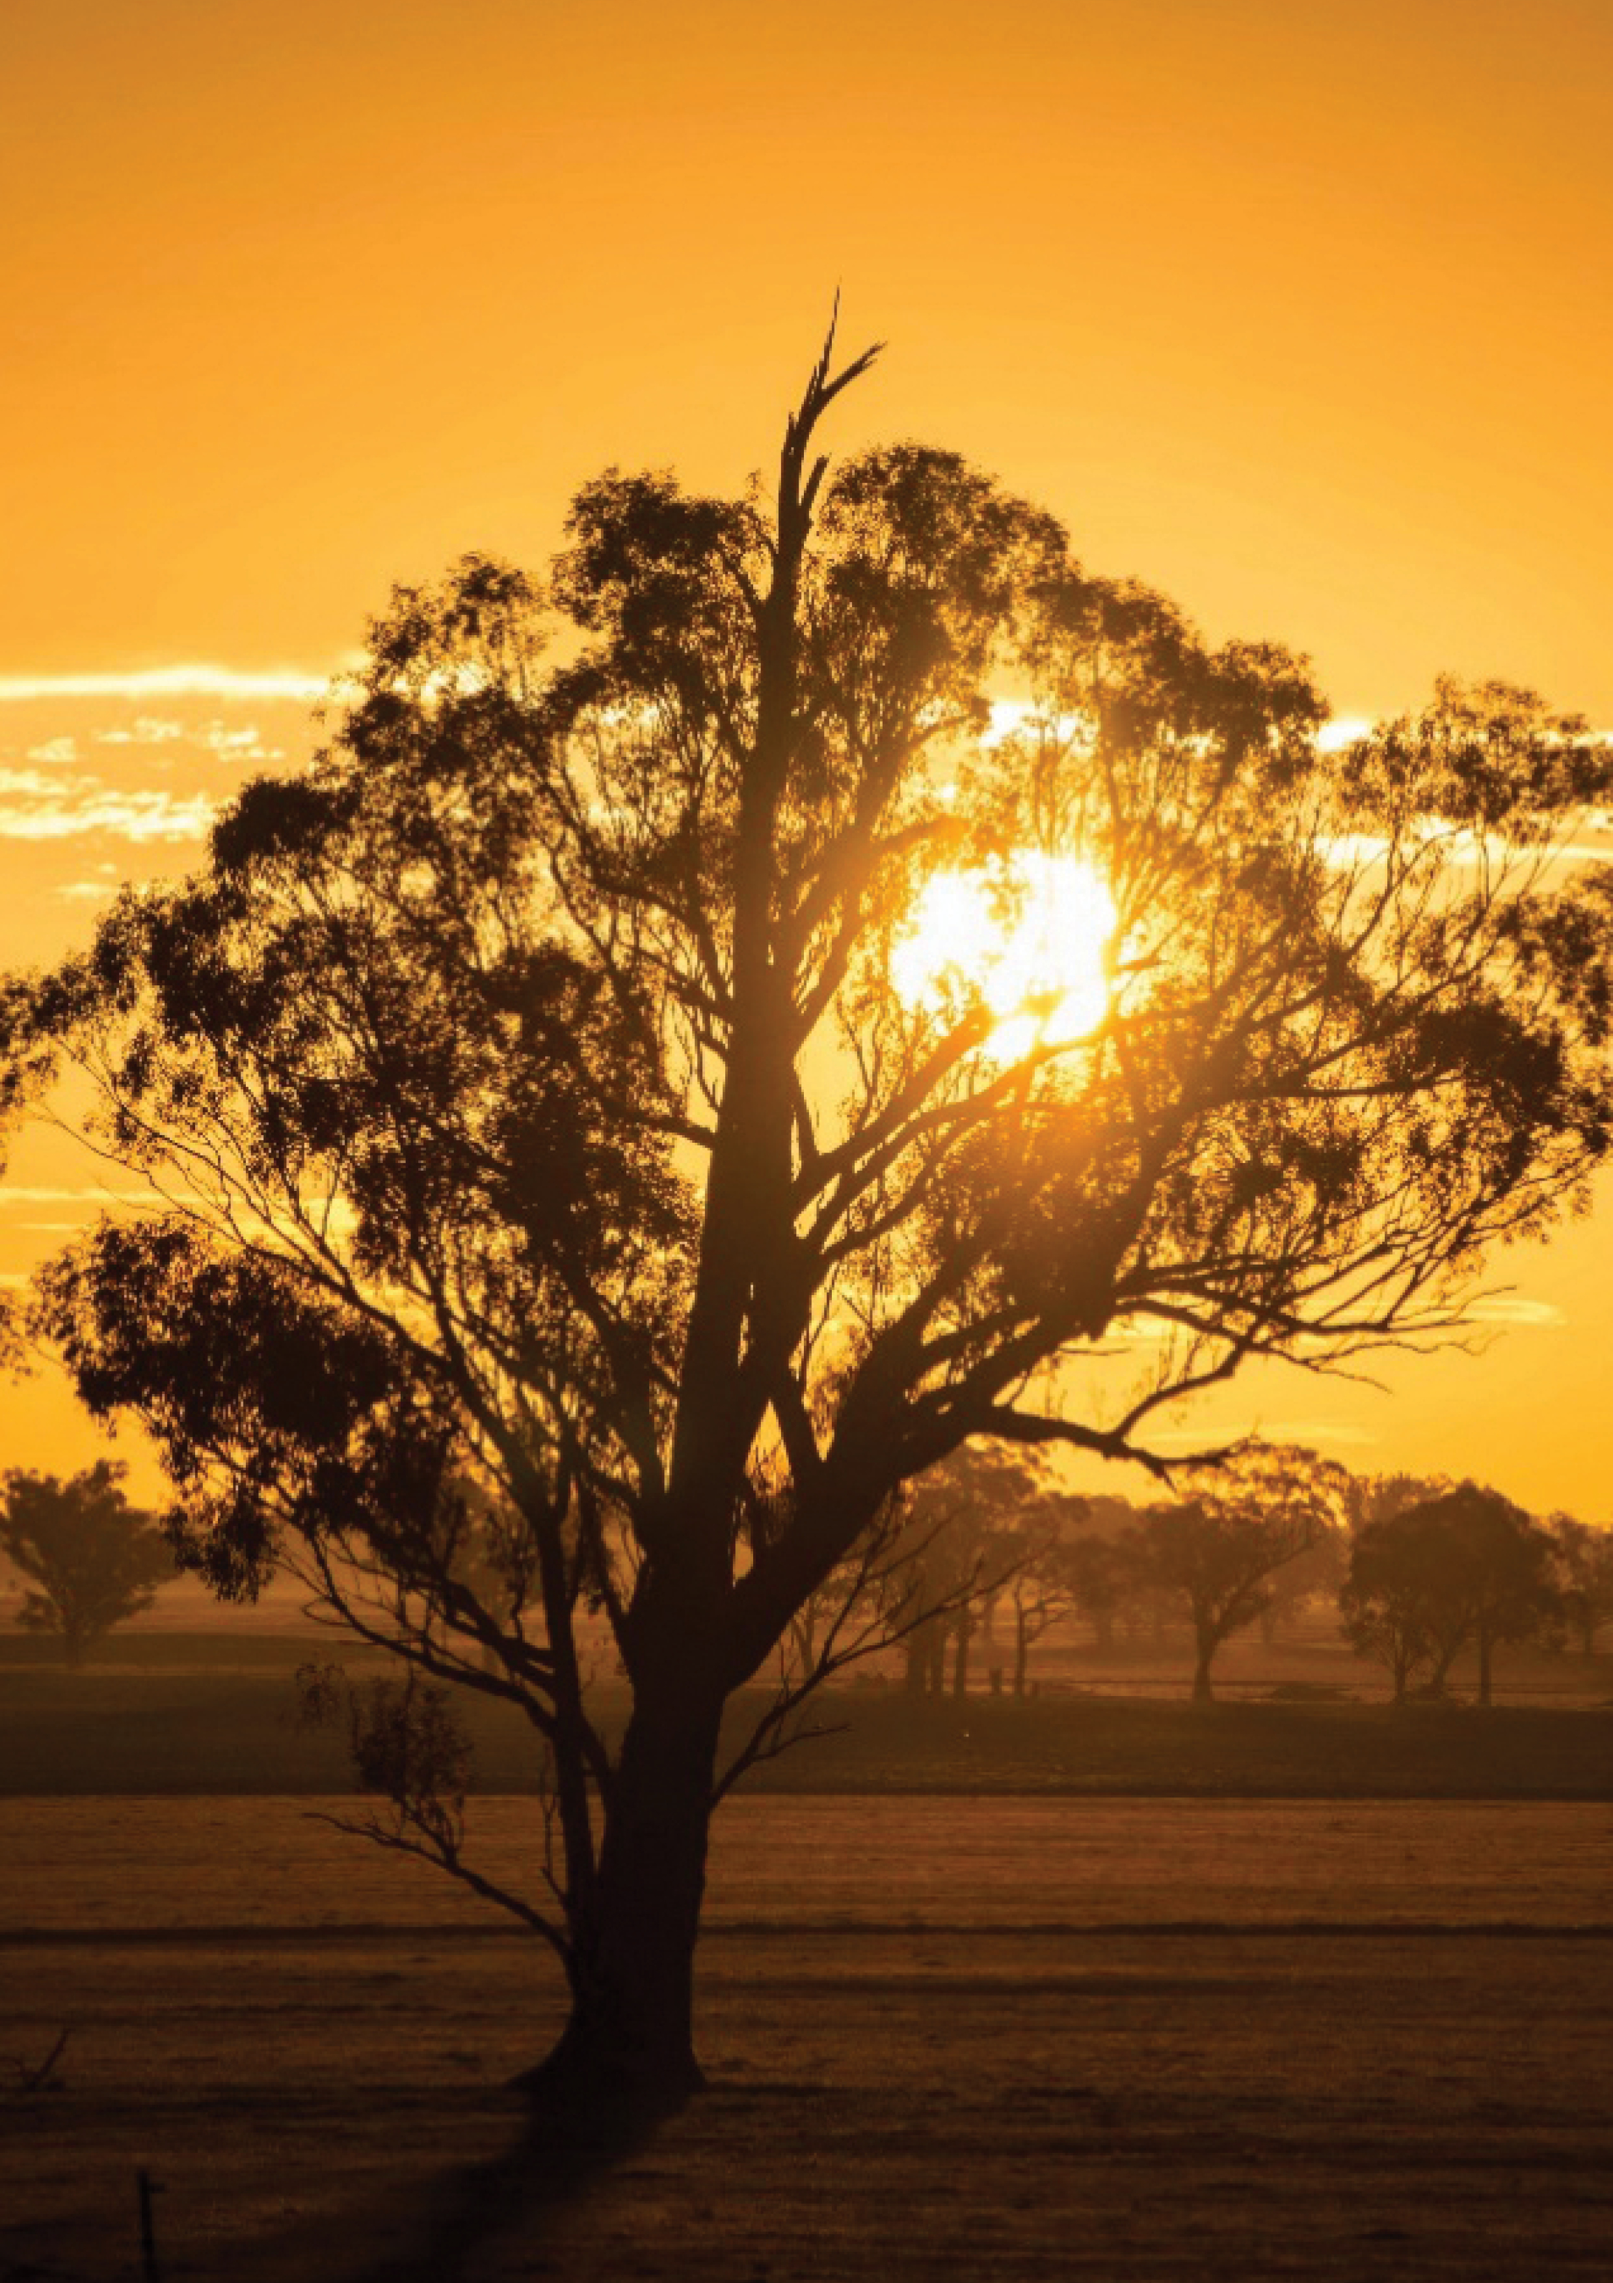
Tree in sunset, Marwan El Hassan, naturepicsart.com

Message from the Future Drought Fund Consultative Committee Chair
From the beginning the goal of the Future Drought Fund has been building drought resilience by providing our farmers and regional communities with the necessary skills, tools and networks to plan, manage and persevere through drought. In doing so, we have attempted to better our triple bottom line and by catering to the environmental, economic and social needs of farmers and their communities.
Transformational change takes time, but I am confident we are on our way. We are at the mid-way point of our 4-year Drought Resilience Funding Plan cycle, and it is encouraging to see the strong progress being made.
I am particularly excited to see the reach of our programs extending with thousands of people now involved in various Future Drought Fund activities across Australia.
We also have new programs in development which seek to further the success of our foundational programs. The new investments consolidate our 4-year strategy by embedding lessons learnt and feedback from across the sector.
This year's Annual Report details our achievements including through monitoring, evaluation and learning metrics to make sure work is on track to achieving our goals.
The Future Drought Fund is for everyone in Australia, so it's essential we have your regular input to make sure we're getting it right. I invite you to read the report and welcome your views on the Fund and it programs. Your feedback is important and will inform what we do next, as we continue our work to build drought resilience and better support Australian farmers and communities.
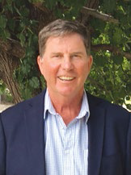

Brent Finlay
Chair
Future Drought Fund Consultative Committee

Table of Contents
Minister's Message iii
Message from the Future Drought Fund Consultative Committee Chair v
About the Future Drought Fund 1
Building Drought Resilience 2
Future Drought Fund Programs 4
Key Achievements 6
Better Climate Information 7
Climate Services for Agriculture 9
Drought Resilience Self-Assessment Tool 9
Better Planning 12
Farm Business Resilience Program 12
Regional Drought Resilience Planning 16
Better Practices 23
Drought Resilience Adoption and Innovation Hubs 27
National Enabling Activities 30
Drought Resilience Innovation Grants 32
Natural Resource Management Drought Resilience Program 33
Drought Resilient Soils and Landscapes Program 35
Future Work: New Programs Announced 36
Better Prepared Communities 38
Networks to Build Drought Resilience 40
Drought Resilience Leaders 42
Future Drought Fund Administration 45
Governance 46
Program Design and Delivery 47
Funding 49
Appendix A: Glossary 51
Appendix B: References 52

List of Tables
Table 1 Funding Allocation 49

List of Figures
Figure 1 About the Future Drought Fund 1
Figure 2 Future Drought Fund Investment Themes 4
Figure 3 Future Drought Fund Programs 5
Figure 4 2021-22 Key Achievements 6
Figure 5 CSA and DRSAT Coverage of Agricultural Commodities 10
Figure 6 Farm Business Resilience Program Participants by Industry 14
Figure 7 Regional Drought Resilience Planning Stakeholder Engagement 20
Figure 8 Future Drought Fund Administration 45
Figure 9 Consultation and Engagement 48

List of Maps
Map 1 CSA and DRSAT Pilot Regions 10
Map 2 Foundational Regions for Regional Drought Resilience Planning 19
Map 3 Projects Supporting Better Practices Across Australia 26
Map 4 Drought Resilience Leaders Across Regional Australia 43

About the Future Drought Fund
The Future Drought Fund (FDF) is an investment by the Australian Government to build drought resilience in Australia’s agriculture sector, landscapes and communities.
Figure 1 About the Future Drought Fund
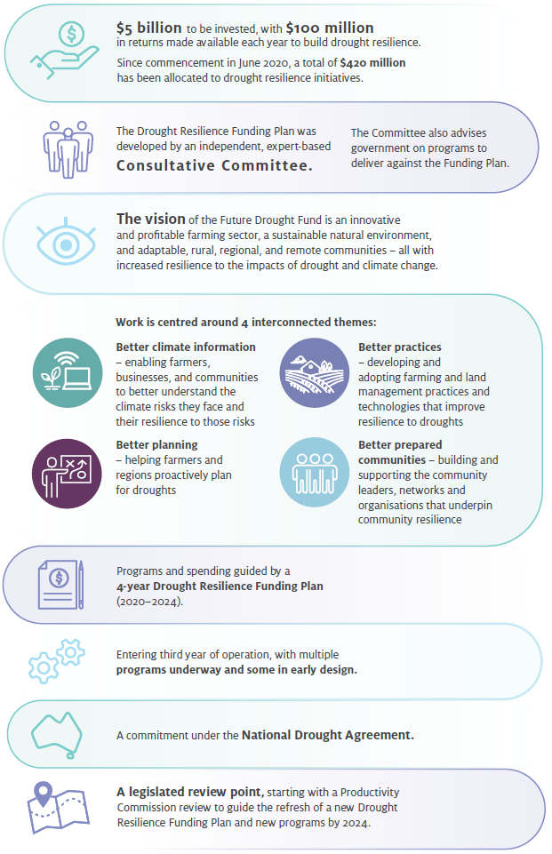

Building Drought Resilience
Drought resilience is the ability to adapt, reorganise or transform in response to changing temperature, increasing variability and scarcity of rainfall and changed seasonality of rainfall, for improved economic, environmental and social wellbeing.
Drought Resilience Funding Plan (2020-2024)
Drought resilience is a complex concept. There is no simple measure of resilience as it depends on context and therefore means something different to each person, farm, community and agricultural landscape. This is why tailored and practical interventions are required to increase drought resilience - there is no 'one-size fits all approach'.
Further, the effects of drought generally build and subside over time and are only one of the many challenges faced by farmers and regional communities. This dynamic nature of drought means that building drought resilience requires an ability to respond effectively to a continuously changing context.
For these reasons, FDF programs are ultimately focused on building resilience, through resources, practices and capabilities. This enables farmers, agri-businesses, communities and others to make better decisions about how to best manage the risks and impacts of droughts for their context.
When surveyed about drought resilience:
Most farmers saw 'drought resilience' as interchangeable with 'drought preparedness'
Over half of the farmers (51%) described drought resilience as being prepared and having procedures in place for drought.
An overwhelming number of farmers (94%) agree that 'the best time to prepare for drought is before it happens'.
Where To, FDF Market Research, 2021
In particular:
Better Climate Information
- The FDF is making climate information more accessible, relevant and actionable. This enables farmers, businesses and communities to better understand and monitor the drought and other climate risks they face, how prepared they are for those risks, and areas for action to improve preparedness.
Better Planning
- The FDF is building the focus and skills of famers in business and risk management. This enables farmers to proactively prepare for the potential impacts of drought on their business, and better manage their business through times of drought.
- The FDF is supporting local councils and other regional stakeholders to develop regional drought resilience plans. The planning process, and the development of the resulting plans, bring key stakeholders together around common objectives and prioritised actions to build preparedness and respond effectively in times of drought.

Better Practices
- The FDF is supporting the development and adoption of drought resilient farming and land management practices. Farmers can learn about, and get support to try and adopt, practices that may help them be more productive during times of drought and recover quicker following drought.
Better Prepared Communities
- The FDF is building the capability of community members, leaders and organisations to drive local action to prepare for drought. People are more resilient when they are part of a supportive community network and this has flow on benefits for driving changes in awareness, attitudes and practices.
What does drought resilience mean to our farmers and regional communities?
- planning ahead and recognising the signs of drought early
- good land management practices
- continuing operations and making profit during a drought
- managing water supply
- having silage/storage options and storing more feed
- being financially prepared
- diversity of revenue
- good risk and farm business management practices
- adherence to industry best practice
- learning from past experiences and others
- managing your own farm appropriately with the goal of surviving in a good enough condition to be able to thrive when the drought has receded.
Where To, FDF Market Research, 2021
DAWE, Shared Responsibilities Consultation, 2021

Future Drought Fund Programs
The FDF is in its third year of operation, with multiple programs underway and new programs announced with the 2022-23 Budget. The first two years of operation have focused on building the foundations of the FDF, with feedback and lessons learnt incorporated into new program development and roll-out. Funding for the first 4-year Funding Plan has been fully allocated with uptake and on-ground outcomes starting to flow.
Our programs are structured around 4 key themes (Figures 2 and 3). They contribute to the 3 strategic objectives of economic, environmental and social resilience to drought. Programs do not operate in isolation. The themes and programs have key areas of focus but also work together to build drought resilience.
Figure 2 Future Drought Fund Investment Themes
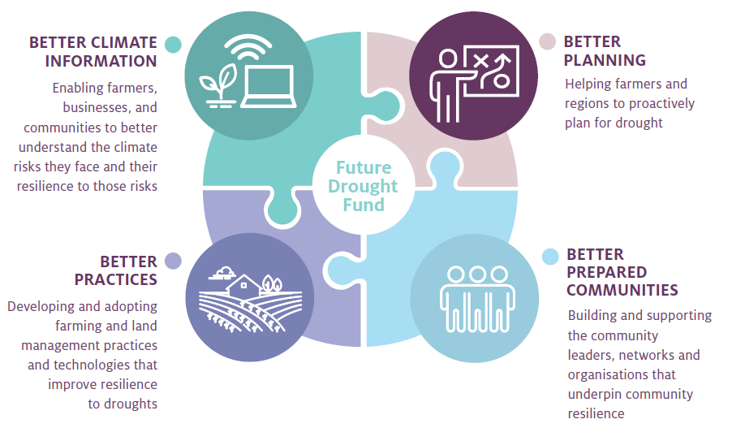
Note: The FDF Annual Report 2020-21 previously reported against five themes including 'harnessing innovation' and 'better land management'. These two themes are now contained under the theme 'Better Practices'.
Figure 3 Future Drought Fund Programs
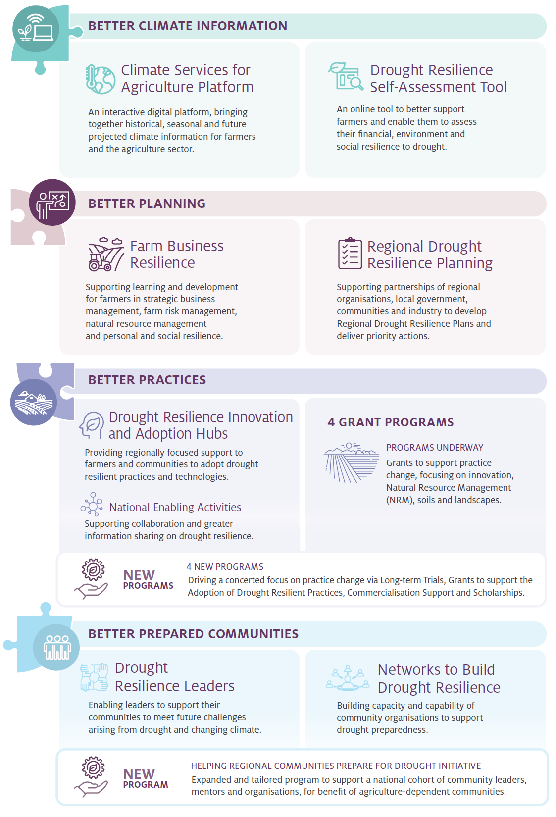

Key Achievements
Figure 4 2021-22 Key Achievements
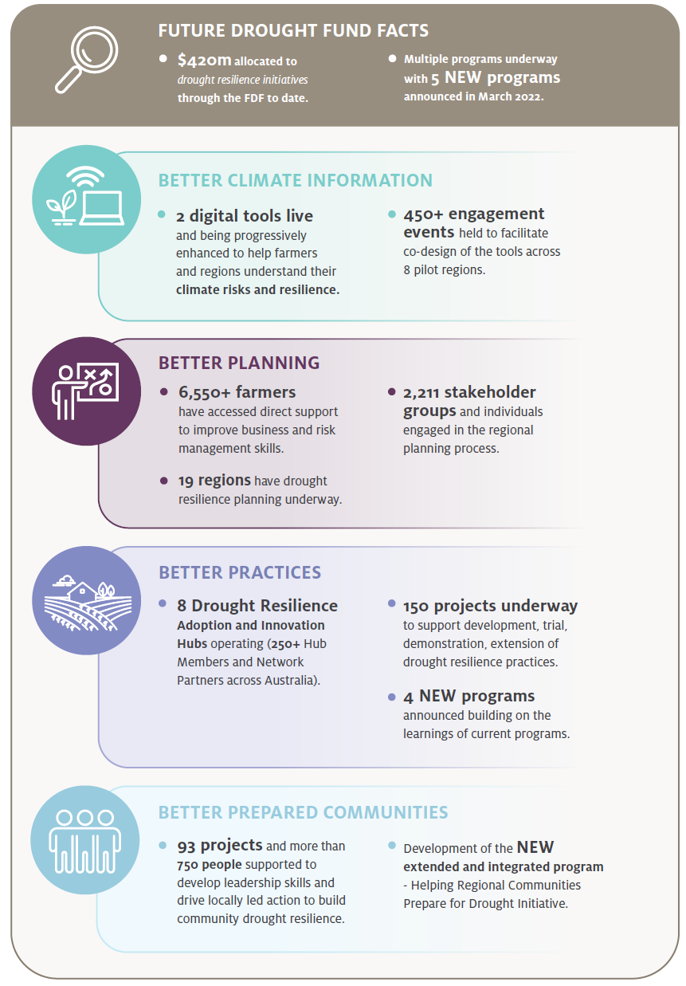

Better Climate Information
Enabling farmers, businesses, and communities to better understand the climate risks they face and their resilience to those risks
Objectives | Program information
The strategy | Establish new authoritative national capabilities that make climate information accessible and useful for understanding climate risk and resilience
What are we trying to achieve? | The new national capabilities are actively used by farmers, agribusinesses and communities to understand climate risks, resilience, and adaptation pathways, and to inform action
How will this support drought resilience? | Farmers, businesses, and communities that better understand their climate risks, resilience, and adaptation pathways are more likely to take action to manage drought risk
How will we assess whether it is successful? | Overall success measures  - The climate information capabilities are used and valued by the target audience (CI 1)  - Users take action in response to the improved information and understanding (CI 2)  - The climate services platform and the self-assessment tool are scientifically rigorous (CI 3)
Progress and performance
2020-21 results | 2021-22 results | 2022-23 measures | 2023-24 measures
Release of digital prototype of the Climate Services for Agriculture (CSA) platform  Met, see 2020-21 annual report  Release of web-based Drought Resilience Self-Assessment Tool (DRSAT) prototype  Met, see 2020-21 annual report  Four pilot regions selected as a basis for further development of the capabilities  Met, see 2020-21 annual report | (CI 1) User numbers and experiences measured from reference group feedback and web statistics (CSA and DRSAT prototypes)  Met, see assessment below  (CI 1) Evidence of co-design process  Met, see case study 1 | (CI 1) FDF-level survey to gauge and extend reach, and to help set target reach  (CI 2) FDF-level survey to gauge actions taken in response to improved information from (a) CSA and (b) DRSAT  (CI 3) Peer review has validated further platform development for CSA, including impact insights and adaptation opportunities | (All measures) Program case studies and commissioned studies explore and assess reasons/drivers/barriers around farmers' use of the CSA platform and DRSAT  (CI 1, CI 2) Evaluation: use and value placed on CSA and DRSAT to base local and regional agricultural resilience decisions and related actions on

Key Achievements 2021-22
Key achievements | Next steps
CLIMATE SERVICES FOR AGRICULTURE
Enhancements to digital platform includes more commodities and regions | Development completed with nation-wide coverage by mid-2024
4,700 users accessed the platform since it was released in late June 2021, including 1,300 return users | Information to be tailored to 20 of Australia's top agricultural commodities
250+ engagement events and consultation sessions to co-design the platform across 8 pilot regions
2,500+ people reached with engagement and outreach to promote platform
Information tailored to 14 agricultural commodities
DROUGHT RESILIENCE SELF-ASSESSMENT TOOL
Live digital tool publicly released in December 2021 with subsequent enhancements, including an update released in April 2022 | Development completed with nation-wide coverage of financial and personal resilience assessments by early 2023
6,409 users accessed the platform since it was released in December 2021, with 574 of these users creating accounts | Environmental resilience information will be available for 8 of Australia's key commodities across the main regions they are produced in
1,200 self-assessments have been completed | Information to be tailored to 20 of Australia's top agricultural commodities
950+ people reached with engagement and outreach activities to promote the tool
200 engagement events and consultation sessions to co-design the platform across 8 pilot regions
Access to environmental assessments tailored to
8 agricultural commodities

Climate Services for Agriculture
The Climate Services for Agriculture (CSA) digital platform is designed to make climate information more accessible and useful for farmers, industry, and rural and regional communities. It aims to build resilience by enabling users to anticipate future climate conditions, draw comparisons with recent weather and consider what it could mean for the commodities they produce. It also provides information on what can be done to prepare for future drought.
A prototype of the platform was publicly released in June 2021, with updates in December 2021 and August 2022. The platform brings together historical, seasonal and future projected climate information at a resolution of 5 square kilometres across Australia. This includes information about past and future rainfall, temperature, heat and frost risk and evapotranspiration. This is the first time the bite-size pieces of data and analytics relating to climate for all of Australia have been provided in a single location. The platform also contains specific information for commodities such as beef, sheep, wheat, almonds, apples, barley, canola, lupins, oranges, sugarcane, cotton, sorghum, dairy and wine grapes. Additional commodities will continue to be added over the next 2 years as well as regular updates to historical data for all current commodity indices across Australia.
The prototype was developed through a co-design process within 8 pilot regions (see Map 1). Pilot regions were selected to include a broad range of different climatic zones, commodities and production systems.
An additional $7 million in funding was announced in conjunction with the 2022-23 Budget to complete the development of the platform and achieve national coverage with total spending on this measure amounting to $29 million over 4 years to 2023-24. The extended program will enable scaling out of the platform from a focus on the pilot regions, to a platform that is available nation-wide, covering more than 20 of Australia's top agricultural commodities (see Figure 5).

Drought Resilience Self-Assessment Tool
The Drought Resilience Self-Assessment Tool (DRSAT) complements the CSA platform (see above). DRSAT is an online tool to help farmers understand and improve their financial, environmental, and social resilience to drought and a changing climate. It enables farmers anywhere in Australia to add farm-scale data to the regional-scale data, understand their own farm-scale resilience, see farm-level climate change projections, view satellite data for their farm and see suggested tailored pathways to improve resilience.
Informed by user testing in 8 pilot regions (Map 1 refers) DRSAT was released publicly in December 2021 as a live tool.
The first release in December 2021 had a focus on cattle grazing and dry land cropping. Two updates to the tool were released in April 2022 and August 2022 and included additional commodities, satellite imagery and improved functionality. The tool now includes commodities such as sheep, wool, dairy, citrus and temperate fruits. This will expand further to incorporate roots, tubers, and leafy green vegetables in the final major update to be completed by early 2023 (see Table 3).
Map 1 CSA and DRSAT Pilot Regions
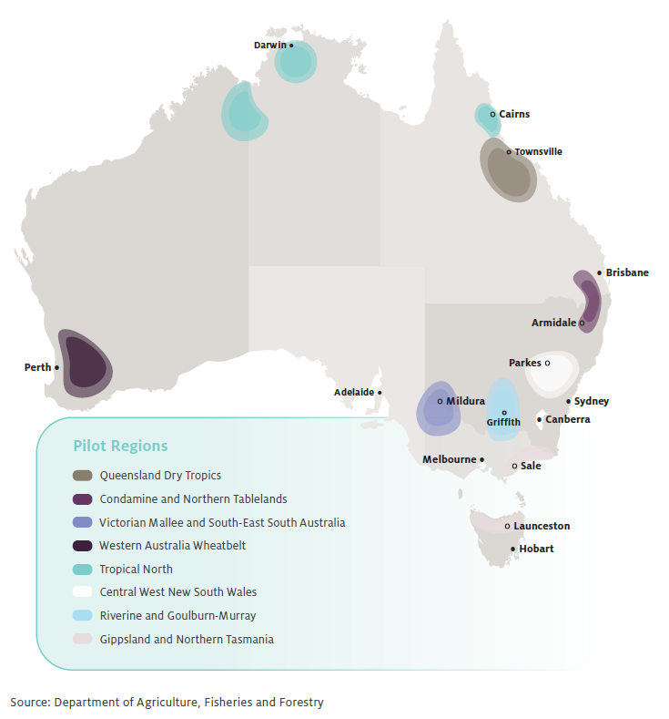
Figure 5 CSA and DRSAT Coverage of Agricultural Commodities
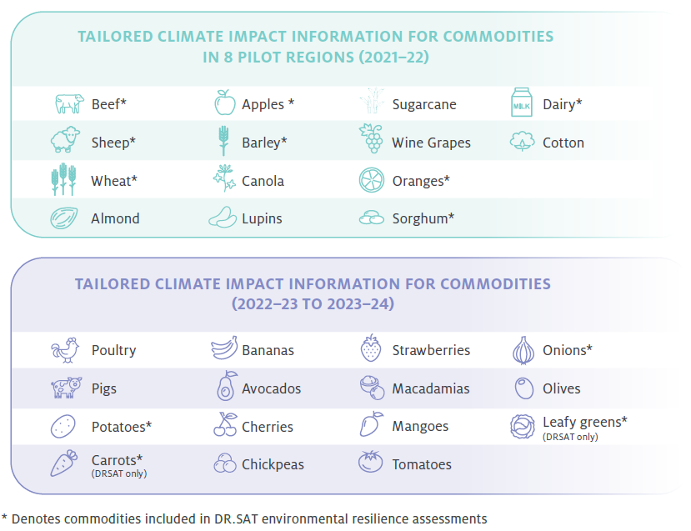
CASE STUDY 1 - Human-centred design for Climate Services for Agriculture
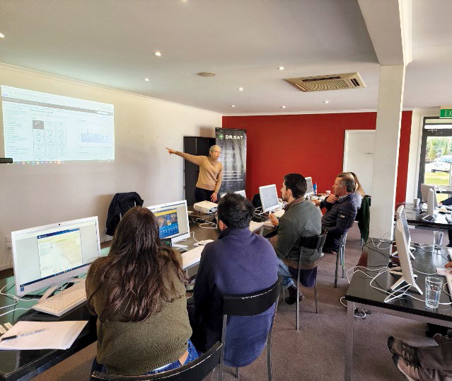
Sigrid Tijs, Program Lead - Climate Services for Agriculture presenting to a group of Victorian farmers, advisors and rural industry professionals. Photo credit: FarmLink
The Climate Services for Agriculture digital platform is a user-driven service. Reaching out to groups and farmers and seeing what information was needed to help make decisions has been integral in the development of the service.
Delivered by CSIRO, the Bureau of Meteorology and Farmlink Research, the FDF initiative uses a collaborative design process with end users to ensure the service has been designed with and for all farmers and their advisors.
There were two types of interactions with end users for the co-design of the service comprising engagement, and feedback interviews within the 8 identified pilot areas, one of which was Victoria's Gippsland region.
Face-to-face workshops and interviews with end-users promoted discussion between growers that represented different grower groups and grower demographics. It was an ideal forum for informing co-design.
Gippsland farmers and agricultural industry members specifically mentioned the need for new climate insights, more commodities and region- specific forecasts. These are just some of the many additional functionalities that are now included in the latest release of the prototype.
'This would be really useful for my medium- to-longer term planning', a Gippsland vegetable farmer said at a face-to-face workshop.
Additional climate risk, impact and resilience information will be developed with users in pilot regions through to June 2023.
To get involved, visit the CSA platform – Climate Services for Agriculture (indraweb.io).

Better Planning
Helping farmers and regions to proactively plan for drought

Farm Business Resilience Program
Objectives | Program information
The strategy | Build the capacity of farmers to plan for and manage risks, including drought
What are we trying to achieve? | A step-change in the use of farm business management skills to proactively manage drought risks
How will this support drought resilience? | Farmers who have better business management skills and plan for risks are more likely to take actions that help sustain farm business productivity and profitability in times of drought
How will we assess whether it is successful? | Overall success measures:  - There is an increase in the business management skills and confidence of farmers to manage risk (RM 1)  - There is an increase in farm business plans that consider drought risks (RM 2)  - More farmers are taking actions to manage risk, including drought (RM 3)
Progress and performance
2020-21 results | 2021-22 results | 2022-23 measures | 2023-24 measures
All states and territories agree to partner with the Australian Government and design programs  Met, see 2020-21 annual report | (RM 1, RM 2) Number of participants, training and other learning events, and farm performance assessments  Met, see assessment below  (RM 2) Number of farm business plans developed/updated and professionally reviewed  Met, see assessment below  (All measures) Change in participant surveys and farm performance assessments  Met, see assessment below  (RM 1, RM 3) Case studies selected for monitoring post participation  Met, see assessment below | As for 2021-22, plus:  - (All measures) Monitoring of case studies  - (All measures) Mid-program evaluation | As for 2021-22, plus:  - (All measures) Final evaluation
Note: The FDF Annual Report 2020-21 previously reported the above program information and metrics under the theme of 'Better Risk Management'. This information is now listed under the theme of 'Better Planning'. The program information and metrics have not been otherwise altered.
Key achievements 2021-22
Key achievements | Next steps
6,546 farmers took part in the program in 7 jurisdictions across Australia¹ | Extending program to reach as many as 17,000 farmers by 2024
4,47¹ learning and development activities and events held | Expanding program to more industries and more learning areas
903 farm business plans were reviewed or advised on by a professional during their development | Following up with participants through refresher training, farm business plan reviews, benchmarking, and voluntary performance assessments
538 farm business plans were completed (new plans developed or existing plans updated)
1 This may include duplication due to some instances where individuals attend multiple events and are not uniquely recorded.
The Farm Business Resilience program, delivered in partnership with state and territory governments, aims to build the capacity of farmers to plan for and manage risks, including drought. Across Australia, subsidised learning and development opportunities are being rolled out in areas such as strategic business skills, risk management, natural resource management and personal resilience. The program also supports farm business planning, tailored to participants' circumstances, and the opportunity for professional feedback on plans.
In 2021-22, over 6,546 participants across Australia benefited from more than 4,471 learning and development activities, including coaching sessions, workshops and events. During the program, 903 farm business plans were reviewed or advised on by a professional during their development and 538 plans were considered complete (new plans developed or existing plans updated).
Within the national framework, each state and territory has tailored its design or delivery for its local context, building on existing initiatives delivered via government and industry. Figure 6 shows the different industries engaged in the program. For example, Queensland is working in partnership with industry to deliver the program in the sugarcane, horticulture, grazing, broadacre and dairy sectors. New South Wales has capitalised on the success of its Young Farmer Business Program model, with the participating farmers undergoing intensive one-on-one coaching with an expert business coach and connecting with other farmers through small-group networks.
Feedback on the foundational year has been positive across Australia, with participants valuing the program highly. Some reported highlights include:
- In South Australia, the AgRi-Silience delivery to livestock and grains farmers received an 8 out of 10 for overall satisfaction, while horticulture and vegetable farmers reported very high satisfaction towards multiple aspects of the program (planning, workshops and feedback on farm plans), with all scores 8/10 or above (one being lowest satisfaction and 10 being the highest).
- Victorian farmers reported an average satisfaction rating of 8.8/10 and 100% of participating farmers would recommend the program to other farmers.
- In New South Wales, 67% of participants reported an increased likelihood of changing their behaviour because of their participation and 100% of farmers who undertook intensive coaching reported specific intentions to implement priority changes. About one-third of farmers have already implemented something they learnt at an event.
- In Queensland, 98% of broadacre participants agreed that the Building Business Resilience Workshop would improve their ability to develop specific plans to better prepare for drought and 94% agreed that the program was a good way of spending public money.
Working with industry, states and territories have developed a suite of legacy products, including learning materials, video recordings, farm business planning templates and sector-specific benchmarking tools. This work represents a large scale-up in capability and, coupled with ongoing collaboration between jurisdictions to share resources and learnings, will drive momentum for future program years.
The program has also enabled deeper research and analysis into specific issues relevant to building farm business resilience. For example, through the program, the NSW Government Behavioural Insights Unit is conducting research into behavioural barriers and enablers of farm succession planning and identifying opportunities to apply behavioural insights to the program.
Figure 6 Farm Business Resilience Program Participants by Industry
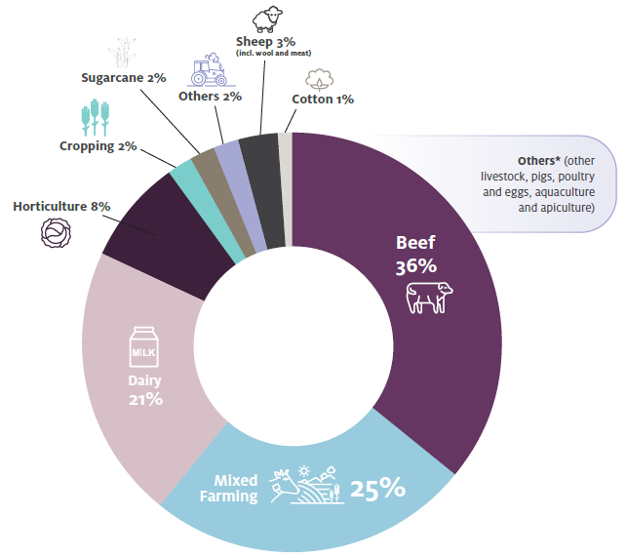
Planning for the extension to the program to 2024 is well underway in most jurisdictions. The extension will capitalise on the success and learnings from the foundational year, including:
- expanding the program to reach more farmers from a broader range of sectors
- an increased focus on areas identified as priorities, such as succession planning
- creating new industry partnerships and identifying opportunities to make better linkages with existing offerings
- adding continuous learning, with active follow-up and peer-to-peer learning.
Case studies are being developed following the experience of participating farmers in several jurisdictions. Going forward, the FDF will continue to follow the journeys of more farmers to see how their farm businesses are evolving and adapting as a result of the program.
CASE STUDY 2 - Two farming families' journey through the Farm Business Resilience Program in New South Wales
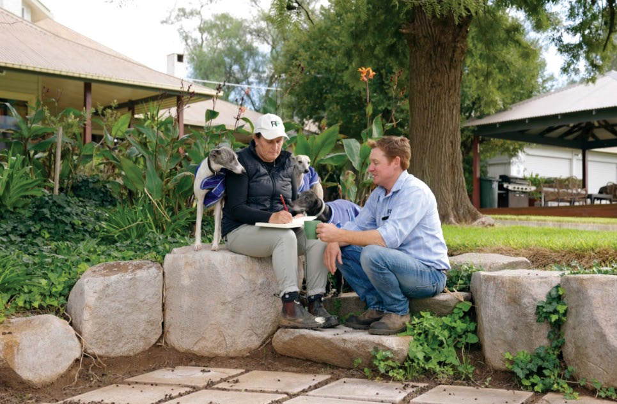
Coddington Family: Matthew and Cherie Coddington at their home in Central Western New South Wales. Photo credit: NSW Department of Primary Industries
In New South Wales, the program supports farmers to undergo intensive one-on-one coaching with an expert business coach and connects farmers through small-group networks to work through issues together.
Matthew and Cherie Coddington run a sheep, lamb, cattle and cropping farm in Central Western New South Wales, and shared their thoughts on the program.
Following the last drought, we wanted to get our policies operating procedures and systems in place. We also have five children, so succession will become quite a key thing in the future.
Our coach has held us very accountable. Each meeting brings up issues that we find within the business that we need to address. Out of these meetings comes actions that we have to act upon.
Having a group that we have been involved in has helped us lay things on the table and discuss them openly. Together we’re solving these issues and putting systems in place so that we’re better prepared for drought and worse seasons ahead.
Farm business resilience to me means being able to adapt to change. By developing better confinement feeding systems, we aim to retain our core breeding stock. Because we are a seed stock merino stud producer, we need to maintain our breeding genetics and improve our carrying capacity while looking after our landscape in drought.
Everything’s better structured and planned, rather than being reactionary. We’ve recently purchased more properties. The earlier you start planning for the long term, the better off you’ll be.

CASE STUDY 2 - Two farming families' journey through the Farm Business Resilience Program in New South Wales
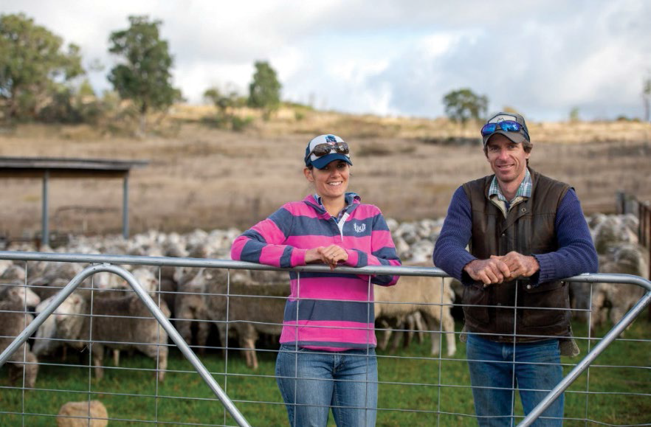
Schneider Family: Rachelle Hergenhan and Derick Schneider at one of their properties in New South Wales. Photo credit: NSW Department of Primary Industries
Rachelle Hergenhan and Derick Schneider own three farming properties located throughout regional New South Wales. They said,
Although we both grew up on farms and we’ve been around farming our whole lives, we had to be able to manage our farm business in an economically responsible way.
The program was appealing because I wanted to get a better understanding of our financial information. We didn’t have a good handle on the nitty-gritty of the finances and how to use the information we’ve got to make decisions for improving our business.
Business coaching has helped with our long-term business goals - distilling down what we're trying to achieve. For me it’s about how we can manage our farms so that both of us don’t have to work off farm.
Participating has helped me to see the bigger picture. I’m more positive and can see the opportunities rather than just the bottom line. It’s given me confidence to say, actually, we can grow our farm business, we can be more resilient moving forward and there is still capacity to achieve what we want to and make the best life for ourselves and our kids.

Regional Drought Resilience Planning
Objectives | Program information
The strategy | Establish drought resilience plans across agricultural regions, based on evidence and collaboration, to drive proactive management of drought risks
What are we trying to achieve? | Regional drought resilience plans drive decisions, actions, and investments to proactively manage drought risks
How will this support drought resilience? | Informed and planned action to manage drought risks at a regional scale will support resilience of the region's economy, farmers, businesses, communities and the landscape
How will we assess whether it is successful? | Overall success measures:  - There is an increase in the number of agricultural regions that have drought resilience plans (RM 4)  - Plans have buy-in from key stakeholders in the region (RM 5)  - Plans are informed by relevant data, co-design, and best practice approaches to resilience planning (RM 6)  - Plans are implemented (RM 7)
Progress and performance
2020-21 results | 2021-22 results | 2022-23 measures | 2023-24 measures
All states and territories agree to partner with the Commonwealth, and design detailed programs  Met, see 2020-21 annual report | (RM 4, RM 6) Number of plans commenced drafted, assessed, approved, and published  Met, see assessment below  (RM 5) Number and extent of stakeholder engagements in planning processes  Met, see assessment below  (RM 5, RM 6, RM 7)  Case studies selected for monitoring post-planning (e.g. stakeholder buy-in and implementation)  Met, see assessment below | (All measures) As in 2021-22 - monitoring outputs, independent assessments, and implementation  (RM 4, RM 6) Extent to which plans identify and respond to key risks  (RM 5, RM 6) Extent to which stakeholders co-designed/partnered in planning (qualitative via independent assessments, surveys)  (RM 7) Number of plans implemented (grants or other means)  (All measures) Interim evaluation | (All measures) As in 2022-23 - monitoring outputs, surveys and/or independent assessments, implementation, and case studies  (All measures) End-of-program evaluation
Note: The FDF Annual Report 2020-21 previously reported the above program information and metrics under the theme of ‘Better Risk Management'. This information is now listed under the theme of ‘Better Planning'. The program information and metrics have not been otherwise altered.
Key achievements 2021-22
Key achievements | Next steps
23 regions announced as foundational regions (see across all Australian states and territories [Map 2]) | Planning support to be extended, with the aim to reach all agricultural regions by 2024
19 regions have commenced resilience planning across 7 jurisdictions | Grants to support regions to implement priority actions in their plans to be available from 2022-23
CSIRO appointed to undertake independent reviews of plans
2,211 stakeholder groups and individuals engaged in planning process
1,413 planning, consultation and engagement activities informed plan development
The Regional Drought Resilience Planning program, delivered in partnership with state and territory governments, supports regions to develop drought resilience plans to drive proactive management of drought risks. Plans are community led and owned through partnerships of local governments, regional organisations, community organisations and industry.
Twenty-three regions were announced as the first to benefit from the program (see Map 2). In 2021-22 planning commenced in 19 regions, with the remaining 4 regions expected to undertake planning in 2022-23. Across the 19 regions, 1,413 consultation and engagement activities informed plan development, with 2,211 stakeholder groups and individuals engaged.
Consultation was extensive and input was diverse (see Figure 7). Some of the most represented partners and stakeholders included local governments, First Nations people, community service organisations, farming groups and agriculture representative bodies. Planning activities varied across the country and included one-on-one meetings and interviews, kitchen table conversations, community led workshops and forums, regional summits and online surveys.
In 2021-22 CSIRO was engaged to provide expert feedback on every plan using the science of resilience, adaptation and transformation at the local level. This process will enable best practice and learnings to be applied across Australia, and ensure regions are well-placed to tackle the risk of future droughts. As at September 2022, 15 plans have been submitted for review.
Feedback on the foundational year has been positive across Australia, with widespread recognition that the planning process has been successful in uniting and empowering communities to develop connections and pathways to build drought resilience in their region. In Western Australia, the program resulted in new tools, techniques and data, as well as technical advice. This provides a scientific evidence base that has previously not existed in Western Australia to demonstrate the impact, exposure, sensitivity and ultimately vulnerability of these communities to drought.
Work on the extension to the program to 2024 is well underway in most jurisdictions. The next phases of regions are being planned, with an aim to reach all key agricultural regions by 2024. To support regions to kick start action on priority activities identified in their plans, small implementation grants will be available from 2022-23.
Case studies are being developed following the experience of participating regions in several jurisdictions. We will continue to follow the journeys of regions to see how the development and implementation of their plans has benefited their region.
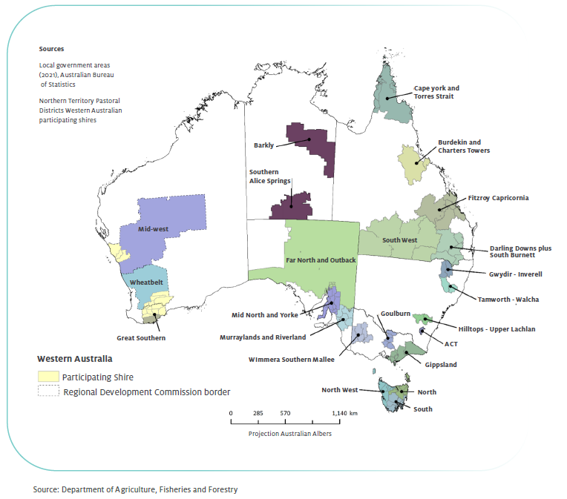
Map 2 Foundational Regions for Regional Drought Resilience Planning

Figure 7 Regional Drought Resilience Planning Stakeholder Engagement
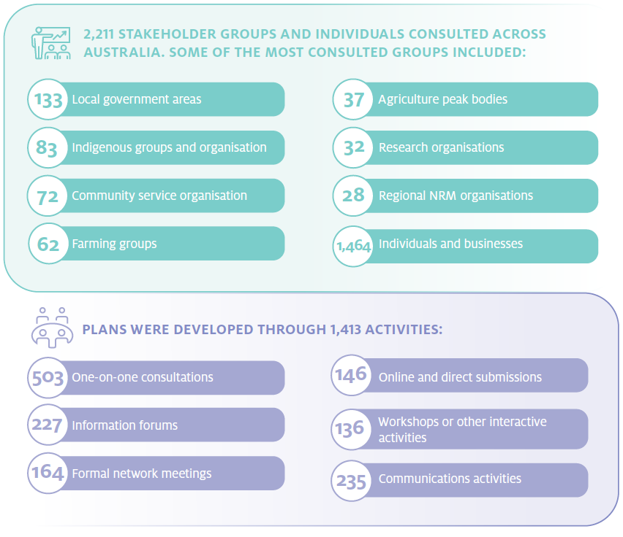
CASE STUDY 3 - Regional drought resilience plan development in Western Australia's grain belt: Valuing First Nations People and Practices
The Western Australian grain belt is the largest agricultural producing area in the state and a key contributor to the Australian economy. Three FDF Regional Drought Resilience Plans are in progress in the area - the Great Southern, Mid-West and Wheatbelt regions - covering an impressive 670,000km².
A broad cross-section of stakeholders, particularly First Nations communities and land managers, were engaged in the development of these plans. Although the economic and environmental impacts of drought have been widely studied, few studies have examined the broader impacts of drought on First Nations communities, and how traditional land management practices could contribute to drought resilience.
Targeted consultation with local traditional owners from the Noongar and Southern Yamatji communities ensured the plans recognise and represent the needs and interests of the First Nations communities who speak for Country. Stories shared by Elders about the changes they had seen over time, along with big picture solutions proposed by First Nations youth, fed into the planning process. This allowed formation of a comprehensive picture of the impact, sensitivities, adaptive capacity and therefore vulnerability, of these communities to drought.
A wealth of cultural land management knowledge and experience within the Noongar community and Southern Yamatji people was drawn upon during the consultation. First Nations community members were extremely concerned about the impacts of drought on biodiversity, bushfire regimes and the surrounding community, including broadacre farmers and pastoralists. They prioritised investment in water infrastructure (also including water conservation incentives and education) and cultural land management practices such as revegetation and fire management as activities to build resilience to drought. Barriers to integration of cultural land practices was also noted - primarily a lack of appropriate access to country due to legislation and red tape.
Through genuine collaborations, the program is helping First Nations communities, such as the Noongar and the Southern Yamatji people, engage in planning that will help to build drought resilience, and are empowered to work in partnership toward a healthier, more resilient landscape.
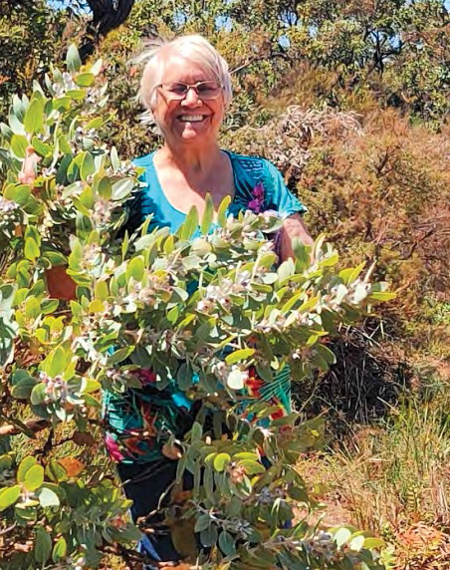
Carol Petterson, Menang-Ngadju Elder, is in the southwest of Western Australia and was consulted and interviewed as part of developing the Western Australia Great Southern regional drought resilience plan.
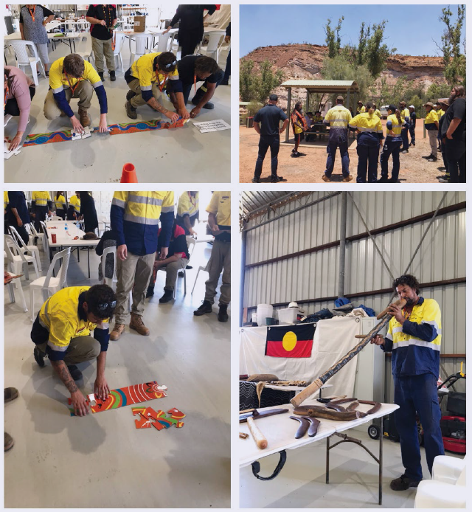
Drought impacts and resilience-building activities were discussed with First Nations
land holders and other interested parties during a series of interviews, workshops and meetings.
One of the workshops is depicted on the photo series above.
Photo Credit: Northern Agricultural Catchments Council

Better Practices
Developing and adopting farming and land management practices and technologies that improve resilience to droughts
Objectives | Program information
The strategy | Improve the drought resilience of agricultural landscapes and drive the development, extension, adoption and commercialisation of drought resilient technologies and practices
What are we trying to achieve? | A step-change in:  - awareness, acceptance, and adoption of drought resilient land management practices among farmers and other land managers  - the development, adoption and commercialisation of drought resilience technologies and practices
How will this support drought resilience? | The careful management of natural capital and uptake of new technologies and practices can make agricultural landscapes and agricultural businesses more resilient to drought, enabling productivity and profitability to be sustained during and following droughts
How will we assess whether it is successful? | Overall success measures:  - There is an increase in availability and accessibility of, and capacity to use and adopt, knowledge that can be applied to improve drought resilience (HI 1)  - There is an increase in land managers trialling and adopting land management practices (LMi)  - There is increased adoption and commercialisation of drought resilience technologies practices (HI 2)  - Collaborative networks between farmers and other land managers in support of increased adoption of drought resilience land management practices are strengthened (LM 2)  - The technologies and land management practices adopted are effective in improving drought resilience (HI 3/LM 3)  - Design and delivery of hub activities is responsive to end-user needs (HI 4)
Note: The FDF Annual Report 2020-21 previously reported the above program information under the themes of ‘Harnessing Information' and ‘Better Land Management'. It referenced foundational year programs called the ‘Drought Resilience Research and Adoption Program' and the ‘Natural Resource Management Drought Resilience Program'. This information is now listed under the theme of ‘Better Practices'. The performance metrics for each year have not been altered.

Progress and performance
2020-21 results | 2021-22 results | 2022-23 measures | 2023-24 measures
Establish 8 Drought Resilience Adoption and Innovation Hubs  Met, see 2020-21 annual report  Hold inaugural Science to Practice forum  Met, see 2020-21 annual report | (HI 1) Drought Resilience Research and Adoption Investment Plan delivered  Partially met, see assessment below  (HI 4) Hub partnership arrangements are embedded, and co-designed activity plans in place  Met, see assessment below  (HI 1, HI 2) Number and nature of activities to support research, development, extension, adoption and commercialisation (RDEA&C) and uptake by end users  Met, see assessment below  (HI 1) Attendance at annual Science to Practice forum (SPF)  Met, see assessment below | (HI 1) Hub linkages in the innovation system  (HI 2, HI 3, HI 4) Uptake of the Drought Resilience Research and Adoption Investment Plan priorities by hubs and research organisations  (HI 1) Improvement in end-user access to DEA&C information  (HI 1, HI 2) Number of activities to support RDEA&C uptake by end users  Attendance at SPF (HI 1)  (All measures) Reporting on mid-program evaluation | (All measures) As in 2022-23 - activities to support DEA&C  (HI 2, HI 3, HI 4) Case studies of uptake by end users  (HI 4) Number of partnerships developed to support RDEA&C  (HI 1) Attendance at SPF  (HI 2, HI 3) End-of- program evaluation - extent to which there is increased adoption of drought resilience technologies and practices and evidence that these are effective in improving drought resilience
80 NRM projects funded following competitive processes  Met, see 2020-21 annual report | (LM 1) Grantees' baseline data and targets for change in land management practices  Met, see assessment below  (LM 1, LM 2) Numbers and types of services (activities) in grantees' activity plans  Met, see assessment below  (LM 2) Number of land managers and other stakeholders engaged through grantees' activities  Met, see assessment below  (LM 3) Grantees' baseline data and early evidence of biophysical impacts of project activities (i.e. improvement in natural capital health and resilience)  Partially met, see assessment below | (All measures) Reviewing final reporting from initial grants (with project outcome data)  (All measures) As in 2021-22, reporting against activity plans and targets  (LM1) Evaluation: case studies of land management practices trialled  (LM 2) Evaluation: methods to assess network strengths and role in adoption (applied to case studies)  (LM 2, LM 3) Evaluation: early evidence of practices that may be adopted (case studies) | (All measures) As in 2022, reviewing final reporting from remaining initial grants (with project outcome data)  (LM 3) Evaluation: assess practices that have been or could be adopted; generate learning  (All measures) Map project outcomes against soil and other natural capital data, as well as relevant economic and social outcomes, to begin assessing contributions to long-term trends

Key achievements 2021-22
Key achievements | Next steps
Eight Regional Adoption and Innovation Hubs stood up with over 250 Hub Members and Network Partners involved across Australia  All hubs have established activity work plans informed by co-design with stakeholders in their region  Recruitment commenced for adoption officers to drive uptake of drought resilience practices | Continued roll out and delivery of hubs on-ground drought resilience projects, with an increasing focus on extension and adoption. Adoption officers are being onboarded in every hub to support on-ground extension and adoption activities
5 cross-hub collaborative projects underway | The hubs will work together to complete these projects over 2022-23
Science to Practice Forum held on 7-9 June 2022 | The next forum will be held from 6-8 June 2023
44 Drought Resilience Innovation projects underway | Innovation projects are due for completion between 30 June 2023 to 30 September 2024
80 projects rolled out for the Natural Resource Management Drought Resilience Program with 35 projects completed by 30 June 2022 | The remaining 45 projects are underway and progressing. Project results to be reported in the next annual report
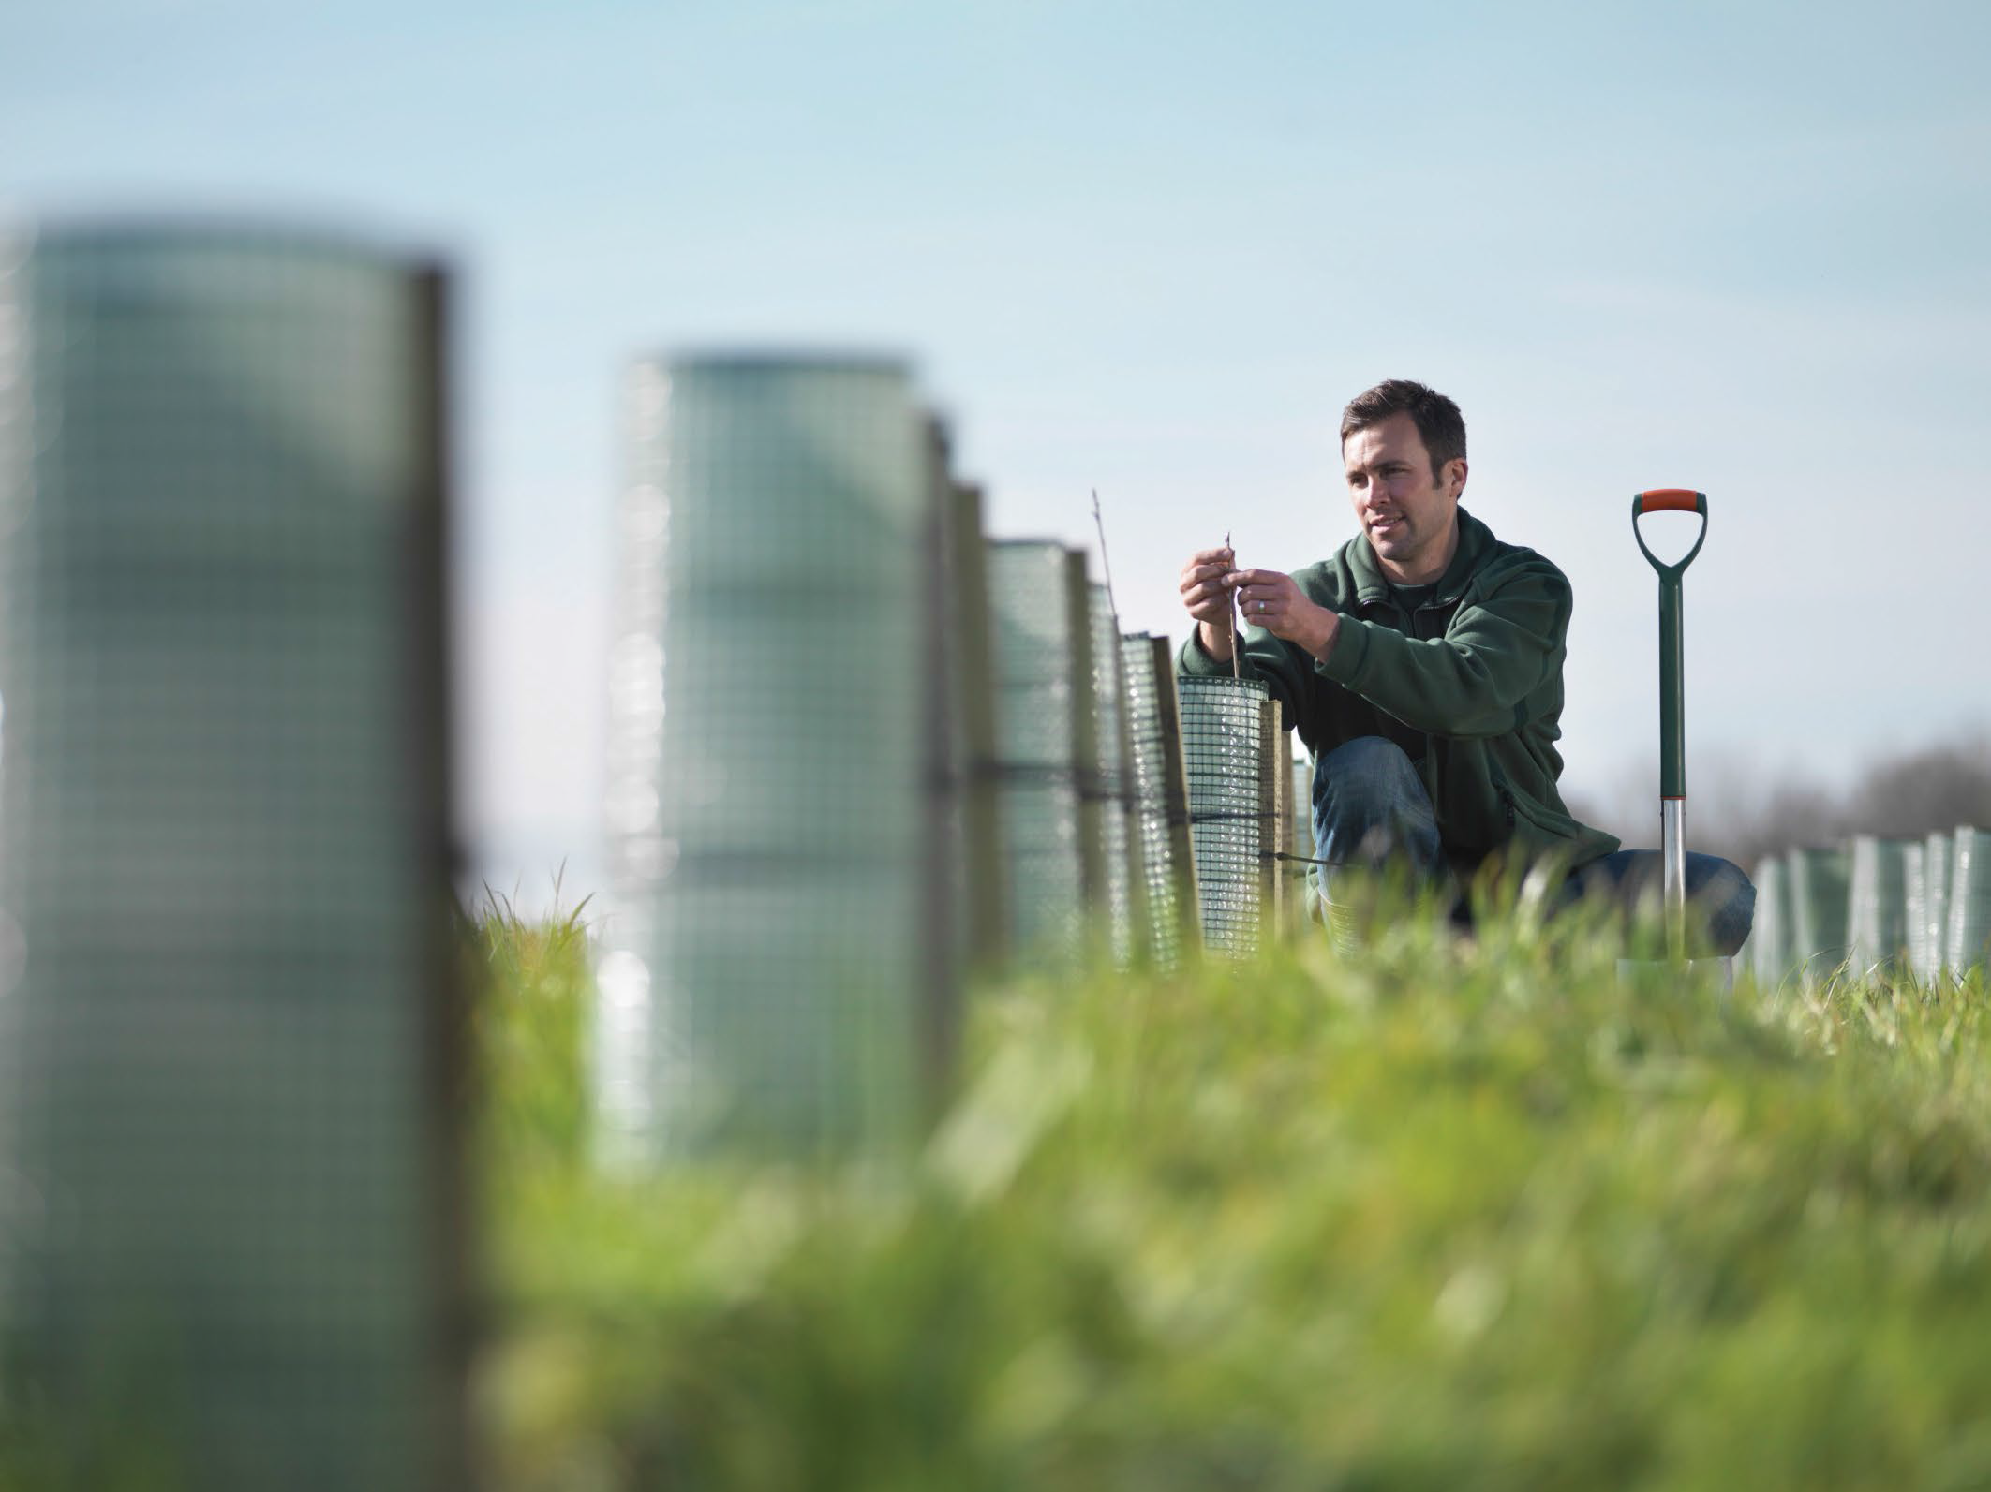
Farmer tending to young trees, Getty Images/Cultura RF
Map 3 Projects Supporting Better Practices Across Australia
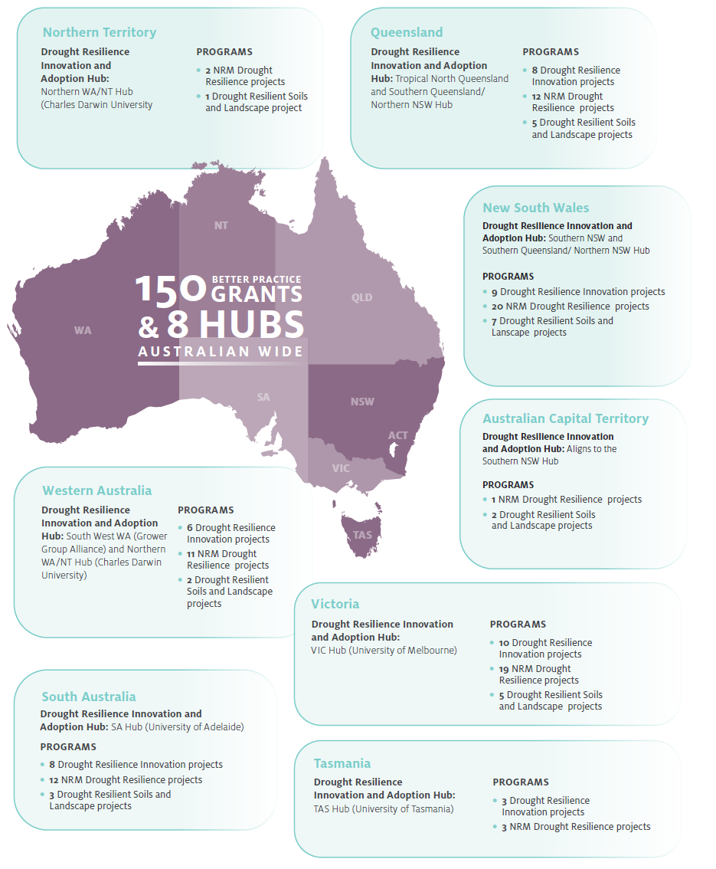

Drought Resilience Adoption and Innovation Hubs
In 2021-22, the eight Regional Adoption and Innovation Hubs focused on building hub partnerships as well as co-designing and implementing activities. On-ground projects are now underway.
The hubs are supporting primary producers in building drought resilience through activities to meet the unique needs of each hub region. Across Australia, activities in 2021-22 included:
- linking up farming groups, Landcare networks, universities and governments
- supporting adoption of drought resilience technologies and practices including through demonstration site projects and on-farm trials
- establishing extension activities such as workshops, field days, webinars and presentations to engage end users and foster drought resilience practices
- fostering peer to peer learning among primary producers and other stakeholders through workshops, farm visits, seminars, and other collaborative networks
- developing and testing commercialisation opportunities with stakeholders
- developing targeted communications strategies to promote projects and knowledge emerging from the hubs, and ways for regional farmers and communities to access resources to increase their drought preparedness
- forming First Nations forums and/or developing engagement frameworks to support inclusion
- leveraging the expertise and experiences of their diverse network of members and network partners for the benefit of their regions.
Hubs are focused on end-user needs and have conducted substantial consultation to develop each hub's regional priorities and to co-design new projects. Knowledge Brokers translate science into practice for farmers. They problem solve, share learnings, and collaborate with other hubs.
Adoption Officers are being onboarded by each hub to facilitate and support on-ground extension and adoption activities, and to drive uptake of new on-farm and local innovations for improved drought resilience. They will help identify and engage individuals who could benefit from the services and support provided by the hubs and share information on the many FDF opportunities.
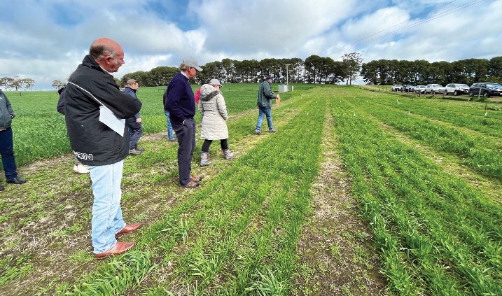
Hub Advisory Committee on a field trip with the South Australian Hub, Mr Dale Park and Emeritus Professor James Rowe OAM (left to right)
In 2021-22, 5 collaborative cross-hub projects were identified. Each project involves at least 2 hubs and their regions. The focus areas are:
- Drought resilience practices in mixed farming systems - Supporting cropping and livestock farmers across Victoria, South Australia and Tasmania in managing pastures and use of livestock containment and feeding systems for drought resilience.
- Modern soil moisture monitoring to improve irrigation management - Establishing on-farm demonstration sites at growers' properties in Southern Western Australia, Northern Western Australia, Northern Territory and Victoria. Growers will be supported by Irrigation Development Officers to build their capacity to strategically implement soil moisture monitoring and irrigation management.
- Fast tracking Western Australia and Northern Territory to align with nutritional feed base mapping technology advancements at a national level - Trialling and calibrating mapping technology on cattle stations and disseminating this information amongst the broader livestock industry in the Northern Territory. This project addresses research gaps by refining a suitable system to allow pastoralists to manage grazing pressure and better prepare properties for changing climatic conditions.
- Managing rangelands - Establishing at least 6 demonstration sites to showcase technologies and techniques that use mapping to improve rangeland management. Using digital precision mapping technologies at the property scale, each site will be analysed using property use and land condition tools to develop a plan for future management and infrastructure changes that could be implemented to improve drought resilience.
- Drought management for the health and longevity of perennial horticulture plants - Building strategies to ensure plant health and orchard/vineyard longevity are maintained through drought.
Since commencement, the hubs have also taken on additional work to support delivery of the National Agriculture Innovation Agenda (receiving funding of $20 million over 2 years) and the Regional Soils Coordinator Program (receiving funding of $3 million over 2 years). These initiatives are not funded by the FDF but leverage the infrastructure and networks that have been created by the hubs. This will see practical uptake of innovation by producers, stimulate collaboration in the agricultural innovation system and increase commercialisation outcomes.
CASE STUDY 4 - South Australian Drought Hub: Improving canola establishment in dry conditions
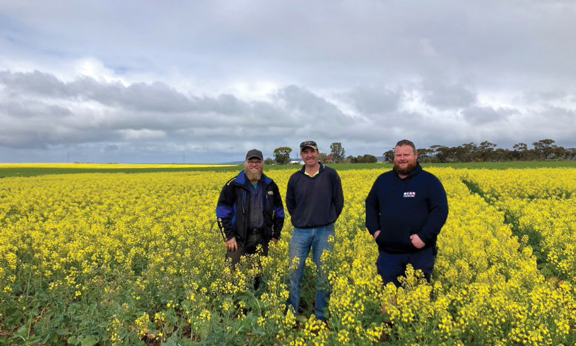
Adrian Bormann, Murray Plains Farmers Treasurer, Steen Paech, Murray Plains Farmers President, and Dan Seidel, Drought Resilience Research and Adoption Hubs Advisory Committee Member, at the canola establishment trial site near Palmer, South Australia (left to right). Photo credit: South Australian Drought Hub
'Break crops' of legumes or oilseeds such as canola, grown between cereal crops, can provide important additional income for farmers and support integrated disease and weed management. Sowing timing is a key consideration, with farmers often waiting for season-opening rains before planting these crops. In years when rains arrive late, growers may lose the opportunity to maximise a break crop's full potential.
In 2021, a delayed start to the season in the Murray Plains region meant many growers did not plant canola crops and missed out on selling into a booming market. Delaying canola planting until winter rains arrive is based on the perception that establishing crops in dry conditions presents unacceptable risks. To reduce these risks, growers need strategies for successful dry planting.
The Murray Plains Farmers, who are supported by the South Australian Drought Hub, established an ‘Improving canola establishment in dry conditions' demonstration trial in 2022. Murray Plains Farmers are a not-for-profit farming systems group covering the broadacre farming region between the Murray River and the eastern Adelaide Hills. The trial has been designed to support the specific needs of Murray Plains Farmers grower members, who often face dry starts to the growing season, and aims to develop improved approaches to managing canola in dry conditions. It is focused on dry seeding, as well as agronomic practices that maximise return on investment for canola crops.
'The trial results will improve growers' understanding of agronomic management practices such as time of sowing, fertiliser strategy and sowing rate', said MPF committee member Deanna Lush, whose farm provides the trial site. 'This will feed into strategies to improve canola establishment in dry conditions and ultimately underpin drought-resilient farming systems in low rainfall environments.'
The trial will also compare canola varieties to determine the best return on investment, and the knowledge gained will underpin drought-resilient farming systems in low rainfall environments.
Trial results will be shared with growers through a series of field visits and community forums.

National Enabling Activities
The FDF provides funding for a range of activities that will help farmers and regional communities build drought resilience through investments in collaboration, including greater information sharing.

Drought Resilience Research and Adoption Investment Plan
The development of a Drought Resilience Research and Adoption Investment Plan was commissioned in April 2020. Consultation and research was conducted during 2021-22 to better understand the various programs and projects being undertaken across large parts of Australia related to drought resilience. However, as a result of COVID impacts, the delivery of this component of the project was delayed. Whilst the outcomes highlighted potential gaps across the sector, it has been acknowledged that many of these gaps will now be addressed through the new FDF programs announced in March 2022. Any remaining gaps will be considered in the context of developing the next FDF Funding Plan and associated programs.

Knowledge Management
We engaged the Nous Group Pty Ltd to conduct a scoping study on a possible future drought resilience knowledge management system. This project engaged with key stakeholders and analysed over 250 drought and climate information sources and 90 tools. Three key observations were made:
- The drought resilience knowledge ecosystem is complex with numerous existing methods of sharing drought resilience information and knowledge.
- There are significant opportunities to improve the creation and sharing of drought resilience information, knowledge and tools.
- Primary producers prefer to acquire knowledge from trusted sources, either peer-to-peer or through intermediaries.
The report was delivered on 5 August 2022 outlining possible future directions for a knowledge management system, with options to improve information management, sharing and flow.

First Nations Engagement
First Nations people have a unique connection to country, strong cultural knowledge, and ways of managing the land for drought resilience that dates back thousands of years. The FDF acknowledges the impact drought has on First Nations people and is committed to delivering outcomes through the National Agreement on Closing the Gap.
In 2021-22, the FDF commissioned advice by Terri Janke & Company Pty Ltd and Murawin Pty Ltd to provide advice on culturally appropriate engagement as well as gaps, barriers and opportunities for First Nations peoples' resilience and innovation in rural and remote communities.
The advice includes considerations such as education, trust, land and water, resourcing, governance, structure and community wellbeing. Research, development, extension, adoption and commercialisation priorities, specific to the needs of First Nations people have also been identified as they relate to each of the Drought Resilience Adoption and Innovation Hubs.
Looking forward there is opportunity to deliver on the recommendations of these projects while continuing to embed the perspectives of First Nations people into policy and program design through collaborative partnerships and community led consultation. This is an area of focus for future FDF work.

Science to Practice Forum
From 7-9 June 2022 the second Science to Practice forum was held, featuring a mix of interactive, online and in person events in regions across Australia. Participants heard from the 8 hubs about their work to support the development and adoption of drought resilience practices and technologies. Presenters including farmers, economists, natural resource management organisations and First Nations knowledge holders explored the economic, environmental, and social aspects of building drought resilience. Strong attendance and participation rates as well as overwhelmingly positive feedback indicate that the forum continues to increase the availability and accessibility of drought resilience knowledge and uptake by end users. The next Science to Practice Forum will be held from 6-8 June 2023.
Key statistics | Feedback
- 550 participants  - 26 presentations  - 4 panel discussions  - 7 fields trips  - 871 participants comments submitted online | 'The forum highlights that community resilience to drought is not only about on farm and farmer resilience. Advisors, service providers and local government are all impacted. Agriculturally dependent communities also require strategies to build independence from the seasonal impacts on the economy and community.¹  'Fantastic presentation on the localised approach for young farmers - look forward to following the progress of this project.'  'Great to learn of the breadth of work across the country and plans for the future.'
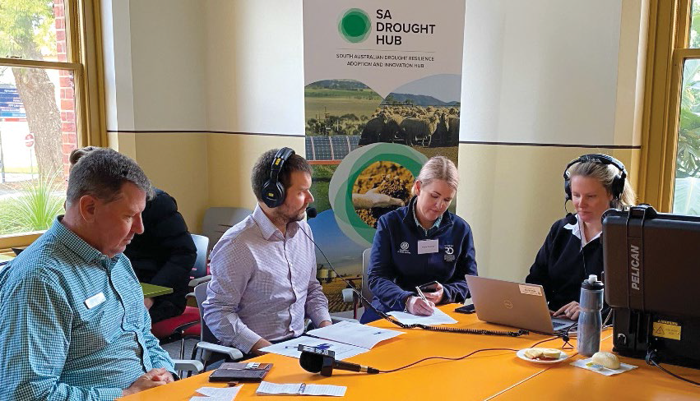
ABC Country Hour live broadcast from the South Australia hub Roseworthy forum viewing location
'The focus of the hubs is very much working with farmers, with farming systems groups to allow them to implement projects that are co-designed with service providers, with researchers to translate those research outcomes that we have, like places here at Roseworthy Campus, into real world change in farming systems.¹
Steven Lee - SA Hub Director, speaking on ABC Radio SA, as part of the Science to Practice Forum

Drought Resilience Innovation Grants
The Drought Resilience Innovation Grants Program supports projects that will drive the development and adoption of new and innovative technologies and practices to improve the drought resilience of Australian farmers and agriculture-dependent communities. A variety of projects are being supported at different stages of development, including early-stage proposals, feasibility testing for new products, processes and services and large-scale innovation projects.
Substantial interest was shown in the competitive program and 46 grants were awarded totalling $28.93 million in March 2022. This consisted of 15 Innovation Grants, 8 Proof-of-Concept Grants and 23 Ideas Grants. Two projects have since ceased.
The funded projects are diverse and encompass activities such as: harvesting atmospheric moisture; using irrigation management technology and livestock ranking strategies; trialling diversified vegetation cover; demonstrating different crop rotation cycles; developing digital tools to support decision making ahead of droughts; and using behavioural science approaches to building drought resilience.
CASE STUDY 5 – WaterSmart Dams: Making dams work again
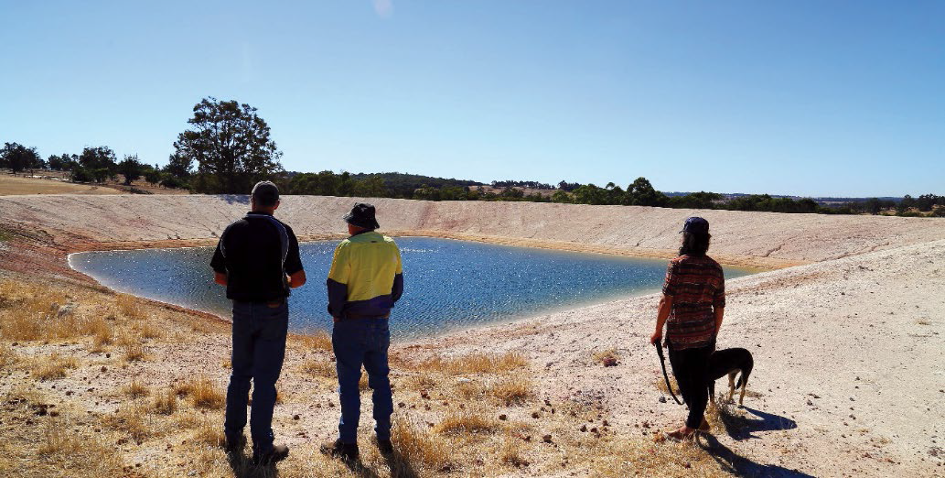
Dr Richard George from the WaterSmart Dams project (left), with farmer and grower group representatives
at a West Kojonup farm dam, discussing how decreasing runoff is reducing dam effectiveness.
Photo credit: Associate Professor Nik Callow, The University of Western Australia
South-west Australia's wheatbelt produces a significant portion of Australia's annual grain harvest, despite a drop of more than 20% in annual rainfall since the 1970's. Its farmers are amongst the world's most productive, but they need more help to better understand how their dams can function in dry years.
That's where the WaterSmart Dams: Making dams work again project comes in.
Led by the Grower Group Alliance, WaterSmart Dams received funding of $3 million over 3 years from the Innovation Grant program and $1 million from the West Australian state government.
'The South-west West Australian Hub is all about collaboration and getting important projects off the ground. Our core goals and project focus are exemplified by this project and its sister program WaterSmart Farms, which address farmers’ critical water security needs’, hub Director Mark Holland told the FDF Science to Practice Forum in June 2022.
WaterSmart Dams, in partnership with regional grower groups and researchers, is investigating solutions to understand how to make dams function in dry years, including codesigning new farm water planning tools to help farm businesses and regional communities become more water- efficient, resilient and profitable, in even the driest years.
Project partners are Compass Agricultural Alliance, Southern Dirt, Merredin and Districts Farm Improvement Group and the Fitzgerald Biosphere Group. Researchers are from The University of Western Australia and the Department of Primary Industries and Regional Development.

Natural Resource Management Drought Resilience Program
The Natural Resource Management (NRM) Drought Resilience Program was the first FDF program to provide funding for the trial and adoption of on-ground practices that contribute to drought resilience.
The program was rolled out through 2 streams and projects were implemented throughout 2021-22 across all states and territories, reaching hundreds of people.
- Fourteen landscapes projects were supported to the value of $5.6 million, to assist regional NRM bodies to promote and implement transformational approaches to improve the management and drought resilience of natural resources and agricultural landscapes.
- A further 66 grants worth a total of $7.8 million were also awarded to organisations, farmer groups and individuals to build drought resilience in agricultural landscapes through management of natural capital.
Each project plan contains baseline information and targets for change in land management practices. Examples of the practices and approaches that were trialled under these projects include: novel approaches to grazing management; groundcover and soil monitoring and management; use of native shelterbelts; and rehabilitating farm dams and riparian areas. Individual projects varied as to their planned outreach to stakeholders. Some have focused engagement at catchment scale, with a small number of adjoining landholders. Others have held large regional extension or industry-focused events.
By 30 June 2022, 35 projects across the 2 streams were completed. The remaining 45 projects have been extended beyond 30 June 2022 due to the impacts of COVID-19, floods and other adverse weather conditions. The combination of these factors has delayed the ability of some grantees to complete activities and to measure, monitor and evaluate their projects. It is essential that our grantees be given the time and space to see projects through to completion as originally planned if they are to observe and report on drought resilience improvements.
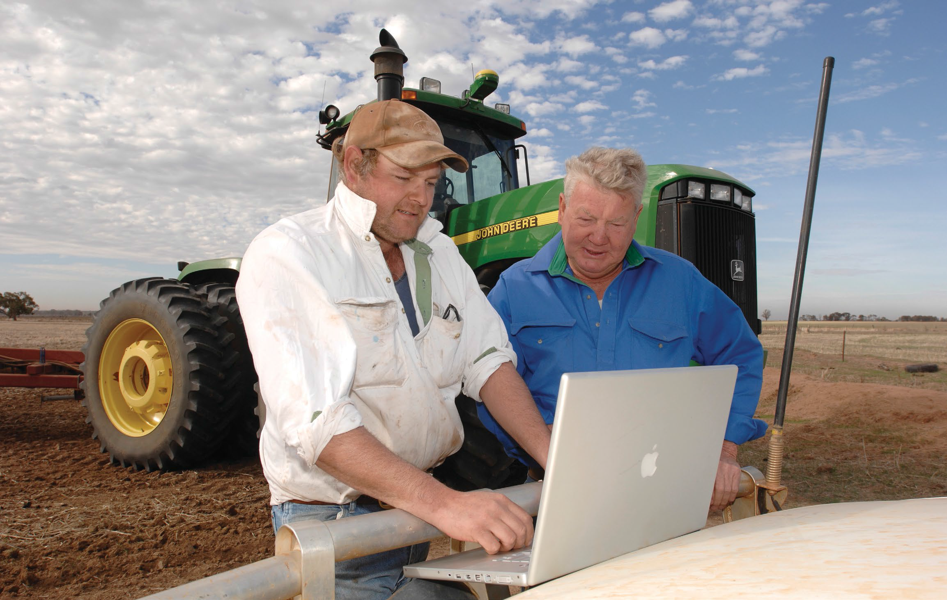
Two farmers facing computer with field and tractor in background, Department of Agriculture, Fisheries and Forestry
CASE STUDY 6 - Building drought resilience in the Australian Capital Territory
Healthy farm dams and riparian areas greatly benefit the properties that host them, and the broader landscape and biodiversity around these properties.
Through our NRM Drought Resilience Program – Landscapes stream, the ACT Government has established a project to assist landholders in reconsidering how they manage their dams and riparian areas.
The project is rehabilitating 8 farm dams and 5 km of Naas Valley river frontage for interstream erosion control, biodiversity conservation and improvement of water quality and stock health.
The rehabilitated dams are being used to demonstrate to landholders that by enhancing a farm dam, the water retention and quality in that dam can be dramatically improved, and simultaneously turned into a refuge that form part of wildlife corridors across the broader landscape.
The Naas River catchment was chosen as the primary location to demonstrate the positive effects that come from riparian areas restoration. Brian Butlerkemp, the project manager at the ACT Government, noted that the catchment was chosen due to its history with harsh environmental conditions, saying
'The area was hit hard in the drought followed by the fire, then the rainfall. And then it had years and years of typical European farming practices. It's a small area so it is the perfect location to solve a few problems and then to see some direct results',
John and Carol Lilleyman own 'Amberly', one of the 8 properties involved in the dam restoration project. Enhancing their farm dams has proved successful for the family, who have cattle and pastured chickens on their property. The Lilleymans are now enjoying the benefits of improved stock health, land health and on-farm biodiversity, saying
'Part of rebuilding the environment around a dam is to allow water to be cleansed by the plants and [other living organisms] in the dam. Turning the dam into a great habitat will attract more species of everything back to the dams. We are improving herd health and by improving stock health, improving productivity’.
The project is a successful partnership with landowners, not-for-profit conservation groups, Landcare and citizen scientists. It is a great example of the benefits that come from leveraging networks of stakeholders to achieve landscape-scale drought resilience.
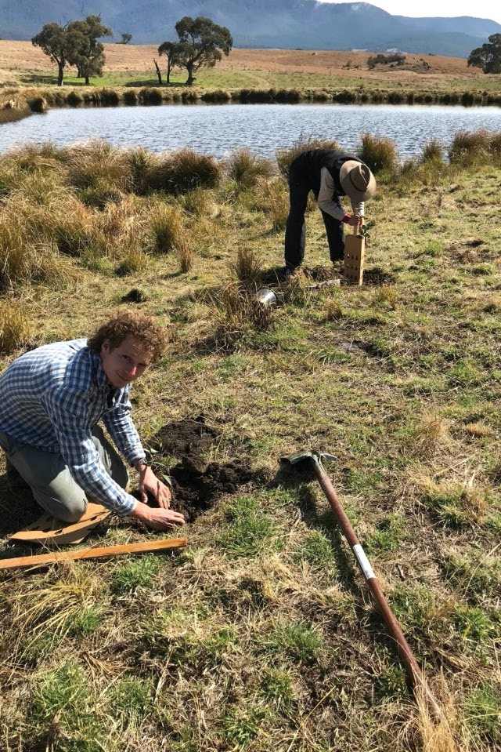
Volunteers planting trees with Landcare ACT as part of the Farm Dam Restoration project. Photo credit: Sally Holliday, ACT Landcare

Drought Resilient Soils and Landscapes Program
In April 2022, 26 projects were announced under the Drought Resilient Soils and Landscapes Program at a total value of $23.1 million.
The program builds on the foundational NRM Drought Resilience Program, and the practices that were trialled under it. The program specifically aims to trial and demonstrate how scaling of practices (or combinations of practices) to improve management of natural capital, which underpins productivity and profitability of the land, can build drought resilience.
Another key feature of this program has been supporting partnerships between various stakeholders to achieve and measure impact at scale. The program seeks to create and communicate an evidence-base and case studies that contribute to scaling out the successful practices.
Activities under the program have commenced and will be reported in the next annual report. Projects include:
- integrated groundcover and soil management
- landscape rehydration
- regenerative grazing management
- trialling combinations of native shrubs and perennial pasture species and sowing times
- rehabilitation of farm dams and riparian areas.
Many projects will use innovative technology, for example to forecast weather conditions and estimate pasture and livestock conditions for many months in advance. These tools will support timely decision making for cropping or grazing management ahead of droughts. Many field days, workshops and demonstration sites are planned, as well as focused engagement with smaller groups across the 26 projects. Digital communication will also enhance the reach of this program.
A robust monitoring, evaluation and learning plans are being developed with grantees, with baseline information and targets set to ensure project deliverables can be reported.
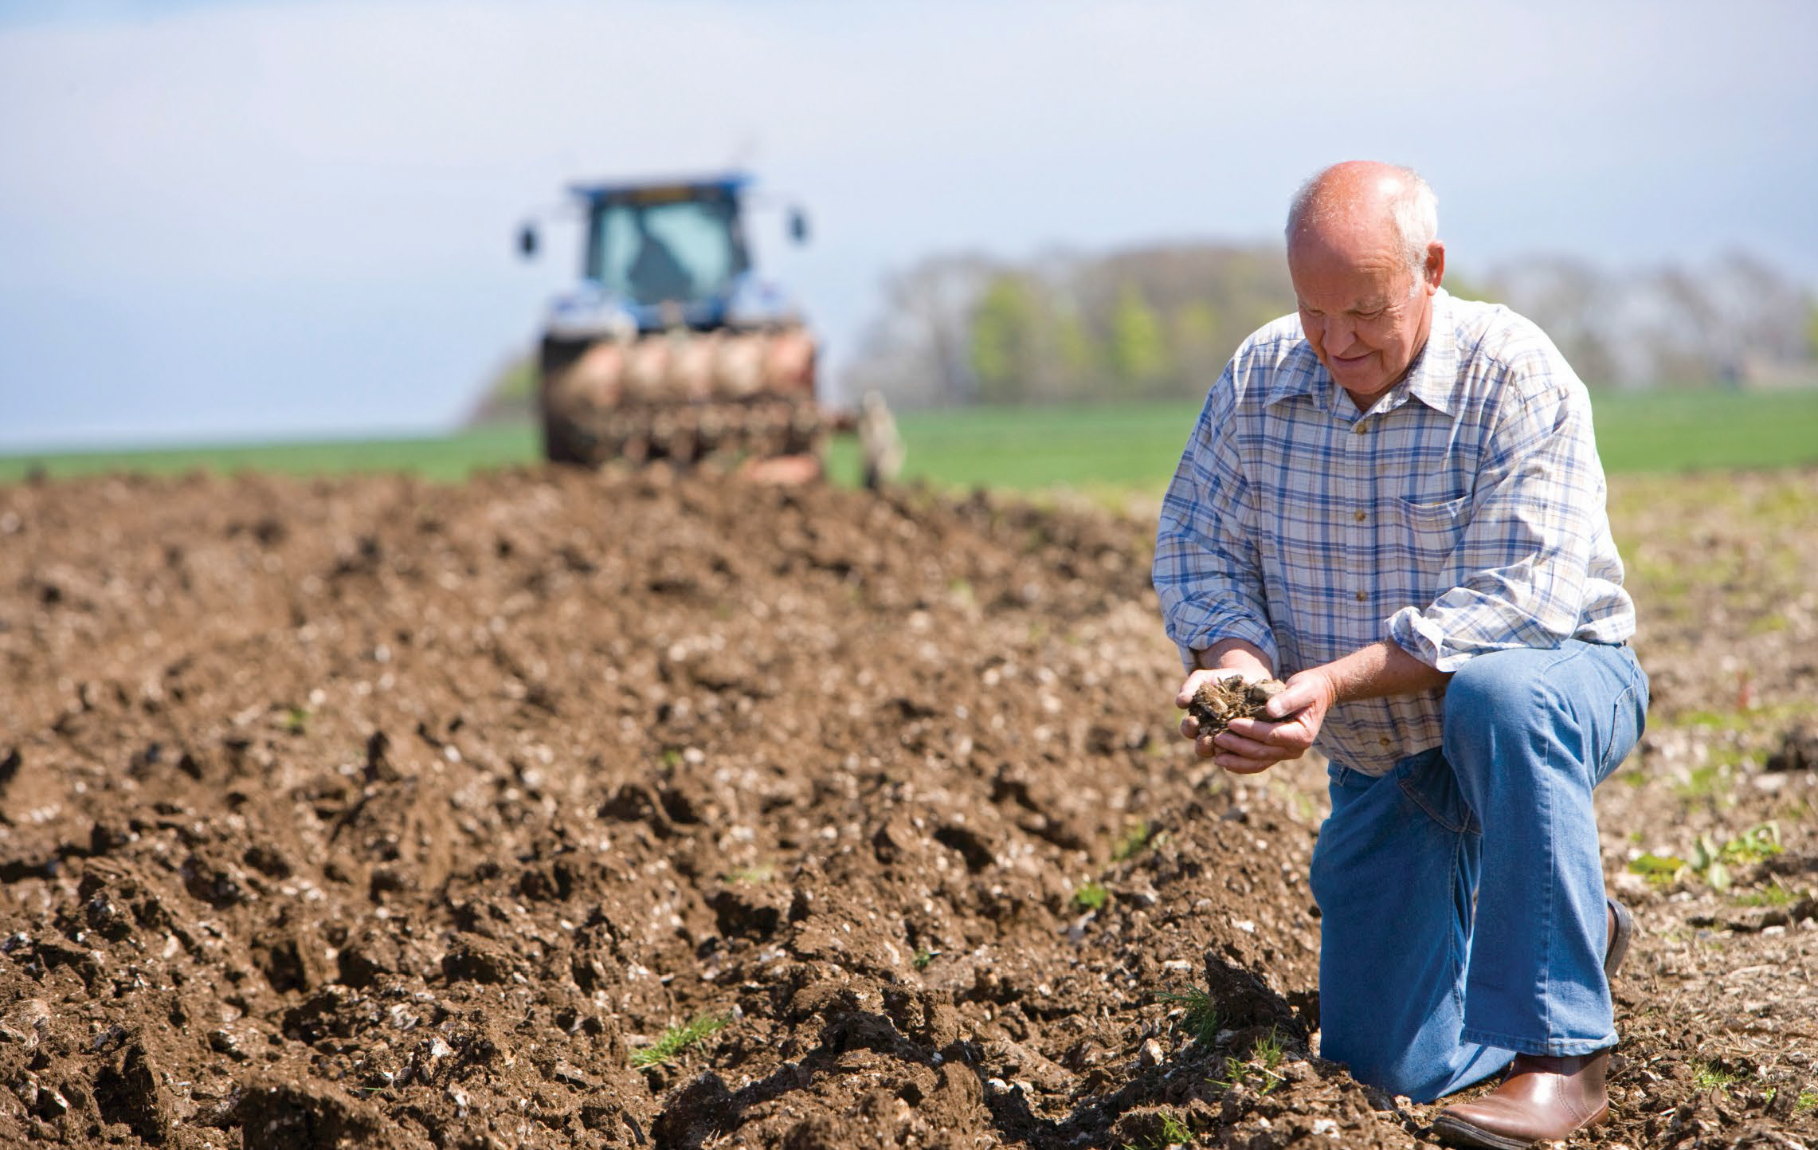
Farmer cupping soil in field with tractor and plough in background, Getty Images/Cultura RF

Future Work: New Programs Announced
In conduction with the 2022-23 Budget, an additional $94.5 million was committed to address identified gaps and opportunities and build upon foundational programs.

Long-Term Trials of Drought Resilience Farming Practices
Over the next 6 years (2022 to 2028) $40.0 million will be invested to support the establishment of a national network of drought resilience farm laboratories and conducting trials of new drought resilience farming practices.
The trials will test drought resilience practices over the long term and in 'real world' conditions, to provide farmers with the confidence and information they need to try the practices themselves. The program will operate as a hub and spoke model, with central laboratories complimented by satellite sites on commercial farms. Each laboratory will trial a farming practice, or set of farming practices, specific to a certain agricultural commodity and region.
An advisory panel has been set up to assist in identifying the types of farming practices to be trialled. Co-design with a range of partners, including Research and Development Corporations, hubs, state and territory governments, industry groups, researchers and farmers, are central to the success of the program.

Grants to Support the Adoption of Drought Resilient Practices
A new $14.3 million grants program will support adoption of proven drought resilient farming practices and technologies, based on existing Australian and international research and development. The projects will need to be focussed on driving adoption at a large scale, either across multiple farms, a farming system, landscapes, regions or industries.
This new grant program is an evolution from the Drought Resilience Innovation Grants Program, during which significant interest was demonstrated in mobilising drought resilience practices.
The program will provide grants up to $3.0 million to eligible Australian entities and is expected to launch in late 2022.

Drought Resilience Commercialisation Initiative
The Commercialisation Initiative is a $10.0 million investment to help innovators turn their good ideas into commercially viable, drought resilient products and services.
The aim of the pilot is to work with innovators while they commercialise their drought resilience product or service. Through a facilitator, the initiative will offer one-on-one facilitation services, commercialisation planning and funding for specialist activities, as required to increase their market readiness.
The pilot will seek to:
- prove the impact of public funding in drought resilience commercialisation
- increase the commercial viability of a participant's product or service
- gather feedback through participant evaluation to inform future policy development.

Drought Resilience Scholarships
The Drought Resilience Scholarship Program was developed to support leaders and innovators and drive a continued focus on drought resilience. Up to $1.6 million has been committed over 2 years to support new scholarships. Scholarships will recognise and reward innovators and leaders in the field of drought resilience and encourage ongoing learning and uptake within the agriculture sector.
The program builds on the success of the Drought Resilience Leaders Program and the connectivity fostered by the annual Science to Practice Forum, and forms part of Nuffield Australia's prestigious annual program for primary producers.
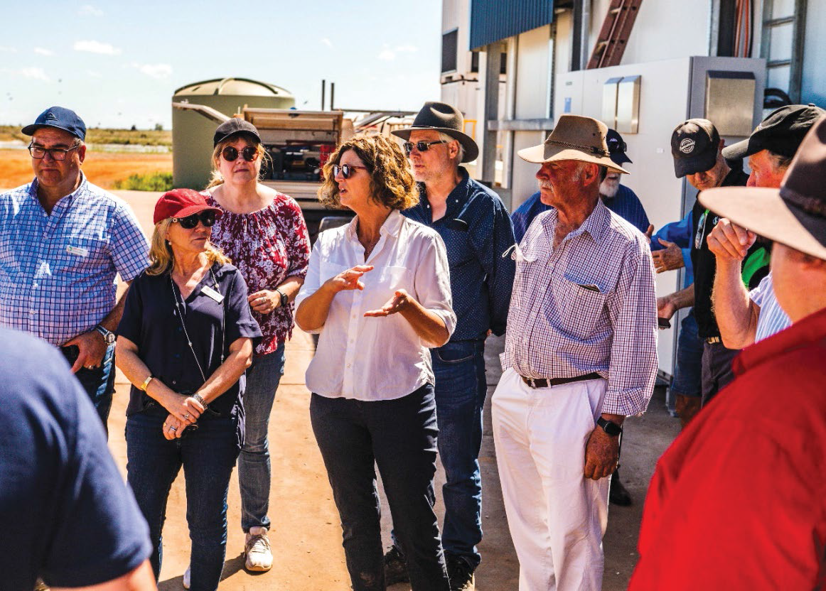
Ms Caroline Welsh (white long-sleeve), Hubs Advisory Committee and FDF Consultative Committee Member, speaking to the group during the Darwin visit.
Photo credit: Patch Clapp/Northern Hub

Better Prepared Communities
Building and supporting the community leaders, networks and organisations that underpin community resilience
Objectives | Program information
The strategy | Establish and support a national cohort of community leaders, networks, mentors and organisations to drive action on drought resilience in their community
What are we trying to achieve? | Communities have the capabilities and motivation to drive action to plan and prepare for drought
How will this support drought resilience? | Community leaders, mentors, networks and organisations play a key role in driving changes in drought preparedness attitudes and action, and supporting people in times of drought
How will we assess whether it is successful? | Overall success measures  - There is an increase in the reach and activities of community leaders, mentors, networks and organisations driving action on drought resilience (RC 1)  - There is a change in awareness of and attitudes to drought preparedness at the community level (RC 2)
Progress and performance
2020-21 results | 2021-22 results | 2022-23 measures | 2023-24 measures
Partnered with the Australian Rural Leadership Foundation to develop a program to build leadership and mentoring networks  Met, see 2020-21 annual report  Partnered with the Foundation for Rural and Regional Renewal (FRRR) to design programs to support community networks and organisations  Met, see 2020-21 annual report | (RC 1) Numbers, types and reach of people trained, mentored, mentoring or engaged in other activities  Met, see assessment below  (RC 1) Numbers and types of community capacity building and engagement projects  Met, see assessment below  (RC 2) Baseline assessment of awareness, attitudes, and sense of preparedness (survey)  Met, see assessment below | (RC 1, RC 2) As in 2021-22  (RC 1) Evaluation: evidence that program activities have increased capacity where gaps existed  (RC 1) Evaluation: evidence of communities planning to manage drought risk  (RC 2) Evaluation: evidence of behaviour change/action (e.g. income diversification) | (RC1, RC 2) As in 2022-23  (RC 1) Mapping of gaps  (RC 1) Evaluation: evidence of impact from programs, and testing the theory of how this occurs  (RC1, RC 2) Revision of program approach
Note: The FDF Annual Report 2020-21 previously reported the above program information and metrics under the theme of ‘More resilient Communities'. The program information and metrics have not been otherwise altered.
Key achievements 2021-22
Key achievements | Next steps
More than 530 people involved in a national mentoring network | Launch of the extended and integrated Helping Regional Communities Prepare for Drought Initiative, with activities launched in August 2022
93 projects underway nationally to strengthen the role of community organisations and networks in preparing for drought | An integrated package of leadership and grant support for community networks in 35 regions across remote, rural and regional Australia
246 people across 9 regions supported to take on drought resilience leadership roles, with 55 of them accessing Community Extension Grants to implement activities within their community | Drought preparedness support for individuals and community organisations outside of the 35 regions through small network grants and mentoring opportunities
 | A National Learning Network to connect up individuals, organisations, and communities so that they can continue to learn from and support each other's drought preparedness efforts
Commencing in 2020, the Drought Resilience Leaders and Networks to Build Drought Resilience Programs sought to build the capacity and capabilities of community organisations and individuals to support drought preparedness at the local level. In March 2022, the government announced an additional $29.64 million to extend and better integrate these programs into the Helping Regional Communities Prepare for Drought Initiative. The refocused initiative commenced in 2022.
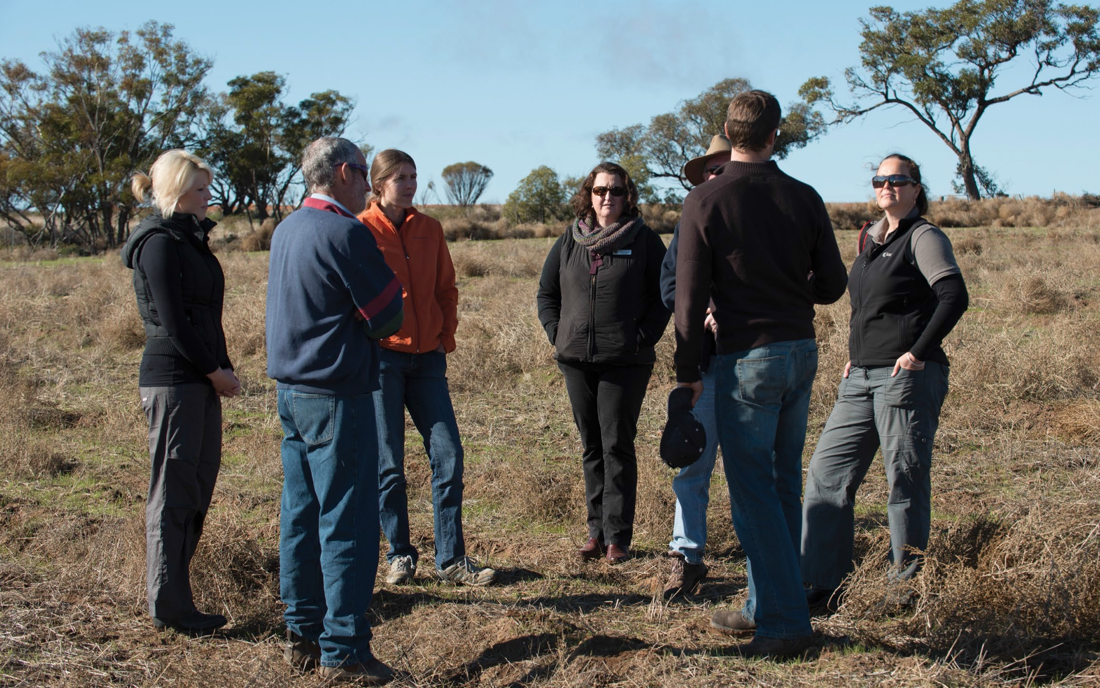
Delegation of NRM visitors at trial site. Photo features Jen Vincent, Greg Richards, Amy Davidson, Lisa Jane Clark, Nathan Phillips, Michael Grasby and Tracy Hobbs (from left to right).

Networks to Build Drought Resilience
The Networks to Build Drought Resilience Program seeks to build the capacity and capability of community organisations and networks to support drought preparedness. This program is delivered by the Foundation for Rural and Regional Renewal (FRRR).
In 2021-22, the program supported 93 projects for community organisations to build their capacity and capability, hold community events and strengthen ties across community networks. Grants were awarded across every state and territory and included funding for several First Nations organisations as well as projects to benefit rural youth and women.
Project highlights included farmers building new connections in their local region through drought and climate resilience workshops, and young farmer and women focused events, which built drought awareness and strategies to address local issues.
In addition to FDF grant funding, the program leveraged almost $4.50 million in philanthropic donations and in-kind contributions, bringing the total program value to $7.73 million.
The program concludes in late 2022, with all projects finishing by 31 December. Analysis of program reach, participation and engagement will be conducted once all projects are finalised and will be reported on in our next annual report. No new grants will be awarded in 2022-23.
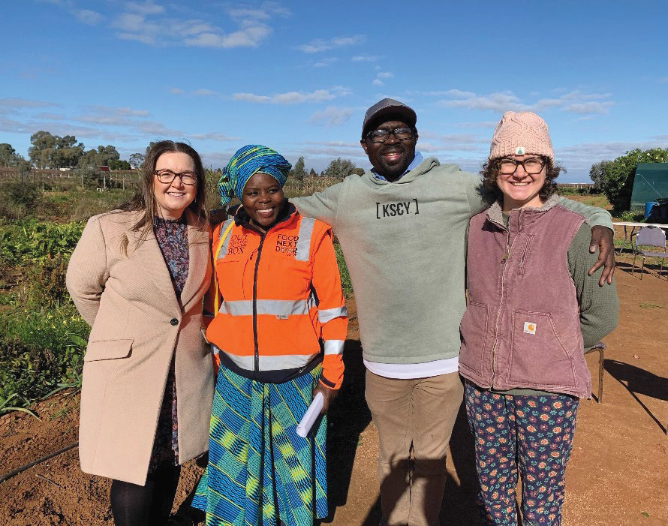
Foundation for Rural and Regional Renewal staff with team members from the Food Next Door Co-op project, which received funding in 2021-22 through the Networks to Build Drought Resilience Program.
Photo credit: Food Next Door and Foundation for Rural and Regional Renewal
CASE STUDY 7 - Supporting our region's next leaders
Through funding provided in 2021-22, the Red Earth Community Foundation hosted the Red Earth 'Cultivate our Future' leadership forum in Murgon, Queensland.
Delivered by the FRRR through the FDF's Networks to Build Drought Resilience Program, the inaugural forum aimed to create opportunities for the Burnett Inland community to take an active part in creating solutions for the future.
The leadership forum was the first region-wide forum of its type and encouraged participants to connect and contribute to building resilience in the Burnett Inland. The initiative featured guest speakers, panel discussions and workshops.
The event's panel of national thought leaders included Natalie Egleton, from FRRR; former State and Federal MP Prof. Dr John McVeigh, the executive director of the Institute for Resilient Regions; Bega Cheese executive chairman Barry Irvin and Dr Chad Renando, from the Rural Economies Centre of Excellence.
Red Earth Community Foundation Chair, Georgie Somerset said that 'people in the Burnett Inland are exceptionally community-focused and events such as this bring together like-minded people’.
'You can only build resilience one person at a time. People must own their future. A resilient community is one that works together through the good and tough times', she said.
'Resilient communities are those that have the internal connectivity between people so that they can solve their challenges and know where to find the information to become resilient’.
The region knows a thing or two about resilience, after recently coming out of an extended drought period and then experiencing multiple floods.
'Our community is highly skilled at adapting to the environment around us and we can codesign the future together’, Georgie explained.
The forum was an extension of the established Red Earth Community Leadership Program, which has more than 200 alumni in the local region.
New and established local leaders took part in sessions across the day and attendees walked away with actions and felt empowered to take ownership of their resilience and their communities' resilience.
The successful event will make a return in 2023, visit https://www.redearth.org.au/ for more information.
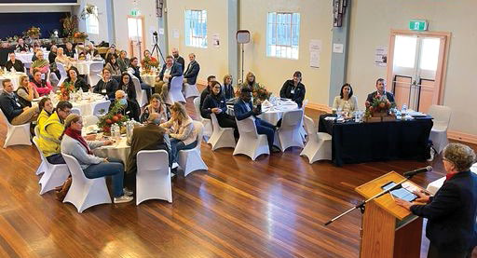
Georgie Somerset, Red Earth Community Foundation Chair presenting at the leadership forum.
Photo credit: Red Earth Community Foundation

Drought Resilience Leaders
The Drought Resilience Leaders Program provides opportunities for individuals from agriculture-dependent communities in 12 regions to gain leadership knowledge and skills to support their communities to meet the challenges arising from drought and a changing climate. This program is delivered by the Australian Rural Leadership Foundation (ARLF). See Map 4 for the 12 regions supported by this program.
To 30 June 2022, the ARLF delivered leadership programs to 246 people in nine regions. Leadership development courses across the final three regions were rolled out later in 2022, with results to be reported next year. Participants learnt and shared knowledge across personal and community leadership, climate resilience and collaboration skills in order to work with their communities to prepare for the impacts of drought. COVID-19 posed some challenges with courses adapting to a mix of in-person and virtual sessions.
Participants in the leadership development course were also eligible to apply for Community Extension Grants, giving them an opportunity to apply the skills and knowledge developed through the course. Participants could elect to work on a community initiative individually, or collectively with some of their leadership cohort. In 2021-22, 55 participants took up the opportunity, implementing 23 projects valued at a total of $220,000. These projects included workshops for women in rural communities and community field days to discuss drought adaptation strategies at a local level, and a community garden which brought community members together to share skills and experiences while tending to a communal facility.
A third and final round of Community Extension Grants was awarded in the second half of 2022 and will be reported on in our next annual report. The program will conclude in December 2022.
A further 537 people were involved in the National Mentoring Program component of the Drought Resilience Leaders Program. Participants shared knowledge and skills to build resilience in their communities. Another key aspect of the program was a series of 6 development webinars, designed to challenge thinking, provide new ideas, and introduce new skills and knowledge.
Drought Resilience Leaders Mentoring Program Participant Quotes
'The program is an inspired way of trying to tackle drought without it being a handout. It sets up a social fabric and you can’t get much better than that can you?
'The program is enabling a whole bunch of people to solve their own problems, rather than relying on government to solve problems for us - it’s people power for us.’ Lisa Anderson (Mentor)
'To have resilience for any business requires agility and having both the ability and openness to apply different practices or manage things in a way that you wouldn’t normally do or haven't done before.'
'Resilience can come from being connected with your industry and community. This connection allows us to understand what practices and processes have worked elsewhere in similar conditions and to share decisions that may benefit others.' Allister Clarke (Mentee)
'When we go through adversity there is such a need for people and communities to get together and talk about the ups and downs and how we get through them together. '
'I want to contribute to the greater good of our industry, share what knowledge I have, and see other leaders emerge within horticulture.’ Andrew Bulmer (Mentor)
Map 4 Drought Resilience Leaders Across Regional Australia
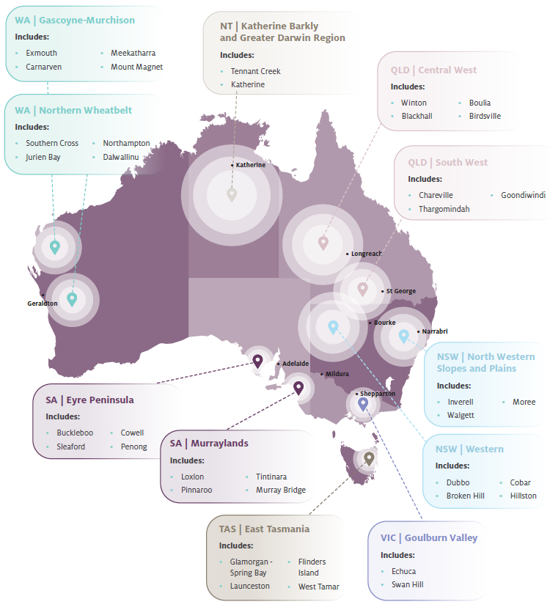
CASE STUDY 8 - Good leadership will take us out of our comfort zone
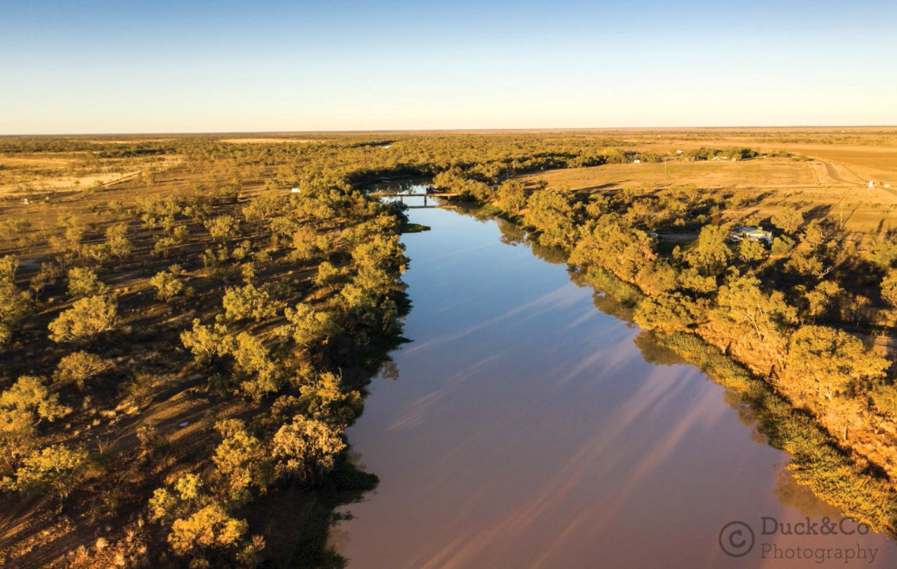
Phil's hometown of Longreach, Queensland. Photo credit: Duck & Co Photography
After 37 years in various roles, Phil Kuhne knows a thing or two about emergency and disaster management. The Longreach resident currently works with Queensland Fire and Emergency Services as an Emergency Management Coordinator.
Phil explained that his 'main role is to provide disaster management training, advice and support to local government, state agencies, nongovernment organisations and the community'.
Phil is a participant of the FDF's Drought Resilience Leaders Program in Central West Queensland and joined the program to expand his perspective of resilience.
'In my work there is resilience to a whole range of disasters and events that may impact a community. In the beginning [of the program], I thought the term 'drought resilient' was focused on the agricultural industry in the area. As the program developed it became apparent it was more about drought resilient communities not just agriculture', Phil said.
The program challenges participants to develop skills and mindsets to allow them to integrate deeper into their community in a leadership capacity.
'It has provided me with more people to engage with, whether it be for work or just social interaction in a small community. This leadership opportunity enables me to assist the community with the skills I have' Phil continued.
Phil explains that leadership within a regional community involves identifying new ideas and providing encouragement, coaching and mentoring for those willing to have a go at something new.
Phil reflected that 'It [building resilience] is looking at a community and identifying the ways they respond to and manage an event and finding pathways back to a life where they can function freely without the hindrance of drought or other disasters'.
Since completing the program, Phil and many others are now prepared to go back to their communities and grow their capacity to adapt to future challenges.

Future Drought Fund Administration
Strong governance arrangements are in place to support the effective administration of our programs.
Figure 8 Future Drought Fund Administration
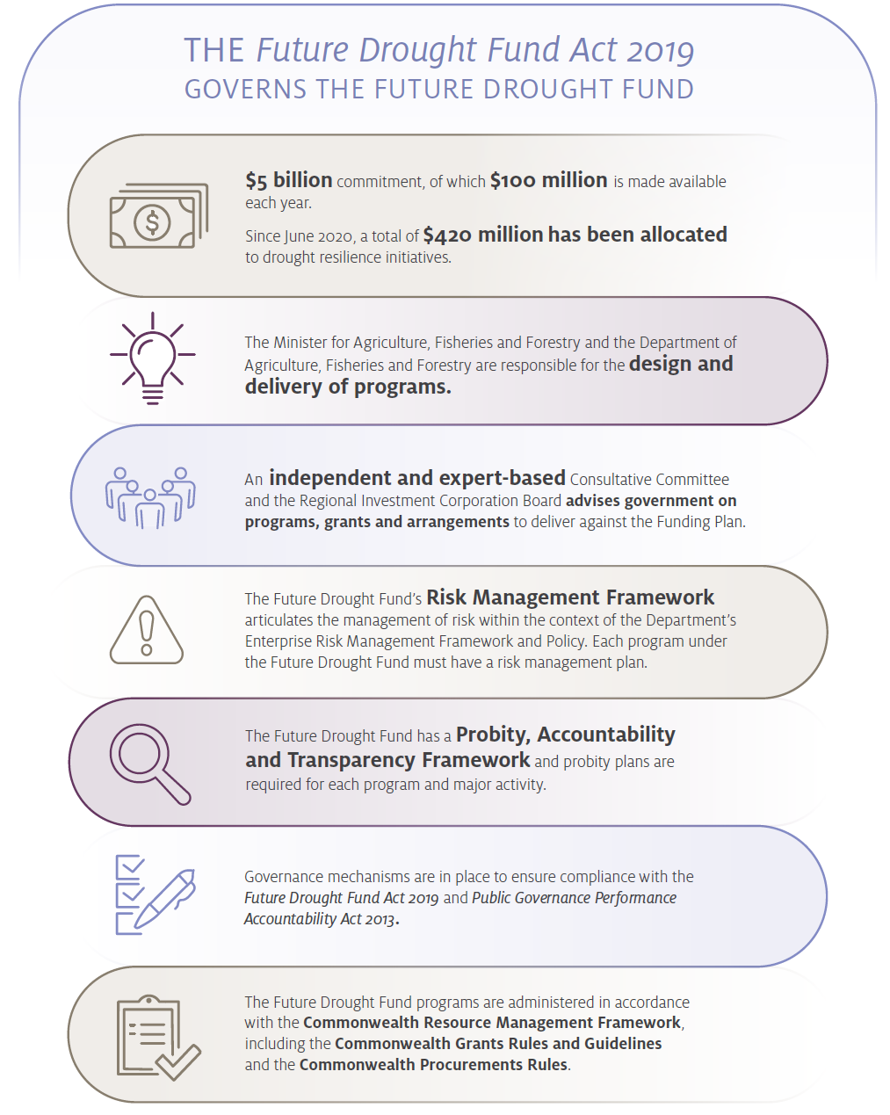

Governance

The Future Drought Fund Consultative Committee
Under the Future Drought Fund Act 2019 (FDF Act), the Minister must seek advice from the independent, expert-based FDF Consultative Committee on whether the design of each new program is consistent with the Funding Plan.
The Consultative Committee is chaired by Mr Brent Finlay and includes Dr Kate Andrews, Dr Wendy Craik AM, Dr Elizabeth Peterson and Ms Caroline Welsh as committee members.
In 2021-22 the Consultative Committee met 11 times to primarily discuss the design and delivery of FDF programs and their consistency with the Funding Plan. The committee has also been focused on the progress being made towards achieving the Funding Plan's strategic priorities and objectives, as well as stakeholder engagement, risks to FDF delivery and management strategies.
The committee, primarily through its chair, also meets regularly with stakeholders to discuss the FDF and hear a wide range of feedback on its activities to date.

Drought Resilience Research and Adoption Hubs Advisory Committee
Mr Brent Finlay also chairs the Advisory Committee. The other members are Caroline Welsh (also a member of the FDF Consultative Committee), Emeritus Professor James Rowe OAM, Dale Park, Trent De Paoli, Dr Christine Pitt and Professor Bronwyn Harch.
In 2021-22 the committee met 9 times to discuss and provide advice on the Drought Resilience Adoption and Innovation Hub activities and projects. The committee has focused on key strategic risks, performance, monitoring and evaluation activities as well as adoption and commercialisation pathways. In the second half of 2021-22 the committee commenced meeting at hub locations to connect with hub staff and stakeholders.
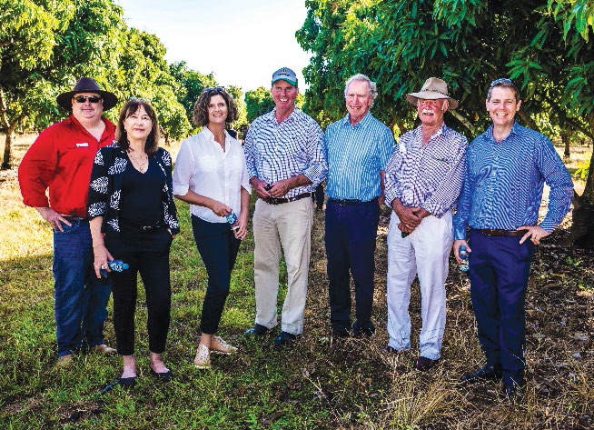
Hubs Advisory Committee and Northern West Australian and Northern Territory Hub Director during a Darwin visit. Mr Jed Matz (NWANT Hub Director), Dr Christine Pitt, Ms Caroline Welsh, Mr Brent Finlay (Chair), Emeritus Professor James Rowe OAM, Mr Dale Park, Mr Trent De Paoli (left to right).
Photo credit: Patch Clapp/Northern Hub

Program Design and Delivery
Design and funding of new drought resilience programs has been undertaken progressively, in support of an adaptive approach to FDF delivery, informed by ongoing review, reporting, engagement and learning.
The programs in the first year, announced in conjunction with the 2020-21 Budget, were designed to be short term and foundationally focused. They accounted for the full $100 million available in 2020-21, as well as one longer-term program, supporting the establishment of the Drought Resilience Research and Adoption Hubs with funding for these grants, out to 2023-24.
A second and then third round of programs was announced in conjunction with the 2021-22 and the 2022-23 Budgets, building on the foundation year programs. The new and extended programs consolidate the 4-year strategy by embedding learnings of established programs.
Further allocations from the FDF to support new programs are expected to be considered, following the development of a new Funding Plan in 2023-24. Program design will be guided by the Funding Plan, the advice of our Consultative Committee, and feedback received through our consultation and engagement processes (see Figure 9).
Monitoring, evaluation, reporting and learning are fundamental to the delivery of the FDF. The FDF Monitoring, Evaluation and Learning Framework (MEL Framework) was established to monitor the effectiveness of each program in achieving its outcomes. It also monitors the FDF as a whole in achieving the triple bottom line objectives set out in the Funding Plan of increasing economic, social and environmental resilience. Mid-term evaluations of the Funding Plan and the current programs are scheduled for the financial year 2022-23, and will feed into next year's FDF annual report.
In addition, the FDF Act establishes a 4-year review cycle to ensure the Fund remains effective. A significant review point is approaching with a Productivity Commission Review expected to commence in late 2022. This review is required by the FDF Act and will inform the development of a new Funding Plan and new programs to be delivered from mid-2024. The review will involve opportunities for public consultation.
This annual report and the performance measurement framework it presents are key parts of operationalising the MEL Framework. We will continue to develop, review and improve these frameworks over time, including with input from stakeholders.
Figure 9 Consultation and Engagement
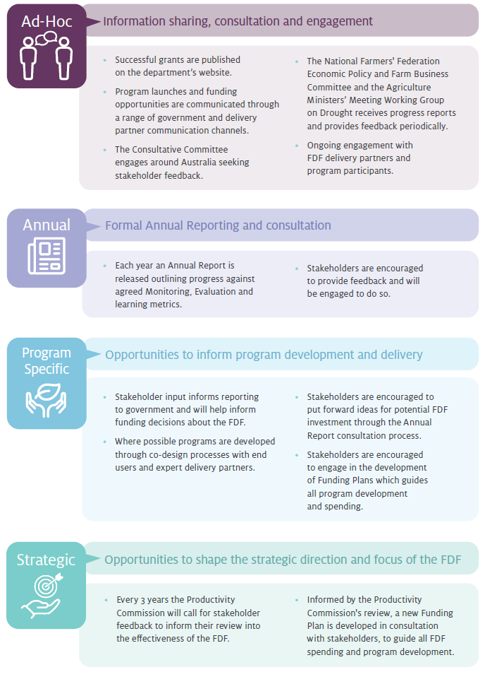

Funding
The government has allocated a total of $420 million to FDF programs over 2020-2028.
In 2021-22, $71.858 million was spent from the FDF. A total of $136.985 million has been spent from 1 July 2020 to 30 June 2022. A total of $342.465 million has been contracted and will be paid under milestones in the next few years.
Table 1 Funding Allocation
Theme and program | Total Allocated $m | Total Contracted $m | Total Expensed $m | 2020-21 Spent $m | 2021-22 Spent $m
Better climate information | 38.858 | 38.858 | 17.596 | 4.940 | 12.656
Climate Services for Agriculture | 28.988 | 28.988 | 12.296 | 3.500 | 8.796
Drought Resilience Self-Assessment Tool | 9.870 | 9.870 | 5.300 | 1.440 | 3.860
Better Planning | 116.818 | 116.818 | 26.081 | 25.818 | 0.263
Farm Business Resilience Program* | 75.965 | 75.965 | 15.965 | 15.965 | 0
Regional Drought Resilience Planning* | 40.853 | 40.853 | 10.116 | 9.853 | 0.263
Better Practices | 203.472 | 145.945 | 77.107 | 23.173 | 53.934
Drought Resilience Adoption and Innovation Hubs | 66.000 | 66.000 | 34.000 | 16.000 | 18.000
Hub Projects | 4.097 | 4.097 | 4.097 | 0 | 4.097
Adoption Officers | 9.000 | 9.000 | 3.000 | 0 | 3.000
National Enabling Activities | 8.011 | 1.380 | 1.195 | 0.380 | 0.815
Drought Resilience Innovation Grants | 33.961 | 28.930 | 18.821 | 0 | 18.821
Natural Resource Management Drought Resilience Program - Grants | 7.806 | 7.806 | 7.806 | 1.171 | 6.635
National Resource Management Drought Resilience Program - Landscapes | 5.622 | 5.622 | 5.622 | 5.622 | 0
Drought Resilience Soils and Landscapes | 23.110 | 23.110 | 2.566 | 0 | 2.566
Grants to support the Adoption of Drought resilient Practices | 14.265 | 0 | 0 | 0 | 0
Drought Resilience Long Term Trials | 20.000 | 0 | 0 | 0 | 0
Drought Resilience Commercialisation Initiative | 10.000 | 0 | 0 | 0 | 0
Drought Resilience Scholarships | 1.600 | 0 | 0 | 0 | 0
Better prepared communities | 40.844 | 40.844 | 16.200 | 11.196 | 5.004
Drought Resilient Leaders | 7.446 | 7.446 | 7.446 | 7.446 | 0
Networks to Build Drought Resilience | 3.750 | 3.750 | 3.750 | 3.750 | 0
Helping Regional Communities Prepare for Drought Initiative | 29.648 | 29.648 | 5.004 | 0 | 5.004
Totals | 400.000 | 342.465 | 136.985 | 65.127 | 71.858
* Note - the Farm Business Resilience and Regional Drought Resilience Planning Programs are currently subject to negotiations with the states and territories to determine final funding for jurisdictions.
2020-21 and 2021-22 figures are actual spend. Any unexpended funds from the $100m each year has been moved into future years for forward commitments.
Long Term Trials of Drought Resilience Farming Practices is funded to 2027-28 ($40m over six years). $20m has been allocated for 2024-25 to 2027-28

Appendix A: Glossary
Term | Definition
ABARES | Australian Bureau of Agricultural and Resource Economics and Sciences
ARLF | Australian Rural Leadership Foundation
CSA | Climate Services for Agriculture
CSIRO | Commonwealth Scientific and Industrial Research Organisation
Consultative Committee | Future Drought Fund Consultative Committee
DAWE | Department of Agriculture, Water and the Environment
department | Department of Agriculture, Water and the Environment - the department name at the time of the reporting period (2021-22)
DRSAT | Drought Resilience Self-Assessment Tool
FDF | Future Drought Fund  The Future Drought Fund is a suite of programs, funded through to 2023-24, that will continue to provide farmers and regional and rural communities with the tools they need for building drought resilience.
FDF Act | Future Drought Fund Act 2019
FRRR | Foundation for Rural and Regional Renewal
Funding Plan | Drought Resilience Funding Plan 2020-2024
Hub | Drought Resilience Adoption and Innovation Hub
MEL Framework | Future Drought Funding Monitoring, Evaluation and Learning Framework
NRM | Natural Resource Management
Productivity Commission | The Productivity Commission is the Australian Government's independent research and advisory body on a range of economic, social and environmental issues affecting the welfare of Australians.
RDEA&C | research, development, extension, adoption and commercialisation

Appendix B: References
DAWE 2020, Future Drought Fund Monitoring, Evaluation and Learning Framework, Department of Agriculture, Water and the Environment, Canberra, December.
Future Drought Fund Act 2019, No. 55, 2019.
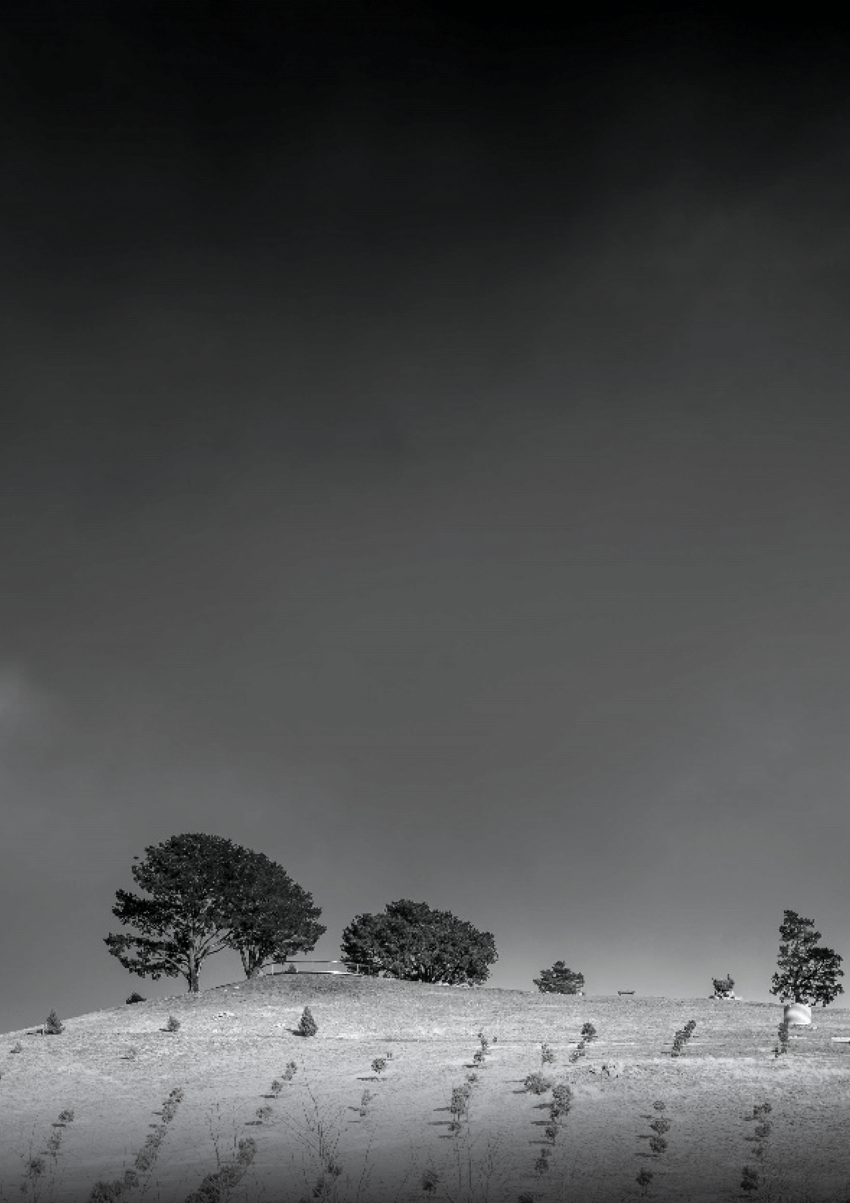
Field with trees in black and white, Marwan El Hassan, naturepicsart.com

